Anatomy of Liver and Radiographic Study on Hepatic Duct in a South African Ostrich Struthio camelus australis

.
ABSTRACT

The South African Ostrich Struthio camelus australis, an acarinate flightless ratite bird, native to the African continent has been introduced in many countries including India in the recent past for meat as well as egg purpose. Although this largest extant bird is gaining popularity globally, the functional anatomy of this majestic giant has received relatively less attention. The liver, the largest gland in the body of an Ostrich (weighing approximately 1.5-2 Kg) is also the heaviest among all the birds. The Ostrich lacks gall bladder and thus, the bile needs to be produced continuously as in the case of certain mammals like horses and elephants. The present study aimed to investigate the gross morphological and radiographic characteristics of the liver of the Ostrich. The liver was divisible into two primary lobes: an undivided right lobe and a divided left lobe. The later consisted of dorso-cranial, intermediate, and ventro-caudal lobes. Notably, the ventro-caudal lobe was observed as the largest, while the intermediate lobe was the smallest. The right lobe, larger than the left, was connected to later by a thick isthmus at its cranial extremity. Using barium sulphate injection and positive contrast radiography, the intrahepatic course of the hepatic duct was visualized, revealing two distinct divisions and tributaries thereof for draining bile from the right and left lobes, respectively. A radiographic study of the intrahepatic course of the hepatic duct revealed a single right intralobar duct and two left intralobar ducts. The distinct isthmus was drained by the branch of the left intralobar duct.

Keywords: Hepatic duct; Liver; Anatomy; Ostrich; Radiography.

1. INTRODUCTION

The South African Ostrich Struthio camelus australis, a majestic and flightless ratite bird, holds the distinction of being the largest extant bird species globally. Native to the African continent, this remarkable avian species has gained substantial popularity on a global scale and is being introduced in various countries, including India for meat as well as egg purpose. Within the Ostrich's robust physique, the liver, a vital organ and the largest gland stands as the heaviest among all avian species, weighing approximately 1.5-2.0 Kg. Unlike many animals and birds, the Ostrich Struthio camelus required a continuous bile production due to the absence of a gall bladder [1, 2, 3]. Such absence of gall bladder has been observed as a characteristic shared with certain mammals such as Equus cabalus and Elephus maximus indicus [4, 5] as well as certain birds like Melopsittacus undulatus [6, 7], Columba livia [8]. The existing literature on the intrahepatic course of the hepatic duct in Ostriches appears to be limited. Therefore, the present study was initiated to document gross anatomical and radiographic observations of the liver of the South African Ostrich.

2. material and methods

The specimen of the South African Ostrich Struthio camelus australis was obtained during a post-mortem examination at the Department of Veterinary Pathology, College of Veterinary and Animal Sciences, Kerala Veterinary and Animal Sciences University, Pookode, Kerala, India. The post-mortem examination involved a thorough inspection of the Ostrich carcass to ensure the absence of pre-existing health conditions that could compromise the integrity of the liver. After careful dissection, the liver was removed from the carcass and the gross anatomical observations were made followed by radiography in Ventrodorsal view to visualize the intrahepatic course of the hepatic duct using a positive contrast radiographic approach. Barium sulphate, a radiopaque positive contrast medium, was introduced into the hepatic duct using a number six infant feeding tube. This was carefully guided to ensure proper placement within the duct. Radiographs were captured at a voltage of 60 kV and an exposure of 13 mAs, depicting the contrast-filled hepatic duct and its tributaries.

3. results

On gross observation, the liver of the South African Ostrich exhibited a dark red hue and possessed a thick, lanceolate structure. The liver had two surfaces viz., convex parietal and lightly concave visceral surfaces. The former was situated more cranially and showed a well-defined depression to accommodate the heart. Ventrally, the parietal surface came in contact with the sternum. The lightly concave visceral surface was defined caudally by the ventriculus and dorsally by the proventriculus, lungs, oesophagus, and caudal vena cava. The liver was comprised of two lobes mainly, an undivided right lobe and a divided left lobe (Fig.1) similar to other birds. The left lobe was further subdivided into dorso-cranial, intermediate, and ventro-caudal lobes based on the location. The intermediate lobe was the smallest, whereas, the ventro-caudal lobe was the largest. The right lobe was larger than the left lobe. It showed blunt cranial and caudal extremities, was thickest at its middle and exhibited a robust connection with the left lobe, facilitated by a thick isthmus (Fig.2). This structural linkage might play a role in maintaining integration between the two lobes. The presence of the isthmus has been poorly described in the available literature. The caudal vena cava was observed to pierce through the cranial extremity of the right lobe of the liver (Fig.2). The passage of the caudal vena cava possessed numerous openings (Fig.3) from the substance of the liver indicating an absence of a well-defined hepatic vein and was substantiated by the presence of aforesaid direct openings.
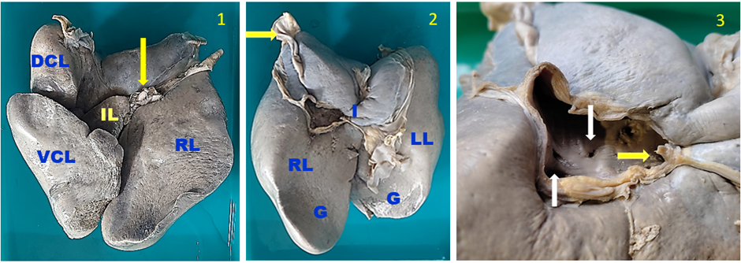
Fig.1 - Dorsal view of liver of the South African Ostrich, RL=Right lobe, DCL=Dorso-cranial lobe, VCL=Ventro-caudal lobe, IL=Intermediate lobe, Arrow-Hepatic duct
Fig.2 - Ventral view of Liver, 1. Isthmus, Yellow arrow=Caudal vena cava, G = Impression for Gizzard, RL=Right lobe, LL=Left lobe
Fig.3 – Interior of caudal vena cava passing through liver showing the variable sized openings, white arrow(s) = openings leading to the left lobe of the liver; Yellow arrow = opening leading to the right lobe of the liver

Positive contrast radiography of the intrahepatic course of the hepatic duct in the liver of South African Ostrich revealed a complex branching pattern of ductal divisions. The graphical representation of the branching pattern of the hepatic duct is given in Fig.4. The hepatic duct was divided into right and left intralobar ducts. The left intralobar duct was observed to divide into proximal intralobar and distal intralobar ducts. The proximal left intralobar duct was observed to be associated with the dorso-cranial lobe. Distal left intralobar duct divided into left interlobular ducts extending their presence across the dorso-cranial, intermediate, and ventro-caudal lobes, suggesting a comprehensive drainage system for multiple liver segments. Notably, the distal intralobar duct gave rise to branches contributing to both the isthmic and interlobular regions. The right intralobar duct gave rise to a couple of interlobular ducts and contributed to bile drainage within the right lobe. The identification of an isthmic branch originating from the distal left intralobar duct might indicate dual drainage from the undivided right lobe.
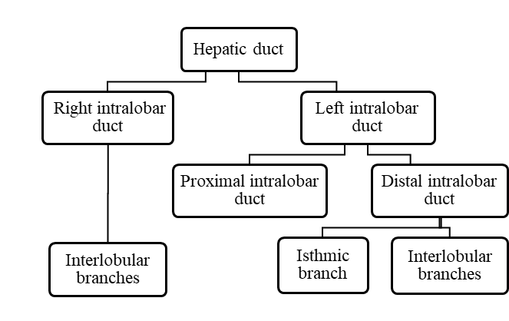
Fig.4 Intrahepatic course of Hepatic duct of the South African Ostrich

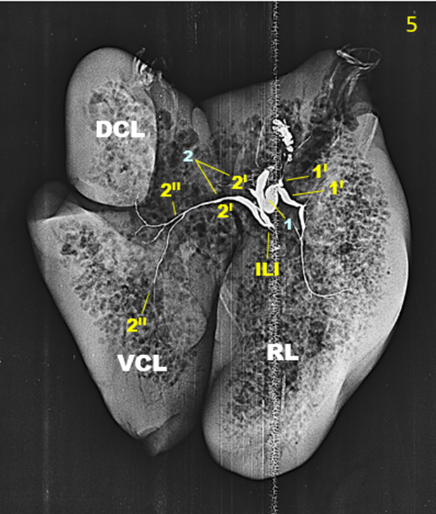
Fig.5 - Ventro-dorsal radiograph showing branching pattern of hepatic duct of the South African Ostrich, 1=Right intralobar duct, 1I=Interlobular branches of right lobe, 2=Left intralobar ducts, 2I=Proximal and distal left Intralobar duct, 2II=Intralobular branch of distal left intralobar duct, RL=Right lobe, DCL=Dorso-cranial lobe, VCL=Ventro-caudal lobe, ILI= Isthmic branch of distal left intralobar duct

4. DISCUSSION
The gross anatomy of the liver in the Ostrich Struthio camelus has been described by several workers [2, 3, 9, 10]. A thick, lanceolate-shaped liver was observed and it was deep red. The liver presented with a convex parietal surface and a concave visceral surface. The cranial aspect of the convex parietal surface exhibited a well-defined fossa to accommodate the apex of the heart. Ventrally, the parietal surface contacted the sternum. The caudally located, slightly concave visceral surface bordered the ventriculus posteriorly, while the proventriculus, lungs, oesophagus, and caudal vena cava bordered it dorsally. Prior investigations confer similar anatomical features in the liver of the Ostrich Struthio camelus [2, 9, 10].
The present work revealed a bi-lobed structure of the liver in the Ostrich Struthio camelus australis. The right lobe was unsegmented, while the left lobe displayed further division into smaller sections. In comparison to the left lobe, right lobe was observed to be larger in the case of the South African Ostrich similar to Melopsittacus undulatus and Larus canus [7]; in Columba livia and Gallus gallus domesticus [11]; in streptopelia senegalensis (now known as Spilopelia senegalensis) and Halcyon smyrnensis [12] and in Cairina moschata [13]. Whereas, [2, 6] observed that, the left and the right lobes were the same size in the Gallus gallus domesticus and the Ostrich Struthio camelus, respectively. The size of both the lobes was found to be either the same or variable in Galliformes, wherein, the left lobe was observed to be slightly larger than the right [14]. The left lobe was further divided into three sub-lobes based on location (dorso-cranial, intermediate, and ventro-caudal), with the ventro-caudal lobe being the largest. Our observations agree with [2, 9, 10]. However, [3] considered the intermediate lobe separate in the Ostrich Struthio camelus. Furthermore, the left lobe was divisible into only two lobes as noticed in Gallus gallus domesticus and Meleagris gallopavo [6,15]; in Anas platyrhynchos, Gallus gallus domesticus and Columba livia [11]; in Fulica atra [16]; in Gallus gallus [17] and in Cairina moschata domestica [13]. In the present work, it was observed that the right lobe was thicker in the middle with blunt ends and displayed a strong connection to the left lobe facilitated by a prominent isthmus. This structural bridge was similar to the one observed in Gallus gallus domesticus [4], and might play a role in coordinating function between the lobes. The caudal vena cava passed through the cranial extremity of the right lobe of the liver. This passage had numerous openings draining the entire parenchyma of the liver, indicating that venous blood might drain directly from the liver into caudal vena cava instead of flowing through a single, well-defined hepatic vein. However, according to earlier works in the Ostrich Struthio camelus [18, 19], a distinct hepatic vein was observed to be formed by the union of right and left hepatic veins on the visceral surface of the liver between the right and left lobes at the point of hilus, opposite to the direction of the hepatic artery. Further studies need to be conducted to explore and confirm the presence or absence of a distinguishable hepatic vein, if any. The absence of the gall bladder in the Ostrich Struthio camelus resulted in a single hepato-enteric duct, while, in other birds with a gall bladder, distinct bile duct, as well as hepatic duct, were observed [2]. In Columba livia, two hepato-enteric ducts were present, with the duct on the right leading to the ascending duodenum, while the one on the left led to the descending duodenum [2]. In the case of Galliformes and Anatidae, the extrahepatic duct consisted of the hepato-enteric duct, which conveyed bile from the left lobe to the ascending duodenum, the hepato-cystic duct which brought bile from the left lobe to the gall bladder, and the cysto-enteric duct that conveyed bile from the gall bladder to the ascending duodenum [2, 20].
Positive contrast radiography revealed a complex branching pattern of the hepatic duct within the liver of South African Ostrich Struthio camelus australis. The hepatic duct was divided into left and right intralobar ducts, with the left duct exhibiting further subdivisions. The distal portion of the left intralobar duct gave rise to branches supplying both the left lobe's sub-lobes and the isthmus, highlighting a potentially specialized distribution system in the left lobe. Additionally, the right intralobar duct gave rise to branches supplying the right lobe. Similar observations were not available for comparison within the known scope of literature. The identification of an isthmic branch originating from the distal intralobar duct has not been documented elsewhere, suggesting a unique biliary ductular pattern in the isthmus of liver in South African Ostrich. No previous studies are available for comparison in the Ostrich regarding the intrahepatic course of the hepatic duct.

5. Conclusion

The present study provides a detailed description of the gross morphology and radiographic observations on the liver of the South African Ostrich Struthio camelus australis, with a focus on the intrahepatic course of the hepatic duct. The Ostrich liver exhibited a unique structure, with two lobes and a thick isthmus connecting them. The absence of a gall bladder resulted in a single hepato-enteric duct, and the radiographic images revealed a complex branching pattern of ductal divisions within the liver. The right intralobar duct was unpaired and the undivided right lobe. The left intralobar duct was observed to divide into proximal and distal intralobar ducts, with the distal intralobar duct giving rise to branches contributing to both the isthmic and interlobular regions. These findings suggest a specialized bile drainage system within the hepatic parenchyma of the liver in the South African Ostrich. The comparative observations on the intrahepatic course of the bile duct (hepatic and cystic ducts) among the birds need to be established to illuminate the bile drainage system on the backdrop of climatic adaptations and its importance on evolutionary lines. Since a definitive hepatic vein could not be observed in the present case, further studies are required to explore and confirm the presence or absence of a distinguishable hepatic vein in Ostriches in general.

References

- Anderloni G. Alimentare lo struzzo. Large Animals Rev. 1996.
- Stornelli MR, Ricciardi MP, Giannessi E, Coli A. Morphological and histological study of the Ostrich (Struthio camelus) liver and biliary system. Italian Journal of Anatomy and Embryology. 2006;111(1):1-7.
- Umar Z, Qureshi AS, Shahid RU, Deeba F. Macroscopic, Microscopic and Histomorphometric Analysis of Intestine, Liver and Pancreas of Ostrich (Struthio camelus) with Advancement of Age and Sex. Pakistan Veterinary Journal. 2021;41(3):313-320.
- Dyce KM, Sack WO, Wensing CJG. Textbook of Veterinary Anatomy. 4th ed. Philadelphia: W.B. Saunders; 2009.
- Rajani CV, Patki HS, Surjith KP, Patgiri S, Deepa PM, Abraham D. Morphology of the Liver of Asian Elephant (Eelephas maximus indicus). Indian Journal of Veterinary Anatomy. 2020;32(1):26-28.
- McLelland J. A colour atlas of avian anatomy. Wolfe Medical Publications Ltd; 1990.
- Hamodi MH, Abed AA, Taha MA. Comparative anatomical, histological and histochemical study of the liver in three species of birds. Rafidain Journal of Science. 2013;24(9):12-23.
- Ahmed JA, Mahdi AA, Khaleel IM. Morphological, Histological, Anatomical and Histochemical Study of the Liver in Poultry (Gallus gallus), Love Birds (Melopsittacus undulatus) and Racing Pigeon (Columba livia). Euphrates Journal of Agricultural Science. 2017;775 -785.
- Bezuidenhout AJ. The topography of the thoraco-abdominal viscera in the Ostrich (Struthio camelus). Onderstepoort Journal of Veterinary Research. 1986; 53:111-117.
- Moslem D. Histological study of the African Ostrich liver and anatomical comparison of it with poultry liver. In Biological Forum. Satya Prakashan. 2015.
- Shafey AFM. Some comparative anatomical studies on the stomach, intestine and liver in ducks, chicken and pigeon. Ph.D. thesis. Benha University. 2006.
- Al-hamadawi HA, Alnaaly AJ, Alumeri JK, Al-bideri AW. Comparative Anatomical and Histological Study of the Liver in Three Species of Wild Birds in Iraq. Journal of Global Pharma Technology. 2017;10(9):387-394.
- Al Shammary, HKA. Histomorphological Study of the Liver in Muscovy duck (Cairina moschata domestica). Journal of Agricultural Science. 2021; 21:112-118.
- Schmid RE, Reavill DR, Phalen DN. Pathology of pet and aviary birds. 1st ed. Iowa State Press: Blackwell Publishing Company: 2003.
- Denbow DM. Gastrointestinal anatomy and physiology. 6th ed. In Sturkie's avian physiology. Academic Press. 2015. https://doi.org/10.1016/B978-0-12-407160-5.00014-2
- Selman HA. Morphological and histological study for liver local coot birds (Fulica Atra). Basrah Journal of Veterinary Research. 2013;12(1):152-158.
- Iqbal J, Bhutto AL, Shah MG, Lochi GM, Hayat S, Ali N, Khan T, Khan AM, Khan SA. Gross anatomical and histological studies on the liver of broiler. Journal of Applied Environmental Biological Science. 2014;4(12):284-295.
- Attia HF, Soliman SM. Histological and histochemical studies on the Ostrich’s liver. Benha Veterinary Journal. 2005; 16:1-11.
- Ferreira NF, Carvalho RGD, Souza WMD, Souza NTMD, Melo APFD. Rodrigues R.F. Tributaries of the hepatic vein in the Ostrich (Struthio camelus). Ciência Animal Brasileira. 2020;21.
- Getty R. Sisson and Grossman's the Anatomy of the Domestic Animals. 5th ed. WB Saunders Company; 1975.

