A study about human interference on the two caves of Udayagiri of Odisha state, India in the viral pandemic year (2020), in comparison with a normal year (2021)

Abstract
The subterranean karst system with its unexplored fauna and flora is an area of curiosity for researchers. The present study on the faunal diversity of the twin caves of Udayagiri, located in the capital of Odisha, is one of such less explored terrains. The seasonal variation of the vertebrates (including bats, geckos, frogs) and invertebrates (including ants and cave beetles) is compared with temporal changes in the two caves of Udayagiri, Bhubaneswar, Odisha, India in the COVID 19 pandemic year of 2020 with the normal year of 2021. These caves are a tourist destination; the faunal distribution is disturbed by human activities. The comparative diversity of animals in such caves is of high implication to understand the bio-geological phenomena and its reflex to anthropogenic activities.
Keywords: Caves, fauna, Anthropogenic, Odisha, Udayagiri Cave.
INTRODUCTION
Caves are a type of karst landscape formed in soluble rocks (e.g., limestone, dolomite, gypsum, halite) that roughly coincide with the global distribution of carbonate sedimentary rocks of all geological ages (e.g., Ford and Williams,2007). Karst covers about15–20% of the Earth’s ice-free land surface. These underground karst systems of horizontal caves and vertical abysses are distributed throughout the Earth and are fragile natural resources that may contain records of archaeological, palaeontological and palaeoenvironmental change.
The density, frequency and number of voidsin karst are important for the development of cave and karst ecosystems. (e.g. Ford and Williams,2007; Palmer,2007). There can be three main habitat zones of a cave that are connected to the surface, based on light penetration and intensity: entrance, twilight, and dark zone. Each zone has specific physicochemical and nutrient conditions associated with geochemical gradients that influence the colonisation potential and distribution of life (Bonacci et al., 2009).
Although the understanding of the geomicrobiological and biogeochemical role of cave and karst microbes in metal and nutrient cycling, including carbonate dissolution and precipitation, has made important advances, many new challenges lie ahead. One line of research that will undoubtedly continue is the unexplored faunal diversity of the karst habitat. This is a common thread running through most cave ecology and environmental microbiology studies. At present, more baseline data are needed to test hypotheses about the distribution, dispersal, and reservoir size of the different, and possibly distinct microbial and microfaunal groups in these subterranean habitats (Hoyos et al., 1998; Groth et al.,2001).
AIMS AND OBJECTIVES
Over the past decade, cave biodiversity has emerged as a growing interdisciplinary field involving the efforts of biologists, geologists, and chemists to address challenging questions of microbial metabolism and biogeochemistry. The research is also helping land managers to recognise the importance of species in cave ecosystems, thereby further protecting cave environments. With the advantage of living in close proximity to two very important historical caves, out of which two caves have been explored for their micro-fauna richness. The present piece of work is an attempt to study the faunal diversity in two caves of Udayagiri in the COVID 19 pandemic year 2020 and compare it with the normal year 2021 to see how human interference affects the animal population. Further to sensitise the appropriate authority to take steps to limit human interference and thus conserve the bio-habitats of caves within the two different caves studied i.e. Khandagiri and Udayagiri located in Bhubaneswar, Odisha. This work is the first of its kind in the region to study the biodiversity of these historically important caves.

MATERIALS AND METHODS
- The study sites:
The latitudinal and longitudinal extent of Odisha ranges from 17°49ˊ N to 22°34ˊN and from 81°29ˊ E to 87°29ˊE respectively on the eastern coast of India, with an area of about 1, 55,707 sq. km. Physically, Odisha can be divided into three broad regions: the coastal plains; the middle mountainous country: the plateaus and the hilly uplands. Most of the caves are found in the plateaus and hilly regions. The sub-mountainous area in the coastal plain is also dotted with some typical cave formations.
Udayagiri (Lat 20°15ˊ N, Long 85°47ˊ E) are located on Kumari Hill at an altitude of 82 m above MSL(Mean Sea Level). The Caves of Udayagiri (Hill of Sunrise) are partly natural and partly artificial caves of archaeological, historical and religious importance located in the capital of Odisha, India i.e. Bhubaneswar and occupy a unique position in rock carving architecture, art and religion. The caves are located on two adjoining hills, mentioned as Kumari Parvat in the Hathigumpha inscription. The number of existing caves at Udayagiri is 18, while Khandagiri has 15.
Out of these 18 caves of Udayagiri, two caves were selected for sampling for this study due to their accessibility and location.
Cave-1 of Udayagiri(Fig.1): This is located within the 2-storey Ranigumpha cave complex and has2 openings, each opening leading to an inner chamber. The inner chamber is 3-7 m in wide, 15-20 m long and ½ to 1½ m high. There are three large holes leading to tunnels about ½ m in diameter and 1 to 5 m long. There are many small holes and crevices. Structures resembling shelves are also present. The temperature inside the cave 30±5°C in summer and 25±5°C in winter.
Cave-2 of Udayagiri (Fig.2)) of Udayagiri is present at the base of Cave-1. It is present in the twilight zone with maximum human disturbance. This cave has single entrance of about 1½ m height and about 2-3 m width. One the left side, it is only 5 m long and then divides into a small tunnel for about 1m. On the right side it is about 10m long and gets narrower as it goes. At the beginning there is a small fork about 2m long and ½ m wide. Many small holes and fractures found inside the cave simulate a darker zone. The temperature inside the cave is 2±7°C lower than outside temperature.
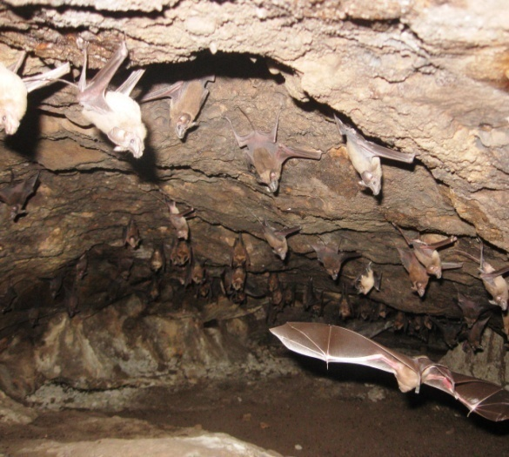
Fig.1 Cave-1 of Udayagiri

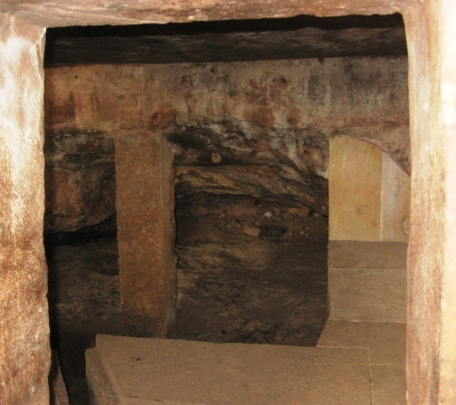
Fig.2 Cave-2 of Udayagiri
The animals found inside and around the caves were also used as material for the study. Prior to the study, the following materials were arranged and kept on a suitable surface within the reach.
INSTRUMENTS USED:
- Measuring tape, ruler, string and straight stick were used for measuring the caves.
- Sling psychrometer (OMSONS Instruments, model 80) was used to measuring temperature and humidity.
- LED torch light and battery-powered emergency light were used as light sources inside the cave.
- A digital camera of (make: Sony) was used for photographing the caves and their fauna.
- Baits like piece of bread, piece of meat, sugar, piece of fruit were used to attract animals.
- Small nylon nets were used for sampling.
- Scalpel, needle, forceps, gloves were used to handle the sample.
- Plastic collection jars, polyethylene bags, small cardboard boxes were used for sample collection.
- Stereozoom microscope.
- Ethyl alcohol of 70% was used as a preservative.
- Hand tally counter for counting animals.
- Google Map software and Google Earth software were used to locate the latitude, longitude and altitude of the study sites.
Geomorphological study of caves was done using Google Map software, Google Earth software.
The climatic study of caves:
Between spring to winter 2020 and spring to winter 2021, temperature and humidity readings were taken from the inside and out side of the two selected caves, Khandagiri-1, and Udayagiri-1. These readings were taken for four seasons i.e. spring, summer, monsoon &autumn and winter. A sling psychrometer was used to recorded temperature and humidity using the standard wet bulb/dry bulb method. Various observations such as sky cover, precipitation, unusual wet or dry conditions in the cave at the recording sites, etc., were also noted.
DATA COLLECTION ON CAVE ANIMALS:
- Counting
- Manual counting: Animals are counted by hand tally counter (Biswas andKanoje, 1992).
- Square area method: A frame of 30cm square area was taken for sampling (Harries etal., 2008; Ruggieri and Biswas, 2011).
- Photography: After taking the photograph with a digital camera (Canon Power Shot A590 IS), it was analysed in a computer (DELL-Vostro-1510, Intel Core2 DUO) for the number of animals and their density (Biswas and Shrotriya, 2011).
- Observation
Observations were categorised as either direct or indirect. Direct observations included observation of invertebrates with the naked eye and hand lens. It was used for any type of invertebrate species. Indirect observations included evidence of invertebrates, such as cast exoskeletons, spent body parts, or egg and larval stages.
Direct and indirect observations were made as follows:
Direct observations included observing wildlife with the naked eye observation of wildlife through binoculars. This technique was used for all species. Direct observations were made with or without collecting the organism. The probability of direct observation of small mammals, reptiles, and amphibians was increased by searching under debris, logs, and rocks.
Indirect observations included evidence of animals such as amphibian and bird calls, bird songs, tracks, droppings, burrows, runs, caches, and remains, such as feathers, bones, skeletons, etc. Bats were surveyed by direct observation, indirect observation, netting and photography (Biswas and Shrotriy, 2011).
- Trapping of insects
Insects were caught directly trapped with hands, forceps, sticks and polythene. Some insects were passively caught passively using funnels and bottle traps, some of which were baited with small pieces of sweet food (such as bread crumbs). In the present study, a small tube plugged with cotton was used as a pooter. A sweep net was used to collect flying insects.
- Identification of animals
In the laboratory of ZSI and RMNH, the animals were captured, photographed and the data were analysed. Detailed macro-analyses of the collected animals were carried out using stereo-zoommicroscope. This led to the identification of the animals.
In all of the counting methods, when the number of organisms was numerous, they were grouped for a given number of organisms.
RESULTS
The climatic conditions outside the cave are constantly changing. The light allows green plants to grow in abundance; these are eaten by herbivores, which in turn are eaten by carnivores. When any of these die, they may be eaten or decomposed by bacteria and fungi, the nutrients released being used by plants for new growth. All these organisms forma complex and constantly changing food web (Das et al., 2007 and Romero, 2009).
Many animals species are found in the caves studied. Of these, randomly only five species example: (Table 1) were used for comparison in the present study.

Table 1: Cave-wise distribution of animals with their scientific names.
Sl.No. |  |  | COMMON NAME |  | SCIENTIFIC NAME
 |  |  | BEETLE
1 |  |  | CAVE BEETLE |  | Species of Tenebrionidae Latreille, 1802.
 |  |  |  | ANT
2 |  | EAST INDIAN HARVESTING ANT |  |  |  | Pheidologeton diversus(Jerdon, 1851)
 |  | AMPHIBIA
3 |  | TOAD |  |  | Duttaphrynus melanostictus  (Schneider, 1799)
REPTILIA
4 |  | GECKO |  |  |  |  |  |  | Hemidactylus leschenaultii  Duméril&Bibron, 1836
MAMMAL
5 | FRUIT BAT |  |  |  |  |  |  | Rousettus leschenaultia Desmarest, 1820

Table 2: Annual diversity of fauna in Cave U1 across seasons.
SEASON | BAT |  |  | ANT (1=50) |  | TOAD |  | GECKO |  | CAVE BEETLE (1=10)
SEASON | 2020 | 2021 | 2020 |  | 2021 | 2020 | 2021 | 2020 | 2021 | 2020 | 2021
SPRING | 300 | 280 | 0 |  | 5 | 3 | 2 | 8 | 6 | 15 | 13
SUMMER | 335 | 320 | 0 |  | 5 | 2 | 1 | 8 | 6 | 4 | 2
MON & AUT | 315 | 300 | 1 |  | 7 | 5 | 4 | 10 | 8 | 10 | 10
WINTER | 330 | 310 | 0 |  | 4 | 2 | 2 | 9 | 8 | 12 | 11

Fig 3: Variation of animal distribution across years in U1.

Table 3: Annual diversity of fauna in Cave U2 across seasons.
SEASON | BAT |  | ANT (1=50) |  | TOAD |  | GECKO |  | CAVE BEETLE(1=10)
SEASON | 2020 | 2021 | 2020 | 202 | 2020 | 2021 | 2020 | 2021 | 2020 | 2021
SPRING | 36 | 34 | 2 | 5 | 4 | 3 | 3 | 2 | 15 | 12
SUMMER | 35 | 34 | 0 | 5 | 5 | 4 | 3 | 2 | 14 | 14
MON & AUT | 38 | 37 | 0 | 7 | 7 | 6 | 3 | 2 | 10 | 8
WINTER | 30 | 27 | 0 | 4 | 2 | 1 | 3 | 2 | 12 | 11

Fig 4: Variation of animal distribution across years in U2.
In the present study, it is very much clear that the number of animals in both U1and U2 caves (Table 2, Table 3, Fig. 3, Fig. 4) decreases significantly from the year 2020 to the year 2021, except for the ant species, which increases.
DISCUSSION
During the COVID 19 pandemic period, due to lockdown human interference is significantly less in the year 2020than in the year 2021 due to the closure, which may explain why the number of animals seen in 2020 is higher than in 2021.Human disturbance is greater in cave U2 than in cave U1 in 2021 than 2020, so the animal population decreases more in cave U2 than in cave U1. However, the ant population increases in both caves from 2020 to 2021(Table 2, Table 3, Fig. 3 Fig. 4). This may be due to an increase in food debris as a result of increased human disturbance from 2020 to 2021. The increase in the population of other animals in 2020 may adversely affect the population of ants, as ant larvae are one of the rich food sources for many animals.
CONCLUSION
From the present study, it is very much clear that human interference is always a key factor for the population of other species. Even in the cave ecosystem, which is very much endemic and micro, but very much fragile. To protect such fragile ecosystem, human interference should be controlled.

REFERENCES
Biswas J (2009) The biodiversity of KremMawkhyrdop of Meghalaya, India, on the verge of extinction. Current Science,96(7):904-910.
Biswas J (2010) Kotumsar Cave biodiversity: a review of cavernicoles and their troglobiotic traits. Biodiversity and Conservation,19(1):275-289.
Biswas J and Kanoje S (1992) Seasonal and photoperiodic control of the activity and daily exodus of a colony of cave-dwelling bat. J. Ravishankar Univ., 4-5:33-41.
Biswas J and Shrotriya S (2011) Dandak: a mammalian dominated cave ecosystem of India. Subterranean Biology, 8: 1-7.
Bonacci O, Pipan T, Culver DC (2009). A framework for karst ecohydrology. Environ Geol 56:891–900
Charles VR (1892) Directions for collecting and reserving insects Bulletin (United States National Museum). Govt. Printing Off, Washington, pp 39-43.
Das M, Goswami S, Guru BC (2007) Caves and caverns. Everyman’s science,XLI(6): 392-396
Ford D, Williams P (2007).Karst hydrogeology and geomorphology. Wiley, West Sussex
Groth, I., Schumann, P., Laiz, L., Sanchez-Moral, S., Cañaveras, J.C., Saiz- Jimenez, C. (2001).Geomicrobiological study of the GrottadeiCervi, Porto Badisco, Italy.Geomicrobiol. J. 18, 241-258.
Harries DB, Ware Fj, Fischer CW, Biswas J and Khapran-Daly BD (2008) A Review of the Biospeleology of Meghalaya, India. India. J. Cave and Karst Studies, 70(3):163-176.
Hoyos, M., Soler, V., Cañaveras, J.C, Sanchez-Moral, S., Sanz-Rubio, E. (1998). Microclimatic characterization of a karstic cave: human impact on micro environmental parameters of a prehistoric rock art cave (Candamo Cave, northern Spain). Environ. Geol. 33, 231-242.
Palmer AN (2007). Cave Geology. Cave Books, Dayton, OH
Romero A (2009). Cave Biology: life in darkness. Cambridge University Press, Cambridge
Ruggieri R and Biswas J (2011) The Karst MandhipKhol-python cave complex in the lenticular limestone intercalations of the metamorphic Chhatela formation (Chhattisgarh, India). Spleleologia, 63(31): 58-63

