DIVERSITY OF AQUATIC MACROPHYTE FLORA ABUNDANCE IN MEGHADRIGEDDA RESERVOIR AT VISAKHAPATNAM, ANDHRA PRADESH, INDIA

ABSTRACT

Meghadrigedda reservoir is located in the Gajuwaka municipality of Visakhapatam district in Andhra Pradesh, India. The research was conducted at six distinct sites in the reservoir catchment region from April 2023 to March 2024, throughout pre-monsoon, monsoon, and post-monsoon periods. The current analysis indicated the presence of 52 weed species belonging to twenty orders, 33 families, and four classes. The present investigation compiled a list of hydrophytes, including their class, order, family, genus, species, and common name. The mentioned species under free floating, submerged species, and emergent weeds were found mostly around the mouths of the reservoir's main tributaries, in shallow areas with depths of about 7 feet. Among the 21 orders of aquatic weeds recorded, emergent weeds accounted for 52.38% (11 species), followed by submerged weeds 42.85% (09) and free floating weeds 21.81%. In 30 families, emergent weeds accounted for the most (66.66%), followed by submerged weeds (30.00%) and free floating weeds (20.00%). Emergent weeds dominate with 36 species, accounting for 69.23% of the total species, followed by submerged weeds with 10 (19.23%) and free floating weeds with 6 (11.53%). According to the IUCN (2014), there are 52 different species of hydrophytes. The status of these 42 aquatic weed species is least worried; 9 are not evaluated (NE), and one species is vulnerable (VU). The common name, habitat and IUCN (2024) status of the macrophytes has also been noted in the present paper.
Key words: Free floating, Submerged, Emergent, Emergent weeds, hydrophytes

INTRODUCTION
In the natural environment, herbivorous and omnivorous fish might find edible plants for consumption. Aquatic plants can provide a nutritious food for fish in aquariums or backyard ponds. Ipomoea aquatica, an aquatic weed, might be managed in an environmentally benign way by including it into fish diet. Fish feed is critical to the long-term viability of aquaculture production. However, fish nutrition is crucial since feed is the most costly component of the aquaculture system, accounting for around 60% of total production costs (Craig et al., 2017; Prabu et al., 2017; Daniel, 2018). The young grass carp prefer duckweeds such as Lemna, Spirodela, Wolffia, and Azolla until they reach a greater size and can consume macrophytes. Aquatic weeds are potential fish and animal feed components that are extensively spread across Indian water bodies. The higher nutritional content of aquatic weeds has lately enabled fish meal to be largely or entirely substituted (Ghosh et al., 2021; Nandi et al., 2023). Naseem et al., 2021) found that aquatic weed meal has 11 to 32% crude protein, 2.9 to 16.81% crude fat, 8 to 31% crude ash, and a very high amino acid, mineral, and vitamin content, depending on the components employed.

Nearly 50 aquatic weed species are known to be used as direct or indirect diet for both herbivorous and omnivorous fish (Mandal et al., 2019; Akmal et al., 2014; Naseem et al., 2021). Water hyacinth (Eichhornia crassipes) is potentially useful in many tropical places throughout the world. It's a toxic aquatic plant that grows quickly in aquatic medium (Ganguly et al. 2012). Recent studies also suggest that macrophytes play a central role in shallow reservoirs which can have two possible stable equilibrium: a clear-water state that is dominated by aquatic macrophytes and a turbid-water state that is dominated by phytoplankton (Jeppesen et al., 1998). Aquatic plants are an essential component of an aquatic environment. They may provide a valuable source of food for humans and a nutritious diet for water birds and animals, building the groundwork for aquatic wildlife conservation techniques. They can also be used as an energy source (Majid, 1986). Researchers such as Wetzel (1975), Majid (1986), Meshram (2003), Ambasht (2005), Raut, and Pejawer (2005) studied macrophytes in diverse water bodies across India. Macrophytes act as a connection between sediment, water, and the atmosphere in reservoirs, lakes, and rivers. Plants' most recognized function is as primary producers. However, macrophytes have a role in ecosystem processes like as biomineralization, transpiration, sedimentation, elemental cycling, material transformation, and the release of biogenic trace gases into the atmosphere (Carpenter and Lodge, 1986). The Meghadrigedda Reservoir hosts a varied diversity of macrophytes over many substrata, which have been documented for the first time. The current study is aimed at assessing the distinctive temporal variation in macrophyte varieties in the Meghadrigedda reservoir, along with their potential use as bioindicators.

MATERIAL AND METHODS

Study area
Meghadrigedda is a non-perennial river that flows east and rises in the Eastern Ghats in Nandikonda Hills. It flows towards Rajaourajapeta village in Visakhapatnam district's S. Kota mandal, then swings south up to Karuvapuvanipalem village, where it passes in a south-east direction before joining the Bay of Bengal at Ramapuvanipalem. The reservoir area is bounded by three administrative mandals of Visakhapatnam district, namely Sabbavaram, Pendurthi, K.Kotapadu, and Kothavalasa mandal of Vizianagaram district, with geographic coordinates ranging from 170 42' to 170 57' north and 830 00' to 830 17' east. The three primary ephemeral rivers that flow into the reservoir are Naravagedda (by Anantapuram and Chintapatla villages), Meghadrigedda (via Pinagadi, Rampuram, and Pedagadi villages), and Borramgedda (via Kothavalasa, Pendurthi, Fig. 1).

Laboratory analysis
The research was conducted at six distinct sites in the reservoir catchment region from April 2023 to March 2024, throughout pre-monsoon, monsoon, and post-monsoon periods (Fig 2). The macrophytes were gathered by hand and with nets, then transported to the laboratory, fixed in 10% formalin, and identified in the laboratory by using standard accessible literature (Cook, 1996). The identification of aquatic plants was done using standard books and monographs such as and Biswas and Calder (1953), Naskar, K.R. (1990), Stromberg, (1993), Singh and Karthikeyan (2000 and 2001), Adesina (2007).
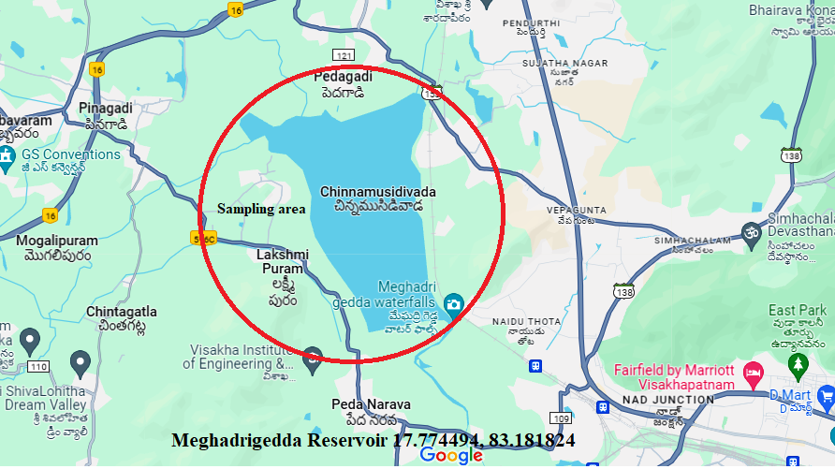
Fig: 1 Map showing study location

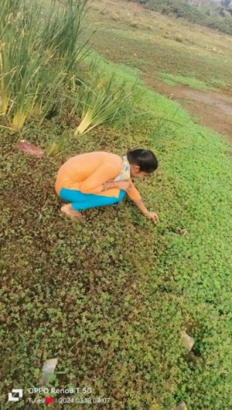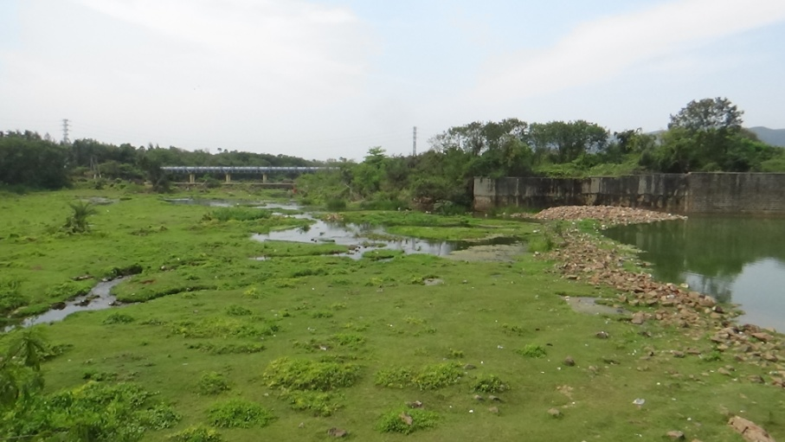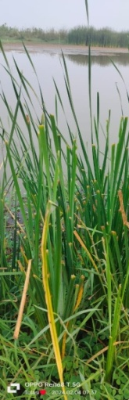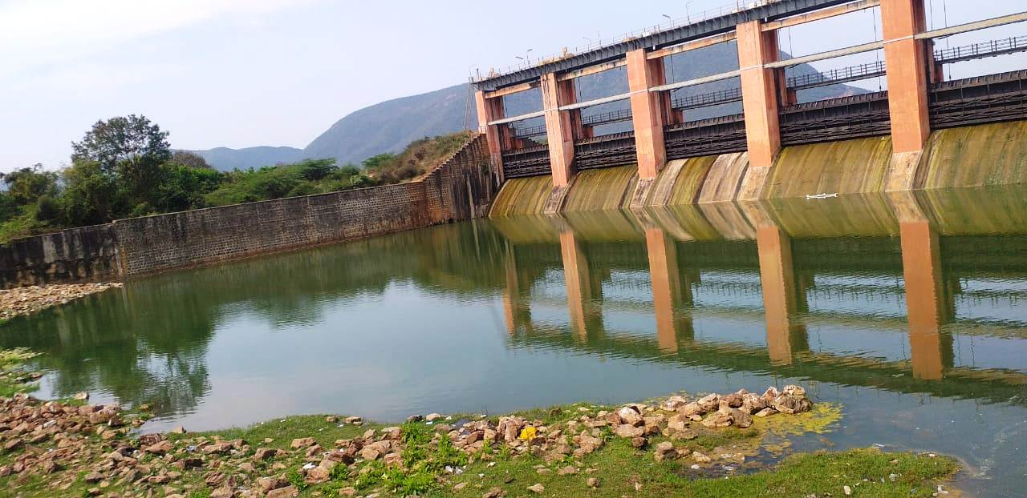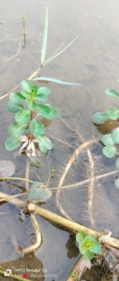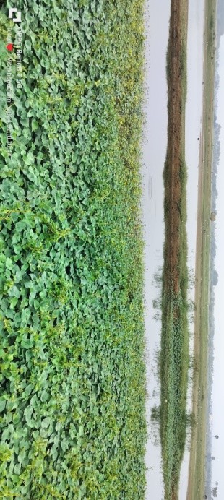
Fig: 2. Samples collection at various locations around the Meghadrigedda Reservoir

RESULTS AND DISCUSSION
The results of the present study revealed that the occurrence of 52 weed species belong to twenty orders, 33 families and four classes. The listed species under free floating, Submerged species and emergent weeds were identified mostly around the mouths of the reservoir's main tributaries, in shallow places with depths about 7feet (Table 1, 2, 3). The similar study were represented by Rama Rao et al., (2014) recorded forty-eight distinct aquatic macrophytes reported in four classes, twenty orders, and 26 families, including five free floating macrophytes, ten submerged, and thirty-three emergent weds in Lower Manair Dam. Thomaz et al., (1999) investigated over 62 species, 25 families, and 42 genera of aquatic macrophytes in the Itaipu Reservoir. James et al., (2006) identified 12 submersed, 3 floating, and 18 emergent aquatic plants to species level; some samples were only identified to genera, and none of the filamentous algae were identified to either genera or species in Arizona’s Reservoirs. Patil et al., (2012) explained on hydrophytes and amphibious plants occurred in Panchganga River in vicinity of Ichalkaranji city district Kolhapur, Maharashta. Bandita Kumari et al (2019) reported a total 60 species of hydrophytes belonging to 39 genera and 25 families were identified. Among these, Cyperaceae was the dominant family comprising 17 species in in Different Aquatic Habitats of Puri District, Odisha. Das et al., (2009) reported 13 genera of water macrophytes belonging to 10 families, as well as 24 plant species (bank flora) belonging to 16 families in Krishnagar, West Bengal, India. Ayodhya et al., 2013 reported to the 74 species of macrophytes foundduring the present study at Mula river flowingthrough the Pune City. The similar results were found in Meghadrigedda reservoir during the study period.

In the present investigation the number of classes, orders and families under three types of weeds were shown in Table 4. Fig: 3. the submerged and emergent weeds are highest contributed each six class and Free floating weeds contributed lowest for three classes in Meghadrigedda Reservoir. Recorded aquatic weeds under twenty one orders, the emergent weeds occupied highest 52.38% (11 species), followed by submerged weeds 42.85% (09) and free floating weeds 21.81 % (05). In 30 families which are the emergent weeds occupied highest 66.66%, followed by submerged weeds 30.00 % and free floating weeds 20.00%. Emergent weeds are dominant with 36 species which contributes 69.23% of the total species followed by submerged weeds with 10 (19.23%) and free floating weeds with 06 (11.53%).

In terms of the number and percentage composition of free floating, submerged, and emergent weeds across twenty-one orders, Arales was dominant with two species accounting for 33.66% of the total five species of free floating weeds, followed by Salviniales, Liliales, Aslimatales, and Myrtales, each with one species (16.66%). Out of ten recorded submerged weed species, Slanales contributed two (20%), followed by Salviniales, Myrtales, Charales, Ceratophyllales, Hydrocharitales, Najadales, Poales, and Polypodiales, each contributing one (10%) of the total population Table 5. Fig: 4.

Recorded emergent weeds out of 36 species, Poales was dominant with five species which contributed 30.55%, followed by Caryophyllales 16.66%, Lamiales 13.88%, Asterales 11.11%, Commelinales 8.33%, Fabales 5.55%, and Myrtales, Amaranthaceae, Malphigiales, Boraginales, Sphigomondales which contributed each one species 2.77%. Recorded 52 species of aquatic weeds Poales were dominant with 12 (23.07%), followed by Caryophyllales with 6 species which contributed 11.53%, Lamiales with 5 species (9.61%), Asterales was dominant with 4 species (7.69%), Myrtales and Commelinales each with 3 (5.79%), Salviniales, Arales, Slanales, Fabales with 2 species, and liliales, Aslimatales, Charales, Ceratophyllales, Hydrocharitales, Najadales, Polypodiales, Amaranthaceae, Malphigiales, Boraginales, Sphigomondales contributed each one species (1.92%) Table 6. Fig: 5.

James et al., (2006) surveyed aquatic plants in 38 reservoirs throughout Arizona from an inventory of species and to determine species distribution and composition patterns. They identified 12 submersed, 3 floating, and 18 emergent aquatic plants to species level. Adesina, (2007) studied an assessment of aquatic vegetation of Jebba Lake, Nigeria. Olsen, (1950) and Spence, (1964) represented aquatic plants and hydrospheric factor and the macrophytes vegetation of lochs, swamps and associated fens. Ambasht, (2005), Billore, and Vyas, (1981) were studied the macrophytes limnology, distribution and production of macrophytes in the Indian subcontinent. Kiran, et al, (2006) Krull, 1970, Madsen, and Chambers (2001) were studied aquatic macrophytes in fish culture ponds, aquatic plant-invertebrate associations and the Interactions between water movement, sediment dynamics and submersed macrophytes.

The number and percentage composition of free floating, submerged and emergent weeds under 30 families, recorded 6 species of free floating weeds Araceae contributed highest with 28.57%, followed by Azollaceae, Pontederiaceae, Hydrocharitaceae, Onagraceae, 14.28%. Recorded ten species of submerged weeds Convolvulaceae family was dominant with two species (20%) followed by Hydrocharitaceae, Onagraceae, Characeae, Ceratophyllaceae, Marsileaceae, Potamogetonaceae, and Typhaceae, Pteridaceae contributed each with one (10%) species. Recorded 36 species of emergent weeds were dominated by Cyperaceae with contributed seven (19.44%) followed by Asteraceae with four (11.11%), Amaranthaceae and Commelinaceae each with three (8.33%), Fabaceae and Poaceae each with two (5.55%), Onagraceae, Typhaceae, Hythraceae, Euphorbiaceae, Eriocaulaceae, Molluginaceae, Boraginaceae Plantaginaceae, Polygonaceae, Vertebae, Orobanchaceae, Sphinogomonadaceae and Verbanaceae ach with one (2.77%) Table 7, Fig: 6. The percentage contribution of Macrophytes shown in Fig: 7.
The 52 recorded aquatic weed species have been classified into 30 families, with Cyperaceae comprising seven species, or 13.46% of the total. Asteraceae contributed four (7.69%) species. Onagraceae, Amaranthaceae, and Commelinaceae each produced three (5.76%) species. Araceae, Hydrocharitaceae, Convolvulaceae, Typhaceae, Fabaceae, Scrophulariaceae, and Poaceae all have two (3.84%) species. Azollaceae, Pontederiaceae, Characeae, Ceratophyllaceae, Marsileaceae, Potamogetonaceae, Pteridaceae, Hythraceae. Euphorbiaceae, Eriocaulaceae, Molluginaceae, Boraginaceae, Plantaginaceae, Polygonaceae, Vertebae, Orobanchaceae, Sphinogomonadaceae, and Verbanaceae all contributed one species (2.77%). The similar study was conducted by an assessment of macrophyte diversity of a freshwater reservoir of Bhadrawati Tehsil in Chandrapur district, by Shashikant R.Sitre (2013). Gokhele, et al., (2011) conducted a survey on flora of wet coastal and associated ecosystem to Maharastra.

In the present study the total of 52 species of hydrophytes according to IUCN (2024) status of these 42 species of aquatic weeds are least concerned, 9 are not evaluate (NE), 1 species is vulnerable (VU). The least concerned of free floating weeds contributed 7.62%, 3.84% species are not evaluated. The submerged weeds 15.38% are least concerned and 3.84% species are not evaluated. In the emergent weeds 57.69%) are least concerned, 9.61%) are not evaluated and1.92% is vulnerable Table 8. Fig: 8. The similar study was observed by Rama Rao et al., (2014) reported a total of 48 species of hydrophytes belonging to 4 classes, 20 orders and 26 families were studied. According to IUCN (2013.2) of these 35 species of aquatic weeds are least concerned, 12 are not evaluate (NE), 1 species is vulnerable (VU). In the free floating weeds, three species are least concerned (6.25%), two (4.17%) species are not evaluated. In the submerged weeds, eight species (16.67%) are least concerned and two (4.17%) species are not evaluated. In the emergent weeds 24 species (50%) are least concerned, eight (16.67%) are not evaluated; one (2.03%) is vulnerable.

Table: 1. Checklist of free floating weeds of their scientific name, common name, class, order, family, habitat and IUCN red list at Meghadrigedda Reservoir

S.No | Name of Species | Common name/s | Class | Order | Family | Habitat | IUCN  (2024)
1 | - Azolla filiculoides | Water Fern | Polypodiopsida | Salviniales | Salviniaceae | It is most frequent in ponds, lakes, canals, ditches and slow flowing rivers. | NE
2 | Eichornia crassipes (Mart.) Solms. | Water hyacinth | Liliopsida | Commelinales | Pontederiaceae | Shallow impermanent ponds, wetlands and marshes, slow-moving waterways, lakes, reservoirs, and rivers | NE
3 | Lemna perpusilla Torrey | Duckweed | Liliopsida | Arales | Lemnaceae | It grows in paddy fields, ponds and other still water bodies. | LC
4 | Ludwigia peploides | Floating primrose – willow | Magnoliopsida | Myrtales | Onagraceae | It is commonly found in wetlands, marshes, ponds, and slow-moving streams. It relishes shallow water with ample sunshine and nutrition. | LC
5 | Ottelia alismoides (L.) Pers. | Duck-lettuce, waterplantain ottelia | Liliopsida | Hydrocharitales | Hydrocharitaceae | This species grows in shallow water edges and ponds and in rice field | LC
6 | Pistia stratiotes L. | Tropical duck-weed, water lettuce | Liliopsida | Arales | Araceae | It is a free-floating weed and capable of forming dense mats on the surfaces of lakes, ponds, rivers and other water bodies. | LC

Table: 2. Checklist of Submerged weeds of their scientific name, common name, class, order, family, habitat and IUCN red list at Meghadrigedda Reservoir

S.No | Name of Species | Common Name/s | Class | Order | Family | Habitat | IUCN  (2024)
1 | Aponogeton natans L.f | Floating lace Plant, Drifting Sword Plant | Liliopsida | Najadales | Aponogetonaceae | It grows in seasonal and permanent still or flowing waters, rice fields and marshy places. | LC
2 | Chara globularis J. L.T | Muskgrass, stonewort, muskwort | Charophyceae | Charales | Characeae | It may be found in both fresh and brackish water. It may be found in both oligotrophic and eutrophic waters, including lakes and rivers. It grows on a sand, clay, mud, or marl substrate. | NE
3 | Ceratophyllum demersum L. | Rigid Hornwort , Coontail, Hornwort | Magnoliopsida | Nymphaeales | Ceratophyllaceae | Less saline parts of sea inlets, ponds, slow-flowing streams | LC
4 | Hydrilla verticillata (L. f.) Royle | Florida-elodea, Indian Stargrass, Water-thyme | Liliopsida | Hydrocharitales | Hydrocharitaceae | Rrivers and ponds. This species is hardy and tolerant to heavy metals. | LC
5 | Ipomoea aquatica Forsk (Rooted) | Water spinach | Magnoliopsida | Solanales | Convolvulaceae | Found in marshy habitats and ditches, muddy stream banks, ponds, lakes, rice paddies and waste areas. | LC
6 | Ipomoea carnea jacq | Pink morning glory | Magnoliopsida | Solanales | Convolvulaceae | Grows in dense concentrations along riverbeds, riverbanks, canals, and other soggy locations. It has gotten naturalized along canals, drains, and roadside. | NE
7 | Marsilea quadrifolia | Water Shamrock | Polypodiopsida | Salviniales | Marsileaceae | It grows in still waters such as ponds, rice fields and ditches. | LC
8 | Najas minor L. | Slender Naiad | Liliopsida | Hydrocharitales | Hydrocharitaceae | Ponds, lakes, rivers, streams, ditches and paddy fields. | LC
9 | Potamogeton pectinata L. | Fennel Pondweed | Liliopsida | Najadales | Potamogetonaceae | Typical of eutrophic or brackish waters  lakes, reservoirs, rivers, streams, canals, ditches, pond | LC
10 | Vallisneria spiralis L. | Tapegrass | Liliopsida | Hydrocharitales | Hydrocharitaceae | Estuarine habitats, lakes, rivers, waterlogged swamps with open water, man-made reservoirs, | LC

Table: 3. Checklist of emergent weeds of their Scientific name, common name, class, order, family, habitat and IUCN red list at Meghadrigedda Reservoir

S.No | Name of Species | Common Name/s | Class | Order | Family | Habitat | IUCN  2024
1 | Alternanthera sessilis (L).R.Br.ex | Sessilis joyweed | Eudicots | Amaranthacea | Amaranthaceae | Aquatic and wetland environments.It may spread to branchish water and estuary environments along the shore. | LC
2 | Alternanthera philoxeroides | Dwarf copper leaf | Eudicots | Caryophyllales | Amaranthaceae | Aquatic and wetland plants. | LC
3 | Ammannia baccifera L. | Blistering ammania | Eudicots | Caryophyllales | Lythraceae | It is an annual herbaceous plant that may be found in swamps, rice paddies, and freshwater. | LC
4 | Aeschynomene indica L. | India joint-vetch | Eudicots | Fabales | Fabaceae | Grows in field margins, ditches, grasslands,trail sides and river margins. | LC
5 | Bacopa monnieri (L.) wettestin | Water hyssop | Eudicots | Lamiales | Scrophulariaceae | Forms dense mats in marshy places,the banks of pools and along stream and ditches. | LC
6 | Commelina benghaleasis L. | Bengal day flower | Monocots | Commelinales | Commelinaceae | A widespread weed often found in ditches, wet fields and places | LC
7 | Commelina hasskarlii C.comm.cyrt. | Carolina dayflower | Monocots | Commelinales | Commelinaceae | Commonly found in fields.swamps, yards, waste places, along roadsides, rarely in the forests. | LC
8 | Cyperus rotundus L. | Nut - grass | Monocots | Poales | Cyperaceae | It dwells in a wide variety of wetland environments, including seasonally wet grasslands, swamps, ditches, pond and lake margins, springs, stream and river banks.. | LC
9 | Cyperus difformis L. | Small flower umbrella sedge | Monocots | Poales | Cyperaceae | The plant generally flourishes in flooded or extremely moist soils.It may be found in small pools, rivers, canals, streams, open wet places, and grassy marshes. | LC
10 | Cynodon dactylon (L)Pets. | Devils grass | Monocots | Poales | Poaceae | Water courses, wetlands | LC
11 | Cyathocline purpurea (Buch-Ham.ex D.Din )Oktze | Purple bane | Eudicots | Asterales | Asteraceae | It is found growing in water logged soilssubjected to seasonal inundation and along waterways. | LC
12 | Chrozophora rottleri (Geisel)A.juss.ex.spr | Suryavarti | Eudicots | Malpighiales | Euphorbiaceae | Paddy fields and reservoir banks | NE
13 | Dopatrium junceum | Rushikesh dopatrium | Eudicots | Caryophyllales | Scrophulariaceae | It grows in post- monsoon pools, rice fields and perennially wet places below 1,800m | LC
14 | Eclipta alba | False Daisy, bhringraj | Eudicots | Asterales | Asteraceae | Grows commonly in moist places as a weed in warm temperate to tropical areas worldwide | LC
15 | Eleocharis geniculata (L.) | Canada spikesedge | Monocots | Poales | Cyperaceae | It is an annual plant that forms clusters and is gregarious in shallow water. It is particularly common in fallow rice fields, brackish water along the coast, and damp sandy places. | LC
16 | Eleocharis capitata R.Br. | Spike -rush | Monocots | Poales | Cyperaceae | Wetlands,banks of pools and streams, terrestrial; freshwater | LC
17 | Eriocaulon cinereum R.Br | Pipewort | Monocots | Poales | Eriocaulaceae | Damp shady place.rice fields, valleys, and damp soils from near sea level | NE
18 | Echinochloa colona (L.)link | Wild grass | Monocots | Poales | Eriocaulaceae | Rice banks, pond shorelines, mangrove swamp inner borders, and ancient clearings are all examples of wetland ecosystems. | LC
19 | Fimbristylis miliacea | Grass-like fimbristylis | Monocots | Poales | Poaceae | It is an annual or perennial herb growing in wet places, ponds, streams and at the edges of drying pools. | LC
20 | Gomphrena celosioides Mart. | Gomphrena weed | Magnoliopsida | Caryophyllales | Amaranthacea | A common plant of roadsides, and sometimes invading pastures as a weed | NE
21 | Glinus lotoides L. | Lotus sweetjuice | Magnoliopsida | Caryophyllales | Molluginaceae | Lake, marsh | NE
22 | Grangea maderaspatana | Madras carpet | Magnoliopsida | Asterales | Asteraceae | The species occurs on the edges of ponds,canals and ditches, as well as rice fields, | LC
23 | Heliotropium supinum L. | Dwarf heliotrope | Eudicots | Boraginales | Boraginaceae | Sandy and alluvial plains, waste ground, edges of cultivation. | LC
24 | Limnophila sessiliflora L. | Asian marshweed | Tracheophyte | Lumiales | Plantaginaceae | Wetland habitats include the borders of ponds, marshes, rice fields, seasonally flooded habitats along streams, and low-lying wet places. | LC
25 | Polygonum glabrum willd. | Marsh buckwheat | Eudicots | Polygonales | Polygonaceae | Common, grows gregariously in marshy areas.plains | NE
26 | Phyla nodiflora (L) greene | Turkey tangle frog fruit | Tracheophyte | Laminales | Verbenaceae | A marshy herb which grows in open and wet places near streams, ponds, paddy fields, ditches, backwaters, brackish water | LC
27 | Sesbania bispinosa ( jacq.)w.t.wight | Sesbania pea | Eudicots | Fabales | Fabaceae | It is not limited to wetlands; it may also be found in swamps, marshy wastelands, waterlogged regions, pond and river banks, rice fields, and periodically inundated areas. | LC
28 | Sopubia delphinifolia (L).G.Don | Sopubia delphinifolia | Eudicots | Lamiales | Orabancheaae | Western India,as a root parasite. | VU
29 | Sphaeranthus indicus L. | East Indian globe thistle | Eudicots | Asterales | Asteraceae | It is an annual that grows in moist places, often momentarily submerged.Common in and around irrigation canals. | LC
30 | Typha angustata Bory and chaub | Reed mace, elephant grass | Monocots | Poales | Typhaceae | It occurs in shallow water of lakes, ponds, rivers, swamps and channels. | NE
31 | Sphsgneticola trilobata | Yellow creeping Daisy | Alphaproteobacteria | Sphingomonadales | Sphingomonadeaae | A weed found in urban woodlands, waterways, lake margins, wetlands, roadsides, disturbed sites, waste areas, vacant lots, and coastal sand dunes in tropical and subtropical countries. | LC
32 | Cyperus javanicus | Javanese flatsedge | Monocots | Poales | Cyperaceae | Asia to pacific. it is a perennial grows primarily in the seasonally dry tropical biome | LC
33 | Cyperus haspan | Haspan flatsedge | Monocots | Poales | Cyperaceae | It is widely distributed in tropical and sub-tropical region in Africa, Madagascar, southern asia | LC
34 | Murdannia nodiflora | Dove weed | Liliopsida | Commelina | Commelinaceae | Is a major weed of cotton and food crops on temporarily flooded hydromorphic soil | LC
35 | Phyla nudiflora | Turkey tangle frog fruit | Tracheophyte | Lamiales | Verbenaceae | Wet location along the edges of ponds and ephemeral fresh water wetlands,sabal palmetto | LV
36 | Ludwigia octavalvis | Mexican primrose willow | Eudicots | Myrtales | Onagraceae | It’s fast growth and matted roots will help stabilize | LC

Table: 4. Number of classes, orders, families and species of Macrophytes at Meghadrigedda Reservoir
Classification | Total species | Free floating weeds |  | Submerged weeds |  | Emergent weeds
Class | 09 | 03 | 33.33 | 06 | 66.66 | 06 | 6666
Order | 21 | 05 | 21.81 | 09 | 42.85 | 11 | 52.38
Family | 30 | 06 | 20.00 | 09 | 30.00 | 20 | 66.66
Species | 52 | 14 |  | 24 |  | 37

Table: 5. Number and Percentage contribution of Macrophytes in Nine classes.
Class | Free floating |  | Submerged weeds |  | Emergent weeds
Class | Total No.s | % contribution | Total No.s | % contribution | Total No.s | % contribution
Filicoposida | 01 | 16.66 | - | - | - | -
Liliopsida | 04 | 66.66 | 02 | 20.00 | 01 | 2.77
Magnoliopsida | 01 | 16.66 | 03 | 30.00 | 03 | 8.33
Charophyceae | - | - | 01 | 10.00 | - | -
Polypodiopsida | - | - | 02 | 20.00 | - | -
Monocots | - | - | 01 | 10.00 | 13 | 36.11
Eudicots | - | - | 01 | 10.00 | 15 | 41.66
Tracheophyte | - | - | - | - | 03 | 8.33
Alpharoteobacteria | - | - | - | - | 01 | 2.77
 | 06 |  | 10 |  | 36

Table: 6. Number and Percentage contribution of Macrophytes in Twenty one orders.
Order | Free floating |  | Submerged weeds |  | Emergent weeds |  | Total
Order | Total No.s | % contribution | Total No.s | % contribution | Total No.s | % contribution | Total No.s | % contribution
salviniales | 01 | 16.66 | 01 | 10.00 | - | - | 02 | 3.84
liliales | 01 | 16.66 | - | - | - | - | 01 | 1.92
Arales | 02 | 33.66 | - | - | - | - | 02 | 3.84
Aslimatales | 01 | 16.66 | - | - | - | - | 01 | 1.92
Myrtales | 01 | 16.66 | 01 | 10.00 | 01 | 2.77 | 03 | 5.76
Charales | - | - | 01 | 10.00 | - | - | 01 | 1.92
Ceratophyllales | - | - | 01 | 10.00 | - | - | 01 | 1.92
Slanales | - | - | 02 | 20.00 | - | - | 02 | 3.84
Hydrocharitales | - | - | 01 | 10.00 | - | - | 01 | 1.92
Najadales | - | - | 01 | 10.00 | - | - | 01 | 1.92
Poales | - | - | 01 | 10.00 | 11 | 30.55 | 12
Polypodiales | - | - | 01 | 10.00 | - | - | 01 | 1.92
Amaranthaceae | - | - | - | - | 01 | 2.77 | 01 | 1.92
Caryophyllales | - | - | - | - | 06 | 16.66 | 06
Fabales | - | - | - | - | 02 | 5.55 | 02 | 3.84
Lamiales | - | - | - | - | 05 | 13.88 | 05 | 11.53
Commelinales | - | - | - | - | 03 | 8.33 | 03 | 5.76
Asterales | - | - | - | - | 04 | 11.11 | 04 | 7.69
Malphigiales | - | - | - | - | 01 | 2.77 | 01 | 1.92
Boraginales | - | - | - | - | 01 | 2.77 | 01 | 1.92
Sphigomondales | - | - | - | - | 01 | 2.77 | 01 | 1.92
Total | 06 |  | 10 |  | 36 |  | 52

Table: 7. Number and Percentage contribution of Macrophyte in Thirty families.
Families | Free floating |  | Submerged weeds |  | Emergent weeds |  | Total
Families | Total No.s | % contribution | Total No.s | % contribution | Total No.s | % contribution | Total No.s | % contribution
Azollaceae | 01 | 14.28 | - | - | - | - | 01 | 1.92
Pontederiaceae | 01 | 14.28 | - | - | - | - | 01 | 1.92
Araceae | 02 | 28.57 | - | - | - | - | 02 | 3.84
Hydrocharitaceae | 01 | 14.28 | 01 | 10.00 | - | - | 02 | 3.84
Onagraceae | 01 | 14.28 | 01 | 10.00 | 01 | 2.7 | 03 | 5.76
Characeae | - | - | 01 | 10.00 | - | - | 01 | 1.92
Ceratophyllaceae | - | - | 01 | 10.00 | - | - | 01 | 1.92
Convolvulaceae | - | - | 02 | 20.00 | - | - | 02 | 3.84
Marsileaceae | - | - | 01 | 10.00 | - | - | 01 | 1.92
Potamogetonaceae | - | - | 01 | 10.00 | - | - | 01 | 1.92
Typhaceae | - | - | 01 | 10.00 | 01 | 2.77 | 02 | 3.84
Pteridaceae | - | - | 01 | 10.00 | - | - | 01 | 1.92
Amaranthaceae | - | - | - | - | 03 | 8.33 | 03 | 5.76
Hythraceae | - | - | - | - | 01 | 2.77 | 01 | 1.92
Fabaceae | - | - | - | - | 02 | 5.55 | 02 | 3.84
Scrophulariaceae | - | - | - | - | 02 | 5.55 | 02 | 3.84
Commelinaceae | - | - | - | - | 03 | 8.33 | 03 | 5.76
Cyperaceae | - | - | - | - | 07 | 19.44 | 07 | 13.46
Poaceae | - | - | - | - | 02 | 5.55 | 02 | 3.84
Asteraceae | - | - | - | - | 04 | 11.11 | 04 | 7.69
Euphorbiaceae | - | - | - | - | 01 | 2.77 | 01 | 1.92
Eriocaulaceae | - | - | - | - | 01 | 2.77 | 01 | 1.92
Molluginaceae | - | - | - | - | 01 | 2.77 | 01 | 1.92
Boraginaceae | - | - | - | - | 01 | 2.77 | 01 | 1.92
Plantaginaceae | - | - | - | - | 01 | 2.77 | 01 | 1.92
Polygonaceae | - | - | - | - | 01 | 2.77 | 01 | 1.92
Vertebae | - | - | - | - | 01 | 2.77 | 01 | 1.92
Orobanchaceae | - | - | - | - | 01 | 2.77 | 01 | 1.92
Sphinogomonadaceae | - | - | - | - | 01 | 2.77 | 01 | 1.92
Verbanaceae | - | - | - | - | 01 | 2.77 | 01 | 1.92
Total | 06 |  | 10 |  | 36 |  | 52

Table: 8. Number and Percentage contribution of aquatic weeds to their IUCN Read list (2024) at Meghadrigedda Reservoir
IUCN (2024) | Free floating |  | Submerged weeds |  | Emergent weeds
IUCN (2024) | Total No.s | % contribution | Total No.s | % contribution | Total No.s | % contribution
LC | 4 | 7.62 | 8 | 15.38 | 30 | 57.69
NE | 2 | 3.84 | 2 | 3.84 | 5 | 9.61
VU | - |  | - |  | 1 | 1.92

22

CONCLUSION
The dominant weed species are Ipomoea aquatic, Pistia aquatic, Marsilea quadrifolia, Ipomoea carnea, Typa domingenisis were identified in Meghadrigedda Reservoir. The second dominance species are Commelina benghalensis, Ludwigia peploides, Ceratophyllum demersum, Alternanthera sessils and Cyprus rotundans. Very rare species are Ceratopteris thalictroides, Ludwigia adscendens, Eleocharis geniculate Phyla nodiflora (L) Green. As a consequence, exploiting and generating nutritious components from these plant products in the Reservoir is a fantastic choice for food and development, while also stimulating ecosystem restoration and encouraging an efficient and ecologically friendly feed formulation process. Despite this, the absence of defined laws and processes for employing aquatic plants in fish feed may be a barrier to both large-scale commercial deployment and market uptake.

Ethical approval
This study was conducted according to international ethical standards set by the Institutional Plant care and Use Committee

Data availability statement
The authors confirm that the data used to support the findings of this study are available within the manuscript.

REFERENCES

Adesina G O, Akinyemiju O A, Olaleye, V F. Assessment of aquatic vegetation of Jebba Lake, Nigeria. African Journal of Ecology. 2007; 45:365-373.

Ambasht, R. S. Macrophytes limnology in the Indian subcontinent. Ukaaz Publication, Hyderabad; 2005:58 - 174.

Billore, D. K, Vyas, I. N. Distribution and production of macrophytes in pichhola lake, Udaipur. Dnt J Ecol Env-sci. 1981; 7:45-54.

Akmal M, Hafeez-ur-Rehman M, Ullah S, Younus N, Khan KJ, Qayyum M. Nutritive value of aquaticplants of HeadBaloki on Ravi River, Pakistan. International Journal of Bio-science. 2014; 4: 115–122.

Ambasht, R. S. Macrophytes limnology in the Indian subcontinent. Ukaaz Publication, Hyderabad. 2005; 58 - 174.

Ayodhya Kshirsagar, Venkat R Gunale. Diversity of aquatic macrophytes from River Mula Pune City, MS, India. Science Research Reporter 2013; 3(1):09-14.

Bandita Kumari Dalasingh, Sagarika Parida, Dipankar Bhattacharyay, Gyanranjan Mahalik. Diversified Hydrophytes in Different Aquatic Habitats of Puri District, Odisha, India. Advances in Zoology and Botany. 2019; 7(3): 53-60.

Biswas K, Calder L. C. Handbook of common water and marsh plants of India and Burma, xvii 216, Bishensingh Mahendra palsingh [Dehradun] 1984.

Carpenter S R, Lodge D. M, Effects of submersed macrophytes on ecosystem processes. Aquatic Bot. 1986; 26: 341-370.

Cook C.D.K. Aquatic and wetland plants in India Oxford University press. London. 1996.

Craig SR, Helfrich LA, Kuhn D, Schwarz MH. Understanding fish nutrition, feeds, and feeding. Virginia Tech, 2017; 1-6.

Daniel N. A review on replacing fish meal in aqua feeds using plant protein sources. InternationalJournal of Fisheries and Aquatic Studies. 2018; 6(2): 164-179.

Das S.K, D. Biswas, S. Roy. A study of hydrophytes in some lentic water bodies in West Bengal, India. ECOPRINT. 2009; 16: 9–13.

Ganguly A, Chatterjee PK, Dey A. Studies on ethanol production from water hyacinth—Areview. Renewable and Sustainable Energy Reviews. 2012; 16(1): 966-972.

Ghosh, T, Paul, B, Chattopadhyay, D. And Mandal, R. Duckweed (Lemna minor) as feedingredient for fingerlings of common carp (Cyprinus carpio) 2021.
Gokhele M.V, S.S.Shsikh, N.S. Chavan. Floaral survey of wet coastal and associated ecosystem to Maharastra. Indian journal of Geomarine Sciences. 2011;Vol. 40 (5) 725-730.
James e. Fulmer, T. Robinson. Aquatic Plant Species Distributions and Associations in Arizona’s Reservoirs. J. Aquat. Plant Manage. 2006; 46: 100-106.

Jeopesen E, Søndergaard, M, Søndergaard M, Christoffersen K. (Eds.) The Structuring Role of Submerged Macrophytes in Lakes. Ecological Series. 1998; vol. 131. Springer-Verlag, 423 pp.

Kiran B.R, Patel A.N, Kumar Vijaya, Puttaiah E.T. Aquatic macrophytes in fish culture ponds at Bhadra fish farm, Karnataka. J. Aqua.Biol. 2006; 21(2): 27– 30.

Krull, J.N. Aquatic plant-invertebrate associations and waterfowl. Journal of Wildlife Management. 1970; 34:707-718.

Madsen J.D, P.A. Chambers, W.F. James, E.W. Koch, D.F. Westlake. The Interactions between water movement, sediment dynamics and submersed macrophytes. Hydrobiologia. 2001; 444:71-84.

Majid,F.Z. Aquatic Weeds –Utility and Development, Agro Botanical Publishers, India.1986.

Mandal S, Ghosh K. Utilization of fermented Pistia leaves in the diet of rohu, Labeo rohita(Hamilton): Effects on growth, digestibility and whole-body composition. Waste and BiomassValorization. 2019; 10(11): 3331-42.

Meshram, C. B. Macro invertebrate fauna of lake Wadali, Amaravati, Maharashtra., J. Aqua. Biol. 2003; Vol. 18(2): 47 – 50.

Muhammad Anamul Kabir, Shishir Kumar Nandi1, Afrina Yeasmin Suma and Nik Shahman NikAhmad Ariff. Aquatic Weeds as Functional Ingredients for Aquaculture Feed: Recent Advances, Challenges, Opportunities, New Product Development (NPD), and Sustainability. AgricultureReports. 2023; 2(2): 1-16.

Naseem S, Bhat SU, Gani A, Bhat FA. Perspectives on utilization of macrophytes as feedingredient for fish in future aquaculture. Reviews in Aquaculture. 2021; 13(1): 282-300.

Nandi SK, Suma AY, Rashid A, Kabir MA, Goh KW, Abdul Kari Z, Van Doan H, Zakaria NN, Khoo MI, Seong Wei L. The Potential of Fermented Water Spinach Meal as a Fish Meal Replacement and the Impacts on Growth Performance, Reproduction, Blood Biochemistry and Gut Morphology of Female Stinging Catfish (Heteropneustes fossilis). Life. 2023; 13(1): 176.

Naseem S, Bhat SU, Gani A, Bhat FA. Perspectives on utilization of macrophytes as feedingredient for fish in future aquaculture. Reviews in Aquaculture. 2021; 13(1): 282-300.

Naskar, K.R. Aquatic and Semi-aquatic Plants of the Lower Ganga Delta. Daya Publishing House, New Delhi. 1990.

Olsen, S. Aquatic plants and hydrospheric factor, I. Aquatic plants in Switzerland, Arizona. J. Sevensk. Botanisk Tidskriff, 1950; 44, 1-34.

Patil V.G, Khabade S.A, Khade S.K. Study of hydrophytes and amphibious plants occurred in Panchganga River in vicinity of Ichalkaranji city district Kolhapur, Maharashta. Ecology and Fisheries. 2012; 5(2): 63-66.

Prabu E, Felix S, Felix N, Ahilan B, Ruby P. An overview on significance of fish nutrition in aquaculture industry. International Journal of Fisheries and Aquatic Studies. 2017; 5(6): 349-355.

Rama Rao. K.,Ramakrishna. N, Amravati. D. Checklist Of The Aquatic Macrophyte Flora Abundence In Lower Manair Dam At Karimnagar Dt. Andhra Pradesh, India. IOSR Journal of Environmental Science, Toxicology and Food Technology. 2014; 8 (5): Ver. III, 11-20.

Raut, Nayana. S, Pejaver Madhuri. Survey of diversity of plankton attached to macrophytes from weed infested lakes. J. Aqua. Biol. 2005; 20 (1): 1 - 7.

Shashikant R.Sitre. Assessment of Macrophyte Bio-Diversity of a Freshwater Reservoir of Bhadrawati Tehsil in Chandrapur District. Online International Interdisciplinary Research Journal. 2013; 3 (3).

Singh NP, Karthikegan S. Flora of Maharashtra-I. Dicotyledones. Botanical Survey of India.2000.

Singh NP, Karthikegan S. Flora of Maharashtra-II. Dicotyledones. Botanical Survey of India. 2001.

Spence, D.H.N. The macrophytes vegetation of lochs, swamps and associated fens. The vegetation of Scotland (Ed.: J.H. Burnett). Edinburgh.1964; 306-425.

Stromberg JC. Instream flow models for mixed deciduous riparian vegetation within a semiaridregion. Regulated rivers: Research and Management. 1993; 8:225-235.

Thomaz, S.M., L.M. Bini, M.C., Souza, K.K. Kita and Camargo. Aquatic Macrophytes of Itaipu Reservoir, Brazil: Survey of Species and Ecological Considerations. Braz Arch Biol.Techn 1999; 42: 15-22.

Wetzel, R.G. Limnology, W.B. Saunders Company, Philadelphia. 1975; 743.

