Neem leaves extract (Azadirachta indica) and its bactericidal activity against biofilm-forming pathogenic bacteria

Abstract
Antibiotics are used in healthcare as for prophylaxis and have therapeutic value against drug-resistant bacteria. The main aim of the study was to analyze the potential of neem leaf extract against pathogenic bacteria. The leaves were dried and phytochemicals were extracted with methanol, ethyl acetate, chloroform, and water. The methanol extract showed maximum yield. The total phenolic and flavonoid contents were found to be maximum in methanol extract. The methanol extract showed maximum activity followed by ethyl acetate, chloroform, and water. The methanol extract exhibited maximum activity against Enterobacter aerogenes (18±2 mm zone of inhibition), Salmonella typhimurium (16±1 mm zone of inhibition), Pseudomonas aeruginosa (20±2 mm zone of inhibition), Staphylococcus aureus (12±0 mm zone of inhibition), and Escherichia coli (20±0 mm) (p<0.05). The minimum inhibitory concentration values ranged from 6.25±1.25 to 300±125 µg/ml and methanol extract showed least value against bacteria (p<0.05).
Keywords: Neem leaves, Antibacterial; multidrug resistant bacteria, minimum inhibitory concentration
- Introduction
Neem (Azadirachta indica) is a green tree that is mostly found in Africa, the United States, and India. It has been extensively utilized in the practice of Ayurveda (traditional medicine) for more than 4,000 years due to its therapeutic properties[1].A concentrated form of the flower and leaf made of warm water is applied to heal burns and topically to cure hysteria. Flowers that have been dried are used to cure diabetes. An extract of hot water from dried fruit is used locally for the treatment of skin diseases and ulcers. Woolen and other materials are used to keep leaves long because of their insecticidal properties. Leaves are used to lower heat, or their combination is used as an antibacterial wash to help cure ulcers and wounds.Neem seed oil detoxifies the blood, thickens hair, improves liver function, and controls blood sugar levels. The primary constituent of neemis utilized in the treatment of skin irritation, including eczema[2]. Additionally, it has been documented that a high-performance liquid chromatography study of neem leaves has identified several polyphenols and phenolic acids in the water-soluble extract of the neem leaves. The phytochemicals gallic acid (5.31 g/mg DW), coffee acid (0.05 g/mg DW), and rutin (0.78 g/mg DW) were determined. Additionally, it has been noted that substancessuch as taxifolin, kaempferol, vanillin, cinnamic acid, ferulic acid, and chlorogenic acid are all found in neem leaves[3].
Medicinal plants, especially neem plants, have been related to cell-regeneration activity. The free radical generation isthe major cause of several diseases, including cancer. Cancer prevention medications assist in generating antioxidative molecules that limit the damage produced by radicals that are free or responsive oxygen species, as well as settle or deactivate radical extremists before they attack target cells[4]. Extensive studies were conducted to evaluate the mobility of in vitro cancer-preventing agents throughout multiple crude extracts of Azadirachta indica (Neem) leaves. The results showed that these were the cell reinforcement limits of the various unrefined extracts: butanoic > ethyl acetate > hexane > methanolic separates from chloroform[5]. According to a study, some gastrointestinal pathogenic microorganisms, such as the gram-positive bacteria Staphylococcus pyogenes, Escherichia coli, and Pseudomonas aeruginosa, can induce ocular infection[6]. The stems and leaves of Azadirachta indica were shown to have antibacterial qualities upon analysis. When evaluated for their potential to inhibit Trichophyton and Epidermophyton floccosum, two dermatophytes, the leaf extracts of Azadirachta indica (neem) showed significant antifungal activity[7]. The main objective of the study is to determine the antimicrobial and antioxidant activities of neem leaves.
- Materials and methods
  - Samples

Neem leaves were collected from Tamil Nadu, India. After utilizing distilled water for three separate washings, the leaves were dried to remove any remaining water. Following that, the plant samples were weighted and dried in a controlled environment with active encapsulation and ambient temperatures for a period of fifteen days. After weighing the dehydrated samples, a mixer grinder was used to pulverize them. When they were used in later processes, the fine powder samples were stored in light-resistant, airtight containers at room temperature.
  - Extraction of phytochemicals
Neem leaf (50 g) was crushed and extracted with 250 mL methanol, ethyl acetate, chloroform, and water using a Soxhlet apparaturs for 48 h. The bottom flask was heated to vaporise the solvents, which then condenses in the condenser and drips back. The liquid filled the bottom flask once again and the procedure was repeated when it reached the syphon arm. It was evaporated at 70 °C for 8 hours, the extract was concentrated before being dried. Prior to phytochemical screening, the concentrated extract was prepared as a gel and kept at room temperature [8].
  - Total Phenolic Content (TPC) Analysis
The Folin-Ciocalteu reagent method was used to measure the total phenolic content after a fewmodifications. Double-distilled water was used to adjust the final volume of the extract to 2 mL.Two milliliters of sodium carbonate (4 g Na₂CO₃/20 mL) were added to the resulting mixture after 0.25milliliters of extracts were mixed with an equal amount of Folin-Ciocalteu reagent (0.33 M). After that, the combination was incubated atambient temperature for 60 minutes in the dark. A total of three duplicates of each experiment were carried out. The absorption of the colour developed at a wavelength of 650 nm was detected using a spectrophotometer to determine the absorbance, with the blank reagent acting as the reference. One milligram of gallic acid (GA) was prepared between 10 and 100 μg/mL. The amount of gallic acid equivalent (μg of GAE/g of extract) in milligramsper gram of dry extract was used to quantify the amount of phenolic substances in the extract [9].

  - Total Flavonoid Content (TFC) Analysis
With a few minor modifications, the aluminium chloride colorimetric technique was used to determine flavonoid concentrations in plant extract. Briefly, four milligramsof plant matter were weighed out and then dispersed in DMSO. After that, double-distilled water was mixed withthe resultant solutions until a total volume of two milliliters was reached. The plant extracts were then prepared in several stocks, each containing 2000 micrograms per milliliter. The experiment was carried out in triplicate, with 0.5 mL of extracts added to all test tubes. Then each test tube was filled with 0.5 mL of distilled water. After vortexing the test tubes, 0.3 mL of sodium nitrite (1 g NaNO₂/20 mL) was added. The test tubes were allowed to stand at room temperature for five minutes. In each test tube, 0.3 mL of an aluminium chloride solution (2 g AlCl₃/20 mL) was equally distributed. After completely mixing the contents of the test tubes with a vortex mixer, they were allowed to stand at room temperature for five minutes without being disturbed. Two milliliters of a 1 M NaOH solution were added to each test tube, and then they were thoroughly vortexed. After that, the test tubes were incubated for 15 minutes at room temperature in the dark. The generated colourabsorbance was then measured using a spectrophotometer at 510 nm. Quercetin was used as a standard, with a concentration range of 100:1000 μg/mL [8].

  - Antimicrobial Activity of Neem Leaves
    - Tested Microorganisms
A study was performed to determine the antibacterial activity of neem extracts against Enterobacter aerogenes, Salmonella typhimurium, Pseudomonas aeruginosa, Staphylococcus aureus, and Escherichia coli. The stock cultures were kept in a refrigerator until they were needed later. They were cultured on slant nutrient agar slants for 24 hours at 37 °C.
    - Disc Diffusion Technique
Mueller-Hinton agar medium was poured into Petri dishes. It was solidified, and cotton swabs were used to spread culture. The extracts were dipped in sterile discs, and chloramphenicol was used as a positive control. Using sterile forceps, the discs were gently placed on the bacteria-seeded plates. Following the inoculation process, the plates were incubated for twenty-four hours at 37 °C. The diameter of the clear zone—which included the diameter of the disc—was measured to reflect the inhibitory zones following the incubation period[10].
    - Determination of Minimum Inhibitory Concentration (MIC)
The broth dilution method was used to determine the minimum inhibitory concentration (MIC). In order to obtain an inoculum of 10⁸ CFU/mL, the bacterial species under experiment were cultured for 24 hours. The resulting culture was then diluted using the 0.5 McFarland standard in 10 mL of tryptic soy broth (TSB). To generate a range of Neem extract concentrations from 2.5 µg/mL to 300 µg/mL, DMSO was used to prepare a series of culture tubes. The test tubes were filled with 0.1 mL of bacterial cell suspension, and5 mL of broth, and the tubes were incubated for 24 hours at 37 °C. By measuring the broth's turbidity, the inoculum's growth in the mixture was established. The plates were left to incubate for 24–48 hours at 25 °C in temperature[11].

2.4. Statistical Analysis
A one-way variance analysis (ANOVA) was used to analyze the significance. The p-value <0.05 was considered statistically significant.

- Results and discussion

  - Solvent extraction of phytochemicals from neem leaves
The extraction of phytochemicals varied widely. Figure 1 shows the organic solvent extraction yield from neem leaf extracts. Methanol extract showed maximum yield (19.4±1%), and water extract showed minimum yield (4.7±0%) (p<0.05). Selecting the suitable extraction solvent is crucial to separating and extracting as many phytochemical components as possible from plant materials. The extraction yield values were significantly raised upon adding methanol, revealing the extraction of certain phenolic compounds. The fact that the polarity and characteristics of the extraction solvent affect the solubility of phenolic compounds may help to explain this situation. Certain phenolic compounds extract more readily from inorganic solvents like water than from organic ones like alcohols. In organic solvents that are less polar than water, other polyphenols are more soluble [12].

Fig. 1. Extraction of phytochemical compounds with organic solvents using Soxhlet apparaturs for 48 h. 50 g neem leaves were extracted with 250 mL solvent and the yield was calculated after evaporating the residue at 70 °C for 8 hours.
  - Total phenolic and flavonoid content in neem extract
Plants produce a wide range of secondary metabolites, with phenolic chemicals being a well-known type. As shown in Figures 2 and 3, the total phenol content (TPC) and total flavonoid content (TFC) of consecutive extracts made from neem leaves were measured. The total phenol content (µg/g GAE) of the neem plant varied depending on which extract was used. Methanol extract exhibited maximum total phenolic and flavonoid content, followed by ethyl acetate, chloroform, and water (p<0.05). The existence of polar phenolic compounds was indicated by the increased concentration of total phenol content in the methanolic extracts. There was a statistically significant difference between the methanol and water extracts in terms of total phenol concentration. The total flavonoid concentration of the neem plant varied widely, and an increased concentration was observed in the methanol extract.

Fig. 2. Total phenolic content of neem leaves extracted with various organic solvents.

Fig. 3. Total flavonoid content of neem leaves extracted with various organic solvents.

  - Antibacterial activity of neem extract against bacterial pathogens
A disc diffusion method was used to determine the antibacterial activity against various pathogenic bacteria. The methanol extract showed maximum activity, followed by ethyl acetate, chloroform, and water. The antibacterial activity (zone of inhibition) is depicted in Table 1. The minimum inhibitory concentration of the extract was tested against bacterial pathogens and is included in Table 2. It has been previously reported that the A. indica extract exhibited maximum activity against K. pneumoniae (14 mm) and M. azedarach showed high activity against S. aureus (15 mm). The MIC value obtained in this study was similar with previous study [13].
Table 1. Antibacterial activity of solvent extracts of neem extract against pathogenic bacteria.
Bacteria | Zone of inhibition (mm)
 | Methanol | Ethyl acetate | Chloroform | Water | Standard
Enterobacter aerogenes | 18±2 | 15±1 | 15±2 | 12±0 | 20±1
Salmonella typhimurium | 16±1 | 15±2 | 12±1 | 16±0 | 20±0
Pseudomonas aeruginosa | 20±2 | 20±1 | 20±2 | 14±2 | 35±2
Staphylococcus aureus | 12±0 | 14±3 | 14±1 | 13±1 | 25±1
Escherichia coli | 20±0 | 20±1 | 20±1 | 12±0 | 35±2
The result was expressed mean ± standard deviation
a b
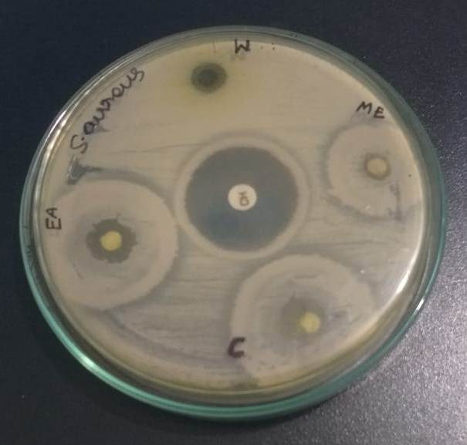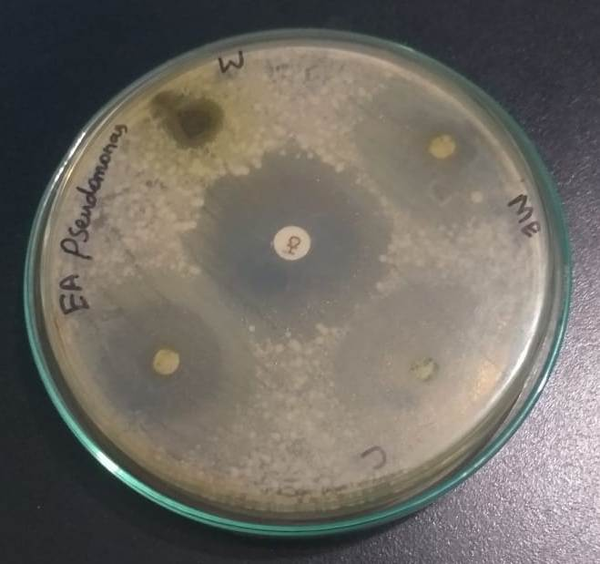
c d
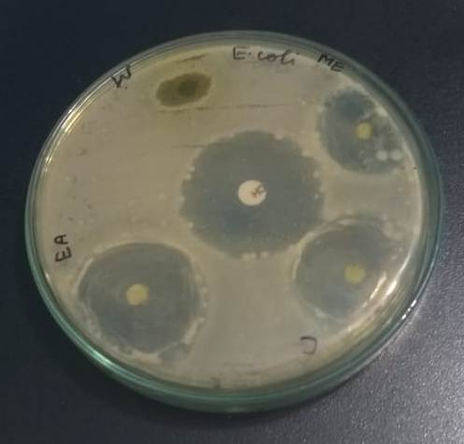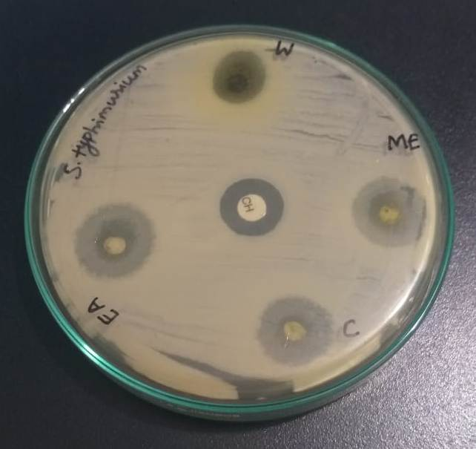
e
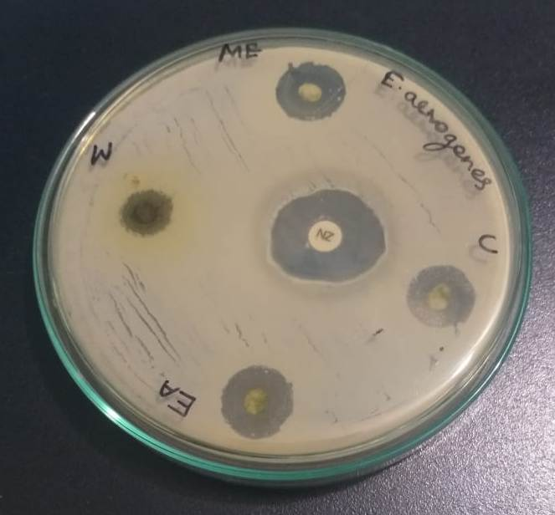
Fig. 4. Antibacterial activity of neem leaf extract against bacterial pathogens. About 20 µg of sample was loaded on a disc and placed on Mueller Hinton Agar plates and incubated for 24 h, and the zone of inhibition was observed (a- Staphylococcus aureus; b-Pseudomonas aeruginosa; c- Escherichia coli; d- Salmonella typhimurium; and e-Enterobacter aerogenes.

Table 2. Minimum inhibitory concentration of neem leaves extract against bacterial pathogens.
Bacteria | Minimum inhibitory concentration (µg/mL)
 | Methanol | Ethyl acetate | Chloroform | Water | Standard
Enterobacter aerogenes | 12.5±2.5 | 150±1.25 | 250±2.5 | 300±1.25 | 1±0
Salmonella typhimurium | 20±1.25 | 150±2.5 | 150±1.25 | 250±1.25 | 1±0
Pseudomonas aeruginosa | 6.25±1.25 | 75±1.25 | 300±2.5 | >300 | 1±0
Staphylococcus aureus | 50±0.125 | 300±0.25 | 175±1.25 | >300 | 1±0
Escherichia coli | 6.25±0.125 | 100±2.5 | 300±125 | >300 | 1±0
The result was expressed mean ± standard deviation
Alkaloids, glycosides, flavonoids, phenolic compounds, steroids, triterpenoids, carotenoids, tetra-triterpenoids, and azadirachtin are among the many antimicrobial phytoconstituents found in neem extract [13]. The methanolic extract of neem leaves in this study showed excellent antibacterial activity. The most abundant phytochemical components were those previously known to possess antibacterial activity. The phytochemical compounds such as 15-Tetramethyl-2-hexadecane-1-ol, 1,5-Anhydro-2-deoxy-L-arabino-hex-1-enitol, 1,3-Propanediol, N-Hexadecanoic Acid, 2-(hydroxymethyl)-2-nitro-, beta-d-Mannofuranoside, O-geranyl, and phytol exhibited antibacterial activities [14]. The neem leaf methanolic extract utilised in this investigation has shown strong antibacterial activity against a variety of microorganisms. Numerous investigations conducted globally in the past have documented the antibacterial properties of crude neem extract. A wide spectrum of chemicals with antibacterial activity and polarity can be extracted by methanol and other solvents [15]. Neem extract's efficacy against several pathogens, such asEnterobacter aerogenes, Salmonella typhimurium, Pseudomonas aeruginosa, Staphylococcus aureus, and Escherichia coli. Neem leaf ethanolic extract has been shown to have antibacterial properties against various pathogenic bacterial strains [16]. Furthermore, the neem plant's crude extract was shown to be highly efficient against S. aureus and E. coli[17]. In this study, the neem leaves exhibited higher activity than in previous reports. It has been reported moderate activity against E. coli, P. aeruginosa, Proteussp, K. pneumoniae, and P. aeruginosa[16].
Secondary metabolites are compounds found in plants that have the potential to acquire antioxidant, antibacterial, and/or antifungal properties. They can also function as a part of the plant's defense system against pathogens [18, 19]. Depending on the polarity of the molecules and the properties of the vegetable portion being used, these phytochemicals are extracted. Studies using methanolic extracts from A. indica leaves thereby controlled Bacillus growth, whereas oils from seeds, bark, and leaves may prevent both Gram-positive and Gram-negative bacteria from growing and/or being viable. A. indica leaves were highly effective against pathogenic bacteria such as Streptococcus mutans, M. pyogenes, and Staphylococcus aureus.
Conclusions
In this study, various solvents were used for the extraction of antimicrobial phytochemicals from neem leaves. The ethanolic extract of neem leaf exhibited an increased amount of total phenolic and flavonoid compounds. These phytochemicals showed antibacterial activity against drug-resistant bacterial pathogens. Further in vivo and in silico studies are required to be carried out in the healthcare industry to observe its antibacterial efficacy.

References
1.Kumar VS, Navaratnam V.Neem (Azadirachta indica): Prehistory to contemporary medicinal uses to humankind. Asian Pacific journal of tropical biomedicine, 2013;3(7):505-514.
2. Septiyani R, Wibowo C. April. Identification of active compounds and testing the antioxidant properties of neem leaf extract. In AIP Conference Proceedings (Vol. 2094, No. 1). AIP Publishing.2019.
3. Solaiman MA, Ali MA, Abdel-Moein NM, Mahmoud EA. Synthesis of Ag-NPs developed by green-chemically method and evaluation of antioxidant activities and anti-inflammatory of synthesized nanoparticles against LPS-induced NO in RAW 264.7 macrophages. Biocatalysis and Agricultural Biotechnology, 2020;29:101832.
4. Fitzgerald M, Heinrich M, Booker A. Medicinal plant analysis: A historical and regional discussion of emergent complex techniques. Frontiers in pharmacology, 2020;10:423244.
5. Nunes CDR, Barreto Arantes M, Menezes de Faria Pereira S, Leandro da Cruz L, de Souza Passos M, Pereira de Moraes L, Vieira IJC, Barros de Oliveira D. Plants as sources of anti-inflammatory agents. Molecules, 2020;25(16):3726.
6. Hossain MA, Al-Toubi WA, Weli AM, Al-Riyami QA, Al-Sabahi JN. Identification and characterization of chemical compounds in different crude extracts from leaves of Omani neem. Journal of Taibah University for Science, 2013;7(4):181-188.
7. Natarajan V, Pushkala S, Karuppiah VP, Prasad PVS. Anti dermatophytic activity of Azardirachta indica (neem) by invitro study. Indian Journal of Pathology and Microbiology, 2002;45(3):311-313.
8. Wu X, Al Farraj DA, Rajaselvam J, Alkufeidy RM, Vijayaraghavan P, Alkubaisi NA, Agastian P, Alshammari MK. Characterization of biofilm formed by multidrug resistant Pseudomonas aeruginosa DC-17 isolated from dental caries. Saudi Journal of Biological Sciences, 2020;27(11):2955-2960.
9. Valan Arasu M, Vijayaraghavan P, Al‐Dhabi NA, Choi KC, Moovendhan M. Biocontrol of Trichoderma gamsii induces soil suppressive and growth‐promoting impacts and rot disease‐protecting activities. Journal of Basic Microbiology, 2023;63(7):801-813.
10. Ramkumar SRS, Sivakumar N, Vijayaraghavan P. Enzymatic Inhibition of Phytochemical from Garcinia imberti on Homology Modelled Beta-lactamase Protein in Staphylococcus sciuri. Journal of Young Pharmacists, 2020;12(1):37.
11. Balasubramanian B, Soundharrajan I, Al-Dhabi NA, Vijayaraghavan P, Balasubramanian, K, Valan Arasu M, Choi KC. Probiotic characteristics of Ligilactobacillus salivarius AS22 isolated from sheep dung and its application in corn-fox tail millet silage. Applied Sciences, 2021;11(20):9447.
12. Bosse R, Wirth M, Konstanz A, Becker T, Weiss J, Gibis M. Determination of volatile marker compounds in raw ham using headspace-trap gas chromatography. Food chemistry, 2017;219:249-259.
13. Malar TJ, Antonyswamy J, Vijayaraghavan P, Kim YO, Al-Ghamdi AA, Elshikh MS, Hatamleh AA, Al-Dosary MA, Na SW, Kim HJ. In-vitro phytochemical and pharmacological bio-efficacy studies on Azadirachta indica A. Juss and Melia azedarach Linn for anticancer activity. Saudi journal of biological sciences, 2020; 27(2):682-8.
14. Lee W, Woo ER, Lee DG. Phytol has antibacterial property by inducing oxidative stress response in Pseudomonas aeruginosa. Free radical research, 2016;50(12):1309-1318.
15. Parekh J, Jadeja D, Chanda S. Efficacy of aqueous and methanol extracts of some medicinal plants for potential antibacterial activity. Turkish Journal of Biology,2005;29(4):203-210.
16. Mohammed HA, Omer AFA. Antibacterial activity of Azadirachta indica (Neem) leaf extract against bacterial pathogens in Sudan. American Journal of Research Communication, 2015;3(5):246-251.

17. Pokhrel B, Rijal S, Raut S, Pandeya A. Investigations of antioxidant and antibacterial activity of leaf extracts of Azadirachta indica. African Journal of Biotechnology, 2015;14(46):3159-3163.
18. Atif M, Ilavenil S, Devanesan S, AlSalhi MS, Choi KC, Vijayaraghavan P, Alfuraydi AA, Alanazi NF. Essential oils of two medicinal plants and protective properties of jack fruits against the spoilage bacteria and fungi. Industrial Crops and Products, 2020 ;147:112239.
19. Al-Ansari MM, Andeejani AM, Alnahmi E, AlMalki RH, Masood A, Vijayaraghavan P, Rahman AA, Choi KC. Insecticidal, antimicrobial and antioxidant activities of essential oil from Lavandula latifolia L. and its deterrent effects on Euphoria leucographa. Industrial Crops and Products, 2021; 170:113740.

