Molecular Identification of Neoechinorhynchus iraqensis (Acanthocephala: Neoechinorhynchidae) from Planiliza abu in Darbandikhan Lake

Abstract

A total of 100 fishes belonged to Planiliza abu (Heckel, 1843) were taken from Darbandikhan Lake in Sulaimani Province, Kurdistan Region, Iraq from December 2023 to February 2024. The fish were checked forparasitic acanthocephalan. The research showed that Neoechinorhynchus iraqensis existed. In this study, 18S rDNA and DNA sequencing were used to identify N. iraqensis. The findings of the molecular analysis show that 533 bp was the PCR product of N. iraqensis and observed the smallest genetic distance with Neoechinorhynchus sp. GL-2015 (KU363972.1) and Neoechinorhynchus sp. XL-2014 (KM507363.1) was (0.025), and the highest genetic distance was recorded with Tenuisentis niloticus (MZ727194.1) was (0.194). Neighbor - Joining trees inferred for 18S rDNA showed that N. iraqensish as a separate clade in the trees, demonstrating that this species originated in Iraq. This finding indicates that the species is the same species that was morphologically identified and described for the first time in Iraq.
Keywords: Neoechinorhynchus iraqensis, Planiliza abu, 18S rDNA, Darbandikhan Lake, DNA Sequencing

1. INTRODUCTION
There are several different types of parasites that belong to the main groups, such as trematoda, cestoda, acanthocephala, and monogena, infest fish [1]. According to earlier research, the fish culture sector in Iraq was having a significant effect and beneficial impact on the parasite populations of freshwater fish [2]. The significance of fish parasites is closely related to the significance of the fish they may infect. Consequently,, the previous knowledge of fish's breeders, parasites, and their effects is crucial from an economic perspective [3].
Acanthocephala, often known as thorny-headed worms, have an ever-present proboscis that is equipped with hooks and spines. It frequently attaches to the intestine of the final host and is an obligatory endoparasite. [4]. The basic life cycle and developmental stages are the same for all acanthocephalans. For the development of the larva, all require an arthropod as an intermediate host, and all use vertebrates as their only host [5].
Regarding the genus Neoechinorhynchus 11 species have been recorded in freshwater fish in Iraq [6]. [7] Described for the first time N. iraqensis in intestine of the mugilid fish Planiliza abu (as liza abu) from Euphrates River in Al-Anbar Province, Iraq.
The family Mugilidae is distributed widely. Its major species are found in temperate and tropical coastal waters. Some species survive all or part of their lifespan in lakes, rivers, and coastal lagoons [8]. Only 80 of the 304 species that were available in this family were valid [9].
There isn't any extensive research on the molecular of N. iraqensis in the Iraq and Kurdistan region. The objective of this research is to use DNA sequencing by Polymerase chain reaction (PCR) to identify N. iraqensis in Darbandikhan Lake.

2. MATERIALS AND METHODS
2.1 Sample Collection
A total of 100 fish belonging to mugilid species (Planilizaabu) (Fig. 1)were collected from the Darbandikhan Lake in Sulaimani, Kurdistan region, Iraq. It is confined to latitudes 35º 06' 58''-35º 21' 07'' N and longitudes 45º 40' 59''-45º 44' 42'' E, 65 kilometers southeast of the city of Sulaimani (Fig. 2).
Gill nets or cast nets were used for collecting fish, from December 2023 to February 2024. Shortly after being caught, newly obtained fish were checked in the lab for parasites. Fish names are based on [10].The recovered acanthocephalans had been first cleaned in saline solution, then chilled in chilly water for 12 hours, and finally preserved in seventy percent ethanol [11].
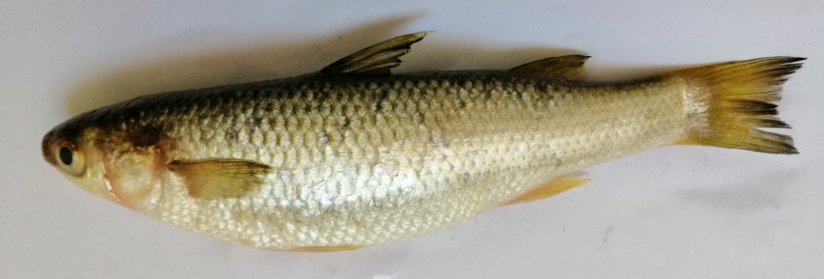

Fig. 1. Palaniliza abu

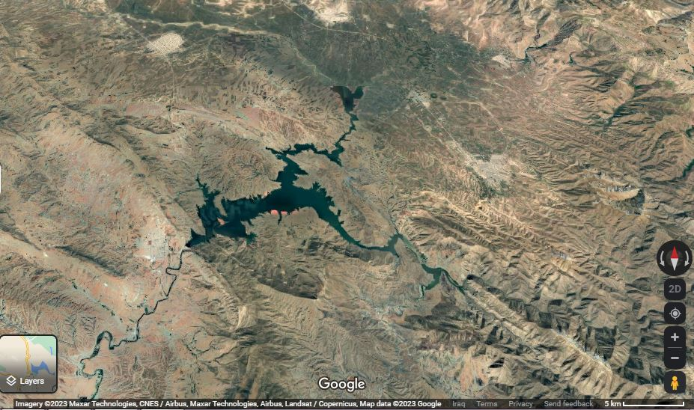

Fig.2. Map of Darbandikhan Lake

2.2 DNA extraction
The AddPrep Genomic DNA Extraction Kit (ADD BIO INC. Korea) was used to extract DNA from N. iraqensis samples according to the instructions provided by the manufacturer.One percent agarose gel was used to determine the DNA purity, and the DNA concentration was determined using a Nanodrop spectrophotometer. In preparation for use, DNA Samples had been stored at -20 °C.

2.2.1 Primer sequence and PCR conditions
The primers were used to amplify the nuclear ribosomal DNA's 18S rDNA region, (forward: 5'-: CGGGGGGAGTATGGTTGC-3') and (reverse: 5'TGATCCTTCTGCAGGTTCACCTAC-3'). The thermo cycling conditions were as follows: an initial denaturation at 94 °C for 8 min, followed by 35 cycles for 30 s at 94 °C, for 30 s at 56 °C for annealing, an extension for 30 s at 72 °C, a final extension for 10 min, and then storage at 4 °C.
The genomic DNA had been diluted into a volume of 25 μl l for the PCR reaction, and it also contained 2 μl of each primer, 12.5 μl of Master Mix 10 X buffer containing MgCl2, 3 l of dNTPs (10 mM), 0.9 l of 1 U of Taq DNA polymerase (Biotools, Spain), 7 μl of the genomic DNA, and 3.5μl of distilled water.
Using the same primer as above, the sequencing processes were carried out using a Genetic Analyzer 3500, Applied Bio Systems (USA), in accordance with the instructions provided by the manufacturer.The 18S rDNA sequences were obtained, and using Mega X's default ClustalW [12], they were matched with sequences from other similarly associated species.

3. RESULTS
During the current study period, Planiliza abu was surveyed for parasitic acanthocephalans. One acanthocephalan, a species of the genus Neoechinorhynchus, was found during the survey. A brief description of this parasite is given below.
Neoechinorhynchus iraqensis Amin, Al-Sady, Mhaisen and Bassat, 2001
Host: Planiliza abu (Heckel, 1843).
Prevalence of infection: 7 %.
Mean intensity: 2.4 worm/ fish.
Site infection: Intestine.
Locality: Darbandikhan Lake
In this present research, the DNA sequences of Neoechinorhynchus iraqensis have been compared to the sequences of other acanthocephalans and closely associated species that belong to the same genus obtained from GenBank (Table 1).
The 18S rDNA fragment was 533 bpafter editing by using the BioEdit program 7.2(Figure 3).The genetic distance estimated betweenacanthocephalan species used for phylogenetic analysis varied from 0.025 to 0.194 (Table 2).The nucleotide composition was as follows: 24.95% T, 28.57% C, 25.67% A, and 20.79% G are shown in (Table 3).
As a result, Figure 4 shows the Neighbor Joining tree. The 18S rDNA dataset's phylogenetic tree reveals that N. iraqensisis in the separation position in this tree.

Table 1. Acanthocephala, host and accession numbers used for phylogenetic analysis based on the 18S rDNA region.
Acanthocephala | Host | GenBank accession no.
Neoechinorhynchus sp. GL-2015 | Capoeta aculeata | KU363972.1
Neoechinorhynchus saginata | Na | AY830150.1
Neoechinorhynchus pseudemydis | Na | U41400.1
Neoechinorhynchus crassus | Capoeta aculeata | KU363974.1
Neoechinorhynchus qinghaiensis | Na | MW144440.1
Neoechinorhynchus cylindratus | Micropterus salmoides | MF974925.1
Neoechinorhynchus buttnerae | Na | MW590330.1
Neoechinorhynchus buttnerae | Na | MK249749.1
Neoechinorhynchus sp. XL-2014 | BH-liaoning | KM507363.1
Neoechinorhynchus crassus | Na | AF001842.1
Neoechinorhynchus sp. JDC-2005 | Na | DQ181946.1
Neoechinorhynchus personatus | Mugil cephalus | MT020795.1
Neoechinorhynchus personatus | Mugil cephalus | MT020793.1
Neoechinorhynchus pseudemydis | Capoeta aculeata | KU363973.1
Neoechinorhynchus agilis | Mugil cephalus | MN705824.1
Neoechinorhynchus simansularis | Na | KF156877.1
Neoechinorhynchus sp. JYW-2010 | Siganusfuscescens | HM545898.1
Neoechinorhynchus aldrichettae | Aldrichettaforsteri | OM103595.1
Neoechinorhynchus salmonis | Na | KF156878.1
Neoechinorhynchus tumidus | Na | KF156876.1
Neoechinorhynchus beringianus | Na | KF156875.1
Neoechinorhynchus sp. AC3 | Heteropneustesfossilis | MF784256.1
Tenuisentis niloticus | Lates niloticus | MZ727194.1
- Na= not available

Table 2. Genetic distance between Neoechinorhynchus iraqensis and other genus of Neoechinorhynchus and Acanthocephalan species.

Acanthocephalan species | Genetic distance
Neoechinorhynchus iraqensis
Neoechinorhynchus sp. GL-2015 | 0.025
Neoechinorhynchus saginata | 0.059
Neoechinorhynchus pseudemydis | 0.054
Neoechinorhynchus crassus | 0.057
Neoechinorhynchus qinghaiensis | 0.054
Neoechinorhynchus cylindratus | 0.050
Neoechinorhynchus buttnerae | 0.045
Neoechinorhynchus buttnerae | 0.047
Neoechinorhynchus sp. XL-2014 | 0.025
Neoechinorhynchus crassus | 0.057
Neoechinorhynchus sp. JDC-2005 | 0.071
Neoechinorhynchus personatus | 0.086
Neoechinorhynchus personatus | 0.086
Neoechinorhynchus pseudemydis | 0.053
Neoechinorhynchus agilis | 0.089
Neoechinorhynchus simansularis | 0.057
Neoechinorhynchus sp. JYW-2010 | 0.091
Neoechinorhynchus aldrichettae | 0.093
Neoechinorhynchus salmonis | 0.065
Neoechinorhynchus tumidus | 0.061
Neoechinorhynchus beringianus | 0.064
Neoechinorhynchus sp. AC3 | 0.095
Tenuisentis niloticus | 0.194

Table 3. Nucleotide composition for Neoechinorhynchus iraqensis and other acanthocephalan species recorded in Genbank.

Acanthocephalan species | T | C | A | G
Neoechinorhynchus iraqensis | 24.954 | 28.571 | 25.678 | 20.795
Neoechinorhynchus sp. GL-2015 | 25.836 | 20.057 | 27.252 | 26.856
Neoechinorhynchus saginata | 25.845 | 19.542 | 27.908 | 26.705
Neoechinorhynchus pseudemydis | 26.441 | 19.379 | 27.627 | 26.554
Neoechinorhynchus crassus | 26.509 | 20.069 | 26.740 | 26.682
Neoechinorhynchus qinghaiensis | 25.899 | 19.927 | 27.300 | 26.874
Neoechinorhynchus cylindratus | 25.916 | 19.987 | 26.849 | 27.249
Neoechinorhynchus buttnerae | 26.442 | 20.052 | 27.065 | 26.442
Neoechinorhynchus buttnerae | 25.888 | 19.853 | 27.580 | 26.678
Neoechinorhynchus sp. XL-2014 | 25.730 | 20.000 | 27.303 | 26.966
Neoechinorhynchus crassus | 25.622 | 20.474 | 26.778 | 27.126
Neoechinorhynchus sp. JDC-2005 | 25.634 | 20.828 | 26.569 | 26.969
Neoechinorhynchus personatus | 26.615 | 19.844 | 26.848 | 26.693
Neoechinorhynchus personatus | 26.714 | 20.016 | 26.556 | 26.714
Neoechinorhynchus pseudemydis | 26.507 | 20.364 | 26.962 | 26.166
Neoechinorhynchus agilis | 26.416 | 19.976 | 26.237 | 27.370
Neoechinorhynchus simansularis | 26.452 | 19.140 | 26.667 | 27.742
Neoechinorhynchus sp. JYW-2010 | 26.545 | 19.613 | 26.814 | 27.028
Neoechinorhynchus aldrichettae | 27.314 | 19.364 | 26.405 | 26.917
Neoechinorhynchus salmonis | 26.372 | 19.268 | 26.480 | 27.879
Neoechinorhynchus tumidus | 25.781 | 19.531 | 26.674 | 28.013
Neoechinorhynchus beringianus | 26.316 | 19.261 | 26.316 | 28.108
Neoechinorhynchus sp. AC3 | 25.952 | 19.940 | 27.555 | 26.553
Tenuisentis niloticus | 26.811 | 20.289 | 26.268 | 26.630
Average | 26.238 | 20.019 | 26.924 | 26.820

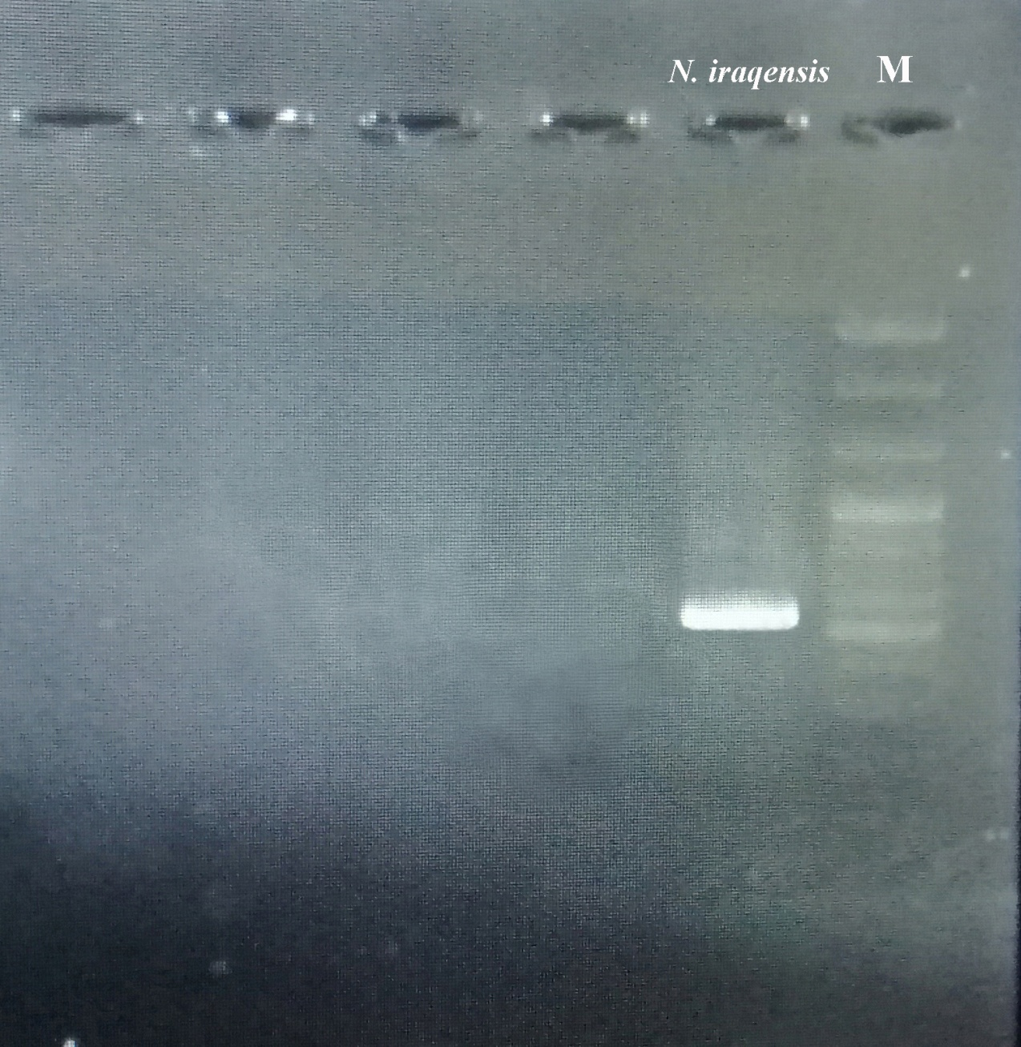
Fig. 3. PCR product for Neoechinorhynchus iraqensis from Planiliza abu fish. M: DNA ladder. The size of band = 533 bp.

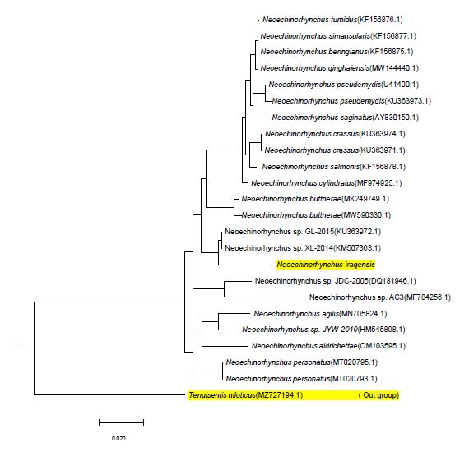
Fig. 4.The phylogenetic tree of Neoechinorhynchus iraqensis obtained for the present research and the other genus of Neoechinorhynchus were received from GenBank based on the partial 18S rDNA gene. This phylogenetic tree has been created dependent on the neighbor joining tree. Tenuisentis niloticusis out group.

4. DISCUSSION
There have not been any studies on molecular identification for Neoechinorhynchus iraqensis to classify it; it was only characterized morphologically by [7]; [13] and [14]. This study investigated N. iraqensis, which was identified for the first timeby molecular technique and compared tothe same genusand otheracanthocephalan species recorded in the Genbank.
The eleven species of Neoechinorhynchus reported according to [15] so far in freshwater fish in Iraq are: N. australis (Van Cleave, 1931), N. chilkaensis, (Podder, 1937), N. cristatus (Lynch, 1936), N. dimorphospinus (Amin and Sey, 1996), N. iraqensis (Amin, Al-Sady, Mhaisen& Bassat, 2001), N. macronucleatus (Machado Filho, 1954), N.rutili (Mu¨ller, 1780 re described by Hamann in Stiles and Hassall, 1905), N. zabensis (Amin, Abdullah &Mhaisen, 2003), N. tigrisensis (Al-Ayash, Gustinelli, Al-Nasiri & Caffara, 2021) , N. planilizai(Al-Ayash, Gustinelli, Al-Nasiri & Caffara, 2021) and N. Barbi (Al-Ayash, Gustinelli, Al-Nasiri & Caffara, 2021).
In the present study, the low value of genetic distance recorded betweenN. iraqensis, Neoechinorhynchus sp. GL-2015(KU363972.1) and Neoechinorhynchus sp. XL-2014 (KM507363.1) was0.025 andthe high value of genetic distance was recorded between N. iraqensis and Tenuisentisniloticus (MZ727194.1)was0.194.Phylogenetic study revealed that N. iraqensis takes a separate location within the trees, denoting that this species originated in Iraq because it wasoriginally discovered and describedby [7]. Neoechinorhynchus is a genus that contains a wide variety of species, as already noted in several studies [16]; [17] and [18].According to a phylogenetic tree study, N. zabensis is in a separate position from other species [14]. Phylogenetic study showed that N. johnii has a distinct location in the trees, most likely indicating that this species originated in Asia [19].Nuclear DNA sequences of the 18S rDNA gene and mitochondrial DNA sequences of COX1 of N. poonchensis sp. n. have been amplified and matched with other sequences on GenBank.
N. poonchensis sp. n. was shown to be nested in a separateposition based on ML and BI method calculated for 18S rDNA and cox1 [20].For the 18S rRNA gene, the estimated genetic difference between the Neoechinorhynchus species varied from 0 to 2.5%. [21].The genetic identification of the species N. personatus and N. yamagutii in gray mullets fish that are caught in the Atlantic and Pacific Oceans was reported by [22].The intra specific differences ranged from 0.01 to 0.02%, while the genetic divergence between N. schmidti and N. emyditoides was 4%. The pairwise variations ranging from 9.5 to 33% were found amongthese two species and four other congeners that are parasitic in fresh and brackish water fishes: Neoechinorhynchus golvani, Neoechinorhynchus roseum, Neoechinorhynchus saginatus and Neoechinorhynchus sp.[23].Using a partial 18S rDNA dataset, the relatively large genetic differences amongN. ponticus n. sp. and other Neoechinorhynchus species confirm its status of independence. Neoechinorhynchus personatus and Neoechinorhynchus ponticus n. sp. share an ancestry with Neoechinorhynchus species that are gathered from saltwater fish. [24].

5. CONCLUSION
The findings of this study demonstrate the importance of identifying N. iraqensis using molecular techniques. For a study of the upper-level phylogeny, 18S rDNA was well preserved and appropriate. The results of this research show that N. iraqensis occupied an independent position within the trees; this result confirms that the species is the same type that was initially found and identified morphologically, showing that Iraq was the location where this species first appeared.

REFERENCE
- Hoffman, G.L. (1998). Parasites of North American freshwater fishes. 2nd Edition. Cornell Univ. Press, London.
- Abdullah, S.M. and Rasheed, A.R.A.M. (2004). Parasitic fauna of some freshwater fishes from Dokan lake, north of Iraq. I: Ecoparasites.
- Okaeme, A. N., Olufemi, B. E. and Obiekezie, A. (2000). Parasites and non-fish predators of tilapia with particular reference to the sustainable management of fisheries of Lake Kainji Nigeria.
- Taraschewski, H. (2000). Host-parasite interactions in Acanthocephala: A morphological approach. Advances in Parasitology 46: 1-179. http://doi.org/10.1016/s0065- 308x (00)46008-2.
- Kennedy, C.R. (2006). Ecology of the Acanthocephala. Cambridge: Cambridge
University Press, pp. 249.
- Mhaisen, F.T. (2023). Index-catalogue of parasites and disease agents of fishes of Iraq (Unpublished: xxx@yahoo.co.uk).
- Amin, O. M., Al-sady, R. S., Mhaisen, T., F. and Bassat, S. F. (2001). Neoechinorhynchus iraqensis sp. n. (Acanthocephala: Neoechinorhynchidae) from the Freshwater Mullet, Liza abu. Comp. Parasitol, 68(1), 108-111.
- González-Castro, M. and Ghasemzadeh, J. (2015). Morphology and morphometry based taxonomy of Mugilidae. In: Crosetti D,Blaber S, editors. Biology, ecology and culture of grey mullet (Mugilidae). CRC Press, Boca Raton, USA; 1-21.
- Fricke, R., Eschmeyer, W. N. and Fong, J. D. (2021). Eschmeyer's Catalog of Fishes Species by family/subfamily. Online Version Accessed 3. Available: http://researcharchive.calacademy.org/ research/ ichthyology/ catalog/ Species ByFamily.asp).
- Froese, R. and Pauly, D. (eds.) (2023). FishBase. World Wide Web electronic publication. www.fishbase.org, version (02/2023).
- Amin, O. M., Abdullah, S. M. A., and Mhaisen, F. T. (2003). Neoechinorhynchus (Neoechinorhynchus) zabensis sp. n. (Acanthocephala: Neoechinorhynchidae) from freshwater fish in northern Iraq. Folia Parasitologica, 50 (4), 293-297. https://doi.org/10.14411/fp.2003.048
- Kumar, S., Stecher, G. and Tamura, K. (2016). Molecular Evolutionary Genetics Analysis version 7.0 for bigger datasets. Mol. Biol. Evol. 33: 1870–1874.
- Abdullah, Y. S. (2013) Study on the Parasites of some Fishes from Darbandikhan Lake in Kurdistan Region, Iraq. Master of Science, Collage of Science Biology, University of Sulaimani.
- Ali, M. K. (2020). Morphological and Molecularly Studies On the Genus Neoechinorhynchus STILES and HASSALL, 1905 from Two Freshwater Fishes in Sulaimani Province. Doctor of philosophy in Fish Parasitology, Collage of Agricultural Engineering Sciences, University of Sulaimani.
- GBIF.org (2023). GBIF Home page. Available from http://www.gbif.org.
- Amin, O. M. (2013). Classification of the Acanthocephala. Folia Parasitologica, 60(4), 273-305. https://doi:https://doi.org/10.14411/fp.2013.031
- Pinacho-Pinacho, C. D., García-Varela, M., Sereno-Uribe, A. L. and Pérez-Ponce de León, G. (2018). A hyper-diverse genus of acanthocephalans revealed by tree-base and non-tree based species delimitation methods: ten cryptic species of Neoechinorhynchusin Middle America freshwater fishes', Molecular Phylogenetics and Evolution, 127: pp.30-45.
- Pinacho-Pinacho, C. D., Hernández-Orts, J. S., Sereno-Uribe, A. L., Pérez-Ponce de León, G. and García-Varela, M. (2017). Mayarhynchus karlae n. g., n. sp. (Acanthocephala: Neoechinorhynchidae), a parasite of cichlids (Perciformes: Cichlidae) in southeastern Mexico, with comments on the paraphyly of Neoechynorhynchus Stiles & Hassall, 1905'Systematic Parasitology, 94(3): 351-365.
- Amin, O. M., Chaudhary, A., Heckmann, R., Ha, N. V. and Singh, H. S. (2019). Redescription and molecular analysis of (Neoechinorhynchus) johniiYamaguti, 1939 (Acanthocephala, Neoechinorhynchidae) from the Pacific Ocean off Vietnam. Parasite, 26, 43.
- Amin, O. M., Ahmed, M., Chaudhary, A., Heckmann, R. A. and Singh, H. S. (2022). The morphological and molecular description ofNeoechinorhynchus (Neoechinorhynchus) poonchensissp. n. from Schizothoraxrichardsonii (Gray) in Poonch, Jammu and Kashmir, India. Folia Parasitol. 69: 001.
- Malyarchuk B., Derenko, M., Mikhailova, E. and Denisova, G. (2014).Phylogenetic relationships among Neoechinorhynchus species (Acanthocephala: Neoechinorhynchidae) from North-East Asia based on molecular data', Parasitology International, 63: pp. 100–107.
- Sarabeev, V., Tkach, Ie., Sueiro, R. A. and Leiro, J. (2020). Molecular data confirm thespecies status of Neoechinorhynchus personatus and N. yamagutii (Acanthocephala, Neoechinorhynchidae) from the Atlantic and pacific grey mullets (Teleosteı, Mugilidae). Zoo diversity 54 (1), 1–10.
- García-Varela, M., García-Prieto, L. and Pérez Rodríguez, R. (2011). Molecular identification and first description of the male of Neoechinorhynchus schmidti (Acanthocephala: Neoechinorhynchidae), a parasite of Trachemys scripta (Testudines) in México. Parasitology International, 60(4): 433-439.
- Amin,O. M., Sharifdini,M., Heckmann,R. A., Rubtsova, N. and Chine, H. J. (2020). On the Neoechinorhynchus agilis (Acanthocephala:Neoechinorhynchidae) complex, with a description of Neoechinorhynchus ponticusn. sp. from Chelon auratusin the Black Sea. Parasite, 27(48): 119.

