Effectiveness of sodium thiosulfate and resveratrol in remodeling lung injury and expression of BCL2 in nicotine-stressed rats

ABSTRACT
Background and objective: Nicotine is linked to the development of several illnesses, including cancer The current study aimed to assess the ability of sodium thiosulfate (STS) to decrease the harmful effects of nicotine in lungs and gene expression of Bcl₂ gene in rats and compare them with resveratrol (RES) supplement. Methods: Thirty-six male rats, Rattus norvegicus (weighing 190–220 g) were chosen randomly and separated into six equal groups. Animals in the control group were administered an intraperitoneal injection of normal saline, while those in group G1 were injected (I/P) with nicotine (1.5 mg/kg b.wt.). G2: were injected I/P with STS (450 mg/kg b.wt) and nicotine (1.5 mg/kg b.wt). G3: rats were gavaged with resveratrol supplement (87 mg/kg b.wt) and (I/P) injected with nicotine at the same dose. G4 group were (I/P) injected with STS (450 mg/kg b.wt) and administered (RES) (87 mg/kg b.wt) plus injected with nicotine (1.5 mg/kg b.wt). I/P injections of STS (450 mg/kg b.wt) and Resveratrol (87 mg/kg body weight) were given to group G5. All groups were administered for 28 days, after 24 hours after the last administration, all animals were sacrificed, and tissue specimens were collected from the lung for histopathological changes and for gene expression analysis of Bcl₂. Results: The results of Lung sections for G1 showed severe peribronchiolar and perivascular lymphocytic cuffs, congestion, pulmonary emphysema, cuboidal metaplasia of the bronchiolar epithelium, granulomatous inflammation, thickening in the alveolar walls, and severe hemorrhage with hemosiderosis as compared with other experimental groups while group G2 showed that STS attenuating the effect of nicotine on lung tissue characterized by normal bronchioles which lined by normal columnar epithelium with scattered macrophages slight perivascular lymphocytic cuffs, a few desquamations of the bronchiolar epithelium, G3 group which administered RES showed that some alveoli had thickened walls; others showed slightly distended walls, few infiltrations of macrophages and lymphocytes, and desquamation of the bronchiolar epithelium. Moreover sections of lungs for G4 that administered both STS and RES with nicotine showed that most alveoli were normal, with slight thickening in their walls and slight blood vessel congestion. Furthermore, results represented a significant decrease in expression of the BCl2 gene for G1 compared with other groups. In contrast, a significant increase in the fold change of the BCL2 gene was observed in the G2, G3, G4, and G5 groups, indicating the protective effects of RES and STS on histopathological sections and fold change for the BCL2 gene against nicotine-stressed rats. Conclusion: Rats who received STS showed more effectiveness in modulating the bad effects of nicotine than those who received RES, which can give an idea that STS is more effective as an antioxidant than RES.
Key words: Sodium thiosulfate , Resveratrol, Nicotine , Rats , BCL2 gene, Lung
INTRODUCTION
Nicotine is linked to the development of several illnesses, including cancer.(Uliński, Kwiecień and Domagała-Kulawik, 2022). Nicotine addiction is affected by genetics, social and environmental variables, and learned or conditioned behaviours,. (Benowitz, 2010).Tobacco smoking negatively impacts healthcare resources worldwide, increasing morbidity and mortality (D’Souza, 2016). Along with other components, tobacco smoke contains reactive oxygen- and nitrogen species (ROS and RNS). These chemicals can damage lipids, proteins, and nucleic acids ,according to (Caliri, Tommasi and Besaratinia, 2021). A multitude of research studies have been conducted to examine the impact of nicotine on pulmonary illness.The maintenance of epithelial cell health plays a crucial role in the pathogenesis of chronic obstructive pulmonary disease (COPD) (Ananth and Hurst, 2023) . The initiation or contribution to the advancement of certain lung disorders through airway remodeling can be attributed to the occurrence of epithelial cell death ,according to the studies conducted by(Mo et al., 2022; Paulin et al., 2022). Individuals who now smoke or have a history of smoking who are diagnosed with COPD face an elevated susceptibility to developing lung cancer, cardiovascular disease, and diabetes, according to (Morjaria et al., 2022). Nicotine injection induced pathological changes in the lung tissues of mice, induces notable alterations in pulmonary tissues and levels of oxidant indicators, specifically malondialdehyde (MDA) and reduced glutathione (GSH), according to (Mohammed and Al-Thwani, 2019). Oxidative stress (OS) arises from a perturbation in the equilibrium between the generation of Reactive Oxygen Species (ROS) and the protective mechanisms provided by antioxidant defense systems. The depletion of antioxidants takes place, leading to dysfunction and harm at the cellular level (Mahdi, Wadood and Hamza, 2019).The occurrence of oxidative stress in the lungs as a result of nicotine exposure has been documented in many rat models Cell membrane damage is a consequence of lipid peroxidation resulting from heightened oxidative stress, (jasim Mohammed, AL-Thwani and Kannan, 2016; Hamady and Al-Okaily, 2022). According to the research conducted by (Nawfal and Al-Okaily, 2022;Ali and Khudair, 2019), it was found that the assessment of total antioxidant capacity and malondialdehyde (MDA) levels is widely regarded as a reliable and robust method for detecting the presence of stressful conditions. Also , (Ali, et al ., 2020;Murad and Al-Okaily, 2020), also showed the relation of these biomarkers with oxidative stress . Sodium thiosulfate, a clinically licensed hydrogen sulfide (H2S) donor, has shown promise in the treatment of critical disease. It possesses diverse biological functions, including the modulation of vascular tone, as well as exhibiting anti-oxidant and anti-inflammatory qualities. (Merz et al., 2020). STS exhibits potential as an anticancer. This is achieved through several mechanisms, including its robust antioxidant capacity, and capacity to inhibit apoptosis. These effects are accomplished by suppressing the activation of TLR4/MAPKp38/NF-κB signaling pathways, (Khames et al., 2020). The binding of sulfur to thiosulfate leads to the activation of the Nrf2 system by causing structural alterations in Keap1 proteins and promoting the phosphorylation of AKT (Zhang et al., 2021). Effectiveness of sodium thiosulfate (STS) have been reported in several models of urolithiasis, vascular calcification, and ischemia reperfusion injury (IR). The compound in question is recognized as an antioxidant and calcium chelator (Ravindran et al., 2017). Numerous studies have demonstrated the considerable antioxidant properties of several plant extracts and products, which effectively safeguard the human body from harm caused by reactive oxygen species (Al-Jowari, 2012). Resveratrol is a naturally occurring polyphenolic molecule that exhibits a range of biological activities, including antioxidant properties, anti-aging effects, and potential as a cancer chemopreventive agent, RES possesses anti-inflammatory(Yunusoğlu, 2023) and antifibrotic capabilities, which contribute to its protective effects in respiratory ailments such as acute lung injury, asthma, and chronic obstructive pulmonary disease (Conte et al., 2015;Ahmed, Mohammed and Alghetaa, 2022). According to (Shahcheraghi et al., 2023). ), resveratrol mitigates oxidative stress by reducing cellular proliferation, attenuating reactive oxygen species (ROS) activity, enhancing superoxide dismutase (SOD) enzyme activity, and improving glutathione (GSH) concentration. According to(J. Zhang et al., 2022). Resveratrol (RES) is widely recognized for its robust antioxidant, anti-inflammatory, and anti-aging properties (Ahmed, Mohammed and Alghetaa, 2022). A study also provides evidence that the development of acute respiratory distress syndrome (ARDS) caused by Staphylococcal Enterotoxin B (SEB) leads to an imbalance in the microbial communities of the lungs and gut. Furthermore, it suggests that the protective effects of Resveratrol in attenuating ARDS may be attributed, at least partially, to changes in the microbiota present in both the lungs and gut. (Alghetaa et al., 2021) . The process of apoptosis in Schwann cells is initiated by mitochondrial-related oxidative stress, which is accompanied by the downregulation of Bcl-2 family proteins, according to (Tiong et al., 2019). Therefore the present work was designed to evaluate the possibility of reducing toxic effects induced by nicotine in lung tissue by sodium thiosulfate and resveratrol in adult rats.

MATERIALS AND METHODS
Animals and experimental design
Thirty-six male rats (Rattus norvegicus) weighing )190–220 g., 3-3.5-month-old( were utilized in the present investigation. Animals were kept in cages with a 12-hour light/dark cycle at 22–25 °C. Rats were kept for 2 weeks at the animal house / college of veterinary medicine / university of Baghdad for accilimatization had full access to water and pellets throughout the study period. Rats were randomly assigned into six equal groups and treated daily for 28 days. The rats in the control group received i.p. injections of normal saline 0.1 ml/100 gm b.wt. and receive orally distilled water ; those in the test groups Group(G1): in this group , rats were injected ip with nicotine 1.5 mg/kg b.w. Group (G2 ) rats in this group were injected ip with Sodium thiosulphate 450mg/kg. b.wt. and Nicotine at dose of 1.5 mg/kg. b.wt. Group (G3 ): Rats in this group were gavaged with resveratrol 87 mg/kg.b.wt. and ip injected with nicotine at a dose of 1.5mg/kg.b.wt.Group (G4):Rats in this group were injected with sodium thiosulfate450mg/kg.b.wt. plus administered resveratrol supplement 87 mg \kg.b.wt plus injected with nicotine 1.5 mg \kg.b.wt. Group (G5) Rats in this group were injected Sodium thiosulphate 450 mg/kg.b.wt plus administered Resveratrol supplement 87 mg /kg.b.wt. ( Nicotine 72290 >97%, KP 243-248o, Liquid 162.24 Switzerland, STS 20268 K05 purity 99.50, SDFCL, SD Fine Chemical Limited, Mumbai, India , resveratrol supplement capsules were obtained from NOW company /USA).
Tissue samples collection
The animals were subjected to regular weighing both prior to and throughout the duration of the experiment. This was done in order to accurately administer STS, RES and nicotine dosages in accordance with the rats' respective weights. Rats were subjected to anaesthesia with ketamine and xylazine according to (Veilleux-Lemieux et al., 2013). The lungs of the sacrificed specimens were preserved in a solution of natural buffer formalin (10%) in order to facilitate further histological examinations. Additional lung tissues were subjected to Trizol for the purpose of assessing gene expression analyses of BCl2 gene
The primers sequences for Bcl2 and GAPDH primers used for real time PCR was illustrated in table -1 Table 1 presents the primers utilised in the current study, along with their corresponding references.
Gene | Primer name | 5'-3' | Product | Accession number | Reference
BCL-2 | F | ATCGCTCTGTGGATGACTGAGTAC | 134 | NM_016993.2 | (Sari et al., 2013)
BCL-2 | R | AGAGACAGCCAGGAGAAATCAAAC | 134 | NM_016993.2 | (Sari et al., 2013)
GAPDH | F | ATGACTCTACCCACGGCAAG | 89 | NM_017008 | (Kunst et al., 2013)
GAPDH | R | CTGGAAGATGGTGATGGGTT | 89 | NM_017008 | (Kunst et al., 2013)

Total RNA extraction: The extraction of total RNA from lungs specimens was performed using the TRIzol® reagent kit (Bioneer/ Korea) following the directions provided by the manufacturer. The measurement of total RNA yield involved the assessment of the extracted RNA's quantity (measured in ng/μL) and purity. This was accomplished by utilising a nanodrop spectrophotometer (THERMO. USA) to measure the absorbance at 260 and 280 nm.
The cDNase I treatment involved the utilisation of a DNase I enzyme kit (Promega, USA) to eliminate DNA contaminants from the extracted RNA. The procedure was carried out in accordance with the instructions provided by the manufacturer. The cDNA synthesis process involved the treatment of RNA with the DNase-I enzyme, followed by the utilisation of the M-MV Reverse Transcriptase Kit (manufactured by Bioneer, Korea) in accordance with the provided instructions.
Quantitative Real-Time PCR (qPCR): The expression of the target gene BcL2 in lung tissue was evaluated using quantitative real-time PCR (qPCR). The housekeeping gene GAPDH was employed as a reference to normalise the control and experimental samples, utilising the Real-Time PCR technique. The qPCR master mix was prepared utilising the GoTaq® qPCR Master Mix kit, which employs SYBR green dye for the detection of the target gene and GAPDH gene amplification in a Real-Time PCR machine.
Analysis data of qRT-PCR: The data obtained from the quantitative real-time polymerase chain reaction (qRT-PCR) analysis was analysed. The fold change analysis (using the ΔCT Method) was performed on the qRT-PCR data of both housekeeping and target genes to determine the quantitative levels of gene expression. (Livak and Schmittgen, 2001) .
Statistical analysis: The statistical analysis of the data was conducted using the computer software SPSS version 24. The values are provided as the mean ± standard error (SE). The statistical methodology employed in this study was the use of a one-way analysis of variance (ANOVA) using the least significant difference (LSD) test at a significance level of 0.05. This approach was utilized to compare the differences between the various groups.. (Baarda and van Dijkum, 2019)
RESULTS: The results in figures 1,2,3 that expressed as fold change of Bcl2 gene

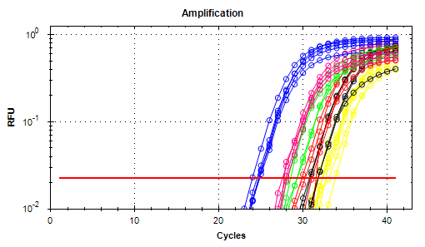
Figure (1) Effects of sodium thiosulfate and resveratrol on Bcl2 gene expression in Adult Males Rats lung tissue injected with nicotine for 28 days

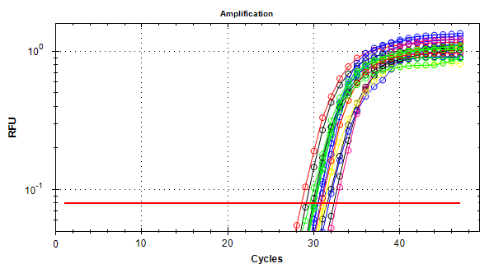
Figure (2) The real time amplification plots of BCL2 gene expression of lung tissue in rats experimental samples. The control group is represented by pink plots, the G1 group by yellow plots, the G2 group by red plots, the G3 group by black plots, the G4 group by green plots, and the G5 group by blue plots.

values expressed as mean ± SE. N= 6 rats . C= Control group rats were injected with normal saline .G1= rats were injected with nicotine1.5mg/kg.b.wt G2=Rats were injected i/p with Sodium thiosulphate 450 mg/kg.b.wt+ Nicotine1.5 mg/kg.b.wt.G3= rats were gavaged with resveratrol 87mg/kg.b.wt+ ip injected with nicotine at a dose of 1.5mg/kg .b.wG4= rats injected with sodium thiosulfate 450 mg\kg. b.wt. + administered resveratrol supplement 87 mg\kg b.w.+injected with nicotine1.5 mg\kg.b.wt.G5=were i/p injected with Sodium thiosulphate 450mg/kg.b.wt. plus administered Resveratrol supplement 87mg /kg. b.wt. Different letters denote significant differences between groups, (p≤0.05).

Figure (3) The real time amplification plots of housekeeping Gene GAPDH of lung tissue in male rats The control group is shown by pink plots, while the G1 group is represented by yellow plots. The G2 group is represented by red plots, the G3 group by black plots, the G4 group by green plots, and the G5 group by blue plots

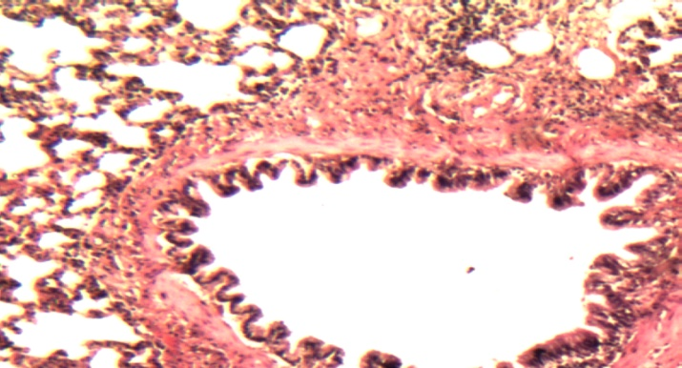
Figure (4 ) Histological section of rat lung tissue for control group shows normal pulmonary tissue , there is normal and thin walls of alveoli(A) with normal and distended lumen . The bronchioles lined by normal columnar epithelium(C ) with normal muscularis(M) . 50X H&E.
A
C
M
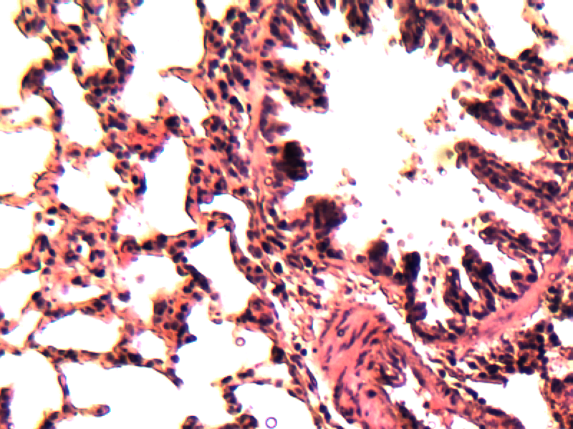
Figure (5) Histological section of rat lung tissue for control group shows normal bronchioles with columnar epithelium(C) with normal muscularis(M) , normal blood vessels also there is thin – wall alveoli which lined by pneumocytes(A) 50X H&E .
A
C
M

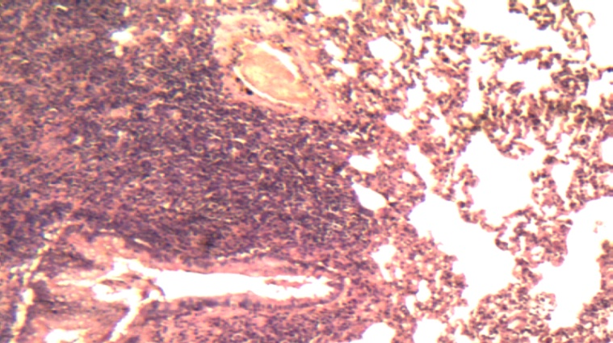
Figure (7) Histological section of lung tissue in rat of G1 group ip injected with nicotine1.5 mg/ kg B.W for 28 days shows a marked and severe peribronchiolar and perivascular lymphocytic cuffs(CU) .degeneration and desquamation(D) of bronchiolar epithelium with hyperplasia of these epithelial cells and proliferation of goblet(GO) cells . Congestion of blood (CO) vessels and distended alveolar spaces pulmonary emphysema(PE) . 20X H&E.
D
GO
CU
CO
PE
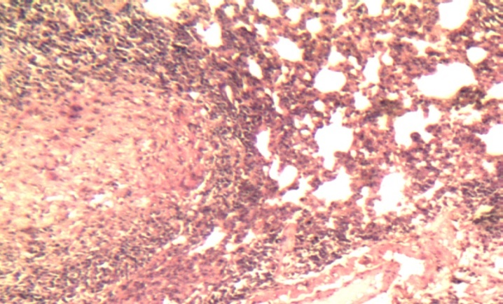
Figure (6) Histological section of lung tissue in rat of G1 group ip injected with nicotine1.5 mg/ kg B.W for 28 days shows a granulomatous inflammation(G ) with degenerate neutrophils , macrophages ,lymphocytes and presence of multinucleated giant cell (GI) around necrotic center(N) of the lesion . Thickened alveolar walls and congested blood vessels(CO) also were seen .20X H&E .
N
GI
G
CO

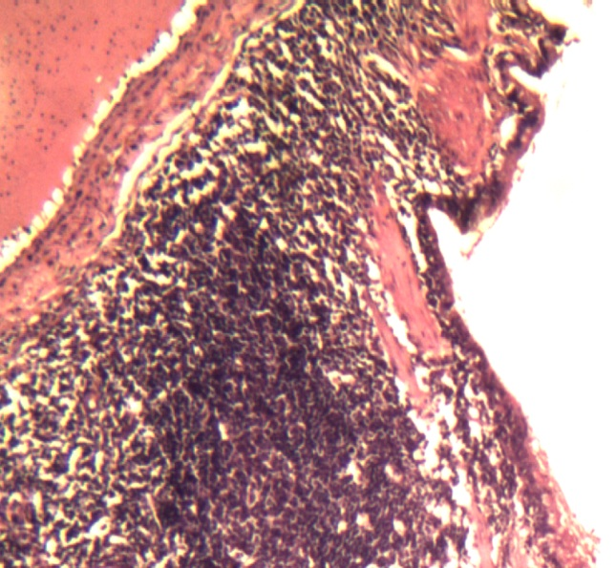
Figure (8) Histological section of lung tissue in rat of G1 group ip injected with nicotine1.5 mg/ kg B.W for 28 days shows a severe peribronchiolar lymphocytic cuffs(CU) with cuboidal metaplasia (CM) of the bronchiolar epithelium with congestion of blood vessels(CO) .50X H&E.
CO
CM
CU
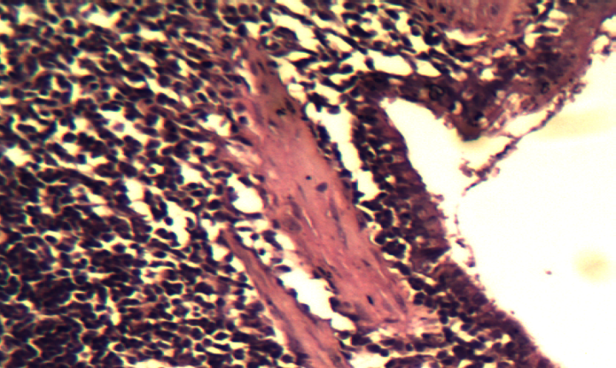
Figure (9) Histological section of lung tissue in rat of G1 group ip injected with nicotine1.5 mg/ kg B.W for 28 days shows Higher magnification there is marked cuboidal metaplasia(CM) of bronchiolar epithelium with peribronchiolar lymphocytic cuffs (CU) and degeneration of muscularis(M) . 50X H&E .
CM
M
CU

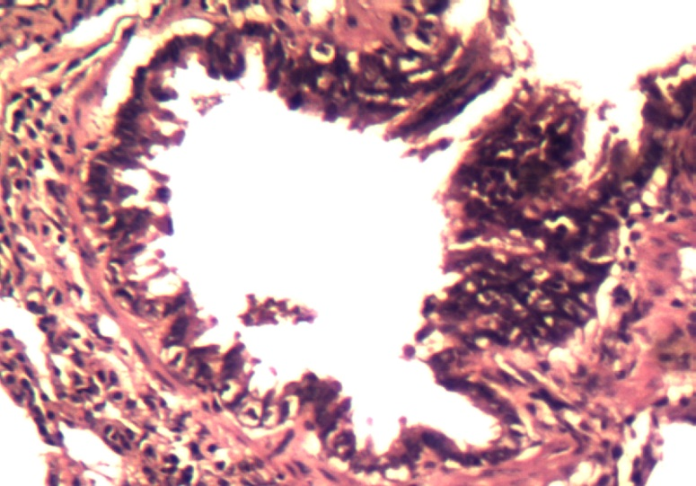
Figure (10 ) Histological section of lung tissue in rat of G1 group ip injected with nicotine1.5 mg/ kg B.W for 28 days shows Marked hyperplasia (H) of columnar epithelium of bronchioles , with marked degeneration of these cells with desquamation (D) in the lumen of bronchiole . Infiltration of inflammatory cells mainly macrophage(MO) in the mucosa of bronchiole .50X H&E.
D
MO
H

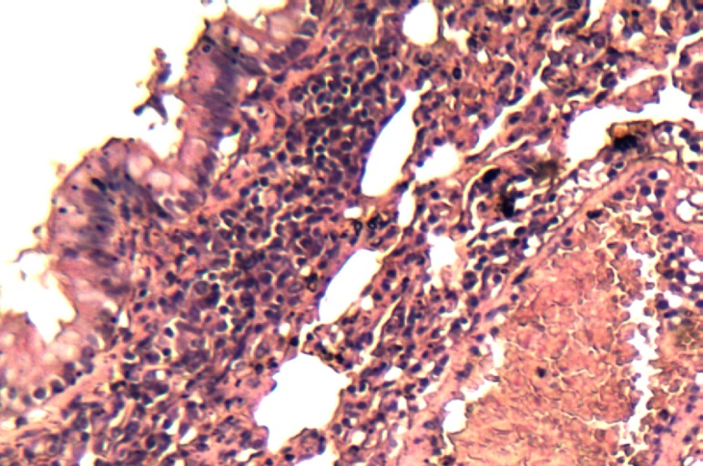
Figure (11 ) Histological section of lung tissue in rat of G1 group ip injected with nicotine1.5 mg/ kg B.W for 28 days shows severe hemorrhage(H) with hemosiderosis(HE) and high infiltration of inflammatory cells mainly macrophages(MO) in the mucosa of bronchioles , the bronchiolar epithelial cells showed marked degeneration(DE) with proliferation of goblet cells(GO) . 50X H&E.
HE
H
DE
GO
MO

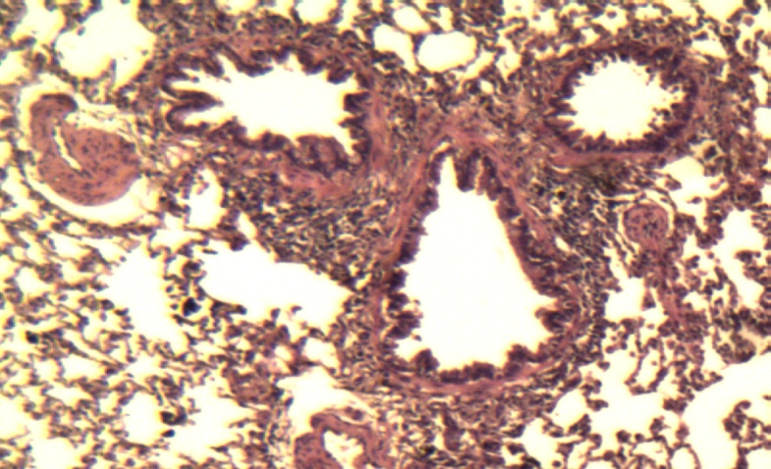
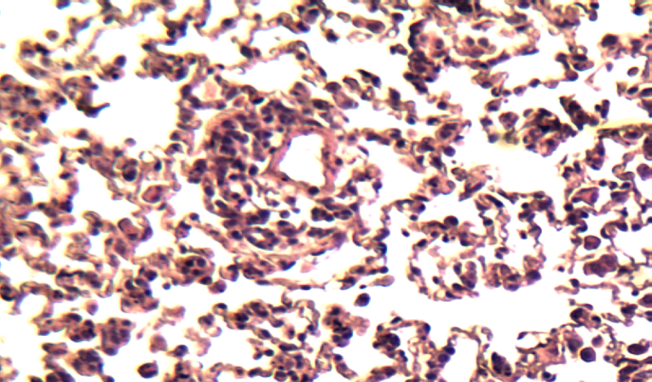
Figure (13 ) Histological section of lung tissue in rat of G2 group ip injected with Sodium thiosulphate 450 mg/kg. B.W and Nicotine 1.5 mg/kg. B.W shows a normal bronchioles(B) which lined by normal columnar epithelium(C) with slightly peribronchiolar lymphocytic cuffs(CU) with normal blood vessels(BV) 20X H&E .
B
B
CU
C
BV
Figure (12 ) Histological section of lung tissue in rat of G2 group ip injected with Sodium thiosulphate 450 mg/kg. B.W and Nicotine 1.5 mg/kg. B.W shows a thin alveolar walls(A) which lined by pneumocytic alveolar cells . Slightly perivascular lymphocytic cuffs(CU) around the normal blood vessels (bv).50X H&E.
bv
A
CU

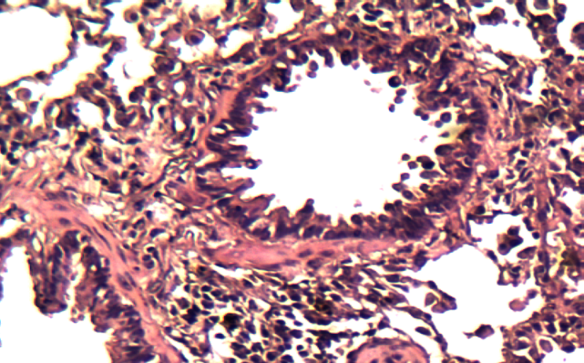
Figure (14 ) Histological section of lung tissue in rat of G2 group ip injected with Sodium thiosulphate 450 mg/kg. B.W and Nicotine 1.5 mg/kg. B.W shows a few desquamation(D) of bronchiolar epithelium which appear with normal columnar shape( C) , infiltration of inflammatory cells (MO) in the interstitial tissue of the lung 50X H&E .
C
D
MO
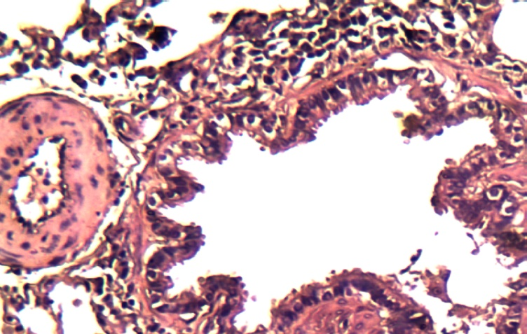
Figure (15 ) Histological section of lung tissue in rat of G2 group ip injected with Sodium thiosulphate 450 mg/kg. B.W and Nicotine 1.5 mg/kg. B.W shows a Scattered infiltration of macrophages(MO) in the interstitial tissue of the lung , with normal columnar epithelium( C) of bronchioles , normal blood vessels (BV) .50X H& E
MO
C
BV

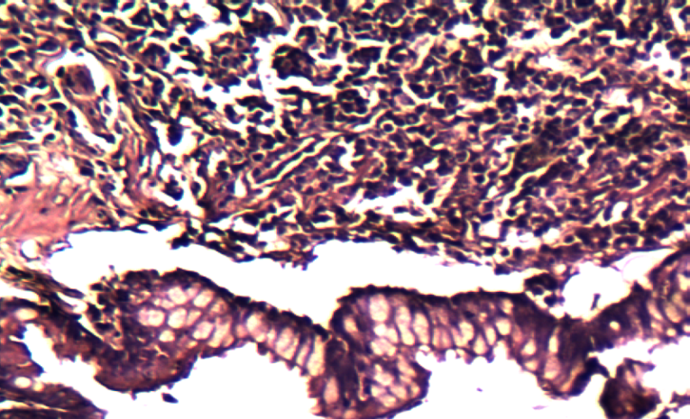
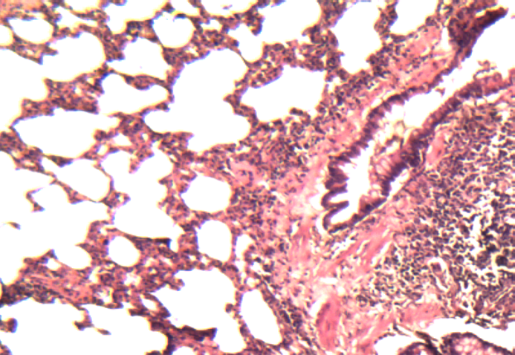
Figure (17 ) Histological section of lung tissue in rat of G3 group gavaged with resveratrole 87 mg/kg B.W. and ip injected with 1.5 mg/kg B.W shows proliferation of goblet cells(GO) in the epithelium of bronchioles , infiltration of inflammatory cells around the bronchioles particularly macrophages (MO) .50X H&E.
GO
MO
Figure (16 ) Histological section of lung tissue in rat of G3 group gavaged with resveratrole 87 mg/kg B.W. and ip injected with 1.5 mg/kg B.W shows the presence of peribronchiolar lymphocytic cuffing(CU) with normal columnar epithelium(C) of bronchiole and proliferation of goblet cells(GO) . Thickened alveolar walls (A)and others showed with distended walls(PE) 20X H&E.
PE
A
GO
CU
C

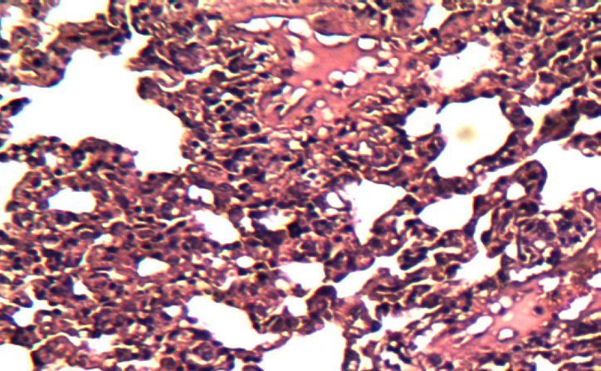
Figure (18) Histological section of lung tissue in rat of G3 group gavaged with resveratrole 87 mg/kg B.W. and ip injected with 1.5 mg/kg B.W shows Some alveoli showed with thickened walls(T) and others showed slightly distended(DE) .Few infiltration of macrophages and lymphocytes in the interstitial walls and presence of few inflammatory exudate(IE) . 50X H&E .
DE
IE
MO
T
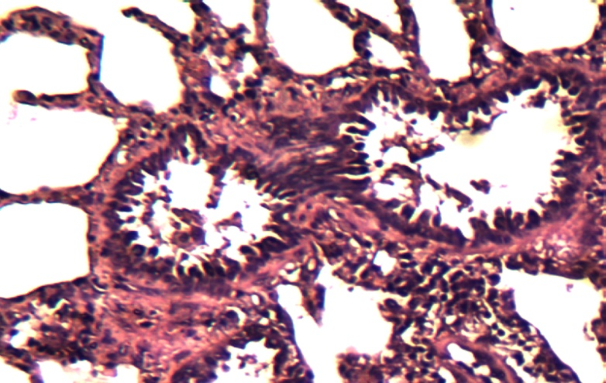
Figure (19 ) Histological section of lung tissue in rat of G3 group gavaged with resveratrole 87 mg/kg B.W. and ip injected with 1.5 mg/kg B.W shows Some alveoli with thickened walls(T) , and others showed slightly distended . Few infiltration of macrophages and lymphocytes(MO) in the interstitial tissue with desquamation of bronchiolar epithelium (D) . 50X H&E .
D
T
MO

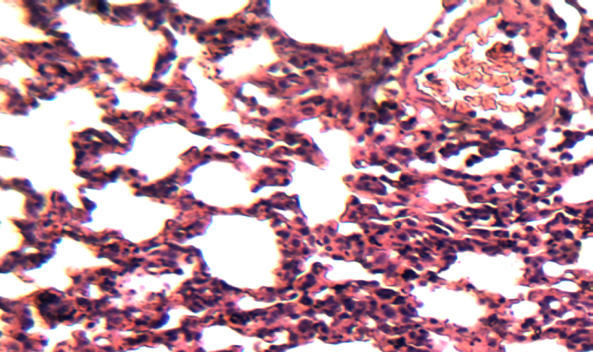
Figure (20 ) Histological section of lung tissue in rat of G4 group injected with sodium thiosulfate 450 mg/ kg B.W plus administered resveratrol supplement 87 mg /kg B.W plus injected with nicotine 1.5 mg /kg B.W shows that Most alveoli are normal (A)with slightly thickening in their walls . The blood vessels showed slightly congestion(CO) and thickened wall . 50X H&E .
A
CO
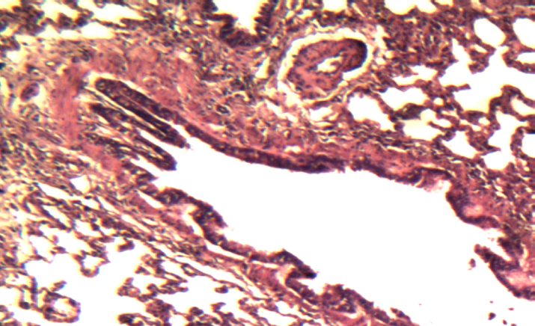
Figure (21 ) Histological section of lung tissue in rat of G4 group injected with sodium thiosulfate 450 mg/ kg B.W plus administered resveratrol supplement 87 mg /kg B.W plus injected with nicotine 1.5 mg /kg B.W shows the bronchioles lined with normal columnar epithelium(C) and normal muscularis(M) the alveoli showed normal but other showed slightly distended(PE) and thin walls . Normal blood vessels(BV) . 20X H&E .
PE
C
BV
M

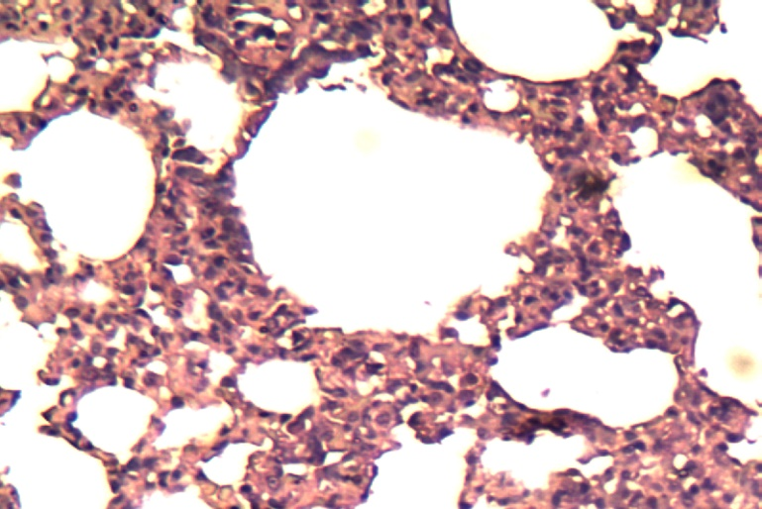
Figure (23) Histological section of lung tissue in rat of G5 group injected ip Sodium thiosulphate 450 mg/kg. B.W plus administered Resveratrol supplement 87 mg /kg B.W. shows Normal and thin alveolar walls(A) which lined by normal flattened pneumocytic cells(PC) . The lumen of alveoli showed normal and distended(L) .50X H&E.
L
L
A
PC
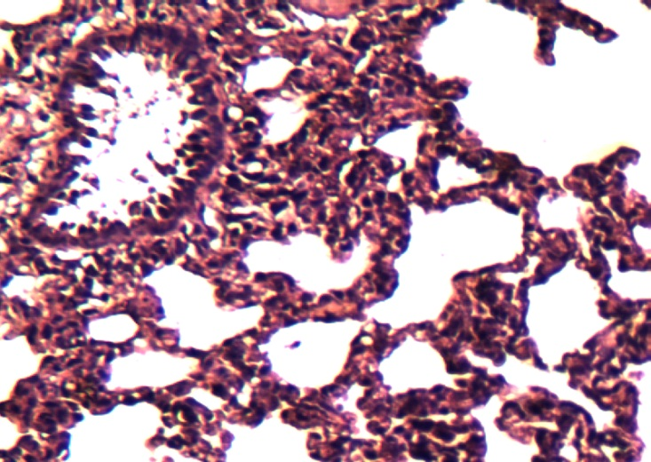
Figure (22 ) Histological section of lung tissue in rat of G4 group injected with sodium thiosulfate 450 mg/ kg B.W plus administered resveratrol supplement 87 mg /kg B.W plus injected with nicotine 1.5 mg /kg B.W shows the bronchiole showed normal columnar epithelial cells( C) with slightly desquamation(D) in these cells , also there is normal and thin alveolar walls(A) 50X H&E .
A
C
D

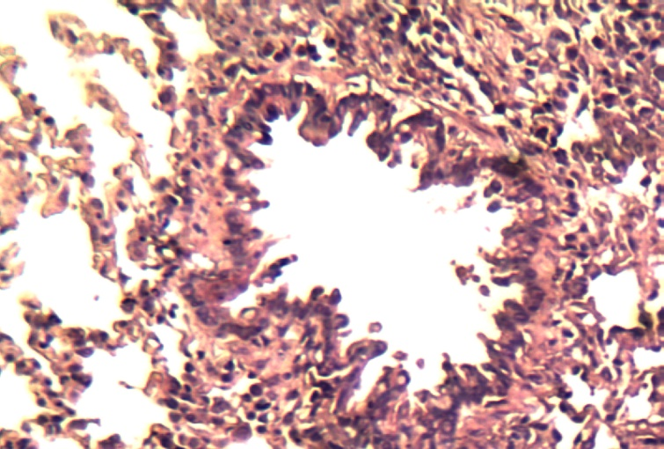
Figure (24) Histological section of lung tissue in rat of G5 group injected ip Sodium thiosulphate 450 mg/kg. B.W plus administered Resveratrol supplement 87 mg /kg B.W. shows normal bronchiole which lined by normal and columnar epithelial cells( C) , scattered with normal inflammatory cells(MO) in the interstitial tissue with normal and thin wall alveoli(A) . 50X H&E .

C
A
MO

Discussion:
The gene under inquiry is an apoptotic regulator gene, according to mRNA-lung tissue analysis. This gene was highly upregulated in antioxidant-treated and control groups. Group 5 had a significantly higher gene expression than all other groups except the control group, while Group 1 had a significantly lower gene expression. The study found that CSE cigarette smoke extract increases ROS and induces cellular apoptosis depending on dosage and duration.), Bax, Bad, and Fas were upregulated and Bcl-2 and NF-kB were downregulated, causing signalling pathway apoptosis. (Hu et al., 2009). Many studies were in agreement with present study results , (Zeng, Kong, et al., 2020; Ma et al., 2022and Cha et al., 2023) ,it has been found that the expression level of Bcl-2 was decreased in human umbilical vascular endothelial cells were treated with cigarette smoke extract by increasing the methylation status of the Bcl-2 promoter . Mechanistically, Bcl-2 regulated mitochondrial membrane permeability and its interfere with the release of the mitochondrial apoptotic factors (e.g. Bax or cytochrome c) to the cytosol, thus suppressed apoptotic index(Kluck et al., 1997and Rong and Distelhorst, 2008) . Bcl-2, a principal anti-apoptotic protein, is an agonist of the pro-apoptotic protein Bax (Qian et al., 2022 and Moldoveanu, 2023) Thus, release of cytosolic cyt C from mitochondria, eventually triggering apoptosis due to decreased Bcl-2/Bax a cell death switch(Vaskivuo et al .,2002) . AStudy showed the relationship between smoking and downregulation of Bcl2 gene expression , (Zeng, Li, et al., 2020) Higher ROS levels and pulmonary apoptosis were observed in COPD patients than in healthy controls. The present results showed a significant increase in the expression of BcL2 gene in G3 and G4 treated groups as compared to G1. These results are consistent with Zhang et al.(2022), who showed that for the first time that preserving of renal grafts in University of Wisconsin solution supplemented with STS resulted in protection against prolonged cold ischemia reperfusion damage (IRI).The deactivation of caspase-3 is caused by STS binding to its active site via strong hydrogen bonds. This contact blocks the active site, preventing the natural substrate from entering and stopping apoptosis. JNK, a key protein in the signalling cascade that leads to programmed cell death, is also inhibited by sodium thiosulfate (STS). Furthermore sodium thiosulphate inhibited apoptosis in the renal cells of Sodium thiosulphate_treated groups through decreasing the apoptotic marker Bax and increasing the anti-apoptotic Bcl-2 compared with doxorubicin group (Khames et al., 2020). Regarding the results of the current study which concerned with groups of rats which were administered resveratrol that showed also a significant upregulation in Bcl2 gene as compared with nicotine stressed group, (Wang, Wang and Zhao, 2015)Who examined the effects of resveratrol (Res) on lung cancer A549 cells. Resveratrol modulated p53, Bax, Bcl-2, and cleaved caspase-3 to inhibit A549 cell growth and induce apoptosis. (Ma et al., 2015) . )showed that resveratrol enhances cisplatin's effects on cancer cell proliferation, apoptosis, mitochondrial membrane potential, cytochrome c release, and Bcl-2 and Bax expression. The antitumor efficacy of resveratrol has been enhanced by its anticancer effects on non-small cell lung cancer cell lines H838 and H520. (Sha et al., 2009). Resveratrol and dexamethasone reduced lung damage in a severe acute pancreatitis model group. In addition, the resveratrol group had higher Bcl-2 expression and lower Bax, caspase-3, and cytochrome c expression than the model group. Recently accumulated evidence confirm that Resveratrol stimulate P38-MAPK and suppress AKT activation in ovarian cancer cells may be via activation of signaling molecules suh as ERK1/2 and JNK these effect of resveratrol enhanced cisplatin inducing cell cycle arrest by downregulation the expression of responsible cycle proteins and activation caspase and has been an observed rise which occur in apoptotic cells (Hankittichai et al., 2023). RES alters the metabolic reprogramming of Staphylococcal enterotoxin-B (SEB) -activated immune cells, through suppression of mTOR activation and its down- and upstream effects on energy metabolism. Also, miR-100 could serve as novel potential therapeutic molecule in the amelioration of Acute Respiratory Distress Syndrome (ARDS). (Alghetaa et al., 2023).
Lung sections of nicotine treated rats G1 were showed marked histopathological changes characterized by severe peribronchiolar and perivascular lymphocytic cuffs , blood vessels congestion and(pulmonary emphysema),granulomatous inflammation with degenerate neutrophils ,macrophages,lymphocytes and multinucleated giant cells, thickening in alveolar walls , severe hemorrhage as compared to the control group( C) which showed a normal lung and bronchial tissue. These results agree with (Leberl, Kratzer and Taraseviciene-Stewart, 2013) reported that (COPD) can only show pathological symptoms seen in extended nicotine consumption. Emphysema, airway remodelling, and pulmonary hypertension only arise in chronic models with structural problems because they progress over time. Nicotine induces ROS accumulation and inflammation in lung tissues, the results were consistent with studies of (Ateyya et al., 2017; Biczysko-Murawa, Stopa and Marszałek, 2008) who demonstrate that nicotine administration for 8 weeks induced oxidative stress in lung tissue as evidenced by increased levels of total and differential blood cell counts, along with the increased iNOS protein levels in lung tissues. Also (Khaled et al.,2020) found agreeable results with the present findings of G1 group which showed a granulomatous inflammation with degenerate neutrophils , macrophages , lymphocytes , necrosis and congested blood vessels . As well as STAT1 promoted skin tumors through enhancing iNOS and COX-2 genes (Bozeman et al., 2015). Besides, nicotine enhance the expression of COX-2 enzyme and increase the release of prostaglandin E2 ( PGE2) and thromboxane A2(Huang and Chen, 2011) leading to cellular proliferation and apoptosis (Moon, White and Borowsky, 2020). While, PGE2 has proinflammatory actions that promotes tumor growth (Elisia et al., 2020).
Lung sections of rats in G2 group( treated with nicotine plus STS ) were showed slight perivascular lymphocytic cuffs around normal blood vessels , few desquamation of bronchiolar epithelium , infiltration of inflammatory cells , scattered infiltration of macrophages STS intraperitoneally reduced Acute Lung Injury in mice by inhibiting lung permeability, PMN influx, and IL-6 downregulation in the lungs of mice. Sulfide and thiosulfate concentrations in mice's lungs and plasma increased significantly (Sakaguchi et al., 2014). Inhalation of hydrogen sulfide H2S associated with intravascular sodium sulfide Na2S cause ameliorating of acute lung injury induced by high tidal volume ventilation by prevent depletion of GSH through activation of Nr-f2 , the master regulator of antioxidant response mechanism which is responsible for regulation the redox state of cells (Francis et al., 2011). G3group that received nicotine and resveratrol showed that some alveoli were thickened walls others showed slightly distended, few infiltration of macrophages and lymphocytes in in interstitial tissue with desquamation of bronchiolar epithelium. In comparison to free RSV, pretreatment with RSV loaded into lipid nanocapsules (LNCs) is more successful in preventing acute pneumonitis. It also clearly exhibited anti-inflammatory, anti-apoptotic, and antioxidant properties while maintaining the structure and function of the pulmonary tissue. (Albanawany et al., 2022). The anticancer action of resveratrol is thought to be fueled by its ability to disrupt numerous dysregulated signalling pathways in altered cells. (Khayoon and Al-Rekabi, 2020). Histological analysis of lung tissue demonstrated that resveratrol therapy reduced fibrosis and mucus hypersecretion. Furthermore, resveratrol decreased the expression of the Beclin1 protein in mice lung (Chen et al., 2016). RES's antioxidant properties, which also helped to mitigate testicular tissue damage by maintaining the integrity of the cellular membrane (Abdulla and Al-Okaily, 2022). Through its ability to modulate the histological alterations in the kidney caused by hydrogen peroxide, resveratrol was able to partially restore the examined criteria related to renal functioning (Khudair and Al-Okaily, 2022). Histological sections of G4 group of the current study showed the synergistic action of STS and RES together on nicotine harmful effect on lung tissue of rats , it can be noticed most alveoli were normal with slightly thickening in their walls , slight congestion (Olson et al., 2021), suggest that polyphenols are autoxidized to a semiquinone radical and that this, in turn, oxidizes H₂S to a thiyl radical from which polysulfides and thiosulfate derived, also is catalyzed by a semiquinone radical and it is independent of either superoxide or hydrogen peroxide concomitantly produced during polyphenol autoxidation. G5 group histological sections for rats treated with STS and resveratrol supplement showed normal thin alveolar walls , normal and distended lumen of alveoli , normal bronchioles In conclusion the histopathological sections of G2 group showed more effectiveness in modulating the bad effect of nicotine than G3 results which can give an idea about the antioxidant activity of STS more than REV antioxidant activities , and when they are together in G4 group they have more powerful effect than their effect separately on oxidative stress induced by nicotine on rats lung tissues.
CONCLUSION: A current study found that STS and RES caused upregulation of Bcl2 gene expression in lung tissue, also results suggest that STS mitigates histological changes induced by nicotine due to its properties as an antioxidant , anti-inflammatory , anti apoptotic property which were more effective as compared with RES in nicotine stressed rats .
Authors’ contribution: All authors checked and approved the final version of the manuscript. Competing interests There is no conflict of interest.
Ethical approval: Animal care and treatment in this study was carried out at the College of Veterinary Medicine within the University of Baghdad in strict accordance with the code of ethics for animal experiments, and ethical approval was given through the local committee of animal care and use (P.G. 899 date 27-4-2023).

Acknowledgments: The authors express their gratitude to the University of Baghdad, namely the Faculty of Veterinary Medicine, for granting permission to carry out the present study and for providing valuable resources and support during the research process.
REFERENCES
Abdulla, J. M. and Al-Okaily, B. N. (2022) ‘Histomorphometric and histopathological alterations of rat testis following exposure to hydrogen‎ peroxide: Protective role of resveratrol supplement’, The Iraqi Journal of Veterinary Medicine, 46(1), pp. 17–23.
Ahmed, A. A., Mohammed, A. K. and Alghetaa, H. F. K. (2022) ‘STUDY THE PROTECTIVE EFFECTS OF RESVERATRON AGAINST DELETERIOUS INFLUENCES OF CRYOPRESERVATION ON CANINE SPERMATOZOA PHYSIOLOGICAL FUNCTIONS.’, Biochemical & Cellular Archives, 22(1).
Al-Jowari, S. A. (2012) ‘Effect of spices mixture on blood glucose and lipids profile in experimentally-induced oxidative stress female rabbits’, Iraqi Journal of Science, 53(2), pp. 279–284.
Albanawany, N. M. et al. (2022) ‘Histopathological, physiological and biochemical assessment of resveratrol nanocapsules efficacy in bleomycin-induced acute and chronic lung injury in rats’, Drug Delivery, 29(1), pp. 2592–2608.
Alghetaa, H. et al. (2021) ‘Resveratrol-mediated attenuation of superantigen-driven acute respiratory distress syndrome is mediated by microbiota in the lungs and gut’, Pharmacological research, 167, p. 105548.
Alghetaa, H. et al. (2023) ‘Resveratrol attenuates staphylococcal enterotoxin B-activated immune cell metabolism via upregulation of miR-100 and suppression of mTOR signaling pathway’, Frontiers in Pharmacology, 14, p. 1106733.
Ali, I. M. M., Yenzeel, J. H. and Al-ansari, H. M. S. (2020) ‘Evaluation of oxidative stress and leptinlevel in samples of Iraqi obese women’, Iraqi Journal of Science, pp. 1565–1570.
Ali, Z. S. and Khudair, K. K. (2019) ‘Synthesis, characterization of silver nanoparticles using Nigella sativa seeds and study their effects on the serum lipid profile and DNA damage on the rats’ blood treated with Hydrogen peroxide’, The Iraqi Journal of Veterinary Medicine, 43(2), pp. 23–37.
Ananth, S. and Hurst, J. R. (2023) ‘Definitions and Diagnosis of COPD: State of the Art’, European Respiratory Journal.
Ateyya, H. et al. (2017) ‘Influence of alpha-lipoic acid on nicotine-induced lung and liver damage in experimental rats’, Canadian Journal of Physiology and Pharmacology, 95(5), pp. 492–500.
Baarda, B. and van Dijkum, C. (2019) Introduction to Statistics with SPSS. Routledge.
Benowitz, N. L. (2010) ‘Nicotine addiction’, New England Journal of Medicine, 362(24), pp. 2295–2303.
Biczysko-Murawa, A., Stopa, J. and Marszałek, A. (2008) ‘Structural changes in tracheal epithelium in environmental smoke exposed rats--experimental studies’, Przeglad Lekarski, 65(10), pp. 462–465.
Bozeman, R. et al. (2015) ‘A novel mechanism of skin tumor promotion involving interferon‐gamma (IFNγ)/signal transducer and activator of transcription‐1 (Stat1) signaling’, Molecular carcinogenesis, 54(8), pp. 642–653.
Caliri, A. W., Tommasi, S. and Besaratinia, A. (2021) ‘Relationships among smoking, oxidative stress, inflammation, macromolecular damage, and cancer’, Mutation Research/Reviews in Mutation Research, 787, p. 108365.
Cha, S.-R. et al. (2023) ‘Cigarette Smoke-Induced Respiratory Response: Insights into Cellular Processes and Biomarkers’, Antioxidants, 12(6), p. 1210.
Chen, J. et al. (2016) ‘Therapeutic effects of resveratrol in a mouse model of LPS and cigarette smoke-induced COPD’, Inflammation, 39, pp. 1949–1959.
Conte, E. et al. (2015) ‘Anti-inflammatory and antifibrotic effects of resveratrol in the lung’.
D’Souza, M. S. (2016) ‘Neuroscience of nicotine for addiction medicine: novel targets for smoking cessation medications’, Progress in Brain Research, 223, pp. 191–214.
Elisia, I. et al. (2020) ‘The effect of smoking on chronic inflammation, immune function and blood cell composition’, Scientific Reports, 10(1), p. 19480.
Francis, R. C. et al. (2011) ‘Protective and detrimental effects of sodium sulfide and hydrogen sulfide in murine ventilator-induced lung injury’, The Journal of the American Society of Anesthesiologists, 115(5), pp. 1012–1021.
Hamady, J. J. and Al-Okaily, B. N. (2022) ‘Alveolar gene expression of tight junction protein in nicotine rats treated with zinc and vitamin D’, International journal of health sciences, 6(June), pp. 232–246. doi: 10.53730/ijhs.v6ns9.12218.
Hankittichai, P. et al. (2023) ‘Resveratrol Enhances Cytotoxic Effects of Cisplatin by Inducing Cell Cycle Arrest and Apoptosis in Ovarian Adenocarcinoma SKOV-3 Cells through Activating the p38 MAPK and Suppressing AKT’, Pharmaceuticals, 16(5), p. 755.
Hu, W. et al. (2009) ‘Involvement of Bcl-2 family in apoptosis and signal pathways induced by cigarette smoke extract in the human airway smooth muscle cells’, DNA and cell biology, 28(1), pp. 13–22.
Huang, R.-Y. and Chen, G. G. (2011) ‘Cigarette smoking, cyclooxygenase-2 pathway and cancer’, Biochimica et Biophysica Acta (BBA)-Reviews on Cancer, 1815(2), pp. 158–169.
jasim Mohammed, B., AL-Thwani, A. N. and Kannan, R. (2016) ‘Demographic and genetic study for a sample of Iraqi smokers’, Cancer Biology, 6(4), pp. 16–27.
Khaled, S., Makled, M. N. and Nader, M. A. (2020) ‘Tiron protects against nicotine-induced lung and liver injury through antioxidant and anti-inflammatory actions in rats in vivo’, Life sciences, 260, p. 118426.
Khames, A. et al. (2020) ‘Sodium thiosulphate shows promising anti-inflammatory role against doxorubicin-induced renal injury depending on tlr4 pathway inhibition’, Plant Arch, 20(2), pp. 2948–2958.
Khayoon, H. A. and Al-Rekabi, F. M. K. (2020) ‘Cytotoxic effect of resveratrol on colorectal cancer cell line’, The Iraqi Journal of Veterinary Medicine, 44(1), pp. 68–74.
Khudair, N. T. and Al-Okaily, B. N. (2022) ‘Renal ameliorating effect of resveratrol in hydrogen peroxide induced male rats’, Iraqi Journal of Veterinary Sciences, 36(3), pp. 571–577.
Kluck, R. M. et al. (1997) ‘The release of cytochrome c from mitochondria: a primary site for Bcl-2 regulation of apoptosis’, Science, 275(5303), pp. 1132–1136.
Kunst, S. et al. (2013) ‘Transcriptional analysis of rat photoreceptor cells reveals daily regulation of genes important for visual signaling and light damage susceptibility’, Journal of neurochemistry, 124(6), pp. 757–769.
Leberl, M., Kratzer, A. and Taraseviciene-Stewart, L. (2013) ‘Tobacco smoke induced COPD/emphysema in the animal model—are we all on the same page?’, Frontiers in physiology, 4, p. 91.
Livak, K. J. and Schmittgen, T. D. (2001) ‘Analysis of relative gene expression data using real-time quantitative PCR and the 2− ΔΔCT method’, methods, 25(4), pp. 402–408.
Ma, L. et al. (2015) ‘Resveratrol enhanced anticancer effects of cisplatin on non-small cell lung cancer cell lines by inducing mitochondrial dysfunction and cell apoptosis’, International journal of oncology, 47(4), pp. 1460–1468.
Ma, Y. et al. (2022) ‘Effect of pirfenidone protecting against cigarette smoke extract induced apoptosis’, Tobacco Induced Diseases, 20.
Mahdi, Q. A., Wadood, S. A. and Hamza, R. H. (2019) ‘Association Between Systemic and Local Oxidative Stress of Infertile Women Undergoing Ivf/Icsi’, Iraqi Journal of Science, pp. 1888–1897.
Merz, T. et al. (2020) ‘H2S in acute lung injury: a therapeutic dead end (?)’, Intensive Care Medicine Experimental, 8(1), pp. 1–16.
Mo, R. et al. (2022) ‘Nicotine promotes chronic obstructive pulmonary disease via inducing pyroptosis activation in bronchial epithelial cells’, Molecular Medicine Reports, 25(3), pp. 1–8.
Mohammed, B. and Al-Thwani, A. (2019) ‘Evaluation the effect of nicotine injection on the lungs of mice’, Journal of Reports in Pharmaceutical Sciences, 8(1), pp. 34–38. doi: 10.4103/jrptps.jrptps_28_18.
Moldoveanu, T. (2023) ‘Apoptotic mitochondrial poration by a growing list of pore‐forming BCL‐2 family proteins’, Bioessays, 45(3), p. 2200221.
Moon, H., White, A. C. and Borowsky, A. D. (2020) ‘New insights into the functions of Cox-2 in skin and esophageal malignancies’, Experimental & molecular medicine, 52(4), pp. 538–547.
Morjaria, J. B. et al. (2022) ‘Health impact of e-cigarettes and heated tobacco products in chronic obstructive pulmonary disease: current and emerging evidence’, Expert Review of Respiratory Medicine, 16(11–12), pp. 1213–1226.
Murad, H. F. and Al-Okaily, B. N. (2020) ‘PROTECTIVE EFFECTS OF ALPHA LIPOIC ACID AGAINST LEADINDUCED OXIDATIVE STRESS AND DNA FRAGMENTATION TO TESTICULAR FUNCTION IN RATS.’, Biochemical & Cellular Archives, 20(2).
Nawfal, A. J. and Al-Okaily, B. N. (2022) ‘Effect of the Sublethal Dose of Lead Acetate on Malondialdehyde, Dopamine, and Neuroglobin Concentrations in Rats’, World, 12(3), pp. 311–315.
Olson, K. R. et al. (2021) ‘‘Antioxidant’berries, anthocyanins, resveratrol and rosmarinic acid oxidize hydrogen sulfide to polysulfides and thiosulfate: A novel mechanism underlying their biological actions’, Free Radical Biology and Medicine, 165, pp. 67–78.
Paulin, L. M. et al. (2022) ‘Association of tobacco product use with chronic obstructive pulmonary disease (COPD) prevalence and incidence in Waves 1 through 5 (2013–2019) of the Population Assessment of Tobacco and Health (PATH) Study’, Respiratory research, 23(1), pp. 1–13.
Qian, S. et al. (2022) ‘The role of BCL-2 family proteins in regulating apoptosis and cancer therapy’, Frontiers in Oncology, 12, p. 985363.
Ravindran, S. et al. (2017) ‘Sodium thiosulfate preconditioning ameliorates ischemia/reperfusion injury in rat hearts via reduction of oxidative stress and apoptosis’, Cardiovascular Drugs and Therapy, 31(5), pp. 511–524.
Rong, Y. and Distelhorst, C. W. (2008) ‘Bcl-2 protein family members: versatile regulators of calcium signaling in cell survival and apoptosis’, Annu. Rev. Physiol., 70, pp. 73–91.
Sakaguchi, M. et al. (2014) ‘Sodium Thiosulfate Attenuates Acute Lung Injury in Mice’, Anesthesiology, 121(6), pp. 1248–1257. doi: 10.1097/ALN.0000000000000456.
Sari, S. et al. (2013) ‘The effect of pentoxifylline on bcl-2 gene expression changes in hippocampus after ischemia-reperfusion in wistar rats by a quatitative RT-PCR method’, Iranian Journal of Pharmaceutical Research: IJPR, 12(3), p. 495.
Sha, H. et al. (2009) ‘Resveratrol ameliorates lung injury via inhibition of apoptosis in rats with severe acute pancreatitis’, Experimental Lung Research, 35(4), pp. 344–358.
Shahcheraghi, S. H. et al. (2023) ‘Resveratrol regulates inflammation and improves oxidative stress via Nrf2 signaling pathway: Therapeutic and biotechnological prospects’, Phytotherapy Research.
Tiong, Y. L. et al. (2019) ‘Melatonin prevents oxidative stress-induced mitochondrial dysfunction and apoptosis in high glucose-treated schwann cells via upregulation of Bcl2, NF-κB, mTOR, Wnt signalling pathways’, Antioxidants, 8(7), p. 198.
Uliński, R., Kwiecień, I. and Domagała-Kulawik, J. (2022) ‘Lung cancer in the course of COPD-emerging problems today’, Cancers, 14(15), p. 3819.
Vaskivuo, T. E., Stenbäck, F. and Tapanainen, J. S. (2002) ‘Apoptosis and apoptosis‐related factors Bcl‐2, Bax, tumor necrosis factor‐α, and NF‐κB in human endometrial hyperplasia and carcinoma’, Cancer, 95(7), pp. 1463–1471.
Veilleux-Lemieux, D. et al. (2013) ‘Pharmacokinetics of ketamine and xylazine in young and old Sprague–Dawley rats’, Journal of the American Association for Laboratory Animal Science, 52(5), pp. 567–570.
Wang, X., Wang, D. and Zhao, Y. (2015) ‘Effect and mechanism of resveratrol on the apoptosis of lung adenocarcinoma cell line A549’, Cell biochemistry and biophysics, 73, pp. 527–531.
Yunusoğlu, O. (2023) ‘Resveratrol inhibits nicotine-induced conditioned place preference in mice’, Brazilian Journal of Pharmaceutical Sciences, 59, p. e20883.
Zeng, H., Kong, X., et al. (2020) ‘Inhibiting DNA methylation alleviates cigarette smoke extract-induced dysregulation of Bcl-2 and endothelial apoptosis’, Tobacco Induced Diseases, 18.
Zeng, H., Li, T., et al. (2020) ‘Oxidative stress mediates the apoptosis and epigenetic modification of the Bcl-2 promoter via DNMT1 in a cigarette smoke-induced emphysema model’, Respiratory Research, 21, pp. 1–14.
Zhang, J. et al. (2022) ‘Enhancing osteogenic potential of hDPSCs by resveratrol through reducing oxidative stress via the Sirt1/Nrf2 pathway’, Pharmaceutical biology, 60(1), pp. 501–508.
Zhang, M. Y. et al. (2021) ‘Hydrogen sulfide metabolite, sodium thiosulfate: Clinical applications and underlying molecular mechanisms’, International Journal of Molecular Sciences, 22(12), p. 6452.
Zhang, M. Y. et al. (2022) ‘Sodium thiosulfate-supplemented UW solution protects renal grafts against prolonged cold ischemia-reperfusion injury in a murine model of syngeneic kidney transplantation’, Biomedicine & Pharmacotherapy, 145, p. 112435.

