Microplastics: Classification, Sources, Characterisation, Fate, and Control Measures

Abstract:
Plastic use has now permeated all aspects of life and new applications are developed every year, and the substitution of other materials with plastic is still expanding in many sectors. They are currently used in single-use packaging, consumer goods, construction materials, automotive, electrical and agriculture applications. Several decades of plastic release into the environment have brought about a wide range of associated problems. Microplastics encompass a wide range of materials composed of different substances, with different densities, chemical compositions, shapes and sizes. They are ubiquitous in the environment and have been detected in a broad range of concentrations in marine water, wastewater, fresh water, food, air and drinking water, both bottled and tap water. Key sources of microplastic pollution are terrestrial run-off and wastewater effluent. Present paper deals with recent approaches on ‘microplastics’ with respect to: definition, common examples, classification, sources by usage sectors, key sources, characterisation, methods for analysis, fate in the aquatic environment, control measures, and research gaps is critically evaluated.
Keywords:
Microplastics, nanoplastics, plastics, pollution, persistent organic pollutant, fate

1. Introduction
Plastics are the synthetic polymers produced using the chemical additives and are modified as per the need of the consumer [21]. They are synthesized by the process of polymerization and because of their properties, worldwide use of plastic has been increased tremendously [4]. Properties such as cheap, durable, lightweight and malleable, plastic has occupied every sector of human need [1, 25]. Rampant use of plastic has resulted into a major environmental problem and since they are non-biodegradable, plastic waste finally ends up in the seas causing severe ocean pollution, affecting the marine biota and water quality [23]. As a result, government, scientific community and social organizations have considered it as a burning environmental issue [12].
Plastic wastes which are released or disposed in the environment, remain for hundreds of years without any decomposition. By various environmental actions, plastics are fragmented into small pieces and minute particles [11]. Since the plastics are hard and non-biodegradable, they are disposed either by burning or released into the environment, will finally end up in the ocean to form the marine waste [18].
Because of their non-degradable nature, plastic pieces or particles formed due to photodegradation, mechanical impact, ambient weathering, or microbial degradation, remain in the environment for many years and cause detrimental effect on the quality of environmental parameters and persists there [6, 16]. As the plastics are cheap and durable, human being make use of plastics in every necessary field, from packaging material to the clothing. Though many earlier reports are available on the various aspects of plastics, meagre information is available on the characteristics and hazards caused by the microplastics. In recent years, large quantity of microplastics was detected in the environment, which attracts the scientific community to focus more on ecological aspects of the microplastics [2]. Plastic particles less than 5 mm were considered as ‘microplastics’ [22], and are posing a severe threat to the health of both the human and the environment [7, 27].
Though plastics have benefited to the human in every sector of life, its production and disposal have become an alarming issue. Single use plastics and other post-use discarded plastic and their fragments finally forms the macroplastic, microplastic, and recently invented nanoplastics materials, which hamper the life and health of both terrestrial and aquatic life, including the human [3, 14].
This review paper deals with recent approaches on definition, common examples, classification, sources by usage sectors, key sources, characterisation, methods for analysis, fate in the aquatic environment, control measures and research gaps is critically evaluated.
  - Structure of the Review paper
Table 1 Structure of the review paper
Section | Details
I | Introduction, Structure of the Review paper
II | Literature Search Methods
III | Definition of ‘Microplastics’ (MPs)
IV | Common examples of Microplastics
V | Classification of Microplastics: Based on Origin & Chemical composition
VI | Sources of Microplastics by Usage Sectors
VII | Key Sources of Microplastics
VIII | Characterisation of Microplastics
IX | Methods for Analysis of Microplastics
X | Fate of Microplastics in the Aquatic Environment
XI | Control Measures for Microplastics
XII | Research Gaps and Next Steps

2. Literature Search Methods
The review was carried out through extensive literature search, using electronic databases, and online search tools, such as EMBASE, Google Scholar, Medline, NCBI, PubMed, Science Direct, Scopus, and Web of Science databases. Data and information was collected from the thorough study of the journal articles, research papers, reports and various literatures. This review paper analysed a total of 24 research articles published in reputed journals. The keywords used for reviewing the literature were the ones that refer to the issues concerning the ‘Microplastics’. For literature search, keyword “Microplastics” is combined with: definition, classification, characterisation, sources, fate, detection methods, abundance, and control measures.
- Definition of Microplastics (MPs)
Thompson et al [19] while studying the oceanic plastic pollution, first described the ‘microplastics". Further, Lassen et al [11] noted that, no official definition of microplastics has been adopted (Table 2).

Table 2 Definition of Microplastics (MPs)
Authority | Definition of Microplastics
Leslie [13] | A wide range of plastic particulates in the milli range (1-5 mm), micro range (1-999 μm) and in the nano-range (1-999 nm).
Duis and Coors [2] | Solid synthetic organic polymer particles with a size between 100 nm and 5 mm.
Boucher & Friot [1] | Small plastic particles (< 5 mm size) directly released into the environment.
Ganesan et al [4] | Plastic particles less than 5 mm and are again divided into primary and secondary.
OECD [17] | Plastics with a size smaller than 5mm, and are found in the environment as fragments, fibres, pellets, or beads of different sizes and physico-chemical compositions.
Zhang et al [27] | Smaller plastic particles of size is < 5 mm formed due to action of physical, chemical and biological processes on plastic wastes are considered as “microplastics”.
Osman et al [18] | Tiny plastic particles with <5 mm in length.

- Common Examples of microplastics
Microplastics reported in the environment show all chemical categories of the plastic polymers. Some commonly available examples of MPs were presented in Fig. 1 and Table 3.
Table 3 Common examples of microplastics
Microplastics | Details
Fibres | Fibres from clothing and other products such as cigarette filters. End up in water systems when clothes containing synthetic fibres are washed in a washing machine.
Foam | Foam particles from sources such as packaging, commercial fishing gear and styrofoam cups.
Microbeads | Small particles of plastic that are used in products such as exfoliating facial scrub or toothpaste.
Nurdles | Pellets of plastic that are used as a raw material in manufacturing. Enter in water systems due to spills such as containers lost at sea.
Plastic Powders | Powders used in industrial moulding.
Scrubbers | Particles of plastic used in industrial processes as a cleaning agent.

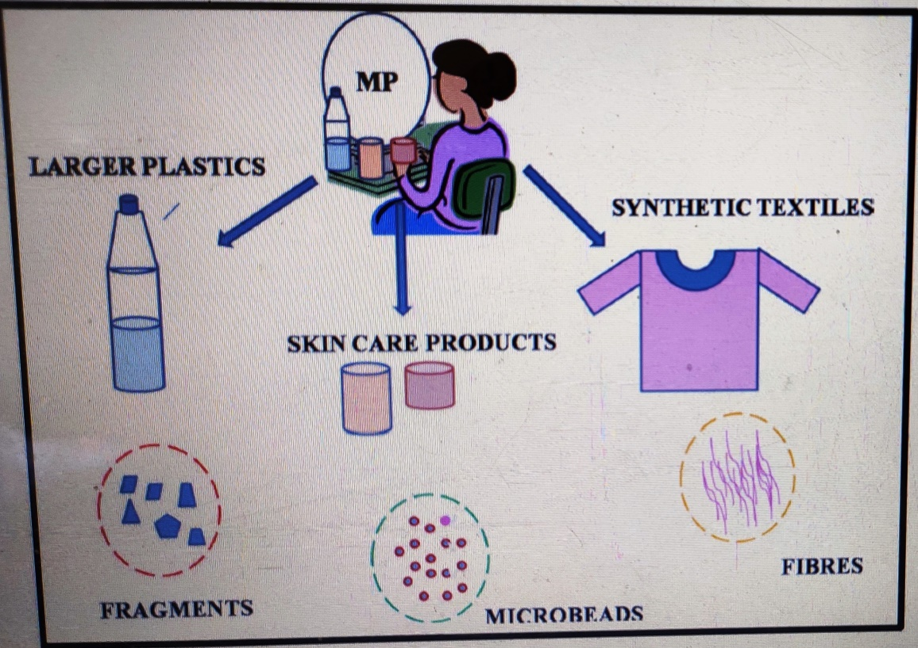
Fig. 1. Common forms of microplastics
(Source: Issac and Kandasubramanian [8])

- Classification of Microplastics according to origin (Lassen et al [11])
5.1. Primary microplastics: They have particle size less than 5 mm and are produced in most of the industries. They are produced with a specific purpose, mainly for addition in the
consumer and commercial products. They are widely used in personal hygiene products cosmetics formulations, fiber and textile manufacture [24].
5.2. Secondary microplastics: They are derived from meso (5 mm–25 mm)/macro (>25 mm) plastic waste through physical, chemical and biological processes. Secondary microplastics are formed in the environment by natural actions such as fragmentation, photodegradation or biological degradation [26] (Table 4).
Table 4 Sources for microplastics (Source: Duis and Coors [2])

Types | Sources
Primary microplastics | Production of plastics, accidental losses, and surface run-off
 | Industrial abrasives
 | Drilling fluids for oil and gas exploration
 | Specific medical applications (e.g. dentist tooth polish)
 | Personal care products containing microplastics as exfoliants /abrasives
Secondary microplastics | Plastics released from sites of waste depots, landfill and recycling facilities
 | Abrasion from car tyres, household plastics and synthetic fibres.
 | General littering, dumping of plastic waste
 | Losses of plastic materials during natural disasters
 | Material lost or discarded from fishing vessels and aquaculture facilities
 | Material lost or discarded from merchant ships, recreational boats, oil and gas platforms
 | Paint coating and abrasion during use and paint removal
- Sources of Microplastics by Usage Sectors
6.1. Land‑based sources of microplastics:
Land based sources are the major sources of microplastics and includes plastic fragments from household plastic containers, beauty and cosmetic products, detergents and gels, along with synthetic fibers and single use products.
6.2. Ocean‑based sources of microplastics: Ocean based sources include fishing components, marine vessels and offshore wastes formed due to marine recreation and tourism (Fig. 2, Table 5).
Table 5 Sources of microplastics by Usage Sectors [5]
Category | Source sector | Description
Individual consumers | Food & drink single-use packaging | Containers, plastic bags, bottles, caps, cups, plates, straws, spoons.
 | Cosmetics & personal care products | Microbeads, packaging, toothbrushes, etc.
 | Textiles & clothing | Fibres
Producers/Converters | Plastic Producers, Fabricators & Recyclers | Pellets & fragments
Sectorial consumers | Agriculture | Greenhouse-sheets, pots, pipes, nutrient prills
 | Aquaculture | Buoys, lines, nets, PVC pipes
 | Construction | EPS, packaging
 | Fisheries | Fishing gear, packaging
 | Shipping/Offshore industry | Paints, pipes, clothes, cargo, miscellaneous, plastic-blasting,
 | Sport | Synthetic turf
 | Terrestrial  Transportation | Pellets, tyres, tyre dust
 | Textile industry | Fibres
 | Tourism industry | Consumer goods, packaging,  Micro-beads, textile fibres
Waste management | Solid waste | Unmanaged or poorly managed waste disposal
 | Water & wastewater | Microbeads, fragments, fibres
Entry points to the ocean | Rivers, Coastline, Marine, Atmosphere | Paints, pipes, clothes, miscellaneous, plastic-blasting, cargo, Containers, plastic bags, bottles, caps, cups, plates, straws, spoons,

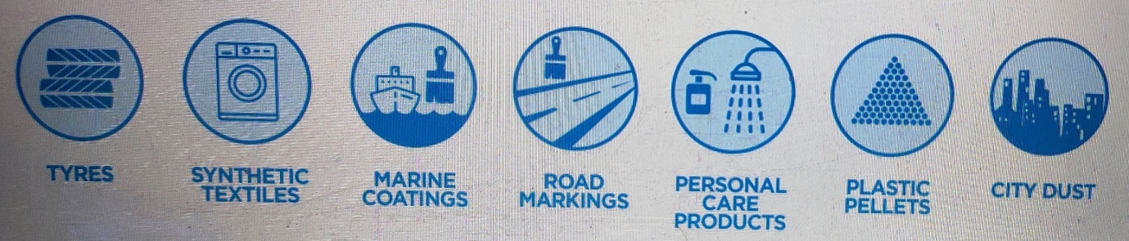
Fig. 2. Sources of microplastics from household or commercial activities
(Source: Boucher and Friot [1])
- Key Sources of microplastics
Boucher and Friot [1] reported that, the main known sources of primary MPs are city dust, marine coatings, personal care products, plastic pellets, road markings, synthetic textiles, and tyres.
7.1. City dust (Weathering, abrasion and pouring)
City dust includes losses from the abrasion of objects and infrastructure, and blasting of abrasives and intentional pouring. The type of loss is mainly unintentional.
7.2. Marine Coatings: (Weathering and incidents during application, maintenance and disposal):
From marine coatings, primary microplastics are released from boats during building, maintenance, repair or use. Activities like surface pre-treatment, coating application and equipment cleaning lead to releases of MPs. Here the type of loss is purely unintentional.
7.3. Personal Care Products: (Pouring during product use)
Use of personal care products results in the direct introduction of the plastic particles into wastewater streams from households, hotels, hospitals, and sport facilities including beaches. The type of loss is intentional.
7.4. Plastic Pellets: (Incidents during manufacturing, transport and recycling)
Due to processing, transport and recycling, plastic pellets are released into the environment through small or large incidents. Pellets are also formed during primary plastic production, transport and plastic recycling, resulting into unintentional loss (Fig. 3).

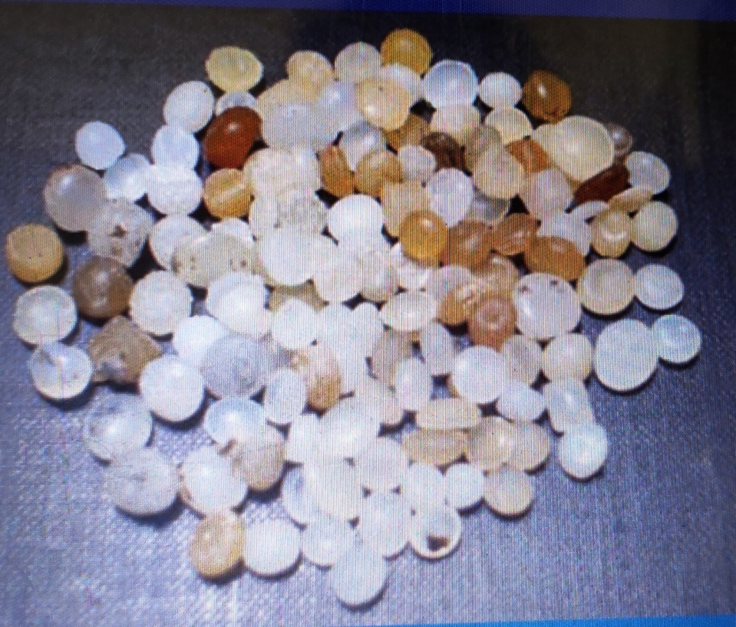
Fig. 3. Plastic pellets (Source: UNEP [20])

7.5. Road Markings: (Weathering and abrasion by vehicles)
Weathering or abrasion of the road markings which are made from paint, thermoplastic, preformed polymer tape and epoxy releases the microplastics into the environment, causing heavy smog and air pollution, affecting the human health. Weathering or from abrasion by vehicles results in loss of MPs. Such microplastics were washed off by the surface runoff and finally end up into the ocean.
7.6. Synthetic Textiles: (Abrasion during laundry)

Abrasion of polymer clothing in professional laundries and household washing machines results in shedding of small plastic fibres, which are also non-degradable and discharged into nearby water bodies and finally to ocean. Type of loss is unintentional.
7.7. Tyres: (Abrasion while driving)
Vehicle tyres due to their continuous use, are get eroded and releases plastic particles from the outer parts. Tyre dust will then be spread by the wind or washed off the road by rain. Such MP particles were then transferred from tyres to the world’s oceans. Type of loss is unintentional.
- Characterisation of microplastics
Microplastics were characterized according to their type, shape, colour, and erosion [26] (Table 6).
Table 6 Characterisation of microplastics (Source: Yuan et al [26])
Class | Sub-class | Description
Shape | Fibers | Filaments, microfibers, strands, threads.
 | Foams | Polystyrene, expanded Polystyrene.
 | General | Irregular, elongated, degraded, rough, broken edges flakes
 | Particles | Resin pellets, nurdles, pre-production pellets, nibs.
 | Spheres | Beads, grains, micro-beads, microspheres, cylinder, disc, flat, ovate, pellet, ellipse.
Colour | Black,  Multicolour,  Transparent,  White | Crystalline, clear-white-cream, red, orange, blue, opaque, grey, brown, green, pink, tan, yellow, pigmented.
Erosion | --- | Fresh, un-weathered, initial change, degree of cracking, weathering, grooves, surface irregularity, jagged fragments, linear fractures, sub-parallel ridges, degradation.

- Methods for Analysis of Microplastics
Methods used for the analysis of MPs as suspended solids in water samples, beach samples, and bed samples are wet sieving, transfer sieved solids, wet peroxide oxidation, density separation, microscope examination, and gravimetric analysis [16].
- Fate of Microplastics in the Aquatic Environment
After the release, MPs are transported and further environmental proceeds. Buoyancy, durability, and wind-driven mixing is an important factor for the fate of plastic particles. Inputs of plastics from land, riverine, and marine sources reach temporary reservoirs on beaches, tidal wetlands, and marine sediments [10, 11, 21].
10.1. Environmental Transportation:
Microplastics were transported from land to freshwater and at the last to marine environments. MPs may undergo degradation during transportation and distributed to various environment compartments, which results in formation of biofilms in marine settlement.
10.2. Environmental Persistence and Degradation:
Degradation of plastic occurs by photo-, thermal, or bio-degradation. Environmental exposure conditions, polymer properties, and quantity of chemical additives will influence MP degradation and fragmentation. Environmental degradation processes involve MP fragmentation into increasingly smaller particles/nanoplastics.
10.3. Interactions with Other Compounds
In the ocean, microplastics concentrate on DDT, polychlorinated biphenyl (PCBs), dioxins, pharmaceuticals, personal care products, flame retardants, and industrial chemicals.
- Control Measures for Microplastics
Practices such as to avoid air dry and use of the dryer, use of non-synthetic and eco-friendly clothes, use of paper bags, reduce and recycle plastic, cleaning of water bodies, and use of public transport should minimize the hazards of microplastics up to certain extent [9].
- Research Gaps and Next Steps
This study identifies many research gaps regarding the microplastics. Gaps like fate of MPs ingested by commercial species and seafood products remain unexplored, along with the time of retention of microplastic in the gut and/or its translocation to the tissues that may be consumed by humans is also not known. Further, how to determine and risks posed by microplastics for food safety and potentially food security was not fully understood.
- Conclusion
Results of this study indicate that, microplastics are produced as a result of an enhanced incidence of plastics debris and microplastics, in the aquatic environment. Number of research gaps need to be filled to better assess the risk of microplastics in aquatic environment and inform management actions. Targeted, well-designed and quality-controlled investigative studies should be carried out to better understand microplastics with respect to their occurrence, numbers, shapes, sizes, composition and sources. Research is also needed to understand the significance of treatment-related waste streams as contributors of microplastics to the environment [18]. Also, the public should take action to minimize plastics released into the environment for the benefits of the environment and human well-being.
16. References
- Boucher J, Friot D. Primary Microplastics in the Oceans: A Global Evaluation of Sources. Gland, Switzerland: IUCN. 2017; 43pp. ISBN: 978-2-8317-1827-9. DOI: dx.doi.org/10.2305/IUCN.CH.2017.01.en.
- Duis Karen, Anja Coors. Microplastics in the aquatic and terrestrial environment: sources (with a specific focus on personal care products), fate and effects. ﻿Environ Sci Eur, 2016; 28:2, DOI 10.1186/s12302-015-0069-y.
- EU (European Union). The environmental impacts of plastics and micro-plastics use, waste and pollution: EU and national measures. Policy Department for Citizens' Rights and Constitutional Affairs Directorate-General for Internal Policies, 2020; PE 658.279 - October 2020. http://www.europarl.europa.eu/supporting-analyses. Pp. 76.
- Ganesan Monnisha, Gobi Nallathambi, Seshachalam Srinivasalu. Fate and transport of Microplastics from water sources. Current Science, 2019; 117(11): 1879-1885. doi: 10.18520/cs/v117/i11/1879-1885.
- GESAMP (Joint Group of Experts on the Scientific Aspects of Marine Environmental Protection). Sources, fate and effects of microplastics in the marine environment: a global assessment. 2015; Reports and Studies 90. London: IMO/FAO/UNESCO-IOC/UNIDO/WMO/IAEA/UN/UNEP/UNDP Joint Group of Experts on the Scientific Aspects of Marine Environmental Protection.
- Haque F, Fan C. Fate and Impacts of Microplastics in the Environment: Hydrosphere, Pedosphere, and Atmosphere. Environments, 2023a; 10: 70. https://doi.org/10.3390/environments10050070.
- Haque Fatima, Chihhao Fan, Fate of microplastics under the influence of climate change. iScience, 2023b; 26, 107649, https://doi.org/10.1016/j.isci.2023.107649.
- Issac Merlin N, Balasubramanian Kandasubramanian. Effect of microplastics in water and aquatic systems. Environmental Science and Pollution Research, 2021; 28:19544–19562. https://doi.org/10.1007/s11356-021-13184-2.
- Jassim Ahmad K. Chapter Effect of Microplastic on the Human Health. Advances and Challenges in Microplastics, 2023; DOI: http://dx.doi.org/10.5772/intechopen.107149.
- Karimpour Shooka, Satinder Brar, Hamidreza Shirkhani. The Fate and Transport of Microplastics in Aquatic Ecosystems: Synthesis and Directions for Future Research, 2021; Pp. 34.
- Lassen Carsten, Steffen Foss Hansen, Kerstin Magnusson, Fredrik Norén, Nanna Isabella Bloch Hartmann, Pernille Rehne Jensen, Torkel Gissel Nielsen, Anna Brinch. Microplastics: Occurrence, effects and sources of releases to the environment in Denmark. Environmental project No. 1793, 2015. The Danish Environmental Protection Agency Strandgade, 2015; 29 1401 Copenhagen K. 2017; ISBN No. 978-87-93352-80-3. Pp. 208.
- Law Kara Lavender. Plastics in the Marine Environment. Annu. Rev. Mar, 2015; Sci. 9:205–229. doi: 10.1146/annurev-marine-010816-060409.
- Leslie HA. Review of Microplastics in Cosmetics, Scientific background on a potential source of plastic particulate marine litter to support decision-making. IVM Institute for Environmental Studies, Report, 2014; R14/29 Pp. 33.
- Li You, Yixin Sun, Jinzhen Li, Ruikai Tang, Yifa Miu, Xiaoyi Ma. Research on the Influence of Microplastics on Marine Life. 3rd International Conference on Air Pollution and Environmental Engineering, IOP Conf. Series: Earth and Environmental Science, 2021; 631: 012006 IOP Publishing doi:10.1088/1755-1315/631/1/012006.
- Masura J, et al. Laboratory methods for the analysis of microplastics in the marine environment: recommendations for quantifying synthetic particles in waters and sediments. NOAA Technical Memorandum NOS-OR&R-48, 2015; Pp. 39.
- Mehra Sukanya, Khushboo Sharma, Geetika Sharma, Mandeep Singh, Pooja Chadha. Chapter Sources, Fate, and Impact of Microplastics in Aquatic Environment. Emerging Contaminants, 2020; DOI: http://dx.doi.org/10.5772/intechopen.93805.
- OECD (The Organization for Economic Cooperation and Development). OECD Policy Highlights. Policies to Reduce Microplastics Pollution in Water Focus on Textiles and Tyres, 2021; Pp. 16.
- Osman Ahmed I, Mohamed Hosny, Abdelazeem S Eltaweil, et al. Microplastic sources, formation, toxicity and remediation: a review. Environmental Chemistry Letters, 2023; https://doi.org/10.1007/s10311-023-01593-3.
- Thompson RC, et al. Lost at sea: where is all the plastic? Science, 2004; 304:838–838. https:// doi. org/ 10. 1126/ science. 10945 59.
- UNEP (United Nations Environment Programme). Microplastics Emerging Issues, 2011; United Nations Environment Programme, P.O. Box 30552 - 00100 Nairobi, Kenya. Pp. 8.
- Wagner Martin, Scott Lambert. Freshwater Microplastics. Emerging Environmental Contaminants? The Handbook of Environmental Chemistry, 2018; ISBN 978-3-319-61614-8 ISBN 978-3-319-61615-5 (eBook). Pp. 309. DOI 10.1007/978-3-319-61615-5.
- Williams Nicola. How do Microplastics Affect our Health? 2021; Saved from URL: https://www.news-medical.net/health/How-do-Microplastics-Affect-Our-Health.aspx. Pp. 5.
- Worm Boris, Heike K. Lotze, Isabelle Jubinville, Chris Wilcox, Jenna Jambeck. Plastic as a Persistent Marine Pollutant. Annu. Rev. Environ. Resour, 2017; 42:1–26. https://doi.org/10.1146/annurev-environ-102016-060700.
- Yang H, Chen G, Wang J. Microplastics in the Marine Environment: Sources, Fates, Impacts and Microbial Degradation. Toxics, 2021; 9, 41. https://doi.org/10.3390/toxics9020041.
- Yee MSL, Hii LW, Looi CK, Lim WM, Wong SF, Kok YY, Tan BK, Wong CY, Leong CO. Impact of Microplastics and Nanoplastics on Human Health. Nanomaterials, 2021; 11, 496. https://doi.org/10.3390/nano11020496.
- Yuan Zhihao, Rajat Nag, Enda Cummins. Human health concerns regarding microplastics in the aquatic environment - From marine to food systems. Science of the Total Environment, 2022; 823, 153730 http://dx.doi.org/10.1016/j.scitotenv.2022.153730.
- Zhang Kai, Amir Hossein Hamidian, Aleksandra Tubi, Yu Zhang, James KH, Fang Chenxi Wu, Paul KS Lam. Understanding plastic degradation and microplastic formation in the environment: A review. Environmental Pollution, 2021; 274, 116554v https://doi.org/10.1016/j.envpol.2021.116554.

