The difference in the source of bee bread (citrus, anise) in its chemical composition

Abstract:
Beebread is a hive product derived from the collection of pollen by bees. To produce beebread, bees enrich the gathered pollen with honey and digestive enzymes, storing the mixture within the combs. The transformation of bee pollen into beebread occurs through an anaerobic fermentation process facilitated by the bees.
Effective beehive management is crucial to encourage the accumulation of beebread, with the intention of marketing it for human consumption. This is due to its recognition as a valuable nutritional supplement, attributed to its rich array of nutrients. The nutritional value of beebread, including protein, amino acids, fatty acids, carbohydrates, and polyphenols, is contingent upon the plant source of the bee pollen, emphasizing the significance of proper hive management for optimizing its quality.
The nutritional and functional composition of beebread lead this research, work was done to collect bee bread from two different geographical regions, namely the coastal region (Lattakia), which was the predominant citrus at the time of collection and the interior region (the countryside of Hama), which was aniseed prevalent at the time of collection.
The results of the research showed the difference in the chemical composition of bee bread collected from the two mentioned areas.
The protein content of bee bread samples from the interior region increased, which amounted to 20%, with a very high significance compared to bee bread from the coastal region, which amounted to 15.6%.
The content of sinters also increased with a very high significance, which amounted to 7.92% and 2.02% in the interior and coastal regions, respectively.
As for the ash, it was 2% and 1.3% in the interior and coastal regions, respectively.
As for the humidity of the samples of the interior region, it was lower than that of the coastal region, which amounted to 8.68%, while 13.5% in the coastal region.
The results also showed the difference in the content of the studied bee bread samples in fructose, where the content of the samples of the interior region amounted to 23.07%, while the content of the samples of the coastal region amounted to 18.10%, while the content of glucose sugar reached 15.74% and 14.82% in both the interior and coastal regions, respectively.
This confirms the difference in the chemical composition of bee bread according to the plant type from which bee pollen was collected.

Keywords: beebread, Bee pollen, protein, fructose.

- Introduction:

Until a few years ago, beekeepers refrained from collecting beebread due to the inherent challenges of extraction, which often necessitated partially destroying the hive (Fuenmayor, 2009). Instead, they typically opted to gather pollen using well-designed trap and container systems (Almeida-Muradian et al., 2005), with this bee product primarily intended for human consumption. Nevertheless, recent studies, including those by Fuenmayor (2014) and Del Risco et al. (2012), have highlighted the increased availability of nutrients and bioactive components in beebread compared to pollen.
Modern advancements have led to the development of specialized materials and devices designed for the non-destructive extraction of beebread, as demonstrated by Zuluaga et al. (2015). Effective hive management practices play a crucial role in facilitating the collection of beebread, with the ultimate goal of marketing the product for human consumption. Beebread stands out as a valuable food supplement due to its rich content of a diverse array of nutrients. Among its nutritional contributions are significant amounts of proteins, carbohydrates, lipids, vitamins, and phenolic compounds, acting as natural antioxidants, as highlighted in the study by Gulcin et al. (2003).
The dual role of beebread, both as a food and a nutraceutical supplement, is intricately tied to its chemical composition, which directly varies with the regional flora and the timing of bee collection, as noted by Markiewicz-Żukowska et al. (2013). In recent times, beebread has emerged as a new product of substantial commercial value, emphasizing the importance of a thorough assessment of its chemical composition to ensure quality. While different countries have proposed standardization measures, Russia stands out as the only nation with an established standard for beebread (GOST R 53408-2009, 2009/1/1). This highlights the growing recognition of beebread's significance and the necessity for standardized evaluation to maintain its quality.
Indeed, beebread is essentially fermented and naturally preserved pollen. Bees collect pollen, mix it with their digestive enzymes, and transport it to the hive where it is preserved with a thin layer of honey and beeswax.
The fermentation process is a crucial aspect of this transformation, modifying the outer layer, known as exine, which is composed of sporopollenin. This compound, identified for its chemical resistance, plays a key role in preserving the compounds within the pollen grain. The alteration of the outer layer through fermentation is necessary to enhance the capacity for absorbing nutrients and bioactive substances present in the pollen, as pointed out in studies such as Atkin et al. (2011). Through an anaerobic fermentation process, bees are adept at converting bee pollen into beebread, a process that not only transforms its composition but also contributes to its nutritional value.
Pollen transformation in beebread occurs as a result of successive interventions of different enzymes, some species of microorganisms such as Pseudomonas, Lactobacillus, Saccharomyces that are naturally present in pollen, moisture and temperature (35- 36C°) (Berene etal., 2015).
During the fermentation process, the disruption of the pollen wall occurs, enhancing the bioavailability of beebread. In comparison to bee pollen, beebread is more easily tolerated by the human organism and exhibits a lower pH (3.8-4.3). This lower pH is attributed to its lactic acid content, providing excellent stability during storage at room temperature, as indicated by Berene et al. (2015).
Various technologies exist for separating beebread from the honeycomb, including soaking in water, manual extraction through vibration, drying, vacuum drying with subsequent granule separation, and a multi-step process involving drying, freezing, segmentation, and filtering. Each method is employed based on specific considerations and desired outcomes in the extraction and processing of beebread.

- Materials and Methods:

- Bee bread samples:
Beebread samples for analysis were procured from various locations in distinct monofloral honey production regions in Syria during the period spanning May to October of 2021. The collected samples were pooled from a minimum of three beehives to ensure representation.

The process involved manual collection of beebread samples directly from honeycombs, followed by immediate preservation at -20°C before undergoing subsequent analyses.

The diverse flora and sampling locations included citrus from the Coastal area and anise from the Inner area. This comprehensive sampling approach aimed to capture the distinct characteristics and variations in beebread composition based on the specific monofloral sources and geographical regions within Syria.
- Chemical analysis:
The chemical analysis of bee bread, including ash, fat, and protein content, was conducted following standard methods outlined by the Association of Official Analytical Chemists (A.O.A.C) – specifically, methods 920.153 for ash, 991.36 for fat, and 960.52 for protein (A.O.A.C 2000).
The moisture content of the bee bread was determined by utilizing a vacuum oven set at 60°C, with continuous weighing until a constant mass was achieved.
Ash content measurement involved a gravimetric approach, with incineration of the sample at 550°C and subsequent weighing.
Total protein content was calculated by multiplying the nitrogen content by the nitrogen-to-protein conversion factor of 6.25.
All analyses were performed in triplicate, and the results were expressed in grams per 100 grams of fresh bee bread.
For the determination of oil content, the ISO 659:2009 standard method (ISO 2009) was employed.
Free sugars were assessed using High-Performance Liquid Chromatography (HPLC) coupled to a Refractive Index (RI) detector (Knauer, Smartline system 1000, Berlin, Germany). The internal standard (melezitose) methodology, as described in the work by Barros et al. (2013), was applied. Results were reported in grams per 100 grams of bee bread (BB).
Aime of study:
The primary objective of this study is to provide a concise overview of significant scientific findings and research pertaining to the chemical composition and biological activities of beebread.
The composition of beebread is contingent upon the plant sources from which worker bees gather pollen, exhibiting considerable variation. Notably, even within the same apiary or beehive, no identical beebread samples may be found (Isidorov et al., 2009).
Beebread possesses a distinct nutritional and compositional profile compared to bee pollen, introducing novel nutrients (Nagai, 2004). In honey bee colonies, essential nutrients for population growth and health maintenance are derived from nectar and pollen. Carbohydrates are supplied by nectar, while pollen fulfills dietary requirements such as proteins, lipids, vitamins, and minerals (Brodschneider and Crailsheim, 2010).
Interestingly, honey bees do not consume nectar or pollen directly; instead, they induce biochemical changes, transforming nectar into honey and pollen into beebread.
The chemical composition of beebread primarily comprises water, proteins, free amino acids, bioactive compounds, fatty acids, and carbohydrates (Del Risco, 2012). In this study, samples were collected from two distinct geographical areas – the Coastal region (north of Latakia) and the interior region (Al-Ghab Plain) – aiming to illustrate the influence of varied vegetation cover on the chemical composition of the beebread samples. This approach allows for a comprehensive understanding of how geographical factors may impact the nutritional content and bioactive compounds present in beebread.

- Results and Discussion:
- chemical composition of bee bread
- Protein, fat, moisture and ash contents:
The nutritional composition results, as presented in Table 1, indicate that proteins are the predominant macronutrients in the bee bread samples from both the interior and coastal regions, with values of 20 ± 0.3g/100g BB and 15.6 ± 0.3g/100g BB, respectively.

In contrast, ash and fat constitute minor components in the bee bread samples. For ash content, values of 2 ± 0.1g/100g BB and 1.3 ± 0.1g/100g BB were observed for the interior and coastal regions, respectively. Regarding fat content, the results show 7.92 ± 0.1g/100g BB for the interior region and 2.02 ± 0.1g/100g BB for the coastal region. These findings underscore the nutritional significance of proteins in bee bread, while ash and fat contribute to a lesser extent in comparison.

Table(1) Chemical composition of the two types of bee bread
Bee Bread | Protein% | Fat% | Ash% | Moisture%
coastal area | 15.6^{b} | 2.02^{b} | 1.58ª | 13.5ª
Inner area | 20ª | 7.92ª | 2^{b} | 8.68^{b}
L.S.D | 0.680*** | 0.2267*** | 0.2267* | 1.156***
C.V % | 1.7 | 2 | 5.6 | 4.6

The protein content of beebread is a highly valued nutritional aspect, with literature data suggesting a range of 14.1 to 37.3g/100g (dry basis) using the factor N x 6.25, yielding a mean of 23.1 (± 2.9)g/100g. It is anticipated that the protein content of beebread should be comparable to bee pollen, approximately 23.8g/100g (Fuenmayor et al., 2014). This alignment is attributed to the biochemical process initiated by bees, which aims to degrade the outer layer of the pollen grain without compromising the inner content (Zuluaga et al., 2015).
In your study, significant differences were observed between the two studied species. The protein content in the bee bread collected from the interior region (Anise) averaged 20g/100g of dry bee bread, while in the coastal region, it averaged 15.6g/100g of dry bee bread. These findings align with previous studies and underscore the impact of geographical and floral variations on the nutritional composition of beebread.
Regarding lipids, their content in raw beebread varies widely based on the plant origin of the pollen. Lipids, in the form of fatty acids, contribute to the biological value of beebread. Studies, such as Kaplan et al. (2016), reported lipid content in bee bread samples from various sources, ranging between 5.93g/100g BB and 11.55g/100g BB. Another study revealed a lipid content range of 1.65% to 5.50% in fifteen bee bread samples (Zuluaga et al., 2015). The observed differences between samples are attributed to the floral origin of the bee bread, as highlighted in previous studies (Urcan et al., 2017).
In summary, your study emphasizes the significant variations in protein and lipid content between bee bread samples from the interior and coastal regions, reaffirming the influence of floral origin on the nutritional composition of this bee product.
The lipid content in the bee bread type collected from the interior region (Anise) averaged 7.92g/100g of dry bee bread, while in the type collected from the coastal region, it averaged 2.02g/100g of dry bee bread. These values align with previous studies, emphasizing the considerable variation in lipid content influenced by the floral origin of the pollen.
Comparing the ash content in your study with that of Meryem Bakour et al. (2019), your results showed a slightly lower average ash content, with 2.1% in the samples from the interior region (Anise) and 1.3% in the samples from the coastal region (Citrus). This discrepancy may be attributed to the geographical and floral variations in the studied regions.
Moisture content in your study differs from the findings of Herbert and Shimanuki, with your coastal region samples (Citrus) having a moisture content of 13.5% and interior region samples (Anise) having a moisture content of 8.68%. The observed variations highlight the impact of regional and floral factors on beebread composition.
The analysis of free sugars in your study revealed that fructose is the predominant sugar, constituting 18.10% in the coastal region (Citrus) and 23.07% in the interior region (Anise). Glucose content was 14.82% in the coastal region and 15.74% in the interior region. In contrast, sucrose content was 0.075% in the coastal region and 0.51% in the interior region. These findings deviate from the typical pattern reported by Brodschneider & Crailsheim (2010), emphasizing the influence of floral sources on sugar composition in beebread.
In summary, your study highlights significant variations in lipid, ash, moisture, and sugar content between bee bread samples from the interior and coastal regions, underscoring the impact of geographical and floral factors on the nutritional composition of beebread.

Table(2) composition of sugars in the two types of bee bread
Bee Bread | Fructose% | Glucose% | Sacarose%
coastal area | 18.10^{b} | 14.82^{b} | 0.075ª
Inner area | 23.07ª | 15.74ª | 0.51^{b}
L.S.D | 4.534* | 2.267^{n.d} | 0.0817***
C.V % | 9.7 | 6.5 | 12.3

The following are the charts that show the sugar content of bee bread using the Hplc.

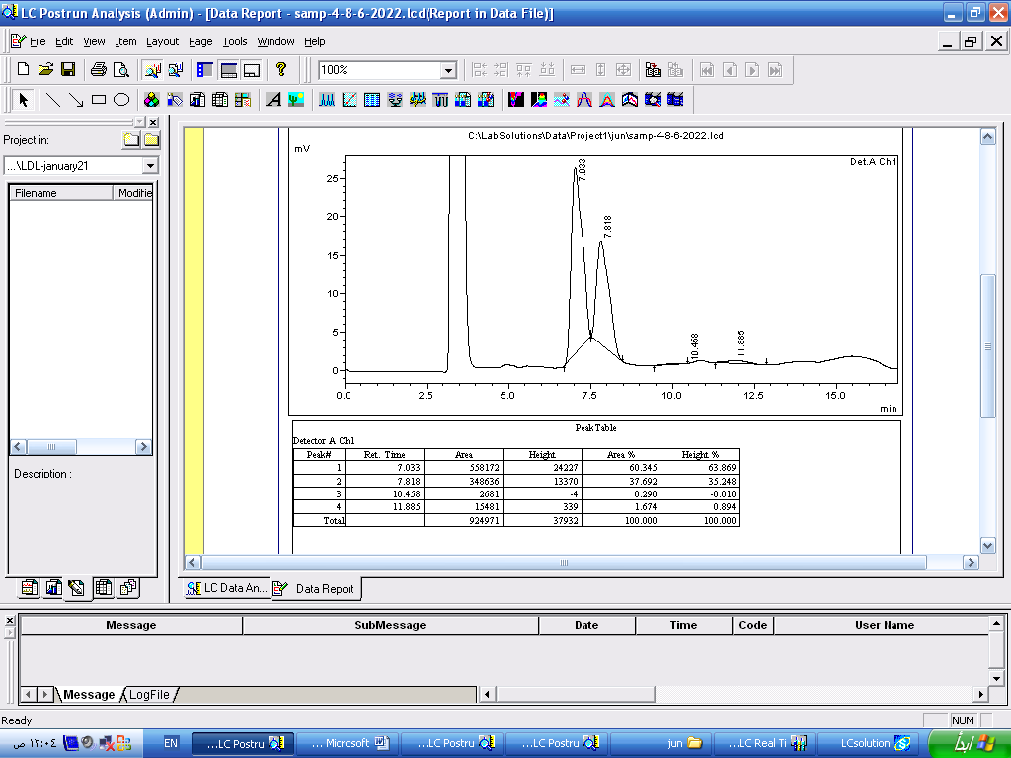

Figure (1) The chromatogram curve of citrus bee bread sugars

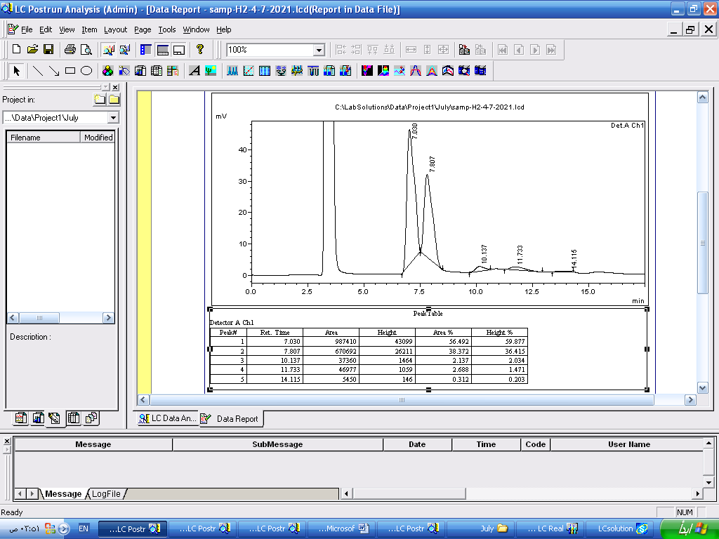

Figure (2) The chromatogram curve of Anise bee bread sugars

- Conclusions and Recommendations:

- Conclusions:
The chemical composition of bee bread samples exhibits variability based on different botanical origins. This variation underscores the influence of plant sources on the nutritional profile of bee bread. The distinctive results obtained in this study can serve as a valuable reference for further research into bee and human health. Additionally, these findings provide a scientific foundation for assessing the nutritional value of bee bread, contributing valuable information to food composition databases.Beebread is recognized as a precious and specialized food. Its value is attributed to the elevated levels of proteins, carbohydrates, mineral salts, and lipids, with the composition influenced by both botanical and geographical origins. The appreciation of these components underscores the significance of understanding the diverse nutritional attributes that make beebread a unique and beneficial food source.

- Recommendations:
- Beebread composition and bioactive properties have not been thoroughly studied in Syria until now. Therefore, there is a pressing need for further research to comprehensively explore the chemical composition and properties of beebread in the region.
- The anticipated outcomes of this research could play a crucial role in cataloging and acknowledging Syrian bee bread as a valuable source of natural nutrients. By understanding its chemical composition and beneficial properties, beebread could be recognized as a favorable product for human nutrition and health.
- This work is expected to contribute significantly to the body of knowledge regarding Syrian bee bread, paving the way for its integration into discussions surrounding natural nutrition and promoting its potential as a health-enhancing product..

- References:

- Almeida-Muradian LB, Panplona LC, Coimbra S, Barth O M, (2005). Chemical composition and botanical evaluation of dried bee pollen pellets. J. Food Comp. Anal., 18(1):105- 111.
- AOAC Official Method 960.52. Microchemical determination of nitrogen (micro-Kjeldahl method). Rockville, MD, USA:AOAC International; 2000.
- AOAC Official Method 920.153. Ash of meat. Rockville, MD,USA: AOAC International; 2000
- AOAC Official Method 991.36. Fat (crude) in meat and meat products. Rockville, MD, USA: AOAC International; 2000.
- Atkin S, Barrier S, Cui Z, Fletcher P, Mackenzie G, Panel V, Sol V, Zhang X, (2011). UV and visible light screening by individual sporopolleninexines derived from Lycopodium clavatum (club moss) and Ambrosia trifida (giant ragweed). J. Photochem. Photobiol. B Biol 102: 209–217.
- Badiaa lyoussi,(2019). Bee bread as a functional product: Chemical composition and bioactive
- Barros, L., Pereira, E., Calhelha, R. C., Dueñas, M., Carvalho, A. M., Santos-Buelga, C.,et al. (2013). Bioactivity and chemical characterization in hydrophilic and lipophilic compounds of Chenopodium ambrosioides L. Journal of Functional Foods, 5, 1732–1740.
- BeeBread, GOST R 53408-2009,2009/1/1.
- Berene I, Daberte I, Siksan S, (2015). Investigation of beebread and development of its dosage forms. Medicinos, 21(1): 16-22
- Brodschneider R, Crailsheim K, (2010) Nutrition and health in honey bees. Apidologie41: 278–294.
- Del Risco C, Pérez A, Álvarez V, Rodríguez G, Leiva V, Puig Y, García R, (2012). Lactic acid bacteria to silage bee pollen, Rev. CENIC CienciasBiológicas 43: 17–21.
- Lactic acid bacteria to silage bee pollen, Rev. CENIC CienciasBiológicas 43: 17–21.
- Fuenmayor C, (2009). Bioprocess application in bee pollen development of a protein nutritional supplement. Universidad Nacional de Colombia, Bogotá, Colombia.
- Fuenmayor C, Zuluaga C, Diaz C, Quicazán M, Cosio M, Mannino S, (2014). Evaluation of the physicochemical and functional properties of Colombian bee pollen. Rev. MVZ Córdoba 19: 4003–4014.
- Gulcin I, Buyukokuroglu ME, Oktay M, Kufrevioglu O, (2003). Antioxidant and analgesic activities of turpentine of Pinus nigraArn.subsp. pallsiana(Lamb.) Holmboe. J. Ethnophar. 86: 51-58.
- Herbert Jr EW, Shimanuki H. Chemical composition and nutritive value of bee-collected and bee-stored pollen. Apidologie. 1978;9:33–40.
- Isidorov VA, Isidorova AG, Szczepaniak L, Czyżewska U, (2009). Gas chromatographic–mass spectrometric investigation of the chemical composition of beebread. Food Chemistry 115(3): 1056-1063.
- ISO 659:2009. Oilseeds – determination of oil content (referencemethod). Geneva Switzerland: International Organization for Standardization (ISO); 2009.
- Kaplan, M., Karaoglu, Ö., Eroglu, N., & Silici, S. (2016). Fatty acid and proximate composition of bee bread. Food Technology and Biotechnology, 54, 497–504. cytotoxic properties of bee venom collected in Northeast Portugal. Food and Chemical
- Markiewicz-Żukowska R, Naliwajko SK, Bartosiuk E, Moskwa J, Isidorov V, Soroczyńska J, Borawska MH, (2013). Chemical composition and antioxidant activity of beebread, and its influence on the glioblastoma cell line (U87MG). Journal of Apicultural Science57(2): 147-157.
- Meryem Bakour, Ângela Fernandes, Lillian Barrosb , Marina Sokovic, Isabel C.F.R. Ferreira ,and
- Nagai T, Nagashima T, Myoda T, Inoue R, (2004). Preparation and functional properties of extracts from beebread. Molecular Nutrition & Food Research48(3): 226-229.
- Stanciu OG, Mărghitaş L, Dezmirean D, (2009). Macro-and Oligo-Mineral Elements from Honeybee-Collected Pollen and Beebread Harvested from Transylvania (Romania). Bulletin of University of Agricultural Sciences and Veterinary Medicine Cluj-Napoca. Animal Science and Biotechnologies 66.
- Urcan, A., Mărghitaș, L. A., Dezmirean, D. S., Bobiș, O., Bonta, V., Mureșan, C. I.
- Zuluaga CM, Serrato JC, Quicazan M, (2015). Chemical, nutritional and bioactive characterization of Colombian beebread. Chemical Engineering Transactions 43: 175- 180.

