INVESTIGATION OF THE CHANGES IN THE HAIR CUTICLE DUE TO CHEMICAL DEGRADATION

Abstract
Various cosmetic alterations done to the hair for aesthetic purposes have a profound damaging impact on its morphology. This study delves into the complex dynamics of hair structure by analysing the changes in the cuticle induced by chemical degradation. Advanced microscopic techniques like Microtopography and Scanning Electron Microscopy (SEM) were employed to investigate the grade of damage on treated hair as compared with virgin hair. On treatment with bleach, it could be observed that the cuticle structure in virgin hair exhibited deteriorating effects like partial degradation whereas the impact on treated hair samples strands that had previously undergone modifications exhibited much more intensifying consequences like complete deterioration exposing holes and gaps. The findings from the current exploration shed light on the nuanced relationships within the hair structure, providing valuable insights into the consequences of chemical degradation. Thus, laying a foundation for suggestive recommendations that include the impact of environment, lifestyle and genetics in the fields of trichology and cosmetology.
Keywords: Hair, Cuticle, Hair damage, Bleach, SEM.
- Introduction
The prevalence of cosmetic transformations on hair are increasing at an alarming rate, especially among the young demographic driven by the everchanging trends. However, such treatments are used by all irrespective of age groups and gender. Such treatments have a capacity to alter the inherent characteristics of hair, resulting in increased fragility, thereby contributing to various hair-related issues like hair loss and breakage. A typical hair shaft is a complex structure [1] made up of keratin proteins which have three distinct layers: medulla, cortex, and cuticle [2], bounded by the cell membrane complex [3]. Medulla is the innermost layer, surrounded by the cortex which makes up most of the hair shaft and cuticle is the outermost layer that protects the hair shaft against mechanical and chemical abrasions [4]. The hair appearance primarily depends on the health of the cuticle [5]. The gloss of the hair depends upon the smooth layering of the cuticle, while the strength depends on the integrity of the cortex [6]. The cuticle is a chemically resistant region comprising of thin flap overlapping scales from the root to the tip of each hair called keratinocytes that looks like a stack of bottomless plastic cups where each cup represents a single thin cuticular cell sheet [7]. The shape and orientation of the cuticle cells are responsible for the differential friction effect in hair [1]. Its thickness depends on the number of layers which is formed by the amount each scale overlaps its neighbour [8,9]. The arrangement of these scales directly affects the porosity of the hair which determines the ability of the hair to absorb moisture and chemicals. Morphology of the cuticle is affected by natural weathering caused due to sunlight, rain, and dirt; mechanical abrasions like brushing, towelling, and handling & chemical procedures such as bleaching, dyeing, smoothening, and so on [10,11]. The natural texture of hair has a scale structure with smooth edges which after the application of chemicals transforms into scales having jagged edges, and complete/partial erosion which is referred to as weathering of the cuticle causing varying degrees of damage to the hair [12]. Cuticle scales are intact for virgin hair while are poorly defined for treated hair [13]. Many chemical procedures like dyeing, bleaching, and smoothening is available in the market which tends to improve the sensorial properties of the hair that are perceived through touch, sight and sometimes smell, by making the cuticles flat and erasing the asperities, however, they do not preserve the hair’s morphology. Bleach is one such chemical product that is commonly used in hair treatments which operate at the cuticle level of the hair [6], causing the hair to appear lighter than its natural hue. It is an oxidative process primarily involving chemicals such as hydrogen peroxide, and ammonia causing the decomposition of melanin granules [14]. The alkaline pH of the hydroxides (9–14) swells the hair shaft, opens its cuticle, and allows the chemicals to penetrate into the cortex [15]. Untreated hair has a pH of 4.5 to 5.5 which helps to keep the cuticular cells closely opposed to the cortex [6]. Hence, an acidic pH agent is added to terminate the process and close the cuticles [16,17]. The Water Retention Index (WRI) for bleached and damaged hair is much higher as compared to that of untreated hair due to chemical degradation of proteins which causes dryness of the hair [18]. Damage to the hair shaft is also due to loss of cysteine content of keratin fibers which imparts mechanical stability primarily through its cross-linking with disulphide bonds [12]. Bleaching causes the breakdown of disulphide bonds which leads to heightened cuticle porosity, elevated hydrophilia, and increased brittleness of the shaft [19]. The continuous pursuit of unique and aesthetic hair treatments has led to an increase in the use of chemicals which causes degradation of the cuticle damaging the structural integrity of hair. An attempt has been made to spread awareness about the consequences of chemicals that is one of the primary contributors of damage to the morphology of the hair. The objective of this research is to study and distinguish between the changes in the structure of the hair cuticle due to chemical degradation by bleaching.
- Materials and Methods
A varied sample set of 50 human hair were collected from participants of varied age groups and gender living in the suburbs of Mumbai, India. The sample pool included a control group, which constituted 50% of virgin hair strands, and a test group, consisting of the remaining 50% of hair strands that underwent chemical procedures such as bleaching, dyeing, and smoothening. The hair samples collected were cast by applying a finger-sized layer of transparent nail polish onto the glass slide and the hair strand was quickly led to rest on top of it and allowed to dry undisturbed. Once dried, it was carefully pulled out using forceps. Nail polish was used as it attaches and retains the scale cast even after the hair is pulled out leaving a clear replica reflecting the texture of the hair [20]. For bleaching, a mixture of ammonium hydroxide, hydrogen peroxide, and distilled water (1:1.5:1) was prepared. The hair strand was dipped into acetone for a few minutes and dried with the help of filter paper [21]. Further it was kept in petri dish to which the mixture was added and covered to allow the exothermic reaction to occur for about 30 mins and gradually the pigments of the hair get bleached, visible to the naked eye. The scale castings were observed under a compound microscope (45X) before and after bleaching the hair to notice the changes in the structure of the scales following standard laboratory protocols. Photographs of the scale casts were taken with a 12 MP dual-lens phone camera. For SEM analysis, the samples were investigated under FEI Quanta 200 Scanning Electron Microscope, a versatile microscope with a tungsten electron source and three modes of operation. High vacuum (HV) mode allows analysis of electrically conducting and non-conducting samples can be analysed after sputter coating. Low Vacuum & ESEM modes allow analysing biological and insulating samples without coating. The hair samples were placed on metal stubs with carbon adhesive. Due to the non-conducting nature of hair platinum sputter coating was applied for half an hour. After completion of platinum coating, the samples on the metal stubs were kept inside the Scanning Electron Microscope stage. The electron beam of 15 KV was used. Detector used in imaging was Everhart-Thornley detector (ETD). Samples were observed under magnification of 1500X. A research survey was also conducted by providing the participants with a questionnaire acquiring data related to their hair condition, hair treatments, hair care practices, as seen in Fig. 1. These responses were then analysed using percentage statistics in the form of graphs with the help of Microsoft Excel.
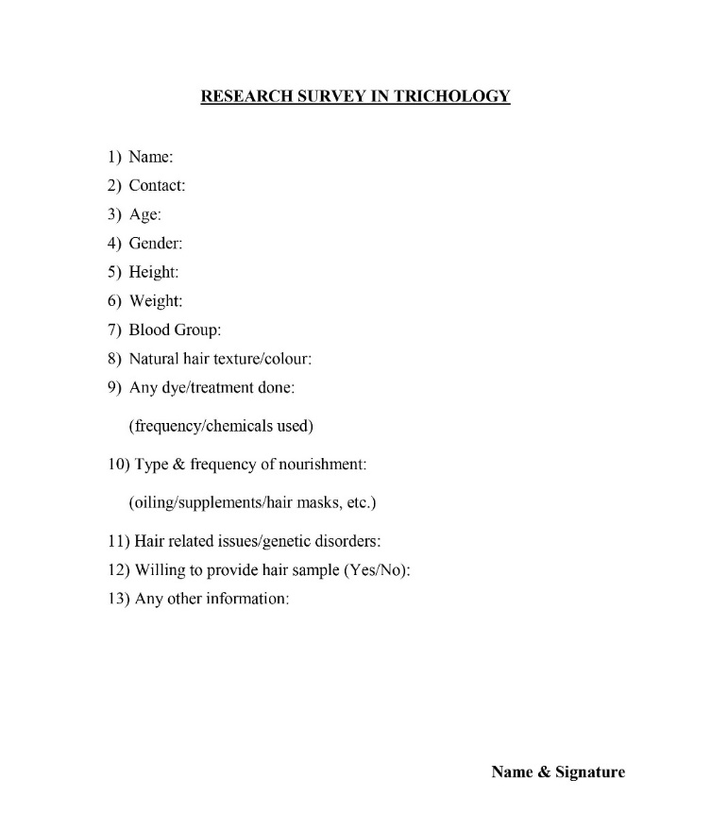
Fig. 1 Research Survey Questionnaire
- Results and Discussion
One of the ways to study a cuticle’s scale pattern is with surface casts made on microscope slides in thermoplastics [9]. However, SEM is a striking alternative to study hair shaft abnormalities [22], as it helps us to examine the results in a much enhanced and intricate manner. Upon examining the casts, it was found that due to bleaching the cuticle of the hair underwent a morphological change mainly concerning the scales on the cuticle. A comparison is in Fig 2,3 and 4 between the following A: Control v/s B: Test samples; A: Virgin hair v/s B: Same virgin hair that was bleached and A: Chemically altered hair v/s B: Chemically altered hair that was again subjected to bleach respectively. The Control is the sample of regularly oiled virgin hair and the test is the sample of cosmetically altered hair with bleach/dye.

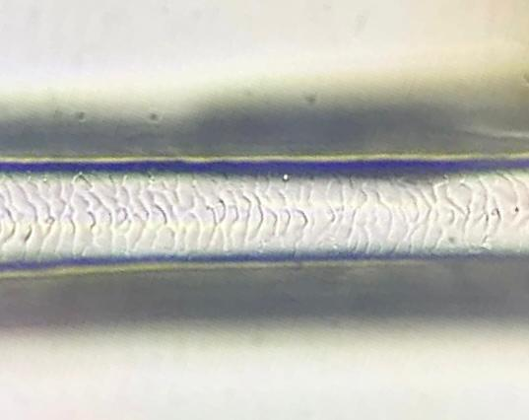  A | 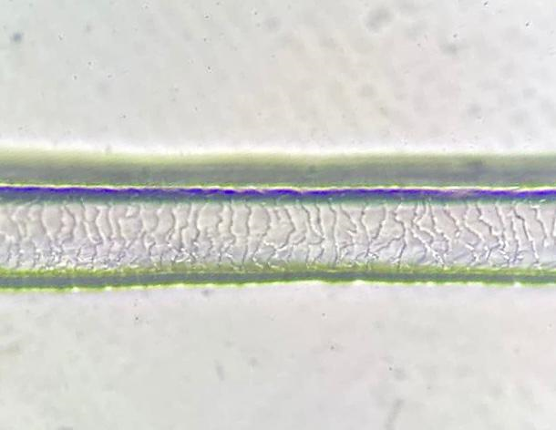  B
A – VIRGIN HAIR STRAND; B – TREATED HAIR STRAND
Fig. 2 Comparative Study of hair - Control V/s Test (Light Microscope – 45X & SEM images – 1500X)

A | 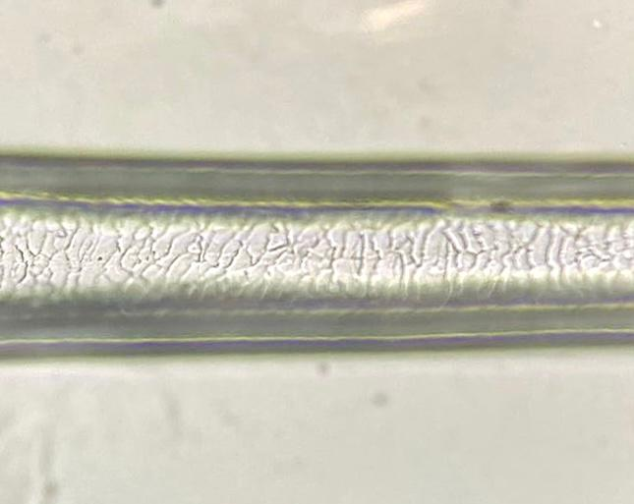  B
A – VIRGIN HAIR STRAND; B – VIRGIN HAIR STRAND AFTER BLEACH
Fig. 3 Virgin Hair Cast: Before and After Bleaching (Light Microscope – 45X & SEM images – 1500X)

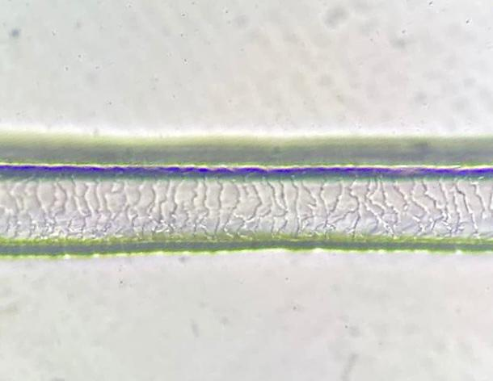  A | 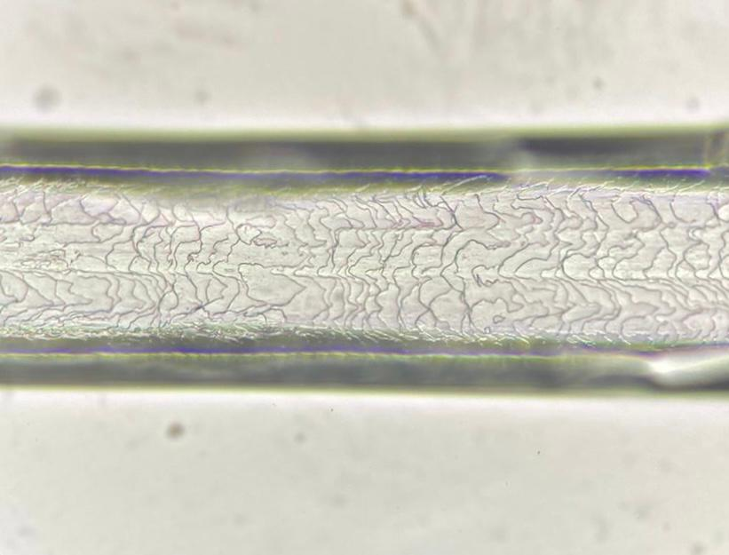  B  Jagged edges
Hole  Irregular overlay | Broken cuticle  Chipped edges

A – ALREADY TREATED HAIR STRAND; B – TREATED HAIR STRAND BLEACHED AGAIN
Fig. 4 Already Treated Hair Cast: Before and After Bleaching (Light Microscope – 45X & SEM images – 1500X)
On further investigation under SEM with the help of higher magnification, the results were distinctly seen. The differences observed in Fig. 3 are that the virgin hair showed regular layering and interval of scales having smooth edges with proportionate inter-scale distance whereas the bleached one showed irregular contour of the cuticle, scales having jagged edges, and lifting up of scales. It was observed that previously treated hair when bleached again showed a dramatic effect on the cuticular structure showing a highly irregular pattern with complete/partial removal of scales leaving gaps exposing the cortical layer as seen in Fig. 4. There was a difference in the cuticular structure having degrading effects on virgin hair and aggravating effects on the already altered hair. In Table 1, the samples were classified into the respective grades of damage ranging from 0 to 4 from least to most damaged respectively [23].
Table. 1 SEM grade classification of damage (0 – Regular overlay of scales; 1 – Irregular overlay of scales without holes/cracks; 2 – Lift up of cuticles with holes/cracks; 3 – Partial exposure of cortex; 4 – Disappearance of cortex completely)
Sr. no | Sample type | Procedures done | Grade
1 | Virgin hair | None (Regular oiling) | 0
2 | Virgin hair bleached | Bleach | 1
3 | Treated hair | Bleach, Dye, Straightening | 2
4 | Treated hair bleached | Sample 3 bleached | 2

Based on the research survey conducted, it was observed that the use of oil (coconut oil) is the primary traditional nourishment method used by majority as it tends to impart essential nutrients to the hair and scalp. However, hair fall is also the most common complaint of the individuals. Upon analysing the statistical data, it was found that, out of the 50% individuals having virgin hair, 44% who regularly applied oil as a form of nourishment had no hair-related issue. However, the remaining 6% rarely/never made use of oil complained of hair fall as seen in the Fig. 5. In the case of remaining 50% individuals having treated hair, 28% complained of hair fall and 22% had no such complaints. As opposed to this, 28% of the individuals with treated hair are also the ones who regularly applied oil (coconut oil) and the remaining 22% did not. These findings indicate that despite the application of oil, treated hair is more susceptible to breakage encountering greater hair loss in comparison to virgin hair which aligns with Swift’s observation in 1999 indicating that hair subjected to chemical and physical manipulation was more prone to premature fracture [24].

Fig. 5 Comparison between Virgin & Treated Hair
All the samples underwent cuticle degradation but the extent was aggravated in treated hair in contrast to virgin hair. A normal healthy cuticle has a smooth texture that reflects light and has limiting friction allowing them to slide gently over neighbouring shafts, imparting lustre to the hair. However, the keratin layer of the hair becomes fragile due to friction, temperature, humidity, application of chemical products, and use of hair dryers affecting the hair quality and compromising its protective role [19,25]. A study has been conducted on the effects of bleaching, dyeing, smoothening, heat, etc which enhance the sensorial properties of the hair by flattening the cuticle and erasing the asperities but they fail to preserve the hair’s morphology resulting in increased coarseness, diminished shine, and reduced softness [13]. Lima et al (2019) evaluated the damage to the epidermis and cortex of the hair fibre by heat loss by using a heating iron which justifies the degradation caused due to the straightening treatment undergone by individuals in our survey study [26]. Ali et al (2015) studied the changes in the hair such as breaking/lifting up of cuticular scales, roughness in the surface, tearing, and fragmentation of cuticles in hair samples that have undergone chemical (bleaching, colouring, waving) and physical treatments (hot straightening) that corroborates with the findings in present investigation [27]. The makeup of human hair is influenced by various factors including age, gender, dietary habits, lifestyle, geographical location, regular washing practices, individual physiological variations along with cosmetic treatments like dyeing, perming, and bleaching [28]. Day to day stimuli such as UV radiation to wet hair are also a factor of damage to the hair causing holes in the cuticular layer [29]. These stimuli are inherent in the daily life and unavoidable, at times, potentially causing similar degrees of damage in the samples as they were sourced from the same geographical area having equivalent levels of pollution and environmental conditions. Major role of genetics and environmental elements comes into play while considering issues related to health of the hair. O’Connor et al (1995) studied the effects of environment on the human hair cuticles by comparing the effects in air versus water conditions as well as determining how pH changes affect hair morphology [30]. Gokce et al (2022) studied the genetic aspects of hair loss and its connection with nutrition received from the Mediterranean diet which is one of the healthiest nutrition models in the world [31]. In 2019, Ahmed et al summarized an article based on the previously conducted studies on the various genetic hair disorders [32]. In the current work enough information on genetic influence was not procured, stemming from participants' limited awareness. However, it can be observed from previous research that genetics can play a role in hair structure and quality and should be considered as one of the factors responsible for cuticle damage along with environmental exposure and lifestyle choices. It is however recommended to incorporate a genetic perspective into future research endeavours aimed at understanding and enhancing hair health to overcome the challenges posed due to lack of awareness, enriching the depth of our investigations.
- Conclusion
The research findings highlight the detrimental effects of chemical treatments on the structure of the hair. Repeated cosmetic procedures to the hair shaft such as bleaching causes damage to the cuticle altering the morphology and compromising the structural integrity of the hair shaft. Awareness about the consequences of excessive usage of chemicals is essential along with promoting haircare practices such as oiling and conditioning that prioritize cuticle health and educating individuals can help minimize the damage and maintain their hair quality. Further research is required to develop innovative techniques and products for treatment and maintenance of the hair health. However, detailed study using more sophistication needs to be carried out to validate the present findings.
References
- Gavazzoni Dias, M. F. (2015). Hair cosmetics: An overview. International Journal of Trichology, 7(1), 2. https://doi.org/10.4103/0974-7753.153450
- Buffoli, B., Rinaldi, F., Labanca, M., Sorbellini, E., Trink, A., Guanziroli, E., Rezzani, R., & Rodella, L. F. (2014). The human hair: From anatomy to physiology. International Journal of Dermatology, 53(3), 331–341. https://doi.org/10.1111/ijd.12362
- Robbins CR. (2012). Chemical and physical behavior of human hair. 5th ed. New York: Springer.
- Leerunyakul, K., & Suchonwanit, P. (2020). Asian Hair: A Review of Structures, Properties, and Distinctive Disorders. Clinical, Cosmetic and Investigational Dermatology, Volume 13, 309–318. https://doi.org/10.2147/CCID.S247390
- Miranda-Vilela, A. L., Botelho, A. J., & Muehlmann, L. A. (2014). An overview of chemical straightening of human hair: Technical aspects, potential risks to hair fibre and health and legal issues. International Journal of Cosmetic Science, 36(1), 2–11. https://doi.org/10.1111/ics.12093
- Madnani, N., & Khan, K. (2013). Hair cosmetics. Indian Journal of Dermatology, Venereology, and Leprology, 79(5), 654. https://doi.org/10.4103/0378-6323.116734
- Swift, J. A. (1991). Fine details on the surface of human hair. International Journal of Cosmetic Science, 13(3), 143–159. https://doi.org/10.1111/j.1467-2494.1991.tb00558.x
- Appleyard, and Greville. “The Cuticle of Mammalian Hair.” Nature, 1950. https://doi.org/10.1038/1661031a0
- Ryder, M. L. (1973). Hair. Edward Arnold (Publishers) Ltd.
- Swift, J. A., & Brown, A. C. (1972). The critical determination of fine changes in the surface architecture of human hair due to cosmetic treatment. Journal of the Society of Cosmetic Chemists, 23, 695-702.
- Yu, Y., Yang, W., Wang, B., & Meyers, M. A. (2017). Structure and mechanical behavior of human hair. Materials Science and Engineering: C, 73, 152–163. https://doi.org/10.1016/j.msec.2016.12.008
- Robinson, V. N. E. (1976). A study of damaged hair. Journal of the Society of Cosmetic Chemists of Great Britain, 27, 155-161.
- Thieulin, C., Vargiolu, R., & Zahouani, H. (2019). Effects of cosmetic treatments on the morphology, biotribology and sensorial properties of a single human hair fiber. Wear, 426–427, 186–194. https://doi.org/10.1016/j.wear.2019.01.065
- Imai, T. (2011). The influence of hair bleach on the ultrastructure of human hair with special reference to hair damage. Okajimas Folia Anatomica Japonica, 88(1), 1–9. https://doi.org/10.2535/ofaj.88.1
- Barreto, T., Weffort, F., Frattini, S., Pinto, G., Damasco, P., & Melo, D. (2021). Straight to the Point: What Do We Know So Far on Hair Straightening? Skin Appendage Disorders, 7(4), 265–271. https://doi.org/10.1159/000514367
- Hatsbach De Paula, J. N., Basílio, F. M. A., & Mulinari-Brenner, F. A. (2022). Effects of chemical straighteners on the hair shaft and scalp. Anais Brasileiros de Dermatologia, 97(2), 193–203. https://doi.org/10.1016/j.abd.2021.02.010
- Da França, S., Dario, M., Esteves, V., Baby, A., & Velasco, M. (2015). Types of Hair Dye and Their Mechanisms of Action. Cosmetics, 2(2), 110–126. https://doi.org/10.3390/cosmetics2020110
- Kaliyadan, F., Gosai, B., Al Melhim, W., Feroze, K., Qureshi, H., Ibrahim, S., & Kuruvilla, J. (2016). Scanning electron microscopy study of hair shaft damage secondary to cosmetic treatments of the hair. International Journal of Trichology, 8(2), 94. https://doi.org/10.4103/0974-7753.188035
- Guerra-Tapia, A., & Gonzalez-Guerra, E. (2014). Hair Cosmetics: Dyes. Actas Dermo-Sifiliográficas (English Edition), 105(9), 833–839. https://doi.org/10.1016/j.adengl.2014.02.003
- Rachael (2022) Hair under a microscope, Rs’ Science. Available at: https://rsscience.com/hair-under-a-microscope/#Method_1_Making_a_scale_casting_with_clear_nail_polish_see_microtopography_of_hair (Accessed: 07 July 2023).
- Chauhan, A., Tyagi, N., & Shukla, S. K. (2018). A study on the presence of medulla types of hair among the young Jaat residents of Western Uttar Pradesh. Journal of Forensic Sciences and Criminal Investigation, 10(4). https://doi.org/: 10.19080/JFSCI.2018.10.555795.
- Echeverría, X. P., Romero, W. A., Carreño, N. R., Zegpi, M. S., & González, S. J. (2009). Hair Shaft Abnormalities. Pili Bifurcati: A Scanning Electron Microscopy Analysis. Pediatric Dermatology, 26(2), 169–170. https://doi.org/10.1111/j.1525-1470.2009.00877.x
- Kim, Y.-D., Jeon, S.-Y., Ji, J. H., & Lee, W.-S. (2010). Development of a Classification System for Extrinsic Hair Damage: Standard Grading of Electron Microscopic Findings of Damaged Hairs. The American Journal of Dermatopathology, 32(5), 432–438. https://doi.org/10.1097/DAD.0b013e3181c38549
- Swift, J. A. (1999). The Mechanics of Fracture of Human Hair. International Journal of Cosmetic Science, 21(4), 227–239. https://doi.org/10.1046/j.1467-2494.1999.186942.x
- Man, Q., Zhang, L., & Cho, Y. (2021). Efficient Hair Damage Detection Using SEM Images Based on Convolutional Neural Network. Applied Sciences, 11(16), 7333. https://doi.org/10.3390/app11167333
- Lima, C. R. R. D. C., Couto, R. A. A. D., Freire, T. B., Goshiyama, A. M., Baby, A. R., Velasco, M. V. R., Constantino, V. R. L., & Matos, J. D. R. (2019). Heat‐damaged evaluation of virgin hair. Journal of Cosmetic Dermatology, 18(6), 1885–1892. https://doi.org/10.1111/jocd.12892
- Ali, N., Zohra, R. R., Qader, S. A. U., & Mumtaz, M. (2015). Scanning electron microscopy analysis of hair index on Karachi’s population for social and professional appearance enhancement. International Journal of Cosmetic Science, 37(3), 312–320. https://doi.org/10.1111/ics.12201
- Chojnacka, K., Zielińska, A., Michalak, I., & Górecki, H. (2010). The effect of dietary habits on mineral composition of human scalp hair. Environmental Toxicology and Pharmacology, 30(2), 188–194. https://doi.org/10.1016/j.etap.2010.06.002
- Maeda, K., Yamazaki, J., Okita, N., Shimotori, M., Igarashi, K., & Sano, T. (2018). Mechanism of Cuticle Hole Development in Human Hair Due to UV-Radiation Exposure. Cosmetics, 5(2), 24. https://doi.org/10.3390/cosmetics5020024
- O’Connor, S. D., Komisarek, K. L., & Baldeschwieler, J. D. (1995). Atomic Force Microscopy of Human Hair Cuticles: A Microscopic Study of Environmental Effects on Hair Morphology. Journal of Investigative Dermatology, 105(1), 96–99. https://doi.org/10.1111/1523-1747.ep12313377
- Gokce, N., Basgoz, N., Kenanoglu, S., Akalin, H., Ozkul, Y., Ergoren, M. C., Beccari, T., Bertelli, M., & Dundar, M. (2022). An overview of the genetic aspects of hair loss and its connection with nutrition. Journal of Preventive Medicine and Hygiene, Vol. 63 No. 2S3, E228 Pages. https://doi.org/10.15167/2421-4248/JPMH2022.63.2S3.2765
- Ahmed, A., Almohanna, H., Griggs, J., & Tosti, A. (2019). Genetic Hair Disorders: A Review. Dermatology and Therapy, 9(3), 421–448. https://doi.org/10.1007/s13555-019-0313-2

