Exploring the In vitro Antibacterial Efficacy of Yemidir Embuay

(Cucumis focifolius) and Endod (Phytolacca dodecandra) of Different Extracts Against Some Bacteria Pathogens

Original Research Article

ABSTRACT

Medicinal plants are one of the most indigenous resources in the world for the treatment of different diseases. Now a day most of infectious diseases are resistant to the antimicrobial agents. Therefore, the aim of this study was to explore the efficacy of Cucumis focifolius and Phytolacca dodecandra against Staphylococcus aureus, Klebsiella Pneumonia and Neisseria gonorrhea. Ethanol, Methanol, Chloroform and Water are used as solvents for the extraction of phytochemical compounds from Cucumis focifolius and Phytolacca dodecandra plants. The effective extraction of bioactive compounds was achieved using methanol, chloroform and water as solvents. According to this study there were bioactive compounds that extracted from selected plants which were potentially effective against Neisseria gonorrhea and some other pathogens. Both Cucumis focifolius and Phytolacca dodecandra some inhibition zone on S. auerus and k. pneumonia strains. Highly statistical significant antibacterial effect against N. gonorrhea (16.6±3.05) for ethanol root extract of Cucumis focifolius followed by methanol root extract with an inhibition zone of (15±2.64) were exhibited. The extract also shows (13.3±1.25mm, 14±1.05mm by chloroform and distilled water root extract respectively. Ethanol C. focifolius root shows lowest Minimum inhibitory concentration against Neisseria gonorrhea as compared to other extracts. Therefore, we recommend people to search for new antimicrobial agents for better treatment of Neisseria Gonorrhea, which is one of causative agent of sexual transmitted disease.

Keywords: Medicinal plants; Cucumis focifolius; phathogens; Phytolacca dodecandra; solvent.

1. INTRODUCTION

1.1 Background

The emergence of drug resistant microorganism and an increasing evolutionary adaptation by microorganism to the commonly used antimicrobial have reduced the effectiveness of the antimicrobial agents in use. According to Ndip et al. [1], medicinal plants constitute a source of both traditional and modern medicines. Hence, today researchers have discovered more than 10,000 medicinal plants with biologically active compounds of microbial origin [2].

In developing nations about 65-80% of the world’s population relies essentially on traditional medicinal plants and traditionally processed products for treatment of different type of bacterial and human aliment diseases [3]. In Ethiopia about 80% of the total populations use plant based traditional medicine by their indigenous knowledge as their major primary health care system. This traditional knowledge of medicinal plants is serving as an input and a walking step for many researchers to investigate the effectiveness of the medicinal plant through scientific work with experimental evidences for the discovery of new drugs [4]. It is known that when plants are exposed to contact with different microorganisms, including viruses, bacteria and fungi, plants synthesizes secondary metabolites like tannins, alkaloids, carbohydrates, terpenoids, steroids and flavonoids, which produce definite physiological action on the human body and these bioactive substances [5,6].

Different studies have been reported to extract plant secondary metabolite with various solvents for antimicrobial properties (ethanol, methanol, petroleum ether, chloroform, hexane, ethyl acetate, dichloromethane (DCM) and water) [7,8,9,1,10,11]. Numerous studies have been carried out on using natural products for screening antimicrobial activity, but no attention has been given to use Phytolacca dodecandra, and Cucumis focifolius for antimicrobial activity [12-19]. Therefore, the main objective of this study is to test the antibacterial activity of the two extract against sexual transmitted disease (STD) and some other selected test organism.

1.2 Statement of Problem

The conventional antimicrobial agents usually provide effective antibiotic therapy for bacterial infections but today many of the antimicrobial agents fail to respond to treatment and resulting in prolonged illness and greater risk of death. Treatment failures are mainly due to the adaptation evolution of resistant bacteria. The treatment failure of the conventional drug leads to longer periods of infectivity, which increase the numbers of infected people moving in the community and thus expose the general population to the risk of contracting a resistant strain. Therefore, the scientific community searches novel classes of antimicrobial agent due to the increasing population at risk and the growing prevalence of resistant pathogenic bacteria. The antimicrobial compounds from plants may inhibit bacteria than the presently used antibiotics and may have clinical value in treatment of resistant microbial strains [7]. This study evaluates the antimicrobial activity of Cucumis focifolius and Phytolacca dodecandra extract to understand its antimicrobial activity against selected both Gram-negative and Gram-positive bacteria. This constitutes part of an effort to identify potential sources of cheap starting materials for the synthesis of new drugs to circumvent the problem of increasing drug resistance against the selected pathogens.

1.3 Significance of Study

Most population in sub-Saharan Africa depends on traditional medicine for their primary healthcare and many of the antimicrobial agents which are in use today were discovered from plant. This makes it necessary to have research on medicinal plants so as to obtain more potent pharmacological agents [20]. In this context, there is a critical need to mainstream traditional medicine into public health care to achieve the objective of improved access to healthcare facilities. Limited information is available regarding antimicrobial activity of Cucumis focifolius and Phytolacca dodecandra; therefore, this study is carried out to investigate the antimicrobial activity of the extracts from against selected standard STD and bacterial species.

1.4 Objectives

1.4.1 General objective

The overall objective of the present study is to explore the in vitro antibacterial efficacy of Yemidir embuay (Cucumis focifolius) and Endod (Phytolacca dodecandra) of different extracts against some bacteria pathogens.
1.4.2 Specific objective

- To screen the major phytochemicals found in crude extracts of Cucumis focifolius and Phytolacca dodecandra
- To evaluate the antibacterial activity of Cucumis focifolius and Phytolacca dodecandra extracts against selected bacteria pathogens.
- To Evaluate the Minimum Inhibitory Concentration of crude extracts of Cucumis focifolius and Phytolacca dodecandra

3. MATERIALS AND METHODS

3.1 Study Area and Period

The study was conducted from March 2023 to September 2023 in Microbiology Laboratory of Biology department, Wachemo University, Hossana, Central region of Ethiopia. Hossana town is located 230 kms far from Addis Ababa. The average annual temperature is 18.6 °C. The rainfall average is 1244mm.The sample of root and leaves of Cucumis focifolius and Phytolacca dodecandra was collected from Hossana area. Hossana is a capital city of central Ethiopia, Located in the Hadiya Zone. Plants were selected based on the indigenous knowledge of the local people.

3.2 Design of Experiment

To conduct this study, the researcher followed experimental and observatory study design. This helped the researcher to facilitate and to get maximum result with minimal expenditure of effort, time, and money. For each selected bacterial isolate, the the efficacy experiment was carried with three replications for precision of result [21].

3.3 Preparation of Plant Extracts

The plant materials of both C. focifolius and P. dodecandra were air dried under shade at room temperature in biology Laboratory of Wachemo University. Plant extraction was as per the method of Ndip et al. [10] with slight modification. The plants were ground using grinding machine and sieved with a mesh to obtain a fine powder. Technical grade solvents (distilled water, chloroform, ethanol and methanol) were employed for extraction. Plant material (20g) was soaked in 100 ml of each solvents and 150 ml distilled water. The slurry was placed in a shaker for 72 hours and filtered through Whitman’s filter paper number one. The filtrate was then concentrated by evaporation of solvent in water bath. The yielded extracts were weighed, dissolved with DMSO and stored in a labeled tight lid container at 4°C for further bioassay.

3.4 Qualitative Screening of the Major Phytochemicals

Chemical tests were carried out using aqueous and methanol crude leave extracts to identify various constituents using standard methods.

Qualitative analysis of some major phytochemicals (tannins, phenol, flavonoids, saponins, free sugars and alkaloids) from solidified crude root and leaf extracts of selected plants were carried out using the standard procedures used by Ajayi et al. [22], Adachukwu et al. [23] and Jaradat et al. [24].

3.5 Bacteria Pathogens

A total of 3 strains including gram positive (Staphylococcus aureus-ATCC25923) and gram negative (Klebsiella pneumonia-ATCC27736 and N. gonorrhea) were selected to assess the susceptibility test against the drug extract. The strains were obtained from Ethiopian public health and research institute, Addis Ababa, Ethiopia. They were maintained in suspension media (nutrient broth) and kept in incubator at 37°C. Later on the organism were cultured on MHA for (Staphylococcus aureus, ATCC25923) and (Klebsiella pneumonia-ATCC27736), and also blood agar for N. gonorrhea and fresh inoculums were taken from the media for test.

3.6 Preparation of Bacterial Suspension

The tested microorganisms were separately cultured on MHA at 37°C for 24 hrs. By streaking the inculcating loop containing bacteria at the top end of the agar plate moving in a zigzag horizontal pattern until 1/3 of the plate was covered.

Then, three to five well isolated overnight cultured colonies of the same morphological type were selected from an agar plate culture. The top of each colony was touched with sterile bent wire-loop and the growth was transferred into 10ml of broth. The turbidity of the inoculum suspension was adjusted using 0.5 McFarland standards. The turbidity of the actively growing broth culture was adjusted with sterile saline to obtain turbidity optically comparable to that of 0.5 McFarland turbidity standard 1.5×10⁸ colony forming units (CFU)/ml. To obtain this, OD value 1.2 was read at 625 wavelength using spectrophotometer.

3.7 Preparation of Culture Medium

Muller-Hinton agar was prepared from commercially available dehydrated base according to manufacturer’s instructions. Muller Hinton Agar Medium (MHA) was prepared by dissolving 38g of MHA medium in 1000ml of distilled water (7.2 PH). The mixture of MHA powder and sterile distilled water was stirred with a sterilized glass rod and covered with aluminum foil and then autoclaved for 15 min at 121°C.Soon after autoclaving, the agar was allowed to cool in the laminar flow hood prior pouring it into the petri plate. Blood agar was prepared from commercially available dehydrated base according to manufacturer’s instructions. By Suspending 28 g of blood agar powder in 1000ml of distilled water the agar was prepared. The mixture was Heated and stirred until all components fully dissolved. Then, the dissolved mixture was autoclaved at 121 degrees Celsius for 15 minutes and allowed to cool but not solidify. When the agar has cooled to 45-50 °C, 5% (v/v) sterile defibrinated sheep blood was added and mixed well gently. Then the prepared medium was poured into the prepared petri plates.

3.8 Antimicrobial Activity of Cucumis focifolius and Phytolacca dodecandra Extract

The antimicrobial activity of Cucumis focifolius and Phytolacca dodecandra extract was determined developed with slight modification [25].

The antibacterial activities of the different extract were determined by agar well diffusion assay on MHA medium and blood agar medium. The standardized inoculums of 100µl (1.5×10 CFU/ml, 0.5 McFarland) were added aseptically and spread with a sterile non-toxic cotton swab on the agar plate surface. 6mm Wells were prepared in the seeded agar plates with sterile cork borer. The test compound or crude extract (100 µl) were carefully dispensed on the wells of blood agar medium. Extract were allowed to diffuse for about 30min before incubation. DMSO alone use as a negative control. Using aseptic conditions all the selected antibiotic (Clarithromycin and Cefepime 30 µg/disc) and the plant extracts were applied on the MHA and left for 30 minutes to allow the extract to diffuse. The plates were then incubated at 37°C for 18-24 hours in an incubator. All tests were performed in triplicate and zone of inhibition were measured from the edge of each wells/disc after the incubation period by using Sliding Calipers and ruler.

3.9 Minimum Inhibitory Concentration

The minimum inhibitory concentration of each extracts were determined by using different concentrations (10, 5, 2.5, 1.25 and 0.625 mg/mL) of the extracts of both plants using the broth dilution method described in the National Committee for Clinical Laboratory Standards (NCCLS) [26].

After the completion of preparation and growth in 24hrs the tube with lowest concentration of the extract showing no growth after incubation was taken as the MIC [26].

3.10 Data Collection and Data Analysis

All the data were analyzed using SPSS version 26.0. Means and standard deviations of the triplicate results were analyzed by ANOVA to determine the significant differences between the means followed by Duncan’s multiple range test (P≤0.05). Furthermore, differences between means were evaluated using analysis of variance (ANOVA) provided by SPSS at P- Values ≤ 0.05.

4. RESULTS

4.1 Extract Yield

All the three extracts with distilled water, chloroform, ethanol and methanol showed varying degree of yields. Ethanol was the best solvent with a yield of 3.37g (16.85%) followed by chloroform 2.65g (13.25%) while methanol and Distilled water was the least with2.02g (10.1%), 2g (10%) respectively for the root part of Cucumis focifolius as shown in Table 1. The yield percentage for Phytolacca dodecandra was also as follows; 4.5g (22.6%), 2.31g (12.55%), 3.37g (16.85%), 5.79g (28.95%) for ethanol, methanol, chloroform and distilled water respectively. In this result highest yield was obtained by distilled water and ethanol, while methanol and chloroform extract was the lowest yield value as compared with each other solvent.

Qualitative phytochemical analysis showed that the two plant extracts had major bioactive compounds that play major therapeutic important role on the controlling of infectious disease. Based on the result obtained from the phytochemical analysis, the phytochemical compounds such as tannins, flavonoids, saponins and alkaloids were found in all the extracts as shown in the table.

Methanol and Ethanol extracts of Cucumis focifolius and Phytolacca dodecandra contains all the secondary metabolites indicated in Table 2. This implies some study shows that plants with antimicrobial activities contain bioactive compounds like tannins, flavonoids, alkaloids, and saponins.

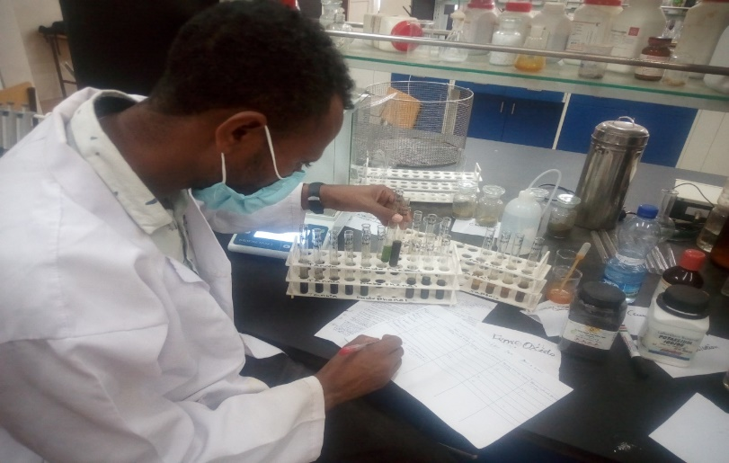

Fig. 1. Screening the major Phytochemicals

Table 1. Extract yield of Cucumis focifolius and Phytolacca dodecandra extracted with different solvents

Plant name | Parts used | solvent | Weight of extract obtained | Yield percentage %
Cucumis focifolius | Root | Ethanol | 3.37g | 16.85%
Cucumis focifolius | Root | Methanol | 2.02g | 10.1%
Cucumis focifolius | Root | chloroform | 2.65g | 13.25%
Cucumis focifolius | Root | Distilled water | 2g | 10%
Phytolacca dodecandra | leaves | Ethanol | 4.52g | 22.6%
Phytolacca dodecandra | leaves | Methanol | 2.31g | 11.55%
Phytolacca dodecandra | leaves | chloroform | 3.37g | 16.85%
Phytolacca dodecandra | leaves | Distilled water | 5.79g | 28.95%

Table 2. Qualitative screening of the major Secondary Metabolites

Phytochemicals | Plant Extracts  Cucumis focifolius |  |  |  |  |  |  |  | Plant Extracts  Phytolacca dodecandra
Phytochemicals | Ethanol Root | Methanol Root | Chloroform Root | Aqueous Root | Ethanol leaf | Methanol leaf | Chloroform leaf | Aqueous leaf | Ethanol Root | Methanol Root | Chloroform Root | Aqueous Root | Ethanol leaf | Methanol leaf | Chloroform leaf | Aqueous leaf
Tannin | + | + | - | - | + | + | + | - | + | + | + | - | + | - | - | -
Saponin | + | + | + | - | + | + | + | - | + | + | + | - | + | + | - | +
Flavonoid | + | + | + | - | + | + | + | - | + | + | + | - | + | + | - | +
Free Sugar | + | + |  | - | + | + | + | - | + | + | - | - | + | - | + | +
Alkaloids | + | + | + | - | + | + | + | - | + | + | + | - | + | - | - | -
Key: - (+) indicates presence whereas (-) indicates absence

Table 3. The mean inhibition zone (mean ±SD (mm) of the roots of C. focifolius against the standard pathogenic bacteria

 | Inhibition zone (mm)
Test organisms | ethanol | methanol | chloroform | DMSO negative control | Distilled water extract | clarithromycin | Cefepime
S. aureus | 11±2.14 | 10.5±2.6 | 8.5±1.35 | - | - | 10.3±2.08 | Not used
K. pneumonia | 6±2.64 | 4.5±2.5 | 3.5±2.4 | - | - | - | Not used
N. gonorrhea | 16.6±3.05 | 15±2.64 | 13.3±1.52 | - | 14±1.05 | Not used | -
Key: - All results shown are the triplicates of mean ± Standard deviation.

Table 4. The mean inhibition zone (mean ±SD (mm)) of the leaves of Phytolacca dodecandra against the standard pathogenic bacterial

 | Inhibition zone of the extracts (mm)
Test organisms | Ethanol | Methanol | Chloroform | DMSO negative control | Distilled water extract | Clarithromycin | Cefepime
S. aureus | 7.5±2.64 | 6±2.26 | 4.7±1.14 | - | - | 12.6±2.51 | Not used
K. pneumonia | 4±2.64 | 3.8±1.34 | 3±2.1 | - | - | - | Not used
N. gonorrhea | 8.6±1.52 | 9.6±2.08 | 8.6±2.88 | - | 8.6±1.15 | Not used | -
Key: All results shown are the triplicates of mean ± Standard deviation.

4.2 Antibacterial Activity of Cucumis focifolius and Phytolacca dodecandra Extracts

In this investigation, the antimicrobial activity of the distilled water, chloroform, ethanol and methanol extracts of the roots of C. focifolius and leaves extracts of phytolacca dodecandra were evaluated using agar well diffusion method. Tables 3 and 4 shows the antibacterial activity of the different extracts of the two medicinal plants against three pathogenic bacteria species. The extracts of these two plant species showed varying degree of inhibitory activity against S. aureus, K. pneumonia and N. gonorrhea at concentration of 50mg/ml.

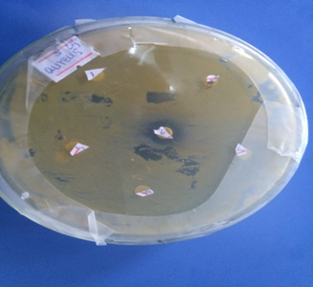

Fig. 2. The activity of root of C. focifolius plant extract on S. aureus

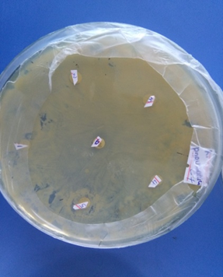
Fig. 3. The activity of root of C. focifolius plant extract on K. pneumonia

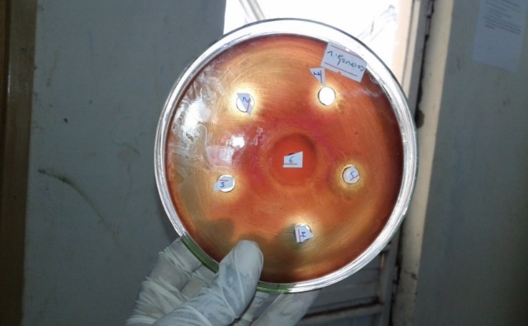

Fig. 4. The activity of root of C. focifolius plant extract on N. gonorrhea
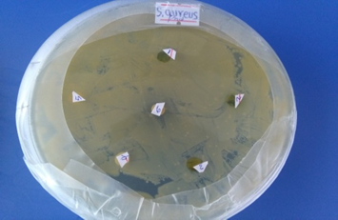

Fig. 5. Antibacterial activity leaves of Phytolacca dodecandra on S. aureus

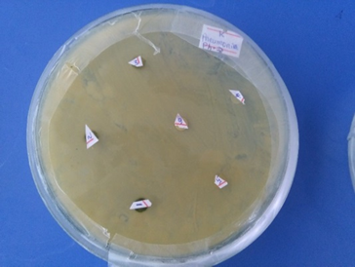

Fig. 6. Antibacterial activity leaves of P. dodecandra on K. pneumonia

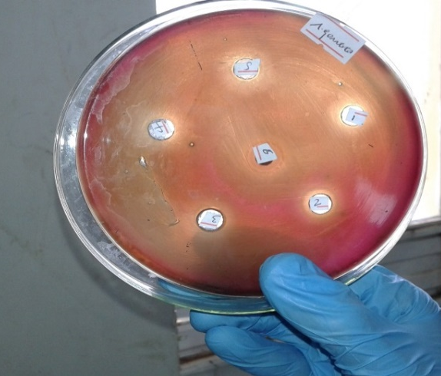

Fig. 7. Antibacterial activity leaves of phytolacca dodecandra on N. gonorrhea

4.3 Minimum Inhibitory Concentration (MIC)

The minimum inhibitory concentrations of each extracts against the selected bacteria varied with bacterial species and type of the extract (Table 5). As indicated in the table, the highest MICs of the root extracts of both plants were observed. In aqueous P. dodecandra on K. pneumonia with MIC values of 10 and 5.0 respectively while the lowest MIC was recorded for Ethanol C. focifolius root against N. gonorrhea and S. aureus with MIC values of 0.625 and 1.25 respectively. The leaf extracts of each plant showed also different MIC against the test bacteria. Generally, the broth dilution assay showed that in both plants leaf extracts had more antibacterial activities against all test bacteria. Therefore, the smallest MIC value indicates as the extract was efficient to inhibit the growth of the test pathogen in minimum dosage.

The lowest MIC values of leaf extracts of both extracts of the two plants were observed against S. aureus. The results obtained in the broth dilution method were consistent with the results obtained from the well diffusion method in this study.
Table 5. Minimum Inhibitory Concentration (MIC)

Antibacterial agent | In-vitro groups
Antibacterial agent | K. pneumonia | N. gonorrhea | S. aureus
Antibacterial agent | mg/mL
Methanol  C. focifolius root | 2.5 | 1.25 | 2.5
Ethanol C. focifolius root | 1.25 | 0.625 | 1.25
Chloroform C. focifolius root | 5 | 2.5 | 5
Aqueous C. focifolius root | 5 | 5 | 10
Methanol C. focifolius leaf | 5 | 1.25 | 5
Ethanol C. focifolius leaf | 2.5 | 0.625 | 1.25
Chloroform C. focifolius leaf | 10 | 5 | 5
Aqueous C. focifolius leaf | 10 | 5 | 10
Methanol P. dodecandra root | 5 | 2.5 | 5
Ethanol P. dodecandra root | 10 | 2.5 | 2.5
Chloroform P. dodecandra root | 5 | 5 | 10
Aqueous P. dodecandra root | 10 | 5 | 10
Methanol P. dodecandra leaf | 5 | 1.25 | 2.5
Ethanol P. dodecandra leaf | 5.0 | 0.625 | 1.25
Chloroform P. dodecandra leaf | 10 | 5 | 5
Aqueous P. dodecandra leaf | 5 | 10 | 10

5. DISCUSSION

In this investigation, four different extracts of Cucumis focifolius and Phytolacca dodecandra yield percentage was calculated. The highest yield was (16.85%) for Ethanol extract followed by chloroform extract (13.25%), while the methanol and distilled water extracts were (10.1%) and (10%), respectively for Cucumis focifolius. The yield percentage for Phytolacca dodecandra was also as follows; 22.6%, 12.55%, 16.85%, 28.95% for ethanol, methanol, chloroform and distilled water respectively. In this result highest yield was obtained by distilled water and ethanol, while methanol and chloroform extract was the lowest yield value as compared with each other solvent. In contrary to this study, phytochemical analysis of leaves extract of Eucalyptus Camaldulensis, chloroform gave the least yield compared to water and ethanol (Mohamed et al., (2015). This may due to the presence of different phytochemical compound in different plant species.

The plant extracts and standard antibiotics showed varied significant activities in all the test strains. Both Cucumis focifolius and Phytolacca dodecandra shows no inhibition zone on S. auerus and k. pneumonia strains. The positive control clarithromycin shows 10.3±2.08mm zone of inhibition on S. auerus while K. pneumonia did not. Similarly (Tegenu, 2011) reported S. typhi shows no inhibition zone by C. focifolius and Z. scabrausing in all solvents used in our study. This might be because of the highly antibiotic resistance of those strains, strain evolution, and the plant spectrum might be narrow.

In this study, there is highly statistical significant antibacterial effect against N. gonorrhea (16.6±3.05) for ethanol root extract of Cucumis focifolius followed by methanol root extract with an inhibition zone of (15±2.64). The extract also shows (13.3±1.25mm, 14±1.05mm by chloroform and distilled water root extract respectively. No inhibition zone was observed for negative control (DMSO). The highest inhibition zone was observed for ethanol and the least inhibition zone was for chloroform by Cucumis focifolius root extract. For the second plant Phytolacca dodecandra, methanol shows highest zone of inhibition (9.6±2.08) mm and all the rest ethanol, chloroform and distilled water shows (8.6±1.52) mm, (8.6±2.88) mm (8.6±1.15) mm zone of inhibition on N .gonorrhea respectively. Both negative control (DMSO) and positive standard antibiotic (Cefepime) did not show any antibacterial activity. In line with this study more antibacterial activity against Staphylococcus aureus (20.10±0.17mm) and Candida abacas (4.20±0.40 mm) for ethanol and methanol extract of W. somnifera respectively were observed (Amit et al., 2015).

6. CONCLUSION

The result of this study shows that the plants have different phytochemical compounds which are polar and non-polar. Thus, the root of Cucumis focifolius and leaf of Phytolacca dodecandra extracts have a great potential of antibacterial activity against Neisseria Gonorrhea strain with the extract of ethanol, methanol, chloroform and water. As per the investigation of this study, the staphylococcus Aureus and klebsiella pneumonia are resistant bacteria against root of Cucumis focifolius and leaf of Phytolacca dodecandra with all ethanol, methanol, chloroform and water extracts and even resistant to the standard antibiotic clarithromycin except S. aeurus.

7. RECOMMENDATION

The following recommendations were forwarded;

- Further phytochemical screening, purification and elucidation of the active compounds in order to provide novel compounds for the synthesis of new antimicrobial drugs.
- Antimicrobial activities against other bacteria to be conducted in order to identify the spectrum activity of the plant extracts.
- Toxicity and mechanism of action of the plant extracts should be investigated.

COMPETING INTERESTS

Authors have declared that no competing interests exist.

REFERENCES

- Ndip RN, Ajonglefac AN, Mbullah SM, Tani NF, Akoachere JFK, Ndip LM, Luma H N, Wirmum C, Ngwa F, Efange SMN. In vitro anti-Helicobacter pylori activity of Lycopodium cernuum. Afr. J. Biotechnol. 2008;7:3989-3994
- Shahidi BGH, Fooladi MH, Mahadevi MJ, Shahghas A. Broad-spectrum, a novel antibacterial from Streptomyces species, Biotechno. 2004;3:126-130.
- WHO. Traditional medicine: Growing needs and potential, WHO Policy perspectives on medicines, World Health Organization, Geneva. 2002;1.
- Berhanu A. Ethiopian Traditional Medicine: Common Medicinal Plants. J. Black Studies. 2002;32:610-612.
- Edeoga HO, Okwu DE, Mbaebi BO. Phytochemical constituents of some Nigerian medicinal plants. Afri. J. Biotechno. 2005;4(7):685- 688.
- Das K, Tiwari RKS, Shrivastava DK. Techniques for the evaluation of medicinal plants products as antimicrobial agents: Current methods and future trend. J. Medicinal Plant Res. 2009;492:104-111.
- Eloff JN. Which extractant should be used for the screening and isolation ofantimicrobial components from plants? J. Ethnopharmacology. 1998;1:1-8.
- Eloff JN, Famakin JO, Katerere DRP. Isolation of antibacterial stilbene from
Combretum woodii (Combretaceae) leaves. Afr. J. Biotechno. 2005;4 (10): 1167-1171.
- Masoko PJ Eloff JN. Antifungal activities of six South African Terminalia species (Combretaceae). J. Ethnopharmacology of Botany. 2005;99:301-308.
- Ndip RN, Ajonglefac AN, Wirna T, Luma HN, Wirmum C, Efange SMN. In vitro antimicrobial activity of Ageratum conyzoideson clinical isolates of Helicobacter pylori. Afr. J. Pharmacy and Pharmacology. 2009;3(11):585-592.
- Ademola IO, Eloff JN. In vitro anthelmintic activity of Combretummolle (R. Br. ex G. Don) (Combretaceae) against Haemonchuscontortusova and larvae. Veterinary Records. 2010;158:485–486.
- Chantana K, Ruchanok Ch, Rinrada P. Screening of medicinal plants from kohkret, nonthaburi for antibacterial activity. 2005;1-5.
- Cowan MM. Plants products as antimicrobial Agents. Clinical Microbiology Reviews. 1999;12: 564-582.
- Lee KH, Hui KP, Tan WC, Lim TK. Klebsiella bacteraemia: A report of 101 cases from National University Hospital, Singapore. J HospInfect. 1994;27:299- 305.
- NLSI (National Laboratory Standard Institute NLSI; 1990,2012.
- Ndip RN, Dilonga HM, Ndip LM, Akoachere JFK, Nkuo TA. Pseudomonas aeruginosa isolates recovered from clinical and environment samples in Buea, Cameroon: current status on biotyping and antibiogram. Tropical Medicine and Inter. Health. 2005;10:74-81.
- Shahwar D, Raza MA. In vitro antibacterial activity of extracts of Mimusops elengi against gram positive and gram negative bacteria. African J. Microb. Res. 2009;3(8):458-462
- WHO. Drug resistance in malaria. The Magazine of WHO M. 2001;4:1-24.
- WHO. Antimicrobial resistance: global report on surveillance; 2014.
- WHO. A publication of united against malaria. The Magazine of WHO M. 2000;3: 547.
- Biswas K, Chattopadhyay I, Banerjee RK, Bandyopadhyay U. Biological activities and medicinal properties of neem (Azadirachta indica). Current Science-Bangalore. 2002; 82(11):1336-1345.
- Ajayi IA, Ajibade O, Oderinde RA. Preliminary phytochemical analysis of someplant seeds. Research Journal of Chemical Scinces. 2011;1(3):58-62.
- Adachukwu IP, Ogbonna AO, Eze FU. Phytochemicals analysis of paw-paw (Carica papaya L.) leaves. International Journal of Life Sciences Biotechnology and Pharma Research. 2013;2(3):348-351.
- Jaradat N, Hussen F, Al Ali A.. Preliminary Phytochemical Screening, Quantitative Estimation of Total Flavonoids, Total Phenols and Antioxidant Activity of Ephedra alata Decne. Journal of Mater Environmental Science. 2015;6(6): 1771-8.
- Boyanova L, Gergova G, Nikolov R, Derejian S, Lazarova E, Katsarov N, Mitov I, Krastev Z. Activity of Bulgarian propolis against 94 Helicobacter pylori strains In vitro by agar-well diffusion, agar dilution and disc diffusion methods. J. Medical Microbiol. 2005;54: 481-483.
- NCCLS. Methods for dilution antimicrobial susceptibility tests for bacteria that grow aerobically: Approved Standard- Fifth Edition. NCCLS document M7-A5: NCCLS: Wayne, PA, USA; 2000.

