Study on Identification and Extraction of Adulterants from Herbal Medicines

ABSTRACT
In modern time, usage of herbal medicines has increased all over the world. Herbal medicines are use for treatment of primary health needs and conventional treatment too. Due to increased demand of these medicines, maniac people have started production of adulterants/ inappropriate chemical properties/ low grade drugs in products. In this concern, examination including, chemical tests, analytical tests, phytochemicals screening tests are performed to determine the purity of products, quantitative analysis of heavy metals, presence of drug. This chapter is mainly focused on the implementation of various analytical techniques i.e. HP-TLC, FTIR etc. for identification of derivatization of adulterants from herbal drugs. Extracted adulterants from these herbal medicines include, guanine, flavonoids, alcohol ferric chloride etc. were attained.
Keywords: Adulterants, extraction, recognition, herbal medicine etc.
INTRODUCTION

In recent years, demand of herbal medicines has increased throughout the world. Herbal medicines are active ingredients of plants attained from various parts including roots, leaves, stem flowers, seeds and fruits. Production of synthesized medicines brought a revolution to traditional medicines for medical care. As per WHO, approx. 90% Indians are using herbal medicines for their primary health care needs and 80% of the country’s population is leaning towards conventional treatment. Many of these medicines focuses on their organic components i.e., essential oils, glycosides, alkaloids, vitamins, antioxidant chemicals, and their pharmacological efficacy and any potential toxicities. In order to increase efficiency, any product with similar therapeutic/ chemical properties, low grade drugs are added in products¹. To recognize adulterants, present in medicines various analytical and chemical methods are used. Chemical test is performed in evaluation of resins, acid, value of volatile oil to tests acid value and saponification value. Phytochemical screening is a qualitative method for the identification of chemical constituents present in the drug. While analytical methods such as TLC, HPLC, GC etc. are used to determine purity of products, quantity of heavy metals and presence of contaminants. This chapter is basically a discussion on adulterations in herbal medicines-, types of adulterants and various methods used to quantify the adulteration².
- SARPAGANDHA
Sarpagandha as potential value in ayurveda and widely known remedy to control high blood pressure, to cure fever, wound and worm infection, to detoxify snakes, scorpions and spider poison. It has astringent properties; also used as a sedative and tranquillizer agent. It consists ophioxylin, resin, starch and wax and the total alkaloid content in plant is 0.8%.
MACROSCOPIC CHARACTERISTICS
It is an evergreen perennial shrub that usually grows up-to to a height of 60cm and found in moist deciduous forest/shady areas. Its root is of pale color and leaves are found bright green and whorls of three leaves. Its flower is of white, while peduncles are long, pedicles are stout with red calyx³. The active ingredients present in sarpagandha are alkaline resprine which help to cure insomnia, hypertension etc. It is prepared from the sarpagandha plant which consist various therapeutic properties.
Sarpagandha chemical constitution: Ajmalicidine, Ajmalicine, Rouhimbine, Indobinine, Reserpiline, Reserpine, Sarpagine, Serpentine, Serpentinine, Yohimbine, Ajmalimine, Ajmaline, Rauwolfinine (Perakenine), Sandwicolidine, Serpinine etc.
Various standardization technique is followed to extract these additional elements present in herbal medicines such as HP-TLC, GC-MS, FTIR and HP-LC. This study is an approach for quantitative and qualitative analysis of the chemically active components in herbal medicines.
METHODOLOGY
Qualitative analysis was determined by HP-TLC and certain parameters was affixed to assess.
Determination of the total ash; 1 gm. of test medicine is taken in a crucible at 450⁰ C in a muffle furnace and cooled. This sample was weighed and total percentage of ash was calculated.
Determination of alcohol soluble extracts; Powdered medicine was mixed with 100 ml of alcohol in a closed flask for 24 hours and left for more 18 hours than filtered. 25ml of each filtrate was evaporated and dried in a porcelain dish at 105⁰ C to constant weight and the alcohol soluble extracts are calculated⁴.
Determination of water-soluble extractives: The powder test drugs were macerated with 100 ml of water in a close flask for 1 hour. Then, it was boiled gently for another hour in a water bath, cooled and weighed and weight was re-adjusted. 25 ml of each filtrate was evaporated to dryness in a porcelain dish at 105⁰ C to constant weight. The percentage of water-soluble extractive was calculated.
Extraction of alkaloids; “1 gm. of each test powdered drug and 0.1g of Sarpagandha root powder were collected. Each material was refluxed with 10 ml methanol containing 0.1M HCl in a water bath for an hour. Then the sample solution was cooled, filtered and liquid-liquid separation was performed using n-hexane. The residual matter after hexane extraction was concentrated in reduced pressure and the residue was then dissolved in methanol-chloroform (98:2, v/v) in a 10 ml volumetric flask. Each sample solution was filtered through 0.22μm filter force using HTLC analysis”⁵.
Loss of drying: 2 gm. of powdered drug was accurately weighed and was taken in porcelain dish, the taken porcelain dish was kept in an open vacuum oven and the sample maintained at a temperature of 100⁰ C followed by room temperature this procedure is repeated until constant weight is observed.
% Loss on drying = Loss in weight of sample/weight of sample× 100
Phytochemical analysis: The phytochemical screening of prepared samples was carried out to test the presence of tannins, saponins, flavonoids, carbohydrates, phenol, and steroids.
Table 1; Description of test drug formulations
TEST DRUG/ FORMULATIONS | INGREDIENTS | QUANTITY (%)
Sarpagandha Churna | Sarpagandha root powder | 100
Sarpagandha Ghana vati | Sarpagandha ghansatwa | 50
 | Khursaniajawain ghansatwa | 10
 | Jatamansi ghansatwa | 5
 | Bijay ghansatwa | 5
 | Pippalimool churna | 25
 | Excepients | 5
M-Sarpagandha Mishran | Sarpagandha root churna | 15.6
 | Jatamansi root churna | 15.6
 | Vacha leaf churna | 15.6
 | Punarnava whole plant | 15.6
 | Churna
 | Brahmi whole plant churna | 15.6

HP-TLC ANALYSIS
HP-TLC profile is a major quality control aspect to reveal phytochemical components of the formulations and efficacy. In this method, peak profiles and their intensities provide both quantitative and qualitative result in comparison with reference standards while the images will give percentage of purity and minimum content information can also be obtained. HP-TLC analysis of the sarpagandha medicine shown that, sarpagandha churna exhibits 11 peaks while sarpagandha Ghana vati has 17 peaks that indicate fingerprint of test drugs⁶. The individual peaks in chromatograms usually depend on chemically distinct components and concentration of these chemically active components are not only responsible for its therapeutic properties but also different symptomatic and non-symptomatic side effects.
TABLE 2: Comparison of Chromatographic Techniques
PARAMETERS | HPLC | HP-TLC | GC
Stationery -Phase | Column | Paper/Glass | Liquid /Solid
Mobile Phase | Solvent Mixture | Solvent Mixture | Pure Inert Gas
Sample | One At One Run | Many at a Single rrun | One At One Run
Pressure | High | Normal | Closed
Results | System Peaks | System Peaks Visual By Bands | System Peaks
Resolution | High To Very High | Moderate To High | High To Very High
Time | 2-60 Min | 1-30min | 2-60 Min
Temperature | Constant | Constant | Increasing

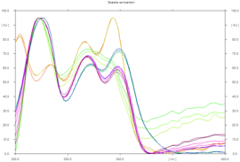
Fig 1: HPTLC spectra of standards

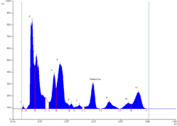
Fig 2: HPTLC of Sarpagandha churna

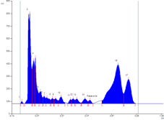
Fig 3: HPTLC of Sarpagandha Ghana Vati

The individual peaks in fingerprint chromatogram are usually depends on chemically distinct components. The concentration of this chemically active components is not only responsible for its toreutic properties but also various symptomatic and non-symptomatic side effects.
- SHANKHPUSHPI CHURNA
Shankhpushpi (Convolvulus pluricaulis) is an herb that has extensively been a topic of investigation for its therapeutic and pharmacological effects. Shankhpushpi is considered as Medhya Rasayana in Ayurvedic texts and plant extraction are used for central nervous system depressants, anxiolytics, sedatives, antidepressants, antistress agents, neurodegenerative agents, antianemics, antioxidants, lipid-lowering agents, immunomodulators, analgesics, it has demonstrated scientific potential in antifungal, antibacterial, antidiabetic, antiulcer, antitonic, and cardiovascular activities. It is extremely beneficial for increasing memory, concentration, and learning capacities, along with treating mental stress, insomnia, anxiety, and depression. Among these phytoconstituents, some are present in higher concentrations (nearly 20% w/w). known as phytoconstituents⁷. This plant contains kaempferol, β-sitosterol, N-hexacosanol, taraxerol, taraxerone, delphinidin and hydroxy-cinnamic acid. In addition, an alkaloid, i.e. Sankhpuspine, has also been isolated from this plant helps as a chemical marker for species. CP also contains other alkaloids (convolamine, convosine, convoline etc.) anthroquinones; carbohydrates (D-glucose, sucrose); coumarin (ayapanin, scopolyne); flavonoids, glycosides (geranilan-3-ol-1-carboxylate-1-O-β-D- xylopyranosyl- (2 ′ → 1 ′) - O-β-D-xylopyranoside; phenols; steroids; and terpenoids. CP is also known for its rich source of vitamins and minerals like phosphorus, manganese, calcium, copper, iron, zinc, sulphur, vitamin C and vitamin E.
MACROSCOPIC CHARACTERISTICS
These plants are grown in rocky soil along/found on road side in north India. Its identical characteristics include cylindrical, ribbed and light-yellow color root with a hairy texture⁸. Stem are prostate/ascending slender and the leaves are ex-stipulate, sessile, simple, linear to oblong in shape, alternate phyllotaxy, reticulate venation. In florescence, 1-3 flowers in axillary heads along with ebracteate, monoecious flowers are observed.
Table 3; PHYTOCHEMICAL SCREENING OF ALKALOIDS
TEST | EXPERIMENT | OBSERVATION
DRAGENDROFF’S TEST | A few mg of the HACP extract dissolved in alcohol + Few  drops of acetic acid + Dragendroff’s reagent | Orange red precipitation
WAGNER’S TEST | Few mg of HACP extract dissolved in acetic acid +few drops of Wagners’s reagent | Reddish brown precipitate.
MAYER’S TEST | Few mg of HACP extract dissolved in acetic acid + Mayer’s reagent | Dull white precipitate
HAGER’S TEST | Few mg of extract dissolved in acetic acid + 3ml of Hager’s reagent | Yellow precipitate

Table 4 CARBOHYDRATES
TEST | EXPERIMENT | OBSERVATION
MOLISCH’S TEST | In a test tube, HACP  extract is taken + 1ml α- naphthol solution + conc.  Sulfuric acid (along the sides of tube) | Violet colour formed at the junction of 2 liquids
FEHLING’S TEST | Few mg of HACP + equal amount of Fehling’s  solutions A and B. Warm the mixture in a water bath. | Brick red precipitate.
BENEDICT’S TEST | Few mg of HACP extract + 5ml of Benedict's reagent. Boil for 2 mins and cool. | Red precipitate

Table 5: STEROIDS
TEST | EXPERIMENT | OBSERVATION
LIEBERMANN | Few mg of HACP extract | Bluish green color solution
BURCHARD TEST | dissolved in chloroform + 1ml of acetic acid + 1ml of acetic anhydride. Heat on a water bath and cool.  Add a few drops of conc. Sulphuric acid along the sides.
SALKOWSKI’S TEST | Few mg of HACP extract dissolved in chloroform + equal volume of conc.  Sulfuric acid | Bluish red to cherry red  colour in chloroform layer and green fluorescence in layer
Table 6: SAPONINS
EXPERIMENT | OBSERVATION
0.5ml of extract + 5- 10 drops of dilute HCl and ZnCl. Boil the solution for a few minutes | Reddish pink or dirty brown color solution
Table 7: TANNINS
EXPERIMENT |  | OBSERVATION
Extract + drop f dil. ferric chloride solution |  | Dark blue color
Table 8.1f FLAVONOIDS
TEST | EXPERIMENT | OBSERVATION
SHINODA’S TEST | 0.5ml of extract + 5-10 drops of dilute HCl and  ZnCl. Boil the mixture for a few minutes | Reddish pink or dirty brown color
Table 9.1g PHENOL
EXPERIMENT | OBSERVATION
HACP extract in alcohol + 2 drops of alcoholic ferric chloride | Blue to black color solution

Table 10; CARBOXYLIC ACID
EXPERIMENT | OBSERVATION
HACP extract dissolved in water and treat with sodium bicarbonate | Brisk effervescence
Table 11: QUININE
EXPERIMENT | OBSERVATION
Few mg of HACP extract + 0.5% NaOH | Deep coloration like pink/purple/ red.

HP-TLC
“ During this process, 1gm. of powdered sample was diluted in 10mL of ethanol and was kept for cold percolation for 24 hours before filtration. By using a Lino mat 5 TLC applicator, 4, 8, and 12 µL of the sample were applied to a precoated silica gel F254 on aluminum plates to a bandwidth of 7 mm”^{9,10}. “Plate was developed in n-butanol: acetic acid: water (4:1:1) developed plates were scanned under short ultraviolet/ long ultraviolet. It was then derivatized using vanillin sulfuric acid reagent and scanned under 254, 366 nm and white light at 620 nm. The densitometric scan, retention factor (Rf), and color of the spots were noted”. [14]
FOURIER-TRANSFORM INFRARED SPECTROSCOPY
Plant leaves were taken from the herb, properly washed before being dried in the shade and powdered.
The powdered leaves were macerated in a shaker for two days with 70% ethanol. The extract was filtered and concentrated with a flash evaporator before being lyophilized to remove the water.
Table 12; Preliminary Phytochemical Tests
TEST | SHANKAPUSHPI
ALKALOID | +
CARBOHYDRATE | +
TANNIN | +
TERPENOID | +
PHENOL | +
Table 13; Confirmation of additives in extraction.

SI. NO | TEST | COLOUR IF POSITIVE | SHANKAPUSHPI
1 | ALKALOID
 | DRAGENDROF’S TEST | Orange precipitate | Orange precipitate
 | WAGNER’S TEST | Red precipitate | Red precipitate
 | MAYER’S TEST | Dull white precipitate | Dull white precipitate
 | HAGER’S TEST | Yellow precipitate
2 | STEROIDS
 | LIEBERMANN BURCHARD TEST | Bluish red | Light red color
 | SALKOWSKI’S TEST | Bluish red to cherry red | Cherry red color in chloroform and colorless in the acid form.
3 | CARBOHYDRATE
 | MOLISH’S TEST | Violet ring | Violet ring
 | FEHLING’S TEST | brick red precipitate | ink blue solution
 | BENEDICT’S TEST | red precipitate | bluish green solution
4 | TANNIN
 | WITH FeCl₃ | dark blue or green or brown |  | Brown
5 | FLAVONOIDS
 | SHINODA’S TEST | red to pink |  | colourless solution
6 | SAPONINS
 | with nahco₃ | stable forth |  | no forth
7 | TRITERPENOIDS
 | tin and thionyl chloride test | red |  | light pink
8 | COUMARINS
 | with 2N NaOH | yellow |  | light brown
9 | PHENOLS
 | With | blue to black, brown |  | Brown
10 | CARBOXYLIC ACID
 | With water and NaHCO₃ | Brisk effervescence |  | No effervescence
11 | RESIN
 | With aqueous acetone | Turbidity |  | No turbidity
12 | QUINONE
 | 5% NaOH | Pink/ purple/ red |  | Light brown
13 | AMINO ACIDS
 | Ninhydrin reagent | Purple color |  | Colorless

Table 14; Result For HPTLC
SHORT UV | LONG UV | AFTER DERIVATIZATION
- | 0.06 (VIOLET) | 0.06 (L PURPLE)
- | 0.11 (FL VIOLET) | 0.11 (L PURPLE)
- | 0.20 (FL BLUE) | 0.20 (L PURPLE)
0.26 (D GREEN) | 0.26 (FL GREEN) | -
- | - | 0.29 (L PURPLE)
0.33 (L GREEN) | 0.33 (VIOLET) | -
0.38 (L GREEN) | 0.38 (FL BLUE) | -
- | - | 0.40 (L PURPLE)
0.46 (D GREEN) | 0.46 (FL PINK) | -
 |  | 0.48 (L PURPLE)
0.51 (L GREEN) | 0.51 (L FL BLUE) | -
- | - | 0.54 (L PURPLE)
- | 0.60 (FL BLUE) | 0.60 (L PURPLE)
0.64 (D GREEN) | - | -
0.69 (D GREEN) | 0.69 (FL BLUE) | -
- | 0.72 (F ORANGE) | -
- | 0.74 (VIOLET) | -
- | 0.78 (FD PINK) | -
0.82 (D GREEN) | 0.82(FL BLUE) | 0.82 (L PURPLE)
- | 0.86 (FD PINK) | 0.86 (D PURPLE)
- | 0.91 (F RED) | 0.91 (D PURPLE)

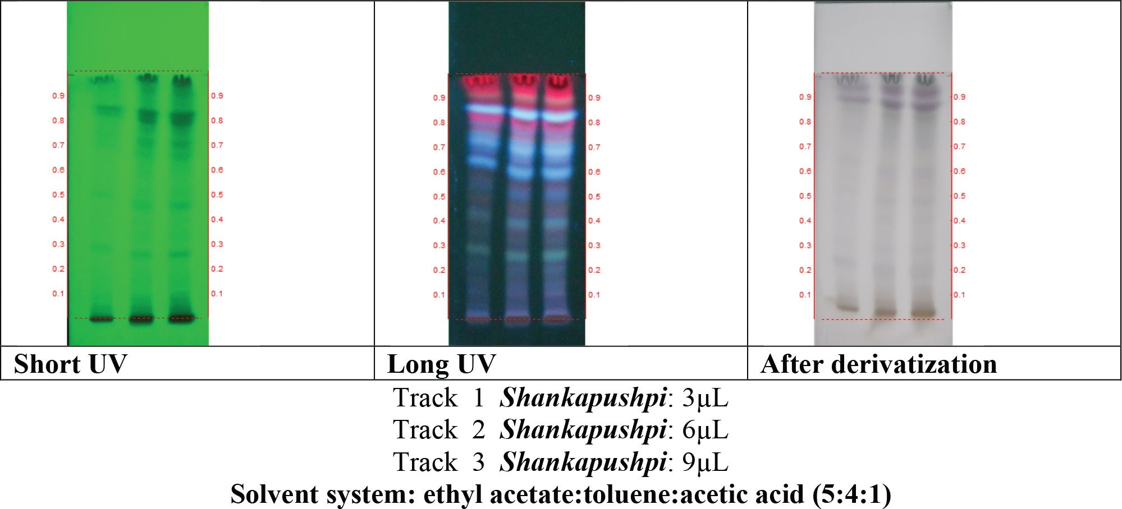
Fig; 4; PTLC PHOTO DOCUMENTATION OF ETHANOLIC EXTRACT OF SHANKHPUSHPI.
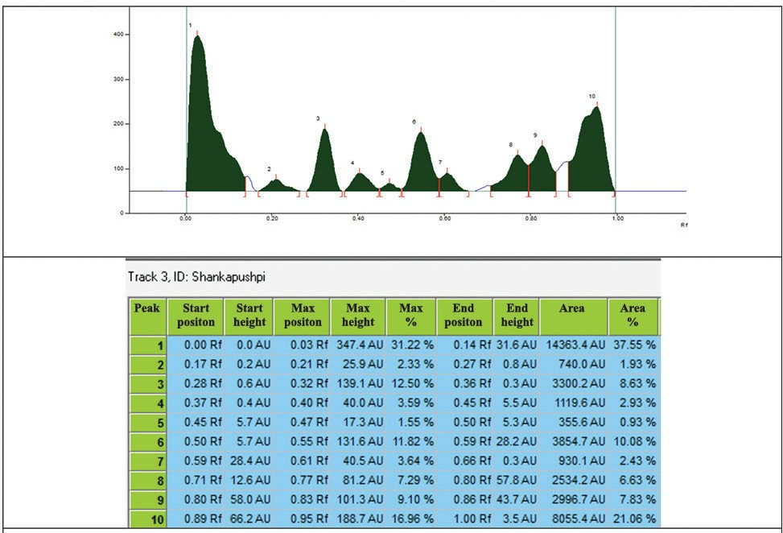
Fig 5; DENSITOMETRIC SCAN AT 254 nm.

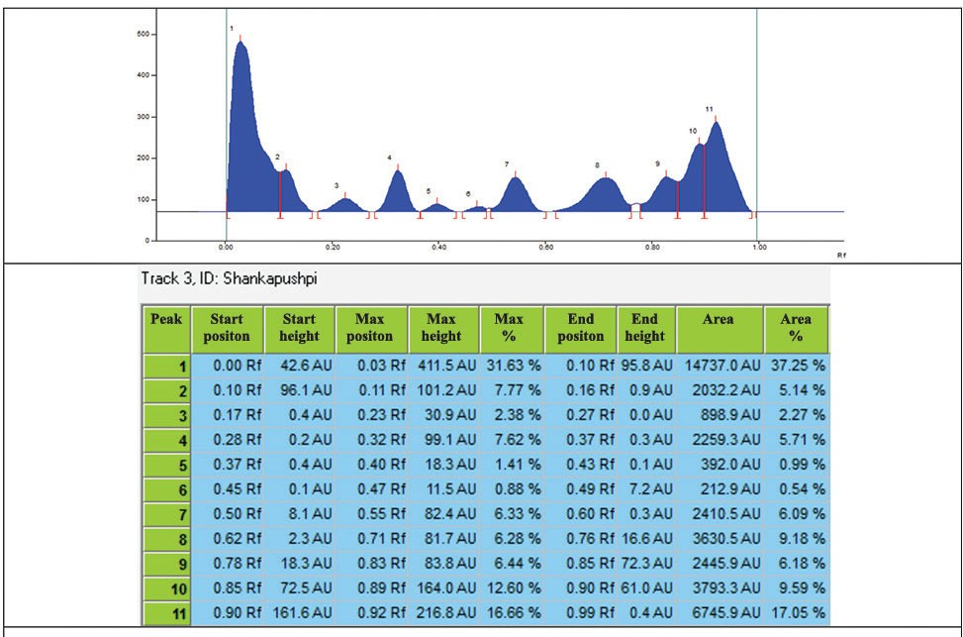
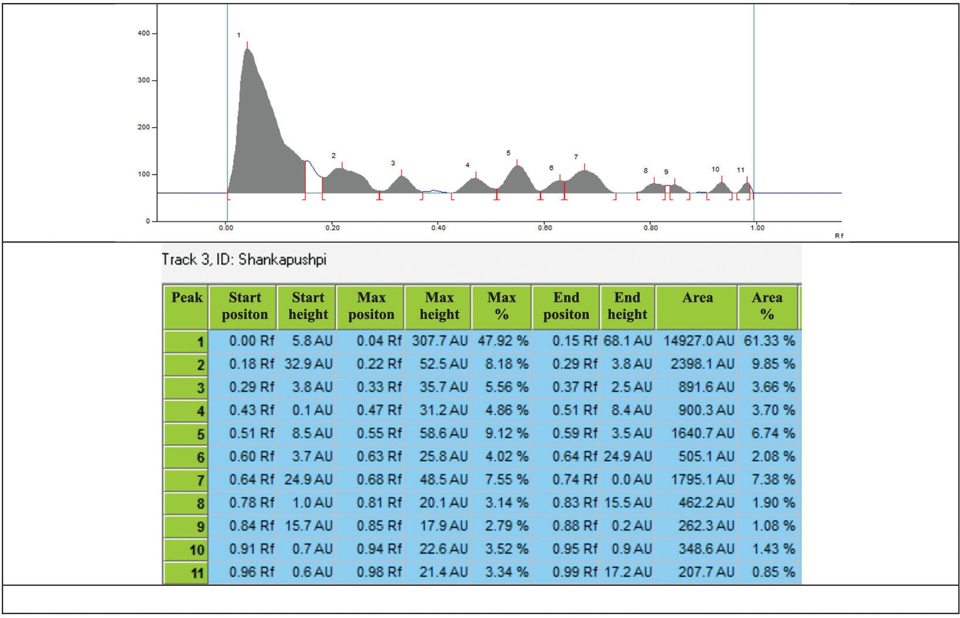
Fig 6; DENSITOMETRIC SCAN AT 366 nm.
Fig 7; DENSITOMETRIC SCAN AFTER DERIVATIZATION AT 620 nm.
RESULT FOR FTIR
“Based on the peak’s values in the IR radiation region, the functional groups of active compounds of C. pluricaulis were studied using FTIR. The plant extract was passed into the FTIR, the functional groups of the compounds were separated based on its peak’s ratio”^{11,12}. The absorption range for the FTIR spectra was between 4000 and 500 cm⁻¹. The results revealed the presence of alcohols, carboxylic acids, acid anhydrides, alkanes, phenols, alkynes, alkyl halides, aromatics, halogens, esters.
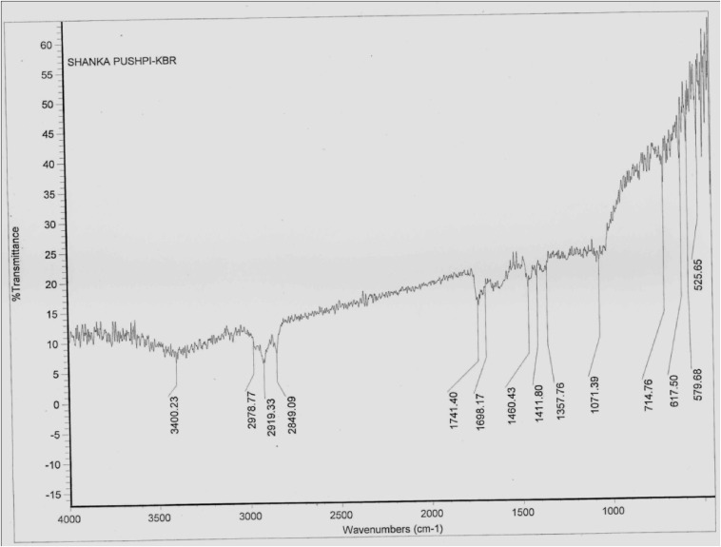

FIG 8; FTIR SPECTRUM OF CONVOLVULUS PLURICAULIS 70% ETHANOLIC EXTRACT.

CONCLUSION
In order to increase efficiency, any product with similar therapeutic/ chemical properties, low grade drugs are usually added in products. Phytochemical screening (qualitative method) along with analytical methods i.e. TLC, HP-TLC, GC etc. are used to determine purity of products, quantity of heavy metals and presence of contaminants. HP-TLC analysis of the sarpagandha medicine shown that, sarpagandha churna exhibits 11 peaks while sarpagandha Ghana vati has 17 peaks that indicate fingerprint of test drugs¹³. Chromatogram usually depends on distinct components and concentration of these chemically active components which are not only responsible for therapeutic properties but also different symptomatic/ non-symptomatic side effects. In Shankhpushpi Churna, vanillin sulfuric-acid reagent were scanned under 254, 366 nm and white light at 620 nm which revealed presence of alcohols, carboxylic acids, acid anhydrides, phenols, alkyl halides, aromatics, halogens, esters etc.
REFERENCES
- Chauhan, M. Sarpagandha Plant - Rauwolfia serpentina - Uses, Benefits & Side effects. Planet Ayurveda. Retrieved September 11, 2022.
- Balkrishna, A., Thakur, p., & Varshny, A. Phytochemical Profile, Pharmacological Attributes and Medicinal Properties of Convolvulus prostratus – A Cognitive Enhancer Herb for the Management of Neurodegenerative Etiologies. National library of medicine. 2022.
- Sethiya, N., Trivedi, A., Patel, M., & Mishra, S. Comparative pharmacogenetic investigation on four ethnobotanicals traditionally used as Shankhpushpi in India. Journal Of Advanced Pharmaceutical Technology &Amp; Research, 2010; 1(4); 388.
- Joshi, T., Gupta, A., Kumar, P., Singh, A., & Kumar, A. Bacopa monnieri (Brahmi). Naturally Occurring Chemicals Against Alzheimer's Disease.2021; 243-256.
- Zhou, Y., Shen, Y., Zhang, C., & Zhang, W. Chemical constituents of Bacopa monnieri. Chemistry Of Natural Compounds, 2007; 43(3), 355-357.
- M.D, S., & P.M, M. Standardization of Bacopa Monnieri and its Formulations with reference to Bacoside A, by High Performance Thin Layer Chromatography. Impactfactor.org. 2022,
- Garg, A., Kumar, A., Nair, A., & Reddy, A. Analysis of some Indian medicinal herbs by INAA. Journal Of Radioanalytical and Nuclear Chemistry, 2017; 271(3), 611-619.
- S S, P., M G, J., & T G, D. Study of Phytochemical Screening, Physicochemical Analysis and Antimicrobial Activity of Bacopa monnieri (L) Extract. 2022,
- Gubbannavar, J., Chandola, H., Harisha, C., Khanpara, K., & Shukla, V. A comparative pharmacognostical and preliminary physico-chemical analysis of stem and leaf of Bacopa monnieri (L.) Pennel and Bacopa floribunda (R.BR.) Wettst. AYU (An International Quarterly Journal of Research in Ayurveda), 2013; 34(1), 95- 102.
- Mathur, D., Goyal, K., Koul, V., & Anand, A. The Molecular Links of Re-Emerging Therapy: A Review of Evidence of Brahmi (Bacopa monniera). Frontiers in Pharmacology, 2016; 7(44).
- 16.S.S, P., & M.G, J. Determination and Quantification of Bacoside a From Bacopa monnieri (L) By High Performance Thin Layer Chromatography. 2022.
- Govil, J.N., Singh, V.K. and Singh, G. Recent progress in medicinal plants. Ethanomedicine & Pharmacog., 2022; 1: 37: 51.
- Nahata, N. Sethiya, N. Jain and V. Dixit, "Analysis of scopoletin and mangiferin in botanicals and formulations of Shankhpushpi by HPLC", Sciendo.com, 2019.
- Swamy G, Holla R, Rao SR. Evaluation of Hydroalcoholic Extract of Convolvulus pluriculis (Shankapushpi) for Standardization by Colorimetric Method: A Preliminary Report. Journal of Health and Allied Sciences NU. 2019 Jul;9(03):121-6.

