First Report of Spinitectus carolini Infection in Bullet Tuna (Auxis rochei) in Syrian Waters

ABSTRACT
Fish parasitology is a leading field in aquatic biology. It is of great importance in uncovering the effects of pollution on fish health and is receiving increasing attention in marine biology. The current research aimed to investigate the infection with internal and external parasites in the bullet tuna fish, Auxis rochei. Fish samples were collected from different fishing sites on the shore of Lattakia (Ras Al-Basit), during the period extending from September 15\9\2024, to February 24\2\2025. The total number of caught individuals was 12. The length, weight were determined, and then external and internal examinations were conducted for all caught individuals. The internal organs were examined to detect infection with internal parasites.
During current research, the species Spinitectus carolini, Holl, 1928, was the first record from the fish Auxis rochei in the marine water of Lattakia Governorate, Syria. The parasitic species Spinitectus carolini, belonging to the Class Nematoda, was isolated from the digestive system, specifically in the Stomach.
During current research, this parasitic species was isolated for the first time from the fish Auxis rochei in Syrian marine waters.

Keywords: Auxis rochei, Spinitectus carolini, Nematode, Marine water, Lattakia, Syria
1. Introduction:
Fish is a rich source of proteins and amino acids necessary for the growth and maintenance of body tissues, as well as their importance in the repair processes that occur in the human body. For decades, fishmeal was used as the main protein source in fish diets, due to its high protein content and balanced amino acid profile. Furthermore, its high palatability, high nutrient digestibility, and general absence of antinutritional factors have contributed to the definition of fishmeal as a golden standard. However, sustainability concerns at the environmental, social, and economic levels lead to increasing research towards fishmeal replacement strategies (Aragão et al., 2022; Zlaugotne et al., 2022). Fish meat is rich in minerals such as phosphorus (which helps the spine and teeth grow and maintains acid-base balance in the blood), calcium, and iodine. Fish oil is also a primary source of vitamins A and D and omega-3 fatty acids, which are essential fatty acids that are vital for healthy skin, heart, and bones (Hasan, 2011).
Fish parasitology is a leading field in aquatic biology. It is of great importance in uncovering the effects of pollution on fish health and is receiving increasing attention in marine biology.
Fish with parasitic infestations often have a slower development rate, lower productivity, impaired reproduction, weight loss, gill abnormalities, and other symptoms (Wangmo, K., & Dorji, 2025). Consequently, identifying the types of parasites that infect tuna species will expand knowledge in the field of aquatic biology (Noga, 2011; Rueckert et al., 2009).
Fish, like other organisms, are vulnerable to parasites and diseases, despite their high resistance to these diseases. The pathological effects of parasites that infect fish vary from depriving the host of its food or feeding on its tissues and body fluids, affecting its growth and disrupting its organ functions. Parasites are among the factors that negatively impact fish population growth, and increasing knowledge about the animal populations that parasitise fish is important for controlling them and reducing their harm. The spiny oleander is a fish found in warm and temperate waters throughout the world's oceans and seas, in surface waters down to depths of 50 meters, and is also found in the eastern Pacific Ocean (Collette, BB, and CR Aadland, 1996). Spiny oleander is caught using a variety of fishing methods, including trawls, longlines, and hook-and-line fishing. This species is considered an economic fish in many countries, such as China, which is the largest consumer of this species (Armani et al., 2016). Numerous studies have been conducted on the parasites of marine commercial fish, including:
Globally:
Merella et al. (2015) in Spain examined the head region of 72 Auxis rochei fish from the western Mediterranean (southeastern Spain and the Strait of Gibraltar) for parasites. They found seven metazoan species in the fish from southeastern Spain, three of which were monogenetic. Researchers Garippa et al. (2014) also examined the gills of 63 Atlantic tuna samples from three regions of the Mediterranean. The results showed the presence of 11 parasite species: five didymozoid trematodes, three capsules, one monogenetic hexapod, and one pseudocopepod. Researchers Leinweber et al. (2016) in Indonesia recorded the parasite Rhadinorhynchus zhukovi on Auxis rochei, Auxis thazard.
Regionally:
A study was conducted in Algeria by Amine and Euzet(2005) on parasites in two fish species, D. vulgaris and D. sargus, caught from Algerian coastal waters. They classified two species of the genus Lamellodiscus in the Diplectandae family: L. falcus and L. ignoratus.
Also in Tunisia, researchers Dhaouadi et al. (2020) conducted a study to determine the presence and distribution of anisakids in three Scombridae species from the Tunisian coast: Scomber japonicus, Scomber scombrus, and Auxis rochei.
Locally:
Othman et al. (2022) recorded the first nematode parasites of the Anisakidae family on Euthynnus alltteratus caught from Syrian marine waters. In the study by Al-Sheikh Rashid et al. (2023), the parasite Glugea sp was recorded for the first time in Alosa Fallax in the marine waters of Lattakia Governorate. In a study conducted by Badour et al. (2024) on the reproductive biology and food spectrum of the blue spotted cornet, the parasite Rocinela signata was recorded for the first time on the gills of this fish.
The importance of the research and its objectives:
The importance of the research lies in its alignment with the directions of governmental and scientific bodies in the Syrian Arab Republic toward completing biological and environmental studies of marine economic fish and the diseases they infect as a result of parasitism (internal and external), and ways to combat them. It also contributes to establishing a database on fish stocks and methods for developing them. Therefore, studying the qualitative composition of parasites that parasitise the twisted bream fish in the marine waters of Lattakia Governorate, and the negative effects they cause on longitudinal and weight growth, reduced productivity, and poor meat quality, is of great scientific and applied importance. This study is being conducted for the first time. This study aimed to identify parasites in the twisted bream fish (Auxis rochei) in the marine waters off the coast of Lattakia Governorate.
2. Research Materials and Methods:
Sample Collection: 1-
Twelve individuals of the Bullet tuna were collected from Syrian marine waters between September 15, 2024, and February 24, 2025, using trawls and hooks from the Ras al-Basit area.

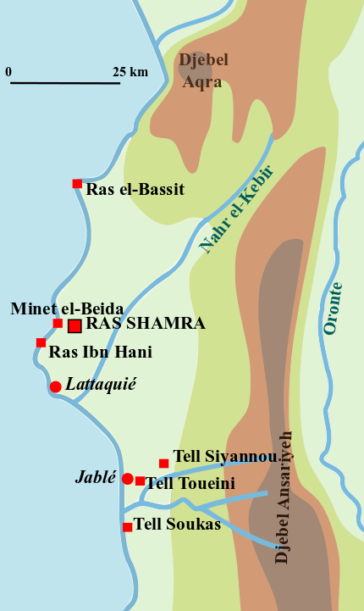
Figure (1): Shows the location of the Ras Al-Basit area on the map using Google Earth
Method: 2-
First: Measurement Phase:
The samples were transported to the fish laboratory at the College of Science, and measurements (total length, standard length, and weight) of the fish were studied in centimetres and weighed in grams using a sensitive digital balance.

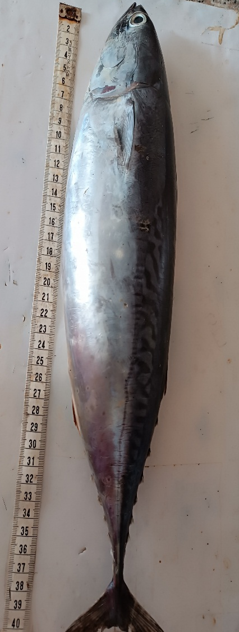
Figure 2: General shape of Auxis rochei (Total length 40 cm, Standard length 38 cm, Weight 850 g) caught in the Ras El Basit area on 18/2/2025.
Second: Examination Phase:
After taking measurements, the fish were dissected according to the method described by the researchers (Moti, 2004; Amlacher, 1977).
A longitudinal incision was made in the midline of the abdomen, extending from the beginning of the head to the end of the anus. Another incision was then made from the end of the first incision to the gill cover. The internal organs were then exposed for examination. They were examined with the naked eye and then with a magnifying glass to detect parasitic worms. The internal organs were then examined, and their contents were placed in a Petri dish with a small amount of water to prevent the sample from drying out. The stomach, intestines, and liver were sliced ​​to detect the parasites within.
The parasite species in this study was isolated after being placed in a lactic acid solution, according to the researchers (Amlacher, 1977; Lucky, 1977; Pritchard and Kruse, 1982). It was identified based on a number of global taxonomic keys that focused on external and internal morphological characteristics, and the anterior and posterior ends of the parasite's body, according to researchers (Bykhovskaya et al., 1964; Mollre and Anders, 1986; Moravec, 1994; Anderson, 2000). The parasite species (Spinitectus carolini) was found in the digestive system, specifically the stomach, of one individual from the fish examined. The parasites were isolated and fixed with 70% alcohol.
3. Results and Discussion:
In this study, for the first time, the parasitic species Spinitectus carolini was isolated and identified from the digestive system, specifically the stomach, of the Bullet tuna fish Auxis rochei (Figure 2) in Syrian marine waters.
Its length is approximately 4 cm (3.5 cm - 4 cm) (Figure 3). Its species was identified as male, distinguishing it from the female by its tail being curved evenly along the body and its slender body. In contrast, the female has a heart-shaped tail and a modified vagina facing backwards.
Table (1): The Classification of the Species Spinitectus carolini.
Animalia | Kingdom
Nematoda | Phylum
Chromadorea | Class
Rhabditida | Order
Cystidicolidae | Family
Spinitectus | Genus
S.Carolini | Species
General characteristics of the parasite:
This type of parasitic nematode (Spiny worm) infects the digestive system. It has rings of spines attached to its anterior end. This parasite is characterised by the presence of anterior rows of spines arranged in four segments and a spineless head region. Spines are absent on the lateral lines, and their number and size decrease toward the rear. The muscular oesophagus begins at the level of the second row of spines.
Males: Slender body, 3.31 (3.45-2.78) cm long and 0.0098 cm wide. A narrow, glandular esophagus, 1.497 cm long, and a tail curved evenly with the body. Females: Slender body, 5.13 (5.70-4.35) cm long and 0.110 cm wide. A glandular esophagus, 0.194 cm long. A retroverted vagina. Eggs with a thick shell and a heart-shaped tail.
Life Cycle:
S. carolini worms of the Cystidicolidae family are rare parasites that parasitise marine and freshwater fish in many seas, oceans, rivers, and lakes (Smith et al., 2016). The parasite passes through four larval stages during its life cycle and requires intermediate hosts such as insect larvae (mayfly nymphs, dragonfly nymphs, stonefly larvae, etc.) (Crites et al., 1982). Previous studies indicate that adult third- and fourth-stage larvae can be transmitted from one definitive host to another.
The parasite is transmitted to humans by eating raw fish infected with the parasite. There are no reports of S. carolini infection of Auxis rochei in Syria, but this parasite has been recorded on the common bluegill (Crites et al., 1982). A species of the genus Spinitectus also parasitises the European eel, according to a study conducted in the Italian River Messima, where it was recorded. This species, S. inermis, was identified for the first time (Ribas et al., 2025).
There is insufficient information and reports on the prevalence of this species, S. carolini, in the eastern Mediterranean basin.
Females release eggs inside the intestine of the definitive host fish. The eggs are excreted into the water with fish faeces. The eggs settle to the bottom, where they are eaten by insect larvae (mayfly nymphs, dragonfly nymphs, stonefly larvae, and flea larvae).
First-stage larvae hatch from eggs inside the insect's midgut, penetrate the midgut wall, and enter the hemocoel. At 20°C, the first moult occurs within the hemocoel 18 hours after infection. Second-stage larvae penetrate the abdominal muscles 6 days after infection, with the second moult occurring 8 days after infection. Second- and third-stage larvae are encased within the abdominal muscles. Third-stage larvae continue to develop and do not become infective to the definitive host until 14 days after infection. The third moult occurs two days after infection of the host. Final moult, where third-stage female larvae can be distinguished from fourth-stage males by the presence of mucus. The final moult occurs 14 days after infection of the definitive host (Crites et al., 1982).

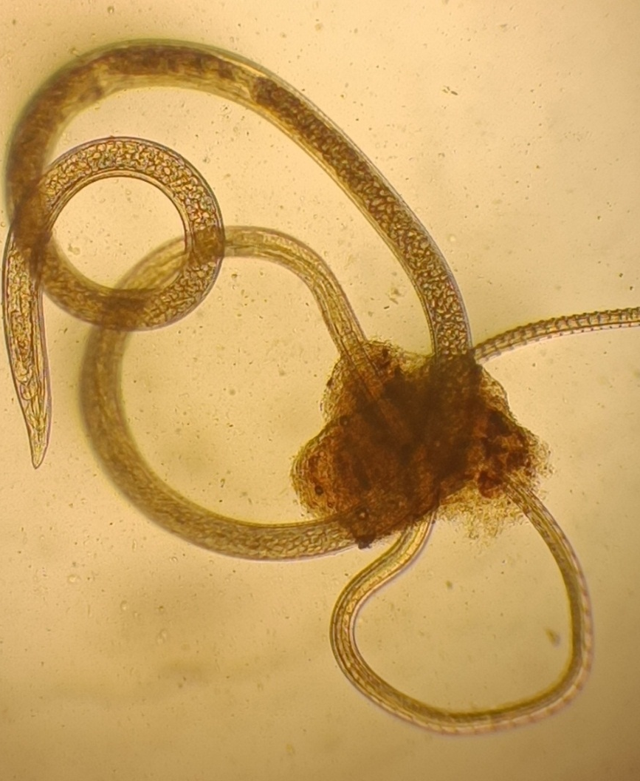

Figure3:General appearance of the parasite S.carolini, Holl 1928, under a microscope at 40 magnification. Its length is about 4 cm.

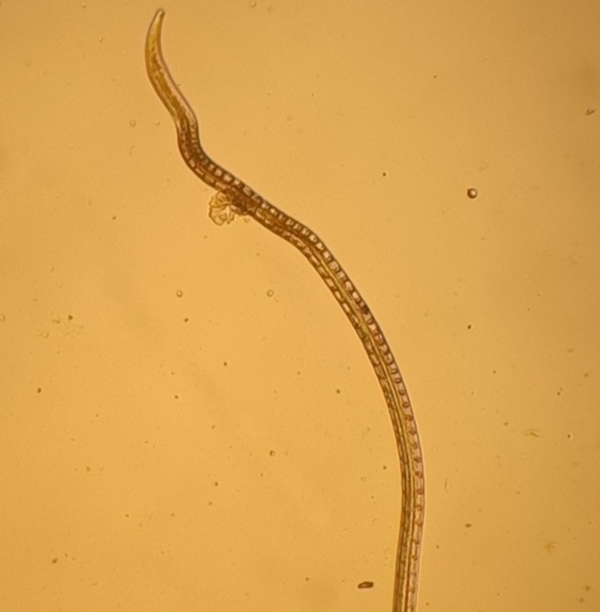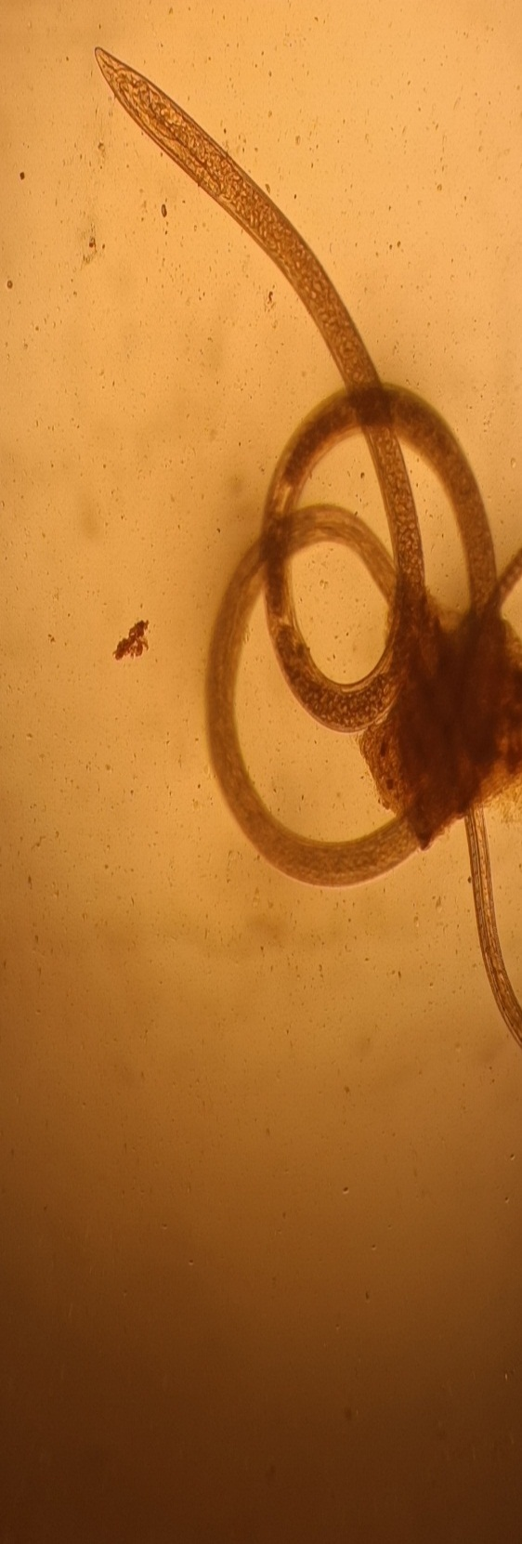
Figure 4: Microscopic images showing:
1
2
1- Anterior end of the parasite, 2-Posterior end of the parasite.

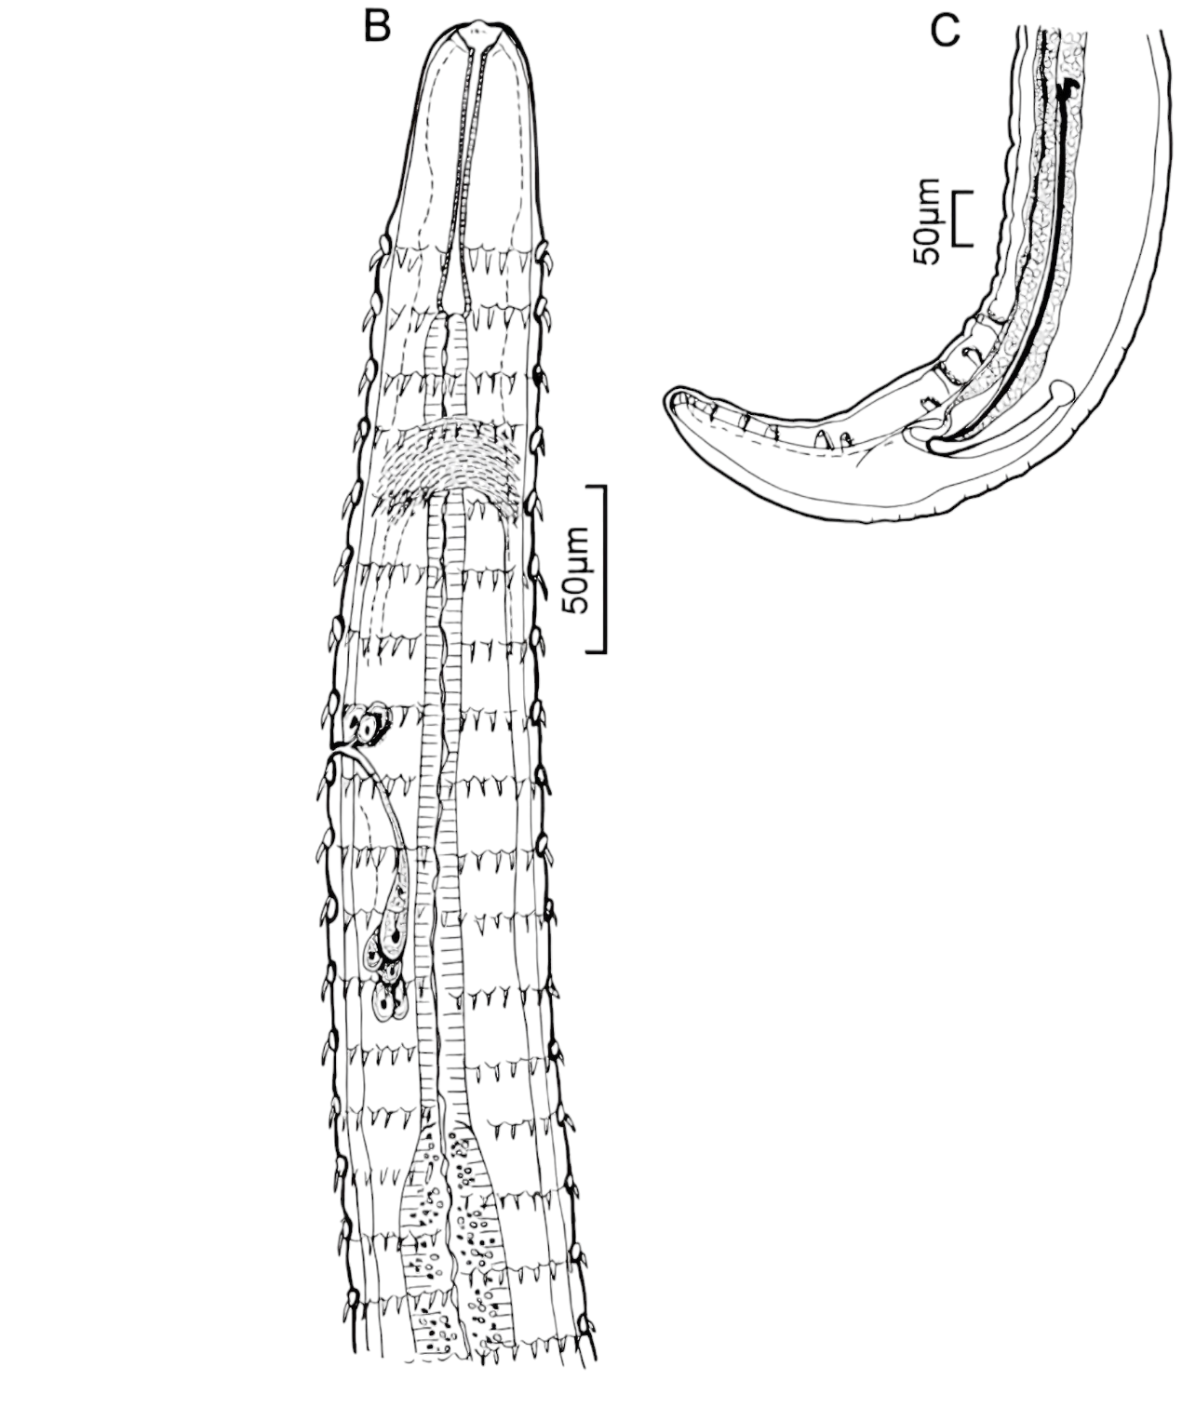

Figure (5): The general shape of the parasite according to the researcher (Mueller & Van Cleave, 1932). B: Anterior end, C: Posterior end
spines

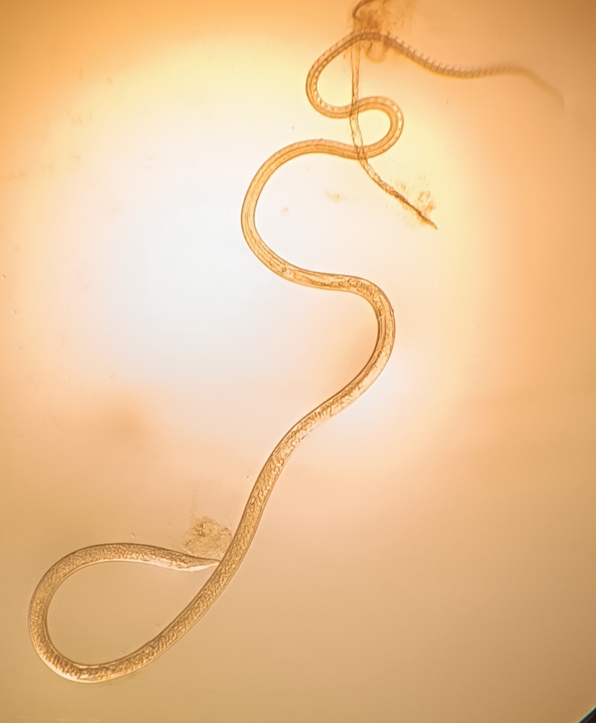
Figure(6): General appearance of the parasite S. carolini

4. Conclusion:
The parasite Spinitectus Carolini (Holl, 1928) was isolated and identified
from the digestive system, specifically the stomach of the spiny-headed fish Auxis rochei, for the first time in Syrian marine waters.
5.Recommendations:

We recommend conducting periodic field studies to monitor changes in the prevalence of parasites in Syrian marine waters and to identify the biological environmental factors that facilitate their spread.

Disclaimer (Artificial intelligence)
Option 1:
Author(s) hereby declare that NO generative AI technologies such as Large Language Models (ChatGPT, COPILOT, etc.) and text-to-image generators have been used during the writing or editing of this manuscript.
Option 2:
Author(s) hereby declare that generative AI technologies such as Large Language Models, etc. have been used during the writing or editing of manuscripts. This explanation will include the name, version, model, and source of the generative AI technology and as well as all input prompts provided to the generative AI technology
Details of the AI usage are given below:
1.
2.
3.

REFERENCES:
1) Arai,H.P.,& Smith, J.W. (2016). FIGURE 66. Spinitectus carolini Holl,1928. A in Guide to the Parasites of Fishes of Canada Part V: Nematoda Zenodo in Zootaxa 274-1.
2)A nderson RC. Nematode parasites of vertebrates: their development and transmission. Cabi; 2000, 340pp.
3) A mlacher E. T. aschenbuch der Fishkheiten fur V eterinarmediziner und Biologen.1977, 394pp.
4) Amine,F;Euzet,L.(2005).Deux especes nouvelles du genre Lamellodiscus Johnston&Tiegs,1922(Monogenea:Diplectanidae)parasites de Sparidae(Teleostei)des cotes de I,Algerie.Systematic Parasitology,60:187-196.
6) Bykhovskaya-Pavlovskaya IE, Gusev A V , Dubinina MN, Izyumova NA, Smimova TS, Sokolovskaya IL, Stein GA, Schulman SS, Epstein V M, Key to parasites of freshwater fish of the USS, 1964,919pp.
7) Baddour,N.G.,Galiya,M.Y.,Sabour,W.G.,&Layka,T.M.(2024).First record of the parasite Rocinela signata (Isopoda:Aegidae)on the gills of the Blue spotted cornet fish Fistularia commersonii(Syngnathiformes:Fistulariidae)in marine water of Syria,1 -5.
8) Collette,B.B, and C.R. Aadland,1996.Revision of the frigate tunas(Scombridae,Auxis),with description of two new subspecies from the eastern Pacific.Fish.Bull.94(3):423-441.
9)Culurgioni,J.,Mele,S.,Merella,P.,Addis,P.,Figus,V.,Cau,A.,…&Garippa,G.(2014).Metazoan gill parasites of the Atlantic Bluefin tuna Thunnus thynnus(Linnaeus)(Osteichthyes:Scombridae)from the Mediterranean and their possible use as biological tags.Folia parasitologica,61(2),148.
10)Kleinertz,S.,Eckhardt,K.U.,Theisen,S.,Palm,H.W.,&Leinweber,P.
(2016).Acanthocephalan fish parasites (Rhadinorhynchidae luhe,1912) as potential biomarkers:Molecular-chemical screening by pyrolysis-field ionization mass spectrometry.Journal of Sea Research,113,51-57pp.
11)JAAFAR,S.,Gritli,A.,MOSBAH,A.,&DHAOUADI,R.(2021).Anisakids occurrence and prevalence in three species of Scombridae fish from Tunisian coasts(Mediterranean Sea):Scomber japonicas,Scomber scombrus and Auxis rochei, 61-7pp.
12) Jilek,R., & Crites, J. L. (1982). Intestinal histopathology of the common bluegill, Lepomis macrochirus Rafinesque, infected with Spinitectus carolini Holl,1928 (Spirurida: Nematoda). Journal of fish diseases,5(1),75-77pp.
13) Jilek,R., & Crites, J. L. (1982). The life cycle and development of Spinitectus carolini Holl, 1928(Nematoda:Spirurida). American Midland Naturalist,100-106.
14) Milazzo,C.,Poonlaphecha,S.,Sperone, E., Rima,P.C.,& Ribas,A.(2025). Spinitectus inermis(Nematoda: Cystidicolidae) in the European Eel, Anguilla Anguilla (Pisces, Teleostei) from the Mesima River (Southern Calabria,Italy). Parasitologia,5(1),10.
15) Moti TB, Bulto AO. Review on Public Importance and Diagnostic Method of Listeria Monocytogenes, Ethiopiam article jbiomedsci,2022,8(3),73-85pp.
16) Moller. H, Anders, k. Diseases and parasites of marine fish. erlag Heino Moller; 1986, 85-93pp.
17) Moravec F. Parasitic nematodes of freshwater fishes of Europe . D ordrecht.470, Kluwer A cademic Publishers, 1994, 473pp.
18)Mele,S.,Saber,S.,Gomez_Vives,M.J.,Garippa,G.,Almany,F.,Macias,D.,&Merella,P.(2015).Metazoan parasites in the head region of the bullet tuna Auxis rochei (Osteichthyes:Scombridae) from the western Mediterranean Sea.Journal of Helminthology,89(6),734-739pp.
19) Noga,E.J.(2011).Fish Parasites disease:diagnosis and treatment .John Wiley& Sons, 471-472pp.
20) OTHMAN,R.,GALIYA,M.,&LAYKA,T.(2022).First Record of the Nematoda Parasites from the family Anisakidae on the Euthynnus alletteratus (Rafinesque,1810) Caught in the marine waters of the Lattakia-Syria.Asian Journal of the Advances in Research,780-784.
21) Rasheed,R.A.S.,Galiya,M.,&Almajaiidmz.(2023).First Record of the Glugea sp.on the Alosa fallax(Lacepede,1830) Caught in the Marine Water of Syria (Eastern Mediterranean).Asian Journal of Fisheries and Aquatic Reseaerch,25(1),10-15.
22) Rueckert,S.,Hagen,W.,Yuniar,A.T.,&Palm,H.W.(2009).Metazoan fish parasites of Segara Anakan Lagoon,Indonesia,and their potential use as biological indicators.Regional Environmental Change.9(4),315-328pp.
23) Xiong, X., Damico, P.,Guardone, L., Castigliego, L., Guidi, A., Gianfaldoni, D., Gianfaldoni, D., & Armani, A.(2016). The uncertainty of seafood labeling in china: A case study on Cod, Salmon and Tuna. Marine Policy, 68, 123- 135pp.
24) Hassan, Rahim Kazim (2011). An analytical study to estimate the production cost functions and the optimal size of fish farms in Babil Governorate for the year 2010. Diyala for Agricultural Sciences, 3(1): 100-93.
25) Aragão, C., Gonçalves, A. T., Costas, B., Azeredo, R., Xavier, M. J., & Engrola, S. (2022). Alternative Proteins for Fish Diets: Implications beyond Growth. Animals, 12(9), 1211.
26) Wangmo, K., & Dorji, U. (2025). Ecological assessment of parasites and environmental drivers in native freshwater fishes of Punatsangchhu River, Bhutan. South Asian Journal of Parasitology, 8(3), 255–268.
27) Zlaugotne, B., Pubule, J., & Blumberga, D. (2022). Advantages and disadvantages of using more sustainable ingredients in fish feed. Heliyon, 8(9).

