Therapeutic potential of phytochemicals present in the polyherbal formulation Aarumuga Chooranam in management of Irritable Bowel Syndrome (IBS). – In Silico Study.
Abstract
Irritable Bowel Syndrome (IBS) is a chronic functional gastrointestinal disorder characterized by bloating, abdominal pain, and altered bowel habits, which includes constipation, diarrhoea, or a combination of both. Although not life-threatening, IBS significantly affects quality of life and mental health of the patients. The criteria for diagnosing IBS have been significantly refined, and most recently based on Rome IV criteria. Visceral hypersensitivity is one of the key mechanisms which implicated in its pathophysiology, which leads to increased perception of pain in response to normal gastrointestinal stimuli. Population-based studies estimate that the prevalence of IBS is at 10-20% and the incidence is at 1-2% per year.
Molecular modelling is the most important method for the investigation and reorganization of receptor protein and compound structure, potentially without giving more investment in research work and time.
Carbonic anhydrase IV (CA IV), is a zinc metalloenzyme which present on the apical membrane of the intestinal epithelium. It plays a crucial role in inflammation and visceral pain. Its activity is elevated in colitis models, leading to visceral pain and colon damage. Blocking CA IV reduces pain sensitivity and protects colon tissue. Targeting CA IV may offer a promising therapeutic strategy for IBS symptoms management.
Aarumuga Chooranam is a traditional Siddha polyherbal formulation with recognized by its gastrointestinal benefits. This study aims to evaluate the interaction of phytoconstituents present in Aarumuga Chooranam with CA IV using molecular docking techniques, followed by in vitro validation.
The results of this investigation is to provide scientific evidence supporting the traditional use of the siddha formulation in IBS management and may lead to the development of effective plant-based therapeutics targeting inflammation and hypersensitivity associated with IBS.
Key words: Molecular Docking, IBS, Carbonic anhydrase, visceral hypersensitivity, Intestinal pain, Inflammation, Herbal, Siddha

Introduction
Irritable Bowel Syndrome is a highly prevalent functional gastrointestinal disorder that affects a significant portion of the global population. It is primarily characterised by recurrent abdominal pain, bloating and altered bowel habits, which may include diarrhoea, constipation, or a combination of both. Although IBS isn’t life threatening, it is a chronic condition with fluctuating certain symptoms and can significantly affects the quality of life and mental well-being⁽¹⁾. Population-based studies estimate that the prevalence of IBS is at 10-20% and the incidence is at 1-2% per year. It affects the quality of life and mental health of the patients⁽²⁾.
The criteria for diagnosing IBS have been significantly refined, and most recently based on Rome IV criteria. According to the Rome criteria IV, IBS is classified into 4 subtypes based on the predominant bowel habits:
- IBS with constipation (IBS-C)
- IBS with diarrhoea (IBS-D)
- Mixed IBS (IBS-M)
- Unclassified IBS (IBS-U) ⁽³⁾.
The pathophysiology of IBS is a complex and include various factors that interact in different mechanisms.
- Visceral hypersensitivity is considered a trademark of IBS, results in exaggerated pain responses to normal intestinal stimuli⁽³⁾.
- Alteration of the gut–brain axis, is a disrupted bidirectional communication between the enteric nervous system and the central nervous system, further plays a substantial role in causing visceral pain, particularly under psychological stress⁽⁴⁾.
- Altered gastrointestinal motility contributes to irregular bowel movements.
- Intestinal dysbiosis, is an imbalance between beneficial and pathogenic bacteria in gut which reduces the microbial diversity in the intestinal flora, has been linked to bloating, and altered mucosal signalling⁽³⁾.
- Immune activation and low-grade inflammation, including mast cell infiltration and increased pro-inflammatory mediators which compromise epithelial barrier integrity and aggravate pain. Additionally, abnormalities in serotonin signalling, a key regulator of gut motility and sensation, contribute to the variability of bowel habits and discomfort in IBS patients.
Within this multifactorial context, Carbonic Anhydrase IV (CA IV), a zinc metalloenzyme which present on the apical membrane of the intestinal epithelium. CA IV has emerged as a crucial mediator of IBS pathophysiology. Some of the Preclinical studies indicate that selective inhibition of CA IV alleviates visceral pain and protects the intestinal mucosa⁽⁵⁾. An increased CA IV expression and activity during intestinal inflammation contribute to visceral hypersensitivity and mucosal injury which leads to visceral pain⁽⁶⁾. Thus highlighting its potential ability, CA IV is selected as a novel therapeutic target.
This study aims to explore the molecular docking potential of phytochemicals present in the polyherbal formulation Aarumuga Chooranam against the CA IV target using in silico molecular docking approaches. The findings were further validated using in vitro assays, providing insight into the therapeutic potential of this traditional formulation in the management of IBS.
Materials and Methods
The poly herbal formulation Aarumuga Chooranam mentioned in “Nam Naattu Vaithiyam” Page No: 184⁽⁷⁾.
Table 1: Ingredients of Aarumuga Chooranam:
 | Kadukkai poo (Terminalia chebula) | 1Part
 | Kadukkai pinchu (Terminalia chebula) | 1Part
 | Omam (Carum copticum) | 1Part
 | Atividayam (Aconitum heterophyllum) | 1Part
 | Chirunagappu (Mesua nagassarium) | 1Part
 | Kirambu (Syzgium aromaticum) | 1Part
 | Thayir (Curd) | Required amount

Molecular modelling is the most important method for the investigation and reorganization of receptor protein and compound structure, potentially without giving more investment in research work and time. Structure prediction of the target and the ligand is important for their interaction studies.
The major phytochemicals which present in the ingrdiants of Aarumuga Chooranam were selected for docking is listed in table 2 and the phytochemicals identified with its Molecular weight, Molecular formula, H-bond donor, H-bond acceptor, Rotatable bonds were listed in table 3

Ligands Preparation
Table 2: List of Phyto components selected for docking
S.No | Herbs | Phytochemicals
 | Kadukkai poo (Terminalia chebula) | Gallic acid⁽⁸⁾.
 | Kadukkai pinchu (Terminalia chebula) | Maslinic acid⁽⁹⁾.
 | Omam (Carum copticum) | Thymol⁽¹°⁾.
 | Atividayam (Aconitum heterophyllum) | Aconitine⁽¹¹⁾.
 | Chirunagappu (Mesua nagassarium) | Beta caryophyllene⁽¹²⁾.
 | Kirambu (Syzgium aromaticum) | Eugenol⁽¹³⁾.

Table 3: Ligand Properties of Compounds selected for Docking Analysis
Compound | Molecular weight g/mol | Molecular Formula | H-Bond Donor | H- Bond acceptor | Rotatable bonds
Gallic acid | 170.12 g/mol | C₇H₆O₅ | 4 | 5 | 1
Maslinic acid | 472.7 g/mol | C₃₀H₄₈O₄ | 3 | 4 | 1
Thymol | 150.22 g/mol | C₁₀H₁₄O | 1 | 1 | 1
Aconitine | 645.7 g/mol | C₃₄H₄₇NO₁₁ | 3 | 12 | 11
Beta caryophyllene | 204.35 g/mol | C₁₅H₂₄ | 0 | 0 | 0
Eugenol | 164.2 g/mol | C₁₀H₁₂O₂ | 1 | 2 | 3

Each selected phytochemical was prepared for docking by obtaining its 2D and 3D structures from Pubchem database (https://pubchem.ncbi.nlm.nih.gov/) in SDF format and converted to PDB format, followed by energy minimization to ensure stable conformations and reduced steric hindrance. Each ligand was then parameterized with appropriate partial charges and rotatable bonds to enable flexible interactions with the target protein. The structured of ligands are shown in Table 4
Table 4: 2D & 3D Structure of Selected Ligands
Ligand | 2D Structure | 3D Structure
Gallic acid | 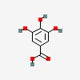 | 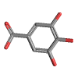
Maslinic acid | 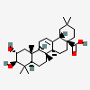 | 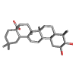
Thymol | 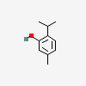 | 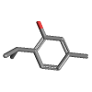
Aconitine | 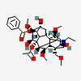 | 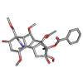
Beta caryophyllene | 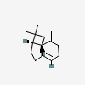 | 
Eugenol | 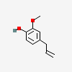 | 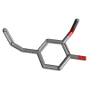

Target Preparation
The carbonic anhydrase class of target CA IV, is carried out for the fetched phytocompounds in the docking calculations. The targeted protein were selected based on Swiss target prediction (http://www.swisstargetprediction.ch/index.php). The predicted targets were downloaded from RCSB PDB database (https://www.rcsb.org/).
The X-ray crystallographic structures of the selected target proteins, each with a resolution of less than 2.0 Å, were retrieved for the study. All non-essential components, including bound ligands, cofactors, and water molecules, were removed to prepare the structures. The cleaned structures were then saved in PDB format for further molecular docking analysis.

Table 5: Properties of Target selected for docking study
Target Protein | Common Name | PDB ID | Role in IBS
Carbonic anhydrase IV | CA IV | 1ZNC | Its activity is elevated in colitis models, leading to visceral pain and colon damage. Blocking CA IV reduces pain sensitivity and protects colon tissue⁽¹⁴⁾.

Structure of the Target
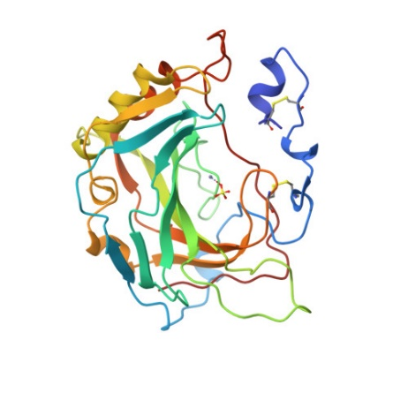

Methodology
Docking simulations were conducted using MGL Auto Dock tools to evaluate the binding interactions between the target protein and each ligand. Molecular docking was carried out by using AutoDock Tools version 1.5.7, by following the protocol established by Morris et al. (2009), to investigate the interactions between the target protein and each ligand.
During ligand preparation, some charges were assigned, non-polar hydrogens were combined, and rotatable bonds were specified. A grid box was strategically positioned over the active site residues to ensure the docking within the biologically relevant region⁽¹⁵⁾.
Key parameters including binding energy (ΔG), inhibition constant (Ki), and interaction surface area were calculated for each ligand. To further validate the findings, the docking procedure was repeated using the SwissDock vina page. This comparative approach helped to confirm the consistency of the interaction results⁽¹⁶⁾.
Results & Discussions
Irritable Bowel Syndrome (IBS) is a chronic functional gastrointestinal disorder characterized by bloating, abdominal pain, altered bowel habits, and a significant reduction in the quality of life of affected individuals. The pathophysiology of IBS is interact in different mechanisms, involving visceral hypersensitivity, dysregulated or altered gut-brain axis, low-grade inflammation, and increased intestinal permeability, commonly referred to as “leaky gut”. These underlying mechanisms often overlap, leading disease progression and symptom manifestation. The Conventional therapeutic options may provide only symptomatic relief and are often associated with some limitations such as poor efficacy and adverse effects, thereby emphasising the need for safer and more effective alternatives.
In the present in silico study, molecular modelling approaches were employed to explore the pharmacodynamic potential of the phytochemicals (Gallic acid, Maslinic acid, Thymol, Aconitine, Beta caryophyllene and Eugenol) against validated molecular targets associated with IBS. The phytochemicals are taken from the polyherbal formulation from siddha literature which indicated for gut health.
Many overlapping targets were found with different mechanism in IBS. Among the various targets, carbonic anhydrase IV (CA IV) was specifically selected due to its crucial role in modulating visceral pain, epithelial barrier function, and mucosal integrity. Elevated expression and activity of CA IV have been observed in experimental models of colitis, contributing to pain sensation and tissue damage. Importantly, selective inhibition of CA IV has been demonstrated to alleviate visceral hypersensitivity and protect colonic architecture, suggesting its therapeutic relevance in IBS⁽¹⁴⁾. Therefore, evaluating the interaction of Siddha-based phytochemicals with CA IV through molecular docking may provide valuable insights into their mechanism of action and therapeutic potential in IBS management.
Curd (yogurt) has emerged as a potential dietary intervention for managing Irritable Bowel Syndrome (IBS), primarily due to its rich probiotic content. Probiotics, such as Lactobacillus and Bifidobacterium strains, play a crucial role in modulating the gut microbiota, enhancing intestinal barrier function, and regulating local immune responses, which collectively contribute to alleviating gastrointestinal symptoms associated with IBS. Several clinical studies have demonstrated that the consumption of probiotic yogurt can significantly reduce common IBS symptoms, including abdominal pain, bloating, and discomfort, when compared to conventional yogurt⁽¹⁷⁾.
Moreover, specialized formulations, such as yogurt enriched with Bifidobacterium lactis have been shown to improve bowel regularity, stool consistency, and overall symptom severity, suggesting a synergistic effect of probiotics and dietary fiber in restoring gut homeostasis⁽¹⁸⁾. The mechanisms underlying these benefits are thought to include suppression of pathogenic gut bacteria, production of short-chain fatty acids, and modulation of the gut–brain axis, which together help in reducing visceral hypersensitivity and inflammation in IBS patients. These findings support the inclusion of probiotic-enriched yogurt as a safe, non-pharmacological adjunct in the dietary management of IBS.
From the results of docking analysis, all the ligand possess 8-10 interactions sites in the selected target. The highest free energy of binding from the interactions were obtained and listed in the table 6. From the table, the highest free energy of binding ranges between -2 to -5 which denotes the higher affinity between the ligand and receptor. The 3D docking interaction of various compounds with the target were tabulated in table 7. All the compounds exhibit higher binding energy against CA IV. By regulating CA IV, the visceral pain and gut damage may be reduced and prevent colitis.

Table 6: Summary of molecular docking study of ligands against Carbonic anhydrase IV
Ligands | No. of Intractions | Highest Free Energy of Binding (kcal/mol)
Gallic acid | 9 | -5.70
Maslinic acid | 20 | -5.58
Thymol | 20 | -3.59
Aconitine | 20 | -4.27
Beta caryophyllene | 20 | -4.44
Eugenol | 20 | -2.69

Table 7: Docking interaction with CA IV
Ligands | Docking Interaction with CA IV
Gallic acid | 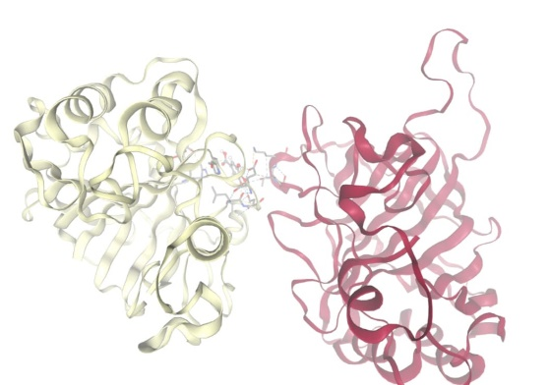
Maslinic acid | 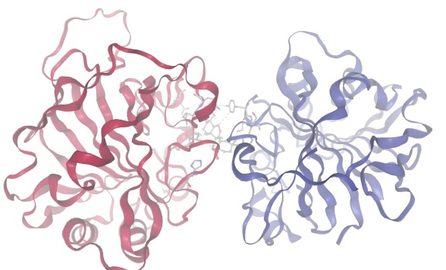
Thymol | 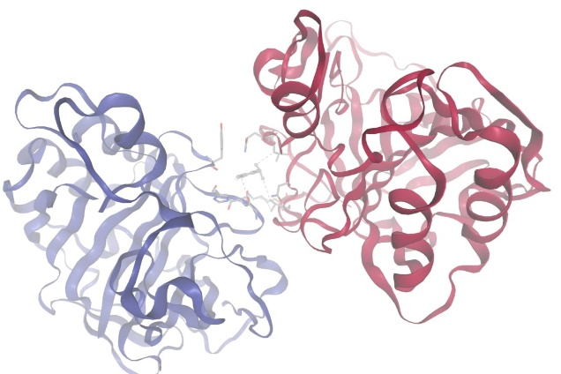
Aconitine | 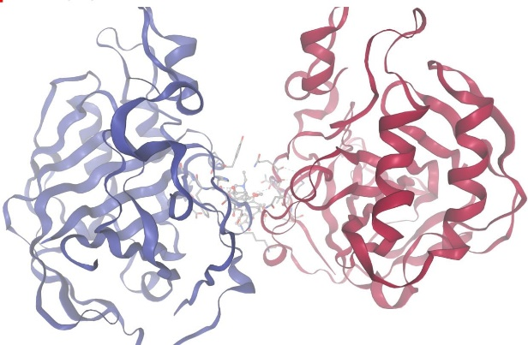
Beta caryophyllene | 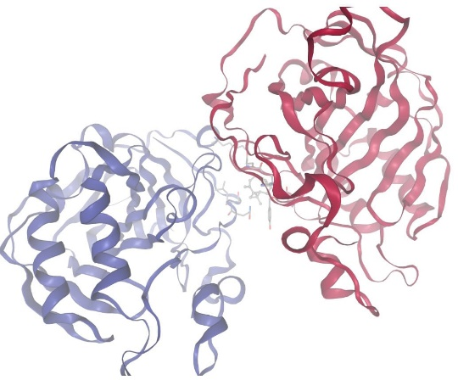
Eugenol | 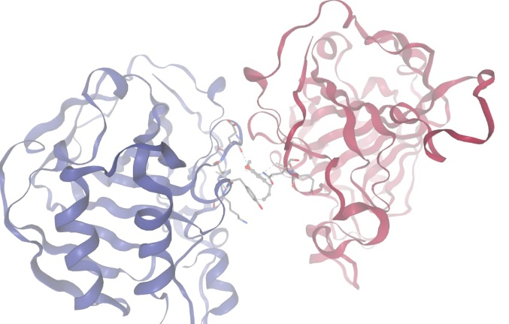

Conclusion
The molecular docking analysis demonstrated that the phytoconstituents Gallic acid, Maslinic acid, Thymol, Aconitine, β-Caryophyllene, and Eugenol, present in Aarumuga Chooranam, exhibited notable binding affinity towards the zinc metalloenzyme Carbonic Anhydrase IV (CA IV). CA IV has been implicated in the development of visceral hypersensitivity and mucosal damage, which are key contributors to the pathophysiology of Irritable Bowel Syndrome (IBS). The strong interactions observed suggest that these compounds may inhibit CA IV activity, thereby alleviating IBS-associated pain and inflammation. These findings highlight the therapeutic relevance of polyherbal formulations in modulating specific molecular targets and support the potential of Aarumuga Chooranam as a source of natural inhibitors for CA IV–mediated pathways in IBS management.

Disclaimer (Artificial intelligence)
Option 1:
Author(s) hereby declare that NO generative AI technologies such as Large Language Models (ChatGPT, COPILOT, etc.) and text-to-image generators have been used during the writing or editing of this manuscript.
Option 2:
Author(s) hereby declare that generative AI technologies such as Large Language Models, etc. have been used during the writing or editing of manuscripts. This explanation will include the name, version, model, and source of the generative AI technology and as well as all input prompts provided to the generative AI technology
Details of the AI usage are given below:
1. ChatGPT only for rephrasing purpose
2.
3.

References:
- Bercik P, Verdu EF, Collins SM. Is irritable bowel syndrome a low-grade inflammatory bowel disease? Gastroenterol Clin North Am. 2005 Jun;34(2):235-45, vi-vii. [PubMed]
- Jenifer K Lehrer, Gary R Lichtenstein. The practice essentials of Irritable Bowel Syndrome. Dt, Feb 15, 2022
- Lacy BE, Patel NK. Rome Criteria and a Diagnostic Approach to Irritable Bowel Syndrome. J Clin Med. 2017 Oct 26;6(11):99. doi: 10.3390/jcm6110099. PMID: 29072609; PMCID: PMC5704116
- Lawate P. Expert opinion on current issues and challenges in irritable bowel syndrome. Int J Adv Med 2024;11:415-22.
- Lucarini E, Nocentini A, Bonardi A, Chiaramonte N, Parisio C, Micheli L, Toti A, Ferrara V, Carrino D, Pacini A, Romanelli MN, Supuran CT, Ghelardini C, Di Cesare Mannelli L. Carbonic Anhydrase IV Selective Inhibitors Counteract the Development of Colitis-Associated Visceral Pain in Rats. Cells. 2021 Sep 26;10(10):2540. doi: 10.3390/cells10102540. PMID: 34685520; PMCID: PMC8533707.
- Farzaei MH, et al. The Role of Visceral Hypersensitivity in Irritable Bowel Syndrome. PMC; 2016.
- Veeraperumal pillai S, Nam Naattu Vaithiyam, 2021, Shanmuganandha book depot, Srinivasa Press, Chennai-112
- Vazirian M, Khanavi M, Amanzadeh Y, Hajimehdipoor H. Quantification of gallic acidin fruits of three medicinal plants. Iran J Pharm Res. 2011 Spring;10(2):233-6. PMID: 24250348; PMCID: PMC3828909.
- Ghosh R, Badavath VN, Chowdhuri S, Sen A. Identification of Alkaloids from Terminalia chebula as Potent SARS- CoV-2 Main Protease Inhibitors: An In Silico Perspective. ChemistrySelect. 2022 Apr 12;7(14):e202200055. doi: 10.1002/slct.202200055. Epub 2022 Apr 11. PMID: 35600910; PMCID: PMC9111116.
- Boskabady MH, Alitaneh S, Alavinezhad A. Carum copticum L.: a herbal medicine with various pharmacological effects. Biomed Res Int. 2014;2014:569087. doi: 10.1155/2014/569087. Epub 2014 Jun 25. PMID: 25089273; PMCID: PMC4096002.
- Paramanick D, Panday R, Shukla SS, Sharma V. Primary Pharmacological and Other Important Findings on the Medicinal Plant "Aconitum Heterophyllum" (Aruna). J Pharmacopuncture. 2017 Jun;20(2):89-92. doi: 10.3831/KPI.2017.20.011. Epub 2017 Jun 30. PMID: 30087784; PMCID: PMC5532466.
- Choudhury, S., Ahmed, R., Barthel, A., & Leclercq, P. A. (1998). Volatile Oils of Mesua ferrea (L.) from Assam, India. Journal of Essential Oil Research, 10(5), 497–501. https://doi.org/10.1080/10412905.1998.9700955.
- Batiha GE, Alkazmi LM, Wasef LG, Beshbishy AM, Nadwa EH, Rashwan EK. Syzygium aromaticum L. (Myrtaceae): Traditional Uses, Bioactive Chemical Constituents, Pharmacological and Toxicological Activities. Biomolecules. 2020 Jan 30;10(2):202. doi: 10.3390/biom10020202. PMID: 32019140; PMCID: PMC7072209.
- Lucarini E, Nocentini A, Bonardi A, Chiaramonte N, Parisio C, Micheli L, Toti A, Ferrara V, Carrino D, Pacini A, Romanelli MN, Supuran CT, Ghelardini C, Di Cesare Mannelli L. Carbonic Anhydrase IV Selective Inhibitors Counteract the Development of Colitis-Associated Visceral Pain in Rats. Cells. 2021 Sep 26;10(10):2540. doi: 10.3390/cells10102540. PMID: 34685520; PMCID: PMC8533707.
- Eberhardt J, Santos-Martins D, Tillack AF, Forli S.. AutoDock Vina 1.2.0: New Docking Methods, Expanded Force Field, and Python Bindings. J. Chem. Inf. Model., 2021.
- Bugnon M, Röhrig UF, Goullieux M, Perez MAS, Daina A, Michielin O, Zoete V. SwissDock 2024: major enhancements for small-molecule docking with Attracting Cavities and AutoDock Vina. Nucleic Acids Res. 2024.
- Zareie M, Khafri S, Eslami G. The effect of probiotic yogurt on symptoms of irritable bowel syndrome. J Ardabil Univ Med Sci. 2006;6(2):123-9.
- Min YW, Park SU, Jang YS, Kim YH, Rhee PL, Ko SH, et al. Effect of composite yogurt enriched with acacia fiber and Bifidobacterium lactis on irritable bowel syndrome: A randomized, double-blind, placebo-controlled trial. J Gastroenterol Hepatol. 2012;27(9):1394-400. doi:10.1111/j.1440-1746.2012.07184.x.
- Bor S, Lehert P, Chalbaud A, Tack J. Efficacy of pinaverium bromide in the treatment of irritable bowel syndrome: a systematic review and meta-analysis. Therap Adv Gastroenterol. 2021;14:17562848211033740.
- Zheng L, Lu W, Xiao Q, Lai Y, Fan H, Sun Y, et al. Assessing the post-treatment therapeutic effect of pinaverium in irritable bowel syndrome: a randomized controlled trial. Sci Rep. 2021;11(1):13894

