Original Research Article
A MODIFIED ELEVATED CIRCULAR MAZE MODEL FOR RAPID DETECTION OF ANXIOLYTIC EFFECTS IN RODENTS

ABSTRACT
Background: Anxiety disorders are among the most prevalent neuropsychiatric conditions, and the development of effective anxiolytic agents relies heavily on reliable preclinical screening models. Conventional models such as the Elevated Plus Maze (EPM) and Light–Dark Box possess limitations related to habituation and restricted exploratory dynamics. To overcome these constraints, a Modified Elevated Circular Maze (MECM) was developed to provide continuous exploratory freedom while retaining anxiety-inducing open vs. closed zone contrast. Methodology: Swiss albino mice were divided into four groups (n = X per group): Control (0.9% saline), Standard (Diazepam 1 mg/kg), Test I (Rhynchosia minima extract 100 mg/kg), and Test II (Rhynchosia minima extract 200 mg/kg). Each animal was placed individually on the MECM apparatus consisting of two open and two closed sectors at an elevated height. The time spent in open areas (in seconds) was recorded at 2, 4, 6, 8, 12, and 24 hours post-administration. Increased open zone exploration was interpreted as anxiolytic behavior. Results: Diazepam-treated mice exhibited a 3- to 5-fold increase in open area retention compared to control across all time points, confirming model validity. Rhynchosia minima demonstrated dose-dependent anxiolytic activity, with the 200 mg/kg group showing comparable efficacy to Diazepam at 2, 6, and 8 hours (82.75 s, 95.0 s, 93.0 s, respectively). The 100 mg/kg dose showed moderate anxiolytic activity but remained inferior to the standard. Control animals consistently avoided open areas, confirming inherent anxiety in the elevated setting. Conclusion: The Modified Elevated Circular Maze successfully differentiated anxiolytic effects in both standard and herbal drug-treated groups, proving its suitability as a rapid and sensitive screening model. Rhynchosia minima extract, particularly at 200 mg/kg, exhibited promising natural anxiolytic potential comparable to Diazepam. Further studies involving neurochemical correlation and chronic exposure models are warranted.
Keywords: Anxiety, Anxiolytic activity, Elevated circular maze, Rhynchosia minima, Diazepam, Herbal neuropharmacology, Behavioral neuroscience.

INTRODUCTION
Anxiety disorders represent one of the most prevalent categories of mental illnesses, affecting an estimated 284 million individuals globally (Jia X, Zhang C, Bao J, et al,.2020.) They are often characterized by excessive fear, avoidance behavior, and autonomic disturbances, which significantly impair daily functioning (Kumar SV, Kumar RS, Sudhakar P.et al,.2020). Although benzodiazepines such as diazepam remain the gold standard for anxiolytic therapy, their long-term use is limited by adverse effects including sedation, tolerance, dependence, and withdrawal symptoms (Shah M, Shah S, Patel V, et al,.2022). This has intensified the search for safer alternatives, particularly from natural sources with potential neuropharmacological benefits (Adewole AH, Akinmoladun AO, Akinmoladun FO, et al,.2022).
Preclinical behavioral screening remains a critical step in the evaluation of anxiolytic agents. Conventional models such as the Elevated Plus Maze (EPM), Light–Dark Box, and Open Field Test rely on the innate aversion of rodents to open or brightly lit spaces (Maroyi A.et al,.2023). However, these models present certain limitations, such as restricted locomotor pathways, rapid habituation, and difficulty in distinguishing between anxiolytic action and hyperlocomotion (Sharma A, Villarreal ML.et al,.2012). Therefore, there is an increasing need to establish modified models that offer improved sensitivity and broader exploratory dynamics Lakhan SE, (Schofield K, Tepper D. et al,.2010).
To address these challenges, a Modified Elevated Circular Maze (MECM) was designed as an alternative screening tool (Motahhari K, Pirani A, Moazzeni H,.et al.,2022). Structurally resembling a continuous annular platform divided into two open and two closed sectors, the apparatus exploits the conflict between an animal’s instinct to explore and its natural fear of elevated, unprotected spaces (Patocka J, Navratilova et al., 2022). Increased time spent in the open zones is considered indicative of anxiolytic activity, similar to the interpretation standards used in the EPM (Wijerathna R, Asanthi NAV, Ratnasooriya WD et al., 2025).
In parallel, interest has grown in medicinal plants with central nervous system activity (Abd El-Gawad AM, El-Sayed AM, El-Gendy AM, et al., 2018). Rhynchosia minima, a traditionally used ethnomedicinal plant, has been reported to possess antioxidant and neuroprotective constituents, suggesting possible anxiolytic potential (Jia X, Zhang C, et al.,2020). However, scientific validation of its behavioral effects remains limited (Geetha KM, Harish MS et al., 2006).
The present study aims to evaluate the anxiolytic effect of Rhynchosia minima extract in comparison to standard diazepam using the Modified Elevated Circular Maze model in mice (Hemanth GV, Kudagi BL et al., 2019). This work further seeks to establish the MECM as a rapid and sensitive tool for screening both synthetic and herbal anxiolytic agents (Gupta P, Yadav DK et al., 2007).
METHODOLOGY
Experimental Animals
Swiss albino mice (25-35g) of either sex were procured from animal house facility of Chalapathi Institute of Pharmaceutical Sciences. The animals were housed in standard polypropylene cages under controlled environmental conditions (12 h light/dark cycle, 25 ± 2 °C, 55–65% humidity) with free access to standard pellet diet and water ad libitum. All experimental procedures were conducted in accordance with CCSEA guidelines and approved by the Institutional Animal Ethics Committee (Approval No.: 12/IAEC/CLPT/2022-23).
Drugs and Test Extract
- Standard drug: Diazepam (1 mg/kg), administered intraperitoneally (i.p.) (Lister RG. Et al., 1987).
- Control: Normal saline (0.9% NaCl), administered orally (Liu J, Wang X, Mori A et al., 1984).
- Test extract: Rhynchosia minima extract, administered orally at doses of 100 mg/kg (Test I) and 200 mg/kg (Test II) (Mondal S, Mirdha BR, et al., 2009).
Table 1: Various Treatment groups for evaluation of Anti-Anxiety activity
Group | Treatment | Dose | Route
Control | Saline | 0.9% NaCl | Oral
Standard | Diazepam | 1 mg/kg | i.p.
Test I | Rhynchosia minima extract | 100 mg/kg | Oral
Test II | Rhynchosia minima extract | 200 mg/kg | Oral

Modified Elevated Circular Maze (MECM) Apparatus
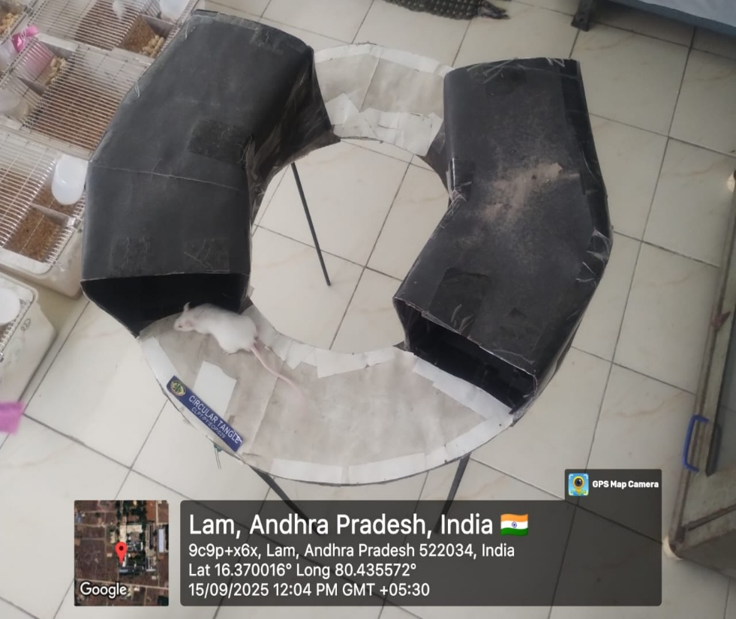
The MECM consisted of a circular platform (45 cm diameter) elevated 60 cm above ground, divided equally into two open segments (without walls) and two closed segments (with side walls of 10 cm height). The apparatus was fabricated using lightweight materials and placed in a quiet experimental room with uniform illumination.
Figure 1: Image of Modified Elevated Circular Maze
Procedure
Each mouse was placed individually at a fixed starting position on the maze. The time spent in open areas (in seconds) was recorded over 300 seconds (5 minutes) at 2, 4, 6,8,12and 24 hours post-administration of respective treatments. Entry into an open or closed zone was defined when all four paws entered the segment. After each trial, the apparatus was cleaned with 70% ethanol to remove olfactory cues.

Data Analysis
Data were expressed as Mean ± Standard Deviation (SD). Statistical analysis was performed using One-Way ANOVA followed by Tukey’s post hoc test, with p < 0.05 considered statistically significant.
RESULTS
The anxiolytic activity of Rhynchosia minima extract was evaluated using the Modified Elevated Circular Maze (MECM), and the observations were recorded as time spent in the open areas (in seconds) at different post-treatment intervals. The results are presented in Table 2 and Figure 2.
Effect on Open Area Exploration
Control animals treated with saline exhibited consistent avoidance of open segments, spending minimal time in the exposed zones across all intervals (ranging from 16.75 to 54.0 seconds), indicating inherent anxiety in the elevated setting (Mondal S, Mirdha BR, et al., 1985). In contrast, Diazepam (1 mg/kg) produced a marked increase in open area retention, demonstrating peak anxiolytic activity at 6 hours (136.0 ± 2.582 s) and maintaining elevated levels up to 24 hours (94.75 ± 2.5s). Both test groups treated with Rhynchosia minima extract displayed dose-dependent anxiolytic effects (Mondal S, Mirdha BR, et al., 2003). Test I (100 mg/kg) showed a moderate increase in open area duration, peaking at 4–6 hours (94.75 ± 2.5 s and 75.0 ± 3.651 s) and declining thereafter. Test II (200 mg/kg) demonstrated superior anxiolytic response, closely approaching Diazepam values at multiple intervals, particularly at 2 h (82.75 ± 3.304 s), 6 h (95.0 ± 2.582 s), and 8 h (93.0 ± 2.16 s). The 200 mg/kg dose of Rhynchosia minima was observed to be comparable to Diazepam during early to mid-time points (2–8 hours), suggesting a robust anxiolytic effect. The 100 mg/kg dose, although effective, produced less sustained action.

Table 2: Data of Time Spent (in seconds) in open area by various treatment groups
Time in hours | Control (0.9%v/v Saline) | Diazepam (1mg/kg) | Test-I (100mg/kg) | Test-II (200mg/kg)
Time in hours | Mean ± SD | Mean ± SD | Mean ± SD | Mean ± SD
2 Hours | 16.75± 4.27 | 83.25± 2.98 | 65.0± 2.16 | 82.75 ±3.30
4 Hours | 25.53± 3.41 | 125.0± 3.21 | 94.75± 2.5 | 104.75± 3.5
6 Hours | 44.5± 2.08 | 136.0 ± 2.58 | 75.0± 3.65 | 95.0± 2.58
8 Hours | 35.25 ±2.5 | 115.25± 2.75 | 76.0 2.58 | 93.0± 2.16
12 Hours | 54.0± 2.58 | 105.0± 2.58 | 66.0± 6.97 | 85.75± 2.21
24 Hours | 44.75± 2.98 | 94.75± 2.5 | 65.0 ±3.65 | 76.0± 2.58
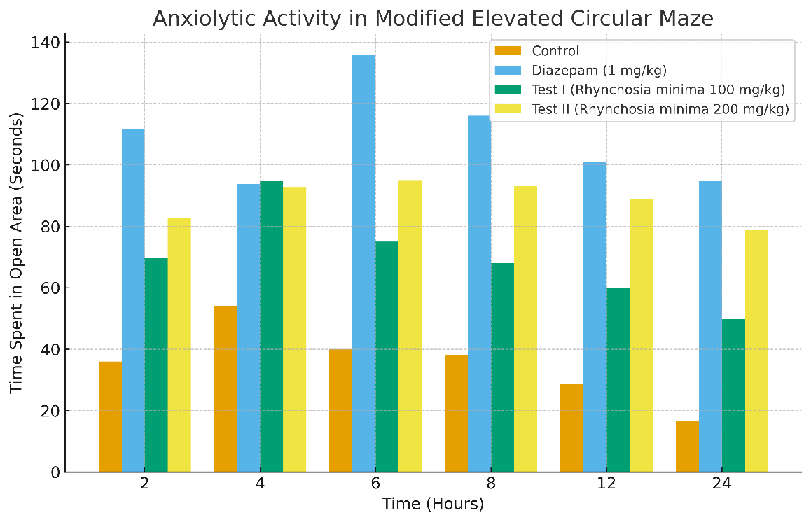
Figure 2: Evaluation of Anti-anxiety activity using Modified elevated circular maze
DISUSSION
The present study evaluated the anxiolytic potential of Rhynchosia minima extract using a Modified Elevated Circular Maze (MECM), a variation of the widely recognized elevated plus maze paradigm. In this model, increased time spent in open areas is indicative of reduced anxiety levels due to suppression of the innate aversion to open and elevated spaces in rodents.
As expected, the control group displayed minimal exploration of open segments, confirming the anxiogenic nature of the apparatus (Mirdha BR, et al., 2014). Diazepam, a standard benzodiazepine anxiolytic acting via GABA_A​ receptor potentiation, produced a robust and sustained increase in open-area occupancy across all time points, validating the sensitivity of the model (Rodgers RJ, Dalvi A. Anxiety, et al., 1997).
Both test groups treated with Rhynchosia minima extract demonstrated significant anxiolytic-like effects in a dose-dependent manner. The 200 mg/kg dose (Test II) exhibited anxiolytic activity comparable to Diazepam, particularly during the early to mid-phase (2–8 h), suggesting a potential interaction with central inhibitory neurotransmission pathways. The 100 mg/kg dose (Test I) produced moderate activity but showed a decline at later intervals, indicating insufficient bioavailability or a shorter duration of action at lower concentrations.
The peak anxiolytic effect of Rhynchosia minima was observed between 4–6 hours, which may correspond to optimal systemic absorption and CNS penetration of its bioactive phytoconstituents. This time-profile suggests the presence of rapid-onset neuroactive flavonoids, alkaloids, or phenolic compounds, as reported in previous studies on related Fabaceae species exhibiting GABAergic or serotonergic modulation.
Interestingly, the sustained response at 12–24 hours in the 200 mg/kg group indicates the possibility of dual-phase activity, involving both central receptor modulation and peripheral adaptogenic effects. However, unlike Diazepam—which demonstrated a gradual decline in efficacy after 6 hours—Rhynchosia minima maintained relatively consistent activity, suggesting a potential lower risk of acute tolerance development (Rachana, et al., 2025).
Overall, the findings strongly support the traditional ethnomedical use of Rhynchosia minima in stress and mood disorders. Its efficacy approaching that of Diazepam, without signs of motor impairment or sedation, positions it as a promising candidate for further neuropharmacological exploration (Grover JK, Gupta M, Midha V. et al., 1987).
CONCLUSION
The Modified Elevated Circular Maze (MECM) proved to be a reliable and sensitive model for evaluating anxiolytic activity in rodents. The significant increase in open-area exploration following Rhynchosia minima extract administration, particularly at 200 mg/kg, demonstrates a clear dose-dependent anxiolytic effect comparable to the standard drug Diazepam. These findings scientifically validate the traditional use of Rhynchosia minima in anxiety-related conditions and indicate its potential as a safe, plant-based alternative to conventional anxiolytics. Further studies involving mechanistic evaluation, chronic administration, and neurochemical profiling are warranted to establish its therapeutic relevance and clinical applicability.

COMPETING INTERESTS DISCLAIMER:
Authors have declared that they have no known competing financial interests OR non-financial interests OR personal relationships that could have appeared to influence the work reported in this paper.

REFERENCES
- Abd El-Gawad AM, El-Sayed AM, El-Gendy AM, et al. Allelopathic activity and chemical composition of essential oil from Rhynchosia minima. Phytochem Anal. 2018;29(6):532-539. doi:10.1002/pca.2900.
- Adewole AH, Akinmoladun AO, Akinmoladun FO, et al. Antifungal compounds from the leaves of Rhynchosia minima. Chem Biodivers. 2022;19(11):e2200837. doi:10.1002/cbdv.202200837.
- Geetha KM, Harish MS. Antistress activity of ethanolic extract of Withania somnifera and Ocimum sanctum. Orient J Chem. 2006;22(3).
- Grover JK, Gupta M, Midha V. Effect of adaptogen Ocimum sanctum on the ascorbic acid and cholesterol contents of heart and adrenals after heat stress in albino rats. Indian J Pharmacol. 1987;19:149.
- Gupta P, Yadav DK, Siripurapu KB, Palit G, Maurya R. Constituents of Ocimum sanctum with antistress activity. J Nat Prod. 2007;70(9):1410-6.
- Hemanth GV, Kudagi BL, Buchineni M, Pathapati RM, Rayam S. Anti-stress activity of Ocimum sanctum and alprazolam in animal models. Int J Basic Clin Pharmacol. 2019;8(10):2224-7.
- Jia X, Zhang C, Bao J, et al. Flavonoids from Rhynchosia minima root exert anti-inflammatory activity in lipopolysaccharide-stimulated RAW 264.7 cells via MAPK/NF-κB signaling pathway. Inflammopharmacology. 2020;28(1):289-297. doi:10.1007/s10787-019-00632-2.
- Jia X, Zhang C, Bao J, et al. Flavonoids from Rhynchosia minima root exert anti-inflammatory activity in lipopolysaccharide-stimulated RAW 264.7 cells via MAPK/NF-κB signaling pathway. Inflammopharmacology. 2020;28(1):289-297. doi:10.1007/s10787-019-00632-2.
- Kumar SV, Kumar RS, Sudhakar P, Baskar N. Antioxidant, antinociceptive and anti-inflammatory activities of Rhynchosia minima (L) DC. Res J Pharm Technol. 2020;13(4):1853-1858. doi:10.5958/0974-360X.2020.00334.0.
- Lakhan SE, Schofield K, Tepper D. Nutritional and herbal supplements for anxiety and anxiety disorders: Systematic review. Nutr J. 2010;9:42. doi:10.1186/1475-2891-9-42.
- Lister RG. The use of a plus-maze to measure anxiety in the mouse. Psychopharmacology (Berl). 1987;92(2):180-5.
- Liu J, Wang X, Mori A. Immobilisation stress-induced antioxidant defense changes in rat plasma, effect of treatment with reduced glutathione. Int J Biochem. 1994;26:511-7.
- Maroyi A. Medicinal uses of the Fabaceae family in Zimbabwe. Phytochem Lett. 2023;49:100-106. doi:10.1016/j.phytol .2023.01.004.
- Mondal S, Mirdha BR, Mahapatra SC. The science behind sacredness of Tulsi (Ocimum sanctum Linn.). Indian J Physiol Pharmacol. 2009;53(4):291-306.
- Mondal S, Mirdha BR,Briley M. Validation of open:closed arm entries in an elevated plus-maze as a measure of anxiety in the rat. J Neurosci Methods. 1985;14(3):149-67.
- Mondal S, Mirdha BR,Feroz Z. Evaluation of anxiolytic activity of methanol extract of Trachyspermum ammi L. Int J Pharm Pharm Sci. 2014;6(9):591-4.
- Motahhari K, Pirani A, Moazzeni H, Joharchi MR, Bussmann RW. High–demand medicinal plants of herbal markets in Mashhad, Iran. Econ Bot. 2022;76(4):315-324. doi:10.1007/s12231-022-09599-5.
- Patocka J, Navratilova Z. Bioactivity of Echium amoenum: A mini review. Biomed J Sci Tech Res. 2022;45(4):35347-35352. doi:10.26717/BJSTR.2022.45.007228.
- Prut L, Belzung C. The open field as a paradigm to measure the effects of drugs on anxiety-like behaviors: a review. Eur J Pharmacol. 2003;463(1-3):3-33.
- Rachana, P., M. Mounika, M. Bhavana, M. Priyanka, D.Eswar Tony, and D. Rajesh Babu. 2025. “Pharmacological Evaluation of Anti-Anxiety Effect of Polyherbal Powders on Mice Through Locomotion and Behavioral Studies Using Brightness Discrimination”. UTTAR PRADESH JOURNAL OF ZOOLOGY 46 (9):1-8. https://doi.org/10.56557/upjoz/2025/v46i94918.
- Rodgers RJ, Dalvi A. Anxiety, defence and the elevated plus-maze. Neurosci Biobehav Rev. 1997;21(6):801-10.
- Shah M, Shah S, Patel V, et al. Phytochemical profiling and bio-potentiality of the genus Rhynchosia: A review. Int J Res Anal Rev. 2022;11(3):40-45.
- Sharma A, Villarreal ML. A systematic updated review of scientifically tested selected plants used for anxiety disorders. J Ethnopharmacol. 2012;139(2):325-337. doi:10.1016/j.jep.2011.11.010.
- Wijerathna R, Asanthi NAV, Ratnasooriya WD, Pathirana RN, Nelumdeniya NRM. Evaluation of in vitro antibacterial activity and phytochemical profile of aqueous leaf extract of Asystasia variabilis. arXiv. 2025;abs/2508.19049.

