Silver and Iron Oxide Nanoparticles as Potential Therapeutics for CAUTI Associated E. coli Biofilms

ABSTRACT
Catheter-associated urinary tract infections (CAUTIs) are a significant concern due to the formation of biofilms by pathogens such as Escherichia coli. This study evaluates the antibiofilm efficacy of silver nanoparticles (AgNPs) and iron oxide nanoparticles (FeONPs) against clinical E. coli isolates from CAUTI patients. Clinical E. coli isolates were procured from catheterized patient urine samples and identified using HiCrome UTI Agar and VITEK 2 Compact system. AgNPs and FeONPs were prepared in DMSO and tested at concentrations from 5 to 100 µg/mL using a modified crystal violet assay. AgNPs exhibited superior antibiofilm activity compared to FeONPs; at 5 µg/mL, AgNPs achieved 65.35% inhibition, rising to 92.38% at 100 µg/mL. FeONPs exhibited significantly lower inhibition, with a maximum of 63.47% at a concentration of 100 µg/mL. The minimum biofilm inhibitory concentrations (MBIC) indicated AgNPs had an MBIC₅₀ of 5 µg/mL, while FeONPs ranged from 40 to 80 µg/mL, highlighting the disparity in efficacy. AgNPs demonstrate promising potential as an alternative or adjunctive therapy for preventing and treating CAUTI-associated infections due to their superior antibiofilm properties.
Keywords: Silver nanoparticles, Iron oxide nanoparticles, Antibiofilm, Escherichia coli, Catheter-associated urinary tract infections

INTRODUCTION
Biofilms pose a formidable challenge in healthcare, especially in catheter-associated urinary tract infections, where Escherichia coli is notorious for forming highly resilient biofilms (Salwiczek et al., 2013). Biofilms pose a significant challenge in healthcare-associated infections, particularly CAUTIs, by forming a protective matrix that enhances bacterial persistence, resists antibiotics, and contributes to multidrug resistance (Swolana et al., 2020; El-Saadony et al., 2025). Consequently, novel therapeutic strategies, such as the deployment of engineered nanoparticles, are crucial for disrupting biofilm architectures and resensitizing bacterial populations to conventional antimicrobial treatments. The ability of uropathogens to form biofilms on catheters contributes to the chronic nature of CAUTIs, limiting treatment efficacy and conferring resistance to conventional antimicrobial agents and host immune responses (Sánchez et al., 2021). Consequently, the search for alternative antimicrobial strategies, particularly those targeting biofilm eradication, has become crucial to combat recurrent urinary tract infections caused by multidrug-resistant, biofilm-forming E. coli (Jubair et al., 2022). Nanoparticles are emerging as promising candidates for this purpose, given their unique physicochemical properties that enable novel mechanisms of action against bacteria and their biofilms (Mancuso et al., 2024; Thomas et al., 2014).

The limitations of conventional antibiotics against these structured communities have necessitated the exploration of novel antimicrobial agents (Patra et al., 2024). This growing concern over multidrug-resistant bacterial strains and biofilm-associated infections has led to increased interest in nanoparticle-based materials as an alternative approach to antimicrobial therapy (Beyth et al., 2015). Specifically, silver nanoparticles and iron oxide nanoparticles have garnered considerable attention due to their established antimicrobial properties. Nanoparticles' distinct size and physical characteristics enable them to target biofilms and treat resistant pathogens (Hetta et al., 2023). Moreover, the incorporation of antimicrobial agents, such as nanoparticles, into the catheter itself presents a promising solution for CAUTI (Crintea et al., 2023).
Nanoparticles have demonstrated significant potential as antibiofilm agents due to their unique properties that allow for enhanced penetration into biofilm matrices and multifaceted mechanisms of action against embedded microorganisms (Hetta et al., 2023; Pinto et al., 2019). This includes disrupting cell membranes, generating reactive oxygen species, and interfering with essential bacterial processes, thereby reducing the likelihood of resistance development compared to conventional antibiotics (Sánchez et al., 2021). Their small size also facilitates localized drug delivery and sustained release, offering a more effective approach to combat persistent infections (AlQurashi et al., 2025). Given these advantages, nanoparticles offer a promising strategy against biofilm-encased, drug-resistant bacteria. This enables the improved delivery of active compounds to bacterial cells, thereby significantly enhancing the efficacy of antibiofilm treatments (Iaconis et al., 2024). Given these advantages and their ability to overcome barriers like biofilm resistance, nanoparticles present a viable strategy for combating the inherent resistance of biofilm-encased bacteria to conventional antimicrobial treatments (AlQurashi et al., 2025; Xie et al., 2025).
Numerous mechanisms, such as the disruption of bacterial cell membranes, the production of reactive oxygen species, and the disruption of metabolic pathways, all contribute to the powerful antibacterial and antibiofilm properties of silver nanoparticles, which have attracted a lot of attention.This multifaceted approach reduces the emergence of bacterial resistance, a significant advantage over conventional antibiotics, particularly in combating drug-resistant pathogens such as E. coli. (Kumar et al., 2023). It is important to note that the antibacterial activity of silver nanoparticles depends on their shape. Some shapes work better against Gram-negative bacteria like Escherichia coli. (Casals et al., 2025) For instance, studies have demonstrated that silver nanoparticles effectively inhibit this common uropathogen even at low concentrations (Kolte et al., 2017.), by attaching to the surface of the cell membrane, disturbing permeability and respiration functions of the cell (AlQurashi et al., 2025), making them a potent agent against this common uropathogen. Despite their efficacy, concerns have emerged regarding the potential for bacterial resistance to silver nanoparticles, highlighting the need for continued investigation into their long-term applicability and synergistic combinations(Panáček et al., 2017).
Iron oxide nanoparticles also hold promise as antibiofilm agents due to their magnetic properties, low toxicity, and ability to disrupt biofilm matrices through oxidative and hyperthermic mechanisms (Olawade et al., 2024). They are among the least studied nanoparticles for use as antimicrobials. Their magnetic properties enable external manipulation, facilitating their collection at infection sites. Additionally, their inherent catalytic activity generates reactive oxygen species that break down bacterial membranes and biofilm structures. Additionally, their superparamagnetic nature makes them effective at killing bacteria through hyperthermia-based methods and breaking down the extracellular polymeric substance matrix, thereby increasing their potential to combat biofilms.(Wasfi et al., 2020). Iron oxide nanoparticles possess natural antimicrobial properties; however, their primary application in anti-biofilm strategies is often to deliver drugs directly to specific areas and enhance the effectiveness of other antimicrobial agents when used in combination. (Wasfi et al., 2020).
This study evaluates the antibiofilm efficacy of silver and iron oxide nanoparticles against Escherichia coli isolates from patients with CAUTI in Chandrapur. We hypothesise that both nanoparticles will significantly inhibit biofilm formation and facilitate the eradication of established biofilms. The goal is to identify effective concentrations and elucidate underlying mechanisms to support nanoparticle-based therapeutic strategies for CAUTI.
MATERIAL AND METHOD
Isolation of E. coli and Nanoparticle Preparation
Urine specimens were aseptically obtained from catheterised patients clinically diagnosed with urinary tract infections in hospitals of Chandrapur, Maharashtra. Samples were inoculated onto HiCrome UTI Agar and incubated at 37°C for 24 hours. Colonies exhibiting the characteristic shape of Escherichia coli (pink to purple with a halo) were subsequently identified using the VITEK 2 Compact system. Silver and iron oxide nanoparticles were obtained from Sai Biosystem, Nagpur and characterized by EDAX and SEM suspensions were prepared in dimethyl sulfoxide (DMSO) and sonicated to ensure homogeneity. Working concentrations ranging from 5 to 100 µg/mL were prepared for use in the experiment.
Biofilm Formation and Treatment Assay
A modified crystal violet assay in 96-well microtiter plates was used to evaluate the effectiveness of metal nanoparticles against biofilms. Clinical isolates of Escherichia coli were reactivated and cultured on UTI agar and nutrient agar, followed by incubation at 37 °C for 24 hours. A loopful of well-separated colonies was inoculated into nutrient broth and adjusted to a 0.5 McFarland standard to ensure a uniform bacterial density for the experiment. To test how well biofilms form, 10 µL of the bacterial suspension was added to 190 µL of sterile tryptic soy broth (TSB) in each well of a sterile, flat-bottom 96-well microtiter plate. To minimize edge effects caused by evaporation, sterile distilled water was used to fill all peripheral wells. After that, the plates were incubated at 37°C for 24 hours without any movement to facilitate the growth of the biofilm.
Following incubation, the culture medium was aspirated to exclude planktonic cells, and the wells were rinsed three times with sterile phosphate-buffered saline (PBS, pH 7.4). The pre-formed biofilms were subsequently subjected to different quantities (5–100 µg/mL) of silver and iron oxide nanoparticles, which were produced in DMSO. Following treatment, the plates were incubated at 37°C for an additional 24 hours.
The biomass of the biofilm was assessed utilizing the crystal violet staining technique. Following treatment, wells were rinsed with PBS, and the adherent biofilm was preserved with 99% methanol for 15 minutes. Following air-drying, 200 µL of a 0.2% crystal violet solution was dispensed into each well and incubated for 5 minutes. Surplus stain was eliminated by rinsing with distilled water, and the wells were air-dried. The bound dye was solubilised with 200 µL of 33% glacial acetic acid, and the absorbance was measured at 570 nm using a microplate reader. The biofilm inhibition percentage was determined using the formula: Inhibition (%) = [1 – (OD₅₇₀ treatment / OD₅₇₀ control)] × 100
Biofilm Quantification and Data Analysis
The minimum biofilm inhibitory concentrations (MBIC₅₀ and MBIC₉₀) were determined, indicating the concentrations at which 50% and 90% biofilm inhibition occurred, respectively.
The percentage inhibition values for each E. coli isolate at varying doses of iron oxide and silver nanoparticles (ranging from 5 µg/mL to 100 µg/mL) were recorded using a microtiter plate-based crystal violet test. To ensure reproducibility, the assay was run in triplicate for each concentration.
Using Microsoft Excel, the results were presented as mean ± standard deviation (SD). The antibiofilm activity trend was found by calculating the average percentage inhibition for each concentration among isolates.
The concentrations of nanoparticles required to prevent 50% and 90% of biofilm development, respectively, are the Minimum Biofilm Inhibitory Concentration 50 (MBIC₅₀) and MBIC₉₀ for each isolate. These figures were then combined to provide an overview of the antibiofilm effectiveness of each nanoparticle.
RESULT
Isolation of Escherichia coli and Nanoparticle Preparation
A total of ten clinical isolates of Escherichia coli were successfully collected from urine samples of catheterised patients diagnosed with catheter-associated urinary tract infections (CAUTI). On HiCrome UTI Agar, the isolates produced pink to purple colonies with an adjacent halo, a distinctive characteristic of Escherichia coli. Biochemical identification conducted with the VITEK 2 Compact system confirmed their identity with high confidence scores. Silver nanoparticles (AgNPs) and iron oxide nanoparticles (FeONPs) were obtained in their pure form and formulated as stock suspensions in DMSO. Sonication ensured that the particles were evenly dispersed before use. EDAX analysis confirmed that AgNPs showed up to 100% silver purity (Figure 2A)while FeO nanoparticles contained 25.6–28.0% oxygen and 72.0–74.4% iron (Figure 2B). SEM imaging revealed that the average particle size of AgNPs was 6.66 nm and that of FeO nanoparticles was 78.63 nm, with both types primarily exhibiting a spherical shape, as captured at an accelerating voltage of 20 kV. Working concentrations ranging from 5 to 100 µg/mL were freshly prepared for the antibiofilm assay.

Antibiofilm Activity of Silver and Iron Oxide Nanoparticles
The antibiofilm efficacy of silver nanoparticles (AgNPs) and iron oxide nanoparticles (FeONPs) against Escherichia coli isolates is presented in Table 1. AgNPs demonstrated a significantly higher inhibitory capacity compared to FeONPs across all concentrations tested. At a concentration of 5 µg/mL, AgNPs achieved an inhibition rate of 65.35 ± 6.26%, which progressively increased to 92.38 ± 3.85% at 100 µg/mL. Conversely, FeONPs exhibited considerably lower inhibition at lower concentrations, with only 12.15 ± 4.93% inhibition at 5 µg/mL. However, their inhibitory activity gradually increased, reaching 63.47 ± 17.28% at a concentration of 100 µg/mL. The concentration-response trends indicate that AgNPs achieved more than 70% inhibition at a concentration of 30 µg/mL. In contrast, FeONPs required concentrations of 80 µg/mL or higher to attain similar levels of inhibition.

The Minimum Biofilm Inhibitory Concentrations (MBIC) for individual isolates are detailed in Table 2. Silver nanoparticles (AgNPs) exhibited an MBIC₅₀ (Graph 1) at the lowest tested concentration of 5 µg/mL for all isolates, with MBIC₉₀ values ranging from 90 to 100 µg/mL. Conversely, iron oxide nanoparticles (FeONPs) demonstrated higher MBIC thresholds, with MBIC₅₀ values ranging from 40 to 80 µg/mL. Notably, only one isolate, ECU58, achieved an MBIC₉₀ at 90 µg/mL, while most other isolates did not reach an MBIC₉₀ within the tested range. These results substantiate the superior antibiofilm efficacy of AgNPs compared to FeONPs.

Comparative Efficacy Analysis
The biofilm inhibition profile of Silver and iron oxide nanoparticles (Graph 2) across various concentrations indicates that silver nanoparticles (AgNPs) exhibit rapid and consistent antibiofilm activity, achieving over 70% inhibition at relatively low concentrations. Conversely, iron oxide nanoparticles (FeONPs) display a slower and more variable response. Further demonstrates that AgNPs maintain high inhibition levels (greater than 80%) across most isolates at moderate to high concentrations. In contrast, FeONPs exhibit variability dependent on the isolate, with some strains showing only moderate inhibition, even at maximum concentrations.
Table 1: Antibiofilm Activity of Silver and Iron Oxide Nanoparticles
Concentration (µg/mL) | Silver (% Inhibition ± SD) | Iron Oxide (% Inhibition ± SD)
5 | 65.35 ± 6.26 | 12.15 ± 4.93
10 | 66.51 ± 5.58 | 14.57 ± 5.37
20 | 69.11 ± 6.22 | 18.14 ± 2.95
30 | 72.15 ± 4.77 | 21.12 ± 4.42
40 | 73.3 ± 7.18 | 26.98 ± 10.3
50 | 75.74 ± 7.28 | 32.16 ± 12.76
60 | 79.73 ± 6.88 | 36.03 ± 13.38
70 | 77.94 ± 7.52 | 47.72 ± 13.45
80 | 75.79 ± 4.8 | 59.77 ± 13.37
90 | 80.2 ± 7.05 | 59.93 ± 11.84
100 | 92.38 ± 3.85 | 63.47 ± 17.28

Table 2: MBIC of Silver and Iron Oxide Nanoparticles
Isolate | Silver |  | Iron Oxide
Isolate | MBIC50 (µg/ml) | MBIC90 (µg/ml) | MBIC50 (µg/ml) | MBIC90 (µg/ml)
ECU31 | 5 | - | 50 | 100.0
ECU08 | 5 | 90.0 | 70 | -
ECU41 | 5 | 100.0 | 80 | -
ECU15 | 5 | - | 80 | -
ECU38 | 5 | 100.0 | 60 | -
ECU72 | 5 | - | 80 | -
ECU28 | 5 | 100.0 | 80 | -
ECU01 | 5 | 100.0 | 50 | -
ECU58 | 5 | 100.0 | 40 | 90.0
ECU118 | 5 | 100.0 | 80 | -

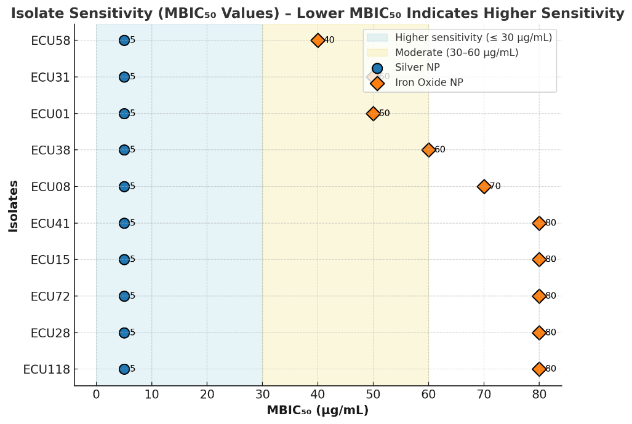 | Graph 1: MBIC₅₀-Based Sensitivity of E. coli Isolates to Silver and Iron Oxide Nanoparticles
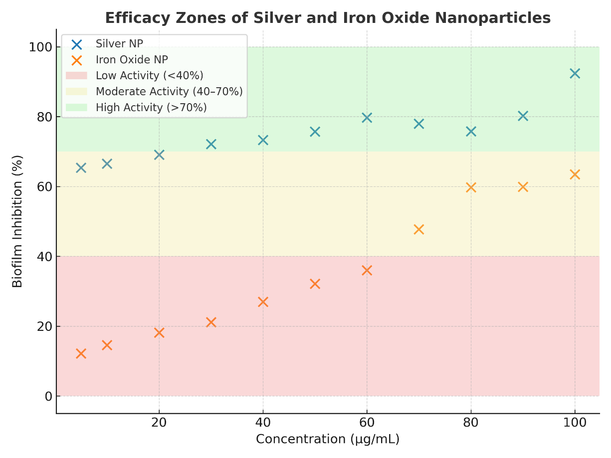 | Graph 2: Biofilm Inhibition Profile of Silver and Iron Oxide Nanoparticles Across Concentrations

A | B
 | 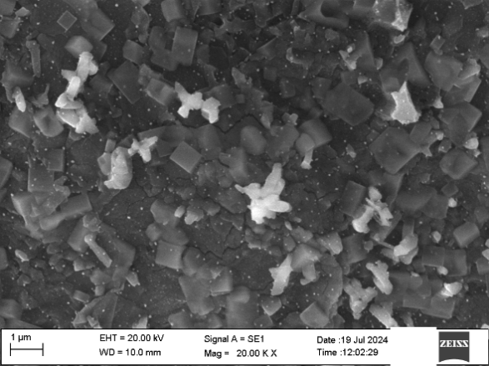
Fig. 1 Representative scanning electron microscopy image of (A) FeONPs and (B) AgNPs

A | B
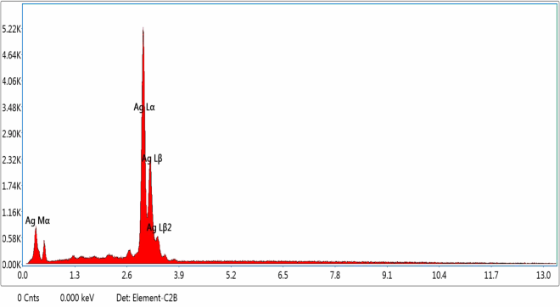 | 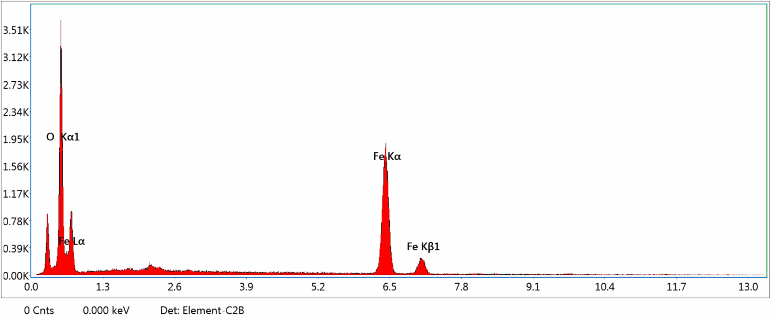
Fig. 2 Representative EDAX spectrum of (A) Silver and (B) Iron oxide nanoparticle

DISCUSSION
This study investigated the comparative efficacy of silver nanoparticles and iron oxide nanoparticles as antibiofilm agents, particularly against clinical isolates relevant to catheter-associated urinary tract infections. Our findings demonstrate a significant and consistent superior antibiofilm activity of AgNPs over FeONPs, even at considerably lower concentrations. This research contributes to the growing body of evidence supporting the critical role of AgNPs as a potent antimicrobial alternative in an era challenged by increasing antimicrobial resistance.
AgNPs consistently exhibited potent antibiofilm action, achieving over 70% inhibition at concentrations as low as 30 µg/mL. This aligns with extensive literature supporting the rapid, broad-spectrum antibiofilm capabilities of silver nanoparticles, often effective at lower doses compared to other metallic nanoparticles (Yao et al., 2025) . A notable strength of AgNPs in our study was their uniform inhibitory effect, with a consistent MBIC₅₀ of 5 µg/mL across all tested isolates. This uniformity suggests a high degree of reliability for AgNPs in clinical applications, where variability in pathogen susceptibility often presents a challenge. The potent antimicrobial activity of AgNPs stems from their multifaceted mechanisms of action, including disruption of cellular processes, targeting the plasma membrane, release of Ag+ ions, interference with cell wall synthesis, and inhibition of DNA replication and ribosomal protein expression (Jangid et al., 2024) . These mechanisms underscore the broad-spectrum applicability of AgNPs and position Them as a promising alternative, especially against difficult-to-treat infections like those found in CAUTI patients, where biofilm formation and multidrug resistance are prevalent (AlQurashi et al., 2025; Rodrigues et al., 2024). Furthermore, the literature suggests that combining AgNPs with conventional antibiotics can enhance efficacy and mitigate the development of resistance, offering a promising avenue for further research to improve treatment outcomes (Fahmy et al., 2025)
In contrast, FeONPs demonstrated comparatively limited efficacy, requiring concentrations of 80 µg/mL or higher to achieve inhibition comparable to AgNPs. Most isolates treated with FeONPs did not reach MBIC₉₀ within the tested concentration range, highlighting their less potent antibiofilm activity in this context. Moreover, FeONPs exhibited marked variability in their efficacy between isolates, with some showing only moderate inhibition even at maximum concentrations. This variability underscores the substantial impact of bacterial strain-specific factors on FeONP efficacy, suggesting a less reliable and narrower-spectrum action compared to AgNPs (Es‐haghi et al., 2024).
The superior performance of AgNPs strongly supports their consideration as an alternative or adjunctive therapy for infections prevalent in CAUTI patients, reinforcing their suitability for incorporation into advanced antimicrobial catheter coatings. Our results corroborate findings that the incorporation of nanoparticles into catheter surfaces can effectively inhibit biofilm formation. (Almatroudi, 2025). FeONPs were not as effective on their own, but their unique magnetic properties and ability to be guided from the outside could be utilised in targeted drug delivery systems or as co-agents in combination therapies to specifically overcome biofilm resistance. (Álvarez et al., 2021). Future research should explore optimizing FeONPs through surface modification or novel combination strategies to enhance their therapeutic potential.
Despite the demonstrated potency of silver nanoparticles, it is crucial to acknowledge concerns regarding the potential for bacterial adaptation and the development of resistance over time (Casals et al., 2025). Therefore, long-term studies are essential to assess whether clinical application might select for reduced susceptibility to AgNPs. Continuous surveillance of AgNP-resistant strains is paramount to maintain their therapeutic effectiveness and to inform future antimicrobial strategies, ensuring their sustained utility in combating the persistent challenge of antimicrobial resistance.

CONCLUSION
This study systematically compared the antibiofilm efficacy of silver nanoparticles and iron oxide nanoparticles against clinically relevant bacterial isolates. Our findings unequivocally demonstrate the superior and consistent antibiofilm activity of AgNPs at significantly lower concentrations compared to FeONPs(Fahmy et al., 2025) . AgNPs exhibited potent, broad-spectrum inhibition, attributed to their multifaceted mechanisms of action and a notable uniformity in their minimum biofilm inhibitory concentrations (Trzcińska-Wencel et al., 2023).
While FeONPs showed limited antibiofilm efficacy, requiring higher concentrations and exhibiting greater variability, their unique properties suggest potential for targeted drug delivery or as components in combination therapies (Es‐haghi et al., 2024) . The robust performance of AgNPs underscores their significant promise as a reliable alternative or adjunctive therapy for preventing and treating infections, particularly those associated with catheter-related biofilms, and reinforces their suitability for incorporation into advanced antimicrobial coatings (Frippiat et al., 2025).
Ultimately, this research contributes valuable data to the ongoing effort to combat antimicrobial resistance. However, continued surveillance and long-term studies are crucial to monitor potential resistance development against AgNPs, ensuring their sustained effectiveness and guiding future strategies in the ever-evolving landscape of antimicrobial therapeutics (Jangid et al., 2024).

REFERENCES
- Almatroudi, A. (2025). Biofilm resilience: Molecular mechanisms driving antibiotic resistance in clinical contexts. Biology, 14(2), 165. https://doi.org/10.3390/biology14020165
- AlQurashi, D. M., AlQurashi, T. F., Alam, R., Shaikh, S., & Tarkistani, M. A. M. (2025). Advanced nanoparticles in combating antibiotic resistance: Current innovations and future directions. Journal of Nanotheranostics, 6(2), 9. https://doi.org/10.3390/jnt6020009
- Álvarez, E., Estévez, M., Jiménez‐Jiménez, C., Colilla, M., Izquierdo‐Barba, I., González, B., & Vallet‐Regí, M. (2021). A versatile multicomponent mesoporous silica nanosystem with dual antimicrobial and osteogenic effects. Acta Biomaterialia, 136, 570–582. https://doi.org/10.1016/j.actbio.2021.09.027
- Beyth, N., Houri‐Haddad, Y., Domb, A. J., Khan, W., & Hazan, R. (2015). Alternative antimicrobial approach: Nano-antimicrobial materials. Evidence-Based Complementary and Alternative Medicine, 2015, 246012. https://doi.org/10.1155/2015/246012
- Casals, E., Gustà, M. F., Bastús, N. G., Rello, J., & Puntes, V. (2025). Silver nanoparticles and antibiotics: A promising synergistic approach to multidrug-resistant infections. Microorganisms, 13(4), 952. https://doi.org/10.3390/microorganisms13040952
- Crintea, A., Carpa, R., Mitre, A.-O., Petho, R. I., Chelaru, V.-F., Nădășan, S.-M., Neamți, L., & Duţu, A. (2023). Nanotechnology involved in treating urinary tract infections: An overview. Nanomaterials, 13(3), 555. https://doi.org/10.3390/nano13030555
- Dutt, A., Sharma, N., Singh, R., & Verma, A. (2022). Multifaceted antibacterial and antibiofilm potential of silver nanoparticles: Mechanisms and biomedical applications. Journal of Applied Microbiology, 132(4), 2445–2459. https://doi.org/10.1111/jam.15329
- El‐Saadony, M. T., Saad, A. M., Mohammed, D. M., Korma, S. A., Alshahrani, M. Y., Ahmed, A. E., et al. (2025). Medicinal plants: Bioactive compounds, biological activities, combating multidrug-resistant microorganisms, and human health benefits—A comprehensive review. Frontiers in Immunology, 16, 1491777. https://doi.org/10.3389/fimmu.2025.1491777
- Es‐haghi, A., Amiri, M. S., & Yazdi, M. E. T. (2024). Ferula latisecta gels for synthesis of zinc/silver binary nanoparticles: Antibacterial effects against gram-negative and gram-positive bacteria and physicochemical characteristics. BMC Biotechnology, 24(1). https://doi.org/10.1186/s12896-024-00878-x
- Fahmy, N., Abdel-Kareem, M., Ahmed, H. A., Helmy, M., & Mahmoud, E. (2025). Evaluation of particles and their synergistic effect with antibiotics on nosocomial bacteria. Microbial Cell Factories, 24(1). https://doi.org/10.1186/s12934-024-02604-w
- Frippiat, T., Art, T., & Delguste, C. (2025). Silver nanoparticles as antimicrobial agents in veterinary medicine: Current applications and future perspectives. Nanomaterials, 15(3), 202. https://doi.org/10.3390/nano15030202
- Hetta, H. F., Ramadan, Y. N., Al-Harbi, A. I., Ahmed, E. A., Battah, B., Ellah, N. H. A., Zanetti, S., & Donadu, M. G. (2023). Nanotechnology as a promising approach to combat multidrug resistant bacteria: A comprehensive review and future perspectives. Biomedicines, 11(2), 413. https://doi.org/10.3390/biomedicines11020413
- Iaconis, A., Plano, L. M. D., Caccamo, A., Franco, D., & Conoci, S. (2024). Anti-biofilm strategies: A focused review on innovative approaches. Microorganisms, 12(4), 639. https://doi.org/10.3390/microorganisms12040639
- Jangid, H., Singh, S., Kashyap, P., Singh, A., & Kumar, G. (2024). Advancing biomedical applications: An in-depth analysis of silver nanoparticles in antimicrobial, anticancer, and wound healing roles. Frontiers in Pharmacology, 15, 1438227. https://doi.org/10.3389/fphar.2024.1438227
- Jubair, N., Rajagopal, M., Fatima, A., Mahdi, Y. K., & Abdullah, N. H. (2022). Evaluation of catechin synergistic and antibacterial efficacy on biofilm formation and acrA gene expression of uropathogenic E. coli clinical isolates. Antibiotics, 11(9), 1223. https://doi.org/10.3390/antibiotics11091223
- Kolte, N. A., Tumane, P. M., & Wasnik, D. D. (2017). Extracellular biosynthesis and characterization of silver nanoparticles by Bacillus cereus GAD20 and their antibacterial potential against E. coli and S. aureus. International Journal of Current Research, 9(11), 61849–61856.
- Kumar, L., Bisen, M., Harjai, K., Chhibber, S., Azizov, S., Lalhlenmawia, H., & Kumar, D. (2023). Advances in nanotechnology for biofilm inhibition. ACS Omega, 8(24), 21391–21402. https://doi.org/10.1021/acsomega.3c02239
- Mancuso, G., Trinchera, M., Midiri, A., Zummo, S., Vitale, G., & Biondo, C. (2024). Novel antimicrobial approaches to combat bacterial biofilms associated with urinary tract infections. Antibiotics, 13(2), 154. https://doi.org/10.3390/antibiotics13020154
- Olawade, D. B., Wada, O. Z., Fapohunda, O., Egbewole, B. I., Ajisafe, O., & Ige, A. O. (2024). Nanoparticles for microbial control in water: Mechanisms, applications, and ecological implications. Frontiers in Nanotechnology, 6, 1427843. https://doi.org/10.3389/fnano.2024.1427843
- Panáček, A., Kvı́tek, L., Smékalová, M., Večeřová, R., Kolář, M., Röderová, M., Dyčka, F., Šebela, M., Prucek, R., Tomanec, O., & Zbořil, R. (2017). Bacterial resistance to silver nanoparticles and how to overcome it. Nature Nanotechnology, 13(1), 65–71. https://doi.org/10.1038/s41565-017-0013-y
- Patra, D., Ghosh, S., Mukherjee, S., Acharya, Y., Mukherjee, R., & Haldar, J. (2024). Antimicrobial nanocomposite coatings for rapid intervention against catheter-associated urinary tract infections. Nanoscale, 16(23), 11109–11121. https://doi.org/10.1039/d4nr00653d
- Pinto, R. M., Lopes, D., Martins, M. C. L., Dijck, P. V., Nunes, C., & Reis, S. (2019). Impact of nanosystems in Staphylococcus aureus biofilms treatment. FEMS Microbiology Reviews, 43(6), 622–637. https://doi.org/10.1093/femsre/fuz021
- Rodrigues, A. S., Batista, J. G. S., Rodrigues, M. Á. V., Thipe, V. C., Minarini, L. A. da R., Lopes, P. S., & Lugão, A. B. (2024). Advances in silver nanoparticles: A comprehensive review on their potential as antimicrobial agents and their mechanisms of action elucidated by proteomics. Frontiers in Microbiology, 15, 1440065. https://doi.org/10.3389/fmicb.2024.1440065
- Salwiczek, M., Qu, Y., Gardiner, J., Strugnell, R. A., Lithgow, T., McLean, K. M., & Thissen, H. (2013). Emerging rules for effective antimicrobial coatings. Trends in Biotechnology, 32(2), 82–90. https://doi.org/10.1016/j.tibtech.2013.09.008
- Sánchez, S. V., Navarro, N. A. G., Catalan, J., & Morales, J. (2021). Nanoparticles as potential novel therapies for urinary tract infections. Frontiers in Cellular and Infection Microbiology, 11, 656496. https://doi.org/10.3389/fcimb.2021.656496
- Swolana, D., Kępa, M., Idzik, D., Dziedzic, A., Kabała‐Dzik, A., Wąsik, T. J., & Wojtyczka, R. D. (2020). The antibacterial effect of silver nanoparticles on Staphylococcus epidermidis strains with different biofilm-forming ability. Nanomaterials, 10(5), 1010. https://doi.org/10.3390/nano10051010
- Thomas, R., Nair, A. P., K. R., Mathew, J., & EK, R. (2014). Antibacterial activity and synergistic effect of biosynthesized AgNPs with antibiotics against multidrug-resistant biofilm-forming coagulase-negative staphylococci isolated from clinical samples. Applied Biochemistry and Biotechnology, 173(2), 449–460. https://doi.org/10.1007/s12010-014-0852-z
- Trzcińska-Wencel, J., Wypij, M., Rai, M., & Golińska, P. (2023). Biogenic nanosilver bearing antimicrobial and antibiofilm activities and its potential for application in agriculture and industry. Frontiers in Microbiology, 14, 1125685. https://doi.org/10.3389/fmicb.2023.1125685
- Wasfi, R., Hamed, S. M., Amer, M. A., & Fahmy, L. I. (2020). Proteus mirabilis biofilm: Development and therapeutic strategies. Frontiers in Cellular and Infection Microbiology, 10, 414. https://doi.org/10.3389/fcimb.2020.00414
- Xie, Y., Liu, H., Teng, Z., Ma, J., & Liu, G. (2025). Nanomaterial-enabled anti-biofilm strategies: New opportunities for treatment of bacterial infections. Nanoscale. https://doi.org/10.1039/d4nr04774e
- Yao, L., Yuan, L., Guo, X., Jiang, N., Xu, L., Zhao, Q., Xu, Y., & Li, J. (2025). Curcumin biosynthesized silver nanoparticles-loaded polycaprolactone nanofibers for antibacterial applications. Materials Technology, 40(1). https://doi.org/10.1080/10667857.2024.2445641

