Original Research Article
DETERMINATION OF AZOXYSTROBIN AND COPPER RESIDUES IN ROHU, LABEO ROHITA, INDIVIDUALLY AND IN COMBINATION ALONG WITH THE USE OF ACTIVATED CHARCOAL

ABSTRACT:
This research aims to understand the toxic impact of the fungicide Azoxystrobin and the heavy metal Copper on Rohu (Labeo rohita) and potential role of activated charcoal in mitigating their effects. In the present study the experimental fish used as an analytical matrix for residue analysis of selected toxicants. These are affecting every aspect of fish physiology, including biochemical, histology, haematology and behaviour. The data represents maximum amount of copper residues found in the liver tissues of 1 day lethal and 14 days sublethal exposures but in the case of 1day sublethal exposures the maximum residues were noticed in intestine except in the liver of AZ-CS exposure. In this study tissue specific bioconcentration was observed for Azoxystrobin and copper in intestine, liver, and Kidney. The minimum amount of residues were found in in the combination of activated charcoal exposures due to their ability to bind the conjugated drug.

Key words: Physiology, Biochemical, Histology, Haematology and Behaviour

- Introduction:
In recent years, numerous s studies have shown fish plays a major role in aquatic environmental toxicological studies. According to Indian Pesticides Industry, Credit Analysis & Research Limited, 2011 The Indian pesticide industry is dominated by insecticides, whereas globally, herbicides and fungicides are the key segments. Our state Andhra Pradesh is the first highest pesticide consuming state in India. In recent studies, a residue of fungicide was most frequently detected pesticide in food products, etc., and thereby raising public concern on safety. Fish representing as bio- indicators of environmental contamination and may play an important role in the evaluation of the potential risk of pollution in aquatic environments, since they may

directly expose to chemicals caused by agricultural output through runoff or indirectly by food chain of the ecosystem, this may reflect the biological influences of environmental contamination in water (Ramesh et al., 2009).
Heavy metals, metalloids and pesticides when occurring in higher concentrations, become severe poisons for all living organisms (Kaoud Hussein 2015). Many of these chemical residues, especially derivatives of chlorinated pesticides, exhibit bioaccumulation which could build up to harmful levels in the body as well as in the environment (Crinnion, 2009). Due to bioconcentration, bioaccumulation and biomagnification processes chemical residues are accumulated into organisms, concentrated into organs; magnified from one organism to another, one species to another species through food chain and food web. Persistent chemicals can be magnified through the food chain and have been detected in products ranging from meat, poultry and fish, to vegetable oils, nuts and various fruits and vegetables.
Pesticide residue defined as the pesticides that may remain on or in food after they are applied to food crops. According Rahman et al., 2021 most vegetable samples tested positive for pesticide residues exceeding Maximum Residue Levels. The maximum allowable levels of these residues in foods are often stipulated by regulatory bodies in many countries. Regulations such as pre-harvest intervals also often prevent harvest of crop or livestock products if recently treated in order to allow residue concentrations to decrease over time to safe levels before harvest. Exposure of the general population to these residues most commonly occurs through consumption of treated food sources. Chen et al., 2004 determined residue of azoxystrobin on Chinese cabbage, declined from 4.10 to 0.63 mg per kg with 18 days and from 13.21 to 0.10 mg per kg within 9 days on Chinese kale. The results Sundravadana et al., 2008 revealed that the half-life of azoxystrobin in mango, when sprayed at recommended dose (1.0 mL per L) was one day and residue dissipates within three days after spray. For HPLC-UV analysis of Azoxystrobin recoveries ranged between 83.69% to 91.58% and 81.99% to 107.85% for green beans and peas, respectively. For GC–MS analysis, mean recoveries ranged from 76.29% to 94.56% and 80.77% to 100.91% for green beans and peas, respectively (Abdel raheem et al., 2015).

As demand for food is increasing, so provide the quality of food in India should be geared up in order to meet increasing demand for food. The wide use of pesticides for agricultural performance represents thousands of molecules with an enormous variety of physicochemical properties that are hazardous not only to living organisms but also non-living things like air, water and soil. It is due to contamination of a number of ecosystems, including sediments, water and biota. In order to protect aquatic biota, it is necessary to determine contamination levels of trace elements through chemical biomonitering and evaluation of biomarkers that represent early indicators of biological effects (Annabi et al., 2013). Fishes are better bioindicators of specific pesticides and heavy metal contamination compared to others by bearing some special characteristics. Hence, the present study was planned to estimate the residues of Azoxystrobin, Copper and their combine mixture in water samples as well as in intestine, liver and Kidney tissues of freshwater fish Labeo rohita.
- Materials and methods:
The toxicity study was conducted using 15 litres capacity of experimental containers; each container was filled with 10 liters of tap water and 10 fishes. Three different groups (A, B and C) were maintained. A (Azoxystrobin), B (Copper) and C (combined synergism) groups contains six different treatments, it follows 1 day lethal, 1 day lethal+ AC, 1 day sublethal, 1 day sublethal+ AC, 14 days sublethal and 14 days sublethal+ AC. Among them 9 treatments with charcoal and another 9 treatments are without charcoal. The dosage of AC is determined either by the amount of toxin ingested if known or by the body weight of the person concerned. When the amount of toxin to be bound is known 10 times more AC should be given (Olson, 2010). i.e the dosage ratio of activated charcoal to toxin is described as 10:1 or 0.5 to 1g/kg Body weight (Zellner T et al., 2019) 1 mg AC per 1g body weight of the test fish Labeo rohita. Hence, in the present study I have given 10 times more AC (mg) according to the fish body weight (gm) to maintained balanced dosage in all the AC exposed containers. After the addition of the activated charcoal the containers were leaving out allowed staying for some time.
Later the doses of 96hrs lethal concentrations and Sublethal concentrations of Azoxystrobin, Cu and their combine mixture are 3.30 mg/L, 2.90 mg/L, 1.75 mg/L and (1/10th of LC50) 0.33mg/L, 0.29mg/L, 0.175mg/L respectively were added to all test groups. The selected organs such as intestine, kidney and liver were isolated after

1day lethal, 1 day sublethal and 14days sublethal for conducting the experiments. The treated Water was also analyzed for the residue of Azoxystrobin, Copper sulfate and their combine mixture.
Test chemicals:
  - Azoxystrobin,
  - Copper
  - Combine mixture.
- Azoxystrobin:
Instrumentation:
Analysis and validation was performed using Waters 2695 Alliance HPLC system (Waters Corporation, Milford, MA, USA) consisting of quaternary pump, auto injector, column compartment with temperature control, online degasser using Waters 487 UV detector. The LC is interfaced with a mass spectrometer coupled with an electrospray ionization source operated in the positive mode.
Table.1: Chemicals and Solvents:

Methanol | HPLC Grade and purchased from Thermo Fisher Scientific India private limited, Mumbai.
Acetonitrile | HPLC Grade and purchased from Merck chemicals private limited, Mumbai
Water | HPLC Grade and purchased from Thermo Fisher Scientific India private limited, Mumbai.
Acetone | AR grade ethanol purchased from Thermo Fisher Scientific India private limited, Mumbai.
Hexane | AR grade hexane purchased from Thermo Fisher Scientific India private limited, Mumbai.
Preparation of solutions:
Preparation of mobile phase:
Methanol, Acetonitrile and 0.05% Formic acid in the ratio of 65:30:05 (v/v) respectively and sonicated the solution for ten minutes to ensure the homogeneous mixing using ultra sonicater, and then it was filtered through 0.45 µ nylon membrane filter paper using vacuum filtration set. An equal ratio of methanol and acetonitrile was used as diluent in the analysis. For the preparation of diluents solution, 50mL of methanol was transferred into a 100 mL reagent bottle and 50mL of acetonitrile was added, mixed and sonicated for 5 minutes.

Preparation of calibration standards and quality control samples:
Standard stock solution was prepared by dissoving analytical standard azoxystrobin (C22H17N3O5; 96% purity) in acetone. Working solution was prepared by diluting the standard stock solution with acetone, which was then used for sample fortification (10, 12, 14, 16 and 18ng/ml) and for injection in the LC system.
Sample extraction procedure:
Extraction method
A QuEChERS extraction procedure was developed for the fish muscle having a weight of 3 g. Fish samples were thawed out at +4 °C, grinded, and 3 g of muscle was sampled in 50 mL polypropylene centrifuge tube. Four millilitres of acetonitrile was added. A high performance disperser, ultra-turrax (IKA, Lille, France), was used to grind the sample in tubes maintained in water at 20 °C. Ultra-turrax was then rinsed with 6 mL of acetonitrile. One millilitre of ultrapure water, 3 mL of hexane and200 μL of internal standards solution at 50 μg L−1 (diflufenican-d3, carbendazim-d4 and isoproturon-d3) were added, and the mixture was shaken during 30 s. Next, citrate salts (Agilent Sample QuEChERS (quick, easy, cheap, effective, rugged and safe method) extraction) was added directly in the tube; the mixture was immediately and manually shaken to avoid the agglomeration of salts and was vigorously shaken during 1 min.
A centrifugation (5,000 rpm, 2 min, 20°C) was performed, and upper phase (hexane) was removed. Six milliliters of the second liquid phase (acetonitrile) was transferred into a glass tube, and 50 μL of DMSO were added. After evaporation (under nitrogen stream at 40 °C) until 50 μL is left, residue was reconstituted in 2,950 μL of acetonitrile/water (10:90, v/v). Finally, the sample was capped, dark stored (−20
°C) and vortexes thoroughly before LC-MS/MS analysis (Lazartigues et al., 2011). HPLC Analysis followed by S. Sundravadana et al., 2008.
- Copper sulfate:
Instrumentation:
Analysis was performed one Inductive Coupled Plasma Optical Emission Spectrometer (ICP-OES) for metal determination.
Chemicals and Solvents:
LR grade perchloric acid, HNO3-HCLO4 purchased from Thermo Fisher Scientific India private limited, Mumbai

Extraction of Cu from tissue:
In the procedure 1 g of the samples was digested with perchloric acid and nitric acid ratio (1:1) HNO3-HCLO4, followed by sulphuric acid, and the mixture was heated at 200⁰C for 30mins.The complete digest was then cooled down to room temperature and made up to 10 ml scale with distilled water and analyzed for Cu, using Atomic ICP-OES for Copper metal determination. An analytical blank was prepared in a similar manner (Bawuro et al., 2018).
III. Results
Chromatography is an analytical technique and the objective is to separate the various components from a complex mixture. It plays an important role in the realms of food regulation, forensics, athlete testing, and quantity of accumulation of contaminated toxicants in the tissues of animals and human and to estimate quality in alcoholic drinks. A chromatogram can provide a wealth of information about the chemistry of the intermolecular interactions between the analytes and the stationary phase. Exposure samples introduced and volatilized in the injection port of the liquid chromatograph. They pass through a column, which is coated with material to attract the various components of the sample at varying degrees. This is called the stationary phase and it’s the level of attraction during this phase that causes components to separate and elute at different times, which shows as peaks on the resulting chromatogram.
In the present study obtained chromatogram are placed (Fig.2 to Fig.45) below. In the chromatogram the X-axis gives Retention Time. Usually, the x-axis of the liquid chromatogram shows the amount of time taken for the analytes to pass through the column and reach the mass spectrometer detector. The peaks that are shown in the chromatograms correspond to the time at which each of the components reached the detector. The type of column used during the analysis, as well as the LC parameters (e.g. flow rate, injection.), have a large impact on the retention time. The Y-axis showed Concentration or Intensity Counts and it is a reflection of the amount of a specific analyte that’s present.

All samples were found contaminated with different concentrations of selected toxicants. The highest level of Azoxystrobin concentration was recorded in the liver 28.690 µg/g of Az-CS.

Table.2: Preparation of Azoxystrobin standard Calibration curve:

S No | Concentration in ng/ml | Peak Area
1 | 10 | 20861
2 | 12 | 24615
3 | 14 | 28963
4 | 16 | 32527
5 | 18 | 35651
Fig.1: Azoxystrobin standard Calibration curve:
Azoxystrobin standard Calibration curve
40000

30000
y = 1874.6x + 2279
R² = 0.9968
20000

10000

0
0
5
10
Concentration in ng/ml
15
20
Area

Selected toxicants residue levels in water and tissues:
Table.3: Estimation of Azoxystrobin from exposure water samples:

S.NO | Sample Name | Area | Concentration in mg/10L (ppm)
1. | AZ+F+1L | 6491 | 22.476
2. | AZ+F+AC-1L | 3335 | 5.635
3. | AZ+F-1SL | 2598 | 1.702
4. | AZ+F+AC-1SL | 2396 | 0.624
5. | AZ+F-1L(CS) | 3625 | 7.182
6. | AZ+F+AC+AC-1L(CS) | 2569 | 1.547
7. | AZ+F-ISL(CS) | 2415 | 0.726
8. | AZ+F+AC-1SL x | 2351 | 0.384
AZ- Azoxystrobin, CS- Combine Synergism, F-Fish, AC- Activated Charcoal, 1L- 1day lethal and 1SL-1day Sublethal.

Fig.2: Chromatogram of Azoxystrobin exposure water exposed Fig.3: Chromatogram of Azoxystrobin exposure water along

to the freshwater fish Labeo rohita for 1 day Lethal.
with AC exposed to the freshwater fish Labeo rohita for 1 day lethal.

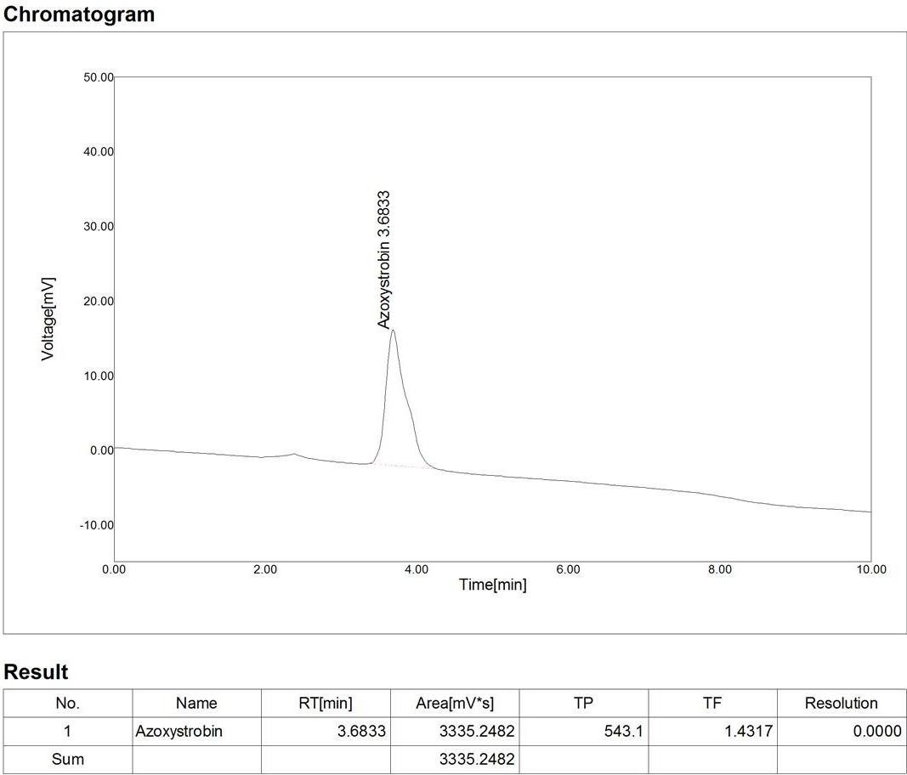
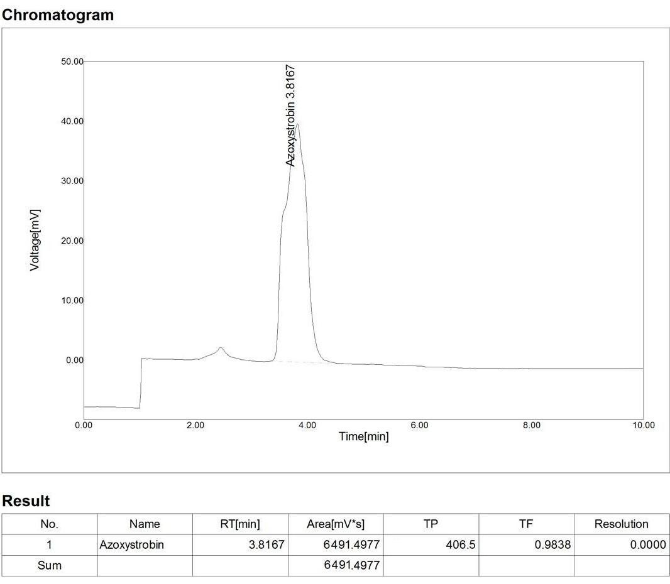
Lethal

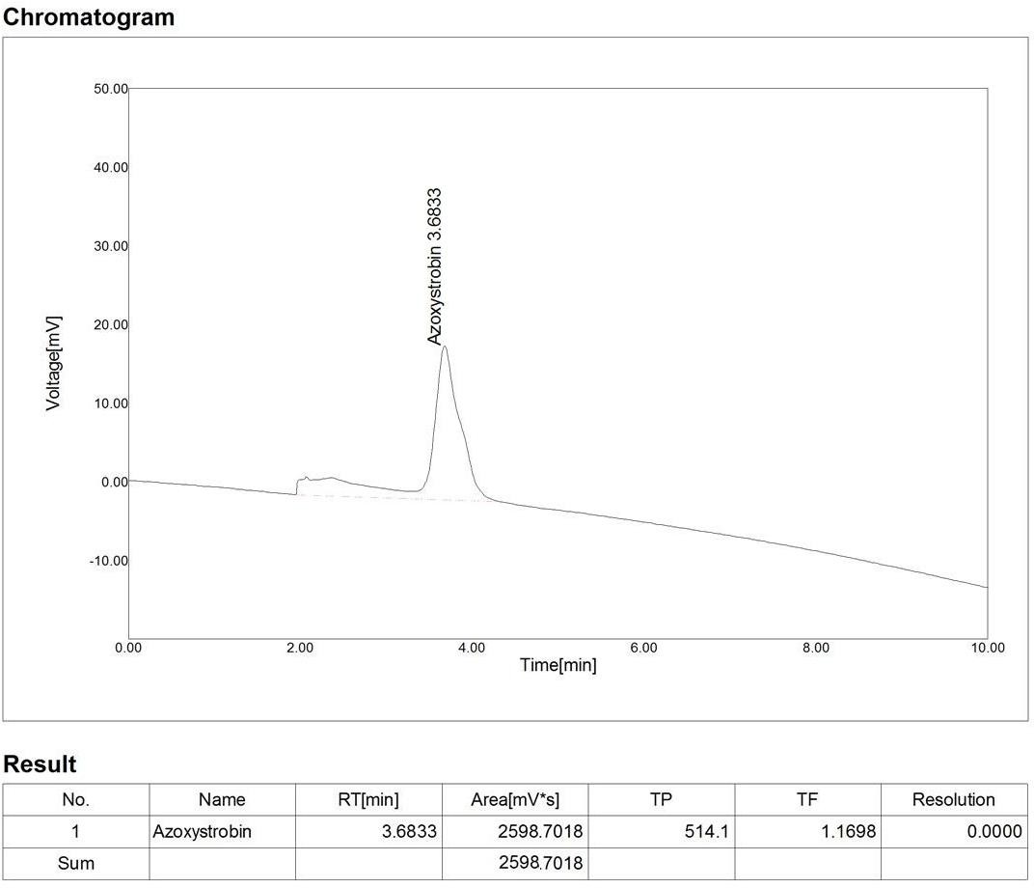
Fig.4: Chromatogram of Azoxystrobin exposure water exposed to the freshwater fish Labeo rohita for 1 day Sublethal.
Fig.5: Chromatogram of Azoxystrobin exposure water along with AC exposed to the freshwater fish Labeo rohita for 1 day Lethal.

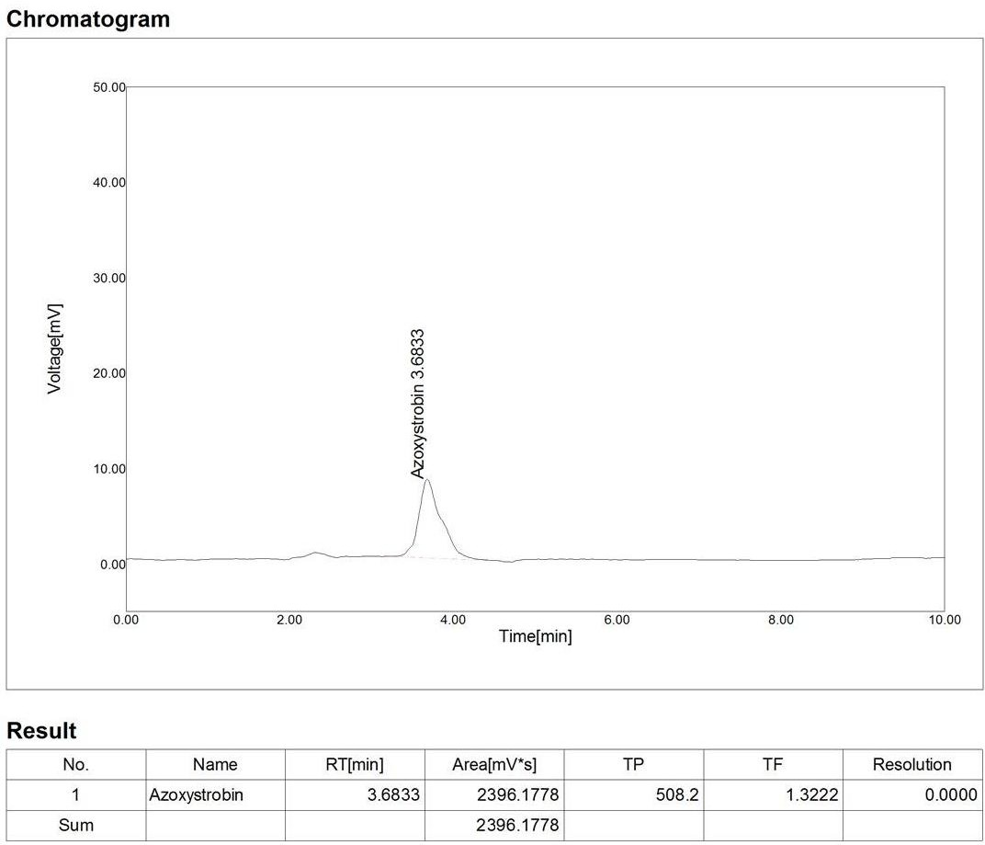

Fig.6: Chromatogram of Azoxystrobin from Combine Synergism exposure water exposed to the freshwater fish Labeo rohita for 1 day Lethal.
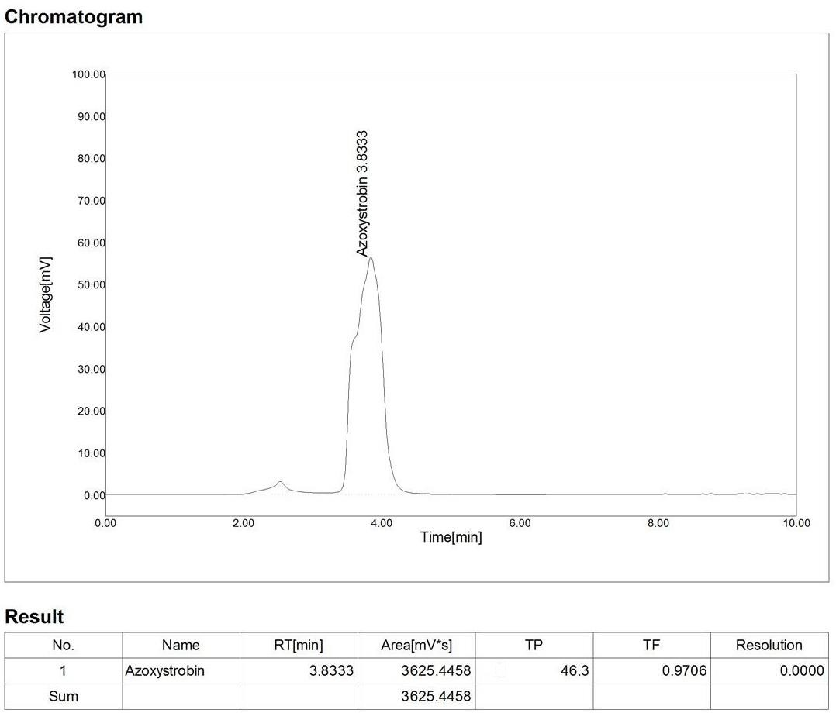
Fig.7: Chromatogram of Azoxystrobin from Combine Synergism along with AC exposure water exposed to the freshwater fish Labeo rohita for 1 day Lethal.
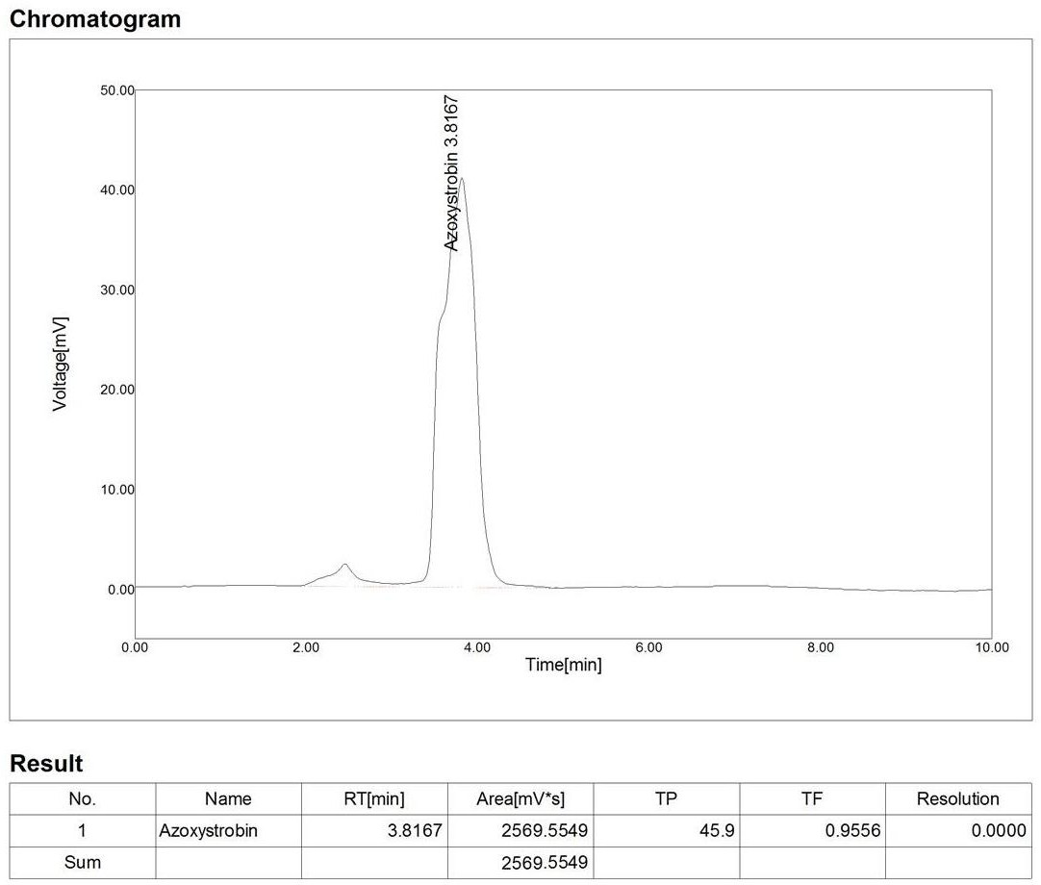
V

.Fig.8: Chromatogram of Azoxystrobin from Combine Synergism exposure water exposed to the freshwater fish Labeo rohita for 1 day Sublethal.
Fig.9: Chromatogram of Azoxystrobin from Combine Synergism exposure water along with AC exposed to the freshwater fish Labeo rohita for 1 day Sublethal.

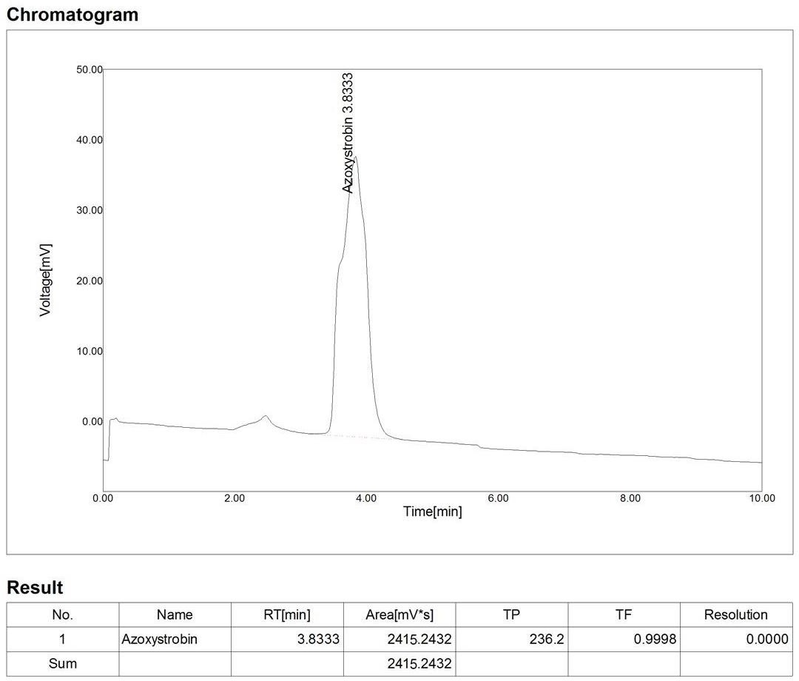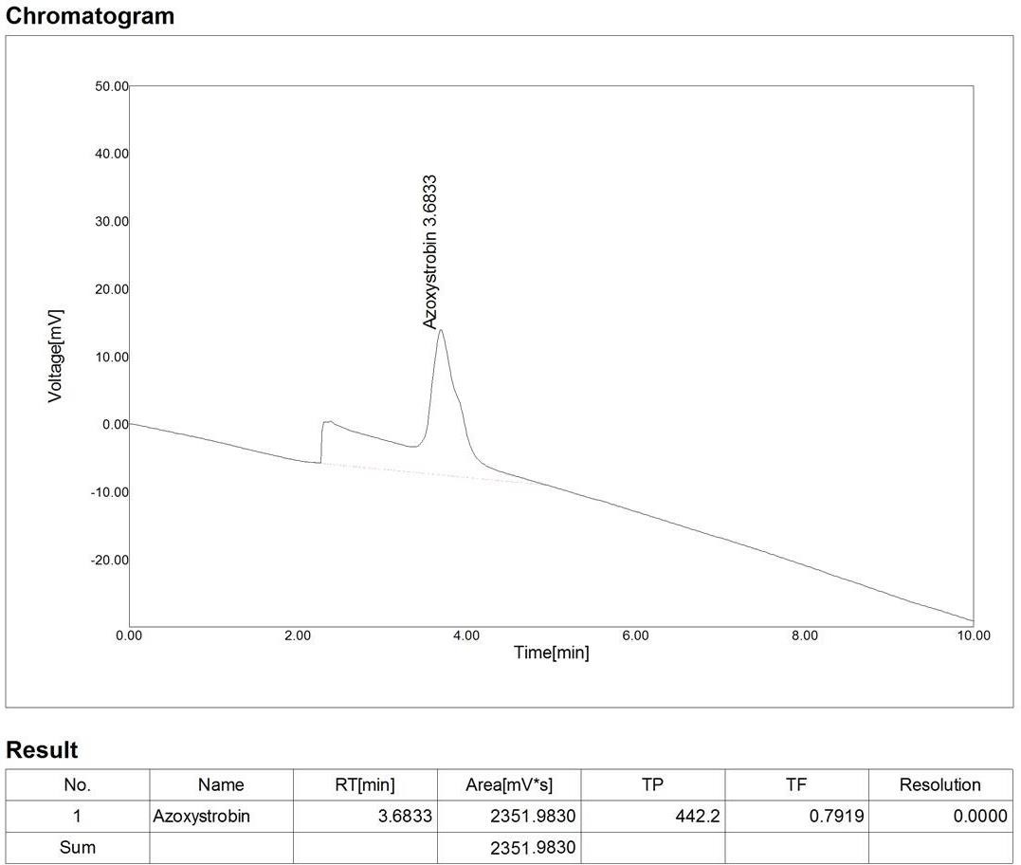

Fig. 10: Chromatogram of Azoxystrobin exposed to the freshwater fish Labeo rohita liver for 1 day Lethal.
Fig. 11. Chromatogram of Azoxystrobin along with AC exposed to the freshwater fish Labeo rohita liver for 1 day Lethal.

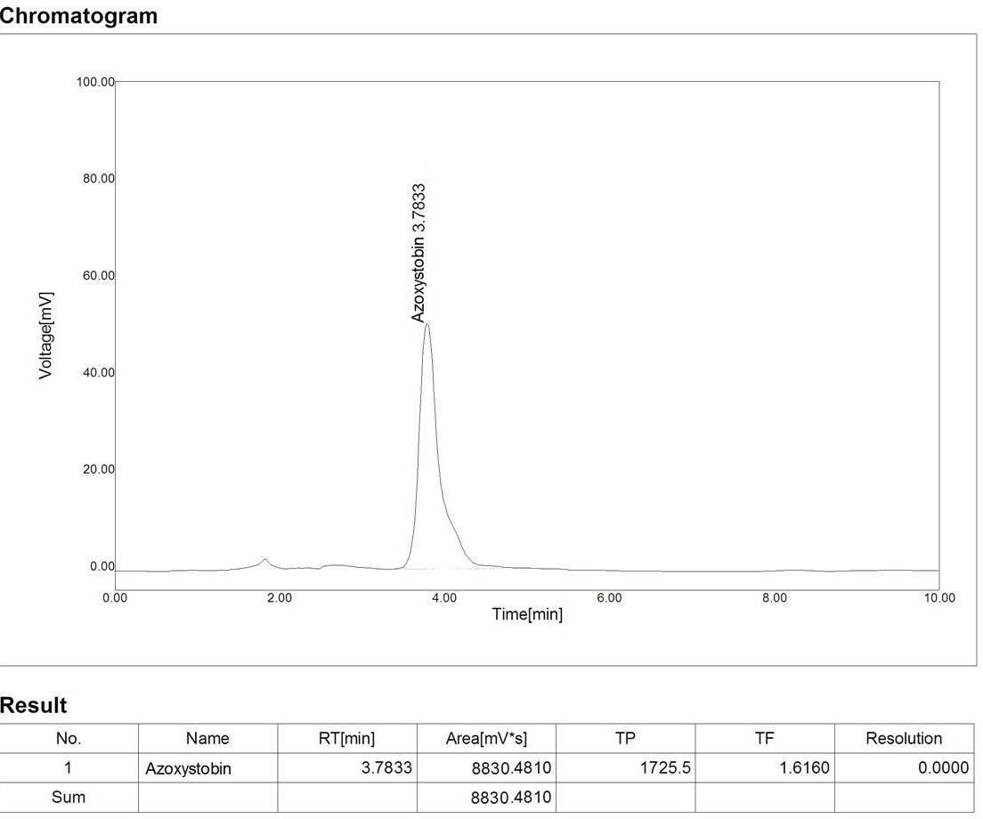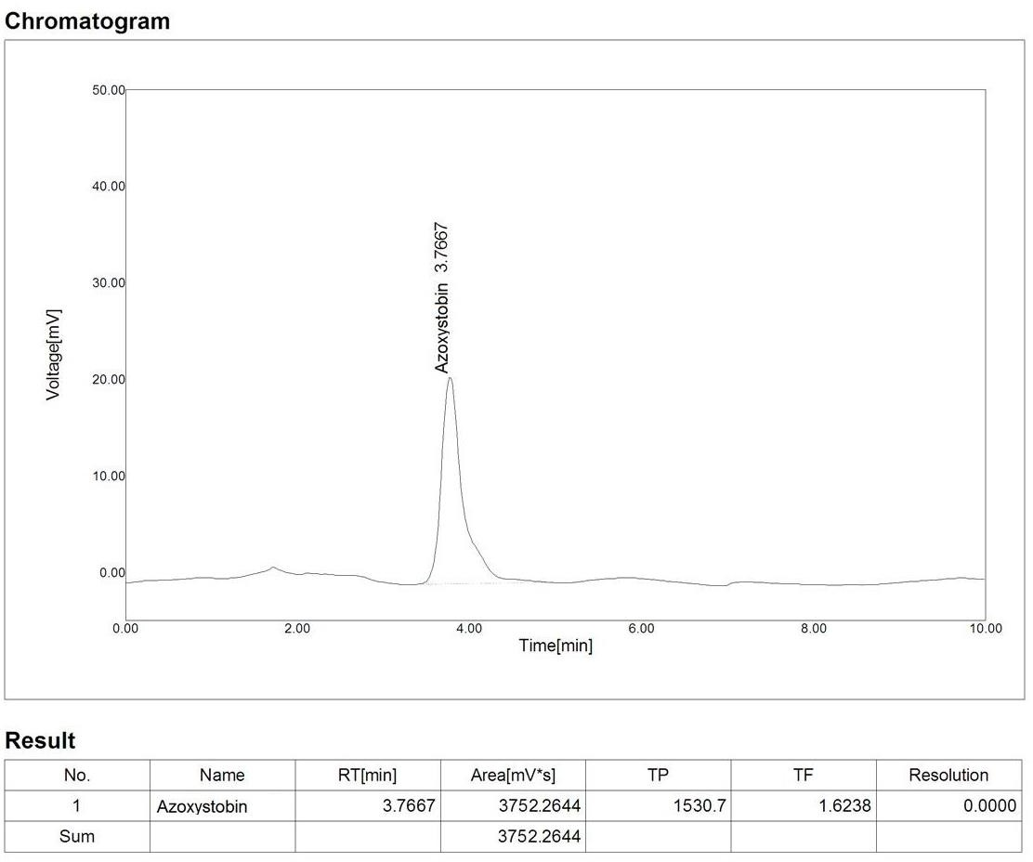

Fig..12: Chromatogram of Azoxystrobin exposed to the freshwater fish Labeo rohita Kidney for 1 day Lethal.
Fig..13. Chromatogram of Azoxystrobin along with AC exposed to the freshwater fish Labeo rohita Kidney for 1 day Lethal.

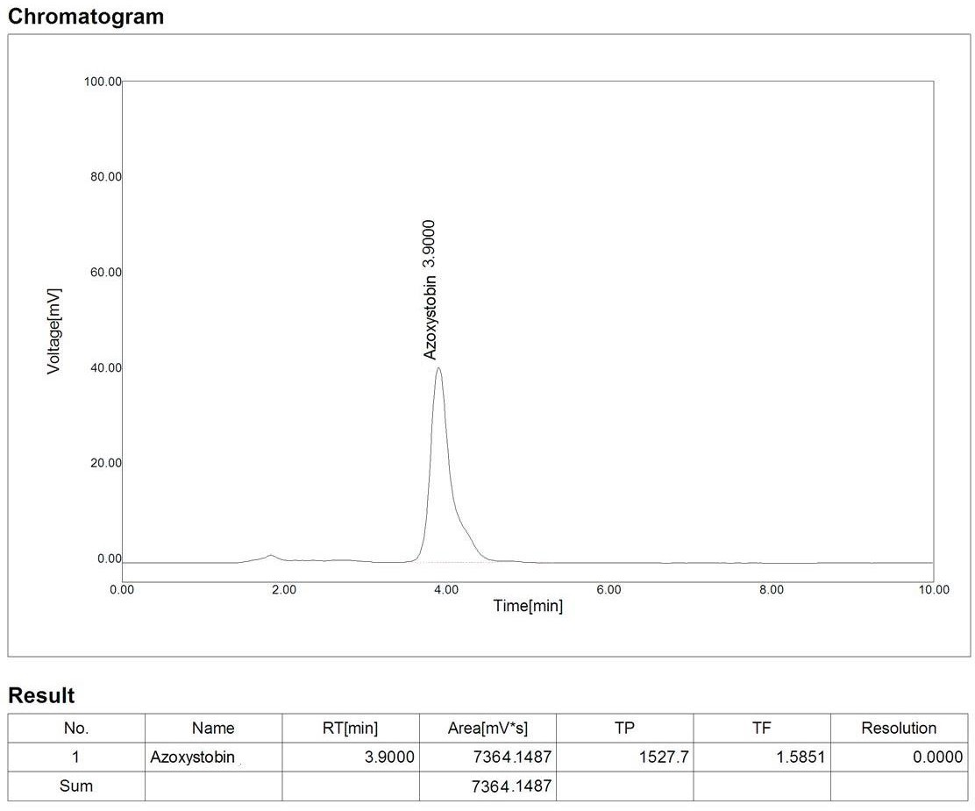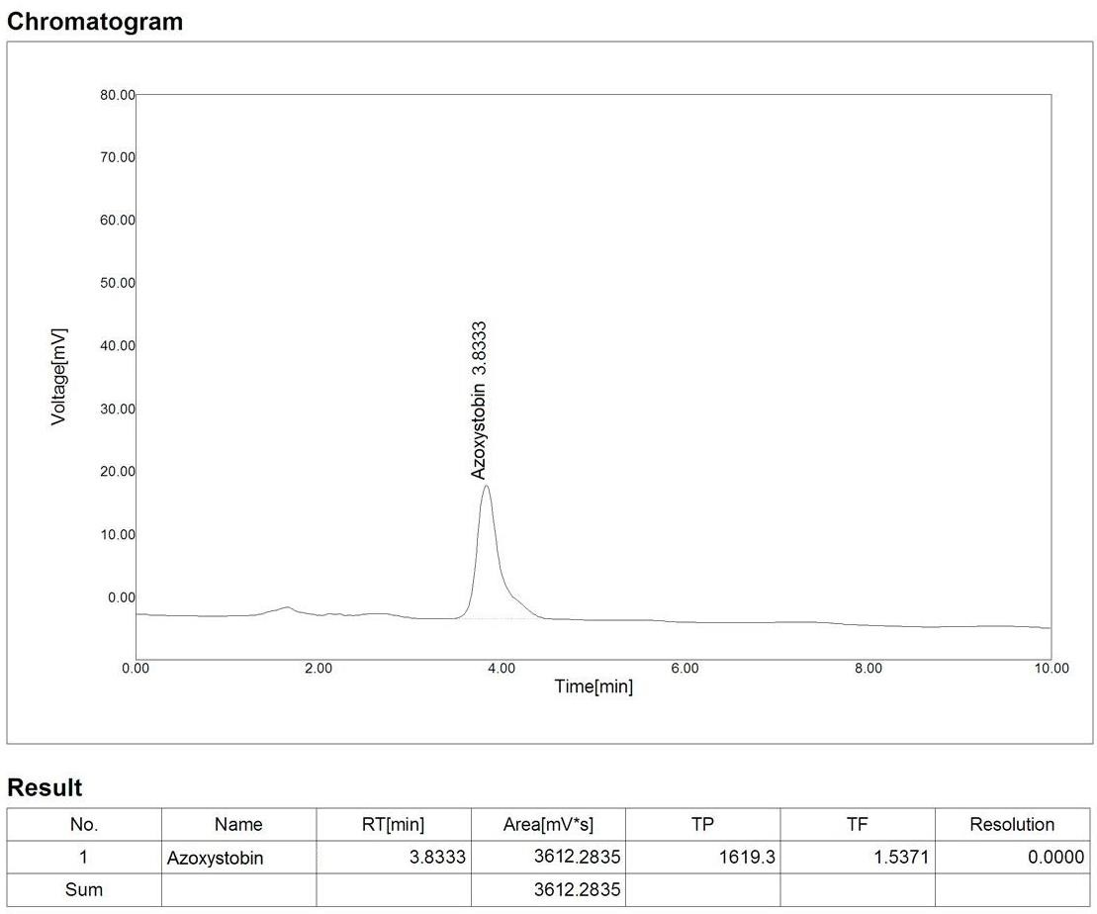

Fig.14: Chromatogram of Azoxystrobin exposed to the freshwater Fish Labeo rohita Intestine for 1 day Lethal.
Fig.15: Chromatogram of Azoxystrobin along with AC exposed to the freshwater fish Labeo rohita Intestine for 1 day Lethal.

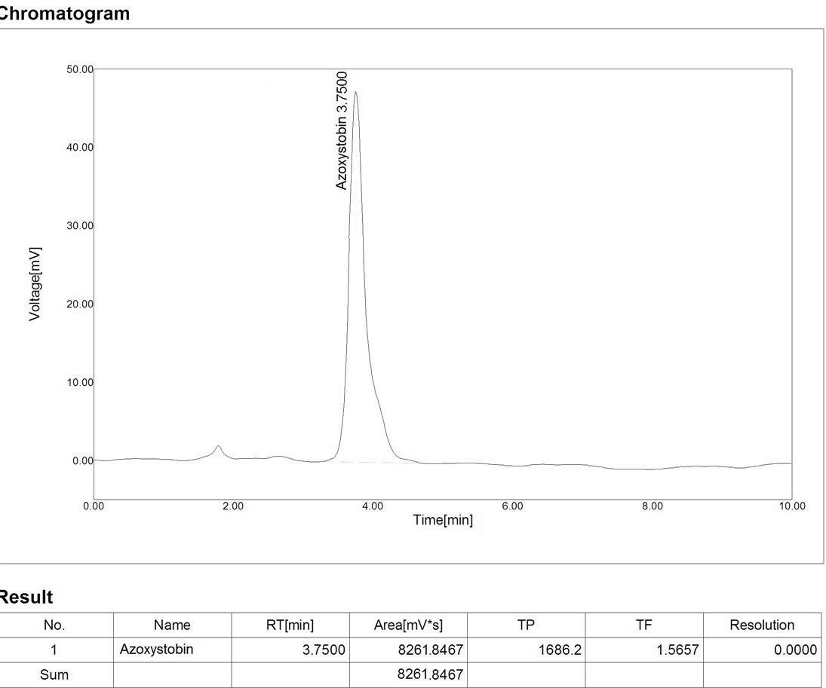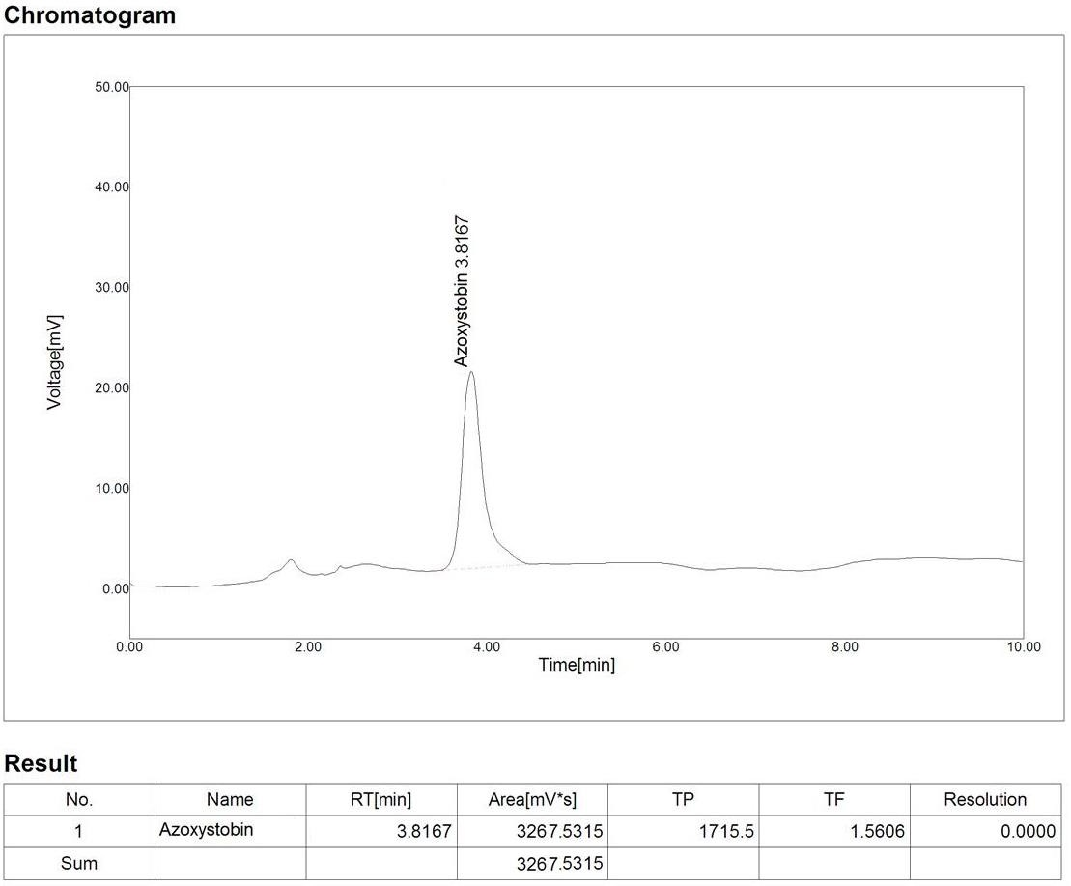

Fig.16: Chromatogram of Azoxystrobin (CS/Mix) exposed to the freshwater fish Labeo rohita liver for 1 day Lethal.
Fig.17: Chromatogram of Azoxystrobin (CS/Mix) along with AC exposed to the freshwater fish Labeo rohita liver for 1 day Lethal.

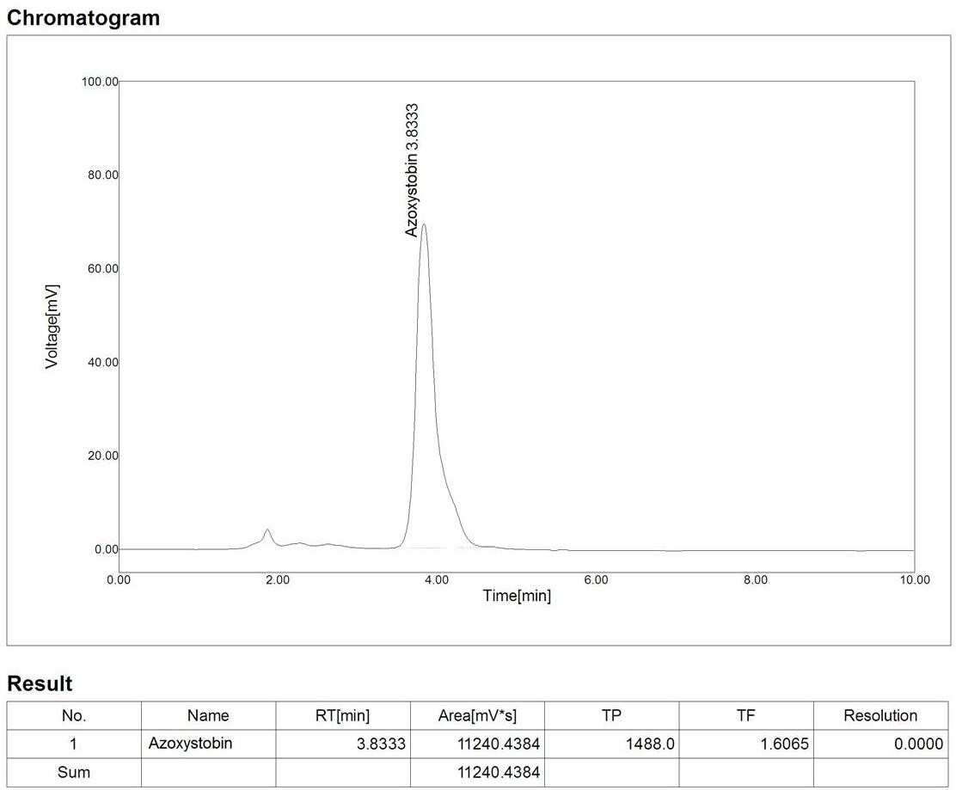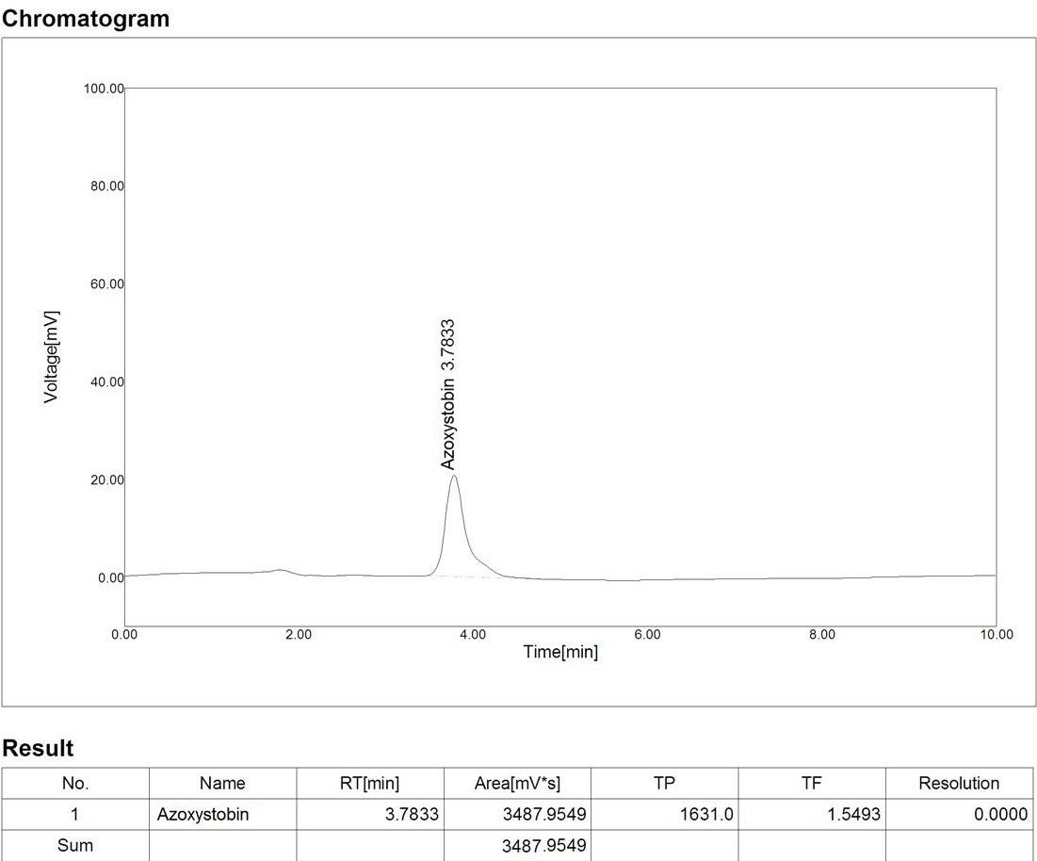

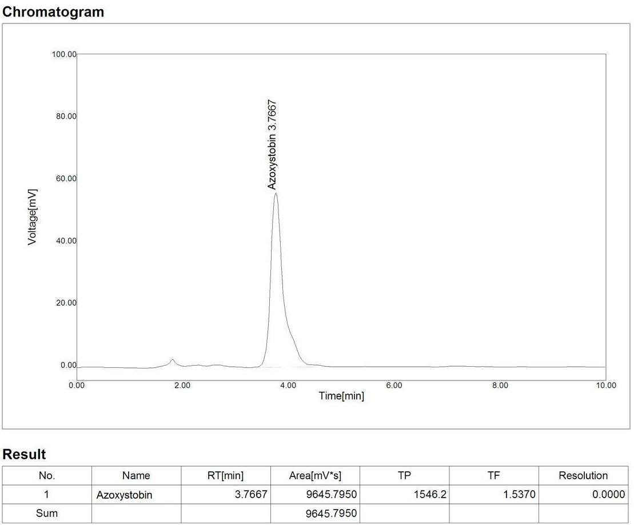
Fig.18: Chromatogram of Azoxystrobin (CS/Mix) exposed to the freshwater fish Labeo rohita Kidney for 1 day Lethal.
.Fig.19: Chromatogram of Azoxystrobin (CS/Mix) along with AC exposed to the freshwater fish Labeo rohita Kidney for 1 day Lethal.

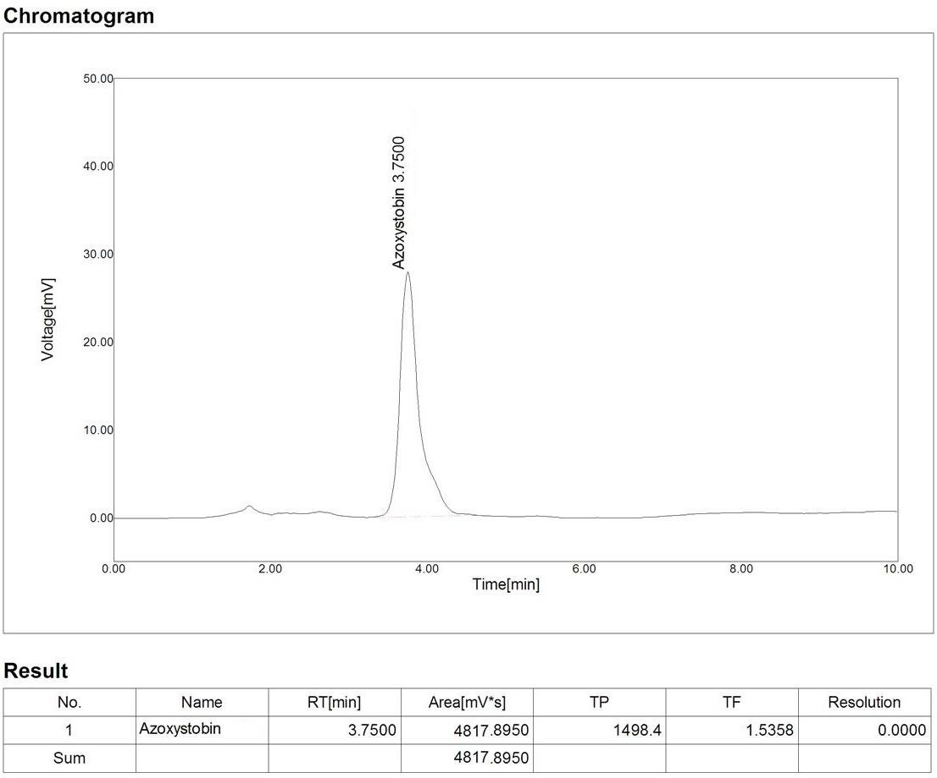

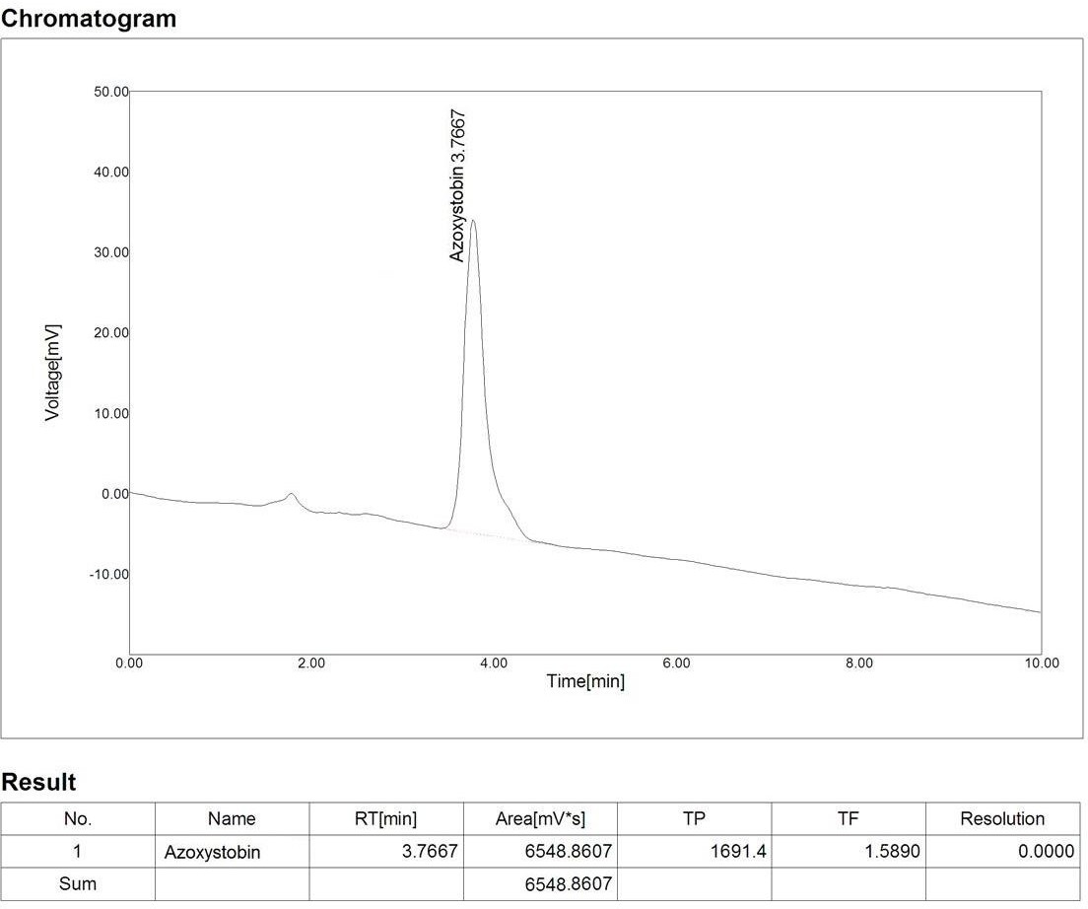
.Fig.20: Chromatogram of Azoxystrobin (CS/Mix) exposed to the freshwater fish Labeo rohita Intestine for 1 day Lethal.
Fig.21: Chromatogram of Azoxystrobin (CS/Mix) along with AC exposed to the freshwater fish Labeo rohita Intestine for 1 day Lethal.

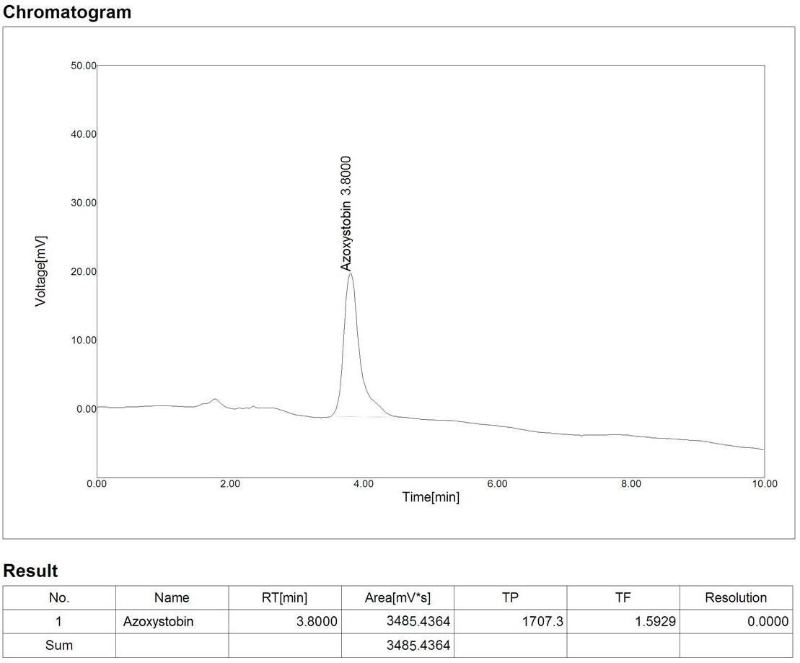

Fig.22: Chromatogram of Azoxystrobin exposed to the freshwater Fish Labeo rohita Intestine for 1 day Sublethal.
.Fig.23: Chromatogram of Azoxystrobin along with AC exposed to the freshwater Fish Labeo rohita Intestine for 1 day Sublethal.

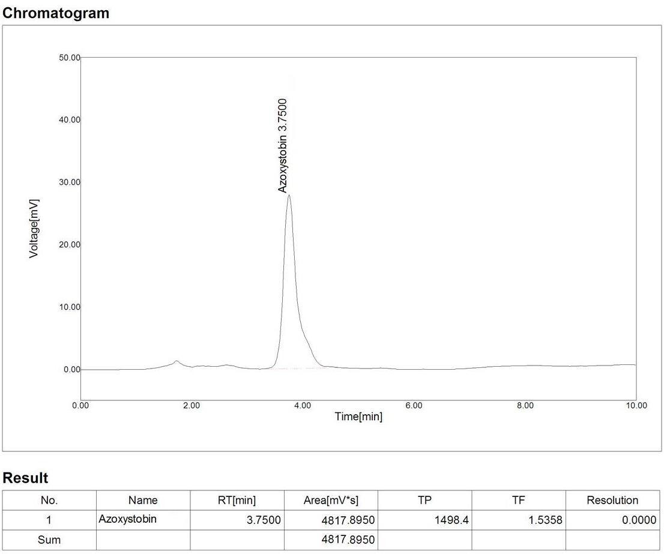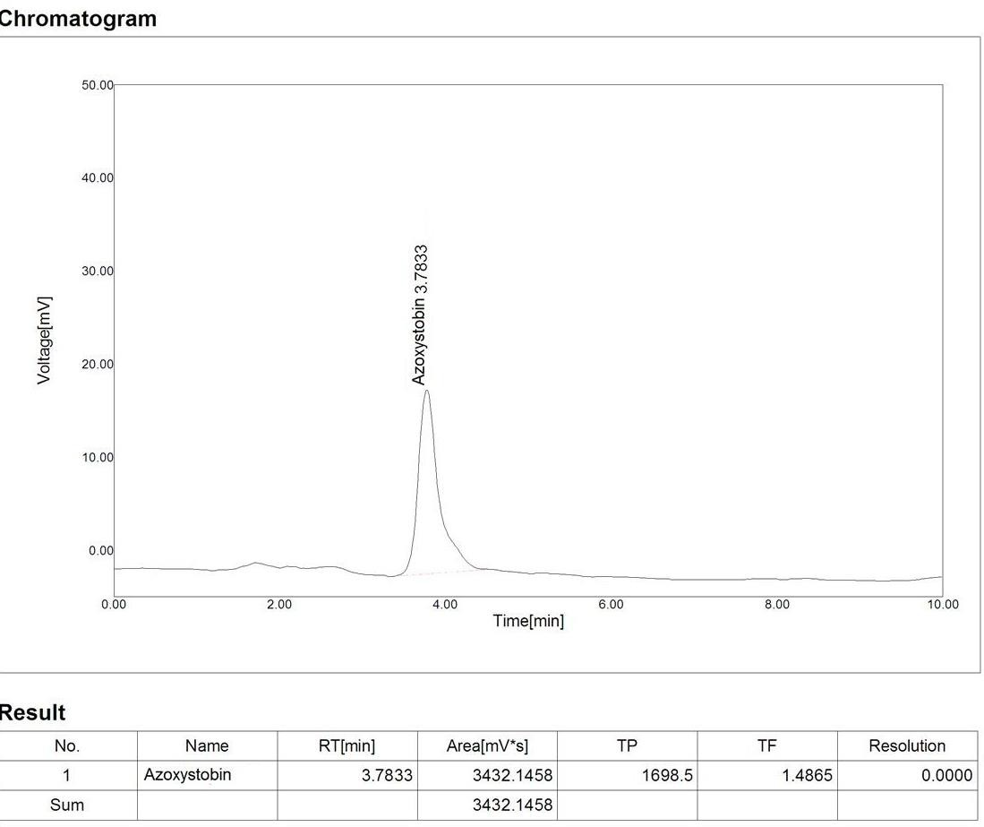

Fig.24: Chromatogram of Azoxystrobin exposed to the freshwater Fish Labeo rohita Kidney for 1 day Sublethal.
Fig.25: Chromatogram of Azoxystrobin Along with AC exposed to the freshwater Fish Labeo rohita Kidney for 1 day Sublethal.

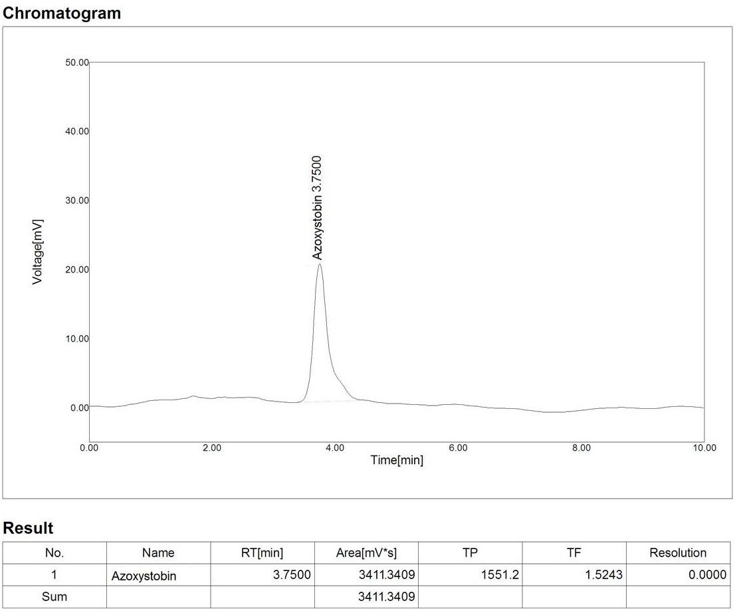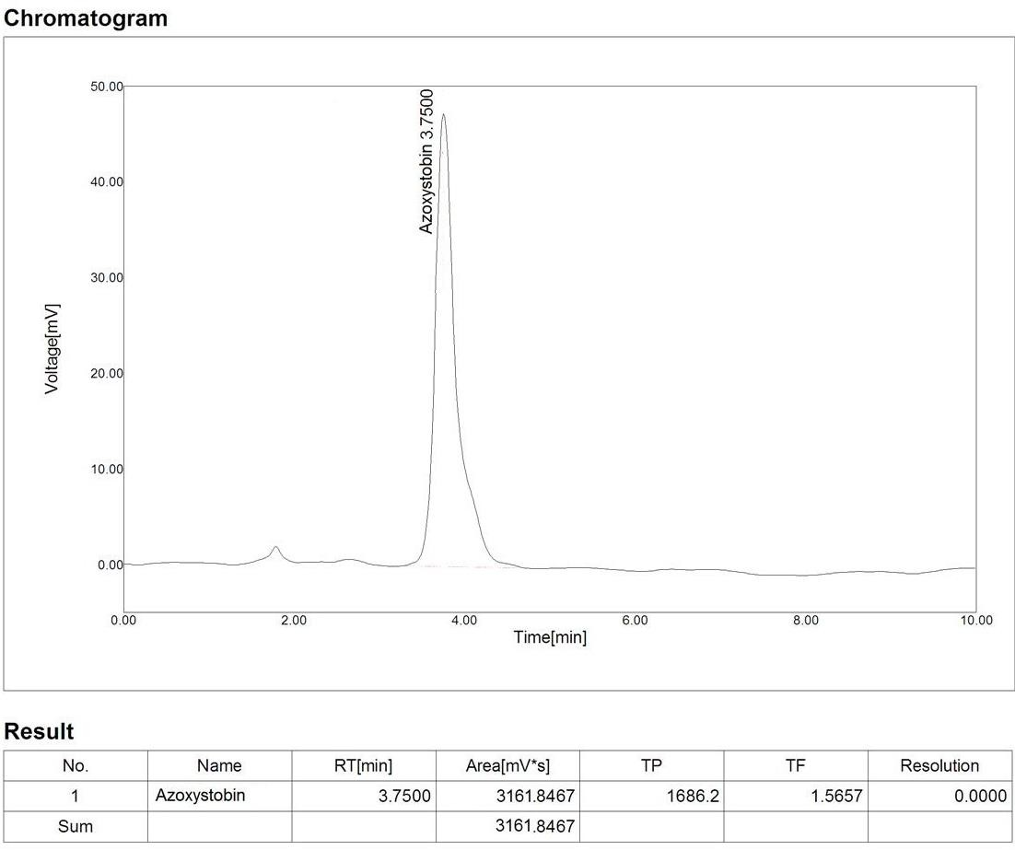

Fig.26: Chromatogram of Azoxystrobin exposed to the freshwater Fish Labeo rohita Liver for 1 day Sublethal.
Fig.27: Chromatogram of Azoxystrobin along with AC exposed to the freshwater Fish Labeo rohita Liver for 1 day Sublethal.

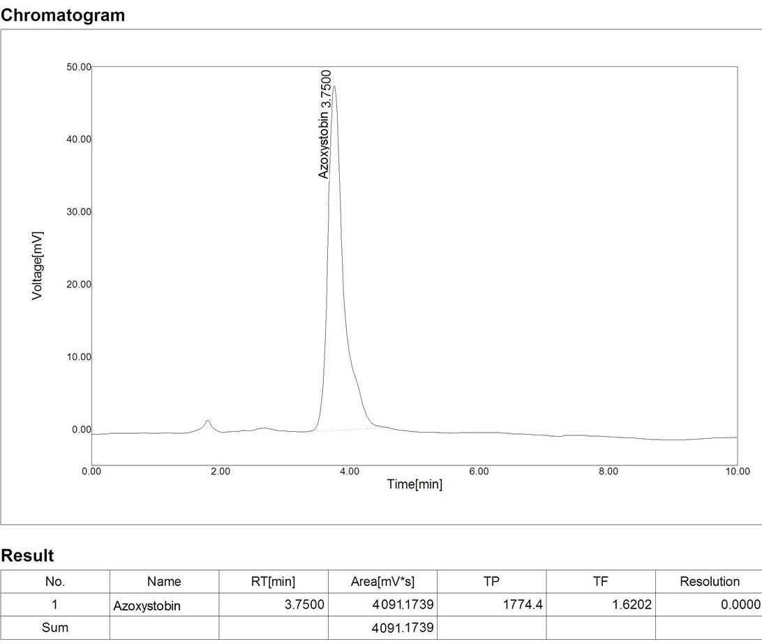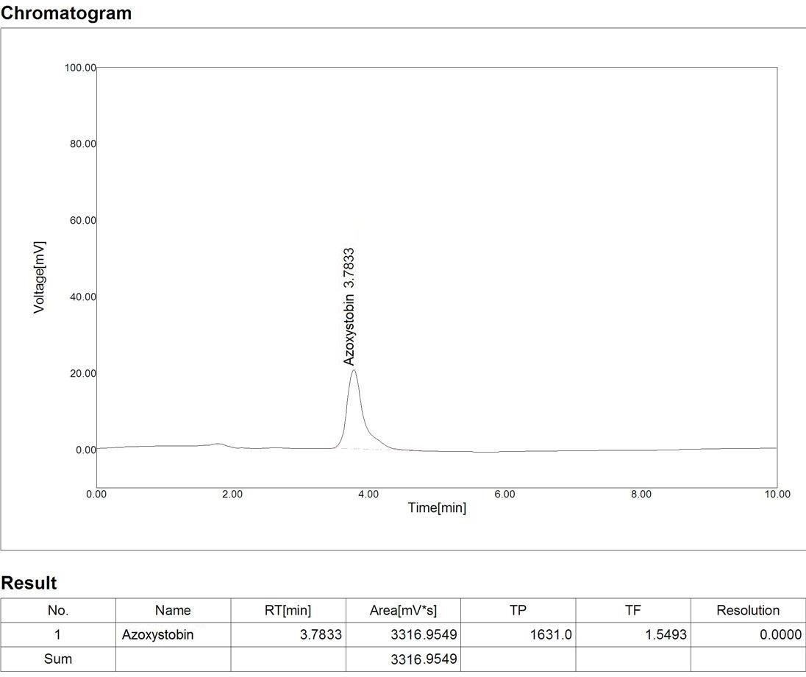

Fig.28: Chromatogram of Azoxystrobin (CS/Mix) exposed to the freshwater Fish Labeo rohita Intestine for 1 day Sublethal.
Fig.29: Chromatogram of Azoxystrobin (CS/Mix) along with AC exposed to the freshwater Fish Labeo rohita Intestine for 1 day Sublethal.

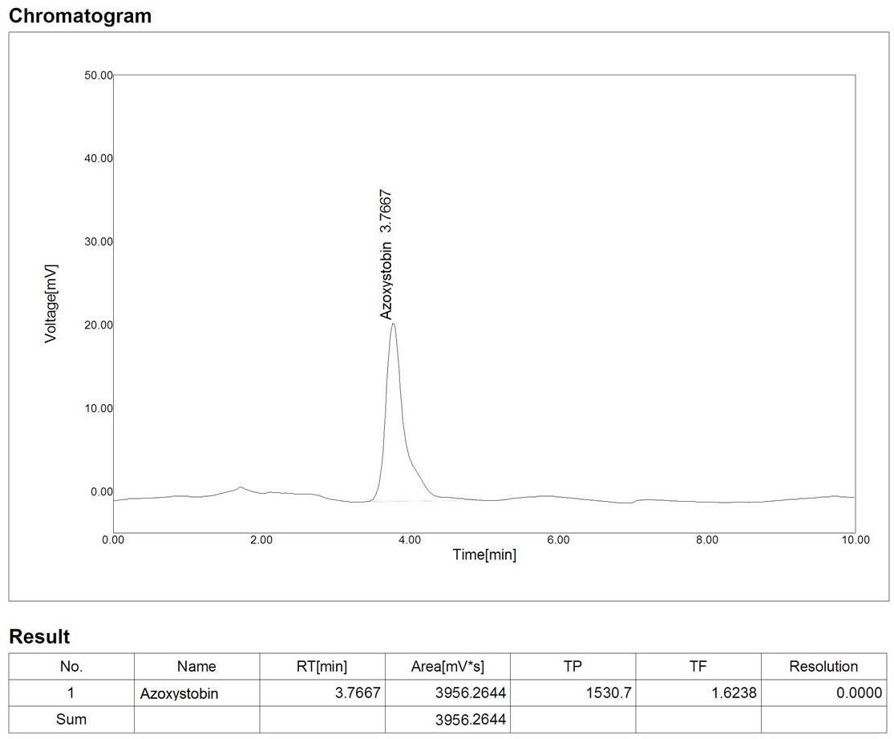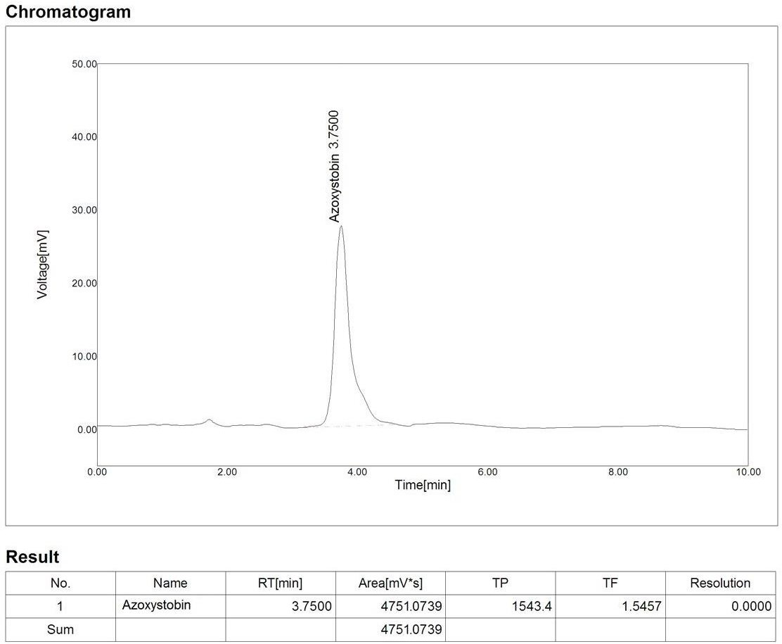

Fig.30: Chromatogram of Azoxystrobin (CS/Mix) exposed to the freshwater Fish Labeo rohita Liver for 1 day Sublethal.
Fig.31: Chromatogram of Azoxystrobin (CS/Mix) along with AC exposed to the freshwater Fish Labeo rohita Liver for 1 day Sublethal.

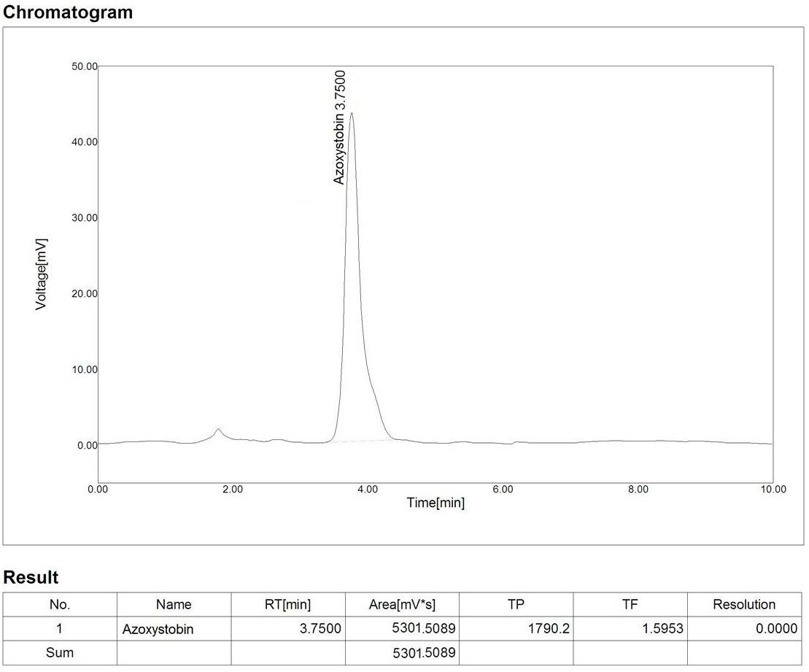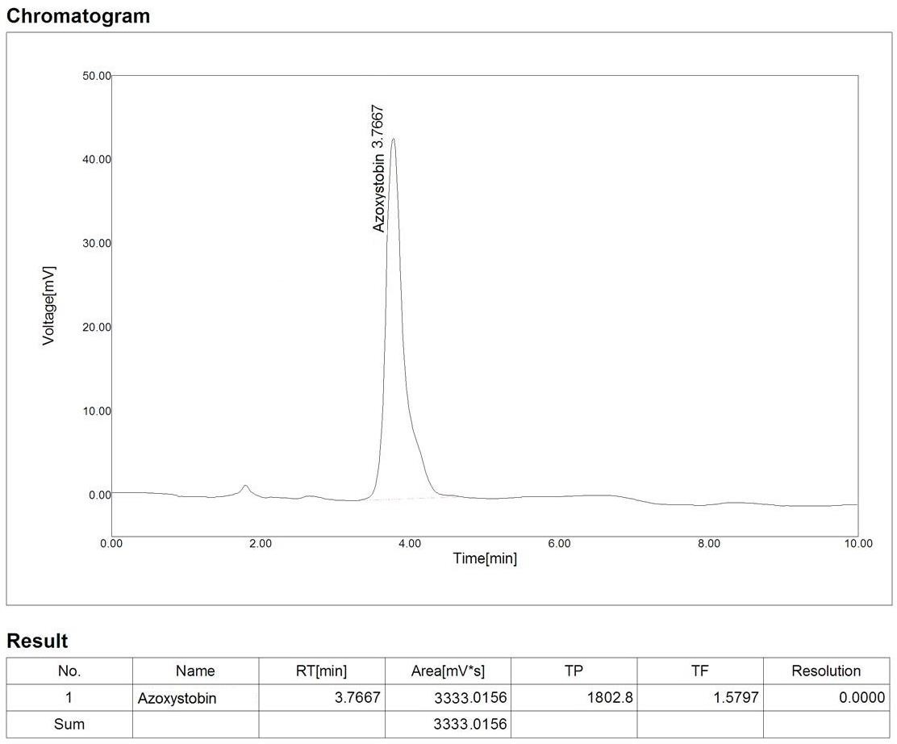

Fig..32. Chromatogram of Azoxystrobin (CS/Mix) exposed to the freshwater Fish Labeo rohita Kidney for 1 day Sublethal.
Fig. 33. Chromatogram of Azoxystrobin (CS/Mix) along with AC exposed to the freshwater Fish Labeo rohita Kidney for 1 day Sublethal.

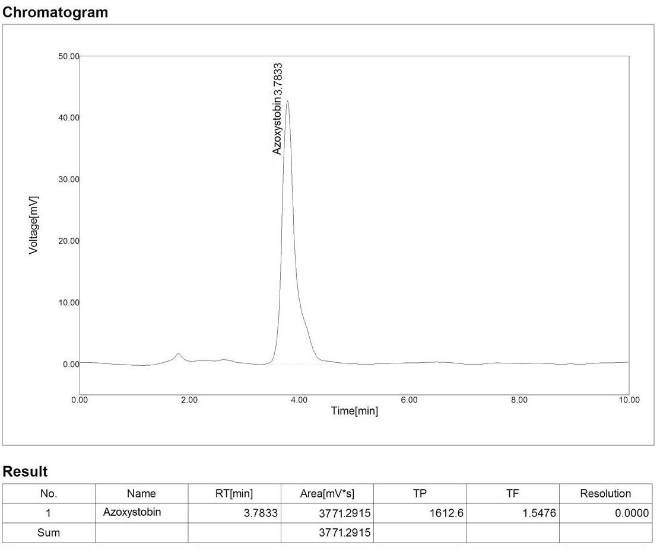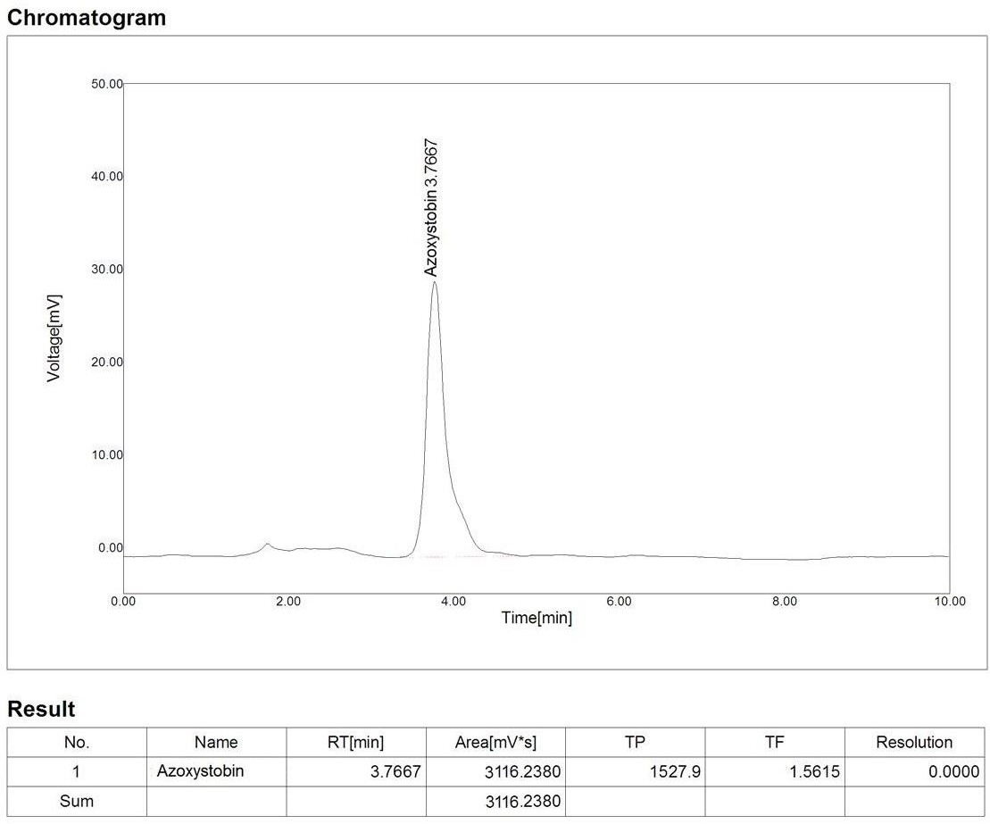

Fig.34: Chromatogram of Azoxystrobin exposed to the freshwater Fish Labeo rohita Intestine for 14 days Sublethal.
.Fig.35: Chromatogram of Azoxystrobin along with AC exposed to the freshwater Fish Labeo rohita Intestine for 14 days Sublethal.

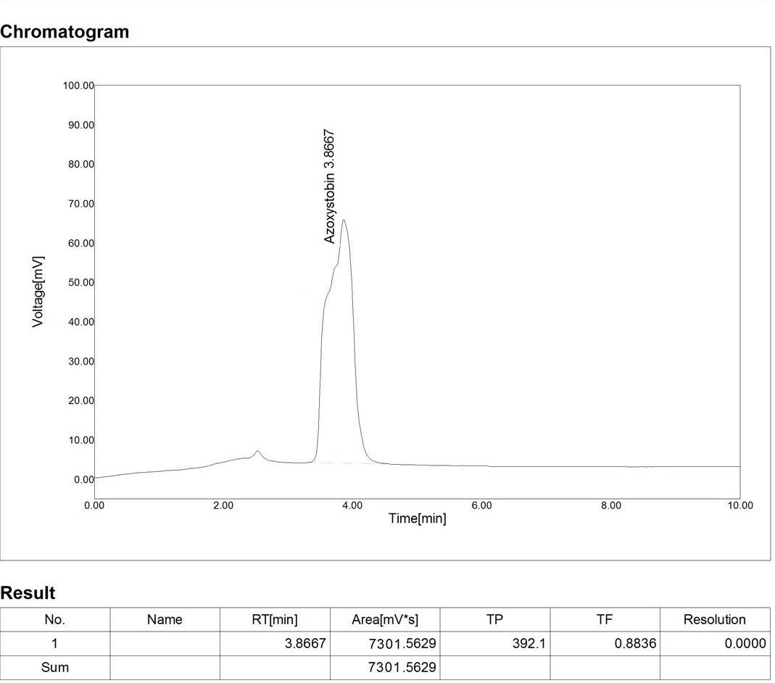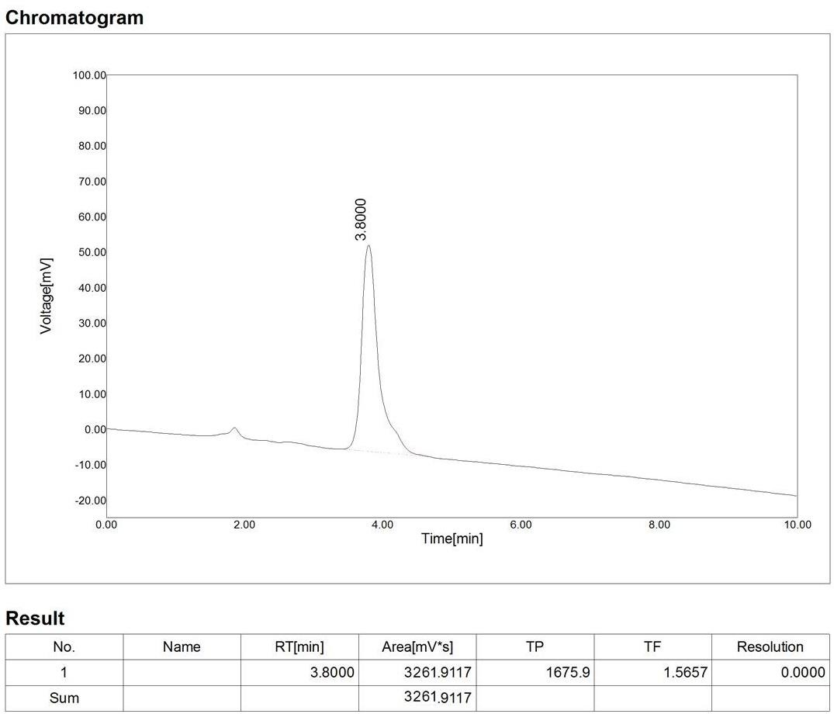

Fig.36: Chromatogram of Azoxystrobin exposed to the freshwater Fish Labeo rohita Kidney for 14 days Sublethal.
Fig.37: Chromatogram of Azoxystrobin along with AC exposed to the freshwater Fish Labeo rohita Kidney for 14 days Sublethal.

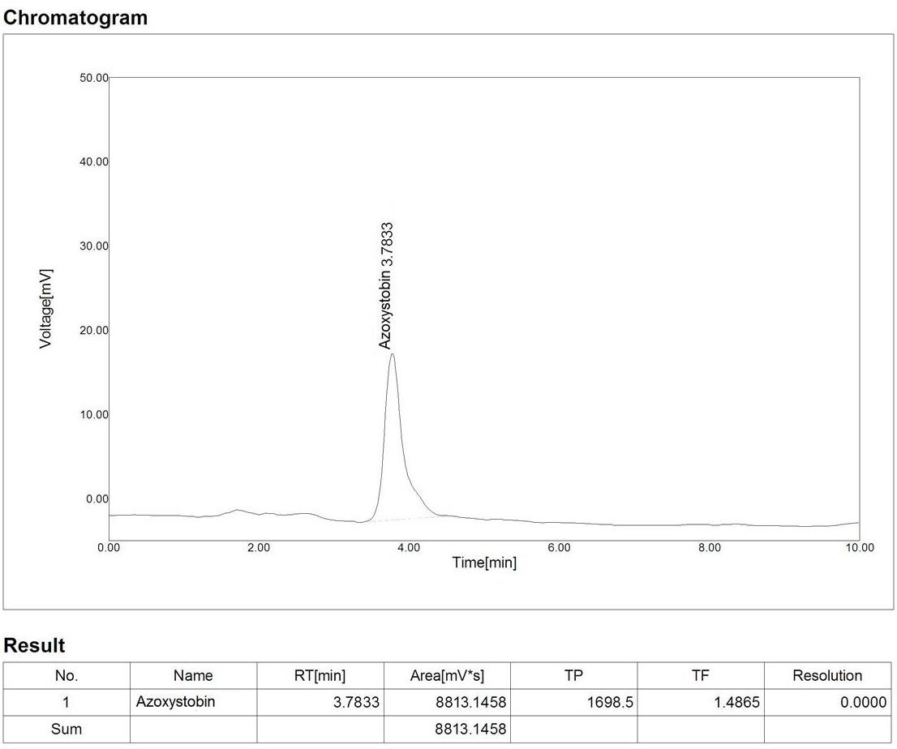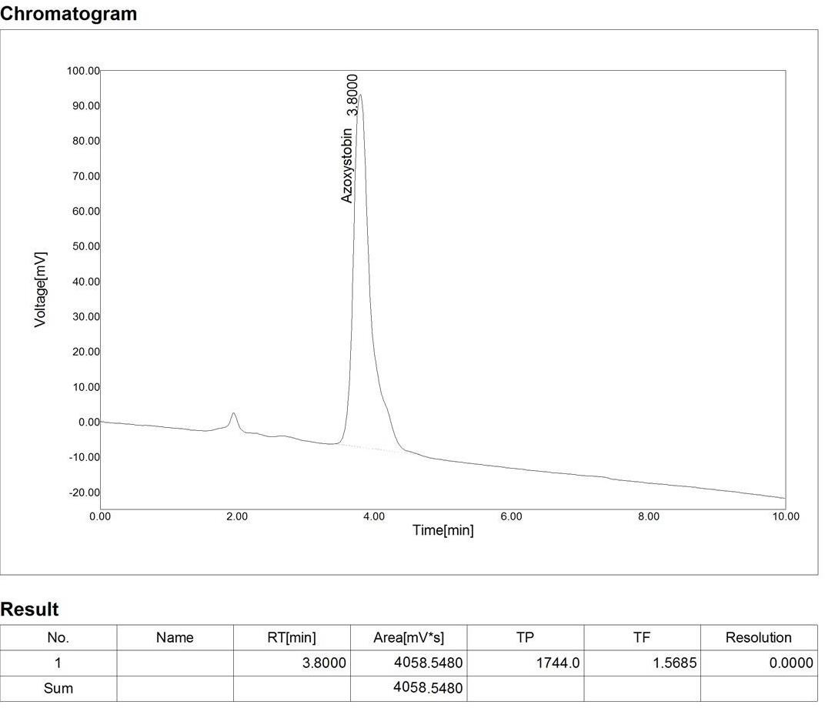

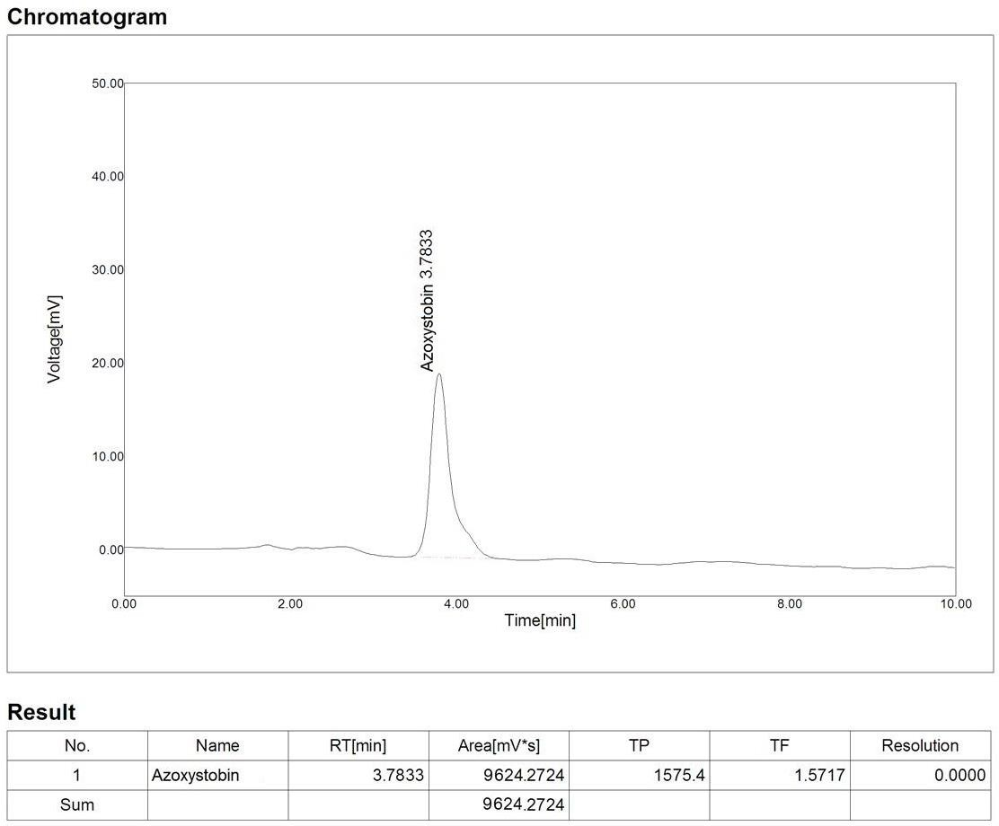
Fig.38: Chromatogram of Azoxystrobin exposed to the freshwater Fish Labeo rohita Liver for 14 days Sublethal.
Fig.39: Chromatogram of Azoxystrobin along with AC exposed to the freshwater Fish Labeo rohita Intestine for 14 days Sublethal.

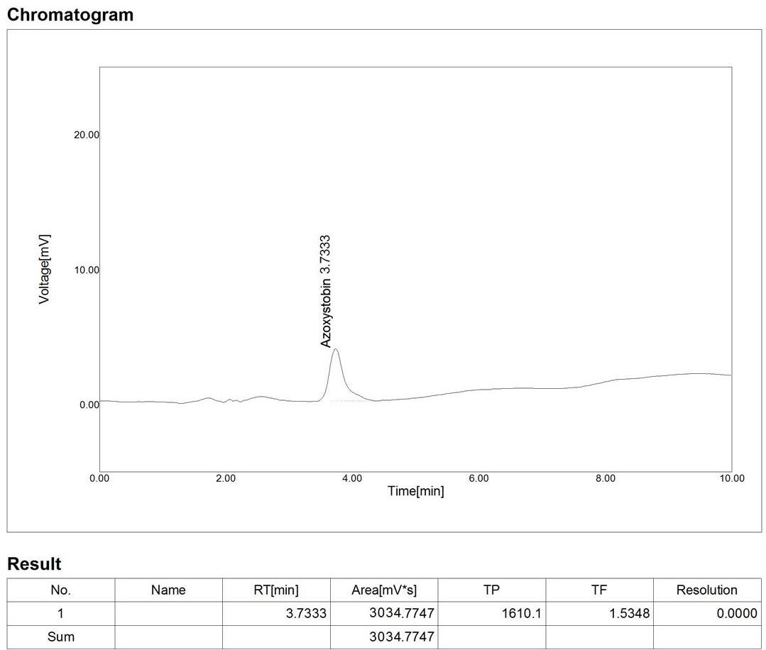

Fig.40: Chromatogram of Azoxystrobin (CS/Mix) exposed to the freshwater Fish Labeo rohita Liver for 14 days Sublethal.
.Fig.41: Chromatogram of Azoxystrobin (CS/Mix) along with AC exposed to the freshwater Fish Labeo rohita Liver for 14 days Sublethal.

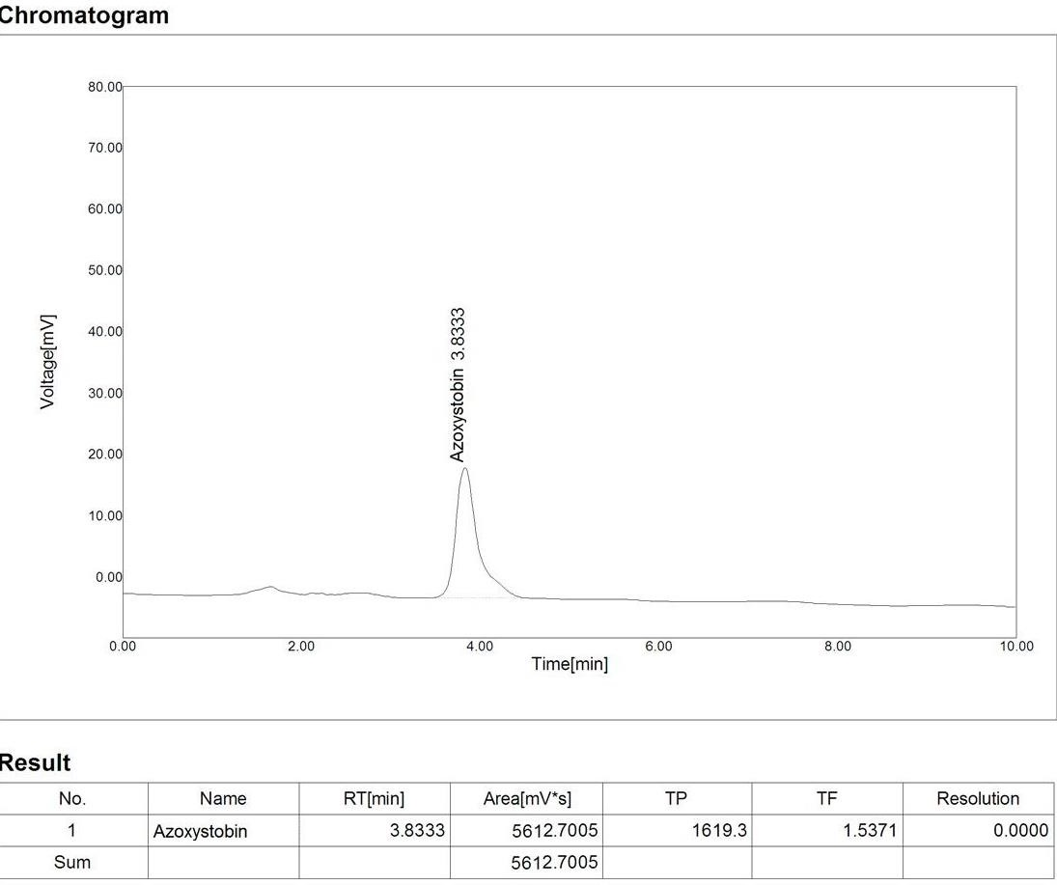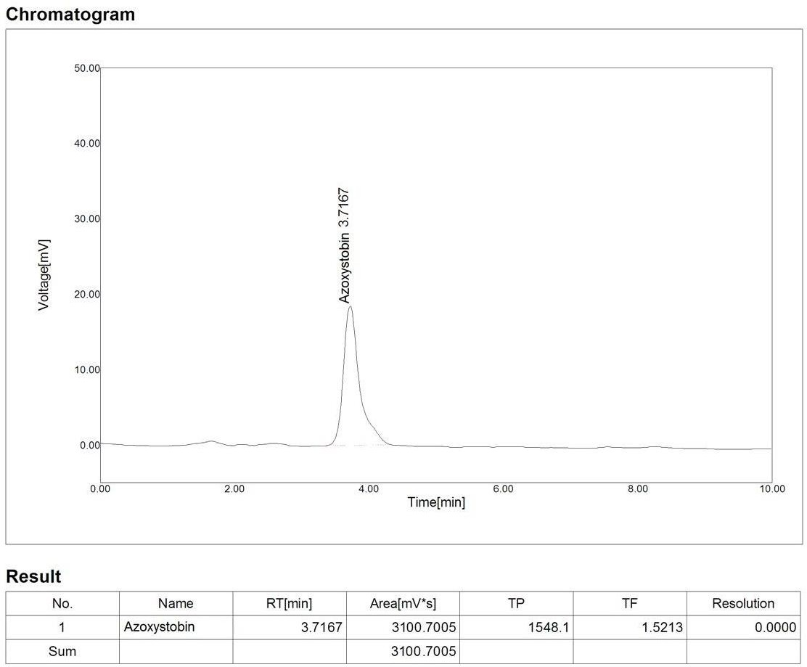

Fig.42: Chromatogram of Azoxystrobin (CS/Mix) exposed to the freshwater Fish Labeo rohita Intestine for 14 days Sublethal.
Fig.43: Chromatogram of Azoxystrobin (CS/Mix) along with AC exposed to the freshwater Fish Labeo rohita Intestine for 14 days Sublethal.

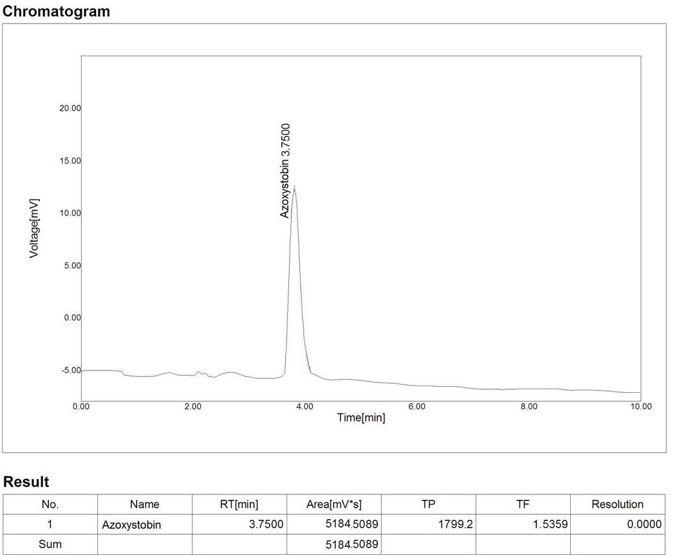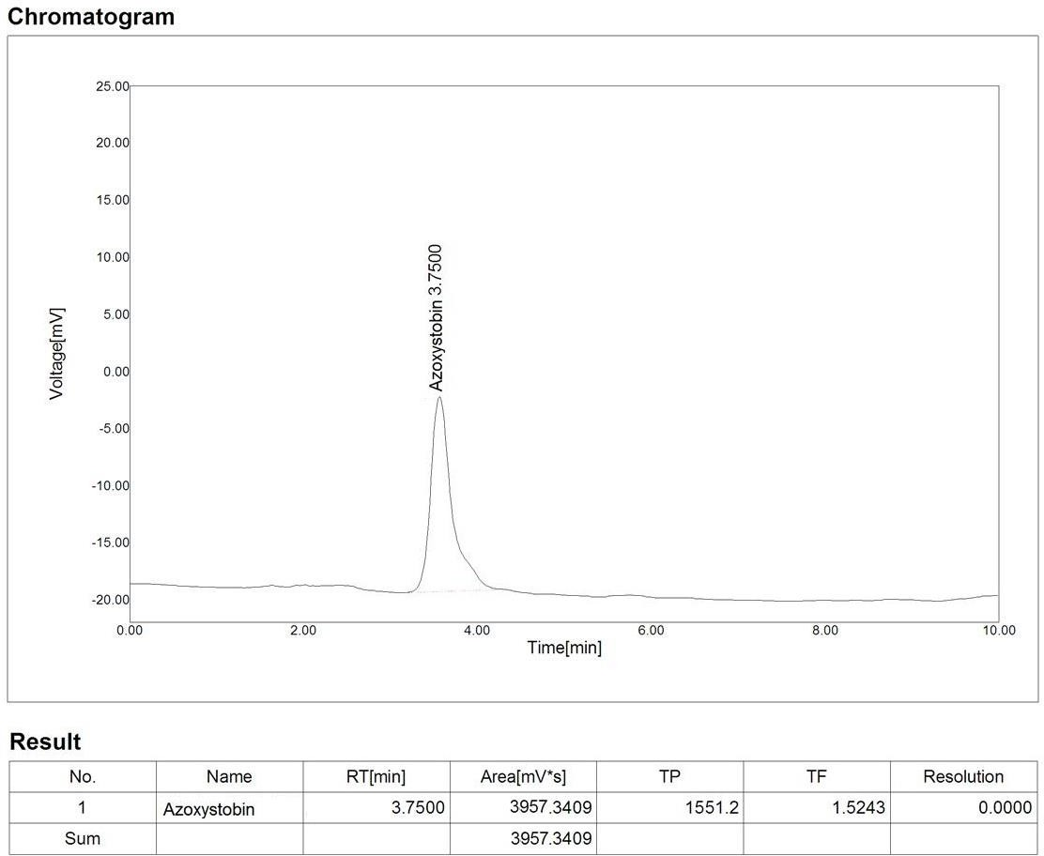

.Fig.44: Chromatogram of Azoxystrobin (CS/Mix) exposed to the freshwater Fish Labeo rohita Kidney for 14 days Sublethal.
Fig.45: Chromatogram of Azoxystrobin (CS/Mix) exposed to the freshwater Fish Labeo rohita Kidney for 14 days Sublethal.

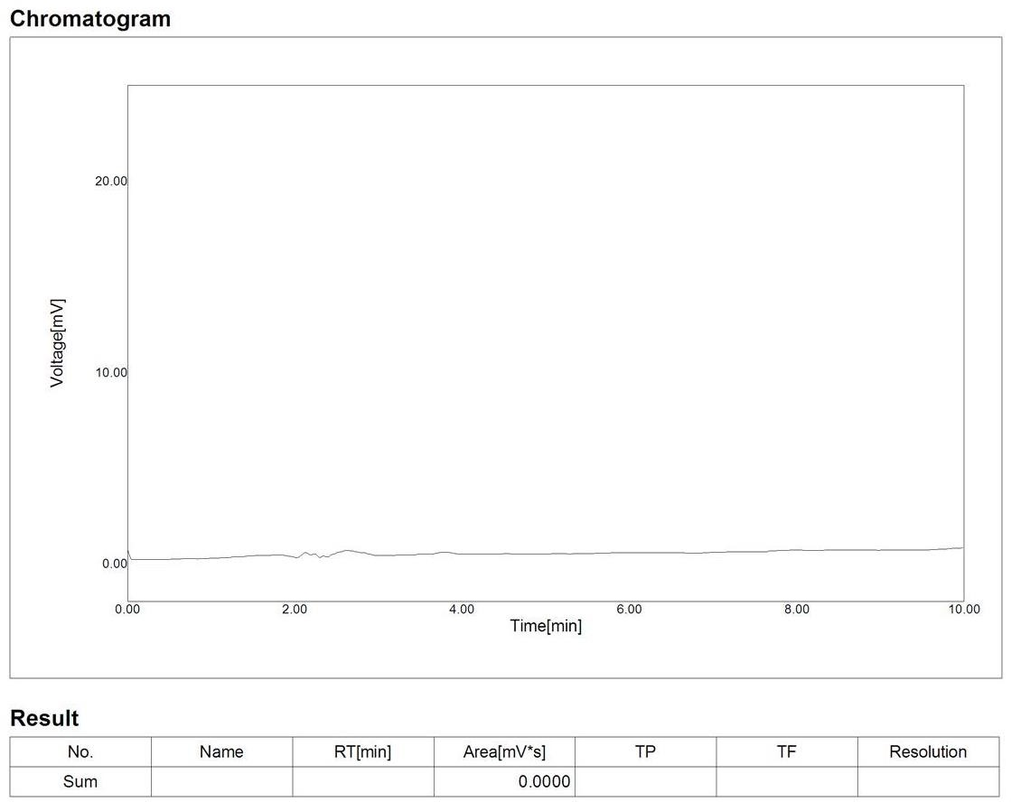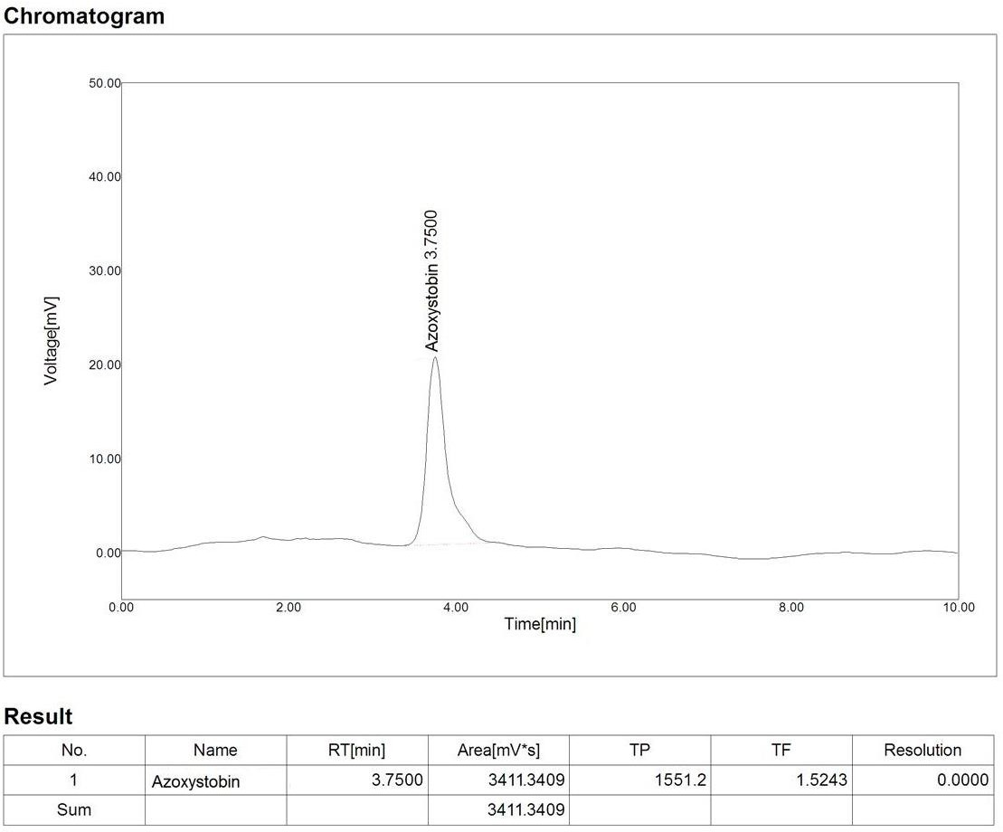

Legends for figures: Az- Azoxystrobin, F- Fish, AC- Activated charcoal, 1L- 1day lethal, 1SL- 1 day Sublethal, CS- Combined synergism, Mix- Mixture.
EXPLANATIONS OF CHROMATOGRAMS

The chromatograms of Azoxystrobin 1day lethal in treated water studied is shown in Fig.2: AZ+F-1L. The chromatogram showed highest peak at 3.8167 minutes and the peak area was 6491. Azoxystrobin 1day lethal along with activated charcoal in treated water studied was shown in.Fig.3: AZ+F-AC-1L. The chromatogram showed highest peak at 3.6833 minutes and the peak area was 3335. Azoxystrobin 1day lethal in combined synergism treated water studied is shown in.Fig.6: AZ+F-1L (CS). The chromatogram showed highest peak at 3.8333 minutes and the peak area was 3625. Azoxystrobin 1day lethal combined synergism along with activated charcoal in treated water studied is shown in Fig.7: AZ+F+AC-1L (CS), the chromatogram showed highest peak at 3.8167 minutes and the peak area was 2569. The peaks obtained just at the beginning and at the ending of running the sample, for 10minutes duration. The peaks eluted indicated the presence of Azoxystrobin in these treated water samples after 1day of lethal exposure concentrations at 3.33mg/l.
The chromatograms of Azoxystrobin 1day sublethal in treated water studied is shown in Fig.4: AZ+F-1SL. The chromatogram showed highest peak at 3.6833 minutes and the peak area was 2598. Azoxystrobin 1day sublethal along with activated charcoal in treated water studied is shown in Fig.5: AZ+F+AC-1SL. The chromatogram showed highest peak at 3.6833 minutes and the peak area was 2396. Azoxystrobin 1day lethal in combined synergism treated water studied is shown in.Fig.8: AZ+F-1SL (CS). The chromatogram showed highest peak at 3.8333 minutes and the peak area was 2415. Azoxystrobin 1day lethal combined synergism along with activated charcoal in treated water studied is shown in .Fig.9: AZ+F+AC-1SL (CS). The chromatogram showed highest peak at 3.6833 minutes and the peak area was 2351. The peaks obtained just at the beginning and at the ending of running the sample, for 10minutes duration. The peaks eluted indicated the presence of Azoxystrobin in these treated water samples after 1day of sublethal exposure concentrations at 0.33mg/l.
The chromatograms of Azoxystrobin 1 day lethal in treated freshwater fish Labeo rohita
liver studied is shown Fig. 10.Az, Fig..11.Az+AC,.Fig.16: Az(CS) and.Fig.17:

Az+ AC(CS). The chromatogram showed highest peaks at 3.7833, 3.7667, 3.8333 and 3.7833 minutes; and the peak areas was 8830, 3752, 11240 and 3487 respectively. The chromatograms of Azoxystrobin 1day sublethal studied is shown Fig..26.Az, Fig..27.Az+AC,.Fig.30: Az(CS) and.Fig.31: Az+ AC(CS). The chromatogram showed highest peaks at 3.7500, 3.7833, 3.7500 and 3.7667 minutes; and the peak areas was 4091, 3316, 5301 and 3333 respectively. The chromatograms of Azoxystrobin for 14 days sublethal concentrations were studied is shown Fig. 38.Az, Fig..39.Az+AC,.Fig.40: Az(CS) and.Fig.41: Az+ AC(CS). The chromatogram showed short peaks at 3.7833, 3.7333, 3.8333 and 3.7167 minutes;
and the peak areas was 9624, 3034, 5612 and 3100 respectively.
The chromatograms of Azoxystrobin 1 day lethal in treated freshwater fish Labeo rohita kidney studied is shown Fig..12.Az, Fig. 13.Az+AC,.Fig.18: Az(CS) and Fig.19: Az+ AC(CS). The chromatogram showed highest peaks at 3.9000, 3.8333, 3.7667 and 3.7500 minutes; and the peak areas was 7364, 3612, 9645 and 4817 respectively. The chromatograms of Azoxystrobin 1 day sublethal studied is shown Fig..24.Az, Fig. 25.Az+AC,.Fig.32: Az(CS) and.Fig.33: Az+ AC(CS). The chromatogram showed highest peaks at 3.7500, 3.7500, 3.7833 and 3.7667 minutes; and the peak areas was 3411, 3161, 3116 and 3771 respectively. The chromatograms of Azoxystrobin for 14 days sublethal concentrations were studied is shown Fig..36.Az, Fig. 37.Az+AC, and.Fig.45: Az+ AC(CS). The chromatogram showed highest peaks at 3.7833, 3.8000 and 3.7500 minutes; and the peak areas was 9624, 3034 and 3411 respectively. The chromatogram for the fish tissue kidney sample of 14 days sublethal is shown in.Fig.44: Az(CS). No peak was obtained at the same retention time of Azoxystrobin and it indicated the absence of Azoxystrobin. It is also considered as BDL (Below Detection Limit).
The chromatograms of Azoxystrobin 1 day lethal in treated freshwater fish Labeo rohita intestine were studied is shown Fig. 14.Az, Fig. 15.Az+AC, Fig.20: Az(CS) and.Fig.21: Az+ AC(CS). The chromatogram showed highest peaks at 3.7500, 3.8167, 3.7667 and 3.8000 minutes; and the peak areas was 8261, 3267, 6548 and 3485 respectively. The chromatograms of Azoxystrobin 1 day sublethal studied is shown Fig..22.Az, Fig..23.Az+AC,.Fig.28: Az(CS) and.Fig.29: Az+ AC(CS). The chromatogram showed highest peaks at 3.7500, 3.7833, 3.7667 and 3.7500 minutes; and the peak areas was 4817, 3432, 3956 and 4751 respectively. The chromatograms of Azoxystrobin for 14 days

sublethal concentrations were studied is shown Fig..34.Az, Fig..35.Az+AC,.Fig.42: Az(CS) and.Fig.43: Az+ AC(CS). The chromatogram showed peaks at 3.8667, 3.8000, 3.7500 and 3.7500 minutes; and the peak areas was 7301, 3261, 5184 and 3957 respectively.

Table.4: Estimation of Copper from exposure water samples:

S.NO | Sample Name | Concentration in  mg/10L (ppm)
1. | Cu+F-1L | 14.285
2. | CU+F+AC 1L | 3.047
3. | Cu+F-1SL | 1.446
4. | Cu+F+AC-1SL | 0.368
5. | Cu+F-1L x (CS) | 4.136
6. | Cu+F+AC-1L X(CS) | 1.062
7. | Cu+F-1SL X(CS) | 0.640
8. | Cu+F+AC1SL X(CS) | 0.448

The presence of Azoxystrobin, Copper and their combination before and after treatment with activated charcoal in water and selected tissues after completion of selected time duration were measured by HPLC and ICP-OES techniques. The amount of toxicants added to water according to their lethal and sublethal concentrations initially. The results showed that the heavy metal Copper is quickly consumed by fish than Azoxystrobin in the absence of AC and very low amount in the presence of AC and the residue toxicants detection was shown in Table. 3,4,5,6,7 and Fig. 2, 3,4,5,6 and 7 respectively.

1 day lethal exposue of Azoxystrobin, Copper and Combine synergism:
During exposure of Azoxystrobin for 1 day Lethal the concentration of the residue in water was 22.476 mg/10L and the amount of residues accumulated in the selected organs of test fish Labeo rohita such as liver, kidney and intestine were 20.974 µg/g, 16.281µg/g and 19.153µg/g. The residue of Azoxystroobin along with AC exposures in the water was 5.635mg/g and the concentration of the residue accumulated in liver, kidney and intestine were 4.716µg/g, 4.268µg/g and 3.163µg/g respectively.
Azoxystrobin 1day lethal: Liver < intestine < kidney Azoxystrobin+ AC 1day lethal: Liver < kidney < intestine
During exposure of Copper for 1 day Lethal the concentration of the residue in water was
14.285 mg/10L and the amount of residues accumulated in the selected organs of test fish Labeo rohita such as liver, kidney and intestine were 121µg/g, 93.2µg/g and 52.3µg/g. The residue of Copper along with AC exposures in the water was 3.11mg/g and the concentration of the residue accumulated in liver, kidney and intestine were 21µg/g, 14µg/g and 18µg/ respectively.
Copper 1day lethal: Liver < kidney < intestine Copper + AC 1day lethal: Liver < intestine < kidney
During exposure of Combine synergism for 1 day Lethal the concentration of the Azoxystrobin and Copper residues in water were 7.182 mg/g and 4.136 mg/g. The amount of residues accumulated in the selected organs of test fish Labeo rohita such as liver, kidney and intestine were 28.690µg/g, 23.584µg/g and 13.668µg/g of Azoxystrobin and 75µg/g, 54µg/g and 32µg/g of Copper residues were obtained from the exposures of the combine synergism. The residue of Azoxystrobin and Copper along with AC exposures in the water were 5.635 mg/g and
3.047 mg/g. The concentration of the residue accumulated in liver, kidney and intestine were 3.868 µg/g, 8.126µg/g and 3.861µg/g respectively.
CS-Azoxystrobin and Copper 1day lethal: Liver < kidney < intestine CS-Azoxystrobin+ AC 1day lethal: kidney < Liver < intestine
CS-Copper + AC 1day lethal: Liver < intestine < kidney

Table.5: Residue analysis in different tissue of the freshwater fish, Labeo rohita exposed to 1day lethal concentrations of Azoxystrobin, Copper alone and combined along with AC.

Selected organs  Treatments | Intestine (µg/g) | Liver (µg/g) | Kidney (µg/g)
Azoxystrobin | 19.153 | 20.974 | 16.281
Azoxystrobin+ AC | 3.163 | 4.716 | 4.269
Copper | 52.3 | 121 | 93.2
Copper+ AC | 18 | 21 | 14
Az-CS | 13.668 | 28.690 | 23.584
Az-CS+ AC | 3.8612 | 3.8676 | 8.126
Cu-CS | 32 | 75 | 54
Cu-CS+ AC | 0.20 | 0.60 | 0.80
.Fig.46: Residue analysis in differen4t tissue of the freshwater fish, Labeo rohita exposed to 1day lethal concentrations of Azoxystrobin alone and combined along with AC.
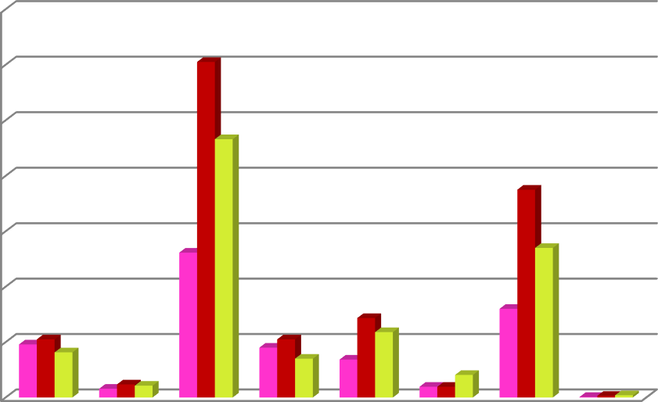

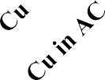


140

120
Intestine
Liver Kidney
100

80

60

40

20

0

1day sublethal exposure of Azoxystrobin, Copper and Combine synergism:
During exposure of Azoxystrobin for 1 day Sublethal the concentration of the residue in water was 1.702mg/10L and the amount of residues accumulated in the selected organs of test fish Labeo rohita such as liver, kidney and intestine were 5.801 µg/g, 7.095µg/g and 7.805µg/g. The residue of Azoxystroobin along with AC exposures in the water was 0.624 mg/10L and the concentration of the residue accumulated in liver, kidney and intestine were 3.320µg/g, 2.824µg/g and 3.692µg/g respectively. The remaining amounts of residues were accumulated in the exposed fish body.
Azoxystrobin 1day sublethal: intestine < kidney < Liver Azoxystrobin+ AC 1day sublethal: intestine < Liver < kidney
During exposure of Copper for 1 day Sublethal the concentration of the residue in water was 1.446mg/10L and the amount of residues accumulated in the selected organs of test fish Labeo rohita such as liver, kidney and intestine were 7.30µg/g, 5µg/g and 14.20µg/g. The residue of Copper along with AC exposures in the water was 0.368mg/g and the concentration of the residue accumulated in liver, kidney and intestine were 2.2µg/g, 1.9µg/g and 0.7µg/ respectively.
Copper and Copper + AC 1day sublethal: Liver < kidney < intestine
During exposure of Combine synergism for 1 day Sublethal the concentration of the Azoxystrobin and Copper residues in water were 0.726 mg/g and 0.640 mg/g. The amount of residues accumulated in the selected organs of test fish Labeo rohita such as liver, kidney and intestine were 9.676µg/g, 4.777µg/g and 5.369µg/g of Azoxystrobin and 75µg/g, 54µg/g and 32µg/g of Copper residues were obtained from the exposures of the combine synergism. The residue of Az and Cu along with AC exposures in the water were 0.384 mg/g and 0.448 mg/g. The concentration of the residue accumulated in liver, kidney and intestine were 3.375 µg/g, 2.680µg/g and 7.915µg/g; BDL.
CS-Azoxystrobin 1day Sublethal: Liver < intestine < kidney Copper 1day Sublethal: Liver < kidney < intestine
CS-Azoxystrobin+ AC 1day Sublethal: intestine < Liver < kidney CS-Copper + AC 1day Sublethal: BDL

Table.6: Residue analysis in different tissue of the freshwater fish, Labeo rohita exposed to 1day Sublethal concentrations of Azoxystrobin, Copper alone and combined along with AC.
Selected organs  Treatments | Intestine (µg/g) | Liver (µg/g) | Kidney (µg/g)
Azoxystrobin | 7.806 | 5.801 | 7.095
Azoxystrobin+ AC | 3.692 | 3.320 | 2.824
Copper | 14.20 | 7.30 | 5
Copper+ AC | 2.20 | 0.70 | 1.9
Az-CS | 5.3692 | 9.6756 | 4.777
Az-CS+ AC | 7.9146 | 3.3746 | 2.6798
Cu-CS | 6.20 | 5.20 | 4.70
Cu-CS+ AC | BDL | BDL | BDL

Fig.47: Residue analysis in different tissue of the freshwater fish, Labeo rohita exposed to 1day Sublethal concentrations of Azoxystrobin, Copper alone and combined along with AC.
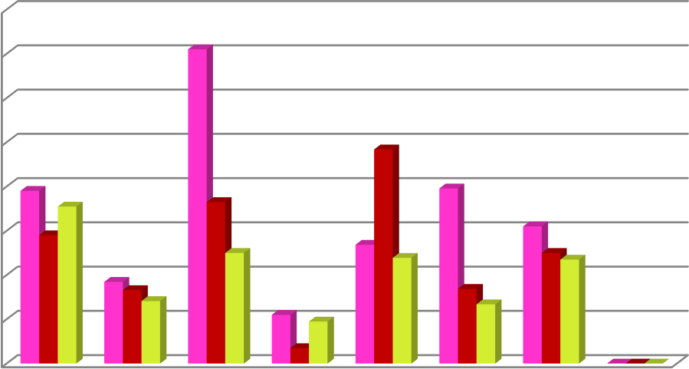

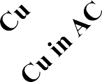


16
14
Intestine
Liver Kidney
12
10
8
6
4
2
0

14days sublethal exposure of Azoxystrobin, Copper and Combine synergism:
During exposure of Azoxystrobin for 14 days Sublethal the concentration of the residues accumulated in the selected organs of test fish Labeo rohita such as liver, kidney and intestine were 23.517 µg/g, 20.920µg/g and 16.079µg/g. The residue of Azoxystroobin along with AC exposures the concentration of the residue accumulated in liver, kidney and intestine were 2.417µg/g, 5.696µg/g and 3.144µg/g respectively. The remaining amounts of residues were accumulated in the exposed fish body.
Azoxystrobin 14 days sublethal: Liver < kidney < intestine Azoxystrobin+ AC 14 days sublethal: kidney < intestine < Liver
During exposure of Copper sulfate for 14 days Sublethal the concentration of the residues accumulated in the selected organs of test fish Labeo rohita such as liver, kidney and intestine were 41µg/g, 33µg/g and 19.5µg/g. The residue of Copper along with AC exposures accumulated in liver, kidney and intestine were 3.1µg/g, 2.4µg/g and 1.9µg/ respectively.
Copper 14 days sublethal: Liver < kidney < intestine Copper + AC 14 days sublethal: Liver < intestine < kidney
During exposure of Combine synergism for 14 days Sublethal the concentration of the Azoxystrobin and Copper residues accumulated in the choosen organs of the test fish Labeo rohita such as liver, kidney and intestine were 10.671µg/g, 18.506µg/g and 9.301µg/g of Azoxystrobin and 38µg/g, 29.8µg/g and 21µg/g of Copper residues were obtained from the exposures of the combine synergism. The residues of Azoxystrobin and Copper along with AC exposures accumulated in liver, kidney and intestine were 2.629 µg/g, 3.624µg/g and 5.372 µg/g;
3.6 µg/g, 2.9 µg/g and 5.8 µg/g respectively.
CS-Azoxystrobin 14days sublethal: kidney < Liver < intestine CS-Copper 14 days Sublethal: intestine < kidney < Liver
CS-Azoxystrobin+ AC 14 days sublethal: intestine < kidney < Liver CS-Copper + AC 14 days sublethal: kidney < Liver < intestine

Table.7: Residue analysis in different tissue of the freshwater fish, Labeo rohita exposed to 14 days Sublethal concentrations of Azoxystrobin, Copper alone and combined along with AC.
Selected organs  Treatments | Intestine (µg/g) | Liver (µg/g) | Kidney (µg/g)
Azoxystrobin | 16.079 | 23.517 | 20.920
Azoxystrobin+ AC | 3.144 | 2.417 | 5.696
Copper | 19.5 | 41 | 33
Copper+ AC | 1.9 | 3.1 | 2.4
Az-CS | 9.301 | 10.671 | 18.506
Az-CS+ AC | 5.372 | 2.629 | 3.624
Cu-CS | 21 | 38 | 29.8
Cu-CS+ AC | 5.8 | 3.6 | 2.9
Fig.48: Residue analysis in different tissue of the freshwater fish, Labeo rohita exposed to 14 days Sublethal concentrations of Azoxystrobin, Copper alone and combined along with AC.
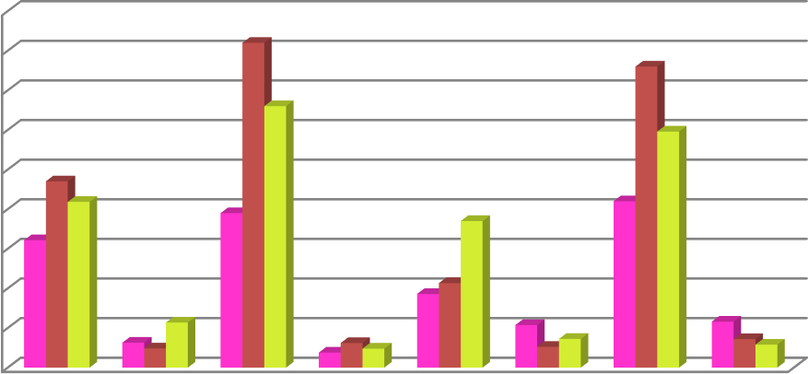

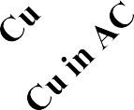
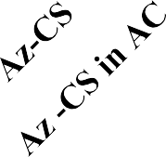

45
40
35
30
25
20
15
10
5
0
Intestine Liver
Kidney

III.DISCUSSION:
Pesticide residues present in aquatic animals of marine and freshwater media is a continuous issue for food safety and environmental monitoring. The evidence about different kinds of pesticides currently used worldwide and their existence in the tissues of freshwater fish presented at trace levels. The bioaccumulation of banned persistent organic pollutants in edible fish is still a matter of interest for human exposure.
The concentrations of Azoxystrobin, Copper and CS in water were decreased and increased in the selected tissues of the exposed fish Labeo rohita such as liver, kidney and intestine. Some chemicals can enhance the effect of other chemicals, so that they jointly exert a larger effect than predicted. The residue amounts of toxicants more in 14 days of sublethal exposures while compared with one day sublethal concentrations so the accumulation of the toxicants in the organism increases with time of exposure increased. Some degradable properties of chemicals may be the reason for low amounts of residues even thereafter the 24 hrs of lethal and sublethal exposures. It was coincided with Bangeppagari et al., 2015 that the concentration of chlorpyrifos decreases in water and increase in liver of Zebrafish with increase in time of exposure is an indication of the accumulation of the toxicant in the organism through uptake. Even in the exposures of activated charcoal applications few amounts of residues were noted, it indicates that the adsorbent did not absorb all toxicants completely.
A decrease amounts of residues were found in toxicants along with AC exposures due to the effects of charcoal would include the ability of activated charcoal to bind the conjugated drug before hydrolysis or the free deconjugated drug before reabsorption and the concept of back diffusion. Toxicants from the systemic circulation across the gastrointestinal tract into the intestinal fluids and, finally, binding to the activated charcoal in the gut (Levy 1982). In the current study low amount of residues were found in the AC exposure treatments. Toxicants residue in the treated water of Az, Cu and CS refers to its concentration that has remained in the water after it has been added to AC exposures and the residue in the selected organs such as intestine, liver and kidney refers to concentration that has accumulated in tissues as a result of uptake of toxicants+ AC holding water by exposed fish; it means toxicants absorbed into the blood in two ways through 1). intestinal fluids from the gastrointestinal tract 2). gaseous exchange of water in the gills of the test fish Labeo rohita. Charcoal moved out of the

gastrointestinal tract by intestinal motility. This work suggests AC could not remove toxicants completely.
According to Akoto et al., 2016 that all the mean concentrations of organochlorine pesticide residues in fish ranged from 0.017 to 0.17, 0.043 to 0.30, 0.027 to 0.243 and 0.097 to
0.263 µg/g in Sarotherodon galilaeus, Clarias anguillaris, Schilbe intermedius and Marcusenius senegalensis respectively were obtained in the water of Tono reservoir and had their concentrations below the detection limit. Health risk estimation revealed that aldrin in M. senegalensis had great potential for systemic toxicity to consumers. Thus, deaths and chronic diseases worldwide are sometimes reported to have resulted from pesticide poisoning (Rigotto et al., 2013). Chronic exposure of pesticides, heavy metals and pharmaceutical substances could accumulate in the tissues of exposed organisms and it may lead to mortality. Heptachlor concentration was determined as 0.0598 μg/g in Dicentrarchus labrax sample from Marmara Sea, which is nearly nine thousand times more than the maximum allowable concentration of environmental quality standards biota of heptachlor listed in 2013/39/EU (Topal T and Onac C 2020).
Seasonal variations also reason for the amount of toxicant residues in the aquatic animal tissues. High levels of total pesticide residues in water and sediment samples were detected in autumn (73.57 ± 62.97 and 103.03 ± 16.05 ppb, respectively), which may be attributed to the increase in suspended matter (low flood) and high application of pesticides during that season. Pesticide residue in tissue samples of C. gariepinus amounted to 49.1 ± 17.8 ppb followed by T. zillii (48.3 ± 18.9 ppb) and O. niloticus (45.6 ± 28.7 ppb) (Shalaby et al., 2018). According to Huseen and Mohammed 2019, that the higher concentration of lead in fish meat was 9 mg/kg found in Autumn which may be related to the region of river were the hunting of fish, because it polluted with hydrocarbons discharge from diesel which used in electrical generators that used by the near restaurants and pollution the air from cars fumes and the rate of lead accumulation was dependent on both holding salinity and the temperature. Fish held at high temperature accumulated lead more rapidly than fish held at low the temperature therefore lead concentration highly in Autumn because temperature is (22^{◦c}) lead accumulation was depth holding salinity.
Accumulation and Concentration of Azoxystrobin, Copper and Combine synergism were differing from organs to organs; it is also applicable to organisms depending upon the

availability of the toxicants and variations in uptake process of food. Some species of fishes accumulate more amount of copper and some may not, even if they have same ecosystem. The concentration of Cu in gills, kidney, liver and muscles of Ciprinus carpio was ranged from 0.77±0.01 to 1.40±0.06, 1.40±0.06 to 2.50±0.06 and 25.30±0.62 to 43.00±0.58 and 1.10±0.06 to
1.67±0.01 mg/Kg, respectively. The level of Cu in gills, kidney, liver and muscles of Walluga attu was ranged from 3.00±0.12 to 5.90±0.21, 1.40±0.06 to 3.47±0.03, 11. 50±0.29 to
24.00±0.58 and 2.90±0.0.6 to 5.50±0.06 mg/Kg, respectively (Mahboob et al., 2016).
Comparing the data for one day lethal and sublethal exposures in water and tissues revealed higher concentration of the pesticides noted in water than exposed tissues. If it occurs regular decreased concentration of toxicants in water and increased in various selected organs with increase period of exposure indicate the accumulation of the toxicant in the organism through uptake. This could be hazardous as it could make its way through the food chain.The higher levels of pesticides found in the fish due to the fact that fish have a greater tendency to accumulate the pesticides in their bodies due to bioaccumulation. Thus, the present investigation on residual analysis of of Azoxystrobin, Copper and Azoxystrobin + Copper mixture in different organs amongst liver are more affected in the freshwater fish Labeo rohita while compare with AC combination exposures.
Conclusion:
Overall, it is undoubted that the application of AC offers several benefits and potential economic and environmental advantages, and its efficiency to remove different contaminants in the lab-scale has been widely reported. However, more in situ experiments should be performed to test the AC efficiency using real effluents and to examine the real effect of AC on the environment prior to its large-scale application. Activated charcoal can bind many drugs and poisons in vitro and in vivo can decrease gastrointestinal absorption. While outcome has not been shown to be changed by charcoal in studies till date this may be possible when it is used properly in the correct situation. Accumulation of pesticide in the water body essentially affects the non-target organism especially fish and occurs their depositions. These fish through food chain due to regular consumption have elevated influence on humans and it causes deleterious effects. Hence, the usage of the pesticide should be restricted to protect human healthy and conserve ecology equilibrium.

References:
Abdelraheem, E. M., Hassan, S. M., Arief, M. M., & Mohammad, S. G. (2015). Validation of quantitative method for azoxystrobin residues in green beans and peas. Food chemistry, 182, 246-250.
Akoto, O., Azuure, A. A., & Adotey, K. D. (2016). Pesticide residues in water, sediment and fish from Tono Reservoir and their health risk implications. SpringerPlus, 5(1), 1-11.
Annabi, A., Said, K., & Messaoudi, I. (2013). Cadmium: bioaccumulation, histopathology and detoxifying mechanisms in fish. American Journal of Research Communication, 1(4), 62.
Bangeppagari, Manjunatha & Ortiz Tirado, Juan & Philip, G. H.. (2015). Determination of chlorpyrifos residues in water and liver tissue of zebrafish (Danio rerio) by high performance liquid chromatography (HPLC) with UV detection. Journal of Chemical and Pharmaceutical Research, 7 (6). 721-726.
Bawuro, A. A., Voegborlo, R. B., & Adimado, A. A. (2018). Bioaccumulation of heavy metals in some tissues of fish in Lake Geriyo, Adamawa State, Nigeria. Journal of environmental and public health, 2018. 1854892. doi: 10.1155/2018/1854892.
Chen, C. Y., Wooster, G. A., & Bowser, P. R. (2004). Comparative blood chemistry and histopathology of tilapia infected with Vibrio vulnificus or Streptococcus iniae or exposed to carbon tetrachloride, gentamicin, or copper sulfate. Aquaculture, 239(1-4), 421-443.
Crinnion, W. J. (2009). Chlorinated pesticides: threats to health and importance of detection.
Alternative medicine review, 14(4).
Hadeel M Huseen and Ahmed J Mohammed, (2019). Heavy Metals Causing Toxicity in Fishes. J. Phys.: Conf. Ser 2019, 1294 062028.
Kaoud Hussein, A. (2015). Article review: heavy metals and pesticides in aquaculture: health problems. European Journal of Academic Essays, 2(9), 15-22.
A Lazartigues, L Wiest, R Baudot, M Thomas, 2011. Multiresidue method to quantify pesticides in fish muscle by QuEChERS-based extraction and LC-MS/MS. Analytical and Bioanalytical Chemistry 400(7), 2185-2193.

Levy, G. (1982). Gastrointestinal clearance of drugs with activated charcoal. New England Journal of Medicine, 307(11), 676-678.
Mahboob, A., Farhat, S. M., Iqbal, G., Babar, M. M., Nabavi, S. M., & Ahmed, T. (2016). Alpha-lipoic acid-mediated activation of muscarinic receptors improves hippocampus- and amygdala-dependent memory. Brain research bulletin, 122, 19-28.
Matiur Rahmanª Md. SazedulHoque^{b} ShuvaBhowmik^{c} ShahnilaFerdousiª Meera ProbhaKabiraz^{d} Martin L.van Brake (2021) Monitoring of pesticide residues from fish feed, fish and vegetables in Bangladesh by GC-MS using the QuEChERS method Heliyon, ISSN: 2405-8440, Vol: 7, Issue: 3, Page: e06390
Olson, K. R. (2010). Activated charcoal for acute poisoning: one toxicologist’s journey. Journal of Medical Toxicology, 6(2), 190-198.
Ramesh, M., Srinivasan, R., & Saravanan, M. (2009). Effect of atrazine (Herbicide) on blood parameters of common carp Cyprinus carpio (Actinopterygii: Cypriniformes). African journal of environmental science and technology, 3(12).
Rigotto, R. M., Silva, A. M. C. D., Ferreira, M. J. M., Rosa, I. F., & Aguiar, A. C. P. (2013). Trends of chronic health effects associated to pesticide use in fruit farming regions in the state of Ceará, Brazil. Revista Brasileira de Epidemiologia, 16, 763-773.
Shalaby, S. E. M., El-Saadany, S. S., Abo-Eyta, A. M., Abdel-Satar, A. M., Al-Afify, A. D. G., & Abd El-Gleel, W. M. M. (2018). Levels of pesticide residues in water, sediment, and fish samples collected from Nile River in Cairo, Egypt. Environmental Forensics, 19(4), 228-238.
Sundravadana, S., Alice, D., Samiyappan, R., & Kuttalam, S. (2008). Determination of azoxystrobin residue by UV detection high performance liquid chromatography in mango. Journal of the Brazilian Chemical Society, 19(1), 60-63.
Topal, T., & Onac, C. (2020). Determination of heavy metals and pesticides in different types of fish samples collected from four different locations of aegean and marmara sea. Journal of Food Quality, 2020.
Zellner T, Prasa D, Färber E, Hoffmann-Walbeck P, Genser D, Eyer F. The Use of Activated Charcoal to Treat Intoxications. Dtsch Arztebl Int. 2019 May 3;116(18):311-317. doi: 10.3238/arztebl.2019.0311. PMID: 31219028; PMCID: PMC6620762.

