Seasonality and comparative Study of Butterfly Fauna in the Mining area of Tummalapalle Surroundings and in Palakondalu Forest area – YSR Kadapa – Andhra Pradesh – India

ABSTRACT
Evaluation of butterfly biodiversity at various habitat types in the Kadapa district of Andhra Pradesh State - India, conducted between mid-August 2023 and mid-September2024. Overall, a total of 332 butterfly specimens from 82 species belonging to five families were identified. Hesperiidae and Papilionidae were the least diverse families, while Nymphalidae was the most diverse. In Kadapa District, the habitats of the Tummalapalle mining area and the Palakondalu forest area had different butterfly diversity and richness. At 54 species and 235 individuals, the Palakondalu forest habitat had the highest diversity and richness of butterflies, while the Tummalapalle mining area habitat had the lowest, with 28 species and 97 individuals. The Palakondalu habitat had a greater Simpson diversity index (0.283) compared to the habitat in the Tummalapalle mining area (0.268). The Tummalapalle mining area habitat has a higher evenness index of butterflies (0.377) than the Palakondalu forest environment (0.329). With 0.217 and 0.350, respectively, the evenness and equitability index were highest in the habitat of the Tummalapalle mining region.
KEYWORDS: Biodiversity, Butterfly fauna, Comparative study, Diversity, Habitats, Monitoring

INTRODUCTION
Butterflies are a diverse group of insects belonging to the order Lepidoptera, which also includes moths. They are one of the most varied insect groups on the planet, and as insects, they are an essential component of the ecosystem (Regier et al., 2013; Yang and Gratton, 2014). Butterflies are insects, and like all insects, they are members of the phylum Arthropoda. As a group, butterfly species are among the most extensively researched insects in the world. (Robinson et al., 2012). Like other insects, butterflies are essential for the proper functioning of ecosystems that support both people and other species (Dangles and Casas, 2019). The taxonomically classified Lepidoptera order comprises moths and butterflies. According to animal taxonomy, of the entire animal phylum’s, the Arthropoda has the most diversity and number on Earth. Where in the class Insecta coordinates with the agricultural land as a pollinator in a major way Butterflies were a master work of nature's beauty and artistic expression (Rafi et al., 2000). One type of butterfly was called a bio-indicator. Butterflies According to behavioral research, butterflies utilize their wings to detect visible and infrared light, and they react by changing their behavior to avoid overheating them (Cheng etal., 2020). There are over 18,000 species of butterflies worldwide (Kehimkar, 2008), with 1,051 of those species found in India (Parasharya and Jani, 2007) Butterflies inhabit almost every type of habitat on the planet, ranging from Arctic tundra to tropical rainforests. There was a common taxonomy for moths and butterflies up to the order level, although there are significant physical and behavioral distinctions between them. By serving as pollinators, prey, biological pest controllers, promoting genetic diversity in plants, and increasing the aesthetics of their surroundings, butterflies contribute to the maintenance of the ecosystem (Ghazanfar et al., 2016).Consequently, butterflies and other insect diversity are at the forefront of a decline (Serrat et al., 2015; Van Halder, 2017).
Studying biological indicators helps us comprehend biodiversity and emphasizes the value of forest ecosystems and their management. (Pearce and Venier, 2006, Maleque et al., 2009). The best indication of insects was the butterfly fauna because of its abundance, short generation time, excellent mobility, and high sensitivity to environmental changes. (Lee and Kwon, 2012; Lee and Kwon, 2014; Kwon et al., 2014). There were 1.4 million species on Earth, of which 53% were insects. There were roughly 15,000 to 16,000 species of butterflies worldwide. (Hassan, 1994). Because of their enormous size, vibrant colors, and love of the sun, butterflies were the most well-known insect to humans. Their vibrant colors make them funny to watch. Their allure and ubiquity have allowed them to carve out a place for themselves in poetry and prose from many different cultures. They more captivate the kids. However, flies were the next in line for pollination after bees, and angiosperm survival actually depends on them. One-fifth of all butterfly species worldwide were found in India. The majority of the diversity of Indian butterflies was found in the Himalayan Mountain range. (Haribal,1992). The majority of butterfly species has distinct environmental preferences and was season-specific. (Kunte, 1997).In addition to bringing brightness to their surroundings, butterflies were graceful flying creatures of nature that also indicate the well-being of the local populations by pollinating flowers (Suryanarayana et. al., 2018).There was no documented data on lepidopteran, including butterflies, in the current study region, despite previous efforts to study them in other parts of Tummalapalle. The research area includes mining activities and infertile ground, resulting in low crop yield and significant environmental and ecosystem destruction. Butterfly species are important environmental indicators (Andrade, 1998; Horn, 2003; Parmesan, 2019; Legal et al., 2020) and pollinators of crops (Duara, 2014; Rader et al., 2016; Tanda, 2021). Therefore, assessing and documenting butterfly species was crucial for habitat conservation planning. The current study aimed to assess and document butterfly species across various habitats in Tummalapalle. To understand the effects of shifting natural habitats on butterfly diversity and distribution, it will be necessary to investigate the community structure and dynamic groupings of lepidopteron with regard to various parts of our nation.
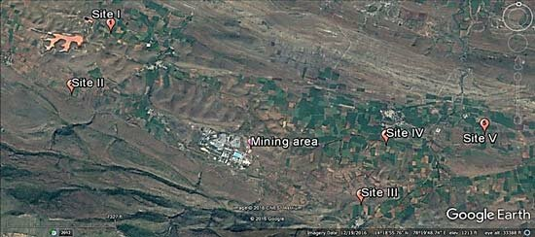
Map 1 : STUDY AREA

Tummalapalle region (14º19’15.794” N 78º16’26.854” E)
Two locations were chosen to participate in the butterfly diversity survey. The initial location was Tummalapalle, about 70 kilometres from Kadapa, in the Vemula Mandal of the Kadapa district, sits the Tummalapalle uranium mine. Pulivendula, the closest town, was almost 15 kilo meters distant. Muddanurru, the closest train station, was almost fifty kilometres away. Mabuchinthapalli was a village located in the Pulivendula Mandal of Kadapa District in the Indian state of Andhra Pradesh.Mabuchintalapalle (MC Palle), Rachakuntapalle, Kota, Bhumaiahgaripalle, KK Kottala, Kanampalle, and Kunummapalle. Though the study conducted areas were near to the mines, those areas were fully covered by plants to reduce the pollution from the radiation.
Palakondalu hills:
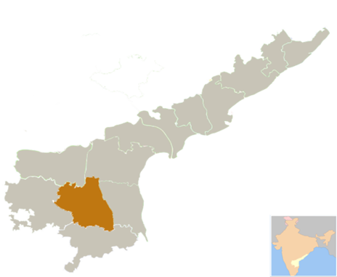

KADAPA
Fig 1 : Palakondalu Forest Area coordinates are 14°28'26.919"N latitude and 78°42'49.446"E longitude
The second location was the Palakondalu Forest Area, close to the Kadapa. This area was significant for butterfly biodiversity and conservation in India due to its species richness and endemism (Gogoi, 2013). Its coordinates are 14°28'26.919"N latitude and 78°42'49.446"E longitude. There were a lot of flowering plants on forest and a lot of vegetation was present in the Palakondalu area. The butterflies were very high in the Palakondalu because richness of greenery and nectar host plants were also present. Palakondalu was one of most visited tourist spots of Kadapa. It was located in the area Puttampalli amid dense forest. There was a temple the God MAHAVISHNU Here Named as “PALAKONDARAYA” SWAMI Along with Goddess Devi. It was an 11th Century Temple. This Hills is also known as Kadapa Palakondalu Hills.
Palakondalu Waterfalls it was a natural waterfall placed among rolling hills. The visitors have to walk for few kilometers as to reach there. The way looks like trekking spot it has some steps and flat surface to walk. The Surroundings was covered with full of Greenery on all sides. Tourists can enjoy the beauty and climate of Palakondalu hills. This was the only Waterfalls that near to Kadapa. There were 5 waterfalls near the Temple one is the bigger and the remaining were the Subs of it.
MATERIALS AND METHODS: -
The poll was conducted between the hours of 9 a.m. and 4 p.m. because this was when butterflies were most frequently seen to be active. Sighted butterflies were noted during the survey, along with information on the food plants, specific butterfly species counts, and their activity. The majority of butterflies were captured on a cell phone while out in the field. Using a swipe net, a few butterflies were caught, identified, and photographed before being released. Standard identification keys were used to identify the butterflies that were observed (Kehimkar 2008, Kunte 2000).
Observation was the basis for data on the seasonality and abundance of the butterfly fauna. There was photographic documentation. After the butterflies were first identified in the wild, undetected butterflies were gathered using nylon nets and identified using the keys of (Kehimkar (2008), Venkata Ramana (2011), and Wynter-Blyth (1957). The life cycle of a few rare and extremely rare butterflies was examined in a lab setting during captive breeding, as well as at a few butterfly parks, using the larvae that were collected together with the leaves of the host plant in petri plates. From August2023 to September 2024, the Tummalapalle butterfly population was examined. A foot survey of this institution was conducted at least once every week. During the course of the study, photos of the butterfly species were also taken. With the use of the field guides by Kunte (2000) and Kehimkar (2008), species identity was verified; taxonomy and nomenclature have been updated after Kunte et al. (2011).
Statistical Analysis: The obtained data were used to determine species richness (S), species abundance (total creatures collected), species diversity (Shannon Weiner index and Simpson's diversity index), and Pielou's evenness index in both the Palakondalu and Tummalapalle habitats.
In the field, the butterflies were immediately spotted and noted. For the purpose of this study, which was carried out from August 2023 to September 2024, a combination of opportunistic sighting methods and direct search approach (Sutherland, 1996) was used to document butterfly diversity and abundance.
RESULTS AND DISSCUSSION:-
The variety of butterfly species found in the Tummalapalle mining region and the Palakondalu forest area throughout the course of the year-long study period (2023 - 2024). Butterfly diversity and abundance were highest in the Palakondalu forest region, with 54 species and 235 individuals, and lowest in Tummalapalle, with 28 species and 97 individuals (Tables 1). A total of 82 species, representing 5 families, were discovered during the investigation at sites A and B. Of these, 54 species were discovered at Palakondalu forest area. Observed species and individuals in Palakondalu forest area were Papilionidea 8 species 41 individuals, Pieridae 16 species 76 individuals, Nymphalidae 17 species 88 individuals, Lycaenidae 10 species 24 individuals and Hesperiidae 3 species 6 individuals. In Tummalapalle a total of 28 species were identified. Observed species and individuals in Tummalapalle mining area surroundings were Papilionidea4 species 18 individuals, Pieridae 10species 26 individuals, Nymphalidae 8 species 38 individuals, Lycaenidae 5 species 12 individuals and Hesperiidae 1 species 3 individuals a total of 28 species 97 individuals were identified.
A total of 332 individuals of 54 butterfly species from five families were found in the study area. With 27 percent of all species, the Nymphalidae family was the most diverse, while the Hesperiidae families were the least diverse, with each family making up only 4 percent of all species. With 126 individuals, or 37.95% of the total butterflies collected, the family Nymphalidae had the highest number of individuals. Pieridae came in second with 102 individuals, or 30.77%, followed by Papilionidae with 59 individuals, or 17.77%, Lycaenidae with 36 individuals, or 10.84%, and the family Hesperiidae with just 9 individuals, or 2.71 percent.

Fig 2 : Percentage of various families of butterflies

Table No. 1: -Identified Butterfly Species in the study area
Scientific Name | Common Name | Family | Number of individuals in Palakondalu | Number of individuals in Tummalapalle | Season* | Status**
Graphium agamenon | Tailed jay | Papilionidea | 2 | 0 | M, PM | C
Graphium doson | Common jay | Papilionidea | 4 | 0 | M, PM, W | VR
Papilio polymnestor | Blue mormon | Papilionidea | 4 | 0 | M, PM | R
Papilio polytes | Common mormon | Papilionidea | 8 | 2 | S, M, PM | VR
Princeps demoleus | Lime butterfly | Papilionidea | 12 | 11 | S | C
Papilio memnon | Common merun | Papilionidea | 1 | 0 | M, PM | V
Graphium nomius | Spot Swordtail | Papilionidea | 2 | 0 | S | O
Pachliopta hector | Crimson rose | Papilionidea | 5 | 2 | S | C
Pachliopta aristalochiae | Common rose | Papilionidea | 3 | 3
Belonias Aurota | The Pioneer | Pieridae | 6 | 0 |  | VC
Appias albina | Common albatross | Pieridae | 8 | 0 | S, M, PM, W | R
Catopsilia crocale | Common emigrant | Pieridae | 6 | 0 | S, M, PM, W | C
Catopsilia pomana | Lemon emigrant | Pieridae | 11 | 4 | S, M, PM, W | VC
Catopsilia pyranthe | Molted emigrant | Pieridae | 12 | 8 | W | VC
Colotis danae | Crimson tip | Pieridae | 6 | 2 | M, PM, W | VC
Colotis eucharis | Plain orange tip | Pieridae | 4 | 0 | M, PM, W | VC
Colotis fausta | Large salmon arab | Pieridae | 2 | 1 | M, PM, W | VC
Colotis.amata | Small orange tip | Pieridae | 2 | 0 | M, PM, W | R
Colotis etrida | Small orange tip | Pieridae | 3 | 2 | M, PM, W | C
Colotis danae | Crimpson tip | Pieridae | 0 | 2 | M, PM, W | C
Eurema hecabe | Three spot grass yellow | Pieridae | 4 | 0 | M, PM, W | C
Eurema blanda | Three spot grass yellow | Pieridae | 3 | 2 | M, PM, W | C
Eurema briggita | Small grass yellow | Pieridae | 2 | 2 | M, PM, W | C
Catapsilia crocale | Common emigrant | Pieridae | 0 | 2 | M, PM, W | C
Belonias aurota | The pioneer | Pieridae | 0 | 1 | M, PM, W | R
Cephora nerisa | Common gull | Pieridae | 2 | 0 | M, PM, W | C
Delias eucharis | Common jejebel | Pieridae | 3 | 0 | S, M, PM, | R
Leptosia nina | The psyche | Pieridae | 2 | 0 | M, PM | R
Danaus chryssipus | Plain tiger | Nymphalidae | 14 | 14 | W | Wide spread
Danaus plexippus | Common tiger | Nymphalidae | 2 | 1 | W | VR
Danaus genutia | Striped tiger | Nymphalidae | 1 | 0 | M, PM, W | C
Tirumala limniace | Blue tiger | Nymphalidae | 5 | 3 | M, PM, W | VC
Euploea core | Common crow | Nymphalidae | 18 | 0 | M, PM, W | VC
Melanitis leda | Common evening | Nymphalidae | 2 | 0 | W | C
Ariadne merione | Common castor | Nymphalidae | 3 | 0 | M, PM, W | C
Byblia ilithyia | The joker | Nymphalidae | 2 | 0 | M, PM, W | R
Hypolimnas bolina | Great egg fly | Nymphalidae | 2 | 0 | S, M, PM, | C
Acrea terpsicore | Tawny coaster | Nymphalidae | 16 | 12 | M, PM, W | VC
Ariadne merione | Common castor | Nymphalidae | 0 | 2 | M, PM, W | R
Byblia ilythia | The joker | Nymphalidae | 0 | 2 | M, PM, W | R
Melanitis leda | Common evening | Nymphalidae | 0 | 2 | W | R
Junonia almana | Peacock pansy | Nymphalidae | 1 | 0 | W | C
Junonia hierta | Yellow pansy | Nymphalidae | 1 | 0 | W | LC
Hypolimnas missipus | Danaid egg fly | Nymphalidae | 2 | 0 | M, PM, W | C
Phalantha phalantha | Common leopard | Nymphalidae | 4 | 2 | S, M, PM, | C
Junoniaorithiya | Blue pansy | Nymphalidae | 3 | 0 | M, PM | C
Junonialemonias | Lemon pansy | Nymphalidae | 8 | 0 | PM, W | C
Ideopsis juventa | gray glassy tiger | Nymphalidae | 4 | 0 | S, M, PM | C
Curetis Thetis | Oak blue | Lycaenidae | 4 | 2 | W | C
Talicada nyseus | Red pierrot | Lycaenidae | 2 | 2 | W | VR
Euchrysops Cnejus | Indian cupid | Lycaenidae | 2 | 1 | M, PM, W | C
Castalius rosimon | Common pierrot | Lycaenidae | 2 | 0 | M, PM, W | VR
Tarucus nara | Rounded pierrot | Lycaenidae | 3 | 0 | M, PM, W | C
Zizeeriakarsandra | Dark grass blue | Lycaenidae | 4 | 5 | S, M, PM, W | w
Spindasisvulcanus | Common | Lycaenidae | 2 | 0 | W | W
Prosotasdubiosa indica | Tailless lime blue | Lycaenidae | 1 | 0 | M, PM, W | C
Chilades pandava | Plains cupid | Lycaenidae | 2 | 0 | M, PM, W | C
Chilades lajus | Lime blue | Lycaenidae | 0 | 2 | M, PM, W | C
Rathinda amor | Monkey puzzle | Lycaenidae | 2 |  | W | VR
Borbo cinnara | Rice swift | Hesperiidae | 3 | 3 | M, PM | C
Hasorachromus | Common banded awl | Hesperiidae | 2 | 0 | M, PM | C
Pelopidas mathias (Fabricius) | Small branded swift | Hesperiidae | 1 | 0 | PM | R
*M - monsoon season, PM - post-monsoon season, ……..
**
Table No. 2 Butterfly composition and distribution across families in Kadapa District Habitat
Family name | Number of species | Percentage % | Number of individuals | Percentage %
Papilionidea | 12 | 14.63 | 59 | 17.77
Pieridae | 24 | 29.26 | 102 | 30.72
Nymphalidae | 27 | 32.92 | 126 | 37.95
Lycaenidae | 15 | 18.29 | 36 | 10.84
Hesperiidae | 4 | 4.87 | 9 | 2.71
Total | 82 |  | 332

Fig 3 : The diversity of butterfly families across the Palakondalu and Tummalapalle habitats

Fig 4 : The abundance of butterfly families across the Palakondalu and Tummalapalle habitats.
Table No. 3 Selected diversity indices of different habitats of Kadapa District.
Diversity indices | Palakondalu | Tummalapalle
Species | 54 | 28
Individuals | 235 | 97
Simpson_1-D | 0.283 | 0.268
Shannon_H | 1.363 | 1.395
Evenness_e^H/S | 0.329 | 0.377
Margalef | 9.90 | 5.91
Equitability_J | 0.217 | 0.350
Fisher_alpha | 9.86 | 5.90

The butterfly species and individual biodiversity indices in the two distinct habitats of Kadapa district were computed and are displayed in the table. The Palakondalu greenery habitat has a higher Simpson diversity index (0.28) than the Tummalapalle environment (0.26). In comparison to the Tummalapalle habitat (1.39), the Palakondalu habitat had a greater evenness index for butterflies (1.36). The Tummalapalle habitat had the highest evenness and equitability index of butterflies, with 0.37 and 0.35, compared to the Palakondalu woodland habitat, which had 0.32 and 0.27.
Plate 1
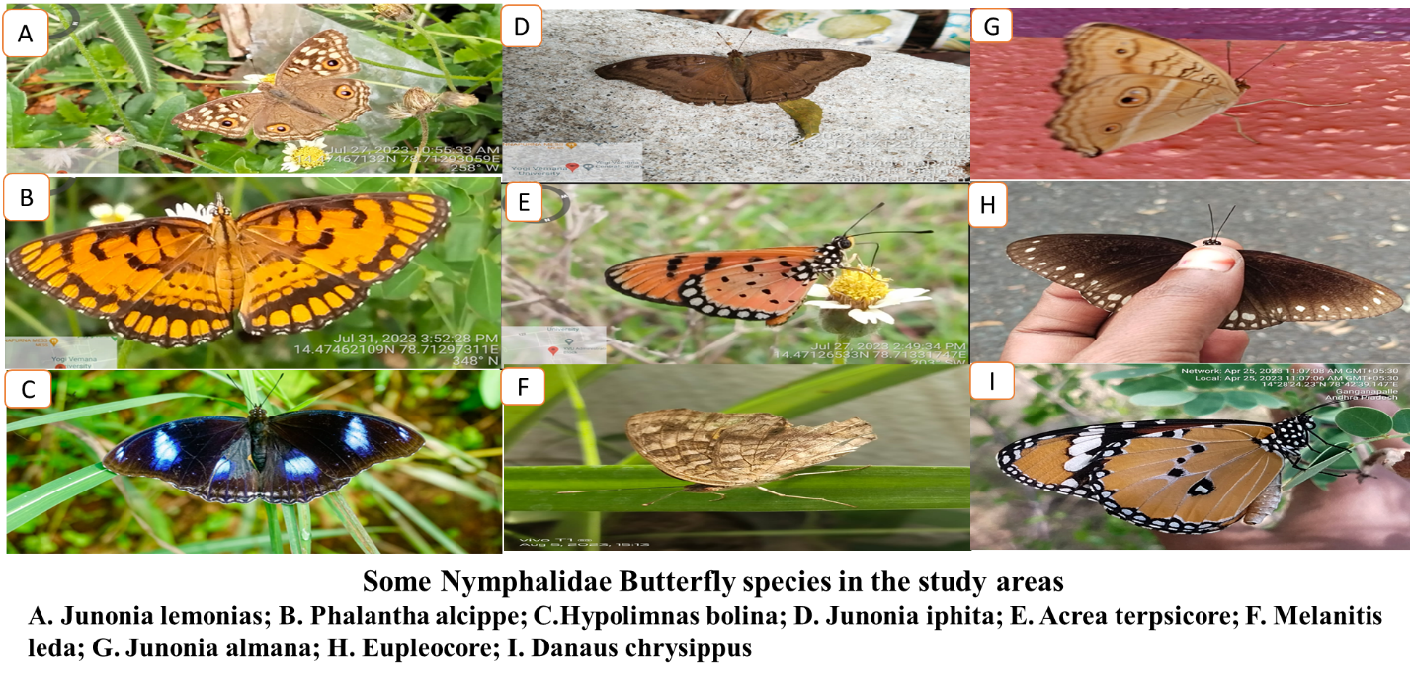
Plate 2
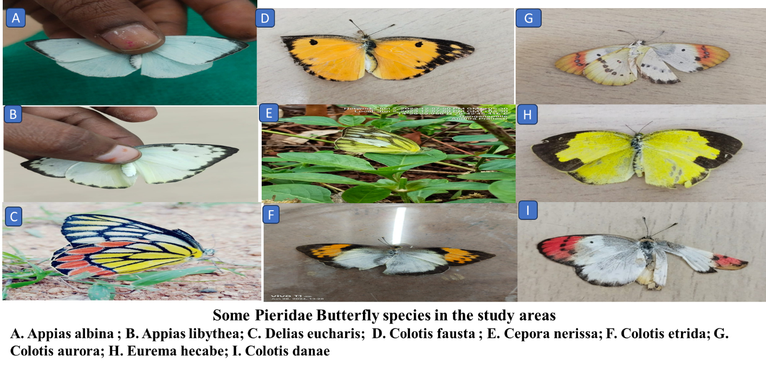
Plate 3
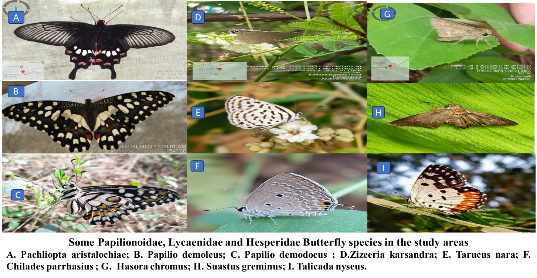
Plate 4
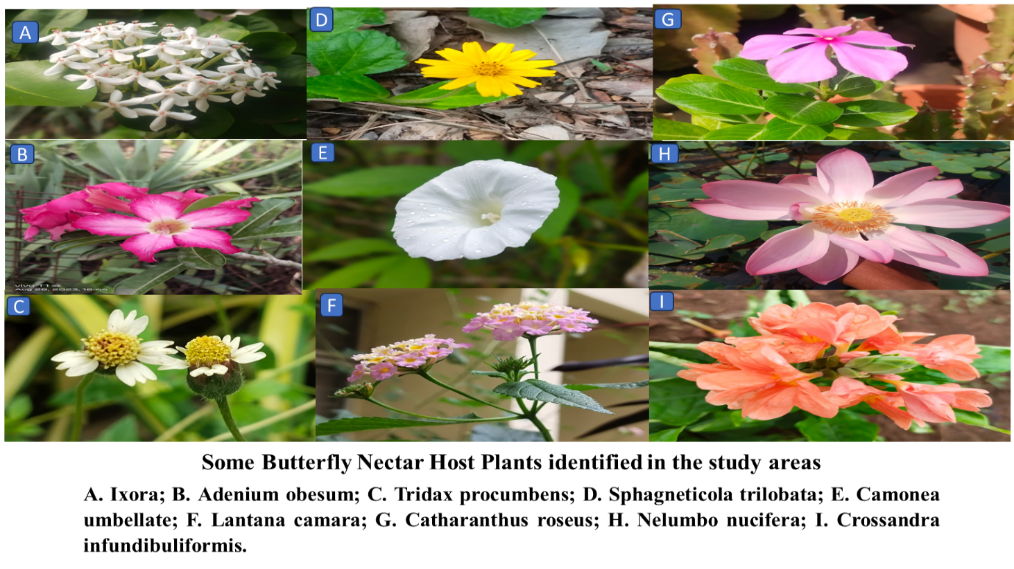
Table 4 : A summary of various butterfly species and the host plants that they feed on can be found in the table
Butterfly Common Name | Butterfly Scientific Name | Host Plant Common Name | Host Plant Scientific Name
Dark Blue Tiger | Tirumala septempunctata | Kalanchoe | Kalanchoe pinnata
Common Grass Yellow | Eurema brigitta | Crotalaria | Crotalaria spp.
Grass Yellow | Eurema hecabe | Cassia | Senna spp.
Lime Butterfly | Papilio demoleus | Citrus | Citrus spp.
Tawny Coster | Acraea terpsichore | Passiflora | Passiflora spp.
Great Orange Tip | Hebomoia glaucippe | Crucifer | Brassica spp.
Common Pierrot | Tarucus balkanicus | Zornia | Zornia diphylla
Common Crow | Euploea core | Calotropis | Calotropis gigantea
Common Leopard | Phalanta phalantha | Passionflower | Passiflora suberosa
Plain Tiger | Danaus chrysippus | Milkweed | Asclepias spp.
Crimson Rose | Pachliopta hector | Sita Ashoka | Saraca asoca
Common Mormon | Papilio polytes | Curry Leaf | Murraya koenigii
Common Tiger | Danaus genutia | Milkweed | Asclepias spp.
Blue Tiger | Tirumala limniace | Kalanchoe | Kalanchoe pinnata

DISCUSSION:-
In the two research regions, 82 butterfly species from five lepidopteron families were identified during the current inquiry. Fisher alpha values (9.86 and 5.90) and the "H" indexes (1.363 and 1.395) showed that there was good butterfly diversity in the Kadapa, with evenness between the two places' ranges. In terms of species richness and the quantity of individuals gathered, the Nymphalidae family was in the lead. This is because species in the Nymphalidae family are found all over the world, occupy a variety of ecological niches, eat a wide variety of generalist plants, and have high species diversity (Hamm and Fordyce, 2015). There were also differences in the number of butterflies in the two habitats; 235 out of 332 butterflies, or 70.7% of the total, were found in the Palakondalu forest habitat, while the remaining 97 butterflies or 29.3% of the total, and were found in the Tummalapalle habitat. Palakondalu forest habitats had higher estimated biodiversity and Shannon diversity indices based on diversity than Tummalapalle habitats. Numerous investigations (Natuhara et al., 1999; Bobo et al., 2006; Yang and Gratton, 2014; Van Halder, 2017) came to similar conclusions. Because habitat loss has been shown to have a significant detrimental impact on biodiversity, Palakondalu woods have more species richness than Tummalapalle ecosystems. Additionally, Palakondalu forest habitats are less degraded than Tummalapalle habitats in order to take advantage of the resources available for their survival in the forest ecosystem; butterflies have a preference for particular habitats. Throughout their life cycle, they exhibit a variety of feeding behaviours, and the varying forest environments provide appropriate locations for mating, foraging, and resting (Santhosh and Basavarajappa, 2017). The outcome shows that there are more species of butterflies in the studied region Palakondalu, because of the presence of a good number of species richness and diversity may be due to the variety of plants and microhabitats for butterflies (Sreekumar & Balakrishna, 2001).
CONCLUSION:-
In comparison to the Tummalapalle, the Palakondalu region reported the greatest number of species. The butterfly species of subfamilies in the Palakondalu and Tummalapalle regions were somewhat equal. The terrain and climate of the area affect species diversity; they are good indicators of the environment and climate (Asher et al., 2001). Since butterflies are sensitive to changes in their environment, another explanation for the low diversity of butterflies could be that the current study area is one of the areas with higher agricultural practices, which leads to habitat fragmentation (Thomas, 2005; Koh, 2007; Warren et al., 2021).The preliminary findings by showing that the Palakondalu region has a little higher level of diversity than the Tummalapalle area. These numbers shows that the butterfly communities in both places are somewhat diverse. Greater diversity is indicated by higher Shannon diversity index values.
According to these findings, there is some diversity and evenness in the butterfly communities in both areas, with the Tummalapalle mining area displaying somewhat greater evenness than the Palakondalu forest area. In comparison to the Tummalapalle mining region, the Palakondalu forest area has higher species richness in relation to the number of individuals.
The distribution of butterfly diversity is more uniform in the Tummalapalle mining region than in the Palakondalu forest area, according to the equitability values. these values show greater diversity in the Palakondalu forest area than in the Tummalapalle mining area. The highest diversity and abundance of butterflies were found in the Palakondalu forest area, with 54 species and 235 individuals, and the lowest diversity and abundance were found in the Tummalapalle, with 28 species and 97 individuals (Table 1 and Table 2). The diversity and abundance of butterflies reported at Kadapa District varied depending on the habitat types (Table 3), with the Nymphalidae family having the maximum diversity. The Hesperiidae family had the fewest species.
Diversity indices further highlight the ecological disparity between the two areas. While the Shannon (H = 1.363) and Simpson (1–D = 0.283) indices were higher in the Palakondalu forest, indicating greater species richness and overall diversity, the evenness (J’ = 0.377) and equitability values were higher in the Tummalapalle mining area. This suggests a more uniform distribution of individuals among the fewer species present in the disturbed habitat—likely due to dominance by generalist, disturbance-tolerant taxa.
These findings confirm that butterflies are sensitive bioindicators of environmental change. The lower species richness in Tummalapalle can be attributed to habitat degradation caused by mining activities, agricultural expansion, and associated land-use changes, which lead to habitat fragmentation and reduced availability of host and nectar plants (Thomas, 2005; Koh, 2007; Warren et al., 2021). In contrast, the relatively intact vegetation, diverse flora, and minimal anthropogenic pressure in Palakondalu create favourable conditions for a richer and more complex butterfly community.
In summary, this study demonstrates that habitat type strongly influences butterfly diversity and community structure. The Palakondalu forest emerges as a vital refuge for butterfly biodiversity in the region and warrants conservation attention. Meanwhile, the altered landscape of Tummalapalle highlights the ecological costs of industrial and agricultural intensification. These results emphasize the need to integrate insect biodiversity monitoring into environmental impact assessments and post-mining rehabilitation programs to ensure ecologically sustainable development in the Eastern Ghats.
REFERENCES:-
- Andrade, C., (1998). Use of butterflies like bioindicators of habitat type and their biodiversity in Colombia. Revista de la Academia Colombiana de Ciencias Exactas, Fisicasy Naturales. 22(84): 407-421.
- Asher, J., Warren, M., Fox, R., Harding, P., Jeffcoate, G., & Jeffcoate, S., (2001). The millennium atlas of butterflies in Britain and Ireland. Oxford University press, Oxford, pp.456.
- Bobo, KS., Waltert, M., Fermon, H., Njokagbor, J., Mühlenberg, M., (2006). From forest to Farmland: Butterfly diversity and habitat associations along a gradient of forest conversion in South-western Cameroon. Journal of Insect Conservation, 10(1): 29-42 v.
- C.M. Lee., T.-S. Kwon., (2014). Rarity and shifts in occurrence of endangered butterflies in South Korea Journal of the Faculty of Agriculture Shinshu University, 50 (2014), pp. 37-42.
- Cheng, C., Richard, A., Norman, N., Crystal, R., Julianne, N., Gary D., Naomi, E., & Nanfang, Y., (2020). Physical and behavioural adaption to prevent overheating of the living wings of butterflies. Nature Communication 11 551.
- Dangles, O., Casas, J., (2019). Ecosystem services provided by insects for achieving sustainable development goals. Ecosystem Services, 35: 109-115.
- Duara, P., (2014). Effectiveness and importance of butterflies as pollinators to the flowers of Ixora coccinea. International Journal of Research Studies in Biosciences, 2(11): 71-74.
- Enkerli, J., Felix, G., Boller, T. (1999). The enzymatic activity of fungal xylanase is not necessary for its elicitor activity. Plant Physiol. 121: 391–397.
- Gogoi, M.J., (2013). Book Review: Butterflies of the Garo Hills. Journal of Threatened Taxa 5(10): 4527–4528.
- Hamm & Fordyce, Hamm, CA., Fordyce, JA., (2015). Patterns of host plant utilization and diversification in the brush footed butterflies. Evolution, 69(3): 589-601.
- Kehimkar, I., (2008), the Book of Indian Butterflies. Bombay Natural History Society and Oxford University Press, Mumbai, India, 1-497.
- Koh, LP., (2007). Impacts of land use change on South-east Asian Forest butterflies: a review. Journal of Applied Ecology, 44(4): 703-713.
- Kunte, K., (2000). Butterflies of Peninsular India. Universities Press (Hyderabad) and Indian Academy of Sciences (Bengaluru), pp. 270.
- Kunte, K. J., (1997). Seasonal patterns in butterfly abundance and species diversity in four tropical habitats in Northern Western Ghats. Journal of Bioscience 22, 593–603.
- Kunte, K., Shea, C., Aardema, M.L., Scriber, J.M., Juenger, T.E., Gilbert, L.E., & Kronforst, M.R., (2011). Sex Chromosome Mosaicism and Hybrid Speciation among Tiger Swallowtail Butterflies. PLoS Genet. 7(9): e1002274.
- Kwon, TS., Lee, CM., Kim, SS., (2014). Northward range shifts in Korean butterflies. Clim Cha. 126 (1-2):163–174.
- Lee, CM., Kwon, TS., (2012). Characterization of the butterfly community of a fragmented urban forest, Hongneung Forest. Korean J Appl Entomol 51:317–323;
- Legal, L., Valet, M., Dorado, O., Jesus-Almonte, JMD., López, K., Céréghino, R., (2020). Lepidoptera are relevant bioindicators of passive regeneration in tropical dry forests. Diversity, 12(6): 231
- Maleque, M.A., Maeto, K., and H.T. Ishii., (2009). “Arthropods as Bioindicators of Sustainable Forest Management, with a Focus on Plantation Forests.” Applied Entomology and Zoology 44: 1–11.
- Meena Haribal., (1992).The Butterflies of Sikkim Himalaya and Their Natural History: Includes Many Species Found Also in Other Parts of India and Himalaya: with 60 Colour Plates and Nine Sketches, Sikkim Nature Conservation Foundation, pp.217.
- Mobeen Ghazanfar., Muhammad Faheem Malik., Mubashar Hussain., Razia Iqbal., Misbah Younas., (2016). Butterflies and their contribution in ecosystem: A review, Journal of Entomology and Zoology Studies, 4(2) 115-118.
- Natuhara, Y., Imai, C., Takahashi, M., (1999). Pattern of land mosaics affecting butterfly assemblage at Mt Ikoma, Osaka, Japan. Ecological Research, 14(2): 105-118.
- Parasharya, BM., & Jani, JJ., (2007), Butterflies of Gujarat. Anand Agricultural University, Anand, Gujarat, 1-138.
- Parmesan, C., (2019). Butterflies as bioindicators for climate change effects. In: Butterflies. University of Chicago Press, USA. pp. 541-560,
- Pearce, J.L., & L. A. Venier., (2006). “The Use of Ground Beetles (Coleoptera: Carabidae) and Spiders (Araneae) as Bioindicators of Sustainable Forest Management: A Review.” Ecological Indicators 6: 780–793.
- Rader, R., Bartomeus, I., Garibaldi, LA., Garratt, MP., Howlett, BG., Winfree, R., (2016). Non-bee insects are important contributors to global crop pollination. Proceedings of the National Academy of Sciences of USA, 113(1): 146-151.
- Rafi, M A., Matin, MA., Sheikh, MK and Ashfaque, M., (2000). Papilionoid (Swallowtails) butterflies of Pakistan, Gull Awan Printers, Islamabad, Pakistan 1-33.
- Regier, JC., Mitter, C., Zwick, A., Bazinet, AL., Cummings, MP., Kawahara, AY., Mitter, KT., (2013). A large-scale, higher-level, molecular phylogenetic study of the insect order Lepidoptera (moths and butterflies). PloS one, 8(3): e58568.
- Robinson, N., Armstead, S., Deane Bowers, M., (2012). Butterfly community ecology: the influences of habitat type, weather patterns, and dominant species in a temperate ecosystem. Entomologia Experimentalis et Applicata, 145(1): 50-61.
- Santhosh, S., Basavarajappa, S., (2017). Biology of few butterfly species of agriculture ecosystems of arid regions of Karnataka, India. Research Journal of Life Sciences, Bioinformatics, Pharmaceutical and Chemical Sciences 2(6):1-19.
- Serrat, A., Pons, P., Puig–Gironès, R., Stefanescu, C., (2015). Environmental factors influencing butterfly abundance after a severe wildfire in Mediterranean vegetation. Animal Biodiversity and Conservation, 38(2): 207-220.
- Sreekumar, PG., Balakrishna, M., (2001). Diversity and habitat preferences of butterflies in Neyyar Wildlife Sanctuary, South India. Entomology 26(1):11-22.
- Suryanarayana, K., Venkata Reddy, M., Sreekanth, B., Nagalakshmi, P., & Venkataramana, SP., (2018). Butterfly diversity (Lepidoptera: Rhopalocera) from three road side sites at different elevations of seshachalam, nallamala hills - eastern Ghats - Andhra Pradesh -India” International Journal of Current Research in Life Sciences, 7(04) 1789-1793.
- Syed Azhar Hasan., (1994). Butterflies of Islamabad & the Murree hills, Asian study group, Islamabad region, murree hills, Pakistan. pp.68.
- Tanda, AS., (2021). Why insect pollinators are important in crop improvement. Indian Journal Entomology, e20370.
- Thomas, JA., (2005). Monitoring changes in the abundance and distribution of insects using butterflies and other indicator groups. Philosophical Transactions of the Royal Society B: Biological Sciences, 360(1454): 339 357.
- Van Halder, I., (2017). Conservation of butterfly communities in mosaic forest landscapes: effects of habitat quality, diversity, and fragmentation. Doctoral dissertation, Université de Bordeaux, France.
- Venkata Ramana, S.P., (2011). The flying Jewels- Butterflies. Sri Venkateswara publications, Kadapa, A.P.
- W. J. Sutherland., (1996). From Individual Behaviour to Population ecology, School of biological sciences, University of East Anglia Norwich, pp.209.
- Warren MS., Maes D., van Swaay CA., Goffart P., Van Dyck H., Bourn NA., (2021). The decline of butterflies in Europe: Problems, significance, and possible solutions. Proceedings of the National Academy of Sciences, 118(2).
- Wynter-Blyth, M. A., (1957). Butterflies of the Indian Region. Bombay Natural History Society, 523 pp.
- Yang, LH., Gratton C., (2014). Insects as drivers of ecosystem processes. Current Opinion in Insect Science, 2: 26-32.

