Protective role of hesperidin nanoparticles and hesperidin against methotrexate-induced reproductive system toxicity in male albino rats

Abstract
Background:In light of the widespread use of the Methotrexate in the medical field and the lack of awareness of its side effects and its effect on fertility. Objective:find effective substances from plants to reduce the effect of the drug’s side effects on fertility.Materials and Methods:The study involved a group of 30 adult male rats, rats were divided into five groups :control group These animals were dosed with Normal Saline ,second group animals that were dosed orally with Methotrexate at 1 mg/kg once a week for two consecutive months ,third group dosed orally with hesperidin(62mg/kg) ,The fourth group were dosed simultaneously with the hesperidin(62mg/kg)andwith the 1 mg/kg Methotrexate,The fifth group were dosed with(62mg/kg) hesperidin nanoparticles and simultaneously with 1 mg/kg methotrexate orally for 60 days.The dosage amount was also chosen based on previous research, and an experiment was conducted on hemolysis and antioxidant activity to determine the safety of the dosage concentration.
Results:The Methotrexate caused a decrease in the level of sex hormones and had a negative effect on the level of sperm count and morphology, while hesperidin had a clear effect in raising the level of LH, FSH and testosterone and also sperm count and reducing abnormalities in the sperm, while on the histological level it was found that Methotrexate displays a distorted structure of the testicular tissue. This is characterized by an enlargement of the spaces between the seminiferous tubules, resulting in increased diameters. Additionally, there is a decrease in the size of the epithelial cell layer, cell necrosis, and a scarcity or absence of sperm.The cohort administered with the active compound hesperidin had a typical configuration of testicular tissue, characterized by the presence of tubules. Sperm has an oval morphology and exhibit a consistent and organized arrangement. The tubules are enveloped by a basement membrane that is composed of sperm-generating cells, including dispersed Sertoli cells with triangular nuclei. In close proximity to the cavity, the cells exhibited a larger size and had black, round nuclei, accompanied by spermatids that displayed a round or rectangular form. The presence of sperm was discovered within the interior spaces of the seminal tubules. Conclusion:The hesperidin nanoparticles had the best effect on increasing fertility,Hesperidin played a role in reducing the amount of damage caused by the drug Methotrexate on the tissues of the reproductive system. Hesperidin also had a role in restoring the level of reproductive hormones to a level similar to normal, while the nanoparticles of hesperidin had a greater role in maintaining the level of hormones in a way similar to the control groups and in protecting the reproductive tissues from the damage caused by methotrexate.
Key words: oxidative stress, hesperidin nanoparticles, hesperidin, methotrexate
Introduction
Several medicinal plants and their extracts are utilized as antibiotics due to their ingestion safety and lack of side effects [1]. Some substances are utilized as supplements in animal feed to enhance output [2]
Medicinal plants are essential and significant in the treatment of numerous ailments. Similarly, in the majority of African nations, a significant 80% of the populace significantly and commonly relies on herbal remedies. The reason for this is that herbal medications are known for their minimal adverse responses, bad side effects, and cost-effectiveness in comparison to regular pharmaceuticals. Plant medicine is considered a viable alternative to manufactured medications [3].
Medicinal herbs are utilized for their anti-inflammatory, anti-allergic, and antibacterial properties, particularly those containing phenolic compounds which exhibit antioxidant effects. Phenolic compounds encompass various categories, including phenolic acids, anthocyanins, and flavonoids. These compounds play a crucial and significant role in promoting health and preventing the onset of numerous diseases. Additionally, certain herbs contain glycosides and alkaloids, which are regarded as significant constituents by pharmaceutical scientists [4].
Medicinal herbs with a long history of use are commonly employed in various parts of the globe and have the potential to serve as an alternative form of treatment for enhancing fertility. Currently, these substances have captured the interest of numerous experts because of their minimal or nonexistent adverse effects [5].
Citrus aurantiufolial
Thanks to its delectable flavor and unique fragrance, it can be aptly described as a miraculous fruit. Lemons are cultivated globally, particularly in tropical and subtropical areas, and it ranks among the leading nations in terms of lemon production.
Argentina, Mexico, the United States of America, Turkey, and South Africa The reference [6] is mentioned.
The pomegranate plant harbors numerous natural compounds that provide significant health advantages and qualities. The cosmetics and pharmaceutical sectors utilize citrus goods, such as essential oils and pectin [7]. conducted the study.
Citrus fruits and citrus by-products contain medicinal components that have pharmacological effects. Essential oils extracted from citrus peel contain phytochemicals that have been proven to possess strong abilities to neutralize harmful free radicals. These oils also exhibit anti-fungal, anti-inflammatory, and anti-oxidative stress properties. Furthermore, citrus pulp and peel have been found to have healing effects onearache, sore throat, vomiting and cough by combating pathogens. Additionally, extracts obtained through steam distillation from citrus fruits, as well as from citrus fruits with seeds, have been used as analgesics and heart tonics, respectively [8, 9].
Hesperidinis a water-soluble antioxidant that has positive effects on the mechanisms of hypertension by enhancing the availability of NO. According to the study conducted by [10], human exposure to both chemicals is strongly associated with the development of endocrine disorders, and is also consistent with research conducted by [11], one of its components is flavonoids, and flavones are a secondary metabolite found in citrus fruits. C. aurantifolia is rich in flavonoids. Hesperidin exhibits various biological effects, such as anti-cancer action, as well as being a powerful antioxidant. It is commonly found in fruit peels and has been used as a natural antioxidant due to its high effectiveness in neutralizing free radicals [12]. The compound hesperidin has been used as an anti-inflammatory agent due to its remarkable effectiveness as a powerful anti-inflammatory. It is also present in living organisms as an anti-inflammatory agent by disrupting or changing biological and morphological parameters. This is achieved through the presence of essential oils such as limonene and alpha-terpinene, which increase the production of anti-inflammatory cytokines[13]. Research literature indicates that consuming a diet rich in hesperidin has a marked effect in preventing bone loss in mice, as reported by [14]. Hesperidin likely has additive effects on lipid metabolism and holds the potential for the prevention and management of obesity-related disorders.Research has also demonstrated a defensive impact, functioning to decrease adipose tissue[15].
Methotrexate (MTX), a folic acid analogue and antagonist, is frequently employed in the treatment of many malignant and non-malignant diseases. It is widely utilized as a therapeutic option across multiple medical conditions [16] MTX, approved by the World Health Organization, is an essential drug and a remarkable success in the pharmaceutical field. It has demonstrated significant effectiveness in treating various diseases, as documented by[17,18,19]The therapeutic effect of high doses of MTX on malignant diseases is well-established. MTX acts as an antagonist of folic acid, inhibiting the activity of folic acid-dependent enzymes and the synthesis of purines and pyrimidines necessary for the production of DNA and RNA in rapidly dividing malignant cells [20].
Methotrexate exerts substantial adverse health consequences on humans as it functions as an endocrine disruptor. It is regarded as one of the most often used anti-tumor medications worldwide. This medication is also referred to as an emergent environmental contaminant, as it is eliminated from the body through defecation or urination. In aquatic environments, due to the limited effectiveness of liquid waste treatment plants in eliminating medicines, these compounds interact with nucleic acids, resulting in morphological and internal alterations that ultimately cause cell death. Several studies were performed on mice and resulted in the system becoming disabled. The testes of exposed mice had both endocrine and cytotoxic alterations, resulting in a modification of the structural arrangement of the seminiferous tubules and the occurrence of oxidative stress [21].
The utilization of chemotherapy is recognized to induce profound and deleterious impacts on all bodily systems and organs. Research has shown that chemotherapy can cause male patients to experience a reduction or complete absence of sperm production, leading to infertility [22] Methotrexate is an antineoplastic medication employed in the treatment of malignant neoplasms, specifically leukemia. The disorders that can be treated with this method include acute lymphocytic leukemia, lymphoma, breast cancer, malignant tumors of the head and neck, as well as non-neoplastic ailments, including rheumatoid arthritis [23]. It functions as an antagonist to folic acid. Prior research has consistently shown that the MTX causes harm to the seminiferous tubules of the testicle, resulting in their disappearance and disarray. Additionally, the treatment leads to a reduction in sperm count and damage to sperm DNA, as reported by [24].
This study aims to determine the effect of hesperidin, active hesperidinand hesperidin nanoparticles on rats adverse effects of Methotrexate.
Materials and methods
Experimental animals
This study was conducted at the animal facility of the College of Pharmacy, University of Karbala. Ethical permission was obtained from the Research and Experimental Ethics Committee of the College of Education for Girls, University of Kufa, under ethical approval No. 27095 in December 2022. Male albino albino laboratory rats were used in the study.The study involved a group of 30 adult male rats, ranging in age from (8 – 10) weeks, and weighing between (168 - 178 gm). The rats were transferred from the animal facility at the College of Pharmacy. They were kept in clean and well-ventilated enclosures for the entire duration of the study, ensuring continuous access to food and water.
Groups of experimental animals
In the experiment 30 male rats were divided into five groups, as follows:
1- control group (G1): which included 6 animals. These animals were dosed with (1 ml) Normal Saline for two months.
2- second group )G2(:It included 6 healthy animals that were dosed orally with the Methotrexate at 1 mg/kg once a week for two consecutive months to cause oxidative stress.
3- The third group )G3): included 6 healthy animals that were dosed orally with the hesperidin, at 62mg/kgof hesperidin[25] depending on the weight of the rat for 60 days.
4- The fourth group (G4): It included 6 animals They were dosed simultaneously with the 62mg/kgof hesperidin every day for 60 days and once a week at 1 mg/kg of methotrexate for 2 months
5-The fifth group (G5):It included 6 animals that were dosed with hesperidin nanoparticles62mg/kg every day for 60 days andonce a week at 1 mg/kg of methotrexate for 2 months
Preparing the aqueous extract of the citrus aurantifolial
-The present investigation encompassed the acquisition of dehydrated citrus aurantifolial from indigenous marketplaces inside the Karbala Governorate. The process of extraction encompassed a series of successive procedures, which are delineated as follows:
The experiment involved submerging around 250 grams of citrus aurantifolial in 1 liter of boiling water. The mixture was then allowed to remain undisturbed until the water evaporated, after which it was dried at room temperature.
The extract was subjected to grinding using an electric mixer grinder after the drying process. The powder that was obtained was then placed in plastic containers until the active components were determined by using HPLC technology.
Nanoparticle synthesis
The nano-extraction was made by dissolving 1 gram of zinc oxide in 50 millilitres of deionized water, then adding 1 gram of the active chemical obtained from citrus leaves (hesperidin) and stirring the mixture for 24 hours. At room temperature by a magnetic stirrer. Then shake the mixture for 18 hours at 40 °C. The sediments were then separated by centrifugation at 3000 rpm for 20 minutes and then washed numerous times with deionized water. Then they were dried at 50°C and pulverised thoroughly using a ceramic mortar until a fine powder consistency was achieved. Then, it was cuancilted at 300 degrees Celsius using an electric oven, according to [26].
The statistical analysis
According to the study data, the arithmetic mean and standard error for each indicator were calculated, and the One way analysis of variance (ANOVA) test was used, along with calculating the value of the Least Significant Difference (LSD) in order to determine the significant differences between the means, which were determined at the probability level (p <0.05).

Results
Results of the nano-extract diagnosis of the hesperidinextracted from the aqueous extract of the citrus aurantifolialplant :-
Scanning Electron Microscope (SEM)
The results of the current study, which were demonstrated by images taken using a scanning electron microscope, indicated that the particle sizes of the nano-extract consisting of hesperidin and zinc oxide ranged between (53.80-96.64 nm) and the average size of the nanoparticles was 71.69 nm) and the shapes of these particles were spherical and in single or In a clustered manner, as shown in Figures (1 a-b)

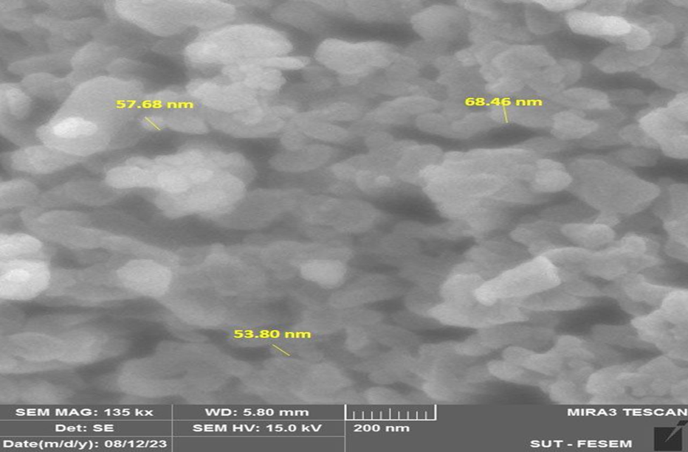

Figure (1 a) A scanning electron microscope (SEM) image of hesperidin nanoparticles extracted from the aqueous extract of the plantCitrus aurantiufolial at around 200 nm.
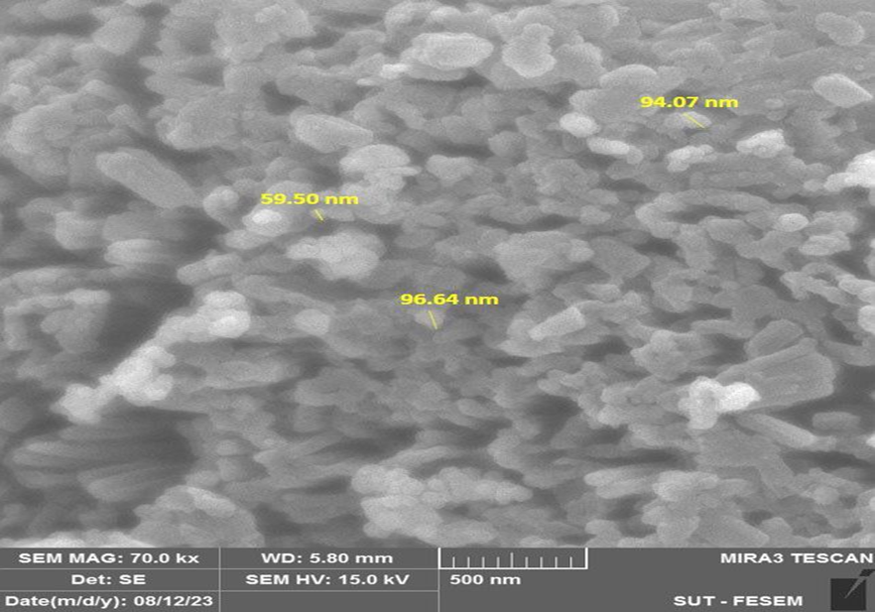

Figure (1b) A scanning electron microscope (SEM) image of hesperidin nanoparticles extracted from the aqueous extract of the Citrus aurantiufolialplant at a size of 500 micrometers.

Atomic force microscope(AFM)
The results of the current study showed the process of revealing the nature of the surface of the manufactured nanoparticles, which showed the surface roughness of the nanoparticles as well as the shape and size of the created particles and the extent of their agglomeration, as in Figure (2). The results of the analysis by AFM showed that the average size of the nanoparticles reached (60.96 )

Figure (2) AFM analysis of zinc oxide nanoparticles manufactured from hesperidin nanomaterial
Antioxidant activity of hesperidin nanoparticles(DPPH radical scavenging assay)
The in vitro antioxidant capacity of hesperidin nanoparticles to scavenge free radicals was assessed using the picrylhydrazyl (DPPH) test. The introduction of hesperidin nanoparticles into the DPPH solution resulted in the complete suppression of DPPH activity across all concentrations examined. The greatest level of inhibition was observed in the combination of DPPH and hesperidin at a concentration of 30 mg/ml, whilst the lowest level of inhibition was observed in the combination of DPPH and hesperidin at a value of 7.5 mg/ml. show Figure (3)

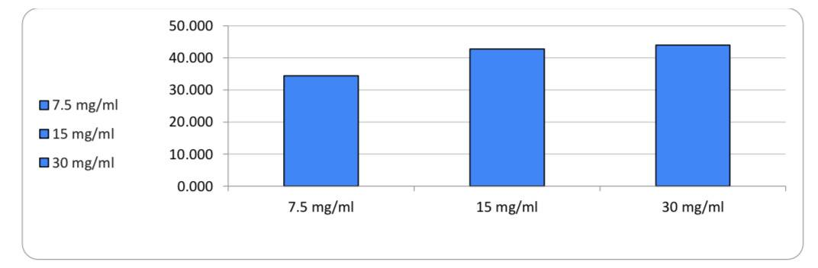

Figure (3) shows the antioxidant activity of hesperidin nanoparticles (removal of DPPH free radicals)
Antioxidant activity of the hesperidin(removal of free radicals DPPH):-
The DPPH test was employed to assess the capacity of hesperidin, an active antioxidant, to diminish free radicals. The addition of hesperidin to the DPPH solution resulted in the complete suppression of DPPH at all concentrations examined. The greatest level of inhibition was observed in the combination of DPPH and hesperidinat a concentration of 30 mg/ml, whilst the lowest level of inhibition was observed in the combination of DPPH and hesperidinat a value of 7.5 mg/ml. show Figure (4)
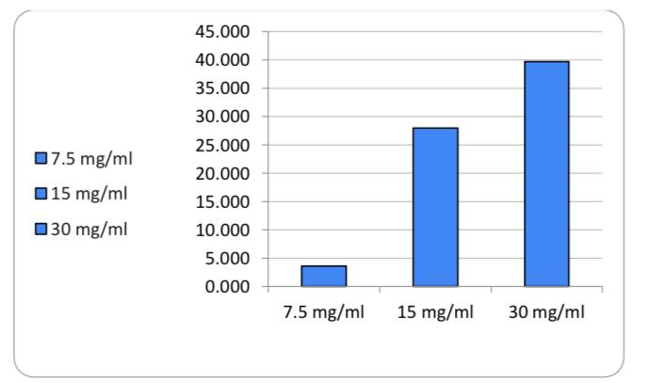

Figure (4) shows the antioxidant activity of thehesperidin(removing DPPH free radicals).
The counter effect of hesperidin nanoparticles on hemolysis
An in vitro hemolysis test was performed to detect the extent of hemolysis of the nano-hesperidin extract at concentrations (7.5-15-30 μg/ml). In general, the nano-hesperidin does not contain any significant hemolytic potential compared to the control triton 100X% used in the study. At the concentration (30 µg/ml), a hemolysis rate of (0.7598%) was observed as shown in Table (1), which is within the permissible limit.
Table (1) shows the anti-hemolytic effect of zinc oxide nanoparticles of hesperidin extract.
concentration (mg/ml) | test result | hemolysis %
30 | 0.7598 | 0
15 | 0.6209 | 0
7.5 | 0.4632 | 0
POSITIVE | 1.6422 | 100
NEGATIVE | 0.311 | 0

The counter effect of hesperidin extract on hemolysis
An in vitro hemolysis test was performed to detect the extent of hemolysis of pure active hesperidin extract at concentrations (7.5-15-30 μg/ml). Pure active hesperidin does not contain any significant hemolytic potential compared to the 100X% triton control used in the study at ( 30 micrograms/ml), a hemolysis rate of (0.6002%) was observed as shown in Table (2), which is within the permissible limit.
Table (2) shows the anti-hesperidin extract effect on hemolysis
concentration (mg/ml) | test result | hemolysis %
30 | 0.6002 | 0
15 | 0.4406 | 0
7.5 | 0.4029 | 0
POSITIVE | 1.6422 | 100
NEGATIVE | 0.311 | 0

Changes of sperm parameters
Sperms count of epididymis cauda
The results in )Table3) show a significant decrease (p<0.05) in the number of sperm in the tail of the epididymis in the drug group compared to G1.
The results in )Table3) also show that there are no significant differences (p<0.05) in the prophylactic active hesperidingroup and also the active hesperidingroup in comparison with G1, and the presence of significant differences (p<0.05) when compared with G2.
The results also showed a significant increase (p<0.05) in the preventive hesperidin nanoparticles group compared to the control and drug groups.
Percentage of motile sperms
The results in )Table3) indicate that there was a significant decrease (p<0.05) in the percentage of motile sperm in the group dosed with methotrexate compared to G1.
The results in )Table3) also show that there are no significant differences (p<0.05) in the active hesperidingroup and the preventive hesperidin nanoparticles group compared to the control group, and the presence of significant differences (p<0.05 )when compared with the drug group.
The results in )Table3) also showed a decrease, but not to the level of significance (p<0.05) in the prophylactic active hesperidingroup when compared with G1, and when compared to G2 the increase becomes significant (p<0.05) in the prophylactic active hesperidingroup.
Percentage of live sperms
The results in )Table3)show a significant decrease (p<0.05) in the percentage of live sperm in the group dosed with methotrexate compared to G1.
The results in )Table3) also show that there are no significant differences (p<0.05) in G3 compared to G1, and there is a significant increase (p<0.05) when compared to G2.
The results in )Table 3) show a decrease, but not to the level of significance (p<0.05) in the prophylactic active hesperidingroup compared to G1, and an increase reaching the level of significance (p<0.05) compared to G2.
The results in )Table3) also showed that there was an increase in the number of live sperm, but it did not reach the level of significance (p<0.05) in G5 compared to G1, and the increase reached the level of significance (p<0.05) when compared to G2.
Percentage of died sperms
The results in )Table3), which show the effect of the parameters in the study on the percentage of dead sperm, showed a significant increase (p<0.05) in the percentage of dead sperm in G2 compared to G1.
The results in )Table3) also showed that there were no significant differences (p<0.05) in the active hesperidingroup, the G4 group, and the G5 group compared to the G1 group, and significant differences (p<0.05) also appeared when compared to the G2 group.
Percentage of abnormal sperms
The results in (Table 3) showed a significant increase (p<0.05) in the percentage of abnormal sperm in the second group compared to the control group.
The results in (Table 3) also showed that there were no significant differences (p<0.05) in the percentage of abnormal sperm in the active hesperidingroup compared to group G1, and there were significant differences (p<0.05) when compared to group G2.
The results in (table3) also show a non-significant decrease (p<0.05) in the prophylactic active hesperidingroup. Likewise, the preventive hesperidin nanoparticles group when compared with G1, and the decrease is significant (p<0.05) compared with G2.
Table (3) shows the sperm standards of male rats in the experimental groups
Standard ± Means
Sperms count of epididymis cauda  1ml*10⁶ | Percentage of motile sperms | Percentage of live sperms | Percentage of died sperms | Percentage of abnormal sperms
79.58  ± 2.23  C | 31.04  ± 0.59  A | 92.96  ± 1.42  AB | 18.40  ± 2.27  B | 4.96  ± 1.08  BC | G1
2.83  ± 1.15  D | 1.00  ± 0.36  C | 4.38  ± 2.43  C | 98.35  ± 0.92  A | 98.69  ± 0.79  A | G2
79.74  5.60 ±  C | 31.10  0.39±  A | 92.52  ± 2.92  AB | 15.02  ± 1.69  B | 5.37  ± 1.30  BC | G3
76.33  ± 3.62  A | 30.31  ± 0.69  A | 85.63  ± 5.00  A | 18.03  ± 2.21  B | 2.85  ± 0.59  C | G4
98.70  5.92±  A | 31.93  0.68±  A | 94.25  1.02±  A | 14.82  ± 2.28  B | 3.34  0.89±  C | G5
1.2257 | 1.7335 | 7.7606 | 5.70 | 3.6004 | LSD 0.05

Measuring levels of reproductive hormones
Level of Testosterone hormones
The results in (Table4)show that there is a significant decrease (p<0.05) in the level of testosterone in the drug group. The results in the table also show that there are no significant differences (p<0.05) in the prophylactic active hesperidingroup when compared with G1, and there are significant differences (p< 0.05) when compared with G2.
The results in the table also showed that there was a significant increase (p<0.05) in the active hesperidingroup and also the preventive hesperidin nanoparticles group when compared with G1 and G2
Level ofLH hormone
The results in (Table 4) show that there is a significant decrease (p<0.05) in the LH hormone in the second drug group. The results in the table also show that there is a significant increase (p<0.05) in the LH hormone level in the active hesperidinand preventive hesperidin nanoparticles groups when compared with the control and the drug.
The results in (Table 4) also showed that there were no significant differences (p<0.05) when compared with the control group in the level of the LH hormone in the prophylactic active hesperidingroup and there were significant differences (p<0.05) when compared with G2.
Level ofFSH hormone
The results in (Table 4) indicate that there was a significant decrease (p<0.05) in the level of FSH in G2 compared to G1.
The results in (Table 4) also showed an increase, but it did not reach the level of significance (p<0.05) in the level of FSH in the prophylactic active hesperidingroup when compared with G1, and there were significant differences (p<0.05) when compared with G2.
The results in (Table 4) also show a significant increase (p<0.05) in the level of FSH in the active hesperidingroup and the preventive hesperidin nanoparticles group when compared with the control as well as when compared with the drug.

Table (4) shows an estimate of the level of the testosterone, LH, and FSH hormones among the treated groups.
FSH | LH | testosterone | Groups
1.41  ± 0.21  CD | 1.40  ± 0.14  B | 1.40  ± 0.17  C | G1
0.50  ± 0.12  E | 0.36  ± 0.13  C | 0.22  ± 0.07  D | G2
2.08  ± 0.22  AB | 2.31  ± 0.30  A | 2.34  ± 0.29  AB | G3
1.65  ± 0.20  BCD | 1.15  ± 0.12  B | 1.35  ± 0.13  C | G4
2.56  ± 0.25  A | 2.70  ± 0.25  A | 3.01  ± 0.42  A | G5
0.6385 | 0.6381 | 0.7368 | LSD 0.05

Histopathological changes
Pathological changes in testicular tissue:
Microscopic analysis of histological sections obtained from the testicles of animals in the G1 (Figure 5) revealed the existence of Leydeck cells and intact tubules containing sperm. The cohort administered with the G3 (Figure 7) had a typical configuration of testicular tissue, characterized by the presence of tubules. Sperm has an oval morphology and exhibit a consistent and organized arrangement. The tubules are enveloped by a basement membrane that is composed of sperm-generating cells, including dispersed Sertoli cells with triangular nuclei. The cellular components responsible for sperm production consist of sperm progenitors, which undergo purification to create spherical cells and are situated on the basement membrane.In close proximity to the cavity, the cells exhibited a larger size and had black, round nuclei, accompanied by spermatids that displayed a round or rectangular form. The presence of sperm was discovered within the interior spaces of the seminal tubules. Furthermore, it was observed that the interstitial tissue was found to be present within the interstitial gaps located between the seminiferous tubules. (Figure 7) illustrates a notable augmentation in the quantity of cellular layers, encompassing Leydeck cells and blood vessels.
The Figure in G2 (Figure 6) also displays a distorted structure of the testicular tissue. This is characterized by an enlargement of the spaces between the seminiferous tubules, resulting in increased diameters. Additionally, there is a decrease in the size of the epithelial cell layer, cell necrosis, and a scarcity or absence of sperm. Furthermore, there is evidence of blood congestion and the presence of interspaces. The observed findings also indicated the breakdown of the germinal layer, along with a deficiency in the link between the Sertoli cells and the spermatogenic cells. Additionally, the germinal layer was observed to detach from the basal membranes.
The histological sections of the testicles in the prevention group (G4, G5) revealed no significant damage in the testicular tissue compared to G2. The histological structure of the testicles in the G4 showed normal structure in the seminiferous tubules, with intact basal membranes that were not separated from the germinal layer. Additionally, there were few interstitial spaces present. In addition, they were distinguished by their typical abundance of sperm-producing cells, as well as the presence of sperm in the seminiferous tubules, and the interstitial tissues normally including blood arteries and Leydeck cells. The G5 groups were characterized by the presence of normal testicular structure, intact basal membranes, normal sperm content, and the presence of interstitial tissues and blood vessels (Figure 8,9).

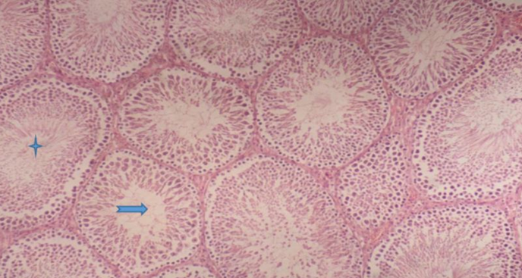

Figure (5) A cross-section of the testicle of a rat from the G1 showing the normal structure of the testicular tissue ( ) the sperm and the middle cavity ( ) (E and H stain , 100X)

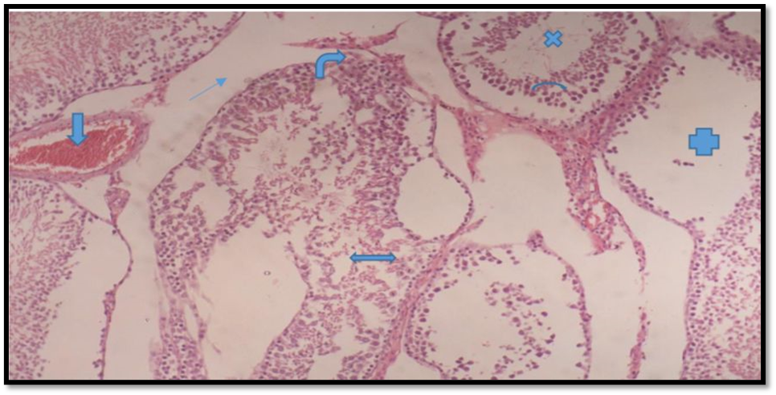

Figure (6) A cross-section of the tissue in the testicle of a rat from the drug group, representing ( ) ) leydigcell paucity, ( ) represents blood congestion, ( ), interstitial spaces, increased diameters ( ), oligozoospermia ( ), cell necrosis ( ), and a decrease in the size of the epithelial cell layer. (E and H stain , 100X)
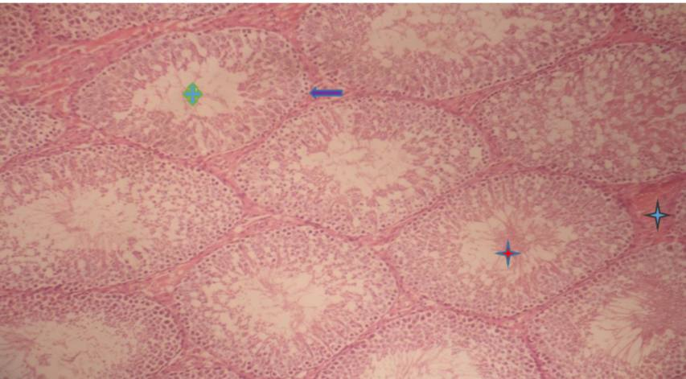

Figure (7) a cross-section of a histological section of a rat testicle from the group of active substance hesperidin showing the normal structure of the testicle () represents an
increase in the number of cell layers ( ) represents an increase in sperm ( ) represents the presence of )leydigcells, and ( ) represents a decrease in the diameter of the cavity (E and H stain , 100X)

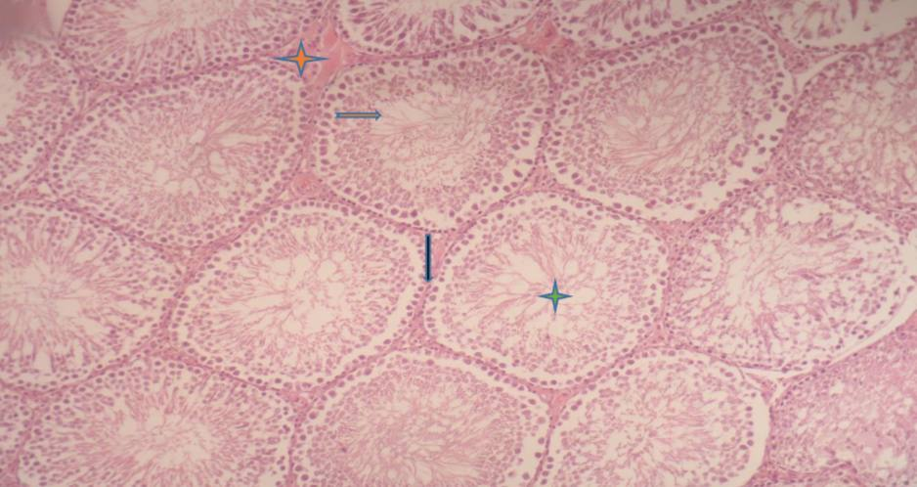
Figure (8) A cross-section of a histological section of the testicle of a rat from the hesperidinand drug prophylactic group, showing an improvement in sperm ( ), a decrease in the diameter of the central lumen ( ), an increase in the germinal layer that forms sperm ( ), and an improvement in seminal tubules ( )(E and H stain , 100X)
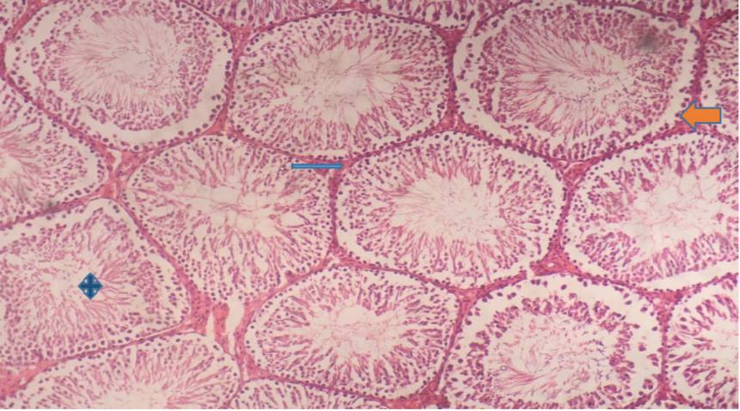

Figure (9) a cross-section of a histological section of a rat testicle from the preventive group hesperidin nanoparticles and the drug, showing normal tissues of the testes and normal tubules ( ), and the presence of Leydec cells ( ) and sperm-filled cells ( ) (E and H stain , 100X)
Histological changes in the cauda epididymis
Histological sections and pictures taken from the tail of the epididymis of animals from the G1 (Figure 10), as well as the group of the active ingredient hesperidin G3(Figure 12) showed a normal histological structure of the epididymal tubules, as they appear large and dilated with normal epithelial tissue, and their cavities are filled with large numbers of sperm, as the G2 showed (Figure 11) Atrophy of the epididymal tubules, a reduction or absence of the number of sperm in the cavities of the epididymal tubules, as well as a reduction in the thickness of the lining epithelial tissue, detachment of the epithelial cells from the basement membranes, a failure to distribute the epididymal tubules in a regular manner, as well as disintegration of the connective tissue.
The histological sections of the protective groups (G5,G4) also showed a significant reduction in histopathological changes, as it was noted that the tubules were wider and also contained large quantities of sperm, and that the epithelium lining the tubules was thicker, as shown in the images (Figure 13,14).

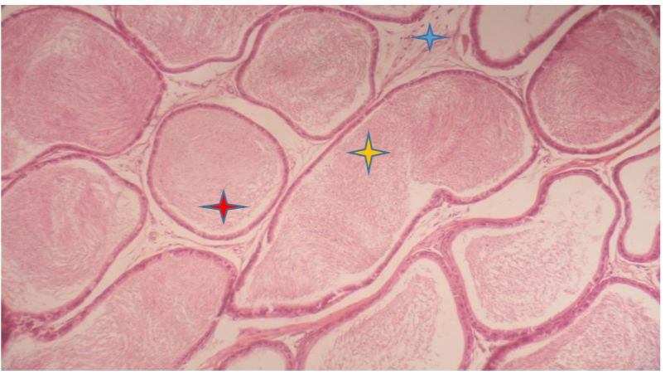

Figure (10) is a cross-section of the epididymis of a rat from G1, showing the epididymal tubules distributed regularly. ( ) The cavity is filled with sperm. ( ) represents a normal tubule of the epididymal duct. ( ) represents smooth muscle cells around the tubule. (E and H stain , 100X)

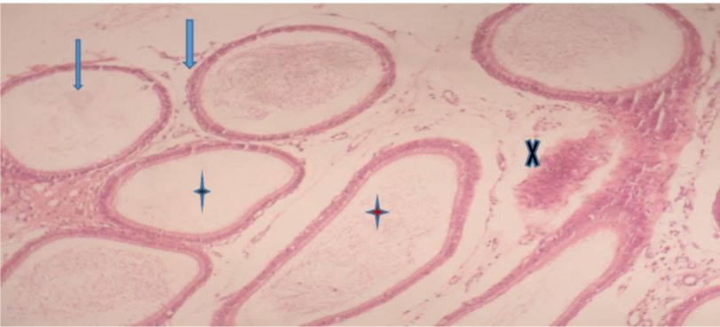

Figure (11) a cross-section of the epididymis of a rat from G2 showing atrophic and irregularly distributed epididymal tubules ( ) and lack of sperm ( ) or absence of sperm ( ) and lack of smooth muscle ( ) (E and H stain , 100X)
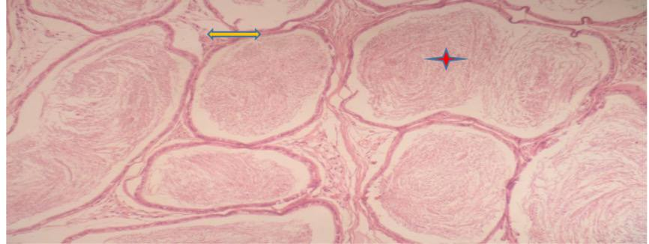

Figure (12) A transverse histological section of the tail of the epididymis of a rat from the active hesperidingroup, in which the epididymal tubules appear regularly distributed and the tissue appears normal ( ) and ( ) represents the filling of the cavities with sperm (E and H stain , 100X)

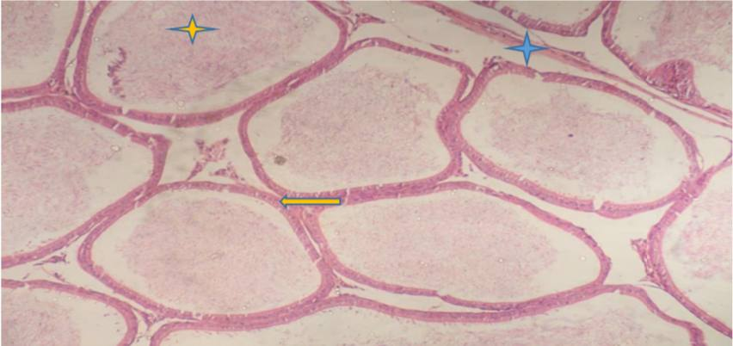

Figure (13) A cross-section of the tail of the epididymis of a rat from the group of protective active hesperidin, in which the epididymal tubules appear regularly distributed and the tissue appears closer to normal. ( ) Represents smooth muscle and epididymal tubule tissue closer to normal. ( ) Increased number of sperm in the lumen of the epididymis ( ). (E and H stain , 100X)
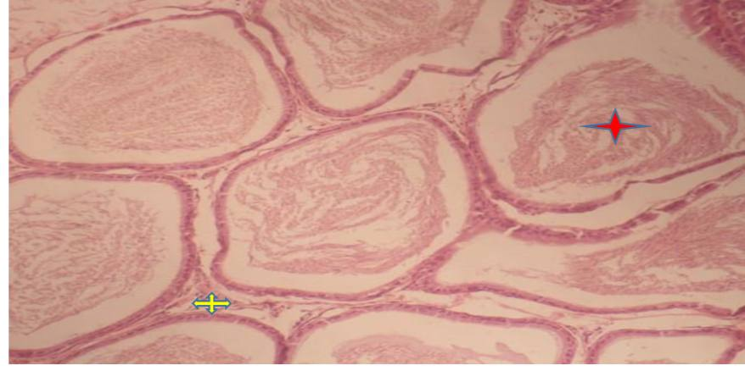

Figure (14) A cross-section of the tail of the epididymis of a rat from the group of protective hesperidin nanoparticles, in which the sperm appear normal and increasing ( ). The epididymal tubules are normal and regular, and the interspaces are small ( )(E and H stain , 100X)
Discussion
The findings of the present study corroborated the findings of two previous studies [27] regarding the protective effects of hesperidinagainst reproductive system toxicity in male rats. hesperidindemonstrated a preventive effect in maintaining and restoring normal levels of reproductive hormones LH, FSH, and T in rats. Recent research confirmed that the seminal vesicle and prostate regained their normal state, which led to the restoration of normal hormone levels in male rats.
The results of the current study support the results of a study [28] regarding the protective effects of hesperidinagainst oxidative stress. hesperidin has also been found to alleviate pathological changes caused by chemicals that induce oxidative stress.
Methotrexate exhibited an unexpected influence on reproductive hormone concentrations, including LH, testosterone, and FSH. The production of oxidative stress in the reproductive system leads to a decrease in sperm count, sperm morphological indices, and sperm structure [29]. Stimulating oxidative stress in the reproductive system, in addition to leading to a decrease in sperm count, sperm morphology indicators, and sperm structure.
The present results confirm a statistically significant decrease (P < 0.05) in the number of sperm in the tail and in the testis [29]. Giving a single dose of MTX to males led to changes in the concentration and motility of sperm, as well as the percentage of live, abnormal, and dead sperm. Testicular tissue in the MTX group showed obvious depletion of sperm cells and a marked decrease in spermatogenesis.
The results of the current research indicate that there are statistically significant differences in that hesperidin nanoparticles have protective properties against oxidative stress, stimulate the secretion of reproductive hormones, and enhance sperm count due to their antioxidant properties. In addition, nanoparticles enhance strong oxidation efficiency. This a significant increase in the volume of live and motile sperm, as well as the concentration of sperm in the cauda epididymis, compared to both G1 and G2 and is similar to the findings of [30,31]. While hesperidin efficiently mitigates the negative effects of methotrexate when compared to G2. Furthermore, it reduced aberrant sperm growth rate, decreased sperm motility, and increased sperm density [32].
The present study corroborated the findings of [33]by showing that administration of a dose of 50 mg/kg of hesperidinfor 14 days, in conjunction with a pharmaceutical chemotherapeutic drug, enhances drug-induced toxicity and ameliorates Tissue damage in male albino rats. The study found that it effectively enhances male reproductive hormones while reducing apoptosis, inflammation, and oxidative stress. Taking hesperidinand the drug resulted in a significant increase in the levels of reproductive hormones LH, FSH, and T, indicating its significant therapeutic effects on hormones. As can be seen from the groups. Individuals who received hesperidinhad a significantly higher concentration of reproductive hormones compared to the groups that were administered the methotrexate. The results of the present study corroborated the findings of [34] that nano-loaded flavonoids, specifically hesperidin, exhibit protective effects against cellular toxicity. Furthermore, the study demonstrated that the effects of nano-loaded flavonoids are significantly more potent in eliminating oxidative stress compared to non-nano materials, which aligns with the findings of the current study. The levels of reproductive hormones exhibited a significant rise in male rats administered with nano-hesperidin, in comparison to the other experimental groups.
Pathological changes in testicular tissue
The findings of the present study corroborated the findings reported by [35] as methotrexate induces histological alterations characterized by the breakdown of germinal tissue, the absence of coherence and linkage between the sperm-producing cells and Sertoli cells, and the detachment and shedding of the germinal layers from the basement membrane in the tubules. The cavities are also empty of sperm and there is a deficiency in their amount in the testes. The study also shown a decline in the quantities of sperm cells and Sertoli cells, which is the finding of the present study.
Methotrexate induces oxidative stress by promoting the generation of free radicals and impairs the activity of antioxidant enzymes, rendering cells more susceptible to free radicals (ROS) and consequent cellular harm. High levels of oxidative stress in the testicles can lead to atypical sperm count and infertility. MTX. In addition, it leads to a significant decrease in body weight, testicle weight, structural abnormalities in the testicles, along with decreased testosterone levels. MTX also causes a significant decrease in the amount of germinal epithelium and causes damage to the tubular tissue. Sperm production and reproductive hormone synthesis stop [36,37].
hesperidin and hesperidin nanoparticles help restore the normal structure of the testicles, and increase reproductive hormone levels through their antioxidant properties. Because it is a natural antioxidant that plays an important role in eliminating free radicals. hesperidin reversed the changes in body and testicular weights and structural characteristics of the testicles, as well as semen parameters and reproductive hormones, returning them to their original state [38]. The results showed the toxic effects of MTX on the male reproductive system in rats[39], as MTX negatively affects the functional structure of the testicles and epididymis.Causing a decrease in germ cells. In addition to the hypertrophy of the interstitial tissue. As for hesperidin and hesperidin nanoparticles, they showed a protective effect in restoring sperm count levels in the epididymis and normalizing the structure of testicular and epididymal tissue. In addition, hesperidin plays an important therapeutic role in repairing damaged tissue [38]. Through its ability to enhance fertility, increase reproductive hormone levels, and restore sperm vitality and natural shape in males to restore normal tissue structure [39].

Conclusion
hesperidinextract works to suppress the negative effects of the methotrexate and increase the efficiency of the male reproductive system

References
1.Collin, H. "Herbs, spices and cardiovascular disease." Handbook of herbs and spices. Woodhead Publishing, 2006. 126-137.‏
2.Windisch, Wilhelm, E. L. I. S. A. B. E. T. H. Rohrer, and Karl Schedle. Phytogenic feed additives to young piglets and poultry: Mechanisms and application. Nottingham University Press: Nottingham, UK, 2009.
3. Singh, J., et al. "Plant based drug development: a pharmaceutical industry perspective." (2001): 554-563.
4. Murakami T., Mori N. Involvement of Multiple Transporters-mediated Transports in Mizoribine and Methotrexate Pharmacokinetics. Pharmaceuticals. 2012;5:802–836.
5.Rabeh, Naeem M. "Effect of halawatahinia alone or with ginger and cinnamon on sex hormones in adult male rats." International Journal of Nutrition and Food Sciences 5.3 (2016): 211-219.‏
6.Liu Y, Heying E, Tanumihardjo SA. History, Global distribution, and nutritional importance of citrus fruits. Compr Rev Food Sci Food Saf. (2012) 11:530–45.
7.Kiefer S, Weivel M, Smits J, Juch M, Tiedtke J, Herbst N. Citrus flavonoids with skin lightening effects – Safety and efficacy studies. Int J Appl Sci. 2010;132:46–54.
8.Grosso G, Galvano F, Mistretta A, Marventano S, Nolfo F, Calabrese G, Buscemi S, Drago F, Veronesi U, Scuderi A. Red orange: Experimental models and epidemiological evidence of its benefits on human health. Oxid Med Cell Longev. (2013) 2013:1–11.
9.Sharma K, Mahato N, Lee YR. Extraction, characterization and biological activity of citrus flavonoids. Rev Chem Eng. (2019) 35:265–84.
10.Leelavinothan P, Asaithambi K, Paramasivam K, AyyasamyR , ] Protective effects of hesperidin on oxidative stress, dyslipidaemia and histological changes in iron-induced hepatic and renal toxicity in rats . 2015;2 - 46-55.
11.Ješeta, Michal, et al. "Overview of the mechanisms of action of selected bisphenols and perfluoroalkyl chemicals on the male reproductive axes." Frontiers in Genetics 12 (2021): 692897.‏
12.Herlina T., Julaeha E., Evy Ernawati E., Darwati, Nurzaman M. AntioksidandariJerukNipis (Citrus aurantifolia) PeningkatImunitasTubuhdalam COVID-19. J. ITEKIMA. 2020;8:19–29.
13.Malleshappa P., Kumaran R.C., Venkatarangaiah K., Parveen S. Peels of Citrus Fruits: A Potential Source of Anti-Inflammatory and Anti-Nociceptive Agents. Pharmacogn. J. 2018;10:s172–s178.
14.Chiba, H.; Uehara, M.; Wu, J.; Wang, X.; Masuyama, R.; Suzuki, K.; Kanazawa, K.; Ishimi, Y. Hesperidin, a Citrus Flavonoid, Inhibits Bone Loss and Decreases Serum and Hepatic Lipids in Ovariectomized Mice. J. Nutr. 2003, 133, 1892–1897.
15.Horcajada, M.N.; Habauzit, V.; Trzeciakiewicz, A.; Morand, C.; Gil-Izquierdo, A.; Mardon, J.; Lebecque, P.; Davicco, M.J.; Chee, W.S.S.; Coxam, V.; et al. Hesperidin inhibits ovariectomized-induced osteopenia and shows differential effects on bone mass and strength in young and adult intact rats. J. Appl. Physiol. 2008, 104, 648–654.
16.Chan E.S.L., Cronstein B.N. Mechanisms of action of methotrexate. Bull. NYU Hosp. Jt. Dis. 2013;71:S5–S8
17.Conway R., Carey J.J. Risk of liver disease in methotrexate treated patients. World J. Hepatol. 2017;9:1092–1100.
18.Tareq Abdulazeez, S., Salman, S., & I Goria, F. (2019). Efficacy, Safety and Predictors of Response to Rituximab in Treatment of Iraqi Patients with Active Rheumatoid Arthritis. Al-Anbar Medical Journal, 15(1), 16-21.‏
19.Kalantari, Elham, Naime Majidi Zolbanin, and Morteza Ghasemnejad-Berenji. "Protective effects of empagliflozin on methotrexate induced hepatotoxicity in rats." Biomedicine & Pharmacotherapy 170 (2024): 115953.‏
20.Tian H., Cronstein B.N. Understanding the mechanisms of action of methotrexate: Implications for the treatment of rheumatoid arthritis. Bull. NYU Hosp. Jt. Dis. 2007;65:168–173.
21.da Cunha de Medeiros P, Nascimento CC, Perobelli JE. Antineoplastic drugs in environmentally relevant concentrations cause endocrine disruption and testicular dysfunction in experimental conditions. Environ ToxicolPharmacol. 2023 Jun;100:104122.
22.Kim J, Kim K, Chung M. Testicular cytotoxicity of DA-125, a new anthracycline anticancer agent, in rats. Reproductive Toxicology. 1999;13(5):391–397.
23.Padmanabhan S, Tripathi DN, Vikram A, Ramarao P, Jena GB. Methotrexate-induced cytotoxicity and genotoxicity in germ cells of mice: intervention of folic and folinic acid. Mutation Research. 2009;673(1):43–52.
24.Vardi N, Parlakpinar H, Ates B, Cetin A, Otlu A. Antiapoptotic and antioxidant effects of β-carotene against methotrexate-induced testicular injury. Fertility and Sterility. 2009;92(6):2028–2033 .
25.Aksu, Emrah Hicazi, Fatih Mehmet Kandemir, and Sefa Küçükler. "The effects of hesperidin on colistin‐induced reproductive damage, autophagy, and apoptosis by reducing oxidative stress." Andrologia 53.2 (2021): e13900.‏
26.Bashir, Taqadus, et al. "Are behavioral biases influenced by demographic characteristics & personality traits? Evidence from Pakistan." European Scientific Journal 9.29 (2013).
27.Khamis T, Hegazy AA, El-Fatah SSA, Abdelfattah ER, Abdelfattah MMM, Fericean LM, Arisha AH. Hesperidin Mitigates Cyclophosphamide-Induced Testicular Dysfunction via Altering the Hypothalamic Pituitary Gonadal Axis and Testicular Steroidogenesis, Inflammation, and Apoptosis in Male Rats. Pharmaceuticals (Basel). 2023 Feb 15;16(2):301.
28.Atta IS, Elnady MR, Alghamdi AG, Alghamdi AH, Aboulata AA, Shatla IM. Assessing the hepatoprotective effects of hesperidin on liver-associated disorders in albino rats with experimentally induced obesity and type II diabetes: A histological and biochemical study. Heliyon. 2023 May 6;9(5):e16031.
29.Aldhahrani A. Paulliniacupana seed extract ameliorated methotrexate-induced testicular dysfunction through the regulation of antioxidants, inflammatory, apoptosis/anti-apoptosis, and steroidogenesis-associated genes. Environ Sci Pollut Res Int. 2023 Feb;30(6):15115-15127.
30.Ganaie, Majid Ahmad. "The protective effects of naringenin on testes gonadotoxicity induced by cisplatin in rats." Bull Env Pharmacol Life Sci 5 (2015): 15-21.‏
31.El-Shahawy, Ahmed AG, et al. "A novel layered double hydroxide-hesperidin nanoparticles exert antidiabetic, antioxidant and anti-inflammatory effects in rats with diabetes." Molecular Biology Reports 48 (2021): 5217-5232.‏
32.Belhan S, Özkaraca M, Kandemir FM, Gülyüz F, Yıldırım SÖA. Effectiveness of hesperidin on methotrexate-induced testicular toxicity in rats. Kafkas Univ Vet Fak Derg. 2017; 23(5):789–96.
33.Tekin S, Çelebi F. Investigation of the effect of hesperidin on some reproductive parameters in testicular toxicity induced by Bisphenol A. Andrologia. 2022 Nov;54(10):e14562.
34.Sahu, Nidhi, et al. "Synthesis of silver nanoparticles using flavonoids: hesperidin, naringin and diosmin, and their antibacterial effects and cytotoxicity." International Nano Letters 6 (2016): 173-181.‏
35.Kilinc, Leyla, and Yesim Hulya Uz. "Protective effects of curcumin against methotrexate-induced testicular damage in rats by suppression of the p38-MAPK and nuclear factor-kappa B pathways." Clinical and Experimental Reproductive Medicine 48.3 (2021): 211.‏
36.Güvenç, Mehmet, and Mesut Aksakal. "Ameliorating effect of kisspeptin‐10 on methotrexate‐induced sperm damages and testicular oxidative stress in rats." Andrologia 50.8 (2018): e13057.‏
37.Abdelzaher, W. Y., et al. "Role of nitric oxide donor in methotrexate-induced testicular injury via modulation of pro-inflammatory mediators, eNOS and P-glycoprotein." Human & Experimental Toxicology 39.12 (2020): 1700-1709.‏
38.Abu-Khudir, Rasha, et al. "The palliative and antioxidant effects of hesperidin against lead-acetate-induced testicular injury in male wistar rats." Biomedicines 11.9 (2023): 2390.‏
39.Yallamati, Mahesh Babu, et al. "Ameliorative effect of Vitis vinifera (Linn.) seed extract on lead acetate induced oxidative damage on testis and sperm quality in Wistar rats." Journal of Experimental Zoology Part A: Ecological and Integrative Physiology 339.2 (2023): 210-219.‏

