Histological Alterations in the liver of Heteropneustes fossilis (Bloch, 1794) exposed to Polystyrene Nanoparticles.

Abstract
Plastic pollution has been a serious environmental threat through its increasing application in every field whether it is household or industry. Plenty of plastic in aquatic debris ends up in aquatic environments where it degrades and fragments are nanosized through various ways. These nanoparticles can travel to almost all locations within the organisms via endogenous transport to cause severe damage to them. Among nanoplastics, polystyrene is creating more health hazards in aquatic organisms. Fishes are the best indicator of aquatic pollution as they get exposed to these toxicants by the unscrupulous use of plastic due to its easy applications in personal and public life. In the present study, Heteropneustes fossilis, was exposed to various concentrations of polystyrene nanoparticles for 20 days to investigate the histological alterations in the liver under a Scanning Electron Microscope.
Keywords: Polystyrene Nanoparticles, Histology, Heteropneustes fossilis, Scanning Electron Microscope

Introduction:

Plastic production and its uses have increased tremendously in recent years ( Guimaraes et al. 2000, Nielsen et al.,2020) due to their durability, low production cost and light weight. Plastics are made up of a wide range of polymers such as polystyrene, polypropylene, polyethylene terephthalate and polyvinyl chloride (Quecholac –Pina et al., 2020; Kelpsiene et al.,2021). One of the most widely used plastics is polystyrene and it is commonly called thermocol. Polystyrene is commonly used for moulding or expanding into foams as cosmetics, disposable plates, cups, trays, toys, food containers, medical equipment, etc.( Loos et al,. 2014; Plastic Europe, 2018; Wunch 2000; Kik et al,.2020). In inefficient waste management and recycling process, huge amounts of plastic debris enter the environment (Geyer et al., 2017) and adversely affect aquatic organisms.
The accumulation of nanoplastics in the aquatic system is undergoing a continuous process of contamination which causes many harmful effects on aquatic organisms, especially on fish. Fish can ingest nanoplastics directly or via praying on other organisms or eventually enter through the food chain (Mattsson et al,. 2015; Horton et al,.2018; Cedervall et al,.2012) and greatly affects vital organs such as the liver, intestine, and pancreas (Brun et al,.2019; Zhou et al,. 2022,. Cui et al,. 2023).
H. fossilis is selected for the present study due to its easy availability and adaptability in laboratory conditions. H. fossilis is good indicator of environmental contaminants and gets adversely affected by environmental toxicants
Several workers have studied several aspects of the toxicity of PS-NPs on the various tissues of the fishes but studies on the effect of 100nm size PS-NPs toxicity on the liver of H. fossilis is meagre. Therefore this study has been undertaken to investigate the hepatotoxicity of this toxicant.

2. Materials and Methods:
Experimental fishes irrespective of sex with an average weight of 30-35gm and a total length of 100-150mm were procured from the local fish market. After examining carefully healthy fishes were acclimatized for 15 days before experimentation in a large tank in the laboratory. During acclimatization, fishes were continuously aerated and maintained natural photoperiod. The fish were fed with commercial nutritious food once a day. The tank was cleaned thoroughly and filled with fresh water.

Experimental Design:
Fishes were divided into five groups: One Control and four PS-NPs treated and maintained in five tank. Each fish tank contained ten fishes. Fishes were exposed to a freshly prepared stock solution of Polystyrene nanoparticles with different dosages as 10μg/L, 20μg/L, 30μg/L, and 40μg/L in 50L dechlorinated water. During the exposure period of 20 days, the control and PS-NPs treated tank were subjected to the same environmental conditions. During experimentation, the experimental tanks were renewed completely with a fresh solution of the same concentration in two-day intervals. Aerators were used to maintain the levels of dissolved oxygen (DO) in both the control and experimental groups. After completion of the exposure period, fish were sacrificed for the histological study of the liver.

Sampling
At the end of the experiment after 20 days fish were collected from the control and various exposure sets with polystyrene nanoparticles. Five fishes were anaesthetized with clove oil (Argungu et al,. 2017) mixed in cold water, and their liver was dissected out and fixed in respective fixative accordingly and finally proceeded for histological observation on Scanning Electron microscope (SEM).

Histological Analysis
For SEM study liver samples were fixed in Karnovsky’s Fixative (mixture of 2% paraformaldehyde and 2.5% glutaraldehyde prepared in 0.1M phosphate buffer, pH 7.4) for 2-6 hours at 4°C and after washing with 0.1M phosphate buffer, it was post-fixed with 1% osmium tetraoxide solution (prepared in phosphate buffer, 0.2M and pH 7.4) for 2h at 4°C. After fixation samples were dehydrated through a graded series of acetone. Then tissues were dried using liquid CO₂ at a critical point drier at 31.5° C at 1100 psi, mounted on aluminium stubs followed by sputter coating using gold to coat samples with 20-30 nm thick film for observation under SEM (EU 018) at the Electron Microscope Facility Centre, SAIF, AIIMS, New Delhi, India.

RESULTS:
The liver of the control fish showed a normal palisade arrangement of hepatocytes under SEM observation. Hepatic cords and mucus mass over hepatocytes clearly visible under SEM Study. Columns of hepatocytes extend from the portal region to central veins with well-demarcated sinusoids. Endothelial cells were flattened in shape. The round nuclei were seen. Leucocytes and kupffer cells frequently adhere to endothelium. Hepatic cords were seen as net-like structures.
Sinusoidal openings were small in size. The Bile canaliculi run along the entire cell surface. Portal space was very distinctly observed under SEM. In the control group, no pathological alterations were observed under SEM (Fig. 01).
The normal architecture of liver organization showed abnormal features when treated with test toxicant Polystyrene Nanoparticles. The structure of hepatic lobules had been changed
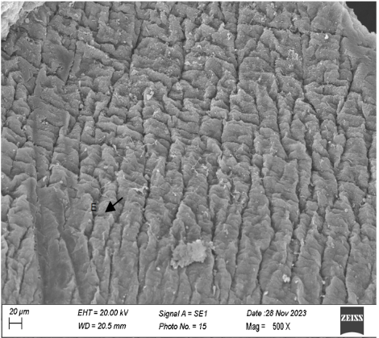
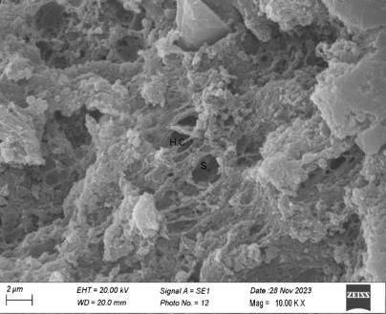
Fig. 1. Micrographic representation
of Heteropneustes fossilis liver.
(Control group), E. Endothelium
Magnification 500X.
Fig. 2. Micrographic representation
of Heteropneustes fossilis liver.
(Control group), S, Sinusoids, HC Hepatic cord Magnification 10KX.

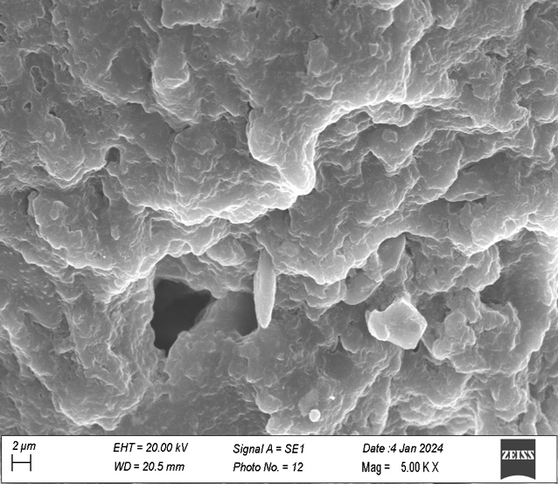
Fig. 3. Micrographic representation of Heteropneustes fossilis liver treated with 10μg/L PSNPs. after exposure for 20 days.
Magnification 5.00KX
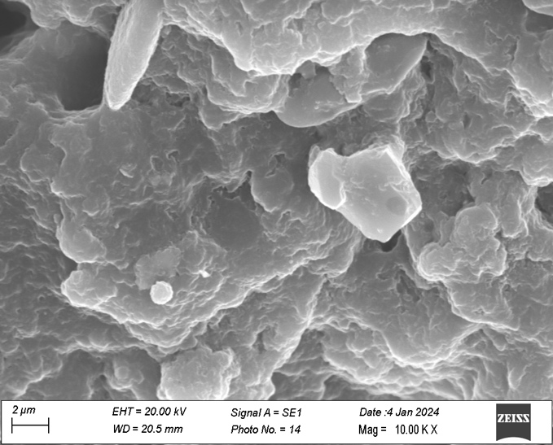
Fig. 4. Micrographic representation of Heteropneustes fossilis liver treated with 20μg/L PSNPs. after exposure for 20 days .
Magnification 10.00KX

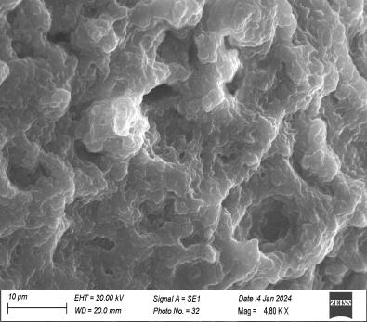
Fig. 5. Micrographic representation
of Heteropneustes fossilis liver treated with 30μg/L PSNPs. after exposure for 20 days.
Magnification 10.00KX

Fig 6: Micrographic representation of Heteropneustes fossilis liver treated with 30μg/L PSNPs. after exposure for 20 days.
Magnification 5.00KX

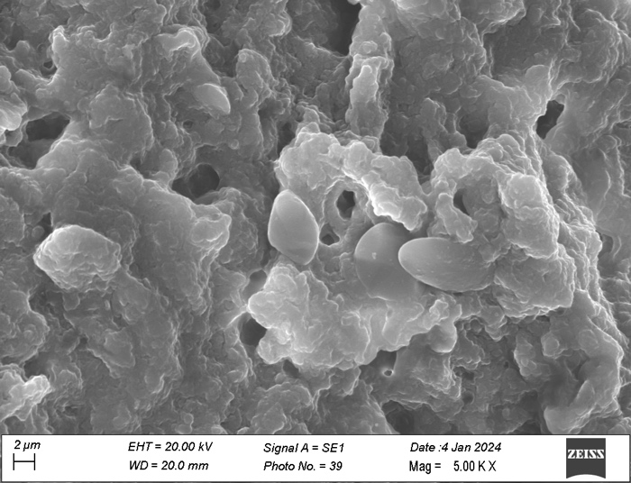
Fig. 7: Micrographic representation of Heteropneustes fossilis liver treated with 40μg/L PSNPs. after exposure for 20 days .
Magnification 5.00KX
Fig. 8: Micrographic representation of Heteropneustes fossilis liver treated with 40μg/L PSNPs. after exposure for 20 days .
Magnification 10.00KX

in comparison with the control group (fig. 2) under SEM observation. Hepatic lobules are identified as irregular polyhedral structures. Endothelium became irregular in shape. In low concentrations of PS-NPs (10µg/L), kupffer cells increase in number. Sinusoidal openings became large in shape
(fig. 3). Kupffers cells become less in number and cell borders became invisible on exposure of 20µg/L of PS-NPs (fig. 4). The liver of H. fossilis treated with 30µg/L of PS-NPs, the hepatocytes appeared to float in empty spaces among the hepatocytes (fig. 5,6). Tremendous number of hepatocytes, blood vessels were ruptured therefore haemorrhage occurred with infiltration of lymphocytes when the liver of H.fossilis was treated with 40µg/L of PS-NPs for 20 days. Vacuoles were observed both in extracellular space and in the cytosol (Fig. 7,8.).

Discussion
Fishes play an important role in aquatic ecosystems. Contamination of fishes by plastics especially polystyrene nanoparticles so far studied has brought intense effects on histological architecture. In the present study, the effects of Polystyrene Nanoparticles on the liver were examined and progressive histological changes were documented. Significant changes in histological structure were noticed under SEM observation during on exposure of PS-NPs in experimental groups.
At prolonged exposure of high doses of PS-NPs for 20 days showed varied degrees of hepatic destruction within and around the hepatic parenchyma. Several authors have reported that different toxicants adversely affect the integrity of hepatic cells. Pandey et al., (2015), observed that the parenchymal architecture of the liver was disturbed and hepatocytes showed dissociation and granular appearance in the liver of H. fossilis exposed to Pentachlorophenol (PCP). Acute and extensive necrosis of liver cells was observed and the density of connective tissue increased. C. Uguz et al.,(2003) observed neoplastic proliferation of reticuloendothelial cells in the liver of fish rainbow trout (Onchorynchus mykiss), exposed to a higher concentration of NP for a long duration (four weeks). The replacement of normal liver tissues by the fibrous septum may be considered as carcinogenic development in the liver (Chiriboga et al.
2000 a,b).
Under SEM observation severe damage in hepatocytes and hepatic chords were seen. Alterations in hepatocytes such as vacuolation, necrosis and haemorrhage were observed in the present study. Cytoplasmic vacuolation in hepatocytes indicated decreased protein synthesis due to a lack of lipid-protein conjugation that accompanied hepatic injury (Cheville NF, 1994). In the liver, severe necrosis in hepatocytes, vacuolization of cytoplasms, degeneration of cell membrane, and severe leukocytes infiltration under SEM study were observed by Palas Samanta et al., 2018 in Oreochronis niloticus exposed to Glyphosate-based Herbicide, Excel Mera 71.
In the present study under SEM observation the liver of the fish exposed to a higher concentration of PS-NPs, hepatic lobules were observed as floated in a empty spaces. The initiation of hepatocellular carcinoma cannot be ruled out with increase in concentration of PS-NPs as the floating hepatocytes marks advent of metastatic state. The accumulation of PS-NPs has caused mechanical damage to the blood vessels and hepatocytes as well leading to infiltration of lymphocytes. The nuclei appear spherical and enlarged (G.Macchiarelli et al,.
1986, Motta P. et al,.1978) showing a departure from normal to hepatic malignancy.

CONCLUSIONS
The findings of this study provide strong evidence that exposure to polystyrene nanoparticles can severely damage the liver of H. fossilis over an extended period. The histological findings demonstrate that the health status of fish can serve as a reliable bio-indicator for assessing the level of contamination in aquatic environments. Therefore, it is imperative to closely monitor and regulate the release of PS-NPs to safeguard the health of aquatic organisms and preserve the integrity of aquatic ecosystems. Besides the plastic pollution calls for special attention as the fragmented particles can reach to human beings in subtle manner through several ways to cause acute histopathological conditions.

.

References

Argungu, L.A. and Siraj, S.S. and Christianus, A. and Amin, M.S.N. and Daud, S.K. and Abubakar, M.S. and Abubakar, I.A. and Aliyu-Paiko. A simple and rapid method for blood collection from walking catfish, Clarias batrachus (Linneaus, 1758), volume 16, number 3, 2017
Brun N. R., van Hage P., Hunting E. R., Haramis A.-P. G., Vink S. C., Vijver M. G., et al. (2019). Polystyrene Nanoplastics Disrupt Glucose Metabolism and Cortisol Levels with a Possible Link to Behavioural Changes in Larval Zebrafish. Commun. Biol. 2, 382. doi:10.1038/s42003-0190629-6
C. Loos , T. Syrovets , A. Musyanovych , V. Mailänder , K. Landfester , G. U. Nienhaus and T. Simmet , Functionalized polystyrene nanoparticles as a platform for studying bio-nano interactions, Beilstein J. Nanotechnol., 2014, 5 , 2403 —2412
Cedervall, T., Hansson, L. A., Lard, M., Frohm, B., & Linse, S. (2012). Food chain transport of nanoparticles affects behaviour and fat metabolism in fish. PloS one, 7(2), e32254.
Cheville NF. Ultrastructural pathology. Ames: Iowa: State University Press; 1994.
Chiriboga, L., Yee, H., Diem, M., (2000aa). Infrared spectroscopy of human cells and tissue. Part VI: a comparative study of histology and infrared microspectroscopy of normal, cirrhotic, and cancerous liver tissue. Appl. Spectrosc. 54 (1), 1–8.
Chiriboga, L., Yee, H., Diem, M., (2000bb). Infrared spectroscopy of human cells and tissue. Part VII: FT-IR microspectroscopy of DNase- and RNase-treated normal, cirrhotic, and neoplastic liver tissue. Appl. Spectrosc. 54 (4), 480–485
Cui, R., Kim, S.W., An, Y.-J., (2017). Polystyrene nanoplastics inhibit reproduction and induce abnormal embryonic development in the freshwater crustacean Daphnia galeata. Sci. Rep. 7 (1) https://doi.org/10.1038/s41598-017-12299-2.
Gabriel, Ugwemorubong. (2012). Changes in Metabolic Enzymes Activities in Selected Organs and Tissue of Clarias Gariepinus Exposed to Cypermethrin.
Guimarães, A. T. B., Estrela, F. N., Pereira, P. S., de Andrade Vieira, J. E., de Lima Rodrigues, A. S., Silva, F. G., & Malafaia, G. (2020). Toxicity of polystyrene nanoplastics in Ctenopharyngodon idella juveniles: A genotoxic, mutagenic and cytotoxic perspective. Science of The Total Environment, 141937. doi:10.1016/j.scitotenv.2020.141937
Horton A. A., Jürgens M. D., Lahive E., van Bodegom P. M., Vijver M. G. (2018). The Influence of Exposure and Physiology on Microplastic Ingestion by the Freshwater Fish Rutilus rutilus (Roach) in the River Thames, UK. Environ. Pollut. 236, 188–194. doi:10.1016/j.envpol.2018.01.044
Kelpsiene, E.; Ekvall, M.T.; Lundqvist, M.; Torstensson, O.; Hua, J.; Cedervall, T. Review of ecotoxicological studies of widely used polystyrene nanoparticles. Environ. Sci. Process. Impacts 2021, 24, 8–16.
Kik, K., Bukowska, B., & Sicińska, P. (2020). Polystyrene nanoparticles: Sources, occurrence in the environment, distribution in tissues, accumulation and toxicity to various organisms. Environmental Pollution, 262, 114297.
Macchiarelli G, Motta PM. The three-dimensional microstructure of the liver. A review by scanning electron microscopy. Scan Electron Microsc. 1986;(Pt 3):1019-38. PMID: 3541157.
Mattsson K., Ekvall M. T., Hansson L.-A., Linse S., Malmendal A., Cedervall T. (2015). Altered Behavior, Physiology, and Metabolism in Fish Exposed to Polystyrene Nanoparticles. Environ. Sci. Technol. 49, 553–561. doi:10.1021/es5053655
Motta P, Muto M, Fujita T.(1978). The Liver. An Atlas of Scanning Electron Microscopy, Igaku 1033 Shain, Tokyo/New York, Pp.: Preparation of Liver Samples for SEM, 1-4; The Peritoneal Liver Surface, 5-13; Liver Architecture and Vasculature, 14-29, 83-143; Liver Parenchymal Cells and Intrahepatic Biliary Tree, 30-81; Future Applications of SEM in Hepatology, V, 145-171.
Nielsen, T.D., Hasselbalch, J., Holmberg, K., Stripple, J., 2020. Politics and the plastic crisis: a review throughout the plastic life cycle. Wiley Interdisciplinary Reviews: Energy and Environment 9 (1), e360
Pandey, A.K. & Dubey, S.. (2015). Histological changes in liver and kidney of cat fish, heteropneustesfossilis, exposed to Pentachlorophenol (PCP). 15. 1117-1120.
PlasticsEurope (2018). “Plastics-The Facts 2018, An Analysis of European Plastics Production, Demand and Waste Data,” in Association of Plastics Manufacturers and EPRO (Brussels: European Association of Plastics Recycling & Recovery Organisations, Association of Plastic Manufacturers and European Association of Plastics Recycling and Recovery Organizations), 18.
Quecholac-Piña, X., Hernández-Berriel, M. del C., Mañón-Salas, M. del C., Espinosa-Valdemar,
R. M., & Vázquez-Morillas, A. (2020). Degradation of Plastics under Anaerobic Conditions: A Short Review. Polymers, 12(1), 109. doi:10.3390/polym12010109
R. Geyer , J. R. Jambeck and K. L. Law , Production, use, and fate of all plastics ever made, Sci. Adv., 2017, 3 , e1700782
Samanta, Palas & Kumari, Pragya & Pal, Sandipan & Mukherjee, Aloke & Ghosh, Apurba. (2017). Histopathological and Ultrastructural Alterations in Some Organs of Oreochromis niloticus Exposed to Glyphosate-Based Herbicide, Excel Mera 71. Journal of Microscopy and Ultrastructure. 10.1016/j.jmau.2017.03.004.
Uguz C, Iscan M, Ergüven A, Isgor B, Togan I. The bioaccumulation of nonyphenol and its adverse effect on the liver of rainbow trout (Onchorynchus mykiss). Environ Res. 2003 Jul;92(3):262-70. doi: 10.1016/s0013-9351(03)00033-1. PMID: 12804523.
Wünsch, J. R. Polystyrene: Synthesis, Production and Applications; Rapra Technology: Shropshire, 2000.
Zhu B.-K., Fang Y.-M., Zhu D., Christie P., Ke X., Zhu Y.-G. (2018). Exposure to Nanoplastics Disturbs the Gut Microbiome in the Soil Oligochaete EnchytraeusCrypticus. Environ. Pollut. 239, 408–415. doi:10.1016/j.envpol.2018.04.017

