A STUDY ON THE HUMAN INTERFERENCE ON FAUNAL DIVERSITY IN THE TWO CAVES OF UDAYAGIRI, ODISHA IN THE COVID PANDEMIC YEAR IN COMPARISON WITH A NORMAL YEAR
Title suggested:
A study about human interference on the caves Udayagiri and Odisha in the viral pandemic year (2020), in comparison with a normal year (2021)

Abstract
The subterranean karstic system with its unexplored fauna and flora stands an area of curiosity for researchers. This study of Animalia diversity of twin caves in Udayagiri, situated in the capital of Odisha; is one such less explored terrains. The seasonal variation of the vertebrates (including bats, gecko, frogs) and invertebrates (including ants and cave beetle) is compared with temporal changes in the two caves of Udayagiri, Bhubaneswar, Odisha, India in the COVID pandemic year of 2020-21 with normal year of 2021-22. These caves being a spot of tourism; the faunal distribution is interfered by human activities. The comparative diversity of animals in such caves is of high implication to understand the bio-geological phenomena and its reflex to anthropogenic activities.
Keywords: Caves, fauna, Anthropogenic, Odisha, Udayagiri Cave.
INTRODUCTION
Caves are one type of karst landscape, which develops in soluble rocks (e.g., limestone, dolomite, gypsum, halite) that coincides roughly with the global distribution of carbonate sedimentary rocks of all geologic ages (e.g., Ford and Williams,2007). The karsts comprise approximately 15–20% of the Earth’s ice-free land surface. These subterranean karstic systems of horizontal caves and vertical abysses are distributed throughout the Earth and are fragile natural resources that may contain records of archaeological, paleontological and paleo-environmental change.
The density, frequency, and number of void spaces in karst are important to the evolution of cave and karst ecosystems. (e.g. Ford and Williams,2007; Palmer,2007; Bonacci et al.,2009). There can be three major habitat zones of a cave connected to the surface, based on light penetration and intensity: entrance, twilight, and dark zone. Each zone has specific physicochemical and nutrient conditions related to geochemical gradients influencing the colonization potential and distribution of life (Bonacci et al., 2009).
Although our understanding of the geo-microbiological and biogeochemical roles of cave and karst microbes in metal and nutrient cycles, including carbonate dissolution and precipitation, has made important advancements, many new challenges still lie before us. One research direction will undoubtedly continue, and that is the unexplored faunal diversity of the karstic habitat. This research direction has been a common thread in most cave ecology and environmental microbiology studies. At present more baseline data are needed to test hypotheses related to the distribution, dispersal, and reservoir size of the different, and possibly distinctive, microbial and micro-fauna groups in these subsurface habitats. (Hoyos et al. 1998; Groth et al.,2001).
AIM AND OBJECTIVES
In the past decade, cave biodiversity has emerged as a growing interdisciplinary field involving the efforts of biologist, geologists, and chemists to address challenging questions regarding microbial metabolism and biogeochemistry. The research also is helping land managers to recognize the importance of species in cave ecosystems, further protecting cave environments. With the advantage of residing at a close proximity of two very important historical caves renewed our interest, to explore some of the virgin caves in terms of its micro-fauna wealth. The present piece of work is an attempt to study the faunal diversity in two caves of Udayagiri in the COVID pandemic year of 2020-21 and compare it with normal year of 2021-22 to see how human interference affects the animal population. Further to aware the appropriate authority to take steps to limit human interference and thus conserving the bio habitats of caves within the two different studied caves i.e. Khandagiri and Udayagiri located in Bhubaneswar, Odisha. This work is the first of its kind in this region to explore the biodiversity of these historically important caves.

MATERIAL AND METHOD
1 The study sites:
Latitudinal and longitudinal extent of Odisha ranges from 17°49ˊ N to 22°34ˊN and from 81°29ˊ E to 87°29ˊE respectively on the eastern coast of India, having an area of about 1, 55,707 sq. km. Physically, Odisha can be divided into three broad regions: the coastal plains; the middle mountainous country: the plateaus and rolling uplands. Most of the caves are found in the regions of the plateaus and rolling uplands. The sub mountainous tract present in coastal plain is also dotted with some typical cave formations.
Udayagiri (Lat 20°15ˊ N, Long 85°47ˊ E) are located on Kumari hill at an altitude of 82 m from MSL(Mean Sea Level). The caves of Udayagiri (Hill of Sunrise) are partly natural and partly artificial caves of archaeological, historical and religious importance located in the capital of Odisha, India i.e. Bhubaneswar and command a unique position in rock-cut architecture, art and religion. The caves are situated on two adjacent hills, mentioned as KumariParvat in the Hathigumpha inscription. The number of existing caves at Udayagiri is 18, while Khandagiri has 15.
Out of these 18 caves of Udayagiri, two caves have been selected for collection of samples for this study due to its accessibility and location.
Cave-1 of Udayagiri(Fig.1): This is within 2 storied Ranigumpha cave complex having 2 openings, each opening leads to a one inner chamber. The inner chamber is 3-7 m in width, 15-20 m in length and ½ to 1½ m in height. There are three large holes leading to tunnels about ½ m diameter and 1 to 5 m long. Many small holes and crevices are found. Structures resembling shelves are also present. The temperature inside the cave during summer is 30±5°C and during winter it is 25±5°C.
Cave-2 of Udayagiri (Fig.2)) of Udayagiri is present at the base of cave-1. It is present at twilight zone with maximum human interference. This cave has single entrance of about 1½ m height and about 2-3 m width. At left side, it is only 5 m in length and then divides for about 1m small tunnel. At right side it is about 10m in length and becomes narrower as it extends. A small bifurcation of about 2m length and ½ m wide is formed at the beginning. Many small holes and fractures found inside the cave simulate darker zone. The temperature inside the cave is 2±7°C that of temperature in the external environment.
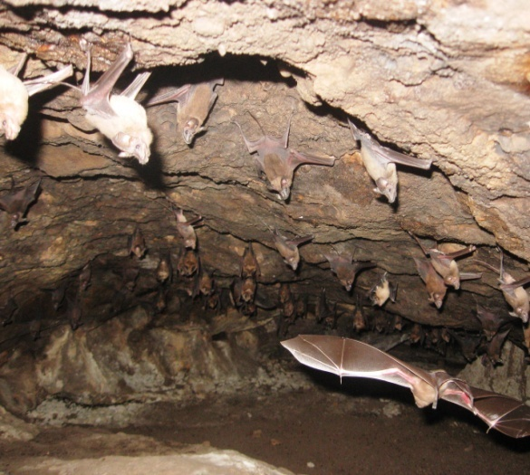
Fig.1 Cave-1 of Udayagiri

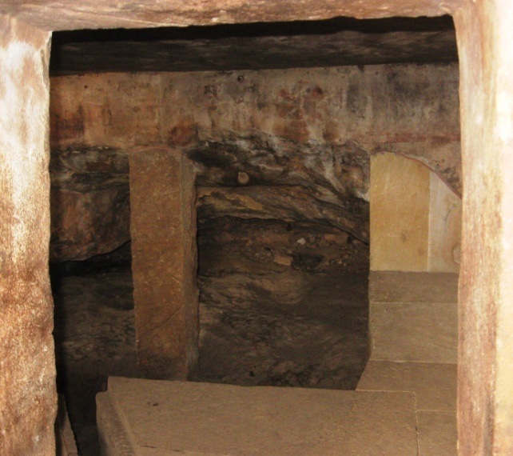
Fig.2 Cave-2 of Udayagiri
The animals found inside and peripheries of caves were also taken as material for the study. Prior to the study the following materials were arranged and kept on suitable surface within the reach.
INSTRUMENTS USED:-
- Meter tape, scale, string and straight stick were used for measuring caves.
- Sling psychrometer (OMSONS Instruments, model 80) was used for measuring temperature and humidity.
- LED torch light and battery operated emergency light were used as light source inside the cave.
- A digital camera of (Make: Sony) was used for taking photograph of caves and resident fauna.
- Baits like bread chunk, meat piece, sugar, fruit piece were used to attract animals.
- Small nylon nets were used for sample collection.
- Scalpel, needle, forceps, gloves were used for handling the sample.
- Plastic collection jar, polyethene bags, small cardboard boxes were used for collection of samples.
- Stereozoom microscope.
- Ethyl alcohol of 70% was used as preservative agent.
- Hand tally counter for counting animals.
- Google Map software and Google Earth software were used for locate Latitude, Longitude and Altitude of study sites.
Geomorphological study of caves was done using Google map software, Google earth software.
The climate study of caves:
Between Autumn of 2013 to Summer of 2014 temperature and humidity readings were recorded on the inner side and outer side of the two selected caves Khandagiri-1, and Udayagiri-1. These readings were taken for four seasons i.e. spring, Summer, Monsoon & Autumn and Winter. A sling psychrometer was used to record the temperatures and humidity using the standard wet bulb/dry bulb method. Miscellaneous observations such as sky cover, precipitation, unusual wet or dry conditions in the cave at the recording sites, etc., were also noted.
CAVE ANIMAL DATA COLLECTION:
- Counting
- Counting by hand tally method (Manual): Animal are counted by fingers.(Biswas and Kanoje, 1992).
- Square Area Method: A frame of 30cm square area was taken for sampling (Harries et.al., 2008; Ruggieri and Biswas, 2011).
- Taking Photograph: After taking the photo by a digital camera (Canon Power Shot A590 IS), analysed in computer (DELL-Vostro-1510, Intel Core2 DUO) for the number of animals and their density (Biswas and Shrotriya, 2011).
- Observation
Observations were categorized as direct or indirect. Direct observations included observing invertebrates with the naked eye and hand magnifier. It was used for any type of invertebrate species. Indirect observation included evidence of invertebrates, such as cast exoskeletons, spent body parts, or egg and larval stages.
Direct and Indirect observations made are as follows:
Direct observations included observing wildlife with the naked eye, through binoculars. This technique was being used for all animal species. Direct observations were taken with or without collecting the organism. The probability of direct observation of small mammals, reptiles, and amphibians was increased by searching under debris, logs, and rocks.
Indirect observations included evidence of animal, such as amphibian and bird calls, bird songs, tracks, droppings, burrows, runs, caches, and remains, such as feathers, bones, skeletons etc. Bats were surveyed by direct observation, indirect observation, netting and by taking photograph (Biswas and Shrotriy, 2011).
- Trapping the insects
Insects were directly trapped by hands, forceps, sticks and polyethenes. Some insects were passively caught using funnels and bottle traps, some of which were baited with small bits of sweet foods (such as bread crumb). In the present study a small tube plugged with cotton was used as pooter. A sweep net was used to collect flying insects (Charles, 1892).
- Identification of animals
In the laboratory of ZSI and RMNH, trapped, photographed and the data of animals collected were analysed. Detailed macro analyses of animals collected were done by using stereozoom microscope. This led to identification of animals.
In all of the counting methods when the number of organisms were numerous then they were grouped for a particular number of organisms.
RESULT& DISCUSSION
The climatic conditions outside the cave change constantly. The light allows green plants to grow in abundance; these are eaten by herbivores that are in turn consumed by carnivores. When any of these die they may be eaten or decomposed by bacteria and fungi, the nutrients released are used by plants for new growth. All these organisms create a complex and constantly changing food web (Das et al., 2007 and Romero, 2009).
Many species of animals found in the studied caves. Out of which in the present study only five animal species (Table 1) were taken for comparison.

Table 1: Cave-wise distribution of animals with their scientific names.
Sl.No. |  |  | COMMON NAME |  | SCIENTIFIC NAME
 |  |  | BEETLE
1 |  |  | CAVE BEETLE |  | Species of TenebrionidaeLatreille, 1802.
 |  |  |  | ANT
2 |  | EAST INDIAN HARVESTING ANT |  |  |  | Pheidologetondiversus(Jerdon, 1851)
 |  | AMPHIBIA
3 |  | TOAD |  |  | Duttaphrynusmelanostictus  (Schneider, 1799)
REPTILIA
4 |  | GECKO |  |  |  |  |  |  | Hemidactylusleschenaultii  Duméril&Bibron, 1836
MAMMAL
5 | FRUIT BAT |  |  |  |  |  |  | Rousettus leschenaultia Desmarest, 1820

Table 2: Annual diversity of fauna in Cave U1 across seasons.
SEASON | BAT |  |  | ANT (1=50) |  | TOAD |  | GECKO |  | CAVE BEETLE (1=10)
SEASON | 2020-21 | 2021-22 | 2020-21 |  | 2021-22 | 2020-21 | 2021-22 | 2020-21 | 2021-22 | 2020-21 | 2021-22
SPRING | 300 | 280 | 0 |  | 5 | 3 | 2 | 8 | 6 | 15 | 13
SUMMER | 335 | 320 | 0 |  | 5 | 2 | 1 | 8 | 6 | 4 | 2
MON & AUT | 315 | 300 | 1 |  | 7 | 5 | 4 | 10 | 8 | 10 | 10
WINTER | 330 | 310 | 0 |  | 4 | 2 | 2 | 9 | 8 | 12 | 11

Fig 3: Variation of animal distribution across years in U1.

Table 3: Annual diversity of fauna in Cave U2 across seasons.
SEASON | BAT |  | ANT (1=50) |  | TOAD |  | GECKO |  | CAVE BEETLE(1=10)
SEASON | 2020-21 | 2021-22 | 2020-21 | 2021-22 | 2020-21 | 2021-22 | 2020-21 | 2021-22 | 2020-21 | 2021-22
SPRING | 36 | 34 | 2 | 5 | 4 | 3 | 3 | 2 | 15 | 12
SUMMER | 35 | 34 | 0 | 5 | 5 | 4 | 3 | 2 | 14 | 14
MON & AUT | 38 | 37 | 0 | 7 | 7 | 6 | 3 | 2 | 10 | 8
WINTER | 30 | 27 | 0 | 4 | 2 | 1 | 3 | 2 | 12 | 11

Fig 4: Variation of animal distribution across years in U2.

In the present observation, it is very much clear that the number of animals decreases significantly both in U1and U2 caves (Table 2, Table 3, Fig. 3 Fig. 4) from the year 2020-21to the year 2021-22 except in ant species which increases. During COVID pandemic period due to lockdown human interference is significantly less in the year 2020-21than in the year 2021-22 due to which may be the number of animals seen in 2020-21 is more than the year 2021-22. The human interference is more in U2 cave than U1 cave during the year 2021-22 than 2020-21, due to which the animal population decreases more significantly in U2 cave than U1 cave. But ant population increases in both caves from 2020-21 to 2021-22 (Table 2, Table 3, Fig. 3 Fig. 4). This may be due to increase in food debris by increase in human interference from the year 2020-21 to 2021-22. Increase in population of other animals during 2020-21 may adversely affect the population of ants; as ant larvae are one of the rich food sources for many animals.
From the present study it is very much clear that human interference is always a key factor for population of other species. Even in cave ecosystem which is very much endemic and micro but very much fragile. To protect such fragile ecosystem, human interference should be controlled.

REFERENCES
Biswas J (2009) The biodiversity of Krem Mawkhyrdop of Meghalaya, India, on the verge of extinction. Current Science ,96(7):904-910.
Biswas J (2010) Kotumsar Cave biodiversity: a review of cavernicoles and their troglobiotic traits. Biodiversity and Conservation,19(1):275-289.
Biswas J and Kanoje S (1992) Seasonal and photoperiodic control of the activity and daily exodus of a colony of cave-dwelling bat. J. Ravishankar Univ., 4-5:33-41.
Biswas J and Shrotriya S (2011) Dandak: a mammalian dominated cave ecosystem of India. Subterranean Biology, 8: 1-7.
Bonacci O, Pipan T, Culver DC (2009). A framework for karst ecohydrology. Environ Geol 56:891–900
Charles VR (1892) Directions for collecting and reserving insects Bulletin (United States National Museu). Govt. Printing Off, Washington, pp 39-43.
Das M, Goswami S, Guru BC (2007) Caves and caverens. Everyman’s science,XLI(6): 392-396
Ford D, Williams P (2007).Karst hydrogeology and geomorphology. Wiley, West Sussex
Gale SJ (1992). Long-term landscape evolution in Australia. Earth Surf Proc Land 17:323–343
Groth, I., Schumann, P., Laiz, L., Sanchez-Moral, S., Cañaveras, J.C., Saiz- Jimenez, C. (2001).Geomicrobiological study of the GrottadeiCervi, Porto Badisco, Italy.Geomicrobiol. J. 18, 241-258.
Harries DB, Ware Fj, Fischer CW, Biswas J and Khapran-Daly BD (2008) A Review of the Biospeleology of Meghalaya, India. India. J. Cave and Karst Studies, 70(3):163-176.
Hoyos, M., Soler, V., Cañaveras, J.C, Sanchez-Moral, S., Sanz-Rubio, E. (1998). Microclimatic characterization of a karstic cave: human impact on microenvironmental parameters of a prehistoric rock art cave (Candamo Cave, northern Spain). Environ. Geol. 33, 231-242.
Palmer AN (2007). Cave Geology. Cave Books, Dayton, OH
Romero A (2009). Cave Biology: life in darkness. Cambridge University Press, Cambridge
Ruggieri R and Biswas J (2011) The Karst MandhipKhol-python cave complex in the lenticular limestone intercalations of the metamorphic Chhatela formation (Chhattisgarh, India). Spleleologia, 63(31): 58-63

