A Critical Study on Endemic Wildlife - Their Unique importance for Nature as whole

ABSTRACT
"In the intricate mosaic of Earth's ecosystems, endemic wildlife emerges as a unique and irreplaceable component, embodying the essence of specific regions. This abstract delves into the profound importance of endemic species for nature as a whole, considering their ecological roles, cultural significance, and the urgent need for conservation measures. Endemic wildlife species, found exclusively in particular geographic areas, contribute significantly to biodiversity. Their specialized adaptations and interactions within ecosystems make them crucial indicators of environmental health and stability. As stewards of intricate niches, these species often play key roles in regulating populations, pollination, and maintaining overall ecosystem balance.
Beyond their ecological functions, endemic wildlife holds profound cultural importance. They become emblematic symbols of regions, shaping local traditions, folklore, and identities. Indigenous communities often form deep connections with these species, integrating them into their spiritual and daily lives. The loss of endemic species, therefore, not only threatens ecological integrity but also erodes cultural diversity and heritage. However, endemic wildlife faces an array of threats in the modern era. Habitat loss due to human activities, climate change altering familiar landscapes, and unsustainable practices place these species at risk of decline and extinction. Urgent action is imperative to address these challenges comprehensively.
Conservation efforts must adopt a multifaceted approach, integrating scientific research, community engagement, and international collaboration. Sustainable land-use practices, habitat restoration, and climate resilience strategies are essential components. Moreover, recognizing and respecting the traditional knowledge of indigenous communities is pivotal for the success of conservation initiatives.
In conclusion, the preservation of endemic wildlife is not merely a biological imperative but a holistic commitment to safeguarding the intricate web of life and the cultural richness woven into our planet. Through unified global efforts, we can ensure that the unique importance of endemic species endures, contributing to the resilience and balance of nature as a whole."
Key Words: Endemic Wildlife, Indigenous Knowledge, Multifaceted Approach & Resilience.

INTRODUCTION
"In the intricate tapestry of Earth's biodiversity, endemic wildlife occupies a special niche, embodying the unique and often delicate threads that weave through specific regions. These species, found nowhere else on the planet, hold a profound significance for nature as a whole. Endemic wildlife not only captivates scientific curiosity but serves as a crucial indicator of environmental health, contributing to the rich mosaic of life on our planet. This introduction delves into the extraordinary importance of endemic species, exploring their ecological roles, cultural significance, and the pressing need for comprehensive conservation efforts to safeguard these irreplaceable components of Earth's natural heritage."
1. *Project Tiger:* Launched in 1973, Project Tiger aims to protect and conserve Bengal tigers and their habitats. While focused on tigers, it indirectly benefits other endemic wildlife by preserving their ecosystems.
2. *Project Elephant:* An initiative started in 1992, Project Elephant focuses on the conservation of elephants and their habitats. It contributes to the protection of various endemic species sharing these ecosystems.
3. *National Mission for Clean Ganga (NMCG):* The NMCG addresses the conservation and rejuvenation of the Ganges River, a vital ecosystem supporting diverse endemic wildlife.
4. *Integrated Development of Wildlife Habitats (IDWH):* This initiative emphasizes the conservation and management of wildlife habitats, contributing to the protection of endemic species across various ecosystems.
5. *National Afforestation Program (NAP):* This afforestation initiative aims to increase forest and tree cover, providing crucial habitats for numerous endemic wildlife species.
6. *National Biodiversity Authority (NBA):* The NBA, established to implement the Biological Diversity Act, works towards conservation, sustainable use, and equitable sharing of benefits arising from biodiversity, including endemic wildlife.

7. *Compensatory Afforestation Fund (CAF):* The CAF aims to mitigate the environmental impact of development projects by promoting afforestation and conservation of wildlife habitats, benefiting many endemic species.
8. *Green India Mission (GIM):* As one of the eight missions under the National Action Plan on Climate Change, GIM focuses on biodiversity conservation and ecosystem services, directly impacting the protection of endemic wildlife.
9. *Wildlife Institute of India (WII):* While not a direct government initiative, WII plays a significant role in wildlife research and conservation, contributing valuable knowledge and expertise to safeguard endemic species.
10. *National Mission for Himalayan Studies (NMHS):* This mission addresses the specific environmental challenges in the Himalayan region, including the conservation of unique endemic wildlife inhabiting these sensitive ecosystems.
1. Habitat Loss and Fragmentation;
- Citation: Brooks, T. M., Mittermeier, R. A., Mittermeier, C. G., da Fonseca, G. A. B., Rylands, A. B., Konstant, W. R., ... & Hilton-Taylor, C. (2002). Habitat loss and extinction in the hotspots of biodiversity. Conservation Biology, 16(4), 909-923.
- Explanation: The alteration and destruction of natural habitats through activities such as deforestation and urbanization pose a significant threat to the survival of endemic wildlife.
2. Climate Change;
- Citation: Parmesan, C., & Yohe, G. (2003). A globally coherent fingerprint of climate change impacts across natural systems. Nature, 421(6918), 37-42.
- Explanation: Changes in temperature and precipitation patterns can disrupt the delicate balance of ecosystems, impacting the distribution and behavior of endemic species.
3. Invasive Species;
- Citation: Sala, O. E., Chapin III, F. S., Armesto, J. J., Berlow, E., Bloomfield, J., Dirzo, R., ... & Wall, D. H. (2000). Global biodiversity scenarios for the year 2100. Science, 287(5459), 1770-1774.
- Explanation: The introduction of non-native species can outcompete or prey upon endemic wildlife, leading to population declines and habitat degradation.
4. Overexploitation and Poaching;
- Citation: Ripple, W. J., Newsome, T. M., Wolf, C., Dirzo, R., Everatt, K. T., Galetti, M., ... & Van Valkenburgh, B. (2015). Collapse of the world's largest herbivores. Science Advances, 1(4), e1400103.
- Explanation: Unregulated hunting and poaching can significantly reduce the populations of endemic wildlife, disrupting ecosystems and threatening their unique ecological roles.
5. Pollution;
- Citation: Díaz, S., Settele, J., Brondízio, E. S., Ngo, H. T., Agard, J., Arneth, A., ... & Zayas, C. N. (2019). Pervasive human-driven decline of life on Earth points to the need for transformative change. Science, 366(6471), eaax3100.
- Explanation: Pollution from various sources, including chemicals and plastics, can have detrimental effects on endemic wildlife, affecting their health and the overall health of ecosystems.
6. Disease Outbreaks;
- Citation: Harvell, C. D., Mitchell, C. E., Ward, J. R., Altizer, S., Dobson, A. P., Ostfeld, R. S., & Samuel, M. D. (2002). Climate warming and disease risks for terrestrial and marine biota. Science, 296(5576), 2158-2162.
- Explanation: Climate change can influence the spread of diseases, posing an additional threat to the already vulnerable populations of endemic wildlife.
These citations and explanations provide insight into the various factors affecting endemic wildlife and their unique importance for nature.
1. Increased Focus on Ecosystem-based Conservation;
- Conservation efforts are shifting towards holistic ecosystem management, recognizing the interconnectedness of species and the importance of preserving entire habitats to support endemic wildlife.
2. Technology Integration for Monitoring and Protection;
- Advancements in technology, such as satellite imagery, drones, and acoustic monitoring, are being increasingly utilized to monitor and protect endemic wildlife, aiding in more efficient conservation strategies.
3. Community Engagement and Indigenous Knowledge;
- There is a growing emphasis on involving local communities and incorporating indigenous knowledge in conservation initiatives, recognizing the vital role communities play in the protection of endemic wildlife.
4. Climate Resilience Strategies;
- Conservation plans are adapting to the challenges posed by climate change, with an increased focus on strategies that enhance the resilience of endemic species to changing environmental conditions.
5. Global Collaborations for Conservation;
- International collaboration and information sharing have become more prevalent, allowing for a more comprehensive and coordinated approach to the conservation of endemic wildlife on a global scale.
6. Restoration Ecology and Rewilding Initiatives;
- Restoration ecology and rewilding projects are gaining momentum, aiming to restore degraded habitats and reintroduce endemic species to areas where they have disappeared, promoting overall ecosystem health.
7. Policy Integration for Sustainable Development;
- Governments and organizations are working towards integrating conservation policies with broader sustainable development goals, recognizing the need for balancing conservation efforts with socio-economic considerations.
8. Conservation Finance and Innovative Funding Models;
- New funding models and innovative financing mechanisms, such as payments for ecosystem services and impact investing, are being explored to secure financial resources for endemic wildlife conservation.
9. Citizen Science Participation;
- Citizen science initiatives are on the rise, involving the public in data collection, monitoring, and conservation efforts, fostering a sense of shared responsibility for the protection of endemic wildlife.
10. Education and Advocacy for Biodiversity Conservation;
- Increasing awareness about the importance of biodiversity and the unique roles played by endemic species is a current trend, with educational and advocacy initiatives seeking to garner public support for conservation actions.

India and the USA differ significantly in terms of wildlife, considering factors such as biodiversity, conservation approaches, and ecosystems. Here's a brief comparison:
1. *Biodiversity:*
- India: India is one of the world's biodiversity hotspots, boasting a diverse range of species due to its varied ecosystems, including tropical rainforests, deserts, and Himalayan regions.
- USA: While the USA has diverse ecosystems, including forests, grasslands, and coastal areas, its biodiversity is not as concentrated as in India. The USA is known for iconic species like the bald eagle and grizzly bear.
2. *Endemic Species:*
- India: India is home to numerous endemic species, including the Bengal tiger, Indian rhinoceros, and various endemic bird species found in the Western Ghats and the Himalayan region.
- USA: The USA has its share of endemic species, such as the Florida panther and California condor, but the concept of endemism is generally less pronounced compared to India.
3. *Conservation Initiatives:*
- India: India has implemented flagship conservation programs like Project Tiger and Project Elephant to protect endangered species and their habitats. There is also a focus on community-based conservation.
- USA: The USA has a well-established system of national parks and wildlife refuges. Conservation efforts are often decentralized, with federal and state agencies working together on initiatives like the Endangered Species Act.
4. *Legal Framework:*
- India: India has strong wildlife protection laws, including the Wildlife Protection Act and Forest Rights Act, aimed at preserving and managing wildlife and their habitats.
- USA: The Endangered Species Act and various state laws in the USA provide legal protection to endangered and threatened species, and regulations vary between states.
5. *Challenges:*
- India: India faces challenges such as human-wildlife conflict, habitat loss due to urbanization and agriculture, and poaching, especially in the case of iconic species like tigers and rhinoceros.
- USA: Challenges in the USA include habitat fragmentation, climate change effects, and conflicts arising from the coexistence of wildlife with urban areas.
6. *Role of Indigenous Communities:*
- India: Indigenous communities often play a significant role in wildlife conservation, especially in regions with diverse tribal populations.
- USA: Indigenous communities, particularly Native American tribes, have a distinct role in conservation efforts, and collaborations with these communities are increasingly recognized.
7. *Research and Technology:*
- India: Research in wildlife biology and ecology is active, with a growing emphasis on technology, including the use of GPS tracking and remote sensing.
- USA: The USA has well-established research institutions and utilizes advanced technologies for wildlife monitoring and conservation research.
While both India and the USA face distinct challenges in wildlife conservation, their approaches reflect the unique ecological and socio-cultural contexts of each country.
OBJECTIVES
- To identify and document Endemic Wildlife species in specific regions to establish a baseline for conservation efforts.
- To assess the current population status and distribution of Endemic species to determine their conservation needs.
- To investigate the ecological functions of Endemic Wildlife and their contributions to ecosystem services.
Please read intruction to authors, UPJOZ, it will help you to well structure your document.
LITERATURE REVIEW (A brief literature review should insert in your introduction, not as a different section.)
VIKAS KUMAR SONI ( 2020 ); The term Wildlife was coined by William Hornady in 1913 in his book Our vanishing Wildlife and Wildlife implies to all the biotic elements on the Earth including all species of plants, animals, bird and microbes of the world excluding man, domestic animals and cultivated plants. VIKAS KUMAR SONI (2021); Wildlife refers to these plants and animals species which live and grow in areas uninhabited by human and it includes all non - domesticated animals and plants including many other organisms and fungi and wildlife is found in all ecosystems such as forests and plains and grasslands. KANI ISIK ( 2011 ); A species is considered to be rare if it exhibits any one of following attributes ( 1 ) naturally occurs in a narrow geographical area. ( 2 ) occupies only one or a few specialized habitats. ( 3 ) forms only small populations in its range and an Endemic species and however goes on. EVAN BUECHLEY, CAGAN H SEKERCIOGLU ( 2013 ); As human populations have increased dramatically over the last few hundreds years mirrored by similarly expanding pressures on the natural world and a strong movement concerned with the well being of nature has grown in response and its care this environment. RADHIKA KAPUR ( 2018 ); The main purpose of this research paper is to acquire an understanding of wildlife tourism. In India since ancient times individuals develop an interest in wildlife tourism. In India since ancient times individuals develop an interest in wildlife tourism and in the present existence to the tribal population residing in hilly and mountainous regions. SIMONE CIUTI, JOSEPH M. NORTHRUP, TYLER B. MUHLY ( 2012 ); Human disturbance can influence wildlife behavior which can have implications for the wildlife populations for example wildlife may be more vigilant near human disturbance resulting in decreased forage intake and reduced reproductive success. SANAM NAZ, MUBASHAR HUSSIAN ( 2016 ); This review highlights the major issues about wildlife life extinction, endangerment and conservation and it is necessary to know current scenarios about wildlife protection and conservation at national and international level. ALISSA AMBACHER ( 2011 ); The main challenge for implementing this plan is getting the word out and getting people involved, getting the administration involved and motivated to help us make these changes is another big challenge. Dr. ADRIANA CONSORTE ( 2015 ); The present paper draws from a study of the role of zoos in forming attitudes towards biodiversity and native wild carnivores that are considered for reintroduction and this project is being developed.
M. MOHSIN ZAHEER ( 2017 ); Wildlife management is interdisciplinary that deals with protecting endangered and threatened species and subspecies and their habitats as well as the non threatened agricultural animals and game species. VIJAY KUMAR KOLI ( 2014 ); Understanding the diversity and structure of bird communities is essential to delineate the importance of regional or social landscapes for Asian conservation and birds are very sensitive environmental changes. JOYDEB MAJUNDER, B.K.AGARWALA, RAHUL LODH
( 2015 ); Several wildlife sanctuaries in the world are home to the surviving populations of many endemic species. Trishna wildlife sanctuary in northeast India is protected by law and is home to the last surviving populations of Asian Bison spectacle Monkey and Capped Langur. ALOK KUMAR CHANDRAKAR ( 2018 ); wildlife is a precious gift of God to this planet. The term ‘wildlife’ not only caters to wild animals but also takes into account all undomesticated lifeforms including birds, insects, plants, fungi and even microscopic organisms. For maintaining a healthy ecological balance on this earth, animals, plants and marine species are as important as humans.
DORST. J ( 1991 ); Wildlife has a considerable and highly varied impact on the environment. Furthermore, in transforming the environment, man has indirectly altered some of the many links which associate animals with the environment. C.L. SPASH, J. ALDRED ( 1998 ); Wildlife conservation is a reaction to the increasing loss of species, the rate of which has accelerated dramatically this century. Species loss has been highlighted by some notable cases of extinction and near extinction in recent centuries, such as the dodo and the American buffalo. R.A. EMONGOR, ... V.E. EMONGOR ( 2021 ); Wildlife conservation and food and nutrition security are in increasing competition due to increased human population and demand for agricultural and development land for settlements. In order to achieve wildlife conservation and food and nutrition security in Kenya. PAUL R.KRAUSMAN ( 2024 ); The Journal of Wildlife Management publishes original research contributing to fundamental wildlife science. Topics encompass biology and ecology of wildlife and their habitats with implications for conservation or management. Published research covers habitat use, genetics, demographics, behavior, population ecology, human dimensions, and more topics that address contemporary conservation issues. CHARDONNET ( 2002 ); The value of wildlife has been widely ignored or under-rated in the past by the international community. At most, wildlife was considered from the limited aesthetic and touristic aspects. This situation has changed somewhat. In the majority of the veterinary profession, which is largely livestock-oriented, wildlife is increasingly considered in terms of wild animal production and occupies just as relevant a position as domestic animal production. JUANITA GOMEZ ( 2015 ); Wild animals are important worldwide because of the multiple values they represent for human societies. Different frameworks have been proposed to understand the values of wildlife from economic and noneconomic perspectives. Despite efforts from different disciplines to provide a holistic framework for the analysis of wildlife values, the focus is still based on the monetary value derived from market prices. NATHALIA M. CASTILLO - HUITRON ( 2020 ); Animals have always been important for human life due to the ecological, cultural, and economic functions that they represent. This has allowed building several kinds of relationships that have promoted different emotions in human societies.
Prof. Dr. DIMITRIOS ( 2014 ); Wildlife has faced various threats in recent decades and has therefore attracted attention with regard to research and conservation worldwide. The impacts of human activities, such as habitat degradation and loss, introduction of alien species, overexploitation, changes in disturbance regime, climate change, and synergetic factors, are the main responsible factors for increasing the risk of extinction for many wildlife species.

Material and methods

The type of research adopted here is empirical research where a total of 226 samples have been collected. The sample has been collected through a non probability convenience sampling method. The sample frame has been taken through online in and around Chennai,Tamil Nadu. The Independent Variables are Age, Gender, Educational Qualification, Occupation & Monthly Income. The Dependent Variables are Endemic Wildlife plays a crucial role in maintaining Biodiversity and Ecological balance. Protecting Endemic Species is essential for preserving the uniqueness and richness of a region’s Natural Heritage. Endemic Wildlife can serve as indicators of the overall health and stability of an Ecosystem. Endemic Species are more vulnerable to extinction and therefore require special conservation efforts. The loss of Endemic Wildlife can disrupt the delicate web of life in an ecosystem, affecting other Species and Habitats. The statistical tools used in this study are Graphical Representation, ANOVA & Chi-Square.
ANALYSIS

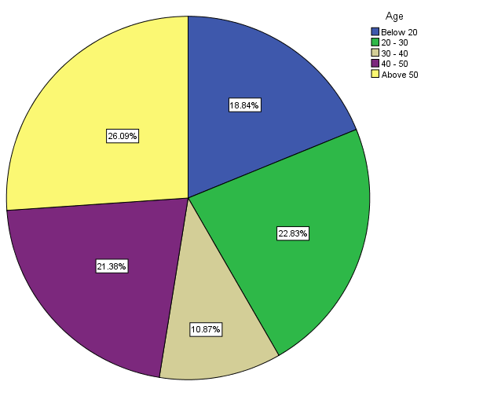
LEGEND; The above graph - 1 shows the percentage of the participating AGE Groups.

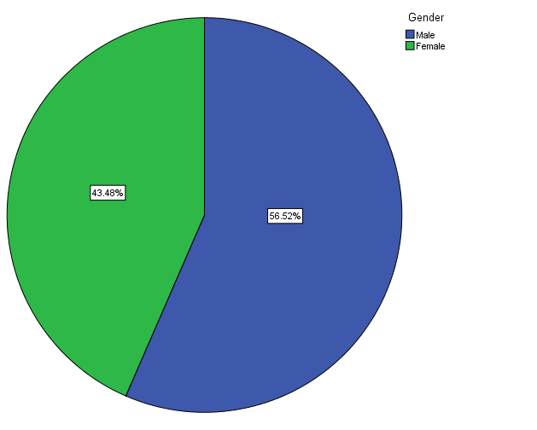
LEGEND; The Above graph - 2 shows the percentage of participating GENDERS.
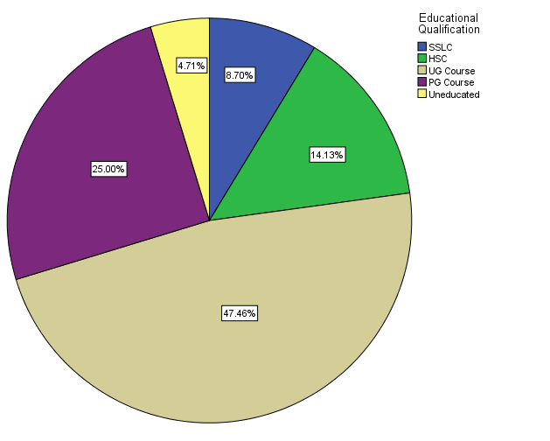
LEGEND; The Above graph - 3 shows the percentage of participating EDUCATIONAL QUALIFICATIONS.

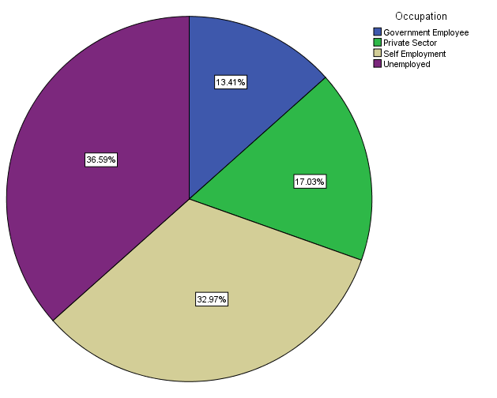
LEGEND; The Above graph - 4 shows the percentage of participating OCCUPATIONS.
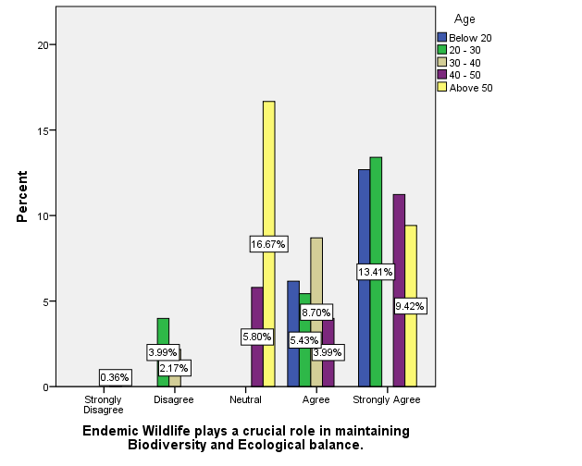
LEGEND; The Above graph - 5 shows the percentage of votes for the question in terms of AGE category.

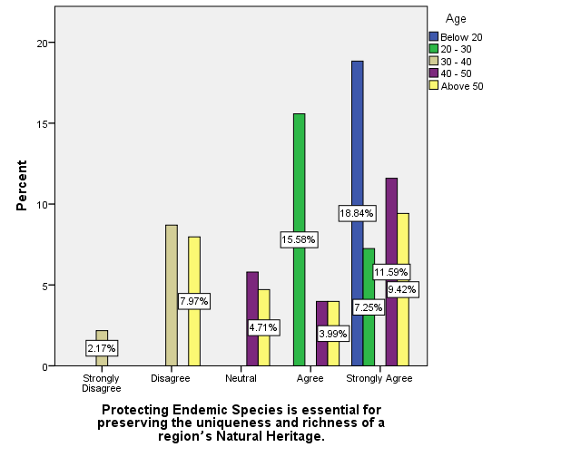
LEGEND; The Above graph - 6 shows the percentage of votes for the question in terms of AGE category.
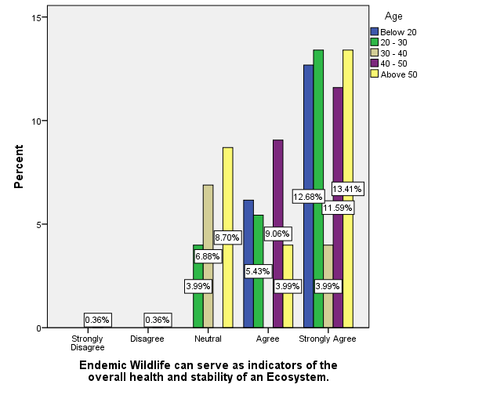
LEGEND; The Above graph - 7 shows the percentage of votes for the question in terms of AGE category.

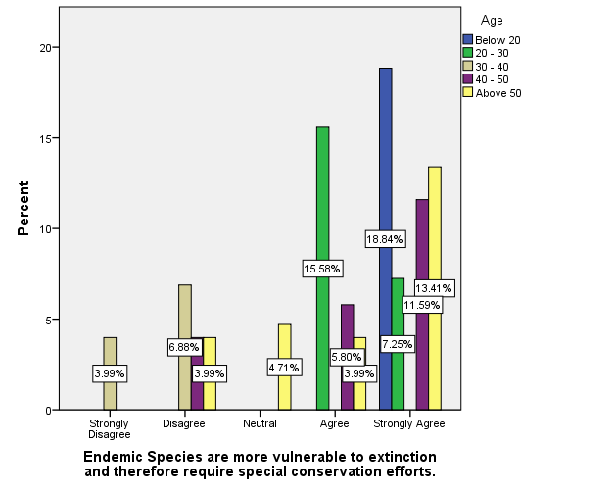
LEGEND; The Above graph - 8 shows the percentage of votes for the question in terms of AGE category.

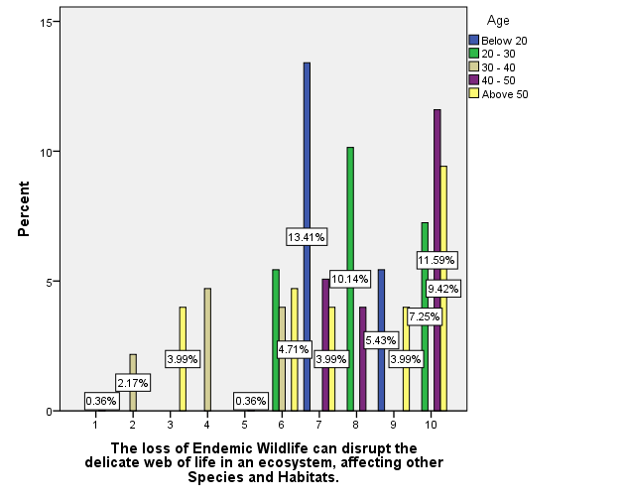
LEGEND; The Above graph - 9 shows the percentage of votes for the question in terms of AGE category.

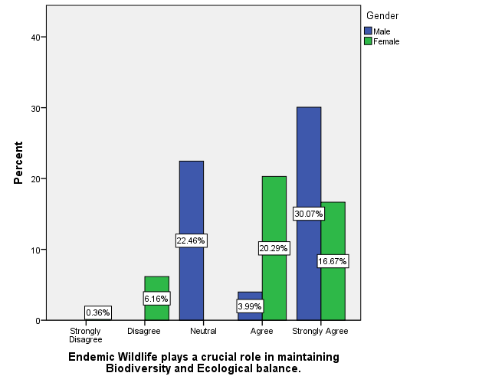
LEGEND; The Above graph - 10 shows the percentage of votes for the question in terms of GENDERS.

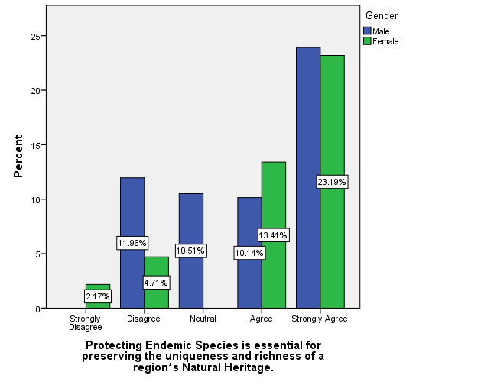
LEGEND; The Above graph - 11 shows the percentage of votes for the question in terms of GENDERS.

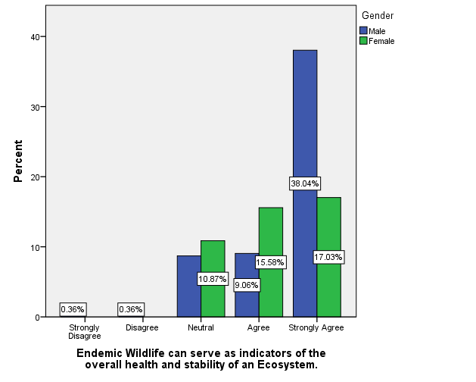
LEGEND; The Above graph - 12 shows the percentage of votes for the question in terms of GENDERS.
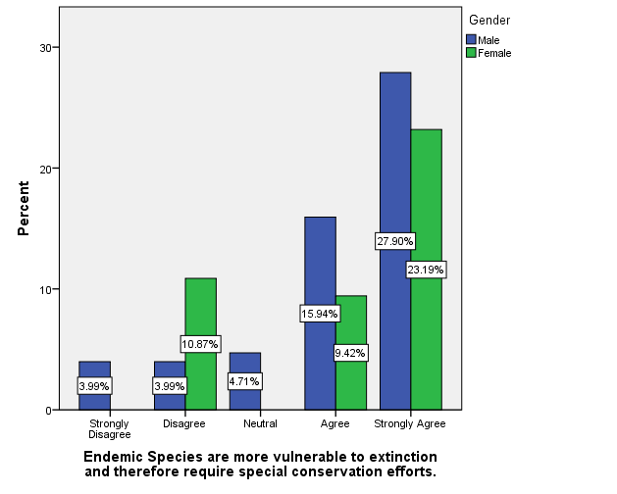
LEGEND; The Above graph - 13 shows the percentage of votes for the question in terms of GENDERS.

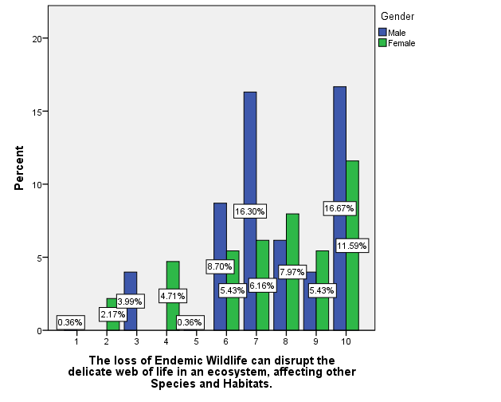
LEGEND; The Above graph - 14 shows the percentage of votes for the question in terms of GENDERS.
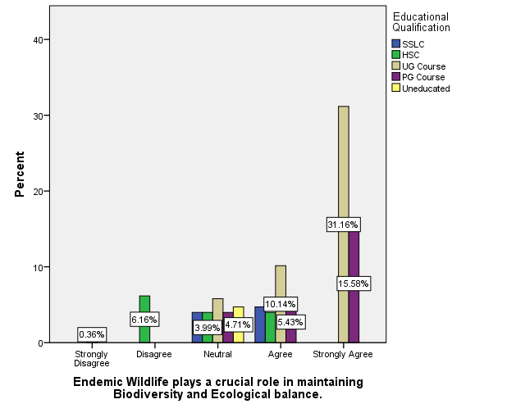
LEGEND; The Above graph - 15 shows the percentage of votes for the question in terms of EDUCATIONAL QUALIFICATION.

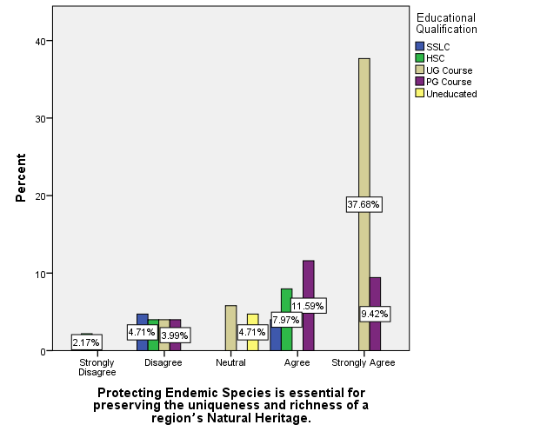
LEGEND; The Above graph - 16 shows the percentage of votes for the question in terms of EDUCATIONAL QUALIFICATION.
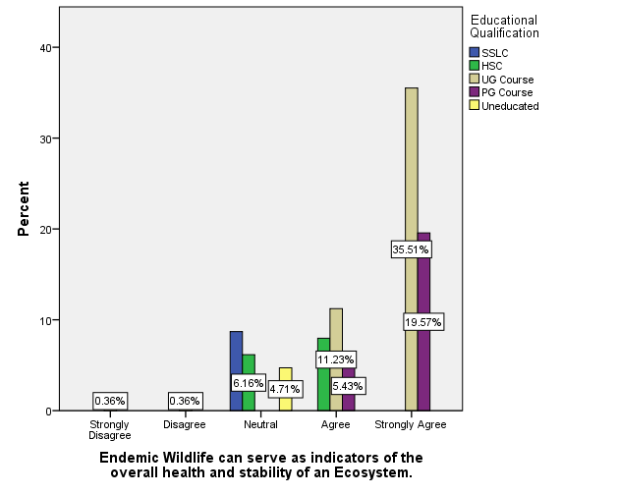
LEGEND; The Above graph - 17 shows the percentage of votes for the question in terms of EDUCATIONAL QUALIFICATION.

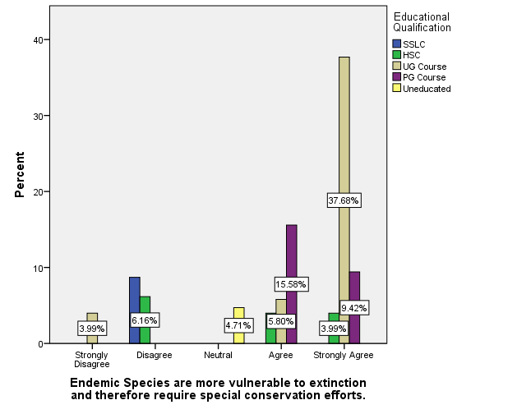
LEGEND; The Above graph - 18 shows the percentage of votes for the question in terms of EDUCATIONAL QUALIFICATION.
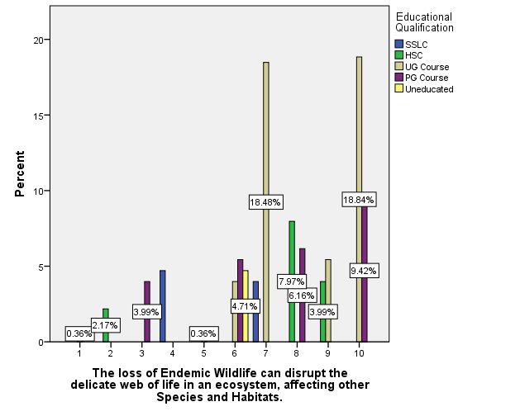
LEGEND; The Above graph - 19 shows the percentage of votes for the question in terms of EDUCATIONAL QUALIFICATION.

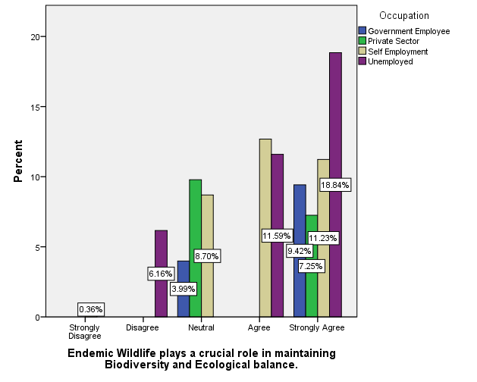
LEGEND; The Above graph - 20 shows the percentage of votes for the question in terms of OCCUPATIONS.
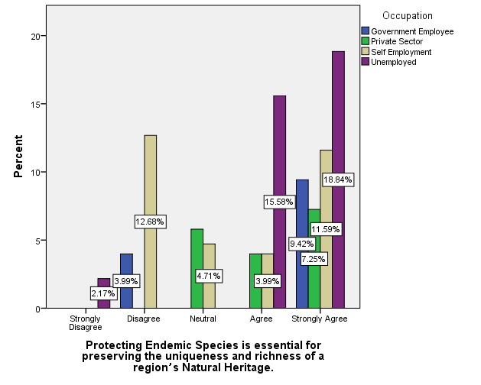
LEGEND; The Above graph - 21 shows the percentage of votes for the question in terms of OCCUPATIONS.

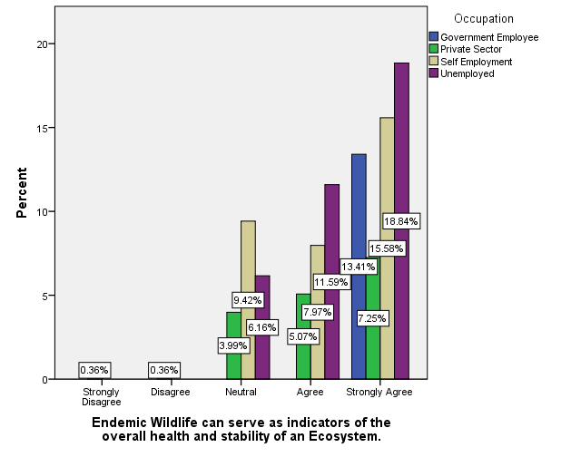
LEGEND; The Above graph - 22 shows the percentage of votes for the question in terms of OCCUPATIONS.
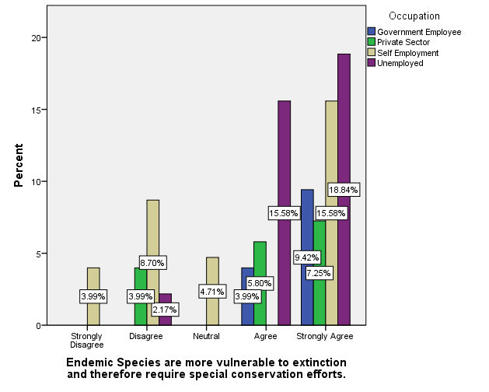
LEGEND; The Above graph - 23 shows the percentage of votes for the question in terms of OCCUPATIONS.

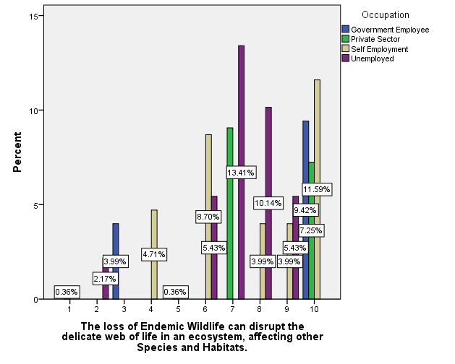
LEGEND; The Above graph - 24 shows the percentage of votes for the question in terms of OCCUPATIONS.
ANALYSIS (Table)

Table - 1; Age * Endemic Species are more vulnerable to extinction and therefore require special conservation efforts.
In your methodology, you said you worked on 226 samples, I don’t understand the number 276 in your result.
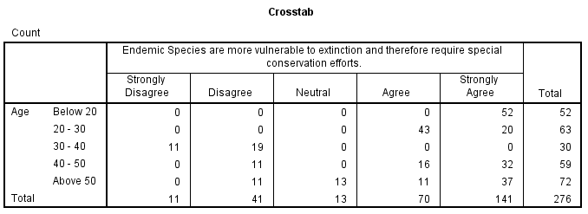
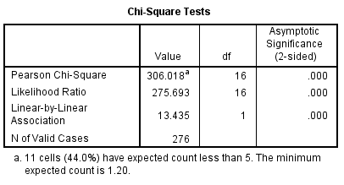

LEGEND; The above Table - 1 shows the relationship between AGE and Endemic Species are more vulnerable to extinction and therefore require special conservation efforts using Chi - Square.

HYPOTHESIS; NULL Hypothesis is Accepted and Alternative Hypothesis is Rejected.

INFERENCE; There is a significant relationship between AGE and Endemic Species are more vulnerable to extinction and therefore require special conservation.
Table - 2; Gender * Endemic Species are more vulnerable to extinction and therefore require special conservation efforts.

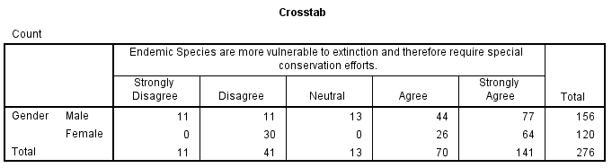
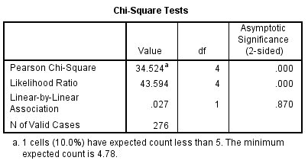

LEGEND; The above Table - 2 shows the relationship between GENDER and Endemic Species are more vulnerable to extinction and therefore require special conservation efforts using Chi - Square.

HYPOTHESIS; NULL Hypothesis is Rejected and Alternative Hypothesis is Accepted.

INFERENCE; There is a significant relationship between GENDER and Endemic Species are more vulnerable to extinction and therefore require special conservation.

Table - 3; Educational Qualification * Endemic Species are more vulnerable to extinction and therefore require special conservation efforts.

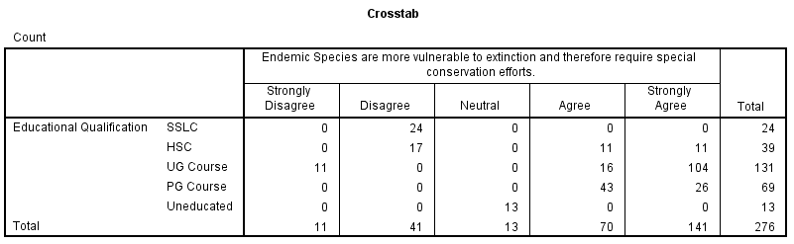
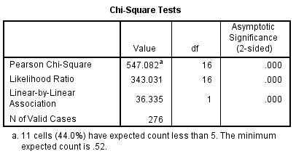

LEGEND; The above Table - 3 shows the relationship between EDUCATIONAL QUALIFICATION and Endemic Species are more vulnerable to extinction and therefore require special conservation efforts using Chi - Square.

HYPOTHESIS; NULL Hypothesis is Accepted and Alternative Hypothesis is Rejected.

INFERENCE; There is a significant relationship between EDUCATIONAL QUALIFICATION and Endemic Species are more vulnerable to extinction and therefore require special conservation.

Table - 4; Occupation * Endemic Species are more vulnerable to extinction and therefore require special conservation efforts.

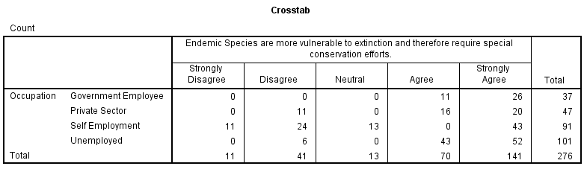
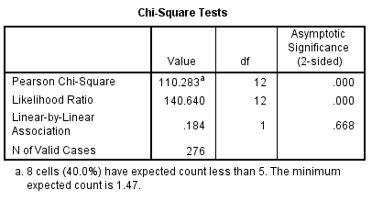

LEGEND; The above Table - 4 shows the relationship between OCCUPATION and Endemic Species are more vulnerable to extinction and therefore require special conservation efforts using Chi - Square.

HYPOTHESIS; NULL Hypothesis is Rejected and Alternative Hypothesis is Accepted.

INFERENCE; There is a significant relationship between OCCUPATION and Endemic Species are more vulnerable to extinction and therefore require special conservation.

Table - 5; Age * Endemic Wildlife can serve as indicators of the overall health and stability of an Ecosystem.

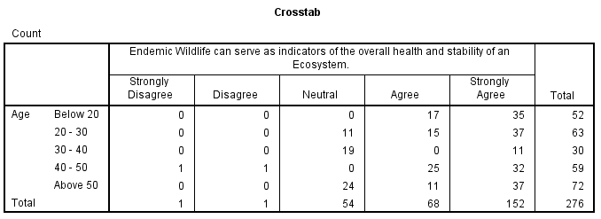
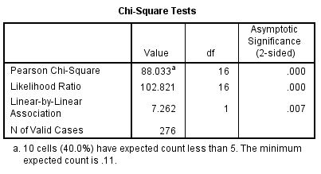

LEGEND; The above Table - 5 shows the relationship between AGE and Endemic Wildlife can serve as indicators of the overall health and stability of an Ecosystem using Chi - Square.

HYPOTHESIS; NULL Hypothesis is Rejected and Alternative Hypothesis is Accepted.

INFERENCE; There is a significant relationship between AGE and Endemic Wildlife can serve as indicators of the overall health and stability of an Ecosystem.

Table - 6; Gender * Endemic Wildlife can serve as indicators of the overall health and stability of an Ecosystem.

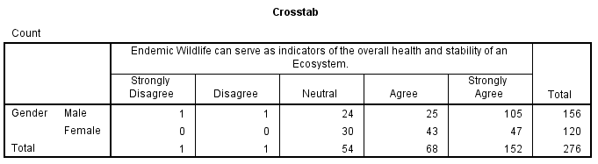
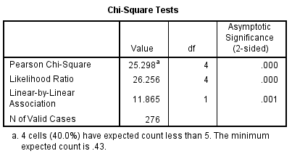

LEGEND; The above Table - 6 shows the relationship between GENDER and Endemic Wildlife can serve as indicators of the overall health and stability of an Ecosystem using Chi - Square.

HYPOTHESIS; NULL Hypothesis is Rejected and Alternative Hypothesis is Accepted.

INFERENCE; There is a significant relationship between GENDER and Endemic Wildlife can serve as indicators of the overall health and stability of an Ecosystem.

Table - 7; Educational Qualification * Endemic Wildlife can serve as indicators of the overall health and stability of an Ecosystem.

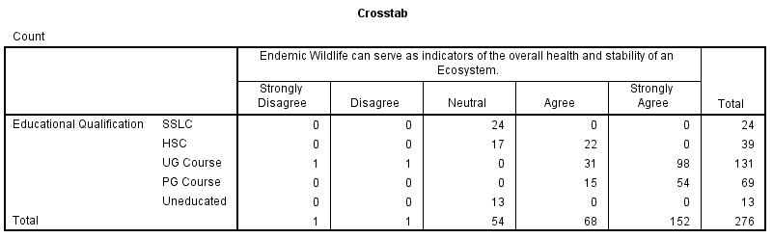
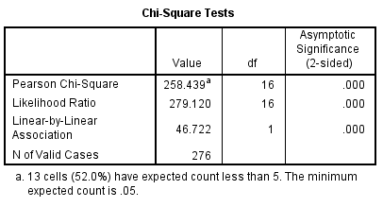

LEGEND; The above Table - 7 shows the relationship between EDUCATIONAL QUALIFICATION and Endemic Wildlife can serve as indicators of the overall health and stability of an Ecosystem using Chi - Square.

HYPOTHESIS; NULL Hypothesis is Accepted and Alternative Hypothesis is Rejected.

INFERENCE; There is a significant relationship between EDUCATIONAL QUALIFICATION and Endemic Wildlife can serve as indicators of the overall health and stability of an Ecosystem.

Table - 8; Occupation * Endemic Wildlife can serve as indicators of the overall health and stability of an Ecosystem.

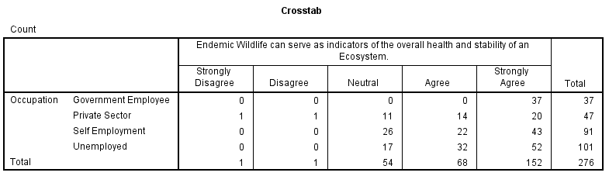
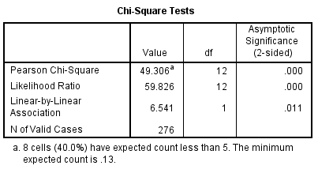

LEGEND; The above Table - 8 shows the relationship between OCCUPATION and Endemic Wildlife can serve as indicators of the overall health and stability of an Ecosystem using Chi - Square.

HYPOTHESIS; NULL Hypothesis is Rejected and Alternative Hypothesis is Accepted.

INFERENCE; There is a significant relationship between OCCUPATION and Endemic Wildlife can serve as indicators of the overall health and stability of an Ecosystem.

RESULT

Graph 1, As the Research topic was on the grounds of Democracy and Human Rights. I just want to cover various AGE categories in order to review the level of thinking on my research topic and their thoughts on my issues. So I tried my level best to collect responses from all of the AGE categories and Graph 1 shows the percentage of the participating AGE Groups. Graph 2, I just want to refer the responses of my respondents in terms of GENDER so that I can analyze the responses given by both Male and Female and also I just want to have responses of the 3rd Gender so that I can also have a view on the perspective of them towards our Democracy and Human Rights. Graph 3, As the Research topic was on the grounds of Democracy and Rights. I just want to cover various AGE categories which also includes various EDUCATIONAL QUALIFICATIONS also. Because each human being in our society has their own thoughts and perspective on the related things. So I just want to cover a huge population in certain categories which also includes EDUCATIONAL QUALIFICATION, which helps me to figure out the difference in the thoughts of the common citizens of our country. Graph 4, As I stated before, my research topic or my research issues requires a large number of responses. So I just want to cover a huge population in certain categories which also includes OCCUPATION, So that I can have a view on the responses in terms of their occupation like mainly a good example is Government Employees can be utilized on the topic related to our government so the same process was carried out. Graph 5, The above graph shows the percentage of votes for the question in terms of AGE category. Most of my respondents from various AGE groups STRONGLY AGREED with my statement. Whereas most of the contribution is from the 20 - 30 AGE group. Graph 6, The above graph shows the percentage of votes for the question in terms of AGE category. Most of my respondents from various AGE groups STRONGLY AGREED with my statement. Whereas most of the contribution is from the Below 20 AGE group. Graph 7, The above graph shows the percentage of votes for the question in terms of AGE category. In this case most of my respondents from 20 - 30 & Above 50 AGE categories STRONGLY AGREED with my given statement. Graph 8, The above graph shows the percentage of votes for the question in terms of AGE category. Most of my respondents from Below 20 AGE category STRONGLY AGREED with the given statement. Graph 9, The above graph shows the percentage of votes for the question in terms of AGE category. In this class I totally ended up with mixed reviews from all AGE categories. Graph 10, The given result graph clearly shows the percentage of the responses for the question which I mentioned in the terms of GENDER. Here most of my MALE respondents STRONGLY AGREED with my given statement. Graph 11, The given result graph clearly shows the percentage of the responses for the question which I mentioned in the terms of GENDER. In this case most of my MALE and FEMALE respondents STRONGLY AGREED with the given statement. Graph 12, The given result graph clearly shows the percentage of the responses for the question which I mentioned in the terms of GENDER. Here most of my MALE respondents STRONGLY AGREED with the given statement. Graph 13, The given result graph clearly shows the percentage of the responses for the question which I mentioned in the terms of GENDER. I totally ended with a variety of responses. Graph 14, The given result graph clearly shows the percentage of the responses for the question which I mentioned in the terms of GENDER. Same as the last Graph we ended up with mixed reviews. Graph 15, The given result graph clearly shows the percentage of the responses for the question which I mentioned in the terms of EDUCATIONAL QUALIFICATION. Most of my respondents belonging to UG Course placed with a high percent in STRONGLY AGREE option with 31.16%. Graph 16, The given result graph clearly shows the percentage of the responses for the question which I mentioned in the terms of EDUCATIONAL QUALIFICATION. Same as the last Graph most of my respondents belonging to UG Course STRONGLY AGREED with the given statement with 37.68%. Graph 17, The given result graph clearly shows the percentage of the responses for the question which I mentioned in the terms of EDUCATIONAL QUALIFICATION. In this case both UG and PG Course respondents STRONGLY AGREED with my statement with 35.51% & 19.57% respectively. Graph 18, The given result graph clearly shows the percentage of the responses for the question which I mentioned in the terms of EDUCATIONAL QUALIFICATION. I totally ended with a variety of mixed reviews. Graph 19, The given result graph clearly shows the percentage of the responses for the question which I mentioned in the terms of EDUCATIONAL QUALIFICATION. In this question most of my UG respondents gave a 7 and 10 star rating for the given statement with 18.48% & 128.84%. Graph 20, The given result graph clearly shows the percentage of the responses for the question which I mentioned in the terms of OCCUPATION. Here most of my unemployed respondents went on with the 5th option with 18.84%. Graph 21, The given result graph clearly shows the percentage of the responses for the question which I mentioned in the terms of OCCUPATION. In this case I ended up getting more votes from respondents belonging to various OCCUPATION to the 4th and 5th options. Graph 22, The given result graph clearly shows the percentage of the responses for the question which I mentioned in the terms of OCCUPATION. Here in this question a major part of my respondents voted on the STRONGLY AGREE option. Whereas the major contribution was from the UNEMPLOYED category with the highest percent of 18.84%. Graph 23, The given result graph clearly shows the percentage of the responses for the question which I mentioned in the terms of OCCUPATION. In this most of my respondents STRONGLY AGREED with the given statement and major contribution is from UNEMPLOYED and SELF EMPLOYMENT categories with 18.84% and 15.58% respectively. Graph 24, The given result graph clearly shows the percentage of the responses for the question which I mentioned in the terms of OCCUPATION. In this rating question most of my UNEMPLOYED respondents gave an average of SEVEN star rating to the given statement with 13.41%, followed by once again UNEMPLOYED category with 10.14% in EIGHT star rating. In my research the category namely UNEMPLOYED includes students in School and Colleges whom I had more responses to in my research.

DISCUSSION

Graph 1, As I stated before, I just want to cover various AGE categories in order to review the level of thinking on my research topic and their thoughts on my issues. In my responses the AGE category (Below 20) covers on with School and College Students, (20 - 30) covers on with PG students and Working professionals and the other categories goes on with other higher working professionals of our society. Graph 2, As I stated before, I just want to analyze the responses of my respondents in terms of GENDER so that I can have a clear view of Male, Female and 3rd Gender perspectives towards our Democracy and Human Rights. Graph 3, As the Research topic was on the grounds of Democracy and Rights. I just want to cover various AGE categories which also includes various EDUCATIONAL QUALIFICATIONS also. Because each human being in our society has their own thoughts and perspective on the related things. So I just want to cover a huge population in certain categories which also includes EDUCATIONAL QUALIFICATION, which helps me to figure out the difference in the thoughts of the common citizens of our country. Graph 4, As I stated before, my research topic or my research issues requires a large number of responses. So I just want to cover a huge population in certain categories which also includes OCCUPATION, So that I can have a view on the responses in terms of their occupation like mainly a good example is Government Employees can be utilized on the topic related to our government so the same process was carried out. Graph 5, The above graph shows the percentage of votes for the question in terms of AGE category. Most of my respondents from various AGE groups STRONGLY AGREED with my statement. Whereas most of the contribution is from the 20 - 30 AGE group with 13.41%. Graph 6, The above graph shows the percentage of votes for the question in terms of AGE category. Most of my respondents from various AGE groups STRONGLY AGREED with my statement. Whereas most of the contribution is from the Below 20 AGE group with 18.84%. Graph 7, The above graph shows the percentage of votes for the question in terms of AGE category. In this case most of my respondents from 20 - 30 & Above 50 AGE categories STRONGLY AGREED with my given statement with 13.41% and 12.68% respectively. Graph 8, The above graph shows the percentage of votes for the question in terms of AGE category. Most of my respondents from Below 20 AGE category STRONGLY AGREED with the given statement with 18.84%. Graph 9, The above graph shows the percentage of votes for the question in terms of AGE category. In this class I totally ended up with mixed reviews from all AGE categories. Graph 10, The given result graph clearly shows the percentage of the responses for the question which I mentioned in the terms of GENDER. Here most of my MALE respondents STRONGLY AGREED with my given statement with 30.07%. Graph 11, The given result graph clearly shows the percentage of the responses for the question which I mentioned in the terms of GENDER. In this case most of my MALE and FEMALE respondents STRONGLY AGREED with the given statement with 23.19% respectively. Graph 12, The given result graph clearly shows the percentage of the responses for the question which I mentioned in the terms of GENDER. Here most of my MALE respondents STRONGLY AGREED with the given statement with 38.04%. Graph 13, The given result graph clearly shows the percentage of the responses for the question which I mentioned in the terms of GENDER. I totally ended with a variety of responses. Graph 14, The given result graph clearly shows the percentage of the responses for the question which I mentioned in the terms of GENDER. Same as the last Graph we ended up with mixed reviews. Graph 15, The given result graph clearly shows the percentage of the responses for the question which I mentioned in the terms of EDUCATIONAL QUALIFICATION. Most of my respondents belonging to UG Course placed with a high percent in STRONGLY AGREE option with 31.16%. Graph 16, The given result graph clearly shows the percentage of the responses for the question which I mentioned in the terms of EDUCATIONAL QUALIFICATION. Same as the last Graph most of my respondents belonging to UG Course STRONGLY AGREED with the given statement with 37.68%. Graph 17, The given result graph clearly shows the percentage of the responses for the question which I mentioned in the terms of EDUCATIONAL QUALIFICATION. In this case both UG and PG Course respondents STRONGLY AGREED with my statement with 35.51% & 19.57% respectively. Graph 18, The given result graph clearly shows the percentage of the responses for the question which I mentioned in the terms of EDUCATIONAL QUALIFICATION. I totally ended with a variety of mixed reviews. Graph 19, The given result graph clearly shows the percentage of the responses for the question which I mentioned in the terms of EDUCATIONAL QUALIFICATION. In this question most of my UG respondents gave a 7 and 10 star rating for the given statement with 18.48% & 128.84%. Graph 20, The given result graph clearly shows the percentage of the responses for the question which I mentioned in the terms of OCCUPATION. Here most of my unemployed respondents went on with the 5th option with 18.84%. Graph 21, The given result graph clearly shows the percentage of the responses for the question which I mentioned in the terms of OCCUPATION. In this case I ended up getting more votes from respondents belonging to various OCCUPATION to the 4th and 5th options. Graph 22, The given result graph clearly shows the percentage of the responses for the question which I mentioned in the terms of OCCUPATION. Here in this question a major part of my respondents voted on the STRONGLY AGREE option. Whereas the major contribution was from the UNEMPLOYED category with the highest percent of 18.84%. Graph 23, The given result graph clearly shows the percentage of the responses for the question which I mentioned in the terms of OCCUPATION. In this most of my respondents STRONGLY AGREED with the given statement and major contribution is from UNEMPLOYED and SELF EMPLOYMENT categories with 18.84% and 15.58% respectively. Graph 24, The given result graph clearly shows the percentage of the responses for the question which I mentioned in the terms of OCCUPATION. In this rating question most of my UNEMPLOYED respondents gave an average of SEVEN star rating to the given statement with 13.41%, followed by once again UNEMPLOYED category with 10.14% in EIGHT star rating. In my research the category namely UNEMPLOYED includes students in School and Colleges whom I had more responses to in my research.

LIMITATIONS

One of the major limitations of the study is the sample frame.There is a major constraint in the
sample frame as it is limited to the smaller area.Thus, it proves to be difficult to extrapolate it to
a larger population.Another limitation is the sample size of 277 which cannot be used to assume
the thinking of the entire population in a particular country, state, or city. The physical
factors have a larger impact, thus, limiting the study.

CONCLUSION

In conclusion, the discourse on endemic wildlife and its unique importance for nature as a whole underscores the critical need for holistic conservation strategies and global collaboration. The intricate interplay between endemic species and the broader ecosystems they inhabit serves as a compelling narrative that intertwines ecological resilience, cultural heritage, and the sustainable future of our planet.

Ecologically, endemic wildlife emerges as the custodian of specialized niches within ecosystems, influencing the delicate balance of biodiversity. These species often exhibit finely tuned adaptations to their specific environments, contributing to the intricate web of ecological relationships. Their presence is akin to a biological compass, indicating the health and stability of ecosystems. The loss of endemic species can have cascading effects, disrupting the finely tuned interactions that sustain life and jeopardizing the resilience of entire ecosystems.

Moreover, endemic wildlife holds profound cultural significance, acting as symbolic ambassadors for regions and communities. Local traditions, folklore, and identities are intimately woven into the presence of these species. Indigenous communities, in particular, have developed intricate relationships with endemic wildlife, incorporating them into spiritual practices and daily life. The disappearance of these species not only erodes biodiversity but also threatens the cultural diversity and heritage intricately linked to their existence.

However, the unique importance of endemic wildlife faces a myriad of threats, primarily driven by human activities. Habitat loss, a consequence of urbanization, agriculture, and industrialization, remains a pervasive challenge. Climate change amplifies these pressures, altering familiar landscapes and forcing endemic species to adapt to new environmental realities. Unsustainable practices, including overexploitation and pollution, further exacerbate the vulnerability of these species, pushing them towards the brink of extinction.

To address these challenges, conservation efforts must be comprehensive, dynamic, and inclusive. Sustainable land-use practices that balance human needs with ecological integrity are paramount. Habitat restoration initiatives, guided by scientific research, can provide a lifeline for endemic species struggling in fragmented and degraded environments. Climate resilience strategies must be integrated into conservation plans, recognizing the impact of climate change on the distribution and behavior of these species.

Crucially, the involvement of local communities, especially indigenous populations, is central to the success of conservation initiatives. Recognizing and respecting traditional knowledge not only enriches the scientific understanding of ecosystems but also fosters a sense of ownership and stewardship among communities. Inclusive conservation approaches that consider the needs and aspirations of local populations create a sustainable framework for long-term success. International collaboration is equally vital in the face of the global nature of biodiversity challenges. Shared research, data, and resources can inform more effective conservation strategies. Transboundary initiatives that recognize the migratory patterns of endemic species and their interconnected habitats ensure a coordinated effort towards their protection.

In conclusion, the preservation of endemic wildlife is not just a scientific endeavor but a collective responsibility woven into the fabric of a sustainable future. Through concerted global efforts, we can uphold the unique importance of endemic species, safeguarding not only their existence but also the intricate tapestry of life on Earth.

REFERENCE

- Vikas Kumar Soni, 2020, Analysis and Evaluation of Wildlife.
- Vikas Kumar Soni, 2021, Wildlife conservation in India, Research Gate, ISSN - 796-802.
- Kani Isik, 2011, Rare and Endemic Species, Research Gate, Turkish Journal of Botany.
- Evan Buechley, CaganH Sekercioglu, 2013, Endangered Species, Grzimek’s Animal Life.
- Radhika Kapur, October 2018, The Significance of Wildlife Tourism, Research Gate.
- Simone Ciuti, Joseph M. Northrup, Tyler B Muhly, 2012, Research Gate.
- Sanam Naz, Mubashar Hussain, 2016, Current trends in Wildlife Conservations.
- Alissa Ambacher, 2011, Wildlife Conservation Society, Slide Share, December 13, 2011.
- Dr. Adriana Consorte, 2015, Understanding attitudes towards native wildlife and biodiversity in the United Kingdom.
- M. Mohsin Zaheer, 2017, Wildlife management and conservation.
- Vijay Kumar Koli, 2014, Journal of Asia, Pacific biodiversity, Elsever, 2014, 401 - 407.
- Joydeb Majunder, Rahul Lodh, B.K. Agarwala, Butterfly species richness.
- Alok Kumar Chandrakar, Guru Ghasidas University, September 2018.
- J. Dorst, Impact of Wildlife on the Environment, 1991, September 10.
- C.L. Spash, J.Aldred, 1998, Wildlife Conservation, Encyclopedia of Applied Ethics, Second Edition.
- R.A. Emongor, V.E. Emongor, 2021, Food and Nutrition Security and Wildlife Conservation, Food Security and Nutrition.
- Paul R. Krausman, ISSN - 1937 - 2817, The Wildlife Society
- Chardonnet. P, The Value of Wildlife, 01 April 2002.
- Juanita Gomez, Volume 27, Issue 4, Article 23, The Values of Wildlife revisited.
- Nathalia M. Castillo-Huitron, The importance of Human Emotions for Wildlife Conservation, 24 June 2020.
- Prof. Dr. Dimitrios Bakaloudis, School of Forestry and Natural Environment, Laboratory of Wildlife and Freshwater Fisheries, Aristotle University of Thessaloniki, Thessaloniki, Greece.

