Antibacterial Effect of Green Synthesis of Selenium Nanoparticles Against Salmonella typhi in Small Buffalo

ABSTRACT:
Salmonella typhi is one of the most significant public causes of diarrhea in young animals. Bacterial colonies were first diagnosed by bacteriological methods. The aim of this article is to study the antibacterial effect of green synthesis of selenium nanoparticles against salmonella typhi in small buffalo. From 60 fecal samples of diarrhea, Salmonella typhi consisted of 21(35%) Salmonella paratyphi 9(15%), Escherichia coli 10(16,66%), Shigella 8(13,33%) and Staphylococcus aureus 12(20%). Cinnamon extract was utilized for the green synthesis of selenium nanoparticles (SeNPs). The characterization of green SeNPs was detected using: UV–Visible Spectroscopy. The absorption peak appeared at 298 nm. X-ray diffraction (XRD) indicated that the formed Se-NPs were highly crystalline. FTIR analysis indicated the presence of N-C– and –C-C stretching groups, amines, and Carbohydrates in the composition of SeNPs, by SEM the Se-NPs had a virtually spherical form. The size of the Se-NPs was made from cinnamon extract in the ranges of 34.5 to 45 nm. The antibacterial activity of the cinnamic ethanolic extract and synthesized SeNPs each one alone was investigated against salmonella typhi by using the agar well diffusion method and tested by using a concentration of (25,50,100 μg/mL). The results indicate that Se-NPs gave a good inhibition at 100 mg/ml, which was 14.33 mm, while the cinnamon extract at the same concentration gave an inhibition of 12.33 mm. The broth microdilution method was used to determine the MIC and MBC. MIC values recorded 200 and 25 μg/mL for cinnamon extract and SeNPs Respectively. Additionally, MBC values were recorded at 800 and 200 μg/mL for cinnamon extract and for SeNPs respectively. The RT-PCR was used for the detection of Bss and Bssr gene expression before and after being treated with green synthesized Se-NPs.The results show that the expression of the BssS and BssR gene after treatment with a combination of SeNPs and cinnamon extract increased in the cycle number and gave high gene expression.
Keywords: Selenium nanoparticles ; Cinnamon oil; Antimicrobial; S. typhi .
Introduction:
Calf diarrhea is a complex state with a complex etiology that results in economic loss indirectly through treatment expenses and decreased growth rates in affected calves as well as directly through mortality (1). The salmonella germ is one of the most common causes of diarrhea in young animals, as it is older. A problem appeared in the treatment represented in the increase in strains resistant to antibiotics used in the treatment of infection with salmonella germs, and although buffaloes were infected with several species, the important and common species is S.typhi. The mortality rate is high, especially in buffalo calves less than three months old (2). One of the earliest herbal remedies is cinnamon, which was referenced in Chinese writings 4,000 years ago. Historically, numerous societies have used cinnamon as a medicine. Some of these applications include the treatment of yeast infections, arthritis, menstrual cramps, heavy menstruation, and diarrhea. Numerous scientific investigations on the therapeutic effects of cinnamon, including its antibacterial, antioxidant, and immune system boosting properties, have yielded encouraging results (3). Selenium is an essential mineral that integrates with proteins to stop cell damage, regulate thyroid function, and support regeneration. Essential minerals that integrate with proteins to stop cell damage, regulate thyroid function, and support immune system regulation (4). Metal oxides and minerals have been utilized in the past to cure illnesses and infections, and they work by selectively obstructing the process necessary for cell growth in Gram-positive and Gram-negative bacteria. (5). SeNps are described as nanomaterials that can be used for therapeutic purposes. Besides, SeNps has been documented as a potent antibacterial agent to inhibit bacterial growth (6).

Material and methods
- Bacterial Isolates Assembly
Between August 2022 and January 2023, sixty samples from various clinical samples were gathered in the Babil Governorate. These samples were acquired by obtaining swabs from the diarrhea of sixty buffaloes that were infected with various diseases.
- Preparation of the Cinnamon Extract
From neighborhood retail stores, dried cinnamon was purchased and delivered to the lab. Each piece of dried cinnamon was processed in a mill to a fine powder. Cinnamon powder was prepared prior to the extraction process. The extraction was performed in a 500 mL Soxhlet extractor using a reflux technique. For extraction 50 grams of cinnamon powder was extracted with ethanol solvent (concentration = 70%). The system was immersed in a thermostatic bath. When the boiling point of 70% ethanol was reached, the flow was repeated for 8–10 cycles. The extraction process lasted for 7 hours. Next, Whitman filter paper (No.1) was used to filter the extract. Using a vacuum pump and rotary evaporator, extract solutions were evaporated to dryness under reduced pressure at 45 °C. Alcohol was dried for one hour in a water bath at 60 °C from the paste that was produced following rotational evaporation. The final extract was obtained when thick pastes were ultimately dried in an oven at 50 °C. The extracts were stored at 5 °C on a Petri plate until use (7).
- Synthesis of green SeNPs
The green synthesis of selenium nanoparticles was prepared according to the method described in (8). Under magnetic stirring conditions, 2 ml of ethanolic cinnamon extract (20 mg/ml) was applied dropwise to 10 ml of 10 mM sodium selenite. The color change was then noticed when the reaction mixture was reduced for 24 hours at 28 °C and 120 rpm in the dark on a shaker incubator.
- Antibacterial activity of SeNPs and cinnamon extract.
The antibacterial activity of cinnamic ethanol extract and synthesized SeNPs were examined separately against buffalo source S.typhi using well agar diffusion method. The agar-well diffusion experiment and the medium preparation test were carried out as previously described by (9). This experiment was performed in triplicate for confirmation. (10).
- Estimation of MICs and MBCs for SeNPs and cinnamon extract.
The broth micro-method was used to determine the MIC according to CLSI (11). To achieve various concentrations, double serial dilutions of plant extracts or nanomaterials were made directly in a microplate containing nutritional broth. A final concentration of 5 105 CFU/ml of the salmonella typhimurium vaccine was applied to each well. A sterile sealant was applied to the plate, which was then left incubating for 24 hours at 37 °C. A microtiter plate had resazurin applied to each well, and it was then incubated for 30 minutes at 37 °C. While the well without bacterial growth remained blue, the wells with bacterial growth became pink. The MIC was regarded as the lowest amount of extract required to totally prevent bacterial growth.
- Statistical analysis
The difference was considered significant at (P 0.05) in the one-way analysis of variance (ANOVA) performed statistically on the data using the computer program (SPSS), version 23(12).
Results :-
- S.typhi isolation by culture and biochemical tests
Bacteriological techniques, such as colony morphology, Gram staining, cultural traits, and biochemical properties, were first used to identify bacterial colonies (13). From (60) fecal samples of diarrhea, Salmonella typhi consist 21(35%) and Salmonella paratyphi 9(15%), E.coli 10(16,66%), Shigella 8(13,33%) and Staphylococcus aureus 12(20%). Figure No. (1) shows these results.
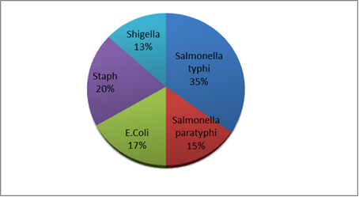
Fig(1): Bacterial isolates in buffalo calves
Salmonella serotypes remain a potential public health and environmental threat. Salmonella infection may not lead to fatal disease, but will remain within the intestines leading to gastroenteritis or may have a septic effect on many organ systems…. Typhimurium was the pathogen. It was isolated from stool samples that (14) mentioned earlier because infectious diarrhea is a common condition affecting young calves such as Salmonella species and Escherichia coli K99+ is known as the most common pathogen identified in drying calves accounting for 56% of isolated bacteria.
- Green synthesis of green SeNPs using Cinnamon Extract
After 24 hours, the color of the selenium-cinnamon extract mixture changed from colorless to brown. as depicted in Figure 2. During the incubation of the cinnamon extract without selenium, no color change was noticed. Since then, the development of Se NPs is indicated by the appearance of a brown color in cinnamon treated with selenium.
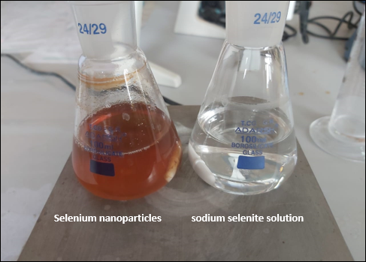
Figure(2): Image demonstrating the transformation in color caused by the addition of Cinnamon Extract to SeNO3.
The creation of a dark red color in solution as a result of the reaction between cinnamon extract and selenite demonstrated the production of Se-NPs and suggested that the cinnamon extract's constituents have the ability to reduce these ions and transform them into Se-NPs. Se-NPs have an excess of bioactivities compared to the bulk liquid as low toxicity chemo preventive agents and biologically active agents(15).The described plant synthesis protocol for Se-NP is environmentally friendly, simple and cheap. The resulting NPs are supposed to be innocent, non-toxic and highly stable (16).Se-NPs undergo color variations during synthesis, and their link with Ps (17) was discovered. The resulting Se-NPs green synthesis is simple, economical, and environmentally safe. The created NPs have good stability and are non-toxic. Several publications have been published and the major area of ​​focus is the aqueous extracts of different plant sections for the synthesis of Se-NPs (18).
- Characterization of green Se NPs
- UV–Visible Spectroscopy
UV-visible spectroscopy is an initial step in confirming the synthesis of green Se-NPs in addition to the color change to dark red. The UV-visible spectra of the green Se-NPs samples were recorded during 24 hours with a scan from 200 to 800 nm. UV-VIS absorbance was analyzed after centrifugation and particle redistribution in deionized water. At 298 nm, the green Se-NPs showed a single, distinct surface flour resonance band. (Fig. 3).
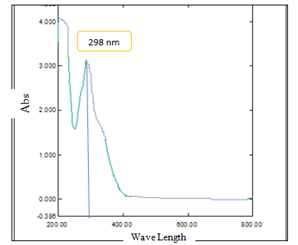
Figure 3: UV-VIS Absorbance Spectroscopy for Green SeNPs from Cinnamon Extract.
To verify the synthesis of NPs (19), UV-visible spectroscopy is used to quantify plasmon resonance and the overall oscillations of conduction band electrons in response to electromagnetic waves. Regarding NP structure, size, aggregation, and stability, it is accurate. A resonance with electrons in the surface conduction band occurs when a specific wavelength of light is incident on the NPs. Due to the separate absorption bands in the characteristic spectra of metal NPs, the range of absorption peaks for each metal varies depending on the size of the NPs. In the range of 200 nm to 800 nm, selenium nanoparticles can be produced on a spectrophotometer (20).
- X-ray diffraction (XRD) Analysis
It is a quick analytical method that can tell you how many manufactured nanoparticles are in a crystalline substance and how many of them there are. It can also tell you how big each unit cell is. The capping agent of the Se-NPs could be to blame for these sharp Bragg peaks.According to the XRD results, the bioorganic phase crystallizes on the surface of the Se NPs. Particle size effects are typically blamed for the broadening of peaks in the XRD patterns of solids. The broad peaks represent the influence of the experimental circumstances on the nucleation and development of crystalline nuclei and denote a lower particle size. Characterization of chemically and biologically produced Se-NPs (cinnamon extract). Forms (4).
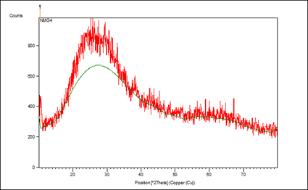
Figure(4): X-ray diffraction for green Se-NPs synthesized from cinnamon extract.
The Se-NPs using the JCPDS standard card, file no. 06-0362 (21) showed identical area peaks to the Joint Committee for Powder Diffraction Standards (JCPDS) standards (21). According to our findings, (22,23,24) reported that monoclinic crystal phase Se-NPs were successfully synthesized utilizing plant extract metabolites at the same XRD diffraction planes. According to the XRD data, the Se-NPs were generated were extremely crystalline for improved applicability.
- Fourier Transform Infrared Spectroscopy (FTIR)
The functional groups between the reducing agent (cinnamon extract) and sodium selenite were identified using FTIR analysis in order to determine their function in the synthesis of selenium nanoparticles. All of these functional groups are represented as peaks in the FTIR spectra in Figure (5). FTIR analysis was performed for samples in the range of 600-4000 cm-1. FTIR spectroscopy showed that the sample analysis had prominent absorption bands at the peaks (3402.43, 2924.09, 2850.79, 1716.95, 1573.91, 1442.75, 1334.74, 1122.57, 1010.70, 883.40, 648.08, 617.22, 513.07, 416.62).
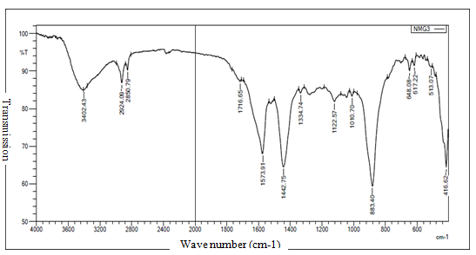
Figure 5: FTIR Spectra Pattern of Dried Powder Green SeNPs Synthesized from Cinnamon Extract.

Our research is consistent with (25) which claimed that for CIE/Se-NPs, the potential biomolecules responsible for the capping of bio-reduced Se-NPs photosynthesized utilizing CIE and the reduction of Se+ ions were found. The stability of the metal NPs found in cinnamon and the capping reagent were both determined by FTIR spectra. (e observed peak signified the carbonyl group at 1629.7 cm1 and the O-H stretching group of phenols and alcohols at 3418.4 cm1 (26). O-H stretching caused the broad absorption band at 3410 cm1 to develop. It was shown that the C=O bond in cinnamon aldehyde was involved in the synthesis of SeNP when the (e shifted band from 1604.3 cm1 (in CIE) to 1629.7 cm1 (in CIE/Se-NP spectra) was seen. At 1336.2 cm1, the (e band matched nitro compounds. Due to the influence of the aromatic ring and conjugation, this band was wider than it would be for typical aldehyde compounds. The aromatic C=C bending caused the band at 1407.3 cm1, and the C-O stretching caused the band at 1087.6 cm1 (27).
- Scanning Electron Microscope (SEM):-
By using SEM, the shape and particle size of cinnamon selenium-NPs were investigated. By using SEM examination, the produced cinnamon selenium nanoparticles' morphological features (size and shape) were calculated as in Figure (6).
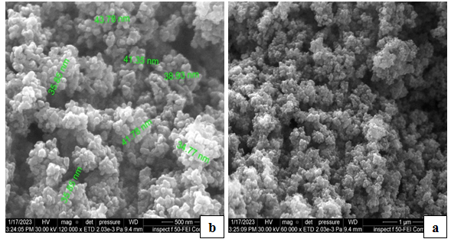
Figure 6: SEM image of SeNPs synthesized by cinnamon extract.(a): The clarity of the layers stacked on top of each other,(b): The selenium layers gave different measurements(34.5 to 45 nm)
The surface morphology and particle size of the Se-NPs were assessed using SEM. The form of the Se-NPs was almost spherical. The seed extract was converted into a liquid suspension at room temperature, and the Se-NPs ranged in size from 50 to 150 nm. The outcome was in line with (28) which produced spherical Se-NPs with the maximum frequency in the 80–220 nm range at 120–140 nm.
- Antibacterial activity test of green SeNPs Against salmonella typhi Isolates by Agar Well Diffusion method:
The antibacterial activity of the cinnamic ethanol extract and the synthesized SeNPs were investigated separately against buffalo isolates of S. typhi using the agar-well diffusion method, and tested with different concentration (25, 50, 100 μg/mL). table (1) and figure (7), show zone of inhibition of tested isolates .
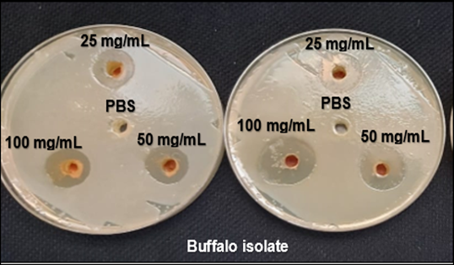
Figure(7) Zone of Bacterial Growth Inhibition According to Green SeNPs Antibacterial Activity in S. typhi Isolates.
Table (1): Zone of inhibition(mm) of tested substance in buffalo (S.typhi)
Concentration of materials  (mg.mL-1) | Buffalo isolates
Concentration of materials  (mg.mL-1) | Cinnamon extract | Selenium nanoparticles
25 | 9.27±0.88Aa | 13±0.57Ab
50 | 10.66±0.88Ba | 13.66±0.66Bb
100 | 10.66±0.66Ba | 14.33±0.33Cb
C | 0±0 | 0±0
LSD(P<0.05) | 0.261

The results in Table (1) indicate that the effect of Se-NPs gave a good inhibition at a concentration of 100 mg/ml, which was (14.33) mm on buffalo isolated, while the cinnamon extract at the same concentration gave an inhibition of (12.33) mm, and the inhibition diameters of both isolates can be seen in Figure (7). The results are similar to the findings of (29) who found that when using (75,50 and 20mg/ml)of cinnamon extract and same concentration of green synthesized SeNPs on buffalo salmonella typhi bacteria, the inhibition effect of(75mg\ml) was better in green synthesized SeNPs compare to the effect of extract alone. Results obtained by (30) reported that the highest concentration at (100mg\ml) of SeNPs exhibited higher zone of inhibition for salmonella typhi.
- Minimal bactericidal concentration (MBC), Minimal inhibitory concentration (MIC) test of green SeNPs:
The MIC was calculated using the complete broth dilution method in accordance with CLSI(11), the observed MIC values ​​of test subjects for S.typhi isolates were analyzed as showed in table (2).
Table (2): Antibacterial activity of green SeNPs against S.typhi by macro-dilution method
Source of bacteria | Cinnamon extract |  | Selenium nanoparticles
Source of bacteria | MIC value | MBC value | MIC value | MBC value
Buffalo | 466.6±176.3 | 1333.3±266.6 | 50±25 | 266.6±66.6

The findings demonstrated that Se-NPs outperformed cinnamon extract in terms of antibacterial activity against S. typhi isolates. Furthermore, the results of this investigation are in line with those of (31) who discovered that S. typhi is more susceptible to Se-NPs' antibacterial action at concentrations greater than or equal to 100 mg/mL. The data unequivocally demonstrate that Se-NP's antibacterial actions are more effective against S. typhi(32). The biosynthesized Se-NPs in our study were rated as having a greater efficacy against Salmonella typhimurium. This is due to a substantial alteration in the structure of the bacterial walls. Similar findings have been reported by other investigations (33, 34). Additionally, (35) noted that the MIC of Se-NPs is 50 g/mL. The creation of ROS, cell barrier interactions (cell wall rupture and permeability alteration), suppression of protein and DNA synthesis, metabolic gene expression, and other factors are thought to be the mechanisms of Se-NPs.(36). The production of reactive oxygen species (hydrogen peroxide, hydroxyl radicals, and superoxide anions) by metal-based nanoparticles is usually linked to the antibacterial action. Se-NPs have been shown to induce ROS in several investigations (32,36). These reactive oxygen species have the potential to damage bacteria's cell membranes and hinder DNA and amino acid replication (37).
- Estimate Bss gene Expression in Salmonella typhi
Quantitative PCR estimates DNA amplification at the cycle index number on the fluorescence index (SYPR green), which was used to measure gene amplification. The reference gene was essential in determining how accurate the tested gene was, and it should express itself consistently under the experimental circumstances (38). The figures(8) and (9) show the difference between tested and control bacteria's Bss gene RT-qPCR amplification.

Figure 8: RT- qPCR amplification biofilm gene ( BssS) and HKG gyrA gene) in treated and control S.typhi isolates

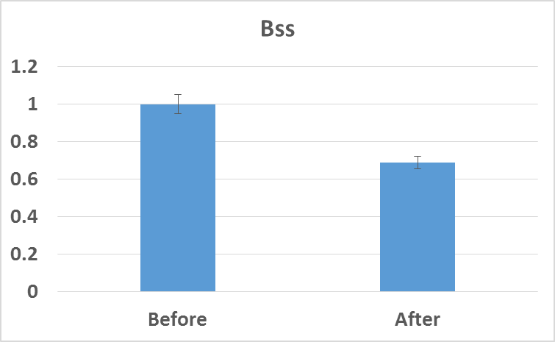
Fig 9: Effect of (SeNPs ) on relative genes expression: the fold change of Bss gene decrease in S. typhi isolates after treated with combination of SeNPs and cinammon extract
The Ct differences between the housekeeping gene and the BssS gene, which represent the expression level of (BssS) following treatment with SeNPs, are displayed in (Fig. 8, 9) to assess variable gene expression. Expression level of BssS Results showing BssS gene expression using RT-qPCR after treatment with a mixture of SeNPs and cinnamon extract resulted in an increase in the cycle number and this shows that this extract will inhibit the biofilm formation system when these bacteria are exposed to it. These results may explain that the action of CINPs and the combination of CINPs with cinnamon extract regulates the gene expression of genes that regulate biofilm formation in bacterial cells. One of the most crucial strategies Salmonella employs to survive in host cells is the creation of biofilms (39). It also helps bacteria dodge host immune responses and increases their resilience to unfavorable conditions (40).
CONCLUSION:-
In the current study, cinnamon extract was employed for the first time in an eco-friendly and environmentally friendly manner to biosynthesize selenium nanoparticles (Se-NPs). According to the characterization findings, the biosynthesized Se-NPs were highly crystalline, spherical, and polydisperse, with diameters ranging from 16 to 95 nm. Se-NPs additionally demonstrated promising antibacterial efficacy against Salmonella Typhimurium bacteria. The biosynthesized Se-NPs will eventually contain potential antimicrobial microorganisms and be useful in the medical industry.
REFERENCE :
- Yilmaz, A., Umar, S., Turan, N., Kayar, A., Richt, J., & YILMAZ, H. (2022). Current scenario of viral diseases and vaccination strategies of cattle in Turkey. Journal of Infection in Developing Countries, 16(8).‏
- Teng, L., Liao, S., Zhou, X., Jia, C., Feng, M., Pan, H., ... & Yue, M. (2022). Prevalence and genomic investigation of multidrug-resistant Salmonella isolates from companion animals in Hangzhou, China. Antibiotics, 11(5), 625.‏
- Mayekar, V. M., Ali, A., Alim, H., & Patel, N. (2021). A review: Antimicrobial activity of the medicinal spice plants to cure human disease. Plant Science Today, 8(3), 629-646.‏
- Hogan, C., & Perkins, A. V. (2022). Selenoproteins in the human placenta: how essential is selenium to a healthy start to life?. Nutrients, 14(3), 628.‏
- M Salem, N., H Alkharabsheh, S. and M Awwad, A. (2018) ‘A novel route for large-scale synthesis silver nanoparticles using Uncaria tomentosa leaves extract: Antibacterial activity’, Advanced Materials Proceedings, 3(5), pp. 324–327.
- Bagheri-Josheghani, S., & Bakhshi, B. (2022). Investigation of the Antibacterial and Antibiofilm Activity of Selenium Nanoparticles against Vibrio cholerae as a Potent Therapeutics. Canadian Journal of Infectious Diseases and Medical Microbiology, 2022.‏
- Al-Garadi, M. A., Qaid, M. M., Alqhtani, A. H., Alhajj, M. S., Al-abdullatif, A. A., & Al-Mufarrej, S. I. (2023). In vitro antimicrobial efficacy assessment of ethanolic and aqueous extracts of cinnamon (Cinnamomum Verum) bark against selected microbes. Brazilian Journal of Poultry Science, 25.‏
- Gunti, L., Dass, R. S., & Kalagatur, N. K. (2019). Phytofabrication of Selenium Nanoparticles From Emblica officinalis Fruit Extract and Exploring Its Biopotential Applications: Antioxidant, Antimicrobial, and Biocompatibility. Frontiers in Microbiology, 10.
- Meenambigai, K., Kokila, R., Chandhirasekar, K., Thendralmanikandan, A., Kaliannan, D., Ibrahim, K. S., ... & Nareshkumar, A. (2022). Green synthesis of selenium nanoparticles mediated by Nilgirianthus ciliates leaf extracts for antimicrobial activity on foodborne pathogenic microbes and pesticidal activity against Aedes aegypti with molecular docking. Biological Trace Element Research, 200(6), 2948-2962.‏
- Al-gburi, A. R. (2016). Complementary and conventional antimicrobials for integrative targeted control of bacterial vaginosis associated pathogens. Rutgers The State University of New Jersey, School of Graduate Studies.‏
- CLSI. (2022). Performance standards for antimicrobial susceptibility testing. 32nd informational supplement, Clinical and Laboratory Standard Institute. Wayne PA.
- Son, K., Lee, W. S., & Lee, K. B. (2021). Effect of different software programs on the accuracy of dental scanner using three-dimensional analysis. International Journal of Environmental Research and Public Health, 18(16), 8449.‏
- Ogodo, A. C., Agwaranze, D. I., Daji, M., & Aso, R. E. (2022). Microbial techniques and methods: basic techniques and microscopy. In Analytical Techniques in Biosciences (pp. 201-220). Academic Press.‏
- Popa, G. L., & Papa, M. I. (2021). Salmonella spp. infection-a continuous threat worldwide. Germs, 11(1), 88.‏
- El-Seedy, F.R., Abed, A.H., Yanni, H.A. and Abd El-Rahman, S.A.( 2016). Prevalence of Salmonella and E. coli in neonatal diarrheic calves. Beni-Suef University Journal of Basic and Applied Sciences 5(1), 45-51
- Salem, S. S., & Fouda, A. (2021). Green synthesis of metallic nanoparticles and their prospective biotechnological applications: an overview. Biological trace element research, 199, 344-370.‏
- Pyrzynska, K., & Sentkowska, A. (2021). Biosynthesis of selenium nanoparticles using plant extracts. Journal of Nanostructure in Chemistry, 1-14.‏
- Gunti, L., Dass, R. S., & Kalagatur, N. K. (2019). Phytofabrication of selenium nanoparticles from Emblica officinalis fruit extract and exploring its biopotential applications: antioxidant, antimicrobial, and biocompatibility. Frontiers in microbiology, 10, 931.‏
- J Premkumar, T. Sudhakar, A. Dhakal, J. B. Shrestha, S. Krishnakumar, and P. Balashanmugam,(2018).“Synthesis of silver nanoparticles (AgNPs) from cinnamon against bacterial pathogens,” Biocatalysis and Agricultural Biotechnology.15(33).311–316.
- ElFaham, M. M., Mostafa, A. M., & Mwafy, E. A. (2021). The effect of reaction temperature on structural, optical and electrical properties of tunable ZnO nanoparticles synthesized by hydrothermal method. Journal of Physics and Chemistry of Solids, 154, 110089.‏
- Shahbaz, M., Akram, A., Raja, N. I., Mukhtar, T., Mashwani, Z. U., Mehak, A., ... & Yousaf, T. (2022). Green synthesis and characterization of selenium nanoparticles and its application in plant disease management: a review. Pakistan Journal of Phytopathology, 34(1), 189-102.‏
- Cruz, L. Y., Wang, D., & Liu, J. (2019). Biosynthesis of selenium nanoparticles, characterization and X-ray induced radiotherapy for the treatment of lung cancer with interstitial lung disease. Journal of Photochemistry and Photobiology B: Biology, 191, 123-127.‏
- Sarkar, R. D., & Kalita, M. C. (2022). Se nanoparticles stabilized with Allamanda cathartica L. flower extract inhibited phytopathogens and promoted mustard growth under salt stress. Heliyon, 8(3), e09076.‏
- Cittrarasu, V., Kaliannan, D., Dharman, K., Maluventhen, V., Easwaran, M., Liu, W. C. & Arumugam, M. (2021). Green synthesis of selenium nanoparticles mediated from Ceropegia bulbosa Roxb extract and its cytotoxicity, antimicrobial, mosquitocidal and photocatalytic activities. Scientificreports, 11(1), 1032.‏
- Alghuthaymi, M. A., Diab, A. M., Elzahy, A. F., Mazrou, K. E., Tayel, A. A., & Moussa, S. H. (2021). Green biosynthesized selenium nanoparticles by cinnamon extract and their antimicrobial activity and application as edible coatings with nano-chitosan. Journal of Food Quality, 2021, 1-10.‏
- Salem, S. S., Badawy, M. S. E., Al-Askar, A. A., Arishi, A. A., Elkady, F. M., & Hashem, A. H. (2022). Green biosynthesis of selenium nanoparticles using orange peel waste: Characterization, antibacterial and antibiofilm activities against multidrug-resistant bacteria. Life, 12(6), 893.‏
- Huang, T., Holden, J. A., Heath, D. E., O'Brien-Simpson, N. M., & O'Connor, A. J. (2019). Engineering highly effective antimicrobial selenium nanoparticles through control of particle size. Nanoscale, 11(31), 14937-14951.‏
- Rangrazi, A., Bagheri, H., Ghazvini, K., Boruziniat, A., & Darroudi, M. (2020). Synthesis and antibacterial activity of colloidal selenium nanoparticles in chitosan solution: a new antibacterial agent. Materials Research Express, 6(12), 1250h3.‏
- Hassan, A., Yousif, M. H., Abd-Elkhaliq, H. M. M., Wahba, A. K. A., & El-Hamaky, A. M. A. (2021). The antimicrobial potential of selenium nanoparticles singly and in combination with cinnamon oil against fungal and bacterial causes of diarrhea in buffaloes. Adv. Anim. Vet. Sci, 9(8), 1238-1248.‏
- Rana, A., Pathak, S., Lim, D. K., Kim, S. K., Srivastava, R., Sharma, S. N., & Verma, R. (2023). Recent Advancements in Plant-and Microbe-Mediated Synthesis of Metal and Metal Oxide Nanomaterials and Their Emerging Antimicrobial Applications. ACS Applied Nano Materials, 6(10), 8106-8134.‏
- Huang, T., Holden, J. A., Reynolds, E. C., Heath, D. E., O’Brien-Simpson, N. M., & O’Connor, A. J. (2020). Multifunctional antimicrobial polypeptide-selenium nanoparticles combat drug-resistant bacteria. ACS Applied Materials & Interfaces, 12(50), 55696-55709.‏
- Cremonini, E., Zonaro, E., Donini, M., Lampis, S., Boaretti, M., Dusi, S., ... & Vallini, G. (2016). Biogenic selenium nanoparticles: characterization, antimicrobial activity and effects on human dendritic cells and fibroblasts. Microbial biotechnology, 9(6), 758-771.‏
- Eleraky, N. E., Allam, A., Hassan, S. B., & Omar, M. M. (2020). Nanomedicine fight against antibacterial resistance: an overview of the recent pharmaceutical innovations. Pharmaceutics, 12(2), 142.‏
- Zhao, G., Wu, X., Chen, P., Zhang, L., Yang, C. S., & Zhang, J. (2018). Selenium nanoparticles are more efficient than sodium selenite in producing reactive oxygen species and hyper-accumulation of selenium nanoparticles in cancer cells generates potent therapeutic effects. Free Radical Biology and Medicine, 126, 55-66.‏
- Nayak, V., Singh, K. R., Singh, A. K., & Singh, R. P. (2021). Potentialities of selenium nanoparticles in biomedical science. New Journal of Chemistry, 45(6), 2849-2878.‏
- Hemeg, H. A. (2017). Nanomaterials for alternative antibacterial therapy. International journal of nanomedicine, 12, 8211.‏
- Hassan, M. S. E. S. (2020). Detection of probiotic microorganisms using RT-PCR, and isolation, identification, probiotic properties of lactobacillus species from kefir.‏
- Niemeyer, C. M. (2019). May the Worm Story Begin...: Evaluation of Caenorhabditis Elegans as Model for Investigations Into Bacterial Cross Talk During Intestinal Immune Responses (Doctoral dissertation, Eberhard Karls Universität Tübingen).‏
- Ferreres, G., Ivanova, K., Ivanov, I., & Tzanov, T. (2023). Nanomaterials and Coatings for Managing Antibiotic-Resistant Biofilms. Antibiotics, 12(2), 310.‏
- Chen S, Feng Z, Sun H, Zhang R, Qin T, Peng D.(2021). Biofilm-Formation Related Genes csgD and bcsA Promote the Vertical Transmission of Salmonella Enteritidis in Chicken. Front Vet Sci.14(7):625049.

