Marine Resources for Bioactive Metabolites/Marine-Derived Drugs: A Review

Abstract:
The oceans are the world’s most important sources of biological activity, water, and biomass production. They supply food, oxygen, and other natural products critical for human existence, and interactions between the oceans and atmosphere shape the climate and weather. The oceans serve as the world’s greatest reservoir of biodiversity, including marine mammals, fish, crustaceans, molluscs, and countless species of zoo- and phytoplankton. The ocean is a key source of organisms that are beginning to yield new and potent drugs for the treatment of human disease, as well as new products for use in biotechnology. Ocean can benefit human health, from providing new sources of drugs to helping unravel many of the mysteries of human disease. Bioactive metabolites derived from marine organisms provide a novel and rich source of chemical diversity that can contribute to design and development of new and potentially useful pharmaceutical agents. The marine ecosystem possesses an excellent pharmaceutical potential with wide scope to identify, isolate and characterize new compounds suitable for therapeutic purposes. Marine sponges, tunicates, fishes, soft corals, nudibranchs, sea hares, molluscs, echinoderms, bryozoans, prawns, shells, sea slugs, and marine microorganisms are sources of bioactive compounds. The current review is designed to collate all currently available data about the marine drugs with respect to sources, classification, chemical classes, metabolites of marine algae, fungi, bacteria and invertebrates, techniques for separation and isolation, and examples. This review aims to provide a holistic, multidisciplinary account of the current state of affairs on this topic.
Keywords:
Biodiversity, cancer, mangroves, marine bioactive metabolites, marine organisms, pharmaceuticals, seaweeds

1. Introduction
World's oceans cover about 70% of the earth’s surface and represent 28 major animal phyla. Marine compounds are underrepresented in routine clinical practice, but aquatic environment may become a potentially valuable source of novel compounds [30]. Drug discovery based on marine biodiversity has been a relatively rapid growing field over the last five decades [16, 33].
Biodiversity provides the foundation in nature for the production of diverse chemical compounds now used to treat human disease. Today, about one-half of all cancer drug discovery focuses on marine organisms, and over 6,000 structurally unprecedented and highly bioactive metabolites have been isolated from marine plants and animals [11, 12].
According to Pomponi [25], marine plants, animals, and microbes produce unique chemicals and metabolites for their defence, reproduction, and communication. These metabolites also interact with receptors and enzymes involved in human disease processes. They also prevent the cells of other organisms from growing and dividing. Therefore, they may also be effective in inhibiting the uncontrolled growth of cancer cells [28].
Jimenez et al [14] reported that, 7 marine-based pharmaceuticals have been approved for marketing, 23 compounds are in clinical trials and over one thousand compounds isolated from marine organisms are undergoing preclinical studies. 4 compounds derived from marine organisms like cytarabine, trabectedin, eribulin mesylate and the conjugated antibody brentuximab vedotin are used in the treatment of cancer [17, 34].
Marine organisms (algae, bacteria, molluscs, soft corals, sponges) produce chemical compounds with beneficial medical and industrial uses. These chemicals and natural products can be developed as pharmaceuticals, nutritional supplements, medical diagnostics, cosmetics, agricultural chemicals (pesticides and herbicides), enzymes and chemical probes for disease research, and for many other applications [32, 35].
Montalvao [20] reported that, extracts from microalgae showed the antimicrobial results against Staphylococcus aureus and fungus Candida albicans. Ciavatta et al [6] stated that, bryozoans are a source of many pharmacologically important bioactive compounds, which acts as anticancer agents and treatments for brain diseases and viral and parasitic infections, was well established [8].
Bhakuni and Rawat [3] noted that, marine natural products exhibit biological activity. Bioactive metabolites of marine flora include brominated phenols, oxygen heterocyclics, nitrogen heterocyclics, sulphur nitrogen heterocyclics, sterols, terpenoids, polysaccharides, peptides and proteins. These compounds were isolated from marine algae, fungi, bacteria, sponges, jelly fish, sea anemones, corals, bryozoans, molluscs, echinoderms, tunicates and crustaceans. Marine fauna yields bioactive metabolites such as steroids, terpenoids, isoprenoids, nonisoprenoids, quinones, brominated compounds, nitrogen heterocyclics, and nitrogen sulphur heterocyclics [11, 15].
Vinothkumar and Parameswaran [36] summarised that, marine organisms produce secondary metabolites as a technique of chemical defence to live in a highly competitive environment. Because of recent advances in underwater exploration, natural products chemistry, genome mining and bioassays have led to the search for novel biomolecules from underexploited habitat. As a result, more than 70% of marine metabolites were obtained from marine sponges, corals and microorganisms [24, 31].
Lindequist [18] stated that, marine organisms produce specific secondary metabolites as an important adaption to survive in the sea. These metabolites possess biological activities which can be possible drugs for human. Marine organisms such as the sponges; corals and jellies; sea stars; molluscs; polychaetes; moss animals; flatworms; acorn worms; lamp shells; crustaceans; and vertebrates have been the most important source of bioactive metabolites [2, 7, 22].
Marine derived pharmaceuticals were used as sources of chemical diversity in drug discovery programs. Marine biotechnology is an emerging field to develop and produce new products in the pharmaceutical industry. Though many compounds were isolated from marine organisms and their biological activities were assessed, those that have either been marketed or are under development are very few [13, 21].
Lomartire and Gonçalves [19] pointed that, species of marine algae or seaweeds (phylum Ochrophyta, Rhodophyta and Chlorophyta) are valuable for the food, cosmetic, pharmaceutical and nutraceutical industries; and also used to treat several diseases. Compounds from seaweeds exhibit antioxidant, antimicrobial, and antiviral activities; and are used for beneficial properties for human health. Due to their non-toxic, edible, cheap and easy culturing properties, macroalgae could replace synthetic compounds with those of natural origin [9, 26].
Bhatia et al [4] have shown that, marine drugs are abundant in number, have diverse structures with mechanisms of action, and have scope for the discovery of new drugs for better treatment and management of several acute to chronic diseases. They show approaches in the treatment of chronic diseases such as cancer, diabetes, neurodegenerative diseases, and cardiovascular disorders [1, 23].
Marine floras include microflora (bacteria, actinobacteria, cyanobacteria and fungi), microalgae, macroalgae (seaweeds), and flowering plants (mangroves and other halophytes). This vast marine floral resource offers a great scope for discovery of new drugs [5]. Mangroves extracts have shown inhibitory activity against human, animal and plant pathogens. They also produce bioactive compounds that show antibacterial activity against pathogenic bacterial strains and control microbial growth. Mangrove extracts is also the sources of mosquito larvicides, antifungal, antiviral, anti-cancer and anti-diabetic compounds [29].
The purpose of this paper is to briefly review recent research on drug discovery based on marine organisms. This review provides information applicable to marine drugs with respect to sources, classification, chemical classes, metabolites of marine algae, fungi, bacteria and invertebrates, techniques for separation and isolation, and examples.
  - Structure of the review paper
Table 1. Structure of the review paper

Section | Details
I | Introduction & Current status of Marine Bioactive Metabolites
II | Literature Search Methods
III | Sources of Marine Natural Products (MNP)
IV | Classification of Bioactive Metabolites based on Therapeutic Category
V | Classes of Marine Natural Products
VI | Bioactive Metabolites of Marine Algae, Fungi and Bacteria
VII | Bioactive Metabolites of Marine Invertebrates
VIII | Bioactive Metabolites of Marine Sponges
IX | Techniques for Separation and Isolation of Bioactive Metabolites
X | Examples of Marine drugs

2. Literature Search Methods
The review was carried out through extensive literature search, using electronic databases, and online search tools, such as EMBASE, Google Scholar, Medline, NCBI, PubMed, Science Direct, Scopus, and Web of Science databases. Data and information was collected from the thorough study of the journal articles, research papers, reports and various literatures. This review paper analysed a total of 38 research articles published in reputed journals. The keywords used for reviewing the literature were the ones that refer to the issues concerning the ‘marine bioactive compounds/marine drugs'. For literature search, keyword “marine bioactive compounds/marine drugs” is combined with: sources, classification, chemical classes, metabolites of marine algae, fungi, bacteria, invertebrates & sponges, techniques for separation and isolation, and examples.
- Sources of Marine Natural Products
Avhad and Bhangale [1] noted that, the organisms producing MNP are divided into three major biological classes such as: marine microorganisms (bacteria, fungi, cyanobacteria, phytoplankton), marine algae (macroalgae/seaweeds: green, brown and red algae) and micro algae (blue green algae, dinoflagellates, bacillariophyta/diatoms), and marine invertebrates (bryozoans, coelenterates, corals, echinoderms, molluscs, sponges, & tunicates) (Fig.1 & Fig. 2, Table 2).

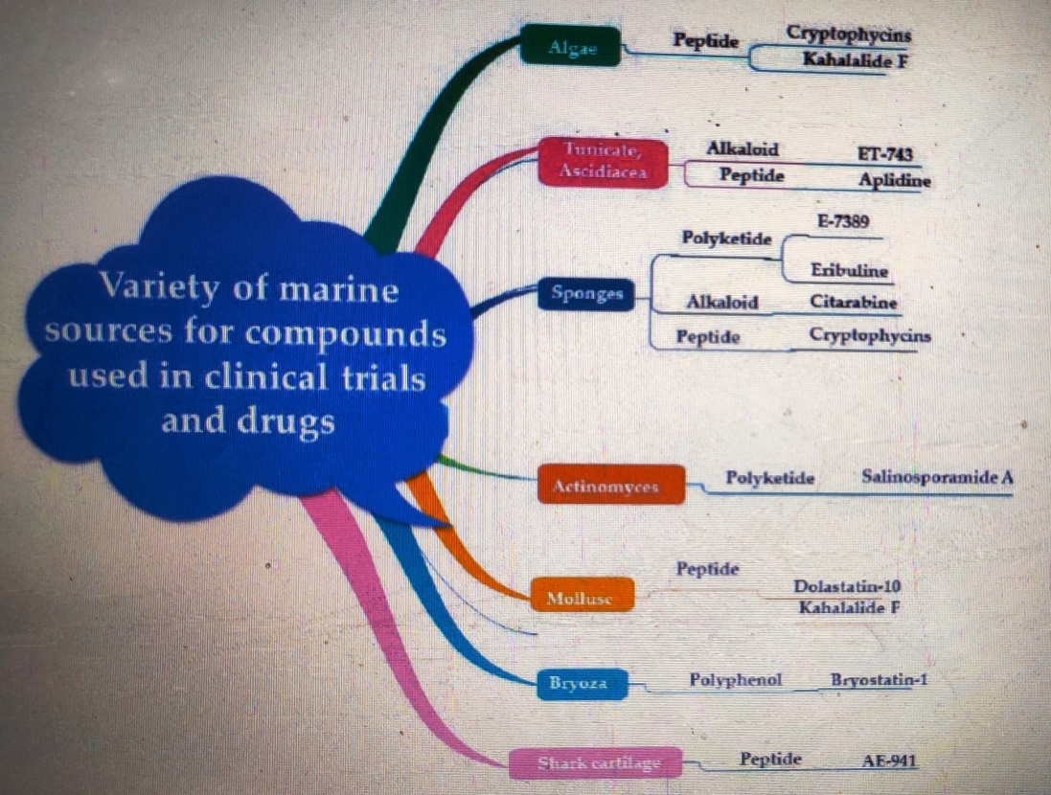
Fig. 1. Sources and chemical nature of marine bioactive metabolites
(Source: Shaden et al [31])

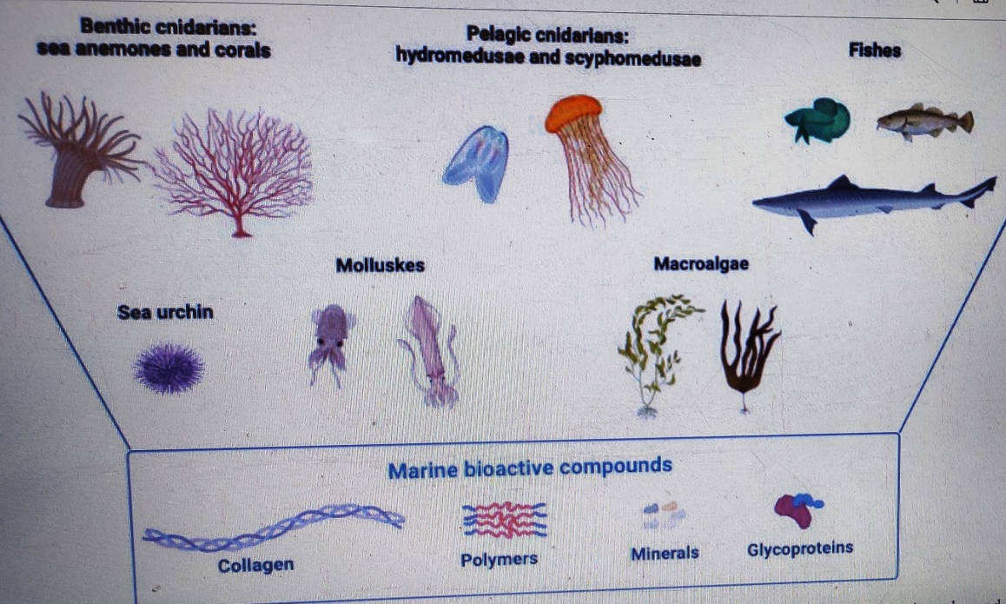

Fig. 2. Sources of marine bioactive compounds
(Source: Rigogliuso et al [27])

Table 2. Sources of Marine Natural Products
Organisms | Examples | Potential Medicinal Applications
Marine snails | Cone snails | - Diabetes, chronic pain,  - Other human illnesses.
 | Gastropods snail  (Slime snail/  mucus snail) | Treatment of Human skin:  - Acne, wrinkles & scars, healing of injured skin.  - Hydration, anti-ageing, dry skin and stretch marks.  - Protection from free radicals, calms the skin, heals damaged tissues, and restores moisture.  - Stimulation of collagen and elastin synthesis.  - Anti-cancer properties & strengthen immune system.
Marine corals | Octocorals  (Sea fans,  sea pens,  soft corals) | - Tissue scaffolds, bone implants,  - Antibacterial, anti-inflammatory & drug delivery agents,  - Aesthetic & other medical implementations
Marine algae  (Phaeophyta, Chlorophyta Rhodophyta) | Brown, Green & Red algae Corallina officinalis | - Avoiding malignancies (breast cancer and lung cancer)  - Used as a food colouring.  - Control the production of skin oil.
Marine Sponges | Hyrtios erectus,  Cryptotethya crypta | Nucleosides used as building blocks for the creation of:  - Ara-A: Antiviral medicine,  - Ara-C: First anticancer drug generated from marine sources
Tunicates | Ascidians, tunicates & sea squirts | - Bioactive secondary metabolites with potential uses in biomedicine.  - Produce potential compounds with anti-bacterial and anti-cancer properties.
- Classification of bioactive metabolites based on Therapeutic category
According to Murti and Agrawal [21] and Navgire [22], based on the therapeutic category, marine bioactive metabolites can be classified into various types such as: analgesic, antibacterial, anticancer, anti-inflammatory, antimalarial, antimicrobial, anti-parasitic, antiviral, bone grafting, ca2+-ATPase & histone deacetylase inhibitor, enzyme, molecular probe, and neuro-protective (Table 3).
Table 3. Classification of bioactive metabolites based on therapeutic category
Therapeutic category | Drugs | Source
Analgesic | Ziconotide (Prialt) | Conus magus
Antibacterial | Eicosapentaenoic acid | Phaeodactylum tricornutum
Anticancer | Squalimine  Bryostatins 1 & 2 | Shark  Bugula neritina
Anti-inflammatory | Topsentin  Tsitsixenicin A | Spongosporites ruetzleri  Capenella thyrsoidea
Antimalarial | Manzamine A  Axisonitrile 3 | Haliclona sp.  Acanthella klethra
Antimicrobial | Cephalosporins  Istamycin | Cephalosporium acremonium  Streptomyces tenjimariensi
Anti-parasitic | α-Kainic acid | Digenia simplex
Antiviral | Didemnin B  Avarol and Avarone | Trididemnum sp.  Disidea avara
Bone grafting | Orthopedic implants | Coral (Family Isididae)
Ca²⁺-ATPase & histone deacetylase inhibitor | Speradine A | Aspergillus tamari
Enzyme | Polyketide synthase | Pseudoceratina clavata
Molecular probe | Okadaic acid | Prorocentrum belizeanum
Neuroprotective | Extracts of South Indian green seaweed | Ulva reticulata

- Classes of Marine Natural Products
Montalvao [20] and Avhad and Bhangale [1] reported that, the MNP are divided into seven classes based on their chemical structure. These classes include Alkaloids, Ethers (including ketals), Peptides, Phenols (including quinones), Steroids (including steroidal saponins), Strigolactones, and Terpenes/Terpenoids.
Table 4. Classes of Marine Natural Products
MNP | Definition | Subclasses | Occurrence | Examples | Activity
Alkaloids | Cyclic organic compounds containing nitrogen in a negative oxidation state. | Indole, Pyrrole, Pyridoacrine, Isoquinoline, Gadinine, Aminoimidazole,  Sterol alkaloids | Sponges  (Agelas, Axinella, Acanthella, Hymeniacidon, Pseudoaxinyssa),  Tunicates | Oroidin,  Nagelamide J,  Nagelamide A,  Trabectedin | Antimicrobial,  Anticancer,
Peptides | Specific protein fragments that act as sources of amino acids & Nitrogen. |  | Tunicate  (Trididemnum solidum),  Marine sponge (Discodermia  Kiiensis),  Marine cone snail | Didemnin B,  Discodermin A,  Ziconotide, | Antitumor, Antiproliferative,  Antimicrobial,  Treatment of chronic pain  in spinal cord injury
Polyketides | Low molecular weight compounds assembled via sequential condensations of small carboxylic acids. | Polyethers, Polyenes, Polyphenols, Macrolides, Polyols, | Sponges (Spirastrella spinispirulifera and Hyrtios),  Fungus (Penicillium sp), | Eribulin (Halichondrin B),  Spongistatin 1,  Macrolides, Brefeldin A, Brefeldin C,  7-oxobrefeldin A, | Anticancer,  Antimicrobial,
Polysaccharides | Heteropolysaccharides | Agar, Alginates, Agarose, Carrageenans, Fucoidans | Microalgae, Macroalgae,  Red  seaweeds (Rhodophyta) | Carrageenan, | Anticoagulant, Antitumor, Anticancer, Antibiotic, Antioxidant, Anti-inflammatory  Antiviral
Terpenes/  Terpenoids | Derived from a five-carbon isoprene structure with several functional groups (e.g., isonitrile, dichloroimine, halogenated, isocyanate) | Monoterpenes (C10), Sesquiterpenes (C15), Diterpenes (C20), Sesterpenes (C25), Triterpenes (C30, steroids), Tetraterpenes (C40, carotenoids) | Seaweeds (Laurencia obtuse,  Laurencia microcladia) | Manoalide | Antibacterial, Cytotoxic

- Bioactive Metabolites of Marine Algae, Fungi and Bacteria
Bhakuni and Rawat [3] reported that, marine algae, fungi and bacteria generate various types of bioactive metabolites having varying occurrence and biological activity (Table 5).
Table 5. Bioactive Metabolites of Marine Algae, Fungi and Bacteria
Organism | Bioactive metabolite | Occurrence | Activity
Marine Algae | Brominated phenols,  (2,3-dibromobenzyl  alcohol, 4,5-disulphate dipotassium salt) | Green, brown & red algae,  Symphyocladia gracilis, Rhodomela larix,  Polysiphonia lanosa | Antibacterial, Antifungal
 | Brominated Oxygen Heterocyclics  (Laurencin, Laureatin, Prelaureatin, Bromofucin) | Red algae  (Laurencia glandulifera,  L. nipponica) | Larvicidal
 | Nitrogen Heterocyclics  (Domoic acid) | Algae, Chondria armata | Antihelmintic  (Ascaris & Pinworms)
 | Kainic acids | Red algae (Digenea simplex,  Corallina officinalis, Digenea) | Antihelmintic  (Ascaris)
 | Guanidine derivatives | Marine plankton (Gonyaulax catenella), Butter clam (Californian mussel) | Neurotropic
 | Phenazine derivatives  (Caulerpin) | Algae (Caulerpa lamourouxii, C. sertularioides) | Anaesthetic
 | Amino acids and Amines  (Laminine) (Methylamine,  Dimethylamine) | Algae (Laminaria angustata & Chondria amata) | Pharmacological agent
 | Sterols (22-  Dehydrocholesterol, Demosterol) | Red algae (Rhodymenia palmata, Porphyra purpurea, P. umbilicalis) | Reduce blood cholesterol level.
 | Sulfated Polysaccharides  (Carrageenan, Agar, Agarose, Furcellaran, Alginic acid, Laminarin) | Seaweed (Chondrus, Eucheuma, Gigartina, Iridea) | Treatment of gastric and duodenal ulcers.
Marine Bacteria & Fungi | Cephalosporin C,  Cephalosporin P,  Cephalothin,  Prodigiosin | Bacteria  (Pseudomonas piscicida, P. bromoutilis), Fungus  (Cephalosporium  acremonium) | Antibiotic, Antiviral, Antifungal,  Anti-yeast, Antimicrobial,

- Bioactive Metabolites of Marine Invertebrates
According to Bhakuni and Rawat [3], among invertebrates, bioactive metabolites have been generated by marine sponges, jelly fish, sea anemones, corals, bryozoans, molluscs, echinoderms, tunicates and crustaceans. Various bioactive metabolites isolated from marine invertebrates include, brominated compounds, isoprenoids, nitrogen heterocyclics, nitrogen sulphur heterocyclics, nonisoprenoids, prostaglandins, quinones, steroids, and terpenoids (Table 6).
Table 6. Bioactive Metabolites of Marine Invertebrates
Organism | Bioactive metabolite | Occurrence | Activity
Brominated compounds | Aplysin-19,  Aplysin-20,  Dibromophakellin,  Aerothionin, | Marine Sponge  (Dysidea herbacea,  Verongia cauliformis)  Sea hare (Aplysia kurodai),  Marine hemichordate  (Balano glossus) | Antibacterial,  Antimicrobial,  Antibiotic
Isoprenoids | Furoventalene | Sea fan (Gorgonia ventalina) | Antibiotic
Prostaglandins | 15-epi-PGA₂, PGA₂,  PGA_{2α} | Gorgonian  (Plexaura homomalla) | Fertility control, Labour induction, Renal physiology
Quinones | Naphthaquinones,  Rhodocomatulin | Marine fauna | Antimicrobial
Steroids | Crustecdysone,  Deoxycrustecdysone,  Callinecdysone A,  Steroid hormones, Sterols, Saponins, | Crustacean  (Cragon vulgaris)  Crayfish (Jasus lalandei)  Marine crab  (Callinectes sapidus),  Holothurian (Halodeima grisea, H. vagabunda) | Neuromuscular, Anticancer,  Antibiotic,  Cytotoxic,  Chemotherapeutic
Terpenoids | Crassin acetate,  Eunicin | Gorgonian  (Eunicea mammosa),  Horny corals (Pseudoplexaura porosa,  P. wagenaari) | Antibiotic,  Antibacterial,

- Bioactive Metabolites of Marine Sponges
Marine sponges are a good source of bioactive metabolites such as: Halistanol, Sterols, Hydroxy sterol, Plakinamine A, Plakinamine B, Furanoid sesquiterpenoids, Nakafuran-8, Nakafuran-9, Agelasidine-A, B, & C; Arenarol, Arenarone, Illimaquinone, Ent-chromazonarol, Kalihinol A, Keramadine, Latrunculin A to D, Panicein A, -B1, -B2, -B3, -C; Phyllofolactore A & Phyllofoloctone, Puupehenone, Sesquiterpene phenol, Siphonodictyal-A, Siphonodictyal-B, Terpenoids, Tetracyclic furanoditerpenes, and Xestospongin A, B, C and D (Table 7).
Table 7. Bioactive Metabolites of Marine Sponges
Sponge | Bioactive metabolite | Activity
Acanthella spp. | Kalihinol A | Antibiotic
Agelas (Okinawan sea sponge) | Agelasidine-A, Keramadine | Antimicrobial
Agelas nakamurai (Okinawan sponge) | Agelasidine B & Agelasidine C | Antibiotic
Disidea pallescens | Ent-chromazonarol
Dysidea arenaria | Arenarol, Arenarone, Illimaquinone
Dysidea fragilis | Nakafuran-8, Nakafuran-9 | Antifeedant
Dysidea species | Hydroxy sterol
Dysidea, Euryspongia & Siphonodictyon | Furanoid sesquiterpenoids
Halichondria mooriei | Halistanol | Antibacterial
Halichondria panacea | Panicein A, -B1, -B2, -B3, -C
Hyrtios eubamma | Puupehenone
Latrunculia magnifica | Latrunculin A to D | Cytotoxic
Marine sponges | Siphonodictyal-A, Siphonodictyal-B
Phyllospongia foliascens  (Pacific sponge) | Phyllofolactore A & Phyllofoloctone | Antifungal, Antiinflammatory
Plakina spp. | Plakinamine A, Plakinamine B | Antimicrobial
Smenospongia echina | Sesquiterpene phenol | Antimicrobial
Spongia officinalis | Tetracyclic furanoditerpenes | Antifungal, Antimicrobial
Spongia officinalis (Bath sponge) | Terpenoids
Toxadocia zumi | Sterols | Antimicrobial
Xestospongia exigua (Australian sponge) | Xestospongin A, B, C and D | Antimicrobial

- Techniques for Separation and Isolation of Bioactive Metabolites
Bioactive secondary metabolites produced by marine organisms consist of mixture of several classes of compounds. Chemically, these compounds could be divided into amino acids, peptides, nucleosides, alkaloids, terpenoids, sterols, saponins, polycyclic ethers etc. A broad separation of the mixture of metabolites can be achieved by fractionation with organic solvents.
Various separation techniques used includes separation of water soluble constituents either by desalting, ion-exchange chromatography, reverse-phase (RP) columns, high/medium pressure chromatography, or combination of ion-exchange and size-exclusion chromatography. Mixture of metabolites can also be separated by following bioassay directed fractionation, general fractionation, or isolation procedures for amino acids and simple peptides, peptides, nucleosides, cytokinins, and alkaloids.
- Examples of Marine drugs
Navgire [22], Bhatia et al [4], and Avhad and Bhangale [1] reported that, at present various categories of marine drugs were used for treatment of different ailments of human. Commonly used marine drugs include: brentuximab vedotin, cytarabine, DMXBA, elisidepsin, eribulin mesylate, marizomib, omega vit -369, plitidepsin, PM00104, trabectedin, vidarabine, and ziconotide. Different marine drugs with their source and application for treatment of human diseases are shown in Table 8.
Table 8. Marine drugs with source and use for treatment.
Marine Drugs | Source | Use/Treatment
Brentuximab Vedotin | Indian Ocean gastropod (Dolabella auriculria) | Anticancer
Cytarabine (Cytosar)  (Cytosine arabinoside or Arabinosyl cytosine, Ara-C) | Caribbean sponge  (Tectitethya cript)  (Cryptotethya crypta) | Types of leukemia  (Acute myelocytic leukemia, Lymphocytic leukemia,  Meningeal leukemia,  Chronic myelogenous leukemia)
DMXBA (GTS-21) [3-(2,4-dimethoxybenzylidene)-anabaseine] | Marine worms of Phylum Nemertea | Schizophrenic patients
Elisidepsin (PM02734) | Marine fauna of Kahalalide family | Antitumor, Cytotoxic
Eribulin mesylate (E7389), Halichondrin B | Marine sponges  (Halichondria okadai) | Irreversible antimitotic activity,  Cell death.
Marizomib  (Salinosporamides A ) | Marine Actinomycete (Salinispora tropica) | Anticancer
Omega vit -369 | Marine fishes (Mackerel, Herring, Tuna, Salmon) | Reduce discomfort and swelling, Prevent blood clotting
Plitidepsin (Aplidine) | Aplidium albicans | Anticancer
PM00104 (Zalypsis) | Pacific Nudibranch (Jorunna funebris) | Antitumor
Trabectedin | Caribbean ascidian (Ecteinascidia turbinate) | Anticancer, Soft-tissue sarcoma,  Platinum-sensitive ovarian cancer
Vidarabine  (Adenine arabinoside, Ara-A or Arabinofuranosyladenine) | Caribbean sponge  (Tethya crypta) | Antiviral, Recurrent epithelial keratitis, Acute kerato-conjunctivitis, Superficial keratitis,
Ziconotide (PRIALT) | Venom of marine snail  (Conus magus) | Analgesic,  Relieve chronic pain,

11. Conclusion
Results of this study indicate that, in recent years the systematic research has led to the isolation, identification and characterization of many new bioactive metabolites of pharmaceutical use. They are used for the treatment of various ailments such as increased levels of cholesterol, viral and protozoan infections, inflammation, and cancer etc. It is recommended that, more basic and applied research should be conducted on marine by-products to convert them into the patented pharmaceutical products. The aim of this review is to initiate research by interdisciplinary teams of medics, biochemists, chemists, organismal biologists, and taxonomists to better utilize the vast array of known and unknown bioactive compounds.
12. References
- Avhad Ashwini B, Charushila J Bhangale. Marine natural products and derivatives. RPS Pharmacy and Pharmacology Reports, 2023; 2: 1–6. https://doi.org/10.1093/rpsppr/rqad008.
- Banks Michael, Caroline Bissada, Peyman Eghtesadi Araghi, et al. Chapter 29. Use of Marine Genetic Resources, United Nations, 2016; Pp. 1-14.
- Bhakuni DS, Rawat DS. Bioactive Marine Natural Products. Springer, 233 Spring Street, New York 10013, USA with Anamaya Publishers, New Delhi, India, 2005; ISBN 1-4020-3484-9 (e-book). Pp. 396.
- Bhatia S, Makkar R, Behl T, Sehgal A, Singh S, Rachamalla M, Mani V, Iqbal MS, Bungau SG. Biotechnological Innovations from Ocean: Transpiring Role of Marine Drugs in Management of Chronic Disorders. Molecules, 2022; 27: 1539. https://doi.org/10.3390/molecules27051539.
- Boopathy N Sithranga, K Kathiresan. Anticancer Drugs from Marine Flora: An Overview. Journal of Oncology, 2010; Article ID 214186, 18 pages. doi:10.1155/2010/214186.
- Ciavatta Maria Letizia, Florence Lefranc, Leandro M Vieira, Robert Kiss, Marianna Carbone, Willem AL van Otterlo, Nicole B Lopanik, Andrea Waeschenbach. The Phylum Bryozoa: From Biology to Biomedical Potential. Mar. Drugs 2020; 18, 200; doi:10.3390/md18040200.
- Dwiti Modak. Marine Pharmacognosy: An Overview. International Journal Of Scientific Progress And Research, 2015; 12(02): 55-59.
- Erwin Patrick M, Susanna López-Legentil, Peter W Schuhmann. The pharmaceutical value of marine biodiversity for anti-cancer drug discovery. Ecological Economics, 2010; 70: 445–451, doi:10.1016/j.ecolecon.2010.09.030.
- Farooq Ahmed. Marine Pharmacognosy and its Biological Diversity in Marine Environment. Research and Reviews: Journal of Pharmacognosy and Phytochemistry, 2022; 10(4): DOI: 10.4172/2321-6182.10.4.003.
- Fenical William. Marine Biodiversity and The Medicine Cabinet, The Status of New Drugs From Marine Organisms. Octanography, 1996; 9(1): 23-27.
- Fenical William, Paul Jensen, Christopher Kauffman, Stephanie Mayhead, et al. New Anticancer Drugs from Cultured and Collected Marine Organisms, Pharmaceutical Biology, 2003; 41:sup1, 6-14, DOI: 10.1080/1388020039051741.
- Ghosh Debosree, Pratap Parida. Drugs fom The Ocean: A Review. World Journal of Pharmacy and Pharmaceutical Sciences, 2014; 3(12): 1437-1442.
- Jha Rajeev Kumar, Xu Zi-rong. Biomedical Compounds from Marine organisms. Mar. Drugs, 2003; 2: 123-146.
- Jimenez Paula Christine, Diego Veras Wilke, Leticia Veras Costa-Lotufo. Marine drugs for cancer: surfacing biotechnological innovations from the oceans. CLINICS, 2018; 73 (suppl 1): e482s. DOI: 10.6061/clinics/2018/e482s.
- Kankad Suvarna, Manisha Sambar, Suchitra Mahala, Anjali kadu, Shaikh Habeeba. Marine drugs: A secret of wealth and a novel epoch in cancer treatment. Journal of Emerging Technologies and Innovative Research, 2022; 9(12): e332-e342.
- Kim Se-Kwon, Ramjee Pallela. CHAPTER 1 Medicinal Foods from Marine Animals: Current Status and Prospects. Advances in Food and Nutrition Research, 2012; 65 Elsevier Inc. ISSN 1043-4526, DOI: 10.1016/B978-0-12-416003-3.00001-9.
- Kiuru Paula, M Valeria DʼAuria, Christian D. Muller, Päivi Tammela, Heikki Vuorela, Jari Yli-Kauhaluoma. Exploring Marine Resources for Bioactive Compounds. Planta Med, 2014; 80: 1234–1246. DOI http://dx.doi.org/10.1055/s-0034-1383001.
- Lindequist Ulrike. Marine-Derived Pharmaceuticals – Challenges and Opportunities. Biomol Ther, 2016; 24(6): 561-571.
- Lomartire S, Gonçalves AMM. An Overview of Potential Seaweed-Derived Bioactive Compounds for Pharmaceutical Applications. Mar. Drugs, 2022; 20, 141. https://doi.org/10.3390/md20020141.
- Montalvao Sofia. Screening of Marine Natural Products and Their Synthetic Derivatives for Antimicrobial and Antiproliferative Properties. Academic Dissertation, Centre for Drug Research, Division of Pharmaceutical Biosciences, Faculty of Pharmacy, University of Helsinki, Finland. 2016; Pp. 90.
- Murti Yogesh, Tarun Agrawal. Marine derived pharmaceuticals-Development of natural health products from marine biodiversity. Int. J. ChemTech Res, 2010; 2(4): 2198-2217.
- Navgire Tejswini Devidas. Study of Marine Drugs. International Journal of Creative Research Thoughts, 2021; 9(9): c729-c737.
- Ocean Studies Board. Oceans and Human Health. Ocean Science Series, National Academies Press, 500 Fifth Street, NW, Washington, DC, 2007; 20001; 800-624-6242; http://www.nap.edu. Pp. 30.
- Peter Proksch, Ru Angelie Edrada-Ebel, Rainer Ebel. Drugs from the Sea - Opportunities and Obstacles. Mar. Drugs, 2003; 1: 5-17.
- Pomponi Shirley A. The Oceans and Human Health: The Discovery and Development of Marine-Derived Drugs. The Roger Revelle Commemorative Lecture. Oceanography, 2001; 14(1): 78-87.
- Riaz Mohamed. “Marine Pharmacognosy: Exploring the Untapped Potential of Marine Organisms in Drug Discovery.” J Pharmacogn Nat Prod, 2022; 8: 216.
- Rigogliuso S, Campora S, Notarbartolo M, Ghersi G. Recovery of Bioactive Compounds from Marine Organisms: Focus on the Future Perspectives for Pharmacological, Biomedical and Regenerative Medicine Applications of Marine Collagen. Molecules, 2023; 28, 1152. https://doi.org/10.3390/molecules28031152.
- Sandifer Paul A, A Frederick Holland, Teri K Rowles, Geoffrey I Scott. The Oceans and Human Health. Environmental Health Perspectives, 2004; 112(8): A454-A455. DOI: 10.1289/ehp.112-a454.
- Saranraj P, D Sujitha. Mangrove Medicinal Plants: A Review. American-Eurasian Journal of Toxicological Sciences, 2015; 7(3): 146-156. DOI: 10.5829/idosi.aejts.2015.7.3.94150.
- Schwartsmann Gilberto. Marine organisms and other novel natural sources of new cancer drugs. Ann Oncol, 2000; 11 Suppl 3: 235-243. DOI: 10.1093/annonc/11.suppl_3.235.
- Shaden AM Khalifa, Nizar Elias, Mohamed A Farag, Lei Chen, Aamer Saeed, Mohamed-Elamir F Hegazy, Moustafa S Moustafa, Aida Abd El-Wahed, Saleh M Al-Mousawi, Syed G Musharraf, Fang-Rong Chang, Arihiro Iwasaki, Kiyotake Suenaga, Muaaz Alajlani, Ulf Göransson, Hesham R El-Seedi. Marine Natural Products: A Source of Novel Anticancer Drugs. Mar. Drugs, 2019; 17, 491; doi:10.3390/md17090491.
- Sruthi V, Grace NS, Monica N, Kumar VM. Marine pharmacology: an ocean to explore novel drugs. Int J Basic Clin Pharmacol, 2020; 9(5): 822-828.
- Tapilatua Yosmina H. Status of Drug Discovery Research Based on Marine Organisms from Eastern Indonesia, ScienceDirect, 2nd Humboldt Kolleg in conjunction with International Conference on Natural Sciences, HK-ICONS 2014. Procedia Chemistry, 2015; 14: 484–492. doi: 10.1016/j.proche.2015.03.065.
- Tyson Frederick L, Donald L Rice, Allen Dearry. Connecting the Oceans and Human Health. Environmental Health Perspectives, 2004; 112(8): A455-A456. DOI: 10.1289/ehp.112-a454.
- University of North Texas. Chapter 23 Connecting the Oceans and Human Health, An Ocean Blueprint for The 21st Century, 2004; Pp. 338-351.
- Vinothkumar Saradavey, PS Parameswaran. Recent advances in marine drug research. Biotechnol. Adv, 2013; 31(8): 1826-1845.

