Note :-
- Make sure all the text in the manuscript are in proper alignment .
- Italicise all the scientific names
- Arrange references alphabetically and in hanging format of paragraph

Review Article

The difference in the source of bee bread (citrus, anise) in its chemical composition

Abstract:
Beebread is a product of the hive obtained from pollen collected by bees, to which they add honey, digestive enzymes and subsequently is stored in the combs.
The bees transform the bee pollen in beebread by an anaerobic fermentation process.
A proper hive management promotes beebread collection, aimed at marketing it for human consumption since it can be considered a valuable food supplement due to its content of a wide range of nutrients. Its value is given by the content in protein, amino acids, fatty acids, carbohydrates and polyphenols which depends on the botanical source of bee pollen.
The nutritional and functional composition of beebread lead this research, work was done to collect bee bread from two different geographical regions, namely the coastal region (Lattakia), which was the predominant citrus at the time of collection and the interior region (the countryside of Hama), which was aniseed prevalent at the time of collection.
The results of the research showed the difference in the chemical composition of bee bread collected from the two mentioned areas.
The protein content of bee bread samples from the interior region increased, which amounted to 20%, with a very high significance compared to bee bread from the coastal region, which amounted to 15.6%.
The content of sinters also increased with a very high significance, which amounted to 7.92% and 2.02% in the interior and coastal regions, respectively.
As for the ash, it was 2% and 1.3% in the interior and coastal regions, respectively.
As for the humidity of the samples of the interior region, it was lower than that of the coastal region, which amounted to 8.68%, while 13.5% in the coastal region.
The results also showed the difference in the content of the studied bee bread samples in fructose, where the content of the samples of the interior region amounted to 23.07%, while the content of the samples of the coastal region amounted to 18.10%, while the content of glucose sugar reached 15.74% and 14.82% in both the interior and coastal regions, respectively.
This confirms the difference in the chemical composition of bee bread according to the plant type from which bee pollen was collected.

Keywords: beebread, Bee pollen, protein, fructose.

- Introduction:

Beekeepers, until some years ago, do not collect beebread since the inherent difficulty of extraction that force the beekeeper to partially destroy the hive (Fuenmayor, 2009), and preferably they collected pollen through well-designed systems of traps and containers (Almeida-Muradian etal., 2005), this bee product being more intended to human consumption. However, several reports have shown how beebread has and increased availability of nutrients and bioactive components with respect to pollen (Fuenmayor, 2014; Del Risco etal., 2012).
Currently, specialized materials and devices have been designed to extract beebread without any damage to the hive (Zuluaga etal., 2015).
A proper hive management promotes beebread collection, which aims at marketing it for human consumption.
Beebread can be considered a food supplement due to its content of a high range of nutrients.
One of the contributions to their high nutritional value is the presence of significant amounts of proteins, carbohydrates, lipids, vitamins and phenolic compounds as natural antioxidants(Gulcin etal., 2003).
The potential application of beebread as a food and as a nutraceutical supplement depends in a greater extent on its chemical composition which varies directly with the flora of the region and the time of collection by the bees (Markiewicz-Żukowska etal., 2013).
Therefore beebread has become lately a product of high commercial value and a fair evaluation of chemical composition is needed to guarantee the quality.
Nowadays, there are different proposals for standardization in several countries, but Russia is the only one who already has a standard for this product (GOST R 53408-2009,2009/1/1).
Beebread is in fact fermented and naturally preserved pollen.
Pollen is gathered by bees and mixed with its own digestive enzymes, carried in the hive and preserved with a tiny layer of honey and bee wax.
Some studies indicate that it is necessary the fermentation process to modify the outer layer overlying the pollen known as exine, made of sporopollenin, a compound that provides chemical resistance to pollen and preserves the compounds which are within it, and responsible for the limited capacity for absorbing nutrients and bioactive substances that are inside the pollen grain (Atkin etal., 2011 )
The bees are able to transform the bee pollen in beebread by an anaerobic fermentation process.
Pollen transformation in beebread occurs as a result of successive interventions of different enzymes, some species of microorganisms such as Pseudomonas, Lactobacillus, Saccharomyces that are naturally present in pollen, moisture and temperature (35- 36C°) (Berene etal., 2015).
During this fermentation, the wall of the pollen is disrupted and in this way the beebread has a better bioavailability.
Comparatively with bee pollen, beebread is better tolerated by the human organism and has a lower pH (3.8-4.3) duo to its content of lactic acid which offers a good stability during the storage at room temperature (Berene etal., 2015).
There are several known technologies for separation of the bee-bread from the honeycomb: soaking in water, manual extraction through vibration, drying; drying and separation of granules through vacuum
drying; drying, freezing, segmentation and filtering of the wax particles.

- Materials and Methods:

- Bee bread samples:
bee bread samples were obtained from different located in different monofloral honey production regions in Syria between May and October of 2021.
The pooled samples were collected from minimum three beehives.
Bee bread samples were hand collected from honeycombs and kept at –20C° before the analyses.
The type of flora and sampling locations were as follows: citrus from Coastal area, Anise from Inner area.
- Chemical analysis:
Chemical analysis of bee bread (ash, fat and protein) was carried out using standard A.O.A.C methods 920.153, 991.36 and 960.52, respectively (A.O.A.C 2000).
Moisture content was measured using a vacuum oven at 60C° and weighing until a constant mass.
The ash content was measured gravimetrically after incineration at 550C° and weighing.
The total protein content was calculated by multiplying the nitrogen content by nitrogen to protein conversion factor of 6.25.
All analyses were made in triplicate and the results were expressed in g per 100g of fresh bee bread.
Determination of oil content was carried out using the ISO 659:2009 standard method (ISO 2009).
Free sugars: Free sugars were determined by HPLC coupled to a RI detector (Knauer, Smartline system 1000, Berlin, Germany) using the internal standard (IS, melezitose) methodology as previously described (Barros etal., 2013) and results were expressed in g per 100g of bee bread (BB).
- Aime of study:
This study aims to present a brief review of the most important scientific findings and research regarding beebread chemical composition and its biological activities .
Beebread chemical composition depends on plants from where worker bees have collected pollen and can vary widely; even in the same apiary or bee hive, no identical samples of beebread may be found (Isidorov etal., 2009).
Beebread has a nutritional and compositional value that differs from bee pollen and has new nutrients (Nagai, 2004).
For honey bee colonies, the nutrients needed to grow colony populations and maintain their health come from nectar and pollen.
Nectar provides carbohydrates and pollen supplies the remaining dietary requirements such as protein, lipids, vitamins, and minerals (Brodschneider and Crailsheim,2010).
Nevertheless, bees do not consume either nectar or pollen directly; in both cases they induce biochemical changes, so nectar is transformed into honey and pollen into bee-bread.
Beebread is primarily composed of water, proteins, free amino acids, some bioactive compounds, fatty acids, and carbohydrates (Del Risco, 2012).
Therefore, in this study, we collected samples of bee bread from two different geographical areas:The coastal region (north of Latakia) and the interior region (Al-Ghab Plain) to show the effect of the different vegetation cover on the chemical composition of the collected samples.

- Results and Discussion:
- chemical composition of bee bread
- Protein, fat, moisture and ash contents:
The results of the nutritional composition are showed in Table 1 and demonstrated proteins (20 ± 0.3g/100g BB) (15.6 ± 0. 3g/100g BB)in the samples of the interior and coastal region, respectively, were the main macronutrients in BB.
The minor contents were found for ash (2 ± 0.1g/100g BB) (1.3 ± 0.1g/100g BB) and fat (7.92 ± 0.1g/100g BB) (2.02 ± 0.1g/100g BB) .

Table(1) Chemical composition of the two types of bee bread
Bee Bread | Protein% | Fat% | Ash% | Moisture%
coastal area | 15.6^{b} | 2.02^{b} | 1.58ª | 13.5ª
Inner area | 20ª | 7.92ª | 2^{b} | 8.68^{b}
L.S.D | 0.680*** | 0.2267*** | 0.2267* | 1.156***
C.V % | 1.7 | 2 | 5.6 | 4.6

Beebread protein content is one of its most regarded nutritional features; According to the literature data this value ranged from 14.1 to 37.3g/100g (dry basis) evaluated by using factor N x 6.25, having a 23.1 (± 2.9)g/100g mean. It is expected that the content of protein in beebread be similar to bee pollen (about 23.8g/100g) (Fuenmayor etal., 2014), since the biochemical process induced by bees is aimed in degrading the outer layer of the pollen grain, without any damage of inner content (Zuluaga etal., 2015).
In our study, the results showed that there were very high significant differences between the two studied species.
Where the percentage of protein in the type collected from the interior region (Anise) reached an average of 20g/100g dry bee bread, while in the type collected from the coastal region it reached an average of 15.6g/100g dry bee bread and these values ​​are consistent with previous studies.
According to the literature, the lipids content of raw beebread varies widely depending on the Plant origin of pollen that is produced.
Lipids are represented by fatty acids which contribute to the biological value of this bee product. There are only few papers published on the fatty acids composition of the beebread.(Kaplan etal. 2016) described that the lipid content in bee bread samples of clover, cotton, chestnut, citrus, and sunflower ranged between 5.93g/100g BB and 11.55g/100g BB.
Another study with fifteen bee bread samples revealed that the lipid content ranged from 1.65% to 5.50% (Zuluaga etal., 2015).
The differences found between the samples could be due to the floral origin of the bee bread (Urcan etal., 2017).
In our study , the results showed that there were very high significant differences between the two studied species.
Where the percentage of lipid in the type collected from the interior region (Anise) reached an average of 7.92g/100g dry bee bread, while in the type collected from the coastal region it reached an average of 2.02g/100g dry bee bread and these values ​​are consistent with previous studies.
The results of the nutritional composition in study with (Meryem Bakour etal.,2019) contents of ash in Bee Bread samples were (3.32 ± 0.08g/100g BB).
However, the ash content in the studied samples was less than that, as the average ash content in the samples of the interior region (anise) was 2.1%, and it was significantly higher with a very high significance than the content of the coastal region samples (citrus), which averaged 1.3%.
Herbert and Shimanuki reported similar findings for the seven bee bread samples they
studied but their data spread out over a wider range than ours.
They found moisture content ranging between 18.8 and 28.0 %.
The moisture content of our samples was 13.5% in the coastal region samples (citrus) and 8.68% in the interior region samples (Anise).
The beebread carbohydrate content varies very widely depending on the origin of the pollen.
The analysis of free sugars revealed that fructose is the representative one (11.8 ± 0.6g/100g BB), followed by glucose (5.7 ± 0.4g/100g BB).
Sugars are the main source of energy expenditure for bees, worker bees require about 4mg of usable sugars per day to survive, and fructose is the most neglected sugar, followed by glucose and maltose. Sucrose appears in a low percentage due to its decomposition during lactic fermentation, in which bacteria use these sugars as a source of oxygen to produce lactic acid ( Stanciu etal.,2009).
The bee bread also contains the disaccharides trehalose, isomaltose and turanose, but in a very small percentage.
Nevertheless, these sugars were not present in the herein studied BB.(Brodschneider & Crailsheim, 2010).
whereas in our study, the percentage of fructose sugar was higher, reaching 18.10% in the coastal region (citrus), while it was higher in the inland region(Anise), which amounted to 23.07%. The same applies to glucose, which was in the coastal region samples (citrus) 14.82% and the interior region samples (anise) 15.74%. As for sucrose, it reached 0.075% in the coastal region (citrus) and 0.51% in the interior region (anise).

Table(2) composition of sugars in the two types of bee bread
Bee Bread | Fructose% | Glucose% | Sacarose%
coastal area | 18.10^{b} | 14.82^{b} | 0.075ª
Inner area | 23.07ª | 15.74ª | 0.51^{b}
L.S.D | 4.534* | 2.267^{n.d} | 0.0817***
C.V % | 9.7 | 6.5 | 12.3

The following are the charts that show the sugar content of bee bread using the Hplc.

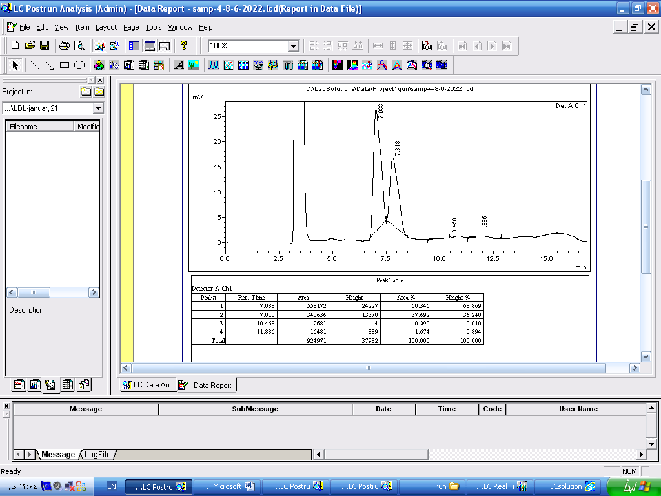

Figure (1) The chromatogram curve of citrus bee bread sugars

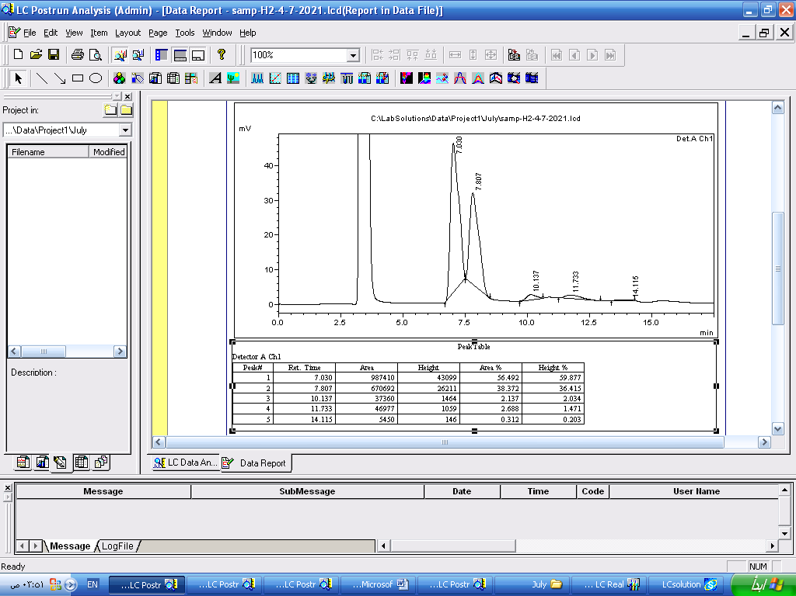

Figure (2) The chromatogram curve of Anise bee bread sugars

- Conclusions and Recommendations:

- Conclusions:
- Chemical composition of bee bread samples from different botanical origins vary.
- The unique results of this study can thus be used as a reference for research into the bee and also human health. The findings can also provide a scientific basis for the nutritional value assessment of the bee bread, thereby making contribution to the food composition database.
- Beebread is regarded as a valuable special food Its value is given by the high content in proteins, carbohydrates, mineral salts and lipids, which depends on the botanical and geographical origin.

- Recommendations:
- Beebread composition and bioactive proprieties have not been studies thoroughly until now in Syria Therefore, more research must be done on bee bread to show chemical composition and proprieties of beebread.
- It is expected that this work would be an important tool for cataloguing and recognizing Syrian bee bread as being a valuable source of natural nutrients and considering it as a favorable product for human nutrition and health.

- References:

- Almeida-Muradian LB, Panplona LC, Coimbra S, Barth O M, (2005). Chemical composition and botanical evaluation of dried bee pollen pellets. J. Food Comp. Anal., 18(1):105- 111.
- AOAC Official Method 960.52. Microchemical determination of nitrogen (micro-Kjeldahl method). Rockville, MD, USA:AOAC International; 2000.
- AOAC Official Method 920.153. Ash of meat. Rockville, MD,USA: AOAC International; 2000
- AOAC Official Method 991.36. Fat (crude) in meat and meat products. Rockville, MD, USA: AOAC International; 2000.
- Atkin S, Barrier S, Cui Z, Fletcher P, Mackenzie G, Panel V, Sol V, Zhang X, (2011). UV and visible light screening by individual sporopolleninexines derived from Lycopodium clavatum (club moss) and Ambrosia trifida (giant ragweed). J. Photochem. Photobiol. B Biol 102: 209–217.
- Badiaa lyoussi,(2019). Bee bread as a functional product: Chemical composition and bioactive
- Barros, L., Pereira, E., Calhelha, R. C., Dueñas, M., Carvalho, A. M., Santos-Buelga, C.,et al. (2013). Bioactivity and chemical characterization in hydrophilic and lipophilic compounds of Chenopodium ambrosioides L. Journal of Functional Foods, 5, 1732–1740.
- BeeBread, GOST R 53408-2009,2009/1/1.
- Berene I, Daberte I, Siksan S, (2015). Investigation of beebread and development of its dosage forms. Medicinos, 21(1): 16-22
- Brodschneider R, Crailsheim K, (2010) Nutrition and health in honey bees. Apidologie41: 278–294.
- Del Risco C, Pérez A, Álvarez V, Rodríguez G, Leiva V, Puig Y, García R, (2012). Lactic acid bacteria to silage bee pollen, Rev. CENIC CienciasBiológicas 43: 17–21.
- Lactic acid bacteria to silage bee pollen, Rev. CENIC CienciasBiológicas 43: 17–21.
- Fuenmayor C, (2009). Bioprocess application in bee pollen development of a protein nutritional supplement. Universidad Nacional de Colombia, Bogotá, Colombia.
- Fuenmayor C, Zuluaga C, Diaz C, Quicazán M, Cosio M, Mannino S, (2014). Evaluation of the physicochemical and functional properties of Colombian bee pollen. Rev. MVZ Córdoba 19: 4003–4014.
- Gulcin I, Buyukokuroglu ME, Oktay M, Kufrevioglu O, (2003). Antioxidant and analgesic activities of turpentine of Pinus nigraArn.subsp. pallsiana(Lamb.) Holmboe. J. Ethnophar. 86: 51-58.
- Herbert Jr EW, Shimanuki H. Chemical composition and nutritive value of bee-collected and bee-stored pollen. Apidologie. 1978;9:33–40.
- Isidorov VA, Isidorova AG, Szczepaniak L, Czyżewska U, (2009). Gas chromatographic–mass spectrometric investigation of the chemical composition of beebread. Food Chemistry 115(3): 1056-1063.
- ISO 659:2009. Oilseeds – determination of oil content (referencemethod). Geneva Switzerland: International Organization for Standardization (ISO); 2009.
- Kaplan, M., Karaoglu, Ö., Eroglu, N., & Silici, S. (2016). Fatty acid and proximate composition of bee bread. Food Technology and Biotechnology, 54, 497–504. cytotoxic properties of bee venom collected in Northeast Portugal. Food and Chemical
- Markiewicz-Żukowska R, Naliwajko SK, Bartosiuk E, Moskwa J, Isidorov V, Soroczyńska J, Borawska MH, (2013). Chemical composition and antioxidant activity of beebread, and its influence on the glioblastoma cell line (U87MG). Journal of Apicultural Science57(2): 147-157.
- Meryem Bakour, Ângela Fernandes, Lillian Barrosb , Marina Sokovic, Isabel C.F.R. Ferreira ,and
- Nagai T, Nagashima T, Myoda T, Inoue R, (2004). Preparation and functional properties of extracts from beebread. Molecular Nutrition & Food Research48(3): 226-229.
- Stanciu OG, Mărghitaş L, Dezmirean D, (2009). Macro-and Oligo-Mineral Elements from Honeybee-Collected Pollen and Beebread Harvested from Transylvania (Romania). Bulletin of University of Agricultural Sciences and Veterinary Medicine Cluj-Napoca. Animal Science and Biotechnologies 66.
- Urcan, A., Mărghitaș, L. A., Dezmirean, D. S., Bobiș, O., Bonta, V., Mureșan, C. I.
- Zuluaga CM, Serrato JC, Quicazan M, (2015). Chemical, nutritional and bioactive characterization of Colombian beebread. Chemical Engineering Transactions 43: 175- 180.

