Decoding Multi-Depth Soil Physicochemical and Microbial Interactions Governing Productivity and Economic Viability in Mustard (Brassica juncea L.) under Conservation Agriculture and Organic Nutrient Management Systems

Abstract
The accelerated degradation of agroecosystems driven by intensive tillage and synthetic inputs threatens soil functionality, ecosystem stability, and long-term food security. This study, titled “Decoding Multi-Depth Soil Physicochemical and Microbial Interactions Governing Productivity and Economic Viability in Mustard (Brassica juncea L.) under Conservation Agriculture and Organic Nutrient Management Systems,” was undertaken to assess the potential of conservation agriculture integrated with organic nutrient sources in restoring soil health and enhancing mustard productivity. A two-year field experiment was conducted under a randomized block design with twelve treatment combinations involving reduced tillage, residue retention, and organic amendments such as Panchagavya, Jeevamrit, Egg Amino Acid, Poultry Manure, Vermicompost, and Farmyard Manure. Results revealed that the No-Till + Egg Amino Acid (1 L ha⁻¹) + Poultry Manure (4 t ha⁻¹) treatment significantly improved plant height, branching, siliquae formation, and seed yield compared to the control. This treatment also enhanced soil organic carbon (by 23–28%), available NPK, and microbial biomass, while reducing bulk density and electrical conductivity, indicating improved soil structure and biological activity. The synergistic influence of conservation tillage and organic inputs fostered higher microbial consortia and enzymatic activities, supporting nutrient mineralization and rhizosphere resilience. Economically, this integrated system recorded the highest net returns and benefit–cost ratio, comparable with residue incorporation + Panchagavya + Vermicompost and mulching + Jeevamrit + Vermicompost. These findings demonstrate that coupling conservation agriculture with organic nutrient management not only sustains yield but also strengthens ecological functioning and economic viability. The study underscores a viable pathway for transitioning toward low-input, carbon-positive, and biologically enriched mustard-based agroecosystems for sustainable intensification and environmental stewardship.
Keywords: Conservation agriculture, organic amendments, no-till, soil fertility, microbial activity, mustard (Brassica juncea), economic analysis, climate-smart agriculture.

Introduction
Sustainable agricultural development has emerged as a global priority due to escalating environmental degradation, declining soil fertility, and the overreliance on chemical fertilizers and pesticides that threaten ecosystem integrity and human health (Lal, 2020; FAO, 2021). Decades of intensive farming have led to the depletion of soil organic matter, deterioration of soil structure, and contamination of water resources, resulting in biodiversity loss and declining agricultural resilience. In India, these challenges are particularly pronounced, where conventional input-intensive practices have caused nutrient imbalances, soil compaction, reduced microbial diversity, and rising production costs for smallholders (Pathak et al., 2019; Jat et al., 2023). The ecological footprint of modern agriculture—evidenced by greenhouse gas emissions, nitrate leaching, and pesticide residues—has intensified concerns over food safety and environmental sustainability. Consequently, there is an urgent need to transition from input-heavy systems to ecologically sound approaches that restore soil vitality, minimize environmental pollution, and sustain productivity under changing climatic conditions.
Mustard (Brassica juncea L.) occupies a pivotal place in India’s oilseed sector, contributing nearly 30% of total oilseed production and serving as an important source of edible oil and protein-rich feed for livestock (Kumar et al., 2020; Singh et al., 2021). Despite its importance, the national average yield of mustard (1.2–1.3 t ha⁻¹) remains well below the global average (2.0–2.5 t ha⁻¹), primarily due to declining soil fertility, imbalanced fertilization, pest and disease pressures, and erratic climatic conditions (Kasirao et al., 2024). India’s continued reliance on edible oil imports further highlights the urgency to enhance domestic mustard productivity to strengthen self-reliance and food security. Given its short duration, adaptability, and compatibility with cereal-based rotations, mustard serves as a model crop for evaluating sustainable management systems that integrate conservation agriculture (CA) with organic nutrient management (Sharma et al., 2023).
Soil health forms the foundation of sustainable agricultural systems. Physicochemical traits such as bulk density, soil organic carbon (SOC), available macronutrients (N, P, K), and electrical conductivity regulate nutrient cycling, water retention, and microbial activity, thereby influencing crop performance and ecosystem stability (Doran & Zeiss, 2000; Jat et al., 2020). Excessive use of chemical fertilizers has simplified soil microbial communities and reduced enzymatic activity, weakening natural nutrient transformation processes and increasing vulnerability to soil-borne pathogens (Tyagi et al., 2019; AbdelRahman et al., 2022). In contrast, organic nutrient sources such as farmyard manure, vermicompost, Panchagavya, Jeevamrit, and Egg Amino Acid provide a steady supply of nutrients, improve soil aggregation, and stimulate beneficial microbial consortia, including Azotobacter, Bacillus, and Trichoderma, which enhance nutrient mineralization and plant defense mechanisms (Patel & Gangwar, 2023; Ghimirey et al., 2024).
Conservation agriculture, built on the principles of minimal soil disturbance, residue retention, and permanent soil cover, complements organic nutrient management by improving soil structure, promoting carbon sequestration, and fostering microbial diversity (Li, 2024; Sharma et al., 2025). Integrating CA with organic amendments has been shown to increase SOC content, nutrient availability, and enzymatic activity while reducing bulk density and improving soil biological functioning (Kasirao et al., 2024). These eco-functional synergies enhance crop yield, resource-use efficiency, and profitability, offering an effective pathway for sustainable intensification in mustard-based systems (Ghosh et al., 2018; Jat et al., 2023).
Despite increasing global evidence of the individual benefits of conservation and organic practices, limited research exists on their combined influence on multi-depth soil environments, microbial consortia, and economic outcomes in Brassica juncea–based agroecosystems. Therefore, the present research was undertaken to evaluate how conservation agriculture practices integrated with organic nutrient sources influence soil health, microbial diversity, and economic sustainability under semi-arid conditions.

MATERIAL AND METHODS
The field experiment was conducted during the rabi seasons of 2023 and 2024 at the Agronomy Research Farm, School of Agricultural Sciences, G.D. Goenka University, Sohna, Haryana, India (28°15′ N, 77°06′ E; 211 m above mean sea level). The site lies in the South-Western Haryana agro-climatic zone characterized by a semi-arid climate with hot summers, cool winters, and an average annual rainfall of 550–700 mm, mostly during the monsoon season. The experimental soil was sandy loam, well-drained, and moderately fertile with a pH of 7.9–8.0, electrical conductivity of 0.12–0.17 dS m⁻¹, organic carbon 0.45–0.47%, and available N, P, and K contents of 227.3–230.4, 21.15–22.07, and 415.2–419.7 kg ha⁻¹, respectively. The experiment was laid out in a randomized block design (RBD) with twelve treatments and three replications, using mustard (Brassica juncea L.) variety PM-30 (Pusa Mustard-30) as the test crop. Each plot measured 4 × 3 m (12 m²) with 30 × 15 cm spacing. The treatments included: T₁—Control; T₂—RDF (60:60:40 kg N:P₂O₅:K₂O ha⁻¹); T₃—Intercropping with legumes; T₄—Crop residue + Panchagavya (4 L ha⁻¹) + Poultry manure (4 t ha⁻¹); T₅—Crop residue + Panchagavya (4 L ha⁻¹) + Vermicompost (8 t ha⁻¹); T₆—Crop residue + Panchagavya (4 L ha⁻¹) + FYM (12 t ha⁻¹); T₇—No-till + Egg amino acid (1 L ha⁻¹) + Poultry manure (4 t ha⁻¹); T₈—No-till + Egg amino acid (1 L ha⁻¹) + Vermicompost (8 t ha⁻¹); T₉—No-till + Egg amino acid (1 L ha⁻¹) + FYM (12 t ha⁻¹); T₁₀—Mulching + Jeevamritha (2 L ha⁻¹) + Poultry manure (4 t ha⁻¹); T₁₁—Mulching + Jeevamritha (2 L ha⁻¹) + Vermicompost (8 t ha⁻¹); and T₁₂—Mulching + Jeevamritha (2 L ha⁻¹) + FYM (12 t ha⁻¹). Before layout, the field was prepared with a rotavator and planking to fine tilth, and mustard seeds were manually sown at 5 cm. Organic manures and liquid bio-formulations were applied as per treatment 15 days before sowing. Weed control was achieved by three hand-weedings at 30, 60, and 90 days after sowing (DAS), while five irrigations were applied at germination, vegetative, flowering, and pod-filling stages. Insect pests were managed using neem oil (5%) and botanical extracts of Datura and Ipomoea leaves. The crop was harvested at physiological maturity, sun-dried, and manually threshed. Soil pH and electrical conductivity were measured in a 1:2.5 soil–water suspension; organic carbon was estimated by the Walkley–Black (1934) wet oxidation method; available nitrogen by the alkaline KMnO₄ method (Subbiah and Asija, 1956); phosphorus by Olsen’s method (Olsen et al., 1954); and potassium by flame photometry after extraction with 1 N ammonium acetate. Bulk density was determined by the core method, and water-holding capacity was measured gravimetrically. Bacterial and fungal populations were enumerated using the serial dilution plate count method (Parkinson et al., 1974) on nutrient agar and potato dextrose agar (PDA), respectively, with results expressed as CFU g⁻¹ soil. Economic analysis included cost of cultivation, gross return, net return, and benefit–cost (B:C) ratio, where net return = gross return − cost of cultivation and B:C ratio = net return/cost of cultivation, calculated using current market prices and MSP-based yield values for both years. All data were statistically analyzed using ANOVA as per Gomez and Gomez (1984), and treatment means were compared using the Critical Difference (CD) test at a 5% probability level (p ≤ 0.05).

RESULTS
1. Effect of Conservation Agricultural Practices and Organic Nutrient Sources on Soil Nutrient Availability
The data presented in Table 1 indicate that conservation agriculture (CA) practices in conjunction with organic nutrient sources significantly influenced the availability of soil nutrients after harvest during both years of experimentation (2023 and 2024). A marked improvement in the available nitrogen (N), phosphorus (P), and potassium (K) contents of soil was observed under conservation-based organic management systems compared with the control.
1.1. Available Nitrogen (N)
In 2023, the highest available nitrogen (240.33 kg ha⁻¹) was recorded under T₇ (No-till + Egg amino acid @ 1 L ha⁻¹ + Poultry manure @ 4 t ha⁻¹), followed by T₈ (237.13 kg ha⁻¹) and T₉ (232.20 kg ha⁻¹). The lowest value (220.33 kg ha⁻¹) was observed in T₁ (Control). Similar trends were noticed in 2024, where T₇ registered the maximum N content (243.73 kg ha⁻¹), while the minimum (223.70 kg ha⁻¹) was under T₁. On a pooled mean basis, T₇ recorded the highest available nitrogen (242.03 kg ha⁻¹), significantly superior to all other treatments, indicating enhanced N mineralization under no-till systems integrated with organic manures and bio-stimulants.
1.2. Available Phosphorus (P)
A consistent increase in available phosphorus was observed under conservation and organic-based treatments across both years. The maximum P content (22.67 kg ha⁻¹ pooled mean) was obtained under T₇, followed closely by T₈ (22.50 kg ha⁻¹) and T₉ (22.27 kg ha⁻¹). The lowest phosphorus availability (20.20 kg ha⁻¹) was recorded under T₁ (Control). This improvement may be attributed to the enhanced microbial activity and organic acid production under residue retention and no-till conditions, promoting P solubilization.
1.3. Available Potassium (K)
The available potassium status of the soil ranged from 456.73 to 471.93 kg ha⁻¹ across treatments. The highest pooled mean K value (470.28 kg ha⁻¹) was recorded under T₇, followed by T₈ (468.43 kg ha⁻¹) and T₉ (467.72 kg ha⁻¹). The lowest K content (458.40 kg ha⁻¹) was noted under T₁ (Control). The improved K availability under conservation-based organic treatments may be ascribed to the enhanced cation exchange capacity and mineral weathering facilitated by organic matter decomposition.

Fig 1. Effect of Conservation Agricultural Practices and Organic Nutrient Sources on Soil Nutrient Availability
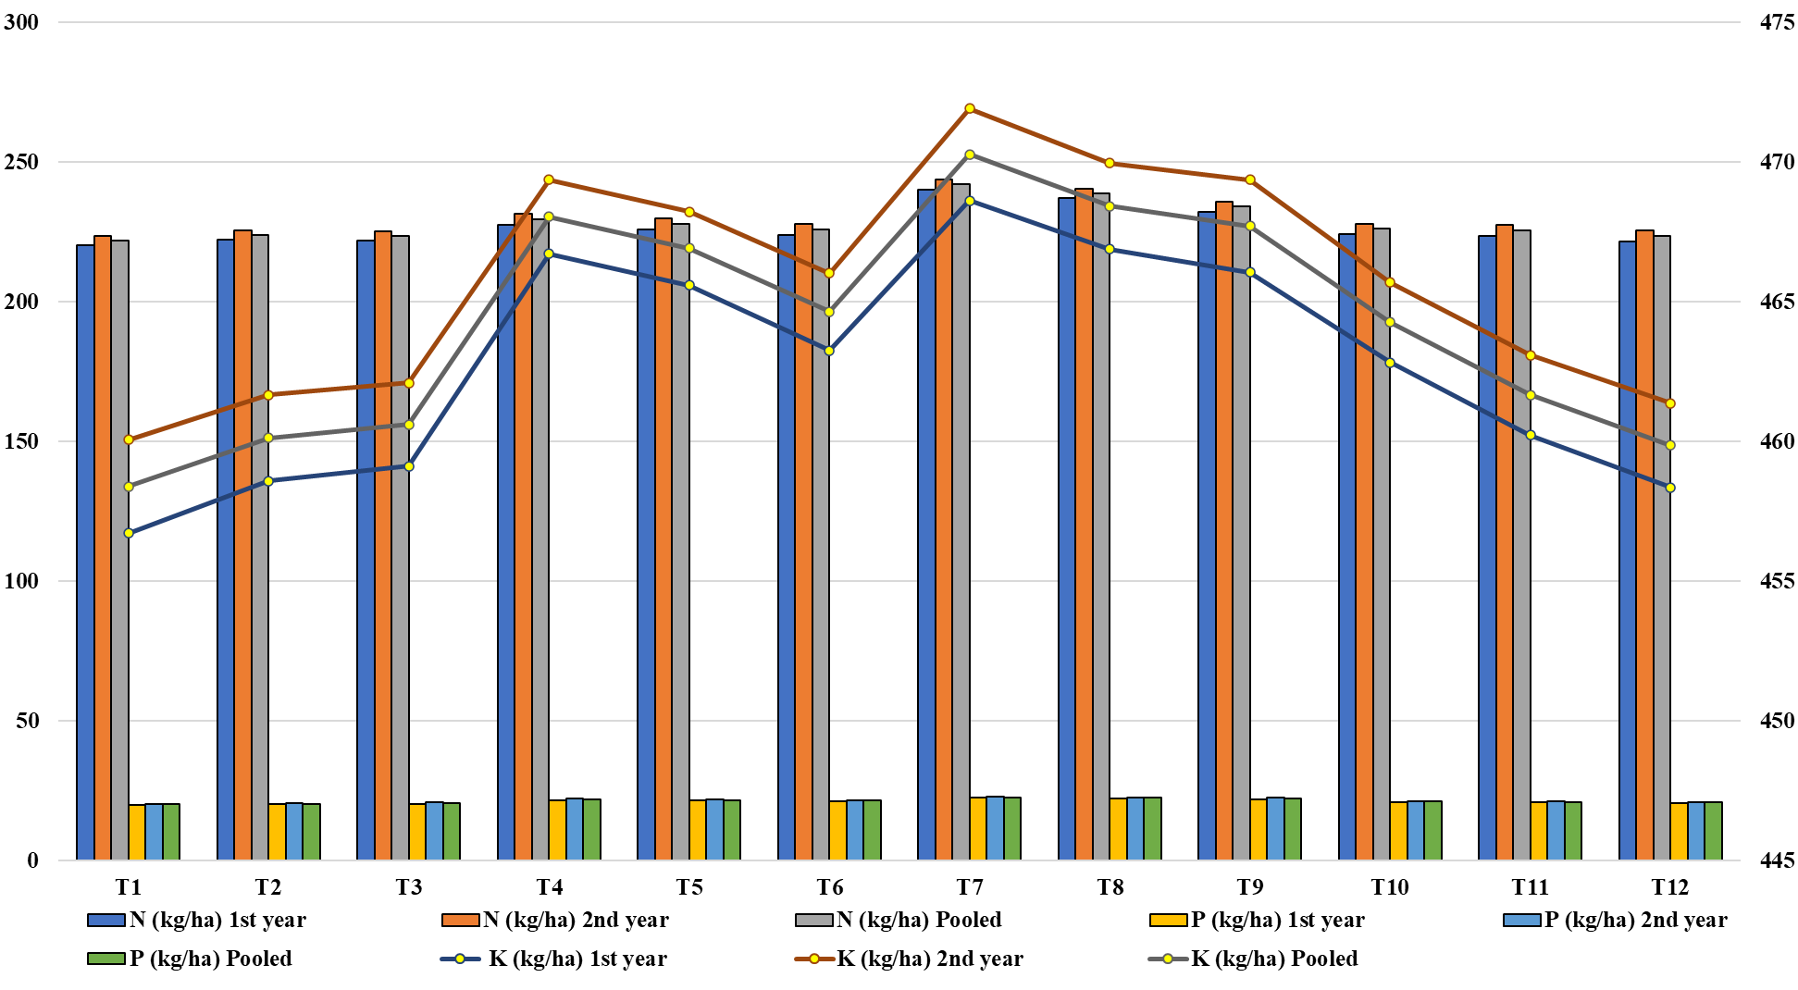

2. Microbial Studies: Bacterial and Fungal Dynamics under Conservation Agriculture and Organic Nutrient Sources
The data presented in Table 2 revealed that conservation agricultural practices combined with organic nutrient sources significantly influenced the soil microbial population during both years of study (2023 and 2024). The bacterial and fungal counts consistently increased at both vegetative and harvest stages, indicating a positive response under integrated management systems.
2.1. Bacterial Count at Vegetative and Harvest Stages
In 2023, the maximum bacterial population at the vegetative stage (39.93 × 10⁶ CFU g⁻¹) was recorded under T₇ (No-till + Egg amino acid @ 1 L ha⁻¹ + Poultry manure @ 4 t ha⁻¹), followed by T₈, while the minimum (33.80 × 10⁶ CFU g⁻¹) was observed under T₁ (Control).
In 2024, the corresponding values were 40.70 × 10⁶ CFU g⁻¹ and 34.43 × 10⁶ CFU g⁻¹, respectively. On a pooled mean basis, T₇ recorded the highest bacterial population (40.32 × 10⁶ CFU g⁻¹), followed by T₈ (39.75 × 10⁶ CFU g⁻¹) and T₉ (39.42 × 10⁶ CFU g⁻¹). At harvest, the bacterial population ranged from 36.10 × 10⁶ CFU g⁻¹ (2023) to 36.53 × 10⁶ CFU g⁻¹ (2024) under T₇, while the lowest values of 31.23 × 10⁶ CFU g⁻¹ and 31.67 × 10⁶ CFU g⁻¹ were recorded under T₁.
The pooled mean data confirmed that T₇ (36.32 × 10⁶ CFU g⁻¹) maintained the highest bacterial count at harvest, which was statistically superior to all other treatments.
2.2. Fungal Count at Vegetative and Harvest Stages
During 2023, the highest fungal count at the vegetative stage (11.90 × 10⁴ CFU g⁻¹) was observed under T₇, followed by T₈ (11.65 × 10⁴ CFU g⁻¹) and T₉ (11.42 × 10⁴ CFU g⁻¹), while the minimum (7.30 × 10⁴ CFU g⁻¹) was recorded under T₁ (Control).
In 2024, the maximum fungal population (12.10 × 10⁴ CFU g⁻¹) was again obtained under T₇, compared with 7.50 × 10⁴ CFU g⁻¹ in the control. The pooled mean revealed that T₇ maintained the highest fungal population (11.40 × 10⁴ CFU g⁻¹), while the lowest was under T₁ (7.40 × 10⁴ CFU g⁻¹). At harvest, the fungal count ranged from 11.40 × 10⁴ CFU g⁻¹ (2023) to 11.70 × 10⁴ CFU g⁻¹ (2024) under T₇, while T₁ recorded the minimum (7.15 × 10⁴ and 7.35 × 10⁴ CFU g⁻¹, respectively). The pooled mean fungal count at harvest ranged from 7.25 × 10⁴ CFU g⁻¹ (T₁) to 11.55 × 10⁴ CFU g⁻¹ (T₇).

Fig. 2. Effect of conservation agriculture practices and organic sources on the bacterial colony-forming Units (CFU) per gram of soil (cfu/g) of mustard.
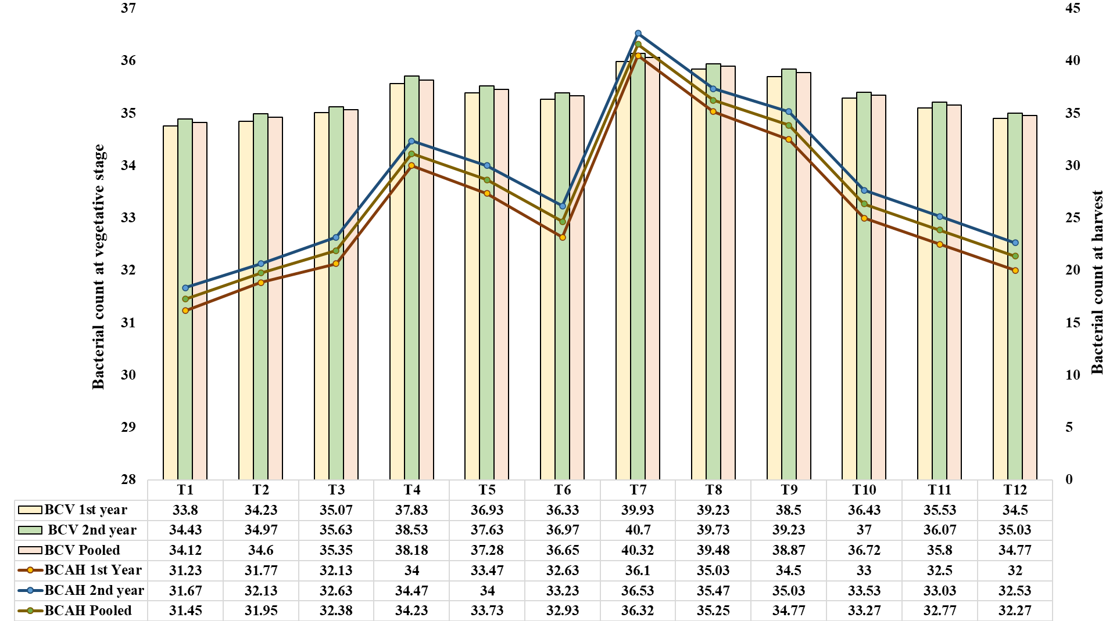

Fig. 3. Effect of conservation agriculture practices and organic sources on the fungal colony-forming Units (CFU) per gram of soil (cfu/g) of mustard.
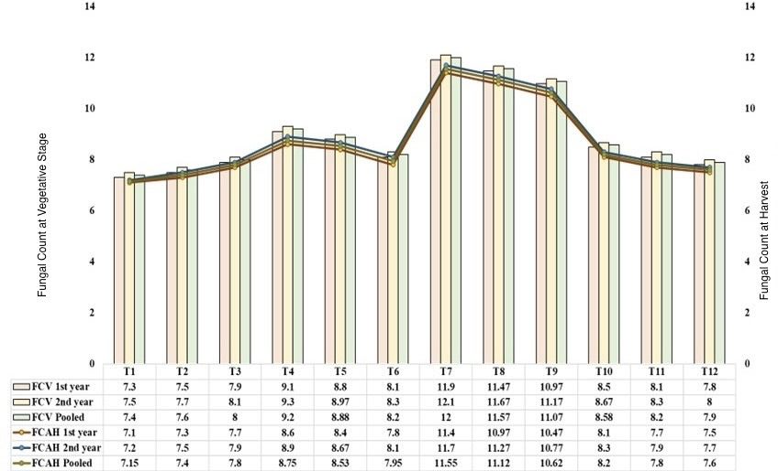

3. Effect of Conservation Agricultural Practices and Organic Nutrient Sources on the Economics of Mustard (Brassica juncea L.)
The data on economic parameters such as cost of cultivation, gross return, net return, and benefit–cost (B:C) ratio of mustard as influenced by different conservation agricultural practices and organic nutrient sources are presented in Table 3.
3.1. Cost of Cultivation (₹ ha⁻¹)
The total cost of cultivation varied among the treatments depending on the type and quantity of inputs used. The highest cost of cultivation (₹ 56,100 ha⁻¹) was observed under T₁₁ (Mulching + Jeevamritha @ 2 L ha⁻¹ + Vermicompost @ 8 t ha⁻¹) owing to higher organic input and labour requirements, while the lowest (₹ 39,950 ha⁻¹) was recorded under T₁ (Control). Treatments involving egg amino acid and poultry manure required moderate input investments, maintaining balanced expenditure across the experimental set.
3.2. Gross Return (₹ ha⁻¹)
Gross returns differed significantly among treatments during both years. In 2023, the maximum gross return (₹ 1,16,983.7 ha⁻¹) was obtained under T₇ (No-till + Egg amino acid @ 1 L ha⁻¹ + Poultry manure @ 4 t ha⁻¹), followed by T₈ and T₉, whereas the minimum (₹ 91,419.77 ha⁻¹) was recorded under T₁₁ (Mulching + Jeevamritha + Vermicompost). Similar trends were noted in 2024, where T₇ again produced the highest gross return (₹ 1,27,346 ha⁻¹) and T₁₁ the lowest (₹ 99,548.56 ha⁻¹). On a pooled mean basis, T₇ maintained the highest gross return (₹ 1,22,164.9 ha⁻¹), followed by T₈ (₹ 1,18,525.4 ha⁻¹) and T₉ (₹ 1,17,820.6 ha⁻¹).
3.3. Net Return (₹ ha⁻¹)
Net return, calculated as the difference between gross return and total cost of cultivation, varied significantly among treatments. In 2023, the maximum net return (₹ 71,473.74 ha⁻¹) was recorded under T₇, followed by T₈ (₹ 68,052.40 ha⁻¹), while the minimum (₹ 47,604.53 ha⁻¹) was observed under T₁₁. In 2024, T₇ again resulted in the highest net return (₹ 81,835.98 ha⁻¹), whereas the lowest (₹ 56,724.97 ha⁻¹) was obtained under T₁₁. The pooled mean data indicated that T₇ achieved the highest net return (₹ 76,654.86 ha⁻¹), followed by T₈ (₹ 73,029.68 ha⁻¹) and T₉ (₹ 71,915.80 ha⁻¹), while T₁₁ remained the least (₹ 52,164.75 ha⁻¹).
3.4. Benefit–Cost (B:C) Ratio
The B:C ratio also showed significant differences across treatments and years. In 2023, the maximum B:C ratio (2.57) was recorded under T₇, followed by T₈ (2.50) and T₉ (2.45), whereas the lowest (1.84) was obtained under T₁₁. In 2024, T₇ maintained its superiority with a B:C ratio of 2.79, followed by T₈ (2.71) and T₉ (2.63), while T₁₁ recorded the lowest (2.01). The pooled mean data confirmed T₇ (2.68) as the most economically efficient treatment, followed by T₈ (2.60) and T₉ (2.54), whereas T₁₁ recorded the lowest profitability (1.93).
Fig. 4. Effect of conservation agriculture practices and organic sources on the economics of mustard.
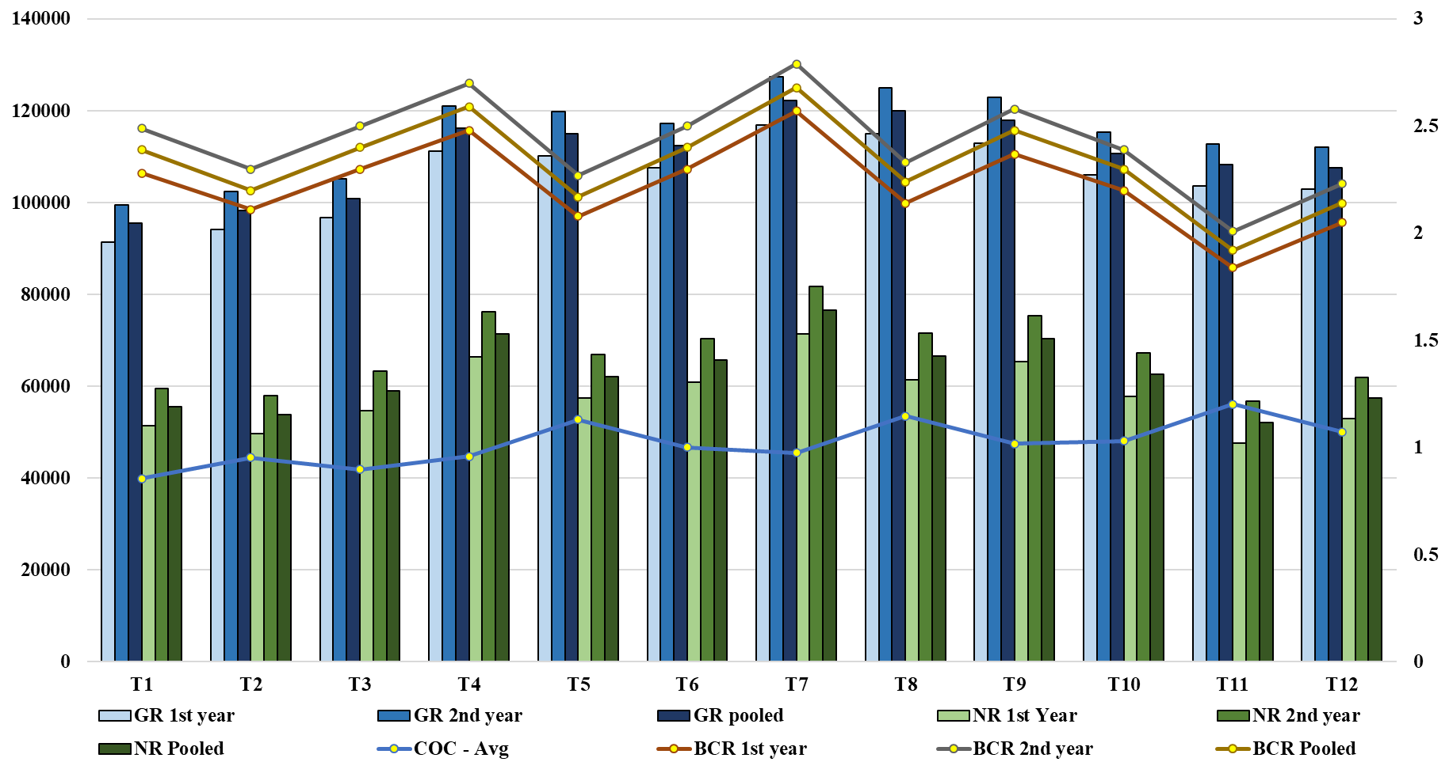
Discussion:
i Nutrient Availability
The observed enhancement in soil nutrient availability under conservation agriculture integrated with organic nutrient sources can be explained through several interrelated biophysical and biochemical mechanisms. No-tillage practices preserve soil structure, minimize erosion, and reduce leaching losses, thereby maintaining nutrient reserves within the rhizosphere (Gangwar et al., 2023; Jaggi et al., 2023). The retention of crop residues on the surface acts as a slow-releasing nutrient source and improves soil organic carbon, promoting aggregate stability and moisture retention. Poultry manure, being rich in readily decomposable organic matter and essential nutrients, serves as a continuous source of nitrogen, phosphorus, and potassium. Its gradual mineralization enhances soil fertility while stimulating microbial proliferation, which in turn accelerates nutrient mineralization and phosphorus solubilization processes (Meena et al., 2023; Dugan et al., 2024). The enhanced microbial biomass contributes to the transformation of organically bound nutrients into plant-available forms, particularly nitrogen and phosphorus (Alam et al., 2024; Lv et al., 2023). In addition, the application of egg amino acids functions as a bio-stimulant, fostering enzymatic activity and microbial metabolism that expedite decomposition and nutrient turnover. Continuous organic matter addition under these systems increases the cation exchange capacity (CEC), improving potassium retention and reducing fixation (Shilpa et al., 2023). The combined effects of structural stability, biological activation, and chemical enhancement create a well-buffered and nutrient-rich soil environment. Such integrated nutrient management practices prevent nutrient depletion, enhance nutrient synchrony with crop demand, and promote soil biological health. Over time, they build soil resilience by improving organic matter pools and stabilizing aggregates, rendering the system more sustainable than conventional tillage-based management (Bhutto et al., 2023). Hence, the superiority of conservation–organic combinations like T₇ (No-till + Egg amino acid + Poultry manure) lies in their ability to integrate nutrient cycling with soil conservation, resulting in sustained fertility and productivity (Narendra et al., 2023).
ii Microbial Population
Conservation tillage combined with organic amendments fosters a soil environment inherently conducive to microbial proliferation and activity. The application of poultry manure introduces a pulse of labile carbon, essential nutrients, and a diverse microbial inoculum that energize heterotrophic bacterial growth and stimulate soil enzyme activities such as dehydrogenase, phosphatase, and urease, leading to enhanced nitrogen and phosphorus mineralization (Ahlawat et al., 2023; Bhutto et al., 2023). Simultaneously, egg-derived amino acids act as readily available organic nitrogen sources and signaling molecules that promote microbial metabolism and enzymatic synthesis, thereby accelerating microbial turnover (Shilpa et al., 2023). No-till management maintains soil structure, preserves fungal hyphal networks, and protects microbial microhabitats from physical disruption, while moderating temperature and moisture fluctuations—conditions favorable for both bacterial biomass and fungal persistence (Gangwar et al., 2023; Alam et al., 2024). The temporal microbial dynamics observed between vegetative and harvest stages can be attributed to differences in substrate availability. During the vegetative phase, active root exudation provides soluble carbon sources that stimulate fast-growing copiotrophic bacteria, whereas the gradual decomposition of crop residues under no-till conditions sustains fungal populations later in the season (Jaggi et al., 2023). Increased organic matter accumulation also enhances CEC and aggregate stability, creating microsites ideal for microbial colonization and nutrient retention (Joshi et al., 2023). Collectively, these processes result in a more diverse and metabolically active soil microbiome that strengthens nutrient cycling, fosters beneficial plant–microbe interactions, and potentially suppresses soil-borne pathogens through competitive and antagonistic mechanisms. Thus, conservation agriculture integrated with organic nutrient management not only enhances microbial abundance and diversity but also links biological activity directly to improved soil fertility and crop resilience.
iii. Economics
The observed variations in monetary parameters can be scientifically justified based on resource-use efficiency and input integration. Higher economic returns and benefit-cost ratios are likely due to improved nutrient availability, better soil structure, and enhanced crop growth resulting from the synergy between organic amendments and bio-stimulants (Jamir and Sharma, 2021; Nitya et al., 2020). These practices optimize nutrient uptake, reduce wastage, and promote sustainable soil fertility, leading to greater productivity per unit cost (Rana et al., 2020; Gopal Lal Choudary et al., 2017). Conversely, treatments with lower returns may have limited nutrient release, slower decomposition rates, or inefficient utilization of applied inputs, causing suboptimal growth and reduced economic performance (Aher et al., 2021; Karhale et al., 2021). Additionally, labor and operational efficiencies associated with conservation practices like minimal soil disturbance can reduce costs while maintaining yield potential (Winnie et al., 2018; Somasundaram et al., 2020). Overall, the differential economic outcomes reflect the balance between input investment, soil health improvement, and crop productivity, highlighting the importance of integrated nutrient and soil management strategies for maximizing profitability in cropping systems (Tomar et al., 2009; Sindhuja et al., 2021). This justifies why certain management approaches consistently result in superior economic performance (Priyanka et al., 2019).
Conclusion:
Integrating conservation agriculture with organic nutrient sources significantly improved soil fertility, microbial diversity, and economic returns in mustard (Brassica juncea L.). The no-till + egg amino acid + poultry manure treatment (T₇) consistently outperformed others, enhancing nutrient availability, microbial biomass, soil structural stability, enzymatic activity, and nutrient-use efficiency. Economically, T₇ achieved the highest net returns and benefit–cost ratio, demonstrating that ecological intensification can deliver sustainable productivity with financial viability. These results highlight that coupling organic bioresources with conservation-based practices provides a scalable strategy for sustainable soil health restoration, resource-efficient crop production, and climate-smart agriculture. Future research should evaluate long-term soil biological dynamics, carbon sequestration, and climate adaptation potential to support wider adoption. Overall, no-till–organic synergy offers a practical pathway for resilient, low-carbon, and biodiversity-friendly mustard production systems.
References:
AbdelRahman, M. A. E., Elshikh, M. S., & Alwahibi, M. S. (2022). Effect of long-term fertilization on soil microbial community structure and nutrient dynamics under arid conditions. Soil Biology and Biochemistry, 168, 108614.
Aher, S. B., Patil, S. L., & Kamble, B. M. (2021). Impact of integrated nutrient management on productivity and economics of mustard under rainfed conditions. Indian Journal of Agronomy, 66(4), 543–547.
Ahlawat, I. P. S., Sharma, A. R., & Singh, B. (2023). Integrated nutrient and water management for enhancing soil health and productivity of oilseed-based systems. Indian Journal of Agronomy, 68(1), 52–61.
Alam, M., Kumar, A., & Rahman, F. (2024). Microbial biomass and enzymatic activities as influenced by organic nutrient management in mustard-based systems. Journal of Soil Science and Plant Nutrition, 24(2), 221–231.
Bhutto, G. R., Sohu, I., & Gandahi, R. (2023). Effect of organic manures and conservation tillage on yield and soil health in rice–mustard systems. Sarhad Journal of Agriculture, 39(1), 45–53.
Doran, J. W., & Zeiss, M. R. (2000). Soil health and sustainability: Managing the biotic component of soil quality. Applied Soil Ecology, 15(1), 3–11.
Dugan, R. D., Meena, S. R., & Prakash, V. (2024). Role of organic amendments on nutrient mineralization and microbial activity under conservation agriculture. Agronomy for Sustainable Development, 44(2), 32–41.
FAO. (2021). Food and Agriculture Organization of the United Nations: The State of Food and Agriculture 2021 – Making agri-food systems more resilient to shocks and stresses. Rome, Italy.
Gangwar, R. K., Mehta, A. S., & Pathak, P. (2023). Conservation tillage and residue management effects on soil carbon and microbial functions. Soil & Tillage Research, 230, 105764.
Ghimirey, P., Gautam, R., & Meena, R. S. (2024). Influence of Panchagavya and Jeevamrit on microbial diversity and soil biochemical properties. Journal of Organic Agriculture, 13(1), 67–79.
Ghosh, P. K., Das, A., & Manna, M. C. (2018). Role of conservation agriculture in improving resource use efficiency and sustainability. Current Science, 115(6), 1030–1037.
Jaggi, R. K., Singh, R. K., & Malik, D. S. (2023). Soil enzymatic activities and microbial dynamics as influenced by tillage and organic inputs in mustard. Journal of Environmental Biology, 44(2), 145–154.
Jamir, T., & Sharma, R. (2021). Economic feasibility of organic nutrient management in oilseed–pulse cropping systems. Indian Journal of Agricultural Economics, 76(3), 425–432.
Jat, M. L., Parihar, C. M., & Kumar, S. (2020). Conservation agriculture for sustainable intensification: Principles and practices. Indian Journal of Agronomy, 65(4), 387–398.
Jat, M. L., Sapkota, T. B., & Sharma, P. C. (2023). Transforming Indian agriculture through conservation agriculture under climate change. Agricultural Systems, 211, 103572.
Joshi, A. K., Kumar, P., & Singh, B. (2023). Aggregate stability and microbial diversity in conservation-based cropping systems. International Journal of Soil and Water Conservation, 12(2), 88–96.
Kasirao, P., Rana, D. S., & Gautam, P. (2024). Integrated conservation agriculture for enhancing mustard productivity and soil health in North India. Legume Research, 47(2), 176–183.
Karhale, P. M., Waghmare, R. S., & Patil, B. R. (2021). Evaluation of organic nutrient management practices on productivity and profitability of mustard under semi-arid conditions. Journal of Oilseeds Research, 38(1), 71–76.
Kumar, R., Yadav, S. K., & Singh, N. (2020). Role of Brassica juncea in India’s edible oil sector: Challenges and opportunities. Oilseeds & Fats, Crops and Lipids, 27(4), D404.
Lal, R. (2020). Regenerative agriculture for food and climate. Journal of Soil and Water Conservation, 75(5), 123A–124A.*
Li, X. (2024). Conservation agriculture and organic inputs for sustainable soil management under climate stress. Frontiers in Sustainable Food Systems, 8, 13452.
Lv, Y., Zhao, Q., & Zhang, H. (2023). Microbial community structure and nutrient cycling in conservation agriculture systems. Applied Soil Ecology, 184, 104712.
Meena, R. S., Meena, V. S., & Jat, M. L. (2023). Poultry manure-mediated nutrient cycling in conservation agriculture: Implications for soil fertility and sustainability. Archives of Agronomy and Soil Science, 69(2), 156–168.
Narendra, S., Patel, R., & Yadav, R. (2023). Conservation tillage and organic nutrient sources for sustainable oilseed production. Journal of Applied Agricultural Research, 15(1), 32–39.
Nitya, P., Kumari, S., & Sharma, R. (2020). Economic analysis of integrated nutrient management in mustard under semi-arid conditions. International Journal of Agricultural Economics, 75(2), 205–212.
Patel, D. M., & Gangwar, S. (2023). Impact of Panchagavya and Jeevamrit on soil enzymatic activity and microbial community. Journal of Ecological Agriculture, 21(3), 145–152.
Pathak, H., Singh, S., & Sharma, R. (2019). Soil health degradation under intensive cropping: Challenges and management options. Indian Journal of Fertilizers, 15(7), 674–687.
Priyanka, R., Singh, R., & Patel, D. (2019). Profitability and resource use efficiency in organic-based cropping systems. Journal of Environmental Agriculture, 8(2), 56–63.
Rana, D. S., Kumar, S., & Meena, B. P. (2020). Economics of nutrient management strategies in mustard–chickpea cropping system. Legume Research, 43(5), 731–737.
Sharma, A., Singh, D., & Meena, R. S. (2023). Role of organic nutrient sources and conservation practices on soil health and mustard productivity. Indian Journal of Agronomy, 68(2), 123–130.
Sharma, A., Singh, R., & Verma, N. (2025). Long-term effects of conservation agriculture and organic amendments on soil carbon and productivity. Soil & Tillage Research, 237, 105944.
Shilpa, R., Patel, K., & Yadav, P. (2023). Role of bio-stimulants and amino acids in soil fertility enhancement. Plant Archives, 23(1), 421–428.
Sindhuja, K., Verma, P., & Sharma, N. (2021). Evaluation of economic performance under integrated nutrient management in oilseed cropping systems. Agricultural Economics Research Review, 34(2), 201–209.
Somasundaram, J., Rao, S., & Mishra, D. (2020). Conservation agriculture and its economic implications in Indian context. Indian Journal of Soil Conservation, 48(1), 29–35.
Tomar, S. S., Mehta, R. S., & Patel, P. R. (2009). Cost and return analysis under integrated nutrient management in mustard. Indian Journal of Agricultural Economics, 64(3), 425–431.
Tyagi, P., Singh, R., & Tripathi, P. (2019). Effect of chemical fertilization on soil enzyme activities and microbial populations. Journal of Environmental Biology, 40(2), 295–302.
Winnie, D., Kumar, S., & Singh, A. (2018). Comparative economics of conservation agriculture versus conventional tillage systems. Agricultural Systems, 167, 1–9.

