Lepidopteran pests associated with safflower: Survey and taxonomic redescription studies
ABSTRACT: Lepidopterans are the most important pest species of safflower and act as either defoliators or capsule borers. In the current paper, lepidopteran pests associated with safflower in North Karnataka are reviewed through roving survey. Totally, five species were collected and reared on the same host. Of these, one species is a new record to Karnataka while, the other is a new record to India. Among these pests, Condica capensis (Guenée) was found to be predominant, followed by Heliothis peltigera (Denis & Schiffermüller). Further, the morphological characteristics of adults of all the five species are redescribed along with images and key.
Keywords: Damage symptoms; Karnataka; keys; lepidopteran pests; Noctuidae; safflower; survey; taxonomic redescription.

- INTRODUCTION
Globally, Lepidoptera is one of the most widespread and widely recognized insect orders with 166,300 described species in the class Insecta (Rao and Sivaperuman, 2025). In India, safflower is an important oilseed crop which is prone to be attacked by several insect pests which are the main cause for its low productivity (Singh et al., 1999). The crop is known to be infested by 101 insect pest species, belonging to different orders (Bharaj et al., 2003; Patil and Halolli, 2005). Of these, lepidopterans particularly defoliators and capsule borers cause significant economic loss (Singh et al., 1996). Five lepidopteran pests viz., C. capensis, Helicoverpa armigera (Hübner), Heliothis peltigera, (Denis & Schiffermüller), Condica conducta (Walker) and Spodoptera exigua (Hübner) were reported as pests on safflower from India (Balikai, 2000; Singh and Prasad, 2005; Hanumantharaya et al., 2007; Hanumantharaya et al., 2009; Akashe et al., 2013). Of these lepidopteran pests, C. capensis and H. armigera are regarded as major economic pests, responsible for substantial reduction in the safflower productivity (Singh and Prasad, 2005). The species C. capensis known to cause 62.2 to 100 % yield loss due to excessive foliage feeding by a large number of larvae (Rajsekhar and Rai, 1989). The species H. armigera is widespread across India, whereas H. peltigera is distributed across Central and South India (Hampson, 1892).
Globally, limited studies have addressed lepidopteran pests of safflower (Saeidi and Adam, 2011; Saeidi et al., 2011; Esfahani et al., 2012; Javed et al., 2013; Saeidi et al., 2015). In India, C. capensis was first reported on safflower by Gaikwad and Pawar (1978), followed by H. armigera and H. peltigera from Andhra Pradesh and Maharashtra (Pawar et al., 1985), with H. peltigera being dominant. Singh and Prasad (2005) identified C. capensis and H. armigera as the most destructive pests, while Akashe et al. (2013) recorded H. armigera as the predominant capsule borer in Maharashtra. A few studies have (Pogue (2002); Muddasar et al. (2017); Hamza et al. (2020); Henaish and Elmetwaly (2020)) provided taxonomic descriptions and keys for S. exigua and S. litura collected through light trap or sweep net collection. Likewise, Li et al. (2013), Sarwar et al. (2017) and Santos et al. (2018) provided the taxonomic description for H. armigera and H. peltigera collected through light trap. Kirti and Dar (2013) and Passoa (2014) provided keys to larvae of Noctuid subfamilies and for two species of Heliothinae viz., H. armigera and H. peltigera.
In Karnataka, Mallapur et al. (1997) reported C. conducta on safflower through surveys from Northern dry tract of Karnataka. Similarly, Balikai (2000) recorded H. armigera and P. capensis on safflower from Karnataka through roving survey. Hanumantharaya et al. (2009) reported that H. armigera and P. capensis as a major pest of safflower from Northern parts of Karnataka through roving survey. Despite of these works, the host based taxonomic studies on lepidopteran pests associated with safflower is lacking from North Karnataka. With this background, in the present study we provide survey, documentation, distribution map, taxonomic redescription of five lepidopteran pests with images and identification keys. Further, we provide valid names and damage symptoms of each species along with larval images.
- MATERIALS AND METHODS
A roving survey was carried out to document the various lepidopteran pests associated with safflower in different localities of North Karnataka during the cropping period of 2019–25. The surveyed locations in Bellary were ARS Hagari (15.13°N; 77.06°E). While in Yadgir district, Bheemarayanagudi (16.73°N; 76.79°E) and Kadechur (16.73°N; 76.94°E) were surveyed. Likewise, in Bidar district, Aurad (16.98°N; 76.77°E), Bhalki (18.05°N; 77.22°E), Honnakeri (17.98°N; 77.39°E), Kasimpur (17.83°N; 77.44°E), KVK (18.08°N; 77.33°E) and Indiranagar (17.74°N; 77.40°E). In Kalaburagi district, Chincholi (17.47°N; 77.43°E), Raddewadgi (17.04°N; 76.79°E), Sedam (17.19°N; 77.29°E), Shahbad (17.08°N; 76.56°E) and Siradgi (17.32°N; 76.83°E) were surveyed whereas, in Raichur district, UAS campus (16.20°N; 77.36°E) was surveyed (Fig. 1).
The larvae were collected from safflower fields and reared to adult stage on the same host. The emerged adults were killed, pinned, stretched, labelled, dried properly and preserved in the Department Laboratory for further studies. Before genital dissection, adult specimens were photographed using Canon EOS 70D attached with 100mm macro lens. Adult characters such as forewing and hindwing, palpi and male and female genitalia were photographed using Trinocular microscope with auto-montage (Leica M 205C). Genitalia and wing venation were prepared following Thomas (2007) and Pasam et al. (2023). Permanent slides were prepared following the methods of Zimmerman (1978) and Thomas (2007) and subsequently deposited in the department with proper labeling. The specimens were identified using relevant literature (Hampson, 1896).The general terminology follows Kitching (2003), while the terminology for male and female genitalia is based on Klots (1970) and Kitching (2003). The classification of studied specimens was done following Keegan et al. (2019) and Chen et al. (2022).
- RESULTS AND DISCUSSION
Totally, five species of Lepidopteran pest’s viz., C. capensis, H. armigera, H. peltigera, S. exigua and S. litura were recorded on safflower (Table 1, Fig. 3). During the survey, totally 157 specimens were collected on safflower and reared on the same host. Of these, 67 specimens were C. capensis (32♂, 67♀), 20 were H. armigera (12♂, 8♀), 47 were H. peltigera (23♂, 24♀), 9 were S. exigua (2♂, 7♀) and 14 were S. litura (5♂, 9♀). Of these, C. capensis was found to be predominant with 42.68 per cent, followed by H. peltigera with 29.94 per cent. Other species i.e. H. armigera, S. litura and S. exigua represents meager percent, recorded 12.74, 8.92 and 5.73, respectively (Fig. 2). In the present study, H. peltigera and S. litura were recorded for the first time on safflower from Karnataka and India, respectively. The distribution of five lepidopteran pests of safflower in North Karnataka indicated that C. capensis was observed in Bheemarayanagudi. While, H. armigera was distributed in Aurad, Kasimpur, Indiranagar, Chincholi, Raddewadgi, Sedam and Bheemarayanagudi. Whereas, H. peltigera was noticed in 14 locations i.e. ARS Hagari, Aurad, Bhalki, Honnakeri, Indiranagar, Kasimpur, KVK, Raddewadgi, Sedam, Shahbad, Siradgi, UAS campus, Bheemarayanagudi and Kadechur. The species, S. exigua and S. litura were found in only one location i.e. Bheemarayanagudi (Table 1, Fig. 1).
The studied specimens showed morphological and genital variations which were used to classify them into subfamilies, genera and species and to prepare an illustrated key for an easy identification. They were assigned to three subfamilies namely: Condicinae, Heliothinae and Noctuinae. The subfamily Condicinae included a single species, C. capensis (Fig. 3A–B). While Heliothinae was represented by two species namely: H. armigera (Fig. 3C–D) and H. peltigera (Fig. 3E–F). Another subfamily Noctuinae was documented with two species viz., S. exigua (Fig. 3G–H) and S. litura (Fig. 3I–J).
Diagnostic characters of family Noctuidae Latreillae, 1809
Noctuidae identified by: proboscis with dentate tip (Fig. 4A); presence of ocelli (Fig. 4B); labial palpi more or less upturned, with the second segment densely scaled, third generally short (Fig. 4C); tibial spurs 0-2-4 i.e. fore tibia without any spurs (Fig. 4D), mid tibia with two spurs (Fig. 4E), hind tibia with four spurs (Fig. 4F); in hindwing, Sc+R₁ separated from Rs, also Sc and R just touches near the wing base (Fig. 4G).
Diagnostic characters of sub-family Condicinae Poole, 1995
Condicinae identified by: large reniform stigma on forewing (Fig. 5A); in male genitalia, uncus with a pair of small, well-defined lateral lobes at the base separated by a depression; valva strap-like (Fig. 5B).
Genus Condica Walker, 1856
Condica capensis (Guenée, 1852); type locality: South Africa (Western Cape), Wlk. Cat. x, p. 296.
Description
Moth medium sized; head, thorax and abdomen pale brown; labial palpi three segmented, well scaled, porrect, second segment thickly clothed with scales, third segment slender, tapering (Fig. 8A); antennae filiform; forewing pale brown with black pale dots, veins dark, inner and outer lines conversely lunulate-dentate, claviform stigma small, outlined in black; hind wing dull white, veins and termen suffused with brown, or wholly brown in female (Fig. 3A–B).
Male genitalia
Uncus elongated, curved, sclerotized, with a pair of small well-defined lateral lobes at the base separated by a depression, hooked at its apex; valvae strap-like, narrow, slightly expanded near the base; corona embedded with rows of setae (Fig. 10A); gnathos slightly sclerotized, rod shaped; tegumen broad, sclerotized with a paired hairy, lobate processes of lateral margin near the articulation of dorso-proximal angle of valvae (Fig. 10A); costal process present (Fig. 10B); saccus U-shaped; Vinculum V-shaped; juxta sclerotized, diamond shaped Fig. 10C); aedeagus long, cylindrical, bulbous near the base, bear a sclerotized patch of cornuti at the apex (Fig. 10D).
Female genitalia
Anterior and posterior apophyses more or less equal length; ostium bursae partially sclerotized; ductus bursae short, narrow, transparent, sclerotized towards distal end (Fig. 12A); corpus bursae elliptical shape, without signum (Fig. 12A).
Wing venation
In forewing, vein costa (C) strong, reaches apex of the wing margin; Sc simple, unbranched runs just beneath the costa; R₁ runs free to the margin; R₂, R₃, R₄, R₅ stalked, arises from the areole; M₁ arises from the upper angle of the discal cell; M₂ emerges from or near the lower angle of discal cell; M₃ arises near the lower angle of the discal cell; CuA₁ and CuA₂ present; in hindwing, Sc+Rs fused near the base; M₁ arises from the upper angle of the discal cell; M₂ vestigial, arises close to M₃ than to M₁; 1A+2A unbranched located near the posterior margin; 3A absent (Fig. 9A)
Larval feeding habit
Larva feeds on leaves of young as well as grown-up plants and cause holes (Fig. 13A-B). In severe infestation, it causes defoliation of the plant.
Remarks
C. capensis is one of the most notorious defoliating pests on safflower (Hanumantharaya et al., 2009) causing 62.2–100 per cent yield loss (Rajsekhar and Rai, 1989).
Diagnostic characters of sub-family Heliothinae Boisduval, 1828
Heliothinae identified by: eyes with hairs (Fig. 6A) and lashes anterior to antennae (Fig. 6B); in male genitalia, uncus simple, valva with two rows of spines (Fig. 6C); in female genitalia, appendix bursae well-developed (Fig. 6D).
Genus Helicoverpa Hardwick, 1965
Helicoverpa armigera (Hübner, 1805); type locality: Europe, Hübn. Samml. Eur. Schmett. Noct.ii, pl. 79, fig. 370; C. & S. no. 1730; Hmpsn. 1ll. Het. ix, pl. 176, fig. 22 (larva); Moore, Lep. Ceyl.iii, pl. 150, figs. 1, 1a (larva)
Description
Moth medium sized, stout bodied; head wide with chaetosemata throughout; labial palpi porrect, tri-segmented, basal segment shorter than mid segment, distal segment comparatively shorter than the other two segments (Fig. 8B); antennae filiform, ciliated; frons smooth, round, bulging; compound eyes globular; maxillary palpi reduced; proboscis well developed; male moths olive green; female moths reddish brown; forewings reddish-brown with orbicular spots in the middle, more prominent underside; median, antemedian, post-median lines less prominent; hindwing pale yellow with dark band on outer margin, with a brown discal spot (Fig. 3C–D).
Male genitalia
Uncus short, curved, sclerotized, hook-shaped, apical portion covered with setae (Fig. 10E); valva narrow, slightly expanded; corona with two rows of small spines (Fig. 10F); gnathos attached to tegumen by a weak membrane; costa narrow internally, not reaching the margin of corona; juxta weakly sclerotized, rectangular shape (Fig. 10E); vinculum V-shaped; saccus U-shaped; aedeagus long, cylindrical, enclosed in the membranous manica (Image 8G), vesica naked (Fig. 10H) with 10–13 sclerotized tact-like cornuti (Fig. 10G–I).
Female genitalia
Anterior and posterior apophysis narrow, anterior one curved slightly, the posterior one straight; ostium bursae weakly sclerotized; ductus bursae appear as short neck; bursa seminalis longer, tough, leathery texture, spirally coiled (7 coils), tilted towards bursa copulatrix; bursa copulatrix membranous, with four slightly sclerotized signa, being the dorsal one smaller, others elongate, twice as large (Fig. 12B).
Wing venation
In forewing, vein costa (C) extended up to a point just beyond the costal margin; Sc simple, unbranched reaches distal one-fourth of costal margin; R separated into R₁ and Rs at the end of discal cell; R₂ reaching the costal margin, R₃ adjacent to R₄, reaching the apex; R₅ reaching the external margin; M₂ much closer to M₃ than to M₁; CuA₁ reaching m-cu; CuA₂ along the anal angle; 2A starting at the distal lower end; 3A projecting towards the first 1/3rd of 2A, and then merging along with it; in hindwing; Vein costa (C) dilated, short; Sc+R₁ dilated, curving towards costal margin; Rs basally very close to Sc+R₁, ending next to Sc; M₁ starting at upper part of cell, while M₂ is vestigial in males and absent in females; M₃ starting at lower part of cell; CuA bifurcating into CuA₁ and CuA₂; 2A and 3A ending at an anal angle (Fig. 9B).
Larval feeding habit
Larva feeds on flower buds, ovaries and developing seeds inside the capsule. The damaging symptom can be easily recognized by the presence of circular hole on the capsule (Fig. 13C–D). Besides, it also feeds on foliage at vegetative stage of the crop.
Remarks
H. armigera is an important pest of safflower during reproductive stage found feeding on leaves, bracts, capsules and flowers (Singh and Prasad, 2005; Saeidi et al., 2015; Basiame, 2022).
Genus Heliothis Ochsenheimer, 1816
Heliothis peltigera (Denis and Schiffermüller, 1775); type locality: Austria, Schiff. Wien. Verz.89, 2; C. & S. no. 1734; Boisd. Chen. Helioth.pl. ii, fig. 1 (larva)
Description
Moth medium sized, stout bodied; head with compound eyes globular, unlashed; labial palpi tri-segmented, upturned with basal segment short, densely covered with scales, mid segment little stouter than the first, distal segment shorter, slender compared to other two segments, sparsely scaled (Fig. 8C); antennae filiform, ciliated; proboscis well developed; males whitish yellow ochreous; females brownish ochreous; forewing upper surface reddish-brown with orbicular spots more prominent underside, medial, antemedial, post-median lines present but less prominent; seven to eight spots present along the apical margin of the forewing; hind wing fuscous, whitish yellow with dark patch towards outer margin, with a brown discal spot (Fig. 3E–F).
Male genitalia
Uncus long, sclerotized, J-shaped with setae on dorsal side bearing apical spine (Fig. 10J); valvae narrow basally, broad towards the apex, with numerous setae dorsally; corona with two rows of spines on dorsal side (Fig. 10K); tegumen with both arms broad basally; gnathos membranous; juxta weakly sclerotized, W-shaped (Fig. 10J); vinculum small, U-shaped; costal process present; aedeagus small, tube-like, vesica narrow, membranous without any cornuti on vesica (Fig. 10L).
Female genitalia
Anterior and posterior apophysis present; ostium bursae faintly sclerotized; ductus bursae appear as a short neck, sclerotization forms a well-defined collar around the base of corpus bursae; ductus seminalis present (Fig. 12C); bursa copulatrix lightly sclerotized, inflated, bears highly sclerotized three signa i.e. one small and two long (Fig. 12C).
Wing venation
In forewing, vein costa (C) straight, runs along the costal margin; Sc unbranched, ending near the costal margin just before the apex; R₁ directed towards the costa; R₂, R₃, R₄, R₅ arise from areole; R₃, R₄ stalked, connate; R₅ approaching towards the apex; M₁ arises near the discal cell apex; M₂ closer to M₃ diverging towards termen; CuA₁ emerges near the lower angle of the cell; CuA₂ away from the middle cell; 1A, 2A and 3A well developed, running towards the inner margin of wing. In hindwing, veins costa (C) and Sc simple, unbranched runs close to costal margin; R₁, R_{S} present; R_{S} extending towards the apical margin; M₁ arises from the distal end of the discal cell reaching towards termen; M₂, M₃ closer to CuA₁; 2A, 3A present (Fig. 9C).
Larval feeding habit
At vegetative stage, it feeds on foliage causing skeletonization and holes in leaves (Image 11E). Its severe infestation resulted in defoliation of the plant. At reproductive stage, it damages the developing capsules. The damaging symptom can be easily recognized by the presence of irregular hole on the capsule (Fig. 13F).
Remarks
H. peltigera commonly known as bordered straw moth and considered to be the dominant pest of safflower during the capsule formation stage (Saeidi et al., 2011, 2015; Esfahani et al., 2012). This is the first record of H. peltigera on safflower from Karnataka.
Diagnostic characters of sub-family Noctuinae Latreille, 1809
Noctuinae identified by: eyes almost always without hair (Fig. 7A) and without lashes (Fig. 7B); in hindwing, venation trifid rather than quadrifid (Fig. 7C); male genitalia without penicular hair on tegumen (Fig. 7D).
Genus Spodoptera Guenee, 1852
Spodoptera exigua (Hübner, 1808); type locality: North America, Hübn. Samml. eur. Schmett., Noct. Fig. 362; C. & S. no. 2122.
Description
Adult brown greyish moth, medium sized; head with frons wider, raised above the plane of eyes; labial palpi porrect, tri-segmented, basal segment cream coloured with black and brownish scales, median segment with black and brown scales in basal half, cream apically, apical segment with brownish black scales (Fig. 8D); antennae filiform; tibia fuscous, inner spur twice the length of outer spur; abdomen cream colour with fine dense whitish scales on 8th segment; forewings mottled grey, brown in color, with an irregular banding pattern, light coloured bean shaped spot, washed with dull yellow, sprinkled with black scales; hindwings semi hyaline white, with the veins dark brown, trimmed with a dark line at the margin (Fig. 3G–H).
Male genitalia
Uncus short, curved like a scimitar; valvae apex broad, elongate (Fig. 11A); costa arched, claspers curved, thorn shaped towards the apex with a fingerlike projection directed towards costa; tegumen bell shaped, bears setae laterally at its base; clavus, costal process, gnathos absent, juxta rat shaped featuring a sclerotized, bifid apex with a triangular base (Fig. 11B); aedeagus cylindrical, with a sclerotized thorn-shaped cornuti, with two rows of bristles laterally (Fig. 11C).
Female genitalia
Ostium bursae distal margin straight, slightly sclerotized; anterior apophyses short, posterior apophyses long, narrow; appendix bursae membranous; ductus bursae short, partially sclerotized (Fig. 12D); bursa copulatrix elongate, completely sclerotized in the apical portion, signum small, elongate present dorsally at the apical half of bursa copulatrix (Fig. 12D).
Wing venation
In forewing, vein costa (C) straight, leading along the costal margin; Sc simple, unbranched runs parallel to costa; R₁ arises from upper arm of discal cell, directed towards costa; R₂, R₃, R₄ and R₅ arises from areole; R₃, R₄ stalked; R reaching near the wing apex; M₁ arises from upper angle of the cell, running towards termen; M₂, M₃ arises close to lower angle, diverging towards mid-termen; CuA₁ just below the lower angle of discal cell; CuA₂ away from the mid-cell; 1A and 2A well developed, fused, 3A short. In hind wing, Sc+R_{S} anastomosed at the base of the wing; M₁, M₃ distinctly visible; M₂ absent; CuA₁, CuA₂ well separated, directed towards the outer margin; 1A, 2A, 3A present near the inner margin (Fig. 9D).
Larval feeding habit
Larva feeds on the leaves which results in skeletonization, followed by defoliation of the plant. (Fig. 13G–H).
Remarks
S. exigua commonly known as beet army worm is a defoliator found feeding on leaves (Sekhar and Rai, 1991; Esfahani et al., 2012).
Spodoptera litura (Fabricius, 1775); type locality: North America, Boisd. Faun Ent. Madag., Lep. p. 91, pl. 13, fig. 8; Moore, Lep. Ceyl. iii, pl. 146, figs. 1 a, b (larva); C. & S. no. 2120.
Description
Adult brown greyish moth, medium sized; head with labial palpi three segmented, basal segment with median patch variably mixed with black, rufous scales, mid segment with black median band mixed with rufous scales, distal segment basal black, apex cream (Fig. 8E); abdomen dorsal surface pale gray; sexual dimorphism present; male usually with ochreous forewing patch between the antemedian and post median lines; orbicular spot more solid in male; hindwing ground colour white, apex, outer margin, veins with light brown scales, fringe white (Fig. 3I–J).
Male genitalia
Uncus curved, apical half directed downwards, with setae few or absent (Fig. 11D); valvae broad with two windows, one triangular and another rectangular, separated by a right angle in the center of valva (Fig. 11E); tegumen lacking a pair of projecting arms on upper third; juxta triangular with a narrow base and a pointed process (Fig. 11F); vinculum V-shaped; clavus small, bump like; costal process small, elongate, narrow and curved; cucullus truncate (nearly square-edged); coremata with two distinct lobes; aedeagus straight, vesica curving ventrally, short, cornuti in the form of minute flat granules (Fig. 11G).
Female genitalia
Ostium bursae distal margin with a broad V-shaped notch; ductus bursae elongate, sclerotized; appendix bursae short, wide, membranous (Fig. 12E); bursa copulatrix bulbous, sclerotized in the apical portion with striate convolutions, signum short, present vertically in apical half of the bursa copulatrix (Fig. 12E).
Wing venation
In forewing, vein costa (C) leading along the costal edge of the wing; Sc runs parallel to costa, ends just before the wing apex; R₁ arises from upper arm of discal cell; R₂, R₃, R₄, R₅ and M₁ often arises from areole; R₃, R₄ stalked, arises from tip of the areole, which gives off R₅ at its end; M₁ arises near the upper angle of the discal cell; M₂ present close to lower angle; M₃ arising directly from the lower angle; CuA₁ lies just below the lower angle of the discal cell; CuA₂ originates away from the cells middle. 1A and 2A present near the inner margin. In hind wing, Sc+R_{S} anastomosed at the base, forming a fork near the cell; M₁ arises at the upper angle of the discal cell; M₂ absent; M3 arises at the lower angle (Fig. 9E).
Larval feeding habit
Early instar larva feeds on leaves causing skeletonization and holes in leaves (Fig. 13I–J). Later instar larva, feed voraciously leading to defoliation of the plant.
Remarks
S. litura commonly known as tobacco cutworm, is an important defoliator during vegetative stage and it is found feeding on leaves (Saeidi et al., 2015). To our knowledge, its occurrence on safflower was noticed for the first time from India.
Key to the species of lepidopteran pests of safflower from Karnataka based on adult morphological and genital characters
- In adult, forewing with reniform stigma; in male genitalia, uncus elongated, with a pair of small, well defined lateral lobes; valvae strap-like throughout its length; in female genitalia, ductus bursae narrow, membranous; appendix bursae absent; signum absent….....C. capensis
− In adult, forewing without reniform stigma; in male genitalia, uncus short, without a pair of small, well defined lateral lobes; valvae narrow basally, expands towards the apex; in female genitalia, ductus bursae wide, sclerotized; appendix bursae present; signum present……………………………………………………………………………………..…..2
2. In male genitalia, uncus with setae on dorsal side; corona of valvae with two rows of spines dorsally; in female genitalia, ductus bursae narrow, membranous; corpus bursae ovate, either with 3 or 4 signa ……………...……………………………………………………….………3
− In male genitalia, uncus with or without setae on dorsal side; corona of valvae without any rows of spines dorsally; in female genitalia, ductus bursae wide, sclerotized; corpus bursae elongate, with only 1 signum……………………………………………………..……..…….4
- In adult, tympanal hood located in ventral side of tympanum; reniform orbicular spots do not tend to reach costa; forewing antemedial, medial and post-median lines prominent; in male genitalia, uncus short, curved; juxta rectangular shaped; aedeagus long, cylindrical with a series of 10 to 13 cornuti on vesica, vesica naked; in female genitalia, appendix bursae longer than corpus bursae; corpus bursae with four signa ….............................................H. armigera
− In adult, tympanal hood located in centre of tympanum; reniform orbicular spots tend to reach costa; forewing antemedial, medial and post-median lines obscure; in male genitalia, uncus medium, curved or J-shaped; juxta w-shaped; aedeagus short, tube like, without any cornuti on vesica, vesica not naked; in female genitalia, appendix bursae shorter than corpus bursae; corpus bursae with three signa ….………….………………….………..………...H. peltigera
- In hindwing, Sc+Rs do not form basal fork; in male genitalia, uncus curved like scimitar; valvae broad, elongate; valvae apex broad, elongate; juxta rat shaped, featuring a sclerotized bifid apex with a triangular base; aedeagus cylindrical, with a sclerotized thorn shaped cornuti; in female genitalia, ductus bursae short, partially sclerotized; corpus bursae elongate, signum elongate…………………………..…………………………………..……....S. exigua
− In hindwing, Sc+Rs form basal fork; in male genitalia, uncus curved, apical half directed downwards with setae few or absent; valvae broad with two windows, one triangular and another rectangular; juxta triangular with a narrow base; aedeagus straight, vesica curving ventrally, short, cornuti in the form of minute flat granules; in female genitalia; ductus bursae short, completely sclerotized; corpus bursae bulbous with striate convolutions in basal half; signum short, present in apical half of corpus bursae….…..............................…….… S. litura
- CONCLUSION
The present study highlights the diversity and significance of lepidopteran pests infesting safflower in North Karnataka. Through a systematic roving survey, five lepidopteran species were documented, including Condica capensis as the most predominant, followed by Heliothis peltigera. Remarkably, the study reports H. peltigera as a new record for Karnataka and S. litura as a new record for India, underlining the dynamic nature of pest populations. Notably, H. peltigera has in recent times been observed as a serious pest, further emphasizing its emerging importance in crop protection. Detailed redescription of adult morphological characteristics, supported by images and identification keys, adds valuable data for accurate field identification and further research.

REFERENCES
Akashe, V. B., Gud, M. A., Shinde, S. K., & Kadam, J. R. (2013). Biodiversity of insect pests of safflower and their natural enemies in Maharashtra. Bioinfolet, 10, 1389–1392.
Balikai, R. A. (2000). Insect pests of safflower and their natural enemies in northern Karnataka. Karnataka Journal of Agricultural Science, 13(3), 737–740.
Basiame, K. (2022). Abundance and diversity of safflower (Carthamus tinctorius L.) insects in Botswana. M.Sc. Thesis, Botswana, University of Agricultural and Natural Resources.
Bharaj, G. S., Deshpande, S. L., & Saxena, M. K. (2003). Field screening of safflower genotypes for resistance against safflower aphid. National Seminar on Stress Management in Oilseeds, Hyderabad, 2003. 28, 126–127.
Chen, C., Li, J., Ding, W., Geng, X., Zhang, H., & Sun, Y. (2022). First complete mitochondrial genome of Acronictinae (Lepidoptera: Noctuidae): genome description and its phylogenetic implications. Biologia, 77, 93–103.
https://doi.org/10.1007/s11756-021-00894-8
Common, I. F. B. (1970). Lepidoptera (moths and butterflies): The Insects of Australia. Melbourne: Melbourne University Press.
Esfahani, M. N., Alizadeh, G., Zarei, Z., & Esfahani, M. N. (2012). The main insect pests of safflower on various plant parts in Iran. Journal of Agriculture Science and Technology, 2, 1281–1289.
Gaikwad, B. B., & Pawar, V. M. (1978). Occurrence of leaf eating caterpillar, Perigea capensis Guen. on safflower and its parasitisation by Apanteles sp. Indian Journal of Entomology, 40(2), 211–212.
Hampson, G. F. (1896). The fauna of British India including Ceylon and Burma. Vol. Moths–1V. Bombay: Taylor and Francis Limited.
Hampson, G. F. (1892). The Fauna of British India including Ceylon and Burma. Vol. Moths–I. London: Taylor and Francis Limited.
Hamza, M., Sarwar, Z. M., Bashir, A., Sharif, T., Ahmed, H., Izhar, U., Waqas, M., & Haider, Z. (2020). Taxonomic studies of family Noctuidae (Lepidoptera) from district Multan, Punjab, Pakistan based on Genitalia characters. Journal of Entomology and Zoology Studies, 8(1), 720–726.
Hanumantharaya, L., Balikai, R. A., Venkateshalu, Basurajappa, M. P., & Somanagouda, G. (2009). Insect pest status of safflower and their natural enemies in Karnataka. Karnataka Journal of Agricultural Science, 22(3), 678–679.
Hanumantharaya, L., Mallapur, C. P., Venkateshalu, V. R., Naik & Kumar, C. J. (2007). Pest status of safflower, Carthamus tinctorius L. in northern parts of Karnataka. 7th International Safflower Conference, Wagga Wagga, Australia, 2007a. pp. 1-3.
Henaish, M. Y. H., & Elmetwaly, N. E. (2020). Identification and Taxonomic notes of Spodoptera species (Lepidoptera: Noctuidae) known to occur in Egypt. Egyptian Academic Journal of Biological Sciences, 13(2), 161–175.
https://doi.org/10.21608/eajbsa.2020.88035
Javed, H., Iqbal, J., & Khan, T. M. (2013). Studies on population dynamics of insect pest of safflower, Carthamus tinctorius L. Pakistan Journal of Zoology, 45(1), 213–217.
Keegan, K. L., Lafontaine, J. D., Wahlberg, N., & Wagner, D. L. (2019). Towards resolving and redefining Amphipyrinae (Lepidoptera, Noctuoidea, Noctuidae): a massively polyphyletic taxon. Systematic Entomology, 44, 451–464.
https://doi.org/10.1111/syen.12336
Kirti, J. S., & Dar, M. A. (2013). Keys for the identification and segregation of Noctuid subfamilies. Insect Environment, 19(3), 176–179.
Kitching, I. J. (2003). Phylogeny of the deaths head hawkmoths, Acherontina (Laspeyres) and related genera (Lepidoptera: Sphingidae: Sphinginae: Acherontiini). Systematic Entomology, 28(1), 71–88.
https://doi.org/10.1046/j.1365-3113.2003.00199.x
Klots, A. B. (1970). Lepidoptera in “Taxonomists glossary of genitalia in insects”. Copenhagen: S. H. Service Agency.
Li, H., Zhang, H., Guan, R., & Miao, X. (2013). Identification of differential expression genes associated with host selection and adaptation between two sibling insect species by transcriptional profile analysis. BMC Genomics, 14(582), 1–12.
- https://doi.org/10.1186/1471-2164-14-582
Mallapur, C. P., Parameshwarappa, K. G., Kulkarni, M. S., Hulihalli, W. K., Kubsad, V. S., & Gulaganji, G. (1997). Pest scenario of safflower in the dry tract of Karnataka. Journal of Oilseeds Research, 14(2), 300–303.
Muddasar, Venkateshalu & Shashank, P. R. (2017). Taxonomic description of three species of Heliothinae (Noctuidae; Lepidoptera). International Journal of Advanced Research, 5(9), 737–745.h
Passoa, S. C. (2014). Identification guide to larval Heliothinae (Lepidoptera: Noctuidae) of quarantine significance, 19 pp. In: Gilligan, T. M., & Passoa, S.C. LepIntercept, An identification resource for intercepted Lepidoptera larvae. Identification Technology Program (ITP), USDA/APHIS/PPQ/S&T, Fort Collins, http://www.lepintercept.org.
Patil, R. H., & Halolli, S. P. (2005). Safflower: A unique crop for oil spices and health consequently, a better life for you. Proceedings. 6th International safflower Conference, Istanbul, Turkey, pp. 229-235.
Pawar, C. S., Bhatnagar & Jadhav, D. R. (1985). Heliothis species and their larval parasitoids on sole and intercrop safflower in India. International Journal of Tropical Insect Science, 6, 701–704.
https://doi.org/10.1017/S1742758400002939
Pogue, M. G. (2002). A World revision of the Genus Spodoptera Guenee (Lepidoptera: Noctuidae). American Entomological Society, 43, 1–202.
Rao, B. S. K., & Sivaperuman, C. (2025). Contribution to the knowledge of Pyraloid moths (Lepidoptera, Pyraloidea) from the Andaman and Nicobar Islands, India. Journal of Insect Biodiversity and Systematics, 11(1), 129–149.
https://doi.org/10.61186/jibs.11.1.129
Rajsekhar, P. R., & Rai, P. S. (1989). Study on the biology and occurrence of natural enemies of safflower caterpillar, Prospalta conducta Walker (Lepidoptera: Noctuidae) in Karnataka (India). Journal of Agriculture Research, 17(1), 19–22.
Robinson, G. S. (1976). The preparation of slides of Lepidoptera genitalia with special reference to the Microlepidoptera. Entomologists Gazette, 27: 127–132.
Saeidi, K., Mirfakhraei, S., Mehrkhou, F., & Valizadegan, O. (2015). Biodiversity of insects associated with safflower (Carthamus tinctorius) crop in Gachsaran, Iran. Journal of Entomological and Acarological Research, 47(1), 26–30.
https://doi.org/10.4081/jear.2015.1910
Saeidi, K., & Adam, N. A. (2011). A survey on pest insect fauna of safflower fields in the Iranian Province of Kohgiloyeh and Boyerahmad. African Journal of Agricultural Research, 6(19), 4441–4446.
Saeidi, K., Adam, N. A., Omar, D., & Abood, F. (2011). Pests of safflower (Carthamus tinctorius l.) and their natural enemies. South Asian Journal of Experimental Biology, 1(6), 286–291.
https://doi.org/0.38150/sajeb.1(6).p286-291
Santos, L. Q., Casagrande, M. M., & Specht, A. (2018). Morphological Characterization of Helicoverpa armigera (Hübner) (Lepidoptera: Noctuidae: Heliothinae). Neotropical Entomology, 47(4), 517–542.
https://doi.org/10.1007/s13744-017-0581-4.
Sarwar, Z. M., Razaq, M., Shad, S. A., Waqar, J., Rizvi, S. A. H., & Khalid, M. F. (2017). Taxonomic studies of Genus Helicoverpa Hardwick with new record of Helicoverpa zea (Boddie) (Lepidoptera: Noctuidae) from Pakistan. Journal of Entomology and Zoology Studies, 5(1), 565–567.
Sekhar, P. R., & Rai, P. S. (1991). Incidence of different caterpillars on safflower and assessment of grain loss due to Prospalta conducta Walker (Lepidoptera: Noctuidae) in Karnataka, India. Tropical Pest Management, 37(1), 9.
https://doi.org/10.1080/09670879109371528

Selim, A. A. (1977). Insect pests of safflower (Carthamus tinctorius) in Mosul Northern Iraq. Mesopotamia Journal of Agriculture, 12(1), 75–78.
Singh, V., & Prasad, R. D. (2005). Insect pests and diseases of safflower and their management. Directorate of Oilseeds Research, p. 48.
Singh, V., Prasad, Y. G., & Lakshminarayana, M. (1999). Insect pests of safflower and their management. In R. K. Upadhyay (Eds.), IPM system in Agriculture (5th Vol., pp. 1-552). New Delhi: Aditya Publications.
Singh, V., Prasad, Y. G., & Narayana, M. L. (1996). Bioecology of insect pests of safflower and their management strategies. In R. K. Upadhyay (Eds.) IPM system in Agriculture (5th Vol., pp. 194-227). New Delhi: Aditya Publications.
Thomas, E. W. (2007). Entomological notes - Preparing wing slides for microlepidoptera. Proceedings of Entomological Society of Washington, 30–31.
Zimmerman, E. C. (1978). Insects of Hawaii. Vol. 9. Microlepidoptera. Hawaii: University of Hawaii Press.

Table 1. Lepidopteran pests collected and reared on safflower from North Karnataka through survey during 2019–25
Sl. No. | Common name | Scientific name | Subfamily | Plant parts affected | Earlier reports cited as pest across the globe
1. | Leaf Eating Caterpillar | Condica capensis (Guenée) | Condicinae | Leaves and bracts | Gaikwad and Power (1978), Balikai (2000), Singh and Prasad (2005), Hanumantharaya et al. (2009)
2. | Capsule Borer | Helicoverpa armigera (Hübner) | Heliothinae | Leaves, bracts, flowers and capsules | Balikai (2000), Hanumantharaya et al. (2007), Hanumantharaya et al. (2009), Esfahani et al. (2012), Akashe et al. (2013), Saeidi et al. (2011), Saeidi et al. (2015), Basiame (2022)
3. | Bordered Straw Moth | Heliothis peltigera (Denis and Schiffermüller) | Heliothinae | Leaves, bracts, flowers and capsules | Pawar et al. (1985), Saeidi et al. (2011), Esfahani et al. (2012), Akashe et al. (2013), Saeidi et al. (2015)
4. | Beet Army Worm | Spodoptera exigua (Hübner) | Noctuinae | Leaves and bracts | Sekhar and Rai (1991), Esfahani et al. (2012)
5. | Tobacco Cutworm | Spodoptera litura (Fabricius) | Noctuinae | Leaves and bracts | Saeidi et al. (2015)

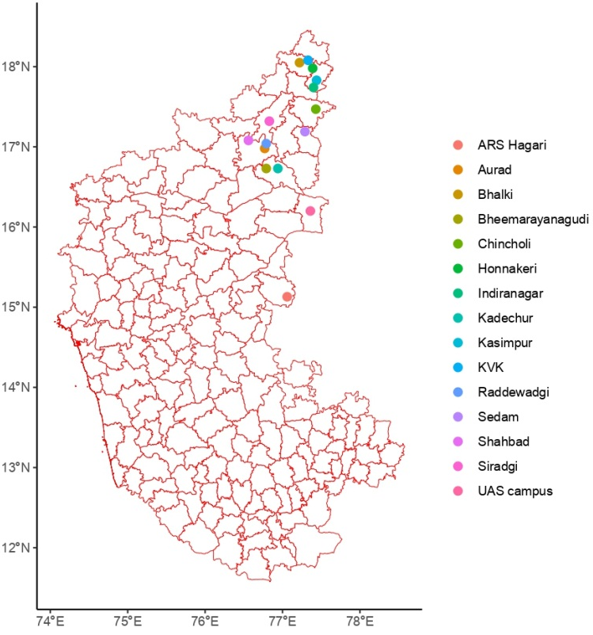
Fig. 2. Species composition and relative abundance of Lepidopteran pests collected and reared on safflower through survey from North Karnataka
Fig. 1. Locations from where lepidopteran pests were surveyed and collected in North Karnataka
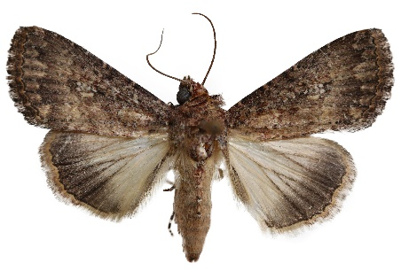  A | 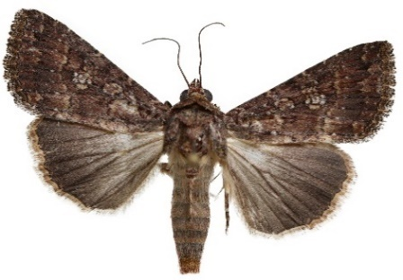  B | 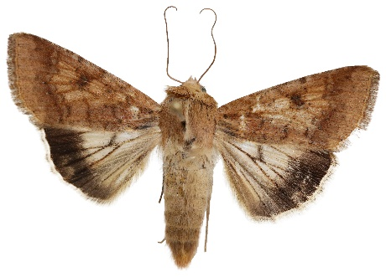  C
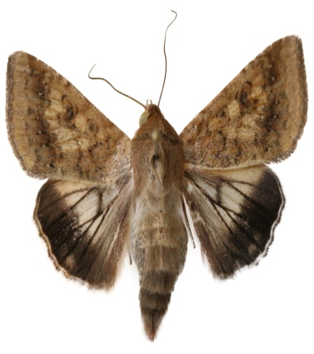  D | 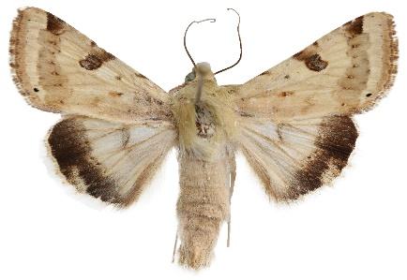  E | 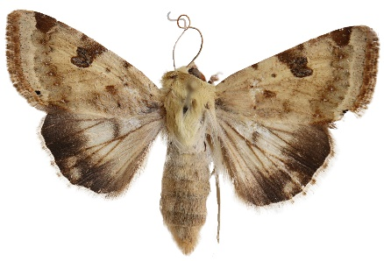  F
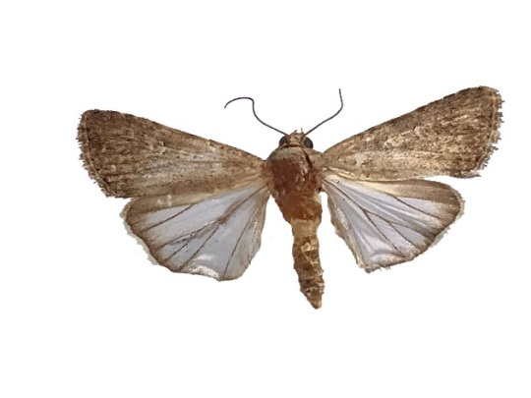  G | 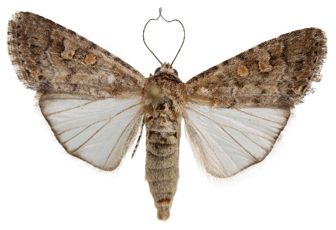  H | 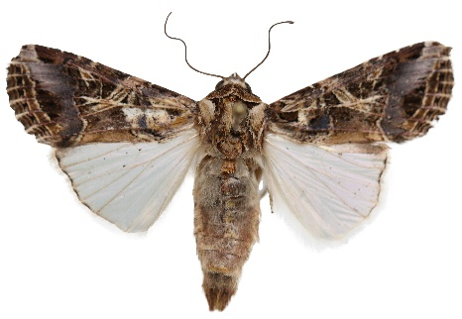  I
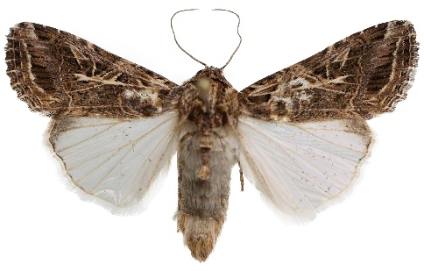
J
Fig. 3. Adult habitus Photographs: A. Condica capensis ♂; B. C. capensis ♀; C. Helicoverpa armigera ♂; D. H. armigera ♀; E. Heliothis peltigera ♂; F. H. peltigera ♀; G. Spodoptera exigua ♂; H. S. exigua ♀; I. Spodoptera litura ♂; J. S. litura ♀

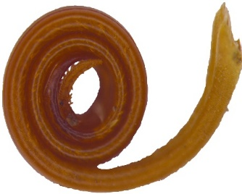  A | 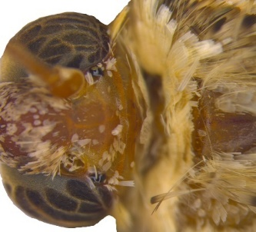  B | 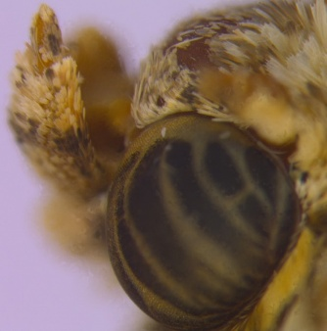  C | 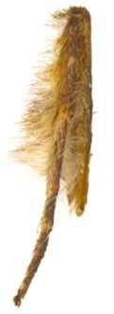  D
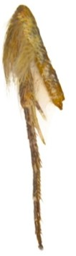  E | 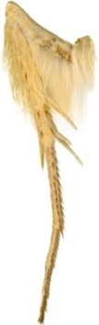  F | 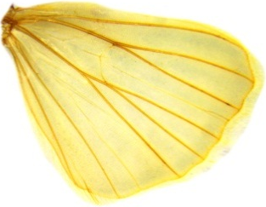  G
Fig. 4. Diagnostic characters of family Noctuidae: A. proboscis with dentate tip; B. presence of ocelli; C. labial palpi more or less upturned, with the second segment densely scaled, the third generally short; tibial spurs (0-2-4); D. fore tibia without tibial spurs; E. mid tibia with 2 tibial spurs; F. hind tibia with 4 tibial spurs; G. in hindwing, Sc+R₁ is separated from Rs, also Sc and R just touches near the wing base

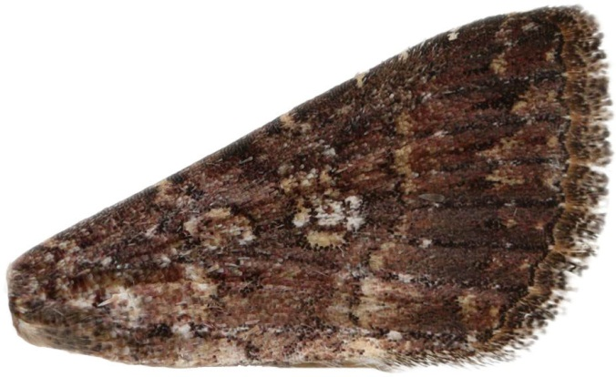
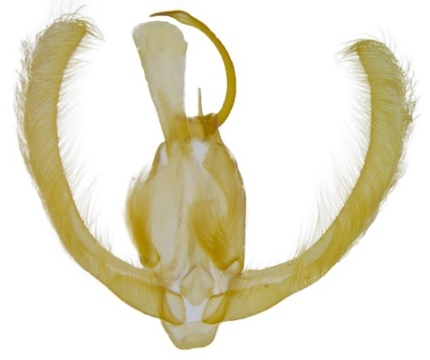
B
A
Fig. 5. Diagnostic characters of sub-family Condicinae: A. large reniform stigma on forewing; B. In male genitalia, uncus with a pair of small but well-defined lateral lobes at the base, valvae strap-like
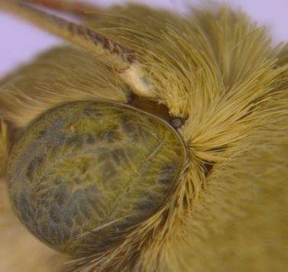  A | 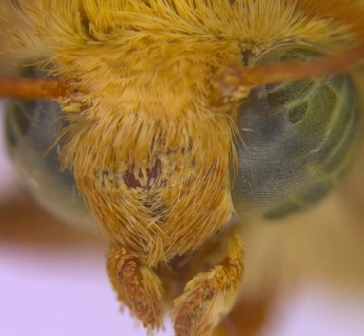  B | 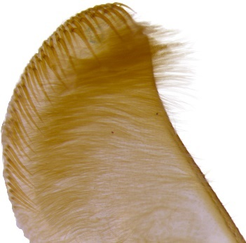  C
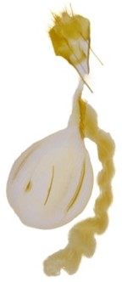
D
Fig. 6. Diagnostic characters of sub-family Heliothinae: A. eyes with hairs; B. eyes with lashes anterior to antennae; C. in male genitalia, valvae with 4 rows of spines (left and right valva each with 2 rows of spines); D. in female genitalia, appendix bursae well developed

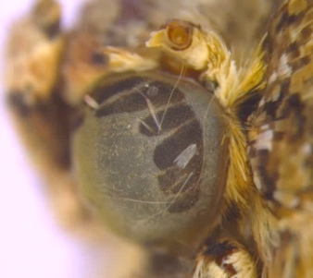  A | 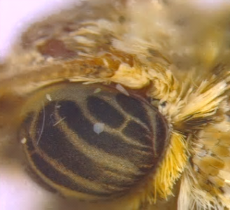  B | 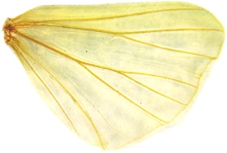  C
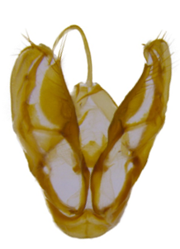
D
Fig. 7. Diagnostic characters of sub-family Noctuinae: A. eyes almost always without hairs; B. eyes without lashes anterior to antennae; C. hindwing venation trifid rather than quadrifid; D. male genitalia without pinacular hair on tegumen
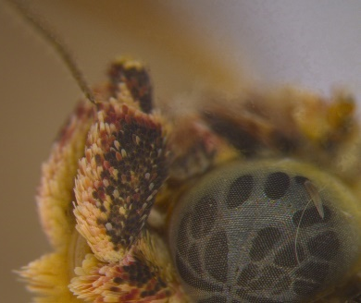  A | 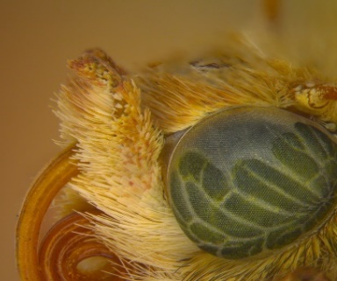  B | 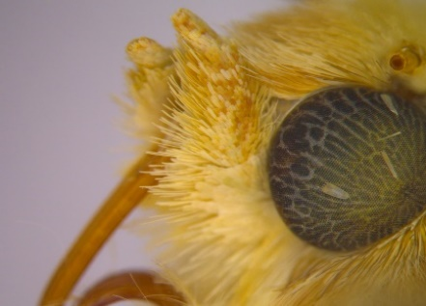  C
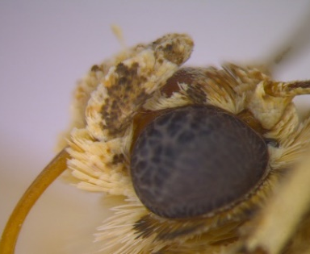  D | 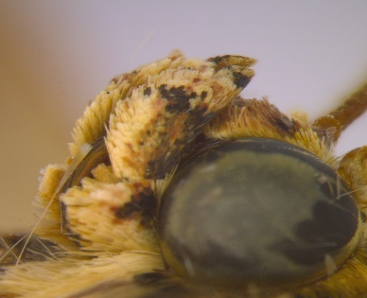  E
Fig. 8. Head and Labial palpi: A. C. capensis; B. H. armigera; C. H. peltigera; D. S. exigua | E. S. litura

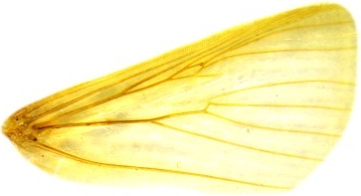  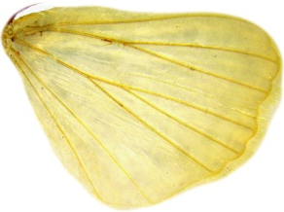  A | 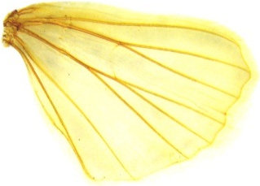  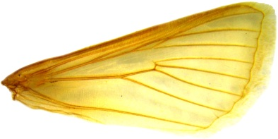  B | 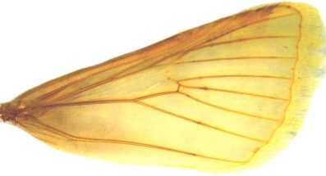  C
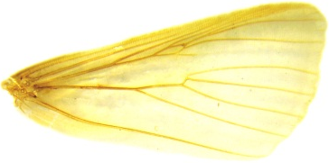  D | 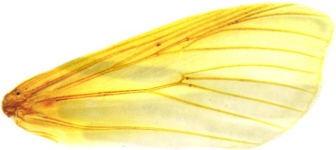  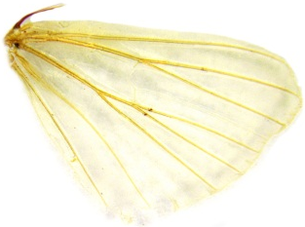  E
Fig. 9. Wing venation. A. C. capensis; B. H. armigera; C. H. peltigera; D. S. exigua; E. S. litura

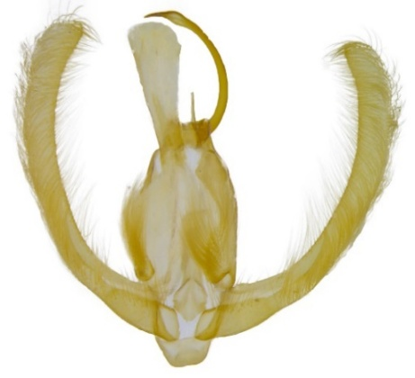  A | 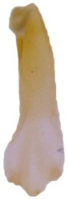  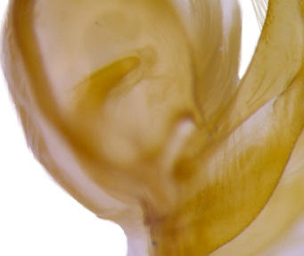  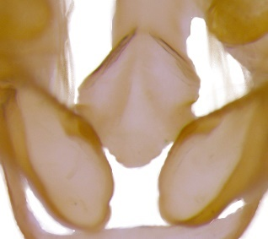  B  C |  | 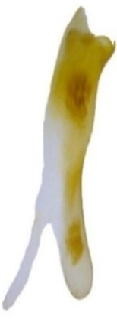  D
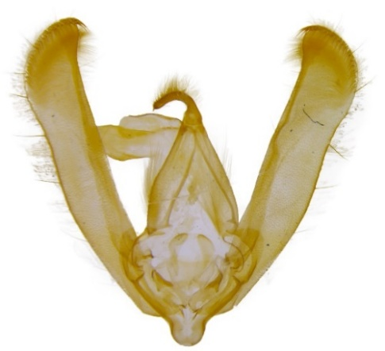  F  E | 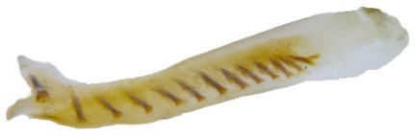  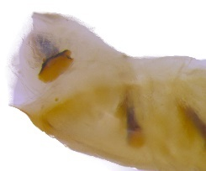  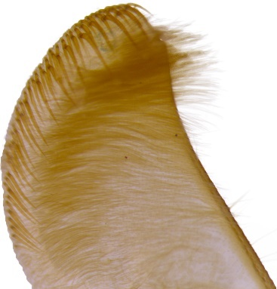  G  H |  | 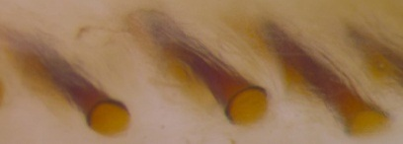  I
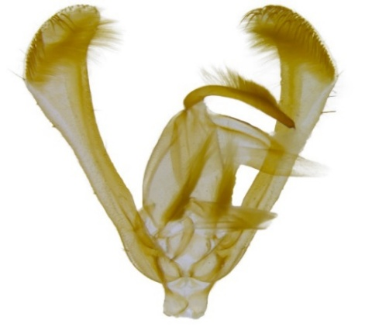  K  J | 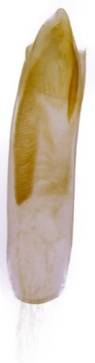  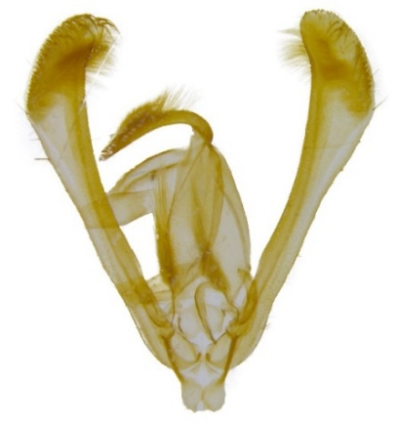  L
Fig. 10. Male genitalia: A–D. C. capensis: A. dorsal view; B. costal process; C. juxta diamond shaped; D. aedeagus; E–I. H. armigera: E. dorsal view; F. corona of valva with two rows of setae; G. aedeagus; H. vesica of aedeagus is naked; I. cornuti in close-up view; J–L. H. peltigera: J. dorsal view; K. ventral view; L. aedeagus
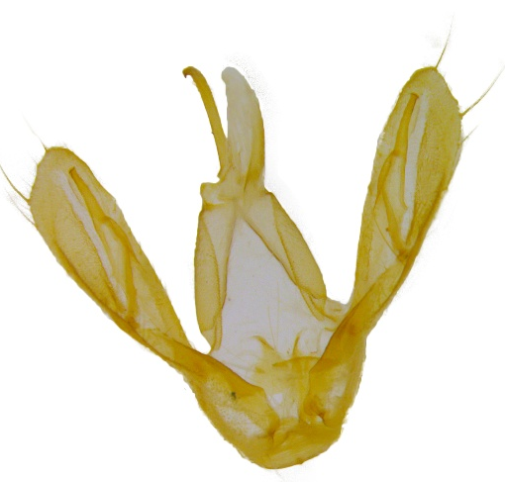  A | 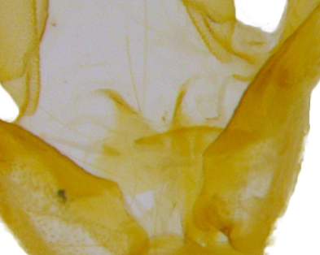  B | 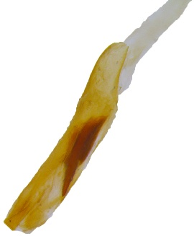  C
D | 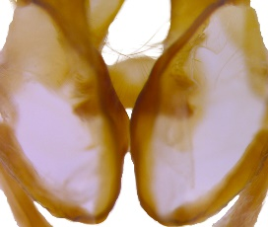  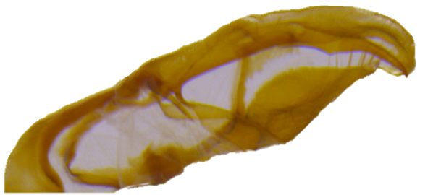  F  E | 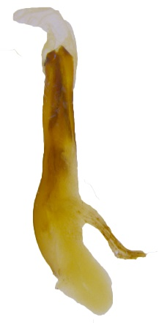  G
Fig. 11. Male genitalia: A–C. S. exigua: A. dorsa view; B. juxta triangular; C. aedeagus; D–G. S. litura: D. dorsal view; E. valva broad with two windows, one triangular and another rectangular, separated by a right angle; F. juxta diamond shaped; G. aedeagus
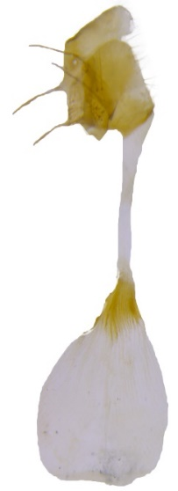  A  A | 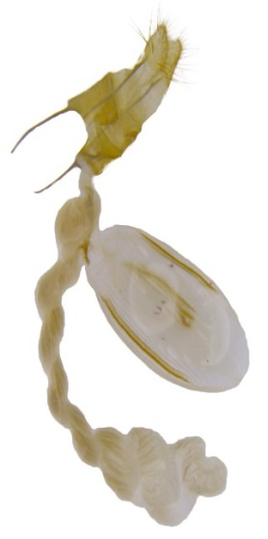  B  B | 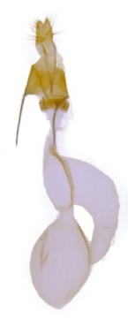  C | 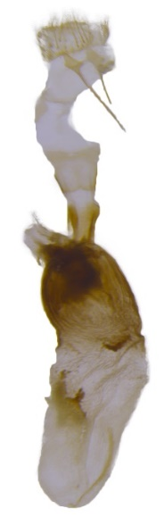  D  D | 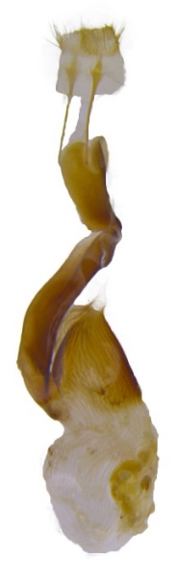  E  E
Fig. 12. Female genitalia: A. C. capensis; B. H. armigera; C. H. peltigera; D. S. exigua; E. S. litura

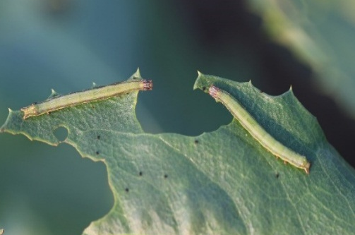  A | 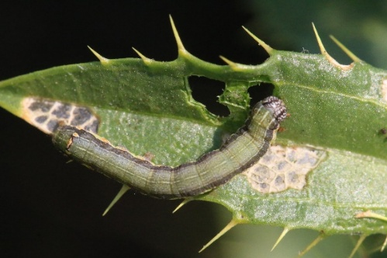  B  B | 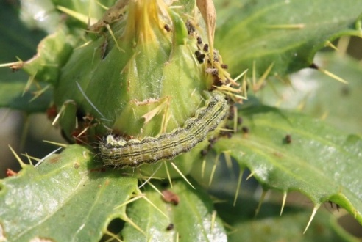  C
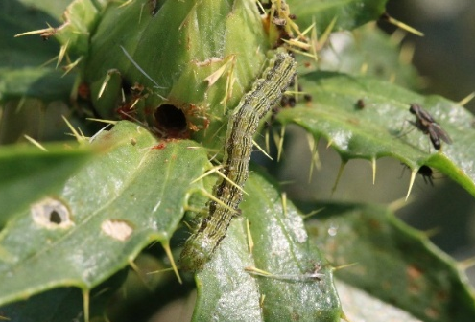  D | 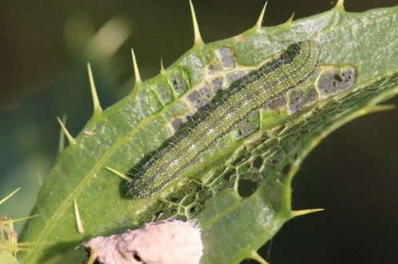  E | 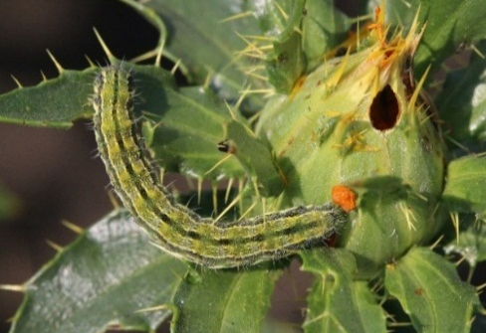  F  F
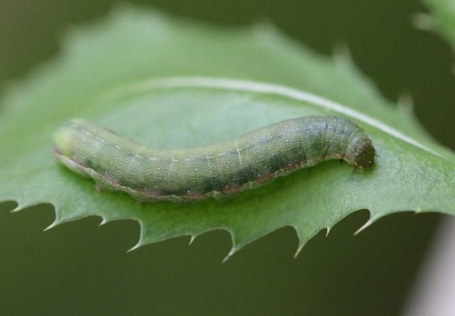  G | 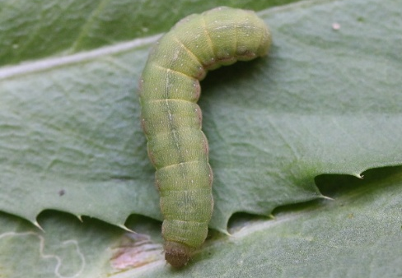  H | 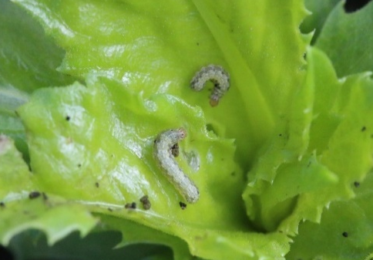  I
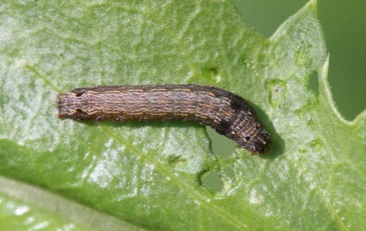
J
Fig. 13. Larval feeding habitus: A–B. C. capensis; C–D. H. armigera; E–F. H. peltigera; G–H. S. exigua; I–J. S. litura

