Species composition of Earthworms in Tropical Dry Evergreen and Southern Thorn Forests of Kolli hill, a part of Eastern Ghats,
Tamil Nadu, India

ABSTRACT
An attempt has been made to study the diversity of earthworms in Tropical Dry Evergreen and Southern Thorn Forests of Kolli hill, a part of Eastern Ghats, Tamil Nadu, India. The present study was carried out between June 2009 and May 2011. The results revealed that a total of seven species of earthworms belonging to five genera and four families under the class Oligochaeta were observed and recorded in the Tropical Dry Evergreen Forest. Among these, two species belong to the family Moniligastridae, Drawida gracilis Gates, 1925, and Drawida bullata Gates, 1933; three species belong to the family Megascolecidae, Megascolex cochinensis Stephenson, 1915, Megascolex eunephrus Cognetti, 1911 and Perionyx ceylanensis Michaelsen 1903; one species belong to the family Rhinodrilidae, Pontoscolex corethrurus Muller, 1857; and one species belong to the family Octochaetidae, Hoplochaetella stuarti Bourne, 1886. However, of these, only five earthworm species were found in the study area all through the study period, while the other two species such as M. cochinensis and M. eunephrus were rarely encountered. A total of five species of earthworms belonging to four genera and three families under the class Oligochaeta were observed in the Southern Thorn Forest. Among these, two species belong to family Moniligastridae Drawida gracilis Gates, 1925 and Drawida bullata Gates, 1933; two species belong to the family Megascolecidae Perionyx ceylanensis Michaelsen, 1903 and Megascolex bidiverticulatus sp. n. and one species belong to the family Octochaetidae Hoplochaetella stuarti Bourne, 1886. Of the five, only three earthworm species viz., D. gracilis, H. stuarti and M. bidiverticulatus were found in the Southern Thorn Forest all through the study period. Of all the earthworm species the D. gracilis Gates 1925 is reported for the first time in India. The lengthy earthworm M. bidiverticulatus sp. n. is new to the science.

INTRODUCTION
Earthworms are present in almost all terrestrial ecosystems and are one of the most important components of the soil invertebrate macro fauna. There are 5,738 species of earthworms identified across 23 families in the world according to Misirlioğlu et al., (2023). In contrast, Reynolds and Wetzel (2025) reported over 8,300 described species worldwide and they are included in 38 families and 811 genera. India is endowed with varied earthworm biodiversity, comprising approximately 71% of genera and 89% of species being unique to the region (Julka and Paliwal, 2005). Currently, India is home to 425 species and subspecies of earthworms, which are categorized into 10 families and 67 genera (Julka, 2014, Ahmed & Julka, 2017, Mandal et al., 2017, Narayanan et al., 2017, Kharkongor, 2018). Earthworms play a crucial role in soil ecosystems, contributing to soil formation, nutrient cycling, and organic matter decomposition. The diversity of earthworms has been studied and documented in different parts of the following regions in India, Tarai region of central Himalaya (Bisht et al., 2003); a part of Rajasthan (Tripathi and Bhardwaj, 2004); Puducherry (Sathianarayanan and Khan, 2006); Sirumalai hills, Tamil Nadu (Karmegam and Daniel, 2007); Triupura (Choudhuri et al., 2008). Researchers in India continues to explore new habitats and regions to study and document the diversity of earthworms. Indian subcontinent, with its varied landscapes and climatic zones, possesses a rich earthworm fauna, yet many areas remain understudied or unexplored. Tamil Nadu is located in southern part of India, and it has diverse ecosystems ranging from coastal plains to mountain ranges. The field investigations in Tropical Dry Evergreen Forest and Southern Thorn Forest of Kolli Hill, Eastern Ghats, Tamil Nadu have revealed potentially undescribed earthworm species. An attempt has been made in this article to describe these earthworm species including a new species, which in turn contributes to our understanding of earthworm diversity in India in general and Tamil Nadu in particular.

MATERIALS AND METHODS
STUDY AREA
The Eastern Ghats are isolated hill ranges in Peninsular India lies between 11⁰ 30' to 21⁰ 0' N and 77⁰ 22' to 85⁰ 20' E. According to Gurugnanam et al., (2014) the Eastern Ghats in Tamil Nadu starts from Jawadi hill and extends up to Alagar hill. Jawadi, Elagiri, Shevaroy, Chitteri, Kalrayan, Bodamalai, Kolli hill, Pachaimalai, Semmalai, Aiyalur range, Karandamali, Sirumalai and Alagar hills are the major hills of Eastern Ghats in Tamil Nadu.
The total area of Kolli hill is 503 km² (Fig. 1) and it is geographically situated between 11⁰10’00’’ to 11⁰30’00’’N and 78⁰15’00’to 78⁰30’00’E. The entire Kolli hill has five different forest types namely 1. Tropical Dry Evergreen Forest; 2. Lateritic Semi Evergreen Forest; 3. Tropical Dry Deciduous Forest; 4. Southern Thorn Forest; and 5. Euphorbia Scrub Forest and they spread in 11 Reserved Forests Gurugnanam et al., (2014).
Scanning and survey of earthworms
The entire five different forest types of Kolli hill was scanned and surveyed for earthworms’ presence/absence during October 2008 to May 2009. Litter was the only microhabitat of earthworms observed in all the five different forest types. During the survey, we observed earthworms in all the reserved forests of the Tropical Dry Evergreen forest, Lateritic Semi Evergreen forest, Southern Dry Mixed Deciduous forest and Southern Thorn forest. In contrast, the forest type Southern euphorbia scrub forest did not support the life of earthworms (as most of the surface areas are covered with huge rocks). Based on the scanning and survey results of earthworms, it was decided to select the Tropical Dry Evergreen and Southern Thorn forests as our study area. The present study was carried out between June 2009 and May 2011.
Tropical Dry Evergreen Forest
In the selected forest type (Tropical Dry Evergreen Forest) twenty quadrats were laid randomly in and around Solaikkadu (Karavallikombai Reserved Forest). We chose this RF for our present study because of its high litter falling, moisture conditions, dense vegetation and rich fertility of soil when compared to other reserved forests. In the selected sampling site, a quadrat of 25 cm x 25 cm x 40 cm depth was dug out as suggested by Senapati and Sahu (1993) in order to study and collect the earthworms. Twenty quadrats were laid randomly and they were visited once in a month.

Southern Thorn Forest
In this selected forest type twenty quadrats (25 cm x 25 cm x 20 cm depth) each were laid randomly in and around Sampling site-I: Vasalurpatti (a.s.l: ~510m; Jambuttu reserved forest), Sampling site-II: Pinnam (a.s.l: ~600m; Selur reserved forest), Sampling site-III: Kadambalam (a.s.l: ~750m; Gundur reserved forest) and Sampling site-IV: Velikkadu (a.s.l: ~400m; Adukamputhukombai reserved forest). We chose these sampling sites in these reserved forests for our present study because of their moderate litter falling, sufficient moisture conditions during rainy seasons, vegetation and fertility of soil when compared to other reserved forests of Southern Thorn forest. Besides these, in order to represent four directions in which the Southern Thorn forests are distributed, the afore-cited four sampling sites were chosen for the present investigation. The distance between the chosen sampling sites was more than 10 km on all directions. In each chosen sampling site approximately 2km x 2km area was selected in which 20 quadrats were laid in order to unearth earthworms once in a month. Although, it was suggested to dig the soil up to a depth of 0-40 cm in vertical soil strata wise (0-10, 10-20, 20-30 and 30-40 cm), in each quadrat, we could dig only up to 20 cm depth. Thereafter, we could not dig because of the interruption of rocky layers and roots of thorn vegetation.
The total number of quadrats selected for sampling in the Tropical Dry Evergreen Forest was 20 and they were selected near to Solakkadu. The Southern Thorn Forest had 80 quadrats and they were chosen close to Vasalurpatti, Pinnam, Kadambalam and Velikkadu villages. The litter microhabitat was chosen for the sampling of earthworms. In total, 100 quadrats were sampled with digging, hand sorting and wet sieving method across these two forest types once in a month from June 2009 to May 2011.

Fig. 1. Location map of Kolli hill in a portion of Eastern Ghats of
Tamil Nadu, South India
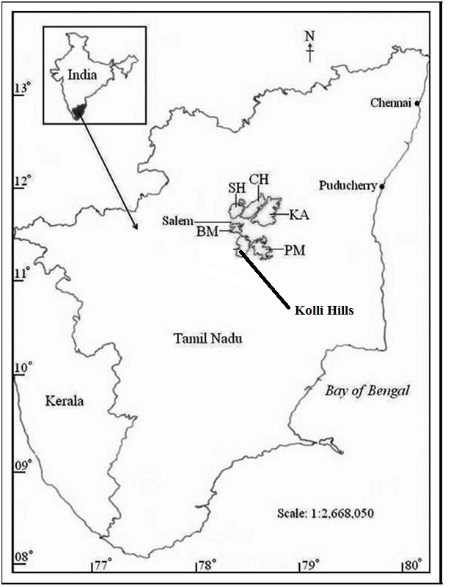

B M- Bodamalai, S H- Shevaroy Hill, C H- Chitteri Hill, K A- Kalrayan Hill and P M-Pachaimalai
The dug out soil from each quadrat was placed on a plastic sheet and then from the heap of soil the earthworms were separated out. Later, the earthworms were killed in 50% ethanol and they were fixed in 5-10% formalin solution for 24 hours in a straightened position and later preserved in suitable glass tubes with 10-15% formalin (Julka and Plaiwal, 1993). In the laboratory, the worms were examined with their morphological and anatomical taxonomy characters for identification. These worms were identified up to genus / species level with the help of available keys given in taxonomy books on earthworms such as Beddard, (1895), Stephenson, (1923 and 1930), Gates, (1972), Sims and Gerard, (1985), Julka, (1988) and Blakemore, (2010). The morphological and anatomical characters of earthworms were observed by using Stereo Zoom Trinocular Microscope, (Optika make – SZM-2, Italy) and were identified and confirmed up to genus and species level. The characters used for the identification of earthworms up to genus / species level were photomicrographed (@40x) by using Nikon D60 digital SLR camera through Stereo Zoom Trinocular head of a Microscope (Optika, Italy). Earthworm specimens have been deposited at Zoological Survey of India, Southern Regional Centre (ZSI-SRC), Chennai (Madras), Tamil Nadu, India. Additional specimens are housed in the Centre for Eco-friendly Agro-Technologies (CEAT), Research Department of Zoology, Nehru Memorial College (Autonomous), Puthanampatti, Tiruchirappalli District, Tamil Nadu, India.
RESULTS AND DISCUSSION
Identification of Earthworms up to Genus / Species level from Tropical Dry Evergreen forest
The results revealed that a total of seven species of earthworms belonging to five genera and four families under the class Oligochaeta were observed and recorded in the Tropical Dry Evergreen forest. Among these, two species belong to family Moniligastridae, Drawida gracilis Gates, 1925; and Drawida bullata Gates, 1933; three species belong to the family Megascolecidae, Megascolex cochinensis Stephenson, 1915; Megascolex eunephrus Cognetti, 1911 and Perionyx ceylanensis Michaelsen 1903; one species belong to the family Rhinodrilidae, Pontoscolex corethrurus Muller, 1857; and one species belong to the family Octochaetidae, Hoplochaetella stuarti Bourne, 1886. However, of these, only five earthworm species were found in the study area all through the study period, while the other two species (M. cochinensis and M. eunephrus were rare species found in our study area during the two year study period. A detailed account on the identification details of all seven species of earthworms are given in the following pages.
Identification of Earthworms up to Species level from Southern Thorn forest
A total of five species of earthworms belonging to four genera and three families under the class Oligochaeta were observed in the Southern Thorn forest. Among these, two species belong to family Moniligastridae Drawida gracilis Gates, 1925 and Drawida bullata Gates, 1933; two species belong to the family Megascolecidae Perionyx ceylanensis Michaelsen, 1903 and Megascolex bidiverticulatus sp. n. and one species belong to the family Octochaetidae Hoplochaetella stuarti Bourne, 1886. Among the five species of earthworms, only three earthworm species viz., D. gracilis, H. stuarti and M. bidiverticulatus were found in the Southern Thorn Forest all through the study period. Of all the earthworm species the D. gracilis Gates 1925 is reported for the first time in India. The lengthy earthworm M. bidiverticulatus sp. n. is new to the science.
Family: Moniligastridae Claus, 1880
Drawida gracilis Gates, 1925
1925. Drawida gracilis, Gates, Ann. Mag. Nat. Hist. Ser. 9, 16: p. 660.
1926. Drawida gracilis, Gates, Rec. Indian Mus. 28: p. 144. Jour. Burma Res. Soc.15: p. 204.
1933. Drawida gracilis, Gates, Rec. Indian Mus.35: p. 441.
Material examined: 2 Clitellate specimens deposited each @ National Repository Reg. No. ZSI/SRC/Chennai/IN/AN/03 and College Ref. No. CEAT/NMC/MoEF/KH/DG/001; the animals were observed and recorded in Solakkadu, Karavallikombai (11˚32’70”N; 78˚35’01”E) and Vasalurpatti (11˚14’54”N; 78˚20’19”E), Kolli hill, Namakkal District, Tamil Nadu, India, 305 m a.s.l., 16 November 2017, M. Murali, D. Selvamuthukumaran, K. Sathis Kumar and P. Neelanarayanan.
Diagnosis
External characters
Colour, white (unpigmented). Segments, 140-340, size, length 180 (Fig. 2) and diameter 3 mm. Clitellum, red in x-xiii. Male pores (Fig. 2a), rather small transverse slits in median half of b, c line, each in a disc extending into x-xi that is protrusible as a rather conical porophore. Spermathecal pores at vii/viii. Genital markings, whitened areas of epidermal thickening, period, in x-xi, Setae, aa<bc, dd ca.= ½C. Dorsal pores absent.
Internal characters
Gizzards, 1-4, in xiv-xxi (Fig. 2b). Intestinal origin, Sperm ducts, rather long but slender throughout, each looped in a small cluster on each side of ix/x. Prostate sessile, flat and circular or more protuberant and rather conical, capsule small. Shortly ovoidal, Spermathecae, duct long, diverticulum stoughtly long with thick wall and narrow lumen, erect in vii. Nephridopores not recognized.

Fig. 2. An adult D. gracilis observed in the Tropical Dry Evergreen and
Southern Thorn Forests
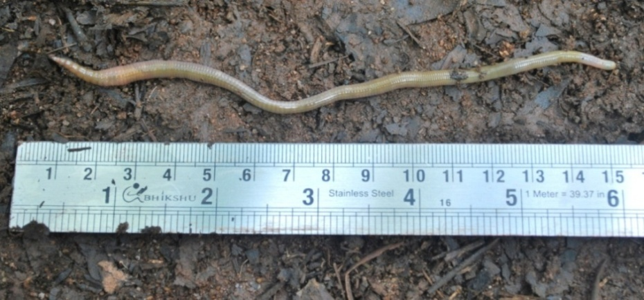

Fig. 2a. Male pores (Photomicrograph @ 40x)
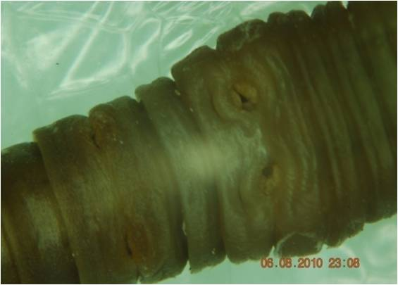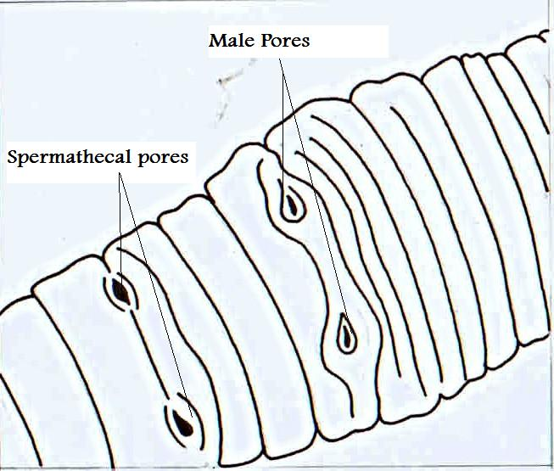
Fig. 2b. Gizzards (Photomicrograph @ 40x)
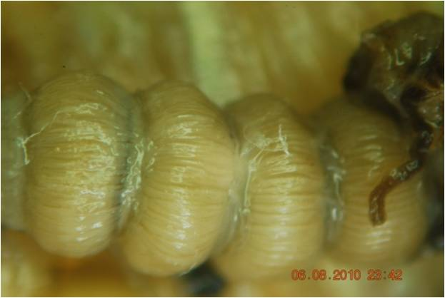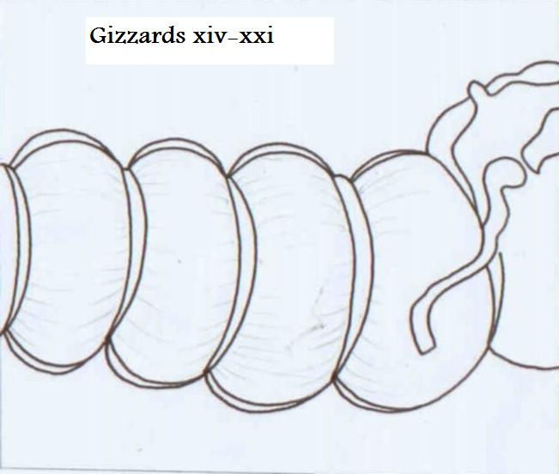
Distribution
Thaton, Kyaikto (Thaton), Thinbawgyin (Bassein), Rangoon, Thongwa, Twante (Hanthawaddy), Hlawga, Wanetchaung Taukkyan (Isein), Pegu, Thanatpin (Pegu), Tharrawaddy, pegu Yomas (Tharrawaddy), Letpadan (Henzada), Prome, Paukkaung (Prome), Sandoway (Sandoway), Thanbula (Thayetmyo), Ramree (Kyaukpyu), Taungdwingyi (Magwe), Tiddim (Chin Hills). From sea level to 5000 feet (Gates, 1972). In India: Tamil Nadu: Recorded for the first time in the Tropical Dry Evergreen (Karavallikombai Reserved Forest; Altitude 1200 m) and Southern Thorn Forests (Vasalurpatti, Pinnam, Kadambalam and Velikkadu) of Kolli hill, Eastern Ghats. This species is reported for the first time in India (Sathis kumar et al., 2025).
Habitat: Dense forest, soil with rich organic material.
Drawida bullata Gates, 1933
Material examined: 2 Clitellate animals deposited each @ National Repository Reg. No. ZSI/SRC/Chennai/IN/AN/04 and College Ref. No. CEAT/NMC/MoEF/KH/DB/002; the animals were observed and recorded in Solakkadu, Karavallikombai (11˚32’70”N; 78˚35’01”E) and Vasalurpatti (11˚14’54”N; 78˚20’19”E), Kolli hill, Namakkal District, Tamil Nadu, India, 305 m a.s.l., 16 November 2017, M. Murali, D. Selvamuthukumaran, K. Sathis Kumar and P. Neelanarayanan.
Diagnosis
External Characters
Colour white, Segments 140-320, Length 184 mm (Fig.3) and diameter 3-4 mm. Clitellum, annular, red in ix-xiv (Fig. 3a); Male pores, rather small transverse slits median to bc, each in a disc extending into x-xi, spermathecal pores, at vii / viii median to c. Genital markings, whitened areas of epidermal thickening in x-xi median of ac or bc. Setae lumbricine arrangement, closely paired aa<bc. Dorsal pores absent.
Internal characters
Gizzards, 1-5, in xiii-xviii, connectives from extra-oesophageals (Fig. 3b). Sperm ducts each with a terminal portion in x. Prostates, short, erect or bent mesially, slightly widened entally. Spermathecae, each duct passing in vii into a digitiform diverticulum that is erected or looped and ovarian chamber, ≈5-70+mm long, closed off from parietes. Female pores not recognized but they may be near b, nephridia pores not recognized.

Fig. 3. A sexually mature D. bullata observed in the Tropical Dry Evergreen and Southern Thorn Forests
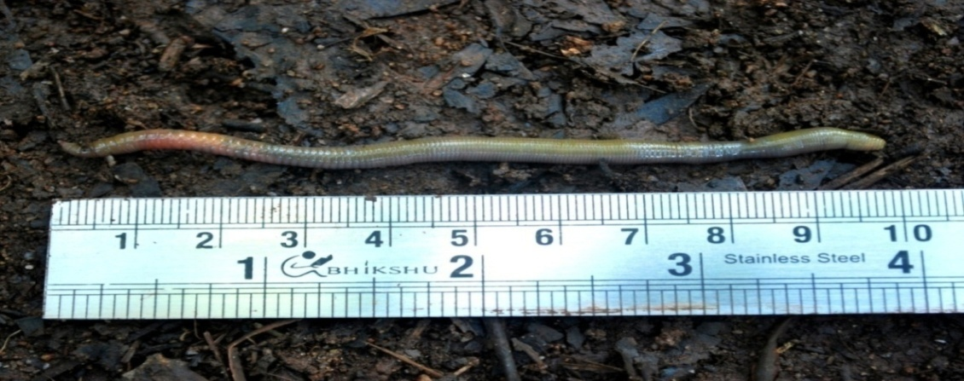

Fig. 3a. Male Pores and Clitellum (Photomicrograph @ 40x)
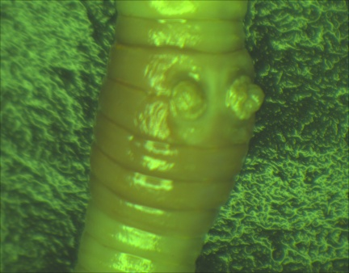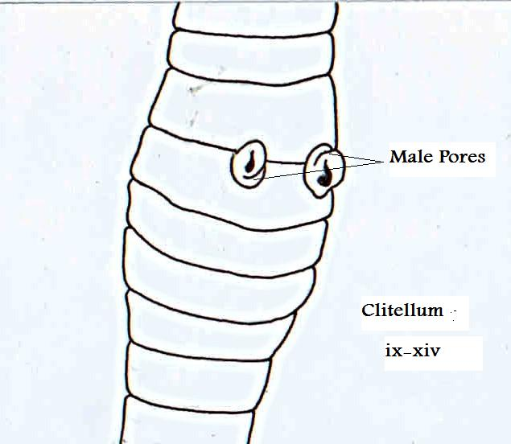
Fig. 3b. Gizzards (Photomicrograph @ 40x)
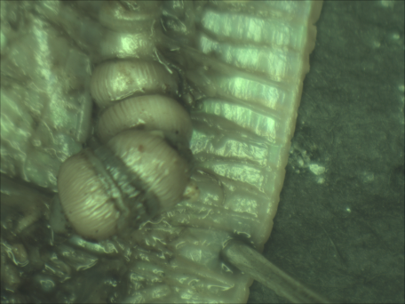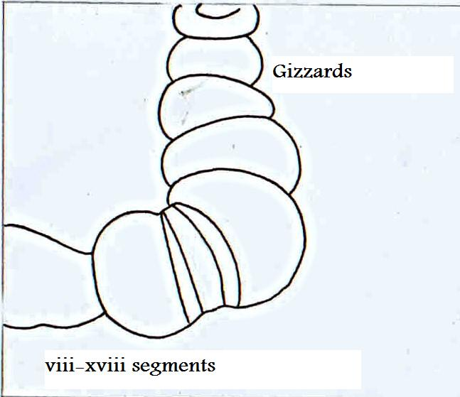

Distribution
Kawkareik (Amherst), Henzada (Henzada), Toungoo, Tantabin (Toungoo), Prome, Laboo (Prome), Thantabula (Thayetmyo), Pyigyaung (Yamethin), Taungdwingyi (Magwe), Minbu (Minbu), Mandalay (Mandalay), Ye-U (Shwebo), Kalewa (Upper Chindwin). Possibly also including some or all of the following; Monywa (Lower Chindwin), Mingin, Laungbyin, Homalin (Upper Chindwin) (Gates, 1972). In India: Tamil Nadu: Recorded for the first time in the Tropical Dry Evergreen (Karavallikombai Reserved Forest; Altitude 1200 m) and Southern Thorn Forests (only in Vasalurpatti) of Kolli hill, Eastern Ghats.
Habitat: Dense forest, soil with rich organic material.

Family: Megascolecidae Rosa, 1891 (sensu Gates, 1959)
Megascolex cochinensis Stephenson, 1915
1915. Megascolex cochinensis, Stephenson, Mem. Indian Mus. 6: 96. Types Zoological Survey of India, Kolkatta (Calcutta), cat. no. 6593 (Reynolds and Wetzel, 2025).
Material examined: 2 Clitellate animals deposited each at National Repository Reg. No. ZSI/SRC/Chennai/IN/AN/06 and College Ref. No. CEAT/NMC/MoEF/KH/MC/004; the animals were observed and recorded in Solakkadu, Karavallikombai RF (11˚32’70”N; 78˚35’01”E), Kolli hill, Namakkal District, Tamil Nadu, India, 1200 m a.s.l., 16 November 2017, M. Murali, D. Selvamuthukumaran, K. Sathis Kumar and P. Neelanarayanan.
Diagnosis
External characters
Length 175-220 mm (Fig. 4); diameter 4 mm. Segments 224. Colour grey, non-pigmented. Prostomium epilobous tongue closed. First dorsal pore at v/vi. Setae perichaetine arrangement, closer set of ventrally. Clitellum, annular, xiv- xvii (Fig. 4a). Male pores as oblique wavy slits, the posterior ends of which approach each other, each on a white oval elevation, also oblique, which touches or almost touches its fellow in the middle line; the area surrounding the papillae depressed, and the whole surrounded by an oval wall; centres of male pores ca. circumference apart; the whole area in longitudinal extent takes up nearly the length of segment xviii (Fig. 4a). Female pore apparently single. Spermathecal pores in vii/viii and viii/ix.
Internal characters
Septa vi/vii-xi/xii moderately thickened, Gizzard large and barrel-shaped, in v. (oesophagus swollen and vascular in xii-xiv. Intestine begins in xix, in front of clitellum nephridia only as tufts by the side of oesophagus; behind clitellum they form a band (but not a single line) in the anterior half of each segment. Testes and funnels free in x and xi, Seminal vesicles, moderately large, racemose, in xi and xii. Prostates limited to xviii, each a mass of small rounded lobules; duct passing straight inwards, wider at its termination. Spermathecal ampulla ovoid; duct as long as ampulla and less than half as wide; diverticulum arising from ectal end of duct, club-shaped, reaching about to middle of ampulla (Fig. 4b). No penial setae.

Distribution
Forest tram way, Cochin state Kerala (Stephenson, 1923). In Tamil Nadu, this species is reported for the first time from Lateritic Semi Evergreen Forest (Sathis Kumar et al., 2025) and Tropical Dry Evergreen Forest of Kolli hill a part of Eastern Ghats.
Fig. 4. An earthworm M. cochinensis encountered during the field visits only in the Tropical Dry Evergreen Forest

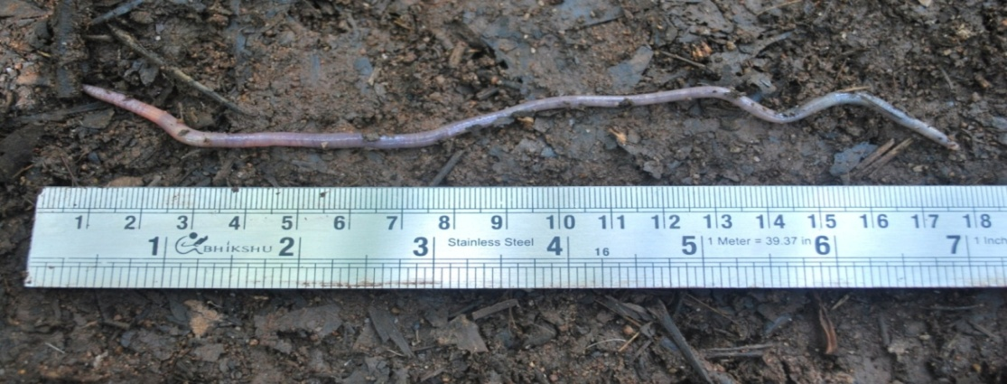
Fig. 4a. Male pores and Clitellum (Photomicrograph @ 40x)
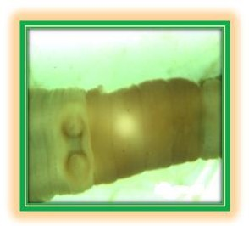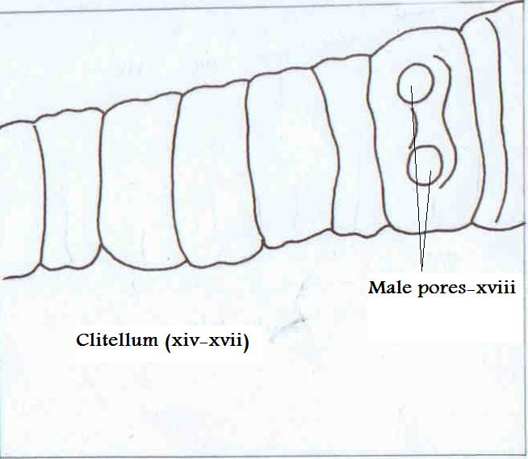
Fig. 4b. Spermatheca diverticulum (Photomicrograph @ 40x)
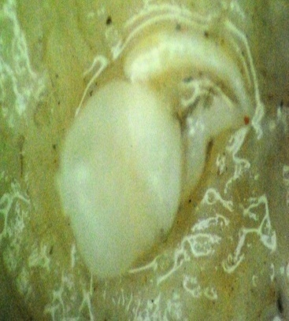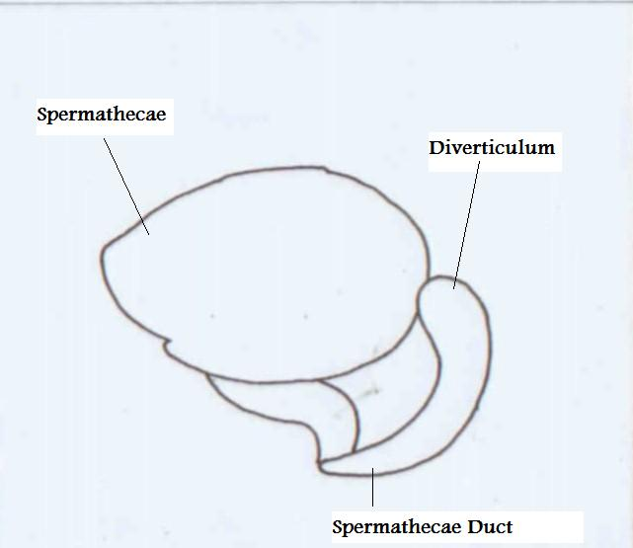
Megascolex eunephrus Cognetti, 1911
1911. Megaxculex eunephrus, Cognetti, Ann. Mag. N. H. (8) vii, p. 498, pl. xiii, figs. 5-7.
1923. Megascolex eunephrus, Stephenson, Fauna of British India, Oligochaeta: pp. 243.
Material examined: 3 Clitellate specimens deposited each at National Repository Reg. No. ZSI/SRC/Chennai/IN/AN/07 and College Ref. No. CEAT/NMC/MoEF/KH/ME/005; the animals were observed and recorded in Solakkadu (11˚18’34”N; 78˚20’57”E), Kolli hill, Namakkal District, Tamil Nadu, India, 1200 m a.s.l., 16 November 2017, M. Murali, D. Selvamuthukumaran, K. Sathis Kumar, and P. Neelanarayanan.

Fig. 5. A full view of M. eunephrus photographed in Tropical Dry Evergreen Forest
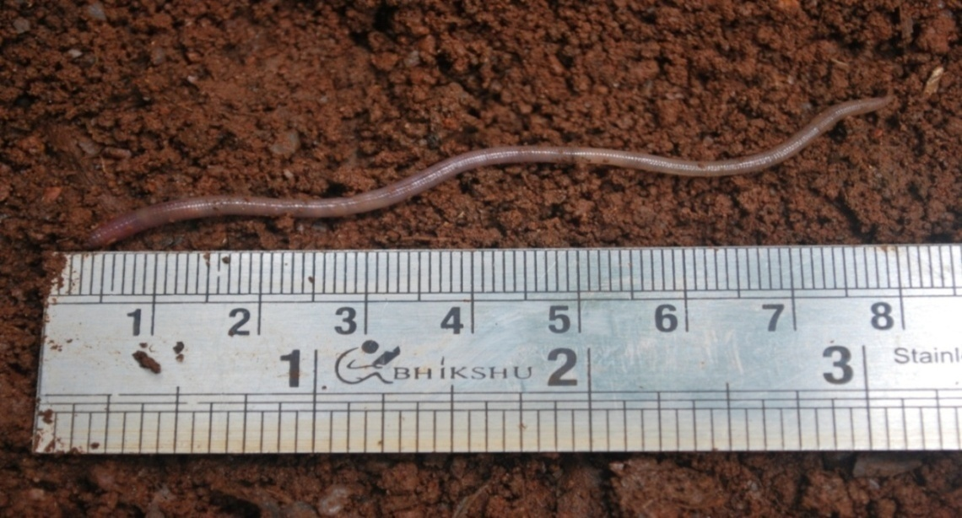

Diagnosis
External characters
Length more than 85 mm. (hinder end wanting); maximum diameter (anteclitellial) 3 mm. Segments 195. Colour a uniform lilae-grey. Prostomium proepilobous. No secondary annulation. First dorsal pore in 8/9. Nephridiopores in iii/iv-viii/ix in line with seta e. Setae nearly constant in number, ca. 24; ventral break regular but not large, =2ab, dorsal break a little larger. Clitellum ring-shaped, xiv-xvii (4 segments). Ventrally on xviii a few large papilla, which, joining together, form a triangular figure enclosing a depression, one angle of the triangle pointing forwards and reaching xvii/xviii ; male pores near the lateral angles, in line with b. Spermathecal pores in b in vii/viii and viii/ix (Figs. 5; A-D).

Internal characters
Septa vi/vii-viii/ix moderately thickened. Gizzard in v. Intestine begins in xxi. No calciferous glands. Nephridia in iii-ix as conspicuous tufts, with thin-walled ribbon like duct, which increases in length from the first to the seventh pair, and passes through the body-wall at the extreme anterior margin of the segment; from x onwards the nephridia are diffuse and small, but in xiv and xv a pair of the larger nephridia are present in addition. Testes and funnels free in x and xi. Sperm vesicles grape-like, in xi and xii. Prostates with glandular part much lobed, in xvii-xx; duct curved with convexity forwards. Spermathecae with club-shaped main pouch; diverticulum finger shaped, opening into ectal end of duct, in length one-third of main pouch (ampulla plus duct). No penial setae (Figs.5; E - H).
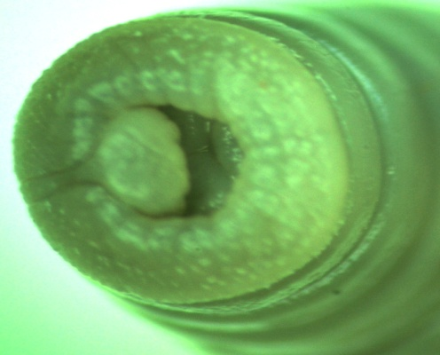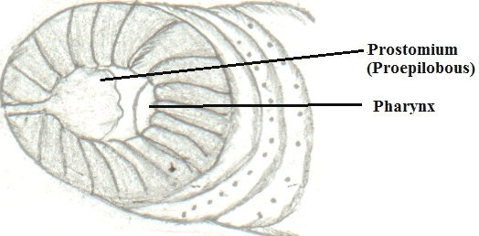
A B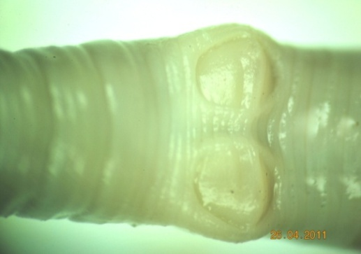 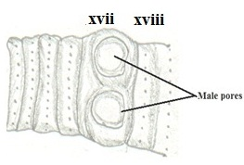
C D
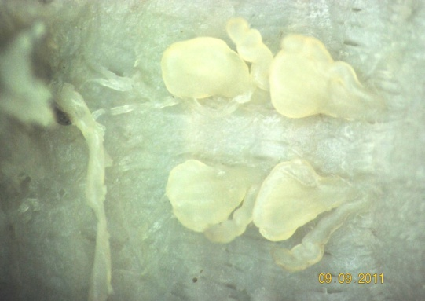 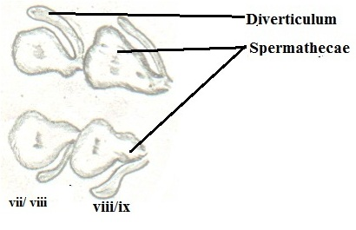 E F
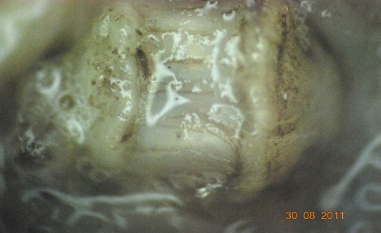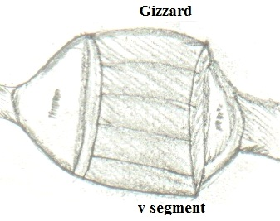
G H
Fig. 5. Photomicrographs and line drawings of M. eunephrus: A, B Prostomium (Proepilobus); C, D Male pores in xvii/xviii; E, F two pairs of Spermathecae; G, H Gizzard, v segment.

Distribution
Coorloon, Travancore, South India (Stephenson, 1923). In Tamil Nadu: Sathyamangalam Forest Division: Thottamkombai and Karumbarai (Andiyur forest range) and for the first time it was recorded in Tropical Dry Evergreen forest in Kolli hill, Namakkal District

Perionyx ceylanensis Michaelsen, 1903

1903. Perionyx ceylanensis, Michaelsen, Sb. Bohm. Ges. Prag. xl, p. 6.
1923. Perionyx ceylanensis Stephenson, Fauna of British India. Oligochaeta. p. 328.
Material examined: One Clitellate animal deposited each @ National Repository Reg. No. ZSI/SRC/Chennai/IN/AN/08 and College Ref. No. CEAT/NMC/MoEF/KH/PC/006; the animals were observed and recorded in Solakkadu (11˚18’34”N; 78˚20’57”E), Kolli hill, Namakkal District, Tamil Nadu, India, 1200 m a.s.l., 16 November 2017, M. Murali, D. Selvamuthukumaran, K. Sathis Kumar, and P. Neelanarayanan.

Fig. 6. A full view of P. ceylanensis photographed during the field visits
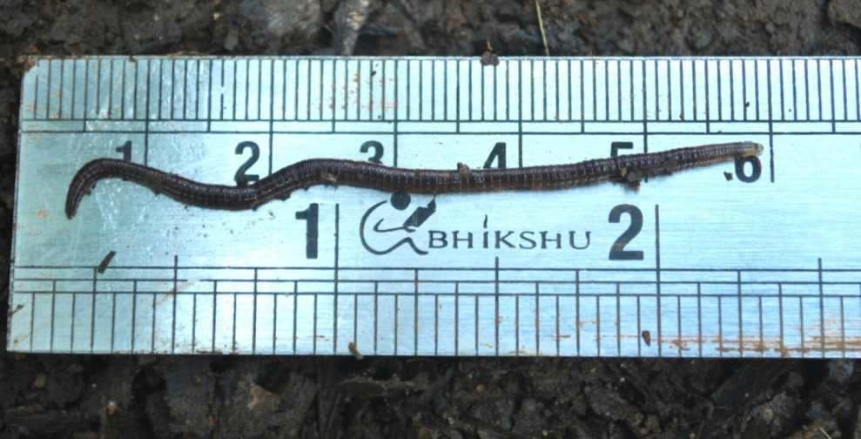
Diagnosis
External Characters
Length ca. 80mm, dia. 1-2 mm; (Fig. 6) Segments ca. 145; Colour purple violet; Prostomium epilobic, tongue open (Fig.6 a); First dorsal pore is at 3/4 but 4/5 functional; Clitellum annular xiii-xvii (=5); Setae preichaetine; Combined male and prostatic pores paired, tiny, close to mid ventral line, in a median oval-shaped slightly depressed male genital field on xviii; Female pore single on xiv; Spermathecal pores, paired, minute, on tiny papillae, in 6/7/8/9, very close to mid-ventral line; Genital markings absent; Nephridiopores in a single, irregular series, close to mid lateral line on each side; Pigmentation dark reddish brown.
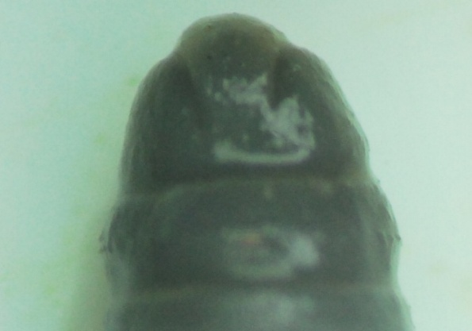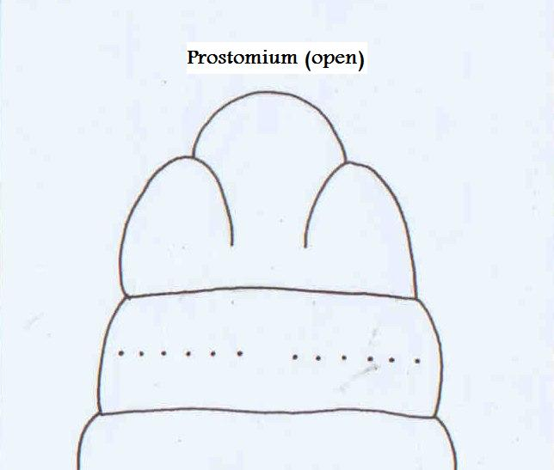
Fig. 6 (a). Prostomium: Epilobous (open)

Internal Characters
Septa: No septum notably thickened; Gizzard vestigial in segment 5 or absent; oesophagus slightly enlarged in xi and xii; Intestine begins in segment xix; Intestinal caeca absent; typhlosole absent; Last pair of hearts in xiii; Holandric, testes paired, free, in segments x and xi; Ovaries in xiii; Seminal vesicles two pairs in xi and xii; Prostates in xviii, ducts straight; Spermathecae paired, in vii, viii and ix, each with 2-3 shortly stalked multiloculate ental diverticula ; Holonephric; nephridia avesiculate.
Distribution: India: Tamil Nadu: Kallar, Mettupalayam Forest Range, Tamil Nadu. Outside India: Sri Lanka. Recorded from Tropical dry evergreen forest (Karavallikombai Reserved Forest) and Southern Thorn Forest (found only in Vasalurpatti), Kolli hill, Eastern Ghats, India.
Family: Megascolecidae Rosa, 1891
(sensu Gates, 1959)
Megascolex bidiverticulatus Selvamuthukumaran sp. n.
1844. Megascolex, Templeton, Proc. Zool. Soc. London, 12: 89.
1923. Megascolex, (in part)-Stephenson, Fauna of British India Oligocheta, p. 222.
1930. Megascolex, (in part)-Stephenson, The Oligocheta, p. 837.

Fig. 7. A full view of M. bidiverticulatus encountered in Southern thorn forest
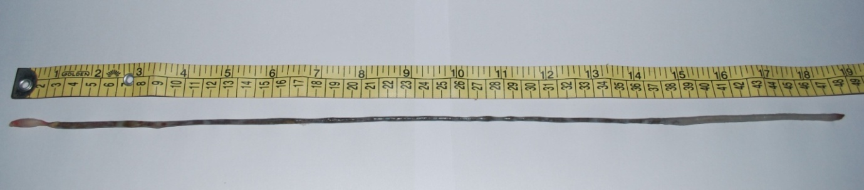
Material examined: Holotype. (1 Clitellate adult, deposited each @ National Repository Reg. No. ZSI/SRC/Chennai/IN/AN/01 and College Ref. No. CEAT/NMC/MoEF/KH/MB/010); the animals were observed and recorded in Kadambalam (11˚18’34”N; 78˚20’57”E), Pinnam (11˚13’13”N; 78˚21’28”E) and Velikkadu (11°19′47″N 78°23′36″E), Kolli hill, Namakkal District, Tamil Nadu, India, 305 m a.s.l., 16 November 2017, D. Selvamuthukumaran, K. Sathis Kumar, M. Murali, and P. Neelanarayanan. Paratype. 2 Clitellate adults deposited at National Repository Reg. No. ZSI/SRC/Chennai/IN/AN/02, same collection data as for Holotype. Additional specimens (0-0-3) at the Centre for Eco-friendly Agro-Technologies, Puthanampatti, Tamil Nadu, India.

Diagnosis
External Characters
Length ca. 500mm, diameter ca. 4-5mm; Colour milky white throughout the body except a few pre-clitellar segments (Fig. 7); Segments number ca. 450; secondary annulations start from v and the same reduced after some post-clitellar segments; Prostomium, prolobous; Setae, perichaetine; Clitellum annular (1/2 xiii – xvi = ca. 4); First dorsal pore starts 13/14; Spermathecal pore single entry, mid-ventral to viii and ix, not in a furrow; Female pore single, very minute on xiv; Male pore inconspicuous and prostate pore single on xviii and no nephridiopores seen.
Internal Characters
Septa thickened 6/7 to 12/13; Gizzard single, large vi/vii; Pharyngeal nephridia present; Spermathecae bidiverticulate in viii as well as in ix (Fig. 7a) (the diverticula are shorter than the ampulla); Calciferous glands between ix-xiii; Intestine starts xvii/xviii; Intestinal caeca not found; Intestinal gizzards not found; Prostate glands tubular to racemose, single pair in xviii (Fig. 7 b), and Meronephridia in all segments.
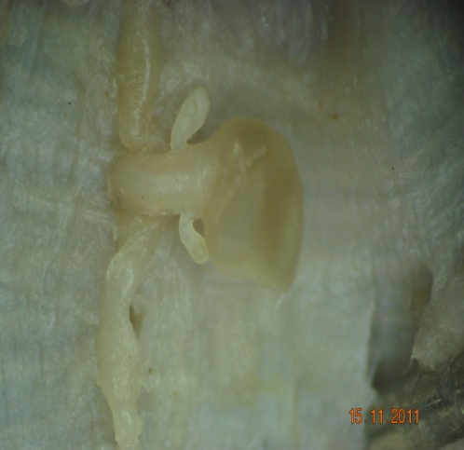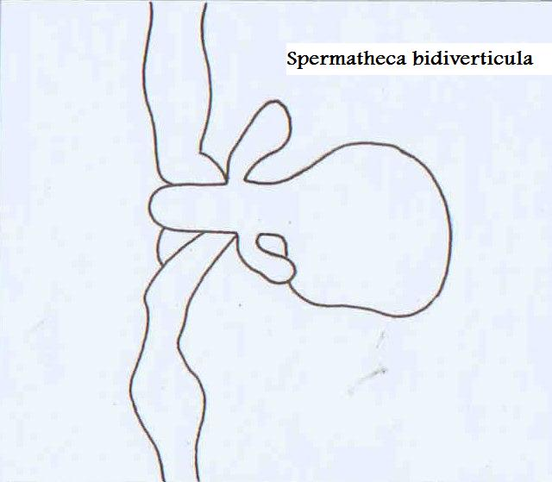

Fig. 7a. Spermatheca bidiverticula in viii
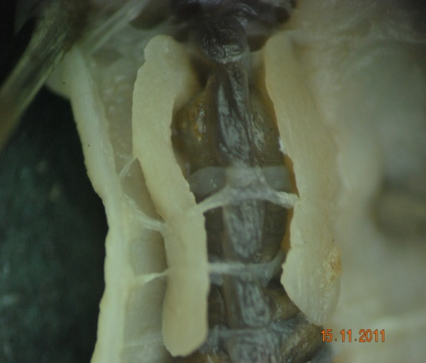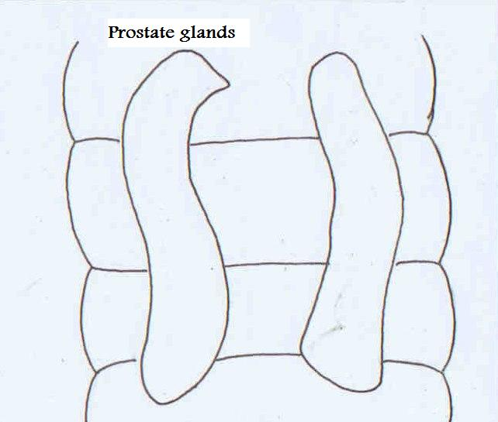
Fig. 7 b. Prostate glands
Distribution: This species was recorded for the first time in Southern thorn forest (except Vasalurpatti area) of Kolli hill and therefore new to India and new to science.

Etymology: This species has been named bidiverticulatus because it possesses two diverticula in the spermatheca (vide Fig. 7a) which is found only in the Megascolex.
Family: Rhinodrilidae Benham, 1890
Pontoscolex corethrurus Muller, 1857
1857. Lumbricus corethrurus, Muller, Abhandl. Ges. Halle. 4: 26 (Type locality, Itajahy, Brazil, Types, probably none.)
1909. Pontoscolex corethrurus, Michnelsen, Mem. Ind. Mus. 1:244.
Material examined: 2 Clitellate animals deposited each @ National Repository Reg. No. ZSI/SRC/Chennai/IN/AN/10 and College Ref. No. CEAT/NMC/MoEF/KH/PSC/008; the animals were observed and recorded in Solakkadu (11˚18’34”N; 78˚20’57”E), Kolli hill, Namakkal District, Tamil Nadu, India, 1200 m a.s.l., 16 November 2017, M. Murali, D. Selvamuthukumaran, K. Sathis Kumar, and P. Neelanarayanan.
Diagnosis
External characters
Length 60-120 mm (Fig. 8), diameter 3-4 mm, Segments 90-205, unpigmented. Prostomium absent, but everted buccal tissue may simulate a prostomium or proboscis. Setae slightly ornamented, transversely grooved at the tip (ornamentation often worn, away). The anterior part of the body closely paired and exceptionally so throughout the body; usually from about x or xii onwards the pairing is wider and in the hinder part of the body the setae are alternately widely and closely paired with a quincunx arrangement (Fig. 8a). Setae in the hinder part of the body much enlarged, with straight distal end. Nephridial pores in c line. Clitellum, saddle shaped, xv, xvi-xxii, xxiii, (= 8 or 9); thickened ridges ("walls") xix-xxii, extending down to B and sometimes to A (Fig. 8b). Tubercula pubertatis, longitudinal bands lateral to B in xix-xxi, xxii. Male pores on xx/xxi near B. Female pores paired slits in xiv/xv and near B. Spermathecal pores three pairs, in vi/vii-viii/ix, in C line. Dorsal pore absent.
Fig.8. A cosmopolitan earthworm P. corethrurus recorded only in the Tropical Evergreen
Forest
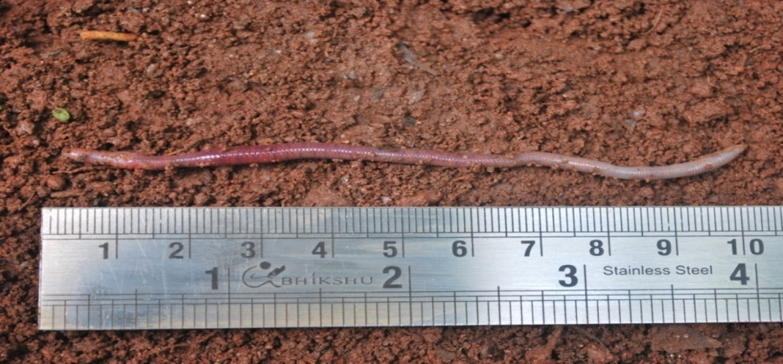

Fig. 8a. Setae (Quincunx type) (Photomicrograph @ 40x)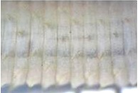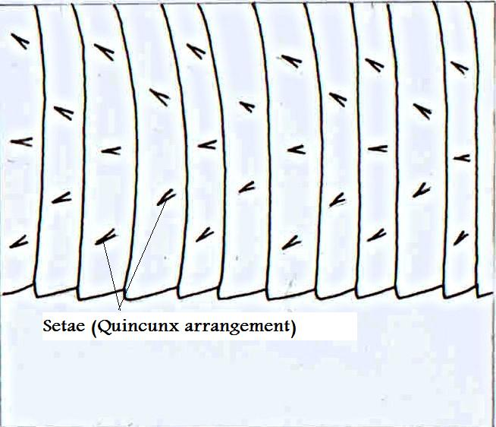

Fig. 8b. Clitellum (Saddle) (Photomicrograph @ 40x)
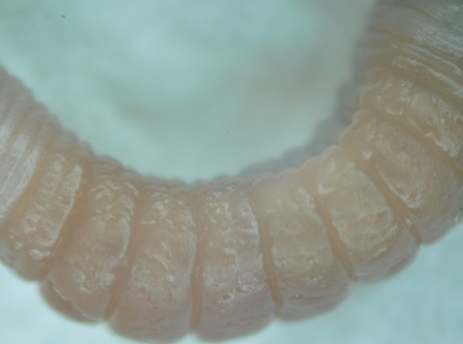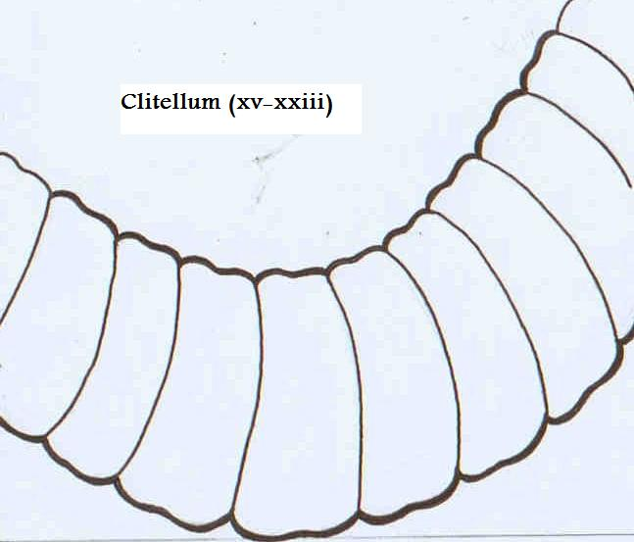
Internal characters
Septa vi/vii-xiii/xiv thickened, the first fairly strongly, the last two gradually less. Single pair of testes in segment xi (metandry), seminal vesicels in xii, extending through viii-x segments. Hearts in vi-xi. Spermathecae very slenderly club-shaped 3 pairs in vii-ix, each small transparent long, ducts slender, non-diverticulum and small ampulla (Fig. 8c). Calciferous glands in vii-ix, prostates glands absent, meganephridial.
Fig. 8c. Spermathecae adiverticulate (Photomicrograph @ 40x)
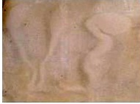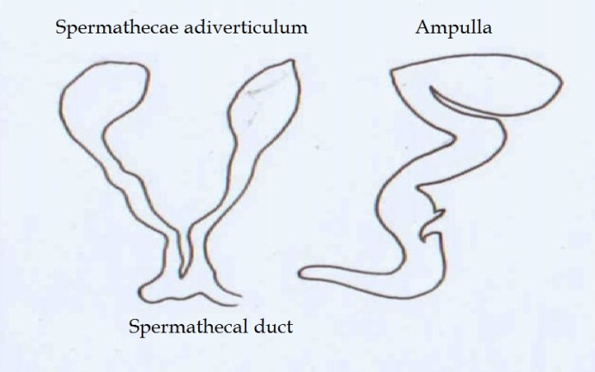
Distribution
Hyderabad, Deccan Andaman Islands, Bombay, Ahmedabad (Western India), Adam's Peak, Peradeniya, Kandy, Colombo, Avissavela, W. Haputale, the W. Province (all in Ceylon now Sri Lanka), Mangalore, Calicut, Tiruvellur, on the Malabar Coast Shimoga (Mysore), Merkara, Madapur, Dubari (Coorg), Coonoor (Nilgiris), Bonaccord, Chimnunga, Shasthancottah, Pallode, Trivandrum, Keruuiaadi, Vellany, Neyyatinkara (Travancore). Outside India the species is circummundane (Stephenson, 1923). In India: Tamil Nadu: Recorded for the first time from Tropical Dry Evergreen Forest of Kolli hill, Eastern Ghats.
Family Octochaetidae Michaelsen, 1900
Hoplocheatella stuarti Bourne, 1886
1886. Perichaeta stuarti, Bourne, Proc. zool. Soc. Lond., 1886: 667.
1923. Hoplochaetella stuarti, Stephenson, Fauna British India, Oligochaeta: p. 468.
1940. Hoplochaetella stuarti, Gates, Rec. Indian Mus., 42: 239.
Material examined: 2 Clitellate animals deposited each @ National Repository Reg. No. ZSI/SRC/Chennai/IN/AN/11 and College Ref. No. CEAT/NMC/MoEF/KH/HS/009; the animals were observed and recorded in Solakkadu, Karavallikombai (11˚32’70”N; 78˚35’01”E; 1200 m a.s.l.) and Velikkadu (11˚14’54”N;78˚20’19”E; 305 m a.s.l.,), Kolli hill, Namakkal District, Tamil Nadu, India, 16 November 2017, M. Murali, D. Selvamuthukumaran, K. Sathis Kumar, and P. Neelanarayanan.

Diagnosis
External characters
Length 111-162 mm (Fig. 9), diameter 3.5-5mm, 110-120 segments. Prostomium epilobous, tongue open. First dorsal pore at 4/5. Clitellum ½ xiii –xvi. Setae perichaetine. Spermathecal pores paired, minute on vii and viii (Fig. 9a). Combined male and prostatic pores, minute, at about centres of somewhat circular and depressed porophores on setal arcs of xvii and xix (Fig. 9b). Genital markings absent.
Fig. 9. A full view of H. stuarti observed in both in Tropical Dry Evergreen and Southern Thorn Forests
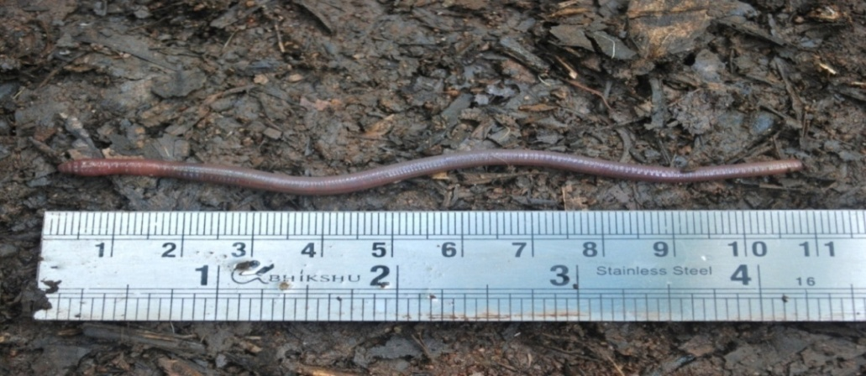

Fig. 9a. Spermathecal pores (on vii and viii) (Photomicrograph @ 40x)
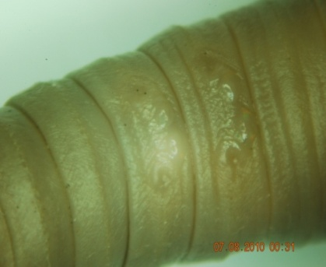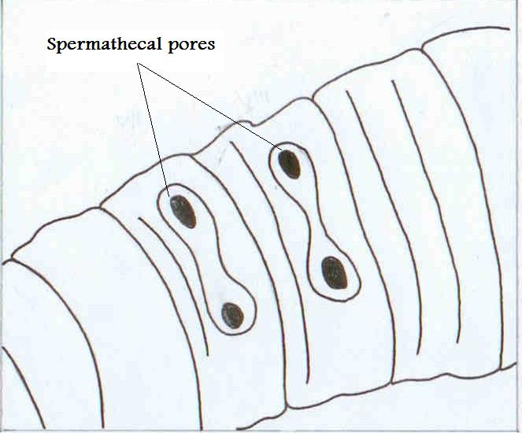
Fig. 9b. Prostatic pores (on xvii and xix) (Photomicrograph @ 40x)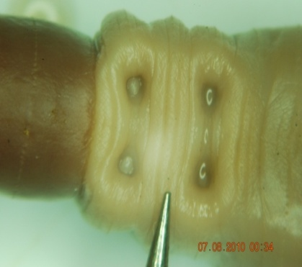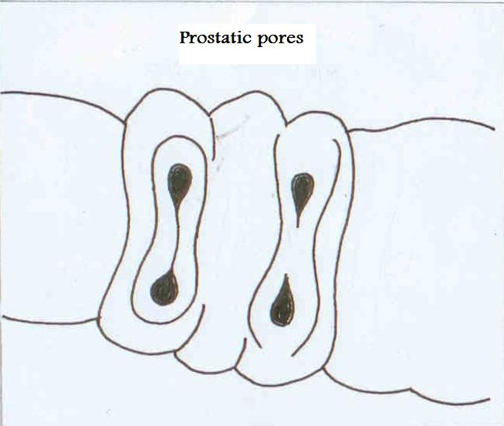
Fig. 9c. Prostate glands (Photomicrograph @ 40x)
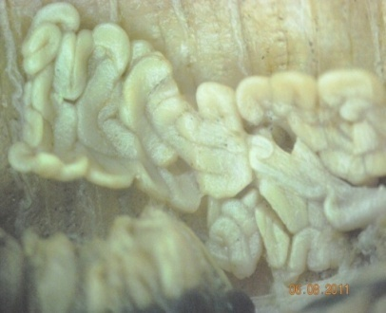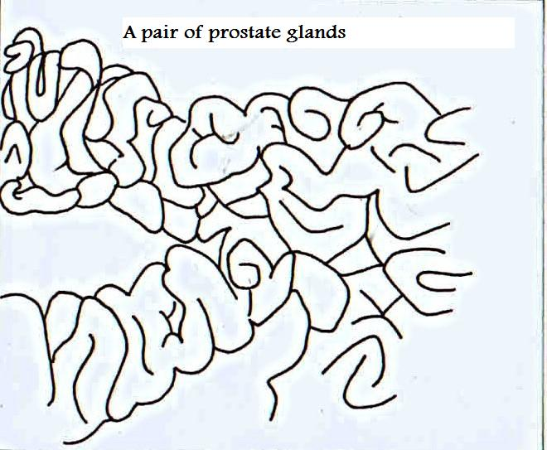
Internal characters:
Septa 4/5, 9/10/11/12 slightly muscular, 5/6 delicate, 6/7/8/9 absent. Gizzard between septa 5/6 and 9/10, belonging to segment vii. Intestinal caeca present, 4 pairs, dorsolateral, in xxv (rudimentrary), xxvi-xxviii; typhlosole xxiv-xxv to lxxxiv-lxxxvi. Supra-oesophageal vessel single, ix-xiii; subneural vessel absent. Last pair of hearts in xiii. Testes and male funnels in x and xi, enclosed in unpaired sacs. Seminal vesicles in ix, x and xii, those of x small. Spermathecae paired, in vii and viii, each with a glove shaped diverticula (Fig. 9c).

Distribution
India: Tamil Nadu: Yercaud (Salem District); Karnataka: Nandhi Hills (Stephenson, 1923, Julka, 1988). In India: Tamil Nadu: Recorded for the first time in the Tropical Dry Evergreen (Karavallikombai Reserved Forest; Altitude 1200 m) and Southern Thorn Forests (Vasalurpatti, Pinnam, Kadambalam and Velikkadu) of Kolli hill, Eastern Ghats.
Habitat: Dense forest, soil with rich organic material.

Eastern Ghats are a discontinuous range of mountains along India’s eastern coast and is older than Himalaya and Western Ghats. However, very meagre earthworm diversity and distribution studies have been carried out in Tamil Nadu regions of Eastern Ghats. Earlier, the data on earthworm distribution is available for the regions like Palani hills, a part of Western Ghats (Jamieson, 1977), Madras (Ismail and Murthy, 1985), parts of Eastern Ghats such as Sirumalai hills (Karmegam and Daniel, 2000a, 2000b, 2001, 2007), and Sathyamangalam division (Ramasamy, 2009).
The present investigation is the first survey of earthworms in Tropical Dry Evergreen and Southern Thorn Forests in Kolli hill Namakkal District, Tamil Nadu a part of Eastern Ghats and it reveals the existence of eight species. All these species, except H. stuarti are reported for first time from Tamil Nadu state, India from these two forest types of Kolli hill, Namakkal District. H. stuarti were already reported from Sathiyamagalam Forest division (Ramasamy, 2009), Yercaud, Salem District (Stephenson, 1923). Stephenson’s (1923) monograph for the descriptions of Indian earthworms became obsolete with the recognition of new taxonomic characters (Gates, 1972; Julka, 1988). Although, Julka (1988) revised the family Octochaetidae, yet we have to depend upon the Stephenson’s (1923) outdated work for the identification of inadequately described species of Drawida and Megascolex which form the dominant elements in the native earthworm diversity of India. According to Stephenson (1923) the Megascolex genus was reported from Sri Lanka, India, Australia and New Zealand. Further, the earthworm viz., D. gracilis is reported for the first time in India as per the checklist of earthworms given by Blakemore (2006).

REFERENCES
Ahmed, S. and Julka, J.M. 2017. First record of exotic earthworm, Amynthas hupiensis (Michaelsen, 1895) (Oligochaeta: Megascolecidae), from India, Megadrilogica, 22(7): 151–154.
Beddard, F.E. 1895. A Monograph of the order Oligochaeta. Clarendon Press, Oxford, 779 pp.
Bisht, R. H., Pandey, D., Bharti, B. and Kaushal, R. 2003. Population dynamics of earthworms (Oligochaeta) in cultivated soil of Central Himalayan Tarai region. Trop. Ecol. 44: 221-226.
Blakemore, R. J. 2006. Checklist of Megadrile Earthworms (Annelida: Oligochaeta) from Tamil Nadu, South India, YNU, Yokohama, Japan.1-12.
Blakemore, R. J. 2010. Cosmopolitan Earthworms – an Eco-Taxonomic Guide to the Peregrine Species of the World. (4th Edn.). VermEcology Solutions, Yokohama, Japan. Pp. 850 +350 Figs.
Choudhuri, P., S. Nath and R. Paliwal, 2008. Earthworm population in rubber plantations (Hevea brasiliensis) in Tripura, India. Trop. Ecol., 49: 225-234.
Gates, G.E. 1959. On a taxonomic puzzle and the classification of the earthworms. Bulletin of
the Museum of Comparative Zoology, Harvard 121(6): 229–261.
Gates, G. E. 1972. Burmese earthworms an introduction to the systematics and biology of megadrile Oligochaetes with special reference of Southeast Asia. Transactions of the American Philosopilical society, Independence square, Philadelphia. 326p.
Gurugnanam, B., K. Kalaivanan and S. Bairavi. 2014. Detailed Geomorphic Mapping using
Remote Sensing & GIS in Kolli Hill, South India. International Journal for Scientific
Research and Development| 2(10): 803–805.
Ismail, S. A. and Murthy, V. A. 1985. Distribution of earthworms in Madras. Proc. Indian Acad. Sci. (Anim. Sci.), 94:556-557.
Jamieson, B. G. M. 1977. Preliminary descriptions of Indian earthworms (Megascolecidae: Oligochaeta) from Plani hills. Bull. Mus. Nat. Hist. Nat. Paris (ser.3) no.450 Zool. 313: 477-502.
Julka, J. M. 1988. The fauna of India and adjacent countries. Megdrile Oligochaeta (Oligochaeta (Earthworms). Haplotaxida: Lumbricina: Megascolecidea: Octochaetidae, Z. S. I., Calcutta, India. 400p.
Julka, J. M. and Paliwal, R. 1993. Collection, Preservation and study of Earthworms. In: Earthworms Resources and Vermiculture. (Ghosi, A. K. (Ed.)). Zool. Surv. India, Culcutta, India. pp.7-11.
Julka, J.M. 2014. Diversity and distribution of exotic earthworms (Annelida, Oligochaeta) in India a review. In. Chaudhuri, P. & Singh, S.M. (Eds.) Biology and ecology of tropical earthworms. Discovery Publishing House, New Delhi, p. 73–83.
Julka, J.M. and Paliwal, R. 2005. Distribution of earthworms in different agro-climatic region of India. In: Ramakrishnan, P.S., Saxena, K.G., Swift, M.J., Rao, K.S. & Maikhuri R.K. (Eds.) Soil Biodiversity, Ecological Processes and Landscape. Oxford and ABH Publications Co. Pvt. New Delhi, p. 3–13.
Karmegam, N. and Daniel, T. 2000a. Utilization of some weeds as substrates for vermicompost preparation using an epigeic earthworm Eudrilus eugeniae. Asian J. Micro. Biot. Env. Sci. 2: pp.63-66.
Karmegam, N. and Daniel, T. 2000b. Abundance and population density of three species of earthworms (Annelida: Oligochaeta) in Foot hills of Sirumalai (Eastern Ghats), India. Indian J. Environ. Ecoplan. 461-466.
Karmegam, N. and Daniel, T. 2001. A first report on the occurrence of a Megascolecidae earthworm, Lampito Kumiliensis (Annelida: Oligochaeta ) in Sirumali Hills of Tamil Nadu, South India. Ecol. Environ. Conserv.7: 115-116.
Karmegam, N. and Daniel, T. 2007. Effect of physicochemical parameters on earthworm abundance: A quantitative approach. J. App. Sci. Res. 3:1369-1376.
Kharkongor, I.J. 2018. Taxonomic and ecological studies on the earthworms (Annelida: Oligochaeta) of West Khasi Hills District, Meghalaya. Records of the Zoological Survey of India, 118(1): 56–74. doi: 10.26515/rzsi/v118/i1/2018/123034.
Mandal, C.K., Hasan, M.N. and Talukder, P. 2017. Octochaetona nurulai sp. nov. (Clitellata: Octochaetidae): a new earthworm from Tamil Nadu, India. International Journal of Advanced Research in Basic Engineering Sciences and Technology, 3(7): 13–17.
Misirlioğlu, M., Reynolds, J., Stojanović, M., Trakić, T., Sekulić, J., James, S., Csuzdi, C., Decaëns, T., Lapied, E., Phillips, H., Cameron, E., and Brown, G. 2023. Earthworms (Clitellata, Megadrili) of the world: an updated checklist of valid species and families, with notes on their distribution. Zootaxa 5255 (1), 417-438. DOI: 10.11646/zootaxa.5255.1.33.
Murali, M. 2012. Diversity of vermin fauna and their ecology in tropical dry evergreen forest, Kolli hill, a part of Eastern Ghats, Tamil Nadu, India. Ph.D. submitted to Bharathidasan University, Tiruchirappalli, Tamil Nadu, India (Unpublished).
Narayanan, S.P., Sathrumithra, S., Christopher, G. and Julka, J.M. 2017. New species and new records of earthworms of the genus Drawida from Kerala part of the Western Ghats biodiversity hotspot, India (Oligochaeta, Moniligastridae). ZooKeys, 691: 1–18. doi: 10.3897/zookeys.691.13174.
Ramasamy, P. K. 2009. Biodiversity of Earthworms in the Eastern Ghats of (Sathyamangalam Division) Tamil Nadu, India and Influence of Vermicompost on growth, yield and Nutritional Status of some selected plants. Ph.D. Thesis, Bharathiar University, Coimbatore, Tamil Nadu, India. (Unpublished).
Reynolds, J.W. and M.J. Wetzel. 2025. Nomenclatura Oligochaetologica – A catalogue of names, descriptions and type specimens of the Oligochaeta. Editio Secunda. URL: https://nomenclatura-oligochaetologica.inh s.illinois.edu (date accessed: 11-05-2025).
Sathis kumar, K., Neelanarayanan, P., & Reynolds, J. W. (2025). Diversity of earthworms from lateritic semi evergreen forest of kolli hill, a part of eastern ghats, Tamil Nadu, India. Megadrilogica. 29 (2).
Sathianarayanan, A. and Khan, A. B. 2006. Diversity, distribution and abundance of earthworms in Pondicherry region. Trop. Ecol. 47: 139-144.
Senapati, B. K. and Sahu, S. K. 1993. Population Biomass and Secondary production in Earthworms. In: Earthworms Resources and Vermiculture. (Ghosi, A. K. (Ed.)). Zool. Surv. India, Calcutta, India. pp. 57-78.
Sims, R. W. and Gerard, B. M. 1985. Earthworms. Keys and notes to the identification and study of the Species. Synopsis of the British Fauna (New series). E.J. Brill, Leiden. 31: 171.
Stephenson, J. 1923. Oligocheta. The fauna of British India including Ceylon and Burma, Taylor and Francis Ltd., London. 518p.
Stephenson, J. 1930. The Oligochaeta. Clarendon Press, London. 978p.
Tripathi, G. And Bhardwaj, P. 2004. Earthworm diversity and habitat preferences in arid regions of Rajasthan. Zoo’s Print Journal 19: 1515-1519.

