Case study

STUDY ON CLINICAL APPLICATION OF EXFOLIATIVE VAGINAL CYTOLOGY IN CANINE REPRODUCTION

.

ABSTRACT
Aim: To study and determine the ovulation time in canines.
Study design: Case Studies.
Place and Duration of Study: Veterinary Clinical Complex, Krantisinh Nana Patil College of Veterinary Science, Shirwal, Satara. September 4th, 2024 to February 26th, 2025.
Methodology: We studied 24 bitches through exfoliative vaginal cytology using Giemsa staining method. Results: In total 24 bitches were studied out of which, natural mating was carried out in 21 bitches whereas in three bitches, artificial insemination with fresh semen was done. Twenty out of 24 bitches were found pregnant upon transabdominal ultrasound one month after mating or artificial insemination. Conclusion: Vaginal cytology increases the conception rates in canine by giving an ideal time for mating.
Keywords: Exfoliative Vaginal Cytology, Dog, Conception, Canine

INTRODUCTION
Infertility in canines arises due to hormonal problems, infectious diseases, congenital or acquired defects of the genital tract. Many a time’s infertility is caused by inappropriate breeding management (Moxon et al. 2012). Veterinarians nowadays are requested to solve problems regarding fertility in canines due to the increased demand for purebred dogs for sentimental or financial reasons (Fontbonne 2011).

The knowledge of the reproductive physiology of the estrous cycle is important for animal management and to determine the reproductive and productive potential of animals (Haji et al.2018). Exfoliative vaginal cytology is a simple technique that can be used by practitioners to help characterize the phases of the estrous cycle and diagnose diseases of the genital tract causing infertility. Assessment of cells at the estrous cycle can help to identify the cause of infertility in canines (Antonov 2017).

Exfoliative vaginal cytology has been used in diagnosing various reproductive stages and in predicting certain abnormal conditions during periparturient and post-partum periods (Kudalkar et al.2020). Vaginal cytology is a simple technique that can be used by practitioners to characterize stages of the reproductive cycle, disease conditions of the genital tract and is a useful tool in determining optimum mating time in bitches (Antonov 2017). It can be an appropriate, least invasive, most economical diagnostic tool (Labib et al. 2018) for differential diagnosis of normal stages of estrus along with any physio pathological deviation of reproductive tracts like pyometra, tumors of the vagina, and various inflammatory changes in the vagina (Llazani et al. 2021; Das and Das 2000). This technique can also be employed to detect uterine malignancies.

Exfoliative vaginal cytology because of its simplicity, accessible equipment, and the possibility of getting rapid results could be used as a valuable technique to any reproductive diagnosis in she-dogs
(Antonov 2017). Vaginal cytology diagnoses physiological and pathological conditions of she-dog reproductive system and can be used in the determination of estrous cycle stages concerning optimal breeding time (Turmalay et al. 2011). Therefore, canine vaginal exfoliative cytology has been proposed as a good alternative to progesterone assay (Bouchard et al. 1991).

The vaginal epithelial cells are classified according to their location in the vaginal mucosa as parabasal, intermediate, superficial cells (Mayor et al. 2005). During proestrus, estrus, and early diestrus, the epithelium and lamina propria are infiltrated with a large number of neutrophils, which eventually escape into the vaginal lumen (Blendiger 2013). Estrus in she-dogs is relatively of longer duration with an average of 9 days. She-dogs accepts males for such a long period and the poor relationship between behavioural characteristic and time of ovulation in she-dogs can lead to difficulties in identifying the optimum mating time (Labib et al. 2018).The fertile period can be predicted by calculating the percentage of epithelial cells, which appear cornified as under the influence of estrogen hormone most of the epithelial cells become cornified during estrus or standing heat (Kusritz 2012). However, Feldman and Nelson (2004) suggested that breeding should be attempted when more than 80 per cent of epithelial cells cornified.

Vaginal cytology can be conveniently used to evaluate the reproductive stages in female dogs. Vaginal smears are characterized by the presence of massive erythrocytes in proestrus, clear background of smear in oestrus, heavy infiltration of polymorphonuclear cells in dioestrus, very few cells mostly parabasal in anestrus, and dirty background in pregnant bitches (Gupta et al. 2012). Haji et al (2018) reported superficial cells to be the largest epithelial cell proportion in the estrus phase. Sharma and Sharma (2016) concluded that vaginal smear during pregnancy is characterized by few intermediate cells, a small number of RBCs, and a moderate to large number of polymorphonuclear cells. For evaluation of vaginal smears, the Giemsa staining method has better cellular characterization as compared to Leishman stain (Venkatesh et al. 2019). However, the modified Shorr staining helps in the clear identification of keratinized and non-keratinized cells based on orange and green color, respectively (Becha and Ghosh 2013).

Therefore, the study was planned to predict the optimum proportion of keratinized cells in exfoliative vaginal cytology for successful conception.

MATERIAL AND METHODS
Determination of ovulation timing in 24 bitches was carried out by using exfoliative vaginal cytology in the Department of Animal Reproduction, Gynaecology and Obstetrics, Teaching Veterinary Clinical Complex, K. N. P. College of Veterinary Science, Shirwal.

Selection of Animals
Total 24 bitches were selected on basis of history of Pro-oestrus bleeding presented in the Department of Animal Reproduction, Gynaecology and Obstetrics, KNP College of Veterinary Science, Shirwal. The details regarding their age, breed, past history of conception, date of vaginal discharge first noticed, feeding habits was recorded. Further, laboratory tests like vaginal cytology and pregnancy diagnosis after 23 to 30 days were performed.

2.2. Collection of vaginal smears
The vulva was cleaned using tissue paper and vulval lips were separated by two fingers followed by sterile cotton tipped swab stick was inserted inside to collect a sample of vaginal cells. The swab was introduced at the dorsal commissure so as to avoid the clitoral fossa. Vaginal smears were collected from mid part of vagina when the swab at its full depth, vaginal mucosa was wiped with a combination of circular, twisting and back and forth motions. Due care was taken to ensure good contact of swab with the vaginal mucosa. The swab was then removed and rolled on clean glass slides and then smears were prepared. Intact cells were obtained during transfer by rolling the swab. Slide of vaginal smear was air dried and stained using Giemsa staining.

Staining techniques
Smear was prepared by inserting sterile cotton swab in vaginal passage and rotating it and the slide was air dried. Stock solution of Giemsa stain was prepared by mixing 0.15 g of Giemsa powder in 12.5 ml of glycerin and 12.5 ml of methyl alcohol. Staining dish was filled with staining solution. Slide was washed and air dried and examined it under microscope under 40X. Results were recorded. Nucleus was blue, basophilic cytoplasm appeared blue, acidophilic cytoplasm appeared slight bluish pinkish

Classification of exfoliative cells in vaginal smears
Exfoliative cells in vaginal smears were classified as per Schmidt (1981)- Anuclear superficial cells, Superficial cells, Intermediate cells, Parabasal cells.
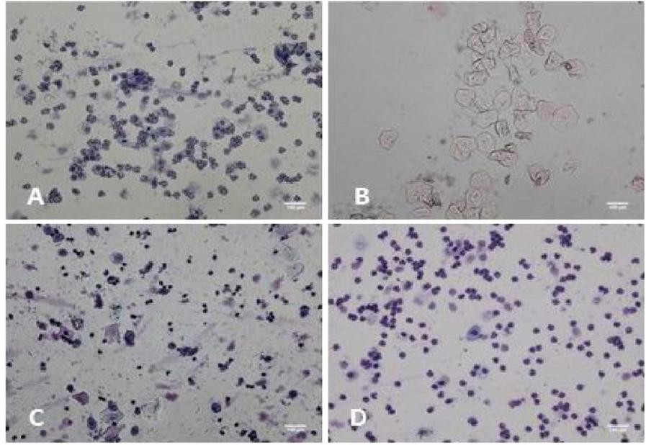

Fig 1. Different cells observed during vaginal cytology of dog.
  - Calculation of Cornification Index (CI)
Cornification Index in percentage was calculated by adding anuclear superficial cells and superficial cells out of 100 cells counted in smear. In present study, pro-oestrus in bitches is described when 70 as suggested by Romagnoli (2006).

Abdominal Ultrasonography
Abdominal ultrasonography was carried out between 23 to 30 days post last mating to diagnose pregnancy in bitches. All the bitches were examined in dorsal recumbency after clipping of hairs, imaging was performed by using Doppler sonography machine. In order to produce image of uterus, the probe was positioned between two rows of mammary glands. Its beam was directed ventro dorsally in front of pubic bones. Initially bladder was located and then uterus was identified below the bladder in the depth of the image. The completely filled urinary bladder was preferred in ultrasound examination, as it acts as acoustic window. Gestational sacs were observed to confirm diagnosis.

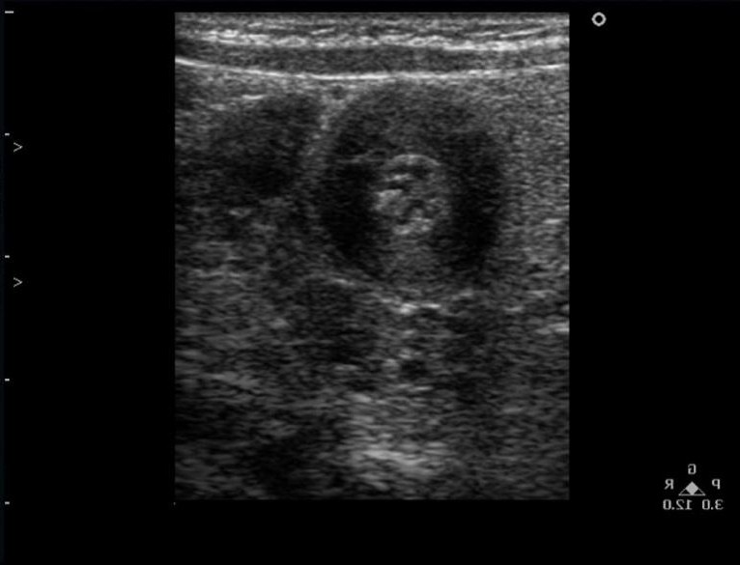
Fig 2. Embryonic vesicles observed during pregnancy detection one month after mating.

RESULTS AND DISCUSSION
The present study was conducted on “Determination of Ovulation Timing by using exfoliative vaginal cytology in Bitches” with an aim to determine ovulation timing and correct date and time for mating in bitches. Total 24 bitches of different breeds were studied at Department of Animal Reproduction, Gynaecology and Obstetrics, KNP College of Veterinary Science, Shirwal. The female dogs presented to Teaching Veterinary Clinical Complex, KNP College of Veterinary Science, Shirwal. Age of bitches ranged from 1.5 - 7 years. Out of 24 bitches 9 bitches had history of not mated previously and 3 bitches with the history of repeat breeding. Age, reproductive history, feeding history, breed and parity were considered. Out of 24 bitches, natural mating was carried out in 21 bitches whereas in three bitches, artificial insemination with fresh semen was done. The observations were recorded in all 24 bitches from pro-estrous onward with regard to the symptoms of behavioural oestrus judged by Vaginal cytology.

In present study ultrasonography was performed one month from the last day of mating to diagnose early pregnancy by ultrasonographic examination of the gestational sac, body and head of the fetus in the pregnant bitches. Fetal heart functioning was also assessed by ultrasonography which indicated the viability of the fetus. Further, non-pregnancies were also confirmed by ultrasonographic examination. Twenty were found pregnant out of 24.
Table 1. Result of pregnancy detection through transabdominal USG one month after mating in different selected dogs.

Sr.No. | Days from Previous Mating / AI | Pregnancy Status | Gestational Length
1 | 32 | Positive | 62
2 | 28 | Positive | 63
3 | 30 | Positive | 61
4 | 32 | Positive | 63
5 | 28 | Positive | 61
6 | 25 | Positive | 64

7 | 35 | Negative | 62
8 | 32 | Positive | 63
9 | 30 | Positive | 62
10 | 28 | Positive | 61
11 | 27 | Positive | 60
12 | 28 | Positive | 61
13 | 34 | Positive | 62
14 | 32 | Positive | 63
15 | 30 | Positive | 62
16 | 28 | Positive | 61
17 | 27 | Negative | 63
18 | 34 | Positive | 62
19 | 32 | Positive | 61
20 | 28 | Positive | 62
21 | 30 | Positive | 63
22 | 32 | Negative | 60
23 | 35 | Positive | 60
24 | 28 | Positive | 63

CONCLUSION

The present study conducted on “Determination of ovulation timing by using different techniques in bitches” at the Department of Animal Reproduction, Gynaecology and Obstetrics, KNPCVS, Shirwal. Total 24 bitches of various breeds were studied from Teaching Veterinary Learning Complex, KNPCVS, Shirwal. All bitches were selected on the basis of history of pro-oestrus bleeding. The study was done by observing and recording the clinical signs, vaginal cytology and after 25 to 35 days ultrasonographic examination for early pregnancy diagnosis. The details of study are summarized.
Vaginal cytology estimation can also be used to detect accuracy of ovulation timing in bitches, Highest percentage of Cornification index and anuclear superficial cells can be used to detect the proper estrous in bitches., Ultrasonographic examination can be used to detect early pregnancy in bitches.

REFERENCES

Alitalio, B.S. (1983) Real time ultrasound pregnancy diagnosis in the bitch. J. Small Anim. Pract., 24:145- 151.

Antonov A. L., J. Dineva and P. Geotgiev (2014) Dynamics of vaginal pH in the bitchduring proestrus and oestrus. Animal and Vterinary Sciences. 2(4) : 101-104.

Antonov, A.L., J. Dineva and P. Geotgiev (2014) Influence of ovarian activity on vaginal electrical resistance in the bitch during proestrus and estrus.

Journal of Mountain Agriculture on the Balkans, Vol. 17, 5,(1070-1086).

Badinard, F. A. and A. Fontbonne (1993) Repeatability of events during successive oestrus periods within bitches: comparison between breeding results and clinical and hornmonal data. J. Reprod. Fertil. Suppl. 47
: 548.

Beijerink, N. (2007) Endocrinology of physiological and progestin-induced canine anoestrus. PhD Thesis. Faculty of Veterinary Medicine, Utrecht University, Netherlands, 176.

Blendinger, K (2007) Physiology and pathology of the estrous cycle of the bitch. 56° Congresso Internazionale Multisala SCIVAC.

Bouchard, G. F., N. Solorzano, P. W. Concannon, R. S. Youngquist and C. J. Beirschwal (1991) Determination of ovulation time in bitches based on teasing, vaginal cytology and ELISA for progesterone. Theriogenology 35(3) : 603-611.

Boyd, J.S., Nicksonda, P. D. Peckersall, J. M. Ferguson, M. J. A. Harvey and J. P Renton (1993) Molecular biological methods for monitoring oocyte maturation and in vitro fertilization in bitches. J. Reprod. Fert (Suppl.)., 47: 231–240.

Cartee, R.E., and P. Rowlers (1984) Preliminary study of the ultrasonographic diagnosis of pregnancy and fetal development in the dog. Am. J. Vet. Res.,45:1259-1261.

Concannon, P. W., W. Hansel and K. Mckentee (1977) Changes in LH progesterone and sexual behaviour associated with preovulatory luteinisation in the bitch. Biol. Repro. 17 : 604-613.

Concannon, P. W. and D. H. Lein (1989) Hormonal and clinical correlates of ovarian cycle, ovulation, pseudopregnancy and pregnancy in dogs. Cited in Current Veterinary Therapy, Ed. X. Edited by Kirk, Small Animal Practice. Saunders. W.B. saunders Co. Philadelphia, USA : (1269- 1281).

Concannon, P.W., G. England, J. Verstegen and C. Linde Forsberg (2002) Recent Advances in Small Animal Reproduction. International Veterinary Information Service., New York, 1-11.

Concannon, P. W. (2010) Reproductive cycles of domestic bitches. ANIREP-4231 : 11.

Concannon, P. W. (2011) Reproductive cycles of the domestic bitch. J. Anim. Reprod. Sci.,124: 200–210.

De Gier, J., H. S. Kooistra and S. C. D. Laanen (2006) Temporal relations between plasma concentrations of luteinizing hormone, follicle-stimulating hormone, estradiol-17 (beta), progesterone, prolactin, and (alpha) – melanocyte stimulating hormone during the follicular, ovulatory, and early luteal phase in the bitch. Theriogenology., 65:1346- 1359.

England, G. C. W. and P. W. Concannon (2002) Determination of the optimal breeding time in the bitch: basic considerations. In : Recent advances in small animal reproduction. Ithaca, NY: International Veterinary Information Service, 2002. Disponible en www.ivis.org. Access on June, 2002.

Goodman, M. (2001) Ovulation timing: Concepts and controversies Vet. Clin. North. Amer. Sm. Anim. Pract., 31:219-235.

Gupta K. A and G. N. Purohit (2001) Use of vaginal electrical resistance (VER) to predict estrus and ovarian activity, its relationship with plasma progesterone and its use for insemination in buffaloes. Theriogenology, 2001, 56, 235-245.

Hase, M., T. Hori, E. Kawakami and Tsuitsui (2000) Plasma LH and progesterone levels before and after ovulation and observation of ovarian follicles by ultrasonography diagnosis system in dogs. J. Vet. Med. Sci.

62(3) : 243-246.

Heape, W. (1900) The sexual season of mammals and the relation of the “prooestrus” to oestrus. Quarterly
Journal of Microbiological Science 44, Part I, pp. 1 – 70.

Ibrahim Aydin, Emarah, Tugba Ozaydin and Dursun Ali Dinc (2011) Determination of the stages of the sexual cycle of the bitch by direct examination. J. Anim. Vet. Adv., 10(15): 1962-1967.

Inaba, T., N. Matsu, R. Shimizu and T. Imori (1984) The use of echography in bitches for detection of ovulation and pregnancy. Vet. Rec., 115:267-277.

Jaller, K., A. Krishnaswamy, V. Chandrashekaramurthy, M. Narayanaswamy and G. Sudha (2017) Study on Conception Rate in Bitches Following Matings at Different Intervals after Optimum Vaginal Cornification. International Journal of Livrstock Research, ISSN :2277. Vol. 7 (6).

Johnston, S.D., M. V Root-Kustritz and P. N. Olson (2001) “In Canine and Feline Theriogenology”.,W.B.Saunders, Philadelphia. pp.16-66.

Kustritz, M.V. (2001) Use of commercial luteinizing hormone and progesterone assay kits in canine breeding management. International Veterinary Information Service., New York, USA.

Kutzler, M. A., H.O. Mohammed, S. V. Lamb and W. V. N. Meyers (2003) Accuracy of canine parturition date prediction from the initial rise in preovulatory progesterone concentration. Theriogenology., 60:1187- 96.

Lenard, Z., B. Hopper, N. Lester, J. Richardson and I. Robertson (2007) Accuracy of prediction of canine litter size and gestational age with ultrasound. Aust. Vet. J., 85:222-5.

Luvoni, G. C. and A. Grioni (2000) Determination of gestational age in medium and small size bitches using ultrasonographic fetal measurements. J. Small. Anim. Pract., 41:294-296.

Oluwatoyin, O., O. E. Ajala, Fayemi and M. O. Oyeyemi (2012) The Oestrous Cycle of the Nigerian Local Bitch. Global Veterinaria., 8 (6): 574-582.

Raskin, R. E. and D. J. Meyer (2001) Atlas of Canine and Feline Cytology. WB Saunders Co. Philadelphia., pp 277-312

Rehm, S., D. J. Stanislaus, and A. M. Williams (2007) Estrous cycle-dependent histology and review of sex steroid receptor expression in dog reproductive tissues and mammary gland and associated hormone levels.

Birth Defects Res B Dev Reprod Toxicol., 80: 233-245.

Romagnoli, S. (2006) Recent advances in canine female reproduction. www.vin.com/proceedings/proceedings

Schaefers-Okkens, A.C. and H. S. Kooistra (2010) Ovaries. In: Clinical Endocrinology of Dogs and Cats. Rijnberk, A. and Kooistra, H.S. (Eds). Schlütersche, Hannover, Germany, 203-234.

Sharma, M and N. Sharma (2016) Vaginal Cytology : An Historical Perspective on its Diagnositic use. Adv. Anim. Vet. Sci. 4(6) : 283-288.

Shille, V.M. and J. Gontarek (1985) The use of ultrasonography for pregnancy diagnosis in the bitch. J.Am.Vet.Med.Asso. 187: 1021-102

Son, C.H., K.A. Jeong, J.H Kim, I. C. Park, S. H. Kim and C. S. Lee, (2001) Establishment of
the prediction table of parturition day with ultrasonography in small pet dogs. J. Vet.
Med. Sci., 63:715-21.

Suyash, V. B. (2002) Studies on management of mating time in bitches by vaginal exfoliative cytology and vagonoscopy. M.V.Sc. Thesis, Veterinary College, University of Agricultural Science.

Taverne, M. A. (1984) The use of linear-array realtime echography in veterinary obstetrics and gynaecology. Tijdschr. Diergeneeskd. 109: 494-506.

Tsutsui, T., T. Hori, N. Kirihara, E. Kawakami and P. W. Concannon (2006) Relation between mating or ovulation and the duration of gestation in dogs. Theriogenology. 66(6-7) : 1706- 1708.

Van-Haaften, B., S. J. Dieleman, A. C. Okkens and A. H. Willemse (1989) Timing of mating of dogs on the basis of blood progesterone concentration. Veterinary Record. 125 : 524-526.

Venkatachalapathy, J.N. (2005) Studies on determination of mating time in bitches. MVSc. Thesis. Veterinary College. KVAFSU, Bidar.

Wehrend, A., K. Von Plato and S. Goericke-Pesch (2013) Exfoliative vaginal cytology in the bitch-- indications, procedure, interpretation. Tierarztl Prax Ausg K Kleintiere Heimtiere.41 (4):267-74.

Wildt, D. E., P. K. Chakraborty, W. B. Panko and S. W. J. Seager (1978) Relationship of reproductive behaviour, serum LH and time of ovulation in the bitch. Bio. of Reprod. 18 : 561-570.

Wright, P.J. and Chu Po-Yin (2001) The Oestrous Cycle of the Bitch: Oestrus Induction and suppression. www.greyhoundvet.co.uk., downloads.

Yener, T. A. T., H. Tunc, H. Asian, Aytan and A. C. Caliskan (2007) Determination of oestrous cycle of the rats by direct examination. Anat.

Histol. Embryo., 36: 75-77.

