ISOLATION AND CHARACTERIZATION OF
COLLAGEN FROM THE CEPHALOTHORAX OF PENAEUS
MONODON

Abstract
This study aimed to examine the yield and properties of collagen protein isolated from the cephalothorax of Penaeus monodon. Collagen underwent analysis using gel electrophoresis. The results indicated that collagen comprises α1 and α2 subunits with corresponding average molecular weights. The investigation into collagen solubility revealed that, in the presence of NaCl, collagen exhibited the greatest relative solubility at 2% NaCl (80.20 ± 4.95%). Conversely, solubility diminished with elevated NaCl concentrations. Additionally, collagen had the maximum relative solubility at pH 3 (91.32 ± 5.14%), with solubility diminishing at elevated pH levels. FT-IR spectroscopy was employed to contrast collagen with a model molecule. Five wavenumbers in the spectrum for model collagen were identified: Amide A (3,406–3,421 cm⁻¹), Amide B (2,916–2,940 cm⁻¹), Amide I (1,639–1,640 cm⁻¹), Amide II (1,539–1,570 cm⁻¹), and Amide III (1,234–1,250 cm⁻¹). The cytotoxic impact on 3T3-L1 cells was evaluated.
Keywords: Collagen, Prawn, SDS-PAGE; FT-IR spectroscopy
Introduction
Collagen derived from prawns is the most abundant type of connective tissue and has several applications in the culinary, medicinal, and photographic fields [1]. One of the most prevalent proteins derived from animals, collagen, is the building block of gelatin, a substance widely used in commercial products. There are nineteen different types of collagens, which make up around 30% of the total protein in most creatures. It may produce insoluble fibers with great tensile strength and has a unique protein sequence [2]. There are many different types of industries that make use of collagen. It has several pharmacological and therapeutic applications, including human tissue engineering for implants, hypertension therapy, osteoarthritis prevention, and the inhibition of angiogenic diseases [3]. Its olfactory and esthetic properties make it a desirable substrate as well [4]. Most notably, its denatured form, gelatin, has found extensive usage in culinary applications [5,6]. The trimetric collagen triple helix is formed by all members of the collagen family, which are identified by domains containing repeats of the proline-rich tripeptide Gly-X-Y [7,8].
Researchers have looked at the functional characteristics of collagens derived from marine sources, such as the skins of both saltwater and freshwater fish, in their quest to find novel collagen sources [9]. serpentine scales [10], brown parallelogram squid skin, red snapper skin, bigeye snapper bones, nile perch skin, squid skin (both juvenile and adult), and paper nautilus skin [5–11]. The skins, bones, and fins of the fish mentioned above are used to extract collagens.
Massive amounts of by-products, which can lead to pollution and unpleasant smells, have been thrown out due to the fast expansion of seafood processing enterprises [1,2]. Therefore, making full use of these by-products, particularly in the manufacturing of value-added goods, is an exciting opportunity for the marine food processing industry to grow and boost producer income [3,4]. One such promising application is the extraction of collagen from seafood sources, which provides an excellent alternative to mammalian collagen, especially for consumers with dietary or religious restrictions [5,6]. Fish-derived collagen has shown superior biocompatibility and functionality, making it suitable for biomedical, cosmetic, and food-related applications [7,8].
Ideal for pond cultivation and fetching premium rates, Penaeus monodon (the giant tiger prawn) is the most economically significant and largest penaeid species, measuring 270 mm in length and 260 g in weight [9]. This species is distributed across the Indian Ocean and western Pacific (Indo-West Pacific), ranging from east and southeast Africa to northern and eastern Australia [10]. The aim of this work was to extract and analyze collagen from Penaeus monodon, leveraging the potential of aquaculture waste utilization for sustainable bioproduct development.
Materials and Methods
Sample: Penaeus monodon exoskeleton waste was collected from the Kovalam fish market. Encased in polythene bags and taken to the lab on ice, the samples were carefully transferred. The sample was rinsed with distilled water to eliminate any dust and microbial particles and stored in a freezer.
Isolation of Collagen: The prawns were defrosted in running water, then their antennae and rostrum were removed, and their wet weight was measured. To eliminate any remaining contaminants, it was treated three times with 0.8% mol/L sodium chloride in a 1:6 (w/v) ratio for 10 minutes each time. Afterwards, the salinity was reduced by washing it with cool distilled water. To further eliminate non-collagenous proteins and inhibit the activity of endogenous proteases, the sample was alkali-treated for three days with 0.1 mol/L sodium hydroxide in a 1:10 (w/v) ratio. After that, it was rinsed with cold distilled water to reduce its alkalinity. Using a homogeniser, the material was now uniformly mashed into minute bits. Acid-soluble collagen (ASC) was made by soaking collagen in 0.5 mol/L of acetic acid for three days, which is one way to extract collagen using acid treatment techniques. The fluid was subsequently spun in a centrifuge at 9000 rpm for 20 minutes at 4°C. After collecting the supernatant, it was salted for 24 hours at 4°C using 2 mol/NaCl. After the solution separated into its component collagen, it was centrifuged again at 9000 rpm for 20 minutes at 4°C to remove any remaining precipitate. After being dialyzed for three days in a phosphate buffer with a concentration of 0.02 mol/L and a pH of 7.2, the residue was dialyzed again for two days in acetic acid with a concentration of 0.05 M according to the method of Kittiphattanabawon et.al. (2005) [4] with slight modification. In preparation for future testing, the materials were lyophilized and frozen. The SDS- PAGE analysis verified that the sample was collagen.
Yield of Collagen: The following formula was used to estimate the collagen yields based on the dry weight [11]
Collagen Yield (%) = (Weight of Raw Material / Weight of Extracted Collagen) ×100
SDS-PAGE: SDS-PAGE was performed by the method of Laemmli [12]. To get a final concentration of 2 mg/mL, the collagen sample was dissolved in 0.5 M acetic acid and incubated at 85 ◦C for 1 hour. To get rid of the insoluble, the mixture was spun in a centrifuge at 5,000×g for 5 minutes at 25 ◦C. debris. The liquid above the sediment was combined with the 2×buffer for loading samples (60 mM Tris-HCl, in a 1:1 (v/v) ratio, with a pH of 8.0, 25% glycerol, 2% SDS, and 0.1% bromophenol blue. A 7.5% resolving gel and a 4% stacking gel were used for the SDS-PAGE. Gels were destained after electrophoresis and stained with 0.1% (w/v) Coomassie blue R-250. Triplicates of each test were run.
Ultraviolet-Visible Spectroscopy (UV-Vis) Scanning: At wavelengths ranging from 190 to 400 nm, the UV absorption spectra of collagen were measured and recorded with a spectrophotometer. Acquiring a concentration of 0.05% (m/v) was accomplished by dissolving the isolated collagen in acetic acid at a concentration of 0.5 M [13]
Amino acid Analysis: Collagen was hydrolysed in 6N HCl at 1200C for 24h. Filtering the test tubes was done using Whatman No. 1 filter paper after cooling. Rinse and filter the tubes with distilled water. The filtrate was evaporated using a vacuum flash evaporator. Then deionized water was poured into the tubes and evaporated until acid-free. After three cycles, the free amino acids were diluted in 0.05M HCl, filtered using a 0.45 micro syringe, and fed into Shimadzu HPLC [14].
pH and salt solubility analysis: The pH and salt solubility of starfish collagens were measured using the Jongjareonrak et al. (2005) [15] method. Collagen solutions were produced in 0.5 M at concentrations of 3 and 6 mg/mL. The pH of 8 mL of collagen solutions (3 mg/mL) was changed to 1-10 using 6 N NaOH or 6 N HCl. The sample solution was produced up to 10 mL using distilled water that had been pH-adjusted to match the collagen solutions. To evaluate salt solubility, 5 mL of collagen solutions (6 mg/mL) in 0.5 M acetic acid were combined with 5 mL of cold NaCl in acetic acid of varying concentrations, yielding final NaCl concentrations of 1, 2, 3, 4, 5, and 6 % (w/v). pH and salt solubility samples were gently mixed at 4°C for 30 minutes before centrifugation at 10,000 × g for 30 minutes.
Fourier Transform-Infrared Spectroscopy (FT-IR): Third-generation infrared spectrometers, or FTIR spectrometers, maintain the fundamental absorption values of different compounds in order to determine the chemical's functional group. We primarily employed infrared absorption spectroscopy at wave numbers ranging from 4000 to 400 cm-1 because organic compounds and phytochemicals are frequently absorbed at these frequencies. FT-IR can be classified into two broad categories: functional group and fingerprint. Functional group regions are found at wavenumbers ranging from 4000 to 1600 cm-1, whereas fingerprint regions are found below 1600 cm-1. [16]
Scanning Electron Microscopy (SEM): Scanning electron microscopy was utilised to examine the morphology and microstructure of collagen [17]
Determination of collagen (Sircoll assay): In order to (prevent airborne contamination), place one drop of sample onto a glass slide and let it dry overnight. 0.25% PSR solution that was newly made. Apply a single drop of the dried sample's 0.25% PSR solution. Take an hour off from the slide. One to two drops of acidified water should be applied to the stained substrate after an hour. Cover the soiled area with a cover-slip. Use a wipe to gently remove any extra liquid. Place the stained slide under a microscope for analysis based on (Lareu RR 2010) [18]
Cytotoxicity Assay: The sample's cytotoxicity was assessed on the 3T3-L1 cell line using the MTT assay (3-(4,5-dimethylthiazol-2-yl)-2,5-diphenyltetrazolium bromide assay) as described by Mossman in 1983 [19]. The cells were placed in 96-well microplates with a seeding density of 1 x 106 cells per well. They were then incubated at a temperature of 37°C for a duration of 48 hours in a CO2 incubator with a concentration of 5%. During this time, the cells were allowed to develop until they reached a confluence of 70-80%. Subsequently, the medium was substituted and the cells were exposed to varying quantities of the sample and incubated for a duration of 24 hours. The untreated (control) and treated cells were examined for morphological changes using a digital inverted microscope at a magnification of 20X. The observations were made and photographs were taken after 24 hours. Next, the cells were rinsed with phosphate-buffered saline (PBS) at a pH of 7.4. Then, 20 μL of a solution containing 5 mg/mL of MTT in PBS was added to each well. The plates were thereafter placed at a temperature of 37ºC in a dark environment for a duration of 2 hours. The formazan crystals were dissolved in 100 μL of dimethyl sulfoxide (DMSO) and the absorbance was measured using spectrometry at a wavelength of 570 nm. The percentage of cell viability was determined by applying the formula,
Cell viability (%) = (Absorbance of sample / Absorbance of control) X 100
Results and discussion
Collagen yield: Wet, 500gm of prawn head were utilized to extract collagen from Penaeus monodon. Collagen, after lyophilisation, was found to be a soft, pale gray fibrous material. The yield from ASC was 25%.
SDS-PAGE: The molecular weight of extracted collagen from Peanaeus mondon was determined using SDS-PAGE. Both proteins exhibited comparable electrophoretic patterns to type I collagen, characterized by two separate α chains, indicating similar protein mobility. The electrophoretic patterns of α chains and the molecular weight of collagen consisted of a 105 kDa α1 chain and a 96 kDa α2 chain, respectively, are shown in Fig.2
Ultraviolet-Visible Spectroscopy (UV-Vis) Scanning: Ultraviolet spectra provide a fundamental, simple method for characterising collagen. Collagen is extracted from Penaeus monodon and commercially accessible collagen is obtained. The results showed that the highest levels of collagen were found at wavelengths of 230 nm and 232 nm for collagen generated from Penaeus monodon and commercially available collagen, respectively, are shown in Fig.1
Amino acid Analysis: The amino acid composition of collagen samples obtained from Penaeus monodon. Glycine (Gly) was the most common amino acid discovered in all collagen samples, followed by glutamic acid (Glu) and proline. This is owing to collagen's unique amino acid sequence, which includes glycine at every third residue (Jongjareonrak et al., 2005). The amino acid sequence of collagen subunits is Glycine-X-Y, where X is variable but commonly proline and Y is variable but often filled with hydroxyproline (Abdollahi et al., 2018). This result was consistent with the glycine concentration of collagen from the skull of Penaeus monodon in Table 1.
pH and salt solubility analysis: pH has a considerable effect on collagen solubility, with the lowest solubility occurring at the isoelectric point (pH 5). Beyond this pH, charge repulsion between protein chains improves water interaction, which increases solubility. NaCl concentrations also impact solubility, with larger ionic strengths lowering solubility owing to aggregation.
FTIR: The FTIR spectrum of collagen extracted from Penaeus monodon shows numerous important absorption bands that are specific to the protein's structural components. The Amide A band at 3300 cm⁻¹ represents the N-H stretching vibrations of the peptide bonds, demonstrating the presence of hydrogen bonds between collagen polypeptide chains. The broadness of this peak indicates substantial hydrogen bonding, which is required to stabilize the collagen triple helix. The Amide B band (around 2920 cm⁻¹) is caused by asymmetric stretching of C-H bonds from aliphatic groups (CH₂ and CH₃), indicating the existence of hydrocarbon chains in collagen molecules. The Amide I band, about 1650 cm⁻¹, indicates the C=O stretching vibrations of the peptide backbone. The strength and location of this band indicate that the collagen's secondary structure, namely the α-helix, was well-preserved in the isolated sample. The Amide II band, at 1550 cm⁻¹, originates from N-H bending and C-N stretching vibrations, showing interactions within the protein backbone. This band verifies the presence of collagen polypeptide chains, as well as the hydrogen bonding network required to preserve the triple helix shape. The Amide III band at 1240 cm⁻¹ is caused by complicated interactions between C-N stretching and N-H bending vibrations. It indicates the protein's triple-helical shape as well as its overall secondary structure. The fingerprint area (900-1200 cm⁻¹) shows several peaks for C-H bending and C-O stretching, perhaps indicating the presence of polysaccharides or carbohydrate residues as impurities or associated molecules in the collagen sample. These main absorption bands, when combined, offer a full perspective of the structural properties of collagen in the isolated sample from Penaeus monodon. The banks are shown in figure (3).
SEM: The scanning electron microscopy (SEM) analysis of collagen extracted from the Penaeus monodon head reveals its generally well-preserved fibrous and porous appearance. Under low magnification, collagen looks like a porous sponge-like matrix with a web of interwoven fibrils. The porosity, with pore widths varying from 1 µm to 10 µm, might be useful in biomedical uses such as tissue scaffolding and wound healing projects. Here, water absorption and permeability are of utmost importance. As one moves up the magnification scale, one can see the fibrils' unique D-periodic banding pattern. Fibril diameters ranging from 50 nm to 200 nm are in agreement with those of marine collagen, indicating that the collagen's structural integrity was maintained during extraction. Parts of the sample are rather smooth, while others are quite rough; this might be due to the presence of non-collagenous proteins or residual impurities. The SEM data validates the natural shape and structural features of Penaeus monodon collagen, making it a promising material for a range of biological and industrial purposes.
Sircoll assay: The Sirius Red (PSR) assay was performed to assess the presence and distribution of collagen in the isolated sample from Penaeus monodon with a 0.25% PSR staining solution. Following the overnight air-drying of the material on a glass slide, the application of the PSR solution resulted in pronounced red staining, signifying the presence of collagen fibrils. Microscopic analysis of the stained slide, following the application of acidified water, revealed that the collagen fibrils displayed pronounced birefringence and a vivid red hue, indicative of Sirius Red binding to the triple-helical configuration of collagen. The red staining exhibited uniformity across the sample, validating a well-preserved collagen matrix. The vibrancy of the red hue indicates a substantial collagen concentration in the extracted substance.
Cytotoxic Assay: The cytotoxicity of isolated collagen was assessed by a cell viability experiment, testing various doses of collagen (from 20 to 100 µg/mL) against control cells. Absorbance values were measured at 570 nm, and cell viability was determined relative to the control group (established at 100%). The findings indicate a dose-dependent reduction in cell viability corresponding to the increasing concentration of collagen. At the smallest quantity (20 µg/mL), cell viability was maintained at 98.63%, signifying little cytotoxic effects. A progressive decline in cell viability was seen with increasing concentration. At 40 µg/mL, vitality decreased somewhat to 97.26%, and further declined to 94.94% at 60 µg/ml. At 80 µg/mL, cell viability significantly declined to 90.82%, indicating a considerable cytotoxic impact at elevated collagen concentrations. The highest concentration evaluated, 100 µg/mL, yielded a cell viability of 88.25%, demonstrating a notable decrease in cell viability while remaining over 80% shown in Table 2, Fig.6&7
Conclusion: Collagen from the head of Penaeus monodon has been effectively extracted. SDS-PAGE analysis verified that the isolated collagen contains α1 and α2 subunits. The solubility of collagen in various pH and NaCl concentrations was examined. The FT-IR spectra of the collagen species Penaeus monodon had significant bands identified as amides A, B, I, II, and III. Collagen from Penaeus monodon might be a viable source of mammalian collagen for biomedical and pharmaceutical uses in industries such as food, medicines, nutraceuticals, and cosmetics.

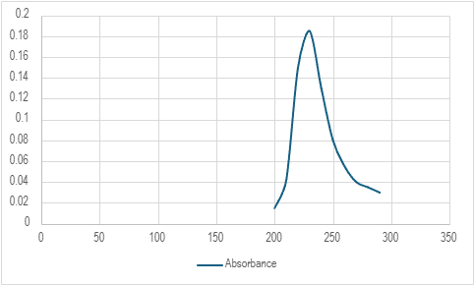
Fig.1 Ultraviolet spectra of Penaeus monodon head collagen
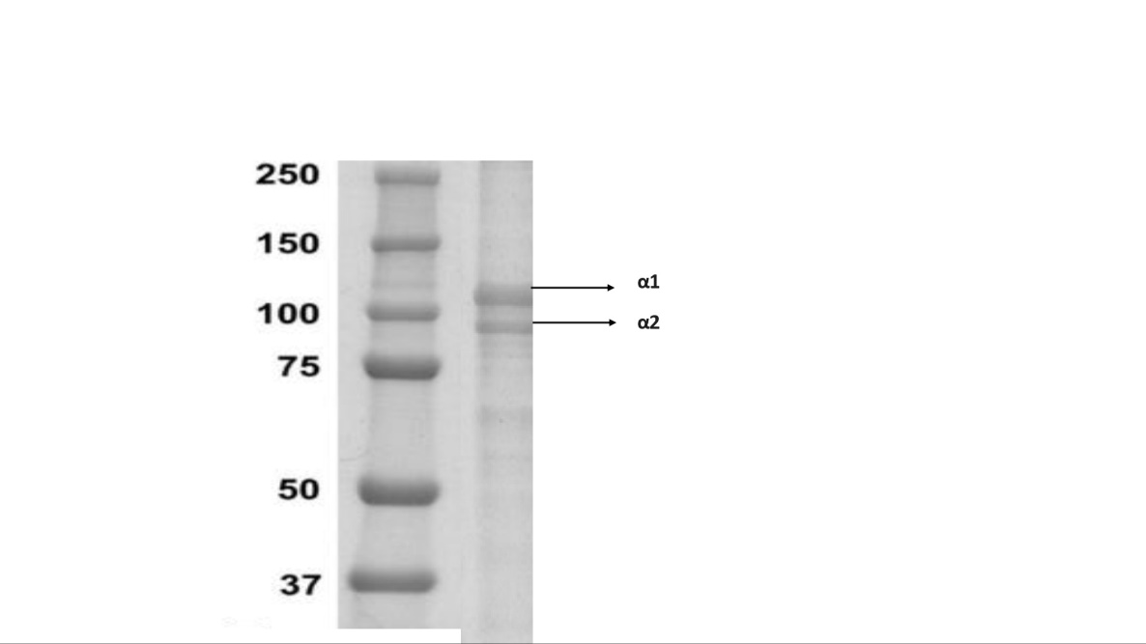
1 2
Fig.2 SDS-PAGE profile of 1: Type 1 Collagen;2: Collagen from Penaeus monodon
Table 1: Amino acid compositions of Penaeus monodon
Amino acid | %
Hydroxyproline | 6.41
Aspartic acid | 3.95
Threonine | 2.49
Serine | 3.41
Glutamic acid | 6.81
Proline | 10.45
Glycine | 17.58
Alanine | 9.68
Valine | 2.11
Methionine | 1.29
Isoleucine | 1.15
Leucine | 2.14
Tyrosine | 0.35
Hydroxylysine | 1.16
Lysine | 2.63
Histidine | 0.79
Arginine | 9.90

Table.2: Percent viability of the cells treated with various concentrations of extracted collagen
Concentrations (µg/mL) | Cell Viability (%)
Control | 100
20 | 98.62778731
40 | 97.25557461
60 | 94.93996569
80 | 90.82332762
100 | 88.25042882

Fig.3 FTIR Spectra of collagen sample extracted from Penaeus monodon
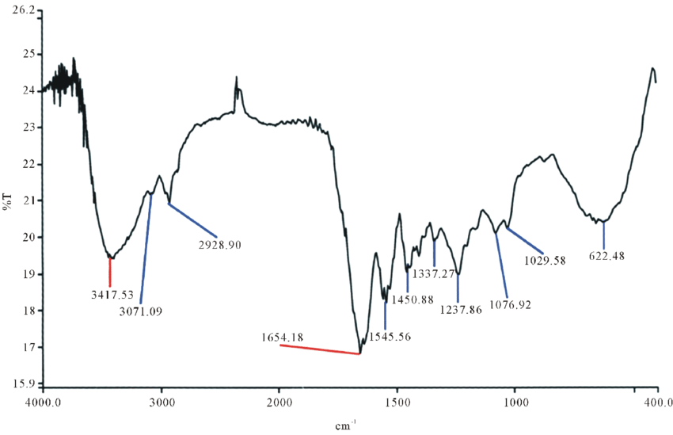Fig.4 FTIR Spectra of Commercial collagen

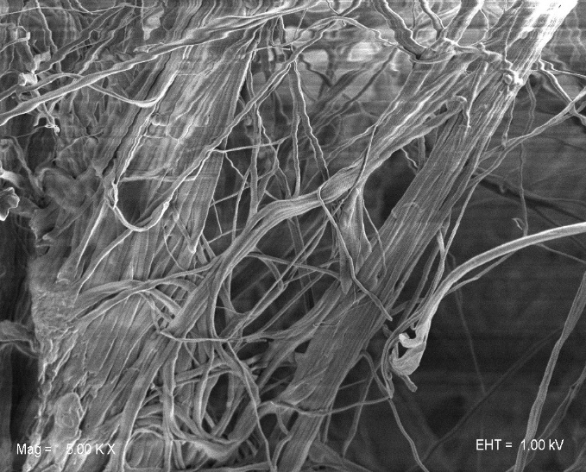
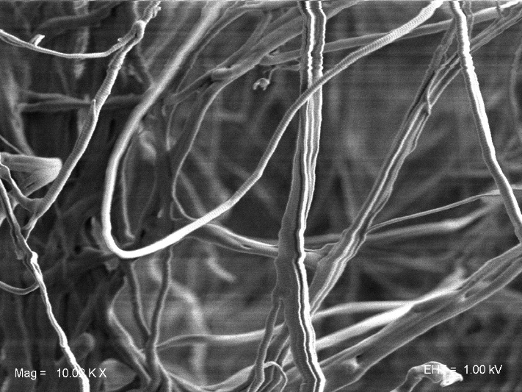
(a) (b)
Fig.5 Scanning Electron Microscopy images of Penaeus monodon
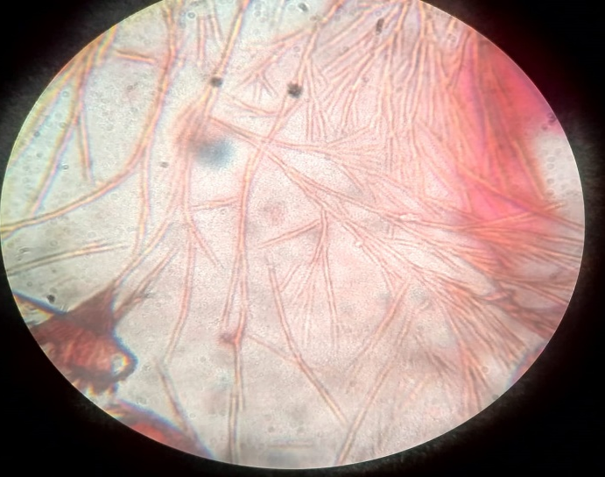
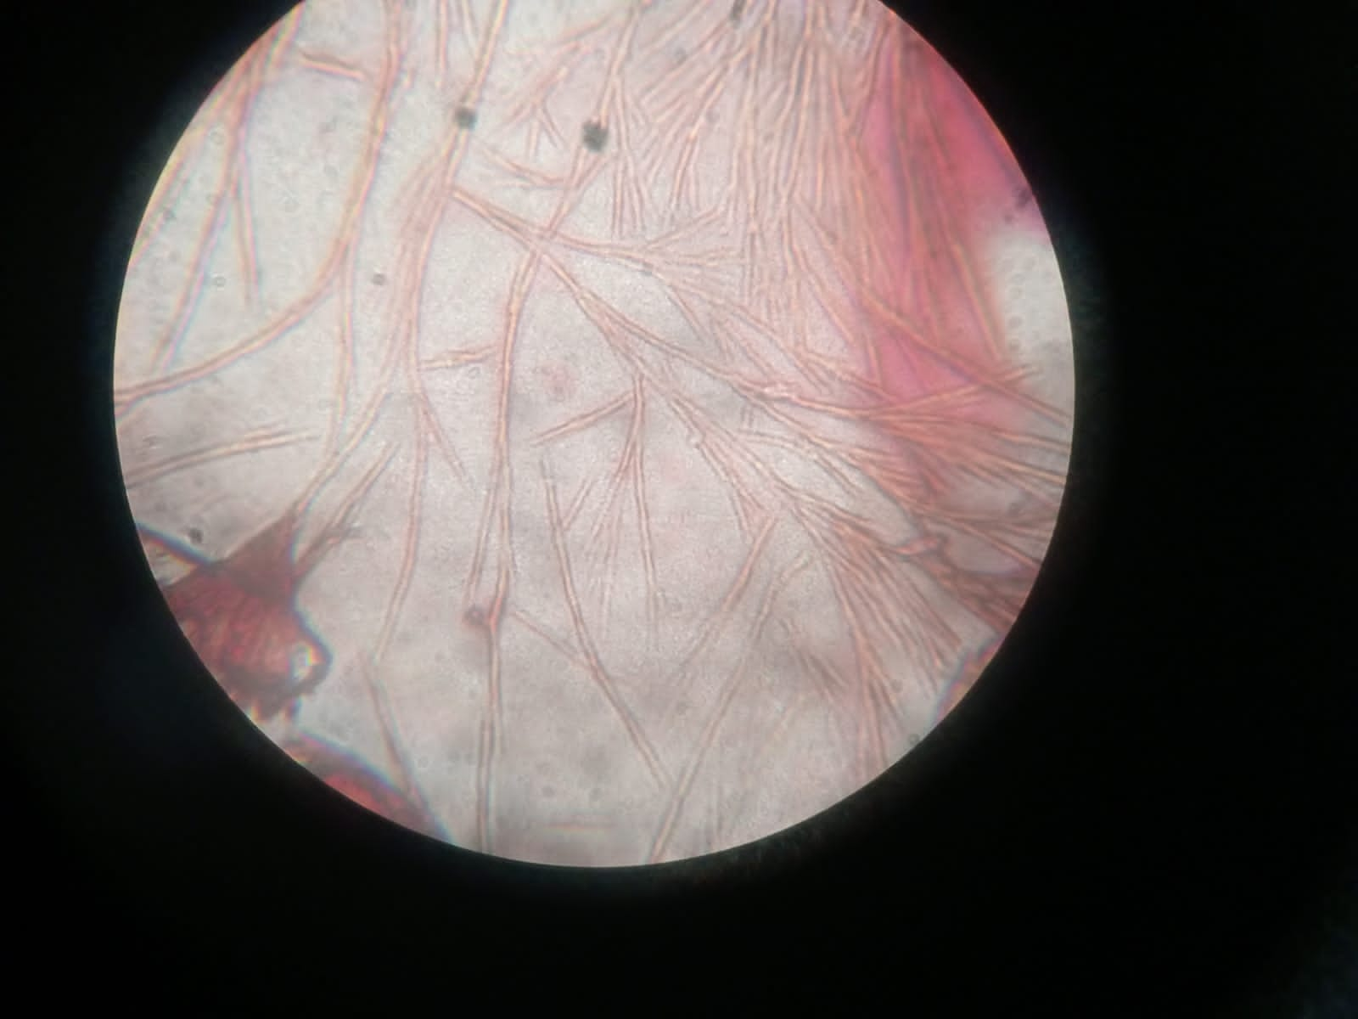
(a) (b)
Fig.6 Sircoll assay shows fibre on (a) commercial collagen and (b) extracted collagen

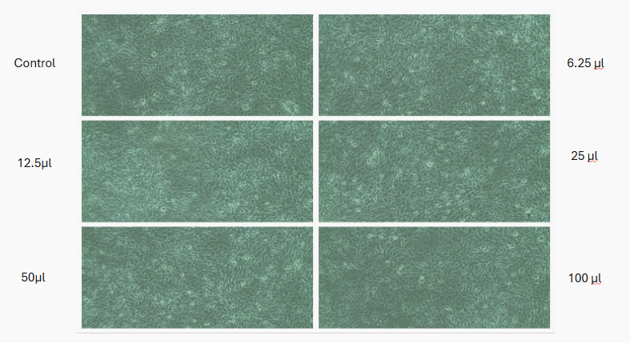
Fig.7 The effect of extracted collagen on 3T3-L1 cell line viability was analyzed by MTT assay and the test compound didn’t show high toxicity
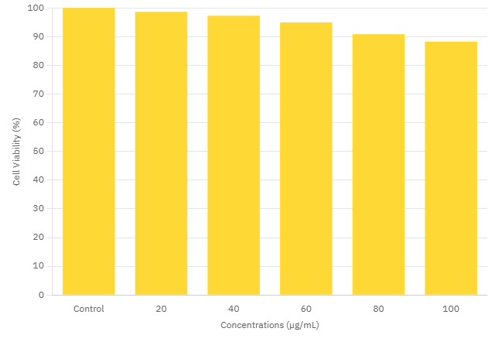
Fig.8 The effect of Penaeus monodon on 3T3L1 cell line viability as determined by 3-(4,5-dimethylthiazol-2-yl)-2,5-diphenyltetrazolium bromide assay method. Each bar graph represents percentage viability of the 3T3L1 cell line against control, 20, 40, 60, 80, and 100 μg/mL concentrations of Penaeus monodon extract after 24h exposure. The data were shown as mean ± standard deviation of triplicate experiments
Reference
- Nagai T, Suzuki N. Isolation of collagen from fish waste material—skin, bone and fins. Food Chem. 2000;68(3):277–81.
- Arvanitoyannis IS, Kassaveti A. Fish industry waste: treatments, environmental impacts, current and potential uses. Int J Food Sci Technol. 2008;43(4):726–45.
- Gómez-Guillén MC, Giménez B, López-Caballero ME, Montero MP. Functional and bioactive properties of collagen and gelatin from alternative sources: A review. Food Hydrocoll. 2011;25(8):1813–27.
- Kittiphattanabawon P, Benjakul S, Visessanguan W, Shahidi F. Isolation and characterization of collagen from the skin of brownstripe red snapper (Lutjanus vitta). Food Chem. 2005;93(3):475–84.
- Haug IJ, Draget KI, Smidsrød O. Physical and rheological properties of fish gelatin compared to mammalian gelatin. Food Hydrocoll. 2004;18(2):203–13.
- Badii F, Howell NK. Fish gelatin: structure, gelling properties and interaction with egg albumen proteins. Food Hydrocoll. 2006;20(5):630–40.
- Muyonga JH, Cole CG, Duodu KG. Characterisation of acid soluble collagen from skins of young and adult Nile perch (Lates niloticus). Food Chem. 2004;85(1):81–9.
- FAO. The State of World Fisheries and Aquaculture 2022: Towards Blue Transformation. Rome: Food and Agriculture Organization of the United Nations; 2022.
- Lavilla-Pitogo CR, Primavera JH, Cruz-Lacierda ER, de la Peña LD. Diseases of Penaeus monodon (Fabricius) in the Philippines. Aquaculture. 1990;89(3-4):273–88.
- Nair CM, Salin KR, Nandakumar G, Raju MS. Species diversification in Indian aquaculture with special reference to Penaeus monodon and Litopenaeus vannamei: A review. Aquac Int. 2013;21(1):1–20.
- Zhang, M., Liu, W., Li, G., & Shi, B. (2009). Isolation and characterization of collagens from the skin of largefin longbarbel catfish (Mystus macropterus). Food Chemistry, 115(3), 826–831.
- Laemmli UK. Cleavage of structural proteins during assembly of head bacterriophage T4. Nature. 1970; 277:680–5.
- Zhang F, Xu S, Wang Z, Zhao Y, Wang X. Isolation and characterization of collagens from skin, scale, and bone of deep-sea redfish (Sebastes mentella). Mar Drugs. 2020;18(10):508.
- Ishida, Y., Fujita, T., & Asai, K. (1981). New detection and separation method for amino acids by high-performance liquid chromatography. Journal of chromatography A, 204, 143-148.
- Jongjareonrak, A., Benjakul, S., Visessanguan, W., Nagai, T. and Tanaka, M.: Food Chem., 93: 475-487 (2005).
- Stuart B. Infrared Spectroscopy: Fundamentals and Applications. John Wiley & Sons; 2004.
- Kittiphattanabawon P, Benjakul S, Visessanguan W, Shahidi F. Comparative study on characteristics of gelatin from the skin of brownbanded bamboo shark and blacktip shark. Food Hydrocoll. 2010;24(2-3):164–71.
- Lareu, R. R., Zeugolis, D. I., Abu-Rub, M., Pandit, A., & Raghunath, M. (2010). Essential modification of the Sircol Collagen Assay for the accurate quantification of collagen content in complex protein solutions. Acta biomaterialia, 6(8), 3146-3151.
- T. Mossmann, Rapid colorimetric assay for cellular growth and survival: application to proliferation and cytotoxicity assays, J. Immunol. Methods. 65 (1983): 55–63.

