Understanding the survival mechanism of Chilo partellus (Swinhoe, 1885) against application of insecticides on maize crop in natural condition

ABSTRACT
Chilo partellus (Swinhoe, 1885) is the major notorious insect pest that are infesting and demanding the maize crop in India and globally. It resulting 15-55% of crop loss and infested corn-cob resulting 25-50% of economical loss. Now a day’s the population of Chilo partellus is increasing rapidly and application of insecticide and pesticides are resulting not so effective in control of said insect pest. To understand reason behind it, this study has been done in two different (1st: - Controlled by hand picking method, 2nd: - Not controlled by hand picking method) maize farming piece of land about 2500m² each. Use seed type was HQPM-1 and the application of insecticides as farmer implicated before. The research revealed that the Chilo partellus were completed its life cycle in 30-38 days. Most of the said pest lay eggs near whorl of plant and newly hatched larvae enter in tassel tube or corn–cob by boring whorl. After entering in tassel tube or corn- cob they remain safe against application of insecticide, pesticide and predational pressure. After completing larval growth and development pupation also occurs inside tassel–tube or corn-cob. It provides a safe place of survival for chilo partellus. The condition of survival inside tassel–tube or corn–cob resulting non- effective application of insecticides and population increase of chilo partellus in maize farming areas. In the controlled piece of land in addition with application of insecticides hand picking method was applied and total 374 larvae (1st, 2nd, 3rd, 4^{th,} 5th in star), 63 pupae of Chilo partellus and 94 larvae (2nd, 4th 5th in star) of Spodoptera litura were eradicated in whole experimental duration. The minimum number of larvae was 2nd the maximum number of larvae was 10 in each tassel–tube or corn-cob husk. In the 2nd piece of land only application of insecticide is used and it resulting infested corn-cob, plant mortality, plant stem damage and low market value or produced maize crop.
Key words: - Corn-cob, Economical losses, infestation, Tassel-tube.

Introduction: -
Insect pest infestation is the major biotic factor for production of most important cereal crop maize after wheat and rice grown virtually in suitable agricultural areas in India. It has been referred as the “Queen of cereals” due to its highest yield potential among all the cereals (Ali et al, 2014). Bihar is sixth of the largest maize growing state of meet food needs for a long time as poultry feed (51%), human food (23%), animal feed (12%), industrial starch products (12%), beverages and seeds (2%). In India maize crop attacked by 139 species of insect pests showing serious damage till harvesting to storage. Among the various insect pests chilo partellus is the most destructive contributing 80-90% of the total damage in Kharif and Rabi season. Maize is most vulnerable to Chilo partellus (Lepidoptera: Crambidae) which causes severe losses to it (Songa et al. 2001). A loss of 24-75% has been reported by the attack of this pest alone (Kumar and Mihm, 1995, 1996, Kumar, 2015). C. partellus has a wide variety of hosts. It occurs together with other stem borer species and in maize their infestation resulting up to 80% of yield losses depending on the cultivar planted, development stage of plant, infestation rate, larval instars and environmental conditions. The most damaging state of chilo partellus is 3rd to 4th Instar larval stage. The 1st instar larvae feed on the surface of tender leaves and then bore through whorl and enter into tassel – tube or corn- cob. As the caterpillar enter into tassel–tube they start feeding tassel particles and complete larval development and pupation Inside. As the tassel–tube start opening before Pupation of mature caterpillar. It moves downward and enter in corn–cob through husk and panicle. Entering in the tassel –tube or corn-cob provide a safe place against insecticides, pesticides and predation pressure to C. partellus for development and survival. Meti et. al., (2014) reported that rainfall and relative humidity showed positive correlation. Mallapur et. al, (2012) revealed that the infestation of stem borer varied during different months. The highest infestation (19.22%) was recorded in the month of August.
Many scientists have been worked and some are still working upon infestation control of C. partellus and its management in laboratorial controlled condition but no work have done to understand the survival mechanism of said pest against application of insecticides in natural condition. In natural condition, that larvae are affected by natural enemy, temperature fluctuation, food scarcity that decrease the rate of population density of the C. partellus.
Taking into consideration of economic losses due to C. partellus, it is necessary to understand the survival mechanism of chilo partellus against application of insecticides on maize crop in natural conditions.
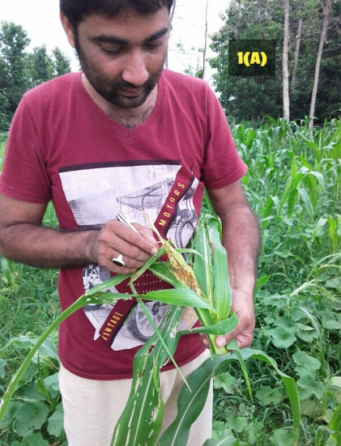
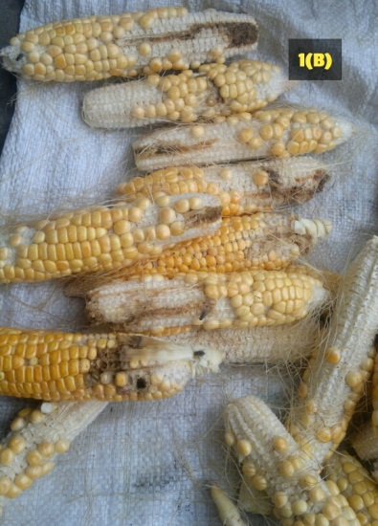

Figure: - 1 (a): Showing infestation of tassel–tube.
Figure : 1 (b): Showing infestation of corn–cob and less Seedlings due to infestation of plant.

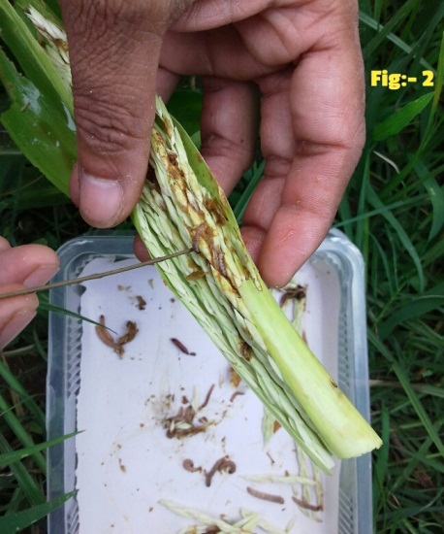

Figure 2: Showing Larvae inside the tassel-tube with deposition of fras.

Materials and Methods: -
To understand the mechanism of survival against application of insecticides of Chilo partellus. 2 piece of maize cultivating land about 2500m² each were selected at village Narhat in district Nawada (Bihar). During 2023-24 for this experiment HQPM-1 type maize seed were sown at selected field. Farmer was given all the required inputs as well as they implicated before. In the 1st plot hand picking method was applied in addition with application of insecticides. But in the 2nd plot hand picking method was not applied to compare and evaluate the infestation and damage states of said pest. Observations were started after plants became 4 weeks older, plants about six to eight leave stage. Hand picking method of infested plant was applied twice weekly until harvested. To understand the survival of C. Partellus in adverse condition. Higher and lower temperature tolerance test and lowest food availability method were also been applied.
Result and Discussion: -
After first foliar application 74 alive and 17 dead larvae from tassel-tube, 63 alive and 8 dead from stem, 26 alive and 26 dead larvae from outer surface by hand picking method were eradicated from 1st experimental plot. After second foliar application with combination of soil application, 73 alive and 11 dead larvae from tassel-tube, 44 alive and 5 dead from stem and 10 alive and 17 dead from outer surface of plants were eradicated by hand picking method in the 1st experimental plot.
Treatment | Larval Stage | Larvae in tassel-tube |  | Larvae in Stem |  | Larvae on out surface
Foliar spray | 1st and 2nd | 22 | 6 | 18 | 5 | 10 | 12
Foliar spray | 3rd and 4th | 23 | 3 | 21 | 0 | 2 | 5
Foliar spray | 5th | 19 | 5 | 17 | 2 | 6 | 7
Foliar spray | Pupa | 10 | 3 | 7 | 1 | 8 | 2
Foliar spray with soil application | 1st and 2nd | 28 | 3 | 15 | 1 | 5 | 9
Foliar spray with soil application | 3rd and 4th | 17 | 2 | 13 | 0 | 2 | 0
Foliar spray with soil application | 5th | 18 | 3 | 11 | 2 | 3 | 5
Foliar spray with soil application | Pupa | 10 | 3 | 5 | 2 | 0 | 3
Table: - 1. Showing eradicated larvae by hand picking method after application of insecticide in 1st experimental plot.
Generally, corn-cob and tassel-tube infestation was high and leaf infestation was low. First instar larvae feed on young terminal leaf whorls producing characteristic patterns of small holes. Later they enter into the tassel tube. Corn-cob and stem. Boring into tassel tube resulting damage flowering parts, into corn-cob resulting corn damage and into stem resulting weaken and breaking of stem. When larval infestation occurs inside tassel tube or corn-cob Fras deposition was visible. Larval infestation upon growing parts showing dead central leaves, withered “dead hearts”. As the number of larvae increase 2 to 10 per plant the tassel-tube, Corn-cob and leaf infestation also increase. The survival of larvae is higher in tassel-tube following corn-cob and lowest on leaf or outside of plant. In the present study data revealed that maximum plant occurred on the plants with 7-10 larvae/plant and minimum on 2 larvae/plant. Such variation in infestation-loss relationship may be due to number of biotic and abiotic factors which influence the life cycle of C. partellus. In the present study when temperature tolerance method applied, C. partellus survived among 10 lepidopteron insects. After giving treatment of 3⁰C for 60 hour and 41⁰C for 60 hours Somme (1982) and Block (1992) also mentioned that, in terms of absolute number of species exhibiting a given strategy, freeze avoidance is dominant. When the 3rd and 4th instar larvae kept into Non-food availability for 72 hours C. partellus survive and the 5th instar larvae start pupation earlier, in scarcity of food. Larval and pupation period becomes shorter at higher temperature. The first experimental plot resulting 340 Kg of Gross Corn production while plot 2nd resulting 215 kg of gross corn yield in which plot 1st treated with application of insecticide and hand-picking method.

Fig: - 3. Showing graphical representation of eradicated larvae by hand picking method.
Conclusion: -
Various control techniques including chemical, cultural, host plant resistance and other biological method were being implicated to control infestation of maize crop by C. partellus in India from a long time. Present study revealed that C. partellus is an internal feeder having high tolerance of temperature and survival of larvae in minimum food availability. In addition of chemical cultural and other control technique, till now C. partellus cannot be effectively controlled. Percentage infestation of Chilo partellus and the number of hibernating larvae was highest in August followed by July.
In this study the hand-picking method of infested plant in addition with bio control treatment not only controls the infestation of maize crop but also may helpful in control of population increase of said insect pest. In the view of C. partellus, outcomes of this study may useful in designing and modeling appropriate control methods for the C. partellus in incoming days.
References: -
1. Ali, A., Khalil, N., Abbas, M., Tariq, R., Ullah, Z. and Hussain, D. (2015). Plant traits as resistance influencing factors in maize against Chilo partellus (Swinhoe). Journal of Entomology and zoological studies. 3 (2): 246-250.
2. Ali, L., Ahmad, S., Ullah, ML, Bari, F., (2002). Comparative resistance of maize stem borer, Chilo Partellus (Swinhoe). Asian Journal of plant science. 1. 571-573.
3. Ganguli, R, N., Chaudhary, R, N., and Ganguli, J., (1997). Effect of time of application of chemical on management of maize stem borer, Chilo partellus (Swinhoe,1885). International Journal of Pest Management 43(4): 53-59.
4. Gupta, S., Handore, K., and Pandey, I, P., (2010). Effect of insecticides against Chilo Partellus (Swinhoe, 1885) damaging Zea mays (maize). International Journal of Parasitology Research 2(2): 4-7.
5. Kumar, H., and Mihm, J.A., (1996). Resistance in maize hybrids and inbreds to first-generation south western corn borer, Diatraea grandiosella (Dyar) and Sugarcane borer, Diatraea saccharalis (fabricus) in selected maize hybrids and varieties. Maydica. 40:245-251.
6. Kumar, P., Singh, G., Rana, R. and Ram, M., (2015). Evaluation of efficacy of some novel chemical insecticides against stem borer, Chilo Partellus (Swinhoe,1885) in maize. Journal of Plant Development science. 7 (3): 239-242.
7. Mallapur, C.P., Chouraddi, M., Nayaka, P., Prashant, K. and Balikai, R.A., (2012). Incidence and distribution of maize stem borers in farmer’s fields of Karnataka state. Journal of Experimental zoology. 15 (1): 245-249.
8. Pats, P., (1991). Activity of Chilo partellus (Lepidoptera; Pyralidae). Eclosion, mating and oviposition time, Bull. Entomol. Res. 81:93-96.
9. Pats, P., and Ekbom, B. (1992). Infestation and dispersal of early instars of Chilo Partellus (Swinhoe) (Lepidoptera; Pyralidae) at different densities. Environ. Entomol. 21(5): 1110-1113.
10. Songa, J.M. Zohu, G. and Overholt, W.A. (2001). Relationship of stem borer damage and plant physical condition to maize yield in a semi-arid zone of Eastern Kenya. Insect science appliances. 21(3): 243-249.
11. Tamiru, A., Getu, E., Jembere, B., 8 Bruce, T. (2012), Effect of temperature and relative humidity on the development and fecundity of Chilo partellus (Swinhoe, 1885) (Lepidoptera; Crambidae). Bulletin of Entomological Research, 102 (01), 9-15.

