ON A NEW TAPEWORM STILESIA PUSHPAI SP.N. (CESTODA: THYSANOSOMIDAE FUHRMAN, 1907) FROM GOAT (CAPRA HIRCUS) IN WAKE, NASIK

Abstract:
A new species of the genus Stilesia Railliet in 1893 namely Stilesia pushpai sp. nov. is being reported from small intestine in goat (Capra hircus) from Wake, Malegaon, Dist. Nashik, (M.S.), India. The present worm under discussion having scolex medium, globular in shape and suckers 4 in number, oval to spherical, neck is medium, broad anteriorly and narrows posteriorly. The mature segments, almost 15-16 times broader than long, genital pore unilateral, regularly alternate, near posterior margin of the segments. Testis 5-8 in number, on each side, round in shape, cirrus pouch medium, oval in shape, cirrus thin, vas deference thin, convoluted; ovary oval, single mass with numerous acini, vagina anterior to cirrus pouch.
Key words: Stilesia, Scolex, Genital pore, Cirrus pouch, Acini, etc.
Introduction:
The genus Stilesia was erected Railliet, in 1893 from Ovis aries, in Europe, Asia and Africa as Stilesia globipunctata (Rivolta, 1874) later on Stilesia vittata was reported by Railliet, in 1896 from Camelus dromedarius in Africa and India. Stilesia hepatica was added to this genus by Wolffhugel, in 1903 from Buffelus caffer and Bos taurus in Asia and Africa. Stilesia okapi was erected as a new species, of this genus by Leiper, in 1936 from Okapi in Africa, is regarded by Baer, in 1950 as a variety of S. globipunctata. The present communication, deals with the description of Stilesia pushpai n.sp. collected from intestine of goat (Capra hircus) from Wake, Malegaon, Dist. Nashik, (M.S.), India.
Material and Methods:
The investigation was carried out for two years during the period from July 2020 to June 2021 and July 2021 to June 2022. About 25 specimens of the cestode parasite were collected from different slaughter houses of Nashik region. Intestines of the host Capra hircus were dissected and observed for the degree of infection. Most of the intestines were infected by cestode parasites. The free worms were preserved in hot 4% formalin and stained with Harris haematoxylin, passed through various alcoholic grades, cleaned in xylene, mounted in D.P.X. and the whole mount slides were prepared for anatomical studies. The drawings were made with the aid of camera Lucida, and all the measurements are calculated in millimeter unless otherwise reported. The Holotype and Paratype specimens have been deposited in P.G and Research Department of Zoology N.Y.N.C.College, Chalisgaon Dist-Jalgaon,Maharastra (India).
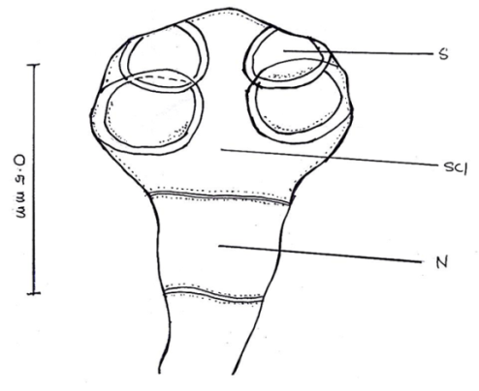
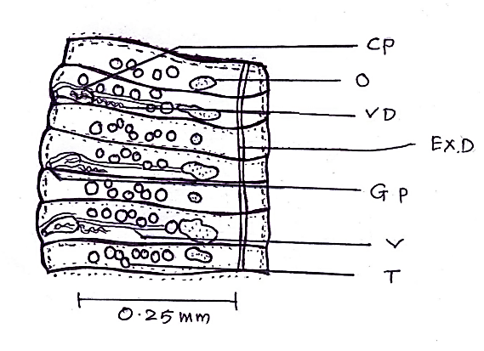

A B
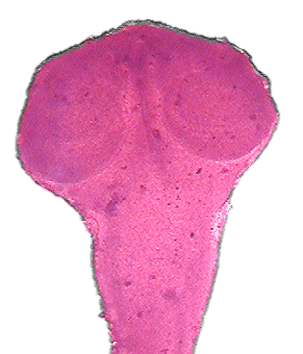
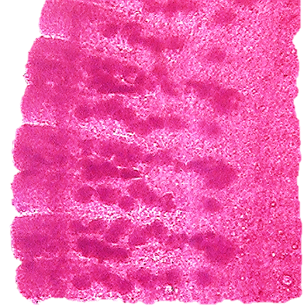

A B

Fig 1 : Camera lucida sketches and Microphotographs of Stilesia pushpai n. sp.
A- Scolex (X 100) B- Mature segments (X 100)

Results and discussion

Description:
All the parasites are small to medium in size, with thin musculature, with scolex, many immature and mature segments. The scolex is medium, globular in shape narrow anteriorly and broad posteriorly, distinctly marked off from the strobila and measures 0.3972 to 0.4109 in length and 0.5753 to 0.5821 in breadth. The scolex bears 4 suckers, unarmed, medium in size, oval to spherical in shape, arranged in two pairs, one pair in each half of the scolex, overlapping to each other in each pair and lateral margin of the scolex, and measure 0.1369 to 0.1849 in length and 0.1849 to 0.2397 in breadth. The rostellum is absent.The neck is medium in size, broad anteriorly and narrows posteriorly and measures 0.2191 to 0.2397 in length and 0.2191 to 0.3082 in breadth. The mature proglottids are medium in size, thin, only one set of reproductive organs in each segment, almost 15-16 times broader than long, with distinct segmentation and convex lateral margins and measure 0.0479 to 0.0547 in length and 0.3424 to 0.3561 in breadth. The testes are 5 to 8 in number on each lateral side, in each segment, medium in size, round in shape, unevenly distributed, outside the longitudinal excretory canals and measure 0.0140 to 0.0205 in diameter. The cirrus pouch is medium in size, oval in shape, slightly obliquely or transversally placed, present in posterior corner of the segment, open marginally and measures 0.0479 to 0.0547 in length and 0.0205 to 0.0280 in breadth. The cirrus is unarmed, wavy, thin, contained within the cirrus pouch and measures 0.0205 to 0.0280 in length and 0.0068 in breadth. The vas deferens is thin, long convoluted, run transversally and measures 0.0068 in length and 0.0890 to 0.1027 in breadth. The ovary is small in size, single mass, oval elongated in shape, placed near posterior margin of the segment and measures 0.0205 to 0.0684 in length and 0.0140 to 0.0280 in breadth. The vagina is thin, straight tube, anterior to the cirrus pouch, arise from the genital pore, run transversally and measures 0.1917 to 0.2054 in length and 0.0068 in breadth. The genital pores are small in size, unilateral, open marginally, regularly alternate, placed at posterior region of the segment and measure 0.0068 to 0.0140 in breadth.The vitelline gland is absent.The excretory canals are longitudinal and narrow and measure 0.0068 in breadth.
Discussion:
The genus Stilesia was established by Railliet, 1893 as a type species globipunctata from Ovis aries. Later on, 33 species are added to the genus by different workers in the world.
The worm under discussion having scolex medium, globular in shape and suckers 4 in number, oval to spherical, neck is medium, broad anteriorly and narrows posteriorly. The mature segments, almost 15-16 times broader than long, genital pore unilateral, regularly alternate, near posterior margin of the segments. Testis 5-8 in number, on each side, round in shape, cirrus pouch medium, oval in shape, cirrus thin, vas deference thin, convoluted; ovary oval, single mass with numerous acini, vagina anterior to cirrus pouch.
- The present tapeworm, differs from S. globipunctata which is having the scolex round, testis 4-7 in number, in two groups, on each side, vas deference not closely coiled and present in between cirrus pouch and excretory canal, cirrus pouch small, pyriform, ventral to the vagina, ovary globular, vagina dorsal to cirrus pouch and found in Ovis aries.
- The present forms, differs from S. vittata which is having testes in two groups, 5-9 on each side, cirrus pouch elongated, cylindrical, cirrus armed, ovary rounded, vagina posterior to cirrus pouch and found in Camelus dromedarius.
- The worm under discussion differs from S. hepatica which is having the testes in two groups, 6-7 on each side, preovarian, in the anterior half of the segments, genital pore in the middle of the segments and found in the Buffelus caffer and Bos taurus.
- The present tapeworms, differs from S. leiperi which is having, circular scolex, testes in two groups, 5-6 on each side, vas deference not closely coiled, cirrus pouch elongated, cylindrical, vagina posterior to cirrus pouch and found in Ovis bharal.
- The cestode under discussion differs from S. caballeroi in having testes 1-11 on each side, vagina posterior to cirrus pouch and vas deference form a less dense bundle of convolutions, anterior to the testes.
- The present parasite, differs from S. southwelli in having scolex, quadrangular in shape, mature segment 5 time broader than long, testes only 4 in each group, cirrus pouch large, sac like, vagina posterior to cirrus pouch and ovary medium, round, compact without acini.
- The present cestode, differs from S. aurangabadensis in having the large, spherical scolex, testes in two lateral groups, 5 on each lateral side, vas deference straight, reaches up to longitudinal excretory canal, cirrus pouch elongated, cylindrical, cirrus coiled, vagina posteriodorsal to the cirrus pouch and found in Ovis bharal.
- The worm under discussion, differs from S. garhwalensis in having the oval to spherical testes, 0-9 in number on each lateral side, vas deference coiled, ovary spherical, vagina posterior to cirrus pouch and genital pore irregularly alternate.
- The present forms, differs from S. kotdwarensis in having the testes 1-12 in number, vas deferens coiled, vagina posterior to cirrus pouch, genital pore irregularly alternate and found in Ovis aries.
- The present parasites, differs from S. marathwadaensis in having scolex circular, testes 5-7 in number, in two groups, the vas deference straight, runs up to longitudinal excretory canal, ovary in anterior half of the segment and vagina posterior to cirrus pouch.
- The present cestodes, differs from S. yawalensis in having the scolex quadrangular, testes 2-3 on each side, lateral to ovary, ovary medium, globular and genital pore irregularly alternate.
- The present forms, differs from S. jadhavae in having the mature segment 8 times broader than long, testes 5-7 in number, ovary rounded and reported from Ovis bharal.
- The present tapeworm, differs from S. alii in having the scolex oval, broad in middle, narrow at both the ends, mature segments squarish and testes medium, 11 in number (5+6 or 6+5), unevenly distributed.
- The present parasites, differs from S. dhondagae in having the scolex quadrangular, testes 8-10 in number, arranged in two rows, ovary distinctly bilobed, elongated with 8-9 acini in each lobe and par uterine organs simple.
- The present cestode, differs from S. caprai in having the mature segment squarish, testes 8-9 in number, arranged in two lateral fields, vas deference slightly curved, vagina posterior to cirrus pouch and genital pore irregularly alternate.
- The worm under discussion, differs from S. pandeyi having testes 20 in number, arranged in two lateral fields, vas deference curve, ovary near anterior margin of the segment and vagina posterior to cirrus pouch.
- The present tapeworm, differs from S. daulatabadensis in having the mature segment squarish, testes small, 11 in number, 7 on poral and 4 on aporal side, vas deference medium slightly curved and genital pore in anterior half of the segment.
- The present form, differs from S. indapurensis in having the scolex quadrangular, mature segment squarish, testes medium, 8-9 in number, cirrus pouch large, elongated and vagina posterior to cirrus pouch.
- The present cestode, differs from S. jadhavi in having scolex large, the testes 14 in number, scattered on dorsal, lateral and ventral sides of the ovary, ovary bilobed with several acini, near posterior part of segment and vagina posterior to cirrus pouch.
- The present worms, differs from S. hircusi in having the scolex circular, testes 10-12 in number, ovary medium, globular and uterus bilobed sac.
- The present cestodes, differs from S. kapadnaensis in having mature segment 8 time broader than long, testes 4-6 in number, vagina dorsal to cirrus pouch and genital pore irregularly alternate.
- The present form, differs from S. shrigondaensis in having the scolex round, mature segment 9-10 times broader than long, testes 10-12 in number, in two lateral fields and vagina posterior to cirrus pouch.
- The present parasites, differs from S. songirensis in having mature segments are acraspidote, testes 7-8 in number, vagina posterior to cirrus pouch and genital pore irregularly alternate.
- The present worms, differs from S. kanegaonensis in having the scolex oval, testes 17-19 in number, in two lateral groups, vagina posterior to cirrus pouch and reported from Ovis bharal.
- The present cestodes, differs from S. intestinalis in having scolex rectangular, mature segment 8 time broader than long, testes 4 in number, on each side and reported from Ovis bharal.
- The present parasite, differs from S. alii (minor) in having scolex quadrangular, mature segment 12 to 13 times broader than long, testes 9 to 10 in number on each side and vagina posterior to cirrus pouch.
- The present parasites, differs from S. indiana in having testes 4-5 in number, vas deference curved, cirrus pouch small, elongated, ovary compact, U shaped and vagina posterior to cirrus pouch.
- The present form differs from S. gangakhedensis in having the scolex quadrangular, mature segment squarish, acraspedot, testes 9 in number, four on poral and five on aporal side, cirrus pouch cylindrical, vagina posterior to cirrus pouch and with two big paruterine organs.
- The present tapeworms, differs from S. abhimanyui in having the scolex circular, mature segments 20-30 times, broader than long, testes 11-12 in number, cirrus pouch pyriform and genital pore irregularly alternate.
- The present worms, differs from S. ganeshraoji in having testes 14 in number, in two lateral fields, ovary medium, bilobed, vagina posterior to cirrus pouch and paruterine organs two in number with eggs.
- The present cestodes, differs from S. gangadharraoi in having testes 8-10 in number, in two lateral fields, vagina posterior to cirrus pouch and par uterine organs one on each lateral side.
- The present worms, differs from S. jadhavae (minor) in having scolex quadrangular, testes 24 in number, in two lateral fields, ovary medium, bilobed, vagina posterior to cirrus pouch and genital pore irregularly alternate.
- The present worms, differs from S. bhadgaonensis having dome shaped scolex, testes 3-4 in number, in two lateral fields, ovary spherical, vagina posterior to cirrus pouch, genital pore irregularly alternate and paruterine organs two in number.
- The present cestodes, differs from S. shindei in having scolex quadrangular, testes 3-3 in number, in two lateral fields, vagina posterior to cirrus pouch, genital pore irregularly alternate and par uterine organs two on each lateral side.
The above noted characters are valid enough to accommodate these worms into a new species and hence the name S. pushpai n. sp. is proposed in honor of the guides’ mother.
References:
- Ahuwalia S S (1960) Gastrodiscoides hominis (Lewis and Mc.Connel) Leiper,1913 (Amphistome parasite of pig). Indian J. Medical Res. 48, 315-325.
- Amjadi A R (1971) Studies on histopathology of Stilesia globipuntata infection in Iran. Veterinary Record 88, 486-488.
- Humbe , A., Jadhav, S. Borade, S. N. (2011):Biochemical studies of gastrointestinal cestode parasites in Capra hircus (L.) and Ovis bharal (L.) from Marathwada region. Int. Multidi scip. Res. J., 1(12):08–10.
- Jadhav B.V., Shivesh P.Singh, Bhure D.B. and Padwal N.D., 2008.Biosystematic studies of Davainea shindei n.sp. (Cestoda- Davainidae) Fuhrmann,1907 from Gallus gallus domesticus. National Acdemy of Science Letter Vol.31 No.7&8 pp.245-250.
- Leiper, R.T. (1935). Report on the helminth parasites of the okapi living in Society’s Gardens. Proceedings of Zoological Society London, pp. 11-12.
- Nanware Sanjay Shamrao (1996) Bio-Systematic Studies of Some Cestode Parasites From Capra hircus L. at Aurangabad District. Ph.D. Thesis, Dr. B. A.M.University, Aurangabad pp.1-150.
- Nanware Sanjay S, Jadhav Baba and Kalyankar S N (2005) Histopathological studies on Anoplocephaline cestodes, Moniezia (Blanchariezia) kalawati Sp.Nov. infecting Capra hircus L. Natl. J. Life Sci. 2, 123-124.
- Nanware Sanjay S, Jadhav Baba and Kalyankar S N (2005) Histopathological changes in intestine of marine fish, Carcharias acutus parasitised by Phoreobothrium sp. Natl. J. Life Sci. 2, 127-128.
- Nanware Sanjay Shamrao (2010) Taxonometric evaluation of a new mammalian cestode Moniezia (Blanchariezia) maharashtrae Sp.Nov. (Cestoda: Anoplocephallidae) infecting Capra hircus L. The Asian J. Animal Sci. 5, 94-97.
- Nanware Sanjay Shamrao and Bhure Dhanraj Balbhim (2011) Histopathology of intestinal tissue of host Capra hircus caused by anoplocephalidean Cestode Stilesia. J. Exp. Sci. 2, 38-39
- Nanware Sanjay Shamrao and Bhure Dhanraj Balbhim (2013) Studies on the cestode Stilesia Railliet, 1893 intestinal infection in Capra hircus L. with reference to histopathology. Asian J. Bio Sci. 8, 76-78
- Railliet, A. (1896). “Sur quelques parasites du Dromadaire.” Comptes Rend. Societe de Biologie Paris.Vol. XLVIII, pp. 489-492.
- Railliet, A. (1893). Traite de Zoologie Medicale et Agricole. Deuxieme Edition. Asselin et Houzaeu. Paris
- Railliet, A. 1892. Notices parasitologiques: Taenia Tenuirostris Rud. Chez Poie domestique: remarques sur pa classification des cestodes parasites des oiseaux. Bull soc. Zool rance 17, 110- 117.
- Rivolta, S. (1874). Sopra alenne specie di Taenia della Pecora. Pisa.
- Wolffhugel, K. (1903). Stilesia hepatica nov.sp. in Band Wurmans den Gallengangen Von Schafen und Ziegen Ostafrikas kan Nerlin. Tierarzt Wochenscher, 43: 661-665.

