Original Research Article
Exploring Antibiotic Resistance Mechanisms and β-Lactamase Interactions with Ceftriaxone and Linezolid

ABSTRACT
Introduction: Antimicrobial resistance (AMR) poses a significant global health challenge, fueled by mechanisms such as β-lactamase production and the formation of biofilms. This study aimed to assess antibiotic resistance, β-lactamase activity, biofilm formation, and explore resistance mechanisms through molecular docking.
Methods:
Thirty-five bacterial isolates from clinical samples, representing seven genera—Escherichia coli, Salmonella spp., Staphylococcus aureus, Acinetobacter spp, Klebsiella pneumonia, Enterococcus faecalis, and Pseudomonas aeruginosa were analyzed. Antibiotic susceptibility testing determined resistance patterns, while β-lactamase production and biofilm formation were assessed phenotypically. Molecular docking evaluated interactions between β-lactamase (PDB ID: 1YLJ) and the antibiotics ceftriaxone and linezolid using Auto Dock Vina 2.0.
Results:
High resistance rates were observed to ceftriaxone (85.7%) and erythromycin (71.4%). Salmonella spp. showed the highest overall resistance (77.3%) with complete resistance to ceftriaxone and cefuroxime. β-lactamase producers accounted for 25.7% of isolates, with a mean resistance rate of 67.3%, higher than non-producers. Biofilm-forming isolates (48.5%) exhibited increased resistance (68.5%) compared to non-biofilm producers (49.5%). Docking results revealed ceftriaxone had moderate binding affinity (-6.45 kcal/mol; Ki: 18.67 µM) to β-lactamase, suggesting vulnerability to enzymatic degradation, while linezolid bound more strongly (-8.66 kcal/mol; Ki: 448.07 nM), indicating better inhibitory potential.
Conclusion:
These findings highlight the need for ongoing resistance monitoring, antimicrobial stewardship, and molecular-level insights to guide effective treatment against multidrug-resistant pathogens.
Keywords: Antimicrobial resistance (AMR), β-lactamase production, Biofilm formation, Molecular docking, Ceftriaxone, Linezolid.
INTRODUCTION
Antibiotic resistance has emerged as a critical global health issue, contributing to hundreds of thousands of deaths annually. Of particular concern is the growing number of bacterial strains that show resistance to commonly prescribed antibiotics, including those considered drugs of last resort, such as vancomycin. The rapid global transmission of resistance genes underscores the urgency of this threat and highlights the need for collaborative international responses. In 2014, the World Health Organization (WHO) identified antimicrobial resistance as a significant global health threat, highlighting the urgency of the issue ^{[1and 2]}.
The widespread and often inappropriate use of antibiotics in human healthcare, veterinary practices and agriculture is a major cause of the increase in antimicrobial resistance. This resistance is increasingly evident in bacteria responsible for community-acquired and hospital-associated infections. In particular, multidrug-resistant organisms such as Escherichia coli, Klebsiella pneumoniae, Staphylococcus aureus, methicillin-resistant (MRSA), Streptococcus pneumonia, Penicillin-resistant, vancomycin-resistant Enterococcus (VRE), Acinetobacter baumannii, and extensively drug-resistant Mycobacterium tuberculosis ^{[3]} are of particular concern ^{[4]}.
β-Lactam antibiotics are the cornerstone of treatment for bacterial infections and are leading targets for resistance development in Gram-negative pathogens worldwide. Constant exposure to various β-lactams has prompted bacteria to develop and diversify β-lactamase enzymes – extended-spectrum β-lactamases (ESBLs) – that can now even break down new β-lactam antibiotics. This trend presents a formidable challenge for the treatment of multidrug-resistant infections. Furthermore, accurately determining the global prevalence of ESBL-producing organisms is hampered by inconsistent detection methods and variations in reporting standards among laboratories ^{[5]}.
Over the last fifteen years, the rise and dissemination of β-lactam resistance in hospital-acquired Gram-negative bacteria, including Pseudomonas aeruginosa, has emerged as a significant global concern—especially with the growing resistance to third- and fourth-generation cephalosporins. While third-generation cephalosporins, like most β-lactam antibiotics, are typically well tolerated and have a relatively low toxicity profile, they can still cause serious adverse effects in some cases. For example, there have been reports of coagulopathies (blood clotting disorders) associated with the use of third-generation cephalosporins ^{[6]}. Nevertheless, all recorded adverse effects from third-generation cephalosporin administration are relatively rare when compared to the serious consequences caused by certain bacterial infections ^{[7]}.
Cephalosporins are a widely used group of β-lactam antibiotics that treat and prevent bacterial infections by disrupting the peptidoglycan layer structure in the cell walls of both Gram-negative and Gram- positive bacteria ^{[8]}. In terms of volume, cephalosporins account for 50–70% of the total antibiotics used by humans ^{[9]}. A large-scale production and consumption of cephalosporin antibiotics has been recorded globally ^{[10]}.
In general, bacterial groups that show resistance to third-generation cephalosporin antibiotics—such as ceftazidime and cefotaxime are commonly referred to as strong ESBL (Extended-Spectrum Beta-Lactamase) producers. This could be attributed to the strong efficacy of third-generation cephalosporins against Gram-negative bacteria. Resistance is primarily attributed to the production of various types of ESBLs, mainly mediated by bacterial and/or plasmid-associated AmpC β-lactamases (PABL) ^{[4]}. Ferjani et al. ^{[11]} reported the occurrence and distribution of both ESBL and PABL in bacterial strains, isolated from the gut microflora of healthy Tunisian children. In India, Basu et al. ^{[12]} identified antibiotic-resistant isolates against third-generation cephalosporins from clinical samples. In 2024, Handa et al. ^{[13]} also reported resistance among isolates to the cephalosporin group of antibiotics.
As part of the strategies to combat drug resistance in microorganisms, it is essential to enhance research efforts, improve diagnostic methods, and identify resistance mechanisms. Currently, there is limited information available on the mechanisms of antibiotic resistance in ESBL-producing isolates through molecular docking studies. Understanding the development of antibiotic resistance is essential for preventing its spread and guiding the design of new therapeutic strategies. Research has demonstrated that molecular docking is a valuable tool for identifying antibiotics that are losing effectiveness due to resistance mechanisms. This approach is not only cost-efficient but also accessible for routine analysis. Therefore, the present study aims to utilize molecular docking to explore the mechanisms and extent of antibiotic resistance in clinical isolates.
MATERIALS AND METHODS
The study isolates were procured from Microtech Microbial Laboratory, Coimbatore, India. The history of each isolate was documented, and all isolates were transported in a coolant box within 7 hours. The isolates were confirmed using selective media and biochemical tests. Confirmed isolates were stored on nutrient agar slants at 4°C for further analysis.
Antibiotic susceptibility testing
Antibiotic susceptibility testing was performed on 35 bacterial isolates following the guidelines of the National Committee for Clinical Laboratory Standards (NCCLS). The Kirby-Bauer disc diffusion method was employed for the antibiogram analysis. All clinical isolates were subjected to this test. Antibiotic discs and Mueller-Hinton Agar (MHA) were procured from Hi-Media, Mumbai. Agar plates were prepared according to the manufacturer's instructions and their sterility was confirmed by overnight incubation at 37°C. Prior to testing, the antibiotic discs were brought to room temperature for one hour. Bacterial inocula were adjusted to a 0.5 McFarland turbidity standard and evenly spread on the surface of the agar plates. The antibiotic discs were carefully placed on the agar surface. Following incubation, the diameters of the zones of inhibition were measured and interpreted using standard reference charts.
Isolation of biofilm producing isolates
All bacterial isolates were screened for biofilm production using the Congo Red Agar (CRA) method as described by Freeman et al. ^{[14]}. Brain Heart Infusion (BHI) agar supplemented with 5% sucrose and 0.08 g/L Congo red was prepared and sterilized by autoclaving at 121°C for 15 minutes. The isolates were streaked onto the prepared medium and incubated aerobically at 35°C for 24–48 hours. Biofilm-producing isolates were identified by the formation of black colonies with a dry, crystalline appearance, whereas non-biofilm producers remained pink. Occasionally, colonies exhibited central darkening without full blackening, which was not considered indicative of biofilm production.
Isolation of ESBL-Producing Isolates
All bacterial isolates were tested for Extended-Spectrum β-Lactamase (ESBL) production using the phenotypic confirmatory method recommended by the Clinical and Laboratory Standards Institute (CLSI). In this approach, a first-generation β-lactam antibiotic, Amoxicillin (30 μg), was tested both alone and in combination with Clavulanic acid (10 μg). After overnight incubation at 37°C, the zones of inhibition were measured. An increase of ≥5 mm in the inhibition zone diameter for the Amoxicillin-Clavulanic acid combination compared to Amoxicillin alone was considered indicative of ESBL production (CLSI, 2008) ^{[15]}.
Tools / Software Used
Auto Dock Vina 2.0 and AutoDock 4.2: Used for performing molecular docking simulations. UCSF Chimera v1.16: open-source molecular visualization software used for 3D structure optimization and preparation of both protein and ligands. BIOVIA Draw 2019: Used for drawing and saving 2D chemical structures of ligand compounds in mol format.
Protein Visualization and Preparation
The 3D crystal structure of the β-lactamase enzyme (PDB (1ZG4)) was downloaded in .pdb format from the Protein Data Bank. The protein structure was visualized and prepared using UCSF Chimera v1.16, where water molecules were removed, hydrogen atoms were added, and Gasteiger charges were assigned. The processed file was saved in pdb format and converted to pdbqt format using AutoDock Tools for docking compatibility.
Drug (Ligand) 3D Conversion
Two antibiotic compounds— Ceftriaxone and Linezolid—were selected for docking. Their 2D chemical structures were drawn using BIOVIA Draw 2019 and saved in .mol format. These ligand structures were imported into UCSF Chimera, converted into 3D conformations, and geometrically optimized. Hydrogen atoms were added, and partial charges were applied. The final ligand files were saved in .pdbqt format suitable for docking.
Docking Execution
Molecular docking was performed using Auto Dock Vina 2.0, and the results were validated with Auto Dock 4.2. A grid box was defined around the active site of the β-lactamase enzyme to restrict the docking search area. Docking simulations were executed using standard parameters to predict the binding poses and affinities of both ligands. The docking scores and interaction profiles were recorded for further analysis.
RESULTS
In the present study, a total of 35 bacterial isolates belonging to seven different genera were identified through selective media and biochemical tests. The genera included Escherichia coli, Enterococcus faecalis, Pseudomonas aeruginosa, Staphylococcus aureus, Klebsiella pneumoniae, Salmonella spp., and Acinetobacter spp.
Antibiotic susceptibility testing showed a variety of resistance patterns among the isolates. Salmonella spp. demonstrated the highest resistance rate (77.3%), with complete resistance (100%) to ceftriaxone and cefuroxime. This high resistance is alarming and consistent with national surveillance data indicating increasing resistance to third-generation cephalosporins. Escherichia coli exhibited a moderate resistance rate of 54.6%, with 100% resistance to ceftriaxone. This suggests widespread extended-spectrum β-lactamase (ESBL) production, in line with earlier reports from various Indian regions. Similarly, Enterococcus faecalis showed 53.3% resistance overall, with 100% resistance to novobiocin and 80% to erythromycin.
Staphylococcus aureus presented the lowest overall resistance rate (35.9%) among the tested isolates, but notably, it showed complete resistance to meropenem, norfloxacin, and imipenem. These findings support previous reports on methicillin-resistant S. aureus (MRSA) strains demonstrating resistance to multiple antibiotics, including quinolones. Acinetobacter spp. exhibited a high average resistance rate of 69.3% against the tested antibiotics. Resistance to imipenem was 100%, and high resistance was also observed for ciprofloxacin (80%), meropenem (60%), and ceftriaxone (80%). These patterns indicate the prevalence of multidrug-resistant and potentially extensively drug-resistant strains (Figure 1).

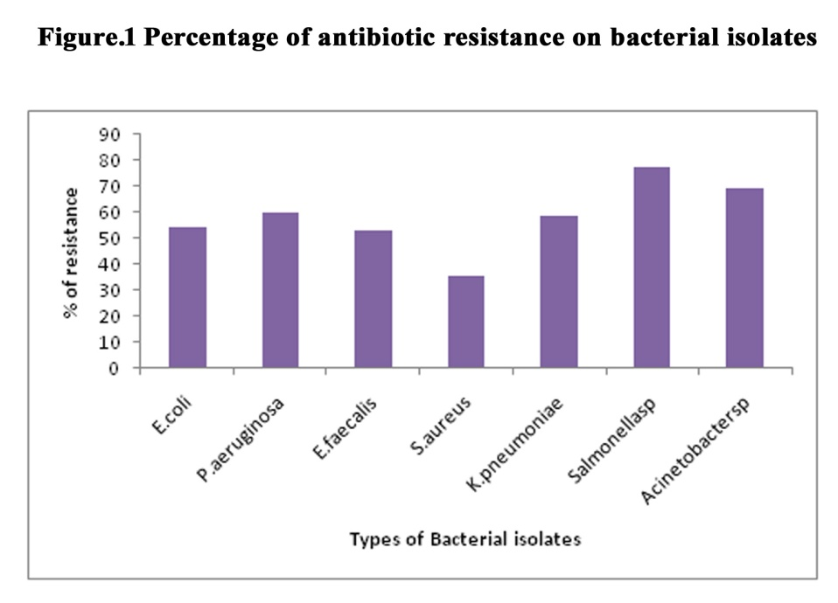
When resistance was analyzed by drug class, ceftriaxone showed the highest resistance rate (85.7%) among all antibiotics tested. Erythromycin resistance was recorded at 71.4%, while cephalosporins such as cefpodoxime and cefuroxime showed resistance rates of 85.7% and 57.1%, respectively. In contrast, meropenem demonstrated the lowest resistance rate at 34.2%. The aminoglycoside gentamycin showed a resistance rate of 45.7%. Fluoroquinolones demonstrated moderate resistance levels, including ciprofloxacin (54.2%), norfloxacin (40%), and levofloxacin (37.1%), with an average resistance of 43.7%. Tetracycline and chloramphenicol exhibited resistance rates of 57.1% and 62.8%, respectively. Carbapenem resistance varied significantly: meropenem (34.2%) and imipenem (77.1%), averaging 55.6% (Figure 2).
Phenotypic β-lactamase detection identified 9 out of 35 isolates (22.5%) as β-lactamase producers. The highest prevalence was observed in E. faecalis and S. aureus, with 40% of their isolates testing positive. β-lactamase-positive isolates demonstrated a mean resistance rate of 67.3%, higher than the 55.8% observed in β-lactamase-negative isolates, indicating their role in resistance escalation. Biofilm production analysis revealed that 17 (48.5%) of the 35 isolates were capable of forming biofilms. E. faecalis had the highest biofilm formation rate at 80%, followed by Salmonella spp. at 65%. E. coli, P. aeruginosa, S. aureus, and K. pneumoniae each showed biofilm production in 40% of their isolates. Biofilm-forming isolates had a higher drug resistance rate (68.5%) compared to non-biofilm-formers (49.5%) (Table 1).

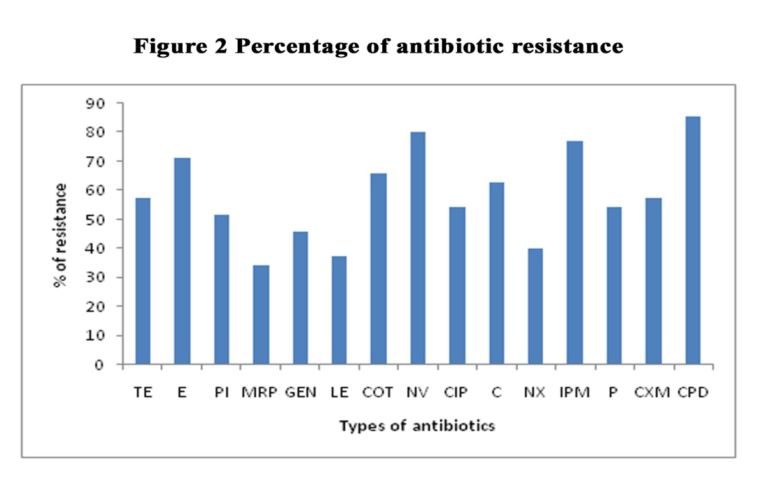

Table 1 Comparison of Antibiotic Resistance in Biofilm and β-Lactamase Producing solates
S.No | Types of parameters | No. of positive | % of resistance
1. | Biofilm positive | 17 | 68.5
2. | Biofilm negative | 18 | 49.5
3. | Betalactamase positive | 9 | 67.3
4. | Betalactamase negative | 26 | 55.8
To understand resistance mechanisms at a molecular level, docking studies were conducted using β-lactamase (PDB ID: 1YLJ) with ceftriaxone and linezolid. Ceftriaxone showed a moderate binding affinity of -6.45 kcal/mol and an inhibition constant (Ki) of 18.67 µM, stabilized by interactions with LYS 212, ASN 214, THR 215, and TRP 229. In contrast, linezolid showed a stronger binding affinity of -8.66 kcal/mol with a much lower Ki of 448.07 nM, forming more stable interactions with residues ARG 222, ALA 223, LEU 225, and THR 230 (Table 2, 3 and Figure 3).

Table 2: Interaction at the Active Site Region of β-lactamase Receptor (1YLJ)

Ligand | Active site region
1YLJ_Ceftriaxone compound | LYS 212; ASN 214; THR 215; ALA 218; ARG 222; ALA 223; LEU 225; TRP 229
1YLJ_ Linezolid compound | GLY 213; ARG 222; ALA 223; LEU 225; PRO 226; THR 227; THR 230; ALA 231

Table 3: Molecular Docking Results Using AutoDock Vina 2.0

Ligand | Binding Affinity | Inhibition Constant, Ki | vdW | Intermolecular Energy
Ceftriaxone | -6.45kcal/mol | 18.67 uM | -8.79kcal/mol | -9.43kcal/mol
Linezolid | -8.66kcal/mol | 448.07 nM | -0.47kcal/mol | -11.64kcal/mol

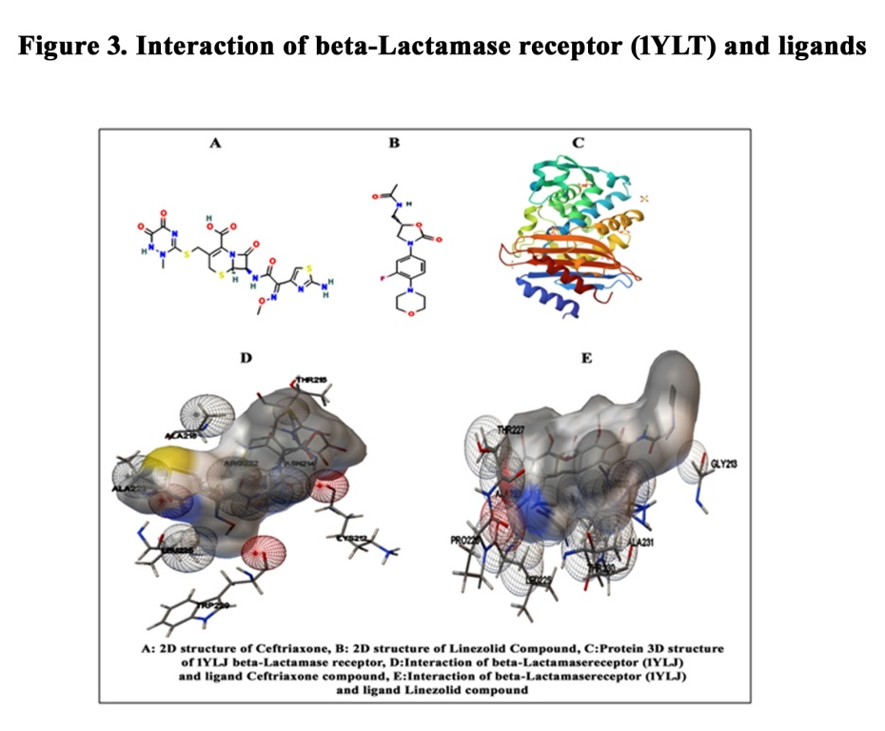
These docking results indicate that ceftriaxone resistance in E. coli is mediated by β-lactamase enzymes. Ceftriaxone binds within the active site of the enzyme, enabling hydrolysis of the β-lactam ring and subsequent inactivation of the drug. In contrast, Linezolid, which is not a β-lactam antibiotic, demonstrated stronger and more stable binding, suggesting its potential as an effective alternative in resistant infections.
DISCUSSION
In the present study, 35 bacterial isolates belonging to seven different genera were procured and confirmed using selective media and biochemical tests. The identified genera included Escherichia coli, Enterococcus faecalis, Pseudomonas aeruginosa, Staphylococcus aureus, Klebsiella pneumoniae, Salmonella spp., and Acinetobacter spp. All isolates were subjected to antibiotic susceptibility test with different groups of antibiotics. The findings revealed a wide range of resistance patterns across both bacterial species and antibiotics.

In our study, Salmonella species showed the highest resistance (77.3%), including 100% resistance to ceftriaxone and cefuroxime, which is closely consistent with recent Indian surveillance data. A case report from North India documented that ceftriaxone-resistant S. typhi carried the ESBL gene and belonged to the H58 lineage ^{[16]}. Similarly, the Ahmedabad study of the SEFI network reported widespread third-generation cephalosporin resistance and plasmid-mediated genes in the H58/IncFIB(K) lineage ^{[17]}. In addition, a South Indian case of ceftriaxone-resistant S. enterica underscores the broad expression of resistant non-typhoidal serovars ^{[18]}.
Our study found E.coli to have a moderate resistance rate of 54.6% and showed complete resistance to ceftriaxone. This is consistent with the data from a multicenter surveillance study conducted in India. In that study, susceptibility to third-generation cephalosporins, especially ceftriaxone, was reported to be only 46.3%, indicating widespread ESBL (Extended Spectrum Beta-Lactamase) production ^{[19]}. Notably, 66.6% of urinary E. coli infections tested in North-East Karnataka during 2012–2015 were resistant to ceftriaxone and 43% of infections were multidrug resistant ^{[20]}.
E. faecalis showed 53.3% drug resistance rates, especially 100% resistance to Novobiocin and 80% resistance to Erythromycin. A study conducted in Iran reported 67% resistance rate of E. faecalis isolates to erythromycin. Similarly, a study conducted in a tertiary care hospital in East India reported 71.24% resistance rate to erythromycin ^{[21]}. Although S. aureus showed the lowest resistance (35.9%), overall resistance rate among the tested isolates, it exhibited complete resistance to drugs such as Meropenem, Norfloxacin, and Imipenem. A study conducted over a six-year period reported that methicillin-resistant S. aureus (MRSA) isolates accounted for 18% to 28% of S. aureus infections, and significant resistance to quinolones, including norfloxacin, was observed ^{[22]}.
In our study, Acinetobacter spp. exhibited a high average resistance rate of 69.3% across 15 antibiotics, with notable resistance to imipenem (100%), norfloxacin (60%), ciprofloxacin (80%), meropenem (60%), and ceftriaxone (80%). Similarly, a study from a tertiary care hospital in Varanasi, India, reported a high prevalence of multidrug-resistant (MDR) Acinetobacter spp. in the intensive care unit (ICU). Among 100 randomly selected isolates, 88.02% were classified as MDR, and 61.97% as extensively drug-resistant (XDR). The study identified the presence of carbapenemase genes, including blaOXA-23, bla_IMP, blaVIM, and bla NDM-1, in a significant proportion of the isolates, contributing to the observed resistance patterns ^{[23]}.
The drug resistance patterns observed in clinical surveillance elements highlight how antimicrobial resistance (AMR) is increasing in healthcare settings. Ceftriaxone had the highest resistance rate of 85.7%. This is consistent with a multicenter longitudinal study in India ^{[24]} that reported a prevalence of ceftriaxone resistance in isolates isolated from bloodstream infections during the period 2017 to 2022. Erythromycin resistance was found to be 37.1%. This is consistent with data from a study in Iran, where significant resistance was reported in Enterococcus species ^{[25]}.
In the present study, antibiotic resistance was analyzed across different classes of antimicrobial agents. The study observed high resistance rates to cephalosporins, with Cefpodoxime showing 85.7% resistance and Cefuroxime 57.1%. A study in Nashik, Maharashtra, reported that extended-spectrum cephalosporin resistance among Escherichia coli and Klebsiella spp. isolates remained above 78.4% and 84.9%, respectively, from 2004 to 2014 ^{[26]}. Similarly, a study in Pune's neonatal intensive care unit found 95% resistance to third/fourth-generation cephalosporins among Gram-negative pathogens ^{[27]}.
The betalactamase producing phenomenon was important for antibiotic resistance. In the present study, all isolates were evaluated for β-lactamase production using a phenotypic method. Enterococcus faecalis and Staphylococcus aureus showed the highest rates of β-lactamase production, with 40% of their isolates testing positive. These results are consistent with previous research conducted in India. For instance, a study from a tertiary care hospital in Vellore reported that 92.2% of urinary E. coli isolates were positive for extended-spectrum β-lactamase (ESBL) production, highlighting the widespread presence of β-lactamase-producing strains in the region ^{[28]}.
The findings from this study underscore the significant role of β-lactamase production in enhancing antibiotic resistance among clinical isolates. Our data reveal that β-lactamase-positive isolates exhibited a mean resistance of 67.3%, notably higher than the 55.8% observed in β-lactamase-negative isolates. Especially cephalosporins group of Cefuroxime and Ceftriaxone antibiotics were highest resistance.
These findings align with a study conducted in the United States, which found that extended-spectrum β-lactamase (ESBL)-producing Escherichia coli and Klebsiella pneumoniae isolates showed significantly higher resistance rates to third-generation cephalosporins compared to non-ESBL producers. The study reported that 88.0% of isolates with elevated cephalosporin minimum inhibitory concentrations (MICs) were ESBL producers, highlighting the major role of β-lactamase enzymes in resistance mechanisms ^{[29]}.
Infections involving biofilm-forming bacteria become more difficult to treat in the presence of resistance factors. It is well established that S. aureus has the capacity to form biofilms. These infections are considered life-threatening due to the complex biofilm structure, which hinders drug penetration. According to a report by the U.S. National Institutes of Health, treatment failure is believed to be the leading cause of over 60% of deaths associated with biofilm-related infections. Therefore, gaining a deeper understanding of biofilm characteristics and their connection to drug resistance is essential for effectively combating these infections ^{[30]}.
Presently, E. faecalis demonstrated the highest biofilm formation rate at 80%. It is widely recognized as a strong biofilm producer, with previous studies reporting up to 13% of clinical isolates exhibiting this trait—especially from wound swab isolates ^{[31]}. In Karnataka, Upadhyaya et al., ^{[32]}, also isolated the 65% of biofilm producing E.faecalis from clinical isolates. The second most was Salmonella species (65%), similarly Nair et al., ^{[33]} observed the 85% of biofilm producing salmonella spp clinical sources and poultry sources. Lately Inbara et al., ^{[34]} observed the biofilm producing salmonella sp from clinical samples in India.
Furthermore, other isolates, including E. coli, P. aeruginosa, S. aureus, and K. pneumoniae, showed biofilm-positive reactions at a rate of 40%. In support of this, a study conducted in India found that 38.29% of S. aureus strains were biofilm producers, of which 18.08% were very strong biofilm producers ^{[35]}. Similarly, 64.7% of P. aeruginosa strains isolated from patients with lower respiratory tract infections in India were reported to form biofilms ^{[36]}. Additionally, a study conducted in a rural hospital in the Western Ghats found that 51% of K. pneumoniae strains were moderate biofilm producers, 27% were strong producers, and only 22% were weak or non-biofilm producers ^{[37]}.
These findings highlight the critical role of biofilm formation in infections caused by these microorganisms. Biofilm formation not only enhances microbial resistance to drugs but also contributes to the chronic persistence and recurrence of infections. Consequently, understanding the mechanisms of biofilm development and its connection to drug resistance is vital for devising effective treatment strategies to manage biofilm-associated infections and combat the growing threat of antimicrobial resistance (AMR).
The relationship between biofilm formation and enhanced drug resistance complicates the effective management of infectious diseases. In our study, biofilm-forming microorganisms had a high drug resistance rate of 68.5%, while non-biofilm-forming microorganisms showed only 49.5% drug resistance. These findings align with several studies conducted in India. For instance, a study in North-East India reported that 29% of Pseudomonas aeruginosa isolates were biofilm producers, and all of these exhibited greater drug resistance compared to non-biofilm-forming isolates. Meanwhile, a study by Jaisal and colleagues ^{[37]} noted that biofilm-forming isolates showed higher drug resistance.
Controlling antibiotic resistance requires regular surveillance and strict regulation of antibiotic. Understanding resistance mechanisms is crucial for developing strategies against multidrug-resistant pathogens ^{[38]}. Among various methods, molecular docking is effective due to its low cost and minimal lab work, though its use in resistance studies remains limited ^{[39]}. In this study, molecular docking was used to investigate resistance mechanisms, focusing on Ceftriaxone, a cephalosporin antibiotic showing high resistance, particularly in E. coli isolates.
The structural and interaction analysis revealed that Ceftriaxone exhibited a moderate binding affinity of -6.45 kcal/mol with an estimated inhibition constant (Ki) of 18.67 µM. Its binding within the β-lactamase active site was primarily stabilized through non-covalent interactions. In contrast, Linezolid demonstrated a stronger binding affinity of -8.66 kcal/mol and a significantly lower Ki of 448.07 nM, indicating a higher inhibitory potential against β-lactamase. Linezolid formed more stable and extensive interactions, which facilitated both hydrophobic contacts and hydrogen bonding. Molecular visualization (Figure 3) further confirmed that while both ligands were well-accommodated in the active site cavity, Linezolid’s broader interaction network contributed to its superior docking performance and enhanced binding stability.
Antibiotic resistance in E. coli is primarily mediated by β-lactamase enzymes, which deactivate β-lactam antibiotics like Ceftriaxone. Normally, Ceftriaxone targets penicillin-binding proteins (PBPs), disrupting peptidoglycan synthesis and leading to bacterial cell lysis. However, in resistant strains, β-lactamase enzymes hydrolyze the β-lactam ring of Ceftriaxone before it reaches PBPs, rendering the drug ineffective. Molecular docking analysis in this study revealed that Ceftriaxone binds to the active site of β-lactamase and forms stabilizing interactions, allowing enzymatic hydrolysis. This confirms that the mechanism of resistance arises from enzymatic degradation rather than target inaccessibility or failure.
The current study highlights the alarming spread of antibiotic resistance in clinical bacterial isolates, with high resistance observed against cephalosporins, erythromycin and novobiocin in particular. In particular, resistance was significantly higher in β-lactamase-producing and biofilm-forming isolates, underscoring their role in treatment failure. Molecular docking analysis further confirmed the mechanism of resistance, with β-lactamase enzymes effectively binding and hydrolyzing ceftriaxone, compromising its efficacy. These findings emphasize the urgent need for routine screening of resistance mechanisms, robust antimicrobial stewardship and the development of targeted therapies to combat multidrug-resistant infections and preserve the efficacy of existing antibiotics.

ETHICS STATEMENT
Not applicable.

DATAAVAILABILITY
All datasets generated or analyzed during this study are included in the manuscript.
REFERENCE
- Bengtsson-Palme, J., Kristiansson, E., & Larsson, D. G. J. (2018). Environmental factors influencing the development and spread of antibiotic resistance. FEMS Microbiology Reviews, 42(1), fux053.
- Urban-Chmiel, R., Marek, A., Stępień-Pyśniak, D., Wieczorek, K., Dec, M., Nowaczek, A., et al. (2022). Antibiotic resistance in bacteria—a review. Antibiotics, 11(8), 1079.
- Alekshun, M. N., & Levy, S. B. (2007). Molecular mechanisms of antibacterial multidrug resistance. Cell, 128(6), 1037-1050.
- Shaikh, S., Fatima, J., Shakil, S., Rizvi, S. M., & Kamal, M. A. (2015). Antibiotic resistance and extended spectrum beta-lactamases: types, epidemiology and treatment. Saudi Journal of Biological Sciences, 22(1), 62–64.
- Aiesh, B. M., Natsheh, M., Amar, M., AbuTaha, S., Qadi, M., AbuTaha, A., et al. (2024). Epidemiology and clinical characteristics of patients with healthcare-acquired multidrug-resistant Gram-negative bacilli: a retrospective study from a tertiary care hospital. Scientific Reports, 14(1), 3022.
- Al-Khikani, F. H., & Al-Janabi, A. A. (2019). Topical amphotericin B formulas: promising new application. International Journal of Medical Sciences Current Research, 2, 187-196.
- Al-Khikani, F. H. (2020). Pulmonary mycoses treated by topical amphotericin B. Biomedical and Biotechnology Research Journal, 4, 65-69.
- Magdaleno, M. E., Saenz, A. B., Juarez, J., & Moretton, J. (2015). Effects of six antibiotics and their binary mixtures on growth of Pseudokirchneriella subcapitata. Ecotoxicology and Environmental Safety, 113, 728–733.
- Selvi, A., & Das, N. (2015). Remediation of cefdinir from aqueous solution using pretreated dead yeast Candida sp. SMN04 as potential adsorbent: an equilibrium, kinetics and thermodynamic studies. Der Pharmacia Lettre, 7, 74–81.
- Mirzaei, R. M., Yunesia, S., Nasseri, M., Gholami, E., Jalilzadeh, S., Shoeibi, A., et al. (2018). Occurrence and fate of most prescribed antibiotics in different water environments of Tehran, Iran. Science of The Total Environment, 619–620, 446–459.
- Ferjani, S., Saidani, M., Hamzaoui, Z., Alonso, C. A., Torres, C., Maamar, E., Slim, A. F., & Boutiba, B. B. I. (2017). Community fecal carriage of broad-spectrum cephalosporin-resistant Escherichia coli in Tunisian children. Diagnostic Microbiology and Infectious Disease, 87, 188–192.
- Basu, H., Giri, P., Kundu, A., & Bhowmik, P. (2022). Isolation and characterization of 3rd generation cephalosporin resistant Gram-positive bacteria from urban environmental soil of West Bengal, India. Journal of Mycopathological Research, 60(3), 395–399
- Handa, V. L., Patel, B. N., Bhattacharya, D. A., Kothari, R. K., Kavathia, D. G., & Vyas, B. R. M. (2024). A study of antibiotic resistance pattern of clinical bacterial pathogens isolated from patients in a tertiary care hospital. Frontiers in Microbiology, 15, 1383989.
- Freeman, D. J., Falkiner, F. R., & Keane, C. T. (1989). New method for detecting slime production by coagulase negative staphylococci. Journal of Clinical Pathology, 42(8), 872–874.
- Clinical and Laboratory Standards Institute. (2008). Performance standards for antimicrobial susceptibility testing: 15th informational supplement M100-S15. Wayne, PA: CLSI.
- Dahiya, S., Katiyar, A., Rai, S., Sharma, P., Kaur, P., & Kapil, A. (2023). Ceftriaxone-resistant Salmonella Typhi isolated from paediatric patients in North India: insights into genetic profiles and antibiotic resistance mechanisms. Indian Journal of Medical Microbiology, 46, 100448.
- Thirumoorthy, T. P., Jacob, J. J., Velmurugan, A., Teekaraman, M. P., Shah, B., Iyer, V., et al. (2025). Recent emergence of cephalosporin-resistant Salmonella Typhi in India due to the endemic clone acquiring IncFIB(K) plasmid encoding bla_CTX-M-15 gene. Microbiology Spectrum, 13, e00875-24.
- Sumana, M. N., Maheshwarappa, Y. D., Rao, M. R., Deepashree, R., Karthik, M. V. S. K., & Shah, N. K. (2024). Ceftriaxone-resistant Salmonella enterica serovar Newport: a case report from South India. Frontiers in Public Health, 12, 1418221.
- Rizvi, M., Malhotra, S., Agarwal, J., Siddiqui, A. H., Devi, S., Poojary, A., et al. (2024). Regional variations in antimicrobial susceptibility of community-acquired uropathogenic Escherichia coli in India: findings of a multicentric study highlighting the importance of local antibiograms. IJID Regions, 11, 100370.
- Kulkarni, S. R., Peerapur, B. V., & Sailesh, K. S. (2017). Isolation and antibiotic susceptibility pattern of Escherichia coli from urinary tract infections in a tertiary care hospital of North Eastern Karnataka. Journal of Natural Science, Biology and Medicine, 8(2), 176–180.
- Chakraborty, A., Pal, N. K., Sarkar, S., & Gupta, M. S. (2015). Antibiotic resistance pattern of Enterococci isolates from nosocomial infections in a tertiary care hospital in Eastern India. Journal of Natural Science, Biology and Medicine, 6(2), 394–397.
- Jama-Kmiecik, A., Mączynska, B., Frej-Mądrzak, M., Choroszy-Krol, I., Dudek-Wicher, R., Piątek, D., et al. (2025). The changes in the antibiotic resistance of Staphylococcus aureus, Streptococcus pneumoniae, Enterococcus faecalis and Enterococcus faecium in the clinical isolates of a multiprofile hospital over 6 years (2017–2022). Journal of Clinical Medicine, 14(2), 332.
- Banerjee, T., Mishra, A., Das, A., Sharma, S., Barman, H., & Yadav, G. (2018). High prevalence and endemicity of multidrug resistant Acinetobacter spp. in intensive care unit of a tertiary care hospital, Varanasi, India. Journal of Pathogens, 2018, 9129083.
- Kaur, J., Singh, H., & Sethi, T. (2024). Emerging trends in antimicrobial resistance in bloodstream infections: multicentric longitudinal study in India (2017–2022). Lancet Regional Health Southeast Asia, 26, 100412.
- Rimaz, S., Tajzadeh, P., Bahrami, M., Nooghabi, M., Eshrati, B., Effati, S., et al. (2023). Epidemiological features, antimicrobial resistance profile and clinical outcomes of healthcare-associated infections in Islamic Republic of Iran. Eastern Mediterranean Health Journal, 29(9), 688–698.
- Odsbu, I., Khedkar, S., Lind, F., Khedkar, U., Nerkar, S.S., Orsini, N., et al. (2018). Trends in resistance to extended-spectrum cephalosporins and carbapenems among Escherichia coli and Klebsiella spp. isolates in a district in Western India during 2004–2014. International Journal of Environmental Research and Public Health, 15(1), 155.
- Shah, M. H., McAleese, S., Kadam, S., Parikh, T., Vaidya, U., Sanghavi, S., et al. (2022). Emerging antibiotic resistance patterns in a neonatal intensive care unit in Pune, India: a 2-year retrospective study. Frontiers in Pediatrics, 10, 864115.
- Nandagopal, B., Sankar, S., Sagadevan, K., Arumugam, H., Jesudason, M. V., Aswathaman, K., et al. (2015). Frequency of extended spectrum β-lactamase producing urinary isolates of Gram-negative bacilli among patients seen in a multispecialty hospital in Vellore district, India. Indian Journal of Medical Microbiology, 33(2), 282–285.
- Castanheira, M., Kimbrough, J. H., DeVries, S., Mendes, R. E., & Sader, H. S. (2023). Trends of β-lactamase occurrence among Escherichia coli and Klebsiella pneumoniae in United States hospitals during a 5-year period and activity of antimicrobial agents against isolates stratified by β-lactamase type. Open Forum Infectious Diseases, 10(2), ofad038.
- Loganathan, A., & Nachimuthu, R. (2022). Antibiotic resistance, biofilm forming ability, and clonal profiling of clinical isolates of Staphylococcus aureus from southern and northeastern India. Asian Biomedicine, 16(4),191–199.
- Nair, P., Sankar, S., & Neelusree, P. (2024). Study on biofilm formation among Enterococcus isolates and association with their antibiotic resistance patterns. Cureus, 16(2), e53594.
- Upadhyaya, P. M. G., Umapathy, B. L., & Ravikumar, K. L. (2010). Comparative study for the presence of enterococcal virulence factors gelatinase, hemolysin and biofilm among clinical and commensal isolates of Enterococcus faecalis. Journal of Laboratory Physicians, 2(2), 100–104.
- Nair, A., Rawool, D. B., Doijad, S., Poharkar, K., Mohan, V., Barbuddhe, S. B., et al. (2015). Biofilm formation and genetic diversity of Salmonella isolates recovered from clinical, food, poultry and environmental sources. Infection, Genetics and Evolution, 36, 424–433.
- Inbaraj, S., Agrawal, R. K., Agarwal, R. K., Thomas, P., Kumar, M., Abhishek, & Choudhury, P. (2019). Quantification of biofilm formation in Indian isolates of Salmonella enterica. International Journal of Current Microbiology and Applied Sciences, 8(2), 2219–2223.
- Triveni, A. G., Kumar, M. S., Manjunath, C., Shivannavar, C. T., & Gaddad, S. M. (2018). Biofilm formation by clinically isolated Staphylococcus aureus from India. Journal of Infection in Developing Countries, 12(12), 1062–1066.
- Saxena, S., Banerjee, G., Garg, R., & Singh, M. (2014). Comparative study of biofilm formation in Pseudomonas aeruginosa isolates from patients of lower respiratory tract infection. Journal of Clinical and Diagnostic Research, 8(5), DC09–DC11.
- Jaisal, S., Singh, A., Verma, R. K., Ram, V. S., Verma, S. K., Yadav, H., et al. (2024). Evaluation of biofilm formation and carbapenem resistance in Klebsiella pneumoniae isolated from clinical samples at a rural hospital in western Uttar Pradesh. Journal of Family Medicine and Primary Care, 13(11), 4894–4900.
- Abushaheen, M. A., Muzaheed, Fatani, A. J., Alosaimi, M., Mansy, W., George, M., et al. (2020). Antimicrobial resistance, mechanisms and its clinical significance. Disease-a-Month, 66(6), 100971.
- Rimac, H., Grishina, M., & Potemkin, V. (2021). Use of the complementarity principle in docking procedures: a new approach for evaluating the correctness of binding poses. Journal of Chemical Information and Modeling, 61(4), 1801–1813.

