Evaluating Fish Biodiversity and Fishing Effort in the Lidder River, Kashmir

Abstract
Assessing the fish diversity and catch per unit effort (CPUE) of the River Lidder, a significant tributary of the Jhelum Kashmir River, was the goal of the current study. Six fish species belonging to the families Cyprinidae, Sisoridae, Balitoridae, and Salmonidae were identified. The species Schizothorax plagiostomus, S. esocinus, and S. labiatus are representatives of the family Cyprinidae.; Balitoridaeis represented by Triplophysa kashmirensis; Sisoridae is represented by Glyptosternon reticulatum; and the family Salmonidae is represented by Salmo trutta fario. At several locations along the river course, schizothoracines were distributed in diverse ways. There were fewer of each of the three Schizothorax species upstream. Triplophysa kashmiriensis was found at all the river sites. The midstream and upstream areas had only G. reticulatum and Salmo trutta fario. Species diversity was analysed via two diversity indices: the Shannon‒Wiener diversity index and the Jaccard similarity index. Autumn experienced the highest value of the Shannon-Wiener diversity index (1.05), while winter had the lowest value (0.83). The highest value was 1.40 at Site 1 (upstream), followed by 1.04 at Site 2 and 0.76 at Site 3. The diversity indices declined as one moved downstream from upstream. The highest Jaccard similarity index (1.00) between Sites 1 and 2 and the lowest (0.33) between Sites 1 and 3 were noted. Sites 1 and 2 had the highest overall mean similarity (0.77), followed by sites 2 and 3 (0.55) and sites 1 and 3 (0.52). From a minimum of 156.25 g/manhour to a maximum of 1250 g/manhour, the total CPUE varied. The mean catch per unit effort (CPUE) was 252.08 g/man-hour at Site 1, 653.33 g/man-hour at Site 2 and 598.95 g/man-hour at Site 3.
Keywords: Lidder River, ichthyofaunal diversity, diversity indices, CPUE.
Introduction
The diversity and richness of organisms found in the aquatic environment are known as aquatic biodiversity. It includes marine ecosystems, such as oceans, estuaries, salt marshes, seagrass beds, coral reefs, kelp beds, and mangrove forests, as well as freshwater ecosystems, such as lakes, ponds, reservoirs, rivers, streams, groundwater, and wetlands. All species, their environments, and the relationships between them are all included in aquatic biodiversity. Aquatic systems provide a habitat for numerous aquatic species, including phytoplankton, zooplankton, and fish. In addition to their extensive economic and aesthetic worth, these systems are in charge of preserving and promoting the health of the aquatic environment. Around 34,800 fish species have been described globally, more than all other vertebrate species combined, including mammals, amphibians, reptiles, and birds [1]. With numerous rivers, streams, and lakes, Jammu and Kashmir is home to over half of the Indian Himalayas' biodiversity. The Himalayas are the source of the majority of rivers [2]. The only significant river in the Himalayan range that traverses the Kashmir Basin is the Jhelum River.
Numerous native fish species, including Schizothorax spp., Glyptothorax spp., Triplophysa spp., and others, can be found in the rivers of the Kashmir Valley. The rainbow trout (Oncorhynchus mykiss) and exotic brown trout (Salmo trutta fario) found in valley streams are well-known worldwide. At the beginning of the 20th century, trouts were introduced into valley waters and have since played a vital role in the sector, attracting visitors from across the world [3]. One of the important rivers present in the Kashmir valley is Lidder. It is a right-bank tributary of the Jhelum River, and before joining Jhelum, it flows through the Lidder valley. The Lidder valley is situated in the central Himalayan mountain range, north of the Anantnag district, between latitudes 33°4′ and 34°15′ N and longitudes 75°05′ and 75°32′ E. According to Rashid and Romshoo [4], the valley is 50 km long and has a diverse topography with altitudinal extremes ranging from 1,600 to 5,200 m. Two mountain torrents that run from north-east and north-west combine to produce the Lidder River. The eastern one emerges from the southern slopes of the Panjtarni Mountains and empties into the oligotrophic Sheshnag Lake. The stream flows westward from Sheshnag and joins the western branch in Pahalgam. Streams from Tarsar and Chandasar Lakes connect the western branch, which has its origins in the Kolohai glaciers. After the two streams meet at Pahalgam, the river continues south, splits into several channels between the towns of Anantnag and Bijbehara, and then, after about 70 km, meets the Jhelum River at the village of Gur [4]. The crystal-clear waters of the river are home to numerous species of fish, and one can also indulge in various water sports, such as fishing, angling and rafting [3].
Fish species reported from the Lidder River include Schizothorax plagiostomus, S. esocinus, and S. labiatus, which belong to the order Cypriniformes; Cyprinidae; Crossocheilus diplocheilus (order Balitoridae); Triplophysa kashmirensis (order Siluriformes; Sisoridae); Glyptosternon reticulatum; and Salmo trutta fario (order Salmoniformes; Salmonidae) [3].
Materials and methods
Study Area
On the basis of the accessibility and variability of the riverine habitat, three sampling sites were chosen along the course of the River Lidder Site 1 (Upstream Zone), which is located near Langanbal Bridge, 7 km below the confluence of east and west Lidder (Pahalgam), where the river flows through a gorge, the bottom is stony, and the water speed is extremely rapid. Site 2 (midstream zone) was located 16 km downstream of Site 1, near the village of Sakhras, Srigufwara. Boulders, gravel, and sand make up the site's bottom. Here, the water is less torrential; Site 3 (downstream zone), located near the Akura Bridge, was approximately 8 km downstream of Site 2 and 8 km above the point where it meets the Jhelum River, as shown Fig 1. The velocity of water at this site was relatively slow, and the Lidder bottom included sand and clay with few pebbles and gravel.

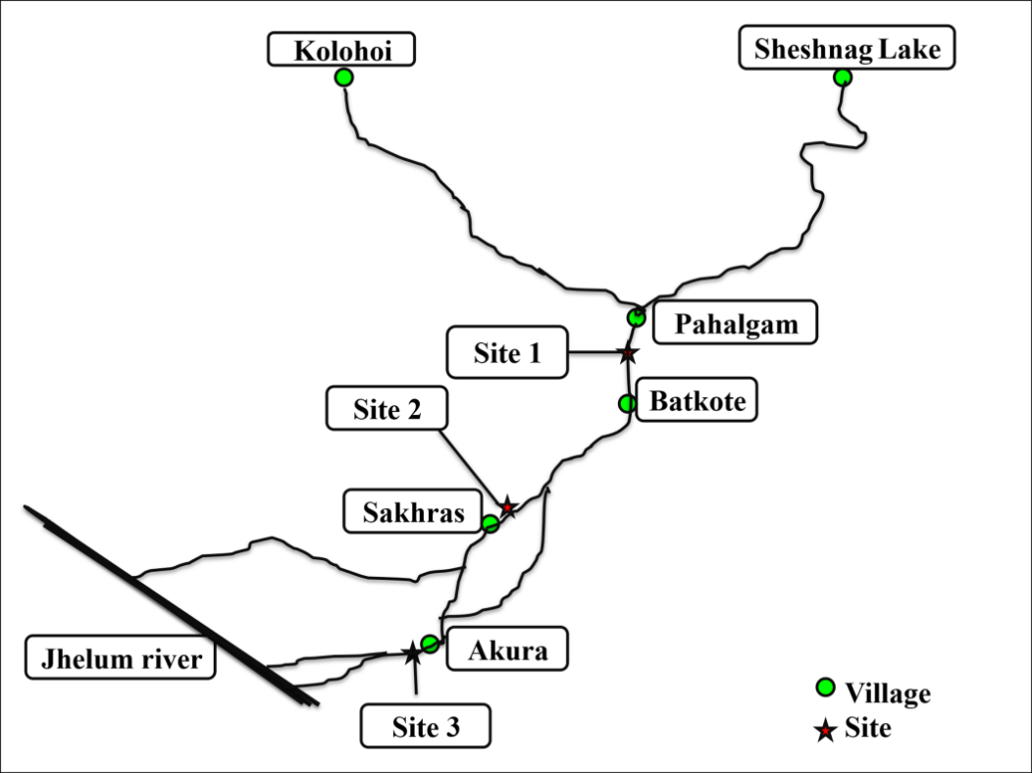

Fig 1. Map showing the river Liddar and sampling sites.
The current study was conducted over a six-month period, from September 2021 to February 2022. For the collection of samples, fishing was carried out at each site via cast nets of different mesh sizes and other locally available gear, such as fishing hooks. At each study site, sampling was carried out in the morning hours with the help of local skilled fishermen. For identification, the fish samples were collected and transported in ice boxes to the lab. According to Talwar and Jhingran, Jayaram, Kullander, Menon [5,6,7,8] and other pertinent scientific reference books, fish were recognised. The samples were placed at the Fisheries Resource Management Laboratory, Faculty of Fisheries, SKUAST-K, Rangil, Ganderbal (Jammu and Kashmir), after being preserved in 10% buffered formalin and kept in jars based on their size.
Diversity indices
Shannon‒Wiener diversity index
The Shannon–Weiner diversity index (H) was calculated via the following formula (Shannon and Weiner [9]:
H’ = -$\sum{pi. }$ln pi
i= 1
where
Pi probability of each species (ni/N).
N: total number of individuals in ‘S’ species.
ni number of individuals in the ith species.
Jaccard similarity index
The qualitative similarity of locations is assessed using the Jaccard index [10]. The Jaccard similarity index takes into account whether a species is present or not. The species similarity between two sites was compared using the Jaccard index. The formula is C_{j}=$\frac{J}{(a+b-j)}$
Where,
j = the number of species found at each site.
a = the number of species recorded at site 1.
b= the number of species recorded at site 2.
Catch per unit effort (CPUE)
Catch per unit effort is the quantity or weight of fish captured per unit of fishing effort. By transforming the time spent on operating gear as the time spent exerting effort and expressing the outcome in grams per man-hour [11].

Results and Discussion
Fish samples were taken early in the morning with the assistance of local fishermen using various kinds of equipment in order to study the fish variety of the River Lidder. The samples were subsequently identified after being shipped in ice cases to the Fisheries Resource Management Laboratory. Schizothoraxplagiostomus [12], S. esocinus [12], S. labiatus [13], Triplophysa kashmirensis [14], Glyptosternon reticulatum [13] and Salmo trutta fario [15] are among the six fish species that were identified in this study. It was examined how the value of Shannon's diversity index (H') varied between locations and throughout two seasons, as shown in Table 1.
Season | Month | Site 1 | Site 2 | Site 3 | Mean
 | September | 1.03 | 0.99 | 1.00 | 1.00
Autumn | October | 1.35 | 1.09 | 0.74 | 1.06
 | November | 1.63 | 1.06 | 0.56 | 1.02
 | Seasonal Mean | 1.33 | 1.04 | 0.76 | 1.05
 | December | 1.26 | 1.12 | 0.57 | 0.98
Winter | January | 1.49 | 0.51 | 0.49 | 0.83
 | February | 1.46 | 0.49 | 0.14 | 0.75
 | Seasonal Mean | 1.40 | 0.70 | 0.4 | 0.83
 | Overall Mean | 1.36 | 0.87 | 0.58 | 0.94

Table 1. Shannon‒Wiener diversity indices for different fish species in the Lidder River, Kashmir
At 1.05, autumn had the highest mean diversity index, while at 0.83, winter had the lowest. The degree of similarity between the two dataset pairings was also ascertained by calculating the similarity in the fish species compositions of various Lidder River sites using the Jaccard similarity index, as shown in Table 2.

Season | Month | Sites 1and2 | Sites 2and3 | Sites 1and3 | Mean
 | September | 0.33 | 0.50 | 0.50 | 0.44
Autumn | October | 0.66 | 0.50 | 0.33 | 0.49
 | November | 0.83 | 0.66 | 0.66 | 0.71
 | Seasonal Mean | 0.60 | 0.55 | 0.49 | 0.54
 | December | 0.83 | 0.50 | 0.50 | 0.61
Winter | January | 1.00 | 0.66 | 0.66 | 0.77
 | February | 1.00 | 0.50 | 0.50 | 0.66
 | Seasonal Mean | 0.94 | 0.55 | 0.55 | 0.68
 | Overall Mean | 0.77 | 0.55 | 0.52 | 0.61

Table 2. Jaccard similarity index for different fish species of the Lidder River, Kashmir
There was a minimum similarity of 0.33 between Site 1 and Site 3, and a total similarity value of 1 between Site 1 and Site 2 as shown in figure 2. Three locations in the River Lidder were used to record the capture per unit effort during a six-month period. For Site 1, the month of February had the greatest CPUE (381.25 g/man-hour), while the month of October had the lowest (156.25 g/man-hour). At Site 2, the month of September had the highest CPUE (875 g/man-hour), while the month of December had the lowest CPUE (312.5% g/man-hour). Similarly, for site 3, the month of September had the highest CPUE (1250 g/man-hour), while the month of January had the lowest CPUE (218.75 g/man-hour). The findings showed non-significant differences across all river sites (P>0.01) during the various months of the study period, and significant differences in both seasons (P<0.01) as shown in Table 3.
Season | Month | Site 1CPUE (g/man-hr) | Site 2CPUE (g/man-hr) | Site 3CPUE (g/man-hr) | p value
Autumn | September | 312.50 | 875.00 | 1250.00
Autumn | October | 156.25 | 770.00 | 875.00
Autumn | November | 218.75 | 512.50 | 312.50
 | Seasonal Mean | 229.16 | 719.16 | 812.50
Winter | December | 218.75 | 312.50 | 406.25 | ˃0.01
Winter | January | 225.00 | 625.00 | 218.75
Winter | February | 381.25 | 825.00 | 531.25
 | Seasonal Mean | 275.00 | 587.50 | 385.41
 | P value | <0.01
 | Overall Mean±S.E | 252.08 ±22.92 | 653.33±87.37 | 598.95±160.04

Table 3: Combined CPUE values of all three River Lidder sites
During the study, the fish species collected were Schizothorax esocinus, S. plagiostomus, S. labiatus, Triplophysis kashmirensis, Glyptothorax kashmirensis and Salmo trutta fario. Khan and Ali [16] reported 6 species of fish from the Jehlum River, namely, Schizothorax curvifrons, Schizothorax esocinus, Schizothorax plagiostomus, Schizothorax labiatus, Schizothorax niger, and Cyprinus carpio. Earlier studies carried out by Yousuf et al. [17] on this river reported 11 species of fish, namely, Carassius carassius, Gambusia affinis, Puntius conchonius, Bangana diplostoma and Triplophysa sp. Three Schizothoracines Schizothorax plagiostomus, S. esocinus, and S. labiatus as well as Salmo trutta fario, Crosscheilus diplochilus, Glyptosternon reticulatum, and Triplophysa kashmiriensis were discovered in the Lidder River [3]. It was discovered that S. plagiostomus predominated in the rivers' upstream sections. While Salmo trutta fario and G. reticulatum were only observed in midstream and upstream areas, Triplophysa kashmirensis and C. diplocheilus were primarily found downstream. The distribution of fish species in various habitats is known to be influenced by depth and water velocity [18,19,20,21,22]. Compared to the lower reaches (Sites 2 and 3), where both speed and depth are minimal, the upper reaches (Site 1) of the Lidder River flow through the canyon more quickly and deeply. There may be fewer but larger and older fish (species) upstream, which could be explained by the significant variations in river characteristics between upstream and downstream. The pattern was reversed in the downstream length, where more species and only smaller fish were observed. The majority of fish in small lotic systems are habitat generalists [23, 24, 25].

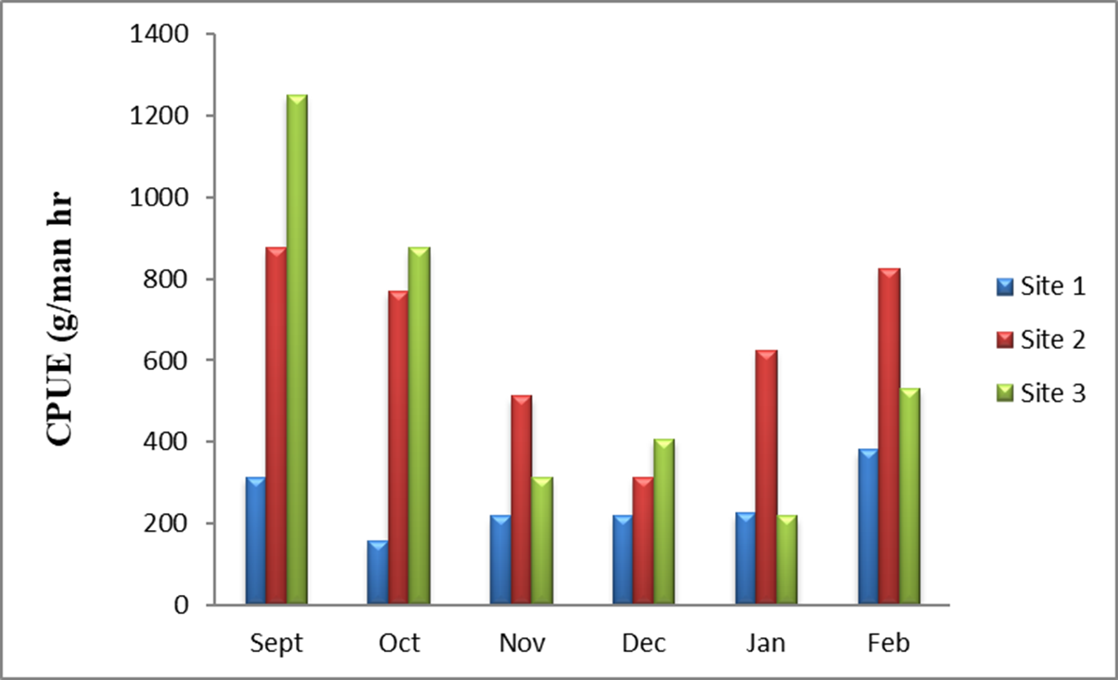

Fig. 2: Combined CPUE values of all the sites

Smaller fish upstream prefer shallow stream margins over midstream portions when the current is fast, too deep, or both because they cannot handle swift-moving rivers. Both the number of species and the distribution of individuals among them are considered by the Shannon-Weiner diversity (H') index. Both the overall population and the total number of taxa were taken into account. Site 1 had the highest Shannon diversity index during the study, followed by Sites 2 and 3. Water that is clean is represented by a Shannon's diversity index (H') value of 3, moderately contaminated by a value between 1.00 and 3.00, and seriously polluted by a value of 1.00 [26]. This rating places the Lidder River in the category of water that is moderately contaminated. According to Biligrami's [27] study on biological monitoring of Indian rivers, a water body must be in better condition for rich fish diversity when the Shannon-Wiener diversity index value falls between 3.0 and 4.5. The water body is less diversified and somewhat polluted, according to the study's diversity score, which ranged from 0.4 to 1.4. This is because of poor water quality brought on by pesticide and insecticide runoff from catchment areas and household discharge. The absence of some fish species, such as Crossocheilus diplochilus, reported in an earlier study by Bhat et al. [3] indicates a loss in fish diversity in the studied area. The current findings are consistent with the findings of various scientists, as, according to Welcomme [28] and Bayley and Li [29], in riverine systems, fish communities' species richness, diversity, and abundance frequently rise from upstream to downstream.

The Jaccard index, which helps in determining similarities in species composition by assigning a value between 0 and 1, was used to calculate the similarity in the fish species compositions of different Lidder River sites. The closer the computed value is to 1, the more similar the fish species composition is. The Jaccard similarity index of site 1 and site 2 was estimated to be 1 in this study, implying that the species compositions of these two locations are extremely similar. The similarities in this study suggested that, in comparison with site 3, sites 1 and 2 were relatively undisturbed. The most important indicator for long-term fishery monitoring is catch per unit effort. It is an indirect indicator of the abundance of a target species. Variations in CPUE are perceived as variations in the target species' actual abundance. The decrease in CPUE may be a sign that the current fishing tempo is too much for the fish population. CPUE increases may be a sign that a fish stock is rebounding and more fishing is possible. Using a cast net and other locally accessible equipment, the current study's catch per unit effort (CPUE) varied from 252.08 g/man-hour at Site 1 to 653.33 g/man-hour at Site 2. Variations in CPUE are perceived as variations in the target species' actual abundance. The decrease in CPUE may be a sign that the current fishing tempo is too much for the fish population. CPUE increases may be a sign that a fish stock is rebounding and more fishing is possible. Fishing activity in the Jhelum River varied from 173.2 to 360.1 g/man-hour, according to Yousuf et al. [17]. Khan and Ali [16] reported that the average fishing effort in Jhelum ranged from 132.26 to 290.46 g/man-hour. Management strategies like reducing fishing pressure and effort may benefit from the current data on catch per unit effort.

CPUE was observed in the Gorai River in Bangladesh by Tikadar et al. [30]. The seine net had the highest CPUE value (5.2±1.72 kg/gear/haul), while the hook and long lines had the lowest (0.0135±0.0015 kg/gear/haul). According to Ahmed et al. [31], the Meghna River in Bangladesh had the highest CPUE (kg/fishermen/day) during the dry season (4.25±0.41) and the monsoon season (3.83±0.5). According to these results, the summer months see the highest species abundance because of the increased availability of food and the migration of fish from the lower reaches for grazing and spawning.

Conclusion
The conservation of biodiversity is one of the key issues for the sustainable use of natural resources. Owing to its unique geography, the fish fauna of the Kashmir valley is unique from that of the rest of the world and has a great deal of potential to support the development of cold-water fisheries. In the present study, six species of fish were collected from the Lidder River. However, it is obvious that the amount and variety of fish caught have declined in this cold-water, snow-fed stream. The absence of fish species, such as Crossocheilus diplochilus, in the present study indicates a loss of fish diversity in the studied area. Overexploitation, flow alteration, habitat degradation, and pollution have been recognized as important risks to fish biodiversity in the study area. The results show that anthropogenic activities such as illegal mining, including the extraction of sand and boulders, sewage disposal and overfishing, pose a threat to the fish populations in the river.

Suggestions for the future
Suggestions and strategies are provided, taking into account the results of research on the fish biodiversity and water quality of the Lidder River, Kashmir. Indiscriminate and illegal mining of sand and boulders should be prohibited, fragile Schizothoracid habitat regions should be designated sensitive zones (sanctuaries), and water quality parameters should be monitored to ensure that favourable conditions are maintained for the fish species to thrive. Sewage disposal into the Lidder. The river should be stopped by the relevant authorities. Fishing should be prohibited during the spawning season. Proper fishing regulations (minimum size, catch and net size limits, etc.) should be enforced. It is important to make efforts to provide fishermen with alternative means of supporting their livelihood. This will encourage, sensitise and avoid destructive fishing methods, hence minimising fishing efforts.
Reference
[1] Froese, R. and Pauly, D. FishBase. Worldwide Web electronic publication. www.fishbase.org, version (06/2022).
[2] Dar, G. H. and Khuroo, A. A. 2020. An introduction to biodiversity of the Himalaya: Jammu and Kashmir state. In Biodiversity of the Himalaya: Jammu and Kashmir State pp. 3-26.
[3] Bhat, F.A., Balkhi, M.H., Najar, A.M. and Yousuf, A.R. 2013. Distribution pattern, Density and Morphometric characteristics of Schozothoracines in Lidder river, Kashmir. The Bioscan An International Quarterly Journal of Life Sciences Vol 8(2): 363-369.
[4] Rashid, I. and Romshoo, S. A. 2012.Impact of anthropogenic activities on water quality Lidder River in Kashmir Himalayas.Environ Monit Assess. 2013 Jun; 185(6): 4705-19.
[5] Talwar, P.K. and Jhingran, A.G. 1991. Inland Fishes of India and Adjacent Countries Vol. I and and II. Oxford and IBH Co., Pvt. Ltd. (New Delhi), 1158pp.
[6] Jayaram, K.C. 1999. The Freshwater Fishes of the Indian Region.Narendra Publishing House, Delhi, India. 551pp.
[7] Kullander, S.O., Fang, F., Delling, B. and Ahlander, E. 1999. The fishes of the Kashmir valley Impacts on the aquatic environment. Nyman, L.ed.Swedmar, Gotebofrgs, Lanstryckeri AB., Swedmar 99-162.
[8] Menon, A.G.K. 1999. Check list of the fresh water fishes of India. Records of the Zoological Survey of India.Occasional Paper175: 1-366.
[9] Shannon, C. E. and Weiner, W. W. 1963.The Mathematical Theory of Communications. University of Illinois Press, Urbana, 117 p.
[10] Krebs, C.J. 1989. Ecological Methodology. Harper Collins, New York. 654pp.
[11] Kurian, J. and Wilmann, R. 1982. Economics of artisanal and mechanized fisheries in Kerala: A study of cost and earnings of fishing units. RAS/77/044.FAO/UNDP working paper, Madras, India. No. 34: 387 - 411.
[12] Heckel, J. J. 1838. Fische aus Caschmir gesammelt und herausgegeben von Carl Freiherrn von Hügel, beschrieben von JJ Heckel. Wien. Fische aus Caschmir gesammelt und herausgegeben von Carl Freiherrn von Hügel, beschrieben von JJ Heckel 1-112.
[13] McClelland, J. 1842. On freshwater fishes collected by William Grifth, Esq. E.L.S. Madras Medical Service, during his travel under the orders of supreme Governor of India, from 1835 to 1842. Calcutta J Nat Hist 2:560–589.
[14] Hora, S. L. 1922. Structural modifications in the fish of mountain torrents. Records of the Zoological Survey of India 24(1):31-61.
[15] Linnaeus, C. 1758. Tomus I. Syst. nat., ed. 10. Holmiae, Laurentii Salvii: [1-4], 1-824.
[16] Khan, I. and Ali, M. 2013. Current status of the fish fauna of River Jhelum, Kashmir, JandK.2:694.
[17] Yousuf, A. R., Bhat, F. A. and Mahdi, M. D. 2006. Limnological features of River Jhelum and its important tributaries in Kashmir Himalaya with a note on fish fauna. J. Him. Ecol. Sustain. Dev.1: 37-50.
[18] Gorman, O. T. and Karr, J. R. 1978. Habitat structure and stream fish communities. Ecology59: 507 – 515.
[19] Moyle, P. B. and Vondracek, B. I. 1985. Persistence and structure of the fish assemblage in a small California stream. Ecology 65: 1-13.
[20] Arunachalam, M. 2000. Assemblage structure of stream fishes in the Western Ghats (India). Hydrobiologia 430:1-31.
[21] Johal, M. S., Tandon, K. K., Tyor, A. K. and Rawal, Y. K. 2002. Fish diversity in different habitats in the streams of lower, middle Western Himalayas. Pol.J. Ecol. 50(1): 45- 56.
[22] Negi, R. K., Joshi, B. D., Negi, T. and Chand, P. 2007. A study on stream morphology of some selected streams hill streams of district Nainital with special reference to its biotic communities. Proceedings of National Seminar on Limnology at Jaipur, India.
[23] Harvey, B. C. and Stewart, A. J. 1991.Fish size and habitat depth relationship in a headwater stream. Ecologia 87:336-342.
[24] Bain, M. B., Finn, J. T. and Booke, H. E. 1988.Stream flow regulation and fish community structure. Ecology 69: 382-392.
[25] Horowitz, R. J. 1978. Temporal variability patterns and the distributional patterns of stream fish. Ecological Monogr48: 307-21.
[26] Wilhm, J. L. and Dorris, T. C. 1966.Species diversity of benthic macroinvertebrates in a stream receiving domestic and oil refinery effluents.Am. Midl. Nat. 76: 427-449.
[27] Biligrami, K. S. 1988. Biological monitoring of rivers, problems and prospect in India.Aquatic Ecotoxicology 245-250.
[28] Welcomme, R. L. 1985. River fisheries.FAO Fisheries Technical Paper, 262: 1-318.
[29] Bayley, P. and Li, H. 1994. Riverine fisheries. In: Calow P, Petts GE (Eds) the river handbook: hydrological and ecological principles. Blackwell, Boston, 1994, pp 251-281.
[30] Tikadar, K. K., Kunda, M. and Mazumder, S. K. 2021. Diversity of fishery resources and catch efficiency of fishing gears in Gorai River, Bangladesh. Heliyon 7 (12): e08478.
[31] Ahmed, T., Hossain, Z., Rahman, M. M. and Mahmud, Y. 2022. The CPUE and Catch Composition of Fishing Nets used by the FishersÎ "in the Lower Meghna River at Chandpur region, Bangladesh. International Journal of Science and Business 13(1): 77-89.

