Original Research Article
Quinic Acid as a Potential Therapeutic Agent in Drosophila Model of Rotenone-Induced Parkinson’s Disease

ABSTRACT
Background: Quinic acid (QA), a cyclic polyol is reported to possess antioxidant, anti-inflammatory and anti-apoptotic properties. The present experiment studied the protective role of QA against rotenone mediated reduction in viability, cognitive dysfunction and oxidative stress in Drosophila melanogaster. Materials and Methods: The antiparkinsonian role of QA was assessed in rotenone induced Drosophila model of PD by performing life span assay, cognitive and behaviour studies and biochemical (oxidant-antioxidant) assays. Results: QA exposure enhanced viability in rotenone (500 µM) exposed fruit flies and enhanced locomotion in open field and negative geotaxis assay. QA significantly attenuated the cognitive impairment (thermotaxis, smell and taste chemotaxis and phototaxis) induced by rotenone. QA significantly reduced TBARS, ROS and protein carbonyl levels and enhanced levels of GSH and activities of SOD, catalase and GST in rotenone exposed flies through its potent antioxidant properties. Conclusion: These results demonstrated the protective effect of QA may be partially due to its potent antioxidant activity. However further research is needed to understand the underlying mechanisms in other cellular and animal models of PD.
Keywords: Drosophila, rotenone, Quinic acid, oxidative stress, behaviour.

- INTRODUCTION
Parkinson’s disease (PD) is mainly considered as a motor disease and the patients are affected by tremor, bradykinesia, rigidity and postural instability (Marinus et al., 2018). Dopaminergic neuronal loss occurred in substantia nigra pars along with their projections into the striatum are the hall marks of PD (Kalia et al., 2015). Although the cause of PD is not known, it may be occurred due to exposure of exposure to environmental toxins (sporadic PD) or/and mutations in genes such as α-synuclein and leucine-rich repeat kinase 2 (familial PD) (Park et al., 2009). Rotenone, a natural piscicide and board spectrum insecticide, potentially inhibits mitochondrial complex I and inhibits ATP synthesis in mitochondria by completely preventing the oxidation of TCA metabolites leading to ROS production (Heo et al., 2022). It closely mimics the pathology of sporadic PD in mammals (rat and mice) and non-mammals (Lymnaea stagnalis, fruit flies, Caenorhabditis elegans, and zebrafish) after its exposure (Fontana et al., 2017, Harrington et al., 2010).
Drosophila melanogaster (fruit fly) is considered as an excellent model for analysing the cause and pathology of neurodegenerative diseases, as it resembles about 75% homology with genes of human beings (Setzu et al., 2024). Drosophila has developed as a good model organism of PD involving either toxin-induced ex. rotenone or genetically (transgenic) linked PD. The existing fly PD models showed the hall marks including behavioural changes and helps to determine pathways involved in PD pathogenesis which could facilitate the development of therapeutic strategies (Muñoz-Soriano et al., 2011). Rotenone exposure for a week leads to locomotor deficits, degeneration of dopaminergic neurons and reduction in levels of dopamine in flies (Manjunath et al., 2013). Moreover, Hosamani and Muralidhara (2009), showed that the exposure of the toxin induced oxidative stress in flies exposed by significant elevation of MDA and hydroperoxide level along with increased activities of catalase, SOD and GST.
PD is considered as a multi-factorial disorder concerning the oxidative stress, mitochondrial dysfunction, inflammation, impaired ubiquitin / proteasome system, glutamatergic toxicity and the activation of apoptosis. Current treatment approaches primarily target motor symptoms but do not halt or slow down disease progression (Majali et al., 2021). Natural products from plants such as phytochemicals have long been valued for their nutritional and health promoting properties (Van et al., 2018). Plant extracts and phytochemicals are the promising candidates for arresting the progression of PD, due to the numerous of pharmacological properties like antioxidant, autophagic, mitochondrial protective, anti-inflammatory, and anti-apoptotic activities (Tsialtas et al., 2021, Xu et al., 2020). Quinic acid (QA) is a cyclic polyol comprising numerous hydroxyl groups. Many food products such as coffee, tea, vegetables and fruits are reported to contain QA with its derivatives like phenolic caffeoylquinic acids (Alcázar Magaña et al., 2021). QA has previously reported to possess potent antioxidant and anti-inflammatory properties (Benali et al., 2024, Ghasemi-Dehnoo et al., 2023). However, the protective effect of QA in rotenone mediated drosophila model has not been explored. So, the aim of the experiment is to explore the neuroprotective role of QA against rotenone induced drosophila model of PD by performing behavioural studies and analysing biochemical indices.
2. MATERIAL AND METHODS
2.1 Drosophila melanogaster stock and culture
The wild-type (Oregon R strain) D. melanogaster were procured from CCMB, Hyderabad, India. They were reared in nutrient medium (2% w/v sucrose, 1% w/v brewer’s yeast, propionic acid, 0.08% v/w nipagin and 1% w/v agar at 22–24°C with 60–70% relative humidity) in 12 h LD cycle.
2.2 Treatment of D. melanogaster with QA and rotenone
Dose dependent study - Phase I
Flies were exposed to various concentration of rotenone (250, 500 and 1000 µM) for 7 days as per previous experiments and the lethality count was made documented as the % of flies survived (Hosamani & Muralidhara 2009). Based on LD50 value (life span test), the dose of rotenone was fixed. To explore the protective effect, various concentrations of QA (25 μM, 50 μM and 100 μM /10 g diet) were exposed to flies for 7 days along with rotenone (LD₅₀) and the maximal protective dose was fixed after analysing life span test on 7th day.
2.3 Study with fixed dose - Phase II
The flies were divided into Group I (control – exposed to 5% sucrose and 0.3% DMSO mixed with diet); Group II (toxin - exposed to 500 μM of rotenone mixed with diet); Group III (toxin + drug - exposed to 500 μM of rotenone and 50 μM of QA mixed with diet); Group IV (drug - exposed to 50 μM of QA mixed with diet).
After the end of the experiment study (7 days), the control and experimental flies were performed for various behavioural assays. Then they were anaesthetized, weighed, homogenized in phosphate buffer (0.1 M, pH 7.4) and centrifuged. Supernatants were used for further assays.
2.4 Open field test
In the open-field test, each control and experimental flies (n = 15) were placed in a petridish (9 cm in diameter), which was divided into 1 cm × 1 cm squares (Hirth et al., 2010). The movement of flies were observed for 60 seconds. The distance travelled was determined by enumeration the n.o of squares crossed in three independent experiments.
2.5 Negative geotaxis
D. melanogaster (n = 15) from each group were placed at the bottom of a vertical glass vial (15 cm × 1.5 cm) with a cotton plug securing the top. To ensure they gathered at the bottom, the vial was lightly tapped. The time taken for D. melanogaster that successfully flied to the top was individually counted. Three experiments were performed and data were calculated as mean ± SEM.
2.6 Phototaxis
From each group (n = 15), flies were placed in separate vials that are plugged with cotton. To facilitate adaptation to darkness, the flies were kept in a dark for half an hour. Each vial was then attached to another vial using adhesive tape and divided into 3 (I, II & III) labelled compartments. A light source from emergency lamp was positioned near to compartment I for one minute. Distribution of flies in compartments I, II & III were counted and articulated as a percentage. Experiment was repeated three times, and the data were presented as mean ± SEM.
2.7 Smell chemotaxis
This study utilized benzaldehyde as a potent repellent. 15 flies from each group were placed in a vial (15 cm × 1 cm) that was sectioned into 3 (I, II & III) compartments. The vial was plugged with cotton (compartment III) that was soaked in benzaldehyde (100 nM). Distribution of flies across the compartments were counted after a minute and expressed as percentages. The experiment was repeated with three independent groups of flies, and the data were reported as mean ± SEM
2.8 Taste chemotaxis
15 flies from each group were placed in a vial (15 cm × 1 cm) that was sectioned into 3 (I, II & III) compartments. The vial was plugged with cotton (compartment III) that was soaked in sucrose (0.1%) solution. Distribution of flies across the compartments was recorded after a minute and expressed as percentages. The experiment was repeated with three separate groups of flies, and the data were reported as mean ± SEM.
2.9 Thermotaxis
This study involved the use of two vials (15 cm × 1.5 cm). One vial was heated to 45ºC and was attached directly to another vial at room temperature using transparent tape. The connected vials were sectioned into 3 compartments (I, II& III), with compartment III representing the heated area. Distribution of flies across the compartments was recorded after a minute and expressed as a percentage. The experiment was conducted with three independent groups, and the results were presented as mean ± SEM.
2.10 Estimation of biochemical variables
TBARS levels was quantified by the method of Niehaus & Samuelson, (1968). To the brain tissue, TCA was added, centrifuged and supernatant was collected. Then, HCl- TBA mixture was added and kept in a boiling water bath. After cooling, the OD was read at 535 nm. For the assay of carbonyl content of protein (Levine et al., 1990), the brain samples were taken into two parts, (each containing 0.1g of protein), and 2N HCl with and without DNPH were mixed, along with 10% TCA. After 1 hr incubation, centrifuged and to the precipitate, an equal volume of ethyl acetate and ethanol (1:1) was added and mixed with guanidine HCl and the absorbance was read at 360 nm. For assaying the superoxide dismutase activity (Kakkar et al., 1984), the brain homogenates were added with NBT and PMS. NADH was added to induce the reaction and glacial acetic acid for inhibition. n-butanol was added and the absorbance was read at 560 nm. To measure the activity of GST (Habig et al., 1974), the brain homogenate was added with CDNB and GSH. The OD was read at 340 nm. The activity of catalase was assayed by the method of Sinha (1972). To the brain homogenate, phosphate buffer and H₂O₂ were added. To stop the reaction, dichromate-acetic acid mixture was added at various time intervals and kept in a boiling water bath. After cooling, the OD was measured at 610 nm. For the assay of activity of GPx (Rotruck et al., 1973), brain homogenate was added with GSH, NADPH, and H₂O₂. After incubation, the OD was measured at 340 nm. For the quantification of the levels of reduced glutathione (Ellman, 1959), brain homogenate were added with DTNB, and was read at 412 nm.
2.11 Determination of Reactive Oxygen Species
To the brain sample, H₂ DCFDA was added in a 96-well plate. After 45-minutes, fluorescence was measured at 490 nm and 522 nm (Filafero et al., 2022).
2.12 Statistical Analysis
One-way analysis of variance and Duncan’s multiple range test (DMRT) were calculated to study statistical significance within groups (p<0.05).
3. Results
3.1 Protective role of QA on life span of rotenone exposed flies
Rotenone treatment diminished the survival rate (%) in a dose and time dependent manners as compared to control flies. Exposure to middle dose (500 µM) of rotenone for 7 days showed approximately 50 % death in flies and used for further studies (Figure. 1).
Rotenone treatment diminished the survival rate (%) as compared to control flies. Co-exposure of QA enhanced the survival rate of rotenone exposed flies as compared with rotenone alone exposed group. As there is no significant difference were found between high dose (100 µM) and medium dose (50 µM) of QA and rotenone co-exposed group, medium dose (50 µM) is considered as the optimum dose for further experiments. No significant alteration of the survival rate was found between QA alone treated flies as compared to group I flies (Figure. 2).
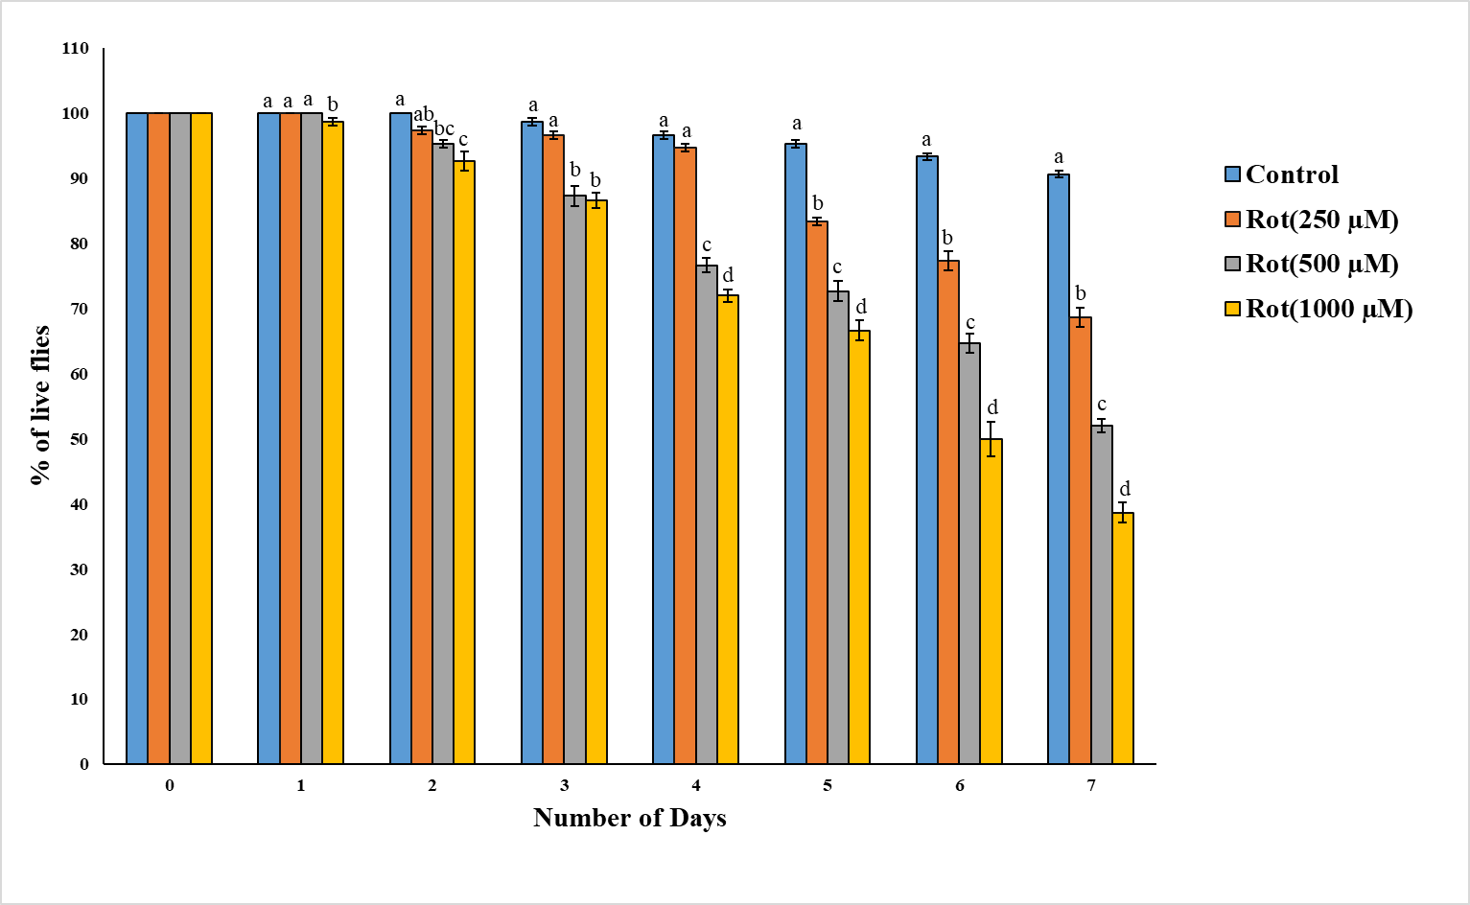

Figure 1: Dose and time dependent effect of rotenone on life span of flies. All the values are expressed as mean ± SEM; n=50, values not sharing the same alphabet differs significantly (p<0.05); ANOVA followed by Dunken’s test)

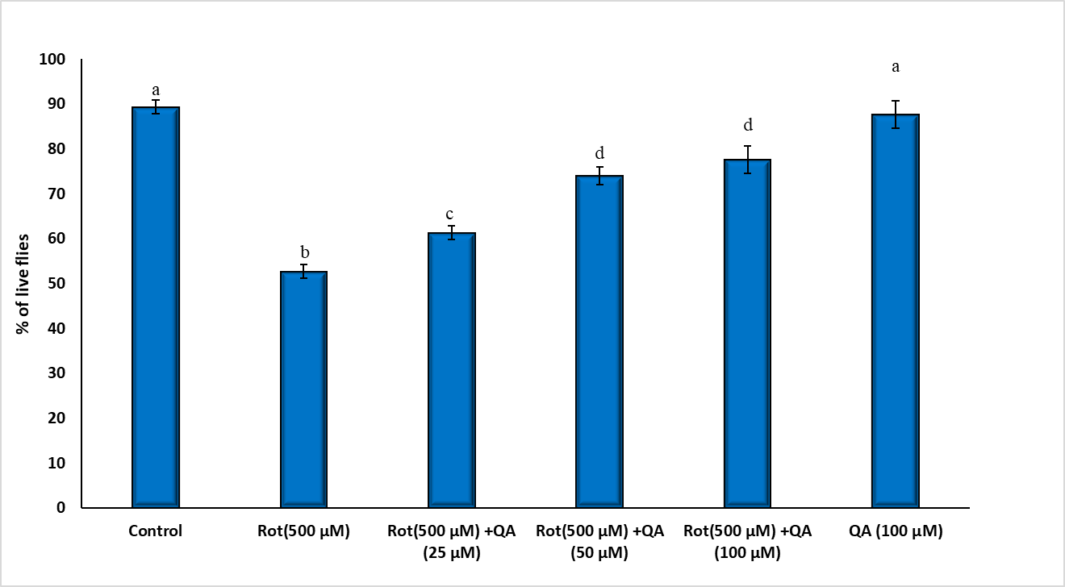
Figure 2: Dose dependent protective effect of QA on rotenone induced viability in flies. All the values are expressed as mean ± SEM; n=15, values not sharing the same alphabet differs significantly (p<0.05); ANOVA followed by Dunken’s test)
3.2 Efficacy of QA on Open field test of rotenone exposed flies
In open-field test, rotenone exposure induced significant decrease in the n.o. of crossings when compared with normal flies and that this effect was attenuated by the co- treatment of QA. No significant alterations in locomotion were found between QA alone exposed and control group (Figure.3).

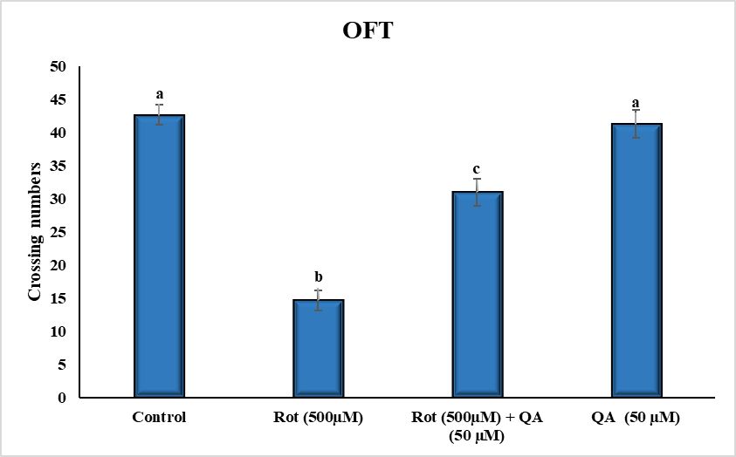

Figure 3: Effect of QA on rotenone induced locomotional deficit in flies. All the values are expressed as mean ± SEM; n=15, values not sharing the same alphabet differs significantly (p<0.05); ANOVA followed by Dunken’s test)

3.3 Role of QA on negative geotaxis assay of rotenone exposed flies
The result of negative geotaxis assay indicated that the climbing ability or flying on top was reduced in the rotenone exposed flies as compared to control flies (Figure. 4). Rotenone toxicity was evident by the increased climbing time (seconds). On QA cotreatment, numerous flies demonstrated the negative geotaxis behavior as evidenced by their reduced climbing time, showing a neuroprotective effect of the cyclic polyol. No significant modification in climbing time was observed between QA alone exposed flies as compared to control group.

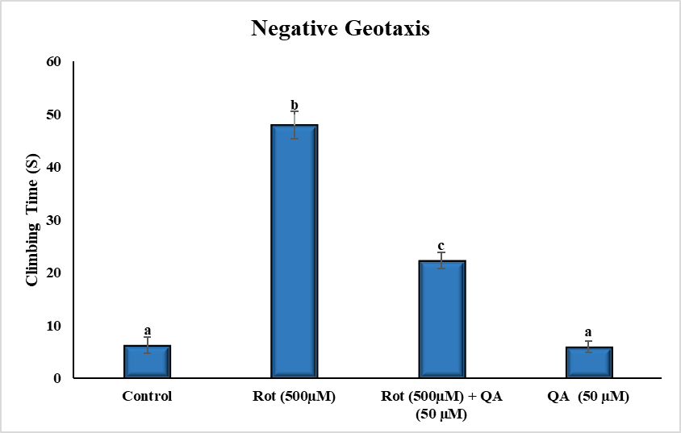
Figure 4: Effect of QA on rotenone induced movement deficit in flies. All the values are expressed as mean ± SEM; n=15, values not sharing the same alphabet differs significantly (p<0.05); ANOVA followed by Dunken’s test)
3.4 Role of QA on cognitive function of rotenone exposed flies
Figure 5 A,B,C,D – revealed the behavioural alterations in smell and taste chemotaxis, phototaxis and thermotaxis of control and experimental flies. Numerous control flies were supposed to move away from the irritating odour of the benzaldehyde (compartment 3) as observed by their movement from 3rd compartment to 1st compartment (smell chemotaxis) as compared to rotenone treated flies (most of them remained in 3rd compartment). Significantly enhanced movements from 3rd compartment to 1st compartment were found in QA+ rotenone treated flies as compared with rotenone alone exposed flies. Several flies from control group move closer to the cotton plug soaked with sucrose solution (compartment III) when compared to the lesser movement of rotenone exposed flies to compartment III The response of QA cotreated flies was similar to the locomotion of group I flies.
In phototaxis, numerous normal flies are move or tend to move closer towards compartment I, where light source is placed nearby. Rotenone exposure reduced this response significantly when compared to group I flies. Large number of rotenone treated flies were found in compartment II. But more and significant QA+ rotenone treated flies were found in compartment I when compared to rotenone exposed flies. In thermotaxis assay, more number control flies tend to move away from the hot surface (compartment III) to the compartment I and II as compared to rotenone treated flies. But there is a reversion in rotenone + QA treated flies when compared to group II flies. Invariably QA alone exposed flies showed similar types of behaviour in above said indices as control flies.

5A
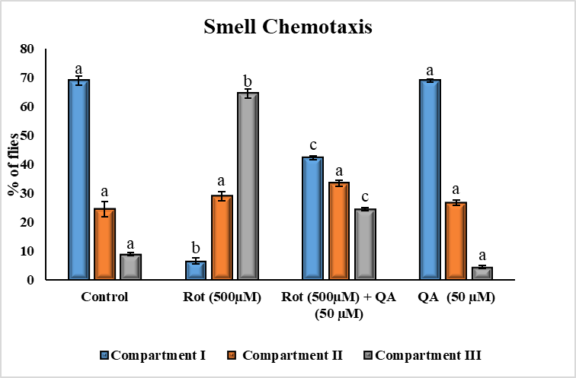

5B
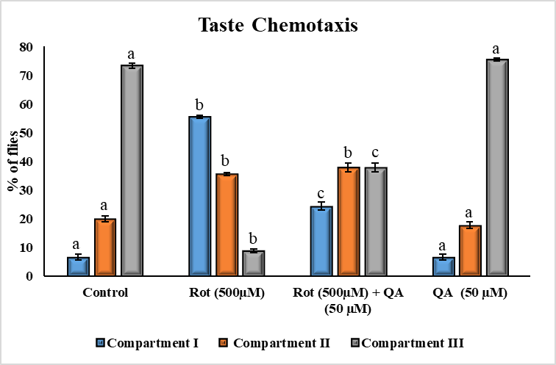

5C
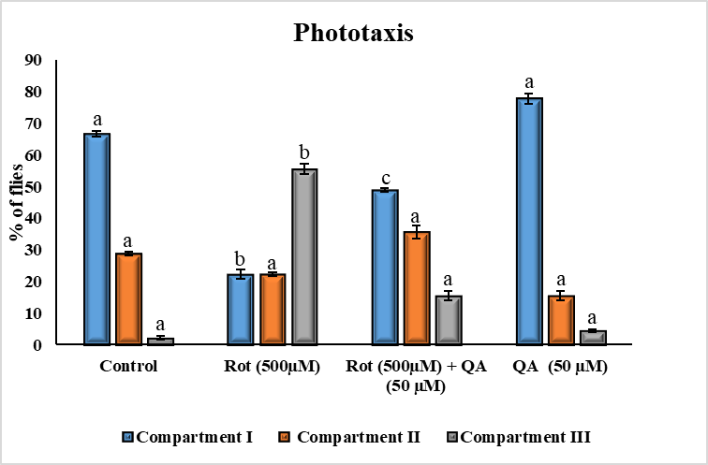
5D
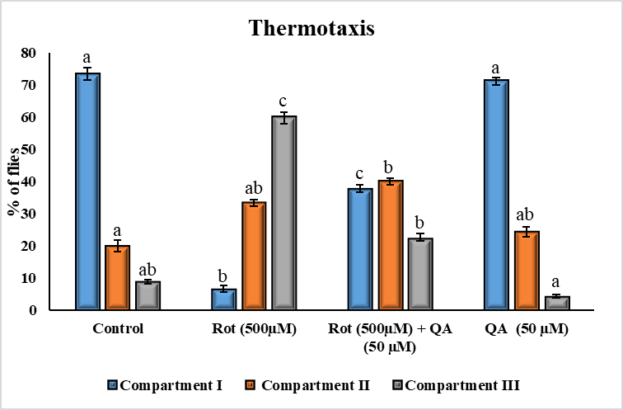
Figure 5 A,B,C,D: Effect of QA on rotenone induced cognitive deficits in flies. All the values are expressed as mean ± SEM; n=15, values not sharing the same alphabet differs significantly (p<0.05); ANOVA followed by Dunken’s test)
3.5 Efficacy of QA in modulating oxidative stress of rotenone exposed flies
Flies exposed with rotenone showed a significant increase in levels of ROS, TBARS and protein carbonyls (Figure. 6 A,B and C) as compared with group I flies. The co-exposure of QA significantly attenuated the neurotoxin mediated oxidative stress as proved by reduction in above said parameters in co-treated flies as compared to rotenone alone treated flies. No significant change in oxidative stress related indices was found between QA alone exposed flies as compared to control group.
6A
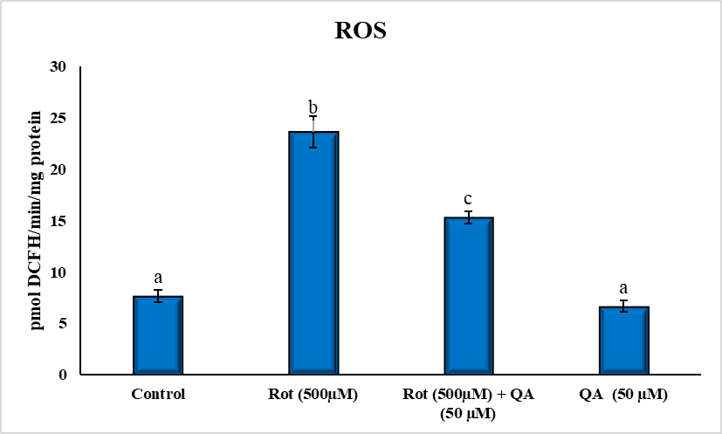
6B
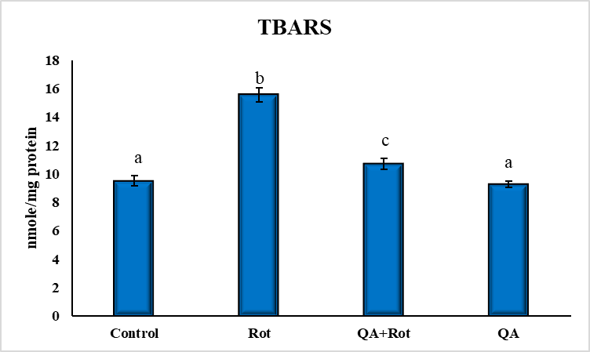

6C
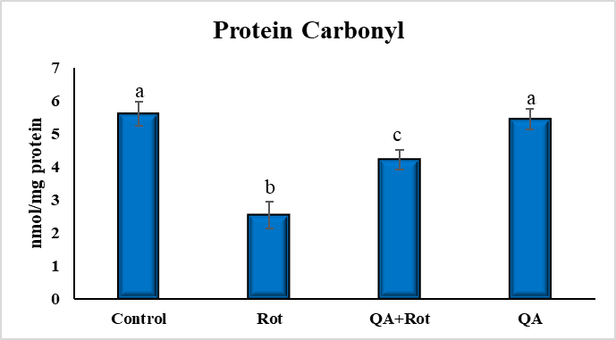
Figure 6 A,B,C: Effect of QA on rotenone induced the levels of oxidants in flies. All the values are expressed as mean ± SEM; n=30, values not sharing the same alphabet differs significantly (p<0.05); ANOVA followed by Dunken’s test)
3.6 Antioxidant effect QA on the levels of GSH and activities of enzymic antioxidant
Rotenone exposure for 7 days induced a significant reduction in GSH levels (Figure.7A) and enhancement in the activities of enzymatic antioxidants such as SOD, catalase and GST (Figure. 7 B,C and D) of flies as compared to control flies. Co-exposure of QA partially restored the levels of GSH and activities of enzymatic antioxidants due to their potent antioxidant functions. QA per se treatment for 7 days slightly but not significantly altered the levels of GSH and activities of antioxidants in whole body homogenate as compared with group I flies.

7A
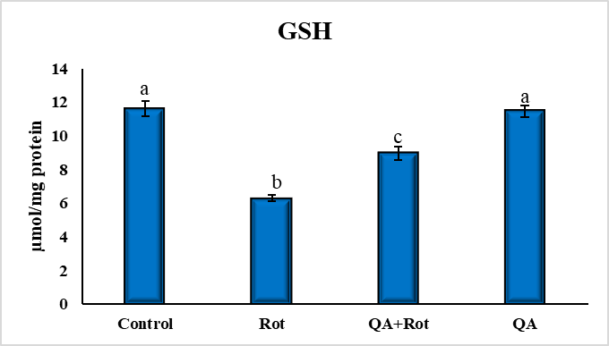
7B
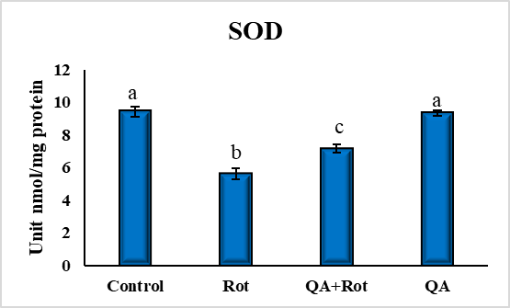

7C
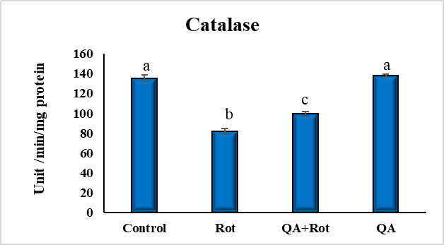
7D
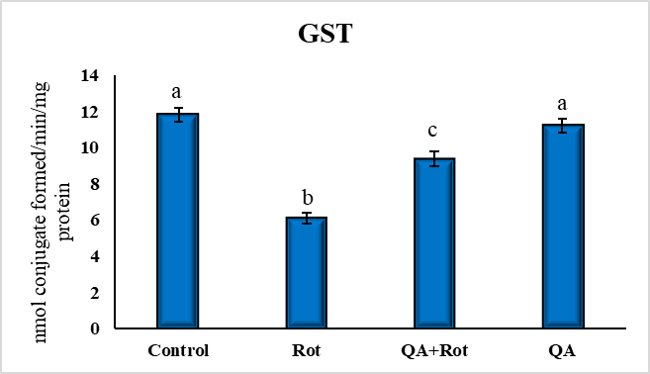
Figure 7 A,B,C, D: Effect of QA on rotenone induced reduction in the levels and activities of antioxidants in flies. All the values are expressed as mean ± SEM; n=30, values not sharing the same alphabet differs significantly (p<0.05); ANOVA followed by Dunken’s test)
4. Discussion
The present investigation studied the neuroprotective role of QA against rotenone model of Drosophila by investigating behavioural, cognitive and biochemical indices. Pre exposure of QA in diet dose dependently enhanced the lifespan of rotenone treated flies as compared with the rotenone alone exposed flies, indicating the anti-aging activity. Zhang et al., (2012) demonstrated the antiaging effect by diminishing oxidative stress and enhancing the expression of antioxidant, stress resistant and life span regulating genes in Caenorhabditis elegans. In vitro studies by Oh et al., (2020) indicated the protective effect of 3,5-Dicaffeoyl-epi-quinic acid, a derivative of QA against UVA-radiation in human dermal fibroblasts and HACAT keratinocytes by diminishing oxidative stress and proinflammatory response and enhancing antioxidant enzyme by increased expression of nuclear factor-like 2 (Nrf2). Sharawy et al., (2025) showed that the galloyl quinic acid derivative offered the antiaging and skin whitening activities in in vitro biochemical experiments.
Initially PD is considered as a motor disorder, but now, there is an increasing concentration on non-motor symptoms (NMS). As cognitive dysfunction particularly dementia is a common form of NMS, it decreases the quality of life (Fang et al., 2020). Negative geotaxis is natural escape behaviour of the flies that tapped to the bottom and in hope to escape, they will fly or climb in container. This test is used as an vital indicator to evaluate the response of toxic substances on movement and exploratory behaviour in flies (Musachio et al., 2020). The decreased capability to climb induced by the rotenone toxicity indicated not only the deficits in the negative geotaxis but also of reflexes and muscle tone. This toxin damages dopaminergic neurons, thus resulting in behavioral impairments, which can be quantified by negative geotaxis assay (Dauer et al., 2003). QA co-exposure improved the climbing ability of flies and thus enhanced innate negative geotaxis response may be by improving reflexes, locomotion and exploratory behaviour. Kilnic et al., (2022) demonstrated the synergistic anti-apoptotic role of QA and L-DOPA on rotenone induced in vitro model of PD. The open field test is performed to determine the exploratory activity of the flies in a new environment, where a reduced number of crossings was detected with rotenone exposure. Alterations in AChE activity is responsible for diminished exploratory behaviors in open field test (Fernandes et al., 2021). Farombi et al. (2019), and Kumar et al., (2020) demonstrated that altered AChE activity was found in rotenone induced D. melanogaster model of PD. In this study, we found that QA attenuated the rotenone-induced reduction in movement of the flies. Liu et al., (2020) indicated that oral administration of QA along with AlCl₃ rescued AChE activity and the behavioral impairments induced by aluminum.
Previous studies showed that the fruit flies are behaviourally sensitive to light (phototaxis) (Hardie et al., 2012), temperature (thermotaxis) (Hamada et al., 2008), chemical odors (smell chemotaxis) (Touhara and Vosshall, 2009) and tastants (taste chemotaxis) (Weiss et al., 2011). The sense of these stimuli is carried by vision, smell (olfaction), taste and thermosensor. The responses may be either towards or outwards movement depending on the nature and the intensity of the stimulus (Vang et al., 2012). D. melanogastor are impulsively phototaxic (Hirsch and Boudreau 1958), and a chance is given in between a light or a dark lane, flies are tend to choose often the light area (Le et al., 1955). In our study, the PD flies showed less attraction towards light source, whereas QA exposure exhibited more attraction in phototaxis assay. Previous studies reported that the plant products able to enhance the memory of several experimental models (Richetti et al., 2010, Xu et al., 2018, Siddique et al., 2009). Results of the present study showed the protective effect of QA.
The fruit flies also vigorously pursue food-related odorants (Semmelhack and Wang, 2009, Wang et al., 2003), and evade many volatiles, which are either indication of danger or highly concentrated (Gao et al., 2013). Olfactory dysfunction is a main symptom of brain damage linked with PD (Avanipully et al., 2022). Insects are more sensitive to volatile substances because of their well-developed olfactory sensory systems. These permit them to sense and retort to various concentrations of several odorants (Störtkuhl et al., 2005). In the present study, the olfactory responses of flies were studied by placing an aversive odorant, Benzaldehyde and attractant sucrose. Hyposmia is considered as one of the symptoms of presymptomatic PD (Doty et al., 2012). The rotenone exposed PD flies demonstrated the less deviation from benzaldehyde and attraction from sucrose, whereas QA treatment enhanced these olfactory and taste receptor functions.
As a poikilothermic organism, flies are capable of sensing and responding suitably to temperature changes in its environment to preserve body temperature (Bellemer, 2015). Thermotactic behaviour of flies are aversive movement – the capability of them to move away from the thermal stimuli (Huda et al., 2022). The rotenone exposed PD flies showed the less aversive behaviour for thermal stimuli, whereas QA treatment attenuated this behaviour. Drosophila have distinct set of dopaminergic (DA) cells. They were symmetrically dispersed and found as multiple clusters (Whitworth et al., 2006, Mao et al., 2009). Like the mammals, DA system not only controlled locomotion but also complex behaviours like sleep, learning, olfaction and memory (Yamamoto et al., 2014). In rotenone exposed group, dopamine is not available due to the loss of dopaminergic neurons, the flies exhibit cognitive impairments, which is evidenced by loss of attractant behaviour towards taste chemotaxis and aversive behaviour towards smell chemotaxis, thermal and light stimuli. The rotenone treated flies exposed to QA attenuated the alterations in memory, olfaction, attractant and aversive behaviours in smell and taste chemotaxis, phototaxis and thermotaxis may be due to protection of dopaminergic neurons. QA in combination with L-DOPA attenuated the SH-SY 5Y against rotenone toxicity by its antiapoptotic effect (Berry et al., 2008). This is evident by the increased locomotion and other cognitive activities in the PD flies exposed to QA.
The oxidative stress and antioxidant related markers such as thiobarbituric acid reactive substances (TBARS, a product of lipid peroxidation), protein carbonyl (PC, an early marker of protein oxidation), ROS, SOD, catalase, GSH and GST were estimated in the study. Rotenone inhibited the mitochondrial complex I that can resulted in enhanced formation of free radicals and subsequently, leading to increased lipid peroxidation i.e. TBARS generation in Drosophila,(Arumugam et al., 2018, Siddique et al., 2009) which is corroborated with our results. Kwon et al., (2016) indicated that QA exhibits antioxidant properties by reducing intracellular ROS levels in PC12 cells exposed to hydrogen peroxide. Enhanced oxidative stress and reduced proteasomal activity leads to increased levels/ accumulation of PC during neurodegenerative disease/aging processes (Butterfield and Sultana, 2011). Proteins altered by ROS are not only resilient to proteolysis but it diminished protease activity (Dalle- Donne et al., 2005). Rotenone exposure induced the levels of PC indicating that the flies were affected by oxidative stress. Reduced levels of protein carbonyls found in QA co-exposed flies suggested its ability to slow down the process of oxidative stress.
The augmentation in the SOD and catalase activities along with the depletion of GSH after rotenone exposure clearly indicates the oxidant-antioxidant imbalance in drosophila,(Arumugam et al., 2018, Siddique et al., 2009). In flies, ROS-induced damage were protected by the activity of enzymatic antioxidants (SOD/catalase) and/or non-enzymatic antioxidants (GSH) (Missirlis et al., 2001). In co-exposure group, flies showed a significant increment in the activities of enzymatic antioxidants proving the potent antioxidant activity of QA. QA exposure normalized the reduced GSH levels in rotenone treated flies. Additionally, studies have shown that phenolic derivatives of quinic acid possess strong antioxidant properties (Roesler et al., 2007, Yang et al., 2013). However, while these derivatives contain a phenolic ring, quinic acid itself has a cyclohexane structure, which is chemically more stable. Despite the presence of hydroxyl (OH) groups in quinic acid's structure, the lack of an aromatic ring negatively impacts its antioxidant properties.
GST is a vital phase II metabolic enzyme, that induces the transfer of GSH to reactive electrophiles, thereby mitigating oxidative stress (Trinih et al., 2008). Rotenone reduces the GST activities due to its pro-oxidant properties, whereas the induction of GST activity by QA may be due to its potent antioxidant function and also in protecting the dopaminergic neuronal loss as mentioned previously (Whitworth et al., 2005). The results collectively highlight the antioxidative effects of QA in the fly model. Although no experiments involved in studying the BBB penetration of QA, few studies indicated the protective effect of QA against aluminum chloride-induced memory deficit (Liu et al., 2020) and stress hormone-induced depressive behavior (Lim et al., 2020). Gallic acid and protocatechuic acid, the metabolites of QA were found in brain tissues after repeated oral exposure (Ferruzzi et al., 2009; Zhang et al., 2011). Among the several pathogenic processes thought to involved in the degeneration of dopaminergic neurons, oxidative stress and inflammation were taken centre stage due to their toxicity. The results of the present study and other experiments proved the neuroprotective effect of QA may be due to its antioxidant (Rebai et al., 2017) and anti- inflammatory properties (Lee et al., 2018).

5. Conclusion
The results of the present study indicated that the rotenone exposure reduced longevity and cognitive functions and enhanced oxidative stress in Drosophila. QA co-exposure attenuated these changes may be partly due to its potent antioxidant property. Further research in various in vitro and in vivo models are needed to understand molecular mechanism and prove the neuroprotective role of QA.

6. References
Alcázar Magaña, A., Kamimura, N., Soumyanath, A., Stevens, J. F., & Maier, C. S. (2021). Caffeoylquinic acids: chemistry, biosynthesis, occurrence, analytical challenges, and bioactivity. The Plant journal: for cell and molecular biology, 107(5), 1299–1319. https://doi.org/10.1111/tpj.15390
Arumugam, M., Jayapalan, J. J., Abdul-Rahman, P. S., Hashim, O. H., & Subramanian, P. (2018). Effect of hesperidin on the temporal regulation of redox homeostasis in clock mutant (Cryb) of Drosophila melanogaster. Biological Rhythm Research, 49(1), 93–102. https://doi.org/10.1080/09291016.2017.1329230
Avanipully, J. N., Thekkekkara, D., Parihar, V. K., & Manjula, S. N. (2022). The role of olfactory system in the etiogenesis of Parkinson’s disease: An overview. Journal of Pharmacology and Pharmacotherapy, 13(1), 31–39. https://doi.org/10.4103/jpp.jpp_88_21
Bellemer, A. (2015). Thermotaxis, circadian rhythms, and TRP channels in Drosophila. Temperature (Austin), 2(2), 227–243. https://doi.org/10.1080/23328940.2015.1004972
Benali, T., Bakrim, S., Ghchime, R., Benkhaira, N., El Omari, N., Balahbib, A., Taha, D., Zengin, G., Hasan, M. M., Bibi, S., & Bouyahya, A. (2024). Pharmacological insights into the multifaceted biological properties of quinic acid. Biotechnology and Genetic Engineering Review, 40(4), 3408–3437. https://doi.org/10.1080/02648725.2022.2122303
Berry, J., Krause, W. C., & Davis, R. L. (2008). Olfactory memory traces in Drosophila. Progress in Brain Research, 169, 293–304. https://doi.org/10.1016/S0079-6123(07)00018-0
Butterfield, D. A., & Sultana, R. (2011). Brain protein oxidation and modification for good or for bad in Alzheimer’s disease. In J. P. Blass (Ed.), Neurochemical mechanisms in disease (Advances in Neurobiology, Vol. 1, pp. 585–605). Springer Science, Business Media. https://doi.org/10.1007/978-1-4419-6852-3_30
Dalle-Donne, I., Scaloni, A., Giustarini, D., Cavarra, E., Tell, G., Lungarella, G., Colombo, R., Rossi, R., & Milzani, A. (2005). Proteins as biomarkers of oxidative/nitrosative stress in diseases: The contribution of redox proteomics. Mass Spectrometry Review, 24(1), 55–99. https://doi.org/10.1002/mas.20006
Dauer, W., & Przedborski, S. (2003). Parkinson's disease: Mechanisms and models. Neuron, 39(6), 889–909. https://doi.org/10.1016/S0896-6273(03)00568-3
Doty, R. L. (2012). Olfactory dysfunction in Parkinson disease. Nature Reviews, Neurology, 8(6), 329–339. https://doi.org/10.1038/nrneurol.2012.80
Ellman, G.L. (1959). Tissue sulfhydryl groups. Archives Biochemistry and Biophysics, 82, 70‒7.
Fang, C., Lv, L., Mao, S., Dong, H., & Liu, B. (2020). Cognition deficits in Parkinson's disease: Mechanisms and treatment. Parkinson’s Disease, 2020, 2076942. https://doi.org/10.1155/2020/2076942
Farombi, E. O., Awogbindin, I. O., Farombi, T. H., Oladele, J. O., Izomoh, E. R., Aladelokun, O. B., Ezekiel, I. O., Adebambo, O. I., & Abah, V. O. (2019). Neuroprotective role of kolaviron in striatal redo-inflammation associated with rotenone model of Parkinson's disease. Neurotoxicology, 73, 132–141. https://doi.org/10.1016/j.neuro.2019.03.005
Fernandes, E. J., Poetini, M. R., Barrientos, M. S., Bortolotto, V. C., Araujo, S. M., Santos Musachio, E. A., De Carvalho, A. S., Leimann, F. V., Gonçalves, O. H., Ramborger, B. P., Roehrs, R., Prigol, M., & Guerra, G. P. (2021). Exposure to lutein-loaded nanoparticles attenuates Parkinson's model-induced damage in Drosophila melanogaster: Restoration of dopaminergic and cholinergic system and oxidative stress indicators. Chemical Biological Interaction, 340, 109431. https://doi.org/10.1016/j.cbi.2021.109431
Ferruzzi, M. G., Lobo, J. K., Janle, E. M., Cooper, B., Simon, J. E., Wu, Q. L., Welch, C., Ho, L., Weaver, C., & Pasinetti, G. M. (2009). Bioavailability of gallic acid and catechins from grape seed polyphenol extract is improved by repeated dosing in rats: Implications for treatment in Alzheimer's disease. Journal of Alzheimer’s Disease, 18(1), 113–124. https://doi.org/10.3233/JAD-2009-1135
Filaferro, M., Codeluppi, A., Brighenti, V., Cimurri, F., González-Paramás, A. M., Santos-Buelga, C., Bertelli, D., Pellati, F., & Vitale, G. (2022). Disclosing the antioxidant and neuroprotective activity of an anthocyanin-rich extract from sweet cherry (Prunus avium L.) using in vitro and in vivo models. Antioxidants (Basel), 11(2), 211. https://doi.org/10.3390/antiox11020211
Fontana, B. D., Mezzomo, N. J., Kalueff, A. V., & Rosemberg, D. B. (2018). The developing utility of zebrafish models of neurological and neuropsychiatric disorders: A critical review. Experimental Neurology, 299(Pt A), 157–171. https://doi.org/10.1016/j.expneurol.2017.10.004
Gao, X. J. (2014). Drosophila chemotaxis: A first look with neurogenetics. Fly (Austin), 8(1), 3–6. https://doi.org/10.4161/fly.26685
Ghasemi-Dehnoo, M., Lorigooini, Z., Amini-Khoei, H., Sabzevary-Ghahfarokhi, M., & Rafieian-Kopaei, M. (2023). Quinic acid ameliorates ulcerative colitis in rats, through the inhibition of two TLR4-NF-κB and NF-κB-INOS-NO signaling pathways. Immunity, Inflammation and Disease, 11(8), e926. https://doi.org/10.1002/iid3.926
Habig, W. H., & Jakoby, W. B. (1981). Assays for differentiation of glutathione S-transferases. Methods in Enzymology, 77, 398–405. https://doi.org/10.1016/s0076-6879(81)77053-8
Habig, W.H., Palst, M.J., & Jakpoly, W.B. (1974). Glutathione transferase: a first enzymatic step in mercapturic acid and formation. Journal of Biological Chemistry, 249,7130‒7139.
Hamada, F. N., Rosenzweig, M., Kang, K., Pulver, S. R., Ghezzi, A., Jegla, T. J., & Garrity, P. A. (2008). An internal thermal sensor controlling temperature preference in Drosophila. Nature, 454(7201), 217–220. https://doi.org/10.1038/nature07001
Hardie, R. C. (2012). Phototransduction mechanisms in Drosophila microvillar photoreceptors. WIREs Membrane Transport and Signaling, 1, 162–187. https://doi.org/10.1002/wmts.20
Harrington, A. J., Hamamichi, S., Caldwell, G. A., & Caldwell, K. A. (2010). C. elegans as a model organism to investigate molecular pathways involved with Parkinson’s disease. Developmental dynamics, 239(5), 1282–1295. https://doi.org/10.1002/dvdy.22231
Heo, G., Sun, M. H., Jiang, W. J., Li, X. H., Lee, S. H., Guo, J., Zhou, D., & Cui, X. S. (2022). Rotenone causes mitochondrial dysfunction and prevents maturation in porcine oocytes. PLoS One, 17(11), e0277477. https://doi.org/10.1371/journal.pone.0277477
Hirsch, J., & Boudreau, J. C. (1958). Studies in experimental behavior genetics. I. The heritability of phototaxis in a population of Drosophila melanogaster. Journal of Comparative and Physiological Psychology, 51(6), 647–651. https://doi.org/10.1037/h0039498
Hirth, F. (2010). Drosophila melanogaster in the study of human neurodegeneration. CNS Neurological Disorders and Drug Targets, 9(4), 504–523. https://doi.org/10.2174/187152710791556104
Hosamani, R., & Muralidhara. (2009). Neuroprotective efficacy of Bacopa monnieri against rotenone-induced oxidative stress and neurotoxicity in Drosophila melanogaster. Neurotoxicology, 30(6), 977–985. https://doi.org/10.1016/j.neuro.2009.08.012
Huda, A., Omelchenko, A. A., Vaden, T. J., Castaneda, A. N., & Ni, L. (2022). Responses of different Drosophila species to temperature changes. Journal of Experimental Biology, 225(11), jeb243708. https://doi.org/10.1242/jeb.243708
Kakkar, P., Das, B., & Viswanathan, P.N. (1984). A modified spectrophotometric assay of superoxide dismutase (SOD). Indian Journal of Biochemistry and Biophysics, 21, 130‒132.
Kalia, L. V., & Lang, A. E. (2015). Parkinson’s disease. Lancet, 386(9996), 896–912. https://doi.org/10.1016/S0140-6736(14)61393-3
Kılınç, S., Günay, N., Cetin, A., & Kuzucu, M. (2022). Synergistic anti-apoptotic effects of L-DOPA and quinic acid on dopaminergic SH-SY5Y cells in rotenone-based Parkinson's disease model. Conference proceedings: 4th Eurasia Biochemical Approaches and Technologies.
Kreher, K. F., Kettler, R., Fischer, S., & Hovemann, B. T. (2005). An increased receptive field of olfactory receptor Or43a in the antennal lobe of Drosophila reduces benzaldehyde-driven avoidance behavior. Chemical senses, 30(1), 81–87.
Kwon, Y. K., Choi, S. J., Kim, C. R., Kim, J. K., Kim, Y. J., Choi, J. H., Song, S. W., Kim, C. J., Park, G. G., Park, C. S., & Shin, D. H. (2016). Antioxidant and cognitive-enhancing activities of Arctium lappa L. roots in Aβ1-42-induced mouse model. Applied Biological Chemistry, 59(4), 553–565. https://doi.org/10.1007/s13765-016-0214-8
Le Bourg, E., & Badia, J. (1995). Decline in photopositive tendencies with age in Drosophila melanogaster. Journal of Insect Behaviour, 8, 835–845. https://doi.org/10.1007/BF02030754
Lee, K. P., Choi, N. H., Kim, H. S., Ahn, S., Park, I. S., & Lee, D. W. (2018). Anti-neuroinflammatory effects of ethanolic extract of black chokeberry (Aronia melanocarpa L.) in lipopolysaccharide-stimulated BV2 cells and ICR mice. Nutrition research and practice, 12(1), 13–19. https://doi.org/10.4162/nrp.2018.12.1.13.
Levine, R.L, Garland, D., & Oliver, C.N. (1990). Determination of carbonyl content in oxidatively modified proteins. In Methods in Enzymology, 186, 464‒478.
Lim, D. W., Park, J., Jung, J., Kim, S. H., Um, M. Y., Yoon, M., Kim, Y. T., Han, D., Lee, C., & Lee, J. (2020). Dicaffeoylquinic acids alleviate memory loss via reduction of oxidative stress in stress-hormone-induced depressive mice. Pharmacology Research, 161, 105252. https://doi.org/10.1016/j.phrs.2020.105252
Liu, L., Liu, Y., Zhao, J., Xing, X., Zhang, C., & Meng, H. (2020). Neuroprotective effects of D-(-)-quinic acid on aluminum chloride-induced dementia in rats. Evidence Based Complementary and Alternative Medicine, 2020, 5602597. https://doi.org/10.1155/2020/5602597
Majali, M. A., Sunnaa, M., & Chand, P. (2021). Emerging pharmacotherapies for motor symptoms in Parkinson's disease. Journal of geriatric psychiatry and neurology, 34(4), 263–273. https://doi.org/10.1177/08919887211018275
Manjunath, M. J., & Muralidhara. (2015). Standardized extract of Withania somnifera (Ashwagandha) markedly offsets rotenone-induced locomotor deficits, oxidative impairments and neurotoxicity in Drosophila melanogaster. Journal of Food Science and Technology, 52(4), 1971–1981.
Mao, Z., & Davis, R. L. (2009). Eight different types of dopaminergic neurons innervate the Drosophila mushroom body neuropil: Anatomical and physiological heterogeneity. Frontiers in Neural Circuits, 3, 5. https://doi.org/10.3389/neuro.04.005.2009
Marinus, J., Zhu, K., Marras, C., Aarsland, D., & van Hilten, J. J. (2018). Risk factors for non-motor symptoms in Parkinson’s disease. Lancet Neurology, 17(6), 559–568. https://doi.org/10.1016/S1474-4422(18)30127-3
Missirlis, F., Phillips, J. P., & Jäckle, H. (2001). Cooperative action of antioxidant defense systems in Drosophila. Current Biology, 11(16), 1272–1277.
Muñoz-Soriano, V., & Paricio, N. (2011). Drosophila models of Parkinson’s disease: Discovering relevant pathways and novel therapeutic strategies. Parkinson’s Disease, 2011, 520640. https://doi.org/10.4061/2011/520640
Musachio, E. A. S., Araujo, S. M., Bortolotto, V. C., de Freitas Couto, S., Dahleh, M. M. M., Poetini, M. R., Jardim, E. F., Meichtry, L. B., Ramborger, B. P., Roehrs, R., Petri Guerra, G., & Prigol, M. (2020). Bisphenol A exposure is involved in the development of Parkinson like disease in Drosophila melanogaster. Food and Chemical Toxicology, 137, 111128. https://doi.org/10.1016/j.fct.2020.111128
Niehaus Jr, W. G., & Samuelsson, B. (1968). Formation of malonaldehyde from phospholipid arachidonate during microsomal lipid peroxidation. European Journal of Biochemistry, 6(1), 126-130.
Oh, J. H., Karadeniz, F., Kong, C. S., & Seo, Y. (2020). Antiphotoaging effect of 3,5-dicaffeoyl-epi-quinic acid against UVA-induced skin damage by protecting human dermal fibroblasts in vitro. International Journal of Molecular Science 21(20), 7756. https://doi.org/10.3390/ijms21207756
Oh, J. H., Karadeniz, F., Lee, J. I., Seo, Y., & Kong, C. S. (2019). Protective effect of 3,5-dicaffeoyl-epi-quinic acid against UVB-induced photoaging in human HaCaT keratinocytes. Molecular Medicine Reports, 20(1), 763–770. https://doi.org/10.3892/mmr.2019.10258
Park, J., Kim, Y., & Chung, J. (2009). Mitochondrial dysfunction and Parkinson’s disease genes: Insights from Drosophila. Disease Models & Mechanisms, 2(7–8), 336–340. https://doi.org/10.1242/dmm.003178
Pramod Kumar, P., & Harish Prashanth, K. V. (2020). Diet with low molecular weight chitosan exerts neuromodulation in rotenone induced Drosophila model of Parkinson's disease. Food and Chemical Toxicology, 146, 111860. https://doi.org/10.1016/j.fct.2020.111860
Rebai, O., Belkhir, M., Sanchez-Gomez, M. V., Matute, C., Fattouch, S., & Amri, M. (2017). Differential molecular targets for neuroprotective effect of chlorogenic acid and its related compounds against glutamate induced excitotoxicity and oxidative stress in rat cortical neurons. Neurochemical Research, 42(12), 3559–3572. https://doi.org/10.1007/s11064-017-2403-9.
Richetti, S. K., Blank, M., Capiotti, K. M., Piato, A. L., Bogo, M. R., Vianna, M. R., & Bonan, C. D. (2011). Quercetin and rutin prevent scopolamine-induced memory impairment in zebrafish. Behaviour, Brain Research, 217(1), 10–15. https://doi.org/10.1016/j.bbr.2010.09.027
Roesler, R., Catharino, R. R., Malta, L. G., Eberlin, M. N., & Pastore, G. (2007). Antioxidant activity of Annona crassiflora: Characterization of major components by electrospray ionization mass spectrometry. Food Chemistry, 104(3), 1048–1054. https://doi.org/10.1016/j.foodchem.2006.12.036.
Rotruck, J. T., Pope, A. L., Ganther, H. E., Swanson, A. B., Hafeman, D. G., & Hoekstra, W. (1973). Selenium: biochemical role as a component of glutathione peroxidase. Science, 179(4073), 588-590.
Semmelhack, J. L., & Wang, J. W. (2009). Select Drosophila glomeruli mediate innate olfactory attraction and aversion. Nature, 459(7244), 218–223. https://doi.org/10.1038/nature07983
Setzu, M. D., Mocci, I., Fabbri, D., Carta, P., Muroni, P., Diana, A., Dettori, M. A., & Casu, M. A. (2024). Neuroprotective effects of the nutraceutical dehydrozingerone and its C2-symmetric dimer in a Drosophila model of Parkinson’s disease. Biomolecules, 14(3), 273. https://doi.org/10.3390/biom14030273
Sharawy, R. T., Hassanein, H. D., Radwan, R. A., El-Taher, E. M., & Kassem, M. E. S. (2025). Antiaging and skin whitening potentials of a galloyl quinic acid derivative from Guiera senegalensis (J. F. Gmel.) bark extract: A comparative in vitro investigation and chemical fingerprints for different extraction techniques. Egyptian Journal of Chemistry, 68(2), 507–513.
Siddique, Y. H., Naz, F., & Jyoti, S. (2018). Effect of capsaicin on the oxidative stress and dopamine content in the transgenic Drosophila model of Parkinson's disease. Acta Biology Hungary, 69(2), 115–124. https://doi.org/10.1556/018.69.2018.2.1
Sinha, A. K. (1972). Colorimetric assay of catalase. Analytical Biochemistry, 47(2), 389-394.
Touhara, K., & Vosshall, L. B. (2009). Sensing odorants and pheromones with chemosensory receptors. Annual Reviews in Physiology, 71, 307–332. https://doi.org/10.1146/annurev.physiol.010908.163209
Trinh, K., Moore, K., Wes, P. D., Muchowski, P. J., Dey, J., Andrews, L., & Pallanck, L. J. (2008). Induction of the phase II detoxification pathway suppresses neuron loss in Drosophila models of Parkinson's disease. Journal of Neuroscience, 28(2), 465–472. https://doi.org/10.1523/JNEUROSCI.4778-07.2008
Tsialtas, I., Georgantopoulos, A., Karipidou, M. E., Kalousi, F. D., Karra, A. G., Leonidas, D. D., & Psarra, A. G. (2021). Anti-apoptotic and antioxidant activities of the mitochondrial estrogen receptor beta in N2A neuroblastoma cells. International Journal of Molecular Science, 22(14), 7620. https://doi.org/10.3390/ijms22147620
Van Wyk, B. E., & Wink, M. (2018). Medicinal plants of the world. CABI, Wallingford.
https://doi.org/10.1079/9781786393258.0000.
Vang, L. L., Medvedev, A. V., & Adler, J. (2012). Simple ways to measure behavioral responses of Drosophila to stimuli and use of these methods to characterize a novel mutant. PLoS One, 7(5), e37495. https://doi.org/10.1371/journal.pone.0037495
Wang, Y., Chiang, A. S., Xia, S., Kitamoto, T., Tully, T., & Zhong, Y. (2003). Blockade of neurotransmission in Drosophila mushroom bodies impairs odor attraction, but not repulsion. Current Biology, 13(21), 1900–1904. https://doi.org/10.1016/j.cub.2003.10.003
Weiss, L. A., Dahanukar, A., Kwon, J. Y., Banerjee, D., & Carlson, J. R. (2011). The molecular and cellular basis of bitter taste in Drosophila. Neuron, 69(2), 258–272. https://doi.org/10.1016/j.neuron.2011.01.001
Whitworth, A. J., Theodore, D. A., Greene, J. C., Benes, H., Wes, P. D., & Pallanck, L. J. (2005). Increased glutathione S-transferase activity rescues dopaminergic neuron loss in a Drosophila model of Parkinson's disease. Proceedings in Natural Academy of Science,e U S A, 102(22), 8024–8029. https://doi.org/10.1073/pnas.0501078102
Whitworth, A. J., Wes, P. D., & Pallanck, L. J. (2006). Drosophila models pioneer a new approach to drug discovery for Parkinson’s disease. Drug Discovery Today, 11(3–4), 119–126. https://doi.org/10.1016/S1359-6446(05)03628-5
Xu, J., Wold, E. A., Ding, Y., Shen, Q., & Zhou, J. (2018). Therapeutic potential of oridonin and its analogs: From anticancer and antiinflammation to neuroprotection. Molecules, 23(2), 474. https://doi.org/10.3390/molecules23020474
Xu, Y., & Chen, F. (2020). Antioxidant, anti-inflammatory and anti-apoptotic activities of nesfatin-1: A review. Journal of Inflammatory Research, 13, 607–617. https://doi.org/10.2147/JIR.S273446
Yamamoto, S., & Seto, E. S. (2014). Dopamine dynamics and signaling in Drosophila: An overview of genes, drugs and behavioral paradigms. Experimental Animals, 63(2), 107–119. https://doi.org/10.1538/expanim.63.107
Yang, Y. J., Liu, X., Wu, H. R., He, X. F., Bi, Y. R., Zhu, Y., & Liu, Z. L. (2013). Radical scavenging activity and cytotoxicity of active quinic acid derivatives from Scorzonera divaricata roots. Food Chemistry, 138(2–3), 2057–2063. https://doi.org/10.1016/j.foodchem.2012.10.122
Zhang, L., Zhang, J., Zhao, B., & Zhao-Wilson, X. (2012). Quinic acid could be a potential rejuvenating natural compound by improving survival of Caenorhabditis elegans under deleterious conditions. Rejuvenation Research, 15(6), 573–583. https://doi.org/10.1089/rej.2012.1342
Zhang, Y. J., Wu, L., Zhang, Q. L., Li, J., Yin, F. X., & Yuan, Y. (2011). Pharmacokinetics of phenolic compounds of Danshen extract in rat blood and brain by microdialysis sampling. Journal of Ethnopharmacology, 136(1), 129–136. https://doi.org/10.1016/j.jep.2011.04.023

