Toxicological and Food Safety Implications of Ethanolic Extract of Avocado (Persea americana) Leaves on the Liver and Gills of Clarias gariepinus Fingerlings.

Abstract
This study investigated the effects of ethanolic leaf extract of avocado (Persea americana) on the behavior and histopathology of Clarias gariepinus fingerlings. One hundred fish specimens were exposed to graded concentrations of the plant leaf extract (0.0, 2.0, 4.0, 6.0, and 8.0 mg/l) over a period of 96 h, Time-dependent (24 h, 48 h, 72 h, and 96 h). Responses were monitored, with particular attention to behavioral alterations and histopathological changes in the gills and liver. The 96-hour LC₅₀ was determined to be 2.8 mg/L, corresponding to a log-transformed concentration of 0.45 mg/L indicating the concentration at which 50 % of the test organisms were lethally affected. The study revealed that P. americana extract influenced water quality parameters in a concentration-dependent manner over time. Exposed fish exhibited prominent behavioral abnormalities, including excessive mucus secretion, air gulping, respiratory distress, erratic swimming, and vertical orientation. Histopathological analysis showed dose-dependent lesions in the gills, such as hyperplasia, epithelial erosion, lamellar fusion, disorganization of secondary lamellae, and cellular degeneration and in the liver, including hepatic coagulative necrosis, vacuolation of the parenchyma, hepatocellular hyperplasia, necrosis, and hepatopancreatic tissue lysis. These alterations suggest that bioactive phytochemicals present in avocado leafs, such as saponins, tannins, flavonoids and persin may disrupt oxidative balance, impair protein and lipid metabolism, and compromise detoxification pathways. While avocado leaves contain compounds with reported antioxidant and antimicrobial benefits at low doses, their indiscriminate use in aquaculture poses risks to fish growth, nutrient utilization, and food safety. The findings underscore the need to define safe exposure limits for P. americana extracts in fish nutrition and to integrate biochemical biomarkers of oxidative stress in future risk assessments.
Keywords: Gills, Liver, Histopathology, Persea americana, Fingerlings, Toxicology

1.0 Introduction
Aquaculture has become a cornerstone of global food security, providing a sustainable means to meet the growing demand for animal protein. It has been identified as one of the fastest-growing food production sectors, contributing significantly to economic development and poverty alleviation (Otoh, et. al., 2022). Among the myriads of aquatic species cultured worldwide, Clarias gariepinus (African catfish) holds a prominent position due to its remarkable adaptability, high fecundity, fast growth rate, and resilience to harsh environmental conditions (Adewumi, et. al., 2011; Otoh, et. al., 2022; 2023; 2024 a, b, c, d). These qualities make it a preferred choice for aquaculture, particularly in sub-Saharan Africa. However, the intensification of aquaculture practices has resulted in increased susceptibility to diseases and environmental stressors, which threaten the productivity and sustainability of fish farming systems (Zhou, et al., 2021). Consequently, there is growing interest in natural and plant-based alternatives to enhance aquaculture sustainability, including the use of plant extracts as therapeutic agents or as dietary supplements.
Building on this interest, researchers and aquaculture practitioners have increasingly explored the application of such natural products to improve fish health and reduce the incidence of disease outbreaks. Plant-derived compounds have gained attention as potential alternatives to synthetic drugs and chemicals due to their bioavailability, eco-friendliness, and reduced risk of antimicrobial resistance (Chakraborty and Hancz, 2011). Among these, the avocado tree (Persea americana) has emerged as a promising candidate owing to its diverse medicinal and bioactive properties.
Although widely recognized its fruit, avocado leaves contain a diverse array of phytochemicals, including flavonoids, tannins, alkaloids, phenolic compounds, and saponins, which is associated with pharmacological activities (Dabas, et al., 2013). These compounds exhibit antimicrobial, antioxidant, and anti-inflammatory properties, suggesting their potential as natural additives in aquaculture to enhance fish health. For instance, studies have shown that saponins can enhance immune responses, while tannins and flavonoids exhibit antimicrobial and antiparasitic effects (Francis, et al., 2001). Avocado (Persea americana) leaves are rich in phytochemicals such as flavonoids, tannins, saponins, and persin. At low levels, these compounds may act as antioxidants, antimicrobials, and immune enhancers, making them attractive as natural feed additives in aquaculture (Chakraborty and Hancz, 2011; Yusuf et al., 2022). However, at higher concentrations, they may trigger oxidative stress, hepatotoxicity, and gill injury, impairing protein and lipid metabolism and reducing fish growth efficiency (Su et al., 2019; Gu and Manautou, 2012; Ibrahim et al., 2024), leading to physiological and histological disruptions in aquatic organisms. Since catfish is a key protein source in sub-Saharan Africa, assessing these dual effects is essential for aquaculture sustainability, food safety, and public health nutrition (FAO, 2022; Madesh et al., 2024).
To evaluate such toxicological impacts at the cellular and tissue levels, histopathology serves as widely technique for assessing the effects of toxicants on fish health at the cellular and tissue levels. Organs such as the gills, liver, and kidney are particularly sensitive to environmental stressors and can act as reliable biomarkers for toxicity (George, et. al., 2024 a, b, c, d). Among these, the gills, being the primary site for respiration and osmoregulation, often display early pathological changes in response to waterborne toxicants (George, et. al., 2023 a, b, c, d). Likewise, the liver plays a central role in detoxification and metabolism, making it a critical organ for detecting chemical-induced tissue damage.
In parallel, avocado leaves, readily available and rich in bioactive compounds, have garnered attention as a potential cost-effective natural additive in fish farming. However, despite their promising properties the safety for avocado leaf extracts for aquatic organisms, particularly across different concentrations, remains largely unexplored. Given the growing reliance on plant-based products in aquaculture, it is essential to balance their therapeutic benefits against any potential toxic effects. To address this knowledge gap, the present study investigates the effects of avocado leaf extract on the survival and histopathology of C. gariepinus fingerlings. By assessing both acute and sub-lethal toxicity, this research aims to provide a comprehensive understanding of the extract's impact on fish health and its feasibility for use in aquaculture systems.

2.0 Materials and Methods
2.1 Collection of Test Organism
Fingerling of Clarias gariepinus were collected from Akwa Ibom State University fish farm, Obio Akpa, Akwa Ibom State, Nigeria. The fingerlings were acclimated in a re-circulatory plastic aquarium measuring 25 ×10 × 15 cm containing hatchery water for 24hours in the fisheries and aquaculture laboratory of Akwa Ibom State fish farm. This process helped stabilize the fingerlings by reducing the stress of collection and supporting physiological and behavioral normalization (George et al., 2023a, b, c). Fish were fed ad libitum twice daily with 2 mm Coppens fish feed prior to commencement of the bioassay. Fish were observed for disease conditions and mortality as stipulated in the OECD guideline (2014).

2.2 Collection of Plant Sample
Fresh leaves of avocado (Persea americana) were collected from Atan in Obio Akpa Village, Oruk Anam Local Government Area, Akwa Ibom State on the 20th November, 2023. The plant material was transported to University of Uyo, Uyo, Akwa Ibom State for identification and authentication. This process was carried out at the Herbarium of the Department of Botany and Ecological studies, University of Uyo, Uyo.

2.3 Preparation of Plant Material
The fresh leaves were first washed thoroughly with running tap water to remove surface impurities and then air-dried in the shade at room temperature for two weeks. After drying, the leaves were ground into a fine powder using a sterilized grinding machine. The resulting powder was stored in a properly labeled, airtight plastic container to prevent contamination and moisture absorption until further use. For extract preparation, ethanol was selected as the solvent due to its high efficiency in extracting a wide range of phytochemicals. A total of 500 g of the powdered plant material was subjected to Soxhlet extraction for 4 hours at 40 °C. After extraction, the solvent was removed by filtration using Whatman No. 1 filter paper, and the filtrate was concentrated using a rotary evaporator at 50 °C to yield a viscous ethanolic extract (Das et al., 2022).

2.4 Experimental Design and Toxicant Exposure
A preliminary range finding test was conducted using varying concentrations of the plant ethanolic extract (0, 4, 8, 12, and 16 mL) to determine the appropriate concentration range for the definitive test (acute bioassay) using fish as test organisms (George et al., 2024a). Based on the range finding test, the following acute concentrations were selected: 0.0 mL, 2.0 mL, 4.0 mL, 6.0 mL, and 8.0 mL of the plant ethanolic extracts. The toxicant exposure was conducted under a static non-renewal bioassay. Mortality was used as an end point of toxicity. Probit analysis method (Finney, 1971) was used to determine the median lethal concentration (LC₅₀) of the extract in the exposed fish. Thereafter, a total of 100 experimental fish were randomly assigned to five treatment groups (control and four treated groups) with 10 fish per group in duplicate tanks, over a 96-hour exposure period. The control group was simultaneously exposed to clean water alone. Feeding was stopped 24-h prior to and during the 96-h exposure period so as to prevent interference with stomach contents and wastes in the fish culture water (George, et. al., 2024 b).
During this period, behavioral and morphological responses of Clarias gariepinus fingerlings exposed to Persea americana ethanolic extract were monitored daily in accordance with OECD (2014) guidelines. Control groups also served as a baseline for comparison with the treated groups.

2.5 Monitoring of Water Quality
The cultured water was monitored throughout the exposure period to ensure consistent environmental conditions for the test organisms. Water samples were collected at 24, 48, and 72 hours to determine key physicochemical parameters, including dissolved oxygen (DO), pH, and temperature (°C). Temperature and pH were measured using a portable multiparameter meter (HANNA HI 991301), while dissolved oxygen was measured using a digital portable analyzer (JPB-607A) from Search Tech Instruments (APHA, 2005).

2.6 Monitoring of Specimen for Mortality
Mortality observations was recorded at 24, 48, 72 and 96 h basis as recommended by George et.al., (2013 a, b, 2014 a, b). Failure of the fish to respond to stimuli from a push with a glass rod was used as an index of death.

2.6.1 Determination of Mortality and Survival Rates of Fingerlings
The percentage mortality and survival rates of the fingerlings in the different concentrations of the ethanolic extract of Persea americana during the period of study was determine using the formula;
% mortality =n/N × 100 (Chan, 1977).
Where;
n = number of dead fish per aquarium per concentration
N = Total Individual Stocked
The difference between dead fish and survivors will give the percentage survival of the fingerlings at the end of the experiment (96 hours) (George et.al., 2013 a, b, 2014 a, b).

2.7 Collection of Samples for Histopathological Examinations
The gills and liver of experimental fish were collected at the end of the 96-h exposure period. However, survivors were euthanized with 40% ethyl alcohol (Okon et al., 2014). The harvested tissue (gills and liver) from the fish was fixed in formalin-saline for 48 hours. The fixed tissue was processed manually through graded ethanol, cleared in xylene impregnated and embedded in paraffin wax, sections of the tissues sample were cut with a rotary microtome, stained by hematoxylin and eosin technique, prepared tissues were finally observed using a microscope for pathological changes at x100 and x400 magnification.
2.8 Data Analysis
. The results of the concentration-dependent effects of the ethanolic extract of P. americana are presented in the tables. A one-way analysis of variance (ANOVA) was conducted to assess significant differences between the varying concentrations in both batches (Batch A and Batch B) at a significance level of P > 0.05. Probit analysis was performed using SPSS version 20.0.
3.0 Results
3.1 Initial Water Quality Parameters
The initial water quality parameters prior to commencement of the toxicity studies are shown in Table 1. The values of dissolved oxygen (5.8 mg/l), temperature (29.5 ⁰C) and Ph (6.97) observed were within the acceptable range for aquaculture operations.
Table 1: Initial Physico-chemical parameters of the test water prior to stocking of test organism
Fish Species | Initial physico-chemical parameters prior to stocking
Fish Species | DO (mg/l) | Temp (ºC) | pH
Clarias gariepinus | 5.8 | 29.5 | 6.97

3.2 Variation in Physico-chemical parameters of the test media with Clarias gariepinus as test organism during the experimental period (96 Hours)
Variation in the water quality parameters (DO, temperature, pH) of the test media at the different concentrations and exposure time is presented Figure 1-3.
3.2.1 Dissolved Oxygen (mg/l)
As presented in Figure 1, dissolved oxygen (DO) levels tended to decrease with increasing concentrations of the toxicant across all exposure times (24, 48, 72, and 96 hours) compared to the control group. However, no significant difference was observed between the 6 mg/L and 8 mg/L concentrations at 72 and 96 hours.

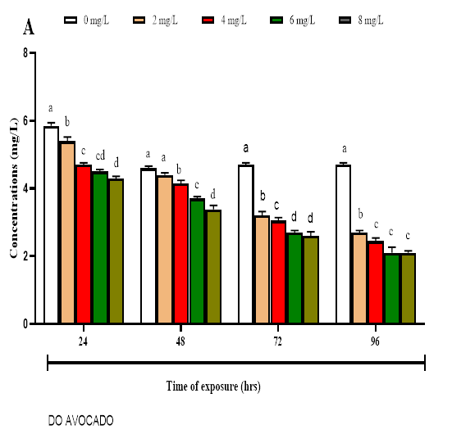
Fig 1. Dissolved Oxygen Variations During the 96th Hours of Test

3.2.2 Temperature (ºC)
In Figure 2, water temperature was significantly reduced in the toxicant group compared to the control group at the 24, 48, and 96-hour exposure times. However, no remarkable changes were observed at the 72-hour mark

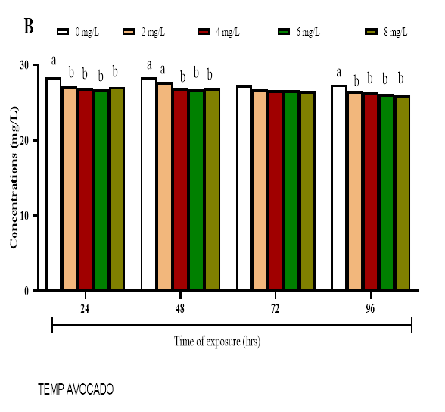
Fig 2. Temperature Variations During the 96th Hours of Test

3.2.3 pH
As illustrated in Figure 3, the pH level was significantly reduced at concentrations of 6 and 8 mg/L after 24 hours of exposure compared to the control group. However, at 48 and 72 hours, no notable differences in pH levels were observed in the 2, 4, and 6 mg/L treatment groups relative to the control. Furthermore, by the 96-hour mark, no significant variations were detected among any of the toxicant-exposed groups.

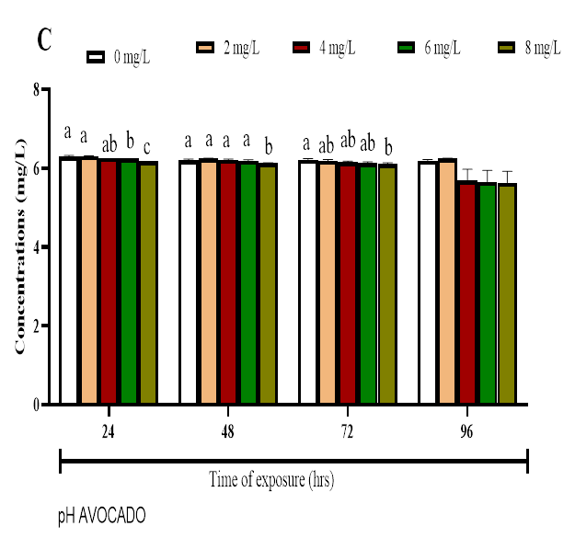
Fig 3. pH Variations During the 96th Hours of Test

3.3 Percentage Mortality and survivors of C. gariepinus Fingerlings in the different concentrations of the ethanoic extract of Persea americana at the end of the experiment (96hrs) (Preliminary Test).
During the preliminary test of the toxicity of the different concentration of the ethanoic extract of persea americana on the test organism, no mortality was recorded in the control (0 mg/l) of the extract used resulting in 100 % survival of the test organisms in both batches A and B respectively during the 96th hour exposure periods. At 4mg/l concentration of the extract 80 % mortality was recorded in both batches during the 24 hours of test and 20 % during the 48 hours of test. 100 % mortality were recorded for 8, 12 and 16 mg/l concentration of the extract during the 24 hours of test in both batches.
3.4 Summary of the Percentage Mortality and survivors of C. gariepinus Fingerlings in the different concentrations of the ethanoic extract of Persea americana at the end of the experiment (96 hrs.) (Acute Bioassay).
The percentage mortality and survivors of C. gariepinus fingerlings at the end of the test period in each of the concentrations are shown in Table 2 for the two batches of the experiment.
In the 0 mg/l concentration of the extract, no mortality was recorded throughout the test period in both batches A and B. in the 2 mg/l concentration of the extract, 80 % mortality was recorded leaving behind 20 % survivors in both bathes.
At the end of the 96-hour bioassay 100 % mortality was observed in the 6 and 8 mg/l concentration of the extract leaving behind no test organisms in the test media for both batches (Table 2). Statistical Analysis using one-way Anova (SPSS 20.0) showed that there was no significant difference (p>0.05) in mortality between the two batches.

Table 2: Summary of the Percentage Mortality and survivors of C. gariepinus in the different concentrations of the ethanoic extract of Persea americana at the end of the experiment (96 hrs).
Conc. of extract (mg/l) | BATCH A |  |  |  | BATCH B
 | Mortality  (M) | %  M | Survivors  (S) | %  S | Mortality  (M) | %  M | Survivors  (S) | %  S
0 | 0 | 0 | 10 | 100 | 0 | 0 | 10 | 100
2 | 2 | 20 | 8 | 80 | 2 | 20 | 8 | 80
4 | 8 | 80 | 2 | 20 | 8 | 80 | 2 | 20
6 | 10 | 100 | 0 | 0 | 10 | 100 | 0 | 0
8 | 10 | 100 | 0 | 0 | 10 | 100 | 0 | 0

3.5 96 Hours LC₅₀ Determination
The 96 hours LC₅₀ for C. gariepinus fingerlings exposed to the different concentrations of the ethanolic extract of persea americana was determine using probit analysis. The concentrations were first transformed into log for the probit analysis (Table 3). The 96 hours LC₅₀ is given at 2.8 mg/l representing a log transformed concentration of 0.45 mg/l a point where 50 % of the test organisms would be killed at the end of the experiment (Fig. 4).
Table 3: LC₅₀ determination for C. gariepinus Fingerlings at the end of the 96-hours bioassay.
Concentration (mg/l) | Log Transformation | Mortality (M) | % Mortality | Survivors  (S) | % Survivor
0 | 0 | 0 | 0 | 10 | 100
2 | 0.30 | 2 | 20 | 8 | 80
4 | 0.60 | 8 | 80 | 2 | 20
6 | 0.78 | 10 | 100 | 0 | 0
8 | 0.90 | 10 | 100 | 0 | 0

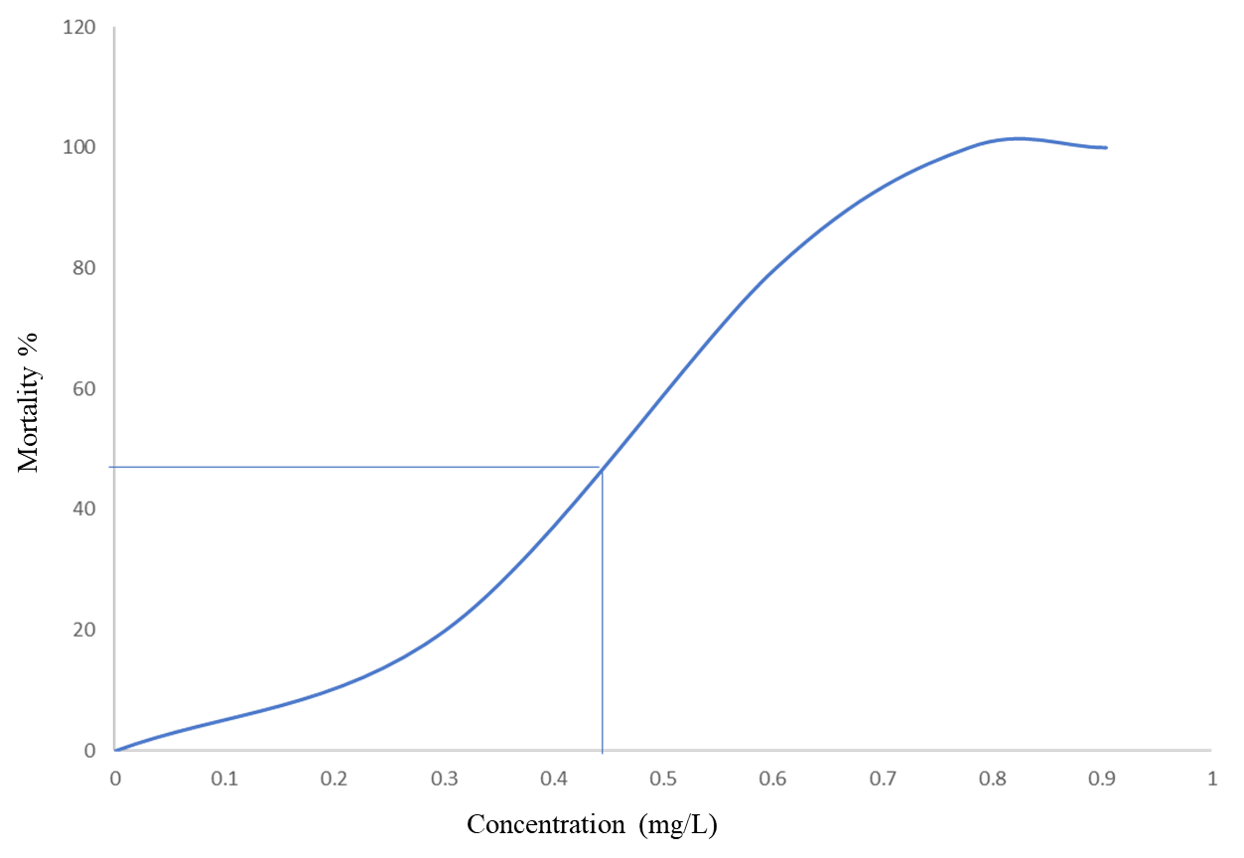
Fig. 4: Probit Graph of mortality (%) against concentration

[
3.6. Behavioral Responses
Behavioral response of C. gariepinus fingerling exposed to concentrations of ethanolic extract of persea americana leaf between 24 to 96-hours exposure periods were analyzed via a semi-quantitative measurement (Table 4). After 24 h exposure, the treated groups exposed to 2–4 mg/l concentrations of the plant extract displayed slight to moderate behavioral changes such as excessive mucus secretion, air gulping, erratic swimming, respiratory distress and vertical erection. in contrast, the control (0 mg/l) concentration shows no such behavioral alteration. Continued exposure (48 to 96 hours) resulted in moderate to severe manifestations of the aforementioned behavioral abnormalities in a concentration-dependent manner, except in the 2 mg/L group, where these effects were less pronounced.

Time in hours | Conc. (mg/l) | Gulping of air | Vertical erection | Respiratory distress | Erratic swimming | Abnormal mucus secretion
24 | control | - | - | - | - | -
 | 2 | + | - | - | - | -
 | 4 | + | + | + | + | +
 | 6 | ++ | ++ | ++ | ++ | +
 | 8 | ++ | ++ | ++ | ++ | ++
48 | control | - | - | - | - | -
 | 2 | + | - | - | - | -
 | 4 | + | + | + | + | +
 | 6 | ++ | ++ | ++ | ++ | +
 | 8 | ++ | ++ | ++ | ++ | ++
 | 2
72 | control | - | - | - | - | -
 | 2 | - | - | - | - | -
 | 4 | + | + | + | + | +
 | 6 | ++ | ++ | ++ | ++ | +
 | 8 | +++ | +++ | +++ | +++ | ++
96 | control | - | - | - | - | -
 | 2 | - | - | - | - | -
 | 4 | + | + | + | + | +
 | 6 | +++ | +++ | +++ | +++ | +++
 | 8 | +++ | +++ | +++ | +++ | +++
Table 4: Effect of Persea americana leaf extract on Behavior of Clarias gariepinus fingerling at Exposure to Varying Concentration at Different Time Intervals

Where;
- = Normal
+ = Mild
++ = Moderate
+++ = Severe

3.7 Histopathology of the gill of C. gariepinus Exposed to the different concentrations of the Ethanolic extract of Persea americana
3.7.1 Gills Histopathology
Histological observations of the gill tissues from fingerlings revealed a concentration-dependent effect of the ethanolic extract of Persea americana leaves. In the control group (Group 1), the gill tissues exhibited normal structural integrity, characterized by intact, highly cellular primary filaments and well-defined secondary lamellae. Supporting cartilaginous elements and dilated blood vessels in the basal gill arch were clearly observed, with consistent distribution of red blood cells within the microcapillaries, and no evidence of pathological alterations. Similarly, Groups 2 and 3, which were exposed to lower concentrations of the extract, maintained normal gill histoarchitecture. The primary filaments in these groups remained structurally intact and cellular, with clearly visible red blood cells and no indications of epithelial damage or tissue degeneration.
In contrast, exposure to higher concentrations of the ethanolic extract in Groups 4 and 5 resulted in pronounced histopathological alterations. Gill tissues from Group 4 exhibited eosinophilic epithelial characteristics, a marked reduction in epithelial cell density, and a complete absence of red blood cells, suggesting early signs of vascular compromise and tissue disruption. More severe degenerative changes were observed in Group 5, including disorganized and structural damaged in the primary and secondary filaments. Notable features such as epithelial lifting, disruption, and the presence of large vacuolated spaces indicative of edema were prominently observed. These pathological changes underscore the significant cytotoxic effects of the avocado leaf extract on gill tissues at higher concentrations.

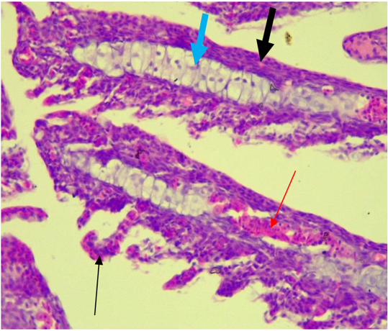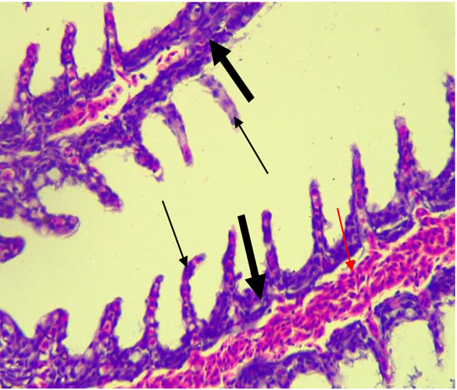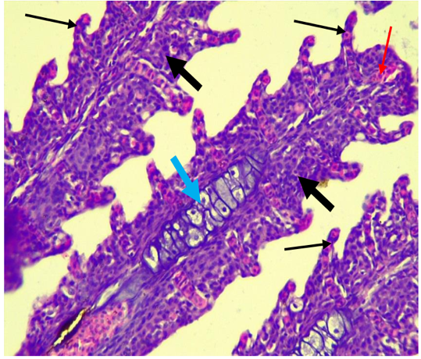
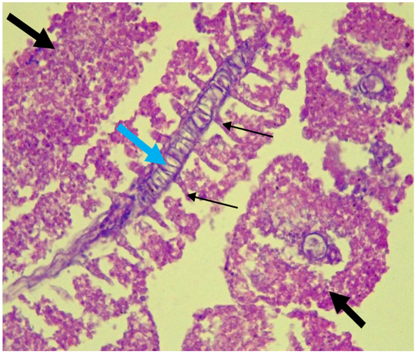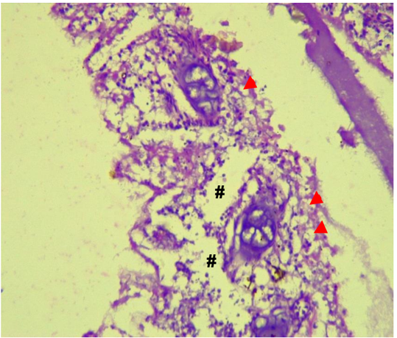

I
II
III
V
IV

Figure 5. Representative photomicrographs of gill tissues from fingerlings exposed to varying concentrations of ethanolic extract of Persea americana leaves.
Group 1 (control) shows intact gill architecture with highly cellular primary filaments (thick arrow), secondary lamellae (thin arrow), supporting cartilage (blue arrow), and red blood cells (thin red arrow). Groups 2 and 3 display similar normal features without pathological changes. Group 4 shows reduced epithelial cell distribution, eosinophilic epithelium, and absence of red blood cells. Group 5 exhibits severe degeneration with disorganized filaments (thick and thin arrows), epithelial lifting (red arrowhead), and vacuolated spaces (#) suggestive of edema. H&E Stain, at x400 magnification
3.7.2 Liver Histopathology
Histopathological examination of liver tissue revealed a range of alterations across the treatment groups, indicative of a dose-dependent effect of the ethanolic extract of Persea americana leaves. Group 1 (control) exhibited normal histoarchitecture, characterized by well-organized cords of hepatocytes and intact blood vessels, with no evidence of pathological changes. In Group 2, the liver tissue largely maintained its structural but showed mild fatty changes within the parenchyma, evidenced by the presence of intracellular lipid vacuoles. Group 3 displayed sporadic fatty changes within hepatocytes, alongside normal cords and a visible central vein, suggesting a mild hepatic response at this concentration level.
More pronounced alterations were noted in Groups 4 and 5. Liver sections from Group 4 liver exhibited generally preserved hepatocellular cords but showed dilated and congested blood vessels, suggestive of vascular stress or early circulatory disturbance. In Group 5, the liver parenchyma appeared distorted with degenerated connective tissue and the presence of mild inflammatory infiltrates, reflecting hepatic injury. The histological pattern in these groups suggests that exposure to higher concentrations of extract induced adverse effects on hepatic architecture and potentially impaired liver function.

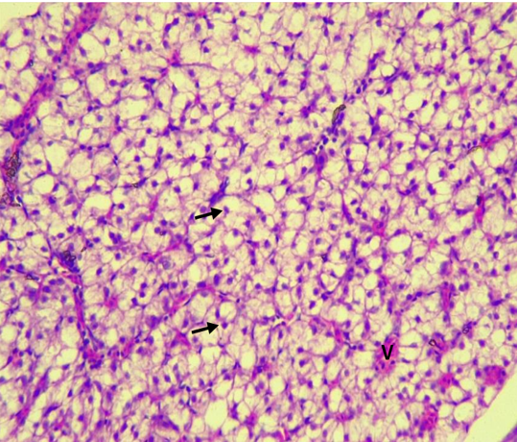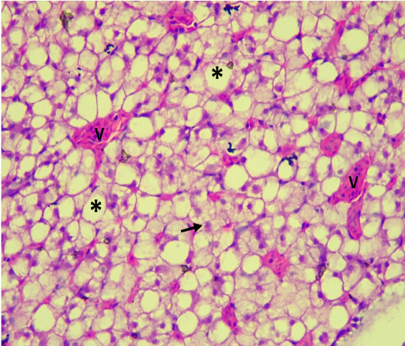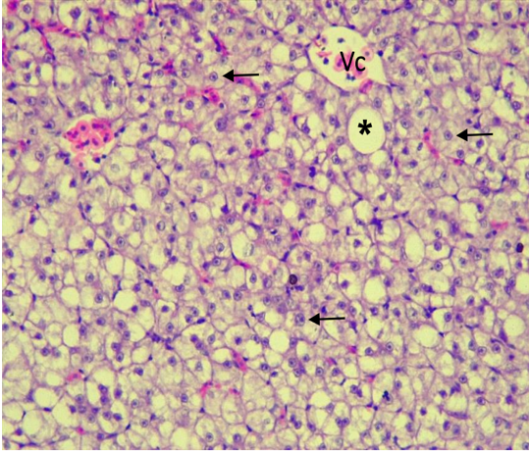
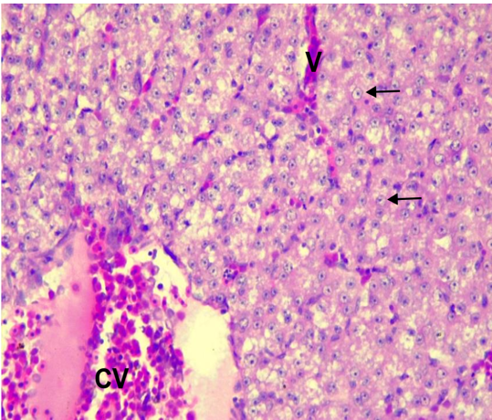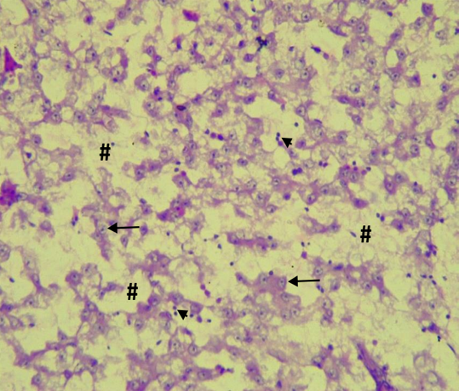
I
II
V
IV
III

Figure 6. Photomicrographs of liver tissues from fingerlings exposed to varying concentrations of ethanolic extract of Persea americana leaves
Control (0 mg/L) shows normal hepatocyte cords (arrows) and blood vessels (V) with no pathological changes. Low dose (2 mg/L) displays mild fatty changes (asterisk) within hepatocytes. Medium dose (4 mg/L) shows sporadic fatty changes (asterisk) and a visible central vein (Vc). High dose 1 (6 mg/L) reveals normal hepatocyte cords with dilated, congested blood vessels (CV). High dose 2 (8 mg/L) exhibits distorted parenchyma, degenerated connective tissue (#), and mild inflammatory infiltrates (arrowhead). H&E Stain, at x400 magnification

4.0 Discussion
In this study, dissolved oxygen (DO) levels consistently decreased with increasing concentrations of the toxicant across all exposure periods (24, 48, 72, and 96 hours), relative to the control group. However, no significant difference was observed between the 6 mg/L and 8 mg/L concentrations at 72 and 96 hours. This consistent reduction suggests that the extract imposed a considerable oxygen-demanding load on the aquatic environment. Such a decline is likely due to the biodegradation of organic phytochemicals—tannins, saponins, and flavonoids, which stimulate microbial activity and elevate biological oxygen demand (BOD). Additionally, metabolic stress in fish attempting to detoxify these xenobiotics may increase their respiratory effort and oxygen consumption (Madesh et al., 2024). The absence of further DO decline at the highest concentrations and longest exposure durations may indicate a physiological threshold, beyond which metabolic activity is suppressed or mortality begins to occur. Critically, diminished DO impairs aerobic respiration, resulting in behavioral signs of respiratory distress and histopathological damage to respiratory organs (Ali et al., 2022).
Complementing the DO findings, temperature was significantly reduced in toxicant-exposed groups at 24, 48, and 96 hours. This temperature reduction may reflect suppressed metabolic activity under physiological stress or the interaction of extract components with water, potentially altering its thermal properties. Decreased temperature can hinder enzymatic reactions, disrupt metabolic homeostasis, and reduce the efficacy of detoxification pathways (Kazmi et al., 2022). Although such temperature shifts may seem modest, even slight deviations from the optimal range can impair immune competence and increase vulnerability to toxic effects.
In addition to DO and temperature, the pH of the water also declined significantly at higher extract concentrations (6 and 8 mg/L) during the first 24 hours. This acidification is likely driven by the release and dissociation of phenolic compounds from the extract. Lower pH disrupts the ionic equilibrium in aquatic systems, affecting ammonia excretion and impairing the function of ion transporters like Na⁺/K⁺-ATPase in gill epithelium (Leone et al., 2017). Such disruptions contribute to osmoregulatory failure and internal acidosis, ultimately hindering cellular function and energy production. While pH values tended to normalize at later exposure times (48–96 hours), likely due to buffering or phytochemical degradation, early exposure to acidic conditions may initiate physiological disturbances that culminate in tissue damage.
Correspondingly, histopathological analysis of the gills revealed dose-dependent structural damage. At lower concentrations (2–4 mg/L), gill architecture remained intact, preserving respiratory and osmoregulatory function. In contrast, higher concentrations (6 and 8 mg/L) caused pronounced pathological changes, including reduced epithelial cell density, eosinophilic epithelial cells, and absence of red blood cells in lamellar capillaries. The most severe damage at 8 mg/L involved epithelial lifting, vacuolation, and structural disorganization—hallmarks of edema and hypoxic injury. Given their direct contact with the environment, gills are especially susceptible to waterborne toxicants (Cruz et al., 2015). These structural changes likely compromised gas exchange and ion regulation, intensifying systemic hypoxia and physiological stress. Similar gill degeneration has been reported in Clarias gariepinus exposed to other phytochemical-based toxicants (George et al., 2023c; George et al., 2014a; b; 2023a; b; d; Essien-Ibok et al., 2024a, b).
Liver histology further confirmed a dose-dependent toxic response. In control and low-dose groups (2–4 mg/L), hepatic tissue remained largely intact, with only mild lipid vacuolation—likely indicative of early, reversible metabolic adjustments. These observations are consistent with reports suggesting mild or even protective hepatic responses to low-dose P. americana exposure (Brai et al., 2014). However, at 6 and 8 mg/L, liver tissues showed substantial pathological changes including vascular congestion, dilated blood vessels, disorganized hepatocyte architecture, and inflammatory infiltration. These findings point to hepatocellular stress and dysfunction in key metabolic processes such as detoxification and protein synthesis. The toxicity may be attributed to phytochemicals like persin and flavonoids, which are known to generate reactive oxygen species (ROS), leading to lipid peroxidation, mitochondrial damage, and eventual cell death (Su et al., 2019). As the principal organ for xenobiotic metabolism, the liver is particularly vulnerable to phytochemical-induced injury (Gu and Manautou, 2012).
Behavioral responses of C. gariepinus served as early, non-invasive indicators of sublethal toxicity, closely mirroring the physiological disturbances observed. At lower concentrations (2–4 mg/L), fish exhibited mild symptoms such as excessive mucus secretion, air gulping, and slight disorientation—typical signs of gill irritation and early hypoxic stress (Shoji et al., 2005). These behaviors intensified with both concentration and time, and at 6–8 mg/L, fish showed erratic swimming, vertical posturing, respiratory distress, and loss of equilibrium. Such behaviors are indicative of neurotoxicity and systemic hypoxia, likely exacerbated by hepatic impairment and insufficient oxygen delivery to neural tissues. The excessive mucus production also suggests gill epithelial irritation, which further compromises respiratory efficiency (Zink and Wood, 2024). These behavioral manifestations not only signal acute stress but also serve as early predictors of potential mortality in toxicological assessments (Franke, 2014).
The results demonstrate a clear concentration-dependent increase in fish mortality upon exposure to P. americana leaf ethanolic extracts. This aligns with previous research indicating that certain plant extracts can exhibit toxic properties in aquatic environments. For instance, a study by George, et al. (2013 a) on the effects of lethal concentration of rubber extract (Hevea brasiliensis) on the survival on fingerlings of Clarias gariepinus under laboratory conditions confirms the results of the present findings as mortality was observed to increase with increase concentration. This assertion is also supported by the reports of George, et. al., 2013 b; 2015a; b; c; 2024 d; Ibrahim, et. al., 2024) in a related study.
Upon introduction of the P. americana extract, significant variations were observed in dissolved oxygen (DO), temperature, and pH levels at different time intervals. These fluctuations can exacerbate stress in fish, as stable water quality is crucial for maintaining physiological homeostasis. Altered DO levels can impair respiration, while changes in pH can affect metabolic processes and the toxicity of other compounds in the water. This assertion has been reported by several authors (George, et. al., 2024 a; b; c) who work on related areas an observed similar variation in physicochemical parameters upon introduction of extract.
The toxic effects observed may be attributed to bioactive compounds present in P. americana. Presence of bioactive compounds in plants extract capable of causing mortality at higher concentrations is reported by George, et. al., (2023 e). Phytochemicals in avocado leaves, including persin, saponins, and tannins, can trigger oxidative stress, reactive oxygen species (ROS) generation, lipid peroxidation, and hepatocellular necrosis (Su et al., 2019; Gu and Manautou, 2012). Although the biochemical biomarkers were not evaluated in this study, phytochemicals and environmental contaminants are known to trigger oxidative stress in fish through overproduction of reactive oxygen species (ROS). Increased levels of antioxidant enzymes (SOD, GPx, GR) and lipid peroxidation products (MDA), alongside histopathological lesions in the gills and liver of catfish, have been reported in response to toxic exposures (Akpakpan et al., 2014). This highlights the importance of integrating biomarkers with histological endpoints when assessing plant-derived toxicants in aquaculture species. The findings underscore the potential risks associated with introducing plant-derived substances into aquatic environments. Even at sub-lethal concentrations, such extracts can cause significant physiological and behavioral disturbances in fish, potentially affecting survival, growth, and reproduction. This has broader ecological implications, as fish play crucial roles in aquatic food webs.
C. gariepinus is one of the most cultured species in Nigeria. Fish farming being a major source of protein, these much-needed sources of essential amino and fatty acids are at risk if toxicants like P. americana are continuously dumped degrading the water quality and causing pathological alterations to the biology of these organisms. As wastewater treatment and water recycling becomes more mainstream, note must be made of the initial pollutants. Organic pollutants like P. americana are usually overlooked as culprits of water pollution, placed more emphasis on inorganic pollutants like heavy metals. This experiment serves as a cautionary tale, encouraging the scientific community and general public to minimize indiscriminate dumping of wastes in water bodies as they can cause pathologic alterations to the biota.

4. 1 Conclusion / Recommendation
In conclusion, the ethanolic extract of Persea americana leaves elicits a spectrum of toxic effects in Clarias gariepinus fingerlings by altering key water quality parameters, inducing organ-level structural damage, and triggering progressive behavioral abnormalities. These findings underscore how extract-induced changes in DO, pH, and temperature can cascade into physiological stress responses, culminating in histopathological lesions and behavioral dysfunction. Therefore, before Persea americana leaves can be considered as feed additives in aquaculture, it is essential to establish safe inclusion limits that maximize their nutritional benefits while minimizing toxic risks. A balanced approach is needed to harness their antioxidant and immunostimulatory potential without compromising fish growth, feed efficiency, or consumer safety. Future studies should integrate phytochemical profiling and biochemical biomarkers of oxidative stress to define these thresholds and ensure sustainable and safe application in aquaculture. Therefore, comprehensive ecotoxicological assessments integrating physicochemical, histological, and behavioral endpoints are essential. Importantly, this study cautions against the unregulated introduction of plant-based substances into aquatic systems, even those derived from medicinal plants, due to their potential to disrupt aquatic health at elevated concentrations. Further studies on the aspects of neurotoxic, molecular and genotoxic tendencies of P. americana to aquatic species are encouraged.

5.0 References
Adewumi, A. A. and Olaleye, V. F. (2011). Catfish culture in Nigeria: Progress, prospects, and problems. African Journal of Agricultural Research, 6(6), 1281-1285.
Akpakpan, E. I., Ekanemesang, U. M., Akpanyung, E. O. and Anazodo, N. O. (2014). Biomarkers of oxidative stress and histopathological studies in fish from Ibaka and Ifiayong Rivers, Akwa Ibom State, Nigeria. World Appl Sci J.; 32(7):1209–1218.
Ali, B., Anushka, and Mishra, A. (2022). Effects of dissolved oxygen concentration on freshwater fish: A review. International Journal of Fisheries and Aquatic Studies, 10, 113-127. https://doi.org/10.22271/fish.2022.v10.i4b.2693
American Public Health Association (APHA) (2005). Standards Methods for Examination of Water and Waste Water. 21st ed., Washinton DC, USA. 1498Pp.
Brai, B. I. C., Rahmat A. Adisa, R. A. A. and Odetola, A. A. (2014). Hepatoprotective Properties of Aqueous Leaf Extract of Persea americana, Mill (Lauraceae) ‘Avocado’ Against Ccl4-Induced Damage in Rats. African Journal of Traditional Complementary and Alternative Medcine; 11(2):237-244 http://dx.doi.org/10.4314/ajtcam.v11i2.2 237
Chakraborty, S. B. and Hancz, C. (2011). Application of phytochemicals as immunostimulant, antipathogenic, and antistress agents in finfish culture. Reviews in Aquaculture, 3(3), 103-119.
Chan, E. I. (1977). Oil pollution and tropical littoral communities. Biological effects of the 1975 Floride key oil spills. In: Procedures of oil spill Conference. Api publication, Washington DC; Pp:187-192.
Cruz, A. L. d., Prado, T. M., Maciel, L. A. d. S., and Couto, R. D. (2015). Environmental effects on the gills and blood of Oreochromis niloticus exposed to rivers of Bahia, Brazil. Ecotoxicology and Environmental Safety, 111, 23-31. https://doi.org/https://doi.org/10.1016/j.ecoenv.2014.09.022
Dabas, D., Shegog, R., Ziegler, G. R. and Lambert, J. D. (2013). Avocado (Persea americana) seed as a source of bioactive phytochemicals. Current Pharmaceutical Design, 19(34), 6133-6140.
Das, K., Asdaq, S. M. B., Khan, M. S., Amrutha, S., Alamri, A., Alhomrani, M., Alsanie, A. Bhaskar, G. C., Shree, P. (2022). Phytochemical Investigation and Evaluation of in Vitro Anti-inflammatory Activity of Euphorbia hirta ethanol leaf and root extracts: A comparative study. J. King Saud Univers. Sci. 34: 102261.
Essien-Ibok, M. A., George, U. U., Abiaobo, N. O. and Mbong, E. O. (2024 a). Evaluation of the Toxic Potentials and Histopathological Variations in Clarias gariepinus Fingerlings Exposed to Ethanolic Extract of Costus afer. Mathews Journal of Cytology and Histology; 8(1):1-12.
Essien-Ibok, M. A., George, U. U., Ajayi, O. O. and Okokon, P. (2024 b). Investigating the Impact of Senna alata Extract on Hematology and Histopathology of Juvenile of Clarias gariepinus. Asian Journal of Environment & Ecology; 23(8):74-85.
Finney, D. J. (1971). Probit Analysis, a Statistical Treatment of Sigmoid Response Curve. 7th Edition, Cambridge University Press, Cambridge.
Food and Agriculture Organization (FAO). (2022). The State of World Fisheries and Aquaculture 2022. Towards Blue Transformation. Rome: FAO.
Francis, G., Makkar, H. P. S. and Becker, K. (2001). Antinutritional factors present in plant-derived alternate fish feed ingredients and their effects in fish. Aquaculture, 199(3-4), 197-227.
Franke, H. A. (2014). Toxic Stress: Effects, Prevention and Treatment. Children (Basel), 1(3), 390-402. https://doi.org/10.3390/children1030390
George U. U., Etim, I. N., Ekanim, M. P. and Akpan, M. K. (2015 a). Toxic Effect of Crude Oil on Hatchery Reared Oreochromis niloticus Fingerlings. Journal of Academia and Industrial Research, 3 (11): 573-576.
George U. U., Etim, I. N., Ekanim, M. P. and Akpan, M. K. (2015 b). Acute Toxic Effects of Hevea brasiliensis on the Gills of Hatchery Reared Oreochromis niloticus Fingerlings. Journal of Academia and Industrial Research, 3 (11): 562-566.
George, U. U and Essien-Ibok, M. A. (2024 d). Investigating the Acute Toxic Effects of Urea Fertilizer on Juvenile Nile Tilapia (Oreochromis niloticus). Asian Journal of Fisheries and Aquatic Research, 26(6):68-75.
George, U. U., Ajayi, O. O., Essien-Ibok, M. A., Abiaobo, N. O. and Mbong, E. O. (2024 c). Assessment of the Toxicity and Histopathological Effects of Launaea taraxocifolia Extract on Fingerlings of Clarias gariepinus. Mathews Journal of Cytology and Histology; 8(1):1-10.
George, U. U., Ajayi, O. O., George, I. E. and Vincent, U. E. (2023 a). Establishing a Dose-Response Toxicity for Clarias gariepinus Fingerlings Exposed to Ethanolic Extract of Latana camara. Asia Journal of Fisheries and Aquatic Research; 24(1):1-10.
George, U. U., Asuquo, F. E., Idung, J. U. and Andem, A. B. (2013 a). Effects of Lethal Concentration of Rubber Extract (Hevea brasiliensis) on the survival on fingerlings of Clarias gariepinus Under Laboratory Conditions. Journal of Natural Sciences Research, 3 (9): 56-60.
George, U. U., Asuquo, F. E., Idung, J. U. and Andem, A. B. (2013 b). A Laboratory Bioassay of the Potential Effects of Rubber Extract (Hevea brasiliensis) on the survival of fingerlings of Oreochromis niloticus. Journal of Biology, Agriculture and Health Care, 3 (11): 70-74.
George, U. U., Essien-Ibok, M. A. Ajayi, O. O., Abiaobo, N. O. and Mbong, E. O. (2024 a). Assessment of the Toxicity and Histo-Morphological Effects of Clint Car Wash Liquid Soap on African Catfish (Clarias gariepinus) Fingerlings. Journal of Aquatic Science and Marine Biology; 5(1):1-10.
George, U. U., Essien-Ibok, M. A. Ajayi, O. O., Abiaobo, N. O. and Mbong, E. O. (2024 b). Investigating the Toxicity and Histopatho-Morphological Alterations Induced by Cana indica Extract on Clarias gariepinus Fingerlings. Annals of Ecology and Environmental Science; 6(1): 46-57.
George, U. U., Etim, I. N., Ekanim, M. P and Otu, U. (2015 c). Acute Toxicity of Ariel Detergent on the Survival of Fingerlings of Nile Tilapia (Oreochromis niloticus). International Journal of Current Research. 7 (4): 14825-14828.
George, U. U., Joseph A. and Andy, J. A. (2014 a). Histopathological Alterations in Gills of Fingerlings of Clarias gariepinus (Burchell, 1822) Following Sublethal Acute Exposure to Hevea brasiliensis. International Journal of Scientific & Technology Research, 3(9):252- 255.
George, U. U., Mbong, E. O., Abiaobo, N. O. and Akpan, I. I. (2023 b). In Vivo Studies on Mortality and Histopathological Indices of Phragmenthera capitata (Mistletoes) on Clarias gariepinus Fingerlings in Aquarium. Mathews Journal of Cytology and Histology; 7(2):1-10.
George, U. U., Mbong, E. O., Bolarinwa, K. A. and Abiaobo, N. O. (2023 e). Ethno-Botanical Verification and Phytochemical Profile of Ethanolic Leaves Extract of two Medicinal Plants (Phramenthera capitata and Lantana camara) used in Nigeria Using GC-MS Technique. Acta Biology Forum; 2(3):1-7.
George, U. U., Otoh, A. J., Ajayi, O. O and George, I. E. (2023 c). Studies on mortality and Histopathological Alteration on the Gills of Oreochromis niloticus Juveniles Following Exposure to Ethanolic Extract of Phramenthera capitata Under Laboratory Conditions. Asian Journal of Fisheries and Aquatic Research, 24(3):23-34.
George, U. U., Otoh, A. J., Ajayi, O. O and George, I. E. (2023 d). Dose-Response Relationship and Histo-Morphological Alterations on Oreochromis niloticus Juveniles following Exposure to Ethanolic Extract of Latana camara. Asian Journal of Research in Zoology;6(4):71-83.
George, U. U., Urom, S. E. and Etanketuk, N. (2014 b). Acute Toxic Effect of Qua Iboe Light Crude Oil on the Gills of Clarias gariepinus Juveniles. International Journal of Environment and Pollution Research, 2(2):16-30.
Gu, X. and Manautou, J. E. (2012). Molecular mechanisms underlying chemical liver injury. Expert Rev Mol Med, 14, e4. https://doi.org/10.1017/s1462399411002110
Ibrahim, F. O., Idowu, A. A., Taiwo, I. O., Adekola, M. B., Towolawi, A. T. and Adesanya, O. E. (2024). Effects of Varying Concentrations of Ethanol Leaf Extract of Paullinia pinnata on Histopathology of Clarias gariepinus Juveniles. Journal of Stress Physiology & Biochemistry; 20(4):36-43.
Kazmi, S. S. U. H., Wang, Y. Y. L., Cai, Y.-E. and Wang, Z. (2022). Temperature effects in single or combined with chemicals to the aquatic organisms: An overview of thermo-chemical stress. Ecological Indicators, 143, 109354. https://doi.org/https://doi.org/10.1016/j.ecolind.2022.109354
Leone, F., Lucena, M., Garçon, D., Pinto, M., and McNamara, J. (2017). Gill Ion Transport ATPases and Ammonia Excretion in Aquatic Crustaceans. In (pp. 61-107). https://doi.org/10.1007/978-3-319-39617-0_3
Madesh, S., Gopi, S., Sau, A., Rajagopal, R., Namasivayam, S. K. R., and Arockiaraj, J. (2024). Chemical contaminants and environmental stressors induced teratogenic effect in aquatic ecosystem - A comprehensive review. Toxicol Rep, 13, 101819. https://doi.org/10.1016/j.toxrep.2024.101819.
Organisation of Economic Cooperation and Development (OECD) (2014). Guidelines for the Testing of Chemicals. Test Guidelines No.301, OECD, Paris, France.
Otoh, A. J., Ekanem, I. E., Okoko, A. C., Asangusung, P. S. and George, U. U. (2024 a). Comparative Study of Inducing Broodstock with Natural and Artificial Hormones on Reproductive Performances of Clarias gariepinus. Asian Journal of Fisheries and Aquatic Research; 26(3): 31-38.
Otoh, A. J., George, U. U., Asangusung, P. S., Okoko, A. C., Ekanem, I. E. and Umaha, M. N. (2024 b). Investigation into the Impacts of Varied Batches of Stripped Eggs on the Reproductive Success of Clarias gariepinus. Asian Journal of Research in Zoology; 7(2): 28-35.
Otoh, A. J., Okoko, A. C., Asangusung, P. S., Ekanem, I. E., George, U. U. and Idiong, T. E. (2024 c). Effect of Different Ages of African catfish (Clarias gariepinus) Broodstock on Reproductive Performance and Fries Production. Asian Journal of Fisheries and Aquatic Research; 26(3): 39-47.
Otoh, A. J., Okoko, A. C., Ekanem, I. E., George, U. U. and Asangusung, P. S. (2024 d). Effects of Multiple Batches of Stripped Eggs on the Reproductive Performances of Heterobranchus longifilis. Asian Journal of Research in Zoology; 7(2): 9-16.
Otoh, A. J., Udo, M. T. and George, U. U. (2023). Comparative Growth Performance and Sex Ratio of Heterobranchus longifilis and its Offspring Induces with Synthetic Hormone and Pituitary gland of Heterobranchus longifilis. Journal of Wetlands and Waste Management; 5(1):106-111.
Otoh, A. J., Udo, M. T., and George, U. U. (2022). Comparative Effects of Inducing Brood stock with Natural and Artificial Hormones on Reproductive Performances of Heterobranchus longifilis. Tropical Freshwater Biology, 31:95-102.
Shoji, J., Masuda, R., Yamashita, Y., and Tanaka, M. (2005). Effect of low dissolved oxygen concentrations on behavior and predation rates on red sea bream Pagrus major larvae by the jellyfish Aurelia aurita and by juvenile Spanish mackerel Scomberomorus niphonius. Marine Biology, 147, 863-868. https://doi.org/10.1007/s00227-005-1579-8
Su, L. J., Zhang, J. H., Gomez, H., Murugan, R., Hong, X., Xu, D., Jiang, F., and Peng, Z. Y. (2019). Reactive Oxygen Species-Induced Lipid Peroxidation in Apoptosis, Autophagy, and Ferroptosis. Oxid Med Cell Longev, 2019, 5080843. https://doi.org/10.1155/2019/5080843
Zhou, X., Wang, Y., Gu, Q., & Li, W. (2021). Pathogenicity, diagnosis, and prevention of bacterial diseases in marine fish. Reviews in Aquaculture, 13(4), 1892-190.
Zink, L. and Wood, C. M. (2024). The effects of microplastics on ionoregulatory processes in the gills of freshwater fish and invertebrates: A prospective review. Comparative Biochemistry and Physiology Part A: Molecular & Integrative Physiology, 295, 111669. https://doi.org/https://doi.org/10.1016/j.cbpa.2024.111669.

