Original Research Article

Production of L-Asparaginase using soil isolate of Cladosporium sp. and Evaluation of its Antitumor and Antioxidant activities

ABSTRACT

The enzyme L-asparaginase is given prime attention in healthcare settings owing to its significant therapeutic applications in oncology. The present study isolated fungi of five different species from soil samples belonging to the genera Aspergillus (23.8 and 9.5%), Cladosporium (19%), Fusarium (14.3%) and Penicillium (19%). Screening on Czapek Dox’s medium indicated that the isolate Cladosporium sp. ASP4 exhibit higher potential of synthesizing L-asparaginase than other fungi by means of causing a halo zone measuring 22.3 mm dia. Fermentation of standard medium ingredients along with the solid substrate soya bean meal by the potential fungal isolate resulted in the production of 20.53 IU/mL of L-asparaginase. Optimization studies deciphered the carbon source sucrose, supplementary nitrogen ammonium nitrate, pH ≥8.0 and the temperature 50ºC as favorable process parameters for the enzyme production. Purified L-asparaginase of the present study demonstrated moderate antineoplastic activity against the A549 lung cancer cells with the IC₅₀ values of ≥50 IU/mL. The enzyme displayed better antioxidant property compared to those of previous studies by way of scavenging the radicals with the SC₅₀ values of ≥250 mg/mL.
Keywords: L-asparaginase, Cladosporium sp., solid state fermentation, antitumor, antioxidant

1. INTRODUCTION

Asparaginase (L-asparigine amidohydrolase) is an enzyme that catalyzes the hydrolysis of asparagine to aspartic acid. L-asparagine is a non-essential amino acid normally involved in the metabolic control of cell functions in nerve and brain tissues. Asparaginases are naturally occurring enzymes expressed and produced by microorganisms, plants, and animals. In plants, asparaginase is used for nitrogen fixation, storage and transport. Highly purified asparaginase has a molecular weight of 36.8-160 kDa and is reported to be stabilized by addition of buffer salts or extra protein [1]. Asparaginase has tremendous applications in various fields such as medical, pharmaceutical, food processing and biotechnology.
L-asparaginase is one of the known drugs in the treatment of cancer, especially acute lymphoblastic leukemia and other malignant neoplasms including myelocytic leukemia, Hodgkin disease, reticulosarcoma, melanosarcoma and so on [2]. It has also been used for treatment of lymphosarcoma, lymphoproliferative disorders and in many other clinical experiments relating to tumor therapy in combination with the chemotherapy. In recent years, several bio-conjugation protocols have been developed to improve the pharmacokinetic and immunological properties of the anti-leukemic enzyme L-asparaginase.
Besides its application in medicine, asparaginase is used as a food processing aid to reduce the formation of acrylamide, a suspected carcinogen, in starchy food products. By adding asparaginase before baking or frying the food, asparagine is converted into another common amino acid, aspartic acid, and ammonium. As a result, asparagine cannot take part in the Maillard reaction, and therefore the formation of acrylamide is significantly reduced. It plays an important role in the biogeocycling of carbon and nitrogen in natural waters and sediments [3].
Since the discovery of L-asparaginase from the bacteria Escherichia coli in 1963, researchers have recognized its oncological importance and continued to focus on many microbial sources to explore its extraction. Among the bacteria, E. coli, Pseudomonas aeruginosa, Serratia marcescens, Bacillus circulans and Photobacterium leigonathi have been reported to produce asparaginase [4,5]. Fungal species of importance in this field are Aspergillus tamari, A. niger, Penicillium, Fusarium, and Cladosporium cladosporioides [6-8]. Besides, the actinomycetes such as Streptomyces sp., Nocardia sp. and the yeasts Rhodotorula sp. and Rhodosporidium [9-11] have also been explored for asparaginase production.
The pharmacological potential of L-asparaginase is greatly influenced by its structural, chemical and kinetic properties. However, the structure-function relationships of L-asparaginase synthesized by different microorganisms vary among themselves and hence some of the enzymes are contraindicated with adverse side-effects in clinical applications [11]. In recent years, there are increasing reports on the complications such as allergic reactions and anaphylaxis caused by L-asparaginase of several bacterial sources in the treatment of human neoplastic diseases [6,12,13].
In order to avoid any undesirable clinical complications, selection of L-asparaginase with safe and in vivo compatible properties is critical for oncological applications. This necessitated the research on exploring the production of this enzyme by other eukaryotic microorganisms viz., yeast and filamentous fungi with minimal hostile effects [14]. The fungi are considered to be a special group of microorganisms endowed with excellent survival capacities in extreme environments and synthesis of wide array of therapeutic enzymes. Therefore, the present study was aimed for in vitro production of L-asparaginase enzyme using soil-borne fungi and to assess its antitumor and antioxidant activities.

2. MATERIALS AND METHODS

2.1 Sample collection
For the isolation of fungi, wet soil samples were collected from five different areas of Northern Border University, Arar, Saudi Arabia. A total of 25 samples each weighing 10g from a depth of 30cm were collected over a period of three months from February-April, 2024. Samples were collected using sterile spatula in sterile polythene bags and transported to the laboratory of Faculty of Applied Medical Sciences and stored at 4ºC until further processing.

2.2 Isolation and identification of L-Asparaginase producing fungi
Soil samples were subjected to isolation of fungi by standard spread plate method on potato dextrose agar (PDA) medium. Briefly, one gram of the soil sample was serially diluted up to 10⁻⁷ dilutions using sterile distilled water. Aliquots of 0.1 ml of samples from the dilutions 10⁻⁴ to 10⁻⁷ were transferred onto PDA plates and spread using sterile L- rod. All the plates were incubated at room temperature and the growth of fungi was observed after 3-6 days.
The isolates of fungi grown on PDA were screened for asparaginase production by a screening method prescribed by Sarquis et al. [6]. Sterile plates of modified Czapek Dox’s (MCD) agar medium were prepared and each plate was inoculated with a loop full of well grown mycelium of fungi in the center. The plates were incubated at 28°C for 3-4 days. Since the production of L-asparaginase causes the increase in pH due to the release of ammonia, the enzyme producing fungus was identified by the zone formation around the colony indicating the change of color of phenol red indicator of the medium. The diameter (cm) of halo zone produced by each fungal colony was measured and recorded for comparative study. Mycelial colony which facilitated highest enzyme activity by way of causing larger zone was designated as a potential fungal isolate.
The selected fungal isolated was further subjected to identification studies by standard techniques for the determination of phenotypic, cultural and microscopic characteristics.

2.3 Production of L-asparaginase
For the production of L-asparaginase by the potential isolate, the method of solid state fermentation [15] was followed. The inoculum was prepared by suspending the spores of the fungus grown on PDA in 5mL of 0.01% of tween-80 solution. Soya bean meal collected from a local market was ground to obtain coarse particles (0.4-0.8 cm) to serve as the solid substrate for the fermentation. Ten gram (w/w) of this substrate taken in a 250mL conical flask was mixed with 20mL of mineral salt solution. The culture medium included the following composition (g/L): Glucose (2.0), L-asparagine (10.0), KH₂PO₄ (1.52), KCl (0.52) and trace amounts of MgSO_{4.}7H₂O, CuNO₃, ZnSO₄ and FeSO₄. This autoclaved medium was inoculated with 5mL of spore suspension, mixed thoroughly and incubated at room temperature for 7 days. Subsequently, the fermentation medium was suspended in 20mL of 0.05M Tris HCl buffer (pH 8.6) and agitated for 30 min. Then, it was filtered through chees-cloth with squeezing and the filtrate was centrifuged at 2500 rpm for 10 min. The supernatant containing crude enzyme was collected in a sterile vial and stored at 4ºC until use.

2.4 Assay of enzyme activity
The assay of L-asparaginase activity was determined in terms of quantitative measure of NH₃ released by the enzyme [16]. Briefly, the reaction mixture contained 0.2mL of 0.05M Tris-HCl buffer (pH 8.6), 1.7mL of 0.01M L-asparagine and 0.1mL of crude enzyme. The reaction was carried out at 37°C for 30 min. The reaction was stopped by adding 0.1 mL of 1.5M trichloroacetic acid. This reaction mixture was added with the reagent grade water to make up a final volume of 7mL and added with 1mL of Nessler’s reagent. The mixture was left at room temperature for 10 min and the color development was measured using UV-vis spectrophotometer at 450 nm. Estimation of release of ammonia was calculated by the standard curve graphical method. The enzyme yield was expressed as IU per milliliter (IU/mL) based on the concentration of the enzyme. One unit of L-asparaginase activity was defined as the amount of enzyme that released 1 μmol NH₃ per min under standard conditions of the assay.

2.5 Optimization of process parameters
In order to achieve enhanced production of L-asparaginase, optimization studies were conducted to determine the influential parameters of the fermentation [11,17]. Carbon sources such as glucose, sucrose, maltose and lactose were tested for their augmenting efficiency of the enzyme production. Supplementary nitrogen sources assessed for their impact on fermentation were, ammonium chloride, ammonium nitrate, ammonium sulfate and peptone. Similarly, the pH of the fermentation medium was set at different ranges (6-8 and 9) and evaluated for their influence on fungal growth and enzyme production. The effect of different incubation temperatures (30, 40, 50 and 60ºC) on the fermentation process was also tested for enzyme production. Best parameters were selected based on the maximum enzyme production as determined by the method mentioned before.

2.6 Purification of L-asparaginase
The purification of enzyme from the crude extract was carried out at 4ºC according to the modified method of [18]. The crude enzyme was concentrated by precipitation using ammonium sulfate to obtain 80% saturation. The precipitate was suspended and dialyzed against 0.01M phosphate buffer (pH 8.5). Separation and elution of crude enzyme was performed using CM-Sephadex G-50 ion-exchange chromatography adjusted with the flow rate of 1mL/min. The active fractions were collected and concentrated using ammonium sulfate and dialysis. Further purification of the enzyme was carried out by gel filtration on Sephadex G-100 column pre-equilibrated with 0.01M phosphate buffer (pH 8.5). Each fraction collected at a flow rate of 1mL/min was stored in a separate microfuge tube containing 2mL of equilibration buffer.

2.7 Assay of Anti-tumor activity
The antitumor activity of the purified L-asparginase, in terms of its cytotoxic effect, against A549 cell line of human lung cancer was estimated by adopting the 3-[4,5-dimethylthiazole-2-yl]-2,5-diphenyltetrazolium bromide (MTT) assay suggested by Prakasham et al. [5]. The reduction of tetrazolium salt of MTT to insoluble formazan crystals by the mitochondrial dehydrogenases in metabolically active cells was indicated by change of color from yellow to purple. Formazan crystals were further solubilized by the addition of detergent solution and the concentration was estimated. Monolayer of A549 cells prepared in a fetal bovine serum free medium were maintained in a 96-well micro titration plate (5 x 10⁴ cells/well). Various concentrations of the enzyme (5, 10, 25, 50, 75 and 100 IU/mL) were added to the wells and incubated at 37ºC for 48 h. Separate wells of cell culture devoid of the enzyme sample served as control cells. The absorbance of the treated cell suspensions was measured at 570 nm by ELISA plate reader (Awareness Tech, USA) at regular intervals. The relative cell viability was estimated with reference to the amount of insoluble formazan salt. The mean percentage of viable cells were determined in comparison with that of control culture. The cytotoxic effects of the enzyme aliquots were calculated from the linear equation of the dose–dependent curve and expressed as inhibitory concentration IC₅₀ values. Further confirmation of cytotoxic effect of the enzyme was accomplished by visualization using inverted tissue culture microscope.

2.8 Evaluation of Antioxidant activity
The antioxidant activity of L-asparaginase samples was determined by DPPH (1,1-diphenyl-2-picryl-hydrazyl) scavenging assay according to Chua et al. [19]. Under oxidized conditions, the DPPH remains as a stable radical owing to the presence of its unpaired electron. The enzyme L-asparaginase, which is an antioxidant radical scavenger, upon addition, donates an electron to DPPH and converts it into a non-radical. This causes the bleaching i.e., change of color of DPPH from violet to pale yellow. Different concentrations of the enzyme (10, 50, 100, 250, 500 and 1000µg/mL) were prepared in dimethyl sulfoxide and aliquots of 150μL were loaded in a 96-well micro titration plate. To each well 150μL of 0.004% DPPH solution prepared in methanol was added and the plate was incubated at RT for 30 min in the dark. Subsequently, the absorbance in the reaction mixture, formed due to the bleaching of DPPH, was monitored by UV-vis Spectrophotometer at 515 nm. Parallel set up using an efficient scavenger (10mM ascorbic acid) was also maintained for the comparative study of tested enzyme aliquots. The percentage of half maximal scavenging concentration (SC₅₀) was calculated by the following equation:
SC₅₀ of Ascorbic acid
Antioxidant capacity (%) = x 10³
SC₅₀ of the sample

3. RESULTS
3.1 Isolation and Identification of soil fungi
Studies on isolation of fungi from the soil samples yielded the growth of six different types of colonies. Further to the standard macroscopic and microscopic studies, the presence of 21 isolates of different fungi were noted. The different species of fungi and their percentages of prevalence in the soil were as follows: Aspergillus niger (23.8%), Fusarium sp. (14.3%), Cladosporium sp. (19%), Penicillium sp. (19%), Microsporum sp. (14.3%) and Aspergillus fumigatus (9.5%). The assay of L-asparaginase production by the soil fungi indicated that the isolates cause the halo zones ranging in sizes of 5.1-22.3 mm diameter (Table 1). The isolate Cladosporium sp. ASP4 was observed to synthesize higher amount of enzyme than the others by way of producing largest halo zone. Upon additional phenotypic, cultural (olivaceous green to blackish green, powdery colonies) and microscopic characteristics (chains of conidia closest conidiophores shield shaped chain branches), the identity of L-asparaginase synthesizing Cladosporium sp. was confirmed (Fig. 2).

Table 1. Results of screening of soil fungi for enzyme activity
Isolate no. | Soil fungi and halo zone diameter (mm)
Isolate no. | AN | FS | CS | PS | MS | AF
1 | 16.3±0.5 | 10.5±0.7 | 17.3±0.4 | 18.1±0.5 | 8.1±0.7 | 9.6±0.3
2 | 15.1±0.2 | 6.7±0.3 | 19.1±0.8 | 13.3±0.3 | 5.1±0.2 | 7.1±0.7
3 | 17.4±0.6 | 8.8±0.5 | 18.2±0.5 | 12.7±0.6 | 7.6±0.4 | NA
4 | 7.6±0.4 | NA | 22.3±0.2 | 9.4±0.4 | NA | NA
5 | 8.9±0.2 | NA | NA | NA | NA | NA
AN, Aspergillus niger; FS, Fusarium sp.; CS, Cladosporium sp.; MS, Microsporum sp.; AF, A. fumigatus; NA, not available

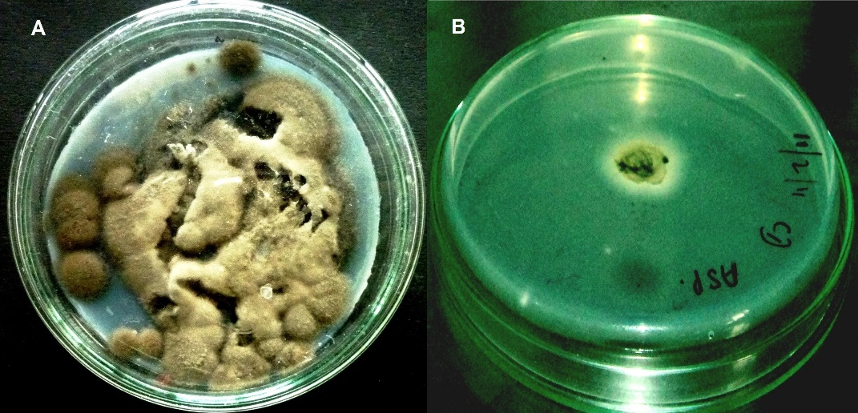
Figure 1. Mycelial growth (A) and enzyme activity (B) of Cladosporium sp. ASP4
3.2 Enzyme production and optimization of process parameters
The fermentation studies indicated that, with the standardized medium composition and incubation conditions, the yield of L-asparaginase by the potential isolate Cladosporium sp. ASP4 is 20.53 IU/mL. Determination of enzyme activity and protein concentration estimation further confirmed the production of L-asparaginase by the fungal strain.
The evaluation of parameters including the essential constituents of fermentation medium and extrinsic factors was carried out by manipulating them in different setups of the fermentation process. These studies revealed the best components that favor the maximum production of the enzyme. Among the different carbon sources tested, sucrose was found to be the most suitable substance as it caused the production of 18.72 IU/mL of L-asparaginase compared to other sugars (Fig. 2). The supplementary nitrogen source ammonium nitrate showed better influencing property on the enzyme yield (17.86 IU/mL) than its counterparts (Fig. 3). The fermentation medium set at a pH of 8.0 favored higher production of the enzyme (20.36 IU/mL) than those with other pH ranges (Fig. 4). Studies on optimization of different incubation temperatures deciphered that the fermentation carried out at 40ºC facilitates a production of 19.73 IU/mL of the enzyme which is much higher than those with other temperature ranges (Fig. 5).

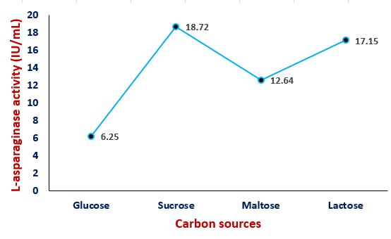
Figure 2. Effect of carbon sources on enzyme activity

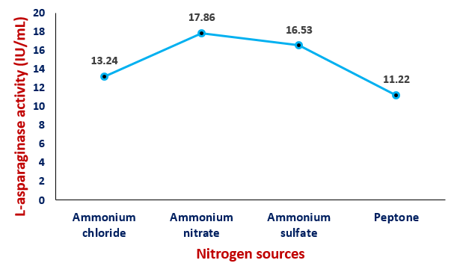
Figure 3. Effect of nitrogen sources on enzyme activity

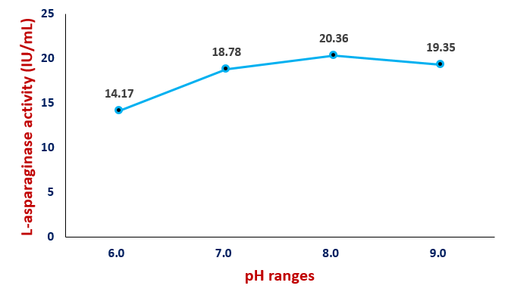
Figure 4a. Enzyme activity at different pH ranges

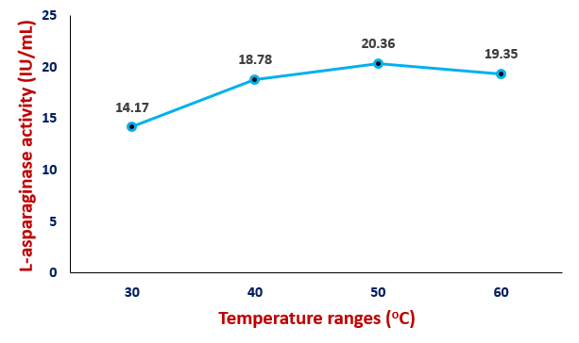
Figure 4b. Enzyme activity at different temperature ranges

3.3 Antitumor activity of L-asparaginase
The studies on the antineoplastic activity of the L-asparaginase produced by the fungal strain Cladosporium sp. ASP4 against the A549 tumor cell lines revealed its cytotoxic potential. Subsequent to the treatment of tumor cells with the enzyme, the viabilities of the cells were recorded in terms of absorbance values at intervals of 10, 15, 24, 36 and 48 h. Different concentrations of the enzyme exhibited varying degrees of cytotoxicity depending on the duration of treatment. The cytotoxic effect was observed to be directly proportional to the concentration of the enzyme as well as the treatment time (Table 5). The lower concentrations of the enzyme did not attain the IC₅₀ values even after 48 h of treatment. The L-asparaginase concentrations ≥50 IU/mL displayed IC₅₀ values commencing from the 15 h of treatment. The microscopic study indicated the cytotoxic effects of the enzyme on the morphology of A549 tumor cells such as segregation, shrinkage, rounding and anomaly of nuclear architecture (Fig. 5).

Table 2. Results of assay of cytotoxicity of L-asparaginase against A549 cells
Concentration of L-asparaginase | Viability (%) of cells and incubation time
Concentration of L-asparaginase | 10 h | 15 h | 24 h | 36 h | 48 h
5 IU/mL | 97±1.5 | 93±1.2 | 88±1.6 | 83±1.7 | 80±1.9
10 IU/mL | 91±1.0 | 86±0.9 | 81±1.2 | 74±1.3 | 69±1.2
25 IU/mL | 87±0.5 | 83±1.3 | 76±0.9 | 68±0.5 | 60±1.7
50 IU/mL | 88±1.3 | 82±1.7 | 68±0.8 | 59±1.1 | 45±1.3
75 IU/mL | 84±0.8 | 72±0.8 | 61±1.0 | 44±0.2 | 38±0.9
100 IU/mL | 76±0.5 | 62±0.4 | 45±1.2 | 33±1.0 | 24±0.7

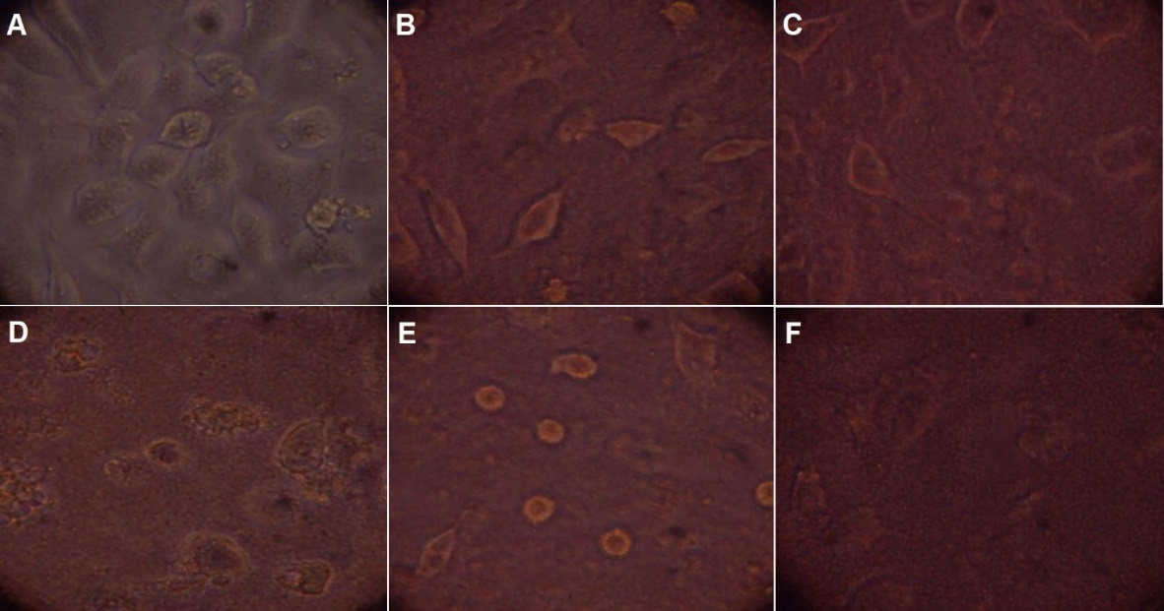
Figure 5. Assay of cytotoxicity of L-asparaginase against A549 cells
A, Control cells and Cells treated for B, 10h; C, 15h; D, 24h; E, 36h; F, 48h

3.4 Antioxidant activity of L-asparaginase
The DPPH assay conducted to evaluate the antioxidant activity the enzyme demonstrated the radical scavenging activity of L-asparaginase in comparison with that of the standard reactant ascorbic acid (Fig. 6). The standard antioxidant displayed superior scavenging activity even with a low SC₅₀ value of 50μg/mL. The enzyme L-asparaginase produced in the present study presented a moderate scavenging activity requiring 250μg/mL as its SC₅₀ value.

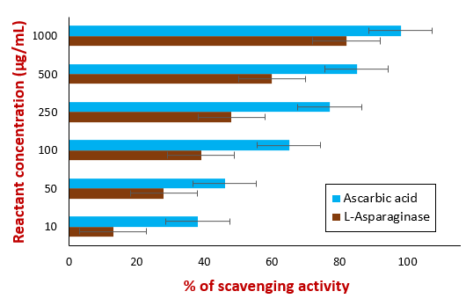
Figure 6. Results of DPPH assay of L-asparaginase for antioxidant activity

4. DISCUSSION

Cancer is a major public health problem and the second most leading cause of deaths worldwide. Leukemia is a life threatening disease of hematological malignancies characterized by differentiation and uncontrolled proliferation of leukocytes in the bone marrow and peripheral blood. Complications due to leukemia are usually high and it mainly afflicts the older adults [20].
Among the different options available for chemotherapy of leukemia, the L-asparaginase based drugs are considered as cornerstone of treatment protocols by virtue of their robust action on tumor cells [21]. The therapeutic potential of L-asparagenase due to a specific mechanism which negatively affects the metabolism of tumor cells. Generally, the growth of both normal cells and malignant cells require L-asparagine amino acid. In order to establish metastasis, the tumor cells need substantial amount of asparagine for protein synthesis. While the normal cells are able to synthesize their L-asparagine, the tumorous cells, due to the low expression or lack of L-asparagine synthetase, depend on extracellular source of this amino acid. The enzyme L-asparaginase, when introduced into the body fluids, causes catalysis and depletion of L-asparagine circulating in the extracellular pool. As a result, the tumor cells are deprived off the essential factor for their malignant growth. Consequently, the cancerous cells undergo starvation and eventual death [22].
Present study has been conducted with an objective of exploring common fungi for the production of L-asparaginase endowed with pharmaceutical properties. For the purpose of isolating L-asparaginase producing fungi, the natural source i.e., the soil was utilized. Since the soil is frequently impacted by the environmental changes, the microorganisms, notably fungi, present in it develop suitable adaptations for their survival in challenging conditions. The metabolites and the enzymes produced by these fungi possess more efficient therapeutic potentials compared to that of other microbes [23]. Similar to our study, Siddalingeshwara and Lingappa [24] and Sisay et al. [17] have utilized soil source for isolating the L-asparaginase synthesizing fungi. Studies conducted elsewhere on L-asparaginase production have isolated fungi from different sources such as animal feed [1], plant endophytes [12,19,25], marine environment [15] and so on.
The present study isolated fungi belonging to six different species from the soil samples such as A. niger, Fusarium sp., Cladosporium sp., Penicillium sp., Microsporum sp. and A. fumigatus (Table 1). Study of prevalence of these fungi indicated that the molds A. niger and A. fumigatus occur with high and low frequencies respectively in the soil. The fungal species Cladosporium sp. and Penicillium sp. were isolated in moderate numbers. The results pertaining to the isolation of soil borne fungi in our research are in conform to the previous studies [15,25]. In contrast, a recent study conducted by Sisay et al. [17] isolated the L-asparaginase producing fungi such as Trichosporan ashahii (mold), Candida palmioleophila and C. manassasensis (yeasts) from the soil samples in and no isolates of the genus Aspergillus, Fusarium, and Penicillium were obtained. It may be explained that the differences of the environmental conditions in the geographical areas of the present research (Saudi Arabia) and that of the previous study (Kenya) influence the existence of microbes in the soil.
The screening of soil fungi for the selection of L-asparaginase producing isolate was carried out on a modified Czapek Dox’s (MCD) agar medium. The production of ammonia indicated by the consequent zone formation due to the change of pH of the medium enabled the identification of L-asparaginase producing fungus. Many research studies have utilized this medium for screening the L-asparaginase synthesizing fungi [19,25,26]. Alternatively, other earlier studies have employed media such as modified M-9 medium [5,9,15], Potato dextrose agar [24]. However, the MCD medium is considered suitable for screening of L-asparaginase producing fungi owing to its composition which favors both the growth of the organism and enzyme production [17].
The screening study revealed that all the fungal isolates were capable of synthesizing L-asparaginase by causing halo zones with the diameter ranging in sizes of 5.1-22.3 mm (Table 1). However, the mold Cladosporium sp. demonstrated superior property for L-asparaginase production. In consonance with our finding, Hatamzadeh et al. [25] have demonstrated the L-asparaginase synthesizing potential of Cladosporium sp. Studies conducted previously have explored the molds such as Fusarium spp. [19], A. niger [1], A. tamarii [6], A. terreus [24,26] and Penicillium [15] for extraction of the enzyme L-asparaginase.
For the purpose of production of L-asparaginase using the potential isolate Cladosporium sp. ASP4, the method of solid state fermentation was carried out in the present study. Our study is in agreement with the contemporary studies which advocate the solid state fermentation as it comprises of slow growth of the mold and stable production of the enzyme [1,9,11,18,24,27]. In contrast, various other studies have produced the enzyme by submerged fermentation [6,9,10,15,19,26,28,29]. The solid substrate utilized in our study was soya bean meal, which reportedly contains substantial protein to offer sufficient nitrogen required for the fermentation process. Similarly, many research studies have utilized the soya bean meal for L-asparaginase production by marine actinomycetes [9], Streptomyces rochei [11], P. aeruginosa [18], A. niger [1] and so on. Some studies have employed groundnut oil cake powder [10,26], carob pod [24] and wheat bran [15] as a solid substrate for L-asparaginase production.
Review of literature inferred that there is no specific medium that can be used for different microorganisms for the enhanced production of L-asparaginase [14]. Generally, the microbes differ among themselves by requiring specific nutrients and environmental conditions for enzyme production. Accordingly, there is a need to optimize the parameters of the fermentation process suiting to the growth characteristics of the microbe to achieve maximum production of the enzyme [11]. Sisay et al. [17] have explained that the carbon and nitrogen sources are the critical factors which influence the physiology and metabolism of fungi to produce the enzyme. Siddalingeshwara and Lingappa [24] have explained that the physiological pH is an important requisite for the tumericidal activity of the enzyme L-asparaginase.
Optimization of carbon source in the present study identified sucrose as the best option for higher production of L-asparaginase by Cladosporium sp. ASP4 (Fig. 2). Comparable works carried out on yeasts demonstrated that the sucrose and fructose have augmenting effect on L-asparaginase production [17,30]. Other independent studies with P. lilacinum [15] and S. rochei [11] have reported dextrose as the optimal carbon source for L-asparaginase production. Another striking observation of our study is the lowest production of L-asparaginase (6.25 IU/mL) when glucose was used as a carbon source. This confirms view that the glucose act as the repressor for production of L-asparaginase [28].
Among the supplementary nitrogen sources, the ammonium nitrate displayed the superior influencing property on the enzyme production followed by ammonium sulfate and ammonium chloride (Fig. 3). In contrast to our finding, Dharmsthiti and Luechai [1] have observed the negative effect of ammonium chloride on the production of L-asparaginase production by the fungus A. niger. However, Baskar and Renganathan [26] have advocated ammonium chloride as the optimal nitrogen source for promoting A. terreus mediated synthesis of L-asparginase.
Optimization studies on the hydrogen ion concentration indicated the pH 8.0 as the promoting factor for L-asparaginase production (Fig. 4). In consistent with our observation, Siddalingeshwara and Lingappa [24] have recorded a stable L-asparaginase production by A. terreus at the alkaline pH of 8.0 and the diminishing activity of the enzyme below this level. Many other studies on the production of fungal L-asparaginase have demonstrated that pH ranges of 7-9 are optimal for the enzyme synthesis by A. niger [1], yeasts T. asahii and C. palmioleophila [17] and the actinomycetes S. gulbargensis [10] and S. rochei [11].
Previous studies on the optimization of incubation temperatures have demonstrated the temperature ranges 30-40ºC as optimal for enzyme production by fungi [1,17,24] and actinomycetes [10]. The potential isolate of the present study produced L-asparaginase at temperature ranges of 40-60ºC with a peak at 50ºC (Fig. 5). The high temperature requirement by Cladosporium sp. ASP4 may be attributed to its adaptation to the tropical climatic conditions of Saudi Arabia from where it was isolated.
The assay on the antitumor activity of the L-asparaginase inferred that the IC₅₀ value is directly proportional to the enzyme concentration (Table 2). The enzyme failed to cause the half maximum cytotoxicity at lower concentrations (5-25 IU/mL) throughout the assay duration. The highest test concentration of the enzyme consumed 24h of treatment to attain its IC₅₀ value. This infers that the enzyme concentrations ≥100 IU/mL would display efficient tumericidal activity in a relatively shorter time against the lung cancer cells A549. Our study resonates with the findings of Prakasham et al. [5] who demonstrated that IC₅₀ values corresponding to 100-200 IU/mL are required for L-asparginase to cause lethality against the human T lymphocytes tumor cells CCRF-CEM. Comparable estimate (112 µg/mL) have been made by Moharam et al. [28] from their studies with the liver cancer cells Hep-G2. Another study with the L-asparaginase of S. rochei recorded an astoundingly low IC₅₀ values (≤10 IU/mL) against the tumor cells of HeLa (epitheliod carcinoma), epidermoid larynx carcinoma (Hep2), breast carcinoma (MCF-7), Colorectal adenocarcinoma (Caco2) and hepatocellular carcinoma (HepG2). The reason may be explained that, by virtue of excellent adaptive capacities, the actinomycetes produce L-asparaginase enzymes with efficient cytotoxic properties.
The enzyme L-asparaginase produced in the current study displayed a moderate radical scavenging activity compared to the standard antioxidant ascorbic acid (Fig. 6). While the ascorbic acid exhibited the half maximum radical scavenging (SC₅₀) even at the lowest test concentration, the enzyme needed relatively higher concentrations (≥250 µg/mL) to achieve its effect. Proximal to our finding, Moharam et al. [28] have abstracted high SC₅₀ values (325 µg/mL) for the L-asparaginase produced in their study. However, a recent study established a substantial SC₅₀ value of 6 mg/mL for the L-asparaginase produced by the mold F. fujikuroi [19]. These estimates signify that the L-asparaginase by Cladosporium sp. ASP4 of our study comprise a more efficient antioxidant property than those reported by the previous studies.
Results obtained in this study are encouraging to carry out further insightful studies with the synthesized L-asparaginase for exploring the opportunities of its promising biotechnological and pharmaceutical applications in the future.

5. CONCLUSIONS

The enzymes produced by soil borne fungi, besides rendering survival characteristics, possess efficient therapeutic potentials. Most of the soil fungi are capable of synthesizing L-asparaginase enzyme which can be detected by screening on Czapek Dox’s agar medium. The mold Cladosporium sp. ASP4, despite its moderate prevalence in soil, displays superior property of L-asparaginase production. The solid state fermentation using soya bean meal renders better production of L-asparaginase by the fungi. The carbon sources glucose and sucrose act respectively as repressor and promotor for the production of the enzyme. Addition of the supplementary nitrogen source enhances the synthesis of L-asparaginase by the potential fungal isolate. The pH of 8.0 and temperature of 50ºC serve as optimal parameters for Cladosporium sp. ASP4 to produce the enzyme. The L-asparaginase produced in the present study displays a moderate antitumor activity against A549 cells with the IC50 values of ≥50 IU/mL. Assay of antioxidant property indicate that the synthesized enzyme demonstrates better radical scavenging activity in comparison with those of previous studies.

DISCLAIMER (ARTIFICIAL INTELLIGENCE)

Author hereby declare that NO generative AI technologies such as Large Language Models (ChatGPT, COPILOT, etc) and text-to-image generators have been used during writing or editing of this manuscript.

REFERENCES

- Dharmsthiti, S. C., & Luechai, S. (2010). Purification and characterization of asparaginase from solid state culture of Aspergillus niger AK10. International Journal of Biotechnology & Biochemistry, 7(1), 81-91.
- Stecher, A. L., De Deus, P. M., Polikarpov, I., & Abrahão-Neto, J. (1999). Stability of L-asparaginase: an enzyme used in leukemia treatment. Pharmaceutica acta helvetiae, 74(1), 1-9.
- Pedreschi, F., Kaack, K., & Granby, K. (2008). The effect of asparaginase on acrylamide formation in French fries. Food chemistry, 109(2), 386-392.
- Abdel-Fattah, Y. R., & Olama, Z. A. (2002). L-asparaginase production by Pseudomonas aeruginosa in solid-state culture: evaluation and optimization of culture conditions using factorial designs. Process Biochemistry, 38(1), 115-122.
- Prakasham R.S., Hymavathi M., Subba Rao., Arepalli S.K., Venkateswara Rao., Kavin Kennady P., Nasaruddin K., Vijayakumar J.B., & P.N.Sarma. (2009). Evaluation of antineoplastic activity of extracellular asparaginase produced by isolated Bacillus circulans. Applied biochemistry and biotechnology, 160, 72-80.
- Sarquis, M. I. de M., Oliveira, E. M. M., Santos, A. S., & Costa, G. L. da. (2004). Production of L-asparaginase by filamentous fungi. Memórias Do Instituto Oswaldo Cruz, 99(5), 489–492.
- Ali, S. S., Rai, V., Soni, K., & Kulshrestha, P. (1994). A fungal L-asparaginase with potential antitumor activity. Indian Journal of Microbiology, 34, 73-73.
- Chakraborty, M., & Shivakumar, S. (2021). Bioprospecting of the agaricomycete Ganoderma australe GPC191 as novel source for L-asparaginase production. Scientific Reports, 11(1), 6192.
- Basha, N. S., Rekha, R., Komala, M., & Ruby, S. (2009). Production of extracellular anti-leukaemic enzyme lasparaginase from marine actinomycetes by solidstate and submerged fermentation: Purification and characterisation. Tropical Journal of Pharmaceutical Research, 8(4).
- Amena, S., Vishalakshi, N., Prabhakar, M., Dayanand, A., & Lingappa, K. (2010). Production, purification and characterization of L-asparaginase from Streptomyces gulbargensis. Brazilian journal of Microbiology, 41, 173-178.
- El-Naggar, N. E. A., & El-Shweihy, N. M. (2020). Bioprocess development for L-asparaginase production by Streptomyces rochei, purification and in-vitro efficacy against various human carcinoma cell lines. Scientific reports, 10(1), 7942.
- Chow, Y., & Ting, A. S. (2015). Endophytic L-asparaginase-producing fungi from plants associated with anticancer properties. Journal of advanced research, 6(6), 869-876.
- Bungtongdee, N., Sopalun, K., Laosripaiboon, W., & Iamtham, S. (2019). The chemical composition, antifungal, antioxidant and antimutagenicity properties of bioactive compounds from fungal endophytes associated with Thai orchids. Journal of Phytopathology, 167(1), 56-64.
- Osama, S., El-Sherei, M. M., Al-Mahdy, D. A., Bishr, M., Salama, O., & Raafat, M. M. (2023). Optimization and characterization of antileukemic l-asparaginase produced by Fusarium solani endophyte. AMB Express, 13(1), 96.
- Vimal, A., & Kumar, A. (2022). Optimized production of medically significant enzyme L-asparaginase under submerged and solid-state fermentation from agricultural wastes. Current Microbiology, 79(12), 394.
- Freitas, M., Souza, P., Cardoso, S., Cruvinel, K., Abrunhosa, L. S., Ferreira Filho, E. X., Inácio, J., Pinho, D. B., Pessoa, A., & O. Magalhães, P. (2021). Filamentous Fungi Producing l-Asparaginase with Low Glutaminase Activity Isolated from Brazilian Savanna Soil. Pharmaceutics, 13(8), 1268.
- Sisay, T., Mobegi, V. A., Wachira, S., & Maina, N. (2024). Isolation and characterization of fungi producing L-asparaginase with reduced L-glutaminase activity from soil samples. Electronic Journal of Biotechnology, 71, 10-18.
- El-Bessoumy, A. A., Sarhan, M., & Mansour, J. (2004). Production, isolation, and purification of L-asparaginase from Pseudomonas aeruginosa 50071 using solid-state fermentation. BMB Reports, 37(4), 387-393.
- Chua, R. W., Song, K. P., & Ting, A. S. Y. (2023). Antioxidant and L-asparaginase activities of culturable endophytic fungi from ornamental Dendrobium orchids. Letters in Applied Microbiology, 77(3), ovad096.
- Siegel, R. L., Giaquinto, A. N., & Jemal, A. (2024). Cancer statistics, 2024. CA: a cancer journal for clinicians, 74(1), 12-49.
- Maese, L., & Rau, R. E. (2022). Current use of asparaginase in acute lymphoblastic leukemia/lymphoblastic lymphoma. Frontiers in Pediatrics, 10, 902117.
- Chand, S., Mahajan, R. V., Prasad, J. P., Sahoo, D. K., Mihooliya, K. N., Dhar, M. S., & Sharma, G. (2020). A comprehensive review on microbial l‐asparaginase: Bioprocessing, characterization, and industrial applications. Biotechnology and applied biochemistry, 67(4), 619-647.
- Udayan, E., Kathiravan, A., & Gnanadoss, J. J. (2023). The nutritional and cultural conditions in shake flask culture for improved production of L-Asparaginase from endophytic fungus Fusarium sp. LCJ324: A sequential statistical method. Italian Journal of Mycology, 52, 62-75.
- Siddalingeshwara, K. G., & Lingappa, K. (2011). Production and characterization of Lasparaginase-a tumour inhibitor. International Journal of PharmTech Research, 3 (1), 314-319.
- Hatamzadeh, S., Rahnama, K., Nasrollahnejad, S., Fotouhifar, K. B., Hemmati, K., White, J. F., & Taliei, F. (2020). Isolation and identification of L-asparaginase-producing endophytic fungi from the Asteraceae family plant species of Iran. PeerJ, 8, e8309.
- Baskar, G., & Renganathan, S. (2009). Application of latin square design for the evaluation and screening of supplementary nitrogen source for L-asparaginase production by Aspergillus terreus MTCC 1782. Indian J. Sci. Technol, 2(12), 50-54.
- da Silva Menezes, B., Rossi, D. M., & Ayub, M. A. Z. (2017). Screening of filamentous fungi to produce xylanase and xylooligosaccharides in submerged and solid-state cultivations on rice husk, soybean hull, and spent malt as substrates. World Journal of Microbiology and Biotechnology, 33(3).
- Moharam, M. E., Gamal-Eldeen, A. M., & El-Sayed, S. T. (2010). Production, immobilization and anti-tumor activity of L-asparaginase of Bacillus sp R36. J. Am. Sci, 6(8), 131-140.
- Moorthy, V., Ramalingam, A., Sumantha, A., & Shankaranaya, R. T. (2010). Production, purification and characterisation of extracellular L-asparaginase from a soil isolate of Bacillus sp. Afr J Microbiol Res, 4(18), 1862-1867.
- Moguel, I. S., Yamakawa, C. K., Brumano, L. P., Pessoa Jr, A., & Mussatto, S. I. (2022). Selection and optimization of medium components for the efficient production of L-asparaginase by Leucosporidium scottii L115—A Psychrotolerant Yeast. Fermentation, 8(8), 398.

