Successful therapeutic management of Notoedres cati infestation in a cat: A case report

Abstract
A three and half months old male Persian kitten weighing One kg was presented to the Referral Veterinary Polyclinic of ICAR- Indian Veterinary Research Institute (IVRI), Izatnagar with a complaint of itching and alopecia for past 15 days. On physical examination skin thickening, dry crusty and scaly lesions on the face, neck and limbs could be noticed. The appetite and defecation was normal and all the clinical parameters (rectal temperature, pulse rate, heart rate etc.) were within the normal range. On laboratory examination, skin scraping was positive for Notoedres cati. Based on the history, clinical manifestations and skin scraping examination, the case was diagnosed as Notoedres cati infestation. Therapeutic management was done with Inj. ivermectin @ 200 μg/kg, b. wt, subcutaneously once in a week for four weeks along with supportive therapy by oral administration of antihistamine hydroxyzine hydrochloride @ 2.2 mg/kg b. wt thrice in a day and supplementation of multivitamin, minerals, omega 3 and omega 6 fatty acids. Owner was advised to give bath with benzyl peroxide shampoo twice in a week. Kitten showed some improvement following the second dose of ivermectin, and complete remission of clinical signs was noticed following the fourth treatment.
Keywords: Alopecia, cat, ivermectin, Notoedres cati
1. Introduction
Dermatological problems are among the most common clinical disorders in household cat. Many parasitic illnesses affect cats, with mange being one of the most common. A mite infection causes the skin to thicken, wrinkle, fold, and finally grow dense, strongly adherent crusts that range in color from yellow to gray [8]. The rare infectious disease known as "notoedric mange" in cats is caused by the obligate burrowing mites of the genus Notoedres (family Sarcoptidae) [3]. With a few subtle variations, it resembles other members of the family, such as Sarcoptes. Notoedres mites are smaller than Sarcoptes species and resemble a thumb print in appearance, with dorsal striations, shorter limb stalks, and a dorsal anus instead of a terminal anus, dorsal legs, and spines [7]. Alopecia, lichenification of the skin, crusts, scales, and occasionally scabs on the head, legs, and genitalia are common feline lesions [2]. Secondary bacterial infections that are brought on by the excoriations from self-trauma frequently exacerbate the clinical symptoms [4]. Although the name of the species suggests that the parasite is exclusive to cats, notoedric mange has been found in more than 15 other animal hosts. When humans come into close contact with an infected cat, they can get the disease, which causes excruciating itching and papular lesions on their arms and legs [1].
2. History and observation
A three and half months old male Persian kitten weighing one kg was presented to Referral Veterinary Polyclinic, ICAR- Indian Veterinary Research Institute (IVRI), Izatnagar with a complaint of itching and alopecia for the past 15 days. Physical examination revealed thickening of the skin, dry crusty and scaly lesions on the face, neck and limbs (Figure 1., 2., 3., 4.).
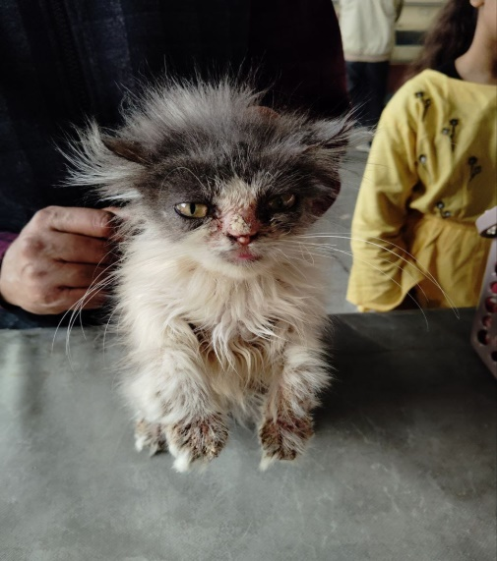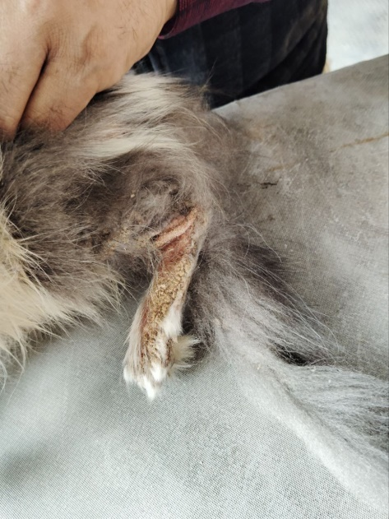
Figure 1. Figure 2.
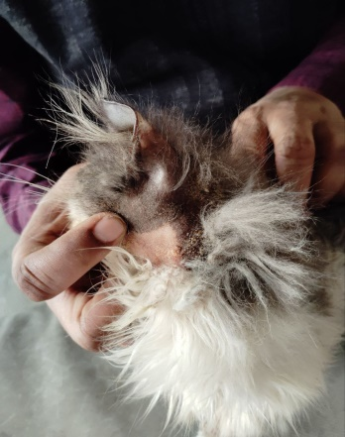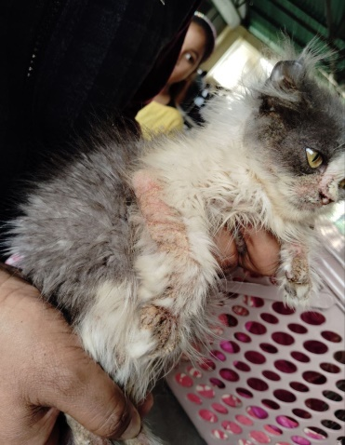
Figure 3. Figure 4.
Figure 1., 2., 3., 4. Presence of dry crusty, scaly lesions and alopecia
The appetite and defecation were normal and all the clinical parameters (rectal temperature, pulse rate, heart rate etc.) were within the normal range. Skin scraping were collected from different sites. For this put a drop of paraffin wax on a sterile scalpel blade. Squeeze the area to be scraped out to help extrude the mites from deep skin. Scrap with moderate pressure until the blood oozes out from superficial layer. Transfer the scrapped material attached on scalpel blade onto the glass slide and stir the mixture. Digest the skin scraping in 10% KOH solution heat [11]. On microscopic examination thumb-print like dorsal striations, shorter limb stalks and a dorsal anus (Figure 5.) are confirmatory morphology of Notoedres cati [9].
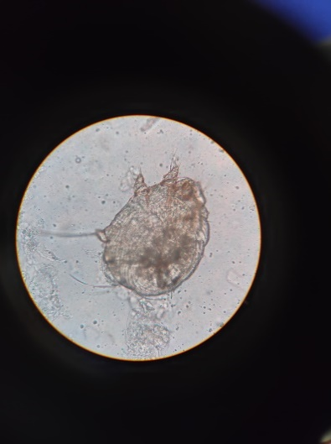
Figure 5. Presence of Notoedres cati (Thumb print like) under low power microscope
Clinical diagnosis was done depending upon the clinical signs and microscopic findings of Notoedres cati.
3. Result
Affected cat was treated with Inj. Ivermectin (Inj. Neomac 10%) at the dose rate of 200 μg/kg, body weight, subcutaneously at weekly interval for four weeks along with supportive therapy by oral administration of antihistamine hydroxyzine hydrochloride @ 2.2 mg/kg b. wt thrice in a day and supplementation of multivitamin, minerals, omega 3 and omega 6 fatty acids. Owner was advised to give bath with benzyl peroxide shampoo twice in a week. The owner were urged to properly disinfect inanimate objects, such as bedding and feeding materials, using antiseptic solutions as per management practice in order to prevent the sickness from spreading and reoccurring. Throughout the course of the treatment, there were no side effects, and no recurrences were noted. Kitten showed some improvement following the second dose of ivermectin, and complete remission of clinical sings (Figure 6. and 7.)

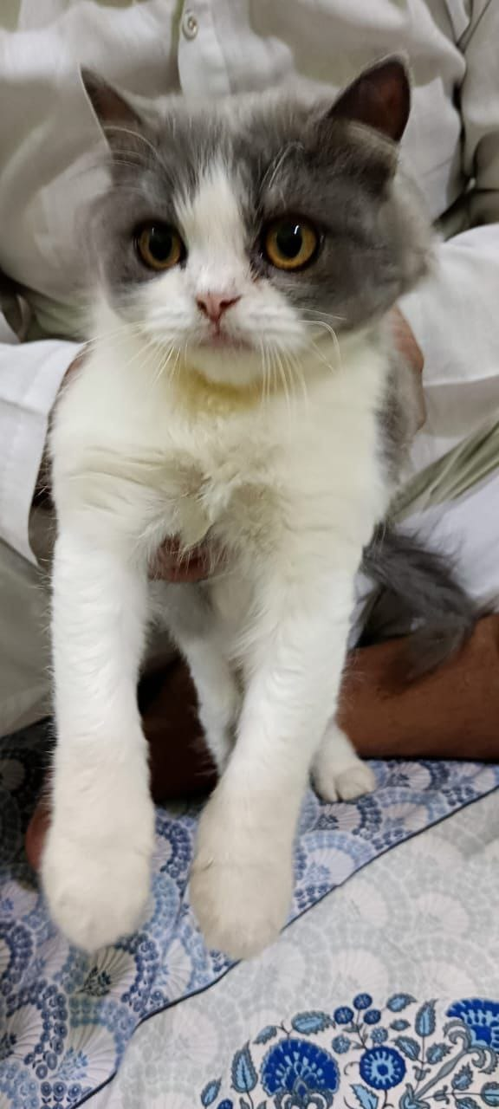 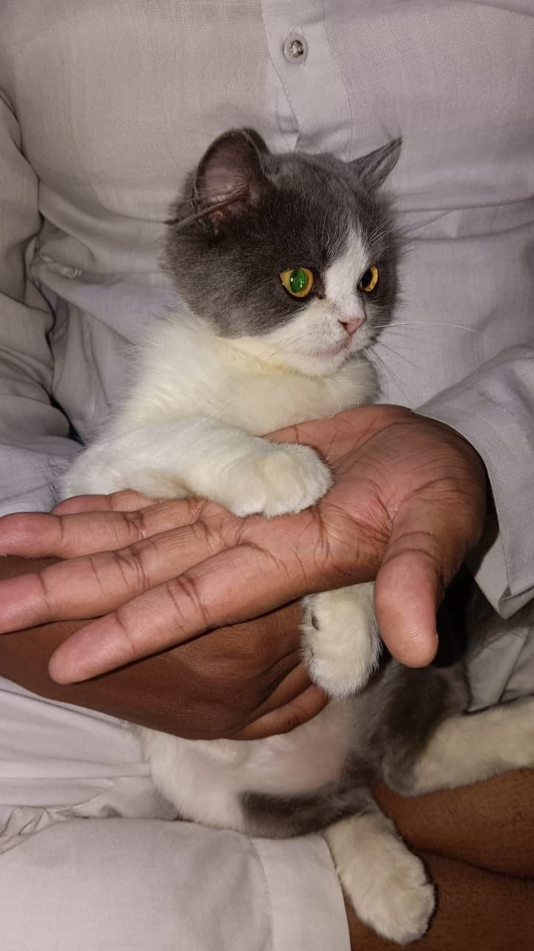Figure 6. Figure 7.
Figure 6. & 7. Cat after complete recovery (40th day post therapy)
was noticed following the fourth treatment. No adverse reactions clinical sign were observed throughout the treatment period, and no recurrence was reported thereafter.
4. Discussion
Usually, severe pruritis, hair loss, and a crusty, scabby appearance of the skin, particularly around the tips of the ears, are the initial symptoms of notoedric mange. It subsequently spreads to the neck and face, and if left untreated, it can spread to other body areas, especially the genital area and feet. Similar sorts of lesions were observed in our current investigation, with the exception of genital areas. In addition to their burrowing behavior and the mechanical harm the parasites inflict during excavation, notoedres also induce irritation through their secretions and excretions, allergic reactions to some of their extracellular products, and most notably, the release of IL-1 [5,10]. Subcutaneous administration of ivermectin selectively binds to glutamate- and gamma-aminobutyric acid-gated chloride channels in mites's nervous systems, causing hyperpolarization of the cells, paralysis, and ultimately death [6]. like other members of the family Sarcoptes -Notoedres can also infect humans. Although the condition is usually self-limiting, our current investigation has shown that it can occasionally induce itching. The best way to avoid infection in cats is to keep healthy cats away from stray or sick cats and steer clear of boarding or grooming cats in unsanitary settings. Because they can be harbor the mites, it is frequently advised that all cats in the family receive treatment if there are numerous cats living there. The owner also reported that for the previous week, they had been severely itching.
5. Conclusion
Based on the clinical indicators and microscopic examinations of the mite's morphology from skin scrapings, Notoedric mange can be diagnosed. After receiving subcutaneous treatment for three weeks at a dose of 200 μg/kg body weight of ivermectin, the afflicted cats fully recovered and showed healthy growth of body coat and hair. That to complete resolution of all symptoms related to severe pruritis, alopecia, scales, or crusts in the affected body parts indicates that ivermectin is a good treatment option for notoedric mange in domestic cats.

References
1. Shraddha Sinha, SK Maiti HK Ratre, L Raj and Neeti Bante. Notoedric mange in cats: It’s treatment and zoonotic importance. The Pharma Innovation Journal. 2023; 12(7S): 2061-2062
2. Dangi, R., Mehta, H. K., Choudhary, N. S., Agrawal, V., Singh, T., & Bhagherwal, R. (2023). Therapeutic management of notoedric mange in cat.
3. Deak, G., & Dumitrache, M. O. (2021). Therapeutic efficacy of topical treatment with selamectin and sarolaner against notoedric mange in a domestic cat: case report.
4. Györke, A., Dumitrache, M. O., Ursache, A. L., D'Amico, G., & Mircean, V. (2022). Case Report: Notoedric Mange and Aelurostrongylidosis in Two Domestic Cats From Rural Environment in Romania. Frontiers in veterinary science, 9, 849525. https://doi.org/10.3389/fvets.2022.849525
5. Henry JB. Clinical diagnosis and management by laboratory methods, 9th edn. WB Saunders Company, Philadelphia, 1996.
6. Scott, Nancy. (2009). Ivermectin Toxicity. Small Animal Critical Care Medicine. 392-394. 10.1016/B978-1-4160-2591-7.10093-1.
7. Ozukum, S., Reihii, J., & Monsang, S. W. (2019). Clinical management of Notoedric mange (Feline scabies) in domestic cats: A case report. The Pharma Innovation Journal, 8(3), 306-308.
8. Sivajothi, S., Sudhakara Reddy, B., Rayulu, V. C., & Sreedevi, C. (2015). Notoedres cati in cats and its management. Journal of Parasitic Diseases, 39, 303-305.
9. Valenzuela, D., Ceballos, G., & García, A. (2000). Mange epizootic in white-nosed coatis in western Mexico. Journal of Wildlife Diseases, 36(1), 56-63.
10. Walker A. The Arthropods of human and domestic animals. Chapman and Hall, London. 1994, 7-8.
11. Islam, M. M. (2023). DIAGNOSIS OF COMMON MITE IN CAT–A CASE REPORT. Chattogram Veterinary & Animal Sciences University, Khulshi, Chattogram.

