Original Research Article
Investigation of plankton ecology in Chinnamuttom and Colachel fishing Harbor in Southeast coast of India

ABSTRACT
Water quality parameters and plankton were analysed in two fishing harbors (Chinnamuttom and Colachel), waters along the complex aquatic ecosystem at Kanyakumari district during July 2021 - June 2022. Seasonal variations of physico-chemical parameters such as AT (27-34ºC), SST (24.3-31ºC), pH (7.46 -8.12), salinity (28.0-33.5 psu) ,DO (3.4-5.6 mg/l) and the inorganic nutrients such as NO₃ (0.042-0.14 mg/l), NO₂ (0.074-0.088 mg/l), PO₄ (0.078-0.193 mg/l), SiO₄ (0.480-0.797 mg/l) and NH₃ (0.054-0.127 mg/l) were estimated in selected study site i.e. harbor waters. A total of 74 species of phytoplankton was recorded in Chinnamuttom harbor water and 59 species were recorded in Colachel harbor water during the study period. Bacilariophycea were dominantly recorded in both ststions.Totally 56 species of zooplankton were observed in Chinnamuttom harbor whereas 46 species were found in colachel harbour. Calanoid groups were dominantly recorded in both stations during the study period. Also the physicochemical parameters influence was correlated.Statistical tools PRIMER (Ver. 6.1.11) and Origin Pro 8.0. were employed to find the species diversity, richness and evenness were calculated.
Keywords: Phytoplankton, Zooplankton, Chinnamuttom, Chlochel, harbor.

1. Introduction
India has many small, medium and large ports along its coast, some of which are natural harbor. Various kinds of anthropocentric and harbour activities are currently polluting port waters by assimilating substantial amounts of waste depending upon its capacity, while the hydrodynamics of the region play a greater role in further dispersion of waste contaminants. Past and current study analysis on marine pollution proves that increasing port activities which could contribute to increased concentration of toxic heavy metals, petroleum hydrocarbons, phenols and many other toxic compounds into harbor environments are greatly affecting the physico chemical properties of port environments [1] where many micro and macro aquatic organisms live.Marine environment as a complex ecosystem is influenced by physical, chemical and biological processes which harbour a rich diversity of flora and fauna [2]. Compared to open ocean, coastal area is more dynamic because of its interaction with the terrestrial zone, which brings about variation in its physico‐chemical parameters.
The biological productivity of the marine system is dependent on the complex physical, chemical and biological processes, the source of pollution load, nutrient content, and availability of biomass[3]. Various valuable biotic and abiotic resources are the source of income for significant portions of the global population [4]. Physico-chemical parameters, such as temperature, salinity, pH, nitrate, nitrite, ammonia, and silicate have a significant impacts on phytoplankton growth and diversity [5].The interaction with physico-chemical parameters of water act as a major factor in controlling the phytoplankton dynamics of the water [6].
Phytoplankton and zooplankton which are the major microflora and fauna dwelling in water [7].phytoplankton are the primary producers and secondary consumer in any aquatic ecosystem. According to [8] phytoplankton followed by zooplankton not only serve as food for aquatic animal but also play an significant role in keeping the biological balance and quality of water[9] in her work specified that zooplankton play an vital role in the food chain, as they are next in trophic level to primary consumers. Differentiated accumulation of taxonomically distinct microscopic organisms inspirations the trophodynamics, ecological energetics, cycling of material and aqua cultural efficiency of all water form. Such important organisms which can restore the climate changes are now getting detoriating due to significant variations in physico-chemical parameters due to environmental damage instigated by human activities, industrialization and pace of urban development. So there is an severe societal and universal necessity to monitor the water quality, the biodiversity and aesthetic beauty of such significant marine environment. With this attention the present study was carried out with an intension to recognize the level of pollution caused by harbor activities on the ecology of the biotic floral (phytoplankton) and faunal (zooplankton) organism and to approximation diversity index of them in the nominated study sites, Chinnamuttom and Colachel harbor, Bay of Bengal.

2. Materials and Methods
2.1. Site description
Kanyakumari district having an area of 1672 sq. km occupies 1.29% of the total extent of Tamil Nadu is home to nearly 1.7 million people with 44 villages and 36,000 families who were totally dependent on fishing occuption. Nearly 4, 000 hectares of land is under inland fishing.
In order to meet international standards, it is imperative to have world class fishing harbor. Kanyakumari stands to gain with a number of fishing harbor works in progress. Chinnamuttom lies between the coordinates (Lat. 8°5'45"N; Long. 77°33'47"E). Colachel, which has always been a fishing harbor is located on the Eastern coastal side of Kanyakumari District that falls in between the coordinates (Lat. 8°09′N; Long. 77°08′E) where the Eastern and Western backwaters approaches as the livelihood of most people around this harbor is fisheries dependent.
2.2. Selection of sampling stations and sample collection
The sample collection was carried out at the following two stations: Station - I Chinnamuttom fishing harbour situated nearly 2 km away from Kanyakumari. Station - II Colachel harbor, a natural harbour situated 20 km left from Nagarcoil in Kanyakumari district in Tamil Nadu. According to the standard procedures the water samples were collected in clean polythene bottles without any air bubbles. The bottles were washed before sampling and forcefully sealed after collection and labeled in the field. The collected samples were kept in ice box to maintain the thermostatic condition till it reaches the laboratory.
2.3. Analaytical methods to determine the water quality parameters
Several water quality variables were monitored and water samples were observed over a period of one year (July 2021 - June 2022). Surface water temperature and atmospheric temperature was measured using a digital multi-stem thermometer of 0.1°C accuracy. Salinity was valued using a hand-held refract meter (Atago hand refract meter, Japan) and the pH (hydrogen ion concentration) was analysed using a pH pen (pH tester, Malaysia) with the accuracy of ±0.1. Dissolved oxygen (DO) was assessed by the modified Winkler's method [10] . Surface water samples were filtered using a Millipore filtering system through a 0.45 μm GF/C filter paper and dissolved inorganic nutrients such as NO₂ was measured by a colorimetric method using sulphanilamide [10], NO₃ by the cadmium reduction method [10], PO₄ by the ascorbic acid method [10] reactive SiO₂ by the molydate method (Strickland and Parsons, 1968) using a PC based double beam spectrophotometer Systronics-2202) and NH₃was estimated by [10] .
2.4. Plankton analysis
The plankton samples from Chinnamuttom and Colachel fishing harbor were collected during July 2021 – June 2022 using standard Indian Ocean hand plankton net (47 μm for phytoplankton and 158 μm mesh for zooplankton) by towing horizontally at surface for 30 minutes. The collected plankton samples were preserved with 5% of neutralized formalin for qualitative analysis. Phytoplankton was identified using the standard keys of [11,12,13,14,15,16,17&18]. Zooplankton samples were identified by using standard keys of [19].The taxonomic identification was done under the compound microscope at a magnification of 10 x 40 x 100, and they were photographically using Inverted Biological Microscope.
2.5. Statistical analysis
Different statistical tools were used to know the diversity indices, richness and evenness using the biodiversity software, PRIMER (Ver. 6.1.11) and Origin Pro 8.0. Biodiversity indices were calculated following the standard formulas; species diversity (H’) was calculated using the following formula [20] (H’ = ∑ pi log₂pi, where pi is the proportion of individuals of each species belonging to the species of the total number of individuals. Species richness (D’) was calculated using the following formula given by [21] D’ = 1 - C; C = ∑pi²; pi = ni/N; evenness or equitability (J’) was calculated using[22] formula: J’ = H’/Jns or J’ = log₂S.

3. Results and Discussion
The surface and atmospheric temperature showed an increasing trend from July 2021 to June 2022 and is influenced by the intensity of solar radiation, evaporation, freshwater influx , cooling and mixing by the ebb and flow from adjoining neritic waters. The low temperature observed in monsoon 2021 might due to strong land sea breeze and precipitation and the recorded high summer value could be attributed to high solar radiation .The average atmospheric temperature recorded at two different harbor waters ranged between 27 to 34ºC. The minimum atmospheric temperature (AT) was observed during monsoon season(November) during the year 2021 at station - II and the maximum (AT) was registered in summer season(May) during the year 2022 at station - I (Fig. 1a). Surface water temperature (ST) varied from 24.3 to 31ºC. The minimum surface water temperature observed during monsoon(November, 2021) at station II and the maximum was registered during summer season (May) at station - I (Fig. 1b).
The pH of sea water is important for a number of reasons. For example, it helps to protect marine life from harmful acids. It also helps to maintain the solubility of minerals and gases in sea water [23]. Hydrogen ion concentration (pH) remained an alkaline nature through out the study period at both the stations with maximum value during August 2022 and minimum during November 2021. Generally, this seasonal variation is attributed to factors like removal of CO₂ by photosynthesis through bicarbonate degradation, dilution of seawater by freshwater influx, low primary productivity, reduction of salinity, temperature and decomposition of organic matter [24]. The recorded high pH in summer might be due to the influence of seawater penetration and high biological activity [25] as well as to the occurrence of high photosynthetic activity .Hydrogen ion concentration (pH) ranged from 7.46 to 8.12. The minimum pH was recorded during monsoon (November) in the year 2021 at station - II and the maximum during summer in the year 2022 at station - I (Fig. 1c).
Salinity is one of the most important hydro graphical parameters, which considerably influences almost all other physical and chemical properties of seawater and thus, significantly determines the distribution of biological communities[26].The salinity was found to be high during summer (May) 2022 and low in monsoon (October) 2021 at both the stations. The recorded higher salinities could be attributed to the low amount of rainfall beside high temperature, higher rate of evaporation and also due to neritic water dominance. During the monsoon season, the rainfall and the freshwater inflow from the land moderately must have reduced the salinity.Salinity values varied from 28 psu to 33.5 psu. The minimum salinity noticed in monsoon 2021 at station - II and maximum during summer 2022 at station - I (Fig. 1d).
Sea water contains dissolved oxygen, which is essential for marine life. The amount of dissolved oxygen in sea water can vary depending on a number of factors, such as temperature, salinity, and currents [23]. The range of dissolved oxygen was found between 3.4 and 5.6 mg/l. The low dissolved oxygen concentration during summer(May) 2022 at station - I and higher concentration was observed during monsoon (November) 2021 at station - II (Fig. 1e). The concentration of inorganic nutrients viz. Nitrate (NO₃) (0.042 - 0.14 mg/l), nitrite (NO₂) (0.074 - 0.088 mg/l), total phosphate (TP) (0.078 – 0.193 mg/l), reactive silicate (SiO₃) (0.480 – 0.797 mg/l) and ammonia (NH₃) (0.054 – 0.127 mg/l) varied in dependently (Figs. 1f-j).
Nitrate is an essential nutrient but at high concentrations, it becomes toxic to the aquatic environment. Nitrate level less than 0.5 mg/L will not pollute the water. Nitrate is one of the most important pollution indicators of water which represents the highest oxidized form of nitrogen. It plays a significant role in sustaining the aquatic life in the marine environment [27].The minimum concentration of nitrate (0.042 mg/l) was obtained during summer (May) 2022 at station - I and the maximum (0.14 mg/l) in monsoon(November) 2021 at station – II.Currently obtained highest monsoonal nitrate value in both harbour waters could be mainly due to the organic materials received from the catchment area during ebb tide ( while the nitrite content recorded the minimum (0.074 mg/l) in summer (March) 2022 at station - I and maximum (0.088 mg/l) noticed during monsoon (November) 2021 at station - II.
Total phosphate concentration was found low the (0.078 mg/l) in summer (May) at station - I and higher (0.197 mg/l), in monsoon(November) 2021 at station - II. Reactive silicate concentration registered its maximum (0.797 mg/l) during monsoon(October) 2021 at station - II and minimum (0.480 mg/l), during summer(May) 2022 at station - I. Ammonia content was resulted minimum (0.054 mg/l) during the monsoon(November) 2021 at station - I and maximum (0.127 mg/l), during the summer(March) 2022 at station - II.Currently obtained highest monsoonal nitrate value in both harbor waters could be mainly due to the organic materials received from the catchment area during ebb tide. Another possible way of nitrate input could be through oxidation of ammonia to nitrite [28,].The recorded low values during non-monsoon period may be due to its utilization by phytoplankton as evidenced by high photosynthetic activity and the dominance of neritic seawater having a negligible amount of nitrate[23] Low value of nitrite was recorded during summer season could be ascribed to less freshwater inflow and high salinity [29]. Whereas the nitrite level was found higher during monsoon season could be mainly due to the organic materials received from the catchment area during ebb tide [30].
The silicate in harbor waters content was always higher than that of other nutrients and the recorded high monsoon values may be due to heavy inflow of freshwater derived from land drainage carrying silicate leach out from rocks and also from the bottom sediment . The observed low summer values could be attributed to uptake of silicate by phytoplankton for their biological activity. The variation of silicate in coastal water is influenced by several factors like physical mixing of seawater with freshwater[31]adsorption of reactive silicate into suspended sedimentary particles [32] chemical interaction with clay minerals [33&34] co-precipitation with humid compounds and iron and biological removal by phytoplankton, especially by diatoms and silico-flagellates [35] Domestic and industrial discharges besides harbor waters into the coastal water increase nutrients (nitrates and ammonia) making it slightly polluted. The strong seasonal currents and seasonal winds however help in well oxygenation and dispersion of excessive nutrient into the offshore waters, rendering it non-polluted, thereby maintaining good productivity in harbor waters. Ammonium is the nitrogenous end product of the bacterial decomposition of natural organic matter containing nitrogen. The recorded higher concentration could be partially due to the death and subsequent decomposition of phytoplankton and also due to the excretion of ammonia by planktonic organisms[25]
In the present study A total of 74 species of phytoplankton was recorded in station - I and 59 species was recorded in station - II during the study period. The percentage composition of (85%) phytoplankton in station - I sample was contributed by diatoms (Bacillariophyceae), 8% by dinoflagellates(Dinophyceae) 7% of green algae (Chlorophycea) whereas blue green algae not noticed. The percentage composition of phytoplankton in station - II was 84% contributed by diatoms (Bacillariophyceae), 8% by dinoflagellates (Dinophyceae) 7% by green algae (Chlorophycea) 9 and 1% by blue green algae (Cynobacteria).In the study area among the various species of phytoplankton identified diatoms population were dominated in all season, as they thrive well in widely changing hydrographical conditions [36 & 37].This finding is also similar to earlier report by many workers [38].The species like Skeletonema costatum, Pleurosigma elongatum, Thalassionema nitzschioides, Navicula longa, Thalassionema longissima, Chaetoceros affinis, Triceratium robertsianum, Coscinodiscus centralis, and Nitzschia closterium were recorded almost all the season. In the present study, phytoplankton species diversity index ($H^{'}$) varied from 3.674 to 4.014 (Fig. 3). The minimum species diversity (3.674) was recorded in station - I during monsoon might be due to the heavy monsoonal flood, which washed the allochthonus species, and even autochthonus species, which could not survive in very low salinity. The turbidity during monsoon season may also responsible for lower values. Similar observations were also made earlier by Santhanam et al. (2012). The maximum level (4.014) was observed in station - II during summer season may be due to the occurrence of allochthonous species [39].The species richness index ($D^{'}$) fluctuated between 0.972 and 0.980 (Fig. 4). The minimum species richness (0.972) was observed in station - I during monsoon, and the maximum (0.980) was noted in station - II during summer season. High and lower species richness recorded during summer and monsoon seasons respectively, which could be correlated with the recorded higher and lower salinity values, as reported by[35]. The species evenness index ($J^{'}$) varied from 0.823 to 0.857 (Fig. 5). In the present study a reverse trend was observed in evenness values. The minimum species evenness (0.823) was observed in station - I during postmonsoon may be due to unequal distribution of the species and the maximum (0.857) was recorded in station - I and II during monsoon and summer that the species were equally distributed and thus not allowing a single species to dominance over others as reported earlier by from Vellar estuary, [40] from Arasalar and Cauvery estuary, [28] from Pichavaram mangrove waters, from Vellar estuary and adjacent neritic waters and [41] from Gulf of Kachchh waters (Fig. 2e).
In the present study, zooplankton of both station - I and II comprised of Calanoida, Cyclopoida, Harpacticoida, Ciliata, Polychaeta and Amphipoda. In station - I, Calanoida (40%), Cyclopoida (14%), Harpacticoida (14%), Ciliata (15%), Polychaeta (12%) and Amphipoda (5%) were recorded. These species were present in all four seasons. In station - II Calanoida (39%), Cyclopoida (12%), Harpacticoida (13%), Ciliata (15%), Polychaeta (15%) and Amphipoda (5%) were recorded. Therefore, totally 56 and 48 zooplankton species were recorded in station - I and II of the harbor water respectively. Among the zooplankton recorded, Calanoid copepod was found dominant followed by Cyclopoida, Harpacticoida, Ciliata, Polychaeta and Amphipoda (Fig. 6). The copepods constituted the dominant group and were numerically abundant throughout the study period. Among the copepods, Macrosetella gracilis was the most dominant genus followed by Acrocalanus gracilis and Oithona rigida. Numerical abundance of copepods was also recorded by different coastal system of India [40].The zooplankton species diversity index ($H^{'}$) varied from 3.812 to 3.156
(Fig. 7). The minimum species diversity (3.812) was recorded in station - I during monsoon may be due to the freshwater flow played a key role in altering the hydrobiology of the marine and estuarine environments and caused a reduction of species number, thereby decreasing the density and diversity. This can be correlated with the observations of from Columbia estuary. Similar results have been reported by from parangipettai waters, form Kadinamkulam estuary and from Goa water. The maximum level (3.156) was observed in Station - II during summer could be due to stable hydrographical condition this. The species richness index ($D^{'}$) fluctuated between 0.941 and 0.976 (Fig. 8). The minimum species richness (0.941) was observed in station - II monsoon and the maximum (0.976) was noted in station - I during summer during this seasons (Fig. 3d). species evenness index ($J^{'}$) varied from 0.997 to 0.999. The minimum species evenness (0.997) was observed in station - I during post monsoon, and the maximum (0.999) was recorded in station - II during summer (Fig . 9). To conclude, marine resources indeed vital water quality has become a matter of serious concern because it affects not only aquatic ecosystem health but human health too. The diversity of phytoplankton and zooplankton, the members of first and second trophic level who play significant role in energy production through out the aquatic food web are much influenced by environmental factors (i.e. Water physic-chemical parameters) in which they live. Hence there is an increasing need for accurate appraisal of plankton study, a good tool for monitoring and management of aquatic ecosystem which can give a idea of water quality and marine biodiversity.

CONCLUSIONS
Seasonal variations of physio-chemical and nutrients characteristics in Chinnamuttom Fishing Harbour and Colachal Harbour inferred that the higher concentration of the nutrients observed in Colachel Fishing harbour. The concentration of nutrients was high during monsoon season and low during summer season in both harbour waters due to incoming of anthropological contaminants in the harbour region from the catchment area and discharge of domestic and ship. The marine phytoplankton and zooplankton density, diversity, richness were recorded in their maximum levels during summer season, and minimum were obtained in the monsoon. The evenness of phyto and zooplankton were recorded during their maximum levels during summer season, and minimum were obtained in the post monsoon.

REFERENCES
- Shirodkar PV, Pradhan UK, Vethamony P. Impact of Water Quality Changes on Harbour Environment Due to Port Activities along the West Coast of India. Second International Conference on Coastal Zone Engineering and Management (Arabian Coast 2010), November 1-3, 2010, Muscat, Oman. ISSN: 2219-3596.

- Ratnam K, Jha DK, Devi MP, Dharani G. Evaluation of photochemical characteristics of coastal waters of nellore, southeast coast of India, by a multivariate statistical approach. Front Mar Sci. 2022.

- Vandarwala U, Bhatt A, Nitin S, Vyas U, Pathak S. 2020. Influence of photochemical parameters on gastropods diversity along the Saurashtra coast of Gujarat, India. J Entomol Zool Stud.2020; 8(5):2195-2198.
- Sahib S. Marine diversity in India with special reference to conservation, status, and issues. IJ Oceanography.2019; 34.
- Sin Y, Wetzel R L & Anderson I C (1999). Spatial and Temporal Characteristics of Nutrient and Phytoplankton Dynamics in the York River Estuary, Virginia: Analysis of Long-Term Data. Estuaries.1999; 22: 260-275. https://doi.org/10.2307/1352982.

- Sharma C, Jindal R, Singh UB, Ahluwalia AS, Thakur RK.Population dynamics and species diversity of plankton in relation to hydrobiological characteristics of river Sutlej, Punjab India.Ecol Environ Conserv. 2013; 19: 717-724.

- APHA. Standard method for the examination of water and waste water. 1985; 15th edition, New York, USA.

- Narasimha Ramulu K and Benarjee G.Physico-Chemical Factors Influenced Plankton Biodiversity and Fish Abundance—A Case Study of Nagaram Tank of Warangal, Andhra Pradesh. International Journal of Life Sciences Biotechnology and Pharma Research.2013; 2: 248-260.

- Aarti D, Sharma KK, Sharma A and Antal N. 2013. Zooplankton Diversity and Physico-chemical Conditions of a Temple Pond in Birpur (J and K, India). Int Res J Environ Sci.2013; 2(5):25-30.
- Strickland JD H, Parsons TR . A Practical Handbook of Sea Water Analysis, 2nd Edn., Bull. No: 167. Fisheries Research. Board, Canada, Ottawa, Onto. 331pp.

- Venkataraman, G., 1939. A systematic account of some south Indian diatoms. Proceedings of Indian Academy of Sciences.1972; 10: 293-368.

- Cupp E E. Marine plankton diatoms of the west coast of North America. Bull., Scripps Institute of Oceanography. Univ. California Press. Berkley and Los Angeles. 1943; 237pp.

- Subrahmayan R. A systematic account on the Madras coast. Proc. Indian Acad. Sci.1946; 24: 85-197.

- Desikachary TV. Cyanophyta, Indian Council of Agricultural Research, New Delhi.1959.

- Hendey NI . An introductory acount of the smaller algae of British coastal waters. Part V: Bacillariophyceae (Diatoms). Ministry of Agriculture Fisheries and Food Fishery Investigations Series 4. Her Majesty's Stationery Office London.1964; 317: 45.
- Steidinger KA and Williams J. Dinoflagellates, Mem. Hourglass cruises.1970 ;2: 1-251 .
- Taylor F JR. Dino-flagellates from the International Indian Ocean Expedition. Bibliotheca Botanica Stuttgart.1976;132, 234.

- Anand P, Elderfield H , Conte M H. Calibration of Mg/Ca thermometry in planktonic foraminifera from a sediment trap time series. Paleoceanography.2003; 18.
- Santhanam P, Perumal P. Effect of temperature, salinity and algal food concentration on population density, growth and survival of marine copepod Oithona rigida Giesbrecht. Indian Journal of Marine Science.2012; 41:369-376.

- Shannon CE, Weaver W. A Mathematical Theory of Communications. 1949; 54 pp.
- Simpson EH. Measurement of diversity. Nature 1949;163:688
- Pielou EC .Ecological diversity.1975; Wiley New York.
- Sagar Bhakare (2023).Analysis of physico-chemical properties of seawater sample.https://www.researchgate.net/publication/373989293 .
- Bragadeeswaran S, Rajasegar M, Srinivasan M, Kanagarajan U. 2007. Sediment texture and nutrients of Arasalar estuary, Karaikkal, southeast coast of India. J Environ Biol.2007; 28: 237-240.
- Godhantaraman N. Seasonal variations in species composition,abundance, biomass and estimated production rates of tintinnids attropical estuarine and mangrove waters, Parangipettai, Southeast coast of India. J Mar Syts.2002; 36: 161-171 .

- Sinu JV,Ajimila B. Quantitative composition distribution and abundance of zooplankton communities in relation to physico-chemical parameters from selected beaches of Alabpuzha in Arabian sea,Southwest coast in India. Total Environ Research Themes. https://doi.org/10.1016/j.totert.2023.100054.
- Nithya P,DhanalakshmiB,Santhanam P,Dineshkumar S.The premonsoon and monsoon season changes in physic-chemical characteristics of Chinnamuttom and Colachel Harbour waters South east coast of India.Indian Journal of Geo marine sciences.2018; 47(01):193-199.

- Karuppasamy PK, Perumal P. Biodiversity of zooplankton at Pichavaram Mangroves South India. Adv Biosci.2000; 19: 23-32.

- Murugan A, Ayyakannu K. Ecology of Uppanar backwaters, Cuddalore-II nutrients Mahasagar. Bull Natl Inst Oceanogr.1991; 24(2): 103-108.

- Das JS, Das N, Sahoo RK. 1997. Semidiurnal variations of some physico chemical parameters in the Mahanadi estuary east coast of India. J Mar Sci.1997; 26: 323-326.

- Purushothaman A and Venugopalan V K. Distribution of dissolved Silicon in the Vellar Estuary. Indian Journal of Marine Sciences.1972; 1: 103–105.

- Lal D. Transfer of chemical species through estuaries to oceans. In Proceedings of a UNESCO/SCOR Workshop on Biogeochemistry of Estuarine Sediments. Melreus Belgium.1978; 166–170.

- Aston S R. Nutrients dissolved gasses and general biochemistry in estuaries. In Olausson E and Cato I (eds.), Chemistry and Biogeochemistry of Estuaries. New York Wiley. 1980;233–262.

- Gouda, Rajashree and Panigrahy RC. 1996. Ecology of phytoplankton in coastal waters off Gopalpur, East coast of India. Ind J Mar Sci.1996; 2: 13-18.

- Liss PS,Spencer CP.Abiological processes in th removal of silicate from seawater.Geochemical et cosmo chirnica acta.1970; 34: 1073-1088.

- Mani P. Natural phytoplankton communities in Pichavaram mangroves. Indian Journal of Jeo Marine Science.1992; 21: 278-280.
- Gowda, B T, Paulus H and Fuess H. Naturforsch Teil A.2001; 56: 386–394.

- Senthilkumar S , Santhanam P and Perumal P. Diversity of phytoplankton in Vellar estuary, southeast coast of India. In: Proc. 5th Indian Fisheries Forum (Eds.: S. Ayyappan, J.K. Jena and M. Mohan Joseph). Published by AFSIB, Mangalore and AeA, Bhubanewar, India.2002; 245- 248 .

- Thillai Rajsekar K, Perumal P and Santhanam P. Phytoplankton diversity in the Coleroon estuary, southeast coast of India. J Mar Biol Ass India.2005 ; 47: 127-132.

- Saraswathi CD, Sreemantula S, Prakash WS. Effect of chronic cold restraint and methods on the germination of various cereals. Sarhad J Agric.1993; 22: 209-213.

- Saravanakumar A, Rajkumar M, Sesh Serebiah J, Thivakaran GA. Seasonal variations in physico-chemical characteristics of water, sediment and soil texture in arid zone mangroves of Kachchh-Gujarat. J Environ Biol. 2008;29: 725-732.

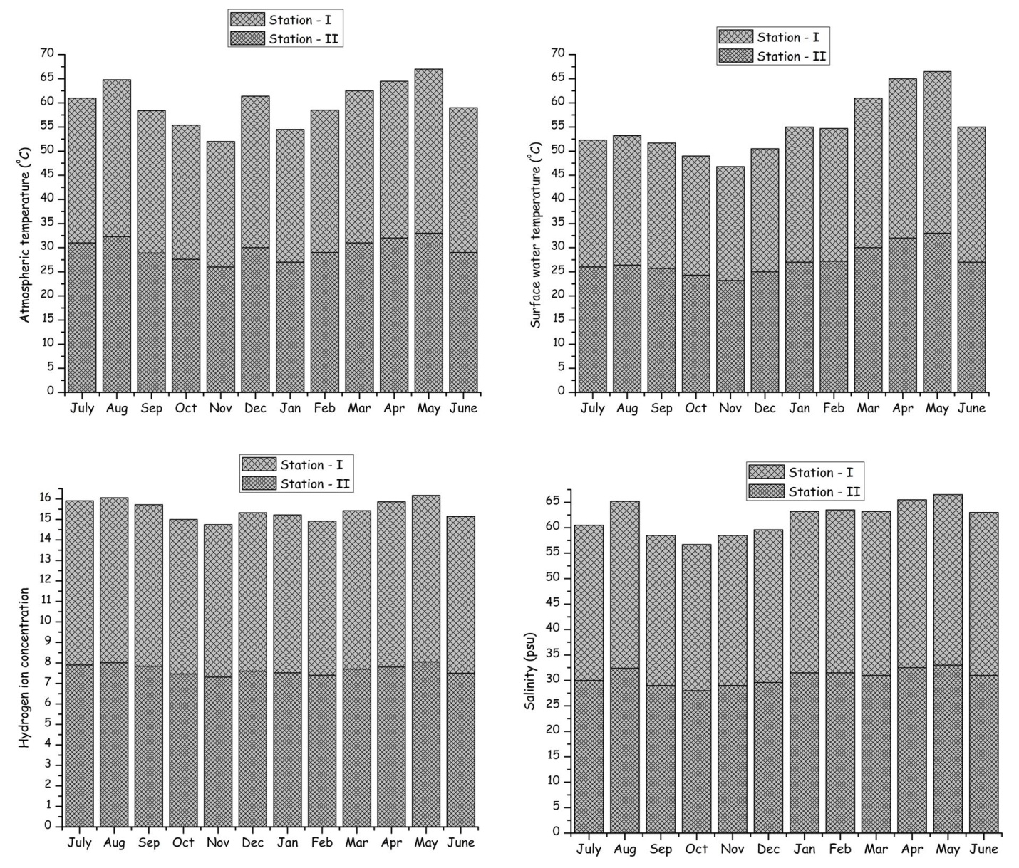

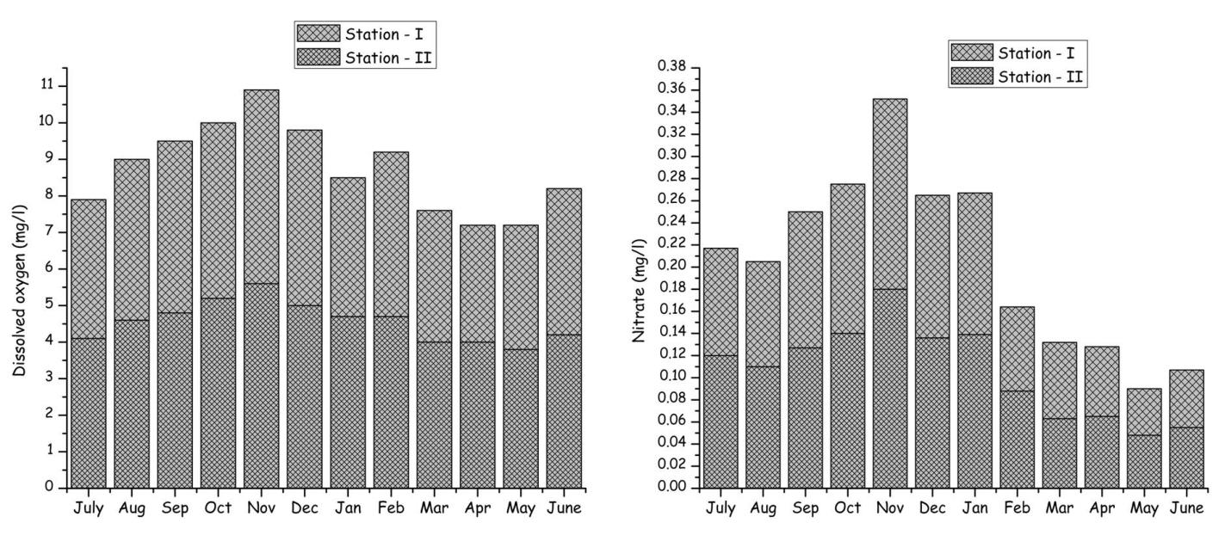

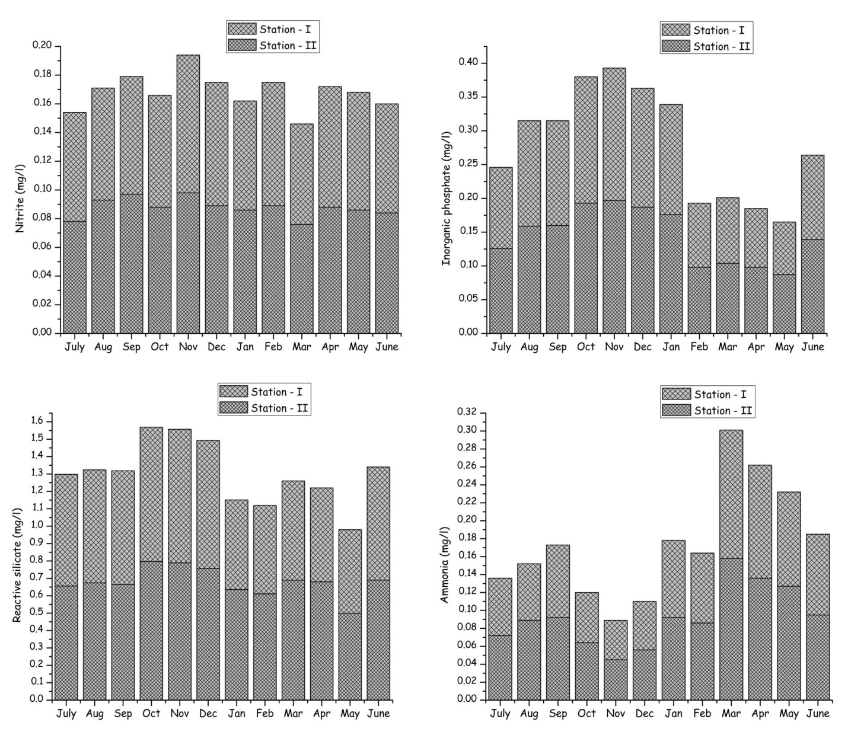
Fig.1 (a-j). Seasonal variations in the physico-chemical parameters of the two different harbor, Tamil Nadu, Southeast of India.

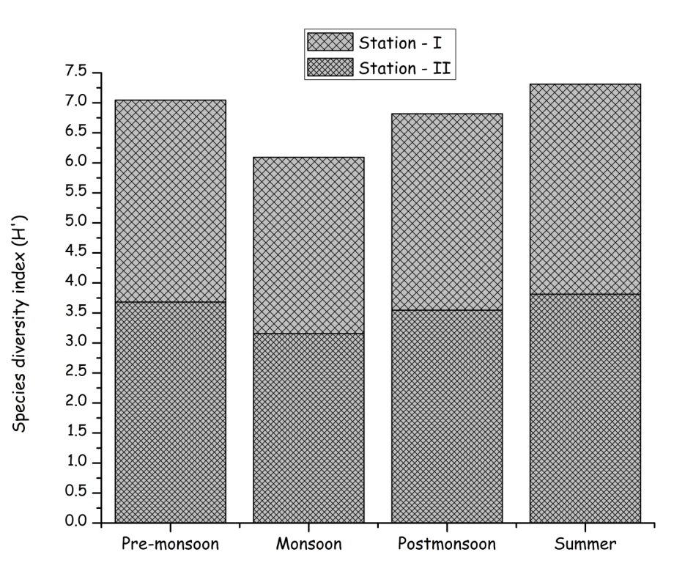
Fig.2. Shannon - Wiener diversity indices of phytoplankton from two stations.
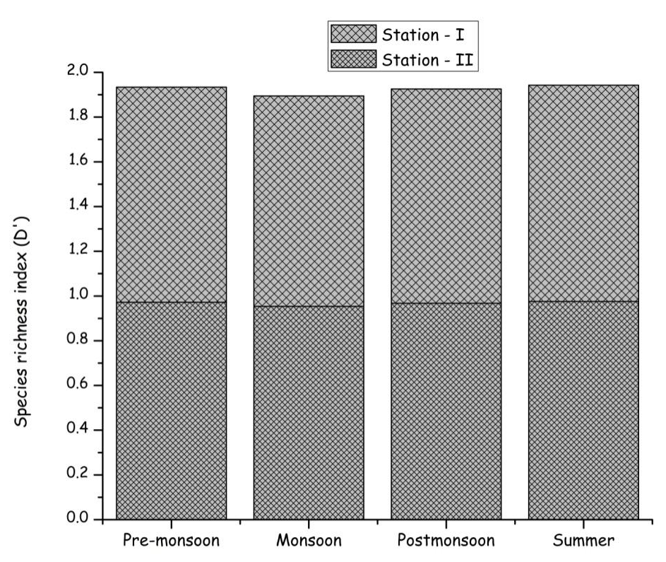
Fig.3. Simpson richness index of phytoplankton from two stations.
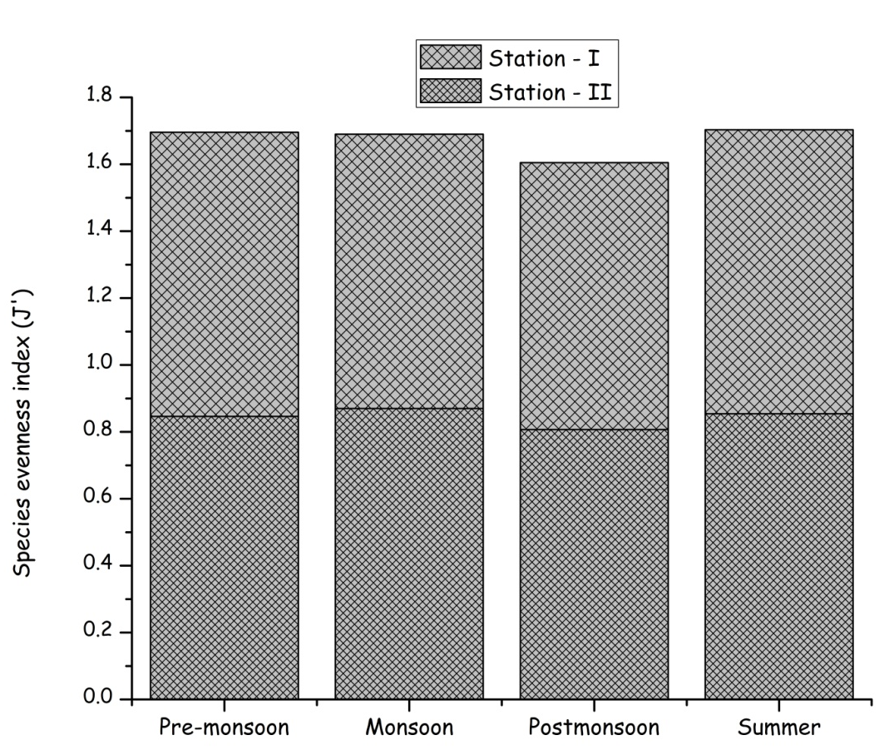
Fig.4. Pielou's evenness index of phytoplankton from two stations.

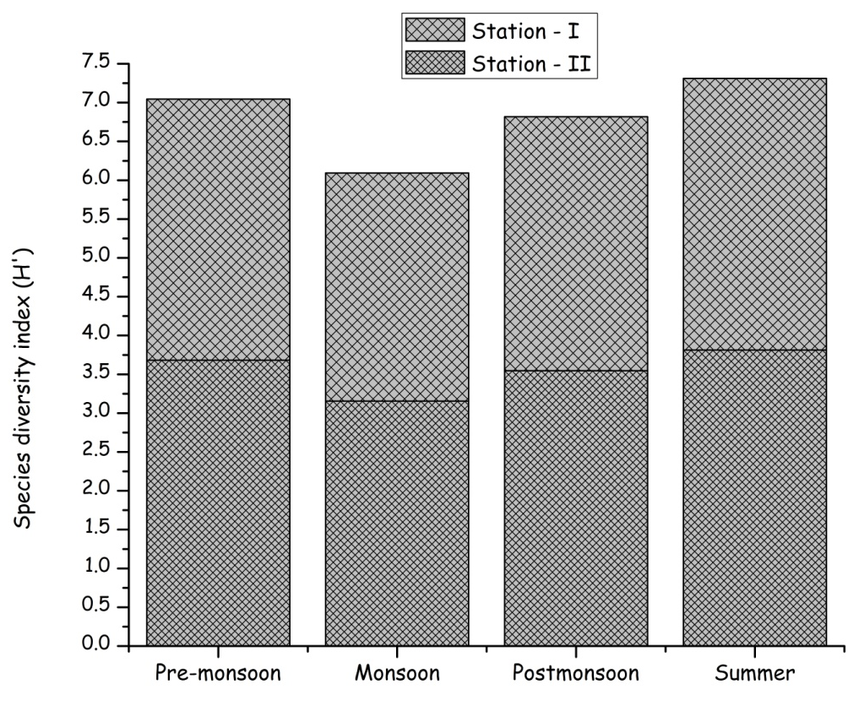
Fig.5. Shannon - Wiener diversity indices of zooplankton from two stations.
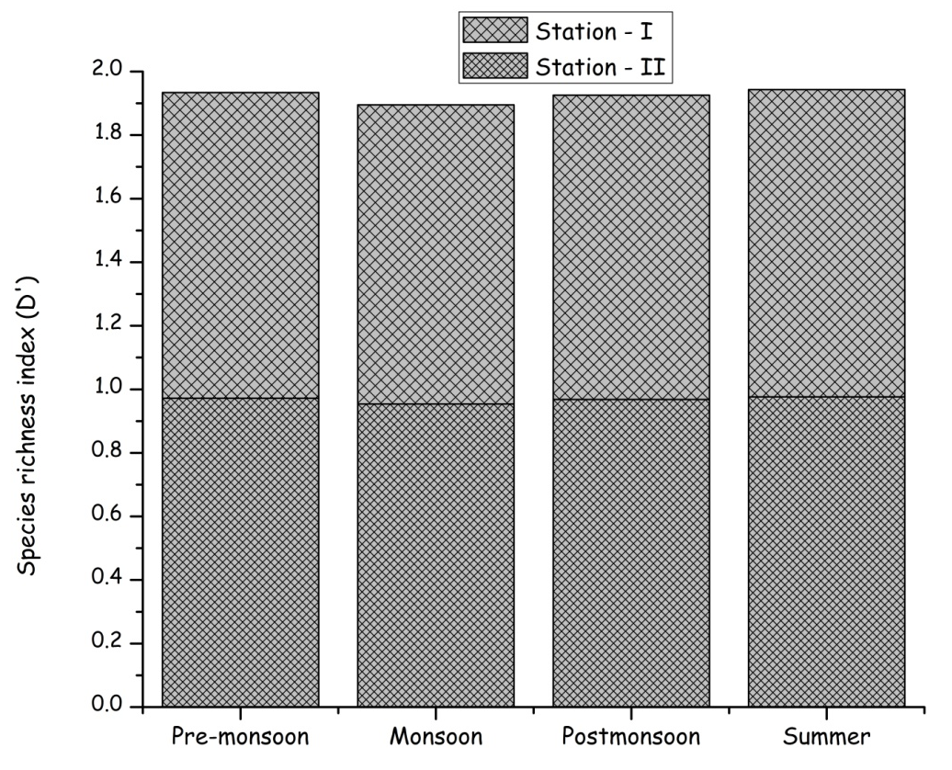

Fig.6. Simpson richness index of zooplankton from two stations.
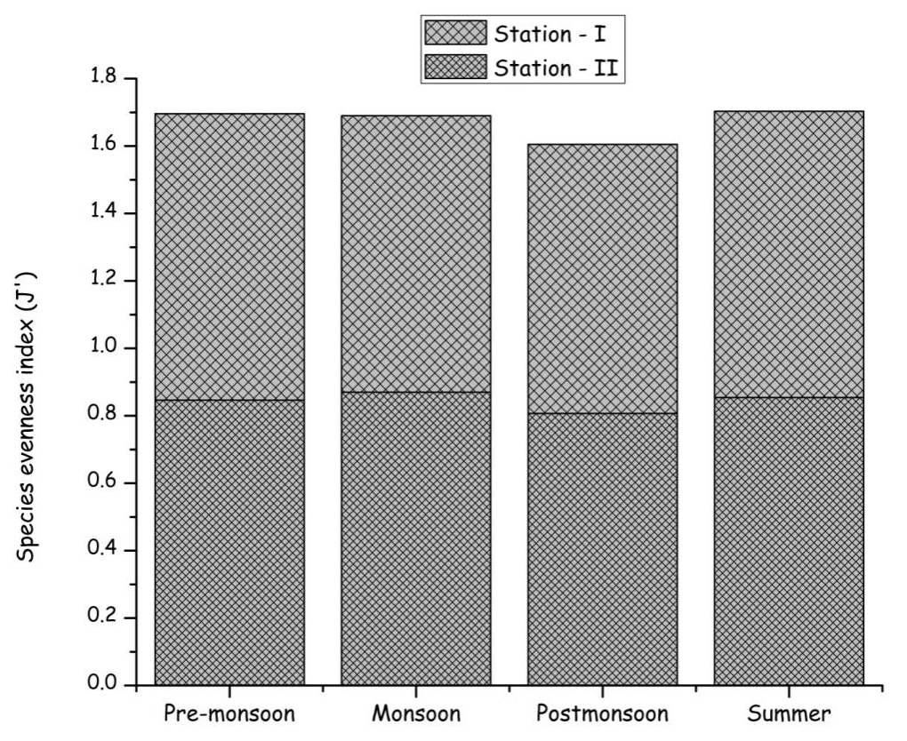
Fig.7. Pielou's evenness index of zooplankton from two stations.

