Original Research Article
IN-VITRO ANTIBACTERIAL ACTIVITY OF YEMIDIR EMBUAY (Cucumis focifolius) AND ENDOD (Phytolacca dodecandra) EXTRACTS AGAINST SOME BACTERIA PATHOGENS.

ABSTRACT
Medicinal plants are one of the most indigenous resources in the world for the treatment of different diseases. Now a day most of infectious diseases are resistant to the antimicrobial agents. Therefore, the aim of this study was to investigate the antibacterial effect of Cucumis focifolius and Phytolacca dodecandra against Staphylococcus aureus, Klebsiella Pneumonia and Neisseria gonorrhea. Ethanol, Methanol, Chloroform and Water are used as solvents for the extraction of phytochemical compounds from Cucumis focifolius and Phytolacca dodecandra plants. The effective extraction of bioactive compounds was achieved using methanol, chloroform and water as solvents. According to this study there were bioactive compounds that extracted from selected plants which were potentially effective against Neisseria gonorrhea and some other pathogens. Both Cucumis focifolius and Phytolacca dodecandra some inhibition zone on S. auerus and k. pneumonia strains. Highly statistical significant antibacterial effect against N. gonorrhea (16.6±3.05) for ethanol root extract of Cucumis focifolius followed by methanol root extract with an inhibition zone of (15±2.64) were exhibited. The extract also shows (13.3±1.25mm, 14±1.05mm by chloroform and distilled water root extract respectively. Ethanol C. ficifolius root shows lowest Minimum inhibitory concentration against Neisseria gonorrhea as compared to other extracts. Therefore, we recommend people to search for new antimicrobial agents for better treatment of Neisseria Gonorrhea, which is one of causative agent of sexual transmitted disease.

Key word: Medicinal plants, Cucumis focifolius, Phathogens, Phytolacca dodecandra, Solvent.

INTRODUCTION

Background
The emergency of drug resistant microorganism and an increasing evolutionary adaptation by microorganism to the commonly used antimicrobial have reduced the effectiveness of the antimicrobial agents in use. According to N. dip et al., (2008), medicinal plants constitute a source of both traditional and modern medicines. Hence, today researchers have discovered more than 10,000 medicinal plants with biologically active compounds of microbial origin (Shahidi et al., 2004).
In developing nations about 65-80% of the world’s population relies essentially on traditional medicinal plants and traditionally processed products for treatment of different type of bacterial and human aliment diseases (WHO, 2002). In Ethiopia about 80% of the total populations use plant based traditional medicine by their indigenous knowledge as their major primary health care system. This traditional knowledge of medicinal plants is serving as an input and a walking step for many researchers to investigate the effectiveness of the medicinal plant through scientific work with experimental evidences for the discovery of new drugs (Berhanu, 2002). It is known that when plants are exposed to contact with different microorganisms, including viruses, bacteria and fungi, plants synthesizes secondary metabolites like include tannins, alkaloids, carbohydrates, terpenoids, steroids and flavonoids, which produce definite physiological action on the human body and these bioactive substances (Edoega et al., 2005; Das et al., 2009).
Different studies have been reported to extract plant secondary metabolite with various solvents for antimicrobial properties (ethanol, methanol, petroleum ether, chloroform, hexane, ethyl acetate, dichloromethane (DCM) and water) (Eloff, 1998; Eloff, 2005; Masoko, 2005; Ndip et al., 2008; 2009; Ademola and Eloff, 2010). Numerous studies have been carried out on using natural products for screening antimicrobial activity, but no attention has been given to use Phytolacca dodecandra, and Cucumis focifolius for antimicrobial activity. Therefore, the main objective of this study is to test the antibacterial activity of the two extract against sexual transmitted disease (STD) and some other selected test organism.

Statement of problem
The conventional antimicrobial agents usually provide effective antibiotic therapy for bacterial infections but today many of the antimicrobial agents fail to respond to treatment and resulting in prolonged illness and greater risk of death. Treatment failures are mainly due to the adaptation evolution of resistant bacteria. The treatment failure of the conventional drug leads to longer periods of infectivity, which increase the numbers of infected people moving in the community and thus expose the general population to the risk of contracting a resistant strain. Therefore the scientific community searches novel classes of antimicrobial agent due to the increasing population at risk and the growing prevalence of resistant pathogenic bacteria. The antimicrobial compounds from plants may inhibit bacteria than the presently used antibiotics and may have clinical value in treatment of resistant microbial strains (Eloff et al., 1998).This study evaluates the antimicrobial activity of Cucumis focifolius and Phytolacca dodecandra extract to understand its antimicrobial activity against selected both Gram-negative and Gram-positive bacteria. This constitutes part of an effort to identify potential sources of cheap starting materials for the synthesis of new drugs to circumvent the problem of increasing drug resistance against the selected pathogens.

Significance of study
Most population in sub-Saharan Africa depends on traditional medicine for their primary healthcare and many of the antimicrobial agents which are in use today were discovered from plant. This makes it necessary to have research on medicinal plants so as to obtain more potent pharmacological agents (WHO, 2000). In this context, there is a critical need to mainstream traditional medicine into public health care to achieve the objective of improved access to healthcare facilities. Limited information is available regarding antimicrobial activity of Cucumis focifolius and Phytolacca dodecandra; therefore, this study is carried out to investigate the antimicrobial activity of the extracts from against selected standard STD and bacterial species.

OBJECTIVEs

General objective
The overall objective of the present study is to determine the antimicrobial activity of crude extracts of Cucumis ficifolius and Phytolacca dodecandraon against some selected test microorganisms.

Specific objective
- To screen the major secondary metabolites found in crude extracts of Cucumis ficifolius and Phytolacca dodecandraon
- To evaluate the antibacterial activity of Cucumis ficifolius and phytolacca dodecandra extracts against selected bacteria pathogens.
- To Evaluate the Minimum Inhibitory Concentration of crude extracts of Cucumis ficifolius and Phytolacca dodecandraon

MATERIALS AND METHODS

Study area and period

The study was conducted from March 2023 to September 2023 in Microbiology Laboratory of Biology department, Wachemo University, Hossana, Central region of Ethiopia. Hossana town is located 230 kms far from Addis Ababa. The average annual temperature is 18.6 °C. The rainfall average is 1244mm.The sample of root of Cucumis ficifolius and leaves phytolacca dodecandra was collected from Hossana area. Hossana is a capital city of central Ethiopia, Located in the Hadiya Zone. Plants were selected based on the indigenous knowledge of the local people.

Design of experiment

To conduct this study the researcher followed experimental and observatory study design. This will help the researches to facilitate and to get maximum result with minimal expenditure of effort, time, and money.

Preparation of plant extracts
The plant materials of both C. ficifolius and P. dodecandra were air dried under shade at room temperature in biology Laboratory of Wachemo University. Plant extraction was as per the method of Ndip et al. (2009) with slightly modification. The plants were ground using grinder machine and sieved with a mesh to obtain a fine powder. Technical grade solvents (distilled water, chloroform, ethanol and methanol) were employed for extraction. Plant material (20g) of soaked in 100 ml of each solvents and 150 ml distilled water. The slurry was placed in a shaker for 72 hours and filtered through Whitman’s filter paper No.1. The filtrate was then concentrated by evaporation of solvent in water bath. The yielded extracts were weighed, dissolved with DMSO and stored in a labeled tight lid container at 4°C for further bioassay.
Qualitative Screening of the Major Secondary Metabolite
Chemical tests were carried out using aqueous and methanol crude leave extracts to identify various constitutes using standard methods.
Qualitative analysis of some major secondary metabolites (tannins, phenol, flavonoids, saponins, free sugars and alkaloids) from solidified crude root and leaf extracts of selected plants were carried out using the standard procedures used by (Ajayi et al., 2011 ; Adachukwu et al., 2013 and Jaradat et al., 2015).

Bacteria Phathogens
A total 3 strains including gram positive (Staphylococcus aureus, ATCC25923) and gram negative (Klebsiella pneumonia-ATCC27736 and N. gonorrhea) were selected to assess the susceptibility test against the drug extract. The strains were obtained from Ethiopian public health and research institute, Addis Ababa, Ethiopia. They were maintained in suspension media (nutrient broth) and kept in incubator at 37°C. Later on the organism were cultured on MHA for (Staphylococcus aureus, ATCC25923) and (Klebsiella pneumonia-ATCC27736), and also blood agar for N. gonorrhea and fresh inoculums were taken from the media for test.

Preparation of bacterial suspension
The tested microorganisms were separately cultured on MHA at 37°C for 24 hrs. By streaking the inculcating loop containing bacteria at the top end of the agar plate moving in a zigzag horizontal pattern until 1/3 of the plate was covered.
Then, three to five well isolated overnight cultured colonies of the same morphological type were selected from an agar plate culture. The top of each colony was touched with sterile bent wire-loop and the growth was transferred into 10ml of broth. The turbidity of the inoculum suspension was adjusted using 0.5 McFarland standards. The turbidity of the actively growing broth culture was adjusted with sterile saline to obtain turbidity optically comparable to that of 0.5 McFarland turbidity standard 1.5×10⁸ colony forming units (CFU)/ml. To obtain this, OD value 1.2 was read at 625 wavelength using spectrophotometer.

Preparation of culture medium
Muller-Hinton agar was prepared from commercially available dehydrated base according to manufacturer’s instructions. Muller Hinton Agar Medium (MHA) was prepared by dissolving 38g of MHA medium in 1000ml of distilled water (7.2 PH). The mixture of MHA powder and sterile distilled water was stirred with a sterilized glass rod and covered with aluminum foil and then autoclaved for 15 min at 121°C.Soon after autoclaving, the agar was allowed to cool in the laminar flow hood prior pouring it into the petri plate. Blood agar was prepared from commercially available dehydrated base according to manufacturer’s instructions. By Suspending 28 g of blood agar powder in 1000ml of distilled water the agar was prepared. The mixture was Heated and stirred until all components fully dissolved. Then, the dissolved mixture was autoclaved at 121 degrees Celsius for 15 minutes and allowed to cool but not solidify. When the agar has cooled to 45-50 °C, 5% (v/v) sterile defibrinated sheep blood was added and mixed well gently. Then the prepared medium was poured into the prepared petri plates.

Antimicrobial activity of Cucumis ficifolius and Phytolacca dodecandra extract
The antimicrobial activity of Cucumis ficifolius and Phytolacca dodecandra extract was determined as per method developed by Boyonova et al., (2005) with slight modification.
The antibacterial activities of the different extract were determined by agar well diffusion assay on MHA medium and blood agar medium. The standardized inoculums of 100µl (1.5×10 CFU/ml, 0.5 McFarland) were added aseptically and spread with a sterile non-toxic cotton swab on the agar plate surface. 6mm Wells were prepared in the seeded agar plates with sterile cork borer. The test compound or crude extract (100 µl) were carefully dispensed on the wells of blood agar medium. Extract were allowed to diffuse for about 30min before incubation. DMSO alone use as a negative control. Using aseptic conditions all the selected antibiotic (Clarithromycin and Cefepime 30 µg/disc) and the plant extracts were applied on the MHA and left for 30 minutes to allow the extract to diffuse. The plates were then incubated at 37°C for 18-24 hours in an incubator. All tests were performed in triplicate and zone of inhibition were measured from the edge of each wells/disc after the incubation period by using Sliding Calipers and ruler.
2.8. Minimum Inhibitory Concentration
The minimum inhibitory concentration of each extracts were determined by using different concentrations (10, 5, 2.5, 1.25 and 0.625 mg/mL) of the extracts of both plants using the broth dilution method described in the National Committee for Clinical Laboratory Standards (NCCLS) (2012).
After the completion of preparation and growth in 24hrs the tube with lowest concentration of the extract showing no growth after incubation was taken as the MIC (NCCLS, 1990).

Data collection and Data analysis

All the data were analyzed using SPSS version 26.0. Means and standard deviations of the triplicate results were analyzed by ANOVA to determine the significant differences between the means followed by Duncan’s multiple range test (P≤0.05).

RESULT

Extract yield
All the three extracts with distilled water, chloroform, ethanol and methanol showed varying degree of yields. Ethanol was the best solvent with a yield of 3.37g (16.85%) followed by chloroform 2.65g (13.25%)while methanol and Distilled water was the least with2.02g (10.1%), 2g (10%) respectively for the root part of Cucumis focifolius as shown in Table 1.The yield percentage for Phytolacca dodecandra was also as follows; 4.5g (22.6%), 2.31g (12.55%), 3.37g (16.85%), 5.79g (28.95%) for ethanol, methanol, chloroform and distilled water respectively. In this result highest yield was obtained by distilled water and ethanol, while methanol and chloroform extract was the lowest yield value as compared with each other solvent.
Table 1: Extract yield of Cucumis focifolius and Phytolacca dodecandra extracted with different solvents.
Plant name | Parts used |  | solvent |  | Weight of extract obtained |  | Yield percentage %
Cucumis focifolius | Root |  | Ethanol |  | 3.37g |  | 16.85%
Cucumis focifolius |  |  | Methanol |  | 2.02g |  | 10.1%
Cucumis focifolius |  |  | chloroform |  | 2.65g |  | 13.25%
Cucumis focifolius |  |  | Distilled water |  | 2g |  | 10%
Phytolacca dodecandra |  | leaves |  | Ethanol |  | 4.52g | 22.6%
 |  |  |  | Methanol |  | 2.31g | 11.55%
 |  |  |  | chloroform |  | 3.37g | 16.85%
 |  |  |  | Distilled water |  | 5.79g | 28.95%
Qualitative screening of the major Secondary Metabolites
Table 2. Qualitative screening of the major Secondary Metabolites
Secondary metabolites | Plant Extracts  Cucumis focifolius |  |  |  |  |  |  |  |  | Plant Extracts  Phytolacca dodecandra
Secondary metabolites | Ethanol Root | Methanol Root | Chloroform Root | Aqueous Root | Ethanol leaf | Methanol leaf |  | Chloroform leaf | Aqueous leaf | Ethanol Root | Methanol Root | Chloroform Root |  | Aqueous Root |  | Ethanol leaf |  |  |  |  |  | Methanol leaf |  |  |  | Chloroform leaf |  | Aqueous leaf
Tannin | + | + | - | - | + | + |  | + | - | + | + | + |  | - |  |  | + |  |  |  |  | - |  |  |  | - |  | -
Saponin | + | + | + | - | + | + |  | + | - | + | + | + |  | - |  |  | + |  |  |  |  | + |  |  |  | - |  | +
Flavonoid | + | + | + | - | + | + |  | + | - | + | + | + |  | - |  |  | + |  |  |  |  | + |  |  |  | - |  | +
Free Sugar | + |  |  | - | + | + |  | + | - | + | + |  | - |  | - |  |  | + |  |  | - |  |  | + |  |  |  | +
Free Sugar | + | +
Alkaloids | + | + | + | - | + |  | + | + | - | + | + |  | + |  | - |  |  | + |  | - |  |  | - |  | - |  |  | -

Key: - + indicates presence whereas - indicates absence
Qualitative phytochemical analysis was showed that the two plant extracts had major bioactive compounds that play major therapeutically important role on the controlling of infectious disease. Based on the result obtained from the phytochemical analysis, the phytochemical compounds such as tannins, flavonoids, saponins and alkaloids were found in all the extracts as shown in the table.
Methanol and Ethanol exracts of Cucumis focifolius and Phytolacca dodecandra contains all the secondary metabolites indicated above (Table 2). This implies some study shown that plants with antimicrobial activities contain bioactive compounds like tannins, flavonoids, alkaloids, and saponins.

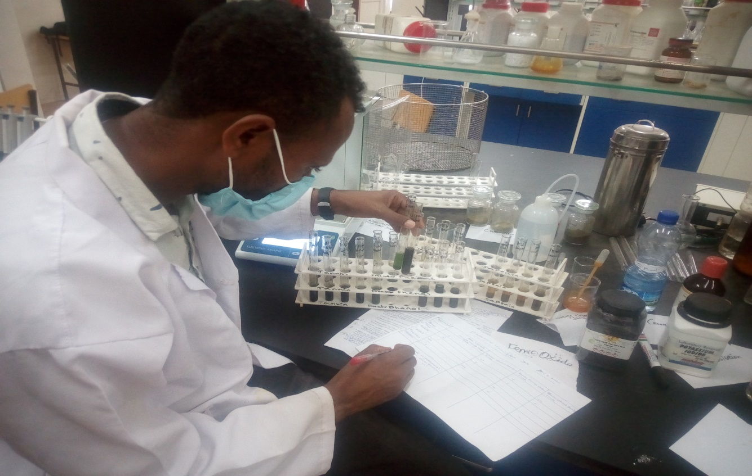

Fig.1. Screening secondary metabolites

Antibacterial activity of Cucumis focifolius and Phytolacca dodecandra Extracts
In this investigation, the antimicrobial activity of the distilled water, chloroform, ethanol and methanol extracts of the roots of C. ficifolius and leaves extracts of phytolacca dodecandra were evaluated using agar well diffusion method. Table 3 and 4 shows the antibacterial activity of the different extracts of the two medicinal plants against three pathogenic bacteria species. The extracts of these two plant species showed varying degree of inhibitory activity against S. aureus, K. pneumonia and N. gonorrhea at concentration of 50mg/ml.
Table3.The mean inhibition zone (mean ±SD (mm) of the roots of C. ficifolius against the standard pathogenic bacteria
 | Inhibition zone (mm)
Test organisms | ethanol | methanol | chloroform | DMSO negative control | Distilled water extract | clarithromycin | Cefepime
S. aureus | 11 | 10.5 | 8.5 | - | - | 10.3±2.08 | Not used
K. pneumonia | 6 | 4.5 | 3.5 | - | - | - | Not used
N. gonorrhea | 16.6±3.05 | 15±2.64 | 13.3±1.52 | - | 14±1.05 | Not used | -

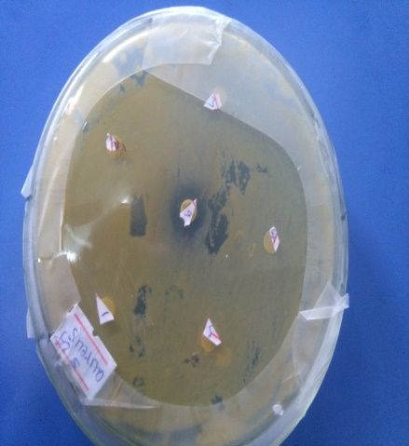

Fig 2: The activity of root of C. focifolius plant extract on S. aureus

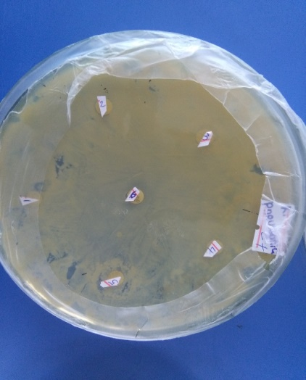
Fig 3: The activity of root of C. focifolius plant extract on K. pneumonia

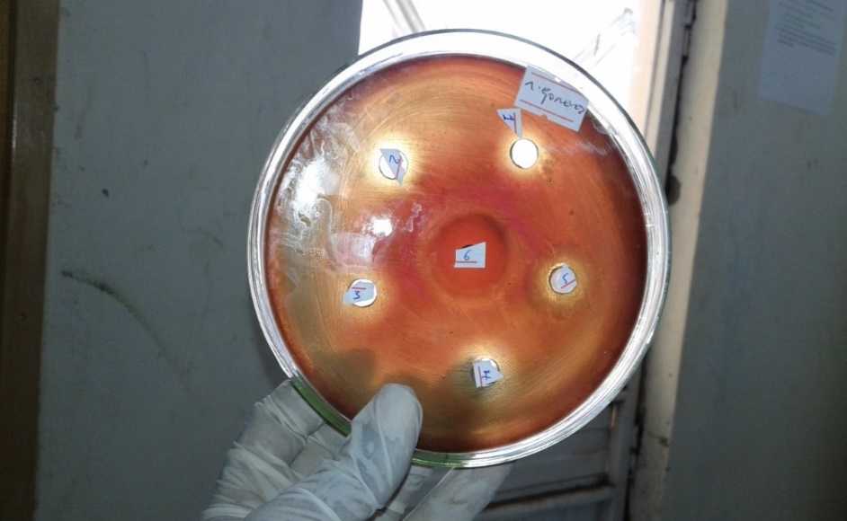
Fig 4:- The activity of root of C. focifolius plant extract on N. gonorrhea

Table 4.The mean inhibition zone (mean ±SD (mm)) of the leaves of Phytolacca dodecandra against the standard pathogenic bacterial
 | Inhibition zone of the extracts ( mm)
Test organisms | Ethanol | Methanol | Chloroform | DMSO negative control | Distilled water extract | Clarithromycin | Cefepime
S. aureus | 7.5 | 6 | 4.7 | - | - | 12.6±2.51 | Not used
K. pneumonia | 4 | 3.8 | 3 | - | - | - | Not used
N. gonorrhea | 8.6±1.52 | 9.6±2.08 | 8.6±2.88 | - | 8.6±1.15 | Not used | -

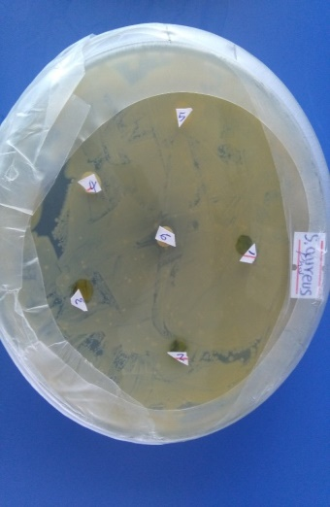
Fig 5:- Antibacterial activity leaves of Phytolacca dodecandra on S. aureus
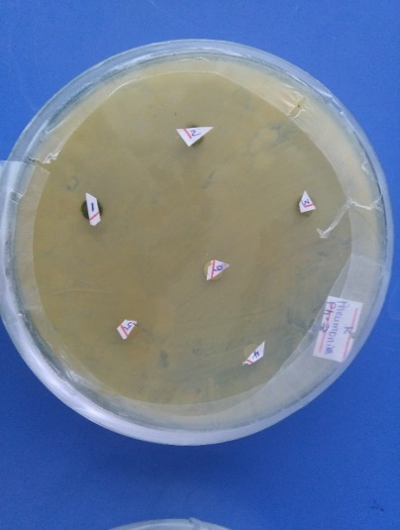
Fig 6:- Antibacterial activity leaves of P. dodecandra on K. pneumonia
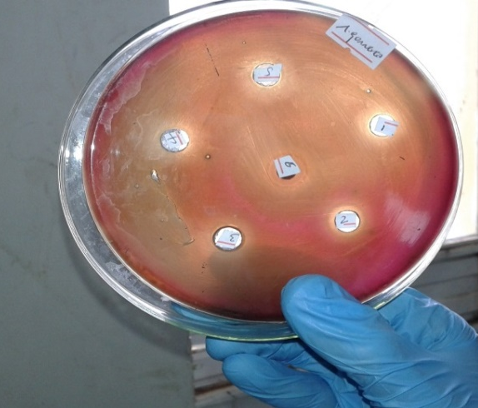
Fig 7: Antibacterial activity leaves of phytolacca dodecandra on N. gonorrhea
MINIMUM INHIBITORY CONCENTRATION (MIC)
The minimum inhibitory concentrations of each extracts against the selected bacteria varied with bacterial species and type of the extract (table 5). As indicated in the table, the highest MICs of the root extracts of both plants were observed. In aqueous P. dodecandra on K. pneumonia with MIC values of 10 and 5.0 respectively while the lowest MIC was recorded for Ethanol C. focifolius root against N. gonorrhea and S. aureus with MIC values of 0.625 and 1.25 respectively. The leaf extracts of each plant showed also different MIC against the test bacteria. Generally, the broth dilution assay showed that in both plants leaf extracts had more antibacterial activities against all test bacteria. Therefore, the smallest MIC value indicates as the extract was efficient to inhibit the growth of the test pathogen in minimum dosage.
The lowest MIC values of leaf extracts of both extracts of the two plants were observed against S. aureus. The results obtained in the broth dilution method were consistent with the results obtained from the well diffusion method in this study.
Table 5. Minimum Inhibitory Concentration (MIC)
Antibacterial agent | In-vitro groups
Antibacterial agent | K. pneumonia | N. gonorrhea |  | S. aureus
Antibacterial agent | mg/mL
Methanol  C. ficifolius root | 2.5 |  | 1.25 |  | 2.5
Ethanol C. ficifolius root | 1.25 |  | 0.625 |  | 1.25
Chloroform C. ficifolius root | 5 |  | 2.5 |  | 5
Aqueous C. ficifolius root | 5 |  | 5 |  | 10
Methanol C. ficifolius leaf | 5 |  | 1.25 |  | 5
Ethanol C. ficifolius leaf | 2.5 |  | 0.625 |  | 1.25
Chloroform C. ficifolius leaf | 10 |  | 5 |  | 5
Aqueous C. ficifolius leaf | 10 |  | 5 |  | 10
Methanol P. dodecandra root | 5 |  | 2.5 |  | 5
Ethanol P. dodecandra root | 10 |  | 2.5 |  | 2.5
Chloroform P. dodecandra root | 5 |  | 5 |  | 10
Aqueous P. dodecandra root | 10 |  | 5 |  | 10
Methanol P. dodecandra leaf | 5 |  | 1.25 |  | 2.5
Ethanol P. dodecandra leaf | 5.0 |  | 0.625 |  | 1.25
Chloroform P. dodecandra leaf | 10 |  | 5 |  | 5
Aqueous P. dodecandra leaf | 5 |  | 10 |  | 10

DISCUSSION
In this investigation, four different extracts of Cucumis focifolius and Phytolacca dodecandra yield percentage was calculated. The highest yield was (16.85%) for Ethanol extract followed by chloroform extract (13.25%), while the methanol and distilled water extracts were (10.1%) and (10%), respectively for Cucumis focifolius. The yield percentage for Phytolacca dodecandra was also as follows; 22.6%, 12.55%, 16.85%, 28.95% for ethanol, methanol, chloroform and distilled water respectively. In this result highest yield was obtained by distilled water and ethanol, while methanol and chloroform extract was the lowest yield value as compared with each other solvent. In contrary to this study, Mohamed et al., (2015) on phytochemical analysis of leaves extract of Eucalyptus Camaldulensis, chloroform gave the least yield compared to water and ethanol. This may due to the presence of different phytochemical compound in different plant species.
The plant extracts and standard antibiotics showed varied significant activities in all the test strains. Both Cucumis focifolius and Phytolacca dodecandra shows no inhibition zone on S. auerus and k. pneumonia strains. The positive control clarithromycin shows 10.3±2.08mm zone of inhibition on S. auerus while K. pneumonia did not. Similarly (Tegenu, 2011) reported S. typhi shows no inhibition zone by C. ficifolius and Z. scabrausing in all solvents used in our study. This might be because of the highly antibiotic resistance of those strains, strain evolution, and the plant spectrum might be narrow.
In this study, there is highly statistical significant antibacterial effect against N. gonorrhea (16.6±3.05) for ethanol root extract of Cucumis focifolius followed by methanol root extract with an inhibition zone of (15±2.64). The extract also shows (13.3±1.25mm, 14±1.05mm by chloroform and distilled water root extract respectively. No inhibition zone was observed for negative control (DMSO). The highest inhibition zone was observed for ethanol and the least inhibition zone was for chloroform by Cucumis focifolius root extract. For the second plant Phytolacca dodecandra, methanol shows highest zone of inhibition (9.6±2.08) mm and all the rest ethanol, chloroform and distilled water shows (8.6±1.52) mm, (8.6±2.88) mm (8.6±1.15) mm zone of inhibition on N .gonorrhea respectively. Both negative control (DMSO) and positive standard antibiotic (Cefepime) did not show any antibacterial activity. In line with this study Amit et al., 2015 obtained more antibacterial activity against Staphylococcus aureus (20.10±0.17mm) and Candida abacas (4.20±0.40 mm) for ethanol and methanol extract of W. somnifera respectively.

CONCLUSION

The result of this study shows that the plants have different phytochemical compounds which are polar and non-polar. Thus, the root of Cucumis focifolius and leaf of Phytolacca dodecandra extracts have a great potential of antibacterial activity against Neisseria Gonorrhea strain with the extract of ethanol, methanol, chloroform and water. As per the investigation of this study, the staphylococcus Aureus and klebsiella pneumonia are resistant bacteria against root of Cucumis focifolius and leaf of Phytolacca dodecandra with all ethanol, methanol, chloroform and water extracts and even resistant to the standard antibiotic clarithromycin except S. aeurus.
RECOMMENDATIONS
The following recommendations were forwarded;
- Further phytochemical screening, purification and elucidation of the active compounds in order to provide novel compounds for the synthesis of new antimicrobial drugs.
- Antimicrobial activities against other bacteria have in order to identify the spectrum activity of the plant extracts.
- Toxicity and mechanism of action of the plant extracts.

REFERENCES
Adachukwu, I.P., Ogbonna, A. O. and Eze, F.U. 2013.Phytochemicals analysis of paw-paw (Carica papaya L.) leaves. International Journal of Life Sciences Biotechnology and Pharma Research, 2(3): 348-351.
Ademola, I.O. and Eloff, J.N., (2010). In vitro anthelmintic activity of Combretummolle (R. Br. ex G. Don) (Combretaceae) against Haemonchuscontortusova and larvae. Veterinary Records, 158: 485–486.
Ajayi I. A., Ajibade O. and Oderinde R. A. 2011. Preliminary phytochemical analysis of someplant seeds. Research Journal of Chemical Scinces, 1(3): 58-62.
Berhanu, A. (2002). Ethiopian Traditional Medicine: Common Medicinal Plants. J. Black Studies. 32: 610-612.
Boyanova, L., Gergova, G., Nikolov, R., Derejian, S., Lazarova, E., Katsarov, N., Mitov, I. and Krastev, Z., (2005). Activity of Bulgarian propolis against 94 Helicobacter pylori strains in vitro by agar-well diffusion, agar dilution and disc diffusion methods. J. Medical Microbiol. 54: 481-483.
Chantana, K., Ruchanok, Ch., and Rinrada, P. (2005). Screening of medicinal plants from kohkret, nonthaburi for antibacterial activity. 1-5.
Cowan, M.M. (1999). Plants products as antimicrobial Agents. Clinical Microbiology Reviews, 12: 564-582.
Das, K., Tiwari, R.K.S. and Shrivastava, D.K., (2009). Techniques for the evaluation of medicinal plants products as antimicrobial agents: Current methods and future trend. J. Medicinal Plant Res., 492: 104-111.
Edeoga, H.O., Okwu, D.E. and Mbaebi, B.O., (2005). Phytochemical constituents of some Nigerian medicinal plants. Afri. J. Biotechno., 4(7): 685- 688.
Eloff, J.N. (1998). Which extractant should be used for the screening and isolation of
antimicrobial components from plants? J. Ethnopharmacology, 1: 1-8.
Eloff, J.N., Famakin, J.O. and Katerere, D.R.P., (2005). Isolation of antibacterial stilbene from
Combretum woodii (Combretaceae) leaves. Afr. J. Biotechno., 4 (10): 1167-1171.
Jaradat N, Hussen F, Al Ali A. 2015. Preliminary Phytochemical Screening, Quantitative Estimation of Total Flavonoids, Total Phenols and Antioxidant Activity of Ephedra alata Decne. Journal of Mater Environmental Science; 6 (6):1771-8.
Lee KH, Hui KP, Tan WC, Lim TK.(1994), Klebsiella bacteraemia: a report of 101 cases from National University Hospital, Singapore. J HospInfect; 27: 299-305.
Masoko, P.J. and Eloff, J.N., (2005). Antifungal activities of six South African Terminalia species (Combretaceae). J. Ethnopharmacology of Botany, 99: 301-308.
NCCLS (2000). Methods for Dilution Antimicrobial Susceptibility Tests for Bacteria That Grow Aerobically: Approved Standard- Fifth Edition. NCCLS document M7-A5: NCCLS: Wayne, PA, USA.
NLSI (National Laboratory Standard Institute NLSI. (1990, 2012).
Ndip, R.N., Ajonglefac, A.N., Mbullah, S.M., Tani, N.F., Akoachere, J.F.K., Ndip, L.M., Luma, H.N., Wirmum, C., Ngwa, F. and Efange, S.M.N., (2008). In vitro anti-Helicobacter pylori activity of Lycopodium cernuum. Afr. J. Biotechnol., 7: 3989-3994
Ndip, R.N., Ajonglefac, A.N., Wirna, T., Luma, H.N., Wirmum, C. and Efange, S.M.N., (2009). In-vitro antimicrobial activity of Ageratum conyzoideson clinical isolates of Helicobacter pylori. Afr. J. Pharmacy and Pharmacology, 3 (11): 585-592.
Ndip, R.N., Dilonga, H.M., Ndip, L.M., Akoachere, J.F.K. and Nkuo, T.A., (2005). Pseudomonas aeruginosa isolates recovered from clinical and environment samples in Buea, Cameroon: current status on biotyping and antibiogram. Tropical Medicine and Inter. Health, 10: 74-81.
Shahidi, B.G.H., Fooladi M. H. Mahadevi, M. J. and Shahghas, A., (2004). Broad-spectrum, a novel antibacterial from Streptomyces species, Biotechno. 3: 126-130.
Shahwar, D., and Raza, M.A. (2009). In-vitro antibacterial activity of extracts of Mimusopselengi against gram positive and gram negative bacteria. African J. Microb. Res., 3(8):458-462
WHO (2000). A publication of united against malaria. The Magazine of WHO M. 3: 547.
WHO (2001). Drug resistance in malaria. The Magazine of WHO M. 4: 1-24.
WHO (2014). Antimicrobial resistance: global report on surveillance.
WHO (2002). Traditional medicine: Growing needs and potential, WHO Policy perspectives on medicines. p. 1, World Health Organization, Geneva.

