Original Research Article
DIVERSITY OF FRESHWATER TURTLES MELANOCHELYS TRIJUGA IN AND AROUND SANKARAPURAM WETLAND COMPLEX ON KALLAKURICHI DISTRICT, TAMIL NADU, INDIA

ABSTRUCT
India is one of the most species-rich regions of freshwater turtles in the world, also, they are being collected, for slaughter, eaten, and traded in huge numbers. The scope of this study on Melanochelys trijuga, also known as the Indian Black Turtle, focuses on collecting comprehensive information about the species in India, specifically in Tamil Nadu, with a special emphasis on Sankarapuram.The study aims to address the lack of current data about this turtle species and contribute to the understanding of its taxonomy, distribution, habitat, behavior, and conservation status. Various methods are employed in this study such as visual sighting of habitiat to encounter the target animal, and, indirectly through interview-based survey information from local communities.Visual survey was conducted on 20 locations of the sankarapuram study area. On the surveyed 20 locations the tortoise was observed in five locations viz. two Coconut farm, two ordinary well which used for irrigation purpose and a lake side muddy shallow area. Totally 10 individuals were observed in this study period. We had an opportunity to examine the specimens very closely once it comes out behind the open well. The captured specimens were later examined by comparison with the standard key characteristics and manuals inorder to identify the specimen and found as Melanochelys trijuga species. In this study we observed both male and female individuals. The individuals are found as adults.The characteristics and ecology information were compared with the existing data in precious record and publications and manuals. Obtained Melanochelys trijuga species was found as Nearly Threatened status in the International Union for Conservation of Nature (IUCN) category.
Keywards: Coconut farm,Indian Black Turtle,Melanochelys trijuga,,Ordinary well,Turtle
- INTRODUCTION
Freshwater turtles are conspicuous amphibians, contributing to effective environmental biodiversity with diverse forest organisms. In India, 24 species of freshwater turtles are available in various habitats such as rivers, lakes, forests, deserts, wetlands, and swamps are the diversity hotspot for aquatic turtles. India is one of the most species-rich regions of freshwater turtles in the world, also, they are being collected, for slaughter, eaten, and traded in huge numbers. Further, these critical turtle habitats are under significant anthropogenic threats of habitat degradation and modification, increase in pollution, climate change, and, invasion of exotic species. In consequence, recently in 2019, over 60% of tortoises are listed as threatened in IUCN Red List.

Sankarapuram is one of the six block in Tirukoilur talk,Kallakurichi district.The Tamil Nadu district’s groundwater development board was announced and predicted sankarapuram block is one of the groundwater overexploited categories area. The panchayat has 5319 ordinary wells and most of them are for irrigation purpose. These adjacent areas are highly productive for agriculture. Unfortunately, these wetlands are facing a range of anthropogenic pressure, in terms of rapid urbanization, alteration of the natural regime due to hydrological development, overexploitation, landfill deposition, and drainage.

Hence, freshwater turtles can have commensurate impacts on the ecosystem processes and are a good indicator of the health of wetland and waterbodies, however, very few scientific contributions exist in terms of species-wise occurrence or abundance in different habitats [1,2 &3]. Hence, conducted studies along sankarapuram waterbodies and documenting the Melanochelys sp. diversity and habitats is a potential addition to further surveys by future and may contribute new information on the ecology of certain turtle species in various waterbodies.The scope of this study on Melanochelys trijuga, also known as the Indian Black Turtle, focuses on collecting comprehensive information about the species in India, specifically in Tamil Nadu, with a special emphasis on Sankarapuram (kallakurichi, TamilNadu – 606 401). The study aims to address the lack of current data about this turtle species and contribute to the understanding of its taxonomy, distribution, habitat, behavior, and conservation status. The study intends to achieve the following objectives and utilize the available resources to study this turtle.To collect the details of freshwater turtle in freshwater ecosystem around Sankarapuram.To examine the locations of freshwater bodies on selected study area based on interview survey.To collect the Taxonomic classification of collected Melanochelys trijuga freshwater turtle species in India.To collect habitat information of the recorded freshwater Turtle species in Sankarapuram (kallakurichi, TamilNadu – 606 401).To understand the status of Melanochelys trijuga, its threats and conservations.

- METHODOLOGY
For every effective conservation activity, collecting baseline information on species occurrences, biogeography, and their conservation status are the first step to be undertaken. They are essential tools for developing our knowledge and understanding of species diversity and distribution, identify threats to the populations and, identify species conservation strategies. Various methods are employed in this study such as visual sighting of habitiat to encounter the target animal, and, indirectly through interview-based survey information from local communities.
Based on the talks about tortoise sightings in rainy seasons, first, we conducted the Questionnaire survey in adjacent area peoples such as farmers, elderly natives, and people who live close to wetlands and water bodies to better grasp their knowledge of freshwater turtles, past sighting details, and general specimen appearance, to confirm the presence of tortoise species through recent sightings information at the study area, Sankarapuram (Figure 1). The questions were asked in the local language and a colored turtle identification guide was used while interviewing people on the study area about the occurrence and abundance of various turtle species. The questions asked for the ecological knowledge of local people about freshwater turtles (feeding areas/basking areas/ nesting areas) and attitudes towards turtles’ presence in the wetland/waterbody. The study was carried out from August 2022 to March 2023 with an aim to determine the diversity, distribution, and present status of freshwater turtles in the selected Sankarapuram study area.
Visual Encounter Survey is another effective method to determine the presence and absence of species in the survey area. Sighting were conducted with local experienced observers using a HQ image facilitated camera mobile during day time (08:00AM – 04:00PM) carefully walking around the periphery of lakes, open well, vegetation-dense wet area, recent urbanized low-lying places, especially on the trails leading to open well. Whenever a turtle was encountered, location was recorded using Mobile phone GPS, all observed activities like basking, surfacing, and burrowing was also noted as evidence to record.

- RESULTS AND DISCUSSION
The questionnaire survey was done by the interactions with 60 individuals in the selected study area. The local people said that the tortoise are present in the sankarapuram and they were seen in rainy season. They told me the tortoise was seen on the shrubs and bushes grown road the sides while passing on vehicles. Others told the tortoise was seen at dawn or morning time at the floats or rocks of the pond, while they basking on the sun. The others told the turtle can be seen always in the open well in some places. The images are shown to the people for identification aid to confirm species by their appearance. However, they were often unconfident to show one species image by seeing all species images (Figure.1 )

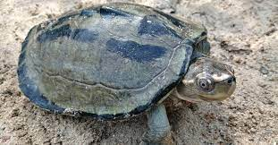  Three-striped roofed turtle | 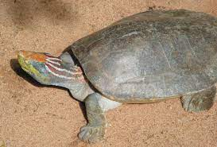  2. Red crowned roofed turtle
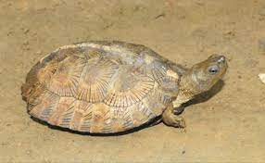  3. Gemels leaf turtle | 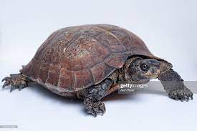  4. Asian leaf turtle
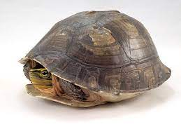  5. Southeast Asian box turtle | 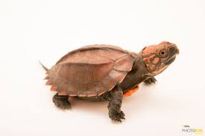  6. Keeled box turtle
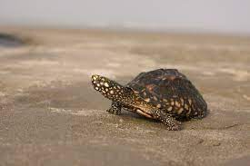  7. Spotted pond turtle | 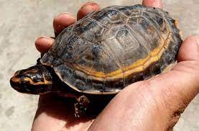  8. Growned River turtle
Fig .1. List of species image used as an aid at Questionnaire survey
Visual survey was conducted on 20 locations of the sankarapuram study area. On the surveyed 20 locations the tortoise was observed in five locations viz. two Coconut farm, twoordinary well which used for irrigation purpose and a lake side muddy shallow area. Totally 10 individuals were observed in this study period. We had an opportunity to examine the specimens very closely once it comes out behind the open well. The captured specimens were later examined by comparison with the standard key characteristics and manuals inorder to identify the specimen and found as Melanochelys trijuga species. In this study we observed both male and female individuals. The individuals are found as adults.The characteristics and ecology information were compared with the existing data in precious record and publications and manuals. Obtained Melanochelys trijuga species was found as Nearly Threatened status in the International Union for Conservation of Nature (IUCN) category.

Table 1. List of visual survey locations on selected study area Sankarapuram
Sl.No | Environment | Latitude (°N) | Long (°E) | Sighting | Count
 | Pond | 11.88331 | 78.91311 | No | 0
 | Coconut farm | 11.88354 | 78.91373 | Yes | 1
 | Ordinary well | 11.88442 | 78.91256 | Yes | 2
 | Urbanized land | 11.884961 | 78.912942 | No | 0
 | Dense plant area | 11.88338 | 78.91495 | No | 0
 | Lake | 11.878741 | 78.912059 | Yes | 4
 | Ordinary well | 11.881041 | 78.910176 | No | 0
 | Ordinary well | 11.879574 | 78.909314 | No | 0
 | Ordinary well | 11.877900 | 78.912695 | No | 0
 | Ordinary well | 11.877643 | 78.913139 | No | 0
 | Coconut farm | 11.877208 | 78.913467 | Yes | 1
 | Ordinary well | 11.877552 | 78.913725 | No | 0
 | Ordinary well | 11.878113 | 78.913933 | No | 0
 | Ordinary well | 11.878855 | 78.914595 | No | 0
 | Ordinary well | 11.879834 | 78.914713 | No | 0
 | Ordinary well | 11.879942 | 78.913668 | Yes | 2
 | Ordinary well | 11.878738 | 78.915819 | No | 0
 | Ordinary well | 11.878801° | 78.916377° | No | 0
 | Ordinary well | 11.876302° | 78.915521° | No | 0
 | Ordinary well | 11.877308° | 78.915438° | No | 0

Melanochelys trijuga is a turtle, which is also commonly known as Indian Black Turtle [4] and Indian Pond Terrapin or the three-striped roofed turtle is a fascinating species of freshwater turtle found in various parts of South Asia. It is an aquatic species that live in lentic water bodies. It is a freshwater turtle with a medium-sized carapace that extends up to 383mm. So far, around 6 subspecies have been reported worldwide out of which, 4 subspecies are described to be present in India.
The Indian black turtle possesses a shell that is predominantly black, with three yellowish stripes running vertically along its carapace, giving it its common name. It is categorized as a member of the genus Melanochelys and a member of the Geoemydidae family [5]. Adults of this species average a carapace length of 25 to 30 centimeters, which is medium in size. They are exceptional swimmers thanks to their sleek and smooth shells and webbed feet.
Melanochelys trijuga is omnivorous, it feeds on both aquatic plants and small invertebrates. Though it lives in standing water bodies, sometimes it also lives in running water bodies, such as rivers and streams. The species is nocturnal and spends its nights at the banks of the water bodies. Due to continued urbanization and infrastructure, its habitat and wetlands have shrunken. In Kerala, its population is exploited and traded for consumption, pet trade [6].
Freshwater turtles are distinctive animals of riverine and wetland ecosystem and are differ from sea turtles and have special adaptation for freshwater habitat.Altering the natural habitat makes the habitat vulnerability to theses reptiles.Freshwater turtles are a key component of biodiversity in aquatic ecosystems.Without turtles, aquatic ecosystems would progressively degrade in ways yet to be understood, and would undergo loss of biodiversity [7 & 8].The present rate of anthropogenic activity and climate change shifts their major drives of habitat loss, habitat fragmentation and cause major decline of turtles. On the other hand many freshwater turtle species are exploited for food and pet trade. The people with less or no knowledge of turtle habitat result in the death of the pet specimen.
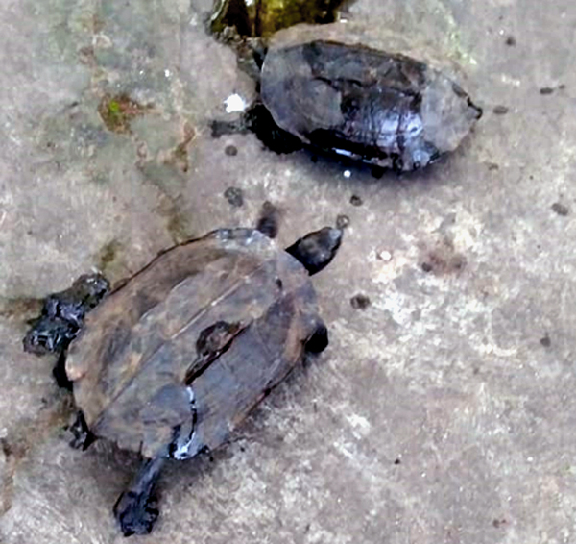
Fig. 2. Specimens of Male and Female Melanochelys trijuga species observed on visual survey
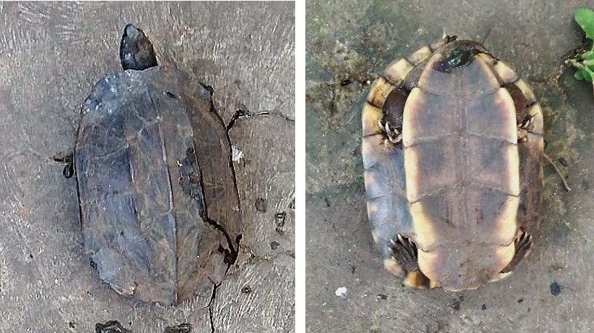
A
B
Figure 3. Carapace and Plastral view of adult Melanochelys trijuga species

3.1 Life Cycle
The life cycle of Melanochelys trijuga, commonly known as the Indian Black Turtle [9] or the Indian Pond Terrapin, encompasses various stages and processes that contribute to the overall survival and reproduction of this remarkable species. Understanding the life cycle of M. trijuga is crucial for conservation efforts and the preservation of its habitat.

3.2 Reproductive Behavior
Melanochelys trijuga exhibits sexual dimorphism, with males typically smaller in size compared to females . During the breeding season, the highest level of gonad activity occurred in both sexes during the reproductive season, which lasts from July to August. These are the monsoon months, when the days are longer. Only during July and August did the male testis in men reach its maximum size before rapidly regressing. During these months, there was mating . Once mating occurs, females undergo a gestation period of approximately 90-120 days [10].

3.3 Nesting Habits
The oviducts of the females reveal the existence of eggs. It is in this state much earlier than July. By the end of August, they started laying eggs in clutches, and they continued until October . Female M. trijuga display strong nesting site fidelity, often returning to the same location year after year to lay their eggs. Preferred nesting habitats include sandy riverbanks, sandbars, and open areas adjacent to water bodies. Nesting occurs during the monsoon season, when water levels are typically higher, providing suitable conditions for egg incubation. The females dig deep nests with their hind limbs, depositing a clutch of 10-30 eggs on average [11]. After carefully covering the eggs, the females return to their aquatic habitat, leaving the eggs to incubate.

3.4 Egg Incubation and Hatching
The incubation period of M. trijuga eggs lasts for approximately 60-90 days [12], depending on environmental factors such as temperature and humidity. The sex determination of the hatchlings is temperature-dependent, with cooler temperatures typically resulting in male hatchlings, while warmer temperatures favor female hatchlings [13]. This phenomenon, known as temperature-dependent sex determination (TSD), adds another layer of complexity to the species' life cycle. The developing embryos derive nourishment from the egg yolk, gradually growing and developing within the protected environment of the egg [14].

3.5 Survival Strategies
Upon hatching, In order to reach the surface during the day, hatchlings dig upward from the nest chamber [15 & 16], but if they do so, they will wait until twilight to leave the nest. The hatchlings face numerous challenges as they make their way to water bodies such as artificial light [17]. The hatchlings employ various survival strategies, including rapid movement, camouflage, and group behavior, to increase their chances of reaching the safety of water [18 & 19]. Once in the aquatic environment, the hatchlings find refuge among aquatic vegetation, where they continue their growth and development.
3.6 Conservation Implications
Understanding the life cycle of Melanochelys trijuga is crucial for effective conservation strategies. The destruction of nesting habitats, pollution of water bodies, and illegal wildlife trade pose significant threats to this species. Conservation efforts should focus on preserving and restoring suitable nesting sites, controlling pollution, and enforcing regulations against the illegal trade of M. trijuga [20]. Additionally, educating local communities about the importance of this species and its role in maintaining ecosystem balance can foster a positive attitude towards conservation.
- CONCLUSION
In this preliminary study ten individuals of Melanochelys trijuga was observed.Hence complete dedicated survey this required to asses the freshwater turtle diversity status in sankarapuram,Kallakurichi district.

REFERENCES

- Rao RJ.Studies on Biological Restoration of Ganga River in Uttar Pradesh: An indicator Species Approach. School of Studies in zoology Jiwaji University Gwalior.1995; pp1-183.
- Singh S, Sirsi S, Basu D, Andrews H. Survey and sampling of turtles in Ganga along Narora, Bulandshahr district, Uttar Pradesh.2006; 3 : 5-6.
- WII. Assessment of Wildlife Values of the Ganga River from Bijnor to Ballia Including Turtle Wildlife Sanctuary. Uttar Pradesh. Technical Report.ildlife Institute of India, Dehra Dun.2018; Pp. 66 .
- Lalitha R, ChandavarVR. Analysis of genetic diversity in CYTB and control region sequences of Melanochelys trijuga (Schweigger, 1812) from Karnataka. Journal of Asia-Pacific Biodiversity.2018; 11: 346-352.
- Schweigger AF.Prodromus monographial cheloniorum konigsberger Archiv for Naturwissenschafl and Mathematik.Konigsberg.1982; 1: 271-358.
- Krishnakumar K,Raghavan R,Pereira B.Protected on paper hunted in wetlands exploitation and trade of freshwater turtles (Melanochelys trijuga coronata and Lissemys Punctata Punctata) in Punnamada Kerala, India.2009.
- Iverson B. A Revised Checklist with Distribution Maps of the Turtles of the World. Richmond. IN Privately printed.1991; 363 pp.
- Gibbons JW. Reproductive patterns in freshwater turtles. Herpetologica.1982; 222-227.
- Lalitha R, ChandavarVR. Analysis of genetic diversity in CYTB and control region sequences of Melanochelys trijuga (Schweigger, 1812) from Karnataka. Journal of Asia-Pacific Biodiversity.2018; 11: 346-352.
- Shine R. Parental care in reptiles. In: Biology of the reptilia, vol 16 (Gans C and Huey RB, eds). New York: Alan R Liss.1988;275–329.
- Hamann M, Shimada T, Duce S, Foster A, Limpus C. Patterns of nesting behaviour and nesting success for green turtles at Raine Island. Australia. Endangered Species Research.2022; 47:217-229.
- Spencer RJ, Janzen FJ. 2011. Hatching behavior in turtles. Integrative and Comparative Biology.2011; 51:100-110.
- Wibbels T, Lutz PL, Musick JA Wyneken J. Critical approaches to sex determination in sea turtles. The biology of sea turtles.2003; 2:103-134.
- Ackerman LJ , Biology, husbandry, and health care of reptiles. TFH Publications.1997.
- Bustard HR. Mechanism of nocturnal emergence from the nest in green turtle hatchlings. Nature 1967;214: 317-317.
- Mrosovsky N. Nocturnal emergence of hatchling sea turtles: control by thermal inhibition of activity. Nature.1968; 220:1338-1339.
- Thums M, Whiting SD, Reisser J, Pendoley KL, Pattiaratchi CB, Proietti M, Hetzel Y, Fisher R Meekan MG. 2016. Artificial light on water attracts turtle hatchlings during their near shore transit. Royal Society open science 3:160142.
- Triessnig P, Roetzer A, Stachowitsch M. Beach condition and marine debris: new hurdles for sea turtle hatchling survival. Chelonian Conservation and Biology.2012; 11: 68-77.
- Schweigger AF.Prodromus monographial cheloniorum konigsberger Archiv for Naturwissenschafl and Mathematik.Konigsberg.1982; 1: 271-358.
- Karunarathna S, Amarasinghe AT., Henkanaththegedara S, Surasinghe T, Madawala M, Gabadage D, Botejue M. 2017. Distribution, habitat associations and conservation implications of Sri Lankan freshwater terrapins outside the protected area network. Aquatic Conservation: Marine and Freshwater Ecosystems.2017; 27:1301-1312.

