Review Article

Recognition and Derivatization of Adulterants from Herbal Medicines.

ABSTRACT
In modern time, usage of herbal medicines has increased all over the world. Herbal medicines are used for treatment of primary health needs and conventional treatment too. Due to increased demand of these medicines, maniac people have started production of adulterants/ inappropriate chemical properties/ low grade drugs in products. In this concern, examination including, chemical tests, analytical tests, phytochemicals screening tests are performed to determine the purity of products, quantitative analysis of heavy metals, presence of drug. This chapter is mainly focused on the implementation of various analytical techniques i.e. HP-TLC, FTIR etc. for identification of derivatization of adulterants from herbal drugs. Extracted adulterants from these herbal medicines include, guanine, flavonoids, alcohol ferric chloride etc. were attained.
Keywords: Adulterants, Extraction, Recognition, Herbal medicine etc.
INTRODUCTION
In recent years, demand of herbal medicines has increased throughout the world. Herbal medicines are active ingredients of plants attained from various parts including roots, leaves, stem flowers, seeds and fruits. Production of synthesized medicines brought a revolution to traditional medicines for medical care. As per WHO, approx. 90% Indians are using herbal medicines for their primary health care needs and 80% of the country’s population is leaning towards conventional treatment. Many of these medicines focuses on their organic components i.e., essential oils, glycosides, alkaloids, vitamins, antioxidant chemicals, and their pharmacological efficacy and any potential toxicities. In order to increase efficiency, any product with similar therapeutic/ chemical properties, low grade drugs are added in products.^{[1]} To recognize adulterants, present in medicines various analytical and chemical methods are used. Chemical test is performed in evaluation of resins, acid, value of volatile oil to tests acid value and saponification value. Phytochemical screening is a qualitative method for the identification of chemical constituents present in the drug. While analytical methods such as TLC, HPLC, GC etc. are used to determine purity of products, quantity of heavy metals and presence of contaminants. This chapter is basically a discussion on adulterations in herbal medicines-, types of adulterants and various methods used to quantify the adulteration.^{[2]}
SARPAGANDHA
Sarpagandha as potential value in ayurveda and widely known remedy to control high blood pressure, to cure fever, wound and worm infection, to detoxify snakes, scorpions and spider poison. It has astringent properties; also used as a sedative and tranquillizer agent. It consists ophioxylin, resin, starch and wax and the total alkaloid content in plant is 0.8%.
MACROSCOPIC CHARACTERISTICS
It is an evergreen perennial shrub that usually grows up-to to a height of 60cm and found in moist deciduous forest/shady areas. Its root is of pale color and leaves are found bright green and whorls of three leaves. Its flower is of white, while peduncles are long, pedicles are stout with red calyx.^{[3]} The active ingredients present in sarpagandha are alkaline resprine which help to cure insomnia, hypertension etc. It is prepared from the sarpagandha plant which consist various therapeutic properties.
Sarpagandha chemical constitution: Ajmalicidine, Ajmalicine, Rouhimbine, Indobinine, Reserpiline, Reserpine, Sarpagine, Serpentine, Serpentinine, Yohimbine, Ajmalimine, Ajmaline, Rauwolfinine (Perakenine), Sandwicolidine, Serpinine etc.
Various standardization technique is followed to extract these additional elements present in herbal medicines such as HP-TLC, GC-MS, FTIR and HP-LC. This study is an approach for quantitative and qualitative analysis of the chemically active components in herbal medicines.
METHODOLOGY
Qualitative analysis was determined by HP-TLC and certain parameters was affixed to assess.
Determination of the total ash: In a crucible, 1 gm. of test medicine is taken and placed in a muffle furnace at 450°C and cooled. The total percentage of ash was calculated by weighing sample.
Determination of alcohol soluble extracts: In a closed flask, powdered medicine was mixed with 100 ml of alcohol for 24 hr and left for 18 hr, then filtered. In a porcelain dish, 25ml of each filtrate was evaporated and dried at 105°C to constant weight and the alcohol soluble extracts are calculated.^{[4]}
Determination of water-soluble extractives: In a closed flask, the powdered test drugs were macerated with 100 ml of water for 1 hr. Then, for an hour, it was boiled gently in a water bath, weighed after cooling cooled and the weight was re-adjusted. On a porcelain plate at 105°C, 25 ml of each filtrate were dried to a constant weight. The amount of extractive that is water soluble was determined.
Extraction of alkaloids: A total of 0.1 g of powdered sarpagandha root and 1 g of each test medication were gathered. Each substance was refluxed in a water bath for an hour with 10 ml of methanol containing 0.1 M HCl. Using n-hexane, liquid-liquid separation was carried out after the sample solution had been cooled. The residue was concentrated in reduced pressure, later dissolved in methanol-chloroform (98:2, v/v). Using HTLC analysis, each sample solution was filtered through a 0.22-m filter force.^{[5]}
Loss of drying: A sample of 2 g of powdered drug was precisely weighed and placed in a porcelain dish. The porcelain dish was then placed in an open vacuum oven and the sample was maintained at 100°C before being brought to room temperature, the process was repeated until a steady weight was observed.
% Loss on drying = Loss in weight of sample/weight of sample× 100
Phytochemical analysis: In order to check for the presence of tannins, saponins, flavonoids, carbohydrates, phenol, and steroids, samples were subjected to a phytochemical screening procedure. The details of such drug formulation have been given below in table no. 1.
Table 1: Description of test drug formulations.
Test drug/ formulations | Ingredients | Quantity (%)
Sarpagandha Churna | Sarpagandha root powder | 100
Sarpagandha Ghana vati | Sarpagandha ghansatwa | 50
 | Khursaniajawain ghansatwa | 10
 | Jatamansi ghansatwa | 5
 | Bijay ghansatwa | 5
 | Pippalimool churna | 25
 | Excepients | 5
M-Sarpagandha Mishran | Sarpagandha root churna | 15.6
 | Jatamansi root churna | 15.6
 | Vacha leaf churna | 15.6
 | Punarnava whole plant | 15.6
 | Churna
 | Brahmi whole plant churna | 15.6

HP-TLC ANALYSIS
HP-TLC profile is a major quality control aspect to reveal phytochemical components of the formulations and efficacy. In this method, peak profiles and their intensities provide both quantitative and qualitative result in comparison with reference standards while the images will give percentage of purity and minimum content information can also be obtained. Sarpagandha churna exhibits 11 peaks and Sarpagandha Ghana vati has 17 peaks, which reflect the fingerprint of test chemicals, as per HP-TLC examination of the sarpagandha medicine^{.[6]} Individual peaks in chromatograms often depend on chemically unique components, and the quantity of these chemically active components is what gives the drug its therapeutic benefits as well as its many symptomatic and non-symptomatic side effects. The comparison of various parameters by chromatographic techniques are given below in table no. 2 along with HPTLC spectra standards in figure 1, HPTLC of Sarpagandha churna figure 2 and HPTLC of Sarpagandha Ghana Vati in figure 3 below-
Table 2: Comparison of Chromatographic Techniques.
Parameters | HPLC | HP-TLC | GC
Stationery -Phase | Column | Paper/Glass | Liquid /Solid
Mobile Phase | Solvent Mixture | Solvent Mixture | Pure Inert Gas
Sample | One At One Run | Many at a Single Run | One At One Run
Pressure | High | Normal | Closed
Results | System Peaks | System Peaks Visual by Bands | System Peaks
Resolution | High To Very High | Moderate To High | High To Very High
Time | 2-60 Min | 1-30min | 2-60 Min
Temperature | Constant | Constant | Increasing

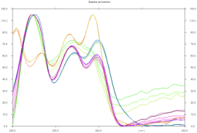
Figure 1: HPTLC spectra of standards.
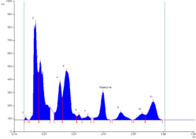
Figure 2: HPTLC of Sarpagandha churna.

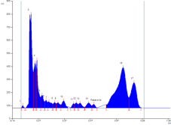
Figure 3: HPTLC of Sarpagandha Ghana Vati.

SHANKHPUSHPI CHURNA
Shankhpushpi (Convolvulus pluricaulis) is an herb that has extensively been a topic of investigation for its therapeutic and pharmacological effects. Shankhpushpi is considered as Medhya Rasayana in Ayurvedic texts and plant extraction are used for central nervous system depressants, anxiolytics, sedatives, antidepressants, antistress agents, neurodegenerative agents, antianemics, antioxidants, lipid-lowering agents, immunomodulators, analgesics, it has demonstrated scientific potential in antifungal, antibacterial, antidiabetic, antiulcer, antitonic, and cardiovascular activities. It is extremely beneficial for increasing memory, concentration, and learning capacities, along with treating mental stress, insomnia, anxiety, and depression. Among these phytoconstituents, some are present in higher concentrations (nearly 20% w/w), known as phytoconstituents.^{[7]} This plant contains kaempferol, β-sitosterol, N-hexacosanol, taraxerol, taraxerone, delphinidin and hydroxy-cinnamic acid. Sankhpuspine, an alkaloid that was identified from this plant, also serves as a chemical species marker. Convolvulus pluricaulis also contains other alkaloids (convolamine, convosine, convoline etc.) anthroquinones; carbohydrates (D-glucose, sucrose); coumarin (ayapanin, scopolyne); flavonoids, glycosides (geranilan-3-ol-1-carboxylate-1-O-β-D- xylopyranosyl- (2 ′ → 1 ′) - O-β-D-xylopyranoside; phenols; steroids; and terpenoids. CP is also known for its rich source of vitamins and minerals like phosphorus, manganese, calcium, copper, iron, zinc, sulphur, vitamin C and vitamin E.
MACROSCOPIC CHARACTERISTICS
These plants are grown in rocky soil along/found on road side in north India. Its identical characteristics include cylindrical, ribbed and light-yellow color root with a hairy texture.^{[8]} Stem are prostate/ascending slender and the leaves are ex-stipulate, sessile, simple, linear to oblong in shape, alternate phyllotaxy, reticulate venation. In florescence, 1-3 flowers in axillary heads along with ebracteate, monoecious flowers are observed. The phytochemical screening of alkaloids are given below in table 3 along with carbohydrates in table 4, steroids in table 5, saponins in table 6, tanins in table 7, table 8 includes flavonoids, table 9 includes phenols while table 10 includes carboxylic acid and table 11 quinine.
Table 3: Phytochemical Screening of Alkaloids.
Test | Experiment | Observation
DRAGENDROFF’S TEST | A few mg of the HACP extract dissolved in alcohol + Few  drops of acetic acid + Dragendroff’s reagent | Orange red precipitation
WAGNER’S TEST | Few mg of HACP extract dissolved in acetic acid +few drops of Wagners’s reagent | Reddish brown precipitate.
MAYER’S TEST | Few mg of HACP extract dissolved in acetic acid + Mayer’s reagent | Dull white precipitate
HAGER’S TEST | Few mg of extract dissolved in acetic acid + 3ml of Hager’s reagent | Yellow precipitate

Table 4: Carbohydrates.
Test | Experiment | Observation
MOLISCH’S TEST | In a test tube, HACP  extract is taken + 1ml α- naphthol solution + conc.  Sulfuric acid (along the sides of tube) | Violet colour formed at the junction of 2 liquids
FEHLING’S TEST | Few mg of HACP + equal amount of Fehling’s  solutions A and B. Warm the mixture in a water bath. | Brick red precipitate.
BENEDICT’S TEST | Few mg of HACP extract + 5ml of Benedict's reagent. Boil for 2 min and cool. | Red precipitate

Table 5: Steroids.
Test | Experiment | Observation
LIEBERMANN | Few mg of HACP extract | Bluish green color solution
BURCHARD TEST | dissolved in chloroform + 1ml of acetic acid + 1ml of acetic anhydride. Heat on a water bath and cool.  Add a few drops of conc. Sulphuric acid along the sides.
SALKOWSKI’S TEST | Few mg of HACP extract dissolved in chloroform + equal volume of conc.  Sulfuric acid | Bluish red to cherry red  colour in chloroform layer and green fluorescence in layer
Table 6: Saponins.
Experiment | Observation
0.5ml of extract + 5- 10 drops of dilute HCl and ZnCl. Boil the solution for a few minutes | Reddish pink or dirty brown color solution
Table 7: Tannins.
Experiment |  | Observation
Extract + drop f dil. Ferric chloride solution |  | Dark blue color
Table 8: 1f Flavonoids.
Test | Experiment | Observation
SHINODA’S TEST | 0.5ml of extract + 5-10 drops of dilute HCl and  ZnCl. Boil the mixture for a few minutes | Reddish pink or dirty brown color
Table 9: 1g PHENOL
Experiment | Observation
HACP extract in alcohol + 2 drops of alcoholic ferric chloride | Blue to black color solution

Table 10: Carboxylic Acid.
Experiment | Observation
HACP extract dissolved in water and treat with sodium bicarbonate | Brisk effervescence
Table 11: Quinine.
Experiment | Observation
Few mg of HACP extract + 0.5% NaOH | Deep coloration like pink/purple/ red.

HP-TLC
1 g of the powdered material was diluted in 10 mL of ethanol and let to cool percolate for twenty-four hours before filtering. 4, 8, and 12 µL of the sample were placed on a precoated silica gel F254 on aluminium plates to a bandwidth of 7 mm using a Lino mat 5 TLC applicator.^{[9,10]} n-butanol, acetic acid, and water (4:1:1) were used to develop the plate. Short and long ultraviolet light were used to scan the plate after development. Afterwards, it was derivatized using a vanillin sulfuric acid reagent and scanned using white light at 620 nm, 254, and 366 nm. The spots' colour, retention factor (Rf), and densitometric scan were reported.
FOURIER-TRANSFORM INFRARED SPECTROSCOPY
The herb's plant leaves were removed, thoroughly cleaned, then dried in the shade and ground into powder. With 70% ethanol, the powdered leaves were macerated in a shaker for two days. Before being lyophilized to eliminate the water, the extract was filtered and rapidly concentrated. The given tables 12 and 13 include information of preliminary phytochemicals and confirmation of additives in extraction are given. Along with the mentioned extractions, figures 4, 5, 6, and 7 present the graphical densitometric at various measures.

Table 12; Preliminary Phytochemical Tests
Test | Shankapushpi
ALKALOID | +
CARBOHYDRATE | +
TANNIN | +
TERPENOID | +
PHENOL | +
Table 13: Confirmation of additives in extraction.
Sl. No. | Test | Colour if positive | Shankapushpi
1 | ALKALOID
 | DRAGENDROF’S TEST | Orange precipitate | Orange precipitate
 | WAGNER’S TEST | Red precipitate | Red precipitate
 | MAYER’S TEST | Dull white precipitate | Dull white precipitate
 | HAGER’S TEST | Yellow precipitate
2 | STEROIDS
 | LIEBERMANN BURCHARD TEST | Bluish red | Light red color
 | SALKOWSKI’S TEST | Bluish red to cherry red | Cherry red color in chloroform and colorless in the acid form.
3 | CARBOHYDRATE
 | MOLISH’S TEST | Violet ring | Violet ring
 | FEHLING’S TEST | brick red precipitate | ink blue solution
 | BENEDICT’S TEST | red precipitate | bluish green solution
4 | TANNIN
 | WITH FeCl₃ | dark blue or green or brown |  | Brown
5 | FLAVONOIDS
 | SHINODA’S TEST | red to pink |  | colourless solution
6 | SAPONINS
 | with nahco₃ | stable forth |  | no forth
7 | TRITERPENOIDS
 | tin and thionyl chloride test | red |  | light pink
8 | COUMARINS
 | with 2N NaOH | yellow |  | light brown
9 | PHENOLS
 | With | blue to black, brown |  | Brown
10 | CARBOXYLIC ACID
 | With water and NaHCO₃ | Brisk effervescence |  | No effervescence
11 | RESIN
 | With aqueous acetone | Turbidity |  | No turbidity
12 | QUINONE
 | 5% NaOH | Pink/ purple/ red |  | Light brown
13 | AMINO ACIDS
 | Ninhydrin reagent | Purple color |  | Colorless

Table 14; Result For HPTLC
Short UV | Long UV | After Derivatization
- | 0.06 (VIOLET) | 0.06 (L PURPLE)
- | 0.11 (FL VIOLET) | 0.11 (L PURPLE)
- | 0.20 (FL BLUE) | 0.20 (L PURPLE)
0.26 (D GREEN) | 0.26 (FL GREEN) | -
- | - | 0.29 (L PURPLE)
0.33 (L GREEN) | 0.33 (VIOLET) | -
0.38 (L GREEN) | 0.38 (FL BLUE) | -
- | - | 0.40 (L PURPLE)
0.46 (D GREEN) | 0.46 (FL PINK) | -
 |  | 0.48 (L PURPLE)
0.51 (L GREEN) | 0.51 (L FL BLUE) | -
- | - | 0.54 (L PURPLE)
- | 0.60 (FL BLUE) | 0.60 (L PURPLE)
0.64 (D GREEN) | - | -
0.69 (D GREEN) | 0.69 (FL BLUE) | -
- | 0.72 (F ORANGE) | -
- | 0.74 (VIOLET) | -
- | 0.78 (FD PINK) | -
0.82 (D GREEN) | 0.82(FL BLUE) | 0.82 (L PURPLE)
- | 0.86 (FD PINK) | 0.86 (D PURPLE)
- | 0.91 (F RED) | 0.91 (D PURPLE)

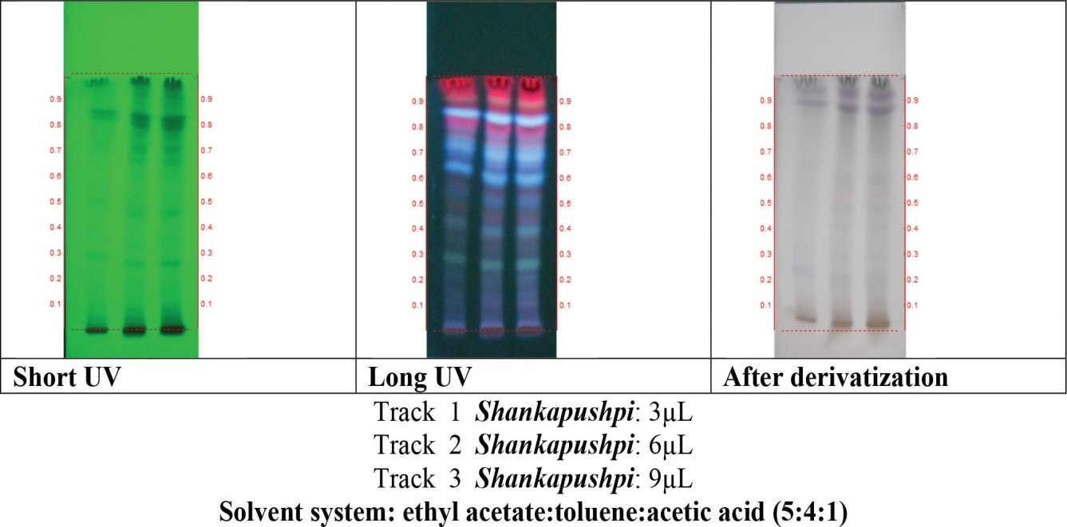
Figure 4: PTLC Photo Documentation of Ethanolic Extract of Shankhpushpi.
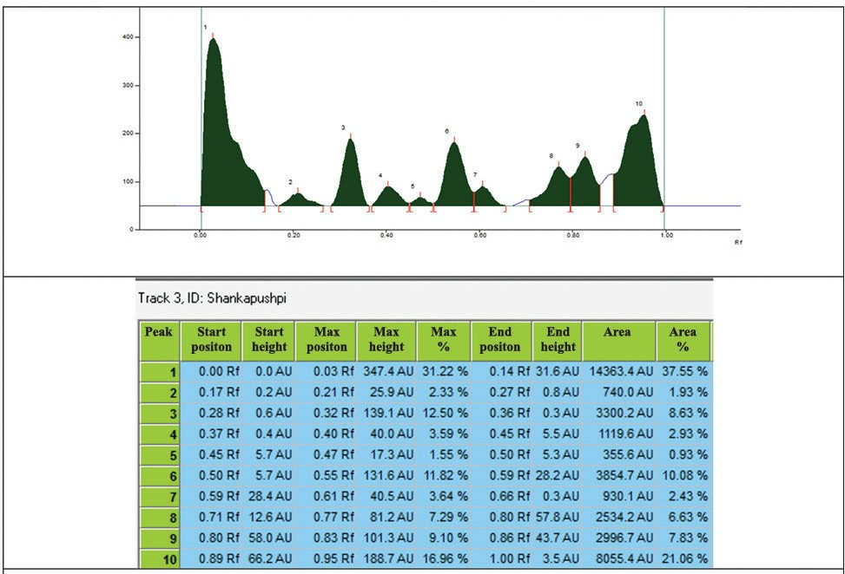
Figure 5: Densitometric Scan At 254 nm.

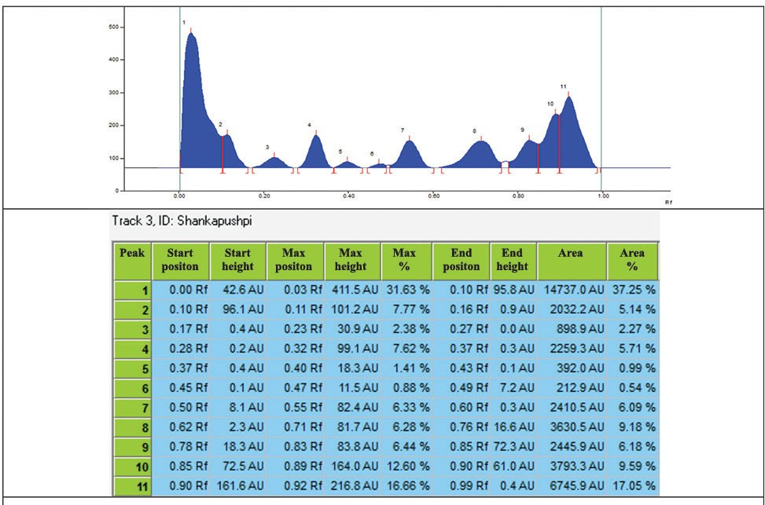
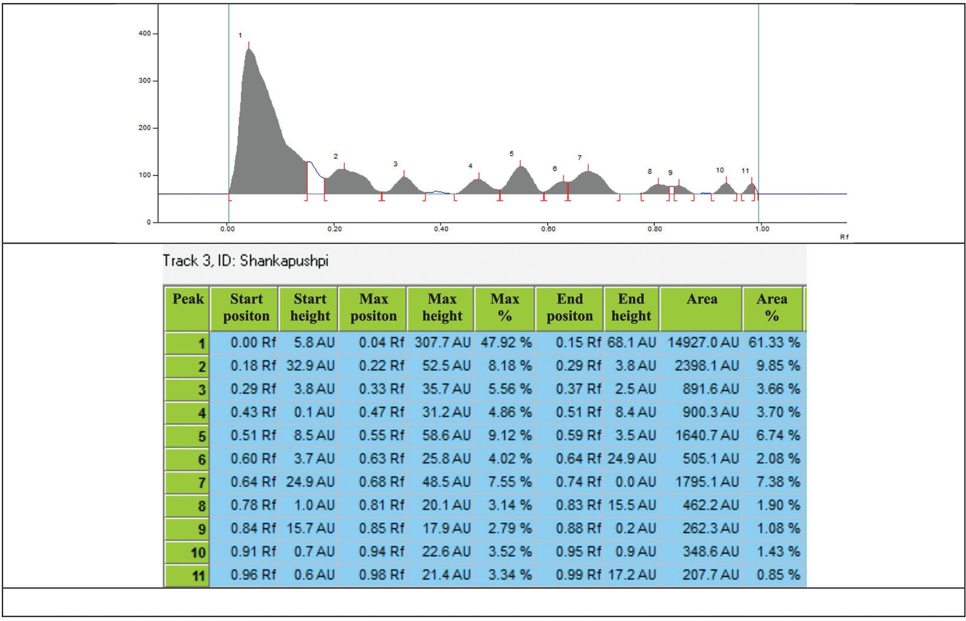
Figure 6: Densitometric Scan At 366 nm.
Figure 7: Densitometric Scan After Derivatization At 620 nm.
RESULT FOR FTIR
Using FTIR, the functional groups of the active compounds of C. pluricaulis were investigated based on the peak values in the IR radiation area. The functional groups of the compounds were divided based on the ratio of their peaks after the plant extract was run through the FTIR. ^{[11,12]} The FTIR spectra's absorption range was in the region of 4000 and 500 cm-1. Alcohols, carboxylic acids, acid anhydrides, alkanes, phenols, alkynes, alkyl halides, aromatics, halogens, and esters were all found in the results (given in fig. 8) below.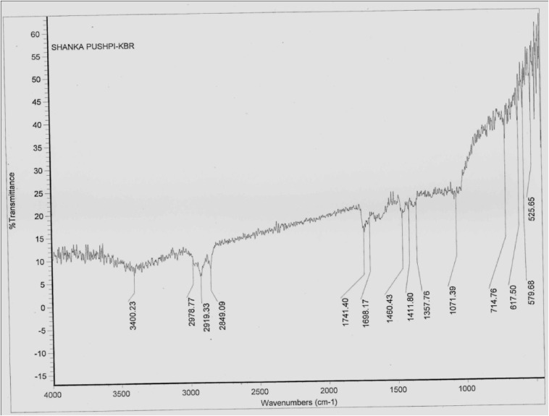
Figure 8: FTIR Spectrum of Convolvulus Pluricaulis 70% Ethanolic Extract.
CONCLUSION
Low grade medications are frequently added to goods to boost efficiency and give them comparable therapeutic/chemical qualities. To assess the purity of goods, the amount of heavy metals present, and the presence of pollutants, phytochemical screening (a qualitative approach) is used in conjunction with analytical techniques like TLC, HP-TLC, GC, etc. Sarpagandha churna presents 11 peaks and Sarpagandha Ghana vati has 17 peaks, which reflect the fingerprint of test chemicals, according to HP-TLC examination of the sarpagandha medication^{[13]}. Chromatograms often depend on unique components and concentrations of these chemically active components, which are also responsible for a variety of symptomatic and non-symptomatic side effects in addition to their therapeutic characteristics. In Shankhpushpi Churna, the presence of alcohols, carboxylic acids, acid anhydrides, phenols, alkyl halides, aromatics, halogens, esters, etc., were detected when the vanillin sulfuric acid reagent was scanned under 254, 366, and white light at 620 nm.

ETHICAL CONSIDERATION
NA
REFERENCES
1. Chauhan M, Plant S. Rauwolfia Serpentina – Uses, Benefits and side effects. Planet Ayurveda.
2. Balkrishna A, Thakur p, Varshny A. Phytochemical profile, pharmacological attributes and medicinal properties of Convolvulus rostrates – A cognitive enhancer herb for the management of neurodegenerative etiologies. National library of medicine; 2022.
3. Sethiya NK, Trivedi A, Patel MB, Mishra SH. Comparative pharmacogenetic investigation on four ethnobotanicals traditionally used as Shankh Pushpi in India. J Adv Pharm Technol Res. 2010;1(4):388-95. Doi: 10.4103/0110-5558.76437, PMID 22247878.
4. Joshi T, Gupta A, Kumar P, Singh A, Kumar A. Bacopa monnieri (Brahmi). Naturally Occurring Chem Alzheimers Dis. 2021:243-56.
5. Zhou Y, Shen Y-H, Zhang C, Zhang W-D. Chemical constituents of Bacopa monnieri. Chem Nat Compd. 2007;43(3):355-7. Doi: 10.1007/s10600-007-0133-y.
6. M.D. S, and P. M, M. Standardization of Bacopa monnieri and its Formulations with reference to Bacoside A, by High Performance Thin Layer chromatography. Impactfactor.org. 2022.
7. Garg AN, Kumar A, Nair AGC, Reddy AVR. Analysis of some Indian medicinal herbs by INAA. J Radioanal Nucl Chem. 2007;271(3):611-9. Doi: 10.1007/s10967-007-0316-9.
8. SS, P. MG, J., T G, Dogra. Study of phytochemical screening, physicochemical analysis and antimicrobial activity of Bacopa monnieri (L.) extract. 2022.
9. Gubbannavar JS, Chandola HM, Harisha CR, Khanpara K, Shukla VJ. A comparative pharmacognostical and preliminary physico-chemical analysis of stem and leaf of Bacopa monnieri (L.) Pennel and Bacopa floribunda (R.BR.) Wettst. Ayu. 2013;34(1):95-102. Doi: 10.4103/0974-8520.115441, PMID 24049413.
10. Mathur D, Goyal K, Koul V, Anand A. The molecular links of re-emerging therapy: a review of evidence of Brahmi (Bacopa monniera). Front Pharmacol. 2016;7(44):44. Doi: 10.3389/fphar.2016.00044, PMID 26973531.
11. 16(S). S, P, and M.G, J. Determination and Quantification of Bacoside a From Bacopa monnieri (L) By High Performance Thin Layer Chromatography. 2022.
12. Govil JN, Singh VK, Singh G. Recent progress in medicinal plants. Ethanomedicine Pharmacog. 2022; 1; 51:37.
13. Nahata N, Sethiya N. Jain and V. Dixit. Analysis of scopoletin and mangiferin in botanicals and formulations of Shankhpushpi by HPLC. Sciendo.com, 2019.

