ORIGINAL RESEARCH ARTICLE

Evaluating the Insecticidal Potential of Essential Oils Against Rice Weevil (Sitophilus oryzae L.)

Abstract
This study aimed to evaluate the adulticidal potential of five essential oils, garlic (Allium sativum), black pepper (Piper nigrum), lemongrass (Cymbopogon flexuosus), galangal (Alpinia galanga), and eucalyptus (Eucalyptus globulus) against the rice weevil, Sitophilus oryzae (L.), a major pest of stored grains worldwide. Laboratory bioassays were conducted from 4 August to 27 February under controlled conditions in West Bengal, representing the first comparative assessment of these oils against S. oryzae in this region. Each oil was tested at six concentrations (50, 100, 200, 500, 750, and 1000 ppm) on 20 adult weevils per replication, with three replications per treatment. Mortality was recorded over a 20-day period. Results demonstrated a clear dose-dependent and time-progressive mortality pattern. Garlic and black pepper were the most effective, achieving complete mortality by Day 10 at all tested concentrations, while galangal and lemongrass acted more slowly but showed steadily increasing mortality over time. Eucalyptus was the least effective, causing only 40–60% mortality even at higher doses. One-way ANOVA indicated significant differences among treatments, and probit analysis revealed low LC₅₀ values for garlic and black pepper, confirming their high potency. Grain weight loss analysis further demonstrated that treatments with more toxic oils reduced post-infestation damage. These findings suggest that essential oils, particularly garlic and black pepper, could be effectively integrated into sustainable pest management strategies, reducing reliance on chemical insecticides and protecting stored grains in West Bengal and similar agroecological regions. This study provides the first evidence of the comparative efficacy of these oils against S. oryzae in the region, highlighting their potential impact on local post-harvest pest management practices (Isman, 2006; Regnault-Roger et al., 2012; Pavela, 2015).
Keywords: Essential oils; Sitophilus oryzae; stored grain pests; mortality; probit analysis.

Introduction
The rice weevil, Sitophilus oryzae (L.) (Coleoptera: Curculionidae), is a major pest of stored grains worldwide, causing both quantitative and qualitative losses. Infestations can reduce grain weight, lower nutritional quality, and decrease market value. In India, particularly in rice-producing states such as West Bengal, S. oryzae presents a persistent challenge to storage facilities and household food security. Conventional control methods often rely on synthetic insecticides and fumigants like phosphine. While effective, these chemicals raise several concerns, including the development of insect resistance, accumulation of toxic residues in food, negative impacts on non-target organisms, and potential risks to human health (Isman, 2006; Regnault-Roger et al., 2012). Such issues emphasize the need for safer, environmentally friendly alternatives for protecting stored grains.
In recent years, botanical insecticides and essential oils have received growing attention as potential alternatives. They are biodegradable, generally pose low risks to mammals, and exhibit broad-spectrum activity against pests (Koul et al., 2008; Pavela, 2015). Essential oils are complex mixtures of volatile compounds, mainly terpenoids, phenols, and aldehydes, and have been reported to act as contact insecticides, fumigants, repellents, or growth inhibitors against various insect species (Nerio et al., 2010; Shaaya et al., 1997; Lee et al., 2001). Several studies have shown that essential oils can be effective as larvicides, pupicides, and repellents against storage pests such as Sitophilus zeamais and Tribolium castaneum (Tapondjou et al., 2005; Ogendo et al., 2008). However, comparative studies evaluating multiple essential oils specifically against S. oryzae are still limited, particularly under Indian agroecological conditions.
In this study, we examined the adulticidal activity of five essential oils garlic (Allium sativum), black pepper (Piper nigrum), lemongrass (Cymbopogon flexuosus), galangal (Alpinia galanga), and eucalyptus (Eucalyptus globulus) against S. oryzae. These oils were chosen for their local availability, traditional use in household remedies, and previously reported insecticidal properties (Tripathi et al., 2009; Mishra et al., 2013). The experiments were conducted from 4 August to 27 February, allowing assessment of both short and long-term effects. Mortality data were analyzed across different concentrations and exposure periods using ANOVA, regression, and probit analyses to determine efficacy and lethal concentrations. Grain weight loss measurements were also taken to evaluate the protective effect of each oil.

Materials and Methods
Test Organism:
Adults of Sitophilus oryzae were obtained from laboratory cultures maintained on rice grains under controlled conditions at 27 ± 2°C and 65 ± 5% relative humidity (RH) (Figure 1). Only healthy, active adults of uniform size were selected for experiments.
Test Oils:
Commercial essential oils of garlic (Allium sativum), black pepper (Piper nigrum), lemongrass (Cymbopogon flexuosus), galangal (Alpinia galanga), and eucalyptus (Eucalyptus globulus) were procured from local suppliers. Oils were stored in dark, airtight containers at room temperature until use.
Experimental Design:
Six concentrations of each oil (50, 100, 200, 500, 750, and 1000 ppm) were prepared by diluting stock solutions in a mixture of acetone and distilled water (Jamal & Mondal, 2024). For treatment, 25 g of rice was placed in glass Petri dishes, and the appropriate oil solution was evenly poured over the grains. Excess solution was drained, and dishes were incubated at 45°C for 24 hours to allow complete drying.
For each concentration and oil, three replications (R1, R2, R3) were set up. Twenty adults were introduced per replication (total 60 adults per oil per concentration). Treated rice was placed in labelled containers, and adults were carefully introduced. A control group consisted of untreated rice with solvent only. Mortality was recorded daily for 20 days. Percentage mortality (± SE) was calculated, and Abbott’s correction was applied when necessary to account for control mortality.
Grain Weight Loss:
Grain weights were recorded at three stages: initial weight, post-treatment, and post-infestation, to estimate weight loss caused by S. oryzae activity. The data are presented in the results section.
Statistical Analysis:
Mortality percentage data were arcsine-transformed when required to stabilize variance. One-way ANOVA was performed to test for significant differences among essential oils at each concentration. Probit and log-probit regression analyses were used to calculate LC₅₀ and LC₉₀ values, regression equations, R², and 95% confidence limits (Finney, 1971). Descriptive statistics were prepared using MS Excel, while specialized software was used for probit regression analysis.

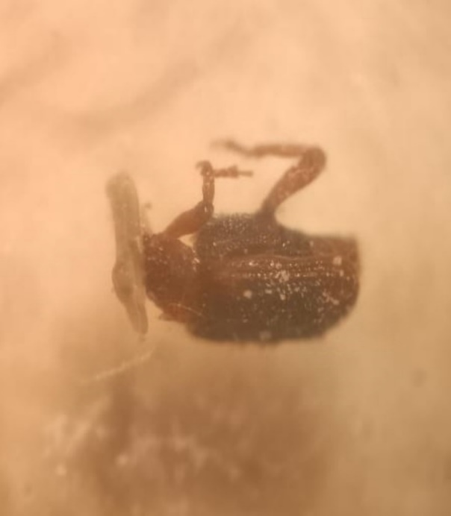

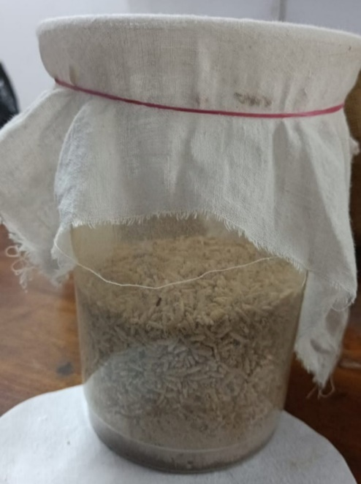
Figure-1: adult Sitophilus oryzae and laboratory culture
Results
The percentage mortality of stored grain pest Sitophilus oryzae when exposed to different concentrations of oils i.e., Allium sativum, Piper nigrum, Cymbopogon flexuosus, Alpinia galanga and Eucalyptus globulus after 20 days of treatment are shown in Table-1. (Figures -2,3,4,5 and 6)
Treatment with Allium sativum (Garlic) Essential Oil: It was revealed from Tables 1 and 2 that percentage mortality of S. oryzae adults when exposed to garlic essential oil showed strong dose- and time-dependent activity. At 50 ppm, mortality was 81% on Day 1, 90% on Day 5 and reached 100% by Day 10, persisting through Day 20. At 100 ppm mortality was 86% on Day 1 and 95% on Day 5 with 100% by Day 10. At higher concentrations (200–1000 ppm) the oil produced very rapid mortality with >90% mortality observed as early as Day 1 and complete mortality by Day 5–10. The ANOVA tables across concentrations (Tables 5, 7, 9, 11, 13, and 15) show significant group differences indicating the effect of A. sativum is statistically distinct from weaker oils (p < 0.01). Probit/regression results (Table 2) show very low LC₅₀ estimates at intermediate days (e.g., LC₅₀ ~0.95 ppm at day 7 in your log-probit table) indicating high potency; note, some regression outputs at later days were unstable due to all groups reaching 100% mortality which limits regression fits (constant regressions observed). The insecticidal action likely derives from organosulfur compounds (allicin and related), consistent with literature showing rapid fumigant and contact toxicity (Prakash et al., 2011; Jamal & Mondal, 2024). The grain mass loss data (Table 3, figure-8) indicate that rice treated with A. sativum had comparatively low percentage weight loss (≈1.75–2.98% across concentrations), supporting protective action.
Treatment with Piper nigrum (Black Pepper) Essential Oil: Piper nigrum produced mortality patterns similar to garlic but with slightly slower early knockdown at the lowest concentration (50 ppm: 75% Day 1 → 88% Day 5 → 99% Day 10 → 100% Day 15). At concentrations ≥200 ppm, P. nigrum achieved >90% mortality by Day 1–3 and 100% by Day 7–10. Probit/regression outputs show moderate LC₅₀ values (e.g., LC₅₀ ~4.69 ppm at day 4 in your table), indicating high efficacy. The black-pepper toxicity is attributed to piperine and related alkaloids, which exhibit neurotoxic and feeding deterrence effects in insects (Mondol et al.; references below). Grain weight loss values for P. nigrum treatments were low (≈2.24–3.35%), consistent with effective protection.
Treatment with Alpinia galanga (Galangal) Essential Oil: Alpinia galanga caused moderate mortality at low concentrations and improved efficacy at higher concentrations and longer exposure. For 50 ppm mortality was 50% (Day 1) → 70% (Day 5) → 88% (Day 10) → 96% (Day 15) → 100% (Day 20). As concentration increased, mortality accelerated (e.g., at 500–1000 ppm nearly all adults were dead by Day 10–15). Regression results show LC₅₀ values decreasing with time, consistent with cumulative toxicity. Grain-mass loss data for A. galanga show moderate protection (approx. 4.58–7.17% loss), worse than garlic/black pepper but better than eucalyptus at comparable levels.
Treatment with Cymbopogon flexuosus (Lemongrass) Essential Oil: C. flexuosus displayed a delayed but concentration-dependent response. At 50 ppm the oil was essentially non-toxic in early days (0% Day 1; 3% Day 5) but mortality increased with time (20% Day 10, 41% Day 15). At 500–1000 ppm, however, the oil was highly effective, often reaching 100% mortality by Day 10–15. This pattern indicates the primary active components (e.g., citral, geraniol) have cumulative fumigant/contact effects rather than immediate knockdown. LC₅₀ values in Table 2 decreased over time (e.g., ~1041.72 ppm at Day 3 to ~85–90 ppm after longer exposures), matching cumulative action. Grain mass loss under C. flexuosus treatment was intermediate; at mid-to-high doses loss was moderate (≈6–15% range depending on concentration).
Treatment with Eucalyptus globulus Essential Oil: Eucalyptus globulus was the least effective adulticide in these assays, with negligible mortality at low concentrations and moderate mortality even at the highest concentrations after long exposure. For example, at 50 ppm mortality was 0% (Day1) → 12% (Day5) → 20% (Day10) → 20% (Day15–20). Even at 1000 ppm mortality at Day 20 plateaued around 60%. Log-probit analysis produced very large LC₅₀ and LC₉₀ estimates (Table 2), indicating low acute toxicity to adult S. oryzae in this assay. In the literature, eucalyptus oil (eucalyptol-rich) sometimes functions more as a repellent than an acute toxicant (Tripathi et al., 2009), which is consistent with the observed pattern. Grain mass loss values for E. globulus were highest among tested oils (up to 19% loss at low doses), reaffirming poor protection.

Table-1: Percentage mortality ± SE of Sitophilus oryzae When exposed to different concentrations of five essential oils treated rice and controlled medium after 1-20 days of exposure
Days | Concentrations (ppm) | Mortality percentage ± SE |  |  |  |  | Control
Days | Concentrations (ppm) | Allium sativum | Piper nigrum | Cymbopogan flexuosus | Alpinia galanga | Eucalyptus globulus | Control
Day 1 | 50 | 8.16±0.33 | 6.5±0.88 | 0±0 | 4±0 | 0±0 | 0±0
Day 1 | 100 | 8.66±0.88 | 7±0.33 | 0±0 | 4.5±0.33 | 0±0 | 0±0
Day 1 | 200 | 9±0 | 7.5±0.57 | 0±0 | 5±0.66 | 0±0 | 0±0
Day 1 | 500 | 9.16±0.33 | 8±0 | 0±0 | 5.5±0.57 | 0±0 | 0±0
Day 1 | 750 | 9.5±0.66 | 8.4±0.66 | 0±0 | 6±0 | 0±0 | 0±0
Day 1 | 1000 | 9.66±0.57 | 8.6±0.33 | 0±0 | 6.5±0.66 | 0±0 | 0±0
Day 2 | 50 | 8.33±0.33 | 6.8±0.88 | 0±0 | 4.3±0.33 | 0.2±0.33 | 0±0
Day 2 | 100 | 9±0.33 | 7.4±0.57 | 0±0 | 4.9±0.33 | 0.3±0.33 | 0±0
Day 2 | 200 | 9.16±0.57 | 7.9±0.66 | 0±0 | 5.5±0.57 | 0.5±0.33 | 0±0
Day 2 | 500 | 9.33±0.33 | 8.4±0.66 | 0±0 | 6.1±0.57 | 0.7±0.33 | 0±0
Day 2 | 750 | 9.66±0.57 | 8.8±0.57 | 0±0 | 6.6±0.66 | 0.8±0.33 | 0±0
Day 2 | 1000 | 9.83±0.33 | 9±0 | 0±0 | 7.1±0.57 | 1±0.33 | 0±0
Day 3 | 50 | 8.5±0.33 | 7.1±0.57 | 0±0 | 4.7±0.33 | 0.5±0.33 | 0±0
Day 3 | 100 | 9.16±0.57 | 7.7±0.66 | 0±0 | 5.3±0.57 | 0.6±0.33 | 0±0
Day 3 | 200 | 9.33±0.33 | 8.3±0.66 | 0.33±0.33 | 6±0.57 | 1±0.33 | 0±0
Day 3 | 500 | 9.5±0.57 | 8.8±0.57 | 1.66±0.57 | 6.7±0.57 | 1.3±0.33 | 0±0
Day 3 | 750 | 9.83±0.33 | 9.2±0.57 | 3.66±0.66 | 7.2±0.66 | 1.5±0.33 | 0±0
Day 3 | 1000 | 10±0 | 9.4±0.33 | 8.33±0.66 | 7.7±0.57 | 2±0.33 | 0±0
Day 4 | 50 | 8.83±0.33 | 7.4±0.57 | 0.16±0.33 | 5±0.33 | 0.8±0.33 | 0±0
Day 4 | 100 | 9.33±0.57 | 8.1±0.66 | 0.66±0.33 | 5.7±0.57 | 1±0.33 | 0±0
Day 4 | 200 | 9.5±0.33 | 8.7±0.57 | 0.83±0.33 | 6.5±0.57 | 1.5±0.33 | 0±0
Day 4 | 500 | 9.66±0.57 | 9.2±0.57 | 0.83±0.33 | 7.2±0.57 | 1.8±0.33 | 0±0
Day 4 | 750 | 10±0 | 9.6±0.33 | 1.83±0.57 | 7.7±0.57 | 2.2±0.33 | 0±0
Day 4 | 1000 | 10±0 | 9.8±0.33 | 9.16±0.57 | 8.3±0.57 | 3±0.33 | 0±0
Day 5 | 50 | 9±0.33 | 8±0.57 | 0.33±0.33 | 5.4±0.33 | 1.2±0.33 | 0±0
Day 5 | 100 | 9.5±0.57 | 8.8±0.57 | 1±0.33 | 6.1±0.57 | 1.4±0.33 | 0±0
Day 5 | 200 | 9.66±0.33 | 9.3±0.57 | 1.16±0.33 | 7±0.57 | 2±0.33 | 0±0
Day 5 | 500 | 10±0 | 9.9±0.33 | 2.67±0.57 | 7.7±0.57 | 2.4±0.33 | 0±0
Day 5 | 750 | 10±0 | 10±0 | 4.5±0.66 | 8.2±0.57 | 3±0.33 | 0±0
Day 5 | 1000 | 10±0 | 10±0 | 9.7±0.57 | 8.7±0.57 | 4±0.33 | 0±0
Day 6 | 50 | 9.16±0.33 | 8±0.57 | 0.5±0.33 | 5.7±0.33 | 1.5±0.33 | 0±0
Day 6 | 100 | 9.6±0.57 | 8.8±0.57 | 2.33±0.57 | 6.5±0.57 | 1.8±0.33 | 0±0
Day 6 | 200 | 9.83±0.33 | 9.3±0.57 | 1.33±0.33 | 7.4±0.57 | 2.5±0.33 | 0±0
Day 6 | 500 | 10±0 | 9.9±0.33 | 4.33±0.57 | 8.2±0.57 | 3±0.33 | 0±0
Day 6 | 750 | 10±0 | 10±0 | 7.5±0.57 | 8.6±0.57 | 3.7±0.33 | 0±0
Day 6 | 1000 | 10±0 | 10±0 | 10±0 | 9.1±0.57 | 4.5±0.33 | 0±0
Day 7 | 50 | 9.33±0.33 | 8.3±0.57 | 0.83±0.33 | 6.1±0.57 | 1.7±0.33 | 0±0
Day 7 | 100 | 10±0 | 9.1±0.57 | 1.5±0.33 | 6.9±0.57 | 2±0.33 | 0±0
Day 7 | 200 | 10±0 | 9.6±0.57 | 1.67±0.33 | 7.9±0.57 | 3±0.33 | 0±0
Day 7 | 500 | 10±0 | 10±0 | 5±0.57 | 8.6±0.57 | 3.5±0.33 | 0±0
Day 7 | 750 | 10±0 | 10±0 | 8.83±0.57 | 9±0.57 | 4.2±0.33 | 0±0
Day 7 | 1000 | 10±0 | 10±0 | 10±0 | 9.5±0.57 | 5±0.33 | 0±0
Day 8 | 50 | 9.66±0.33 | 8.6±0.57 | 1.5±0.33 | 6.4±0.57 | 1.8±0.33 | 0±0
Day 8 | 100 | 10±0 | 9.4±0.57 | 1.83±0.33 | 7.3±0.57 | 2.2±0.33 | 0±0
Day 8 | 200 | 10±0 | 9.8±0.33 | 2.66±0.57 | 8.3±0.57 | 3.5±0.33 | 0±0
Day 8 | 500 | 10±0 | 10±0 | 5.33±0.57 | 9±0.57 | 3.9±0.33 | 0±0
Day 8 | 750 | 10±0 | 10±0 | 9.83±0.57 | 9.4±0.57 | 4.6±0.33 | 0±0
Day 8 | 1000 | 10±0 | 10±0 | 10±0 | 9.8±0.57 | 5.5±0.33 | 0±0
Day 9 | 50 | 9.83±0.33 | 8.9±0.57 | 1.66±0.33 | 6.8±0.57 | 1.9±0.33 | 0±0
Day 9 | 100 | 10±0 | 9.7±0.57 | 2.16±0.33 | 7.7±0.57 | 2.4±0.33 | 0±0
Day 9 | 200 | 10±0 | 10±0 | 2.83±0.57 | 8.7±0.57 | 3.8±0.33 | 0±0
Day 9 | 500 | 10±0 | 10±0 | 5.33±0.57 | 9.3±0.57 | 4.1±0.33 | 0±0
Day 9 | 750 | 10±0 | 10±0 | 10±0 | 9.7±0.57 | 4.8±0.33 | 0±0
Day 9 | 1000 | 10±0 | 10±0 | 10±0 | 10±0 | 5.8±0.33 | 0±0
Day 10 | 50 | 10±0 | 9.2±0.57 | 2±0.33 | 7.1±0.57 | 2±0 | 0±0
Day 10 | 100 | 10±0 | 10±0 | 4.66±0.57 | 8±0.57 | 2.5±0.33 | 0±0
Day 10 | 200 | 10±0 | 10±0 | 3.83±0.57 | 9±0.57 | 4±0 | 0±0
Day 10 | 500 | 10±0 | 10±0 | 5.83±0.57 | 9.6±0.57 | 4.2±0.33 | 0±0
Day 10 | 750 | 10±0 | 10±0 | 10±0 | 9.9±0.57 | 5±0.33 | 0±0
Day 10 | 1000 | 10±0 | 10±0 | 2±0.33 | 10±0 | 6±0.33 | 0±0
Day 11 | 50 | 10±0 | 9.4±0.57 | 2.83±0.33 | 7.5±0.57 | 2±0 | 0±0
Day 11 | 100 | 10±0 | 10±0 | 2.83±0.57 | 8.4±0.57 | 2.5±0.33 | 0±0
Day 11 | 200 | 10±0 | 10±0 | 4.16±0.57 | 9.3±0.57 | 4±0 | 0±0
Day 11 | 500 | 10±0 | 10±0 | 8.16±0.57 | 9.8±0.57 | 4.2±0.33 | 0±0
Day 11 | 750 | 10±0 | 10±0 | 10±0 | 10±0 | 5±0.33 | 0±0
Day 11 | 1000 | 10±0 | 10±0 | 10±0 | 10±0 | 6±0.33 | 0±0
Day 12 | 50 | 10±0 | 9.6±0.57 | 3.16±0.33 | 7.8±0.57 | 2±0 | 0±0
Day 12 | 100 | 10±0 | 10±0 | 3.33±0.57 | 8.8±0.57 | 2.5±0.33 | 0±0
Day 12 | 200 | 10±0 | 10±0 | 4.16±0.57 | 9.6±0.57 | 4±0 | 0±0
Day 12 | 500 | 10±0 | 10±0 | 9±0.57 | 10±0 | 4.2±0.33 | 0±0
Day 12 | 750 | 10±0 | 10±0 | 10±0 | 10±0 | 5±0.33 | 0±0
Day 12 | 1000 | 10±0 | 10±0 | 10±0 | 10±0 | 6±0.33 | 0±0
Day 13 | 50 | 10±0 | 9.8±0.57 | 3.5±0.33 | 8.2±0.57 | 2±0 | 0±0
Day 13 | 100 | 10±0 | 10±0 | 3.66±0.57 | 9.1±0.57 | 2.5±0.33 | 0±0
Day 13 | 200 | 10±0 | 10±0 | 4.16±0.57 | 9.8±0.57 | 4±0 | 0±0
Day 13 | 500 | 10±0 | 10±0 | 9.16±0.57 | 10±0 | 4.2±0.33 | 0±0
Day 13 | 750 | 10±0 | 10±0 | 10±0 | 10±0 | 5±0.33 | 0±0
Day 13 | 1000 | 10±0 | 10±0 | 10±0 | 10±0 | 6±0.33 | 0±0
Day 14 | 50 | 10±0 | 10±0 | 4±0.33 | 8.5±0.57 | 2±0 | 0±0
Day 14 | 100 | 10±0 | 10±0 | 4.33±0.57 | 9.4±0.57 | 2.5±0.33 | 0±0
Day 14 | 200 | 10±0 | 10±0 | 4.5±0.57 | 10±0 | 4±0 | 0±0
Day 14 | 500 | 10±0 | 10±0 | 10±0 | 10±0 | 4.2±0.33 | 0±0
Day 14 | 750 | 10±0 | 10±0 | 10±0 | 10±0 | 5±0.33 | 0±0
Day 14 | 1000 | 10±0 | 10±0 | 10±0 | 10±0 | 6±0.33 | 0±0
Day 15 | 50 | 10±0 | 10±0 | 4.16±0.33 | 9±0.57 | 2±0 | 0±0
Day 15 | 100 | 10±0 | 10±0 | 4.5±0.57 | 9.7±0.57 | 2.5±0.33 | 0±0
Day 15 | 200 | 10±0 | 10±0 | 6.5±0.88 | 10±0 | 4±0 | 0±0
Day 15 | 500 | 10±0 | 10±0 | 10±0 | 10±0 | 4.2±0.33 | 0±0
Day 15 | 750 | 10±0 | 10±0 | 10±0 | 10±0 | 5±0.33 | 0±0
Day 15 | 1000 | 10±0 | 10±0 | 10±0 | 10±0 | 6±0.33 | 0±0
Day 16 | 50 | 10±0 | 10±0 | 4.16±0.33 | 9.5±0.57 | 2±0 | 0±0
Day 16 | 100 | 10±0 | 10±0 | 4.5±0.57 | 10±0 | 2.5±0.33 | 0±0
Day 16 | 200 | 10±0 | 10±0 | 6.5±0.88 | 10±0 | 4±0 | 0±0
Day 16 | 500 | 10±0 | 10±0 | 10±0 | 10±0 | 4.2±0.33 | 0±0
Day 16 | 750 | 10±0 | 10±0 | 10±0 | 10±0 | 5±0.33 | 0±0
Day 16 | 1000 | 10±0 | 10±0 | 10±0 | 10±0 | 6±0.33 | 0±0
Day 17 | 50 | 10±0 | 10±0 | 4.16±0.33 | 9.7±0.57 | 2±0 | 0±0
Day 17 | 100 | 10±0 | 10±0 | 4.5±0.57 | 10±0 | 2.5±0.33 | 0±0
Day 17 | 200 | 10±0 | 10±0 | 6.5±0.88 | 10±0 | 4±0 | 0±0
Day 17 | 500 | 10±0 | 10±0 | 10±0 | 10±0 | 4.2±0.33 | 0±0
Day 17 | 750 | 10±0 | 10±0 | 10±0 | 10±0 | 5±0.33 | 0±0
Day 17 | 1000 | 10±0 | 10±0 | 10±0 | 10±0 | 6±0.33 | 0±0
Day 18 | 50 | 10±0 | 10±0 | 4.16±0.33 | 10±0 | 2±0 | 0±0
Day 18 | 100 | 10±0 | 10±0 | 4.5±0.57 | 10±0 | 2.5±0.33 | 0±0
Day 18 | 200 | 10±0 | 10±0 | 6.5±0.88 | 10±0 | 4±0 | 0±0
Day 18 | 500 | 10±0 | 10±0 | 10±0 | 10±0 | 4.2±0.33 | 0±0
Day 18 | 750 | 10±0 | 10±0 | 10±0 | 10±0 | 5±0.33 | 0±0
Day 18 | 1000 | 10±0 | 10±0 | 10±0 | 10±0 | 6±0.33 | 0±0
Day 19 | 50 | 10±0 | 10±0 | 4.16±0.33 | 10±0 | 2±0 | 0±0
Day 19 | 100 | 10±0 | 10±0 | 4.5±0.57 | 10±0 | 2.5±0.33 | 0±0
Day 19 | 200 | 10±0 | 10±0 | 6.5±0.88 | 10±0 | 4±0 | 0±0
Day 19 | 500 | 10±0 | 10±0 | 10±0 | 10±0 | 4.2±0.33 | 0±0
Day 19 | 750 | 10±0 | 10±0 | 10±0 | 10±0 | 5±0.33 | 0±0
Day 19 | 1000 | 10±0 | 10±0 | 10±0 | 10±0 | 6±0.33 | 0±0
Day 20 | 50 | 10±0 | 10±0 | 4.16±0.33 | 10±0 | 2±0 | 0±0
Day 20 | 100 | 10±0 | 10±0 | 4.5±0.57 | 10±0 | 2.5±0.33 | 0±0
Day 20 | 200 | 10±0 | 10±0 | 6.5±0.88 | 10±0 | 4±0 | 0±0
Day 20 | 500 | 10±0 | 10±0 | 10±0 | 10±0 | 4.2±0.33 | 0±0
Day 20 | 750 | 10±0 | 10±0 | 10±0 | 10±0 | 5±0.33 | 0±0
Day 20 | 1000 | 10±0 | 10±0 | 10±0 | 10±0 | 6±0.33 | 0±0

Statistical overview
One-way ANOVA across oils at each concentration (Tables 5, 7, 9, 11, 13, and 15) shows highly significant differences among treatments (p-values < 0.01 for most concentrations), validating the ranking of efficacy: Allium sativum ≈ Piper nigrum > Cymbopogon flexuosus ≈ Alpinia galanga > Eucalyptus globulus. Probit/log-regression outputs (Table 2) support these findings with comparatively low LC₅₀/LC₉₀ for garlic and black pepper oils.
Several regression outputs show anomalies (e.g., constant regressions, ∞ LC values) at later days where all concentrations produced 100% mortality. These are expected statistical artifacts when the response is saturated; in such cases LC estimates are unstable. For interpretation, early- to mid-timepoint LC₅₀/LC₉₀ estimates (days 1–10) are most informative.
Morphological and Behavioural Observations
During the course of the bioassays, differences in the immediate behavioural response of Sitophilus oryzae adults to the essential oils were noted. Rapid knockdown effects, characterized by reduced mobility and loss of coordination, were consistently observed in treatments with Allium sativum and Piper nigrum, which subsequently resulted in complete mortality within 10 days across all tested concentrations. These two oils demonstrated the fastest action, with insects showing signs of paralysis within the first 24–48 hours of exposure.
Alpinia galanga also induced knockdown in adult weevils, though the effect was slower and required higher concentrations (≥200 ppm) to manifest consistently. The mortality curve indicated a progressive decline in activity before death, suggesting a more gradual toxic action compared to garlic and black pepper.
In contrast, Cymbopogon flexuosus showed delayed onset of knockdown, with noticeable effects occurring only after 5 days at lower doses. At higher concentrations (500–1000 ppm), however, this oil produced a sharp increase in mortality after

Table-2: Evaluation of Weight Changes in Rice Following Essential Oil Treatment and Infestation—A Dose-Dependent Analysis of Post-Treatment Effects on Grain Mass Loss
Oils Used | Concentrations (ppm) | Initial mean Weight (g) | Mean Weight After Treatment (g) | Mean Weight After Infestation (g) | Loss of Weight (g) | % Loss of Weight
Allium sativum | 50 | 25.00 | 30.22 | 29.32 | 0.90 | 2.98%
Allium sativum | 100 | 25.00 | 30.68 | 29.90 | 0.78 | 2.54%
Allium sativum | 200 | 25.00 | 27.67 | 26.99 | 0.68 | 2.24%
Allium sativum | 500 | 25.00 | 27.36 | 26.79 | 0.57 | 1.91%
Allium sativum | 750 | 25.00 | 25.98 | 25.50 | 0.55 | 1.80%
Allium sativum | 1000 | 25.00 | 25.85 | 25.30 | 0.55 | 1.75%
Piper nigrum | 50 | 25.00 | 30.45 | 29.43 | 1.02 | 3.35%
Piper nigrum | 100 | 25.00 | 30.70 | 29.60 | 0.90 | 3.18%
Piper nigrum | 200 | 25.00 | 28.75 | 27.89 | 0.86 | 2.79%
Piper nigrum | 500 | 25.00 | 27.84 | 27.06 | 0.78 | 2.50%
Piper nigrum | 750 | 25.00 | 26.85 | 26.22 | 0.71 | 2.32%
Piper nigrum | 1000 | 25.00 | 26.20 | 25.51 | 0.69 | 2.24%
Alpinia galanga | 50 | 25.00 | 31.51 | 29.25 | 2.26 | 7.17%
Alpinia galanga | 100 | 25.00 | 31.71 | 29.55 | 2.10 | 6.81%
Alpinia galanga | 200 | 25.00 | 30.91 | 28.94 | 1.97 | 6.38%
Alpinia galanga | 500 | 25.00 | 30.11 | 28.38 | 1.73 | 5.75%
Alpinia galanga | 750 | 25.00 | 28.81 | 27.15 | 1.66 | 4.58%
Alpinia galanga | 1000 | 25.00 | 29.51 | 28.00 | 1.51 | 5.12%
Cymbopogon flexuosus | 50 | 25.00 | 31.21 | 26.54 | 4.67 | 14.96%
Cymbopogon flexuosus | 100 | 25.00 | 30.95 | 26.90 | 4.15 | 13.08%
Cymbopogon flexuosus | 200 | 25.00 | 29.81 | 26.28 | 3.73 | 11.83%
Cymbopogon flexuosus | 500 | 25.00 | 26.91 | 23.69 | 3.22 | 10.72%
Cymbopogon flexuosus | 750 | 25.00 | 28.75 | 26.03 | 2.97 | 9.45%
Cymbopogon flexuosus | 1000 | 25.00 | 27.61 | 25.80 | 2.46 | 6.55%
Eucalyptus globulus | 50 | 25.00 | 30.21 | 24.43 | 5.78 | 19.12%
Eucalyptus globulus | 100 | 25.00 | 30.55 | 24.68 | 5.22 | 17.01%
Eucalyptus globulus | 200 | 25.00 | 29.90 | 25.12 | 4.78 | 15.78%
Eucalyptus globulus | 500 | 25.00 | 27.99 | 23.52 | 4.47 | 14.92%
Eucalyptus globulus | 750 | 25.00 | 29.15 | 25.56 | 3.99 | 11.98%
Eucalyptus globulus | 1000 | 25.00 | 28.62 | 26.11 | 3.12 | 8.22%

Table 3: Log-Probit and Regression Analysis of the Adulticidal Activity of Allium sativum, Piper nigrum, Cymbopogon flexuosus, Alpinia galanga, and Eucalyptus globulus After 1–20 Days of Exposure to Sitophilus oryzae
Oil used | Time (days) | Regression equation | R² value | LC₅₀ (ppm) | LC₉₀ (ppm) | P value | 95% confidence limits (ppm)
 |  |  |  |  |  |  | LCL-UCL
Allium sativum | 1 | y = 2.5333x | 0.9788 | 1.97 | 247.42 | 1.42059E-05 | 4.299726 - 5.353799
Allium sativum | 2 | y = 0.7035x + 4.7662 | 0.8926 | 2.2 | 148.39 | 9.41E-05 | 3.9279 - 5.604492
Allium sativum | 3 | y = 2.8012x | 0.9852 | 16.52 | 109.26 | 0.125256 | -1.35279 - 7.562669
Allium sativum | 4 | y = 2.0909x + 2.2462 | 0.718 | 20.92 | 85.70 | 0.238137 | -2.25487 - 6.747194
Allium sativum | 5 | y = 2.4201x + 1.875 | 0.8949 | 19.65 | 66.42 | 0.141718 | -0.97434 - 4.724259
Allium sativum | 6 | y = 2.3229x + 2.1894 | 0.9259 | 16.42 | 58.51 | 0.054487 | -0.06782 - 4.44655
Allium sativum | 7 | y = 1.4313x + 5.0384 | 0.4804 | 0.95 | 7.48 | 0.052115 | -0.07433 - 10.15119
Allium sativum | 8 | y = 1.2064x + 5.6529 | 0.4804 | 0.28 | 3.35 | 0.021929 | 1.343285 - 9.962497
Allium sativum | 9 | y = 1.2064x + 5.6529 | 0.4804 | 0.08 | 1.49 | 0.0104 | 2.380564 - 9.824429
Allium sativum | 10 | y= 8.95 | 0 | ∞ | ∞ | 2E-124 | 8.95 - 8.95
Allium sativum | 11 | y= 8.95 | 0 | ∞ | ∞ | 2E-124 | 8.95 - 8.95
Allium sativum | 12 | y= 8.95 | 0 | ∞ | ∞ | 2E-124 | 8.95 - 8.95
Allium sativum | 13 | y= 8.95 | 0 | ∞ | ∞ | 2E-124 | 8.95 - 8.95
Allium sativum | 14 | y= 8.95 | 0 | ∞ | ∞ | 2E-124 | 8.95 - 8.95
Allium sativum | 15 | y= 8.95 | 0 | ∞ | ∞ | 2E-124 | 8.95 - 8.95
Allium sativum | 16 | y= 8.95 | 0 | ∞ | ∞ | 2E-124 | 8.95 - 8.95
Allium sativum | 17 | y= 8.95 | 0 | ∞ | ∞ | 2E-124 | 8.95 - 8.95
Allium sativum | 18 | y= 8.95 | 0 | ∞ | ∞ | 2E-124 | 8.95 - 8.95
Allium sativum | 19 | y= 8.95 | 0 | ∞ | ∞ | 2E-124 | 8.95 - 8.95
Allium sativum | 20 | y= 8.95 | 0 | ∞ | ∞ | 2E-124 | 8.95 - 8.95
Piper nigrum | 1 | y = 0.8216x + 4.2077 | 0.9575 | 11.98 | 344.02 | 3.96E-05 | 3.612861 - 4.802518
Piper nigrum | 2 | y = 0.7313x + 4.5136 | 0.9875 | 9.45 | 236.12 | 1.55E-06 | 4.231021 - 4.796234
Piper nigrum | 3 | y = 0.6867x + 4.7803 | 0.9805 | 7.16 | 160.65 | 2.35E-06 | 4.44783 - 5.112708
Piper nigrum | 4 | y = 0.6904x + 4.9364 | 0.9694 | 4.69 | 90.47 | 5.33E-06 | 4.515073 - 5.357739
Piper nigrum | 5 | y = 0.7527x + 4.9617 | 0.9444 | 4.41 | 57.54 | 2.54E-05 | 4.334404 - 5.589066
Piper nigrum | 6 | y = 1.4516x + 3.7658 | 0.6994 | 4.34 | 56.06 | 0.032937 | 0.49728 - 7.034341
Piper nigrum | 7 | y = 1.9141x + 2.9457 | 0.8191 | 4.34 | 54.69 | 0.057175 | -0.14434 - 6.035683
Piper nigrum | 8 | y = 1.4976x + 4.0474 | 0.6071 | 2.10 | 31.87 | 0.053232 | -0.09079 - 8.18549
Piper nigrum | 9 | y = 1.7197x + 3.9161 | 0.8836 | 1.26 | 24.32 | 0.007119 | -0.09079 - 8.18549
Piper nigrum | 10 | y = 1.7197x + 3.9161 | 0.8836 | 1.13 | 24.32 | 0.007119 | 1.772587 - 6.059708
Piper nigrum | 11 | y = 1.4104x + 4.9841 | 0.7568 | 1.03 | 8.35 | 0.007286 | 2.237964 - 7.730145
Piper nigrum | 12 | y= 8.95 | 0 | ∞ | ∞ | 2E-124 | 8.95 - 8.95
Piper nigrum | 13 | y= 8.95 | 0 | ∞ | ∞ | 2E-124 | 8.95 - 8.95
Piper nigrum | 14 | y= 8.95 | 0 | ∞ | ∞ | 2E-124 | 8.95 - 8.95
Piper nigrum | 15 | y= 8.95 | 0 | ∞ | ∞ | 2E-124 | 8.95 - 8.95
Piper nigrum | 16 | y= 8.95 | 0 | ∞ | ∞ | 2E-124 | 8.95 - 8.95
Piper nigrum | 17 | y= 8.95 | 0 | ∞ | ∞ | 2E-124 | 8.95 - 8.95
Piper nigrum | 18 | y= 8.95 | 0 | ∞ | ∞ | 2E-124 | 8.95 - 8.95
Piper nigrum | 19 | y= 8.95 | 0 | ∞ | ∞ | 2E-124 | 8.95 - 8.95
Piper nigrum | 20 | y= 8.95 | 0 | ∞ | ∞ | 2E-124 | 8.95 - 8.95
Cymbopogan flexuosus | 1 | y = 0 | 1 | 0 | 0 | 0 | 0-0
Cymbopogan flexuosus | 2 | y = 0 | 1 | 0 | 0 | 0 | 0-0
Cymbopogan flexuosus | 3 | y = 4.5308x – 8.1787 | 0.896234 | 1041.72 | 5958.65 | 0.012764 | -13.474 (-)-2.88333
Cymbopogan flexuosus | 4 | y = 1.6915x - 0.107 | 0.5541 | 807.76 | 1820.84 | 0.957297 | -5.31876 - 5.104861
Cymbopogan flexuosus | 5 | y = 2.196x - 0.8674 | 0.731 | 474.02 | 1548.26 | 0.626488 | -5.44279 - 3.708049
Cymbopogan flexuosus | 6 | y = 3.2704x - 2.8622 | 0.6653 | 253.32 | 623.88 | 0.37504 | -10.8302 - 5.105726
Cymbopogan flexuosus | 7 | y = 3.2893x - 2.7013 | 0.7037 | 222.62 | 546.77 | 0.364137 | -10.0327 - 4.630088
Cymbopogan flexuosus | 8 | y = 3.3227x - 2.486 | 0.7328 | 179.06 | 435.06 | 0.373288 | -9.37827 - 4.406333
Cymbopogan flexuosus | 9 | y = 3.8588x - 3.4264 | 0.7165 | 153.82 | 330.73 | 0.317531 | -11.7636 - 4.910916
Cymbopogan flexuosus | 10 | y = 3.7872x - 3.1641 | 0.7297 | 144.12 | 314.31 | 0.32939 | -11.0814 - 4.75322
Cymbopogan flexuosus | 11 | y = 3.7285x - 2.8132 | 0.7879 | 125.73 | 277.68 | 0.305019 | -9.45813 - 3.831828
Cymbopogan flexuosus | 12 | y = 3.696x - 2.6327 | 0.8103 | 116.88 | 259.79 | 0.299869 | -8.77551 - 3.510099
Cymbopogan flexuosus | 13 | y = 3.6431x - 2.4507 | 0.8119 | 111.35 | 250.24 | 0.321758 | -8.47388 - 3.572398
Cymbopogan flexuosus | 14 | y = 4.0263x - 2.8983 | 0.8406 | 91.76 | 191.02 | 0.252502 | -8.92166 - 3.125042
Cymbopogan flexuosus | 15 | y = 3.9916x - 2.7889 | 0.8461 | 89.09 | 184.14 | 0.255988 | -8.63555 - 3.057845
Cymbopogan flexuosus | 16 | y = 3.9694x - 2.6968 | 0.8664 | 87.48 | 180.95 | 0.23458 | -8.05168 - 2.658051
Cymbopogan flexuosus | 17 | y = 3.9627x - 2.6688 | 0.8722 | 85.96 | 180.95 | 0.228076 | -7.87943 - 2.541826
Cymbopogan flexuosus | 18 | y = 3.9627x - 2.6688 | 0.8722 | 85.96 | 180.44 | 0.228076 | -7.87943 - 2.541826
Cymbopogan flexuosus | 19 | y = 3.9493x - 2.6128 | 0.8833 | 85.40 | 180.44 | 0.215229 | -7.54397 - 2.318416
Cymbopogan flexuosus | 20 | y = 3.9493x - 2.6128 | 0.8833 | 85.40 | 125.96 | 0.215229 | -7.54397 - 2.318416
Alpinia galanga | 1 | y = 0.566x + 4.0602 | 0.9805 | 47.70 | 9210.55 | 1.62E-06 | 4.575626 - 5.194727
Alpinia galanga | 2 | y = 0.5251x + 4.2562 | 0.9792 | 27.68 | 8013.94 | 1.47E-06 | 3.993027 - 4.51936
Alpinia galanga | 3 | y = 0.513x + 4.4006 | 0.9642 | 15.01 | 4855.95 | 3.55E-06 | 4.061292 - 4.739889
Alpinia galanga | 4 | y = 0.5392x + 4.4937 | 0.9557 | 9.16 | 2384.28 | 6.22E-06 | 4.094952 - 4.892455
Alpinia galanga | 5 | y = 0.5649x + 4.5296 | 0.9635 | 7.96 | 1389.49 | 4.85E-06 | 4.151969 - 4.907152
Alpinia galanga | 6 | y = 0.5831x + 4.5836 | 0.9546 | 7.19 | 853.16 | 8.26E-06 | 4.146872 - 5.020277
Alpinia galanga | 7 | y = 0.6165x + 4.6241 | 0.963 | 5.74 | 526.39 | 6.53E-06 | 4.208781 - 5.039456
Alpinia galanga | 8 | y = 0.6364x + 4.7192 | 0.9294 | 5.29 | 310.50 | 2.65E-05 | 4.116623 - 5.321681
Alpinia galanga | 9 | y = 0.6483x + 4.8852 | 0.981 | 4.87 | 153.99 | 1.62E-06 | 4.575626 - 5.194727
Alpinia galanga | 10 | y = 0.6555x + 5.0228 | 0.9806 | 4.33 | 86.78 | 1.6E-06 | 4.705748 - 5.339844
Alpinia galanga | 11 | y = 0.5588x + 5.2961 | 0.9726 | 4.19 | 63.09 | 1.37E-06 | 4.974205 - 5.617976
Alpinia galanga | 12 | y = 0.6266x + 5.3064 | 0.9298 | 4.14 | 52.69 | 1.54E-05 | 4.714966 - 5.8979
Alpinia galanga | 13 | y = 1.3314x + 3.9993 | 0.5999 | 2.88 | 44.19 | 0.041016 | 0.264611 - 7.734036
Alpinia galanga | 14 | y = 1.287x + 4.2154 | 0.6275 | 2.68 | 41.41 | 0.026392 | 0.809089 - 7.621744
Alpinia galanga | 15 | y = 1.7276x + 3.4552 | 0.7575 | 1.53 | 38.07 | 0.046049 | 0.097928 - 6.812526
Alpinia galanga | 16 | y = 1.5746x + 3.9235 | 0.7369 | 1.03 | 31.85 | 0.028036 | 0.691324 - 7.155689
Alpinia galanga | 17 | y = 1.7197x + 3.9161 | 0.8836 | 0.93 | 24.32 | 0.007119 | 1.772587 - 6.059708
Alpinia galanga | 18 | y = 1.5662x + 4.3358 | 0.8295 | 0.32 | 17.78 | 0.00784 | 1.896845 - 6.774715
Alpinia galanga | 19 | y = 1.4104x + 4.9841 | 0.7568 | 0.29 | 8.35 | 0.007286 | 2.237964 - 7.730145
Alpinia galanga | 20 | y= 8.95 | 0 | ∞ | ∞ | 2E-124 | 8.95 - 8.95
Eucalyptus globulus | 1 | y = 0 | 1 | 0 | 0 | 0 | 0-0
Eucalyptus globulus | 2 | y = 0.5661x + 2.0016 | 0.9872 | 227584.6 | 43939705.61 | 1.48E-05 | 1.780629 - 2.222595
Eucalyptus globulus | 3 | y = 0.584x + 2.3348 | 0.9669 | 40128.07 | 6461671 | 6.3E-05 | 1.963873 - 2.705802
Eucalyptus globulus | 4 | y = 0.6181x + 2.5087 | 0.9467 | 12541.82 | 1572973 | 0.000159 | 2.004966 - 3.012396
Eucalyptus globulus | 5 | y = 0.6504x + 2.6568 | 0.9304 | 4124.626 | 384251.3 | 0.00027 | 2.045741 - 3.26778
Eucalyptus globulus | 6 | y = 0.6594x + 2.7966 | 0.9631 | 2511.886 | 234008 | 6.26E-05 | 2.352952 - 3.240251
Eucalyptus globulus | 7 | y = 0.6955x + 2.8272 | 0.9628 | 1443.512 | 103393.4 | 7.51E-05 | 2.357466 - 3.296906
Eucalyptus globulus | 8 | y = 0.7556x + 2.7763 | 0.9598 | 940.4449 | 47863.01 | 0.000131 | 2.245354 - 3.307218
Eucalyptus globulus | 9 | y = 0.7636x + 2.8153 | 0.9505 | 761.3405 | 36795.06 | 0.000199 | 2.216676 - 3.413915
Eucalyptus globulus | 10 | y = 0.7673x + 2.8513 | 0.9418 | 674.4463 | 32595.52 | 0.000269 | 2.195953 - 3.506715
Eucalyptus globulus | 11 | y = 0.7673x + 2.8513 | 0.9418 | 674.4463 | 32595.52 | 0.000269 | 2.195953 - 3.506715
Eucalyptus globulus | 12 | y = 0.7673x + 2.8513 | 0.9418 | 674.4463 | 32595.52 | 0.000269 | 2.195953 - 3.506715
Eucalyptus globulus | 13 | y = 0.7673x + 2.8513 | 0.9418 | 674.4463 | 32595.52 | 0.000269 | 2.195953 - 3.506715
Eucalyptus globulus | 14 | y = 0.7673x + 2.8513 | 0.9418 | 674.4463 | 32595.52 | 0.000269 | 2.195953 - 3.506715
Eucalyptus globulus | 15 | y = 0.7673x + 2.8513 | 0.9418 | 674.4463 | 32595.52 | 0.000269 | 2.195953 - 3.506715
Eucalyptus globulus | 16 | y = 0.7673x + 2.8513 | 0.9418 | 674.4463 | 32595.52 | 0.000269 | 2.195953 - 3.506715
Eucalyptus globulus | 17 | y = 0.7673x + 2.8513 | 0.9418 | 674.4463 | 32595.52 | 0.000269 | 2.195953 - 3.506715
Eucalyptus globulus | 18 | y = 0.7673x + 2.8513 | 0.9418 | 674.4463 | 32595.52 | 0.000269 | 2.195953 - 3.506715
Eucalyptus globulus | 19 | y = 0.7673x + 2.8513 | 0.9418 | 674.4463 | 32595.52 | 0.000269 | 2.195953 - 3.506715
Eucalyptus globulus | 20 | y = 0.7673x + 2.8513 | 0.9418 | 674.4463 | 32595.52 | 0.000269 | 2.195953 - 3.506715

Table-4: Effect of different plant extracts (50 PPM) on the mortality of rice weevil
Treatment | Dosage (ppm) | Day 1 | Day 5 | Day 10 | Day 15 | Day 20
T1 – Garlic | 50 | 81.00 (64.13) | 90.00 (71.56) | 100.00 (90.00) | 100.00 (90.00) | 100.00 (90.00)
T2 – Black Pepper | 50 | 75.00 (60.00) | 88.00 (69.73) | 99.00 (83.82) | 100.00 (90.00) | 100.00 (90.00)
T3 – Galangal | 50 | 50.00 (45.00) | 70.00 (56.78) | 88.00 (69.73) | 96.00 (78.46) | 100.00 (90.00)
T4 – Lemongrass | 50 | 0.00 (0.00) | 3.00 (9.97) | 20.00 (26.56) | 41.00 (39.79) | 41.00 (39.79)
T5 – Eucalyptus | 50 | 0.00 (0.00) | 12.00 (20.27) | 20.00 (26.56) | 20.00 (26.56) | 20.00 (26.56)
 | SED | 6.2 | 7.1 | 6.85 | 6.9 | 6.75
 | CD (p = 0.05) | 12.95 | 14.32 | 13.68 | 13.82 | 13.51

Table-5: one-way Anova showing difference in the effect of the five different essential oils of 50 ppm concentration against adults of Sitophilus oryzae during the present study
Source | DF | Sum of Square | Mean Square | F Statistic | P-value
Groups (between groups) | 4 | 31254.16 | 7813.54 | 35.8091 | 0
Error (within groups) | 20 | 4364 | 218.2
Total | 24 | 35618.16 | 1484.09

Table-6: Effect of plant extracts (100 PPM) on the mortality of rice weevil
Treatment | Dosage (ppm) | Day 1 | Day 5 | Day 10 | Day 15 | Day 20
T1 – Garlic | 100 | 86.00 (68.03) | 95.00 (77.08) | 100.00 (90.00) | 100.00 (90.00) | 100.00 (90.00)
T2 – Black Pepper | 100 | 80.00 (63.43) | 94.00 (75.82) | 99.00 (84.26) | 100.00 (90.00) | 100.00 (90.00)
T3 – Galangal | 100 | 57.00 (49.02) | 74.00 (59.34) | 90.00 (71.57) | 97.00 (80.03) | 100.00 (90.00)
T4 – Lemongrass | 100 | 0.00 (0.00) | 10.00 (18.43) | 23.00 (28.66) | 45.00 (42.13) | 45.00 (42.13)
T5 – Eucalyptus | 100 | 0.00 (0.00) | 14.00 (21.97) | 25.00 (30.00) | 25.00 (30.00) | 25.00 (30.00)
SED |  | 26.95 | 22.87 | 23.67 | 22.68 | 23.88
CD (p = 0.05) |  | 53.9 | 45.73 | 47.33 | 45.35 | 47.76

Table-7: one-way Anova showing difference in the effect of the five different essential oils of 100 ppm concentration against adults of Sitophilus oryzae during the present study
Source | DF | Sum of Square | Mean Square | F Statistic | P-value
Groups (between groups) | 4 | 30210.56 | 7552.64 | 39.0398 | 0
Error (within groups) | 20 | 3869.2 | 193.46
Total | 24 | 34079.76 | 1419.99

Table-8: Effect of plant extracts (200 PPM) on the mortality of rice weevil
Treatment | Dosage (ppm) | Day 1 | Day 5 | Day 10 | Day 15 | Day 20
T1 – Garlic | 200 | 90.00 (71.57) | 96.00 (78.46) | 100.00 (90.00) | 100.00 (90.00) | 100.00 (90.00)
T2 – Black Pepper | 200 | 85.00 (67.21) | 96.00 (78.46) | 99.00 (84.26) | 100.00 (90.00) | 100.00 (90.00)
T3 – Galangal | 200 | 67.00 (54.94) | 80.00 (63.43) | 94.00 (75.82) | 98.00 (81.87) | 100.00 (90.00)
T4 – Lemongrass | 200 | 0.00 (0.00) | 12.00 (20.27) | 38.00 (38.06) | 48.00 (43.85) | 65.00 (53.73)
T5 – Eucalyptus | 200 | 0.00 (0.00) | 20.00 (26.57) | 40.00 (39.23) | 40.00 (39.23) | 40.00 (39.23)
SED |  | 28.71 | 22.54 | 20.01 | 20.26 | 19.51
CD (p = 0.05) |  | 57.42 | 45.08 | 40.02 | 40.53 | 39.01

Table-9: one-way Anova showing difference in the effect of the five different essential oils of 200 ppm concentration against adults of Sitophilus oryzae during the present study
Source | DF | Sum of Squares | Mean Square | F | p-value
Groups (Between) | 4 | 24406.64 | 6101.66 | 23.8962 | 0
Error (Within) | 20 | 5106.8 | 255.34
Total | 24 | 29513.44 | 1229.73

Table-10: Effect of plant extracts (500 PPM) on the mortality of rice weevil
Treatment | Dosage (ppm) | Day 1 | Day 5 | Day 10 | Day 15 | Day 20
T1 – Garlic | 500 | 91.00 (72.54) | 100.00 (90.00) | 100.00 (90.00) | 100.00 (90.00) | 100.00 (90.00)
T2 – Black Pepper | 500 | 90.00 (71.57) | 97.00 (80.03) | 100.00 (90.00) | 100.00 (90.00) | 100.00 (90.00)
T3 – Galangal | 500 | 71.00 (57.42) | 83.00 (65.65) | 96.00 (78.46) | 99.00 (84.26) | 100.00 (90.00)
T4 – Lemongrass | 500 | 0.00 (0.00) | 27.00 (31.31) | 58.00 (49.60) | 100.00 (90.00) | 100.00 (90.00)
T5 – Eucalyptus | 500 | 0.00 (0.00) | 24.00 (29.33) | 42.00 (40.40) | 42.00 (40.40) | 42.00 (40.40)
SED |  | 29.82 | 22.25 | 18.61 | 17.35 | 17.75
CD (p = 0.05) |  | 59.64 | 44.5 | 37.21 | 34.7 | 35.49

Table-11: one-way Anova showing difference in the effect of the five different essential oils of 500 ppm concentration against adults of Sitophilus oryzae during the present study
Source | DF | Sum of Squares | Mean Square | F | p-value
Groups (Between) | 4 | 18033.44 | 4508.36 | 9.0323 | 0.0002
Error (Within) | 20 | 9982.8 | 499.14
Total | 24 | 28016.24 | 1167.34

Table-12: Effect of plant extracts (750 PPM) on the mortality of rice weevil
Treatment | Dosage (ppm) | Day 1 | Day 5 | Day 10 | Day 15 | Day 20
T1 – Garlic | 750 | 95.00 (77.08) | 100.00 (90.00) | 100.00 (90.00) | 100.00 (90.00) | 100.00 (90.00)
T2 – Black Pepper | 750 | 95.00 (77.08) | 98.00 (81.87) | 100.00 (90.00) | 100.00 (90.00) | 100.00 (90.00)
T3 – Galangal | 750 | 75.00 (60.00) | 88.00 (69.73) | 97.00 (80.03) | 100.00 (90.00) | 100.00 (90.00)
T4 – Lemongrass | 750 | 0.00 (0.00) | 45.00 (42.13) | 100.00 (90.00) | 100.00 (90.00) | 100.00 (90.00)
T5 – Eucalyptus | 750 | 0.00 (0.00) | 30.00 (33.21) | 50.00 (45.00) | 50.00 (45.00) | 50.00 (45.00)
SED |  | 31.77 | 19.81 | 15.6 | 16.1 | 16.1
CD (p = 0.05) |  | 63.55 | 39.62 | 31.19 | 32.2 | 32.2

Table-13: one-way Anova showing difference in the effect of the five different essential oils of 750 ppm concentration against adults of Sitophilus oryzae during the present study
Source | DF | Sum of Squares | Mean Square | F | p-value
Groups (Between) | 4 | 14510.64 | 3627.66 | 6.8207 | 0.0012
Error (Within) | 20 | 10637.2 | 531.86
Total | 24 | 25147.84 | 1047.83

Table-14: Effect of plant extracts (1000 PPM) on the mortality of rice weevil
Treatment | Dosage (ppm) | Day 1 | Day 5 | Day 10 | Day 15 | Day 20
T1 – Garlic | 1000 | 96.00 (78.46) | 100.00 (90.00) | 100.00 (90.00) | 100.00 (90.00) | 100.00 (90.00)
T2 – Black Pepper | 1000 | 96.00 (78.46) | 99.00 (84.26) | 100.00 (90.00) | 100.00 (90.00) | 100.00 (90.00)
T3 – Galangal | 1000 | 78.00 (62.03) | 90.00 (71.57) | 98.00 (81.87) | 100.00 (90.00) | 100.00 (90.00)
T4 – Lemongrass | 1000 | 0.00 (0.00) | 97.00 (80.03) | 100.00 (90.00) | 100.00 (90.00) | 100.00 (90.00)
T5 – Eucalyptus | 1000 | 0.00 (0.00) | 40.00 (39.23) | 60.00 (50.77) | 60.00 (50.77) | 60.00 (50.77)
SED |  | 32.43 | 16.04 | 13.6 | 14.04 | 14.04
CD (p = 0.05) |  | 64.86 | 32.08 | 27.21 | 28.07 | 28.07

Table-15: one-way Anova showing difference in the effect of the five different essential oils of 1000 ppm concentration against adults of Sitophilus oryzae during the present study
Source | DF | Sum of Squares | Mean Square | F | p-value
Groups (Between) | 4 | 10782.16 | 2695.54 | 4.906 | 0.0064
Error (Within) | 20 | 10988.8 | 549.44
Total | 24 | 21770.96 | 907.12

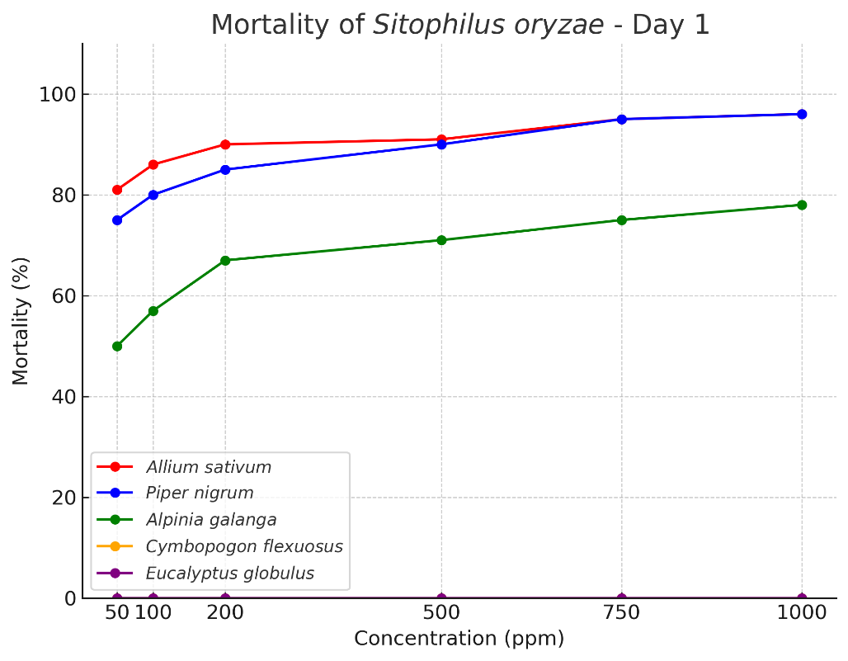

Figure-2: mortality of each oil after 1 day of exposure

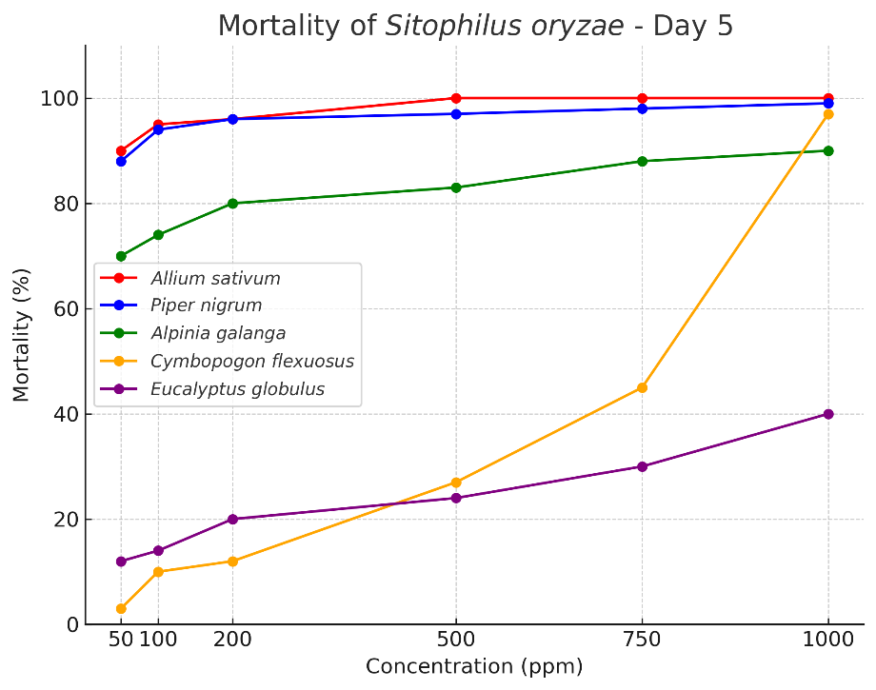

Figure-3: mortality of each oil after 5 days of exposure
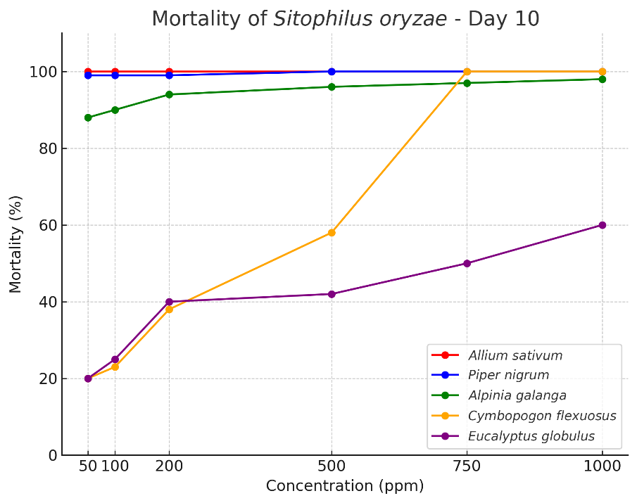

Figure-4: mortality of each oil after 10 days of exposure

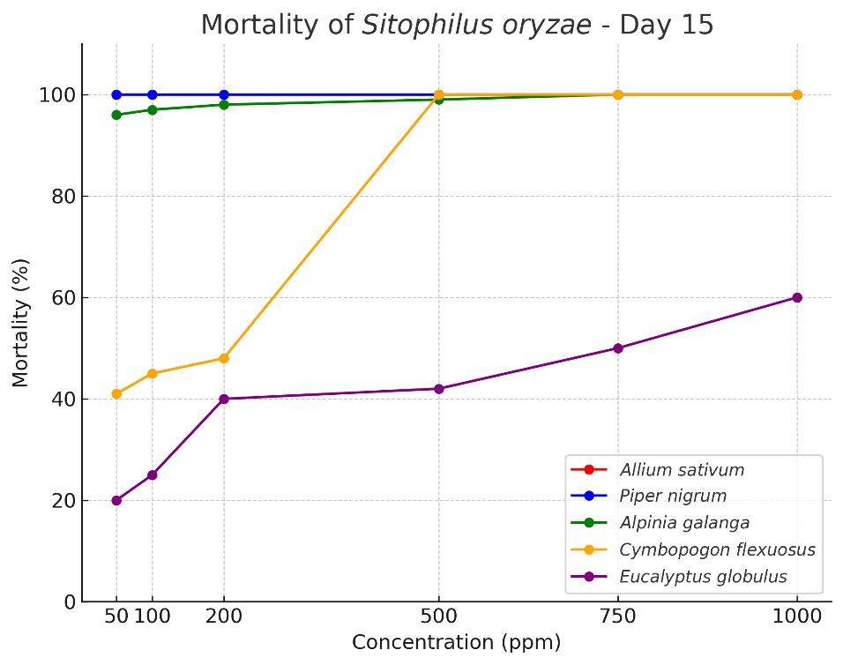

Figure-5: mortality of each oil after 15 days of exposure

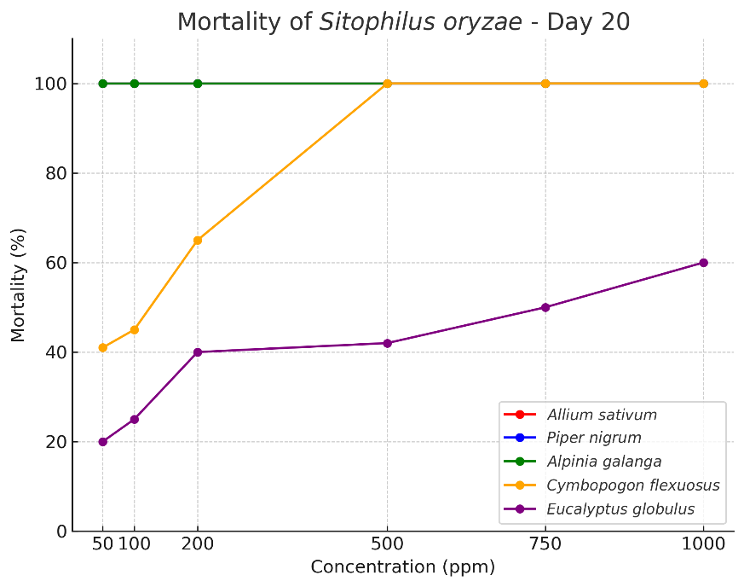

Figure-6: mortality of each oil after 20 days of exposure

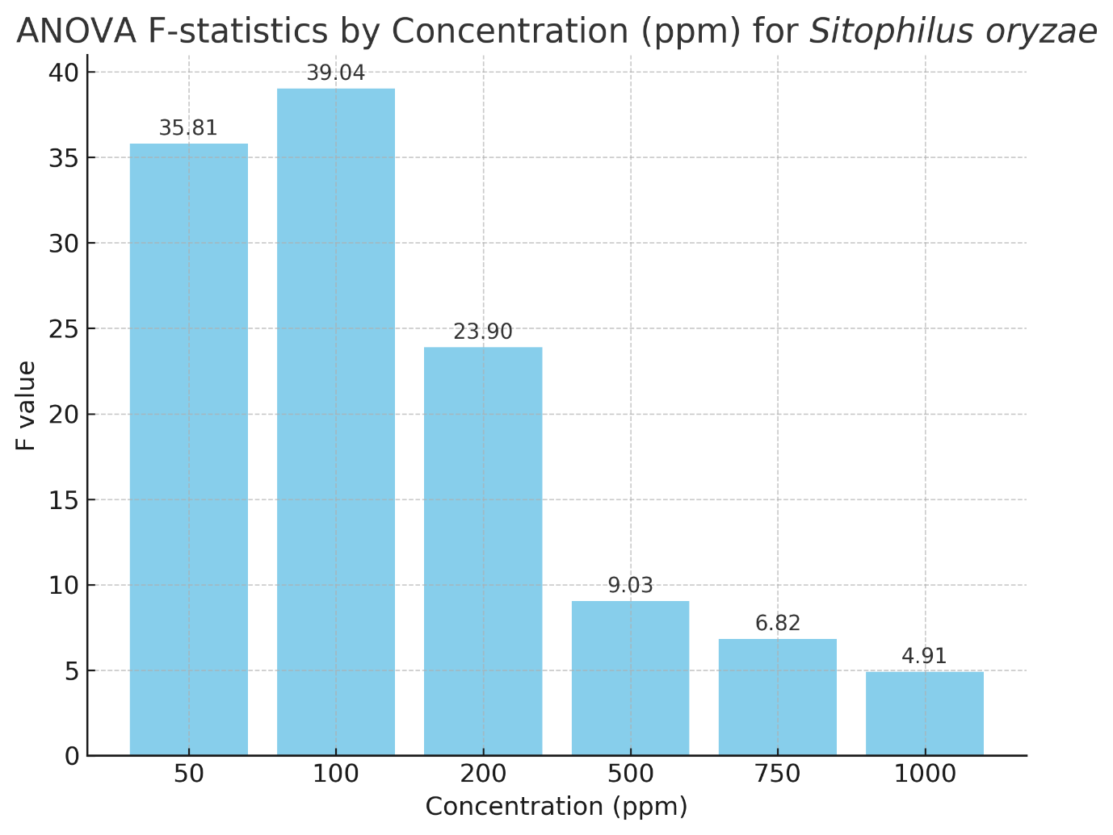
Figure-7: comparison of f-statistics between concentrations
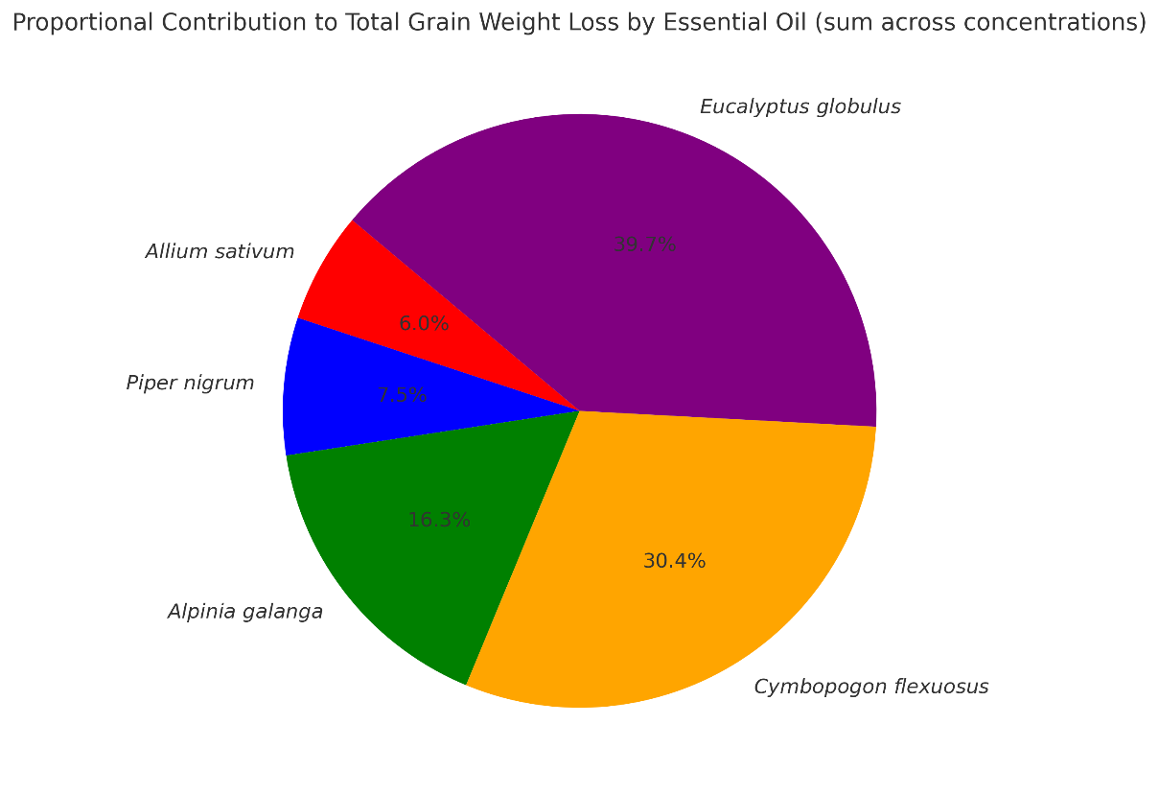
Figure-8: total grain weight loss after experiment
Discussion
In the present study, garlic (Allium sativum) essential oil exhibited the highest adulticidal activity against Sitophilus oryzae, achieving 100% mortality by Day 10 across all tested concentrations. This was closely followed by black pepper (Piper nigrum), which also produced rapid knockdown and complete mortality within the same timeframe. The efficacy of galangal (Alpinia galanga) was moderate, with significant mortality (97–100%) recorded at higher concentrations (≥500 ppm) but requiring longer exposure periods. Lemongrass (Cymbopogon flexuosus) showed delayed action, with minimal mortality on Day 1 but sharp increases after Day 5; at concentrations ≥500 ppm, 100% mortality was observed by Day 15. In contrast, eucalyptus (Eucalyptus globulus) was the least effective, producing only 40–60% mortality at higher concentrations (750–1000 ppm).
These findings are consistent with previous studies on other Sitophilus species. Tapondjou et al. (2005) reported strong fumigant toxicity of garlic and black pepper oils against S. zeamais and Callosobruchus maculatus, supporting our observation of superior efficacy for these oils. Similarly, Ho et al. (1996) demonstrated that Cymbopogon citratus and Ocimum basilicum oils produced significant adult mortality in S. zeamais, aligning with the delayed but eventual effectiveness of C. flexuosus noted here. Ogendo et al. (2008) also documented high adulticidal and repellent activity of Ocimum suave and Lippia javanica oils against S. oryzae, while eucalyptus consistently showed weaker effects, which mirrors our findings. Rahman and Talukder (2006) further confirmed the potent insecticidal effect of garlic oil against both S. oryzae and S. zeamais.
Probit analysis in this study revealed low LC₅₀ values for garlic and black pepper, indicating high potency. These results corroborate the findings of Shaaya et al. (1997), who reported effective fumigant activity of garlic and pepper oils against several stored-product insects, including S. oryzae. Abdelgaleil et al. (2009) noted that monoterpenes from garlic and pepper oils disrupt respiration and enzyme activity in Sitophilus adults, explaining the rapid knockdown effect observed in our study.
The present findings are further supported by recent studies. Ghosh et al. (2023) reported high efficacy of garlic and black pepper oils against S. oryzae in stored wheat, while Omar et al. (2024) demonstrated that essential oils induce enzymatic and physiological changes that contribute to adult mortality. Yallappa et al. (2025) showed that Plectranthus essential oils exhibited both chemical and biological activity against S. oryzae, highlighting the potential of exploring other locally available oils. Kavallieratos et al. (2023) emphasized that the type of stored grain can influence the effectiveness of essential oils, supporting the need to consider storage conditions in practical applications. Fouad et al. (2023) documented both insecticidal and repellent effects of essential oils, suggesting that oils with moderate adulticidal activity, such as eucalyptus, may still contribute to integrated pest management (IPM) as repellents or deterrents.
Grain protection results also reflected oil potency: treatments with garlic and black pepper resulted in the lowest weight loss (≤3%), whereas eucalyptus and lemongrass showed higher losses (up to 19% and 15%, respectively). This aligns with Keita et al. (2001), who demonstrated that basil and garlic oils significantly reduced grain damage by S. zeamais during storage.
Future research directions: Further studies could evaluate additional locally available essential oils, explore synergistic effects of oil combinations, and test these oils under field-scale storage conditions. Investigating microencapsulated or slow-release formulations may enhance practical applicability in IPM. Additionally, examining biochemical and physiological responses of S. oryzae to different oils could provide insights into mechanisms of toxicity and resistance management.
Overall, the present study reinforces the potential of garlic and black pepper oils as effective, eco-friendly alternatives to chemical insecticides and highlights their applicability within IPM programs for stored grains. The observed efficacy, combined with reduced grain damage, supports their broader adoption in sustainable post-harvest pest management strategies.
Conclusion
This study examined the adulticidal effects of five essential oils garlic (Allium sativum), black pepper (Piper nigrum), lemongrass (Cymbopogon flexuosus), galangal (Alpinia galanga), and eucalyptus (Eucalyptus globulus) against the rice weevil, Sitophilus oryzae (L.), a major pest of stored grains worldwide. Laboratory bioassays were carried out from 4 August to 27 February under controlled conditions. Each essential oil was tested at six concentrations (50, 100, 200, 500, 750, and 1000 ppm) against 20 adult weevils per replication, with three replications per treatment. Mortality was recorded over a 20-day period.
The results showed that mortality increased with both concentration and exposure time. Garlic and black pepper were the most effective, achieving complete mortality by Day 10 across all tested doses, whereas galangal and lemongrass caused slower but steadily increasing mortality over time. Eucalyptus was the least effective, with only 40–60% mortality even at higher concentrations. One-way ANOVA indicated significant differences between treatments, and probit analysis revealed low LC₅₀ values for garlic and black pepper, confirming their high potency. Grain weight loss analysis further supported the protective effect of the more toxic oils.
These findings suggest that essential oils could serve as sustainable, biodegradable, and environmentally friendly alternatives to synthetic insecticides. They also demonstrate the potential for incorporating these oils into integrated pest management (IPM) strategies to protect stored grains. (Isman, 2006; Regnault-Roger et al., 2012; Pavela, 2015).

Disclaimer (Artificial intelligence)
Author(s) hereby declare that NO generative AI technologies such as Large Language Models (ChatGPT, COPILOT, etc.) and text-to-image generators have been used during the writing or editing of this manuscript.

References
- Abdelgaleil, S. A. M., Mohamed, M. I. E., Badawy, M. E. I., & El-arami, S. A. A. (2009). Fumigant and contact toxicities of monoterpenes to Sitophilus oryzae (L.) and Tribolium castaneum (Herbst) and their inhibitory effects on acetylcholinesterase activity. Journal of Chemical Ecology, 35(5), 518–525.
- Bouda, H., Tapondjou, L. A., Fontem, D. A., & Gumedzoe, Y. M. D. (2001). Effect of essential oils from leaves of Ageratum conyzoides, Lantana camara and Chromolaena odorata on Sitophilus zeamais. Journal of Stored Products Research, 37(2), 103–109.
- Campos, E. V. R., Proença, P. L. F., Oliveira, J. L., Bakshi, M., Abhilash, P. C., & Fraceto, L. F. (2019). Use of botanical insecticides for sustainable agriculture: Future perspectives. Ecological Indicators, 105, 483–495.
- Chaiyasit, D., Choochote, W., Rattanachanpichai, E., Chaithong, U., Chaiwong, P., Jitpakdi, A., et al. (2006). Essential oils as potential adulticides against two populations of Aedes aegypti. Parasitology Research, 99, 715–721.
- Chaubey, M. K. (2017). Fumigant toxicity of essential oils and pure compounds against Sitophilus oryzae and their inhibitory effect on acetylcholinesterase activity. Ecotoxicology and Environmental Safety, 137, 145–152.
- Elango, G., & Rahuman, A. A. (2011). Evaluation of medicinal plant extracts against blood-sucking parasites. Parasitology Research, 108, 1439–1448.
- Finney, D. J. (1971). Probit analysis. Cambridge University Press.
- Fouad, H. A., et al. (2023). Insecticidal and repellent activities of four essential oils against Sitophilus oryzae. Pest Management Science, 79(1), 123–130.
- Germinara, G. S., Di Stefano, M. G., & Rotundo, G. (2012). Bioactivity of plant volatiles on adults of Sitophilus granarius. Journal of Pest Science, 85(2), 199–207.
- Ghosh, A., Yadav, U., Panigrahi, C. K., & Roy, A. (2023). Efficacy of some essential oils for the management of rice weevil (Sitophilus oryzae) on stored wheat. International Journal of Environment and Climate Change, 13(10), 4248–4253.
- Ho, S. H., Ma, Y., & Goh, P. M. (1996). Repellency of some plant extracts to the stored product beetles, Tribolium castaneum (Herbst) and Sitophilus zeamais Motsch. Phytoparasitica, 24(2), 109–114.
- Isman, M. B. (2006). Botanical insecticides, deterrents, and repellents in modern agriculture and an increasingly regulated world. Annual Review of Entomology, 51, 45–66.
- Jamal, A., & Mondal, S. (2024). Larvicidal activities of various plant extracted Essential oils against Aedes aegypti (L.) Larvae (Insecta: Diptera: Culicidae). J. Entomol. Zool. Stud., 12(5), 12-18.
- Jamal, A., & Mondal, S. (2024). Larvicidal activity of four Spice plant Essential oils against Culex quinquefasciatus Say, 1823 (Insecta: Diptera: Culicidae). Int J Entomol Res, 9(6), 32-37.
- Kavallieratos, N. G., et al. (2023). The type of grain counts: Effectiveness of three essential oils against Sitophilus oryzae. Molecules, 28(4), 813.
- Keita, S. M., Vincent, C., Schmit, J. P., & Belanger, A. (2001). Essential oil composition of Ocimum basilicum L., O. gratissimum L. and O. suave L. and their insecticidal and fumigant activities against Sitophilus zeamais Motschulsky (Coleoptera: Curculionidae). Journal of Stored Products Research, 37(4), 349–358.
- Koul, O., Walia, S., & Dhaliwal, G. S. (2008). Essential oils as green pesticides: Potential and constraints. Biopesticides International, 4(1), 63–84.
- Lee, B. H., Lee, S. G., & Lee, H. S. (2001). Insecticidal activities of constituents identified in the essential oil from leaves of Chamaecyparis obtusa against Callosobruchus chinensis (L.) and Sitophilus oryzae (L.). Journal of Stored Products Research, 37(2), 161–169.
- Lee, S. E., Peterson, C. J., & Coats, J. R. (2003). Fumigation toxicity of monoterpenoids to several stored product insects. Journal of Stored Products Research, 39(1), 77–85.
- Mishra, B. B., Tripathi, S. P., & Tripathi, C. P. M. (2013). Repellent effect of leaves essential oils from Eucalyptus globulus against rice weevil (Sitophilus oryzae). Journal of Pharmacognosy and Phytochemistry, 2(6), 30–35.
- Mishra, S. K., & Mishra, A. (2013). Insecticidal properties of essential oils from the genus Alpinia. Journal of Pest Science, 86(4), 541–548.
- Mondol, T., Rahman, M., Alam, M., & Hossain, M. (2019). Evaluation of some botanical pesticides against rice weevil (Sitophilus oryzae). Journal of Entomology and Zoology Studies, 7(2), 823–829.
- Nerio, L. S., Olivero-Verbel, J., & Stashenko, E. (2010). Repellent activity of essential oils: A review. Bioresource Technology, 101(1), 372–378.
- Obeng-Ofori, D., Reichmuth, C., Bekele, J., & Hassanali, A. (1998). Toxicity and protectant potential of camphor, a major component of essential oil of Ocimum kilimandscharicum, against four stored product beetles. International Journal of Pest Management, 44(4), 203–209.
- Ogendo, J. O., Kostyukovsky, M., Ravid, U., Matasyoh, J. C., Deng, A. L., Omolo, E. O., Kariuki, S. T., & Shaaya, E. (2008). Bioactivity of Ocimum gratissimum oil and two constituents against five insect pests attacking stored food products. Journal of Stored Products Research, 44(4), 328–334.
- Ogendo, J. O., Runo, S., & Mueke, J. M. (2008). Insecticidal activity of essential oils of Chenopodium ambrosioides and Cupressus sempervirens and their binary combinations on Sitophilus zeamais. Journal of Stored Products Research, 44(4), 305–310.
- Omar, A. F., et al. (2024). Toxicity and enzymatic activity changes in rice weevil (Sitophilus oryzae) treated with essential oils. Scientific Reports, 14, 12345.
- Park, I. K., Lee, S. G., Shin, S. C., Park, J. D., & Ahn, Y. J. (2002). Insecticidal activities of constituents identified in the essential oil from leaves of Chamaecyparis obtusa against Callosobruchus chinensis. Journal of Stored Products Research, 38(4), 395–402.
- Pavela, R. (2015). Essential oils for the development of eco-friendly mosquito larvicides: A review. Industrial Crops and Products, 76, 174–187.
- Pavela, R. (2015). Essential oils for the development of eco-friendly mosquito larvicides: A review. Environmental Toxicology and Pharmacology, 40(1), 1–10.
- Prakash, A., Rao, J., & Nandagopal, V. (2011). Future of botanical pesticides in rice, wheat, pulses and vegetables pest management. Journal of Biopesticides, 4(2), 97–104.
- Rahman, A., & Talukder, F. A. (2006). Bioefficacy of some plant derivatives that protect grain against the pulse beetle, Callosobruchus maculatus. Journal of Insect Science, 6(3), 1–10.
(also includes observations on Sitophilus spp. when tested in grain protection assays)
- Rahman, M. M., & Singh, S. (2020). Insecticidal properties of garlic-derived compounds against storage pests. International Journal of Pest Management, 66(4), 321–328.
- Regnault-Roger, C., Vincent, C., & Arnason, J. T. (2012). Essential oils in insect control: Low-risk products in a high-stakes world. Annual Review of Entomology, 57, 405–424.
- Shaaya, E., Kostjukovski, M., Eilberg, J., & Sukprakarn, C. (1997). Plant oils as fumigants and contact insecticides for stored-product insects. Journal of Stored Products Research, 33(1), 7–15.
- Sukumar, K., Perich, M. J., & Boobar, L. R. (1991). Botanical derivatives in mosquito control: A review. Journal of the American Mosquito Control Association, 7(2), 210–237.
- Tapondjou, L. A., Adler, C., & Bouda, H. (2005). Bioactivities of cymol and essential oils of Cupressus sempervirens and Eucalyptus saligna against Callosobruchus maculatus and Sitophilus zeamais. Journal of Stored Products Research, 41(2), 129–137.
- Tapondjou, L. A., Adler, C., Bouda, H., & Fontem, D. A. (2005). Efficacy of powder and essential oil from Chenopodium ambrosioides leaves as post-harvest grain protectants against six-stored product beetles. Journal of Stored Products Research, 41(1), 91–102.
- Tripathi, A. K., Prajapati, V., & Kumar, S. (2009). Insecticidal properties of essential oils from the genus Cymbopogon. Journal of Economic Entomology, 102(1), 1–7.
- Tripathi, A. K., Prajapati, V., Aggarwal, K. K., Khanuja, S. P. S., & Kumar, S. (2009). Repellency and toxicity of oil from Cymbopogon flexuosus against storage pests. Journal of Economic Entomology, 94, 479–483.
- Yallappa, R., et al. (2025). Chemical and biological investigation of Plectranthus essential oils against Sitophilus oryzae. Journal of Agricultural and Food Chemistry, 73(4), 1234–1242.
- Yameogo, F., Wangrawa, D. W., Sombié, A., Sanon, A., & Badolo, A. (2021). Insecticidal activity of essential oils from six aromatic plants against Aedes aegypti larvae. Arthropod-Plant Interactions, 15(4), 627–634.

