Original Research Article
MODULATION OF SILKWORM HAEMOLYMPH PROTEINS AND PROTEASES BY CHITOSAN: A DEFENSE MECHANISM AGAINST BACTERIAL INFECTION

ABSTRACT
Flacherie, a contagious bacterial disease caused by Staphylococcus aureus and Bacillus thuringiensis, presents a critical constraint in tropical sericulture. To probe host-pathogen biochemical interactions, this study investigated total protein content and protease enzyme activity in haemolymph of Bombyx mori (bivoltine hybrid FC1 × FC2) following oral bacterial inoculation and treatment with silkworm pupal chitosan. Silkworm rearing adhered to standard protocols. Pupae-derived chitosan was extracted via sequential deproteinization, demineralization, deacetylation and decolorization. Concentrations of 3500-5000 ppm extracted chitosan as well as 1000 ppm commercial chitosan and 1000 ppm ampicillin were applied to mulberry feed at 6, 12, 18, 24 and 30 hours post-bacterial inoculation (hpi). Haemolymph samples were collected daily from the second to the eighth day of the fifth instar for biochemical analysis. Results demonstrated that total protein content varied significantly by bacterial strain, treatment type, timing and their interactions. Chitosan treatments (3500-5000 ppm) and ampicillin significantly raised haemolymph protein levels over days 1-8, in contrast to control groups, which declined initially and rose only modestly later. Protein levels were consistently higher in S. aureus infections compared to B. thuringiensis. Early chitosan application produced better outcomes, while delayed treatment corresponded to reduced protein accumulation. Protease activity exhibited a similar pattern: enzyme activity increased from day 2 to day 8 across all treatments, peaking in uninfected controls, followed by ampicillin, commercial chitosan and 5000 ppm extracted chitosan treatments. Lowest protease activity occurred in absolute controls. Again, S. aureus induced higher protease activity than B. thuringiensis and delayed chitosan addition led to attenuated enzymatic response. This study reveals that early application of high-concentration silkworm-pupal chitosan significantly enhances immune-related protein content and protease activity, especially under S. aureus infection. These findings underscore chitosan’s immuno-stimulatory potential in sericulture and encourage further mechanistic studies to optimize its use as a natural disease-management strategy in silkworm rearing.
Keywords: Bombyx mori, chitosan, flacherie, protein content, protease activity, sericulture.
1.INTRODUCTION
Sericulture, a thriving ago-based industry, plays a vital role in rural India's economic development. However, silkworms (Bombyx mori) are susceptible to various diseases, including pebrine, muscardine, flacherie and grasserie, which can significantly impact productivity. Flacherie, in particular, is a contagious disease that poses a significant threat (Anantha Selvi et al., 2023).
When pathogens infect silkworms, they trigger a cascade of biochemical and physiological changes. The interaction between the pathogen and host cells leads to a complex interplay, resulting in distinct physiological and characteristic changes (Ma et al., 2018). In particular, host defences involving iron regulation, such as deployment of the ferritin 1 heavy chain homolog, play a crucial role in mitigating bacterial infection by restricting iron availability, thereby limiting pathogen growth and enhancing silkworm survival (Otho et al., 2016).
Proteins, carbohydrates, lipids and enzymes are crucial biomolecules that govern various cellular functions. Proteins play a crucial role in silkworms, serving various functions essential for their growth, development and survival. Enzymes, as biological catalysts, drive metabolic reactions, enabling cells to function optimally. Protease, a specific type of enzyme, plays a key role in protein regulation (Habeanu et al., 2024).
Silkworm pupae, a byproduct of sericulture, are rich in proteins, lipids and energy. India generates around 40,000 MT of dry pupae annually, which can be valorized for their nutritional and biochemical potential (Mahesh et al., 2015). Silkworm pupae can be used to produce chitosan, a biocompatible and antibacterial compound with applications in medicine, agriculture and food preservation. Chitosan also shows promise as a natural growth promoter and bactericide in sericulture (Priyadarshini et al., 2018).
This study investigates the relationship between proteins and protease activity in silkworm haemolymph during pathogen infection (S. aureus and B. thuringiensis) and explores the potential of silkworm pupal chitosan as a control measure.
2. METHODOLOGY
The extraction of chitin and chitosan involved a three-step process, specifically deproteinization, demineralization and deacetylation. The methodology developed by Suresh et al. (2012) was adopted for chitosan extraction.
For the experiment, twenty-five Disease Free Layings (DFLs) of the third instar FC1×FC2 silkworm hybrid were obtained from the Registered Chawki Rearing Centre. The silkworms were reared until the fourth moult on untreated mulberry leaves, following standard practices outlined by Dandin and Giridhar (2014). After the fourth moult, the silkworms were orally inoculated with pathogens by feeding them mulberry leaves smeared with bacterial suspensions.
The mulberry leaves used for inoculation were prepared by washing them in running water, sterilizing them with 70 per cent alcohol and shade-drying them. The leaves were then evenly smeared with a bacterial suspension of 10⁸ CFU/mL (0.27 mL/replication of 50 worms) using non-absorbent cotton. Control batches of silkworms were fed only with non-inoculated, surface-sterilized mulberry leaves, as per the method described by Manjunath Gowda (2009).
The experiment was designed as a completely randomized design with nine treatments, each replicated thrice. The treatments consisted of chitosan at concentrations of 3500 ppm, 4000 ppm, 4500 ppm and 5000 ppm, along with standard ampicillin at 1000 ppm, commercial chitosan at 1000 ppm, solvent control, absolute control and bacteria-uninoculated silkworms. The sterilized mulberry leaves were dipped in the respective treatments for ten minutes and shade-dried. The treated leaves were fed to the silkworms at 6 hours post-inoculation (hpi), 12 hpi, 18 hpi, 24 hpi and 30 hpi of bacterial suspension. For subsequent feedings, inoculum-free leaves suitable for the age were provided to both treated and untreated batches.
Haemolymph was extracted daily post-treatment in the fifth instar from both normal and treated larvae separately. One of the pro-legs of anaesthetized larvae was amputated and the haemolymph that oozed out was immediately collected in pre-cooled vials containing a few crystals of phenyl thiourea (Fig. 1). The collected haemolymph was analysed for biochemical and physiological parameters, including protein levels and protease activity.
The total protein in the haemolymph was estimated using Lowry’s method (Lowry et al., 1951) with Bovine Serum Albumin (BSA) as standard. Proteases break peptide bonds. Sigma's non-specific protease activity assay was used as a standardized procedure to determine the activity of proteases (Fig. 2). In this assay, casein used as a substrate (Cupp-Enyard, 2018).
Further, the data was analysed statistically for the test of significance using Fisher’s method of analysis of variance as outlined by Hobbs et al. (2024). The level of significance of F-test was at 5 per cent. The interpretation of data was done using critical difference (CD) values.
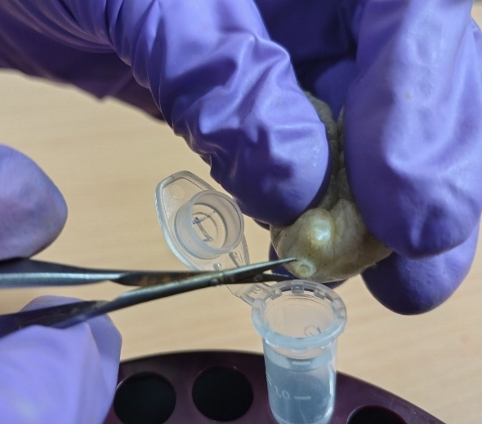
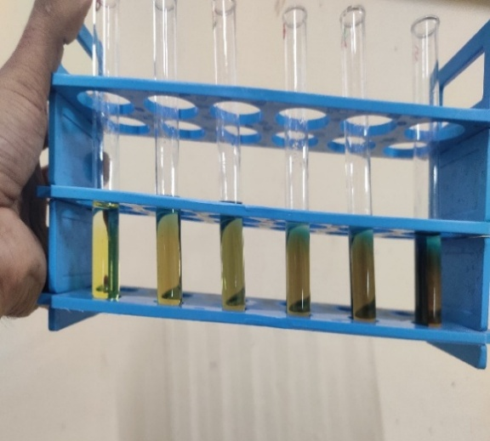
Fig. 1: Collection of the silkworm haemolymph
Fig. 2: Biochemical analysis

3. RESULTS AND DISCUSSION
3.1. Protein content (mg/mL)
Over the course of the fifth-instar larval stage of Bombyx mori, the effects of varying concentrations of chitosan (3500-5000 ppm) on haemolymph protein content were systematically monitored under inoculation with S. aureus and B. thuringiensis. The study included ampicillin (1000 ppm), commercial chitosan (1000 ppm) and control treatments, with comparisons made to bacteria un-inoculated and absolute control groups.
The total protein content differed significantly among bacterial strains (A), treatments (B), time of chitosan application after bacterial inoculation (C) and their interactions (A×B, B×C, A×B×C), from the second to the eighth day, except on the first day, where no significant difference was observed.
On the first day, all treatments produced relatively modest protein levels. Infected silkworms with treatment of chitosan at 3500 ppm have 15.706 mg/mL (S. aureus) and 15.130 mg/mL (B. thuringiensis), with a mean of 15.418 mg/mL of protein levels. The highest value was observed in the bacteria-un-inoculated group at 16.161 mg/mL, significantly surpassing all treatments. No significant treatment, strain, or interaction effects were observed.

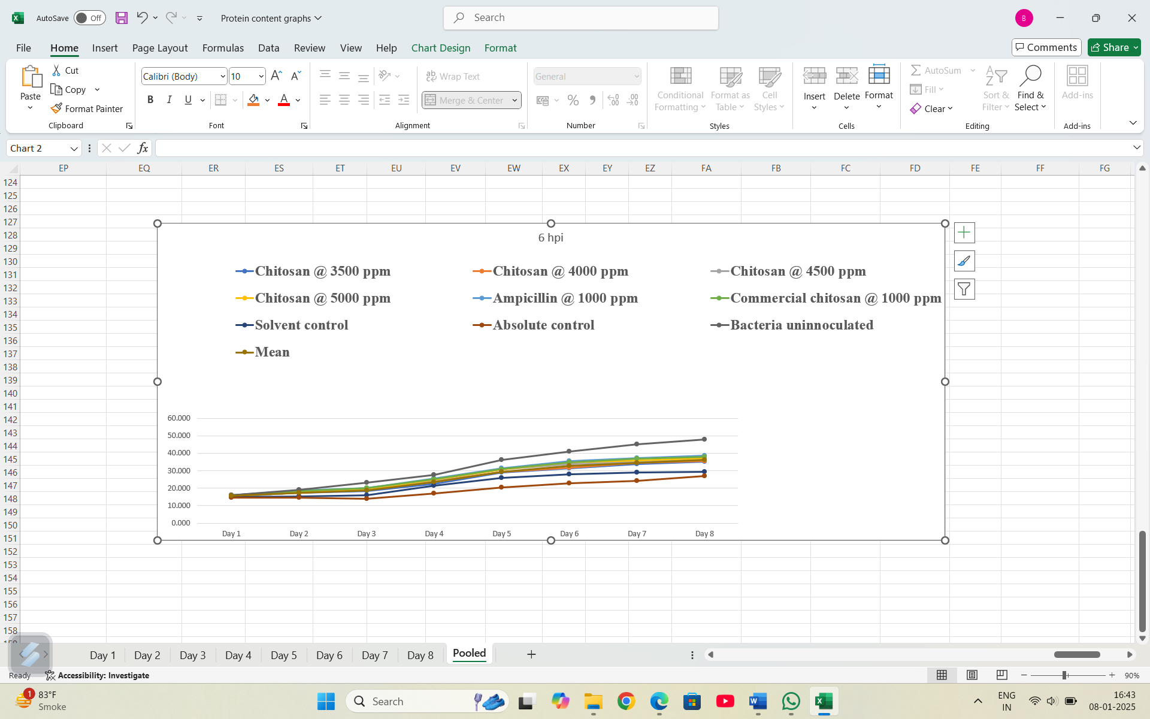

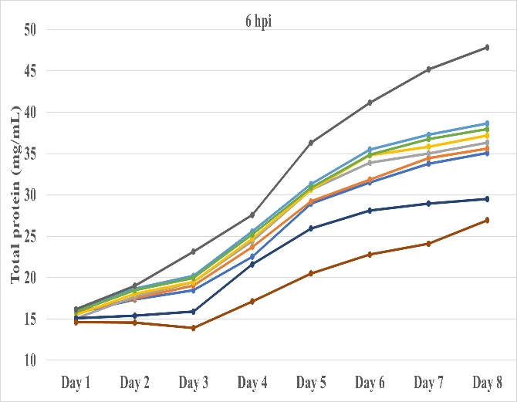
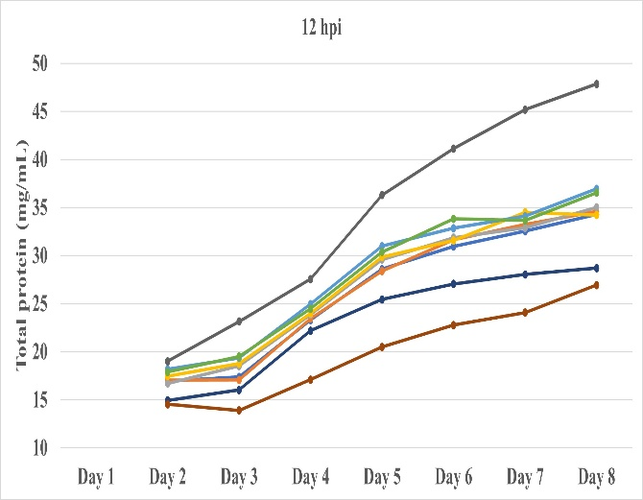

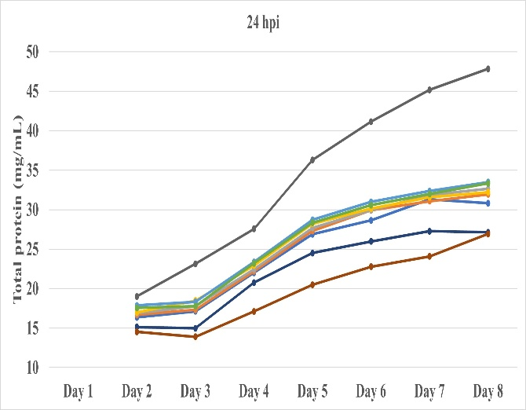
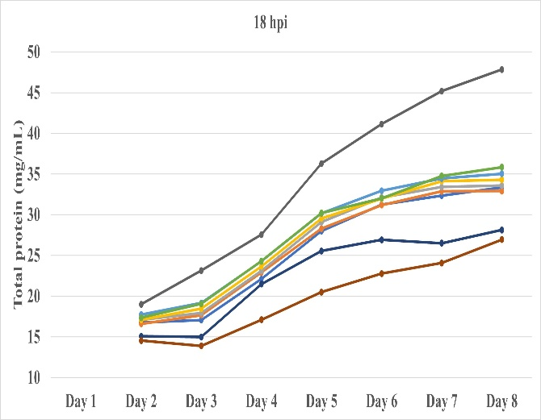

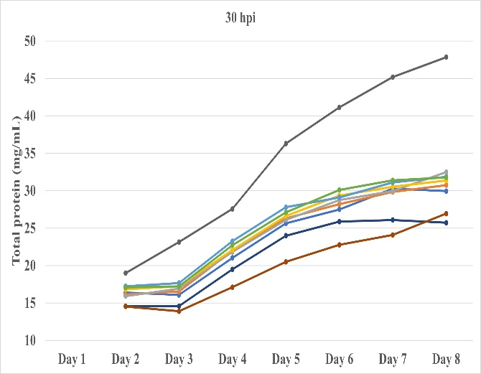

Fig 3: Effect of chitosan on protein content (mg/mL) in haemolymph of fifth instar silkworm inoculated with S. aureus

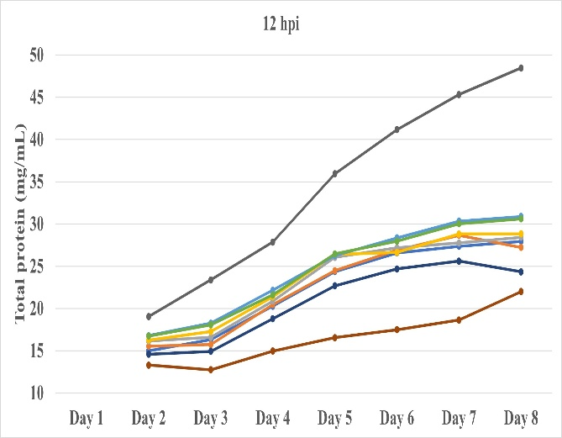
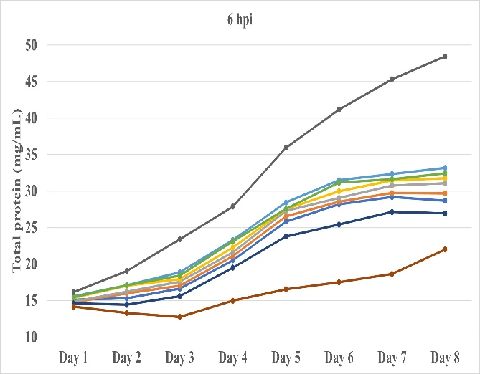

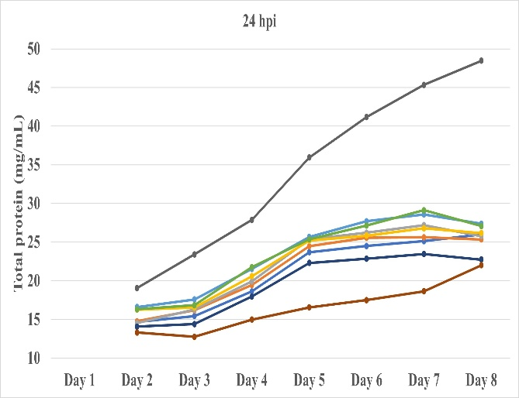
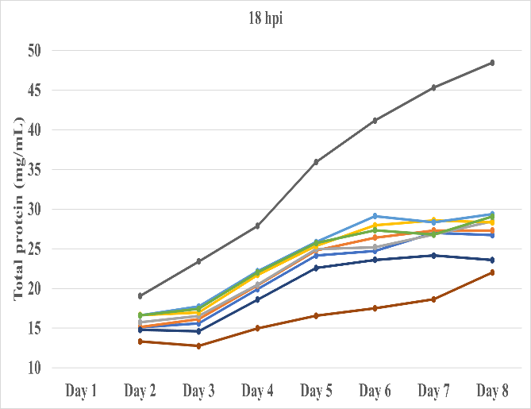

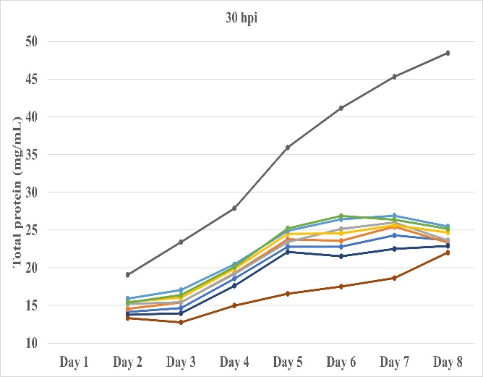

Fig 4: Effect of chitosan on protein content (mg/mL) in haemolymph of fifth instar silkworm inoculated with B. thuringiensis
By the second day, protein content had risen notably across all sampling hours (6 to 30 hours post-inoculation), with clear treatment stratification. Chitosan at 3500 ppm had a mean of 15.80 mg/mL, while 5000 ppm chitosan advanced to 16.81 mg/mL. The effects of bacterial strain, treatment, post-inoculation time and their interactions were all significant.
This trend continued over the next few days, with protein concentrations climbing steadily. On the eighth day, protein levels were highest across all treatments: 3,500 ppm chitosan yielded 29.65 mg/mL, while 5,000 ppm reached 30.91 mg/mL. Ampicillin recorded 32.23 mg/mL and the bacteria-un-inoculated group reached 48.15 mg/mL. All factors and interactions were significant.
The treatments with chitosan at 3500 ppm, 4000 ppm, 4500 ppm and 5000 ppm, as well as ampicillin at 1000 ppm and commercial chitosan at 1000 ppm, resulted in a significant increase in total protein content from the first to the eighth day of the fifth instar. In contrast, the solvent control and absolute control treatments showed a decrease in total protein content levels from the first to the third day, followed by a negligible increase from the fourth day onwards until pupation in silkworms infected with both pathogens. Moreover, the total protein content increased substantially in bacterial un-inoculated groups from day to day.
Treatments with higher concentrations of chitosan (especially 4500 and 5000 ppm) consistently outperformed controls, although the bacteria-un-inoculated groups recorded the highest values on each day. The observed patterns were statistically robust, with significance emerging from the second day onward for all main factors and their interactions. The steady daily increases, especially in treated groups, suggest that chitosan may stimulate protein synthesis or immune-related protein accumulation in haemolymph when challenged with bacteria.
Protein content levels were significantly higher in S. aureus inoculated silkworms compared to B. thuringiensis inoculated silkworms across all treatments. However, protein content levels varied significantly in batches of silkworms fed with chitosan at different timings after bacterial inoculation. Decreasing trend of protein levels was observed in the batches where the chitosan application was delayed (Fig. 3 and 4; Tables 1 A - H).
Chitosan, known for its immunostimulatory properties, may have activated immune responses, leading to increased production of immune proteins. Ampicillin, an antibiotic, likely suppressed bacterial growth, reducing the metabolic burden on the silkworms and allowing for better protein utilization. Conversely, the decrease in protein content in the control groups indicates a decline in overall health and metabolic activity in the infected silkworms. This decline could be attributed to the energy expenditure associated with combating infections, leading to a depletion of protein reserves. The significantly higher protein content in S. aureus inoculated silkworms compared to B. thuringiensis inoculated silkworms might be due to differences in the virulence and pathogenesis of these bacteria. S. aureus may induce a stronger immune response and a greater demand for protein synthesis for immune defence. The decreasing trend in protein levels with delayed chitosan application suggests a time-dependent effect on immune activation. Early chitosan application likely provided a more robust and sustained immune response, leading to better protein utilization and overall health. Delayed chitosan application after the bacterial inoculation might have allowed the infections to progress further, impacting the silkworm's ability to effectively utilize protein resources for growth and development.
This protein depletion in haemolymph could be due to the breakdown of protein into amino acids, so with the entrance of these amino acids to Krebs cycle as a keto acid, they will help to supply energy for the insect. So, protein depletion in haemolymph may be a physiological mechanism and may be involved in compensatory mechanisms under bacterial stress, to provide intermediates to the Krebs cycle, by maintaining free amino acid content in haemolymph, these results are in accordance with the findings of Surendranath et al. (1997).
The present results of haemolymph protein content in infected silkworms are in conformity with the findings of Bhat and Nataraju (2008), who reported that the protein content in haemolymph was higher in healthy larvae compared to infected silkworm larvae (Bombyx mori L.). Similarly, Kumar et al. (2011) reported on the protein profiles in various tissues of the tasar silkworm (Antheria mylitta) during infection by a pathogen and revealed a decrease in protein content in the haemolymph of infected silkworms. Thirupathamma and Savithri (2014) reported that day-to-day variations in silkworms inoculated with the fungal pathogen (Beauveria bassiana) resulted in a gradual reduction of protein content in all tissues (integument, midgut and silk-gland) of the fifth instar silkworm (Bombyx mori L.).
Antibiotics not only prevent disease, but they also promote silkworm growth by reshaping the gut microbiome and enhancing nutrient absorption, highlighting the need for judicious use (Rittick et al., 2025). A similar mechanism may have been influenced by chitosan and antibiotic treatments, which not only prevent disease but also potentially modulate the protein content in chitosan-treated, bacterially infected silkworms compared to those without treatment. Furthermore, Younus (2021) reported that the highest peak of haemolymph total protein content, 45.94 mg/mL, was achieved on the seventh day of the fifth instar, which was statistically higher than the rest of the days. The least value of haemolymph total protein content, 40.50 mg/mL, was recorded on the fourth day of the fifth instar silkworms among the fourth to seventh days of the fifth instar that he studied. So, the result obtained in the bacterial infected silkworm shows decreased haemolymph protein is correlated with findings of other scientists.
Table 1: Day-wise effect of chitosan on protein content (mg/mL) in haemolymph of fifth instar silkworm inoculated with S. aureus and B. thuringiensis
A. Fifth instar first day
Day 1
Treatments (B) | Bacterial strains (A)
Treatments (B) | Sa | Bt | Mean
S₁: Chitosan @ 3500 ppm | 15.706 | 15.130 | 15.418
S₂: Chitosan @ 4000 ppm | 15.767 | 14.767 | 15.267
S₃: Chitosan @ 4500 ppm | 15.039 | 14.858 | 14.948
S₄: Chitosan @ 5000 ppm | 15.494 | 15.373 | 15.433
S₅: Ampicillin @ 1000 ppm | 15.979 | 15.585 | 15.782
S₆: Com. chitosan @ 1000 ppm | 15.858 | 15.464 | 15.661
S₇: Solvent control | 15.070 | 14.615 | 14.842
S₈: Absolute control | 14.615 | 14.161 | 14.388
S₉: Bacteria un-inoculated | 16.161 | 16.161 | 16.161
Mean | 15.521 | 15.124 | 15.322

 | A | B | AB
F-Test | NS | NS | NS
SEm ± | - | - | -
CD @ 5% | - | - | -
Note: * Significant; NS - Non-significant; A- Bacterial strains; B- Treatments; Sa- S. aureus; Bt- B. thuringiensis; Com.- Commercial chitosan

B. Fifth instar second day
Day 2
Treatments (B) | Hours of post inoculation (hpi) (C) |  |  |  |  |  |  |  |  |  |  | Bacterial strains (A) mean |  | Treatments (B) mean
Treatments (B) | 6 hpi |  | 12 hpi |  | 18 hpi |  | 24 hpi |  | 30 hpi |  |  |  |  | Treatments (B) mean
Treatments (B) | Sa | Bt | Sa | Bt | Sa | Bt | Sa | Bt | Sa | Bt | Sa |  | Bt | Treatments (B) mean
S₁: Chitosan @ 3500 ppm | 17.34 | 15.30 | 16.93 | 15.00 | 16.77 | 15.11 | 16.36 | 14.67 | 16.40 | 14.13 | 16.76 |  | 14.84 | 15.80
S₂: Chitosan @ 4000 ppm | 17.47 | 15.99 | 17.06 | 15.55 | 16.62 | 15.14 | 16.68 | 14.76 | 16.14 | 14.54 | 16.79 |  | 15.19 | 15.99
S₃: Chitosan @ 4500 ppm | 17.69 | 16.23 | 16.71 | 16.15 | 17.09 | 15.74 | 16.90 | 14.54 | 15.92 | 15.19 | 16.86 |  | 15.57 | 16.22
S₄: Chitosan @ 5000 ppm | 18.03 | 17.02 | 17.47 | 16.26 | 17.09 | 16.64 | 16.99 | 16.26 | 16.84 | 15.47 | 17.28 |  | 16.33 | 16.81
S₅: Ampicillin @ 1000 ppm | 18.66 | 17.11 | 18.19 | 16.81 | 17.75 | 16.59 | 17.87 | 16.59 | 17.25 | 15.90 | 17.94 |  | 16.60 | 17.27
S₆: Com. chitosan @ 1000 ppm | 18.47 | 17.08 | 17.91 | 16.75 | 17.37 | 16.59 | 17.56 | 16.31 | 17.09 | 15.39 | 17.68 |  | 16.42 | 17.05
S₇: Solvent control | 15.39 | 14.43 | 14.95 | 14.59 | 15.08 | 14.78 | 15.14 | 14.07 | 14.57 | 13.77 | 15.03 |  | 14.33 | 14.68
S₈: Absolute control | 14.54 | 13.31 | 14.54 | 13.31 | 14.54 | 13.31 | 14.54 | 13.31 | 14.54 | 13.31 | 14.54 |  | 13.31 | 13.92
S₉: Bacteria un-inoculated | 19.01 | 19.05 | 19.01 | 19.05 | 19.01 | 19.05 | 19.01 | 19.05 | 19.01 | 19.05 | 19.01 |  | 19.05 | 19.03
Mean | 16.78 |  | 16.46 |  | 16.35 |  | 16.15 |  | 15.81 |  | 16.88 |  | 15.74
Mean A, B, C | 16.31 |  |  |  |  |  |  |  |  |  | 16.31 |  |  | 16.31

 | A | B | AB | C | AC | BC | ABC
F-Test | * | * | * | * | * | * | *
SEm ± | 0.025 | 0.054 | 0.076 | 0.040 | 0.056 | 0.120 | 0.169
CD @ 5% | 0.050 | 0.106 | 0.149 | 0.079 | 0.111 | 0.236 | 0.334
Note: * Significant; NS - Non-significant; A- Bacterial strains; B- Treatments; C- Hours of post inoculation (hpi); Sa- S. aureus; Bt- B. thuringiensis; Com.- Commercial chitosan

C. Fifth instar third day
Day 3
Treatments (B) | Hours of post inoculation (hpi) (C) |  |  |  |  |  |  |  |  |  |  |  |  |  |  |  |  | Bacterial strains (A) mean |  |  | Treatments (B) mean
Treatments (B) | 6 hpi |  |  | 12 hpi |  |  | 18 hpi |  |  |  | 24 hpi |  |  | 30 hpi |  |  |  |  |  |  | Treatments (B) mean
Treatments (B) | Sa |  | Bt | Sa |  | Bt | Sa |  | Bt |  | Sa | Bt |  | Sa | Bt |  | Sa |  | Bt |  | Treatments (B) mean
S₁: Chitosan @ 3500 ppm | 18.47 |  | 16.63 | 17.38 |  | 16.33 | 17.08 |  | 15.59 |  | 17.13 | 15.44 |  | 16.08 | 14.64 |  | 17.23 |  | 15.73 |  | 16.48
S₂: Chitosan @ 4000 ppm | 19.02 |  | 17.03 | 17.08 |  | 15.74 | 17.68 |  | 16.13 |  | 17.33 | 16.18 |  | 16.53 | 15.39 |  | 17.53 |  | 16.09 |  | 16.81
S₃: Chitosan @ 4500 ppm | 19.47 |  | 17.58 | 18.52 |  | 16.58 | 17.93 |  | 16.53 |  | 17.78 | 16.28 |  | 16.93 | 15.44 |  | 18.12 |  | 16.48 |  | 17.30
S₄: Chitosan @ 5000 ppm | 19.47 |  | 17.93 | 18.77 |  | 17.28 | 18.47 |  | 16.98 |  | 18.47 | 16.53 |  | 17.23 | 16.03 |  | 18.48 |  | 16.95 |  | 17.72
S₅: Ampicillin @ 1000 ppm | 20.21 |  | 18.87 | 19.37 |  | 18.27 | 19.17 |  | 17.73 |  | 18.32 | 17.58 |  | 17.68 | 17.03 |  | 18.95 |  | 17.90 |  | 18.42
S₆: Com. chitosan @ 1000 ppm | 19.97 |  | 18.42 | 19.52 |  | 18.07 | 19.07 |  | 17.43 |  | 17.78 | 16.83 |  | 17.23 | 16.38 |  | 18.71 |  | 17.43 |  | 18.07
S₇: Solvent control | 15.89 |  | 15.59 | 16.03 |  | 14.94 | 14.99 |  | 14.59 |  | 14.99 | 14.39 |  | 14.59 | 13.95 |  | 15.30 |  | 14.69 |  | 15.00
S₈: Absolute control | 13.90 |  | 12.75 | 13.90 |  | 12.75 | 13.90 |  | 12.75 |  | 13.90 | 12.75 |  | 13.90 | 12.75 |  | 13.90 |  | 12.75 |  | 13.32
S₉: Bacteria un-inoculated | 23.15 |  | 23.40 | 23.15 |  | 23.40 | 23.15 |  | 23.40 |  | 23.15 | 23.40 |  | 23.15 | 23.40 |  | 23.15 |  | 23.40 |  | 23.27
Mean | 18.21 |  |  | 17.62 |  |  | 17.36 |  |  |  | 17.12 |  |  | 16.57 |  |  | 17.93 |  | 16.82
Mean A, B, C | 17.38 |  |  |  |  |  |  |  |  |  |  |  |  |  |  |  | 17.38 |  |  |  | 17.38
 |  | A |  |  | B |  |  | AB |  | C |  |  | AC |  |  | BC |  |  |  | ABC
F-Test |  | * |  |  | * |  |  | * |  | * |  |  | NS |  |  | * |  |  |  | NS
SEm ± |  | 0.039 |  |  | 0.083 |  |  | 0.118 |  | 0.062 |  |  | - |  |  | 0.186 |  |  |  | -
CD @ 5% |  | 0.078 |  |  | 0.164 |  |  | 0.233 |  | 0.123 |  |  | - |  |  | 0.368 |  |  |  | -
Note: * Significant; NS - Non-significant; A- Bacterial strains; B- Treatments; C- Hours of post inoculation (hpi); Sa- S. aureus; Bt- B. thuringiensis; Com.- Commercial chitosan

D. Fifth instar fourth day
Day 4
Treatments (B) | Hours of post inoculation (hpi) (C) |  |  |  |  |  |  |  |  |  |  |  |  |  |  |  |  | Bacterial strains (A) mean |  |  | Treatments (B) mean
Treatments (B) | 6 hpi |  |  | 12 hpi |  |  | 18 hpi |  |  |  | 24 hpi |  |  | 30 hpi |  |  |  |  |  |  | Treatments (B) mean
Treatments (B) | Sa |  | Bt | Sa |  | Bt | Sa |  | Bt |  | Sa | Bt |  | Sa | Bt |  | Sa |  | Bt |  | Treatments (B) mean
S₁: Chitosan @ 3500 ppm | 22.52 |  | 20.50 | 23.30 |  | 20.28 | 22.11 |  | 19.91 |  | 22.01 | 18.63 |  | 21.04 | 18.55 |  | 22.19 |  | 19.57 |  | 20.88
S₂: Chitosan @ 4000 ppm | 23.70 |  | 21.07 | 23.46 |  | 20.47 | 22.92 |  | 20.37 |  | 22.19 | 19.44 |  | 21.98 | 19.25 |  | 22.85 |  | 20.12 |  | 21.49
S₃: Chitosan @ 4500 ppm | 24.40 |  | 21.61 | 23.86 |  | 20.88 | 23.11 |  | 20.47 |  | 22.46 | 19.91 |  | 21.82 | 19.15 |  | 23.13 |  | 20.40 |  | 21.77
S₄: Chitosan @ 5000 ppm | 24.72 |  | 22.26 | 23.99 |  | 21.40 | 23.67 |  | 21.69 |  | 22.92 | 20.58 |  | 22.09 | 19.85 |  | 23.48 |  | 21.16 |  | 22.32
S₅: Ampicillin @ 1000 ppm | 25.58 |  | 23.29 | 24.96 |  | 22.15 | 24.29 |  | 22.18 |  | 23.38 | 21.53 |  | 23.27 | 20.45 |  | 24.30 |  | 21.92 |  | 23.11
S₆: Com. chitosan @ 1000 ppm | 25.20 |  | 23.10 | 24.48 |  | 21.61 | 24.32 |  | 22.02 |  | 23.22 | 21.75 |  | 22.73 | 20.09 |  | 23.99 |  | 21.72 |  | 22.85
S₇: Solvent control | 21.60 |  | 19.50 | 22.19 |  | 18.79 | 21.49 |  | 18.58 |  | 20.77 | 17.95 |  | 19.51 | 17.60 |  | 21.11 |  | 18.49 |  | 19.80
S₈: Absolute control | 17.11 |  | 14.97 | 17.11 |  | 14.97 | 17.11 |  | 14.97 |  | 17.11 | 14.97 |  | 17.11 | 14.97 |  | 17.11 |  | 14.97 |  | 16.04
S₉: Bacteria un-inoculated | 27.57 |  | 27.87 | 27.57 |  | 27.87 | 27.57 |  | 27.87 |  | 27.57 | 27.87 |  | 27.57 | 27.87 |  | 27.57 |  | 27.87 |  | 27.72
Mean | 22.59 |  |  | 22.19 |  |  | 21.93 |  |  |  | 21.35 |  |  | 20.83 |  |  | 22.86 |  | 20.69
Mean A, B, C | 21.78 |  |  |  |  |  |  |  |  |  |  |  |  |  |  |  | 21.78 |  |  |  | 21.78
 |  | A |  |  | B |  |  | AB |  | C |  |  | AC |  |  | BC |  |  |  | ABC
F-Test |  | * |  |  | * |  |  | * |  | * |  |  | * |  |  | * |  |  |  | *
SEm ± |  | 0.037 |  |  | 0.078 |  |  | 0.110 |  | 0.058 |  |  | 0.082 |  |  | 0.174 |  |  |  | 0.246
CD @ 5% |  | 0.072 |  |  | 0.153 |  |  | 0.217 |  | 0.114 |  |  | 0.162 |  |  | 0.343 |  |  |  | 0.485
Note: * Significant; NS - Non-significant; A- Bacterial strains; B- Treatments; C- Hours of post inoculation (hpi); Sa- S. aureus; Bt- B. thuringiensis; Com.- Commercial chitosan

E. Fifth instar fifth day
Day 5
Treatments (B) | Hours of post inoculation (hpi) (C) |  |  |  |  |  |  |  |  |  |  |  |  |  |  |  |  | Bacterial strains (A) mean |  |  | Treatments (B) mean
Treatments (B) | 6 hpi |  |  |  | 12 hpi |  |  | 18 hpi |  |  | 24 hpi |  |  | 30 hpi |  |  |  |  |  |  | Treatments (B) mean
Treatments (B) | Sa |  | Bt |  | Sa | Bt |  | Sa | Bt |  | Sa | Bt |  | Sa | Bt |  | Sa |  | Bt |  | Treatments (B) mean
S₁: Chitosan @ 3500 ppm | 28.94 |  | 25.83 |  | 28.61 | 24.36 |  | 28.00 | 24.14 |  | 26.89 | 23.69 |  | 25.64 | 22.78 |  | 27.62 |  | 24.16 |  | 25.89
S₂: Chitosan @ 4000 ppm | 29.22 |  | 26.53 |  | 28.39 | 24.47 |  | 28.31 | 24.81 |  | 27.31 | 24.47 |  | 26.31 | 23.78 |  | 27.91 |  | 24.81 |  | 26.36
S₃: Chitosan @ 4500 ppm | 30.64 |  | 27.28 |  | 29.58 | 26.06 |  | 29.11 | 24.94 |  | 27.69 | 25.36 |  | 26.11 | 23.39 |  | 28.63 |  | 25.41 |  | 27.02
S₄: Chitosan @ 5000 ppm | 30.64 |  | 27.53 |  | 29.86 | 26.39 |  | 29.56 | 25.36 |  | 28.22 | 25.19 |  | 26.64 | 24.50 |  | 28.98 |  | 25.79 |  | 27.39
S₅: Ampicillin @ 1000 ppm | 31.31 |  | 28.44 |  | 31.00 | 26.25 |  | 30.17 | 25.86 |  | 28.72 | 25.67 |  | 27.81 | 24.89 |  | 29.80 |  | 26.22 |  | 28.01
S₆: Com. chitosan @ 1000 ppm | 30.89 |  | 27.56 |  | 30.39 | 26.47 |  | 30.22 | 25.72 |  | 28.36 | 25.36 |  | 27.11 | 25.22 |  | 29.39 |  | 26.07 |  | 27.73
S₇: Solvent control | 25.94 |  | 23.78 |  | 25.44 | 22.69 |  | 25.56 | 22.58 |  | 24.53 | 22.31 |  | 24.00 | 22.08 |  | 25.09 |  | 22.69 |  | 23.89
S₈: Absolute control | 20.50 |  | 16.56 |  | 20.50 | 16.56 |  | 20.50 | 16.56 |  | 20.50 | 16.56 |  | 20.50 | 16.56 |  | 20.50 |  | 16.56 |  | 18.53
S₉: Bacteria un-inoculated | 36.31 |  | 35.94 |  | 36.31 | 35.94 |  | 36.31 | 35.94 |  | 36.31 | 35.94 |  | 36.31 | 35.94 |  | 36.31 |  | 35.94 |  | 36.13
Mean | 27.99 |  |  |  | 27.18 |  |  | 26.87 |  |  | 26.28 |  |  | 25.53 |  |  | 28.25 |  | 25.29
Mean A, B, C | 26.77 |  |  |  |  |  |  |  |  |  |  |  |  |  |  |  | 26.77 |  |  |  | 26.77
 |  | A |  | B |  |  | AB |  |  | C |  |  | AC |  |  | BC |  |  |  | ABC
F-Test |  | * |  | * |  |  | * |  |  | * |  |  | * |  |  | * |  |  |  | *
SEm ± |  | 0.033 |  | 0.070 |  |  | 0.099 |  |  | 0.052 |  |  | 0.073 |  |  | 0.156 |  |  |  | 0.220
CD @ 5% |  | 0.065 |  | 0.138 |  |  | 0.195 |  |  | 0.103 |  |  | 0.145 |  |  | 0.308 |  |  |  | 0.435
Note: * Significant; NS - Non-significant; A- Bacterial strains; B- Treatments; C- Hours of post inoculation (hpi); Sa- S. aureus; Bt- B. thuringiensis; Com.- Commercial chitosan

F. Fifth instar sixth day
Day 6
Treatments (B) | Hours of post inoculation (hpi) (C) |  |  |  |  |  |  |  |  |  |  |  |  |  |  |  | Bacterial strains (A) mean |  |  | Treatments (B) mean
Treatments (B) | 6 hpi |  |  | 12 hpi |  |  | 18 hpi |  |  | 24 hpi |  |  | 30 hpi
Treatments (B) | Sa | Bt |  | Sa | Bt |  | Sa | Bt |  | Sa |  | Bt | Sa |  | Bt | Sa |  |  | Bt
S₁: Chitosan @ 3500 ppm | 31.51 | 28.18 |  | 30.96 | 26.59 |  | 31.25 | 24.74 |  | 28.65 |  | 24.51 | 27.50 |  | 22.79 | 29.97 |  |  | 25.36 | 27.67
S₂: Chitosan @ 4000 ppm | 31.85 | 28.54 |  | 31.64 | 26.90 |  | 31.20 | 26.41 |  | 29.92 |  | 25.55 | 28.20 |  | 23.57 | 30.56 |  |  | 26.19 | 28.38
S₃: Chitosan @ 4500 ppm | 33.88 | 29.06 |  | 31.88 | 27.19 |  | 32.14 | 25.21 |  | 29.95 |  | 26.22 | 28.75 |  | 25.16 | 31.32 |  |  | 26.57 | 28.94
S₄: Chitosan @ 5000 ppm | 34.79 | 29.97 |  | 31.59 | 26.64 |  | 31.98 | 27.97 |  | 30.13 |  | 25.83 | 29.35 |  | 24.56 | 31.57 |  |  | 26.99 | 29.28
S₅: Ampicillin @ 1000 ppm | 35.49 | 31.48 |  | 32.86 | 28.36 |  | 32.94 | 29.11 |  | 30.99 |  | 27.71 | 29.11 |  | 26.41 | 32.28 |  |  | 28.61 | 30.45
S₆: Com. chitosan @ 1000 ppm | 34.84 | 31.17 |  | 33.83 | 27.97 |  | 32.03 | 27.34 |  | 30.57 |  | 27.14 | 30.10 |  | 26.85 | 32.28 |  |  | 28.09 | 30.18
S₇: Solvent control | 28.10 | 25.42 |  | 27.06 | 24.69 |  | 26.93 | 23.59 |  | 25.99 |  | 22.84 | 25.89 |  | 21.51 | 26.79 |  |  | 23.61 | 25.20
S₈: Absolute control | 22.79 | 17.50 |  | 22.79 | 17.50 |  | 22.79 | 17.50 |  | 22.79 |  | 17.50 | 22.79 |  | 17.50 | 22.79 |  |  | 17.50 | 20.14
S₉: Bacteria un-inoculated | 41.15 | 41.17 |  | 41.15 | 41.17 |  | 41.15 | 41.17 |  | 41.15 |  | 41.17 | 41.15 |  | 41.17 | 41.15 |  |  | 41.17 | 41.16
Mean | 30.94 |  |  | 29.49 |  |  | 29.19 |  |  | 28.26 |  |  | 27.35 |  |  | 30.97 |  |  | 27.12
Mean A, B, C | 29.04 |  |  |  |  |  |  |  |  |  |  |  |  |  |  | 29.04 |  |  |  | 29.04
 | A |  | B |  |  | AB |  |  | C |  | AC |  |  | BC |  |  |  | ABC
F-Test | * |  | * |  |  | * |  |  | * |  | * |  |  | * |  |  |  | *
SEm ± | 0.034 |  | 0.071 |  |  | 0.101 |  |  | 0.053 |  | 0.075 |  |  | 0.160 |  |  |  | 0.226
CD @ 5% | 0.066 |  | 0.141 |  |  | 0.199 |  |  | 0.105 |  | 0.149 |  |  | 0.315 |  |  |  | 0.446
Note: * Significant; NS - Non-significant; A- Bacterial strains; B- Treatments; C- Hours of post inoculation (hpi); Sa- S. aureus; Bt- B. thuringiensis; Com.- Commercial chitosan

G. Fifth instar seventh day
Day 7
Treatments (B) | Hours of post inoculation (hpi) (C) |  |  |  |  |  |  |  |  |  |  |  |  |  |  |  | Bacterial strains (A) mean |  |  | Treatments (B) mean
Treatments (B) | 6 hpi |  |  | 12 hpi |  |  | 18 hpi |  |  | 24 hpi |  |  | 30 hpi
Treatments (B) | Sa | Bt |  | Sa | Bt |  | Sa | Bt |  | Sa |  | Bt | Sa |  | Bt | Sa |  |  | Bt
S₁: Chitosan @ 3500 ppm | 33.79 | 29.18 |  | 32.55 | 27.37 |  | 32.35 | 27.01 |  | 31.33 |  | 25.13 | 30.29 |  | 24.28 | 32.06 |  |  | 26.60 | 29.33
S₂: Chitosan @ 4000 ppm | 34.45 | 29.74 |  | 33.26 | 28.66 |  | 32.88 | 27.31 |  | 31.09 |  | 25.63 | 29.85 |  | 25.44 | 32.30 |  |  | 27.36 | 29.83
S₃: Chitosan @ 4500 ppm | 35.02 | 30.75 |  | 32.90 | 27.75 |  | 33.43 | 26.79 |  | 31.86 |  | 27.20 | 29.96 |  | 25.99 | 32.63 |  |  | 27.70 | 30.17
S₄: Chitosan @ 5000 ppm | 35.82 | 31.47 |  | 34.50 | 28.83 |  | 34.14 | 28.58 |  | 31.58 |  | 26.79 | 30.53 |  | 25.63 | 33.32 |  |  | 28.26 | 30.79
S₅: Ampicillin @ 1000 ppm | 37.28 | 32.35 |  | 34.12 | 30.34 |  | 34.45 | 28.33 |  | 32.38 |  | 28.58 | 31.11 |  | 26.90 | 33.87 |  |  | 29.30 | 31.58
S₆: Com. chitosan @ 1000 ppm | 36.76 | 31.64 |  | 33.65 | 30.04 |  | 34.78 | 26.79 |  | 31.99 |  | 29.13 | 31.39 |  | 26.37 | 33.71 |  |  | 28.79 | 31.25
S₇: Solvent control | 28.96 | 27.15 |  | 28.06 | 25.60 |  | 26.51 | 24.14 |  | 27.28 |  | 23.45 | 26.10 |  | 22.49 | 27.38 |  |  | 24.57 | 25.98
S₈: Absolute control | 24.09 | 18.63 |  | 24.09 | 18.63 |  | 24.09 | 18.63 |  | 24.09 |  | 18.63 | 24.09 |  | 18.63 | 24.09 |  |  | 18.63 | 21.36
S₉: Bacteria un-inoculated | 45.19 | 45.33 |  | 45.19 | 45.33 |  | 45.19 | 45.33 |  | 45.19 |  | 45.33 | 45.19 |  | 45.33 | 45.19 |  |  | 45.33 | 45.26
Mean | 32.64 |  |  | 31.16 |  |  | 30.60 |  |  | 29.82 |  |  | 28.86 |  |  | 32.73 |  |  | 28.50
Mean A, B, C | 30.62 |  |  |  |  |  |  |  |  |  |  |  |  |  |  | 30.62 |  |  |  | 30.62
 | A |  | B |  |  | AB |  |  | C |  | AC |  |  | BC |  |  |  | ABC
F-Test | * |  | * |  |  | * |  |  | * |  | * |  |  | * |  |  |  | *
SEm ± | 0.033 |  | 0.070 |  |  | 0.099 |  |  | 0.052 |  | 0.074 |  |  | 0.156 |  |  |  | 0.221
CD @ 5% | 0.065 |  | 0.138 |  |  | 0.195 |  |  | 0.103 |  | 0.145 |  |  | 0.308 |  |  |  | 0.436
Note: * Significant; NS - Non-significant; A- Bacterial strains; B- Treatments; C- Hours of post inoculation (hpi); Sa- S. aureus; Bt- B. thuringiensis; Com.- Commercial chitosan

H. Fifth instar eighth day
Day 8
Treatments (B) | Hours of post inoculation (hpi) (C) |  |  |  |  |  |  |  |  |  |  |  |  |  |  |  | Bacterial strains (A) mean |  |  | Treatments (B) mean
Treatments (B) | 6 hpi |  |  | 12 hpi |  |  | 18 hpi |  |  | 24 hpi |  |  | 30 hpi
Treatments (B) | Sa | Bt |  | Sa | Bt |  | Sa | Bt |  | Sa |  | Bt | Sa |  | Bt | Sa |  |  | Bt
S₁: Chitosan @ 3500 ppm | 35.07 | 28.67 |  | 34.27 | 27.95 |  | 33.37 | 26.73 |  | 30.83 |  | 26.01 | 29.95 |  | 23.61 | 32.70 |  |  | 26.59 | 29.65
S₂: Chitosan @ 4000 ppm | 35.61 | 29.69 |  | 34.59 | 27.23 |  | 32.91 | 27.31 |  | 31.95 |  | 25.34 | 30.75 |  | 23.34 | 33.17 |  |  | 26.58 | 29.87
S₃: Chitosan @ 4500 ppm | 36.33 | 31.07 |  | 35.02 | 28.43 |  | 33.58 | 28.49 |  | 32.65 |  | 25.77 | 32.49 |  | 23.63 | 34.01 |  |  | 27.48 | 30.75
S₄: Chitosan @ 5000 ppm | 37.18 | 31.77 |  | 34.22 | 28.83 |  | 34.30 | 28.33 |  | 32.22 |  | 26.17 | 31.37 |  | 24.67 | 33.86 |  |  | 27.95 | 30.91
S₅: Ampicillin @ 1000 ppm | 38.65 | 33.18 |  | 36.94 | 30.89 |  | 35.05 | 29.37 |  | 33.50 |  | 27.37 | 31.87 |  | 25.47 | 35.20 |  |  | 29.26 | 32.23
S₆: Com. Chitosan @ 1000 ppm | 37.95 | 32.43 |  | 36.54 | 30.62 |  | 35.85 | 29.07 |  | 33.34 |  | 27.07 | 31.79 |  | 25.15 | 35.10 |  |  | 28.87 | 31.98
S₇: Solvent control | 29.50 | 26.94 |  | 28.70 | 24.35 |  | 28.14 | 23.58 |  | 27.13 |  | 22.73 | 25.74 |  | 22.89 | 27.84 |  |  | 24.10 | 25.97
S₈: Absolute control | 26.94 | 22.01 |  | 26.94 | 22.01 |  | 26.94 | 22.01 |  | 26.94 |  | 22.01 | 26.94 |  | 22.01 | 26.94 |  |  | 22.01 | 24.47
S₉: Bacteria un-inoculated | 47.85 | 48.46 |  | 47.85 | 48.46 |  | 47.85 | 48.46 |  | 47.85 |  | 48.46 | 47.85 |  | 48.46 | 47.85 |  |  | 48.46 | 48.15
Mean | 33.85 |  |  | 32.44 |  |  | 31.74 |  |  | 30.41 |  |  | 29.33 |  |  | 34.07 |  |  | 29.03
Mean A, B, C | 31.55 |  |  |  |  |  |  |  |  |  |  |  |  |  |  | 31.55 |  |  |  | 31.55
 | A |  | B |  |  | AB |  |  | C |  | AC |  |  | BC |  |  |  | ABC
F-Test | * |  | * |  |  | * |  |  | * |  | * |  |  | * |  |  |  | *
Sem ± | 0.046 |  | 0.097 |  |  | 0.137 |  |  | 0.072 |  | 0.102 |  |  | 0.216 |  |  |  | 0.306
CD @ 5% | 0.090 |  | 0.191 |  |  | 0.270 |  |  | 0.142 |  | 0.201 |  |  | 0.427 |  |  |  | 0.603
Note: * Significant; NS – Non-significant; A- Bacterial strains; B- Treatments; C- Hours of post inoculation (hpi); Sa- S. aureus; Bt- B. thuringiensis; Com.- Commercial chitosan

3.2. Protease activity (Units/mL)
Significant disparities in protease activity (Units/mL) were observed in all factors, including bacterial strains (A), treatments (B), time of chitosan application after bacterial inoculation (C) and their interactions (A×B, A×C, B×C and A×B×C) from the second to the eighth day of the fifth instar silkworms infected with S. aureus and B. thuringiensis.
From the outset of the fifth instar (Day 1), protease activity in the haemolymph across all treatments and bacterial inoculations remained remarkably uniform and low, ranging between 0.0205 and 0.0236 units/mL. The treatment means were similar, with 0.0226 for chitosan at 3500 ppm, 0.0231 for 4000 ppm and 0.0215 for 4500 ppm. Statistical analysis showed no significant differences among bacterial strains, treatments, or their interaction.
However, by Day 2, a rise in protease activity was observed, spanning roughly 0.0199 to 0.0303 units/mL across post-inoculation intervals (6-30 hpi). Treatment means increased accordingly, with 0.0224 for 3,500 ppm, 0.0233 at 4000 ppm and 0.0250 at 5000 ppm. The un-inoculated controls peaked at 0.0299, markedly higher than the absolute control (0.0199). At this point, all main effects (bacterial strain, treatment, hpi) and interactions became statistically significant.
This trend continued over the next few days, with protease activity trending upward. On Day 8, the observed range was 0.0481-0.0687 units/mL, with averaged values like 0.0578 for 5000 ppm chitosan, 0.0608 for ampicillin and 0.0594 for commercial chitosan. The un-inoculated group reached 0.0685. Significance was consistent across all main effects and interactions.
Across the entire eight-day timeline, a clear, progressive escalation in protease activity in the silkworm haemolymph was evident, rising steadily from 0.022 to 0.057 units/mL. Treatments with higher concentrations of chitosan (especially 5000 ppm) consistently elicited higher protease responses compared to solvent or absolute controls. The un-inoculated group repeatedly showed the highest activity, suggesting elevated baseline enzyme levels in the absence of challenge, followed by ampicillin @1000 ppm, commercial chitosan @ 1000 ppm and extracted chitosan @ 5000 ppm among the infected groups on almost all days. Conversely, the minimum protease activity was observed in the absolute control on all days of the fifth instar silkworm.

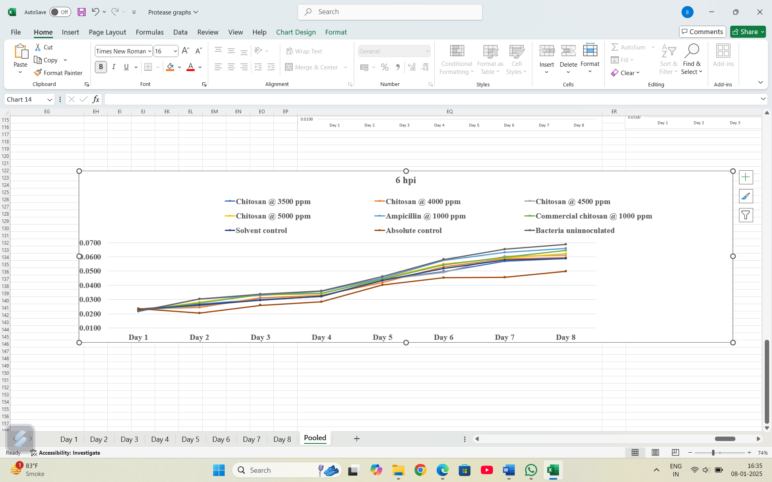

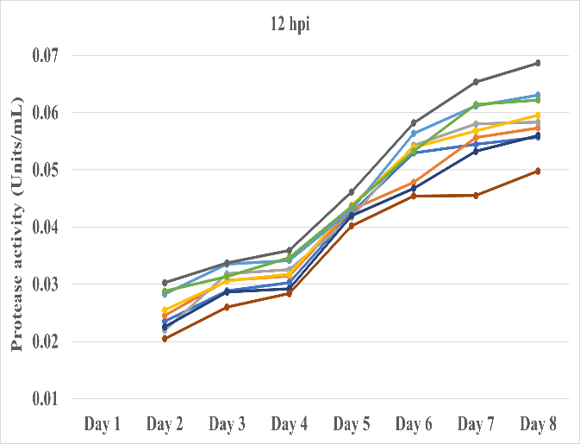
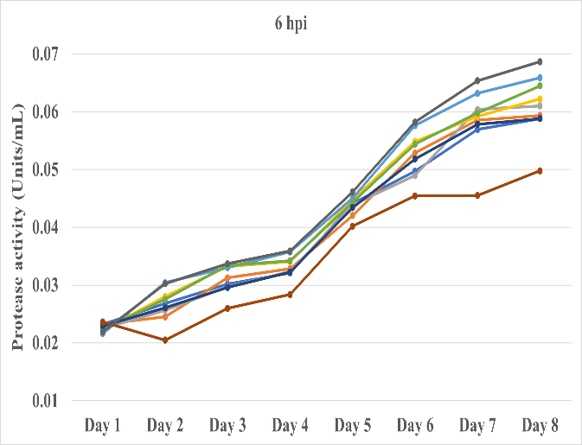

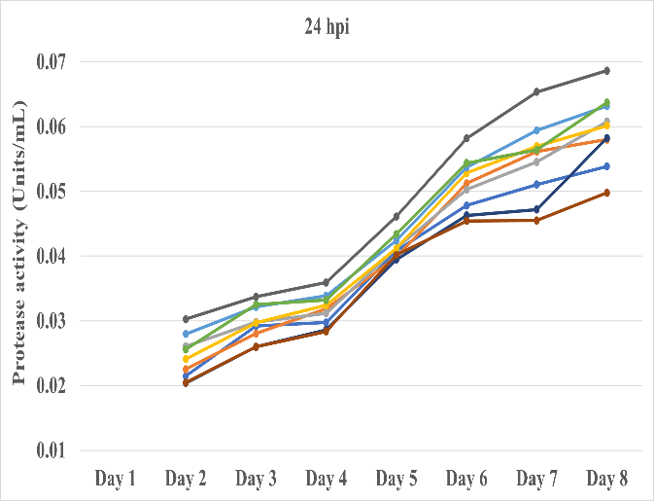
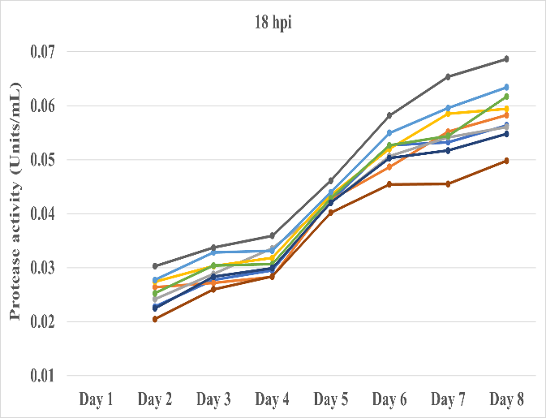

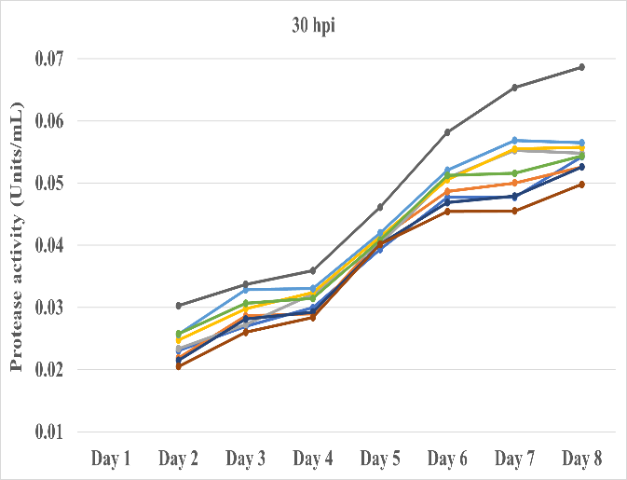

Fig 5: Effect of chitosan on protease activity (Units/mL) in haemolymph of fifth instar silkworm inoculated with S. aureus

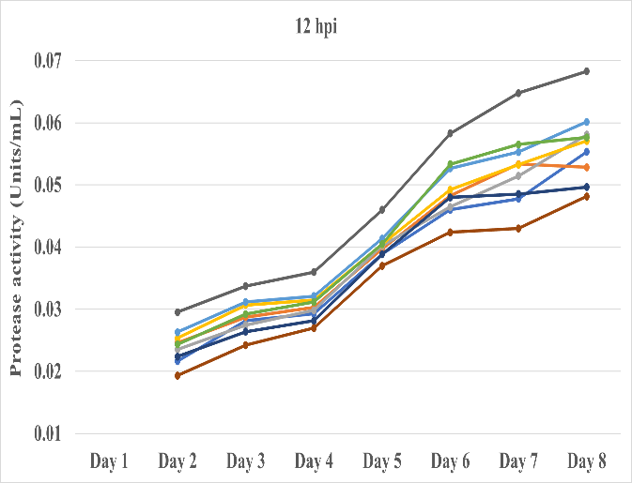
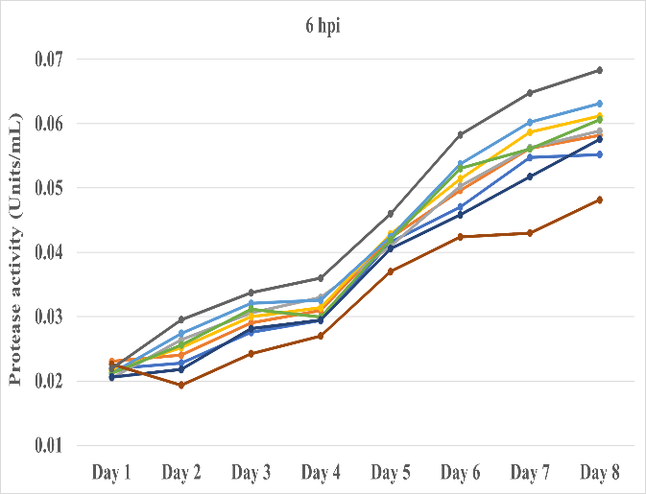

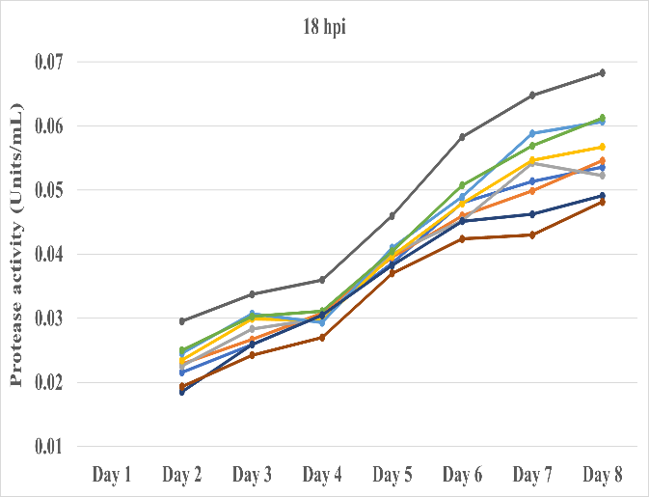
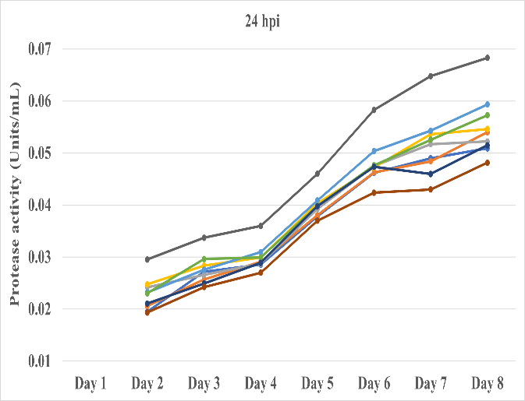

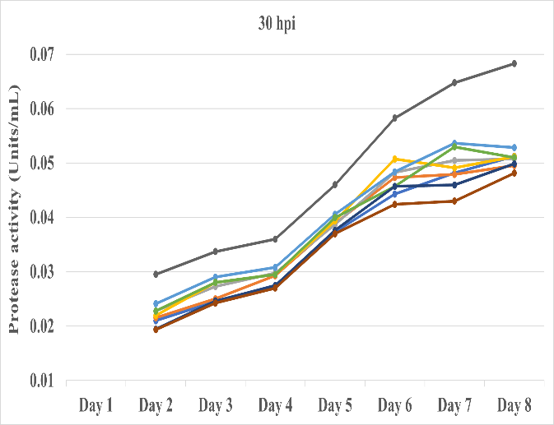

Fig 6: Effect of chitosan on protease activity (Units/mL) in haemolymph of fifth instar silkworm inoculated with B. thuringiensis
Protease activities were remarkably higher in S. aureus inoculated silkworms compared to B. thuringiensis inoculated silkworms across all treatments. From Day 2 onward, every factor bacterial strain, treatment, sampling interval and their complex interactions were statistically significant, underlining that protease activity was not only treatment-dependent but also modulated by the specific hours post-inoculation and the bacteria used. Protease activities were remarkably higher in S. aureus inoculated silkworms compared to B. thuringiensis inoculated silkworms across all treatments. Nevertheless, protease activity fluctuated significantly in batches of silkworms fed with chitosan at different timings after bacterial inoculation. A declining trend in protease activity was observed in batches where chitosan application was postponed or delayed (Fig. 5 and 6; Table 2 A - H).
The observed variations in protease activity across bacterial strains, treatments and time points imply a complex interplay of factors influencing proteolytic processes in silkworms. The elevated protease activity in S. aureus infected silkworms compared to B. thuringiensis infected silkworms likely reflects a more vigorous and robust immune response and lesser tissue damage and pathology caused by S. aureus. Chitosan treatments, especially at higher concentrations, appeared to modulate and regulate protease activity, potentially by influencing immune signalling pathways, affecting protein turnover rates, or altering enzymatic activity. The declining trend in protease activity with delayed chitosan treatment application suggests a potential disruption of immune responses, a reduction in the overall protein turnover rate, or an impairment of cellular homeostasis. The maximum protease activity in the un-inoculated group may be attributed to normal physiological processes such as growth, development and cellular maintenance.
The present results are in agreement with the studies of Lee and Anslee (1995), who reported that protease activity in midgut tissue and digestive fluid of silkworms increased with increasing feeding from the first to the fifth day of the fifth instar and that the secretion of protease occurs in response to feeding. Similarly, Muniv and Bhawane (2012) reported protease activities of 0.611 µg tyrosine/µg protein/h in Pure Mysore, 0.916 µg tyrosine/µg protein/h in Nistari and 0.546 µg tyrosine/µg protein/h in Kolar Gold, which were within the range of the present studies. Furthermore, Mahesha and Kalpana (2012) studied the protease activity of two multivoltine breeds, namely Madagascar and NDV6, during the fifth instar and found that protease activity was highest on the fifth day of the fifth instar larvae and lowest during the pupal stage in NDV6.
Table 2: Day-wise effect of chitosan on protease activity (Units/mL) in haemolymph of fifth instar silkworm inoculated with S. aureus and B. thuringiensis
- Fifth instar first day
Day 1
Treatments (B) | Bacterial strains (A)
Treatments (B) | Sa | Bt | Mean
S₁: Chitosan @ 3500 ppm | 0.0232 | 0.0219 | 0.0226
S₂: Chitosan @ 4000 ppm | 0.0232 | 0.0231 | 0.0231
S₃: Chitosan @ 4500 ppm | 0.0225 | 0.0205 | 0.0215
S₄: Chitosan @ 5000 ppm | 0.0222 | 0.0216 | 0.0219
S₅: Ampicillin @ 1000 ppm | 0.0216 | 0.0212 | 0.0214
S₆: Com. chitosan @ 1000 ppm | 0.0223 | 0.0212 | 0.0218
S₇: Solvent control | 0.0229 | 0.0206 | 0.0218
S₈: Absolute control | 0.0236 | 0.0226 | 0.0231
S₉: Bacteria un-inoculated | 0.0219 | 0.0219 | 0.0219
Mean | 0.0226 | 0.0216 | 0.0221

 | A | B | AB
F-Test | NS | NS | NS
SEm ± | - | - | -
CD @ 5% | - | - | -
Note: * Significant; NS - Non-significant; A- Bacterial strains; B- Treatments; Sa- S. aureus; Bt- B. thuringiensis; Com.- Commercial chitosan

B. Fifth instar second day
Day 2
Treatments (B) |  | Hours of post inoculation (hpi) (C) |  |  |  |  |  |  |  |  |  |  |  |  |  |  |  | Bacterial strains (A) mean |  |  | Treatments (B) mean
 |  | 6 hpi |  |  | 12 hpi |  |  | 18 hpi |  |  | 24 hpi |  |  | 30 hpi |  |  |  |  |  |  | Treatments (B) mean
 |  | Sa | Bt |  | Sa | Bt |  | Sa | Bt |  | Sa | Bt |  | Sa |  | Bt | Sa |  |  | Bt | Treatments (B) mean
S₁: Chitosan @ 3500 ppm |  | 0.0268 | 0.0228 |  | 0.0235 | 0.0216 |  | 0.0228 | 0.0216 |  | 0.0215 | 0.0195 |  | 0.0230 |  | 0.0210 | 0.0235 |  |  | 0.0213 | 0.0224
S₂: Chitosan @ 4000 ppm |  | 0.0245 | 0.0240 |  | 0.0245 | 0.0246 |  | 0.0264 | 0.0229 |  | 0.0225 | 0.0206 |  | 0.0219 |  | 0.0216 | 0.0240 |  |  | 0.0227 | 0.0233
S₃: Chitosan @ 4500 ppm |  | 0.0257 | 0.0264 |  | 0.0220 | 0.0235 |  | 0.0242 | 0.0225 |  | 0.0261 | 0.0242 |  | 0.0234 |  | 0.0228 | 0.0243 |  |  | 0.0239 | 0.0241
S₄: Chitosan @ 5000 ppm |  | 0.0280 | 0.0252 |  | 0.0255 | 0.0253 |  | 0.0274 | 0.0234 |  | 0.0241 | 0.0248 |  | 0.0248 |  | 0.0220 | 0.0260 |  |  | 0.0241 | 0.0250
S₅: Ampicillin @ 1000 ppm |  | 0.0304 | 0.0274 |  | 0.0283 | 0.0263 |  | 0.0277 | 0.0245 |  | 0.0280 | 0.0232 |  | 0.0257 |  | 0.0241 | 0.0280 |  |  | 0.0251 | 0.0266
S₆: Com. chitosan @ 1000 ppm |  | 0.0276 | 0.0256 |  | 0.0288 | 0.0244 |  | 0.0253 | 0.0250 |  | 0.0256 | 0.0230 |  | 0.0257 |  | 0.0228 | 0.0266 |  |  | 0.0242 | 0.0254
S₇: Solvent control |  | 0.0261 | 0.0218 |  | 0.0225 | 0.0224 |  | 0.0225 | 0.0185 |  | 0.0204 | 0.0211 |  | 0.0215 |  | 0.0194 | 0.0226 |  |  | 0.0206 | 0.0216
S₈: Absolute control |  | 0.0205 | 0.0193 |  | 0.0205 | 0.0193 |  | 0.0205 | 0.0193 |  | 0.0205 | 0.0193 |  | 0.0205 |  | 0.0193 | 0.0205 |  |  | 0.0193 | 0.0199
S₉: Bacteria un-inoculated |  | 0.0303 | 0.0295 |  | 0.0303 | 0.0295 |  | 0.0303 | 0.0295 |  | 0.0303 | 0.0295 |  | 0.0303 |  | 0.0295 | 0.0303 |  |  | 0.0295 | 0.0299
Mean |  | 0.0257 |  |  | 0.0246 |  |  | 0.0241 |  |  | 0.0236 |  |  | 0.0233 |  |  | 0.0251 |  |  | 0.0234
Mean A, B, C |  | 0.0242 |  |  |  |  |  |  |  |  |  |  |  |  |  |  | 0.0242 |  |  |  | 0.0242
 | A |  |  | B |  |  | AB |  |  | C |  |  | AC |  | BC |  |  |  | ABC
F-Test | * |  |  | * |  |  | * |  |  | * |  |  | * |  | * |  |  |  | *
SEm ± | 0.0001 |  |  | 0.0001 |  |  | 0.0002 |  |  | 0.0001 |  |  | 0.0002 |  | 0.0003 |  |  |  | 0.0005
CD @ 5% | 0.0001 |  |  | 0.0003 |  |  | 0.0004 |  |  | 0.0002 |  |  | 0.0003 |  | 0.0007 |  |  |  | 0.0009
Note: * Significant; NS - Non-significant; A- Bacterial strains; B- Treatments; C- Hours of post inoculation (hpi); Sa- S. aureus; Bt- B. thuringiensis; Com.- Commercial chitosan

C. Fifth instar third day
Day 3
Treatments (B) |  | Hours of post inoculation (hpi) (C) |  |  |  |  |  |  |  |  |  |  |  |  |  |  | Bacterial strains (A) mean |  |  | Treatments (B) mean
 |  | 6 hpi |  |  | 12 hpi |  |  | 18 hpi |  |  | 24 hpi |  |  | 30 hpi |  |  |  |  |  | Treatments (B) mean
 |  | Sa | Bt |  | Sa | Bt |  | Sa | Bt |  | Sa | Bt |  | Sa |  | Bt | Sa |  | Bt | Treatments (B) mean
S₁: Chitosan @ 3500 ppm |  | 0.0302 | 0.0276 |  | 0.0288 | 0.0281 |  | 0.0278 | 0.0259 |  | 0.0292 | 0.0272 |  | 0.0270 |  | 0.0245 | 0.0286 |  | 0.0267 | 0.0276
S₂: Chitosan @ 4000 ppm |  | 0.0313 | 0.0290 |  | 0.0307 | 0.0287 |  | 0.0272 | 0.0267 |  | 0.0280 | 0.0257 |  | 0.0286 |  | 0.0250 | 0.0292 |  | 0.0270 | 0.0281
S₃: Chitosan @ 4500 ppm |  | 0.0297 | 0.0306 |  | 0.0319 | 0.0275 |  | 0.0288 | 0.0283 |  | 0.0298 | 0.0266 |  | 0.0273 |  | 0.0273 | 0.0295 |  | 0.0280 | 0.0288
S₄: Chitosan @ 5000 ppm |  | 0.0332 | 0.0300 |  | 0.0306 | 0.0307 |  | 0.0303 | 0.0299 |  | 0.0297 | 0.0283 |  | 0.0298 |  | 0.0280 | 0.0307 |  | 0.0294 | 0.0301
S₅: Ampicillin @ 1000 ppm |  | 0.0330 | 0.0321 |  | 0.0335 | 0.0312 |  | 0.0328 | 0.0307 |  | 0.0321 | 0.0276 |  | 0.0328 |  | 0.0290 | 0.0329 |  | 0.0301 | 0.0315
S₆: Com. chitosan @ 1000 ppm |  | 0.0334 | 0.0312 |  | 0.0314 | 0.0292 |  | 0.0304 | 0.0303 |  | 0.0325 | 0.0296 |  | 0.0307 |  | 0.0280 | 0.0317 |  | 0.0297 | 0.0307
S₇: Solvent control |  | 0.0296 | 0.0281 |  | 0.0286 | 0.0264 |  | 0.0283 | 0.0259 |  | 0.0260 | 0.0249 |  | 0.0281 |  | 0.0246 | 0.0281 |  | 0.0260 | 0.0271
S₈: Absolute control |  | 0.0260 | 0.0242 |  | 0.0260 | 0.0242 |  | 0.0260 | 0.0242 |  | 0.0260 | 0.0242 |  | 0.0260 |  | 0.0242 | 0.0260 |  | 0.0242 | 0.0251
S₉: Bacteria un-inoculated |  | 0.0337 | 0.0337 |  | 0.0337 | 0.0337 |  | 0.0337 | 0.0337 |  | 0.0337 | 0.0337 |  | 0.0337 |  | 0.0337 | 0.0337 |  | 0.0337 | 0.0337
Mean |  | 0.0304 |  |  | 0.0297 |  |  | 0.0289 |  |  | 0.0286 |  |  | 0.0283 |  |  | 0.0300 |  | 0.0283
Mean A, B, C |  | 0.0292 |  |  |  |  |  |  |  |  |  |  |  |  |  |  | 0.0292 |  |  | 0.0292
 | A |  |  | B |  |  | AB |  |  | C |  |  | AC |  | BC |  |  | ABC
F-Test | * |  |  | * |  |  | * |  |  | * |  |  | * |  | * |  |  | *
SEm ± | 0.0001 |  |  | 0.0002 |  |  | 0.0002 |  |  | 0.0001 |  |  | 0.0002 |  | 0.0003 |  |  | 0.0005
CD @ 5% | 0.0001 |  |  | 0.0003 |  |  | 0.0004 |  |  | 0.0002 |  |  | 0.0003 |  | 0.0007 |  |  | 0.0009
Note: * Significant; NS - Non-significant; A- Bacterial strains; B- Treatments; C- Hours of post inoculation (hpi); Sa- S. aureus; Bt- B. thuringiensis; Com.- Commercial chitosan

D. Fifth instar fourth day
Day 4
Treatments (B) |  | Hours of post inoculation (hpi) (C) |  |  |  |  |  |  |  |  |  |  |  |  |  |  | Bacterial strains (A) mean |  |  | Treatments (B) mean
 |  | 6 hpi |  |  | 12 hpi |  |  | 18 hpi |  |  | 24 hpi |  |  | 30 hpi |  |  |  |  |  | Treatments (B) mean
 |  | Sa | Bt |  | Sa | Bt |  | Sa | Bt |  | Sa | Bt |  | Sa |  | Bt | Sa |  | Bt | Treatments (B) mean
S₁: Chitosan @ 3500 ppm |  | 0.0321 | 0.0294 |  | 0.0303 | 0.0293 |  | 0.0295 | 0.0305 |  | 0.0298 | 0.0285 |  | 0.0300 |  | 0.0275 | 0.0303 |  | 0.0290 | 0.0297
S₂: Chitosan @ 4000 ppm |  | 0.0328 | 0.0309 |  | 0.0315 | 0.0303 |  | 0.0283 | 0.0308 |  | 0.0319 | 0.0291 |  | 0.0290 |  | 0.0293 | 0.0307 |  | 0.0301 | 0.0304
S₃: Chitosan @ 4500 ppm |  | 0.0323 | 0.0330 |  | 0.0326 | 0.0298 |  | 0.0336 | 0.0300 |  | 0.0312 | 0.0287 |  | 0.0322 |  | 0.0298 | 0.0324 |  | 0.0303 | 0.0313
S₄: Chitosan @ 5000 ppm |  | 0.0341 | 0.0314 |  | 0.0317 | 0.0315 |  | 0.0318 | 0.0297 |  | 0.0324 | 0.0299 |  | 0.0324 |  | 0.0295 | 0.0325 |  | 0.0304 | 0.0314
S₅: Ampicillin @ 1000 ppm |  | 0.0358 | 0.0326 |  | 0.0342 | 0.0321 |  | 0.0331 | 0.0293 |  | 0.0339 | 0.0309 |  | 0.0331 |  | 0.0308 | 0.0340 |  | 0.0311 | 0.0326
S₆: Com. chitosan @ 1000 ppm |  | 0.0342 | 0.0299 |  | 0.0347 | 0.0312 |  | 0.0306 | 0.0311 |  | 0.0332 | 0.0299 |  | 0.0315 |  | 0.0295 | 0.0328 |  | 0.0303 | 0.0316
S₇: Solvent control |  | 0.0323 | 0.0295 |  | 0.0292 | 0.0282 |  | 0.0299 | 0.0305 |  | 0.0286 | 0.0289 |  | 0.0293 |  | 0.0274 | 0.0298 |  | 0.0289 | 0.0294
S₈: Absolute control |  | 0.0284 | 0.0270 |  | 0.0284 | 0.0270 |  | 0.0284 | 0.0270 |  | 0.0284 | 0.0270 |  | 0.0284 |  | 0.0270 | 0.0284 |  | 0.0270 | 0.0277
S₉: Bacteria un-inoculated |  | 0.0359 | 0.0360 |  | 0.0359 | 0.0360 |  | 0.0359 | 0.0360 |  | 0.0359 | 0.0360 |  | 0.0359 |  | 0.0360 | 0.0359 |  | 0.0360 | 0.0360
Mean |  | 0.0321 |  |  | 0.0313 |  |  | 0.0309 |  |  | 0.0308 |  |  | 0.0305 |  |  | 0.0319 |  | 0.0303
Mean A, B, C |  | 0.0311 |  |  |  |  |  |  |  |  |  |  |  |  |  |  | 0.0311 |  |  | 0.0311
 | A |  |  | B |  |  | AB |  |  | C |  |  | AC |  | BC |  |  | ABC
F-Test | * |  |  | * |  |  | * |  |  | * |  |  | * |  | * |  |  | *
SEm ± | 0.0000 |  |  | 0.0001 |  |  | 0.0001 |  |  | 0.0001 |  |  | 0.0001 |  | 0.0002 |  |  | 0.0003
CD @ 5% | 0.0001 |  |  | 0.0002 |  |  | 0.0003 |  |  | 0.0001 |  |  | 0.0002 |  | 0.0004 |  |  | 0.0006
Note: * Significant; NS - Non-significant; A- Bacterial strains; B- Treatments; C- Hours of post inoculation (hpi); Sa- S. aureus; Bt- B. thuringiensis; Com.- Commercial chitosan

E. Fifth instar fifth day
Day 5
Treatments (B) |  | Hours of post inoculation (hpi) (C) |  |  |  |  |  |  |  |  |  |  |  |  |  |  |  | Bacterial strains (A) mean |  |  | Treatments (B) mean
 |  | 6 hpi |  |  | 12 hpi |  |  | 18 hpi |  |  | 24 hpi |  |  | 30 hpi |  |  |  |  |  |  | Treatments (B) mean
 |  | Sa | Bt |  | Sa | Bt |  | Sa | Bt |  | Sa | Bt |  | Sa |  | Bt | Sa |  |  | Bt | Treatments (B) mean
S₁: Chitosan @ 3500 ppm |  | 0.0441 | 0.0416 |  | 0.0425 | 0.0389 |  | 0.0424 | 0.0386 |  | 0.0408 | 0.0378 |  | 0.0393 |  | 0.0373 | 0.0418 |  |  | 0.0388 | 0.0403
S₂: Chitosan @ 4000 ppm |  | 0.0420 | 0.0422 |  | 0.0430 | 0.0397 |  | 0.0425 | 0.0395 |  | 0.0398 | 0.0380 |  | 0.0411 |  | 0.0389 | 0.0417 |  |  | 0.0397 | 0.0407
S₃: Chitosan @ 4500 ppm |  | 0.0439 | 0.0409 |  | 0.0417 | 0.0402 |  | 0.0420 | 0.0401 |  | 0.0412 | 0.0392 |  | 0.0403 |  | 0.0387 | 0.0418 |  |  | 0.0398 | 0.0408
S₄: Chitosan @ 5000 ppm |  | 0.0448 | 0.0428 |  | 0.0438 | 0.0404 |  | 0.0435 | 0.0397 |  | 0.0412 | 0.0403 |  | 0.0414 |  | 0.0393 | 0.0429 |  |  | 0.0405 | 0.0417
S₅: Ampicillin @ 1000 ppm |  | 0.0451 | 0.0424 |  | 0.0430 | 0.0414 |  | 0.0440 | 0.0410 |  | 0.0424 | 0.0409 |  | 0.0420 |  | 0.0406 | 0.0433 |  |  | 0.0412 | 0.0423
S₆: Com. chitosan @ 1000 ppm |  | 0.0443 | 0.0419 |  | 0.0436 | 0.0405 |  | 0.0428 | 0.0404 |  | 0.0434 | 0.0398 |  | 0.0408 |  | 0.0400 | 0.0430 |  |  | 0.0405 | 0.0418
S₇: Solvent control |  | 0.0434 | 0.0406 |  | 0.0420 | 0.0388 |  | 0.0420 | 0.0382 |  | 0.0395 | 0.0398 |  | 0.0402 |  | 0.0376 | 0.0414 |  |  | 0.0390 | 0.0402
S₈: Absolute control |  | 0.0402 | 0.0370 |  | 0.0402 | 0.0370 |  | 0.0402 | 0.0370 |  | 0.0402 | 0.0370 |  | 0.0402 |  | 0.0370 | 0.0402 |  |  | 0.0370 | 0.0386
S₉: Bacteria un-inoculated |  | 0.0461 | 0.0460 |  | 0.0461 | 0.0460 |  | 0.0461 | 0.0460 |  | 0.0461 | 0.0460 |  | 0.0461 |  | 0.0460 | 0.0461 |  |  | 0.0460 | 0.0461
Mean |  | 0.0427 |  |  | 0.0416 |  |  | 0.0415 |  |  | 0.0407 |  |  | 0.0404 |  |  | 0.0425 |  |  | 0.0403
Mean A, B, C |  | 0.0414 |  |  |  |  |  |  |  |  |  |  |  |  |  |  | 0.0414 |  |  |  | 0.0414
 | A |  |  | B |  |  | AB |  |  | C |  |  | AC |  | BC |  |  |  | ABC
F-Test | * |  |  | * |  |  | * |  |  | * |  |  | * |  | * |  |  |  | *
SEm ± | 0.0001 |  |  | 0.0001 |  |  | 0.0002 |  |  | 0.0001 |  |  | 0.0001 |  | 0.0002 |  |  |  | 0.0003
CD @ 5% | 0.0001 |  |  | 0.0002 |  |  | 0.0003 |  |  | 0.0002 |  |  | 0.0002 |  | 0.0005 |  |  |  | 0.0007
Note: * Significant; NS - Non-significant; A- Bacterial strains; B- Treatments; C- Hours of post inoculation (hpi); Sa- S. aureus; Bt- B. thuringiensis; Com.- Commercial chitosan

F. Fifth instar sixth day
Day 6
Treatments (B) |  | Hours of post inoculation (hpi) (C) |  |  |  |  |  |  |  |  |  |  |  |  |  |  |  | Bacterial strains (A) mean |  |  | Treatments (B) mean
 |  | 6 hpi |  |  | 12 hpi |  |  | 18 hpi |  |  | 24 hpi |  |  | 30 hpi |  |  |  |  |  |  | Treatments (B) mean
 |  | Sa | Bt |  | Sa | Bt |  | Sa | Bt |  | Sa | Bt |  | Sa |  | Bt | Sa |  |  | Bt | Treatments (B) mean
S₁: Chitosan @ 3500 ppm |  | 0.0497 | 0.0470 |  | 0.0529 | 0.0460 |  | 0.0527 | 0.0480 |  | 0.0478 | 0.0462 |  | 0.0477 |  | 0.0443 | 0.0502 |  |  | 0.0463 | 0.0482
S₂: Chitosan @ 4000 ppm |  | 0.0529 | 0.0496 |  | 0.0478 | 0.0483 |  | 0.0487 | 0.0460 |  | 0.0512 | 0.0463 |  | 0.0487 |  | 0.0473 | 0.0498 |  |  | 0.0475 | 0.0487
S₃: Chitosan @ 4500 ppm |  | 0.0489 | 0.0503 |  | 0.0543 | 0.0465 |  | 0.0507 | 0.0452 |  | 0.0503 | 0.0475 |  | 0.0509 |  | 0.0483 | 0.0510 |  |  | 0.0476 | 0.0493
S₄: Chitosan @ 5000 ppm |  | 0.0548 | 0.0514 |  | 0.0539 | 0.0492 |  | 0.0520 | 0.0479 |  | 0.0529 | 0.0472 |  | 0.0506 |  | 0.0508 | 0.0528 |  |  | 0.0493 | 0.0511
S₅: Ampicillin @ 1000 ppm |  | 0.0576 | 0.0537 |  | 0.0564 | 0.0527 |  | 0.0549 | 0.0489 |  | 0.0537 | 0.0504 |  | 0.0521 |  | 0.0484 | 0.0549 |  |  | 0.0508 | 0.0529
S₆: Com. chitosan @ 1000 ppm |  | 0.0544 | 0.0530 |  | 0.0532 | 0.0533 |  | 0.0527 | 0.0508 |  | 0.0544 | 0.0476 |  | 0.0512 |  | 0.0457 | 0.0532 |  |  | 0.0501 | 0.0516
S₇: Solvent control |  | 0.0518 | 0.0458 |  | 0.0468 | 0.0480 |  | 0.0503 | 0.0451 |  | 0.0463 | 0.0473 |  | 0.0469 |  | 0.0457 | 0.0484 |  |  | 0.0464 | 0.0474
S₈: Absolute control |  | 0.0454 | 0.0424 |  | 0.0454 | 0.0424 |  | 0.0454 | 0.0424 |  | 0.0454 | 0.0424 |  | 0.0454 |  | 0.0424 | 0.0454 |  |  | 0.0424 | 0.0439
S₉: Bacteria un-inoculated |  | 0.0582 | 0.0583 |  | 0.0582 | 0.0583 |  | 0.0582 | 0.0583 |  | 0.0582 | 0.0583 |  | 0.0582 |  | 0.0583 | 0.0582 |  |  | 0.0583 | 0.0582
Mean |  | 0.0514 |  |  | 0.0508 |  |  | 0.0499 |  |  | 0.0496 |  |  | 0.0490 |  |  | 0.0516 |  |  | 0.0487
Mean A, B, C |  | 0.0501 |  |  |  |  |  |  |  |  |  |  |  |  |  |  | 0.0501 |  |  |  | 0.0501
 | A |  |  | B |  |  | AB |  |  | C |  |  | AC |  | BC |  |  |  | ABC
F-Test | * |  |  | * |  |  | * |  |  | * |  |  | * |  | * |  |  |  | *
SEm ± | 0.0001 |  |  | 0.0002 |  |  | 0.0002 |  |  | 0.0001 |  |  | 0.0002 |  | 0.0004 |  |  |  | 0.0005
CD @ 5% | 0.0002 |  |  | 0.0003 |  |  | 0.0005 |  |  | 0.0002 |  |  | 0.0003 |  | 0.0007 |  |  |  | 0.0010
Note: * Significant; NS - Non-significant; A- Bacterial strains; B- Treatments; C- Hours of post inoculation (hpi); Sa- S. aureus; Bt- B. thuringiensis; Com.- Commercial chitosan

G. Fifth instar seventh day
Day 7
Treatments (B) |  | Hours of post inoculation (hpi) (C) |  |  |  |  |  |  |  |  |  |  |  |  |  |  |  | Bacterial strains (A) mean |  |  | Treatments (B) mean
 |  | 6 hpi |  |  | 12 hpi |  |  | 18 hpi |  |  | 24 hpi |  |  | 30 hpi |  |  |  |  |  |  | Treatments (B) mean
 |  | Sa | Bt |  | Sa | Bt |  | Sa | Bt |  | Sa | Bt |  | Sa |  | Bt | Sa |  |  | Bt | Treatments (B) mean
S₁: Chitosan @ 3500 ppm |  | 0.0569 | 0.0547 |  | 0.0545 | 0.0478 |  | 0.0532 | 0.0514 |  | 0.0510 | 0.0490 |  | 0.0477 |  | 0.0482 | 0.0527 |  |  | 0.0502 | 0.0514
S₂: Chitosan @ 4000 ppm |  | 0.0585 | 0.0561 |  | 0.0556 | 0.0534 |  | 0.0552 | 0.0499 |  | 0.0561 | 0.0484 |  | 0.0500 |  | 0.0479 | 0.0551 |  |  | 0.0511 | 0.0531
S₃: Chitosan @ 4500 ppm |  | 0.0604 | 0.0563 |  | 0.0580 | 0.0514 |  | 0.0541 | 0.0542 |  | 0.0545 | 0.0517 |  | 0.0552 |  | 0.0505 | 0.0565 |  |  | 0.0528 | 0.0546
S₄: Chitosan @ 5000 ppm |  | 0.0592 | 0.0587 |  | 0.0568 | 0.0532 |  | 0.0585 | 0.0547 |  | 0.0570 | 0.0536 |  | 0.0555 |  | 0.0491 | 0.0574 |  |  | 0.0539 | 0.0556
S₅: Ampicillin @ 1000 ppm |  | 0.0632 | 0.0602 |  | 0.0612 | 0.0553 |  | 0.0596 | 0.0588 |  | 0.0594 | 0.0543 |  | 0.0568 |  | 0.0536 | 0.0600 |  |  | 0.0564 | 0.0582
S₆: Com. chitosan @ 1000 ppm |  | 0.0597 | 0.0561 |  | 0.0614 | 0.0565 |  | 0.0544 | 0.0569 |  | 0.0564 | 0.0525 |  | 0.0516 |  | 0.0530 | 0.0567 |  |  | 0.0550 | 0.0559
S₇: Solvent control |  | 0.0578 | 0.0518 |  | 0.0532 | 0.0485 |  | 0.0517 | 0.0462 |  | 0.0472 | 0.0460 |  | 0.0479 |  | 0.0460 | 0.0516 |  |  | 0.0477 | 0.0496
S₈: Absolute control |  | 0.0455 | 0.0430 |  | 0.0455 | 0.0430 |  | 0.0455 | 0.0430 |  | 0.0455 | 0.0430 |  | 0.0455 |  | 0.0430 | 0.0455 |  |  | 0.0430 | 0.0443
S₉: Bacteria un-inoculated |  | 0.0654 | 0.0648 |  | 0.0654 | 0.0648 |  | 0.0654 | 0.0648 |  | 0.0654 | 0.0648 |  | 0.0654 |  | 0.0648 | 0.0654 |  |  | 0.0648 | 0.0651
Mean |  | 0.0571 |  |  | 0.0548 |  |  | 0.0543 |  |  | 0.0531 |  |  | 0.0518 |  |  | 0.0556 |  |  | 0.0528
Mean A, B, C |  | 0.0542 |  |  |  |  |  |  |  |  |  |  |  |  |  |  | 0.0542 |  |  |  | 0.0542
 | A |  |  | B |  |  | AB |  |  | C |  |  | AC |  | BC |  |  |  | ABC
F-Test | * |  |  | * |  |  | * |  |  | * |  |  | * |  | * |  |  |  | *
SEm ± | 0.0001 |  |  | 0.0001 |  |  | 0.0002 |  |  | 0.0001 |  |  | 0.0001 |  | 0.0003 |  |  |  | 0.0004
CD @ 5% | 0.0001 |  |  | 0.0003 |  |  | 0.0004 |  |  | 0.0002 |  |  | 0.0003 |  | 0.0006 |  |  |  | 0.0009
Note: * Significant; NS - Non-significant; A- Bacterial strains; B- Treatments; C- Hours of post inoculation (hpi); Sa- S. aureus; Bt- B. thuringiensis; Com.- Commercial chitosan

H. Fifth instar eighth day
Day 8
Treatments (B) |  | Hours of post inoculation (hpi) (C) |  |  |  |  |  |  |  |  |  |  |  |  |  |  |  | Bacterial strains (A) mean |  |  | Treatments (B) mean
 |  | 6 hpi |  |  | 12 hpi |  |  | 18 hpi |  |  | 24 hpi |  |  | 30 hpi |  |  |  |  |  |  | Treatments (B) mean
 |  | Sa | Bt |  | Sa | Bt |  | Sa | Bt |  | Sa | Bt |  | Sa |  | Bt | Sa |  |  | Bt | Treatments (B) mean
S₁: Chitosan @ 3500 ppm |  | 0.0588 | 0.0552 |  | 0.0557 | 0.0553 |  | 0.0564 | 0.0536 |  | 0.0539 | 0.0509 |  | 0.0542 |  | 0.0513 | 0.0558 |  |  | 0.0532 | 0.0545
S₂: Chitosan @ 4000 ppm |  | 0.0593 | 0.0582 |  | 0.0573 | 0.0528 |  | 0.0582 | 0.0546 |  | 0.0580 | 0.0540 |  | 0.0526 |  | 0.0495 | 0.0571 |  |  | 0.0538 | 0.0555
S₃: Chitosan @ 4500 ppm |  | 0.0610 | 0.0589 |  | 0.0583 | 0.0581 |  | 0.0561 | 0.0523 |  | 0.0608 | 0.0522 |  | 0.0548 |  | 0.0508 | 0.0582 |  |  | 0.0544 | 0.0563
S₄: Chitosan @ 5000 ppm |  | 0.0622 | 0.0612 |  | 0.0595 | 0.0571 |  | 0.0594 | 0.0567 |  | 0.0601 | 0.0546 |  | 0.0558 |  | 0.0512 | 0.0594 |  |  | 0.0562 | 0.0578
S₅: Ampicillin @ 1000 ppm |  | 0.0659 | 0.0631 |  | 0.0631 | 0.0601 |  | 0.0634 | 0.0607 |  | 0.0632 | 0.0593 |  | 0.0565 |  | 0.0528 | 0.0624 |  |  | 0.0592 | 0.0608
S₆: Com. chitosan @ 1000 ppm |  | 0.0645 | 0.0606 |  | 0.0622 | 0.0576 |  | 0.0617 | 0.0612 |  | 0.0637 | 0.0573 |  | 0.0544 |  | 0.0510 | 0.0613 |  |  | 0.0576 | 0.0594
S₇: Solvent control |  | 0.0588 | 0.0576 |  | 0.0560 | 0.0497 |  | 0.0548 | 0.0491 |  | 0.0582 | 0.0515 |  | 0.0526 |  | 0.0499 | 0.0561 |  |  | 0.0515 | 0.0538
S₈: Absolute control |  | 0.0498 | 0.0481 |  | 0.0498 | 0.0481 |  | 0.0498 | 0.0481 |  | 0.0498 | 0.0481 |  | 0.0498 |  | 0.0481 | 0.0498 |  |  | 0.0481 | 0.0490
S₉: Bacteria un-inoculated |  | 0.0687 | 0.0683 |  | 0.0687 | 0.0683 |  | 0.0687 | 0.0683 |  | 0.0687 | 0.0683 |  | 0.0687 |  | 0.0683 | 0.0687 |  |  | 0.0683 | 0.0685
Mean |  | 0.0600 |  |  | 0.0577 |  |  | 0.0574 |  |  | 0.0574 |  |  | 0.0540 |  |  | 0.0587 |  |  | 0.0558
Mean A, B, C |  | 0.0573 |  |  |  |  |  |  |  |  |  |  |  |  |  |  | 0.0573 |  |  |  | 0.0573
 | A |  |  | B |  |  | AB |  |  | C |  |  | AC |  | BC |  |  |  | ABC
F-Test | * |  |  | * |  |  | * |  |  | * |  |  | * |  | * |  |  |  | *
SEm ± | 0.0001 |  |  | 0.0001 |  |  | 0.0002 |  |  | 0.0001 |  |  | 0.0001 |  | 0.0003 |  |  |  | 0.0004
CD @ 5% | 0.0001 |  |  | 0.0003 |  |  | 0.0004 |  |  | 0.0002 |  |  | 0.0003 |  | 0.0006 |  |  |  | 0.0008
Note: * Significant; NS - Non-significant; A- Bacterial strains; B- Treatments; C- Hours of post inoculation (hpi); Sa- S. aureus; Bt- B. thuringiensis; Com.- Commercial chitosan

4. CONCLUSION
In conclusion, the study demonstrated that chitosan treatment significantly influenced protein content and protease activity in silkworms infected with S. aureus and B. thuringiensis. The total protein content increased substantially in silkworms treated with chitosan, particularly at higher concentrations and in those treated with ampicillin. In contrast, the control groups showed a decline in protein content, indicating a negative impact of infection on silkworm health. Notably, protein content levels were higher in S. aureus-inoculated silkworms compared to B. thuringiensis-inoculated silkworms, suggesting differences in the virulence and pathogenesis of these bacteria.
Protease activity also varied significantly across treatments, bacterial strains and time points. Chitosan treatment modulated protease activity, potentially by influencing immune signalling pathways or protein turnover rates. The maximum protease activity was observed in the uninoculated group, likely due to normal physiological processes. The study's findings are consistent with previous research, highlighting the complex interplay of factors influencing proteolytic processes in silkworms.
The results suggest that early application of chitosan can provide a more robust and sustained immune response, leading to better protein utilization and overall health in infected silkworms. Delayed chitosan application, on the other hand, may allow infections to progress, impacting the silkworm's ability to effectively utilize protein resources. These findings have implications for the development of novel strategies to improve silkworm health and productivity, particularly in the context of bacterial infections. Further research is needed to fully understand the mechanisms underlying chitosan's effects on protein content and protease activity in silkworms.

Conflict of interest:
I confirm that, I or my relative have a financial or other interest in the subject / matter of the work in which I will be involved, which may be considered as constituting a real, potential or apparent conflict of interest.

Disclaimer (Artificial intelligence)
We hereby declare that NO generative AI technologies such as Large Language Models (ChatGPT, COPILOT, etc.) and text-to-image generators have been used during the writing or editing of this manuscript.

5. REFERENCES
Anantha Selvi, G. S., Chelladurai, D., Pattu Kumar, V. & Navin Chandran, M. (2023) Bacterial flacherie in Bombyx mori L.: Isolation and identification of pathogenic organism. Uttar Pradesh J. Zool., 44 (14), 52-61.
Bhat, S. A. & Nataraju, B. (2008) Changes in the concentration of proteins in the selected tissues of healthy and microsporidian infected larvae of Lamerin breed of silkworm, Bombyx mori L. SKUAST J. Res., 10, 72- 75.
Cupp-Enyard (2018) Sigma's non-specific protease activity assay - casein as a substrate. J. Vis. Expt., 19, 1-3.
Dandin, S. B. & Giridhar, K. (2014) Handbook of Sericulture Technologies, CSB, Madivala, Bangalore, pp. 335-385.
Habeanu, M., Anca, G., Georgeta, D. & Teodor, M. (2024) An in-depth insight into the profile, mechanisms, functions and transfer of essential amino acids from mulberry leaves to silkworm Bombyx mori L. pupae and fish. Insects, 15 (5), 332-343.
Hobbs, J., Katzfuss, M., Nguyen, H., Yadav, V. & Liu, J. (2024) Functional analysis of variance (ANOVA) for carbon flux estimates from remote sensing data. Geoscientific Model Development, 17, 1133-1151.
Kumar, D., Pandey, J. P., Jain, J., Mishra, P. K. & Prasad, B. C. (2011) Qualitative and quantitative changes in protein profile of various tissue of tropical tasar silkworm, Antheraea mylitta Drury. Int. J. Zool. Res., 7, 147-155.
Lee, M. J. & Anslee, J. H. (1995) Endopeptidase from the midgut of larva Spodoptera littoralis include a chymotrypsin like enzyme with an extended binding site. Insect Biochem. Mol. Biol., 25, 49-61.
Lowry, O. H., Rosebrough, N. J., Farr, A. L. & Randall, R. S. (1951) Protein measurement with the Folin Phenol reagent. J. Biol. Chem., 93, 265-275.
Ma, L., Zhou, L., Lin, J., Jiuyuan, J., Yang, W., Haobo, J., Xihui, S. & Zhiqiang, L. (2018) Manipulation of the silkworm immune system by a metalloprotease from the pathogenic bacterium Pseudomonas aeruginosa. Devp. Comp. Immunol., 24 (90), 176-185.
Mahesh, D. S., Vidhathri, B. S., Narayanaswamy, T. K., Subbarayappa, C. T., Muthuraju, R. & Shruthi, P., 2015, Bio-nutritional science of silkworm pupal residue to many new ways for utilization. Int. J. Adv. Res. Biol. Sci., 2 (9), 35-40.
Mahesha, J. & Kalpana, G. V. (2012) Total midgut protein and protease activity during different stages of multivoltine breeds of silkworm, Bombyx mori L. and their hybrids. Cibtech. J. Zool., 1 (1), 99-105.
Manjunath Gowda (2009) Inheritance of tolerance to BmNPV among popular breeds of silkworm, Bombyx mori L. Ph. D. Thesis, UAS, Bangalore, P.182.
Muniv, Y. S. & Bhawane, G. P. (2012) Comparative study on the characteristics of midgut protease in different multivoltine races of silkworm, Bombyx mori L. Biol. Forum Int. J., 4 (1), 75-78.
Otho, S. A., Chen, K., Zhang, Y., Wang, P. & Lu, Z. (2016) Silkworm ferritin 1 heavy chain homolog is involved in defence against bacterial infection through regulation of haemolymph iron homeostasis. Devp. Comp. Immunol., 55, 152-158.
Priyadarshini, P., Mahalingam, C. A., Prabhu, S., Thangamalar, A. & Umapathy, G. (2018) In-vivo antibacterial effect of chitosan against S. aureus and B. thuringiensis and its impact on economic parameters of silkworm, Bombyx mori. L. J. Pharmacognosy Phytochem., 7 (2), 2448-2451.
Rittick, M., Dipanjan, D. & Amit Kumar, M. (2025) Antibiotic stewardship in silkworms: navigating the pros and cons. Bacteria, 4 (2), 111-122.

Surendranath, B., Suresh, A., Mahendra Varma, B. & Kumar, R. S. (1997) Changes in protein metabolism in haemolymph and fat body of the silkworm, Bombyx mori L., in response to organophosphorus insecticides toxicity, Ecotoxicol. Envi. Saf., 36, 169-173.
Suresh, H. N., Mahalingam, C. A. & Pallavi (2012) Amount of chitin, chitosan and chitosan based on chitin weight in pure races of multivoltine and bivoltine silkworm pupae Bombyx mori L. Int. J. Sci. Nature, 3, 214.
Thirupathamma, D. & Savithri, G. (2014) Day to day changes in protein levels of silkworm Bombyx mori L. infected with Beauveria bassiana (Bals) Vuill. World J. Pharma. Res., 3 (4), 1473-1482.
Younus, M. W. (2021) Identification of superior breeds of mulberry silkworm (B. mori L.) based on biochemical analysis. Ph. D. Thesis, SKUAST, Jammu, P. 185.

