Influence of Physical and Environmental Factors on the Life Cycle of the Black Soldier Fly (Hermetia illucens)

ABSTRACT
In the present study effects of different factors such as temperature,humidity,moisture content of substrate,larval density,salinity of substrate on duration of different life stages of Hermetia illucens have been analysed and their effects are also discussed. Hermetia illucens,commonly known as Black soldier fly can be considered as one of the important species in the field of bioconversion.As an efficient way of disposing waste and conversion into a protein rich and fat rich biomass, the larva becomes suitable as feed for various livestock species particularly fish,poultry,pig,goat etc.The study was carried out from November 2022 to May 2023 in the laboratory of Pandit Deendayal Upadhyaya Adarsha Mahavidyalaya,Dalgaon,Darrang. The study revealed some variation in the length of life-cycle of the larva which was found to be dependent on different seasonal and environmental factors as mentioned above.The main advantage of this fly culture is that the larva feeds on waste materials which are of plant and animal origin,food waste,slaughterhouse waste, sludge etc. The black soldier larva is rich in nutrients, averaging42.1-43.2%crude protein, 33% protein and also micronutrients. Therefore it may better considered to be a alternative to commercially available feed for the livestock and also for recycling. This fly culture or the whole practice may evolve as an alternate pathway for the animal husbandry.
Key Words: Black soldier fly, environmental factor, bioconversion, recycling.

INTRODUCTION
“One of the most innovative technologies for waste management is the bioconversion by use of insects” (Cickova et al., 2015). “Many insects naturally feed on organic wastes, converting it into their own biomass and thus reducing the amount of waste material. Hermetia illucens better known as the black soldier fly is one of the most important species proposed as a converter of organic waste. Pre-pupal black soldier flies comprise of 42% protein and 35% fat, including essential amino and fatty acids. It is a large wasp like fly distributed throughout tropical and temperate regions. The present study explores its biology as it is not known so far”. (Akoijam et al. 2019)
Rearing Hermetia illucens has been proposed since the 1990s as an efficient way to dispose of organic wastes, by converting them into a protein rich and fat rich biomass suitable for various purposes, including animal feeding for all livestock species, biodiesel and chitin production.
“BSF larvae encourage a high rate of waste biomass conversion. For example, it has been reported that the initial capacity of kitchen and municipal waste has been reduced by 50%–80%, and the biomass yield of BSF is higher (approximately 15% as compared to the larval weight). The Larvae of BSF are also quite effective in handling wastes contaminated by heavy metals or pesticides. BSF larvae feed voraciously on organic waste, like rotting plants or animal organs, animal or human manure, food waste, slaughterhouse waste, distiller grains, sludge, etc”. (Singh and Kumari, 2019). According to reports, “the phosphorus and nitrogen contents of waste are significantly reduced to 85% and 75%, respectively. Due to releasing carbon dioxide (CO₂) into the atmosphere, this technology has some global warming potential. However, the former has been concealed due to its many advantages and ability to promote carbon sequestration. Compared to other traditional composting methods, the global warming potential of BSF technology is minimal” (Salomone et al., 2017). “Black soldier larvae have high proteins, lipids, polysaccharides, calcium, etc”. (Popa and Green, 2012). “In the larval stage, the black soldier fly can reduce fecal waste by 50%” (Nguyen et al., 2015). “BSF larvae, after waste treatment, are rich in nutrients, averaging 42.1–43.2% crude protein, 33% fat, and micronutrients. Therefore, they are promoted as a suitable substitute for fish or soybean meals in poultry, pig, and fish feed and provide income-generating opportunities” (Chia et al., 2018b). “Diptera can feed voraciously on various waste streams and convert organic composites into larval biomass, which can be used as animal feed. This capacity can be harnessed in the circular economy for recycling organic food waste and mitigating the adverse effects caused by its release into the environment” (Dzepe et al., 2021).
The main objectives of present studyare ------
- To study effects of different physical and environmental factors on the life-cycle of Black Soldier fly.
- To record the time period for development of each stage to the next.
- To measure average length, average weight and average width of egg, larva, pupa and adult stage.
MATERIALS AND METHODS:
The insect species i.e. Black soldier fly (Hermetia illucens) is a fly (Diptera) of the Stratiomyidae family. The study was conducted under laboratory condition in the departmental laboratory of Pandit Deendayal Upadhyaya Adarsha Mahavidyalaya,Dalgaon,Darrang,Assam from November,2022 up to May,2023. After laying by adult female, eggs were processed for hatching. Then a mixture of organic waste and rice bane was supplied as food to the pre-larvae. After 4 to 5 days of pre-larvae, small amount of food (20% body weight of larvae) was supplied. The food was given once dailyand the process continues. Then the larvae wereleft in the rearingcage. When the larvae attained the stage of 5th instar larva or pre-pupa then intake of food by the larvae become low. After attaining the pupa stage they completely stopsintake of food. We left inthis stage of pupa till adult emergence for mass culture. When fly emerges from pupa then we sprayed water mixed with water inside the net. The adult fly died after laying eggs.
The length, breath and weight of different developmental stages were measured by using measuring scale and electronic balance respectively. The colorvariation was also recorded through regular observation.
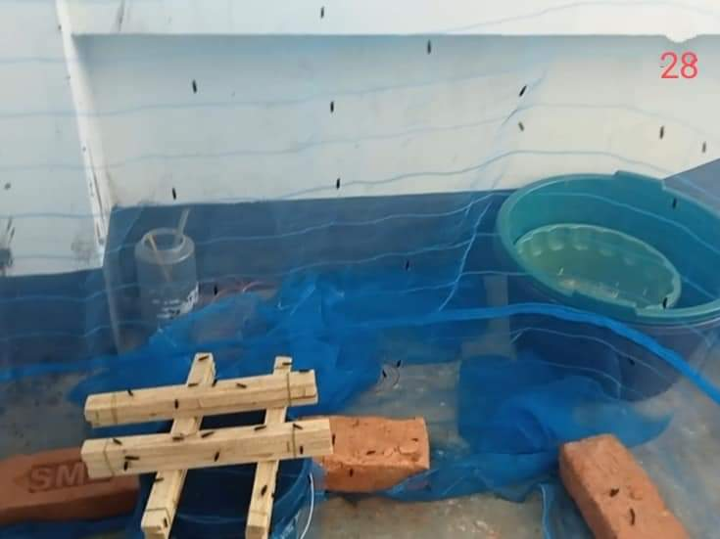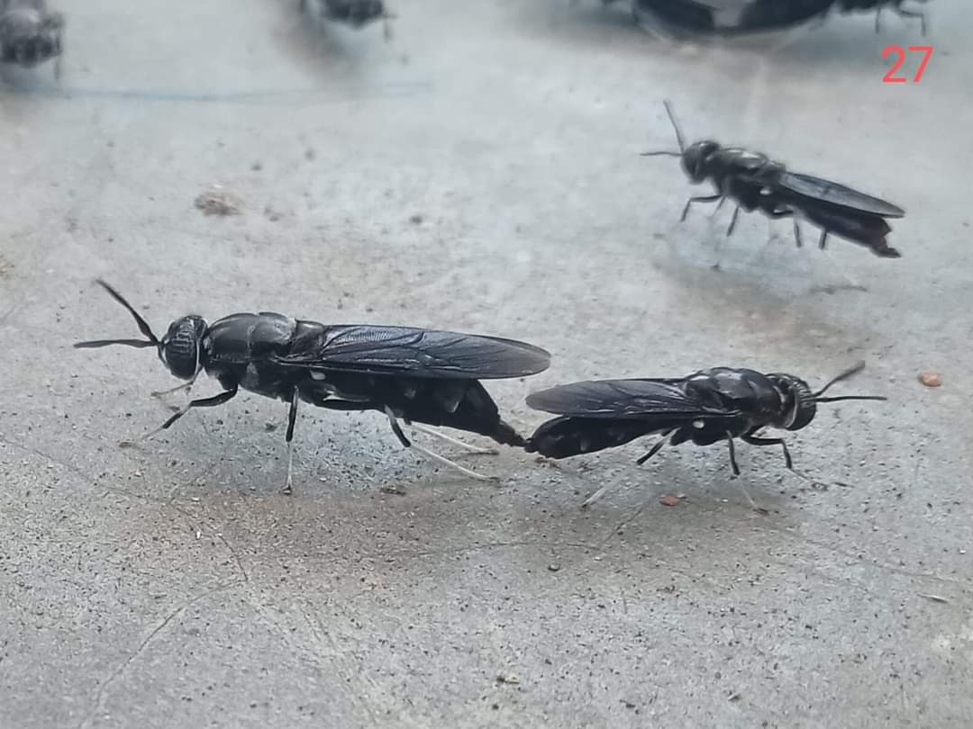
Fig1: Culture of Black Soldier Fly Fig 2: Mating of Adult flies
RESULT AND DISCUSSION:
Present study reveals variation of two developmental stages of life cycle. One cycle covered a period of 68 days but another cycle covered a total of 180 days. In the first cycle, duration of egg stage was recorded 4days.The larval stage covered a total of 21 days. Pre-pupa and Pupa stage covered a total of 16 days and 9 days respectively. The cycle was completed within 68 days. Likewise, the maximum length attained during egg stage was 0.9±0.1mm, in larval stage it was 15.9 ± 0.97 mm, in pre-pupal stage found as 17.30±0.28mm, in pupal stage found as 18.0 ± 0.16mm and in adult stage found as 17.03±0.17mm. The maximum weight gained during egg stage was 0.000027±0.9gm, in larval stage was 0.12±0.01gm,in pre-pupal stage found as 0.13±0.02gm ,in pupal stage found as 0.13±0.01gm and in adult stage found as 0.13±0.02gm.The measurements of breadth was also found varied from egg stage to adult stages. In egg stage the value of breadth was recorded 0.2 ±0.1mm. In larval stage the maximum value was recorded as3.07 ± 0.05mm.In prepupa and pupal stage the maximum value of breadth recorded was 3.55±0.49mm and 4.50±0.28mm.The value of breadth found in adult stage was 4.80± 0.18mm.Table 1 shows duration, measurement of weight, length and breadth of different life stages of Black soldier larva.
Table:-1: Different stages of life cycle of Black Soldier Fly Larva (Fast growth)
Stages |  | Duration | Length(mm)  (Mean ± SD) | Breath(mm)  (Mean ± SD) | Weight(gm)  (Mean ±SD) | Color | Characteristic behavior  (Movement) | Temp(⁰C)
Egg stage |  | 0 to 4days | 0.9± 0.1 | 0.2 ±0.1 | 0.000027±0.9 | beige | No | 29 ±1.14
Larva stage | 1st instar | 4 to 24 days | 8.4 ± 0.71 | 0.95± 0.07 | 0.04±0.02 | Beige | Slow | 30.5 ±0.71
Larva stage | 2nd instar | 4 to 24 days | 11.4 ± 0.71 | 1.65 ± 0.49 | 0.09±0.01 | Creamy white | Slow | 29 ±1.14
Larva stage | 3rd instar | 4 to 24 days | 13.35 ± 0.92 | 2.75 ± 0.35 | 0.10±0.01 | Creamy white | Fast | 27.5 ±0.71
Larva stage | 4th instar | 4 to 24 days | 15.9 ± 0.97 | 3.07 ± 0.05 | 0.12±0.01 |  | Fast | 29.5±0.71
Pre pupa stage | 5th instar | 25 to 40 days | 16.44±0.06 | 3.55±0.49 | 0.12±0.03 | Light Brown | Fast | 28.50 ±2.12
Pre pupa stage | 6th instar | 25 to 40 days | 17.30±0.28 | 4.50±0.28 | 0.13±0.02 | Brown | Fast | 25.50 ± 0.71
Pupa stage |  | 44 to52 days | 18.0 ± 0.16 | 4.70±0.16 | 0.13±0.01 | Black | No | 23.80 ± 1.92
Adult stage |  | 56 to 68 days | 17.03±0.17 | 4.80± 0.18 | 0.13±0.02 | Black | Flying mood | 23.75 ± 2.06

Table:-2: Different stages of life cycle of Black Soldier Fly Larva (Slow growth)

Stages |  | Duration | Length(mm)  (Mean ± SD) | Breath(mm)  (Mean ± SD) | Weight(gm)  (Mean ±SD) | Color | Characteristic behavior | Temperature
Egg stage |  | 0 to 4days | 0.9 ± 0.1 | 0.2 ± 0.1 | 27.06 ± 1.0 | beige | No movement | 28.00 ± 1.43
Larva stage | 1st instar | 4 to 120 days | 5.93 ± 0.96 | 1.15 ± 0.46 | 0.13 ± 0.08 | Beige | Slow movement | 29.00 ± 1.63
Larva stage | 2nd instar | 4 to 120 days | 9.20 ± 1.15 | 1.91 ± 0.91 | 0.46 ± 1.16 | Light Brown | Movement | 24.86 ±1.95
Larva stage | 3rd instar | 4 to 120 days | 13.41 ±1.61 | 2.56 ± 0.22 | 0.59 ±0.41 | Light Brown | Movement | 24.00 ± 1.51
Larva stage | 4th instar | 4 to 120 days | 14.26 ±1.20 | 3.06 ±1.16 | 0.51 ± 0.43 | Brown | Fast Movement | 27.00 ± 2.56
Pre pupa stage | 5th instar | 120 to 140 Days | 16.37 ± 0.15 | 3.67 ± 0.15 | 0.12 ± 0.01 | Dark Brown | Fast movement | 31.67 ± 1.15
Pre pupa stage | 6th instar | 120 to 140 Days | 17.03 ± 1.15 | 4.30 ± 0.20 | 0.13 ± 0.01 | Dark Brown | Fast movement | 24.0 ± 1.0
Pupa stage |  | 152 to 168 days | 17.78 ± 0.25 | 4.93 ± 0.15 | 0.13 ± 0.01 | Black | No Movement | 31.20 ± 3.83
Adult stage |  | 172 to 182 days | 16.43 ±0.10 | 4.80 ± 0.18 | 0.12 ± 0.10 | Black | Fast Movement | 29.25 ± 3.25

In our study it is seen that, gravid female laid eggs in a single clutch of 320 to 850 on the small wood stick on egg laying substrate. The eggs were oval elongated with a length of approximately 0.9mm, beige or creamy white and later turned to black, with an egg period of 4 days. Larvae started feeding on vegetable and gut immediately after hatching. Larvae were pale white and beige in color with a small black head with mouth parts. The growth of larvae occurred covering two different time periods, i.e. some larvae were found grow faster and other larvae grow slow. The fast growth larval period ranged from 4 to 24 days. These observations were found similar to Nguyenet al., (2013). But the duration of slow growth larva was found ranged from 4 to 120 days. The fast growth pre pupa period was 9 days but slow growth pre pupa period was found 28 days on vegetables and guts, respectively. Then the full growth larvae stopped feeding and migrates to a dry site and become black. The fast growth pupal period lasted for 12 days but slow growth pupal period lasted for 16 days.
Freshly emerged adults were brownish with three yellowish spots on the forewing and hind wings which are brownish; two spots on the fore wings sub equal and differentiated with the last abdominal segment; female have a retroactive tubular oviduct whereas males had an adages and a pair of hooks which enable to grasp the female genital organ during copulation. The male female ratio was 1:1.The total lifecycle of male and female were 47- 106 and 57-120 days, respectively. These results are in similar with the findings of Tomberlin (2001), Tomberlin et al. (2009) and Tomberlin et al. (2002)
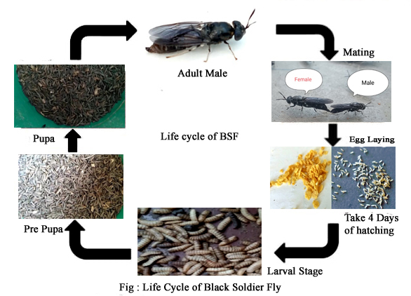
Fig 3: Different stages of the life cycle of Black Soldier Fly
One cycle of Black soldier fly completed within 68 days and other cycle completed within 182 days. Likewise a major difference has been observed in duration of egg stage, larval stage, pre-pupa stage, pupa stage as well as adult stage. Although the same amount of food in regular and in a common interval was supplied to the larval stages but respond was varied. The different factors that may regulate the length of development time from one stage to the next stage which are relative humidity, larval density, temperature, moisture content of substrate, salinity of substrate etc.
The life cycle of black soldier larva is shown in Fig-3.The entire life cycle is mainly contributed by the larval and pupal stages, while the relatively short stages of BSFL include the adult and egg hatching stages (Kaya et al., 2021). As the BSFs life span is very short, the female larvae will lay a considerable amount of eggs, which will develop into newly hatched larvae very soon (Liu et al., 2021). Depending on the environmental conditions, the life cycle of these flies is very small, approximately 6–8 days, although it can be extended to 6–7 weeks, because these flies can slow down their activities under contrary situations (Parodi et al., 2021).The fast and slow growth of the larvae may because of their flexible life cycle. Unfavorable conditions like inadequate food supply, low temperature conditions may leads to lengthening of particular life stages. When there is any kind of shortage of organic waste or competition then such a prolonged developmental phages continues which may helps the population’s feasibility during that period. However to maintain a standard population size, availability of food and other resources are very important for sustenance of the fly.

Temperature is an important factor that affects different stages of lifecycle. BSF is a eurythermic species that can tolerate a wide temperature range (15–47 °C), but at the same time, it is tremendously sensitive (Park, 2016). Relative humidity and temperature significantly affect the development, mating, and oviposition of species (Tomberlin et al., 2009). Several authors carried out related studies and concluded that most (approximately up to 99.6%) oviposition occurs in a temperature range of 27.5 to 37.5 °C and relative humidity of 60% (Holmes, 2010). During our study period temperature ranges from 23⁰C to 31⁰C for both the fast and slow growth cycle of black soldier larva which is same for both the cycle hence it clearly reveals that the temperature range is within the suitable range. Other studies by many authors have shown that maintaining a relative humidity of around 60% and a temperature of 27 °C at the site are perfect conditions for egg-laying and mating (Holmes, 2010).At the same time it is quite doubtful in describing the proper reason for such significant difference of larval, pupal and adult development time between these fast and slow growth cycle.
Humidity is one of the important factors which regulate the length of development period and also the survival rate of the entire population. In the first lifecycle we have seen that larval stage was started in 02.11.22 and completed in 09.01.23.In that particular time period the relative humidity was recorded 25% to 40%.So it is quite far from the optimal range. This may be one cause of increase of their life cycle up to 68 days from the normal cycle of 45 days. But in the second lifecycle, relative humidity ranges from 10% to 50% .It can be assumed that such divergence may be one factor for this.
Sunlight plays a significant role in growth, development, reproduction and survival of Black soldier fly in natural conditions. Sunlight with an intensity of 110μmol m² s⁻¹ is required for almost 85% of mating events (Park, 2016). The mating and oviposition of the species are positively correlated with quartz iodide lamps (135μmol m2 s⁻¹) as sources of artificial light (Zhang et al., 2010). Insects cannot see the light beyond 700 nm, so the wavelength range between 450 and 700 nm is best suited for adult breeding events (Zhang et al., 2010).In our study we kept all the larva together in some plastic buckets, but interestingly some numbers remain left from developing in proper time period. Since our experiment was an indoor setup therefore sunlight might be a regulatory factor for this divergence.

Moisture content is another factor that influence the growth and survival of Black soldier fly. Moisture contents of the waste significantly influence the survival and growth of BSFL (Cheng et al., 2017). Excessive moisture content obstructs the decomposition rate and is agglomerated, and thick materials can accompany the subsequent residue, making further processing difficult (Diener et al., 2011b).Although an estimated amount of moisture content was not recorded but there was a minimum chance of excessive microbial growth for higher moisture content as the food was supplied in a very scientific way.

Besides these, larval density also plays a role in regulating the life cycle.A higher or uncontrolled growth of larvae leads to food scarcity and there will be an intense intra specific competition among them which may hamper survival rate of the entire population. The growth of BSFL is significantly affected by the composition of the feed (Fu et al., 2022).

CONCLUSION

Study of different factors affecting on the life cycle of Black Soldier Fly Larvae promising to be a very important as study of its life cycle and cultureis the most innovative technologies for waste management and also used in the process of bioconversion. This insect naturally feeds on organic wastes and can convert it into their own biomass and thus reducing the amount of waste material. There will be more concern and necessity of future research in the field of culture and life cycle of this fly which may bring some new strategies in the development of aqua culture.

Disclaimer (Artificial intelligence):

Author hereby declare that NO generative AI technologies such as Large Language Models(Chat GPT,COPILOT etc)and text-to –image generators have been used during the writing or editing of this manuscript.

REFERENCES

Bessa, L. W., Pieterse, E., Marais, J., & Hoffman, L. C. (2020). Why for feed and not for human consumption? The black soldier fly larvae. Comprehensive Reviews in Food Science and Food Safety, 19(5), 2747-2763.

Cheng J.Y., Chiu S.L., Lo I.M.: Effects of moisture content of food waste on residue separation, larval growth, and larval survival in black soldier fly bioconversion
Waste Manage., 67 (2017), pp. 315-323, 10.1016/j.wasman.2017.05.046

Chia S.Y., Tanga C.M., Osuga I.M., Mohamed S.A., Khamis F.M., Salifu D., Sevgan S., Fiaboe K.K.M., Niassy S., van Loon J.J.A., et al.:Effects of waste stream combinations from brewing industry on performance of BlackSoldierFly, Hermetiaillucens (Diptera: Stratiomyidae) PeerJ, 6 (2018), p. 5885

Diener, S., Zurbrügg, C., Gutiérrez, F.Roa., Nguyen, D.Hong., Morel, A., Koottatep, T., Tockner, K., 2011b. Black soldier fly larvae for organic waste treatment – prospects and constraints. In: Proceedings of the WasteSafe 2011–2nd International Conference on Solid Waste Management in the Developing Countries, Khulna, Bangladesh. ISBN: 978-984-33-2705-5.

Dzepe D., Magatsing O., Kuietche HM., Meutchieye F., Nana P., Tchuinkam T., Djouaka R.
Recycling organic wastes using black soldier fly and house fly larvae as broiler feed
Circ. Econ. Sustain. (2021)

Fu, S.-F. Wang, D.-H . Xie, Z. Zou, H , Zheng Y:Producing insect protein from food waste digestate via black soldier fly larvae cultivation: a promising choice for digestate disposal
Sci. Total Environ., 830 (2022), Article 154654

Holmes L.:Role of Abiotic Factors on the Development and Life History of the Black Soldier Fly, HermetiaIllucens (L.) (Diptera: Stratiomyidae (Electronic Theses and Dissertations)(2010), p. 285
Kaya C., Generalovic TN., Stahls G., Hauser M., Samayoa AC., Nunes-Silva CG., Roxburgh H., Wohlfahrt J., Ewusie EA., Kenis M., Hanboonsong Y., Orozco J., Carrejo N., Nakamura S., Gasco L., Rojo S., Tanga CM., Meier R., Rhode C., Picard CJ., Jiggins CD., Leiber F., Tomberlin JK., Hasselmann M., Blanckenhorn WU., Kapun M., Sandrock C:Global population genetic structure and demographic trajectories of the black soldier fly, Hermetia illucens
BMC Biol., 19 (1) (2021), p. 94

Liu T., Awasthi SK., Qin S., Liu H., Awasthi MK., Zhou Y., Jiao M., Pandey A., Varjani S., Zhang Z.;Conversion of food waste and sawdust into compost employing black soldier fly larvae (Diptera: Stratiomyidae) under the optimized condition Chemosphere, 272 (2021), Article 129931

Nguyen T.T., Tomberlin J.K., Vanlaerhoven S.:The ability of black soldier fly (Diptera: Stratiomyidae) larvae to recycle food waste Environ. Entomol., 44 (2) (2015), pp. 406-410

Parodi A., Gerrits WJJ., Van Loon JJA., De Boer IJM., Aarnink AJA., Van Zanten HHE.
Black soldier fly reared on pig manure: Bioconversion efficiencies, nutrients in the residual material, greenhouse gas and ammonia emissions
Waste Manage., 126 (2021), pp. 674-683

Park ,H.H.:Black Soldier Fly Larvae Manual Erişim. Tarihi (2016)
http://scholarworks.umass.edu (Accessed date: 31 July 2019)

Popa R., Green T.R.:Using black soldier fly larvae for processing organic leachates
J. Econ. Entomol., 105 (2) (2012), pp. 374-378

Salomone R., Saija G., Mondello G., Giannetto A., Fasulo S., Savastano D.:Environmental impact of food waste bioconversion by insects: Application of life cycle assessment to process using Hermetiaillucens J. Clean. Prod., 140 (2017), pp. 890-905

Singh A., Kumari K.:An inclusive approach for organic waste treatment and valorisation using Black Soldier Fly larvae: A review J. Environ. Manage., 251 (2019), Article 109569

Tomberlin J.K., Sheppard D.C.: Factors influencing mating and oviposition of black soldier flies (Diptera: Stratiomyidae) in a colony J. Entomol. Sci., 37 (4) (2002), pp. 345-352

Tomberlin J.K., Adler P.H., Myers H.M.:Development of the black soldier fly (Diptera: stratiomyidae) concerning temperatureEnviron. Entomol., 38 (3) (2009), pp. 930-934,

Zhang J., Huang L., He J., Tomberlin J.K., Li J., Lei C., Sun M., Liu Z., Yu Z.: An artificial light source influences mating and oviposition of black soldier fly, Hermetiaillucens J. Insect Sci., 10 (1) (2010), 10.1673/031.010.20201
Akoijam, R., Ningombam, A., Beemrote, A., & Telem, R. S. (2019). Detection of thiamethoxam, flubendiamide and endosulphan residues in rice grains. Indian Journal of Entomology, 81(4), 730-732.

