Seasonal Gut Content Analysis of Oil Sardine (Sardinella longiceps) at Dabhol, Harnai and Mirkarwada, Ratnagiri Coast, Maharashtra, India

Abstract
The oil sardine (Sardinella longiceps) is one of the most commercially important pelagic fish species along the Ratnagiri coast of Maharashtra. Understanding the dietary spectrum of oil sardine provides critical insights into trophic dynamics and resource availability in Potential Fishing Zones (PFZs). In this study, 270 specimens of S. longiceps were collected between January–May (pre-monsoon) and September–December (post-monsoon) from fish catched from PFZs of Dabhol, Harnai, and Mirkarwada, Ratnagiri district, Maharashtra. This study examines the qualitative and quantitative composition of gut contents during pre-monsoon (January to May) and post-monsoon (September to December) seasons of year 2024 at three major fish landing centres: Dabhol, Harnai and Mirkarwada. A total of 270 specimens (10 fish per month per site for 9 months) were analyzed using the Occurrence Method. The gut content analysis was not performed during monsoon months i.e. June to August due to fishing ban and PFZs advisory not available during this monsoon months. Planktonic organisms such as diatoms (Fragilaria oceanica, Chaetoceros sp., Thalassiosira sp., Coscinodiscus sp., Biddulphia spp., Rhizosolenia sp.), dinoflagellates (Ceratium sp., Peridinium sp.), copepods (Acartia sp., Paracalanus sp., Copepod nauplii.), fish eggs, Ostracods, polychaete larvae, tintinnids, larvaceans, organic matter, sand particles and detritus were identified. The results revealed marked seasonal variations, with diatom dominance in the post-monsoon period and higher copepod abundance in pre-monsoon months. The findings highlight the influence of coastal productivity and upwelling events on oil sardine feeding ecology.

Keywords: Sardinella longiceps, gut content, PFZ, Dabhol, Harnai, Mirkarwada, plankton, occurrence method

Introduction
The oil sardine (Sardinella longiceps) constitutes a major fishery resource along the west coast of India, contributing significantly to marine landings in Maharashtra (CMFRI, 2024). As a planktivorous fish, its feeding behavior directly reflects seasonal variations in planktonic availability, which in turn are influenced by coastal hydrodynamics, nutrient influx, and monsoonal cycles (Remya et al., 2013; Madhupratap et al., 2001). The Indian oil sardine Sardinella longiceps is one of the most important small pelagic clupeids of the Indian subcontinent, contributing significantly to total marine fish production and the livelihood of coastal fishing communities (Nair & Subrahmanyan, 1955). Along the Maharashtra coast, particularly at Dabhol, Harnai and Mirkarwada landing centres in Ratnagiri district, the species forms a dominant component of the pelagic catch and supports both artisanal and mechanized fisheries (Shah et al., 2025). The feeding ecology of S. longiceps is predominantly planktivorous, with stomach content studies revealing that diatoms form the bulk of the diet, followed by dinoflagellates and zooplankton (Nair, 1960; Shah et al., 2019). Specific phytoplankton taxa such as Fragilaria spp. and Chaetoceros spp. are consistently reported as principal dietary items of oil sardine, closely linked to coastal phytoplankton blooms (Nair & Subrahmanyan, 1955; CMFRI, 2013). Seasonal upwelling along the eastern Arabian Sea enhances nutrient concentrations, stimulates phytoplankton growth, and strongly influences the feeding intensity and catch fluctuations of oil sardine (Holmes et al., 2021). To assist fishers, Potential Fishing Zone (PFZ) advisories are generated by ESSO-INCOIS using remote sensing data on chlorophyll-a and sea surface temperature, highlighting zones of high productivity and fish aggregation (Shenoi, 2012; INCOIS, 2025). Studies have shown that PFZ-based fishing significantly improves catch per unit effort (CPUE) while reducing search time and operational costs, thus serving as an effective management tool for pelagic fisheries (Chavda et al., 2021; Pillai & Nair, 2010). However, despite existing reports on sardine diet from other parts of the Indian coast, detailed species-level and site-specific gut content analysis from PFZ-caught oil sardine in Dabhol, Harnai and Mirkarwada remains limited (Shah et al., 2025). Understanding the feeding composition of oil sardine in these PFZ-guided fisheries will provide valuable insights into trophic dynamics, validate the ecological relevance of PFZ advisories, and contribute to ecosystem-based fisheries management. Understanding gut content composition provides insights into the trophic role of the species, feeding preferences, and potential impacts of environmental changes on fishery productivity. The present study compares pre- and post-monsoon of year 2024 gut content composition of oil sardine across three important fish landing centers: Dabhol, Harnai, and Mirkarwada.

Materials and Methods

Study Area
Sampling was conducted at Dabhol (17°36′N, 73°11′E), Harnai (17°48′N, 73°06′E), and Mirkarwada (16°59′N, 73°18′E), all located along the Ratnagiri coast, Maharashtra.

Sample Collection
- Total fish examined: 270 oil sardines, 10 per month per site, January to December (2024). Excluding June, July and August (Monsoon Months)
- Seasons classified as:
  - Pre-monsoon: January–May
  - Post-monsoon: September–December
- Fish were preserved in ice and dissected within 6 hours of landing.
- Sampling frequency: 10 fish per month per site (total 270 fish; 140 pre-monsoon, 130 post-monsoon)

Gut content Analysis
- Fish were dissected, and the stomachs were carefully removed and preserved in 5% formalin.
- Gut contents were diluted in distilled water and examined under a compound microscope (Magnus MLX Plus) at 10X and 40X magnification.
- Planktonic components were identified using the following keys: Desikachary (1959), Newell and Newell (1977), and Subrahmanyan (1959).

Occurrence Method Calculation
The Occurrence Method (Hynes, 1950; Pillay, 1952) was used:
The occurrence (%) of each food item was calculated using:
Percentage of Occurrence=Number of stomachs containing a food item (n) /Total stomachs examined (N) ×100

Results and Discussion

Table 1: Seasonal and site-wise occurrence (%) of gut content items in Indian oil sardine (Sardinella longiceps) from PFZ zones of Dabhol, Harnai and Mirkarwada (Ratnagiri district). Pre-monsoon - January to May. (N=50 fish gut examined per site); Post-monsoon -September to December. (N= 40 fish gut examined per site)
Plankton Species | Dabhol Pre-Monsoon(N=50) | Dabhol Post-Monsoon(N=40) | Harnai Pre-Monsoon(N=50 | Harnai Post-Monsoon(N=40) | Mirkarwada Pre-Monsoon(N=50) | Mirkarwada Post-Monsoon(N=40)
Phytoplanktons
Fragilaria oceanica | 22 | 20 | 24 | 21 | 23 | 22
Chaetoceros spp. | 19 | 17 | 21 | 19 | 20 | 18
Thalassiosira spp. | 15 | 14 | 16 | 15 | 14 | 17
Coscinodiscus spp. | 14 | 12 | 11 | 10 | 9 | 11
Biddulphia spp. | 5 | 6 | 5 | 6 | 4 | 5
Rhizosolenia spp. | 3 | 4 | 2 | 3 | 2 | 3
Ceratium spp. | 4 | 5 | 3 | 4 | 3 | 4
Peridinium spp. | 1 | 2 | 0 | 2 | 2 | 0
Zooplanktons
Acartia spp. | 9 | 11 | 7 | 10 | 10 | 12
Paracalanus spp. | 6 | 11 | 8 | 9 | 10 | 12
Copepod nauplii | 6 | 8 | 7 | 10 | 7 | 9
Fish eggs | 3 | 2 | 2 | 5 | 3 | 2
Ostracods | 1 | 1 | 0 | 1 | 0 | 1
Polychaete larvae | 1 | 0 | 0 | 1 | 1 | 0
Tintinnids | 1 | 3 | 2 | 3 | 2 | 3
Larvaceans | 1 | 2 | 1 | 2 | 1 | 0
Non-Living Organic Matter
Organic matter | 6 | 5 | 3 | 4 | 4 | 5
Sand particles | 3 | 4 | 2 | 4 | 6 | 8
Detritus | 2 | 4 | 5 | 4 | 7 | 9

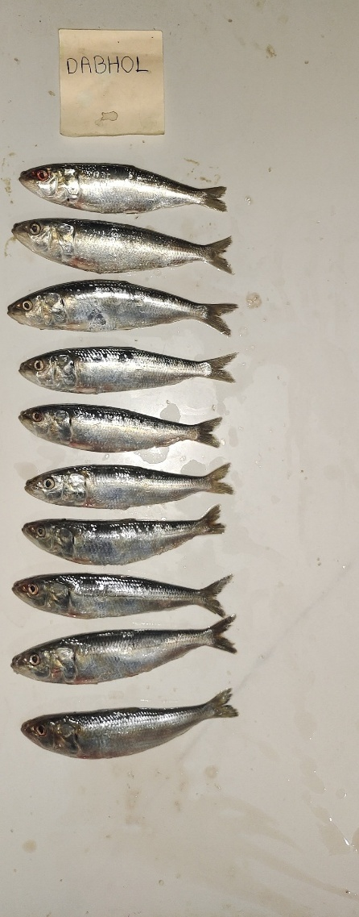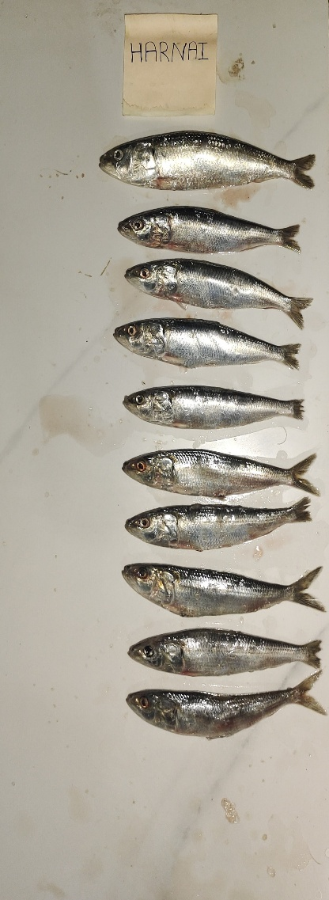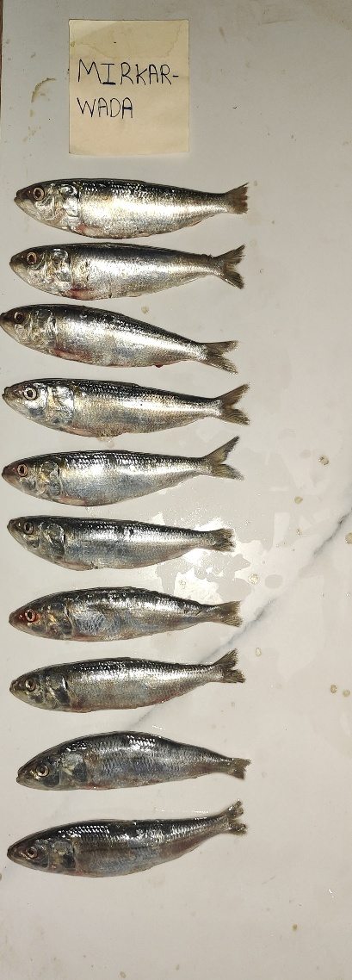

Fig 1: Sardinella longiceps from Dabhol, Harnai and Mirkarwada arranged on tile

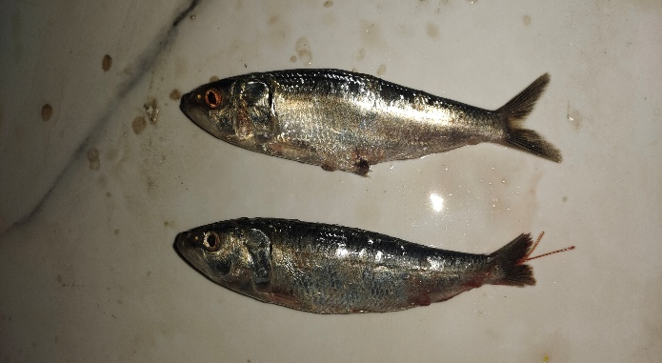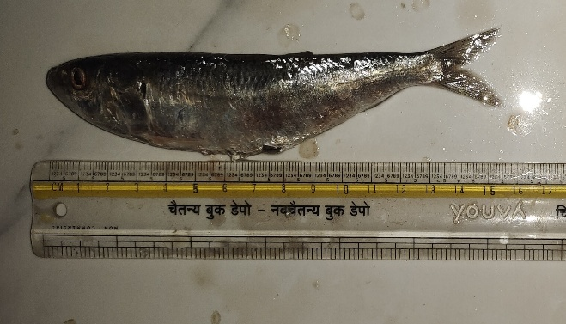

Fig 2: Closer look of Sardinella longiceps.

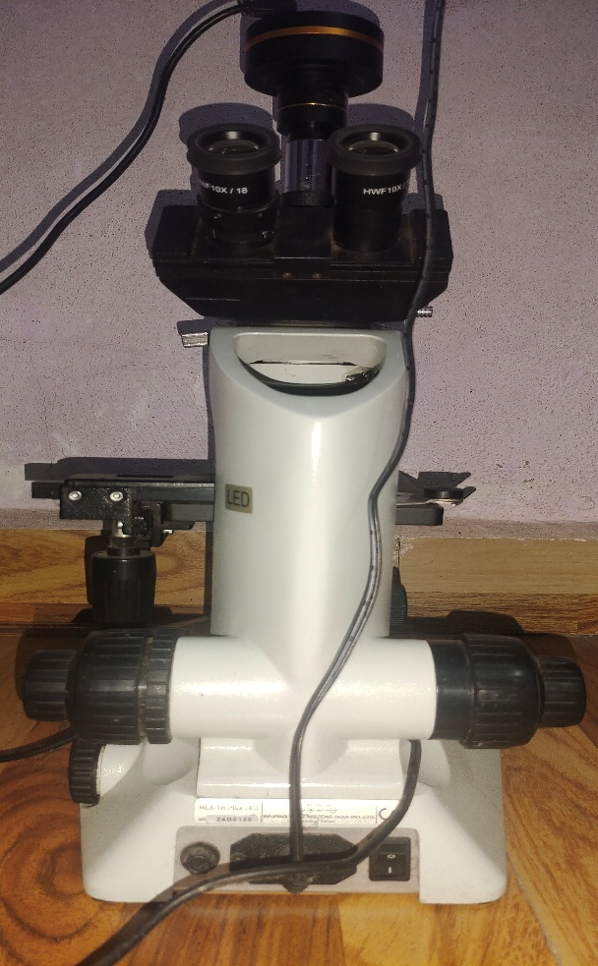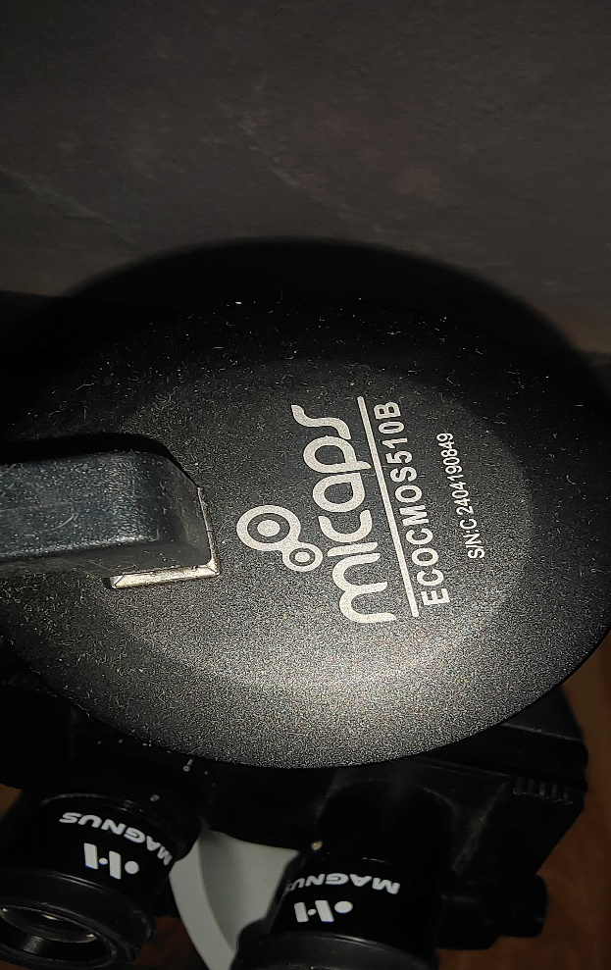
Fig 3: Microscope (Magnus MLX Plus) & Camera (Micaps ECOMOS510B)

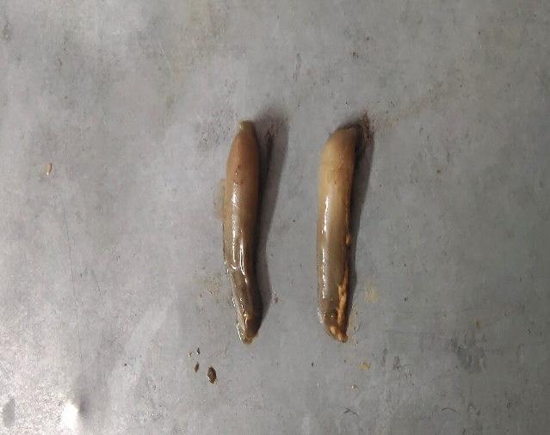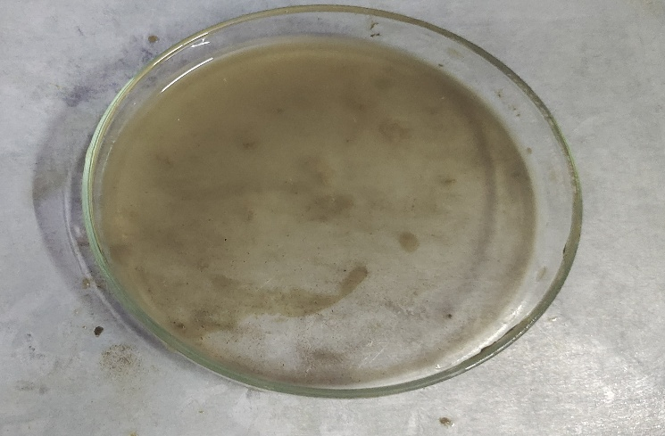
Fig 4 : Gut of Sardinella longiceps and slurry made of gut content for gut content analysis.
Planktons
Phytoplanktons

Diatoms

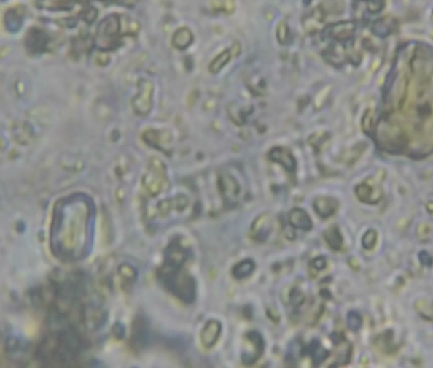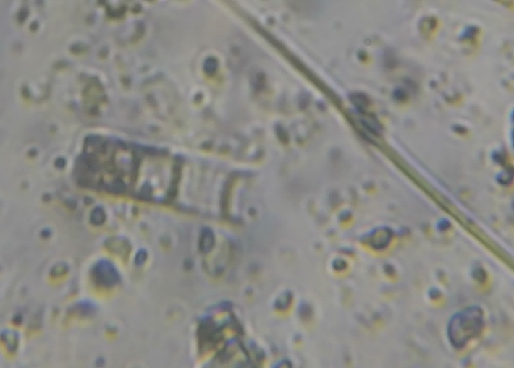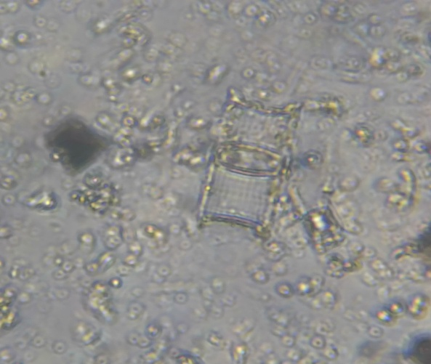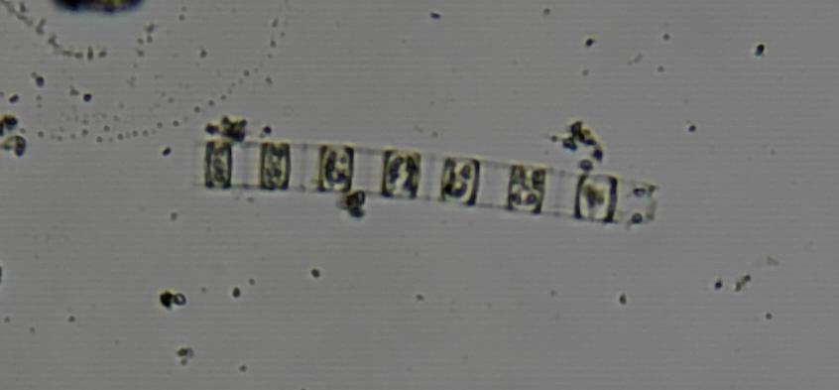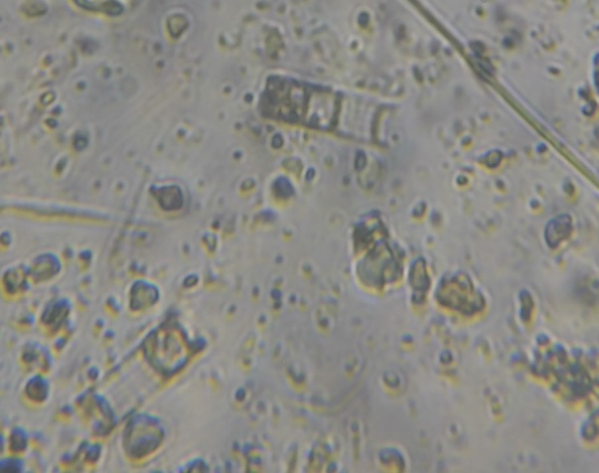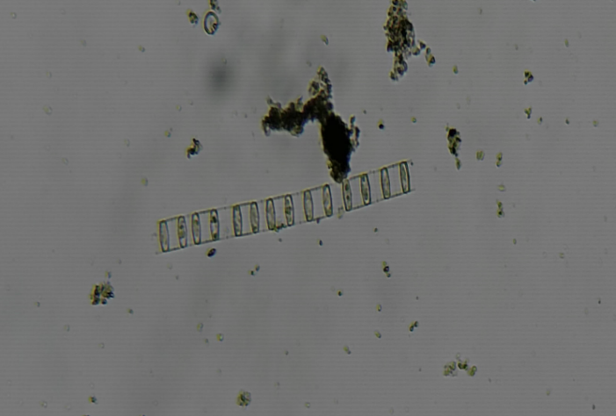
Fig 5: Fragilaria oceanica

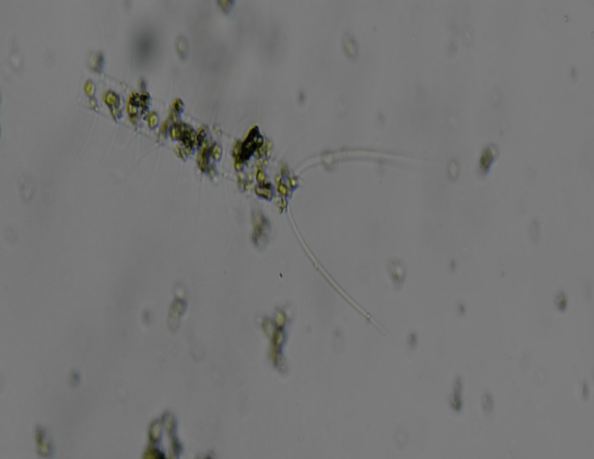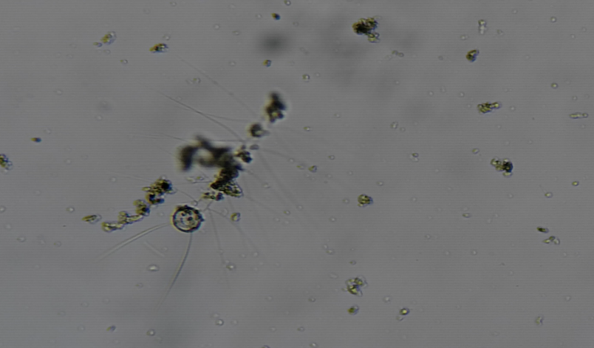

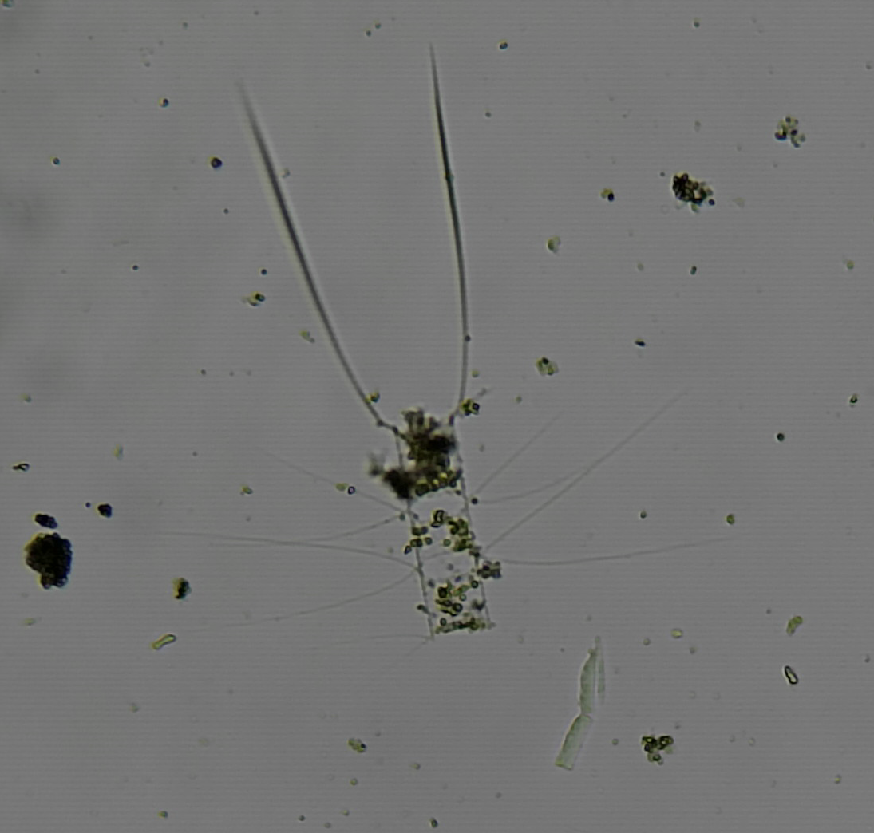

Fig 6: Chaetoceros spp

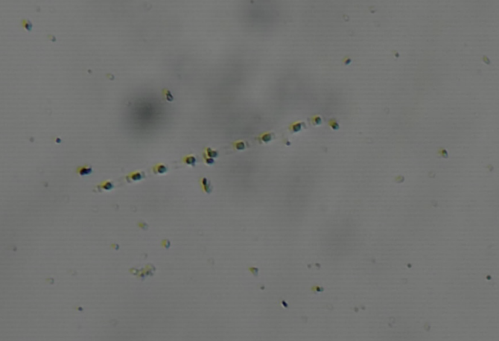

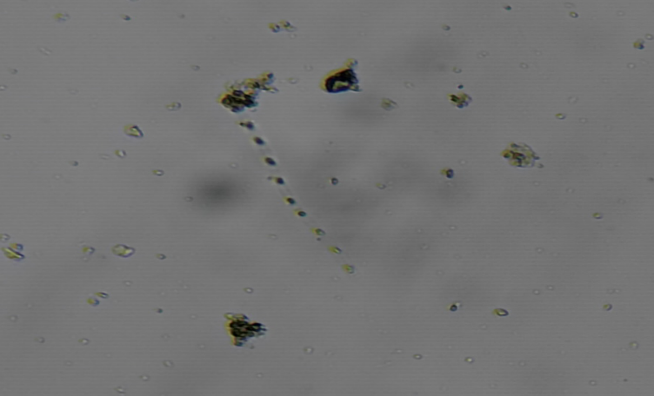

Fig 7: Thalassiosira spp.

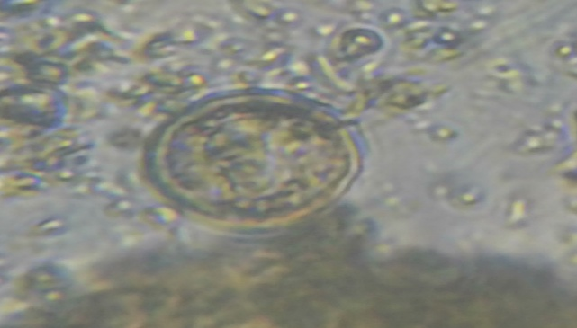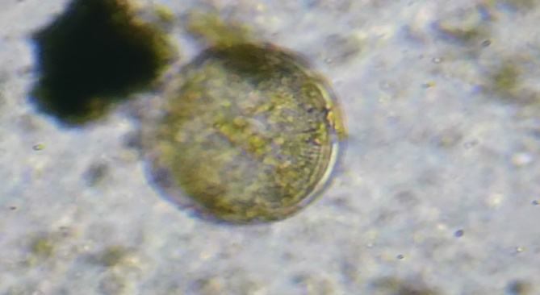
Fig 8: Coscinodiscus spp.

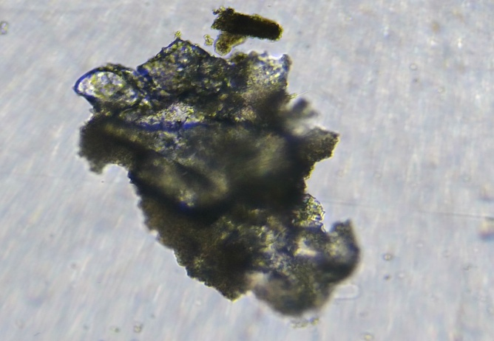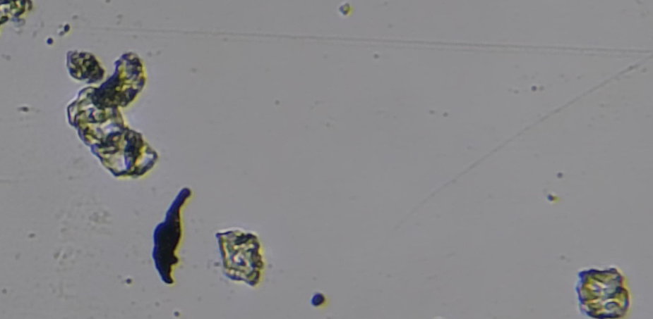
Fig 9: Biddulphia spp.

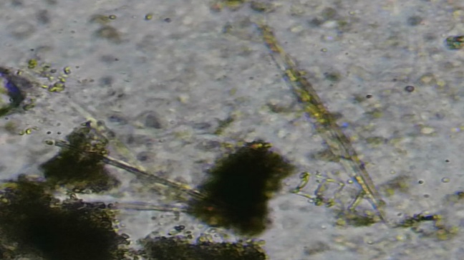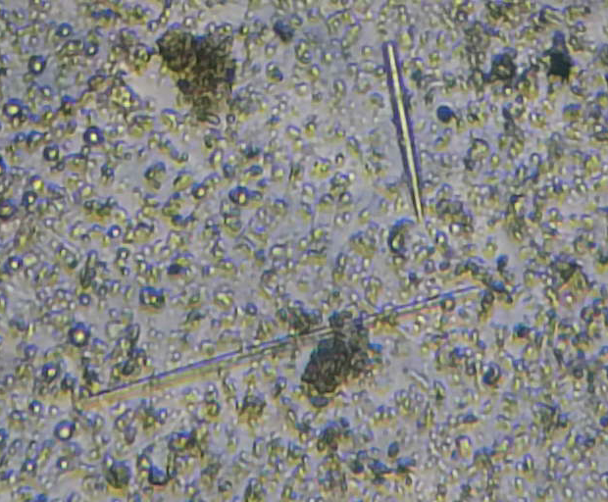
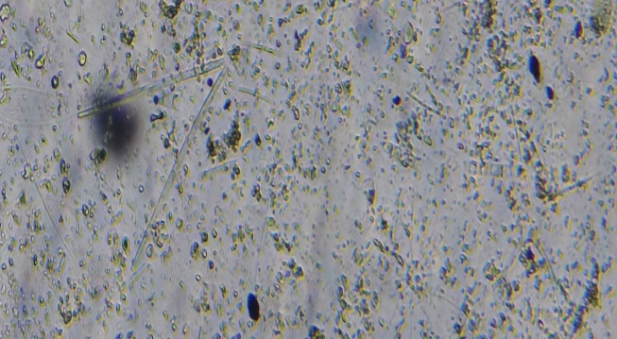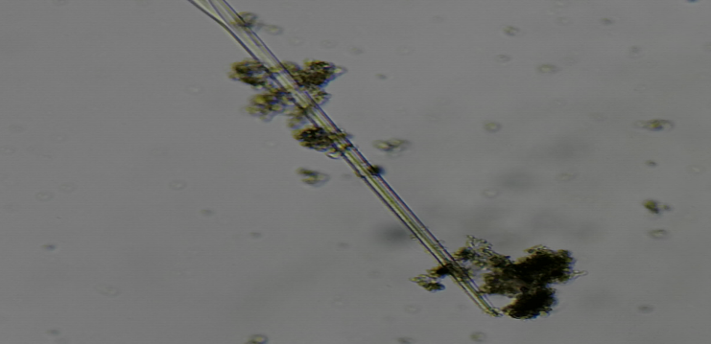
Fig 10: Rhizosolenia spp.

Dinoflagellates

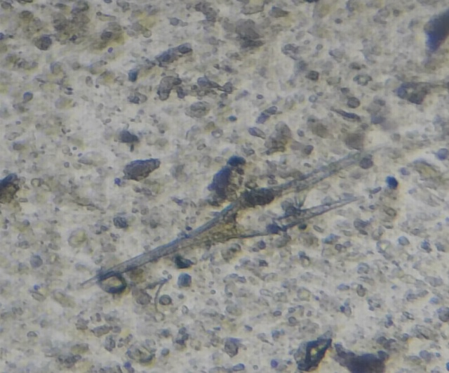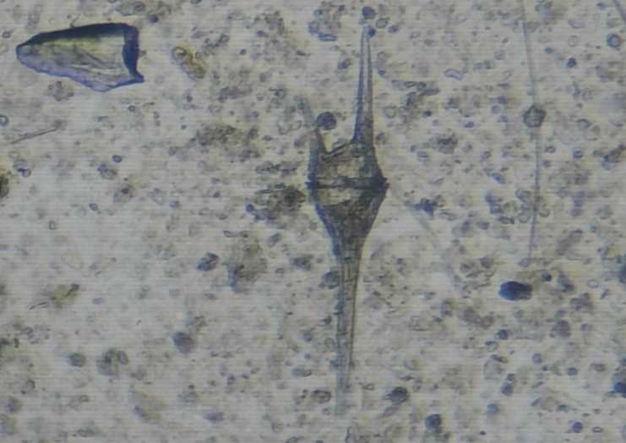
Fig 11 : Ceratium spp.

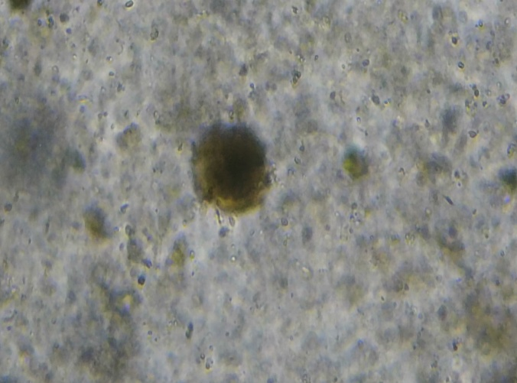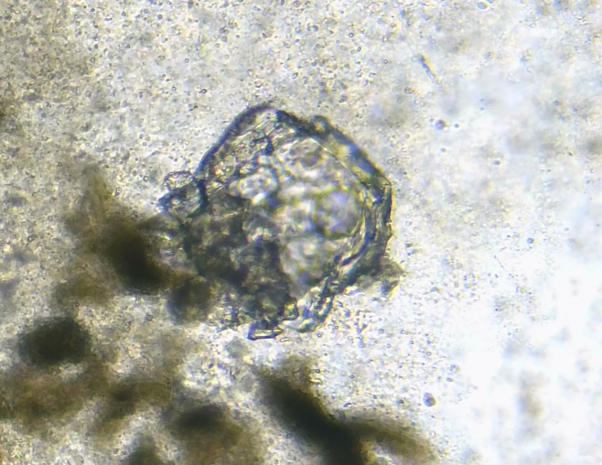
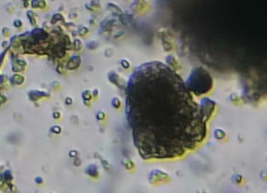
Fig 12: Peridinium spp.

ZOOPLANKTONS

Copepod

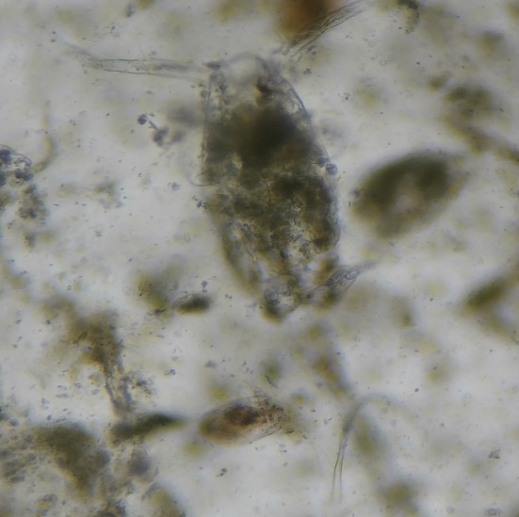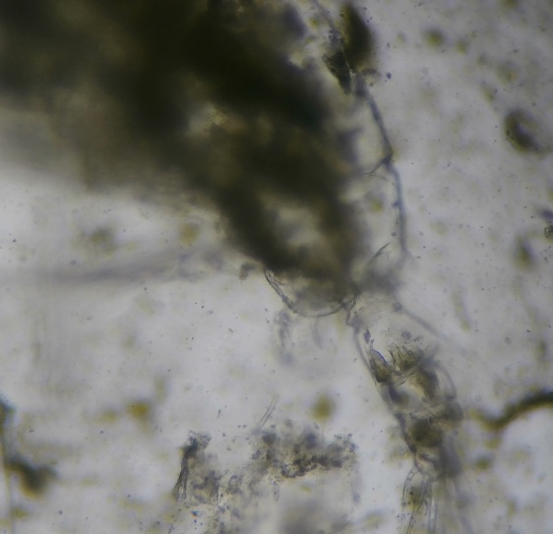
Fig 13: Acartia spp.

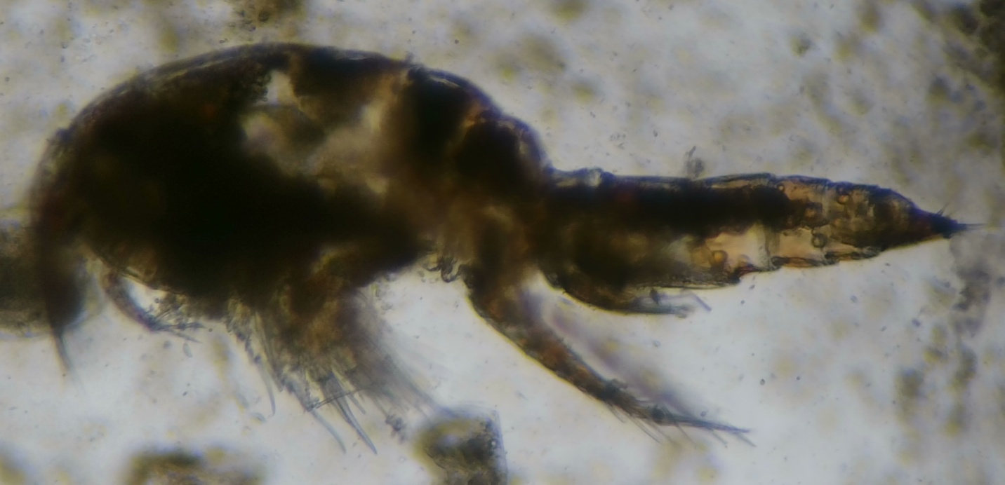
Fig 14: Parancus spp.

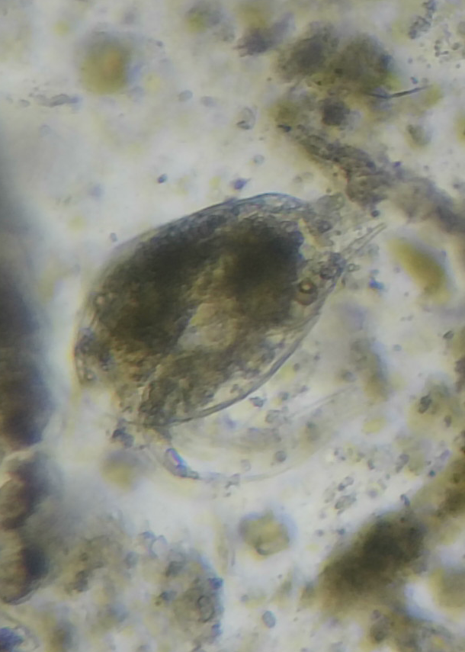
Fig 15: Copepod nauplii

Other zooplanktons

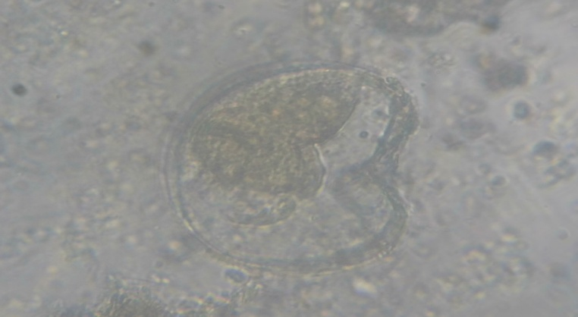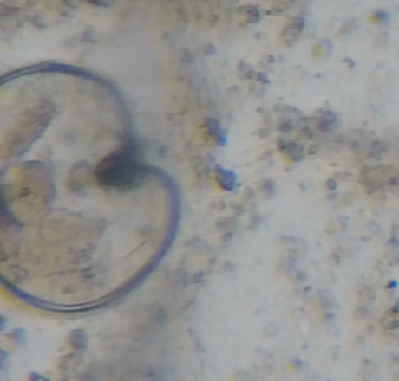
Fig 16: Fish eggs

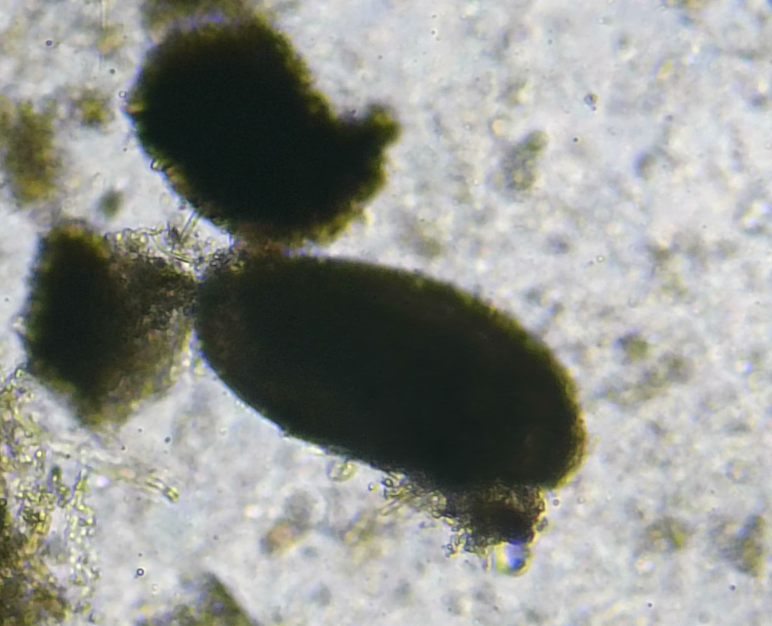
Fig 17: Ostracod (small crustaceans with a bivalve-like shell)

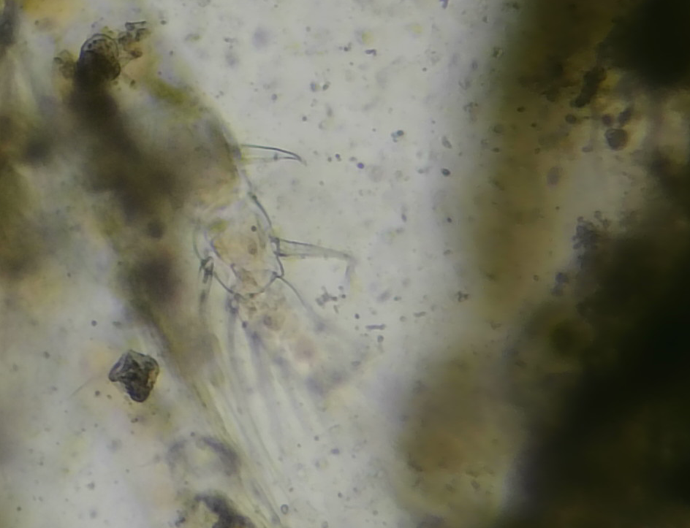
Fig 18: Polychaete larvae

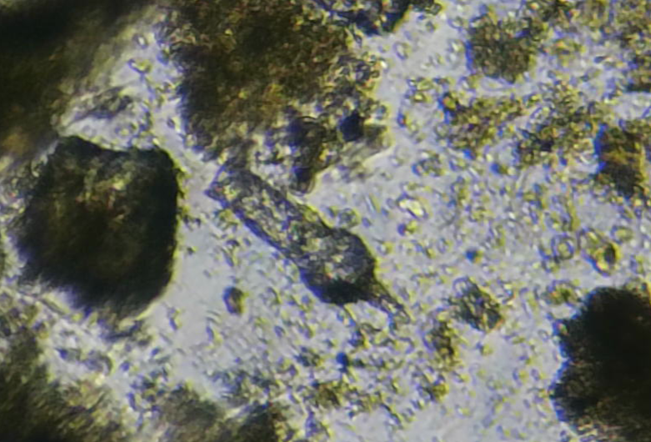
Fig 19: Tintinnids

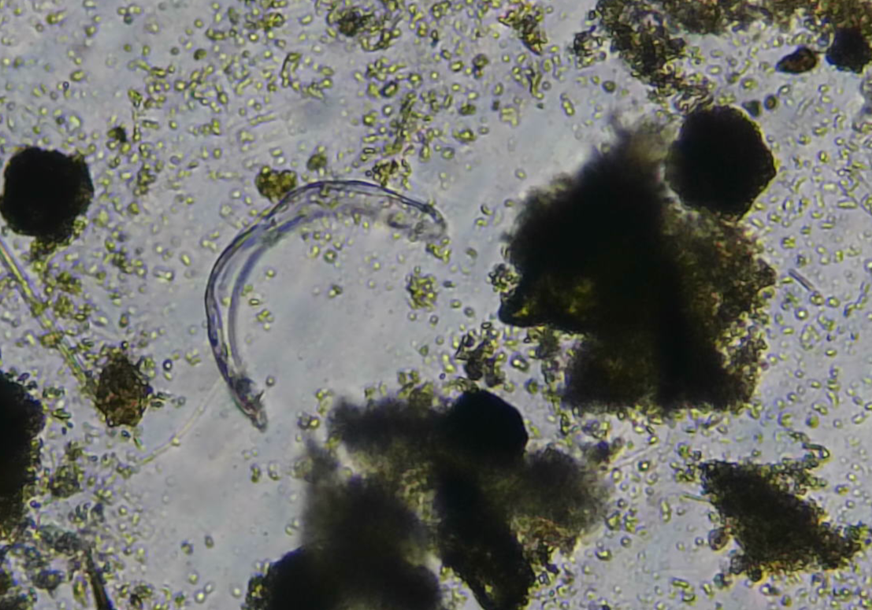
Fig 20: Larvaceans

Non-living Matter

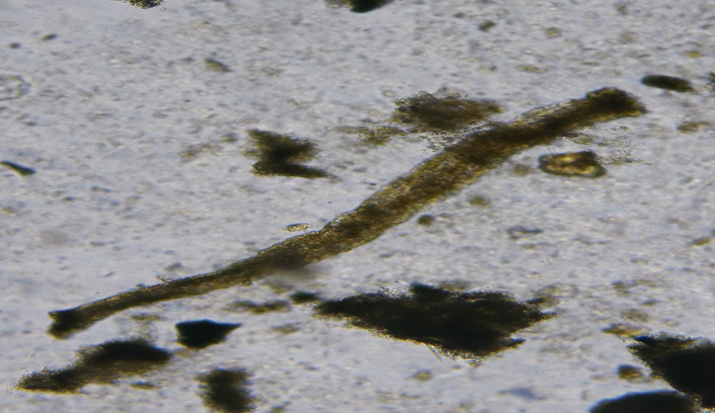
Fig 21: Organic matter

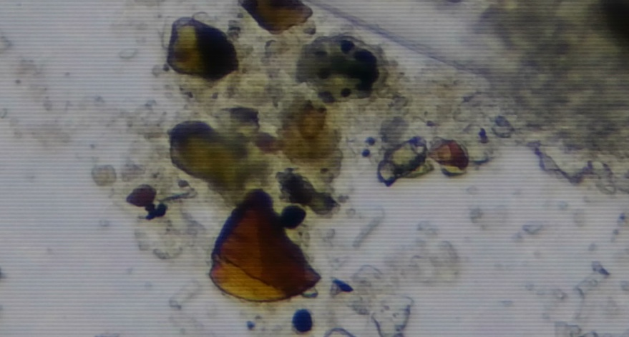
Fig 22: Sand particles

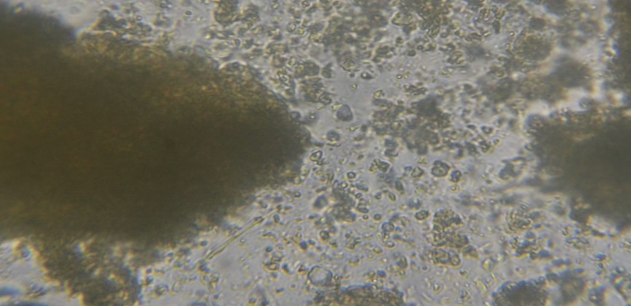
Fig 23: Detritus
Phytoplanktons
Seasonal and Spatial Variation in Phytoplankton
The dominance of diatoms (Fragilaria, Chaetoceros, Thalassiosira) in both seasons indicates that oil sardine feeding is strongly linked to primary productivity in coastal waters (Jyothibabu et al., 2008). Higher post-monsoon diatom abundance can be attributed to nutrient-rich waters following monsoon upwelling (Madhupratap et al., 1990). The gut content analysis of Sardinella longiceps from Dabhol, Harnai, and Mirkarwada during pre- and post-monsoon seasons (2024) revealed a dominance of phytoplankton, particularly diatoms, with secondary contributions from zooplankton and detrital matter (Table 1).
Diatoms such as Fragilaria oceanica, Chaetoceros spp., and Thalassiosira spp. were consistently dominant across all sites, comprising 45–55% of the gut content. The higher occurrence of Fragilaria oceanica (22–24% in pre-monsoon, 20–22% in post-monsoon) indicates its importance as a staple food resource for sardines (Nair & Subrahmanyan, 1955). The relative abundance of Chaetoceros spp. (17–21%) and Thalassiosira spp. (14–17%) supports earlier reports that these genera form the bulk of sardine diets in Indian coastal waters (Shah et al., 2019). Coscinodiscus spp. showed moderate contribution (9–14%), aligning with findings that large centric diatoms are occasionally ingested but less preferred due to their larger size (Rohit & Bhat, 2013). Biddulphia spp. and Rhizosolenia spp. were present in low proportions (2–6%), consistent with prior studies showing seasonal fluctuations of these taxa in plankton communities (Qasim, 1973). Dinoflagellates such as Ceratium spp. and Peridinium spp. contributed marginally (0–5%), reflecting their opportunistic ingestion rather than preference (Devassy et al., 1974).

Ecological role of dominant diatoms
The predominance of diatoms in sardine gut contents confirms the ecological strategy of S. longiceps as an obligate planktivore, optimized for utilizing high-biomass producers. Chain-forming diatoms such as Fragilaria and Chaetoceros are especially advantageous because their morphology promotes buoyancy, bloom formation, and easy filtration by schooling sardines. The consistent contribution of Thalassiosira spp. highlights their resilience across fluctuating seasonal conditions, as they thrive in both nutrient-rich post-monsoon and relatively stable pre-monsoon waters.
The relatively moderate ingestion of Coscinodiscus reflects the constraints of sardine feeding morphology. Larger centric diatoms, although abundant in plankton assemblages, are not efficiently filtered by sardines’ fine gill rakers, leading to reduced representation in gut contents. In contrast, smaller and chain-forming diatoms pass more readily through the filtration system and are consumed in greater proportion. This selective efficiency reflects a strong ecological coupling between sardines and the most productive diatom groups in coastal ecosystems.

Seasonal differences in phytoplankton diet
During pre-monsoon, stable salinity and moderate nutrient levels promote steady diatom availability. Fragilaria oceanica showed higher contribution (22–24%), indicating its suitability as a dominant food source under less turbulent conditions. In the post-monsoon season, the relative contribution of Fragilaria slightly declined, while Chaetoceros and Thalassiosira increased. This pattern may be linked to enhanced nutrient upwelling and coastal mixing, which favors fast-growing diatom taxa capable of exploiting sudden nutrient pulses. Thus, the sardine diet mirrors seasonal shifts in phytoplankton succession, reflecting the species’ opportunistic feeding within the broader framework of monsoon-driven productivity cycles.

Spatial variation across sites
Spatially, phytoplankton contribution varied among PFZs of Dabhol, Harnai, and Mirkarwada. Harnai showed consistently higher percentages of Fragilaria and Chaetoceros, indicating a stronger dependence on chain-forming diatoms. This may reflect favorable hydrography at Harnai, where moderate current patterns and high light penetration enhance diatom stability. Dabhol, influenced by riverine inputs, displayed greater proportions of Coscinodiscus and Rhizosolenia, pointing to episodic nutrient pulses that promote the growth of larger centric diatoms. Mirkarwada exhibited a mixed assemblage, with notable presence of Thalassiosira and detrital matter, suggesting localized sediment resuspension and variable productivity.

Implications of phytoplankton dominance
The overwhelming dominance of diatoms (45–55% of total gut content) reinforces the role of sardines as key conduits of primary productivity in the Arabian Sea. By channeling diatom-derived energy to higher trophic levels, sardines sustain pelagic fisheries and coastal food webs. Their reliance on diatoms also underscores their vulnerability to fluctuations in phytoplankton dynamics. Any long-term decline in diatom abundance, whether due to climate variability, eutrophication, or anthropogenic stressors, could directly affect sardine populations and the fisheries dependent on them.
Zooplanktons
Zooplankton Contribution
Zooplankton, especially copepods (Acartia spp. and Paracalanus spp.), were significant diet components, particularly in the post-monsoon period. Acartia spp. (7–12%) and Paracalanus spp. (6–12%) increased notably after the monsoon, suggesting enhanced secondary productivity due to nutrient enrichment from riverine influx (Madhupratap, 1987). Similarly, copepod nauplii (6–10%) indicated a seasonal dependence of sardines on larval copepods during post-monsoon (Smitha et al., 2008). Other zooplankton groups such as fish eggs (2–5%), ostracods (0–1%), polychaete larvae (0–1%), tintinnids (2–3%), and larvaceans (0–2%) were recorded sporadically. Their low frequency suggests incidental ingestion while filter-feeding (Longhurst, 2007).

Seasonal dynamics of zooplankton in the diet
The clear increase in copepods and copepod nauplii in the post-monsoon season highlights the dynamic relationship between sardine feeding and coastal productivity cycles. Post-monsoon periods are marked by nutrient surges and increased phytoplankton biomass, which in turn supports higher densities of copepods. Sardines capitalize on this secondary productivity by incorporating more zooplankton into their diet. The ability to shift from a predominantly phytoplankton-based diet to one that includes significant zooplankton contributions indicates a high degree of feeding plasticity.
During pre-monsoon, zooplankton formed a smaller component of gut contents, consistent with the relatively stable, less nutrient-enriched conditions. Copepods and their nauplii were still present but in reduced proportions, suggesting that sardines relied more heavily on diatom-rich waters during this time. This seasonal contrast illustrates how sardines track resource availability, maximizing energy intake by switching between primary and secondary producers as needed.

Relative importance of copepod species
The dominance of Acartia spp. and Paracalanus spp. in sardine guts is ecologically significant. These copepod genera are small bodied, abundant in coastal waters, and exhibit rapid population turnover. Their morphology and swimming behavior make them highly available for capture during sardine filter-feeding. Copepod nauplii, due to their minute size and high abundance during blooms, further enhance food availability, particularly in post-monsoon waters when reproduction peaks. The seasonal reliance on nauplii underlines their importance as a nutrient-rich, easily ingestible prey source, complementing the bulk energy intake from diatoms.

Minor zooplankton groups
Other zooplankton groups, though recorded in lower proportions, provide important insights into sardine feeding ecology. Fish eggs (2–5%) were occasionally consumed, most likely as byproducts of filter-feeding during spawning seasons of pelagic fishes. Their presence underscores the non-selective aspect of sardine feeding, where dense patches of planktonic material, including eggs, are ingested opportunistically.

Ostracods, polychaete larvae, tintinnids, and larvaceans each contributed less than 3% of gut contents. While these groups do not constitute targeted food items, their presence reflects the broad-spectrum filtering ability of sardines. Tintinnids and larvaceans, being micro-zooplankton with fragile structures, may also be underrepresented in gut content analyses due to rapid digestion, suggesting that their contribution could be slightly higher in reality than recorded.

Trophic significance of zooplankton intake
The incorporation of zooplankton in sardine diets is ecologically important for several reasons. First, zooplankton such as copepods provide higher protein and lipid content than diatoms, offering a nutrient-dense supplement to sardine diets. This is particularly critical during post-monsoon periods when sardines may require higher energy intake for reproduction and migration. Second, zooplankton feeding allows sardines to buffer against seasonal declines in diatom availability, ensuring resilience in fluctuating environments. Finally, by consuming both phytoplankton and zooplankton, sardines occupy a flexible trophic niche that strengthens their role as a keystone species in coastal ecosystems.

Spatial variability of zooplankton contribution
Spatial differences among the three PFZs sites were also notable. At Dabhol, zooplankton proportions were slightly higher compared to Harnai and Mirkarwada, likely due to riverine input and estuarine mixing that enhance copepod productivity. Harnai exhibited more consistent dominance of diatoms, with zooplankton forming a secondary dietary component. In contrast, Mirkarwada displayed a more balanced diet composition, where zooplankton intake, particularly copepods and nauplii, increased markedly during post-monsoon, coinciding with localized upwelling and nutrient enrichment. These spatial patterns emphasize how local hydrography shapes resource availability and subsequently sardine feeding dynamics.

Non-living Matter
Non-living material, including organic detritus, sand particles, and unidentified organic matter, contributed 5–10% of gut content. The higher presence of detritus and sand in post-monsoon (up to 9% at Mirkarwada) indicates sediment resuspension and coastal turbulence during the season (Varma et al., 1986).

Composition and origin of non-living matter
The presence of non-living material in sardine gut contents is not unexpected given their filter-feeding mode. Organic detritus, often composed of fragmented phytoplankton, decaying zooplankton, microbial biomass, and fine particulate organic matter, enters the water column through multiple processes such as coastal erosion, riverine discharge, and decomposition of plankton. Sand particles and inorganic sediments, on the other hand, are typically resuspended from the seabed during strong wave action, tidal currents, and monsoon-driven turbulence. These materials become entrained in the water column where sardines filter-feed, leading to incidental ingestion.

Seasonal variation
The higher proportion of detrital material observed during the post-monsoon season highlights the influence of hydrodynamic forces on diet composition. Following the southwest monsoon, intense coastal mixing and upwelling increase the turbidity of nearshore waters. This results in a greater concentration of suspended organic detritus and sand grains, particularly in shallow fishing grounds such as Mirkarwada. Sardines, being non-selective filter feeders, ingest these particles while foraging on dense plankton patches.
In contrast, during the pre-monsoon season, calmer hydrological conditions lead to reduced sediment resuspension. Consequently, the gut contents from Dabhol, Harnai, and Mirkarwada exhibited relatively lower proportions of sand and inorganic matter, with cleaner phytoplankton-dominated diets. This seasonal contrast demonstrates how environmental forcing indirectly shapes diet quality and composition.

Nutritional significance of detritus
While detritus may appear to be nutritionally inferior compared to live plankton, its ecological role in sardine diets should not be underestimated. Organic detritus often harbors bacteria, protozoans, and microflagellates that enrich its nutritional value. Ingested detrital particles can thus serve as supplementary sources of energy and micronutrients, especially during periods when live plankton availability fluctuates. However, excessive ingestion of inorganic sediments and sand dilutes dietary quality, potentially reducing assimilation efficiency. This balance between beneficial detritus and inert sediments is a key factor influencing the overall energy gain of sardines.

Site-specific differences
Among the three study sites, Mirkarwada consistently showed the highest proportion of non-living matter in sardine gut contents, particularly in post-monsoon months. This can be attributed to its shallow coastal bathymetry and intense fishing activity that disturb bottom sediments. Dabhol, influenced by riverine inflow, also exhibited considerable detrital presence, though primarily organic in nature. Harnai, being more exposed to open coastal circulation, showed comparatively lower levels of sand and inorganic particles in sardine guts. These spatial variations highlight how local hydrography and anthropogenic activities affect sediment resuspension and consequently influence non-living matter ingestion.

Implications for feeding ecology
The occurrence of non-living matter in sardine diets underscores the non-selective nature of their filter-feeding mechanism. Sardines feed by filtering water through their gill rakers, which trap a wide size range of suspended particles. While this ensures efficient exploitation of dense plankton blooms, it also results in unavoidable ingestion of inorganic sediments and detritus. The energetic trade-off lies in balancing the high intake of nutritious phytoplankton and zooplankton with the incidental ingestion of inert material. In years of high sediment resuspension, sardines may ingest more inorganic particles, potentially lowering growth efficiency. Conversely, when organic detritus dominates, it may actually supplement their diet by providing additional microbial biomass.

Broader ecological perspective
The presence of detritus and sand in sardine guts also reflects larger ecosystem processes such as monsoon-driven turbulence, coastal erosion, and human activity. This makes non-living matter not merely an incidental dietary component but also an indicator of environmental disturbance in coastal ecosystems. High levels of sand and resuspended material may signal increased coastal turbidity, which has implications for both plankton productivity and fish feeding efficiency. Thus, analyzing non-living matter in sardine diets offers insight into the health and dynamics of nearshore ecosystems.

Ecological Implications
The dominance of diatoms across sites highlights the sardine’s role as a primary consumer within the food web (Nair, 1970). Seasonal shifts towards zooplankton in post-monsoon underline the species’ dietary flexibility, which ensures sustenance during fluctuations in phytoplankton biomass (Madhupratap et al., 2001). This adaptability explains the ecological success of S. longiceps in sustaining commercial fisheries along the Ratnagiri coast (Pillai et al., 2000).

Sardines as primary consumers and energy conduits
By feeding predominantly on diatoms such as Fragilaria oceanica, Chaetoceros spp., and Thalassiosira spp., sardines serve as crucial links in transferring energy from microscopic primary producers to higher trophic levels, including larger pelagic fish, marine mammals, and humans. This role underscores their importance as a keystone species in coastal ecosystems. The efficiency of this transfer is enhanced by their capacity to directly utilize primary production rather than relying solely on secondary consumers, thereby channeling large amounts of energy into fishery production.

Flexibility in diet and resilience
The observed dietary shift towards zooplankton in the post-monsoon period highlights the adaptive feeding strategy of sardines. Rather than being strictly obligate phytoplanktivores, they demonstrate opportunism by incorporating copepods, nauplii, and other small zooplankton into their diet when conditions favor secondary productivity. This plasticity ensures that sardines are not limited by seasonal declines in diatom abundance. It also allows them to exploit short-term resource pulses, such as copepod blooms, thereby maintaining growth and reproductive output even during fluctuating environmental conditions.

Influence of monsoon-driven productivity cycles
The monsoon is the most powerful driver of ecological processes along the west coast of India. Its influence extends beyond physical mixing to biological productivity and trophic interactions. During pre-monsoon, stratification favors diatom dominance, providing sardines with abundant phytoplankton food. Post-monsoon, nutrient enrichment from river discharge and upwelling supports both phytoplankton and subsequent zooplankton blooms, enabling sardines to diversify their diet. This synchronization between environmental cycles and sardine feeding ecology underpins the stability of their populations and, by extension, the fishery.

Site-specific ecological roles
The three PFZs study sites exhibited differences that illustrate how local oceanography modifies sardine feeding. Dabhol, influenced by estuarine outflow, offered a mix of diatoms and copepods, demonstrating the impact of riverine nutrient input. Harnai, being more exposed to open waters, supported high diatom dominance and reflected sardines’ reliance on primary producers in less turbid conditions. Mirkarwada, with its shallow bathymetry and higher sediment resuspension, highlighted the role of non-living matter in shaping diet composition, reminding us that environmental disturbances and hydrodynamics also modulate feeding ecology. Together, these sites provide a microcosm of how sardines function across varied habitats along the Ratnagiri coast.

Implications for fisheries
The ecological success of S. longiceps translates directly into their value as a commercial resource. Their ability to thrive on abundant diatom populations ensures predictable fishery yields during bloom periods. Equally, their capacity to shift towards zooplankton feeding during post-monsoon conditions provides resilience to inter-annual variability. This adaptability makes sardines a reliable target for coastal fisheries, supporting livelihoods of artisanal fishers across Maharashtra. However, it also indicates that any disruption in plankton cycles whether due to climate change, coastal pollution, or overfishing of associated species could have cascading effects on sardine populations and the fisheries they sustain.

Ecosystem balance and trophic stability
The feeding ecology of sardines helps stabilize plankton communities by regulating phytoplankton abundance and channeling biomass into higher trophic levels. By grazing heavily on diatoms, they prevent unchecked phytoplankton accumulation, which might otherwise lead to harmful algal blooms. Their occasional reliance on zooplankton further integrates them into the secondary trophic web, balancing the flow of energy across levels. This dual role ensures ecosystem stability by maintaining both primary and secondary production in check.

Long-term ecological perspective
The long-term success of sardines along the Ratnagiri coast reflects evolutionary adaptations to a highly dynamic environment. Their ability to exploit seasonal cycles, tolerate variability in plankton composition, and feed opportunistically on diverse resources has enabled them to remain dominant in the pelagic ecosystem. The continuity of sardine populations also secures food supply for dependent species, making their ecological implications extend far beyond immediate fishery benefits. They are not just consumers but also regulators, stabilizers, and energy transformers in coastal marine systems.

Site Comparisons
The study across PFZs of Dabhol, Harnai, and Mirkarwada revealed both consistent patterns in sardine feeding and distinct site-specific differences, reflecting the influence of local hydrography, nutrient dynamics, and coastal conditions. While the dominance of diatoms was a common feature at all three sites, variations in the relative contributions of zooplankton, detritus, and non-living matter highlighted the ecological uniqueness of each location.

Dabhol: Estuarine influence and mixed diets
Dabhol, situated at the mouth of a riverine system, demonstrated a feeding profile that combined high diatom abundance with notable contributions from zooplankton. The estuarine inflow introduced nutrients and organic matter, promoting phytoplankton blooms dominated by Fragilaria and Thalassiosira spp. Simultaneously, the mixing zone fostered copepod proliferation, particularly Acartia spp. and Paracalanus spp., which were regularly recorded in sardine guts.
In pre-monsoon, Dabhol sardines relied heavily on diatoms, reflecting stable conditions and high primary production. However, in post-monsoon, the input of freshwater and organic detritus from riverine discharge amplified zooplankton abundance, leading to an increase in copepod ingestion. The presence of fish eggs and nauplii at Dabhol was also higher compared to Harnai, indicating a richer secondary productivity fostered by estuarine influences. Overall, Dabhol exemplified how estuarine–marine coupling supports a mixed diet, with sardines exploiting both primary and secondary trophic pathways.

Harnai: Open-coast dominance of phytoplankton
Harnai presented a contrasting scenario, with a clear and consistent dominance of phytoplankton, particularly diatoms, in sardine diets. The open coastal waters at this site favored less turbid conditions and higher light penetration, supporting sustained diatom blooms. Chaetoceros and Thalassiosira were particularly prominent, reflecting the stable coastal productivity typical of this region.
Zooplankton contributions at Harnai were comparatively lower, suggesting that sardines in these waters were primarily functioning as obligate phytoplanktivores. Even in the post-monsoon season, when copepod availability increased at other sites, Harnai sardines showed only modest increases in zooplankton intake. Non-living matter, including sand and detritus, was also lower here than at Dabhol and Mirkarwada, reinforcing the role of Harnai as a relatively less disturbed, plankton-rich environment. This highlights Harnai as a site where sardines maintain a more specialized feeding strategy, tightly linked to phytoplankton productivity.

Mirkarwada: Shallow waters and sediment influence
Mirkarwada displayed the highest variability in dietary composition, with notable contributions from non-living matter in addition to plankton. Its shallow bathymetry and active fishing environment contributed to higher resuspension of sediments, which were reflected in sardine gut contents. Sand and detritus proportions were consistently higher here, particularly in post-monsoon, when turbulent conditions further enhanced resuspension.
Despite this, diatoms still dominated, though at slightly reduced proportions compared to Dabhol and Harnai. Zooplankton contributions were more pronounced, particularly from copepods and nauplii, suggesting that sardines at Mirkarwada exploited both phytoplankton and secondary productivity while simultaneously ingesting incidental inorganic matter. This site thus represented the most complex dietary profile, where sardines balanced between nutritious diatoms, opportunistic zooplankton, and unavoidable sediment ingestion.

Seasonal contrasts across sites
Seasonal variation was evident across all three PFZs sites. During pre-monsoon, diatoms dominated uniformly, though Dabhol exhibited slightly higher zooplankton presence due to estuarine mixing. In post-monsoon, Dabhol and Mirkarwada showed greater increases in zooplankton intake, reflecting nutrient-driven secondary productivity, while Harnai maintained its phytoplankton dominance. The ingestion of detritus and sand peaked in post-monsoon, particularly at Mirkarwada, highlighting the influence of monsoon-driven turbulence and sediment resuspension.

Ecological interpretation of site-specific differences
The site-specific differences in sardine diets underscore the adaptability of S. longiceps. At Dabhol, sardines exploited estuarine-driven productivity; at Harnai, they thrived on open-coast diatom blooms; and at Mirkarwada, they balanced a mixed diet while tolerating higher sediment loads. This variation illustrates the ecological plasticity of sardines in responding to localized conditions while maintaining a consistent reliance on diatoms as the core dietary component.

Conclusion
The present study on the gut content of Sardinella longiceps across PFZs of Dabhol, Harnai, and Mirkarwada revealed a consistent dominance of diatoms, particularly Fragilaria oceanica, Chaetoceros spp., and Thalassiosira spp., which together accounted for nearly half of the diet in both pre- and post-monsoon seasons. This finding reinforces the obligate planktivorous nature of oil sardines and their critical role in channeling diatom-based primary productivity into higher trophic levels. Seasonal shifts were evident, with copepods (Acartia spp. and Paracalanus spp.) and nauplii contributing significantly in the post-monsoon period, reflecting sardine plasticity in exploiting secondary productivity during nutrient-enriched conditions.
Spatial differences further highlighted the influence of local hydrography on feeding ecology. Dabhol, under estuarine influence, supported mixed diets with higher zooplankton contributions; Harnai, representing open-coastal waters, showed strong diatom dominance with minimal detritus ingestion; while Mirkarwada, characterized by shallow bathymetry and sediment resuspension, exhibited the highest intake of non-living matter alongside balanced phytoplankton and zooplankton feeding.
Collectively, these results emphasize the ecological adaptability of S. longiceps, allowing it to thrive under diverse environmental conditions while maintaining a core dependence on diatoms. Such dietary flexibility not only underpins the species’ resilience to seasonal fluctuations but also secures its role as a keystone species sustaining pelagic fisheries along the Ratnagiri coast. However, the reliance on diatom productivity underscores the vulnerability of sardine populations to climate-driven shifts and anthropogenic impacts on coastal plankton communities. Sustained monitoring of plankton dynamics and sardine feeding ecology is therefore essential for predicting fishery outcomes and ensuring long-term ecosystem stability. These findings provide valuable insights for understanding sardine feeding ecology in PFZs, with implications for fisheries management and the sustainable utilization of pelagic resources.

Disclaimer (Artificial intelligence)
Author(s) hereby declare that NO generative AI technologies such as Large Language Models (ChatGPT, COPILOT, etc.) and text-to-image generators have been used during the writing or editing of this manuscript.

References
- Chavda, V. M., Vaghela, D. T., Parmar, H. V., & Parmar, P. V. (2021). Evaluation of Fish Catch in Potential Fishing Zones (PFZs) off Veraval Coast, Gujarat. Biological Forum – An International Journal, 13(3), 127-133.
- CMFRI. (2013). CMFRI Annual Report 2012-13. Central Marine Fisheries Research Institute, Kochi.
- CMFRI. (2024). Marine Fish Landings in India 2023. Technical Report, CMFRI Booklet Series No. 33/2024. ICAR-Central Marine Fisheries Research Institute, Kochi.
- Desikachary, T. V. (1959). Cyanophyta. Indian Council of Agricultural Research, New Delhi.
- Devassy, V. P., Bhattathiri, P. M. A., & Qasim, S. Z. (1974). Succession of organisms following Trichodesmium phenomenon. Indian Journal of Marine Sciences, 8, 89-93.
- Holmes, E. E., Smitha, B. R., Nimit, K., Maity, S., Checkley, D. M. Jr., Wells, M. L., & Trainer, V. L. (2021). Improving landings forecasts using environmental covariates: A case study on the Indian oil sardine (Sardinella longiceps). Fisheries Oceanography, 30, 623-642.
- Hynes, H. B. N. (1950). The food of fresh-water sticklebacks (Gasterosteus aculeatus and Pygosteus pungitius), with a review of methods used in studies of the food of fishes. Journal of Animal Ecology, 19(1), 36-58.
- INCOIS. (2025). Potential Fishing Zone (PFZ) Advisory. Indian National Centre for Ocean Information Services, Hyderabad. Retrieved from https://incois.gov.in/MarineFisheries/PfzAdvisory
- Jyothibabu, R., Asha Devi, C. R., Madhu, N. V., Sabu, P., Jayalakshmy, K. V., Jacob, J., Habeebrehman, H., Prabhakaran, M. P., Balasubramanian, T., & Nair, K. K. C. (2008). The response of microzooplankton (20–200 μm) to coastal upwelling and summer stratification in the southeastern Arabian Sea. Continental Shelf Research, 28(5), 653-671.
- Longhurst, A. R. (2007). Ecological Geography of the Sea (2nd ed.). Academic Press.
- Madhupratap, M. (1987). Status report of zooplankton of Indian estuaries. In Contributions in Marine Sciences (Prof. S. Z. Qasim Felicitation Volume) (pp. 175-196).
- Madhupratap, M., Nair, S. R. S., Haridas, P., & Gauns, M. (1990). Oceanic abundance of myctophids in the Arabian Sea; seasonal and spatial variations. Indian Journal of Marine Sciences, 19, 257-260.
- Madhupratap, M., Prasanna Kumar, S., Bhattathiri, P. M. A., Dileep Kumar, M., Raghukumar, S., Nair, K. K. C., & Ramaiah, N. (2001). Arabian Sea oceanography and fisheries of the west coast of India. Current Science, 81(4), 355-361.
- Nair, R. V. (1960). Synopsis on the biology and fishery of the Indian sardines. In Proceedings of the World Scientific Meeting on the Biology of Sardines and Related Species (Vol. 2, pp. 329-414). FAO, Rome.
- Nair, R. V. (1970). Indian sardines. Bulletin of the Central Marine Fisheries Research Institute, 16, 1-86.
- Nair, R. V., & Subrahmanyan, R. (1955). The diatom, Fragilaria oceanica Cleve, an indicator of abundance of the Indian oil sardine, Sardinella longiceps Cuv. and Val. Current Science, 24(2), 41-42.
- Newell, G. E., & Newell, R. C. (1977). Marine Plankton: A Practical Guide (5th ed.). Hutchinson Educational, London.
- Pillai, V. N., & Nair, P. G. (2010). Potential fishing zone (PFZ) advisories-Are they beneficial to the coastal fisherfolk? A case study along Kerala coast, South India. Biological Forum — An International Journal, 2(2), 46-55.
- Pillai, V. N., Pillai, V. K., Gopinathan, C. P., & Nandakumar, A. (2000). Seasonal variations in the planktonic copepods of the Cochin backwater. Journal of the Marine Biological Association of India, 42(1-2), 125-132.
- Pillay, T. V. R. (1952). A critique of the methods of study of food of fishes. Journal of the Zoological Society of India, 4(2), 185-200.
- Qasim, S. Z. (1973). Productivity of backwaters and estuaries. In The Biology of the Indian Ocean (ed. B. Zeitzschel), pp. 143-154. Springer-Verlag.
- Remya, R., Vivekanandan, E., Manjusha, U., & Nair, P. G. (2013). Seasonal variations in the diet of the Indian oilsardine, Sardinella longiceps Valenciennes off Cochin, Kerala. Indian Journal of Fisheries, 60(1), 55-59.
- Rohit, P., & Bhat, U. S. (2013). Sardine fishery with notes on the biology and stock assessment of oil sardine off Mangalore-Malpe. Journal of the Marine Biological Association of India, 54(1), 61-66.
- Shah, T. H., Chakraborty, S. K., Kumar, T., Sadawarte, R. K., & Sandhya, K. M. (2019). Food and feeding habits of oil sardine Sardinella longiceps from Ratnagiri coast off Maharashtra India. Indian Journal of Geo-Marine Sciences, 48(3), 309-318.
- Shah, T. H., Shirdhankar, M. M., Chakraborty, S. K., Sandhya Devi, S. V., & Bhargava, A. K. (2025). Study of Physico-Chemical Parameters of Water Samples Collected from Potential and Non-Potential Fishing Zones of Ratnagiri District, Maharashtra, India. Uttar Pradesh Journal of Zoology, 46(17), 1-19.
- Shenoi, S. S. C. (2012). An overview of INCOIS activities. Presentation at PFZ-OSF training, INCOIS.
- Smitha, B. R., Sanjeevan, V. N., & Padmakumar, K. B. (2008). Variability of dominance of copepods off southwest coast of India: A biodiversity hotspot in the eastern Arabian Sea. Journal of the Marine Biological Association of India, 50(1), 10-16.
- Subrahmanyan, R. (1959). Studies on the phytoplankton of the west coast of India. Parts I & II. Proceedings of the Indian Academy of Sciences, Section B, 50(4), 113-187, 189-252.
- Varma, P. U., Govindan, K., Stephen, R., Rao, D. P., & Rao, T. S. S. (1986). Spatial and temporal variations in hydrographic parameters off Visakhapatnam, east coast of India. Indian Journal of Marine Sciences, 15, 80-83.

