Assessment of Bird diversity and Threats in Mohoriya Wetland of Darrang district, Assam

ABSTRACT
The present study aimed to assess the avian diversity of Mohoriya wetland located in the Darrang district of Assam which provides shelter and breeding ground to many resident and migratory birds. The survey was conducted from November 2023 to May 2025. A total of 57 species of bird species belonging to 12 orders and 21 families have been recorded from the study area. Out of them 65% have been recorded as resident, 26% were migratory and 9% have been recorded as local mover. Four birds viz. Leptoptilos javanicus, Vanellus vanellus, Anhinga melanogaster, Circus macroureus were listed as near threatened and Aquila nepalensis as endangered species as per IUCN red list.Various anthropogenic activities such as large scale habitat use, agricultural extension,use of pesticides, hunting of birds, are the major threats to survival of avian species.
Keywords: Wetland, migratory,habitat,feeding habit, conservation, anthropogenic
Introduction:Wetlands serve as vital habitats for a wide range of flora and fauna.Wetlands are one of the complex and interlinking ecosystems between aquatic and terrestrial habitat (Zedler and Kercher, 2005). Wetlands have global significance and play a very important role in ecosystem services. The major functions of wetland are biodiversity support, water quality improvement, ûood abatement, and carbon management (Greeson et al., 1979).Wetlands provide excellent habitats for migratory water birds and shorebirds, for feeding, nesting, and rearing young ones, and as wintering grounds or stopover grounds (Anand et al. 2023).Conservation of wetlands is crucial for water storage, flood control and also for protection of biodiversity. The area of our present study, i.e., Mohoriya wetland which is one of the 3,513 wetlands in Assam, consistently vibrant with birdsong throughout the year situated in Sipajhar of Darrang District.Besides aquatic birds, forest or woodland birds are also observed in this area.The community structure of bird of any area helps in understanding present scenario of any ecosystem health. Information on avifauna is vital for an ecosystem conservation effort, and for understanding the implications of habitat degradation or loss and climate change (Peterson et al. 2000; Llanos et al. 2011). Wetlands are also used by the people living in the nearby areas as a mean of their livelihood. In the present day situation, wetlands situated mainly in town and cities of Assam are experiencing a serious existential crisis due to different problems such as encroachment, industrial waste and insensitive development activities. The present work has been carried out to analyze avian diversity and also to assess the status of the wetland, threats and its conservation needs.
Methodology: Mohoriya is a significant wetland located just 18 kilometers from the district headquarter, Mangaldai in Darrang District of Assam. Geographically it is located in between 26.37N (Latitude) and 91.89E (Longitude).It is accessible via the Ghorabandha-Gorukhuti road, about 3km from National-Highway 15 traversed through Assam. The wetland is surrounded by villages like Hatimuria, Niz-Sipajhar, Bhuktabari, Maroi and Bijulibari. The whole area is preserved as a grazing reserve spread over 111.6 hectare. The survey was conducted from November 2023 to May 2025 to assess the avian diversity of the wetland.The surveys were done by randomized walk (Lambert, 1984), visual encounter survey (Heyer et al. 1994) and point count method (Bibby et al. 2000). On average, 10 days of fieldwork were carried out per month.The camera used for observations is Nikon D5600 and binoculars are Olympus(8×40) and Comet(10×50).The time schedule selected for the study was from 0700 hr to1000 hr in the morning and 1400 hr to 1600 hr in the afternoon.Grimmett et al. (2011),Samarpan (2019) field guides were used for bird identification.Also standard literature of Choudhary, A (2000), Ali, S(2002), Burg et al.(1996) ,World Bird Database (Lepage 2016) and merlin.allaboutbirds.org were used for identification and updated nomenclature.
Result: Table 1 summarizes list of recorded bird species along with some other particulars. In our present study a total of 57 species of bird species belonging to 12 orders and 21 families have been recorded from the study area.Order Passeriformes was recorded with the highest 13 number of avian species. Among the families, the highest 8 numbers of species was recorded under the family Accipitridae and Ardeidae. On the other hand, 7species have been recorded under the family Anatidae, 5 species under Charadriidae, 4 species under Rallidae,3 species under Ciconidae, Motaciilidae, and Sturnidae. Family Columbidae, Laniidae and Phalacrocoracidae comprisesof 2 species and only 1 species have been recorded under the families Upupidae,Falconidae,Corvidae,Dicruridae,Muscicapidae,Passeridae,Pycnonotidae,Threskiornithidae and Anhingidae.Out of 57 species, 37(65%)have been recorded as resident,15 (26%) were migratory and 5(9%)were local mover. Feeding habit of each species are depicted in the Table-1 which are dived into seven groups viz Carnivorous,29(51%);Omnivorous,17(30%);Herbivorous,3(5%);Granivorous,3(5%);Insectivorous,2(4%); Frungivorous1(1%)and fish eating,2(4%). This diverse feeding behavior clearly indicates available habitat and foodstuff for the inhabitants where there is negligible competition for food and also shelter. Most of the aquatic birds were observed during morning hours of the winter months.
The aquatic bird species, viz., Anser indicus, Anas creca,Anas platyrhynchos,Anser anser,Anser caerulescens were found as winter migratory. Other migratory birds likeVanellus cinereus,Vanellus vanellus,Lanius cristatus, Motacilla citreola, and Motacilla albawere also recorded during winter.Falco naumanni have been recorded as summer visitor. The species viz., Dendrocgyna javanica, Upupa epops,Ciconia episcopus,Copsychus saularis and Anhinga melanogaster are recorded as local mover.Birds like Leptoptilos javanicus,Vanellus vanellus, Anhinga melanogaster, Circus macroureus were listed as near threatened and Aquila nepalensis as endangered species.

Table 1: Systematic list with some other details of recorded birds of the study area
Sl no | Order | Family | Scientific name | Common name | IUCN Status | Phenological status | Feeding habit
1 | Accipitriformes | Accipitridae | Accipiter badius | Shikra | LC | R | CU
2 | Accipitriformes | Accipitridae | Circus macrourus | Pallid harrier | NT | M | CU
3 | Accipitriformes | Accipitridae | Circus melanoleucos | Pied harrier | LC | R | CU
4 | Accipitriformes | Accipitridae | Butastur tessa | White eyed buzzard | LC | R | CU
5 | Accipitriformes | Accipitridae | Spilornis cheela | Crested serpent eagle | LC | R | CU
6 | Accipitriformes | Accipitridae | Pernis ptilorhyneus | Oriental honey buzzard | LC | R | CU
7 | Accipitriformes | Accipitridae | Aquilia nipalensis | Steppe eagle | EN | M | CU
8 | Accipitriformes | Accipitridae | Buteo rufinus | Long legged buzzard | LC | M | CU
9 | Anseriformes | Anatidae | Dendrocgyna javanica | Lesser Whistling duck | LC | LM | OM
10 | Anseriformes | Anatidae | Anser indicus | Bar Headed Goose | LC | M | HB
11 | Anseriformes | Anatidae | Anas creca | Common Teal | LC | M | HB
12 | Anseriformes | Anatidae | Anas platyrhynchos | Mallard | LC | M | OM
13 | Anseriformes | Anatidae | Anseranser | Greylag Goose | LC | M | HB
14 | Anseriformes | Anatidae | Anser caerulescens | Snow goose | LC | M | GR
15 | Anseriformes | Anatidae | Nettapuscoromendelianus | Cotton Pygmy Goose | LC | R | OM
16 | Bucerotiformes | Upupidae | Upupa epops | Common Hoopoe | LC | LM | CU
17 | Charadriiformes | Charadriidae | Vanellus cinereus | Grey headed lapwing | LC | M | INS
18 | Charadriiformes | Charadriidae | Vanellusvanellus | Northern lapwing | NT | M | INS
19 | Charadriiformes | Charadriidae | Vanellus indicus | Redwattled lapwing | LC | R | CU
20 | Charadriiformes | Charadriidae | Metopidius indicus | Bronze winged jacana | LC | R | OM
21 | Charadriiformes | Charadriidae | Hydrophasianuschirurgus | Pheasent tailed jacana | LC | R | OM
22 | Ciconiiformes | Ciconiidae | Anastomusoscitans | Asian open bill | LC | R | CU
23 | Ciconiiformes | Ciconiidae | Leptoptilos javanicus | Lesser adjutant stork | NT | R | CU
24 | Ciconiiformes | Ciconiidae | Ciconia episcopus | White necked stork | LC | LM | CU
25 | Columbifiormes | Columbidae | Spilopeliashinensis | Spotted dove | LC | R | GR
26 | Columbifiormes | Columbidae | Treronphoenicopterus | Yellow footed green pigeon | LC | R | FR
27 | Falconiformes | Falconidae | Falco naumanni | Lesser Kestrel | LC | M | CU
28 | Coraciiformes | Alcedinidae | Alcedoatthis | Common kingfisher | LC | R | CU
29 | Gruiiformes | Rallidae | Amaurornisphoenicurus | White breasted water hen | LC | R | OM
30 | Gruiiformes | Rallidae | Porphyrioporphyrio | Purple swamp hen | LC | R | OM
31 | Gruiiformes | Rallidae | Gallinula chloropus | Common Moorhen | LC | R | OM
32 | Gruiiformes | Rallidae | Gallicrexcinerea | Watercock | LC | R | OM
33 | Passeriformes | Corvidae | Corvusculminatus | Indian Jungle Crow | LC | R | OM
34 | Passeriformes | Dicruridae | Dicrurusmacrocercus | Black Drongo | LC | R | OM
35 | Passeriformes | Laniidae | Lanius cristatus | Brown shrike | LC | M | CU
36 | Passeriformes |  | Laniusschach | Long tailed Shrike | LC | R | CU
37 | Passeriformes | Motaciilidae | Motacillacitreola | Citrine wagtail | LC | M | CU
38 | Passeriformes | Motaciilidae | Motacilla alba | White wagtail | LC | M | CU
39 | Passeriformes | Motaciilidae | Anthusrufulus | Paddyfield pipit | LC | R | CU
40 | Passeriformes | Muscicapidae | Copsychussaularis | Oriental magpie Robin | LC | LM | OM
41 | Passeriformes | Passeridae | Lonchurapunctulata | Scalybrested Munia | LC | R | GR
42 | Passeriformes | Pycnonotidae | Pycnonotuscafer | Red vented Bulbul | LC | R | OM
43 | Passeriformes | Sturnidae | Sturniamalabarica | Chestnut tailed-starling | LC | R | OM
44 | Passeriformes | Sturnidae | Acridotherestristris | Common myna | LC | R | OM
45 | Passeriformes | Sturnidae | Acridotheres fuscus | Jungle myna | LC | R | OM
46 | Pelecaniformes | Ardeidae | Ardea purpurea | Purple Heron | LC | R | CU
47 | Pelecaniformes | Ardeidae | Ardeolagrayii | Indian Pond Heron | LC | R | CU
48 | Pelecaniformes | Ardeidae | Ixobrychuscinnamomeus | Cinnamon Bittern | LC | R | CU
49 | Pelecaniformes | Ardeidae | Ardea alba | Large egret | LC | R | CU
50 | Pelecaniformes | Ardeidae | Bubulcus ibis | Cattle egret | LC | R | CU
51 | Pelecaniformes | Ardeidae | Egrettagarzetta | Little egret | LC | R | CU
52 | Pelecaniformes | Ardeidae | Ardea intermedia | Intermediate Egret | LC | R | CU
53 | Pelecaniformes | Ardeidae | Nycticoraxnycticorax | Black crowned night Heron | LC | R | CU
54 | Pelecaniformes | Threskiornithidae | Plegadisfalcinellus | Glossy Ibis | LC | M | OM
55 | Suliformes | Phalacrocoracidae | Microcarboniger | Little cormorant | LC | R | FE
56 | Suliformes | Phalacrocoracidae | Phalacocoraxcarbo | Great cormorant | LC | R | CU
57 | Suliformes | Anhingidae | Anhinga melanogaster | Oriental Darter | NT | LM | FE

R-Resident; LM-Local Mover; M-Migratory; IN-Insectivorous; CU-Carnivorous; HB-Herbivorous; GR-Granivorous; FR-Frungivorous; OM Omnivorous; FE-Fish-eating; LC-Least Concern;EN- Endangered; NT- Near threatened.
Discussion: We always fulfil our fundamental needs by the Nature itself. For that we are constantly altering our surrounding environment which has been made basically at the cost of nature. Besides cutting down of valuable trees in the name of road construction natural wetlands are also have been filled up for our selfish needs. Reshaping of our surroundings finally leads to destruction of natural ecosystems.

Fig 1: Percentage of different category of Birds

The wetland is surrounded by some human settlement areas viz Hatimuria, Niz-Sipajhar, Vuktabari, Maroi,Bijulibari etc. surrounding the wetland. So different resident woodland bird species of these areas migrate to this wetland locally very often. Some birds also reside in the trees present in the home campus of the people that directly involved in the farming activity in nearby areas. Presence of birds with diverse feeding habit indicate that the wetland facilitate to maintain a proper interdependence among different trophic levels. The heterogeneity in farmlands, forests, and water bodies provides abundant food sources, fulfilling the needs of various species and increasing bird richness (Tu et. al., 2020). Since the species are not confined to only of aquatic habitat, hence formation of a sound food chain or food web by a proper linkage occur through micro flora or fauna to fish, macro invertebrates and other plant or animal species. 4% of the total birds have been recorded as insectivorous. Insectivorous birds are the habitat specialists and are least dispersive or residential (He et al., 2019), hence are more specialized to the microhabitats.

Fig 2: No of species recorded in each family in the study area
In the present study we have observed one of the major threats to the existence of the migratory and resident birds are anthropogenic disturbances. Since agricultural land surrounds the wetland, hence use of different insecticides in the paddy fields hampers the normal food chain and ultimately may lead to decline of some particular species. The degradation of wetland habitat may cause the water table to drop, the food chain to get disrupted, eventually migratory bird populations to decline, and the nutrient cycle to slow down, all of which are detrimental to the environment, ecosystem, and human beings (Kumar &Kanaujia 2014).

Fig 3: Different feeding groups in the study area
This wetland plays an important role in the whole ecosystem of Sipajhar. To protect this ecologically significant wetland, it’s essential to reduce the use of pesticide and herbicides in nearby fields. Another main reason for the decline in water bird populations is poaching and illegal trade. Frequent engagement with local people also helped us to assess current scenario. Poachers very often use numerous traps and nets to catch birds for various purposes. Proper conservation measures such as development of eco-tourism through declaring the wetland as village sanctuary through involvement of students, NGOs, local people of the area is urgently needed. Also strong conservation laws and acts should be immediately implemented to conserve the rich bird diversity of the wetland.

Plate 1: Photographs showing some of the bird species in Mohoriya
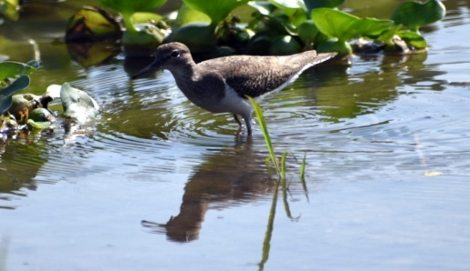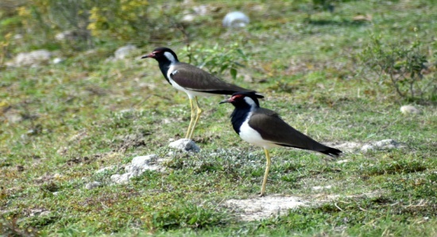
B
AA
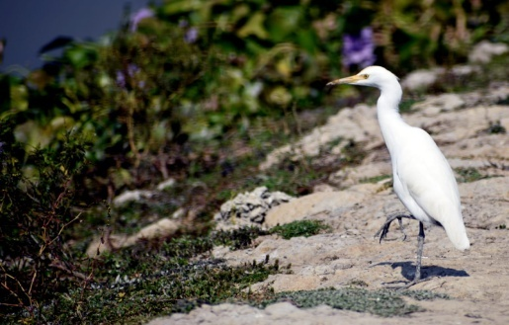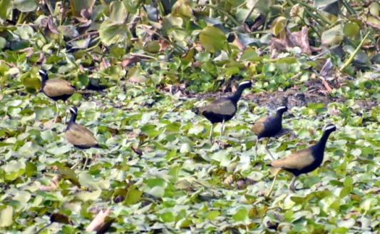
D
C
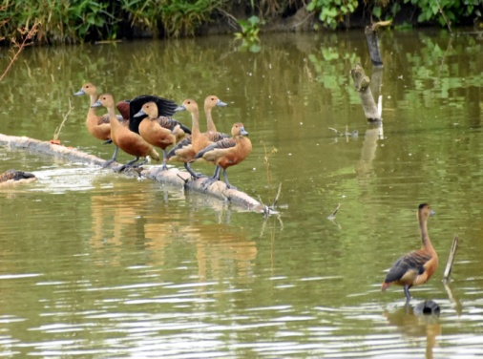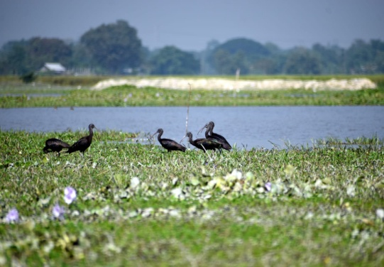
F
E

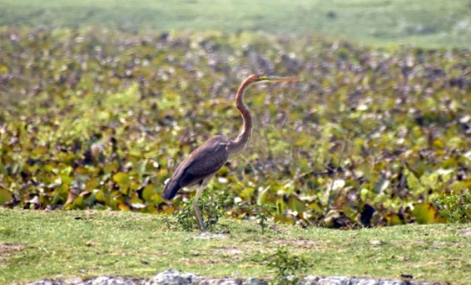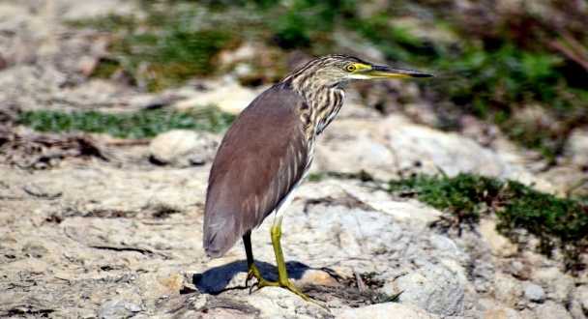
H
G
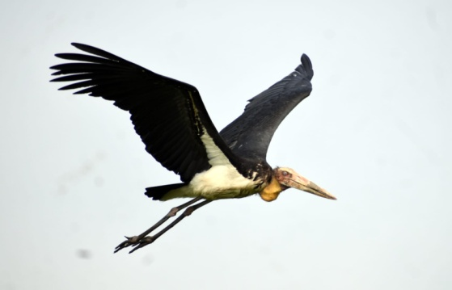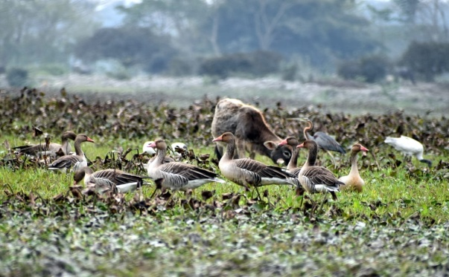
J
I
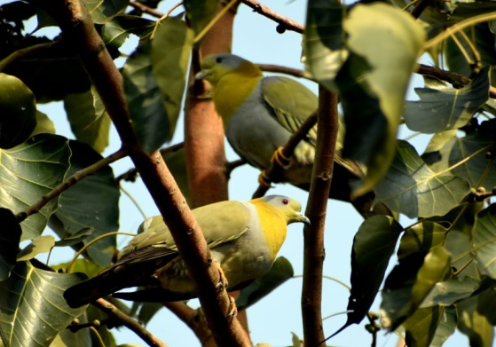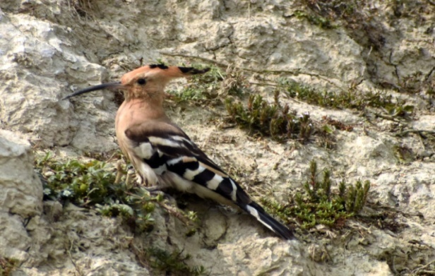
L
K
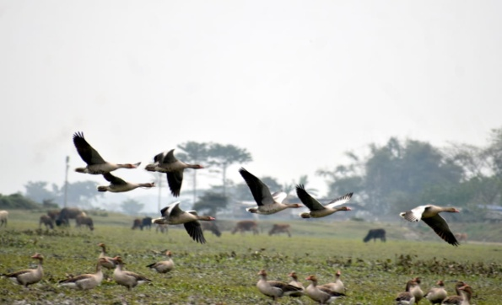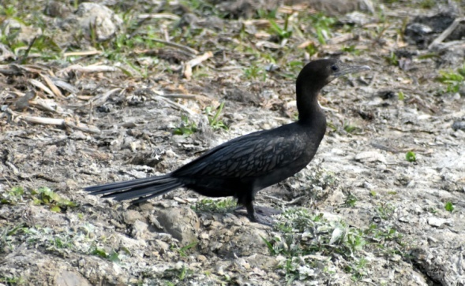
M
N
A: White breasted water hen, B: Red Wattled lapwing, C: Cattle egret, D: Pheasant tailed jacanaE: Lesser Whistling duck F: Glossy Ibis G: Purple Heron, H: Indian Pond Heron, I: Lesser Adjutant stork, J: Greylag goose, K: Yellow footed green pigeon, L: Common Hoopoe, M: Bar headed goose, N:Little cormorant
Again, on the southern edge of Mohoriya, two large ponds under a government mission were created in the past two years. That solar powered lights installed around these ponds have become a matter of concern. Theselights could cause disturbance to both migratory and local birds in several ways. Artificial light is growing worldwide (Kyba et al; 2017) with diverse biological and ecological impacts (Sanders et. al., 2020).Artificial lighting may alter the migration patterns, behavior and vocal communication of birds, leading to confusion and conflict among the bird species of Mohoriya. Artificial light at night (ALAN) can alter daily activity patterns and affect organismal physiology, particularly hormone levels and stress responses (Sanders et. al., 2020).It may disrupt the hormones and sleep patterns of birds and other wildlife. It can mislead migratory birds, affecting their navigation.It may reduce insect populations, which many birds rely on food.Birds may collide with illuminated poles or lights, leading to injury or death. For birds, most well-known effects of artificial light occur during nocturnal migration, when birds are frequently observed aggregating around or colliding with structures with artificial light, such as communication towers and their associated guy wires ( Longcore et al., 2013)
Conclusion:Mohoriya now become an ideal habitat for different resident,locally and periodically migrated bird species along with other plant, invertebrate and vertebrate species.Present study reveals that poaching is the main threat for sustenance of many wild fauna. Illegal trade on the other hand leads to declination of many bird particularly belong to family Anatidae and Ardeidae. Encouragingly many locals now understand the importance of preserving wild birds and wetlands. Massive awareness program and participation of public will help to understand the importance of conservation of such wetland and its biodiversity.

Disclaimer (Artificial intelligence):

Author hereby declare that NO generative AI technologies such as Large Language Models(Chat GPT,COPILOT etc)and text-to –image generators have been used during the writing or editing of this manuscript.

REFERENCES:
Anand, J., H. Byju, A. Nefla, S. Abhijith, O.R. Reshi & K.M. Aarif (2023):Conservation significance of Changaram wetlands — a key wintering site for migratory shorebirds and other waterbirds in the western coast of Kerala, India. Journal of Threatened Taxa 15(1): 22410–22418. https://doi.org/10.11609/jott.8089.15.1.22410 22418
Ali, S. (2002): Book of Indian birds. Bombay Natural History Society. 345 pp
Burg, C.G., B.M. Beehler and S.D.Ripley(1994): Ornithology of the Indian Subcontinent, 1872 1992.An annotated bibliography, 1994, Smithson Institute,Washington, USA.
Choudhury, A. (2000). The Birds of Assam. Gibbon Books and World Wide Fund for Nature-India, North-East Regional Office, 240 pp
Greeson P.E., Clark J.R. and Clark J.E., eds.(1979): Wetland Functions and Values: The State of Our Understanding. MN: Am. Water Resour. Assoc. Minneapolis.
Grimmett, R., Inskipp, C. and Inskipp, T. (2006):. Pocket Guide to the birds of the Indian sub-continent. Oxford University Press, New Delhi. 384 pp
He X, Wang X, DuBay S, Reeve AH, Alström P, Ran J, et al.(2019): Elevational patterns of bird species richness on the eastern slope of Mt. Gongga, Sichuan Province, China. Avian Res. 10:1.
Kumar, A. & A. Kanaujia (2014): Wetlands: Significance, Threats and their Conservation. Green 14(7): 1–25.
Kyba C.C.M, Kuester T, Sánchez de Miguel A, Baugh K, Jechow A, Hölker F, et al.(2017): Artificially lit surface of Earth at night increasing in radiance and extent. Sci Adv. 3:e1701528.

Lepage, D. (2016): Avibase: the world bird database. https://www.bsc eoc.org/avibase/avibase.jsp
Llanos, F.A., M. Failla, G.J. García, P.M. Giovine, M. Carbajal, P.M. González, D.P. Barreto, P. Quillfeldt& J.F. Masello (2011): Birds from the endangered Monte, the Steppes, and Coastal biomes of the province of Río Negro, northern Patagonia, Argentina. Checklist 7(6): 782–797. https://doi.org/10.22029/jlupub-140
Longcore T, Rich C, Mineau P, MacDonald B, Bert DG, Sullivan LM, et al.(2013): Avian mortality at communication towers in the United States and Canada: which species, how many, and where? Biol Cons. 2013; 158: 410–9.
Pandey, N., Khanal, L., & Chalise, M. K. (2020): Correlates of avifaunal diversity along the elevational gradient of Mardi Himal in Annapurna Conservation Area, Central Nepal. Avian Research, 11(1), 31.
Sanders D, Frago E, Kehoe R, Patterson C, Gaston KJ. (2020): A meta-analysis of biological impacts of artificial light at night. Nat Ecol Evol. 2020. https://doi.org/10.1038/s41559-020-01322-x.

Tu H.M., Fan M.W., Ko J.C.J.(2020): Different habitat types affect bird richness and evenness. Scientific Reports. 10(1): 1–11.
Zedler, J.B. and Kercher, S. 2005. Wetland Resources: Status, Trends, Ecosystem Services, and Restorability. Annu. Rev. Environ. Resour. 30:39–74.

