Review Article
The Mulberry-Silkworm Nexus: Nutritional Ecology, Stress Responses, and Their Impact on Silk Production

.
ABSTRACT

Silk production in Bombyx mori is intricately linked to the nutritional quality of mulberry leaves and the stressors encountered during larval development. This review examines the mulberry-silkworm nexus, focusing on how leaf composition, including proteins, amino acids, sugars, vitamins, and secondary metabolites, affects silkworm physiology, silk protein synthesis, and cocoon traits. It also explores the impacts of abiotic, such as temperature, humidity, and drought, and biotic, such as pathogens, pests, and pesticides stressors on digestion, nutrient absorption, gut microbiota, metabolic signalling, and molecular stress responses, highlighting the trade-offs between resilience and productivity. Mechanistic insights into digestive efficiency, nutrient transport, microbiome interactions, and metabolic pathways demonstrate how targeted interventions, ranging from leaf selection and nutrient management to microbial supplementation and strain optimization, can improve silk quality and yield. Future directions emphasize integrated strategies combining breeding, biotechnology, and farm-level practices to stabilize nutrition, mitigate stress effects, and produce consistent, high-quality silk.

Keywords: Nutritional ecology, Stress response, Fibroin synthesis, Silk production, Silk quality

- INTRODUCTION
Sericulture relies on a deceptively simple partnership between an insect and its food source, the mulberry leaf. For the domesticated silkworm, Bombyx mori, mulberry (Morus spp.) leaves are nearly their only food supply. Even slight changes in the chemistry or availability of the leaves have an impact on the development of the larva, the construction of the cocoon, and the final quality of the silk (Sangha et al., 2024). The mulberry-silkworm relationship is both delicate and extremely sensitive due to this close trophic link; changes in leaf protein, sugar balance, or secondary metabolites can affect spinning behaviour, accelerate or slow down larval development, and change fibre qualities that are important to the market (Tassoni et al., 2022; Doliș et al., 2024). Beyond silk, Bombyx mori also provides valuable by-products such as pupae, which are increasingly recognized for their nutritional potential and applications in food and feed industries (Hăbeanu et al., 2023).
Amino acids, vitamins, and antioxidants found in mulberry leaves directly support the silk gland's production of fibroin and sericin. Larvae more effectively transform nutrients into cocoon biomass and silk that is finer, stronger, and glossier when leaf quality is high (Tassoni et al., 2022; Doliș et al., 2024). However, factors such as leaf variety, post-harvest handling, and storage practices can reduce protein availability and antioxidant capacity. Even if these changes do not cause obvious growth problems, they can increase oxidative stress and lower silk protein synthesis, leading to measurable declines in fibre quality (Peng et al., 2023).
In addition to nutrition, stressors are a constant in real farms. Variations in temperature, drought, or humidity affect the metabolism of mulberries and the physiology of silkworms; additional stressors include diseases, pesticide residues, and exposure to sublethal chemicals. Silkworms respond with behavioural, physiological, and molecular adjustments such as alternated feeding, detoxifying enzymes, heat-shock chaperones, and immunological signalling, and these responses frequently interfere with silk production (Homma et al., 2022; Chen et al., 2023a). For instance, even minor pesticide residues on leaves can disrupt digestive function and microbes in the gut, decreasing nutritional absorption and hindering the development of cocoons (Chen et al., 2023a).
Although a mulberry variety with balanced phytochemicals and a high protein content can withstand minor environmental stress, no leaf can completely adapt for extreme heat or significant pesticide drift (Sangha et al., 2024; Peng et al., 2023). Similarly, management decisions on pesticide safety windows, leaf post-harvest handling, harvest timing, and variety selection significantly affect the nutritional environment the silkworms live in and, consequently, the consistency and quality of the silk produced.
Gaining a better knowledge of the relationship between mulberry nutrition and silkworm stress responses is essential to enhancing silk output in spite of current difficulties. Tracing how nutrition and stress affect Bombyx mori physiology allows us to identify areas where interventions, like improving rearing circumstances or creating hardy mulberry cultivars, can have the greatest impact on producing consistent, premium silk.
- NUTRITIONAL ECOLOGY OF MULBERRY LEAVES
Mulberry leaves are not just “leaf and water” for the silkworm. They are an intricate combination of nutrients that determines the rate of development of the larva and the final silk produced by the animal. The major drivers are protein and free amino acids, simple sugars, and a suite of secondary metabolites. Protein and amino acids act as the building blocks for silk proteins (fibroin and sericin), while sugars supply quick energy for feeding and silk gland activity. Phenolics, flavonoids, and alkaloids are examples of secondary compounds that can aid in self-defence, but they also affect digestion, palatability, and the oxidative balance of silkworms (Jan et al., 2021; Yan et al., 2024). In addition to these compounds, mineral elements such as calcium, magnesium, iron, and zinc are vital for enzymatic activity, cocoon formation, and overall silkworm health, making mineral nutrition an often underemphasized but essential component of mulberry leaf quality (Bora et al., 2024). The major nutrients and secondary metabolites in mulberry leaves, along with their direct or indirect influence on silkworm development and silk quality, are summarized in Table 1.
Table 1. Nutritional composition of mulberry leaves and their role in silkworm biology and silk traits
Nutrient / Compound | Role in Silkworm Biology | Impact on Silk Traits | References
Proteins & Amino acids | Building blocks for fibroin and sericin; support larval growth and cocoon development | Increased cocoon weight, finer denier, stronger and more elastic fibers | Doliș et al., 2024; Jan et al., 2021
Sugars (glucose, sucrose, fructose) | Energy source for feeding and silk gland activity; regulates growth and spinning rate | Faster larval development, improved silk gland metabolism | Peng et al., 2023; Liu et al., 2024a
Phenolics & Flavonoids | Antioxidant protection; modulate oxidative stress and detoxification | Supports silk protein synthesis; excessive levels may reduce feeding and silk yield | Jan et al., 2021; Fatima et al., 2024
Vitamins (A, C, E, B complex) | Cofactors in enzymatic reactions; antioxidant and developmental roles | Indirectly improve silk gland health, fiber quality, and luster | Tassoni et al., 2022; Hou et al., 2021
Minerals (Ca, Mg, K, Zn, Fe) | Maintain gut health, enzyme function, and metabolic balance | Affects fiber strength, cocoon shell weight, and uniformity | Liu et al., 2024a; Li et al., 2023
Alkaloids & Secondary metabolites | Defense compounds; influence palatability and gut microbiota | Excessive amounts can reduce silk output; moderate levels may aid stress tolerance | Jan et al., 2021; Yan et al., 2024
Antioxidants | Neutralize ROS; protect midgut and silk gland cells | Prevents oxidative damage to fibroin, maintaining fiber integrity and tensile strength | Doliș et al., 2024; Peng et al., 2023
Protein content varies a lot. Tender, young leaves typically have higher crude protein and nitrogen than mature leaves. Those top-position leaves also show distinct proteomic profiles that reflect active protein synthesis and different photosynthetic roles compared with basal leaves (Hou et al., 2021). Practically, this means which leaves are picked and when they are harvested matters. Younger leaves usually give faster larval growth and better conversion to cocoon mass than over-mature leaves (Li et al., 2023).
Sugars and carbohydrate balance matter too. Simple sugars help maintain feeding rates and gut transit time; they influence how quickly larvae reach the spinning stage. Seasonal swings in carbohydrate levels, driven by light, temperature and plant phenology, translate into measurable changes in larval development time and feed conversion efficiency (Jan et al., 2021; Liu et al., 2024a).
Secondary metabolites introduce important trade-offs. Many mulberry cultivars contain flavonoids and polyphenols that contribute antioxidant capacity. At moderate levels, these compounds protect larvae from oxidative stress during periods of rapid growth, supporting silk protein synthesis. However, excessive concentrations can reduce leaf palatability, lower intake, and interfere with larval detoxification and digestion (Jan et al., 2021; Fatima et al., 2024). Consequently, cultivar selection should consider not only yield per hectare but also the biochemical profile of the leaves consumed by silkworms.
Varietal and seasonal differences in mulberry nutrition are now well-documented. Recent proteomic and metabolomic studies demonstrate that these differences, along with management practices such as pruning systems, influence leaf amino acid composition, antioxidant capacity, and protein content (Liu et al., 2024a). Advances in remote sensing, including hyperspectral imaging, allow rapid and non-destructive assessment of leaf protein content in the field, highlighting how genotype, leaf position, and developmental stage collectively shape nutritive quality in ways that are relevant for both research and production (Li et al., 2023). Figure 1 summarizes practical strategies to optimize mulberry leaf nutrition and silkworm performance by integrating breeding, biotechnology, and farm-level management practices, all aimed at enhancing silk quality and yield.

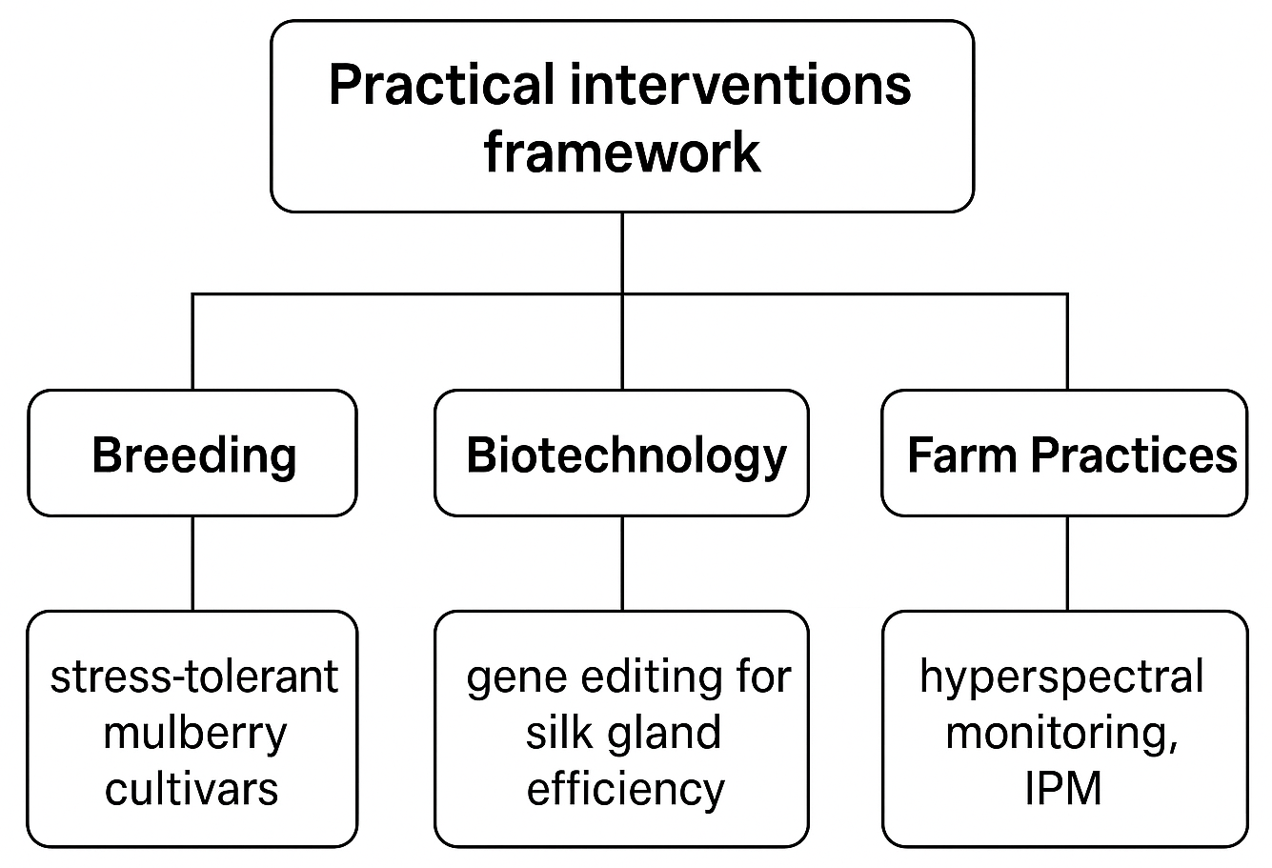

Figure 1. Practical interventions framework for enhancing silk production: integrating breeding, biotechnology, and farm management strategies.

In short, good silk starts at the leaf. Choosing the right cultivar, harvesting the right leaf age, and managing seasonality or using management practices that stabilize leaf nutrient profiles are low-tech, high-impact levers for keeping larval growth steady and silk quality high.

- SILKWORM FEEDING PHYSIOLOGY AND NUTRIENT UTILIZATION
Silkworms consume plant leaf tissue and convert a significant portion of certain nutrients into cocoon proteins, making them exceptional converters. In addition to its hidden partner, the gut microbiota, this efficiency is dependent on four interconnected systems, intracellular metabolic signalling, nutrient transport, digestive enzymes, and ingestion and gut environment. Any modifications to those processes alter the amount and type of food the silkworm can produce, which in turn affects the weight of the cocoon and the characteristics of the silk (Tang et al., 2024; Wu et al., 2022).
  - Digestive efficiency and gut environment
The silkworm midgut is highly alkaline and specialized for rapid breakdown of plant material. That alkaline lumen optimizes activity of major proteases and carbohydrases, so food is processed quickly during the intensive feeding of the final instars (Cao et al., 2021). Anything that disrupts midgut pH, enzyme secretion or tissue integrity, such as heat, heavy metals, pathogens reduce digestion efficiency and lowers the nutrient pool available for silk gland use (Chen et al., 2023b; Xin et al., 2024).
  - Key digestive enzymes and absorption
Proteases like trypsins and chymotrypsins dominate protein digestion, while amylases and glycosidases handle carbohydrates. Variation in expression or activity of these enzymes alters the fraction of leaf protein that becomes free amino acids in the haemolymph. Those free amino acids are the direct precursors for fibroin and sericin synthesis in the silk gland (Cao et al., 2021; Wu et al., 2022). Recent studies also show specific nutrient transporters in the silk gland and gut are critical. For example, the amino acid transporter BmSLC7A5 (LAT1 homolog) is essential for leucine uptake and TOR signalling that drives silk protein synthesis (Tang et al., 2024).
  - Metabolic signalling that links diet to silk synthesis
Nutrient sensing pathways translate the biochemical state of the haemolymph into silk-production decisions. The PI3K–Akt–SGF1–Dimm pathway and TORC1 signalling respond to dietary nutrients and regulate the transcription and translation of silk genes (Cao et al., 2024; Tang et al., 2024). When dietary amino acids or signalling are low, fibroin gene activity drops. Silk protein translation is reduced, resulting in lower cocoon shell weight even if larvae survive (Wu et al., 2022).
  - The microbiota as a modifier of digestion and nutrition
Gut bacteria shape digestion and provide metabolites that affect host metabolism. Disruptions from heavy metals, pesticides, or dietary switch change microbiota composition and metabolite profiles, which in turn modify digestive enzyme expression and nutrient availability to the silk gland (Chen et al., 2023a; Xin et al., 2024). This is one of the reasons that different diets can produce varied cocoon results, such as formula feeds and mulberry leaves (Wu et al., 2022).
  - From diet to cocoon: observed links
Empirical metabolomic and physiological studies connect diet composition directly to cocoon traits. Silkworms fed suboptimal or formula diets show altered metabolic profiles in the midgut, haemolymph, and silk gland. These changes correlate with lower cocoon shell rates, reduced fibroin levels, or altered silk mechanical properties (Wu et al., 2022). Targeted manipulation of single nutrients, such as leucine, or transport mechanisms like BmSLC7A5 can increase silk protein synthesis. These results demonstrate that nutritional or genetic interventions are viable strategies for improving cocoon yield (Tang et al., 2024; Wu et al., 2022).
- STRESS RESPONSES IN THE MULBERRY-SILKWORM SYSTEM
Sericulture is highly sensitive to environmental and biological stresses, which can significantly impair larval performance and reduce silk yield. These stresses can be broadly categorized into two groups. Abiotic stresses, including temperature fluctuations, humidity variations, and drought, influence both the biochemical composition of mulberry leaves and the physiological status of the silkworm. Biotic stresses, such as pathogenic infections, pest infestations, and exposure to agrochemicals, affect the insect directly or indirectly by altering the nutritional quality of its food. Silkworms exhibit a range of responses at behavioural, physiological, and molecular levels to cope with these challenges; however, the activation of stress-response mechanisms often involves trade-offs that compromise silk production (Liu et al., 2024b; Wang et al., 2024). Key abiotic and biotic stressors, along with their physiological effects on silkworms and impacts on silk quality and yield, are summarized in Table 2.
Table 2. Stress factors affecting silkworm physiology and silk production
Stress Factor | Silkworm Response | Consequences for Silk Production | References
Heat / Temperature fluctuations | Induction of heat-shock proteins (HSPs), increased ROS, metabolic shifts | Reduced fibroin synthesis, smaller cocoon size, lower fiber strength and luster | Wang et al., 2024; Iqbal et al., 2025
Humidity extremes (low/high) | Altered water balance, disrupted moulting and spinning behaviour | Incomplete spinning, irregular fiber structure, increased pathogen susceptibility | Manjunatha et al., 2010; Ashraf & Qamar, 2023
Drought / Water stress | Reduced feeding, elevated oxidative stress | Lower cocoon weight, decreased silk yield | Peng et al., 2023; Liu et al., 2024b
Viral & bacterial pathogens (e.g., BmNPV) | Immune activation, resource diversion to defense | Decreased cocoon shell weight, altered fiber composition | Wang et al., 2017; Liang et al., 2024
Pesticide residues / Agrochemicals | Detox enzyme induction, gut microbiota disruption | Impaired digestion, smaller cocoons, weaker/coarser fibers | Chen et al., 2023b; Sun et al., 2024
Oxidative stress | Upregulation of antioxidant enzymes (SOD, CAT, GST) | Maintains fiber integrity if moderate; excessive stress reduces quality | Wang et al., 2024; Wen et al., 2024
Gut dysbiosis | Altered microbial composition, reduced nutrient absorption | Lower fibroin synthesis, decreased cocoon mass | Xin et al., 2024; Yuan et al., 2023

  - Environmental stresses (temperature, humidity, drought)

- Heat and abrupt temperature changes increase reactive oxygen species (ROS) and metabolic rate. Unless protective systems take over, that damages cells in the midgut and silk glands and lowers the production of silk proteins. Although heat-shock proteins and chaperones are the main buffers, they are energy-intensive and divert resources from the production of silk. Even short, sublethal heat events can reduce the quality of the fibre and the cocoon shell ratio (Wang et al., 2024; Iqbal et al., 2025).
- Humidity affects larval water balance, moulting and spinning behaviour. Low humidity increases water loss and can cause incomplete spinning; high humidity encourages pathogens and disrupts silk drying and fibre properties (Manjunatha et al., 2010; Ashraf & Qamar, 2023).

  - Biotic stresses: diseases, pests, and agrochemical exposure

- Viral and bacterial pathogens (especially, BmNPV) trigger widespread changes in host transcription and protein networks; infected larvae divert resources to immune responses and cell-repair pathways, which lowers silk output and may alter fibre composition (Wang et al., 2017; Liang et al., 2024).
- Pesticide residues and sublethal agrochemical exposure cause behavioural and physiological damage, including slower growth, midgut histopathology, enzyme induction related to detoxification, microbiota dysbiosis, and reduced cocoon traits. These effects are often subtle but cumulative, and they represent a common cause of unexpectedly low yields in mixed-crop landscapes (Chen et al., 2023b; Sun et al., 2024; Liu et al., 2022).

  - Physiological and molecular responses in silkworms

- Heat-shock response and chaperones. Heat-shock proteins (HSPs) and small chaperones rise quickly after thermal stress. They protect protein folding in the silk gland, but prolonged HSP activation correlates with reduced fibroin expression and smaller cocoons (Liu et al., 2024b; Iqbal et al., 2025).
- Oxidative stress and antioxidant systems. ROS levels spike under heat or chemical stress. Antioxidant enzymes, including superoxide dismutase (SOD), catalase (CAT), and glutathione S-transferase (GST), along with related genes, are upregulated to counter oxidative damage; however, if these defense systems are overwhelmed, cellular damage to DNA, lipids, and proteins occurs, which impairs silk gland function and reduces silk synthesis (Wang et al., 2024; Wen et al., 2024).
- Detoxification and immune signalling. Exposure to pesticides or pathogens induces xenobiotic-metabolizing enzymes such as cytochrome P450s (CYPs), carboxylesterases, and glutathione S-transferases (GSTs), as well as immune pathways including Toll, immune deficiency (Imd), and Janus kinase/signal transducer and activator of transcription (JAK/STAT). Activation of these detoxification and immune responses competes for amino acids and energy, reducing allocation to silk protein synthesis (Chen et al., 2023b; Liang et al., 2024).
- Gut integrity and microbiota shifts. Stressors change gut structure and community composition. Gut dysbiosis impairs digestion and nutrient absorption, indirectly shrinking the nutrient pool available for silk production (Xin et al., 2024; Yuan et al., 2023). Restoring beneficial microbiota often improves growth and cocoons. The integrated molecular and physiological pathways through which silkworms respond to environmental and biotic stressors are illustrated in Figure 2.

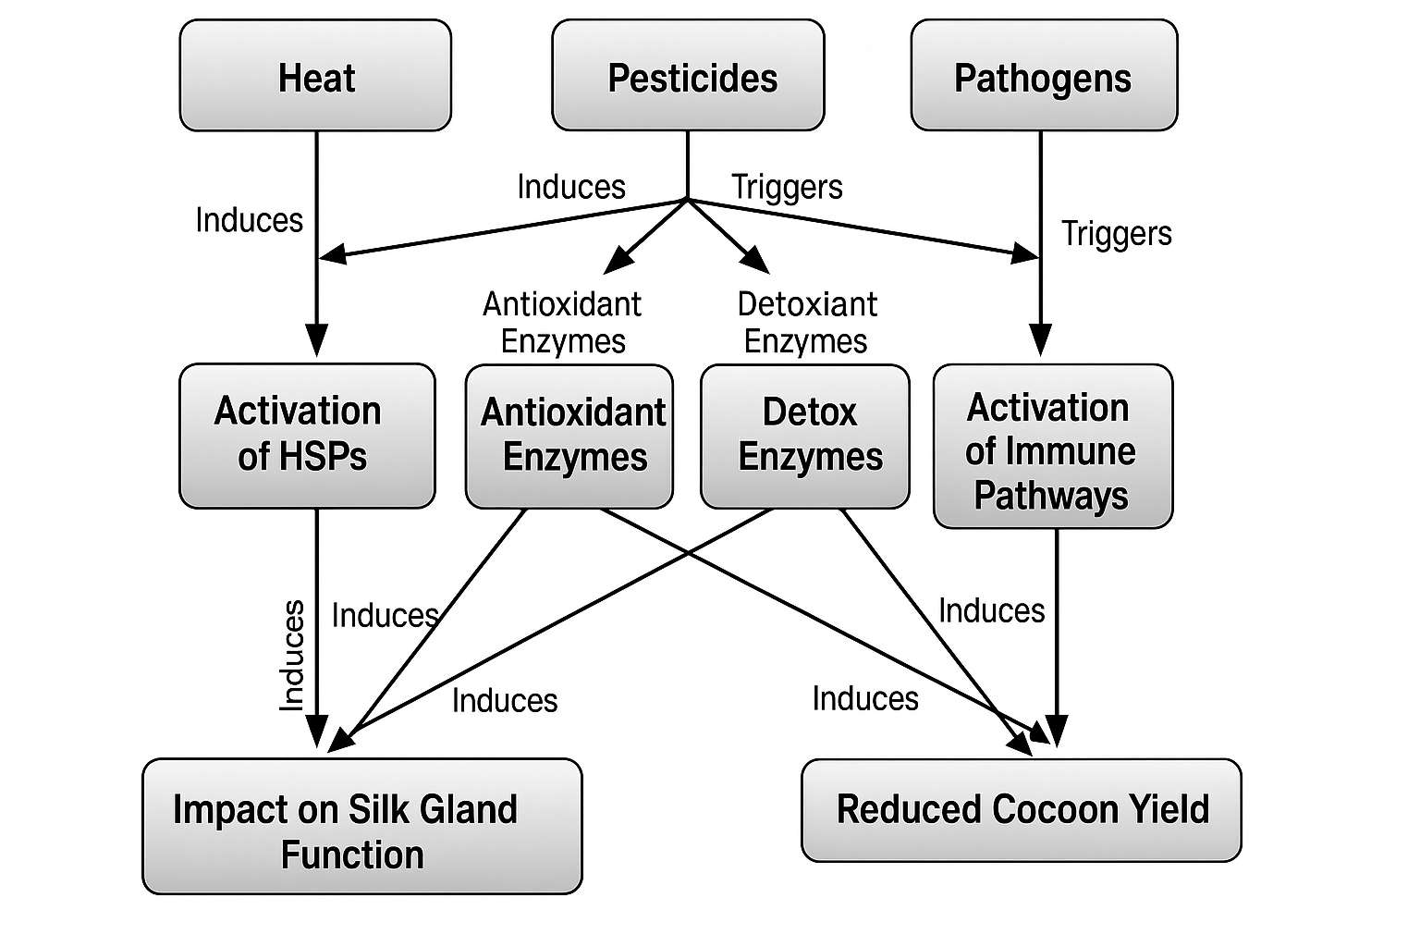

Figure 2. Stress response pathways in Bombyx mori linking heat, pesticides, and pathogens to silk gland function and cocoon yield
Stress responses carry significant energy costs. Even when larvae survive, combined or repeated stresses, such as heat with pesticide exposure, or drought with pathogen pressure reduce cocoon shell weight and alter fiber mechanical properties. Effective field practices, including the removal of contaminated leaves, harvesting at cooler periods, and minimizing pesticide drift are therefore as critical as genetic or biotechnological interventions for maintaining consistent silk quality (Chen et al., 2023a; Liu et al., 2024b).
- IMPLICATIONS FOR SILK QUALITY AND YIELD
The quality and yield of silk are deeply influenced by the nutrition and stress levels experienced by silkworms during their development. These factors not only affect the quantity of silk produced but also its intrinsic properties such as denier, strength, and luster.

  - Role of Nutrition in Silk Quality
Good nutrition is a key determinant of silk quality. When silkworms consume mulberry leaves rich in protein and balanced in amino acids, they obtain the necessary building blocks to synthesize fibroin and sericin efficiently. This results in longer filaments with finer denier, improved tensile strength, and enhanced luster (Muzamil et al., 2023). Trials with leaves fortified with amino acids such as glycine, alanine, and serine, the principal components of fibroin, demonstrated that silk threads became stronger and more elastic due to improved protein structure during spinning (Kim et al., 2023). Improving mulberry leaf quality through fertilization or nutrient management has also been shown to consistently increase cocoon yield and enhance filament properties (Muzamil et al., 2023).
  - Stress Effects on Fiber Properties
Stress undermines silk quality. High temperatures, poor-quality leaves, or crowded rearing conditions force silkworms to divert energy away from silk gland growth and fibroin synthesis. The outcome is shorter, coarser, and more variable filaments with reduced tensile strength (Chen et al., 2024). Chemical stressors can be even more damaging, as exposure to insecticides such as dinotefuran induces oxidative damage and autophagy in silk glands, weakening fiber structure and diminishing luster (Huang et al., 2023). When larvae prioritize survival over spinning, both yield and quality inevitably decline.
  - Influence of the Gut Microbiome
The gut microbiota plays an important role in determining silk quality. Balanced microbial communities enhance the digestion of mulberry leaves and improve access to essential amino acids (Xin et al., 2024). However, the inclusion of certain synthetic or natural preservatives in diets can disrupt this balance, leading to alterations in cocoon traits and overall silk yield (Lei et al., 2024). This highlights a promising research frontier, identifying beneficial microbial strains could support the development of probiotic or microbiome-informed diets that enhance both resilience and productivity (Xin et al., 2024).
  - Trade-Offs Between Resilience and Productivity
It is rarely a free trade-off. Strains that withstand heat or chemical stress often develop smaller silk glands and produce less fibroin, resulting in thicker but less abundant silk (Chen et al., 2024). In contrast, strains selected for high yield generate longer and glossier filaments, but only under optimal rearing conditions (Kim et al., 2023). In practical sericulture systems, the strain must be matched to the prevailing environment. Without adequate nutrition and stable conditions, producers risk sacrificing either resilience or silk quality (Muzamil et al., 2023; Xin et al., 2024).
  - Practical Implications for Sericulture
In practical terms, improving leaf nutrition through targeted amino acid fortification or optimized fertilization can enhance filament quality and yield (Muzamil et al., 2023). Minimizing pesticide exposure is equally important, as it protects silk glands from oxidative damage and helps preserve fiber strength and luster (Huang et al., 2023). Attention to gut health also presents new opportunities; probiotic supplementation or microbiome-informed diets may improve nutrient utilization and cocoon characteristics (Xin et al., 2024). Finally, selecting appropriate strains for local environments remains essential. Under harsh or variable conditions, resilient strains provide greater stability, while in optimal environments, high-yielding strains can maximize productivity (Chen et al., 2024; Kim et al., 2023).
- CONCLUSION AND FUTURE PROSPECTS
Nutrition and stress interact continuously to determine silk production outcomes. High-quality mulberry leaves provide the amino acids and energy required for efficient synthesis of fibroin and sericin, while leaf antioxidants and secondary metabolites help modulate oxidative load and digestion. Under optimal nutrition, silkworms achieve faster growth, greater conversion efficiency, and improved fibre characteristics. Conversely, when nutrition is compromised or stressors accumulate, such as temperature fluctuations, cold-stored leaves, pesticide residues, or pathogens, larvae activate detoxification pathways. They also trigger additional stress-response mechanisms to cope with these challenges. These processes divert resources away from silk synthesis and ultimately reduce yield and quality (Sangha et al., 2024; Peng et al., 2023; Liu et al., 2024a).
Looking ahead, three practical directions hold the greatest promise. First, targeted breeding of mulberry and silkworm varieties that combine high nutritional profiles with stress tolerance will provide material better suited to variable field conditions (Manjunath et al., 2023). Second, advances in biotechnology, including marker-assisted selection, gene editing, and transgenic approaches, offer opportunities to enhance leaf nutrient composition, pest resistance, and silkworm resilience. However, these innovations must be accompanied by careful biosafety assessment and societal acceptance (Kumar et al., 2024; Attria et al., 2024). Third, improved farm practices, such as timely harvesting, minimal leaf storage, integrated pest management, and the adoption of monitoring tools (e.g., hyperspectral imaging or biochemical assays), represent cost-effective strategies to stabilize nutrition and mitigate stress impacts. Integrating these three approaches provides a pathway toward producing consistently high-quality silk without compromising resilience (Li et al., 2023; Huang et al., 2018).
Future research should focus on three priority areas: (1) mechanistic studies that connect specific mulberry leaf metabolites to silk biochemical pathways, (2) field-level trials to evaluate nutrient-aware pruning and harvest schedules across seasons, and (3) socio-regulatory studies addressing the adoption of biotechnology in sericulture. Addressing these gaps will help transition the sector from reactive management to proactive, evidence-driven systems that support both silkworm health and farmer livelihoods (Sangha et al., 2024; Liu et al., 2024).

Disclaimer (Artificial intelligence)
Option 1:
Author(s) hereby declare that NO generative AI technologies such as Large Language Models (ChatGPT, COPILOT, etc.) and text-to-image generators have been used during the writing or editing of this manuscript.

References

- Ashraf, H., & Qamar, A. (2023). A review on heat stress altering the insect life history strategies and underlying mechanisms: Special reference to an economically important Lepidoptera, Bombyx mori (Linnaeus, 1758) (Lepidoptera: Bombycidae). SHILAP Revista de lepidopterología, 51(202), 339-357.
- Attria+, K., GSb, S., Jekinakatti, B., Thrilekha, D., Devi, D. L., Garai, I., et al. (2024). Advancements in Sericulture: Innovations and Sustainability in Silk. Uttar Pradesh Journal of Zoology, 45(16), 305-317.
- Bora, N., Singha, T. A., & Gogoi, D. (2024). Importance of Minerals in Silkworm Nutrition: A Review. Journal of Advances in Biology & Biotechnology, 27(7), 1457-1463.
- Cao, H. H., Zhang, S. Z., Zhu, L. B., Wang, J., Liu, Y. X., Wang, Y. L., et al. (2021). The digestive proteinase trypsin, alkaline A contributes to anti-BmNPV activity in silkworm (Bombyx mori). Developmental & Comparative Immunology, 119, 104035.
- Chen, L., Zhang, J., Ding, L., Gu, T., Andoh, V., Ma, A., et al. (2024). Transcriptomics analyses combined with intestinal microorganism survey suggest Resveratrol (RSV) anti-aging and anti-oxidant effects in silkworm (Bombyx mori). Comparative Biochemistry and Physiology Part D: Genomics and Proteomics, 52, 101344.
- Chen, Q., Sun, S., Yang, X., Yan, H., Wang, K., Ba, X., et al. (2023a). Sublethal effects of neonicotinoid insecticides on the development, body weight and economic characteristics of silkworm. Toxics, 11(5), 402.
- Chen, Y. Z., Rong, W. T., Qin, Y. C., Lu, L. Y., Liu, J., Li, M. J., et al. (2023b). Integrative analysis of microbiota and metabolomics in chromium-exposed silkworm (Bombyx mori) midguts based on 16S rDNA sequencing and LC/MS metabolomics. Frontiers in Microbiology, 14, 1278271.
- Doliș, M. G., Pânzaru, C., Usturoi, M. G., Usturoi, A., Radu-Rusu, C. G., & Davidescu, M. A. (2024). On the digestibility of mulberry leaf fed to Bombyx mori larvae. Agriculture, 14(8), 1394.
- Fatima, M., Dar, M. A., Dhanavade, M. J., Abbas, S. Z., Bukhari, M. N., Arsalan, A., et al. (2024). Biosynthesis and pharmacological activities of the bioactive compounds of white mulberry (Morus alba): Current paradigms and future challenges. Biology, 13(7), 506.
- Hăbeanu, M., Gheorghe, A., & Mihalcea, T. (2023). Nutritional value of silkworm pupae (Bombyx mori) with emphases on fatty acids profile and their potential applications for humans and animals. Insects, 14(3), 254.
- Homma, S., Murata, A., Ikegami, M., Kobayashi, M., Yamazaki, M., Ikeda, K., et al. (2022). Circadian clock genes regulate temperature-dependent diapause induction in silkworm Bombyx mori. Frontiers in Physiology, 13, 863380.
- Hou, Z., Xu, D., Deng, N., Li, Y., Yang, L., Li, S., et al. (2021). Comparative proteomics of mulberry leaves at different developmental stages identify novel proteins function related to photosynthesis. Frontiers in Plant Science, 12, 797631.
- Huang, L., Yang, L., Meng, L., Wang, J., Li, S., Fu, X., et al. (2018). Potential of visible and near-infrared hyperspectral imaging for detection of Diaphania pyloalis larvae and damage on mulberry leaves. Sensors, 18(7), 2077.
- Huang, Y., Zou, S., Zhan, P., Hao, Z., Lu, Q., Jing, W., et al. (2023). Dinotefuran induces oxidative stress and autophagy on Bombyx mori silk gland: Toxic effects and implications for nontarget organisms. Environmental Pollution, 336, 122470.
- Iqbal, J., Lei, X., Qian, Z., Zhang, H., Li, Y., Ahmad, F., et al. (2025). Insights into the heat shock protein 19.9 and 90 in Bombyx mori: Key molecular chaperones in heat stress adaptation. International Journal of Biological Macromolecules, 320, 145838.
- Jan, B., Parveen, R., Zahiruddin, S., Khan, M. U., Mohapatra, S., & Ahmad, S. (2021). Nutritional constituents of mulberry and their potential applications in food and pharmaceuticals: A review. Saudi journal of biological sciences, 28(7), 3909-3921.
- Kim, Y., Yoon, T., Park, W. B., & Na, S. (2023). Predicting mechanical properties of silk from its amino acid sequences via machine learning. Journal of the Mechanical Behavior of Biomedical Materials, 140, 105739.
- Kumar, C. D. S., Gowthami, B., & Durga, V. P. N. (2024). Biotechnological approaches for enhancing mulberry yield and quality. International Journal of Advanced Biochemistry Research, 8(8), 1507–1511.
- Lei, X., Qian, Z., Zhu, X., Zhang, N., He, J., Xiao, J., et al. (2024). Fitness effects of synthetic and natural diet preservatives on the edible insect Bombyx mori. npj Science of Food, 8(1), 39.
- Li, X., Peng, F., Wei, Z., Han, G., & Liu, J. (2023). Non-destructive detection of protein content in mulberry leaves by using hyperspectral imaging. Frontiers in Plant Science, 14, 1275004.
- Liang, W., Zhou, L., Dang, Z., Wang, S., Zhao, P., Xia, Q., et al. (2024). Downregulation of BmSTAT transcription factor promoted nucleopolyhedrovirus replication in Bombyx mori. Frontiers in Microbiology, 15, 1485951.
- Liu, X., Yang, J., Chen, J., Li, F., Sun, H., Wei, J., et al. (2022). Impact of sublethal chlorantraniliprole on epidermis of Bombyx mori during prepupal-pupal transition. Pesticide Biochemistry and Physiology, 187, 105200.
- Liu, Y., Lv, Z., Wei, J., Liu, P., Pan, M., Ma, H., et al. (2024a). Comparative Physiological, Proteomic, and Metabolomic Insights into a Promising Low-Pruning Mulberry Cultivar for Silkworm Rearing. International Journal of Molecular Sciences, 25(24), 13483.
- Liu, Z., Li, C., Yang, W., Wu, Q., Xiao, W., Zhu, Y., et al. (2024b). The Bombyx mori singed gene is involved in the high-temperature resistance of silkworms. Insects, 15(4), 264.
- Manjunath, K. K., Bs, H., Nm, A., & Ha, B. (2023). Breeding for mulberry improvement: A review. Pharma Innov, 12, 477-481.
- Manjunatha, H. B., Rajesh, R. K., & Aparna, H. S. (2010). Silkworm thermal biology: A review of heat shock response, heat shock proteins and heat acclimation in the domesticated silkworm, Bombyx mori. Journal of Insect Science, 10(1), 204.
- Muzamil, A., Tahir, H. M., Ali, A., Bhatti, M. F., Munir, F., Ijaz, F., et al. (2023). Effect of amino acid fortified mulberry leaves on economic and biological traits of Bombyx mori L. Heliyon, 9(10).
- Peng, M., Wang, G., & Zhu, S. (2023). Cold‐stored mulberry leaves affect antioxidant system and silk proteins of silkworm (Bombyx mori) larva. Journal of the Science of Food and Agriculture, 103(15), 7673-7682.
- Sangha, M. N., Barwani, D. K., Xavier, C., Muhonja, L., Moseti, K., Karanja, P. N., et al. (2024). We are what we eat: Implications of host plant suitability on sustainable production of silkworm pupae as novel ingredient with dietary and health benefits. PloS one, 19(12), e0316290.
- Sun, S., Chen, Q., Gao, J., Qu, M., Chen, Z., Wang, K., et al. (2024). Sublethal effects of nitenpyram on the development of silkworm. Science of the Total Environment, 950, 175262.
- Tang, X., Liu, H., Wang, X., Chang, L., Liu, Q., Xia, Q., et al. (2024). BmSLC7A5 is essential for silk protein synthesis and larval development in Bombyx mori. Insect Science, 31(5), 1425-1439.
- Tassoni, L., Cappellozza, S., Dalle Zotte, A., Belluco, S., Antonelli, P., Marzoli, F., et al. (2022). Nutritional composition of Bombyx mori pupae: A systematic review. Insects, 13(7), 644.
- Wang, X. Y., Yu, H. Z., Xu, J. P., Zhang, S. Z., Yu, D., Liu, M. H., et al. (2017). Comparative subcellular proteomics analysis of susceptible and near-isogenic resistant Bombyx mori (Lepidoptera) larval midgut response to BmNPV infection. Scientific Reports, 7(1), 45690.
- Wang, Y., Zhang, X., Tian, C., Guo, X., Shu, Q., Gu, H., et al. (2024). Effects of different diets on thermal tolerance in the silkworm, Bombyx mori. Entomologia Experimentalis et Applicata, 172(1), 27-34.
- Wen, H., Wang, Y., Ji, Y., Chen, J., Xiao, Y., Lu, Q., et al. (2024). Effect of acute exposure of Hg on physiological parameters and transcriptome expression in silkworms (Bombyx mori). Frontiers in Veterinary Science, 11, 1405541.
- Wu, X., Chen, X., Ye, A., Cao, J., He, R., Pan, M., et al. (2022). Multi-tissue metabolomic profiling reveals potential mechanisms of cocoon yield in silkworms (Bombyx mori) fed formula feed versus mulberry leaves. Frontiers in Molecular Biosciences, 9, 977047.
- Xin, L., Chen, Y., Rong, W., Qin, Y., Li, X., & Guan, D. (2024). Gut microbiota analysis in silkworms (Bombyx mori) provides insights into identifying key bacterials for inclusion in artificial diet formulations. Animals, 14(9), 1261.
- Yan, C. H., Chen, F. H., Yang, Y. L., Shen, L. W., Xun, X. M., Zhang, Z. A., et al. (2024). Biochemical and protein nutritional potential of mulberry (Morus alba L.) leaf: partial substitution improves the nutrition of conventional protein. Journal of the Science of Food and Agriculture, 104(4), 2204-2214.
- Yuan, S., Sun, Y., Chang, W., Zhang, J., Sang, J., Zhao, J., et al. (2023). The silkworm (Bombyx mori) gut microbiota is involved in metabolic detoxification by glucosylation of plant toxins. Communications Biology, 6(1), 790.

