Original Research Article
Potential of Ricinodendron heudelotii (‘akpi’) cake as a local resource for animal feed in Côte d'Ivoire

.
ABSTRACT

This study aimed to provide farmers with reliable nutritional data on a locally available, low-cost, and protein-rich ingredient, the defatted flour from Ricinodendron heudelotii (Baill.) kernels, as a potential feed resource for livestock. Kernel cakes were collected from five major production areas in Cote d’Ivoire, and aliquots were analyzed in the laboratory. Proximate composition was determined following AOAC procedures. Carbohydrates were calculated by difference and crude fiber was assessed using sulfuric acid digestion. Energy values were estimated using Atwater and Rosa coefficients. Mineral contents (Mg, P, Ca, K, Fe, Cl, Zn) were determined by atomic absorption spectrophotometry and spectrophotometry. Antinutritional factors, including total polyphenols, phytates, flavonoids, tannins, and oxalates, were quantified by spectrophotometric and titrimetric methods. Results showed that proximate values ranged as follows (g/100 g), dry matter 92.7-95.6; ash 11.2-13.1; crude protein 47.0-61.3; carbohydrates 20.5-37.8; crude fiber 9.5-14.4; and metabolizable energy 322-465 kcal/100 g. pH and titratable acidity varied from 6.1 to 7.1 and 1.9 to 4.5 meq/100 g, respectively. Antinutritional compounds were present in significant amounts, total polyphenols (216.6-403.9 mg/100 g), phytates (52.2-71.4 mg/100 g), flavonoids (1.0-4.6 mg/100 g), tannins (16.4-41.8 mg/100 g), and oxalates (714.7-973.6 mg/100 g). The flour was shown to be a good source of proteins, phosphate, potassium, and calcium, even if it had some antinutritional aspects that made it less useful. To sum up, defatted flours made from Ricinodendron heudelotii kernels are a good alternative protein source for feeding livestock in Côte d'Ivoire. For safe and effective on-farm use, we suggest simple, low-cost detoxification steps like short roasting or toasting (about 120–140 °C for 10–15 minutes) or short boiling (10–20 minutes) followed by sun-drying. If possible, a 24–48 hour lactic fermentation (clean container, discard soak water) will further reduce phytates and tannins, along with basic quality control (low moisture, cool-dry storage).

Keywords: Ricinodendron heudelotii, defatted flour, proximate composition, antinutritional factors, livestock feeding, Côte d’Ivoire

1. INTRODUCTION

Livestock feeding is a major challenge for animal production in Côte d’Ivoire, with direct implications for food security and national sovereignty. Increasing feed expenses, the necessity to enhance feed quality, and the decrease in imports are pivotal challenges for attaining self-sufficiency in animal protein (IPRI, 2019; Ducroquet et al., 2017). Feed constitutes up to 60% of overall production expenses, and sufficient protein consumption is crucial for maintaining animal development, reproduction, and productivity (Feed Business Middle East and Africa, 2025; Poultry News Africa, 2025). Currently, domestic protein supply satisfies merely 57% of national demand, resulting in significant dependence on imports (FAO, 2004).
To mitigate this deficiency, the enhancement of local plant-derived protein supplies emerges as a feasible approach. The kernel cake of Ricinodendron heudelotii, known as akpi, a by-product of oil extraction from its seeds, has been recognized as a possible protein-rich feed component. Prior research indicates that raw kernels contain approximately 24% protein (Saki et al., 2005), however defatted flours may have up to 61% protein, in addition to significant caloric and mineral content (Coulibaly et al., 2018). Moreover, protein isolates derived from this cake exhibit good digestion (enzymatic digestibility > 90%), with a quality akin to reference proteins (Kenfack, 2010).
In addition to its nutritional benefits, the fact that Ricinodendron heudelotii is easy to find in Côte d'Ivoire is important. Recent inventory work shows that the species is found in most of the southern region and parts of the north. Artisans who sell to urban markets like Adjamé "Marché Gouro" do the harvesting and primary processing (Nikiema et al., 2024). It is thought that national kernel harvests are about 100 tonnes per year, which shows that there is an active but informal value chain. There hasn't been any processing on an industrial scale yet. However, the CNRA's domestication and agroforestry projects (like those in Oumé and Agboville) under the PNAGF-CI are making shade trees more common in cocoa systems and are expected to boost kernel production (Nikiema et al., 2024). The average kernel oil content in Côte d'Ivoire is about 47%, so if this harvest were fully pressed, it would theoretically produce about 50 tonnes of defatted cake per year. This shows both the current availability and the room for growth as pressing capacity gets better (Nikiema et al., 2024).
Notwithstanding these encouraging results, the incorporation of Ricinodendron heudelotii (R. heudelotii) kernel cake into animal feed formulations is still restricted. This mostly results from the absence of comprehensive, dependable, and current nutritional databases, which limits its judicious application by farmers and feed formulators. This study was conducted to produce an updated nutritional profile of R. Heudelotii defatted kernel flours in Côte d'Ivoire. The aims were (1) to analyse their proximate, mineral, and antinutritional makeup, and (2) to emphasise their potential applications in cattle nutrition. This initiative seeks to reduce feed costs, enhance protein sovereignty in the livestock industry, and foster sustainable and competitive animal feeding systems.
2. material and methods

Biological material and study area: Samples consisted of kernel cakes of Ricinodendron heudelotii (Baill.) obtained from seeds collected in different localities of Côte d’Ivoire: the autonomous district of Abidjan (coastal); Lôh-Djiboua region Divo; Haut-Sassandra region and Gontougo region, (Zanzan district). These sites span the humid coastal belt and the forest-savanna transition zone further inland. Zanzan borders Ghana to the east, while Abidjan lies on the Gulf of Guinea. Lôh-Djiboua and Haut-Sassandra are located in the south-west/centre-west (Fig. 1; Table 1).
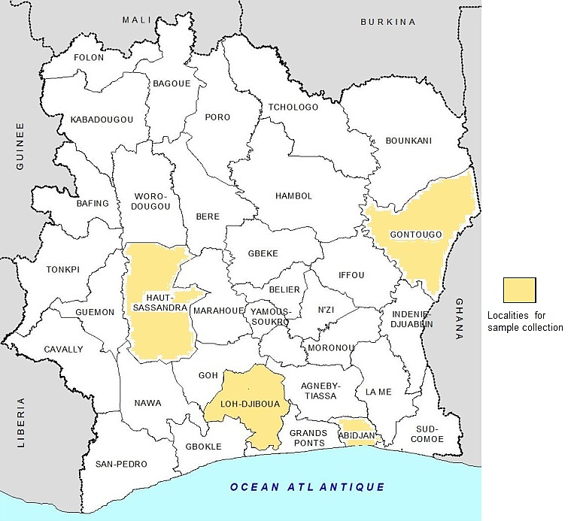
Fig. 1. Localities identified for sample collection (adapted from INS-SODE, 2014).
Table 1: Coordinates, elevation, climate, and distance to the national capital (Yamoussoukro)

Site (city) | Administrative unit | Coordinates (lat, lon) | Elevation (m) | Climate and typical rainfall | Distance to Yamoussoukro*
Abidjan | Autonomous District of Abidjan | 5.345° N, 4.024° W | 18 | Tropical savanna (Aw); 1,450–1,850 mm yr⁻¹ | 215 km
Divo | Lôh-Djiboua Region | 5.837° N, 5.357° W | 147 | Aw; 1,388 mm yr⁻¹ | 110 km
Issia | Haut-Sassandra Region | 6.492° N, 6.586° W | 211 | Aw; rainy season Mar–Nov (district 1,100–1,500 mm yr⁻¹) | 149 km
Koun-Fao | Gontougo (Zanzan) | 7.483° N, 3.250° W | 181 | Aw; Zanzan ~800–1,200 mm yr⁻¹ | 235 km
Source: INS-SODE, 2014
Reagents and equipment: All reagents used were of analytical grade (Sigma-Aldrich®, Merck®). The main equipment included a ventilated oven (Memmert®, Germany), a muffle furnace (Nabertherm®, Germany), a UV-Visible spectrophotometer (Shimadzu®, Japan), a precision balance (Sartorius®, Germany), and an electric grinder (Retsch®, Germany).
Sampling procedure: A prospective survey was conducted in six major markets of Abidjan (Gouro-Adjamé, Abobo, Treichville, Yopougon, Marcory, and Koumassi), which represent the main supply hubs for food products in the city (IFC, 2020). Wholesalers and retailers were interviewed about the origin of R. heudelotii kernels, and ten localities were identified for sample collection through this channel. These included the Haut-Sassandra region (Daloa, Vavoua, Issia), the Lôh-Djiboua region (Divo, Lakota), the Gontougo region (Bondoukou), and the District of Abidjan (Fig. 2).

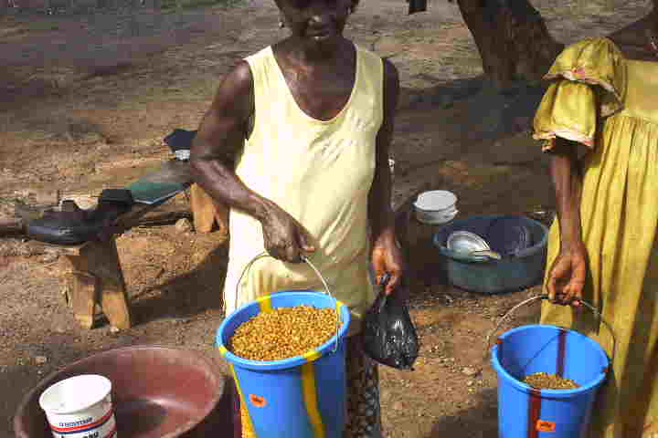  (a) | 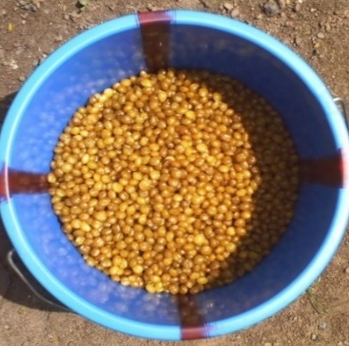  (b) | 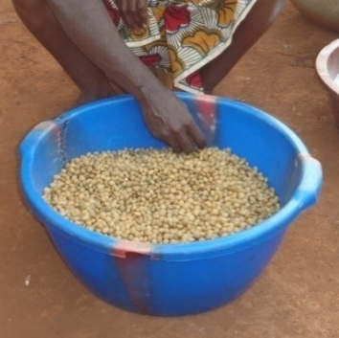  (C)
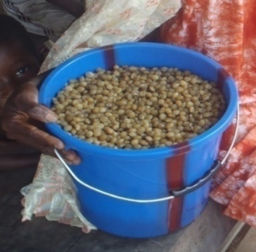  (d) | 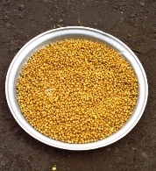  (e) | 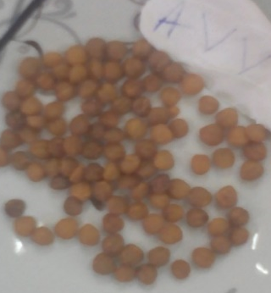  (f)
Fig 2. Kernels from the District of Abidjan (a and b), the Lôh-Djiboua region (Divo, c and d), the Gontougo region (Koun-Fao, e) and the Haut-Sassandra region (Issia, f).

Sample preparation: The analyses were carried out at the food biochemistry and tropical product-processing laboratory of the Department of Food Science and Technology at NANGUI ABROGOUA University. Seeds were cooked in boiling distilled water following the method of Kaankuka et al. (1996) adapted from soybean processing. Cooked seeds were drained, decorticated, and dried in a ventilated oven (45 °C, 24 h). Dried kernels were ground (Moulinex®, France) for 5 min and subjected to hexane extraction of crude fat according to AFNOR (1981). Residues (kernel cakes) were desolventized at room temperature (1 h) and oven-dried (45 °C, 2 h). The resulting flours were sieved (500 µm) and stored in airtight glass containers, protected from light and humidity, until analysis.
Proximate composition: Moisture content was determined by oven drying at 105 °C to constant weight (AOAC, 1990). Crude protein was measured by the Kjeldahl method, using the nitrogen-to-protein conversion factor 6.25. Ash content was obtained by incineration at 550 °C. Total carbohydrates were calculated by difference (FAO/WHO, 1997). Crude fiber was determined by the enzymatic-gravimetric method (Prosky et al., 1988). Metabolisable energy was determined with the factors established by Atwater and Rosa (1899). The pH was measured using a calibrated pH meter (Metrohm 744, Switzerland), and titratable acidity was evaluated using titration with 0.1 N NaOH in the presence of phenolphthalein (AOAC, 1990).
Mineral composition: The mineral composition, including potassium (K), magnesium (Mg), iron (Fe), calcium (Ca), and zinc (Zn), was analysed using atomic absorption spectrophotometry (Analyst 800, Perkin Elmer, USA). Phosphorus and chloride were measured with UV-Visible spectrophotometry (Fiske & Subbarow, 1925).
Phytochemical analysis: Total flavonoids were determined by the colorimetric method of Meda et al. (2005) and expressed as mg quercetin equivalents/g dry matter. Phytates were measured by the colorimetric method of Mohammed et al. (1986). Condensed tannins were quantified following Bainbridge et al. (1996) and expressed as mg catechin equivalents/g dry matter. Oxalates were determined by the titrimetric method of Day and Underwood (1986). Total phenols were determined via the Folin-Ciocalteu technique (Singleton et al., 1999) and reported as mg of gallic acid equivalents per 100 g of dry matter. All these phytochemical analyses (total phenols, flavonoids, condensed tannins, phytates, and oxalates) were performed in triplicate in the same laboratory, in accordance with the methods cited and standard quality control procedures.
Statistical analysis: All analyses were conducted in triplicate, and findings were presented as mean ± standard deviation. Statistical analyses were conducted utilising Statistica 9.0 (StatSoft, Poland) and Excel 2013. The data underwent one-way ANOVA, and mean comparisons were executed utilising Duncan’s multiple range test at p < 0.05.

3. results and discussion

The nutritional component of Ricinodendron heudelotii (akpi) kernel cakes in meeting the nutritional requirements of livestock (cattle, sheep, goats and poultry). The proximate composition of Ricinodendron heudelotii kernel cakes from four production regions of Côte d’Ivoire is presented in Table 2.
Table 2. Proximate composition and energy values of Ricinodendron heudelotii kernel cakes (mean ± SD, n = 3).

Region | Dry matter (%) | Ash (%) | Crude protein (%) | Total carbohydrates (%) | Crude fiber (%) | pH | Titratable acidity (meq/100 g) | Energy (kcal/100 g)
District of Abidjan | 93.5 ± 1.13ᵃ | 12.65 ± 0.20ᵃ | 53.2 ± 5.37ᵃ | 27.9 ± 4.53ᵃ | 11.85 ± 2.62ᵃ | 6.15 ± 0.07ᵃ | 4.4 ± 0.14ᵃ | 324.45 ± 3.46ᵃ
Lôh-Djiboua region | 94.8 ± 1.13ᵃ | 12.55 ± 0.78ᵃ | 55.05 ± 8.84ᵇ | 27.15 ± 9.40ᵃ | 11.8 ± 0.99ᵃ | 6.6 ± 0.14ᵇ | 2.7 ± 0.57ᵇ | 328.9 ± 2.12ᵃ
Gontougo region | 93.7 ± 0.0ᵃ | 12.2 ± 0.0ᵃ | 56.6 ± 0.1ᵈ | 24.9 ± 0.1ᵇ | 14.4 ± 0.0ᵇ | 7.1 ± 0.0ᵇ | 1.9 ± 0.0ᶜ | 325.9 ± 0.2ᵃ
Haut-Sassandra | 95.0 ± 0.0ᵃ | 11.2 ± 0.1ᶜ | 47.0 ± 0.0ᵉ | 37.8 ± 0.1ᶜ | 9.5 ± 0.0ᶜ | 6.8 ± 0.0ᵇ | 2.4 ± 0.0ᵈ | 339.2 ± 0.2ᵃ
Means within a column followed by the same superscript letter (a-e) are not significantly different at the 5% level.
Dry matter ranged from 93.5 to 95.0%, with low variability across regions, confirming the good stability of the samples. Ash content varied between 11.2 ± 0.1% (Haut-Sassandra) and 12.65 ± 0.1% (District of Abidjan), indicating a substantial mineral fraction. Crude protein levels showed strong variability, from 47.0 ± 0.0% in Haut-Sassandra to 56.6 ± 0.1% in Gontougo. Carbohydrates varied from 24.9 ± 0.0% to 37.8 ± 0.1%, whilst crude fibre spanned from 9.5 ± 0.0% to 14.4 ± 0.0%. The pH readings (6.1 - 7.1) suggested slightly acidic to neutral materials; while titratable acidity ranged from 1.9 to 4.4 meq/100 g. Metabolizable energy levels varied from 324.45 ± 3.56 to 339.2 ± 0.2 kcal per 100 grammes. From a nutritional perspective, these protein levels (47 - 61%) significantly surpass the requirements for ruminants, which are estimated at 10 - 14% of the dry matter (NRC, 2016). Therefore, R. Heudelotii kernel cakes may function as a strategic protein supplement in bovine diets. Moreover, their fibre content (9 - 14%) facilitates rumination and enhances rumen microbial activity. The pH of the cakes varied from 6.1 to 7.1, signifying mildly acidic to neutral levels. This range indicates favourable biochemical stability and minimal microbial activity, hence diminishing the likelihood of spoiling during storage (Atasoy et al., 2024). The pH of feed is pertinent to animal nutrition, as it affects protein solubility and mineral bioavailability. In ruminants, near-neutral pH levels promote microbial fermentation and fibre destruction in the rumen (Kubkomawa, 2021), whereas in poultry, feed pH interacts with gastric acidity, potentially influencing protein digestion and mineral absorption (Humer et al., 2015). Additionally, feed pH may indirectly indicate the presence of antinutritional substances, such tannins and organic acids, which alter the acidity of the matrix (Nuamah et al., 2024; Gocheva et al., 2023).
Titratable acidity exhibited considerable variation among locations (1.9 - 4.5 meq/100 g). Higher titratable acidity across markets is probably due to more residual oil hydrolysis (lipase activity) in warmer, more humid storage conditions, along with mild microbial acidification during handling. Lots that were fully roasted or quickly dried had lower values, which is what you would expect when enzymes are inactivated and moisture content is lower. The titration endpoint may also be affected by differences in the source of the kernels and the buffering minerals (Coulibaly et al., 2018). Differences in kernel origin and buffering minerals may further affect the titration endpoint, which explains the range of 1.9 - 4.5 meq/100 g. This parameter indicates the buffering capacity of the cakes and offers supplementary information to pH. Elevated titratable acidity may signify a higher concentration of organic acids or fermentation byproducts, potentially diminishing feed palatability and altering digestive processes in animals (Day and Underwood, 1986; Ogungbenle et al., 2009). In poultry, the crude protein needs for broilers range from 16% to 22%, contingent upon age, while for layers, it is approximately 16% to 18% (Leeson & Summers, 2009). The protein level of "akpi" kernel cakes significantly surpasses these standards, suggesting it may serve as an alternate protein source to soy and imported flours. The elevated energy density (322 - 339 kcal/100 g) is advantageous for facilitating swift broiler growth and egg production. In chickens, increased acidity can reduce feed consumption, whereas in ruminants it may disrupt the equilibrium of rumen fermentation. Moderate acidity can prevent microbial contamination during storage, hence enhancing feed safety (Meda et al., 2005). Increased concentrations of magnesium, calcium, and iron are vital for bone formation, blood cell production, and energy consumption. The existence of antinutritional chemicals may restrict the digestion of proteins and minerals. For bovines, integrating R. Heudelotii flour, when combined with local energy sources like maize, cassava, or rice bran, could enhance its valorisation while mitigating the adverse impacts of antinutritional elements.
Toxic and anti-nutritional factors in Ricinodendron heudelotii (‘akpi’) kernel cakes: Table 3 shows significant variations in the antinutritional profile of the kernel cakes according to their geographical origin.

Table 3. Antinutritional composition of Ricinodendron heudelotii kernel cakes (mean ± SD, n = 3).

Region | Polyphenols (mg/100 g) | Phytates (mg/100 g) | Flavonoids (mg/100 g) | Tannins (mg/100 g) | Oxalates (mg/100 g)
District of Abidjan | 375.15 ± 28.75ᵃ | 57.3 ± 5.0ᵃ | 2.25 ± 0.45ᵃ | 20.15 ± 3.75ᵃ | 972.6 ± 0.3ᵃ
Lôh-Djiboua region | 316.3 ± 31.1ᵇ | 57.05 ± 4.85ᵃ | 2.05 ± 1.05ᵃ | 31.8 ± 1.0ᵇ | 927.35 ± 46.25ᵃ
Gontougo region | 216.6 ± 0.2ᵇ | 63.3 ± 0.0ᵃ | 1.1 ± 0.0ᵇ | 18.5 ± 0.1ᶜ | 908.1 ± 0.0ᵃ
Haut-Sassandra | 348.4 ± 0.0ᵇ | 71.4 ± 0.1ᶜ | 4.6 ± 0.0ᶜ | 22.0 ± 0.0ᵈ | 714.7 ± 0.0ᵃ
Means within a column followed by the same superscript letter (a - d) are not significantly different at the 5% level.

Total polyphenols varied from 216.6 ± 0.2 mg/100 g in Gontougo to 375.2 ± 28.8 mg/100 g in Abidjan, indicating both antioxidant capacity and reduced protein digestibility. Phytate levels (57.05 - 71.4 mg/100 g) may adversely influence phosphorus and mineral bioavailability, but flavonoids were predominantly found in Haut-Sassandra (4.6 ± 0.0 mg/100 g). Tannin concentrations varied from 18.5 ± 0.1 mg/100 g (Gontougo) to 31.8 ± 10 mg/100 g (Lôh-Djiboua), suggesting potential disruption of protein utilisation. Oxalate levels above 700 mg/100 g throughout all regions, peaking at approximately 973 mg/100 g in Abidjan. The protein levels for chicken, ranging from 47% to 61%, significantly surpass the dietary needs of 16% to 22% for broilers and 16% to 18% for layers (Leeson & Summers, 2009), rendering R. Heudelotii as a viable substitute for soybean meal and foreign flours. The caloric density (322 - 339 kcal/100 g) is enough for promoting development and egg production. Poultry are particularly susceptible to phytates, which diminish phosphorus availability, and to tannins, which decrease palatability. Exogenous enzymes, including phytases, tannases, or oxalases, are essential for enhancing digestibility and utilisation in poultry diets (Humer et al., 2015; Nuamah et al., 2024). Worldwide, R. Heudelotii kernel cakes offer significant advantages, including high protein content, considerable mineral richness, and local availability, rendering them crucial resources for diminishing reliance on imported soybean meal. However, the significant diversity of antinutritional chemicals necessitates suitable detoxification methods. Various technologies can alleviate these constraints. Thermal processes, including toasting and extrusion, diminish tannins and polyphenols (Arnau et al., 2015). Microbial fermentation, utilising organisms such as Bacillus subtilis, yeasts, or filamentous fungus, enhances protein digestibility and reduces phytate and oxalate concentrations. The incorporation of particular enzymes (phytase, tannase, oxalase) can degrade antinutritional substances and improve mineral absorption (Maas et al., 2025). Basic techniques like soaking or germination also diminish phytates and oxalates; however, they are less appropriate for industrial-scale manufacturing. Incorporating these technologies into local feed units would enhance the value of this ingredient and guarantee its safety in animal diets.
Mineral composition of Ricinodendron heudelotii kernel cakes: The mineral analysis of R. heudelotii kernel cakes revealed notable regional variations (Table 4).

Table 4. Mineral composition of Ricinodendron heudelotii kernel cakes (mean ± SD, n = 3).
Region | Mg (mg/100 g) | P (mg/100 g) | Ca (mg/100 g) | K (mg/100 g) | Fe (mg/100 g) | Zn (mg/100 g) | Cl (mg/100 g)
District of Abidjan | 24.5 ± 7.78^{c} | 1.5 ± 0.71ª | 0.55 ± 0.07ª | 0.25 ± 0.07ª | 2.5 ± 0.71ª | n.d. | n.d.
Lôh-Djiboua region | 16.0 ± 5.66^{d} | 0.35 ± 0.07^{c} | 0.35 ± 0.07^{b} | 0.15 ± 0.07^{b} | 2.05 ± 0.07ª | n.d. | n.d.
Gontougo region | 30.0 ± 0.0^{b} | 0.4 ± 0.0^{c} | 0.4 ± 0.0^{c} | 0.4 ± 0.0^{c} | 2.1 ± 0.0ª | n.d. | n.d.
Haut-Sassandra | 40.0 ± 0.0ª | 1.0 ± 0.0^{b} | 0.6 ± 0.0^{d} | 0.2 ± 0.0ª | 2.3 ± 0.0ª | n.d. | n.d.
n.d.: not detected.
Means within a column followed by the same superscript letter (a-d) are not significantly different at the 5% level.
In the District of Abidjan, magnesium (Mg) concentrations were 24.5 ± 7.78 mg/100 g, calcium (Ca) was 0.55 ± 0.07 mg/100 g, and phosphorus (P) was 1.5 ± 0.71 mg/100 g. Potassium (K) was measured at a relatively low level of 0.25 ± 0.07 mg/100 g, whilst iron (Fe) was found to be comparatively high at 2.5 ± 0.71 mg/100 g. Zinc (Zn) and chloride (Cl) were absent in these samples. In the Lôh-Djiboua region, the total mineral concentrations were diminished, with magnesium at 16.0 ± 5.66 mg/100 g, calcium and phosphorus each at 0.35 ± 0.07 mg/100 g and potassium at 0.15 ± 0.07 mg /100 g. Iron was quantified at 2.05 ± 0.07 mg/100 g, whilst Zn and Cl were not detectable. Kernel cakes from the Gontougo region had elevated levels of Mg (30.0 ± 0.0 mg/100 g) and K (0.4 ± 0.0 mg/100 g), while both Ca and P were recorded at 0.4 ± 0.0 mg/100 g. The iron level was 2.1 ± 0.0 mg/100 g, although zinc and chlorine were undetectable. The Haut-Sassandra region displayed the greatest levels of Mg (40.0 ± 0.0 mg/100 g) and Ca (0.6 ± 0.0 mg/100 g), with P at 1.0 ± 0.0 mg/100 g and K at 0.2 ± 0.0 mg/100 g. Iron measured 2.3 ± 0.0 mg/100 g, whilst zinc and chlorine were not detected. The kernel cakes from Haut-Sassandra and Gontougo had the highest concentrations of Mg and Ca, potentially enhancing mineral availability in cattle nutrition. Iron levels were consistently stable throughout areas (2.05 - 2.5 mg/100 g), indicating that these cakes may aid in the prevention of anaemia in animals. The lack of detectable Zn and Cl signifies that additional mineral sources are required to provide a balanced nutritional profile.
When compared to cottonseed and groundnut meals, akpi kernel cake has a higher level of magnesium (Mg) but a much lower level of calcium (Ca), sodium (Na), chloride (Cl), and zinc (Zn). Consequently, rations require mineral balancing, with the addition of limestone and/or dicalcium phosphate to maintain a Ca:P ratio of 1.5 - 2.0:1, common salt to supply sodium (Na) and chloride (Cl), and a trace mineral premix providing 30 - 50 mg of zinc (Zn) per kg of dry matter (DM) in the diet. Because of the high phytate levels found in akpi products, total Zn is not a reliable indicator of supply. A phytate:Zn molar ratio of around 15 or higher suggests low bioavailability and highlights the need for supplementation(Heuzé et al., 2018; 2019; 2020). In practice, Ricinodendron heudelotii kernel cake can be used as a protein-energy ingredient, provided minerals are explicitly balanced. As calcium levels are low and phosphorus levels are moderate, rations should be supplemented with limestone and/or dicalcium phosphate to maintain a dietary Ca:P ratio of 1.5 to 2.0:1. Due to the low levels of sodium and chloride, common salt should be added to the concentrate at a level of 0.5 - 1.0% of the dry matter (DM) in the diet or offered as a free-choice lick. As zinc was not detected in our cakes, a standard trace mineral premix providing 30 - 50 mg Zn/kg diet DM for small ruminants (while avoiding excessive copper for sheep) is recommended. To improve mineral bioavailability, apply simple antinutrient mitigation steps that are already compatible with artisanal processing, such as brief roasting or toasting, or short boiling followed by drying, before pressing. For cakes that have already been produced, light post-press toasting reduces moisture and lipase activity. Quality control should prioritise low moisture content and cool, dry storage to limit hydrolytic rancidity. Where appropriate, the cake can also be incorporated into multi-nutritional blocks with molasses/bran and a mineral premix to provide smallholders with a balanced supplement. Overall, these steps convert an abundant local by-product into a safe and useful carrier of protein and consistent iron, while addressing predictable shortfalls in calcium, sodium/chloride, and zinc (Heuzé et al., 2018; 2019; 2020).
Compared with conventional meals, Ricinodendron heudelotii kernel cakes offer a competitive protein content (defatted flours at approximately 47 - 61% DM), but require mineral correction due to their high phytate and oxalate content, and low calcium, sodium chloride and zinc content. Cottonseed meal offers a similar class of protein (30 - 50% DM), but its use is limited by the presence of gossypol, particularly in young and reproductive animals, as well as by variability linked to dehulling and extraction processes. Groundnut meal typically contains 50 - 55% crude protein (CP) and low fibre, but its practical use is limited by the risk of aflatoxins and an amino acid pattern that is deficient in lysine; it performs best when blended with other proteins. Akpi products are promising local alternatives to soybean meal (48 - 55% CP) where supply is reliable, provided antinutrient and mineral issues are managed. On-farm, akpi cake can be introduced to rations at an initial level of 5 - 10% of the diet's dry matter (DM) content (or 15 - 20% of a concentrate), with incremental increases based on intake and performance. This should be done while maintaining a Ca:P ratio of 1.5 - 2:1, providing salt and adding a zinc-containing trace premix (Coulibaly et al., 2018).
Implications for livestock feeding: The incorporation of Ricinodendron heudelotii kernel cakes into animal diets has substantial opportunities for livestock advancement in Côte d'Ivoire. Ruminants are well suited as nitrogenous supplements because to their high protein and fibre content, provided that energy-dense diets be adequately incorporated. For chicken, despite sufficient protein and energy levels, enzymatic treatments are necessary to mitigate the impacts of phytates and tannins. By partially replacing imported protein meals, R. Heudelotii kernel cakes may diminish economic reliance on external markets, augment the valorisation of local resources, and generate additional value inside production chains. This strategy would enhance the competitiveness of the cattle sector and bolster national food security, while fostering sustainable production methods resilient to international market volatility.

4. Conclusion

This study indicated that defatted flours derived from R. Heudelotii kernel cakes are abundant in proteins, fibres, and vital minerals including magnesium, calcium, and iron, rendering them significant resources for cattle nutrition in Côte d'Ivoire. Notwithstanding geographical disparities, their nutritional capacity surpasses the needs of both ruminants and poultry, underscoring their significance as strategic substitutes for imported soybean meal. Nonetheless, elevated concentrations of antinutritional substances such as polyphenols, tannins, phytates, and oxalates pose considerable limitations to their direct application, especially in monogastric nutrition. Processing techniques, including heat treatments, microbial fermentation, and enzymatic supplementation, are crucial for enhancing digestibility and nutritional availability. The enhancement of R. Heudelotii kernel flours may decrease feed expenses, improve protein independence, and bolster the sustainability and competitiveness of animal production systems in Côte d'Ivoire. Subsequent investigations should concentrate on enhancing detoxifying methods and doing in vivo experiments to confirm their safety and efficacy in animal nutrition.

DISCLAIMER (ARTIFICIAL INTELLIGENCE)

Author(s) hereby declare that NO generative AI technologies such as Large Language Models (ChatGPT, COPILOT, etc) and text-to-image generators have been used during writing or editing of this manuscript.

References

AFNOR. (1981). Corps gras, graines oléagineuses et produits dérivés. Recueil des normes françaises (2e éd.). Paris: AFNOR. 438 p.
AOAC. (1990). Official Methods of Analysis (15th ed.). Washington, DC: Association of Official Analytical Chemists.
Arnau, J., Vidal, A., Sanchis, V., Ramos, A. J., & Marín, S. (2015). Thermal stability and kinetics of degradation of deoxynivalenol, deoxynivalenol conjugates and ochratoxin A during baking of wheat bakery products. Food Chemistry, 178, 276–286. https://doi.org/10.1016/j.foodchem.2015.01.098
Atasoy, M., Álvarez Ordóñez, A., Cenian, A., Djukić-Vuković, A., Lund, P. A., Ozogul, F., & De Biase, D. (2024). Exploitation of microbial activities at low pH to enhance planetary health. FEMS Microbiology Reviews, 48(1), fuad062. https://doi.org/10.1093/femsre/fuad062 PMID: 37985709; PMCID: PMC10963064
Atwater, W., & Rosa, E. (1899). A new respiratory calorimeter and the conservation of energy in human body. Physical Review, 9, 214–251.
Bainbridge, Z., Tomlins, K., & Westby, A. (1996). Methods for assessing quality characteristics of non-grain starch (Part 3: Laboratory methods). Chatham, UK: Natural Resources Institute.
Coulibaly, M., Kouamé, C. A., N’Dri, D. Y., Kouassi, N. K., Pereko, K. K. A., & Amani, G. N. (2018). Effect of post-harvest traditional technologies on the nutrient content and antioxidant compounds of defatted flours from Ricinodendron heudelotii seed kernels. Technologies, 6(2), 37.
Day, R. A., & Underwood, A. L. (1986). Quantitative Analysis (5th ed.). London: Prentice Hall. 701 p.
Ducroquet, H., Tillie, P., Louhichi, K., & Gomez-Y-Paloma, S. (2017). Agriculture in Côte d’Ivoire: Review of production systems and policy. JRC Science for Policy Report. European Union. 242 p.
FAO. (2004). FAO global information and early warning system on food and agriculture. FAO/WFP Crop and Food Supply Assessment Mission to Côte d’Ivoire. Special report, March 2004. Rome: FAO.
FAO/WHO Expert Consultation. (1997). Carbohydrates in Human Nutrition. FAO Food and Nutrition Paper 66. Rome: FAO.
Feed Business Middle East and Africa. (2025, April). Côte d’Ivoire cuts feed import taxes to spur livestock growth: New fiscal measures and investment projects aim to boost local production and reduce dependency on imports. Feed Business Middle East and Africa.
Fiske, C. H., & Subbarow, Y. (1925). The colorimetric determination of phosphorus. Journal of Biological Chemistry, 66, 375–400.
Gocheva, Y., Engibarov, S., Lazarkevich, I., & Eneva, R. (2023). Phytases – types, sources, and factors affecting their activity. Acta Microbiologica Bulgarica, 39(3), 249–263.
Heuzé V., Thiollet H., Tran G., Bastianelli D., & Lebas F. (2018). Peanut meal. Feedipedia, a programme by INRAE, CIRAD, AFZ and FAO. https://www.feedipedia.org/node/699 Last updated on July 4, 2018, 14:43
Heuzé V., Tran G., Hassoun P., Bastianelli D., & Lebas F. (2019). Cottonseed meal. Feedipedia, a programme by INRAE, CIRAD, AFZ and FAO. https://www.feedipedia.org/node/550 Last updated on February 8, 2019, 14:21
Heuzé V., Tran G., & Kaushik S. (2020). Soybean meal. Feedipedia, a programme by INRAE, CIRAD, AFZ and FAO. https://feedipedia.org/node/674 Last updated on March 4, 2020, 18:25
Humer, E., Schwarz, C., & Schedle, K. (2015). Phytate in pig and poultry nutrition. Journal of Animal Physiology and Animal Nutrition, 99(4), 605–625.
Institut National de la Statistique (INS-SODE), Côte d’Ivoire. Recensement Général de la Population et de l’Habitat (RGPH) 2014: Répertoire des localités - Région du Lôh-Djiboua. Juin 2015. 38p. http://www.ins.ci/documents/rgph/LOH_DJIBOUA.pdf
IPRI. (2019). Côte d’Ivoire Country Profile. Meat and Dairy Sector Report. Agentur für Wirtschaft und Entwicklung (AWE). 45 p.
International Finance Corporation (IFC). (2020). A Country Private Sector Diagnostic: Creating Markets in Côte d’Ivoire – Mobilizing the Private Sector in Support of Economic Transformation in Côte d’Ivoire. Washington, DC: IFC. Disponible sur: www.ifc.org
Kaankuka, F. G., Balogun, T., & Tegbe, T. S. B. (1996). Effects of duration of cooking full-fat soybeans on proximate analysis, levels of antinutritional factors and digestibility by weanling pigs. Animal Feed Science and Technology, 62, 229–237.
Kenfack, M. B. L. (2010). Nutritional and functional properties of proteins from Ricinodendron heudelotii and Tetracarpidium conophorum (Ph.D. thesis, unpublished). Nancy, France: Institut National Polytechnique de Lorraine, ENSA. 226 p.
Kubkomawa, H. I. (2021). Nutrient requirements of livestock for sustainable productivity in tropical Africa. Global Journal of Agricultural Research, 9(2), 38–76.
Leeson, S., & Summers, J. D. (2009). Commercial Poultry Nutrition (3rd ed.). Nottingham, UK: Nottingham University Press.
Maas, J. M., Kokou, F., Verdegem, M. C. J., & Schrama, J. W. (2025). Enzyme supplementation (phytase and xylanase) improves low quality diets in Nile tilapia. Aquaculture Reports, 40, 102650. https://doi.org/10.1016/j.aqrep.2025.102650
Meda, A., Lamien, C. E., Romito, M., Millogo, J., & Nacoulma, O. G. (2005). Determination of total phenolic, flavonoid and proline contents in Burkina Faso honeys as well as their radical scavenging activity. Food Chemistry, 91, 571–577.
Mohammed, A. I., Ponnamperuma, A. J. P., & Hafez, Y. S. (1986). New chromophore method for phytic acid determination. Cereal Chemistry, 63, 475–478.
NRC. (2016). Nutrient Requirements of Beef Cattle (8th rev. ed.). Washington, DC: National Academy Press.
Nikiema, D., Mouloungui, Z., Oi Koua, K., Sandjon, B., Raynaud, C., Cerny, M., Fabre, J.-F., Merah, O., Lacroux, É., Adjou, A., & Valentin, R. (2024). Overview of the establishment and uses of Ricinodendron heudelotii (Euphorbiaceae): Focus on the central and southern regions of Ivory Coast. OCL, 31, 12.
Nuamah, E., Okon, U. M., Jeong, E., Con, Y. M. I., Chae, B., Odoi, F. N. A., & Choi, N.-J. (2024). Unlocking phytate with phytase: A meta-analytic view of meat-type chicken muscle growth and bone mineralization potential. Animals, 14(14), 2090. https://doi.org/10.3390/ani14142090
Ogungbenle, H. N., Oshodi, A. A., & Oladimeji, M. O. (2009). Direct and indirect effects of salt applications on some functional properties of quinoa flour. Pakistan Journal of Nutrition, 8(1), 49–52.
Poultry News Africa. (2025, April). Côte d’Ivoire eases import taxes on animal feed to boost livestock production. Poultry News Africa.
Prosky, L., Asp, N. G., Schweizer, T. F., De Vries, J. W., & Furda, I. (1988). Determination of insoluble, soluble, and total dietary fiber in foods and food products: Interlaboratory study. Journal of the Association of Official Analytical Chemists, 71, 1017–1023.
Saki, S. J., Mosso, K., Sea, T. B., & Diopoh, K. J. (2005). Determination of some essential components of Ricinodendron heudelotii kernels in Côte d’Ivoire. Agronomie Africaine, 17(2), 137–142.
Singleton, V. L., Orthofer, R., & Lamuela-Raventos, R. M. (1999). Analysis of total phenols and other oxidation substrates and antioxidants by Folin–Ciocalteu reagent. Methods in Enzymology, 299, 152–178.

