Review Article
The Role of Silkworm Host Plants in Promoting Sustainable Agriculture and Carbon Sequestration: A review

.
ABSTRACT

The modern world is weighed down by the difficulties posed by climate change and global warming, which are predominantly the result of human actions. The heightened emissions of carbon dioxide and other greenhouse gases produced by humanity are primarily accountable for the upward trajectory in global temperatures recorded over the past 70 years. The level of CO₂ has demonstrated a significant upward trend, increasing by 50% in the atmosphere, from roughly 280 ppm to almost 416 ppm (CO₂ Earth, 2021) by volume since the industrial revolution began. Studies indicate that global warming must be restricted to a maximum of 1.5°C; surpassing this limit, even by a mere half degree, will considerably increase the risks of drought, floods, extreme heat, and poverty affecting hundreds of millions of individuals. Therefore, it is essential to formulate a thorough strategy for climate mitigation, with carbon sequestration emerging as a significant component of the solution. Increasing the carbon sink ability of the biosphere through carbon sequestration in biomass and soil has been identified as an essential strategy for tackling climate change and reducing the impacts of greenhouse gas emissions. International initiatives are currently being implemented to reduce the effects of greenhouse gases, with plants acknowledged as the most economical means of absorbing green carbon. Sericulture exemplifies an environmentally friendly, nature-based practice that provides both ecological restoration and livelihood support. Through its host plants, sericulture plays a crucial role as a carbon sink. The mulberry plant (Morus spp.) is recognized as an optimal choice for sustainable development. Studies are also carried out to evaluate the carbon sequestration capabilities of host plants for eri and muga silkworms.

Keywords: Silkworm; host plants; climate change; global warming; carbon sequestration

1. INTRODUCTION

The current scenario of the world is such that the challenges of climate change are a constant battle. Many studies support the idea that the primary causes of the anthropogenic greenhouse gas effect and the main contributors to the rise in global temperatures over the past 70 years are increased emissions of methane (CH₄), nitrogen oxides (NOX), and especially carbon dioxide (CO₂), which are brought on by population growth, changes in land use, economic expansion, the burning of fossil fuels and biomass, and the decomposition of soil organic matter (Kamal et al., 2024; Nayak et al., 2022). There is broad scientific consensus that human-caused greenhouse gas (GHG) emissions, in which the burning of fossil fuels and changes in land use are the main drivers, are responsible for the increasing trend in global temperature and the extreme events that accompany it (Fronza et al., 2024). Out of all the total greenhouse gas emitted, carbon dioxide (CO₂) contributes 76% and since the beginning of the industrial revolution, the concentration of CO₂ has displayed a rising trend, increasing by 50% in the atmosphere, from about 280 ppm to nearly 416 ppm by volume (Nayak et al., 2022; Zhang et al., 2024). Since 1975, there has been an estimated increase of 0.158ºC in global temperatures every decade, and leading climate scientists worldwide have already raised concerns that global warming must be confined to a maximum of 1.5°C. Exceeding this limit, even by a meager half degree, will substantially increase the risks of drought, floods, extreme heat, and poverty affecting hundreds of millions of individuals (Prajapati et al., 2023; Jat et al., 2022) .This information is corroborated in the IPCC's 2007 report, which indicates that the rise in global temperatures has led to significant impacts on ecosystems, including an increase in the frequency and severity of wildfires and a rise in sea levels by approximately 15 to 23 cm throughout the twentieth century (Prajapati et al., 2023). The current rates of temperature increase necessitate that the aim of restricting the global temperature to under 2°C above pre-industrial levels, as agreed upon by 125 nations in the Paris Agreement of 2015, demands not only prompt and substantial reductions in CO₂ emissions, targeting complete de-carbonization of the global economy by 2050, but also the adoption of 'negative emission' strategies to retract the CO₂ that has been emitted (Nayak et al., 2022). The most recent, sixth assessment report published by the Intergovernmental Panel on Climate Change (IPCC) stresses the urgent need for intervention to avoid irreversible impacts on both humanity and the planet (Fronza et al., 2024). The present rate of CO₂ emissions does not equate to the Earth's inherent ability to absorb them, which is largely a result of fossil fuel combustion, deforestation, and industrial emissions. The impact on food security, biodiversity, public health are the repercussion of this increase in global temperatures which utlimately affects the overall stability of the planet. Inspite of all the global efforts to minimize GHG emissions through the usage of renewable energy sources and adopting sustainable practices in agriculture, transportation, and industry, these actions are not upto the mark to restrict the rise in global temperatures to safe levels. Ergo, it is imperative to formulate a thorough strategy for climate mitigation, with carbon sequestration surfacing as a vital part of the solution (Murugesan, 2024). Carbon sequestration plays an importal role by substantially reducing the levels of greenhouse gases (GHGs) in the atmosphere (Agarwal et al., 2024). A key strategy being enhancing the carbon sink capacity within the biosphere through carbon sequestration in biomass and soil for thereby addressing climate change and mitigate the consequences of greenhouse gas emissions (Prajapati et al., 2023; Ao et al., 2023).

2. UNDERSTANDING CARBON SEQUESTRATION AND STRATEGIES

Carbon sequestration is a term that has multiple definitions; however, it essentially describes both natural and intentional processes that involve the removal of CO₂ from the atmosphere or its diversion from emission sources, integrating it in terrestrial environments such as vegetation, oceans, soils, and geological formations, among others. It involves the capture of carbon dioxide from the atmosphere and its storage in a way that restricts its release back into the atmosphere (Murugesan, 2024]). Another definition of carbon sequestration describes it as the process of capturing and storing CO₂ in a stable form for a prolonged duration, whether directly or indirectly (Jat et al., 2022). In other words, it plays a crucial role in addressing global warming and its related effects on the environment, while also assisting in the stabilization of carbon in both solid and dissolved states, thereby preventing it from raising the atmospheric temperatures (Agarwal et al., 2024).

2.1 STRATEGIES OF CARBON SEQUESTRATION

Carbon sequestration process can be broadly categorized into biological and non-biological which can be chemical, geological, or physical in nature. Non-biological process encompasses oceanic sequestration, geological sequestration, and chemical sequestration through mineral carbonation. Biological carbon sequestration, on one hand, implies the sequestering of carbon dioxide within various ecosystems in a variety of ecosystems, such as oceans, soils, forests, and grasslands, as well as other environments. It pertains to the natural methods used for the capture and storage of CO₂. On the other hand, geological carbon sequestration refers to the process of capturing CO₂ emissions from industrial sources and subsequently injecting them into subterranean rock formations (Nayak et al., 2022; Agarwal et al., 2024). When compared to non-biological methods that have limitations in terms of efficiency and costs, biotic processes are economical and can be enacted rapidly. The process of photosynthesis is mainly responsible for the uptake of CO₂, which is essential for the global carbon cycle. Annually, about 9 gigatons (Gt) of carbon are emitted into the atmosphere through anthropogenic activities, of which 5 Gt is absorbed naturally by the aquatic and terrestrial systems. Biological carbon sequestration encompasses blue carbon sequestration and terrestrial carbon sequestration (Nayak et al., 2022).
Global initiatives are in progress to reduce the impact of greenhouse effects, with plants being recognized as the most economical absorbers of green carbon. It has been found that on an annual basis, around 30% of anthropogenic CO₂ emissions are taken up by terrestrial ecosystems. The forest ecosystem, as a significant component of this terrestrial biosphere, is vital for regulating energy balance and the water cycle, as well as managing climate and the carbon cycle (Zhang et al., 2024). Trees can directly or indirectly be utilized as a carbon sequestration method. In the direct approach, mature trees serve as a reservoir of carbon, and in the indirect approach fossil fuels are replaced by forest products (Agarwal et al., 2024). The Climate Portal at MIT (Massachusetts Institute of Technology) has conducted studies indicating that in 2021, the United States emitted 5.60 billion tons of CO₂, which requires the absorption capacity of over 30 million hectares of trees. In another estimate, it was revealed that one hectare of trees can absorb 50 tons of carbon, which equates to approximately 180 tons of CO₂ present in the atmosphere (Anon, 2025). This review intends to shed light on terrestrial carbon sequestration, concentrating mainly on the fixation and release of carbon by trees and forest ecosystems.

3. SERICULTURE AND ITS ROLE IN CARBON SEQUESTRATION

India serves as a habitat for a variety of sericigenous insects along with their host plants. There are five primary types of natural silkworms, which include mulberry, eri, muga, tropical tasar, and temperate tasar, that feed on host plants such as mulberry, castor, kesseru, tapioca, som, soalu, arjun, asan, sal, and Quercus spp. Unlike the mulberry silkworm, which is monophagous, wild silkworms are polyphagous in nature. The term silk is often equated with the silk produced by Bombyx mori L., which exclusively feeds on mulberry; other silks are categorized as wild or non-mulberry silk. Mulberry, a perennial deciduous plant, is grown not only for sericulture but also for its fruit, fodder, timber, and wood (Singha et al., 2024). Wild silkworms consume a range of food plants. The temperate tasar silkworm feeds on various Quercus species, while tropical tasar, muga, and eri silkworms feed on numerous annual plants and perennial trees that have diverse applications, hence referred to as multipurpose trees (Tikader & Kamble, 2010). The pressing need to restore degraded land and sequester atmospheric carbon has piqued a growing interest in nature-based solutions, including agroforestry, sustainable agriculture, and silvopastoral systems. Sericulture is an example of an eco-friendly nature-based practice that offers the dual benefits of ecological restoration and livelihood support. Although silkworms do not directly address desertification or climate change, they contribute indirectly to tackling both challenges when integrated into sustainable land use practices. Sericulture is more than just an agricultural economic activity; it is a holistic approach that combines ecological conservation with rural development. In this review article, an effort has been undertaken to examine the potential of various silkworm host plants, including mulberry, eri, and muga, for carbon sequestration.

3.1 MULBERRY SILKWORM HOST PLANT

“Sericulture provides environmental benefits such as air purification, carbon sequestration, and soil and water conservation, which is primarily linked to mulberry production”. The mulberry silkworm Bombyx mori Linn. is a host-specific insect that exclusively feeds on mulberry (Morus spp.) leaves (Fig.1) to form a cocoon that serves as a protective cover. Mulberry (Morus spp.) is classified under the genus Morus within the Moraceae family and comprises approximately 36 varieties. Some of the most common ones are Morus alba, M. indica, M. nigra, M. rubra, M. australis, M. atropurpurea, M. cathayana, M. notabilis and M. mesozygia. There are two species of mulberry, namely M. laeviagata and M. serrata, that exist in the wild in India. The former is found throughout the country, whereas the latter is limited to the northwest area. Notable cultivated species were Morus indica and Morus alba (Moulidharshan et al., 2025). This is a fast-growing, deciduous woody tree species that exhibits perennial traits and is native to the Himalayan foothills of India and China. This resilient plant can be found globally across nearly all types of agro-climatic conditions, ranging from tropical to temperate. Mulberry trees are found all throughout the world, from tropical to subarctic locations, and at elevations ranging from sea level to 4,000 meters. These trees can tolerate soil pH values between 4.5 and 9, survive in temperatures ranging from 40°C to -40°C, and need at least 300 mm of precipitation (Manzoor & Kahkashan, 2024). The mulberry plant is unique because it is widely distributed throughout the world, can be grown in a variety of ways, and has many uses for its leaves. It is also thought to have a significant impact on environmental protection through the bioremediation of polluted areas, the ecological restoration of degraded lands, water conservation, the avoidance of soil erosion, and the improvement of air quality and carbon sequestration. It is also distinguished by a shortened gestation period, increased foliage production, and enhanced environmental adaptability, among other attributes (Moulidharshan et al., 2025; Rohela et al., 2020).

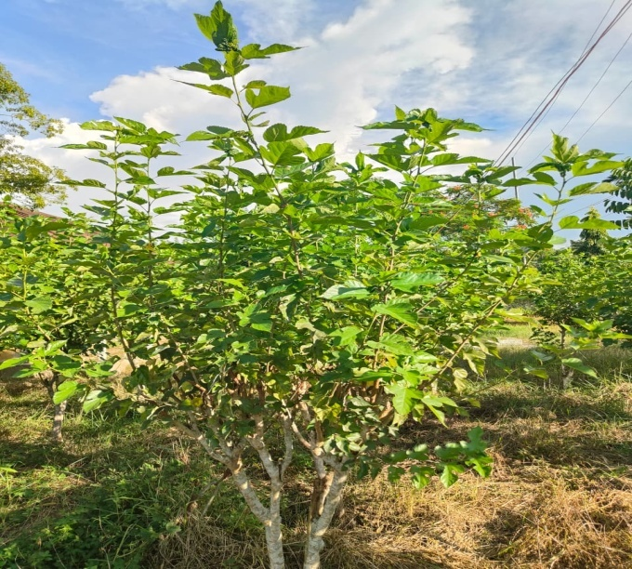

Fig.1: Mulberry plant

The prospective benefits of using mulberries in industry include the manufacturing of many different kinds of goods for the food, cosmetic, pharmaceutical, and healthcare sectors, which have attracted the attention of entrepreneurs (Tikader & Kamble, 2010). The modern era is experiencing an increase in toxic chemicals in the water, air, and soil, which presents serious threats to human health, the environment, and ecosystems. The scenario may be worsened by loss of forests, rapid development, and an excessively crowded urban population. Mulberries contain a number of important characteristics that have been shown to be helpful in the fight against environmental pollution, such as a deep root system, significant biomass output, and strong tolerance to environmental changes (Manzoor & Kahkashan, 2024).

3.1.1 ROLE OF MULBERRY PLANT IN CARBON SEQUESTRATION

The versatility of mulberry trees allows them to be effective sinks of carbon. Their leaves can absorb air pollutants like carbon monoxide, fluoride, sulfur dioxide, carbon dioxide, hydrogen and chlorine from the atmosphere, and their roots have a strong capacity to absorb carbon pollutants and heavy metal pollutants from the soil. Being a C₃ plant, it has the capacity to absorb more CO₂ from the atmosphere and store it in its above ground biomass. This action is advantageous in two ways: first, it lowers the quantity of CO2 in the atmosphere; second, it increases the amount of carbon stored in the soil (Yadav et al., 2020). In addition, study shows that a single mulberry tree may provide 3064 kg of oxygen annually and absorb 4162 kg of carbon dioxide (Ghosh et al., 2017). In an additional investigation, it was found that mulberry trees can absorb 6.241040 kg of carbon dioxide and release 4.60104 kg of oxygen per year. Furthermore, it was shown that one hectare of mulberry can absorb one tonne of carbon dioxide and release 0.73 tons of oxygen daily, which is enough to support 1000 people's respiration (Manzoor. & Kahkashan, 2024). Reports demonstrate the mulberry plant’s capacity to sequester as a carbon sink (Yadav et al., 2020). The experiment, which was carried out in red sandy loam soil using standard mulberry cultivation techniques with modifications like mulching and reduced tillage, as well as two irrigation techniques (drip and furrow), demonstrated the mulberry's capacity to sequester carbon and its carbon stock. The degree of carbon sequestration within the soil was also considerably higher when reduced tillage, mulching, and drip irrigation were combined than when other management techniques were used. During the summer of 2024, the carbon sequestration and oxygen-release (CSOR) potential of six different Mulberry Tree Varieties viz., Zhongsang 1302, Suhu 16, Jin 10, Yu 711, Husang 32, and Zhongsang 9703 was studied and found Zhongsang 1302 to have the highest CSOR potential (Zhang et al., 2024). The cultivar demonstrated benefits in growth, photosynthetic efficiency, and tolerance for a broad range of light intensities. Certain mulberry species, especially Zhongsang 1302 and Suhu 16, showed greater CSOR potential than other tree species, making them good choices for urban green space management. These results deepen our understanding of mulberry trees' ecological significance and their role in lowering carbon emissions and improving the climate. Mulberries have a great resistance to contamination from sulfur dioxide. According to estimates, it can sequester 5.70 g of sulfur dioxide per kilogram of dried leaves every day. Mulberries are good in absorbing nitrogen compounds and waste from industries gasses. It demonstrates notable resistance to sulfur dioxide, a high capacity for fluoride absorption, and can resist fluoride, thereby qualifying it as a species that encourages clean air. The diameter of mulberry roots is greater near the stem area, subsequently decreasing rapidly in size rope-like structure featuring secondary and tertiary roots, as well as root hairs, which together form a fibrous mat-like structure that enables the absorption of high levels of carbon pollutants from the soil (Rohela et al., 2020; Ghosh et al., 2017). It has been noted that mulberry leaves stayed undamaged or part of damage was less than 20 % of total leaf area despite elevated levels of chlorine pollution in the atmosphere, indicating that the mulberry plant possesses a natural resistance to chlorine (Manzoor & Kahkashan, 2024; Rohela et al., 2020; Deepa, et al., 2020; Dineva, 2017). Thus, it may be planted beside rivers, at the peripheries of fields, on slopes, in garden corners, along roadsides, in public parks and other recreation places. Mulberry embankment decreases air temperature and boosts air humidity. It also raises air temperature as the climate becomes colder (Deepa, et al., 2020). These traits of the mulberry plant have warranted its efficient use in the bioremediation of air pollutants in urban environments and the phytoremediation of carbon pollutants in contaminated soil located nearby industrial and chemical factoriesIt has been recognized as a plant that promotes sustainable development because of its ability to reduce environmental pollution by improving air quality and cleaning up carbon and heavy metal contaminants (Deepa et al., 2020).
3.2 ERI SILKWORM HOST PLANTS
The eri silkworm (Samia ricini, Donovan), is the most widely used silkworm for commercial purposes. It has been termed the “Silk of the Millennium” because of its potential for efficient use of products and byproducts, as well as value addition in the textile sectors (Singh & Ahmed, 2017). This silkworm is multivoltine and polyphagous which consumes a variety of host plant leaves. Euphorbiaceae, Araliaceae, Apocynaceae, and Simarubaceae are the families that include the majority of the host plants. It consumes more than 29 kinds of host plants. Castor (Ricinus communis Linn.) (Fig.2) and Kesseru (Heteropanax fragrans Seem.) (Fig.3) are the main food source for eri silkworms. Furthermore, when primary food plants are scarce, eri silkworms are reared on a variety of secondary host plants, including barpat (Ailanthus grandis Baiu.), barkesseru (Ailanthus excelsa Roxb.), tapioca (Manihot utilissima), and payam (Evodia flaxinifolia Hook.) (Das et al., 2020).

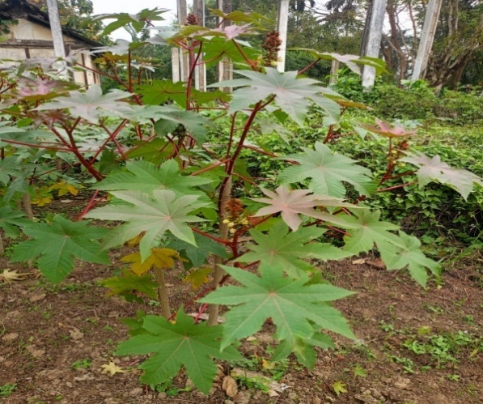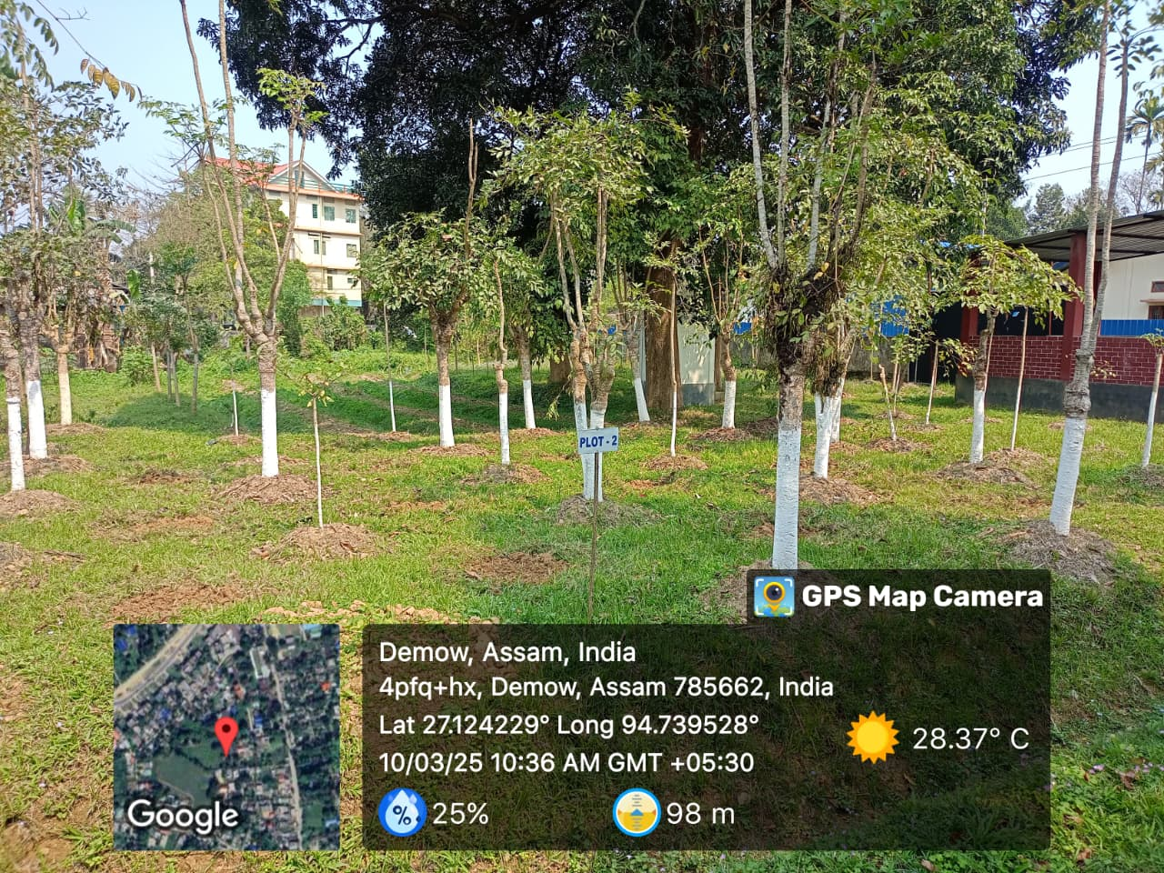
Fig.2. Castor plant Fig.3. Kesseru plant

Castor is an annual plant, though it can occasionally be perennial. Despite being a cross-pollinated plant, it prefers self-pollination. Castor is prevalent in the North-Eastern states of India, including West Bengal, Bihar, Gujarat, Orissa, Rajasthan, and Andhra Pradesh. The majority of the nation's eri silk output comes from the North-Eastern states, which are crucial in the use of castor leaves for eri silkworm rearing. North-East India is home to a number of castor cultivars, but NBR-1 is the first to provide the greatest results in terms of leaf yield and silkworm rearing in the area. Kesseru (Heteropanax fragrans) ranks after castor as the second-best food plant for the eri silkworm. Kesseru is a perennial evergreen tree, offers benefits as its foliage is available all around the year for eri silkworm rearing. The leaves of Kesseru are tough and fibrous, rendering them harder to chew in comparison to castor leaves. This species is widespread in the North-Eastern region of India, found in both wild and cultivated settings. Tapioca (Manihot utilissima) is a tuber crop that is notably utilized by tribal communities. The leaves are used for the rearing of eri silkworms when castor leaves are not readily available. It is capable of withstanding unpropitious climatic conditions. More than 42 species of this plant are present in the wild in this region. Tapioca is distributed throughout all states of North-East India, serving dual purposes: the tubers are consumed as food (Singha et al., 2024), and the leaves are utilized for eri silkworm rearing. Barkesseru are trees that grow rapidly and are resistant to drought, showing deciduous attributes. The term "Ailanthus" have it's origin from the Moluccan Island in far eastern Indonesia and translates to "the highest." This genus encompasses 10 species, essentially found in China, India, Southeast Asia, and Australia (Sarkar & Borpuzari 2022).

3.2.1 ROLE OF ERI SILKWORM HOST PLANTS IN CARBON SEQUESTRATION
The role of Castor (Ricinus communis Linn.) as a climate-robust crop and an ecological engineer has been investigated by researchers. Ricinus communis L. was pin downed as a feasible alternative for the amendment of contaminated land (Bauddh et al., 2015). Its other noteworthy applications for instance incorporates biodiesel production, medicinal products, societal development, and job creation for local communities, along with carbon sequestration and the alleviation of greenhouse gases (GHG). In addition to other organic contaminants like pesticides, it has demonstrated an exceptional capacity to extract large quantities of hazardous metals like Ni, Pb, Cd, As, and Cu. This highlights its potential as a phytomediator for a variety of organic hazardous chemicals, particularly heavy metals and poly aromatic hydrocarbons, alongside to its benefits as an oil-producing and therapeutic plant. It can flourish all year round, even in saline and droughty environments, which increases its dominance over other plants. Being a hyperaccumulator of many metals, it can be used in a sustainable manner to recover sodic soil (Kumar et al., 2017). Three eri host plants that are widely grown in North-East India were examined for their capacity to sequester carbon: Ricinus communis (more especially, the non-bloomy red castor variety at ages of three months, three years, and four years), Heteropanax fragrans, and Manihot esculenta (which includes the Sree Raksha, Majuli Local, and Meghalaya tapioca varieties) (Hemachandran et al., 2025).
The study assessed the effectiveness of aboveground and belowground biomass in capturing and storing carbon. The results showed significant variation in biomass production, carbon storage, CO₂ equivalent, and leaf and shoot characteristics between the plant species. The study found that the examined plants' capacities for sequestering carbon varied significantly. Kesseru emerged as the most effective host plant, revealing the largest aboveground and total biomass. It was followed by castor that was four and three years old. In contrast to the other species, the tapioca cultivars (Majuli Local and Sree Raksha) showed notably reduced biomass. In addition to encouraging carbon sequestration, using regular plantation procedures guarantees silkworms a consistent source of leaves. Plant variety and growth patterns are crucial for sustainable land management, and these findings contain essential ecological and environmental references, particularly with regard to carbon sequestration and climate change mitigation.

3.3 MUGA SILKWORM HOST PLANTS
The muga silkworm (Antherea assamensis Helfer) is an endemic multivoltine, polyphagous insect. The food plants of muga silkworms are widely distributed in North-Eastern India and some parts of Northern India. They are readily accessible in the states of Assam, Meghalaya, Manipur, Mizoram, Nagaland, Tripura, Sikkim, Himachal Pradesh, Uttaranchal, Uttar Pradesh, Gujarat, West Bengal, and Pondicherry, while being infrequently found in Arunachal Pradesh. The muga silkworm consumes a variety of plants, with som (Persea bombycina) and soalu (Litsea monopetala) established as the primary host plants. In addition, mejankori (Litsea citrata) and dighloti (Litsea salicifolia) succour as secondary host plants (Singha & Sonowal 2016). Cinnamomum glaucescens, Actinodaphne obovata, Michaela champa, Zizyphus jujuba, Xanthoxylum rehsta, and Celastrus monosperma, are a selection of additional minor host plants also available and reckoned tertiary in nature (Das et al., 2020).
Persea bombycina King ex Hook f. belongs to the Lauraceae family and is included in the order Laurales. The Persea genus comprises approximately 150 species of evergreen trees. Som (Fig.4) is characterized as a perennial, evergreen, aromatic tree that is medium-sized and propagated via both sexual (seeds) and asexual (stem cuttings and air layering) methods. This aromatic tree does not shed its leaves and can reach a height of around 20 meters when fully mature, featuring a deep tap root system. Its stem is cylindrical, woody, rough, and has grey bark, while the branches extend outward (Ravi, 2024).
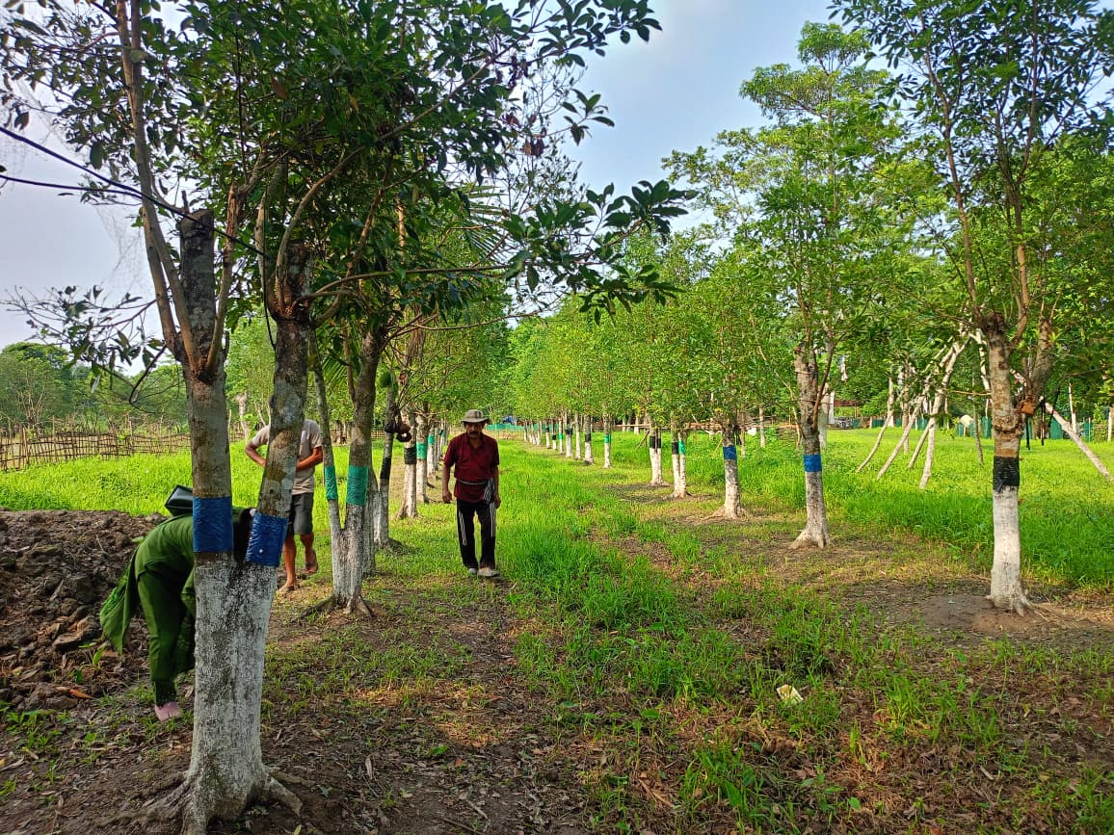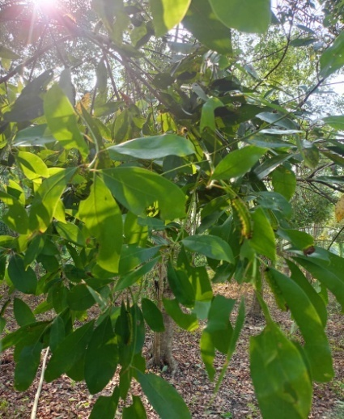
Fig.4. Som plant

3.3.1 ROLE OF MUGA SILKWORM HOST PLANTS IN CARBON SEQUESTRATION
Limited scientific research has been conducted to explore the potential of Muga silkworm host plants in carbon sequestration. In Assam, Machilus gamblei King (Syn. Persea bombycina King) is primarily cultivated through farm forestry and agroforestry systems. Within the agroforestry context, local communities grow it in home gardens, while in the farm forestry system, the plantations are mainly managed as sericulture farms. This species not only provides sustenance for the muga silkworm but also enhances biomass production, aids in carbon sequestration, and contributes ecological benefits to nutrient cycling. It has shown promising potential for sequestering atmospheric carbon in both plant and soil (Upadhyay, 2022). Som is a promising potential to sequester atmospheric carbon in plant as well as in soil (Upadhyay & Baruah, 2023).

4. Conclusion

“In every silken thread lies the quiet work of nature-restoring the soil, cooling the air, and weaving resilience into the fabric of our planet”.
As climate change becomes increasingly grievous and the world faces its aftermath, countries and industries are pursuing novel approaches to reduce carbon footprints. One factor that can help reduce the amount of CO₂ in the atmosphere is carbon sequestration on plantations. Implementing carbon sequestration techniques in sericulture is one such tactic that promotes both environmental sustainability and farmers' economic resilience. Further research is necessary to fully comprehend the potential contribution of silkworm host plants to carbon sequestration. This study should focus on calculating the carbon sequestration potential of various silkworm host plant cultivation techniques in different geographical areas and developing practical recommendations for farmers to implement these strategies. By utilizing the potential of trees and host plant varieties, we may significantly advance the development of a more environmentally friendly and sustainable agriculture system (Sathish, 2024). The possibility of carbon sequestration in plants depends on maintaining and managing natural ecosystems, accepting changing environmental conditions, and putting effective land-use plans into action. It will be essential to investigate ecosystem dynamics, plant biology, and sustainable management techniques in order to increase plants' ability to address the climatic catastrophe (Basher & Akter, 2022). In order to combat climate change in a positive way, scalable methods that can lower atmospheric carbon dioxide are desperately needed. Plants are essential in these conditions because they store carbon in their biomass and absorb CO₂ through photosynthesis. Identifying and promoting species with strong carbon sequestration potential is critical, as numerous studies have demonstrated that increasing plant growth and afforestation can significantly reduce CO₂ levels. It can be confidently propounded that sericulture besides being a means of support, also warrants that its host plants play a crucial role as carbon sinks.

Competing interests

No competing interest among the authors.

Disclaimer (Artificial intelligence)
Option 1:
Author(s) hereby declare that NO generative AI technologies such as Large Language Models (ChatGPT, COPILOT, etc.) and text-to-image generators have been used during the writing or editing of this manuscript.
Option 2:
Author(s) hereby declare that generative AI technologies such as Large Language Models, etc. have been used during the writing or editing of manuscripts. This explanation will include the name, version, model, and source of the generative AI technology and as well as all input prompts provided to the generative AI technology
Details of the AI usage are given below:
1.
2.
3.

References

- Agarwal, K. Borah, D. & Agarwalla, S. (2024). A quantitative investigation on carbon sequestration at Jorhat Kendriya Mahavidyalaya, Jorhat. Research Journal of Agricultural Science.15(6), 1257-1260.
- Anonymous, (2025). Planting Trees for Carbon Credits: Everything You Need to Know. DOI: https://carboncredits.com/planting-trees-for-carbon-credits-everything-you-need-to-know/
- Ao, A., Mere, K. & Tripathi, S.K. (2023). Stand Structure, Regeneration Potential and Biomass Carbon Stock of Subtropical Forest of Mizoram, Northeast India. Indian Journal of Ecology. 50(6),1972-1979. DOI: https://doi.org/10.55362/IJE/2023/4162
- Basher, T. & Akter, F. (2022). The role of plants in carbon sequestration: mechanisms, ecosystem contributions, and their impact on mitigating climate change. Australian Herbal Insight. 5(1),1-5, 9943.

- Bauddh, K., Singh, K., Singh, B. & Singh, R.P. (2015). Ricinus communis: a robust plant for bio-energy and phytoremediation of toxic metals from contaminated soil. Ecological Engineering. 84:640–652
- Das, S., Kumar, B.& Singh, D. (2020). Host plant diversity of non-mulberry silkworms: A review. Journal of Pharmacognosy and Phytochemistry. 9(3): 109-113.
- Deepa, K.B., Vishaka, G.V. & Nithin Kumar, D.M. (2020). Mulberry as a avenue plant. Journal of Pharmacognosy and Phytochemistry. 9(4S),135-137.
- Dineva, S. (2017). Leaf Blade Structure of Morus alba L. and Resistance to Industrial Pollution. Journal of Applied Forest Ecology (eJAFE).5(2),1-8.
- Fronza, E.E., ten Caten, A., Bittencourt, F., Zambiazi, D.C., Schmitt Filho, A.L., Seo, H.L.S. & Loss, A. (2024). Carbon sequestration potential of pastures in Southern Brazil: A systematic review. Rev Bras Cienc Solo. 48:e0230121. DOI: https://doi.org/10.36783/18069657rbcs20230121
- Ghosh, A., Gangopadhyay, D. & Chowdhury, T. (2017). Economical and Environmental Importance of Mulberry: A Review. International Journal of Plant and Environment. 3(2), 51-58. DOI : https://doi.org/10.18811/ijpen.v3i02.10437
- Hemachandran, H., Natarajan, L. & Nath, A. (2025). Ericulture host plants as carbon sinks: understanding the sustainable carbon sequestration potential. Vegetos. DOI: https://doi.org/10.1007/s42535-025-01387-8
- Jat, Mangi L., Chakraborty, D., Ladha, J.K. & Chhiter, M. (2022). Carbon sequestration potential, challenges, and strategies towards climate action in smallholder agricultural systems of South Asia. Crop and Environment. 1(1), 86-101. DOI: https://doi.org/10.1016/j.crope.2022.03.005
- Kamal, M.Z.U., Akter, M., Binte, B.I. & Mina, K.K. (2024). Carbon Sequestration and Climate Change Mitigation. In: Rahman, M.M., Biswas, J.C., Meena, R.S. (eds) Climate Change and Soil-Water-Plant Nexus. Springer, Singapore. DOI:https://doi.org/10.1007/978-981-97-6635-2_15
- Kumar, D., Poonam, Bauddh, K., Tiwari, J., Singh, D.P. & Kumar, N. (2017). Ricinus communis: an ecological engineer and a biofuel resource. In Phytoremediation Potential of Bioenergy Plants.pp. 139-167. Singapore: Springer Singapore. https://doi.org/10.1007/978-981-10-3084-0_5
- Manzoor, S. & Kahkashan, Q. (2024). “Environmental Importance of Mulberry: A Review”. Journal of Experimental Agriculture International. 46(8), 95-105. DOI: https://doi.org/10.9734/jeai/2024/v46i82681.
- Moulidharshan, R., Priyadharshini, P., Shanmugam, R., Tilak, M., Radha, P, Ulaganathan, V., et al. (2025).The multifaceted utility of mulberry (Morus spp.): A comprehensive review on uses of its different parts. Plant Science Today. 12(2): 1-7. DOI:https://doi.org/10.14719/pst.8079
- Murugesan, M. K. (2024). Innovative Approaches to Carbon Sequestration Emerging Technologies and Global Impacts on Climate Change Mitigation. Environmental Reports;an International Journal.15-18. DOI: https://doi.org/10.51470/ER.2024.6.2.15
- Nayak, N., Mehrotra, R. & Mehrotra, S. (2022). Carbon biosequestration strategies: a review. Carbon Capture Science & Technology. 4,100065. DOI: https://doi.org/10.1016/j.ccst.2022.100065
- Prajapati, S. K., Choudhary, S., Kumar, V., Dayal, P., Srivastava, R., Gairola, A., & Borate, R. B. (2023). Carbon Sequestration: A Key Strategy for Climate Change Mitigation towards a Sustainable Future, Emrg. Trnd. Clim. Chng. 2(2), 1-14. DOI: http://dx.doi.org/10.18782/2583-4770.128
- Ravi, R. (2024). Som (Persea bombycina): A Principle Host Plant for Muga Sericulture. 10.22271/ed.book.2940.
- Rohela, G., Shukla, P., Kallur, M., Kumar, R. & Chowdhury, S. (2020). Mulberry (Morus spp.): An Ideal Plant for Sustainable Development. Trees, Forests and People. 2,100011. DOI: 10.1016/j.tfp.2020.100011
- Sarkar, B.N. & Borpuzari, P. (2022). Sustainable ERI culture and impact of different food plants and rearing technology on cocoon. Plant Archives. 22, 247-252. DOI: https://doi.org/10.51470/PLANTARCHIVES.2022.v22.splecialissue.045
- Sathish, K. (2024). Carbon Sequestration Potential of Mulberry Trees in Silk Farming. Agri Articles. 4(4),637-639
- Singh, B.K. & Ahmed, S.A. (2017). Ericulture. In: Omkar (eds) Industrial Entomology. Springer, Singapore. https://doi.org/10.1007/978-981-10-3304-9_12
- Singha, T.A. & Sonowal, P. (2016). An importance of muga silkworm (Antheraea assama ww.) seed crops. Journal of Experimental Zoology, 19 (Supple1),1215-1217.

- Singha, T.A., Bhattacharyya, B., Gogoi, D., Bora, N., Marak, M. & Borgohain, A. (2024). Innovative Utilization of Sericulture Resources to Value Added Products–A Review. Journal of Advances in Biology & Biotechnology, 27(9),1302-1309.

- Tikader, A. & Kamble, C. (2010). Seri-biodiversity with Reference to Host Plants in India. The Asian and Australian Journal of Plant Science and Biotechnology. 4(1),1-11.
- Upadhyay, T. & Baruah, P.P. (2023). Persea bombycina: A potential plant for carbon sequestration. In: Biosystematics and Bioresources: The proceedings of the international conference on “Algae, Fungi and Plants. pp. 219-225
- Upadhyay, T. (2022). Machilus gamblei (lauraceae): A potential plant for carbon sequestration. Journal of the Indian Botanical Society.102(3),252-256. DOI: https://doi: 10.5958/2455-7218.2022.00036.5
- Yadav, V.K., Padhan, D., Sen, S., Gayathri, T., Praveen Kumar, K. & Tewary, P. (2020). Assessment of carbon sequestration potential of mulberry vis-a-vis soils under different cultivation practices. International Journal of Current Microbiology and Applied Sciences. 9(1), 2463-2474. DOI:https://doi.org/10.20546/ijcmas.2020.901.281
- Zhang, K., Yang, Y., Zhai, Z., Fang, Y., He, M., Cheng, J., et al. (2024). Evaluation of Carbon Sequestration and Oxygen-Release Potential of Six Mulberry Tree Varieties During Summer. Forests. 15, 1819. DOI: https://doi.org/10.3390/f15101819

