A Comparative Morphometric Study of Indian Major Carps

Abstract
Amid growing demands for sustainable aquaculture, understanding species-specific growth patterns is essential for maximizing productivity. The findings revealed that Catla exhibited the highest weight gain, Mrigal showed superior linear growth, and Rohu demonstrated moderate overall performance. A significant positive correlation was observed between total length and other morphometric traits. These results highlight the value of species-specific selection for polyculture systems and emphasize the role of morphometric analysis in broodstock selection and aquaculture enhancement.
Keywords: Morphometric analysis, growth performance, polyculture, broodstock selection.
Introduction
In recent years, aquaculture has emerged as one of the fastest-growing sectors in the fisheries industry and is widely acknowledged for its crucial role in ensuring global food security and nutrition in the 21st century. India ranks as the world’s second-largest fish-producing nation, contributing approximately 8.92% to global fish output. In the fiscal year 2022–23, the country's total fish production is estimated at 17.54 million metric tons (MMT), with the inland sector accounting for 13.11 MMT and the marine sector contributing 4.43 MMT. India is also a leading aquaculture producer, holding the second position globally after China. Inland fisheries represent around 75% of the nation’s overall fish production (DoF.gov.Annual report;2023-24)

Indian Major Carps (IMCs), including Catla catla, Labeo rohita, and Cirrhinus mrigala, are pivotal to India's freshwater aquaculture, contributing significantly to food security and economic livelihoods. These species are primarily cultivated through polyculture systems, optimizing resource use and enhancing production efficiency. Indian Major Carps (IMCs) contribute approximately 70–75% of the country’s total freshwater fish production (Chandra et al., 2024). India holds the second position globally in carp production, supported by strong domestic demand and a growing export market for value-added products (Murthy, 2002). The aquaculture sector is expanding at an annual rate of over 7%, with freshwater aquaculture making up 95% of the total output. Advances such as induced breeding and composite carp culture have significantly boosted productivity, with yields ranging from 3 to 6 tons per hectare per year (Jayasankar, 2018).
Morphometric evaluation of Indian Major Carps such as Labeo rohita, Catla catla, and Cirrhinus mrigala plays an important role in understanding their growth dynamics, body configurations, and adaptive strategies under different environmental settings. Standard morphometric traits, including total length, standard length, head and snout length, body depth, and eye diameter, are commonly recorded to compare interspecific differences in body form and growth performance (Yadav & Paul, 2023). Such parameters not only provide reference values for growth assessments in aquaculture but also help to detect phenotypic modifications influenced by ecological factors or feeding regimes.
With the advancement of geometric approaches, landmark-based morphometry has emerged as a more refined tool for assessing shape diversity. By mapping and analyzing precise anatomical points, this method captures subtle variations that traditional linear measurements may overlook. Research employing landmark-based analysis has revealed distinct morphological patterns among carp species, making it possible to distinguish body shapes across developmental phases (K., n.d.). These outcomes are particularly relevant to aquaculture management, where morphometric indicators are increasingly used for broodstock selection, stock differentiation, and monitoring growth responses in both monoculture and polyculture systems. The combination of conventional morphometric measurements with modern geometric methods thus provides a comprehensive framework for evaluating species adaptation, refining culture strategies, and safeguarding genetic resources in Indian major carps.
Materials and Methods
Location/ Place of Work
The study was conducted at the College of Fishery Science, under Nanaji Deshmukh Veterinary Science University, located in Jabalpur, Madhya Pradesh, India. A total 9 no of fishes were selected for the investigation.
1.1 Morphometric measurements
A wide range of morphometric parameters was assessed in Indian major carps, including total length, standard length, fork length, head length, snout length, eye diameter, pre-dorsal length, pre-pectoral length, pre-pelvic length, pre-anal length, body depth, caudal depth, post-orbital length, anal fin base length, pelvic fin base length, and caudal length (Table 1). All linear traits were measured in centimeters, while overall body weight was recorded in grams. The observations were carried out over a 30-day experimental period, extending from June 28 to July 28, 2025, under controlled culture conditions.
To ensure precision and consistency, measurements were taken with standard ichthyological instruments such as dividers, measuring boards, and measuring tapes, while a single-pan balance was used for weighing. The methodology followed the classic protocol outlined by Lowe-McConnell (1978), which is widely recognized for its accuracy in morphometric studies. Morphological landmarks used during data collection were supported by schematic illustrations (Fig. 1) adapted from Ng et al. (2017), thereby reducing the risk of observer error and ensuring uniformity across samples.
Morphometric evaluation holds great importance in fish biology and aquaculture, as it provides fundamental insights into growth performance, body conformation, and species-specific adaptations. These parameters are essential not only for distinguishing closely related taxa but also for detecting phenotypic variations arising from environmental conditions, nutritional regimes, or genetic differences. Additionally, morphometric data serve as valuable tools in assessing cultured stocks, selecting broodstock, and formulating strategies for genetic improvement. In aquaculture management, such analyses are increasingly applied to monitor growth responses under monoculture as well as polyculture systems, thereby supporting more efficient decisions on stocking densities, feeding management, and culture practices.
The integration of conventional morphometric traits with modern statistical and geometric morphometric approaches offers a comprehensive framework for understanding species adaptation, refining aquaculture practices, and conserving the genetic diversity of Indian major carps.
Fig: 1 Typical morphological parameter of Indian major carp (Ng et al.,2017)
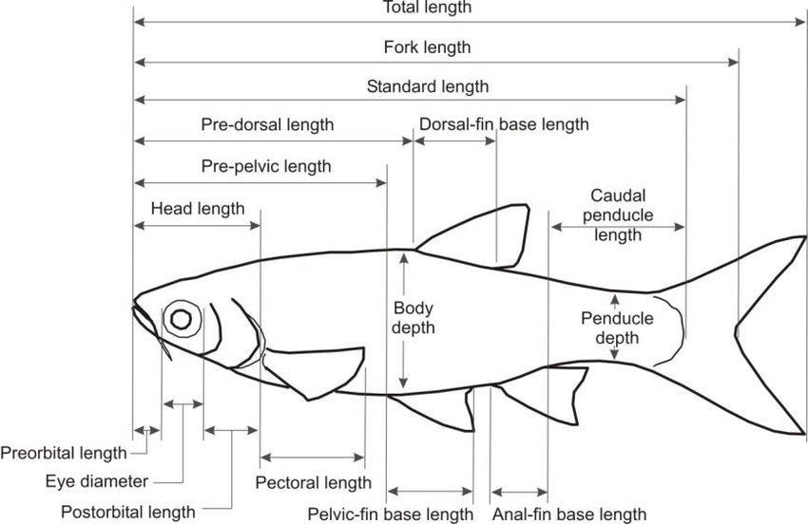

Table 1: Measured morphometric parameters of Indian major carps

Sl. No. | Morphometric Parameter | Abbreviation | Description of measured parameters
1 | Total Length | TL | It is a measurement of body length from tip of largest jaw (snout) to the largest part of caudal fin.
2 | Standard length | SL | Length from snout to the origin of caudal fin.
3 | Fork Length | FL | Length from snout to the point of bifurcation of caudal fin.
4 | Head Length | HL | Length from snout to the posterior most part of operculum.
5 | Pre Dorsal Length | PDL | Length from snout to the origin of the dorsal fin.
6 | Pre Pelvic Length | PPvL | Length from snout to the origin of pelvic fin.
7 | Dorsal Fin base Length | DFL | The distance between the anterior (front) and posterior (rear) ends of the base of the dorsal fin
8 | Caudal Peduncle Length | CPL | Total length – Standard length
9 | Body Depth | BD | Maximum vertical length of body (deepest part of the body).
10 | Eye Diameter | ED | Maximum length of eye orbit from one margin to other.
11 | Pre Orbital Length | PrOL | The distance from the tip of the snout to the anterior (front) margin of the eye.
12 | Post Orbital Length | POL | The distance from the posterior (rear) margin of the eye to the end of the operculum (gill cover)
13 | Pectoral Length | PL | The distance from the point where the pectoral fin is attached to the body (its base) to the tip of the fin.
14 | Pelvic Fin base Length | PFL | Pelvic fin base length is the distance from the front to the rear end of the pelvic fin’s attachment to the body.
15 | Anal Fin base Length | AFL | Anal Fin Base Length is the distance between the front and rear ends of the base where the anal fin is attached to the body.
16 | Peduncle Depth | PD | Peduncle depth refers to the vertical thickness

Result & Discussion
1.1 Morphometric measurements
Table 2: Morphometric observations of Catla
Sr. no. | Parameters | Day 1 | Day 15 | Day 30 | Mean | SE
1 | Weight of the Fish(gm) | 0.572 | 0.691 | 0.857 | 0.71 | 0.07
2 | Total Length(cm) | 36.5 | 36.8 | 36.9 | 36.7 | 0.1
3 | Fork length(cm) | 31.5 | 31.9 | 32 | 31.8 | 0.12
4 | Standard length(cm) | 28 | 28.3 | 28.5 | 28.3 | 0.12
5 | Head Length(cm) | 7.5 | 7.6 | 7.7 | 7.6 | 0.05
6 | Pre dorsal length(cm) | 13 | 13.3 | 13.5 | 13.3 | 0.12
7 | Pre pelvic length(cm) | 15 | 15.1 | 15.2 | 15.1 | 0.05
8 | Dorsal fin base length(cm) | 8 | 8.2 | 8.4 | 8.2 | 0.09
1 | caudal peduncle length (cm) | 7 | 7.1 | 7.2 | 7.1 | 0.05
9 | Body depth(cm) | 9.5 | 10.3 | 10.5 | 10.1 | 0.25
10 | Eye diameter(cm) | 2.2 | 2.3 | 2.5 | 2.33 | 0.07
11 | Preorbital Length(cm) | 3.3 | 3.4 | 3.6 | 3.43 | 0.07
12 | Postorbital length(cm) | 4 | 4.1 | 4.3 | 4.13 | 0.07
13 | Pectoral Length(cm) | 6.1 | 6.3 | 6.4 | 6.27 | 0.07
14 | Pelvic fin base Length(cm) | 1.5 | 1.6 | 1.8 | 1.63 | 0.07
15 | Anal fin base Length(cm) | 2.5 | 2.7 | 2.9 | 2.7 | 0.09
16 | Peduncle Length(cm) | 4 | 4.3 | 4.5 | 4.27 | 0.12

Table 3: Morphometric observations of Rohu
Sr.no | Parameters | Day1 | Day15 | Day30 | Mean | SE
1 | Weight of the Fish(gm) | 0.322 | 0.498 | 0.627 | 0.482 | 0.088
2 | Total Length(cm) | 29.5 | 29.9 | 30.1 | 29.83 | 0.176
3 | Fork length(cm) | 24.8 | 25 | 25.2 | 25 | 0.115
4 | Standard length(cm) | 23.5 | 23.8 | 24 | 23.77 | 0.145
5 | Head Length(cm) | 6 | 6.1 | 6.2 | 6.1 | 0.058
6 | Pre dorsal length(cm) | 11 | 11.2 | 11.4 | 11.2 | 0.115
7 | Pre pelvic length(cm) | 13.5 | 13.7 | 13.9 | 13.7 | 0.115
8 | Dorsal fin base length(cm) | 6 | 6.2 | 6.4 | 6.2 | 0.115
9 | caudal peduncle length (cm) | 5.5 | 5.7 | 5.9 | 5.7 | 0.115
10 | Body depth(cm) | 7 | 7.2 | 7.3 | 7.167 | 0.088
11 | Eye diameter(cm) | 1.3 | 1.5 | 1.6 | 1.467 | 0.088
12 | Preorbital Length(cm) | 2.3 | 2.5 | 2.6 | 2.467 | 0.088
13 | Postorbital length(cm) | 3.2 | 3.3 | 3.4 | 3.3 | 0.058
14 | Pectoral Length(cm) | 5 | 5.1 | 5.2 | 5.1 | 0.058
15 | Pelvic fin base Length(cm) | 1.1 | 1.2 | 1.3 | 1.2 | 0.058
16 | Anal fin base Length(cm) | 2 | 2.1 | 2.2 | 2.1 | 0.058
17 | Peduncle Length(cm) | 3.2 | 3.3 | 3.4 | 3.3 | 0.058

Table 4: Morphometric observations of Mrigal
Sr.no | Parameter | Day1 | Day15 | Day30 | Mean | SE
1 | Weight of the Fish(gm) | 0.612 | 0.746 | 0.978 | 0.77867 | 0.1069079
2 | Total Length(cm) | 37 | 37.3 | 37.5 | 37.2667 | 0.14531
3 | Fork length(cm) | 33.2 | 33.4 | 33.7 | 33.4333 | 0.14531
4 | Standard length(cm) | 31.2 | 31.5 | 31.8 | 31.5 | 0.17321
5 | Head Length(cm) | 7 | 7.1 | 7.2 | 7.1 | 0.05774
6 | Pre dorsal length(cm) | 14 | 14.2 | 14.5 | 14.2333 | 0.14531
7 | Pre pelvic length(cm) | 15 | 15.3 | 15.7 | 15.3333 | 0.20284
8 | Dorsal fin base length(cm) | 7 | 7.2 | 7.5 | 7.23333 | 0.14531
9 | caudal peduncle length (cm) | 7.1 | 7.3 | 7.4 | 7.26667 | 0.08821
10 | Body depth(cm) | 8 | 8.1 | 8.2 | 8.1 | 0.05774
11 | Eye diameter(cm) | 1.5 | 1.6 | 1.7 | 1.6 | 0.05774
12 | Preorbital Length(cm) | 2.5 | 2.6 | 2.7 | 2.6 | 0.05774
13 | Postorbital length(cm) | 3.5 | 3.7 | 3.8 | 3.66667 | 0.08821
14 | Pectoral Length(cm) | 5.1 | 5.3 | 5.5 | 5.3 | 0.11547
15 | Pelvic fin base Length(cm) | 1.8 | 1.9 | 2 | 1.9 | 0.05774
16 | Anal fin base Length(cm) | 2 | 2.1 | 2.2 | 2.1 | 0.05774
17 | Peduncle Length(cm) | 4.2 | 4.3 | 4.4 | 4.3 | 0.05774

The present study aimed to assess the morphometric and growth performance of Indian Major Carps Catla (Catla catla), Rohu (Labeo rohita), and Mrigal (Cirrhinus mrigala) under controlled conditions over 30-days period. The primary focus was on evaluating species-specific differences in body weight, total length, standard length, fork length, and other morphometric characteristics to better understand their growth dynamics, which are essential for broodstock selection and optimizing aquaculture practices. Catla, known for its robust growth, demonstrated the highest weight gain among the three species. Over the 30-day experimental period, its body weight increased from 0.572 g to 0.857 g, with a mean of 0.706 g and a standard error (SE) of 0.067. Mrigal followed closely with a mean weight of 0.779 g (SE = 0.107), while Rohu showed the least growth in terms of body weight, recording a mean of 0.482 g (SE = 0.088). These findings align closely with the study conducted by Noor Khan et al. (2012) reported that when Indian major carps were reared under both monoculture and polyculture management systems, Catla outperformed the other species in terms of growth rate and feed conversion efficiency, indicating its ability to utilize feed resources more effectively and convert them into body mass. In contrast, Mrigal showed relatively superior results in parameters related to body length, suggesting that while it may not match Catla in overall weight gain, it demonstrates stronger linear growth characteristics, which are important for assessing morphological development. It recorded the highest total length with a mean of 37.27 cm, followed by Catla at 36.73 cm, and Rohu at 29.83 cm. Standard length measurements showed a similar pattern, with Mrigal averaging 31.5 cm, Catla at 28.27 cm, and Rohu at 23.77 cm. Fork length also reflected these differences, with Mrigal measuring 33.43 cm, Catla 31.8 cm, and Rohu 25.0 cm. These results highlight Mrigal's naturally elongated body structure, which facilitates faster linear growth, a trend previously documented by (Jhingran, 1991). The differences in body morphology among the species play a significant role in their adaptability and suitability for different aquaculture systems. For example, Mrigal's streamlined body makes it efficient for bottom feeding and sustained linear growth, while Catla's deeper body allows for better feed intake and weight accumulation in the upper and middle water columns.
The analysis of other morphometric traits further reinforced the distinct growth patterns of the species. Catla and Mrigal generally recorded higher values in head length, body depth, and eye diameter when compared to Rohu. Specifically, Catla showed the greatest body depth at 10.1 cm, which supports its classification as a deep-bodied fish with a high growth rate. Mrigal followed with slightly lower body depth but longer head and body proportions. Head length for Catla and Mrigal averaged 7.6 cm and 7.1 cm, respectively, whereas Rohu measured only 6.1 cm. These measurements are crucial indicators of feed intake capacity and overall health status. As per (Khan et al., 2020), body depth and head size are often positively correlated with growth rate and feed utilization efficiency, which explains the superior performance of Catla and Mrigal in this study.
Furthermore, eye diameter and orbital length were proportionally higher in Catla and Mrigal, which may contribute to enhanced visual capacity and better responsiveness to feeding, ultimately impacting growth. The variations observed among the species confirm their ecological adaptations and niche preferences, which must be considered when designing polyculture systems. Catla, being a surface and column feeder, benefits from its larger body mass and broader head profile, while Mrigal, a bottom feeder, leverages its slender structure for efficient grazing along pond substrates. Rohu, typically a mid-water feeder, exhibited moderate values in most traits, suggesting its role as a complementary species in mixed culture systems. The standard errors observed across the measurements were relatively low, indicating consistency in the data and validating the reliability of the experimental outcomes. This consistency underscores the importance of controlled experimental conditions in morphometric studies, allowing for precise comparisons and interpretations. Moreover, the positive and significant correlation between total length and various morphometric parameters observed in this study suggests that these traits increase proportionally. This finding is critical for broodstock selection, as fish with well-proportioned bodies are often preferred for breeding purposes due to their better reproductive and growth potential.
Comparative studies with existing literature further support the findings of the present research. (Das et al.,2019) highlighted that Rohu, while exhibiting moderate growth under monoculture conditions, performs well in polyculture setups due to its compatibility with both Catla and Mrigal. This observation was consistent with the current results, where Rohu showed relatively lower individual growth but remains an essential species for maintaining balance in multi-species systems. Additionally, (Natarajan and Jhingran,1963) emphasized the utility of morphometric and meristic studies in identifying high-quality broodstock, which remains relevant in current aquaculture practices. Reddy et al. (2002) conducted an extensive evaluation of six different Rohu (Labeo rohita) stocks, comparing their growth and survival performance under both monoculture and polyculture production systems that included Catla and Mrigal. The findings revealed that, regardless of culture type, Rohu maintained relatively stable growth rates and survival percentages across all tested stocks. This consistency demonstrated that Rohu is highly adaptable and performs reliably in diverse rearing conditions. More importantly, when integrated with Catla and Mrigal in polyculture, Rohu did not exhibit any negative competitive interactions instead, it complemented the feeding niches of the other two species. These results highlight the ecological compatibility of Rohu within multi-species culture systems, reinforcing its significance as a balancing component in Indian major carp aquaculture practices.
Overall, the study successfully demonstrated the species-specific morphometric and growth characteristics of Indian Major Carps, with Catla excelling in weight gain, Mrigal in linear dimensions, and Rohu maintaining balanced growth. These differences are not only important from a biological perspective but also have practical implications in aquaculture management. Selecting the right combination of species based on their growth traits can enhance overall productivity and sustainability in freshwater fish farming. The results also underscore the need for continued research on genetic and environmental influences on carp growth to further refine breeding and culture strategies.
Conclusion
The study assesses the morphometric and growth performance of Indian Major Carps Catla catla, Labeo rohita, and Cirrhinus mrigala under controlled experimental conditions. A wide range of morphometric parameters, including linear body measurements and body weight, were systematically documented to evaluate interspecific growth trends. The analysis demonstrated that all morphometric traits were significantly and positively correlated with total length, indicating that as the total body length increases, associated traits expand proportionally. This relationship confirms the reliability of morphometric indices as useful indicators of growth status and overall health in cultured fish. Of the three species, Catla exhibited the highest increase in body weight, underscoring its superior growth potential and efficient feed utilization. This characteristic highlights its significance as a key biomass contributor in polyculture systems where rapid weight gain is desirable. Conversely, Mrigal consistently displayed stronger performance in length-based parameters, reflecting its elongated morphology and reinforcing its role as a complementary species that reduces competition with Catla. Rohu showed moderate but steady growth in both length and weight, confirming its adaptability and continued importance as a balancing species within composite carp culture. The implications of these findings are considerable for aquaculture management. Understanding the unique growth dynamics of each species allows for more effective broodstock selection, maintaining desirable genetic traits and sustaining productivity. Moreover, integrating species with complementary growth patterns within polyculture can enhance ecological balance, minimize competition, and increase overall yield. The combination of fast-growing Catla, length-dominant Mrigal, and steady-growing Rohu provides an optimized model for sustainable freshwater aquaculture practices. In summary, morphometric analysis offers not only valuable biological insights but also practical applications in aquaculture planning and broodstock improvement. The integration of morphometric data into breeding programs, stock management, and culture strategies can significantly enhance the efficiency and sustainability of carp farming. Future studies should aim to connect morphometric variation with genetic markers and environmental influences, thereby refining selective breeding approaches and strengthening long-term productivity in aquaculture systems.
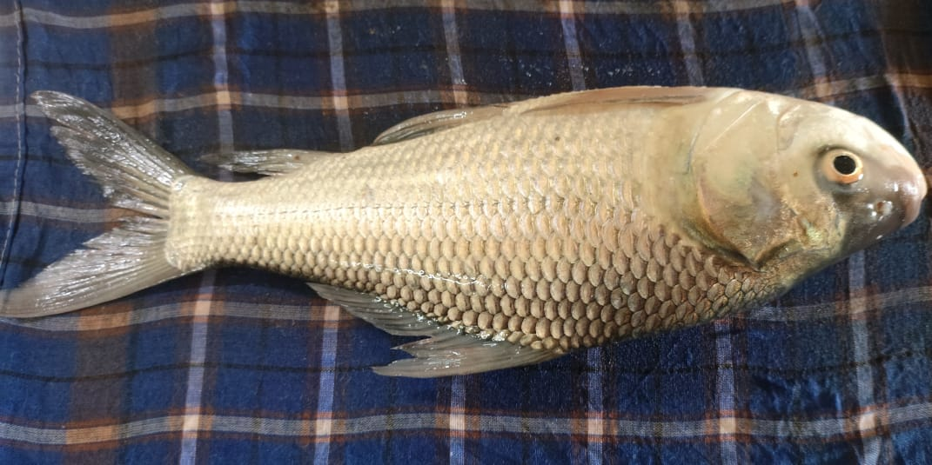  Fig: 2 Catla catla | 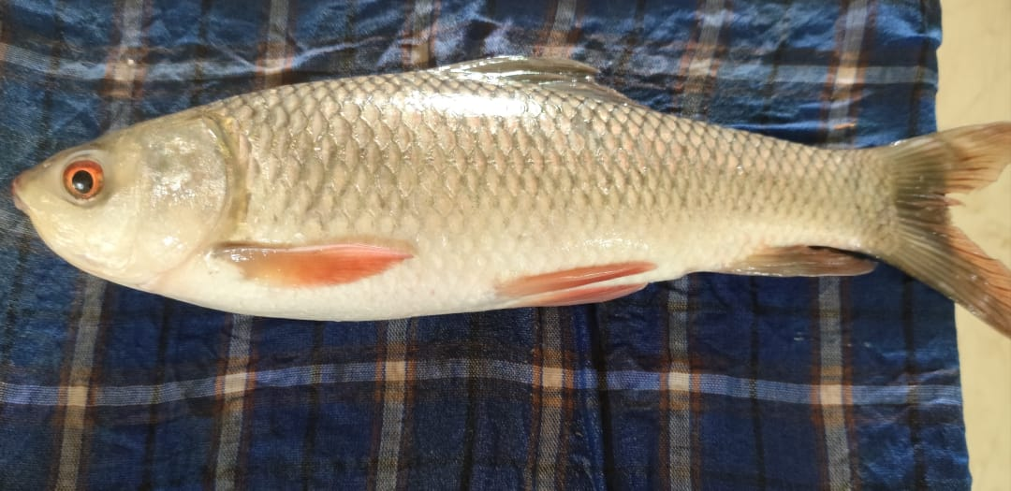  Fig: 3 Labeo rohita
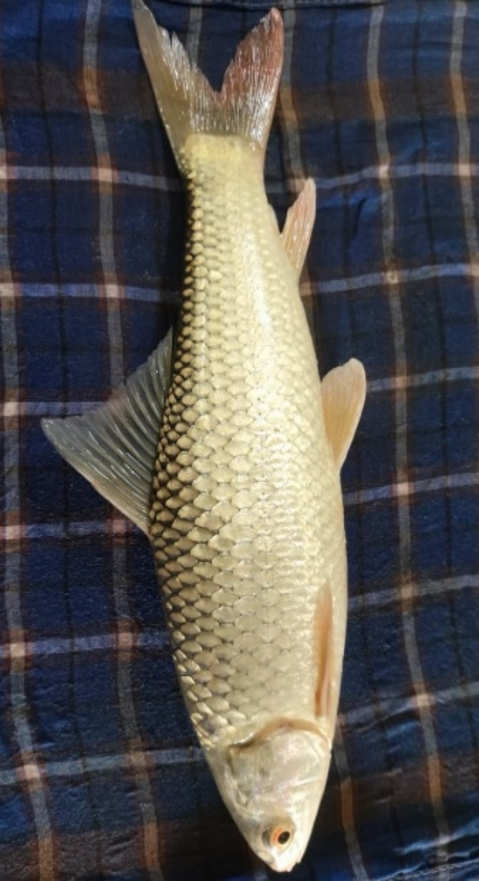  Fig: 4 Cirrhinus mrigala | 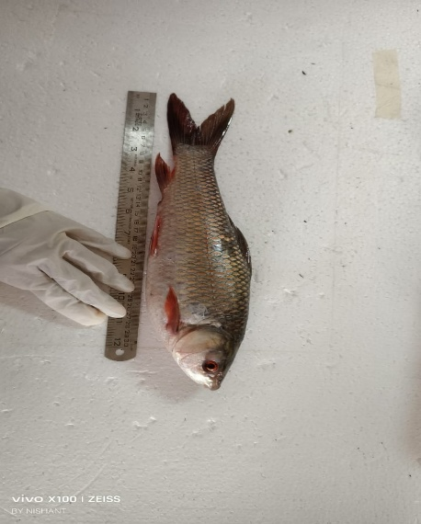  Fig:5 Total Length Measurement
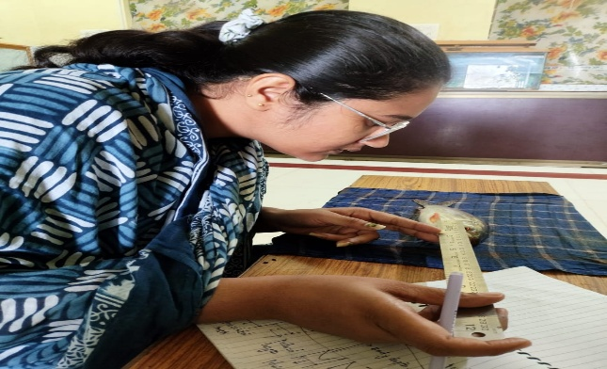  Fig:6 Eye Diameter Measurement | 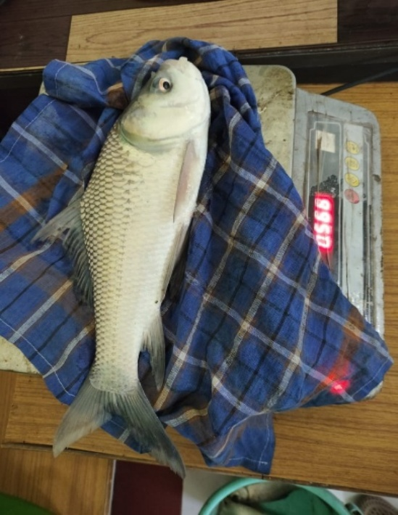  Fig 7: Weighing

Disclaimer (Artificial intelligence)
Option 1:
Author(s) hereby declare that NO generative AI technologies such as Large Language Models (ChatGPT, COPILOT, etc.) and text-to-image generators have been used during the writing or editing of this manuscript.
Option 2:
Author(s) hereby declare that generative AI technologies such as Large Language Models, etc. have been used during the writing or editing of manuscripts. This explanation will include the name, version, model, and source of the generative AI technology and as well as all input prompts provided to the generative AI technology
Details of the AI usage are given below:
1. this is my own written paper
2. I had done this as a project in my ug Programme
3. research articls and papers had been used for refrences
References
DoF.gov.Annualreport;2023-24
Available: https://dof.gov.in/sites/default/files/2025-02/Final_Annual_Report.
Chandra, G., Samanta, R., Pushp, A., & Keer, N. R. (2024). Understanding the biology of Indian major carps: key insights for sustainable aquaculture and conservation (pp. 1–10).
Das, P. C., Mishra, B. K., & Swain, S. K. (2019). Comparative growth performance of Indian major carps under semi-intensive culture system. Journal of Fisheries, 7(2), 45–52. https://doi.org/10.17017/jfish.v7i2.2019.45
Jayasankar, P. (2018). Present status of freshwater aquaculture in India - A review. Indian Journal of Fisheries, 65(4).
Jhingran, V. G. (1991). Fish and fisheries of India (3rd ed.). Hindustan Publishing Corporation.
Karim, A., Shoaib, M. A., Khwaja, S., Yawar, N. A., Raza, A., & Bibi, S. (2024). Variations in growth performance of Catla (Catla catla), Rohu (Labeo rohita) and Mrigal (Cirrhinus mrigala) fed with varying levels of fishmeal-based diets in intensive farming. Brazilian Journal of Biology, 84, e267950. https://doi.org/10.1590/1519-6984.267950
Khan, M. A., Khan, S., & Saini, P. (2020). Morphometric and meristic characterization of Indian major carps from different river systems. Journal of Applied Ichthyology, 36(4), 540–547.
Khan, N., Ashraf, M., Qureshi, N. A., Sarker, P. K., Vandenberg, G. W., & Rasool, F. (2012). Effect of similar feeding regime on growth and body composition of Indian major carps (Catla catla, Cirrhinus mrigala and Labeo rohita) under mono and polyculture. African Journal of Biotechnology, 11(44), 10280-10290.
Murthy, H. S. (2002). Indian Major Carps (pp. 262–272). CABI Publishing.
Natarajan, A. V., & Jhingran, A. G. (1963). On the biology of Catla catla (Hamilton) from the River Yamuna. Indian Journal of Fisheries, 10A (1), 43–95.
Ng, Casey & Ooi, Peter & Wong, Wey-Lim & Khoo, Gideon. (2017). A Review of Fish Taxonomy Conventions and Species Identification Techniques. Journal of Survey in Fisheries Sciences. 4. 54-93. 10.18331/SFS2017.4.1.6.
Reddy, P. V., Gjerde, B., Tripathi, S. D., Jana, R. K., Mahapatra, K. D., Gupta, S. D., ... & Gjedrem, T. (2002). Growth and survival of six stocks of rohu (Labeo rohita, Hamilton) in mono and polyculture production systems. Aquaculture, 203(3-4), 239-250.
RH, L. M. (1978). Identification of freshwater fishes. IBP Handbook (IBP). no. 3.
Yadav, A. ur, & Paul, N. (2023). Morphometric analysis of fish, Labeo rohita in Lucknow, Uttar Pradesh, India. World Journal of Biology Pharmacy and Health Sciences, 14(3), 122–128.

